LES of Turbulent Swirling Flames:
A Tool for Gas Turbine Combustor Simulations

K.K.J.Ranga Dinesh and K.W.Jenkins
Applied Mathematics and Computing Group, School of Engineering, Cranfield University, UK.
Large eddy simulations (LES) of turbulent non-premixed swirling flames with strong emphasis on jet precession, recirculation and vortex breakdown have been investigated. LES techniques have been applied to predict several flames based on the Sydney swirl burner experiments. We solve numerically the governing equations for continuity, momentum and mixture fraction on a structured Cartesian grid, along with the Smagorinsky eddy viscosity model with dynamic procedure as the subgrid scale turbulence model. Finally, the conserved scalar mixture fraction based thermo-chemical variables are described using the steady laminar flamelet model. Results show that LES successfully predicts both the upstream first recirculation zone generated by the bluff body and the downstream second recirculation zone attributed to the vortex breakdown. Generated frequency spectrums demonstrate low frequency oscillations and the existence of precession in the centre jet which agrees very well with the experiment. The scalar predictions are also successful at the most axial locations away from the inlet. Additionally, the study further highlights the predictive capabilities of LES on jet precession with the laminar flamelet model providing a good technique for capturing the basic swirling flame structure.

Key words: Swirl, Vortex breakdown, Recirculation, Combustion, Precession

1. Introduction
Large eddy simulation (LES) has been widely accepted as a promising numerical tool for solving large scale complex turbulent flow problems such as those found in internal combustion engines, industrial furnaces, liquid-fuel rocket propulsion and gas turbine combustors. Encouraging results have been reported recently in the literature [1-2], which demonstrates the ability of LES to capture the unsteady flow field in complex swirl configurations including multiphase flows and combustion processes.
Previous studies using LES have mainly focused on the flow field analysis of the swirling flames such as vortex breakdown [3]. However, there is a need for many more LES studies of Sydney swirling flames to clarify the scalar predictions and oscillations mechanisms. The present work is a continuation of our previous work [4] into the study of oscillations, instabilities and scalar predictions of selected Sydney swirling flames. In this paper we discuss the central jet precession and instability modes while specifically focusing on detecting typical precession frequencies. Finally, we validate the scalar predictions using the steady laminar flamelet model.

2. The Sydney Swirl Burner
The Sydney swirl burner configuration [5] has a 60mm diameter annulus for a primary swirling air stream surrounding a circular bluff body of diameter D=50mm, and the central fuel jet is 3.6mm in diameter. The burner is housed in a secondary co-flow wind tunnel with a square cross section of side length 130mm. Swirl is introduced aerodynamically into the primary annulus air stream at a distance of 300mm upstream of the burner exit plane and inclined 15 degrees upward to the horizontal plane. Swirl number can be varied by changing the relative magnitude of tangential and axial flow rates. The literature already includes the details of flame conditions such as flame types, their velocities, swirl and Reynolds numbers etc. and can be found in [5].

3. Mathematical formulations and numerical modelling
The LES code PUFFIN developed by Kirkpatrick [6] and Ranga-Dinesh [7] is used to perform simulations. PUFFIN computes the temporal development of large-scale flow structures by solving the transport equations for the spatially filtered mass, momentum and mixture fraction. The numerical algorithm is described in detail by Ranga-Dinesh [7] and will only be summarised here.
Equations are discretised in space using the finite volume formulation (FVM) with a cartesian coordinate system on a non-uniform staggered grid. Second order central differences are used for the discretisation of all spatial terms in both the momentum equation and the pressure correction equation. Temporal advancement is achieved using the Crank-Nicolson method for the mixture fraction derivatives, and the momentum equations are integrated in time using a second order hybrid scheme. The functional dependence of the thermo-chemical variables is closed through the steady laminar flamelet approach and a presumed beta probability density function of the mixture fraction is chosen as a means of modelling the sub-grid scale mixing. The computational domain employed a non-uniform grid with 3.4 million cells over a grid size, 300×300×250mm in the x, y and z directions respectively. The mean axial velocity distribution for fuel inlet and mean axial and swirling velocity distributions for air annulus are specified using power law profiles. The fluctuations are generated from a Gaussian random number generator and added to mean velocity profiles such that the inflow has the correct turbulence kinetic energy levels obtained from experimental data.

3. Results and discussion
The Sydney swirl burner is designed to study reacting and non-reacting swirling flow structures for a range of swirl numbers and Reynolds numbers. The aim here is to elucidate the correct flow features such as recirculation, vortex breakdown, central jet precession, precession frequencies, and instability modes for simulated flames. Furthermore, the investigation reveals the success of the scalar predictions by comparison with detailed experimental data.

3.1. Flow Features: Recirculation, Vortex breakdown, Precession frequencies, Instability modes
Figure 1 shows the contour plot of the mean axial velocity of flame SM1. The animation and the contour plot provide an interesting insight into the complex turbulent swirling flow behaviour. It shows the formation of the upstream and central recirculation zones where the axial velocity becomes negative and the dynamics of fuel jet break-up in the upstream recirculation zone can be seen. Figure 2 shows the LES predictions of central jet precession of flame SM1 at different time periods. The images, based on filtering the axial velocity at different time periods show that the jet appears to move more into one side of the geometric centre line before it changes to the other side.
Figure 3 shows the power spectrum of axial velocity on the centreline axial locations for flame SM1. The power spectrum indicates the presence of peaks at low frequencies. Particularly, the power spectrum shows peaks at near 20Hz and also in the range 60-70Hz. This is an interesting finding compared with the experimental observation, and the occurrence of the downstream recirculation zone leads to further mixing of an already turbulent jet. In addition, the considered location is situated near the top of bluff body stabilized recirculation zone, which may also cause some vortex shedding. Figure 4 shows the power spectrum frequencies of flames SMH1 which shows some peaks at low frequency levels and the peaks become more discrete and appear around ~45Hz and this value is very close to the experimental observation. The identification of the precession frequencies relevant to instability modes is classified as a major benchmark of this work.

3.2. Scalar fields
Figures 5 &6 show a snapshot of the filtered mixture fraction and temperature of flame SM1. Temperature animation also shows the dynamic nature of temperature distribution in the central vortex breakdown region. The stochiometric contour is also marked in both figures to highlight the instantaneous high temperature regions which indicate that the instantaneous temperature distribution is very much a dynamic feature with pockets of high temperature regions moving about in an axial and radial direction. Figure 7 shows numerical and experimental comparisons for the radial profiles of the mean mixture fraction, mixture fraction variance and mean temperature at different downstream axial locations for flame SM1. It is evident that the radial spread of the mixture fraction is slightly under predicted in the regions between 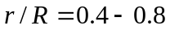at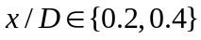. The mixture fraction variance is also over-predicted at this location. Overall, predictions of mixture and its variance show reasonably good agreement at all other locations. Given the complexity of the flow field, the comparison of the temperature field with experimental data is reasonable at most of the axial locations.

4. Conclusions
In this paper we have considered large eddy simulation of turbulent swirling reacting flow test cases from the Sydney swirl burner. The predictions show that the LES has successfully captured the bluff body stabilized upstream recirculation zone and the downstream vortex breakdown (VB). The instantaneous snapshots and power spectrum plots highlight the precession motion of the simulated swirling flames. The central jet precession has been successfully predicted by the present simulations. The LES results identified the precession frequencies and instability modes and given the complexity of the flow this is a good achievement and confirms the ability of LES to predict turbulent chemical interactions in complex combusting flows. We intend to extend this LES work as a computational tool for the simulation of gas turbine combustors.

References
[1] C.D. Pierce, C.D, P. Moin, J. Fluid Mech., 504 (2004) 73-97.
[2] J. C. Oefelein, Prog. Aero. Sci. Vol. 42 (2006) 2-73.
[3] O. Stein, A. Kempf, Proc. Combust. Inst. 31 (2007) 1755-1763.
[4] W. Malalasekera, K.K.J. Ranga Dinesh, S.S. Ibrahim, M.P. Kirkpatrick, Combut. Sci. Tech. 179 (2007) 1481-1525.
[5] A.R. Masri, P.A.M. Kalt, R.S. Barlow, Combut. Flame 137 (2004) 1-37.
[6] M.P. Kirkpatrick, A large eddy simulation code for industrial and environmental flows, PhD-Thesis, The University of Sydney, Australia, 2002.
[7] Ranga Dinesh K.K.J, Large eddy simulation of turbulent swirling flames, PhD Thesis, Loughborough University, UK. 2007.
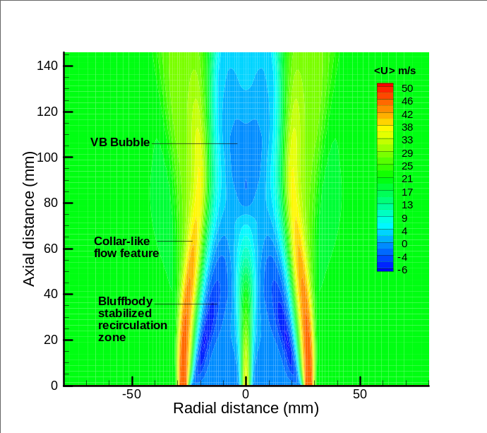 |  | 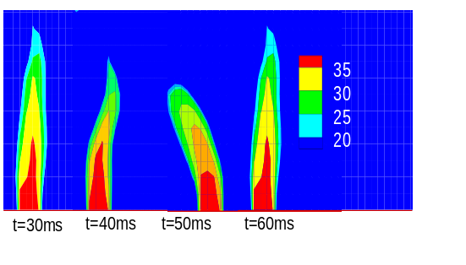
Fig.1. Contour plot of mean axial velocity |  | Fig.2. Central jet precession
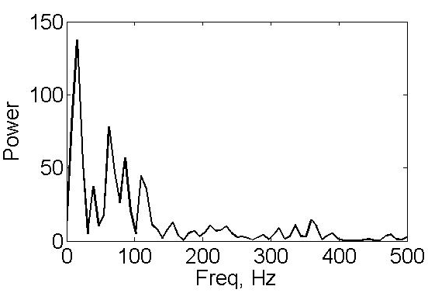 | 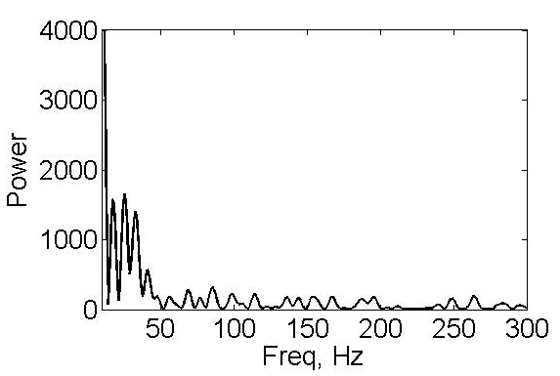
Fig.3. Power spectrum of flame SM1 | Fig.4. Power spectrum of flame SMH1

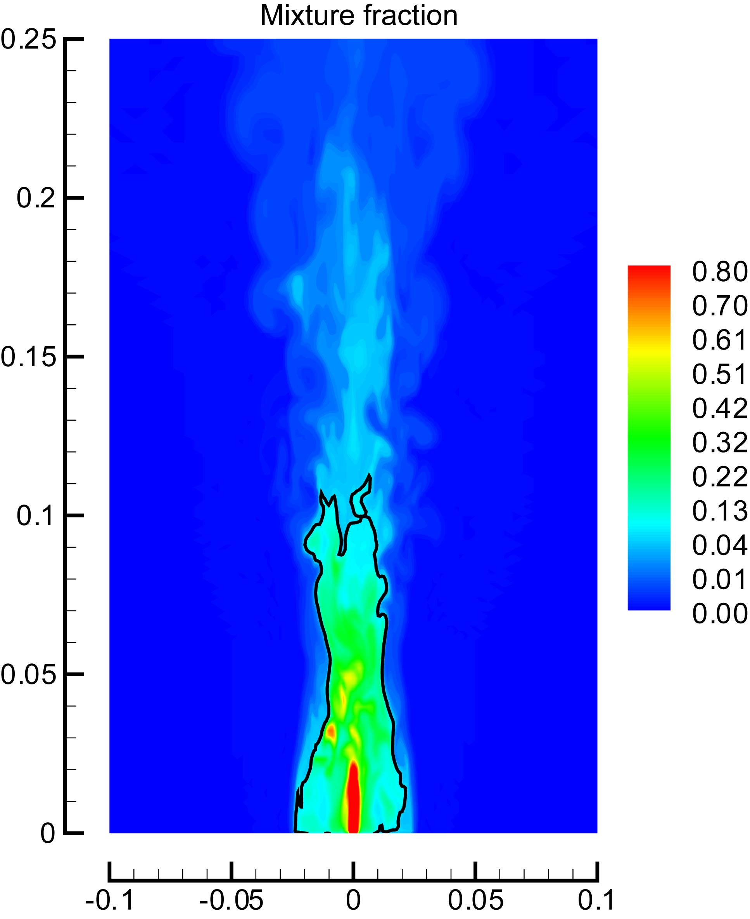 | 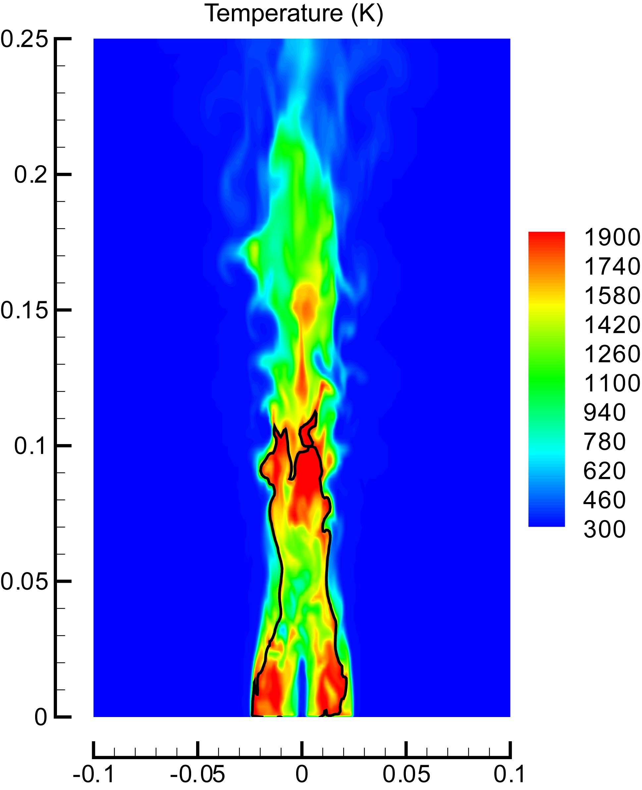
Fig. 5. Filtered mixture fraction | Fig. 6. Filtered temperature

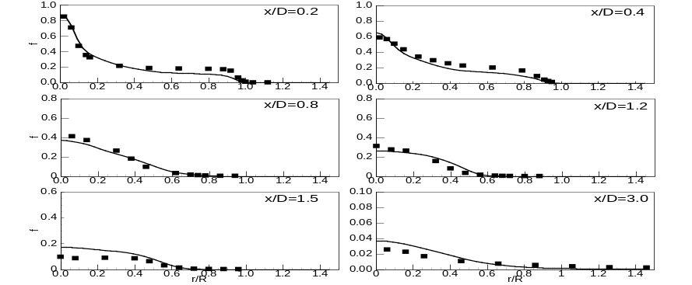
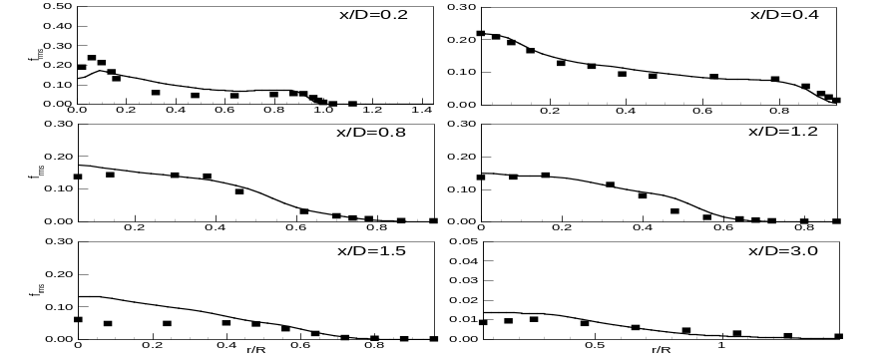
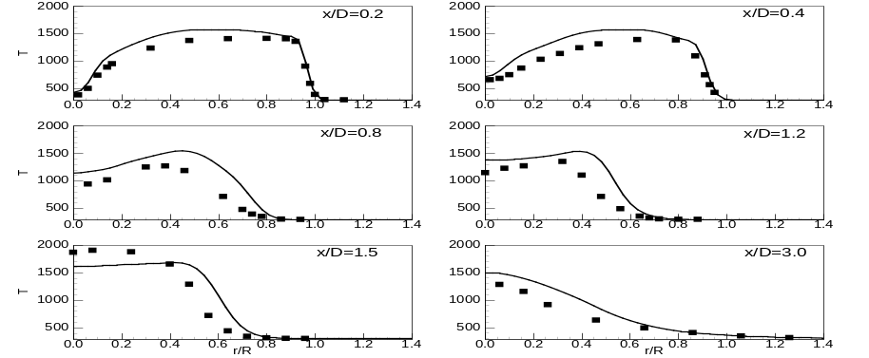
Fig. 7. Comparison of mean mixture fraction, subgrid variance and temperature. Lines represent LES results and symbols represent experimental measurements.

