Submission to BIS Select Committee Inquiry on Open Access

Stevan Harnad
Professor of Web Science, University of Southampton, UK
Canada Research Chair in Cognitive Sciences, Université du Québec à Montréal, Canada
Professor of Psychology, McGill University, Canada

Note: I am responding in an individual capacity not on behalf of my universities. I am summarising a view based on my experience as a UK academic for 20 years and an open-access researcher and advocate for nearly 25 years. I was editor-in-chief of an international journal published by Cambridge University Press (Behavioral and Brain Sciences) from 1978-2002, founded one of the first Gold OA journals (Psycoloquy) in 1989, posted the “Subversive Proposal” proposing Green OA self-archiving and the Gold OA Publishing model in 1994, launched the CogPrints Repository in 1998, commissioned the EPrints software (from which the DSpace software was also developed) in 2000, co-drafted the Budapest Open Access Initiative (BOAI), co-designed the first Green OA self-archiving mandate (Southampton 2003), submitted the recommendation to the 2004 Science and Technology Committee that became the Committee’s recommendation to parliament – and then became the first RCUK Green OA mandates, and have generated a good deal of research on the effects of OA on downloads and citations as well as the effects of OA institutional and funder policies on the growth of OA. I have consulted worldwide on OA policy-making, and am on the Board of EOS and OASIS and the SPARC Advisory Group on Campus OA Policies. (I also coined the terms “Green OA” and “Gold OA” to distinguish the two ways of providing OA.)

Executive Summary:
E1. UK worldwide leadership in OA. The UK has led the world OA movement ever since the historic recommendation of the 2004 (Gibson) Select Committee to mandate Green OA self-archiving. But the new BIS/Finch Committee recommendation to prefer and fund Gold OA pre-emptively and unilaterally, and to restrict UK authors' journal choice -- and the resultant RCUK OA policy -- are having unanticipated and unintended negative consequences, both for UK OA and for worldwide OA.
E2. Unintended negative consequences. The UK's new policy of funding Gold OA pre-emptively and unilaterally in preference to strengthening the UK's existing Green OA mandate model is neither affordable nor sustainable, and the model is not being (and will not be) followed by the rest of the world. It will not only waste scarce UK research funds needlessly and provoke resentment and non-compliance among UK researchers, but it will have perverse effects on publisher policy worldwide, encouraging publishers to offer hybrid Gold OA (i.e., institutional subscription plus optional author Gold OA for an extra fee) as well as encouraging publishers to adopt or lengthen Green OA embargoes in order to makes sure UK authors must choose the paid Gold option.
E3. Mandate and monitor immediate, unembargoed deposit. Irrespective of what funds the UK elects to spend on paying pre-emptively for Gold OA while subscriptions still need to be paid, and independent of embargo policy, the UK should (1) mandate and enforce immediate deposit of the author's peer-reviewed final draft of every journal article in the author's institutional repository immediately upon acceptance for publication and (2) designate repository deposit as the sole mechanism for submitting publications for performance review and research assessment.
E4. Link compliance to funding. Compliance with this immediate-deposit requirement has to be systematically monitored and enforced, with consequences for non-compliance (non-funding and non-renewal of grants), as is now being done to reinforce Green OA mandates worldwide.
E5. Preserve researchers’ journal choice. At the same time, the UK should merely urge strongly, rather than require, that the immediate-deposit be made immediately OA, rather than embargoed. This restores authors’ free choice of journal. It frees authors from having to publish in journals they don’t want to publish in. It frees authors from having to pay for Gold OA if they do not wish to (or can’t). It frees authors from having to provide CC-BY if they do not wish to (or can’t). It ensures that 100% of RCUK-funded research output is deposited.

E7. Facilitated eprint requests during embargos. For whatever deposits are not made immediately OA, the repositories have the automated email-eprint-request Button that allows individual users to request — and authors free to choose whether or not to provide — an individual eprint of a Closed Access deposit with just one click each. (This is not OA but “Almost-OA.”)
E8. ID/OA mandate is globally scalable. The ID/OA mandate allows all funders and all institutions, all over the world, to mandate immediate-deposit (and to provide at least Almost-OA) to all research, irrespective of where it’s published and whether or how long it’s embargoed. The Almost-OA Button tides over research needs during embargos.
E9. Keystroke mandate. Sixty percent of journals already endorse immediate Green OA. Hence ID/OA not only generates at least 60% immediate Green OA plus 40% Almost-OA, but once ID/OA is adopted worldwide, it will usher in the inevitable and well-deserved death of all OA embargoes, under the growing natural peer-to-peer pressure for OA among researchers. OA is -- and always was -- just a matter of keystrokes.
E10. Optimal and inevitable outcome. The UK should accordingly mandate the keystrokes, now, and the rest will take care of itself, as a natural matter of course. Focusing instead on Gold, Gold funds, CC-BY, copyright, and embargoes will delay for yet another decade the obvious, optimal, inevitable (and long overdue) outcome for refereed research in the online age that has already been within reach for decades: Free online access for all users.
E11. Priorities. Free online access for all users (not just subscribers) is urgently needed, and extremely beneficial to all research and researchers – both authors and users -- because it puts an end to access-denial. Text-mining, re-mix and republishing rights are very important in a few fields and will be useful in many fields, but they are not nearly as important or urgent as free online access is today -- and certainly not worth paying pre-emptive Gold OA fees for.
E12. Grasp what is already within immediate reach. Once Green OA has prevailed universally and induced a leveraged transition to Gold OA, as described below, authors will be able to provide as much CC-BY as they wish. But insisting instead on paying for CC-BY now, at the expense of losing the cost-free Green OA that is already within reach, is simply asking for another 10 years in the desert, lacking both free online access and CC-BY.

E13. Unilateral UK Gold is the losing choice in a Prisoner’s Dilemma. If the UK unilaterally mandates Gold OA Publishing (with author publication charges) today, instead of first (effectively) mandating Green OA self-archiving (at no added cost) then the UK has made the losing choice in a non-forced-choice Prisoner's Dilemma:
 | Unilateral Green (rest of world) | Unilateral Gold (rest of world)
Unilateral Green (UK only) | win/win | win/lose
Unilateral Gold (UK only) | lose/win | win/win

"If OA were adopted worldwide, the net benefits of Gold OA would exceed those of Green OA. However, we are not in an OA world... At the institutional level, during a transitional period when subscriptions are maintained, the cost of unilaterally adopting Green OA is much lower than the cost of Gold OA – with Green OA self-archiving costing average institutions sampled around one-fifth the amount that Gold OA might cost, and as little as one-tenth as much for the most research intensive university. Hence, we conclude that the most affordable and cost-effective means of moving towards OA is through Green OA, which can be adopted unilaterally at the funder, institutional, sectoral and national levels at relatively little cost." [emphasis added]
Houghton, John W. & Swan, Alma (2013) Planting the green seeds for a golden harvest: Comments and clarifications on “Going for Gold” D-Lib Magazine 19(1/2)

1. Open Access (OA) means, first and foremost, free online access to peer-reviewed research journal articles. (I will discuss re-use and re-publication rights and CC licenses separately at the end.)
2. There are two ways authors can provide OA:
by (I) publishing in a journal that makes its articles freely accessible online (this is called OA publishing, or “Gold OA”)
or
by (II) publishing in any journal at all, and making their peer-reviewed final drafts freely accessible online by self-archiving them in an OA repository upon acceptance for publication (this is called OA self-archiving or “Green OA”).
3. UK Commitment to Open Access. The commitment of BIS and the Finch Committee to providing OA to UK research output is extremely timely and welcome. It builds on the global leadership role that the UK has been performing for nearly 9 years, ever since the historic recommendation by the 2004 (Gibson) Select Committee to mandate Green OA self-archiving by UK universities and UK research funding councils: http://www.publications.parliament.uk/pa/cm200304/cmselect/cmsctech/399/39903.htm
4. That epochal recommendation took root slowly, but has now spread worldwide and is being acted upon by almost every nation on every continent. This is a highly opportune time for the UK to strengthen and accelerate its OA policy, as BIS and the Finch Committee have expressed a clear desire to do.
5. Strengthening and Accelerating UK OA Policy Fulfillment. The means by which the Finch Committee has proposed to strengthen and accelerate UK OA policy, however, regrettably give rise to some very serious unanticipated problems. Fortunately, however, these problems can be very easily and effectively remedied. It is the problems and the remedies that I will try to describe in this submission.
6. The 2004 UK Select Committee recommendation had been that universities and funders should mandate (require) researchers to self-archive their peer-reviewed journal articles, but it did not specify how to monitor and ensure that the Green OA mandate was complied with.
7. As a consequence, the UK mandates have been only partially successful. The proportion of the UK’s total annual research output that is OA today is about 45%, which is higher than the worldwide baseline for un-mandated OA, which is about 35% (about 2/3 of it Green and 1/3 of it Gold), but it is still disappointingly far from the goal of 100% OA (see Figure 1).

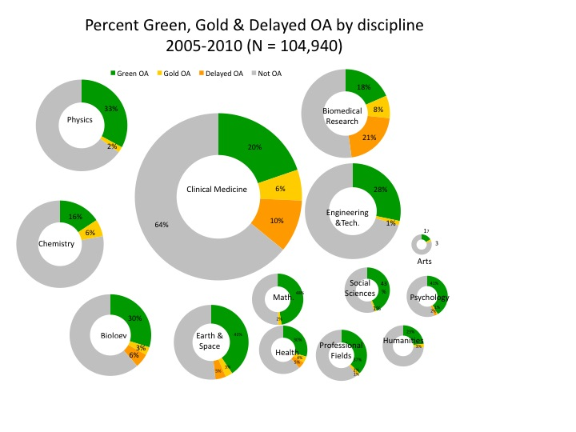
Figure 1. Worldwide percent OA, by discipline. Percent Green, Percent Gold and percent “Delayed-Gold” (which means the publisher makes contents OA after an embargo of 6-12 months or longer) are shown (based on articles indexed by Thomson-Reuters ISI, published 2005-2010, and sampled 2012). Average worldwide OA is about 35%, about 3/4 of it Green and 1/4 of it Gold and “Delayed-Gold”, with Gold (mostly delayed) exceeding Green only in Biomedical Research (Gargouri 2012a; 2013, in prep).
8. For the old RCUK OA mandate, the date at which it was mandatory to provide OA (0 to 6 to 12 months or more after publication) varied from funding council to council, and from UK university to university. Moreover, as noted, no mechanism was proposed to make sure that the OA was provided by the mandatory date: no monitoring for compliance and no consequences for non-compliance.
9. The Most Effective Green OA Self-Archiving Mandate: ID/OA. In adopting the UK Green OA model, some universities and funders (in the UK and abroad) did give some attention to devising a reliable, timely compliance verification system, and one of these systems – the Immediate-Deposit/Optional-Access (ID/OA) mandate, linked to research performance review and research assessment – has proved to be the most effective:
10. The ID/OA Mandate. The Immediate-Deposit/Optional-Access (ID/OA) mandate requires:
- immediate-deposit (even if access to the deposit is allowed to be embargoed: no delayed deposit)
- of the final peer-reviewed draft
- by the author (not the publisher)
- on the date of acceptance by the journal (which is marked by a verifiable calendar date),
- The immediate-deposit must be done directly in the author's own institutional repository (not institution-externally)
- so that immediate-deposit can be monitored and verified by the author's institution (regardless of whether the mandate is from a funder or the institution)
- as a funding compliance condition and/or an institutional employment condition.
- The institutional repository must also be designated as the sole mechanism for submitting publications for institutional performance evaluation, research grant applications and national research assessment.
- Repository deposits must be monitored and measured so as to generate rich and visible metrics of usage and citation, in order to verify and reward authors for deposit as well as to showcase and archive the institution's and funder's research output and impact.
- Although the deposit must be immediate, access to the deposit may be embargoed if the mandating funder or institution elects to allow an embargo (60% of journals endorse immediate, un-embargoed Green OA self-archiving, about 20% endorse Green OA after a 6-12 month embargo, and about 20% have a longer or indefinite embargo): http://www.sherpa.ac.uk/romeo/statistics.php
- For embargoed deposits, the institutional repositories have an Email Eprint Request Button that individual would-be users can click to send an automatic eprint request to the author, who can then decide with one click whether or not to allow the repository software to email the eprint to the requester.

11. Testing the Finch Hypothesis. ID/OA is an upgrade of the UK’s 2004 Green OA mandate, optimizing it for maximal compliance and speed, as well as for global scalability and adoption. The Finch Committee had hypothesized that Green OA mandates are not effective. This hypothesis can be tested objectively. As noted, the UK is already 10% above the worldwide 35% baseline for unmandated OA. This is probably because the UK has the largest number of OA mandates in the world – 24 institutional mandates plus 15 funder mandates: http://j.mp/ukGREEN
12. But which mandate one adopts matters -- and most of the UK Green OA mandates are not the optimal mandate (ID/OA).
13. Classification of OA Mandates By “Strength” (0-12):
0: no OA policy at all
1: no OA requirement: just request, recommendation or encouragement
(non-mandatory OA policy registered in ROARMAP)
2: deposit if/when publisher allows
3: rights-retention by default (but authors can opt out)
3: OA mandatory but embargo of 12 months allowed (no opt-out)
6: OA mandatory but embargo of 6 months allowed (no opt-out)
9: immediate deposit mandatory (no opt-out, but OA embargo allowed)
12: immediate deposit mandatory + linked to performance evaluation (Liège)
(no opt-out, but OA embargo allowed)
14. The Stronger the Green OA mandate, the More the Deposits. Although the total number of institutional Green OA mandates worldwide (161) according to ROARMAP (February 2013) is still relatively few, we tested whether mandate strength was correlated with the number of deposits in the repository (while controlling for the size and webometric rank of the institution as well as the age of the mandate and the repository): Even with only 161 mandated repositories out of 2189, a significant positive correlation is already detectable both for mandate age (the older the mandate, the more the deposits) (+) and for mandate strength (the stronger the mandate, the more the deposits) (++). (There is also a significant negative correlation for repository age, probably indicating that the annual number of deposits in unmandated repositories, which were the vast majority – 2028 out of 2189 repositories in ROAR – tend to fall off with time, for lack of a deposit mandate. There was no relation to institutional webometric rank) . See Figures 2, 3 & 4.

Figure 2. ROARMAP. Growth of OA mandates, 2003-2013
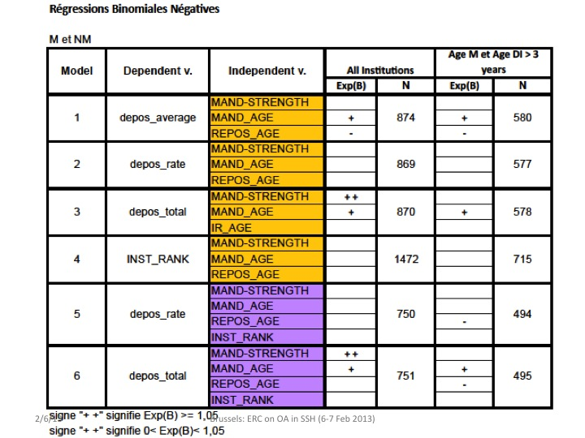
Figure 3. Significant positive correlation of mandate strength with total annual deposits (Gargouri et al 2013, in prep).

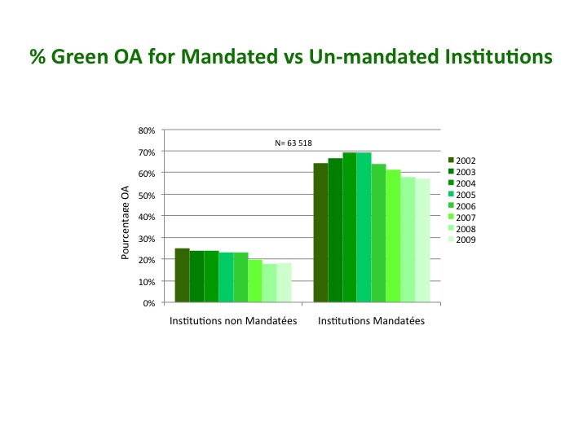

Figure 4. Percent Green OA for mandated and non-mandated institutions. Green self-archiving mandates triple the spontaneous unmandated self-archiving rate (Gargouri et al 2010). The most recent data (Gargouri et al 2013, in prep) show that the strongest mandate (ID/OA, U. Liège) generates a deposit rate of over 80%.

15. ID/OA is Strongest Mandate. We also have some evidence that ID/OA (linked to research evaluation) is the strongest mandate: The percentage of Harvard, MIT and Liege articles published in 2011-2012 and indexed by Thomson-Reuters Web of Science that deposited was 4%, 29% and 82%, respectively. The Harvard and MIT mandates are copyright-retention mandates (which we classify as strength = 3) whereas the Liege mandate is ID/OA (which we classify as strength = 12) (Gargouri et al. 2013, in prep).

16. Finch Hypothesis About Ineffectiveness of Green Is Incorrect. The objective evidence shows that the Finch hypothesis about Green OA mandates is incorrect. What is needed is to upgrade the former RCUK Green OA mandate to ID/OA, as described above, in order to maximize mandate effectiveness.

17. Paying Publishers Still More for Gold Instead of Upgrading Green. Unfortunately, what the Finch Committee recommended as the remedy instead was to downgrade repositories to preservation archiving:

"The [Green OA] policies of neither research funders nor universities themselves have yet had a major effect in ensuring that researchers make their publications accessible in institutional repositories… [so] the infrastructure of subject and institutional repositories should [instead] be developed [to] play a valuable role complementary to formal publishing, particularly in providing access to research data and to grey literature, and in digital preservation…”

18. Instead of upgrading Green, the Finch Committee proposed that Gold OA, funded by article charges, should be seen as "the main vehicle for the publication of research"… Public funders should establish "more effective and flexible arrangements" to pay [Gold OA] article charges… During the transition to [Gold] OA, funding should be found to extend licenses [subscriptions] for non-open-access content to the whole UK higher education and health sectors.

19. Unilateral UK Payment for Gold OA is Double-Payment (Incoming Subscriptions + Outgoing Gold). What this amounts to is the UK double-paying publishers for Gold OA instead of strengthening the UK’s existing mandate to provide extra-cost-free Green OA: The UK publishes about 6% of the world’s research output. Hence, irrespective of how it makes its own research output OA – whether it pays extra for Gold OA or simply mandates Green OA – the UK must continue to pay for its incoming journal subscriptions in order to have access to the remaining 94% of the world’s published research output. Hence unilateral UK payment for Gold OA is double-payment (incoming subscriptions + outgoing Gold).

20. Dictating UK Authors’ Journal Choice Based on Access Policy Instead of Quality. The Finch Committee might also have imagined that if Gold OA were mandated, UK researchers could and would switch from subscription journals to Gold OA journals. But the majority of journals today (and almost all the top journals) are not Gold OA journals. UK researchers are unlikely to accept to have their journal choice dictated to them, preferring to continue choosing their journals on the basis of their quality and track-record rather than their cost-recovery model or whether they are OA or non-OA.

21. UK Subsidizing “Hybrid Gold.” In electing to pay for Gold, the Finch Committee has given subscription publishers an irresistible incentive to add a “hybrid Gold” option for their UK authors. This means journals continue to collect subscriptions from institutions worldwide and in the UK, and their articles continue to be non-OA – except the articles of authors who pay extra for Gold OA: Their articles are made Gold OA. And the journal is double-paid: They receive all of their worldwide and UK subscription revenue, plus whatever extra hybrid Gold OA income they earn from the UK.

22. Gold OA “Rebates” to Counter Charges of “Double-Dipping.” Now suppose the publishers make good on their promise not to “double-dip”: Suppose they give all of their Gold OA income back to their subscribers in the form of a subscription rebate at the end of the year. Suppose a journal earns J euros per year in subscriptions and publishes N articles per year. Let’s say it charges J/N euros per article for its Gold OA fee.

23. UK Unilaterally Subsidizes the World. Now let’s suppose the UK pays this J/N fee for all of UK’s own articles (which, remember, represent 6% of all articles published worldwide). That means the UK increases worldwide publishers’ revenues by 6% per year. True to their word, the publishers give back that extra revenue to their subscribers. How? At year’s end, every subscribing institution worldwide gets back 6% of what they have paid for subscription. So the UK gets back 6% of the 6% it has itself double-paid (for subscription + Gold), and the rest of the world gets back 94% of the 6% that the UK has double-paid.

24. Unilateral UK Gold is the losing choice in a Prisoner’s Dilemma. This would not be a very good deal for the UK -- especially in view of the fact that the UK’s full annual 6% share of worldwide published research could have been made OA at no extra cost, by mandating Green OA (with an upgrade to the ID/OA mandate). If the UK unilaterally mandates Gold OA Publishing (with author publication charges) today, instead of first (effectively) mandating Green OA self-archiving (at no added cost) then the UK has made the losing choice in a non-forced-choice Prisoner's Dilemma:

 | Unilateral Green (rest of world) | Unilateral Gold (rest of world)
Unilateral Green (UK only) | win/win | win/lose
Unilateral Gold (UK only) | lose/win | win/win

"If OA were adopted worldwide, the net benefits of Gold OA would exceed those of Green OA. However, we are not in an OA world... At the institutional level, during a transitional period when subscriptions are maintained, the cost of unilaterally adopting Green OA is much lower than the cost of Gold OA – with Green OA self-archiving costing average institutions sampled around one-fifth the amount that Gold OA might cost, and as little as one-tenth as much for the most research intensive university. Hence, we conclude that the most affordable and cost-effective means of moving towards OA is through Green OA, which can be adopted unilaterally at the funder, institutional, sectoral and national levels at relatively little cost." [emphasis added]
Houghton, John W. & Swan, Alma (2013) Planting the green seeds for a golden harvest: Comments and clarifications on “Going for Gold” D-Lib Magazine 19(1/2)

25. UK-Only Gold OA Rebate. The only alternative to a 6% publisher rebate given to all institutional subscribers worldwide would be for the full rebate for the 6% UK double payment to be given to UK subscribers only. But that would effectively amount to publishers transforming UK institutional journal subscriptions into Gold OA payments, so that in exchange for whatever was being paid for incoming subscriptions by UK institutions already, each UK institution would also be given (hybrid) Gold OA for its research output. (Let us assume that the UK institutions whose article output exceeded what they were paying for incoming subscriptions at J/N euros per Gold article would be “subsidized” by the institutions whose article output was less than their incoming subscriptions, with the UK’s total overall spend on incoming subscriptions roughly equal to its total annual article Gold OA output at J/N euros per article, accounting for 6% of journals worldwide revenues either way.)

26. A UK Gold OA Mandate on Publishers? Such a UK-Only Gold OA rebate would effectively mean that the UK’s OA mandate was binding not on UK researchers but on their publishers. But it is highly unlikely that established subscription publishers worldwide would comply with a unilateral UK mandate to provide Gold OA for UK output just in exchange for the institutional subscriptions they were being paid already. For if publishers did comply with a UK mandate to make all their UK articles Gold OA without the UK paying a penny extra, then of course all other countries could mandate it too.

27. An Unstable Subscription/Gold Equilibrium. But if all articles in all journals worldwide were being made Gold OA in exchange for existing journal subscriptions, there would no longer be any reason for institutions to continue subscribing to journals at all, because the journal articles would be accessible free for all. The journal subscriptions would be hanging by a skyhook, and the equilibrium we had assumed between those institutions that were publishing more Gold OA articles (at J/N euros per article) than they were paying for subscriptions and those who were publishing less would lead to instability: There would be opportunistic institutional subscription cancellations, which would require publishers to raise subscription prices to keep their total subscription revenue levels constant; that would in turn raise the J/N euro Gold OA fee. But higher subscriptions prices would generate more cancellations, which would again raise subscription prices and the corresponding J/N euro Gold OA fee.

28. Transforming Incoming Journal Subscriptions to Outgoing Gold OA Article Payments Stably and Sustainably. It is evident (and certainly foreseeable by publishers) that a full rebate to UK subscribers in the form of free Gold OA would be unstable, unscaleable and unsustainable. The reason is obvious: Journals are subscribed to by institutions as a whole yearly package of incoming articles, whereas articles are published singly, by individuals, as outgoing articles. If there is to be a transition from non-OA journal subscription charges to Gold OA article publication charges, the product that is paid for has to change from annual incoming journal bundles to individual outgoing articles. Such a transformation cannot be sustained by gradually converting incoming yearly journal subscriptions into outgoing yearly subscription rebates for Gold OA.

29. If Offered Double-Payment Is Offered, Publishers Will Double-Dip. Hence the likely outcome of a unilateral Gold OA subsidy from the UK is that no one would get back any rebates from the UK double payments. The UK would just spend a lot of scarce research money on paying publishers even more money, in exchange for OA that the UK could have for its 6% had at no extra cost, by mandating Green. And publishers will double-dip.

30. Restrictions on UK Researchers’ Journal Choice. Double-dipping is not the end of the negative unintended consequences of the UK’s needlessly paying pre-emptively for Gold instead of effectively mandating Green: RCUK, in a well-meaning effort to reduce Green embargo lengths, added a second constraint on authors’ journal choice. Not only did the RCUK express a preference (echoing Finch) for Gold, offering to pay for (some of) it, but it stipulated that if a journal did not offer Gold OA, an RCUK fundee could only publish in that journal if it did not have a Green OA embargo that exceeded 6-12 months.

31. Prospect of UK Gold Subsidy Is Publisher Incentive to Adopt or Lengthen Green OA Embargoes. Not only is UK authors’ journal choice restricted to journals that are either Gold or 6-12 Green, but a second incentive is given to publishers, not only to offer hybrid Gold, but to adopt or increase Green OA embargoes of 13 months or more, in order to ensure that UK authors must pay for Gold if they wish to publish in their journal at all. Apart from the added expense for the UK, this handicaps the Green OA efforts of the rest of the world too: Most other countries have already clearly announced that they have no intention (or funds) to follow the Finch/RCUK U-Turn from the Green Road, on which they had been the pioneers and leaders, to double-paying pre-emptively for Gold instead: http://sparceurope.org/analysis-of-funder-open-access-policies-around-the-world/

32. OA Requires Global Reciprocity. The new UK-induced handicap for the rest of the world’s Green OA mandates is hence longer publisher embargoes, as an unintended consequence of the Finch/RCUK policy. And that in turn redounds negatively on the UK. Because the objective (and the benefits) of OA to the UK are not just to make the UK’s 6% output OA for the users in UK and the rest of the world, but also to make the rest of the world’s 94% OA for users in the UK.

33. The Solution: Mandate ID/OA and Restore Researchers’ Journal Choice. The solution is extremely simple: Upgrade to ID/OA for all UK research output (ID/OA moots publisher embargoes), let UK authors publish wherever they wish, and let UK authors decide whether and when they want to publish Gold, offering them whatever Gold subsidy it is felt can be spared from research without researcher resentment. This will undo both the publisher incentive to offer hybrid Gold and the incentive to adopt or increase Green OA embargo lengths.

34. Transition From Fool’s Gold to Fair Gold. ID/OA will not only accelerate the UK towards 100% Green, but it will eventually also induce the transition to Gold OA, thereby forcing publishers to phase out products and services for which there is no longer need or market in an OA world, so as to allow publishing to evolve toward the obvious, optimal and inevitable outcome: Gold OA at a fair, affordable, sustainable price, with no inflation and no double-dipping:

Subscription to Green to Fair-Gold Transition Scenario

I. Self-archiving mandates (by universities and research funders)
II. Green OA 100% globally

(As Green OA climbs anarchically toward 100% under the effect of ID/OA mandates from institutions and funders worldwide, publishers would do well to start to phase in the second rebate model discussed above as they cut costs by phasing out obsolete products and services -- the same rebate that is unstable and unscaleable until Green OA is globally mandated: The cost of Gold OA is simply deducted from the institutional subscription. As the total publishing price drops instead of rising, driven down by universal Green OA, and the obsolete inessentials and their costs are phased out, this institutional rebate can serve as the transition into the affordable, sustainable asymptotic Fair-Gold OA fee.)

III. Universal Green OA allows journals to be cancelled: subscriptions become unsustainable
IV. Journals are forced by cancellations to downsize and cut costs, phasing out obsolete products and services
V. Print and online editions and their costs are phased out
VI. Archiving & access-provision are all off-loaded onto the distributed worldwide network of institutional Green OA repositories
VII. Conversion to Gold OA cost-recovery model occurs at a fair, affordable, sustainable price, in exchange for the service of peer review and editing only; all else is phased out.
VIII. Institutional subscription funds are freed by the cancelations to pay for the Fair-Gold OA service, per paper

35. Publishers Are Lobbying To Delay Global Green and Fair Gold As Long As They Can. When BIS is lobbied by the publishing industry about potential job losses as a result of the eventual downsizing likely to be induced by globally mandated Green OA, it would be a good idea for BIS to remind both the industry representatives and themselves that the real stakes here are not publishing industry job losses: More publishing industry jobs are being and will be lost to online-era software developments that make publishing more efficient and less labour-intensive than will be lost to OA. What is really at stake is the productivity and progress of research, researchers, research institutions, research funders, doctors, teachers, students, journalists, the general public, and the vast R&D industry that produces research applications for the benefit of the public that funded the research.

36. Publishers are Trying to Embargo OA and Its Benefits. It is a great miscalculation to allow the publishing lobby to keep holding back the natural evolution of research publishing in the online era, depriving so many stake-holders of the potential benefits of OA in order to preserve the publishing industry’s bloated and increasingly undeserved revenues for products and services (print edition, online edition, archiving, access-provision) that are already obsolescent.

37. First Things First. Free online access is urgently needed, and extremely beneficial to all research and researchers – both authors and users -- because it puts an end to access-denial. Text-mining, re-mix and republishing rights are very important in a few fields, would be useful in many fields, but are not nearly as important or urgent as free online access. Moreover, asking subscription publishers (60% of whom already endorse immediate, unembargoed Green OA) to endorse CC-BY would be tantamount to asking them to legalize rival publishers immediately free-riding on their content and selling it at a cut rate having made no investment in it. Nor do all authors want to allow their verbatim texts to be remixed and republished, even with acknowledgment. Hence it is completely unrealistic to demand CC-BY for Green OA – and CC-BY is neither affordable, nor worth paying for, as Gold OA.

38. Post-Green Gold and CC-BY: Once Green OA has prevailed universally and has induced a leveraged transition to Fair-Gold OA, as above, authors will be able to provide as much CC-BY as they wish. Insisting on paying for CC-BY pre-emptively now, at the expense of losing the cost-free Green OA that is already within reach, is simply asking for another 10 years in the desert, lacking both free online access and CC-BY.

REFERENCES
Gargouri, Y., Hajjem, C., Lariviere, V., Gingras, Y., Brody, T., Carr, L. and Harnad, S. (2010) Self-Selected or Mandated, Open Access Increases Citation Impact for Higher Quality Research. PLOS ONE 5 (10) e13636 http://eprints.ecs.soton.ac.uk/18493/
Gargouri, Yassine, Lariviere, Vincent, Gingras, Yves, Carr, Les and Harnad, Stevan (2012a) Green and Gold Open Access Percentages and Growth, by Discipline. In: 17th International Conference on Science and Technology Indicators (STI), 5-8 September, 2012, Montreal, Quebec, Canada, Montreal. http://eprints.soton.ac.uk/340294/
Gargouri, Y, Lariviere, V, Gingras, Y, Brody, T, Carr, L and Harnad, S (2012b) Testing the Finch Hypothesis on Green OA Mandate Ineffectiveness. arXiv:1210.8174 [cs.DL] http://arxiv.org/abs/1210.8174
Harnad, S. (2007) The Green Road to Open Access: A Leveraged Transition. In: Anna Gacs. The Culture of Periodicals from the Perspective of the Electronic Age. L'Harmattan. 99-106. http://eprints.ecs.soton.ac.uk/13309/
Harnad, S. (2010) No-Fault Peer Review Charges: The Price of Selectivity Need Not Be Access Denied or Delayed. D-Lib Magazine 16 (7/8). http://eprints.ecs.soton.ac.uk/21348/
Harnad, S. (2011) Open Access to Research: Changing Researcher Behavior Through University and Funder Mandates. JEDEM Journal of Democracy and Open Government 3 (1): 33-41. http://eprints.ecs.soton.ac.uk/22401/
Houghton, J. & Swan, A. (2013) Planting the Green Seeds for a Golden Harvest: Comments and Clarifications on "Going for Gold" D-Lib Magazine Volume 19, Number 1/2 http://www.dlib.org/dlib/january13/houghton/01houghton.html
Sale, A., Couture, M., Rodrigues, E., Carr, L. and Harnad, S. (2012) Open Access Mandates and the "Fair Dealing" Button. In: Dynamic Fair Dealing: Creating Canadian Culture Online (Rosemary J. Coombe & Darren Wershler, Eds.) http://eprints.ecs.soton.ac.uk/18511/
