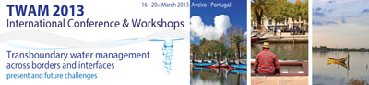
Water- boundaries and borders- the great intangibles in water quality management: Can new technologies enable more effective compliance?
Neil Coles^{(a)}, Jeff Camkin^{(a)}, Nick Harris^{(b)} Andy Cranny^{(b)} Phil Hall^{(a)} Huma Zia^{(b)}
(a) Centre for Ecohydrology, Faculty of Engineering, Computing and mathematics University of Western Australia. Perth WA. Australia  neil.coles@uwa.edu.au jeff.camkin@uwa.edu.au philip.hall@uwa.edu.au | (b) Electronics and Computer Science, University of Southampton, Highfield, Southampton, SO17 1BJ, UK.  nrh@ecs.soton.ac..uk awc@ecs.soton.ac..uk  hz2g11@ecs.soton.ac.uk

Abstract
The challenge of improving water quality has been a longstanding global concern. There has also been a general acceptance that the main drivers of poor water quality are economics, poor water management, agricultural practices, and urban development. Development, implementation, and compliance with transboundary water quality agreements, whether they be across basin, across water bodies or across national or international boundaries, remains constrained by our ability to monitor their effectiveness in real time. Despite significant advances in sensor and communication technologies, water quality monitoring (WQM) is primarily undertaken through small-scale and single-application sampling and testing that is limited by the available techniques, requires expensive highly technical instrumentation, and only provides selective data for decision support tools. The effects of diffuse pollutants and their distribution within water bodies and transboundary rivers systems are, therefore, difficult to capture, as is determination of the exact point and timing of their release into a defined “water system”.

Improved data capture and timely analysis, enabled by innovative sensor technologies and communication networks, is an important aspect of compliance monitoring. This is particularly important for international and trans-border agreements where changes in water distribution, quality, and availability associated with regional climate variability are already creating challenges for future water, energy, and food security. Therefore, it is argued that by including all the multi-level impacts of various stakeholders in a water catchment, on water resources, and by removing the long lead times between when the sample was taken to when sample testing and data analysis has been completed, it is possible to develop and implement an effective water quality monitoring and management framework.

This paper examines the prospect of improved sensor technologies and assessment frameworks that have the potential to be linked with water quality governance, polices and compliance requirements. By employing, a real time integrated and targeted monitoring system, which allows for the assessment of both the catchment functions and modifications to those functions or (eco) services by the various stakeholders, improvements in water quality is possible

Keywords: Water resources, catchments, sensors, networks, policy, governance, monitoring

INTRODUCTION

An increasingly urbanized planet will exert significant pressure on the level and complexity of water resource use and allocation trade-offs required, trade-offs that at the same time must act to minimize ecosystem degradation . Some consider the world's ecosystems as capital assets as they are the basis for continued life on this planet. If we accept this premise, then we must also accept the challenge to find ways to improve how we manage those assets for the future, given the persistent call for growth based on the premise that “growth” will deliver better lifestyles for the majority. However, this pursuit of “growth” and its perceived benefits must be considered in the context of its cost relative to the limitations of the world’s natural capital assets to continue to provide the raw materials and (eco)services necessary to maintain and deliver the aspirations and goals of the worlds’ population. Particularly, in the face of an expanding population and changing climates that are adversely affecting ecosystem resilience. Protecting the world’s freshwater resources requires diagnosing threats over a broad range of scales, from global to local , which translates into an understanding of ecosystem function, fragility and resilience.

Ecosystems yield a flow of vital services, including: the production of goods (i.e. water, food, fibre, and timber); life support processes (e.g. soil formation, pollination, water treatment, climate regulation, genetics); and life-fulfilling conditions (i.e. aesthetics, spiritual fulfilment) . However, ecosystems as capital assets are poorly understood, rarely monitored, and many are in rapid degenerative decline with extensive loss of service capability . This change in service provision is generally undocumented or unreported until the ecosystem collapses. The recent Millennium Ecosystem Assessment (MEA, 2005) report highlight the pressures and drivers of change on and within ecosystems that affect their capacity to deliver essential services for human-well being and maintenance of ecosystem function. The relationship between these ecoservices, for example provision and access to water resources, is such that declines in resource health and availability also reveal critical points and interdependencies in the supply of a combination of services that may also be in decline (Figure 1).

These relationships reflect the subtle variability in the time scales over which the ecosystems perform these functions and deliver services and thus determines their resilience and whether they are amenable to repair . Invariably, these spatial-temporal scales and interrelationships only reveal themselves as they degrade, becoming over-exploited and dysfunctional, and typically respond nonlinearly to these external forces (Daily, Alexander et al., 1997). A primary area of focus, due to its ability to efficiently transport materials and pollutants within regions, basins and across borders, is water.
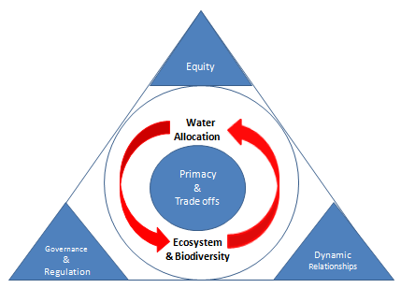
Figure 1. Drivers and actors that impact on water allocation and ecosystem performance that link “primacy” with trades offs, in a policy and science framework. Adopted from

Furthermore, ecosystems and landscapes, and therefore services are formed through localised interactions between, water, soil, vegetation and climatic conditions creating distinctive and individualistic relationships . Within this framework, and of global concern, is the increasing storage of agricultural chemicals in soils and various surface and subsurface water bodies arising from the over-application of fertilisers, hebicides and persticides. Chemical species such as nitrates and chlorides impact on crop growth and adversely on the quality of water supply for both communities and commercial activities . This highlights the diversity of stressors in river systems, that combine the accumulation of diffuse agricultural or horticultural non-point source pollutants with dilution by less impacted tributaries, that are often punctuated by significant point sources delivered from large urbanized areas .

Ecosystem performance and water quality monitoring

From the hydrological perspective, there is a plethora of literature concerning the possible origins and sources of runoff, and therefore pollutants. Such is the nature and complexity of these relationships that ecosystem health indicators, intervention strategies and rehabilitation targets developed at one landscape, or at one scale, are not universally applicable. Therefore, widespread single application solutions are rare, and remedial and conservative actions often require localised “tweaking” to deliver the desired outcomes .

Water – its management, storage, use and reclamation – forms the basis for life on earth, environmental health and energy and food security. Given that over 90 per cent of the world’s population lives in countries that share river basins, of which 40 per cent lives in river and lake basins that comprise two or more countries , access to water, water quality and water allocation becomes increasingly problematic from the headwaters, to the discharge point. This becomes increasingly complex within river basins, as there are multiple monitoring and compliance requirements that are often undertaken across borders, under differing governance structures and administrative capabilities. This creates both logistic and political dificulties in determining and setting appropriate metrics for measuring and reporting ecosystem health and thus, setting targets and indicators that match industry performance with landscape conditions that avoid long-term cumulative impacts within a water system in which multiple activities are undertaken. Therefore in order to meet present and future market demands compliant with water quality agreements, understanding of the drivers and actors of water quality and river health is required to determine equity in terms of water allocation and trade offs (Figure 2).

Changes in water distribution, quality, and availability associated with short-to-medium term regional climate variability will also create challenges for future water, energy and food security (Coles and Hall 2012). To assure the broader community that water and land managers are utilising natural resources sustainably (and are being independently assessed) there is a requirement for both an adequate and flexible eco-accreditation framework supported by a robust real time monitoring and reporting system.

However, the lack of ‘Ground-Truth’ data is common to all scales (from field to catchment size) . Limiting factors include the costs of existing field instrumentation and labour to maintain such networks, both of which result in sparse sampling . The ‘Holy Grail’ of hydrological and water quality research is to secure quality data across all scales to determine the spatial and temporal sources of storm runoff and simultaneously for various chemical species (e.g.Chlorides (Cl-), nitrates (NO₃)), allowing:
- Identification of ‘hot spots’ of both surface and subsurface sources which contribute towards runoff and chemical transport which are key to devising better land – water management strategies;
- Improved models of tracking water and chemical transfer across scales .
As agriculture develops and land and water use intensifies for energy and food production, the adverse impact of these activities on the natural ecosystems that support them will become more apparent. Damaging the integrity of these ecosystems will undermine the energy-generating and food-producing systems that they support. By using local and global scalable approaches, water resources within ecosystems can be protected or restored. These systems by necessity and design will strengthen and create sustainable water resources and maintain ecosystem health. Transferring theory into practice will, by necessity, require locally-based information on the ecosystem performance to be collected and analysed in real time. There are existing spatial models for small scales (<1 km²) which attempt to predict runoff and therefore chemical transport but field campaigns have been limited (due to costs in equipment/labour) and sampling is restricted to physical sampling at each nodal point .
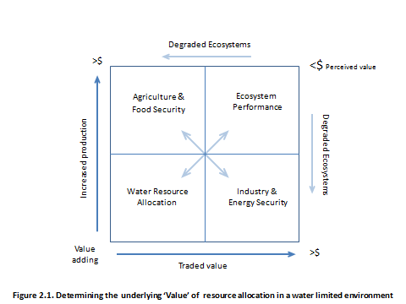
Figure 2. Determining the underlying ‘Value’ of resource allocation in a water limited environment. Adopted from
Creating an accredited assessment framework that will align the various industry-based models, identify and fill gaps in the areas of energy generation, food production and water security to deliver a managed system, requires appropriate data, a relevant regulatory system, and evidentiary-based governance framework (Figure 3).

Integrated systems, monitoring networks and global linkages

The challenges facing us to improve water quality is a growing global concern, typified by the creation of the European Commission Water Framework Directive and the United States Clean Water Act, among others. Development, implementation, and compliance with transboundary water quality agreements, whether they be across basin, across water bodies or across national or international boundaries, remains constrained by our ability to monitor their effectiveness in real time. For example, the effects of diffuse pollutants and their distribution within water bodies and transboundary rivers systems are difficult to capture and determine the exact point and timing of their release into that water system. What is needed, therefore, is the development and implementation of innovative technologies that provide integrated real-time monitoring systems and reporting networks with intelligent assessment frameworks that are able to determine the synergies within an altered “natural” landscape or urban environment, and that will provide the necessary levers to deliver the most balanced and sustainable outcome in a given locality.
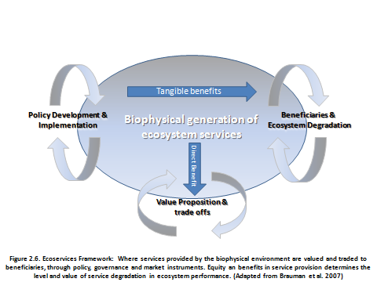
Figure 3 Ecoservices Framework: Where services provided by the biophysical environment are valued and traded to beneficiaries, through policy, governance and market instruments. Adopted from ..

Variations in river flows and contributions within and external to river basins (via groundwater’s) is difficult to calibrate and monitor, particularly flows associated with extreme events (either floods or droughts) during which significant plumes or high concentrations of diffuse pollutants can be released. Tracing sources and impacts is often difficult during these events. To achieve this, a WQM framework is proposed with key attributes for real-time, spatio-temporal and multi-level catchment-level monitoring. Based on surveyed monitoring techniques and a review of their limitations, wireless sensor networks (WSNs) are one tool which despite their current limitations, are attractive for real-time spatio-temporal data collection and reporting for water quality applications.

Development and understanding of better sensor and communication network technologies will provide opportunities for including improved and targeted Water Quality and Natural Resource Management (NRM) indicators. Traditional WQM that relies on data capture through small-scale and single-application sampling and laboratory analysis has not, and will not, enable us to meet the challenge of improving water quality. A transformation in thinking and approach to WQM is necessary with the adoption of new management and development opportunities, which are enabled by innovative technology . Place-based or catchment-based research is an effective way of promoting collaboration and focusing efforts on the integration of reductionist and holistic approaches . Improved data capture through vastly improved sensor technologies is an important aspect of water quality compliance, particularly for international and trans-border agreements.

The amount and quality of data available clearly limits the amount of extractable knowledge gained, and thereby inherently limits the capabilities of the scientist, modeller or land manager to deliver appropriate information on which to base actionable decision . An ideal starting point would be an effective scalable monitoring network, which links the micro to the meso scales and supports understanding water stress from the plant-root level through to the basin scale. This could be achieved through new technologies, that link targeted molecular sensor monitoring with wireless networks that can deliver real time responses within catchments and regions, and potentially globally through satellite monitoring technologies. This would allow the implementation of a more inclusive and effective monitoring and management framework. This framework, would then be underpinned by a real time integrated and targeted monitoring system that allows for the assessment of the both catchment function and modifications to those functions or services by the stakeholders.

As part of this framework remote sensing technologies can be used to provide an inter-comparison analysis of average soil moisture from remotely sensed measurements, ground-based measurements, and land surface models can be utilised to determine variability in soils moisture distribution patterns. Thus they can provide an indication of relative soil moisture conditions to improve runoff predictions and analyze land surface-atmosphere interactions for regional climate predictions in data limited areas. . This linkage and similarities between individual sensing requirements suggests there is need for an autonomous vegetation-soil-water quality monitoring framework based on targeted wireless sensor technologies . Screen-printed chemical sensors (Figure 4a) can potentially address these issues and when coupled with wireless technology and localised energy harvesting, provide a cheap deployment solution for large-scale hydrological monitoring . The key to this is the availability of suitable sensors. Such sensors need to be low cost (as significant numbers will be required), have a suitable lifetime, and actually measure the parameter of interest. Many available sensors are proxy based, for example conductivity is often used as a proxy for moisture content. However, conductivity is affected by salt content as introduced by fertilisers. Thus, there is a requirement for anolyte specific sensors, notably ions common in the environment, such as chloride, nitrate and phosphate (Figure 4b).

Remote technologies and ground based monitoring networks are also required, both as an independent measure and a verification tool for remotely sensed data. The suggested new modelling frameworks will need to be validated and tested against field data. To this end, improved field measurement and data collection networks are required to observe variations in ecosystem performance. Based on the surveyed monitoring techniques and a review of their limitations, we conclude that WSN is one technique which has huge potential for dense data collection for agricultural activities and water quality monitoring. Furthermore, we consider that important application specific requirements like variable frequency range, variable sampling, well-defined sensor interface, lifetime, ease of deployment and configuration for hydrologists, and network model for broad environment are not well catered for by using off-the-shelf components .

In addition to in-field measurements, satellite observations provide spatially distributed data of surface soil moisture and water depth that could be used to investigate ecohydrological processes in spatially extended systems . Thus through the combination of the varied monitoring and tools (e.g. satellites, WSN, targeted molecular sensors) for individual areas of a catchment, within a river basin or within regions, a greater understanding of geo-bio-physical trends and the quantification of the contributing factors is within our grasp. This ccomplementary statistical information derived from improved data capture underpins the effectiveness of real time assessment frameworks, creating an evidentiary-based system of accounting and monitoring required to set meaningful qualitative and quantitative measures and indicators to better inform water resource management. Through a combination of new technologies and a network of like-minded institutions, industry partners and governments, delivery of real time multi-scale observations of the impacts of anthropogenic activities, climate change and localised ecosystem variability is possible.
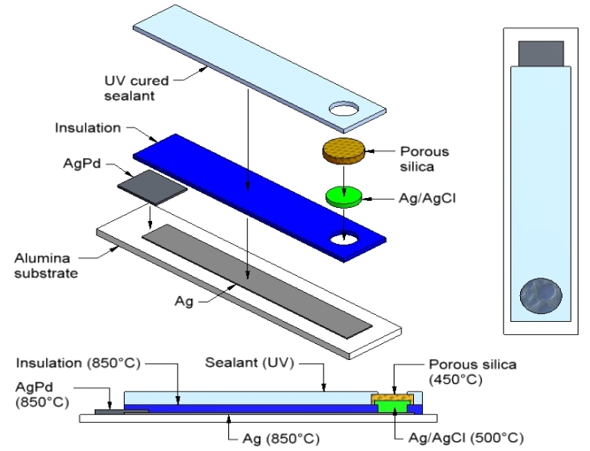
a)
b)

Figure 4: Schematic showing design of a) a single potentiometric chloride sensor composed of a number of sequentially screen-printed layers and b) multi-sensor array (after ).

CONCLUSION

The need for improved water quality monitoring and governance compliance is not in dispute; however how we achieve this, in a timely and cost effective manner is still to be determined. The brief discussion presented here highlights the changing nature of issues surrounding water management, its quality, distribution and allocation. While there is broad discussion on the need for improved monitoring technologies there is also a sustained effort required to develop an appropriate set of performance metrics that are suitable for use as health targets and indicators of change within catchments.

As for any accountable enterprise appropriate measures, metrics and indicators of operational performance need to be developed and categorized, without which short, medium and long-term goals, policies and directions cannot be set with confidence. Therefore, while significant effort in developing innovative sensor and network technologies is forthcoming, additional research is needed to derive performance indicators that clearly identify and monitor shifts in ecosystem resilience. In addition to the need for improved sensor technologies, the design and implementation of appropriate ecosystem performance metrics, monitoring networks and reporting frameworks is required to assess ecosystem performance and deliver sustainable outcomes at multiple levels.

The use of innovative technologies to better monitor the local to global responses to impacts on ecosystems in this time of rapid change and increased demands is imperative. Changes in natural resource management approaches and system functional design bring not only environmental benefits, but are perceived as an increasingly viable, financially sound alternative. By employing, a real time integrated and targeted monitoring system, in an operational performance-based framework, which allows for the assessment of both the catchment functions and modifications to those functions or (eco) services by the various stakeholders, real improvements in water quality management are possible.

AcknoWledgement
This research and collaboration is supported by funding from the Worldwide Universities Network (WUN).

Literature cited
Choi M., Jacobs J.M. & Bosch D.D. (2008). Remote sensing observatory validation of surface soil moisture using Advanced Microwave Scanning Radiometer E, Common Land Model, and ground based data: Case study in SMEX03 Little River Region, Georgia, U.S. Water Resources Research, 44, n/a-n/a.
Coles N., Sivapalan M., Larsen J., Linnet P. & Fahner C. (1998). Modelling Runoff Generation on Small Agricultural Catchments. In: In: Distributed Hydrological Modelling: Applications of the TOPMODEL Concept. (ed. Beven K). John Wiley & Sons. New York., pp. Pp 289-314.
Coles N.A. (2013). Chapter 6: Eco-hydrological Concepts. In: Handbook of Engineering Hydrology: Vol. 1: Fundamental and Application. (ed. Eslamain S). Taylor & Francis. London (in review)
Coles N.A., Farmer D., Cattlin T. & Stanton D. (2004). Managing water, the key to preserving biodiversity in the dryland agricultural areas of Western Australia. In: Proceedings of International Conference: Hydrology Science and Practice for the 21st Century. British Hydrological Society. London. July. 2004 London, UK.
Coles N.A. & Hall P. (2012). Water, Energy and Food Security: Technology challenges of thinking in a Nexus perspective. In: IEEE 2012 Conference on Technology & Scociety in Asia Singapore, p. 6.
Cranny A., Harris N.R., Nie M., Wharton J.A., Wood R.J.K. & Stokes K.R. (2011). Screen-printed potentiometricAg/AgCl chloride sensors: Lifetime performance and their use in soil salt measurements. Sensors and Actuators A, 169, 288-294.
Cranny A., Harris N.R., White N.M., Barrett-Lennard E., Coles N., Rivers M., Smettem K. & Wu J. (2012). Screen-Printed Potentiometric Sensors for Chloride Measurement in Soils. Procedia Engineering, 47, 1157-1160.
Daily G., C., Alexander S., Ehrlich P., R. , Goulder L., Lubchenco J., Matson P., A. , Mooney. Harold A., Postel S., Schneider S., H. , Tilman D. & Woodwel G., M. (1997). Ecosystem Services: Benefits Supplied to Human Societies by Natural Ecosystems. Ecological Society of America., No. 2.
Daily G.C., Söderqvist T., Aniyar S., Arrow K., Dasgupta P., Ehrlich P.R., Folke C., Jansson A., Jansson B.-O., Kautsky N., Levin S., Lubchenco J., Mäler K.-G., Simpson D., Starrett D., Tilman D. & Walker B. (2000). The Value of Nature and the Nature of Value. Science, 289, 395-396
Grayson R. & Blöschl G. (2000). Spatial Patterns in Catchment Hydrology: Observations and Modelling. Cambridge University Press, Cambridge, UK.
Huyen Le T.T., Lorenz M., Prilop K., Lam Q.D. & Meon G. (2012). An ecohydrological, ecohydraulic model system for water management of the saigon river system under tide effect. In: 9th International Symposium on Ecohydraulics Vienna, Austria.
Millennium Ecosystem Assessment (2005). Ecosystem and Human Well-being: desertification synthesis. . In: (eds. Adeel A, Safriel U, Niemeijer D & White R). World Resources Institute Washington DC, p. 26.
Newman B.D., Wilcox B.P., Archer S.R., Breshears D.D., Dahm C.N., Duffy C.J., McDowell N.G., Phillips F.M., Scanlon B.R. & Vivoni E.R. (2006). Ecohydrology of water-limited environments: A scientific vision. Water Resources Research, 42.
Rivers M., Weaver D., Smettem K. & Davies P. (2011). Estimating future scenarios for farm-watershed nutrient fluxes using dynamic simulation modelling. Physics and Chemistry of the Earth, 36, 420-23.
UN Water (2008). Transboundary Waters: Sharing Benefits, Sharing Responsibilities. In: Thematic Paper (ed. Task Force on Transboundary Waters). UNDP, p. 20.
Vorosmarty C.J., McIntyre P.B., Gessner M.O., Dudgeon D., Prusevich A., Green P., Glidden S., Bunn S.E., Sullivan C.A., Reidy Liermann C. & Davies P.M. (2010). Global threats to human water security and river biodiversity. Nature, 467.
Zia H., Harris N., Merrett G., Cranny A., Rivers M. & Coles N. (2012). A Review on the impact of Catchment-Scale Activities on Water Quality: A Case for Collaborative Wireless Sensor Networks. . Journal of Computers and Electronics in Agriculture (in review).

EC, E. C. (2000). Directive 2000/60/EC establishing a framework for Community action in the field of water policy
US, C. (1972). An act to amend the Federal Water Pollution Control Act. PUBLIC LAW 92-500-OCT.18.1972

