Representing Distributed Cognition in Complex Systems: How a submarine returns to periscope depth.

Neville A Stanton, PhD.
Transportation Research Group
Civil, Maritime and Environmental Engineering and Science Unit,
Faculty of Engineering and the Environment,
University Road,
University of Southampton,
Highfield,
Southampton, SO17 1BJ, UK.

Email: n.stanton@soton.ac.uk

Abstract
This paper presents the Event Analysis of Systemic Team-work (EAST) method as a means of modelling distributed cognition in systems. The method comprises three network models (i.e., task, social and information) and their combination. The method was applied to the interactions between the sound room and control room in a submarine, following the activities of returning the submarine to periscope depth. This paper demonstrates three main developments in EAST. First, building the network models directly, without reference to the intervening methods. Second, the application of analysis metrics to all three networks. Third, the combination of the aforementioned networks in different ways to gain a broader understanding of the distributed cognition. The analyses have shown that EAST can be used to gain both qualitative and quantitative insights into distributed cognition. Future research should focus on the analyses of network resilience and modelling alternative versions of a system.

Practitioner summary: This paper presents a practical method for analysing and evaluating distributed cognition in complex systems. The Event Analysis of Systemic Team-work (EAST) method presents task, social and information network models both individually and combined. The network models can be analysed qualitatively by visual inspection and quantitatively using network analysis metrics.

Keywords: distributed cognition, networks, team work, submarine

1. Analysing distributed cognition
Distributed cognition is characterised by multiple individuals and teams working together in pursuit of a common goal (comprising multiple interacting sub-goals). High levels of communication and coordination are required, and there is often an onus placed on technologies to facilitate this. Hutchins’ (1995) investigation into navigation on ships showed how distributed cognition worked in practice. In the analysis of a navigation task, the ship’s crew were trying to determine two things: to identify the ship’s current position and estimate the ship’s future position. Hutchins noted that this task was distributed amongst the crew and artefacts they use. No one individual was able to explain the entirety of navigation. Rather, to understand how ship navigation is performed, one needs to study the interactions within the wider socio-technical system. Hutchins studied navigation in restricted waters as this is perhaps the most challenging task and requires up to 10 personnel comprising the navigator, assistant to the navigator, navigation plotter, navigation bearing recorder and timer, starboard pelorus operator (a starboard observer who takes bearing fixes from landmarks), port pelorus operator (a port observer who takes bearing fixes from landmarks), restricted manoeuvring helmsman, quartermaster of the watch, restricted manoeuvring helmsman in after steering and the fathometer operator. His explanation and analysis was presented in a mixture of transcripts of spoken voice, narrative, diagrams and photographs. The richness of the interpretation is derived by the reader through mental simulation of the scenario as they absorb the information presented. No single Human Factors method has convincingly covered all of this complexity in its entirety (Stanton et al, 2005) making the modelling of distributed cognition a significant challenge. Using an integrated suite of methods however, allows scenarios to be analysed from the perspectives described. More importantly it allows the effects of one set of constructs on other sets of constructs to be considered; for example, how communications influence the way in which tasks are performed and in turn how the way in which the tasks are being performed influences the information being used (Stanton et al, 2008). There are also advantages associated with methods integration, because not only does the combination of existing methods bring reassurance in terms of a validation history, but it also enables the same data to be analysed from multiple perspectives. Assuming that the separate methods integrate on a theoretical level, then their application to the same data set offers a form of ‘analysis triangulation’.

Various approaches have been put forward to analyse complex socio-technical systems (Farrington-Darby et al, 2006; Furniss and Blandford, 2006; Patrick et al, 2006; Stanton et al, 2006; Waterson, 2009; Jenkins et al, 2011). The aim of the approaches is both to make the complexity of socio-technical systems more explicit, so that the interactions between sub-system boundaries may be examined, and to reduce the complexity to a manageable level. This may seem at odds with the non-linear nature of complex systems and the unpredictable properties that may emerge from them (Walker et al, 2010a, b; Stanton et al, 2012). Nevertheless, the representations do enable inspection of the relationships between sub-systems and their boundaries even if some of the fidelity is lost (Griffin et al, 2010). The co-evolution of systems design requires some occasional stock-taking before the next evolution (Stanton et al, 2012). The notion that problems become apparent at boundaries of layers, levels, structures and functions is not new, as it underpins general systems theory (von Bertalanffy, 1950). Of particular interest here is the boundary between distributed cognitive sub-systems, as this is where problems may become apparent.

Walker et al (2010a) proposed Event Analysis of Systemic Team-work (EAST), as a method that could be used to show how distributed cognition could be modelled in air traffic control. The analysis showed how distributed cognition for complex systems could be represented by networks, with the distinct advantage that the networks enabled both qualitative and quantative investigations. Walker et al argued that the multifaceted nature of the different networks revealed the aggregated behaviours that emerge in complex sociotechnical systems. This representation was proposed as a alternative to the reductionistic approaches often used to understand systems, which presented systems in their constituent parts but fail to capture the system as a whole. Walker et al suggested that the insights gained by network modelling were superior to the traditional ethnographic narrative which has previously been used to describe distributed cognition because they present graphical models of systems. Griffin et al (2010) go further to show how the EAST method offers insight into system failure. Again, the cited advantage of the approach was the non-reductionistic, non-taxonomic, method for analysing non-normative behaviour of systems. Whilst EAST does not employ taxonomies in the analysis, the resultant network structures may be classified into archetypes. The systemic approach allows system interactions to be understood in their entirety (Plant and Stanton, 2012).

EAST is underpinned by the notion that complex collaborative systems can be meaningfully understood through a network of networks approach (see Figure 1). Specifically, three networks are considered: task, social, and information networks. Task networks describe the relationships between tasks and their sequence and interdependences. Social networks analyse the organisation of the system (i.e., communications structure) and the communications taking place between the actors working in the team. Finally, information networks describe the information that the different actors use and communicate during task performance (i.e., distributed situation awareness). Each of these approaches have been presented independently in other papers, such as Farrington-Darby et al’s (2006) presentation of task diagrams in a study of railway controllers (an example of a task network), Furniss and Blandford’s (2006) presentation of communication channels in emergency medical dispatch teams (an example of a social network) and Sanderson et al’s (1989) analysis of verbal protocols for a process control task (an example of an information network). What EAST does is bring these three networks together into the same analysis framework.

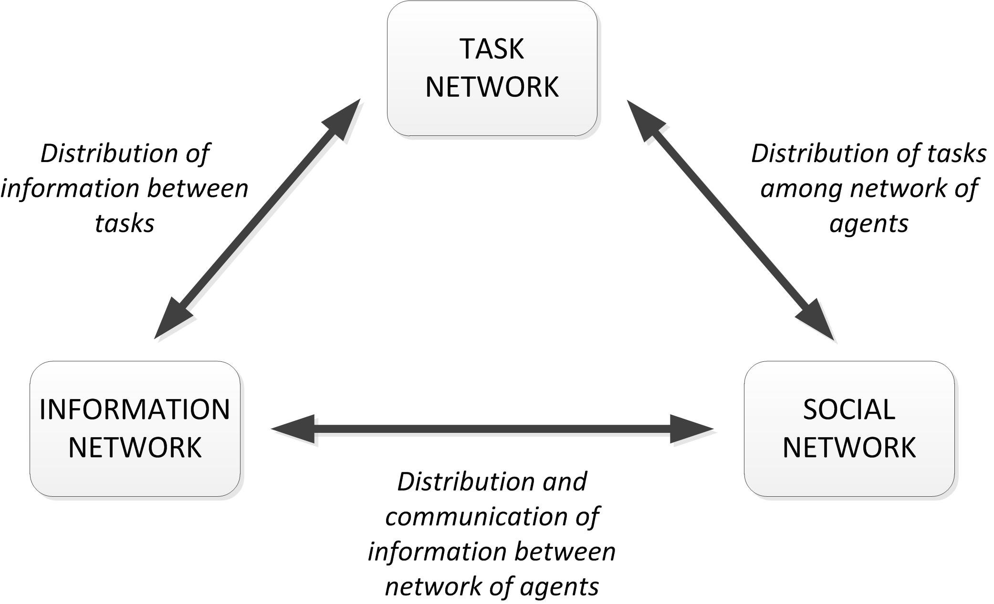

Figure 1. Network of networks approach.

The EAST framework lends itself to in-depth evaluations of complex system performance, examination of specific constructs within complex socio-technical systems (e.g. situation awareness, decision making, teamwork), and also system, training, procedure, and technology design. Whilst not providing direct recommendations, the analyses produced are often highly useful in identifying specific issues limiting performance or highlighting areas where system redesign could be beneficial.

This paper presents a new shortened-form of EAST which focuses on the analysis of collaborative performance (Stanton et al, 2008). This version of EAST does not rely upon the previously defined constituent methods of Hierarchical Task Analysis, Critical Decision Methods, Coordination Demand Analysis, Communications Usage Diagram and Operation Sequence Diagram. Rather, the task, social and information networks are developed directly from the raw data. It also extends the quantative and qualitative network analysis methods to show how network statistics may be applied to all three networks and how the different networks perspectives may be integrated. Since its conception, the framework has been applied in many domains, including naval warfare (Stanton et al, 2006), aviation (Stewart et al, 2008), air traffic control (Walker et al, 2010a), emergency services (Houghton et al, 2006), energy distribution (Salmon et al, 2008), and railway maintenance (Walker et al, 2006). The approach is gaining momentum as well as showing its domain independence.

2. System properties of EAST
EAST is a Systems Ergonomics method and as such is able to be applied to all systems levels: micro (i.e., individual human-machine-interaction), meso (i.e., organizations operating highly automated systems) and macro (i.e., multilayered networked system). At each level of the systems analysis, it is possible to construct the triad of task, social and information networks as each is a distributed cognition system at different units of analysis. Further the EAST representations could be nested such that the micro networks are contained with the meso networks which are also contained in the macro networks. So, whilst the networks might change in terms of the granularity of the analysis, the methodology would remain the same. Wilson (2012) identified six of the defining characteristics essential to Systems Ergonomics as: systems focus, context, interactions, holism, emergence and embedding. Any method that lays claim to be a Systems Ergonomics, such as EAST, should embody these characteristics. Table 1 indicates how EAST encapsulates these properties.

Table 1. Systems characteristics of EAST (from Wilson, 2012).
Characteristic | Property of EAST
Systems focus | Captures the whole socio-technical system in the network analysis and does not favour one system over the other.
Context | Analyses system behaviour at work using observed and recorded from data from that context with input from Subject Matter Experts. System boundaries are defined by subject matter of interest and may also emerge from the analysis conducted.
Interactions | The interacting parts of the system are revealed in the three networks and the relationships between the networks, as indicted in Figure 1. Thus both interactions within and between networks can be analysed showing distributed cognition in terms of task-social, task-informational, social-informational and task-social-informational interactions.
Holism | The networks are analysed as a whole, both quantitatively (using SNA metrics) and qualitatively (using network archetypes). The networks are also superimposed upon each other to produced combined networks.
Emergence | The emergent properties of the system are revealed through the SNA metrics and the network archetypes.
Embedding | The method itself is embedded in the communications and systems engineering disciplines, so it offers familiarity to organisations wishing to scrutinise their socio-technical systems. It has the benefit of representing the networks in graphical form as well as supporting metrics for detailed analysis.

As the contents of table 1 attest, EAST passes the ‘systems’ test. By conceiving of systems as sets of interacting networks (i.e., task, social and information networks) has the distinct advantage of enabling network analysis and classification of network archetypes. This means that the systems analysis methods can be framed in terms of quantitative and qualitative assessments. Networks do not differentiate between different types of node (e.g. artefacts and/or people) so that from a modelling perspective they are not constrained by existing structures of people and artefacts, rather they are related to the tasks associated with a scenario. It is also possible to model the temporal aspects of networks by identifying critical moments in the sequence of activity. To do this the scenario is divided into task phases allowing active and non-active elements to be specified and represented.

3. Data collection and analysis
EAST was undertaken as an ‘information audit’ of the relationship between the sound room and control room on-board a submarine. The control and sound rooms of have all the characteristics of distributed cognition problems (as described by Hutchins, 1995). The purpose was to understand how information flowed around the system in order to determine what requirements might be included in the next generation of tactical systems.

The data were collected over a series of observations in a control room and sound room layout in the Talisman Command Team Trainer. There is a strong communication link between the Officer of the Watch (OOW), Chief Petty Officer for Tactical Systems (CHOPS(TS): sometimes called the OpsO) and the Sound Room Controller (SRC, sometimes called the Sonar Controller or CHOPS(S)). The layout of the control room and sound room is fixed by the equipment layout, but have been optimised over the decades to the current design. The photograph in Figure 2 shows a view into the control room with the periscope on the right hand side.

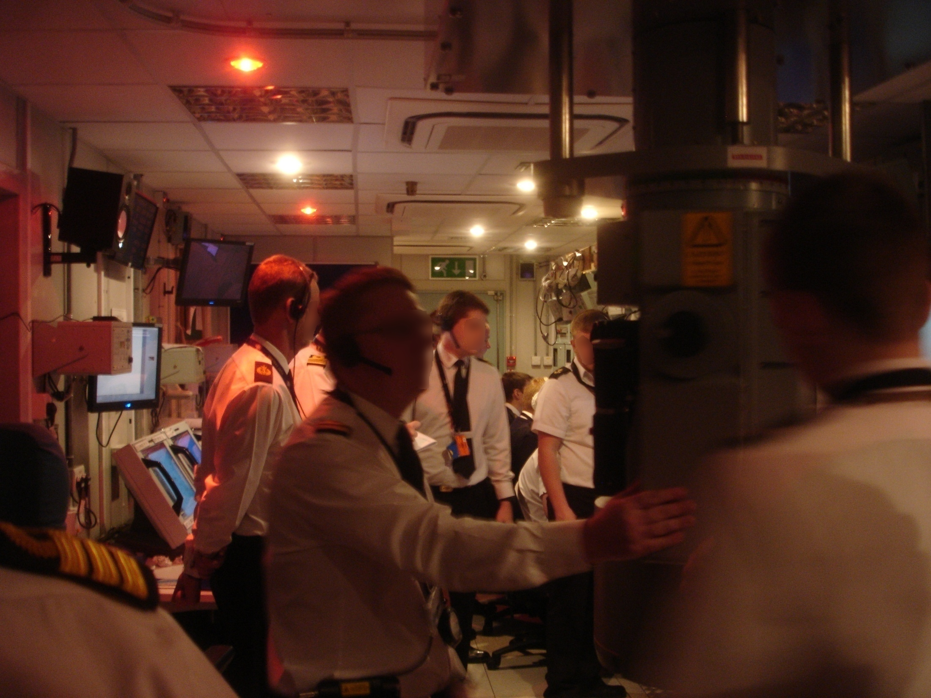
Figure 2. View into the control room with periscope on right hand side.

All of the internal communications were recorded by plugging into the system and recording on a laptop computer using Audacity (version 1.3.14 software). The ambient communications were recorded using an external Yoga BM-26D boundary microphone.

The purpose of this paper was to see if the networks could be analysed quantitatively using Social Network Analysis (SNA) metrics. SNA offers a means of analysing the network as a whole as well as the behaviour of individual nodes and their interactions. As such, SNA is potentially a very powerful tool for Systems Ergonomics. Whilst it has traditionally been applied to the analysis of social networks (as implied by the name of the method: Driskell and Mullen, 2005; Houghton et al, 2006), there is no reason why it cannot be applied to other networks, such as task and information networks. This is a new application for the method, but a potentially useful one. The method can also be applied to the design of anticipated networks, so that more effective task, social and information networks can be designed into new systems which is another new avenue of research for Systems Ergonomics that would enable network resilience to be explored in a practical manner. The first step in a SNA involves defining the network that is to be analysed. Once the overall network type is specified, the tasks, agents or information should be specified. Once the type of network under analysis has been defined, the scenario(s) within which they will be analysed should be defined. For the purposes of this paper, the RTPD scenario was considered. Once the network and scenario(s) under analysis are defined clearly, the data collection phase can begin. There are a number of metrics associated with the analysis of social networks, depending upon the type of evaluation that is being performed. The size of the network determines the number of possible relations, and the number of possible relations grows exponentially with the size of the network. This defines the network’s complexity. An explanation of the metrics analysed using AGNA (version 2.1.1 - a software program for computing the SNA metrics) are provided below. The first set of metrics analyse the individual nodes:

- Emission and reception degree are the number of ties emanating from, and going to, each agent in the network.
- Eccentricity is defined by the largest number of hops an agent has to make to get from one side of the network to another.
- The sociometric status of each agent refers to the number of communications received and emitted, relative to the number of nodes in the network.
- Agent centrality is calculated in order to determine the central or key agent(s) within the network. There are a number of different centrality calculations that can be made. For example, agent centrality can be calculated using Bavelas-Leavitt’s index.
- Closeness is the inverse of the sum of the shortest distances between each individual and every other person in the network. It reflects the ability to access information through the ‘grapevine’ of network members.
- Farness is the index of centrality for each node in the network, computed as the sum of each node to all other nodes in the network by the shortest path.
- Betweeness is defined by the presence of an agent between two other agents, which may be able to exert power through its role as an information broker.

The second set of metrics analyse the whole network:

- The density of a network is defined by the number of social relations that are actually observed and can be represented as some fraction of the total possible.
- Cohesion is defined as the number of reciprocal connections in the network divided by the maximum number of possible connections.
- The largest geodesic distance within a network defines its diameter, which can be thought of as another metric of the network’s size, i.e., the number of hops to get from one side of the network to the other.

The first step in the analysis was to calculate the statistics for each of the nodes in the network, of which a range can be produced to represent the metrics of distance (i.e., eccentricity), sociometrics (i.e., emission/reception and sociometric status ) and centrality (i.e., centrality, closeness, farness and betweeness). The second step was to calculate statistics for the whole network (i.e., density, cohesion and diameter). The final step was to combine the networks for a qualitative assessment. Each of the networks is presented in turn followed by combinations of the networks.

4. Task Network Analysis
The task network was constructed from the main phases of the RTPD activities involved in returning the submarine to periscope depth. Rather than represent the phases as a linear process, the task network portrays the relationships between the tasks which are non-sequential. The decision to RTPD is continually being assessed and reassessed. If an unexpected contact (i.e., another vessel) appears in the area (or going towards the area) where the submarine is heading, then the decision to RTPD will be cancelled and the submarine will head down to the safe depth (below that of the deepest ship’s hull, i.e., greater than 30 metres). A depiction of the task network is shown in Figure 3. As Figure 3 shows, the focus of the task is on identifying all of the contacts surrounding the area where the submarine is intending to RTPD. This focus continues all the way up and when the ‘look’ (i.e., viewing the surface using the periscope) is established. At any point in the manoeuvre the ship will return to a safe depth if a contact is detected. The decision to RTPD begins with the OOW calling an outstations briefing to ensure all people and systems on the submarine are in order and ready for the manoeuvre. This is followed by ballasting (to ensure the submarine is in trim) and clearing of stern arcs (so that the sound room can check for vessels behind the submarine). Then the sound room and control room are engaged in the activities to range all contacts within the local area to find a safe area of sea to RTPD. If no safe area is found, then the submarine will need to change area and continue to range contacts. When all contacts have been ranged and an area of sea has been identified, the OOW reports to the Captain for permission to RTPD. If permission is forthcoming the OOW will request final reports from outstations to check that the people and systems on the submarine are in order and ready for the manoeuvre. A decision will be made by the OOW whether to conduct the standard routine (where range and bearing of all contacts are called out as the submarine returns to periscope depth) or a silent routine (where the submarine returns to periscope depth as stealthily as possible). At periscope depth (called PD in figure 3) the OOW calls “breaking” and conducts two sweeps with the periscope to check that the submarine is clear from potential collision with contacts, and then will range the contacts manually to update the Submarine Maritime Command System (SMCS) operators. Then the mission intentions can be carried out. If the submarine is on a potential collision course with any of the contacts, the OOW will give the order to dive to the safe depth. As stated previously, the task network helps to identify interdependencies and relationships between tasks.

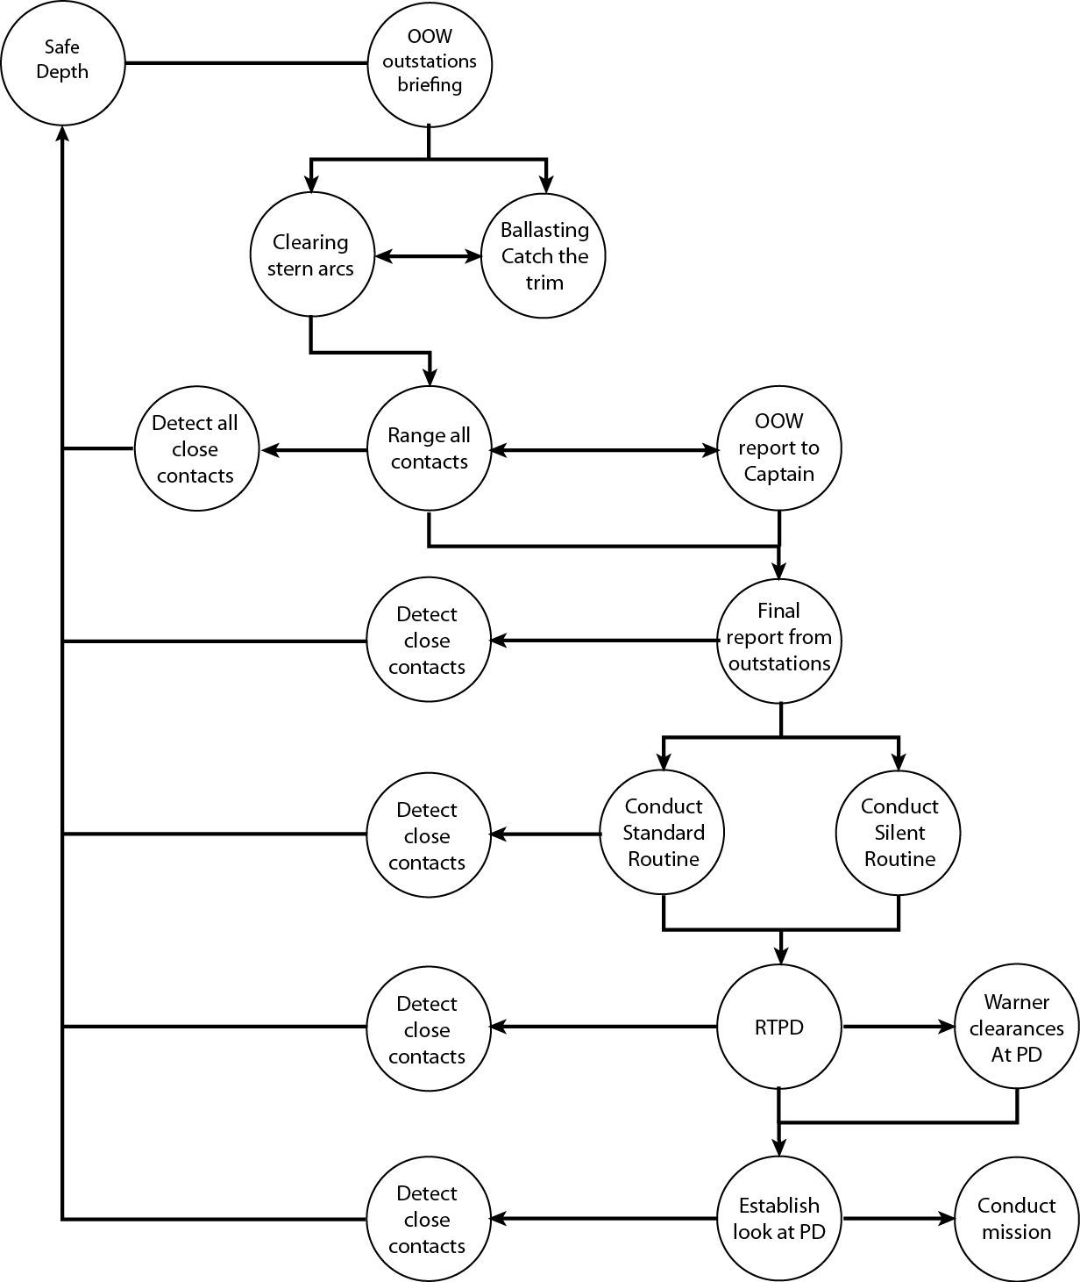

Figure 3. Task network for RTPD.

The network in Figure 3 was used to construct an association matrix to indicate the presence or absence of links between tasks. The number of links into and out of each task are shown in the ‘reception’ row and ‘emission’ rows respectively of Table 2. The network statistics (as described in section 3 on data collection and analysis) were then computed using AGNA. Whilst using SNA to analyse task structures is somewhat new to Ergonomics, it can give us some insights into the use of metrics. Obviously the task ‘detect close contacts’ is critical in RTPD, which is reflected in most of the metrics. Some of the other tasks are less obvious. The two tasks of ‘clear stern arcs’ and ‘range all contacts’ score quite low on Sociometric Status but quite high on Centrality and Betweeness. The higher the value means the higher each task is scored on that metric.

Table 2. Analysis of task network.
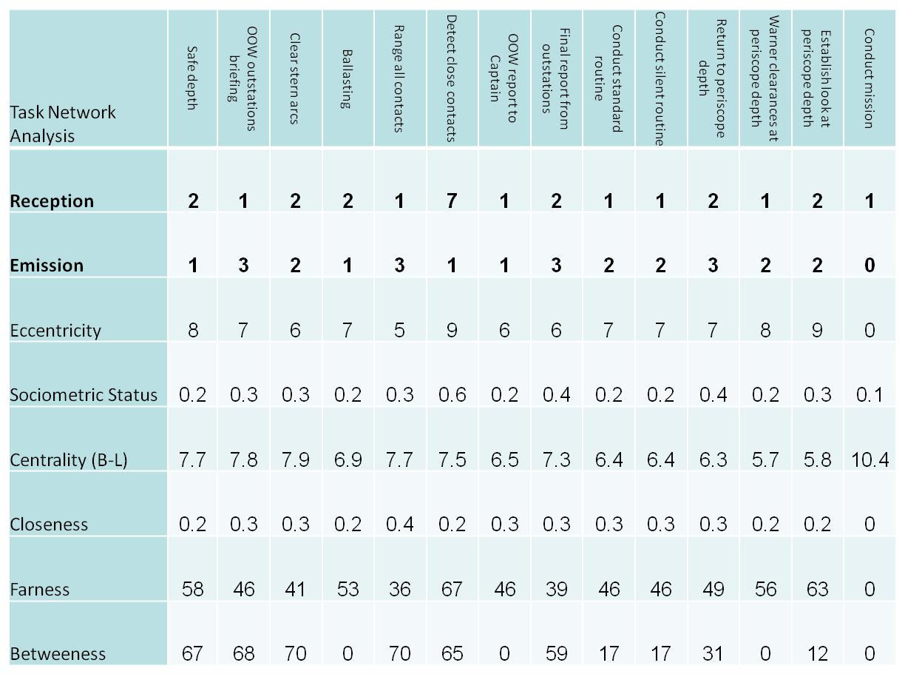

The network density was 0.14 (i.e., a low distribution network) and cohesion was 0.02 (i.e., a very low level of reciprocal links – suggesting very strict dependences in the task network, as shown in the task network diagram) with a diameter of 9 (i.e., nine hops from one side of the network to the other). The network can also be described as weighted (i.e., non-uniform) and asymmetric (i.e., unbalanced).

5. Social Network Analysis
The social network analysed the relationships (e.g. communications and activity) between the agents during the scenario, i.e., the Captain, OOW, Ships Control, WECDIS, Weapons Engineering Officer (WEO), OpsO, Sound Control and SMCS. The matrix represents the frequency of communications between each agent in the network that could be captured through the network communications system and the ambient communications (it is accepted that not all of the communications in the network could be captured, particularly those outside the network communications system). The association matrix for the RTPD scenario is presented in Table 3. This matrix shows whether or not an agent within the system can be associated with any other agent, specifically through frequency of communications.

Table 3. Association matrix for the RTPD scenario.
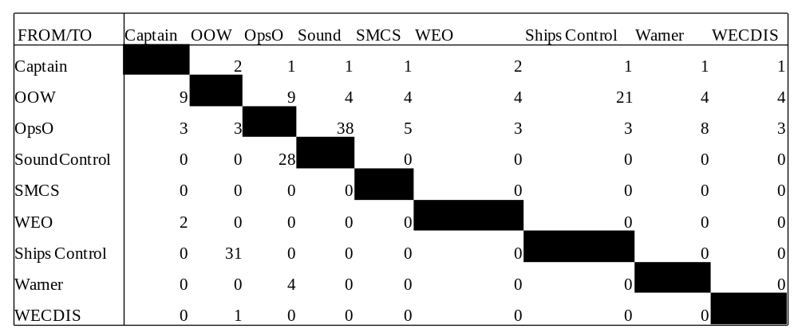

Once the matrix of association is completed, the social network diagram can be created. The social network depicts each agent in the network and the communications between them. The communications are represented by directional arrows, and the frequency of communications is also presented, as shown in Figure 4. The thicker the line, the more communications have occurred, and vice versa.

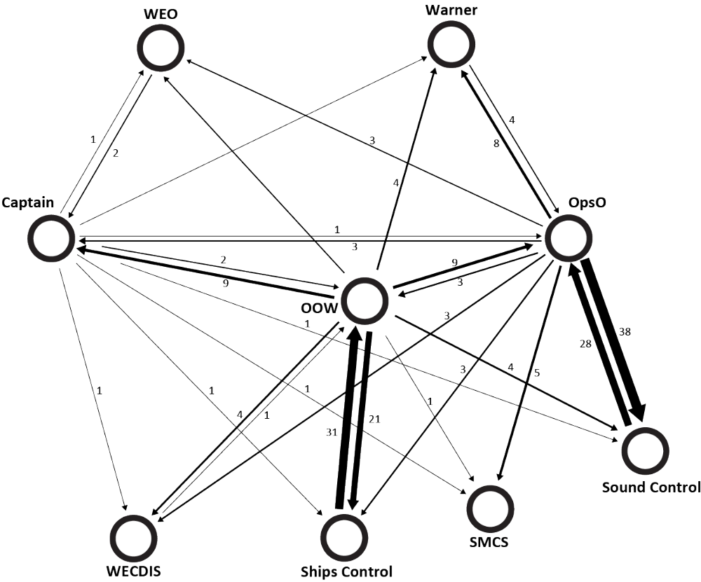

Figure 4. Social network diagram for the RTPD scenario.

Table 4 shows the metrics for the social network in the RTPD scenario. This highlights the Office of the Watch (OOW) and Operations Officer (OpsO) as the highest on sociometric status and betweeness metrics whereas the SMCS operator is highest on Centrality. The Captain, who has the most executive power in the ship is modestly placed on the sociometric status metric for the RTPD scenario. The Captain’s betweeness score hints at his executive power. The higher the value means the higher each task is scored on that metric.

Table 4. Social network metrics for the network for the RTPD scenario.
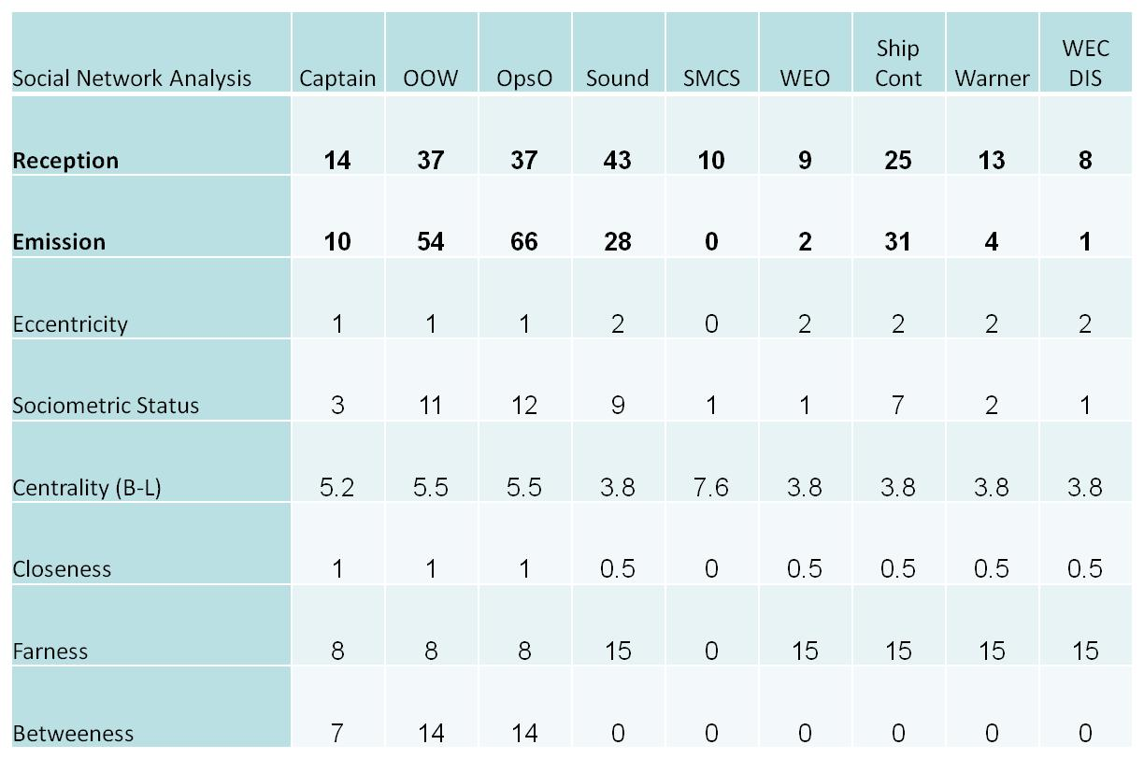

Network density is equal to the total number of links between the agents in the network divided by the total number of possible links. Low network density figures are indicative of a broadly spread network with few links. High density figures indicate a tight network that has many links. In this case the network density was 0.4 (i.e., a medium distributed network – which is likely to have good resilience against failure of the network) and cohesion was 0.2 (i.e., low level of reciprocal links) with a diameter of 2 (i.e., two hops from one side of the network to the other), and 29 edges (i.e., when an in-link to an agent had a corresponding out-link to another agent) for a network of nine nodes. The network can be described as weighted (i.e., non-uniform) and asymmetric (i.e., unbalanced). As a baseline study, this characterised the network for returning the submarine to periscope depth.

6. Information Network Analysis
The information networks were created by analysing the communications transcripts. Each ‘concept’ in the transcript was identified and paired with its nearest relation (i.e., concepts from the same sentence) to build up a network of information concepts in the control room related to the activities of returning the submarine to periscope depth. The networks were then presented to the subject matter experts (SMEs) for verification. The information may be related temporally or spatially to agent or tasks, or both. In this way it is possible to build up a picture of who knows what when and how this relates to task performance. This notion takes the activities of the sound room and control room into the realm of distributed cognition. In this view, cognition is not an individual phenomenon but rather a systemic endeavour performed by the whole team working together. It is argued that cognition transcends the boundaries of individual actors and becomes a function that is achieved by coordination between the human and technological agents working within the collaborative system. Systems theory argues that the cognitive system needs to be analysed as a whole rather than its constituent parts. To this end, the entire transcript is presented in the information network model, as the unit of analysis is not the individual person but the entire system under investigation. The information network for returning the submarine to periscope depth is presented in Figure 5 (note that the node ‘cuts’ at the bottom right of Figure 5 is duplicated merely as a convenience to disentangle the lines). By viewing the system as a whole, it does not matter if humans or technology own this information, just that the right information is activated and passed to the right agent at the right time. Individual human agents are not required to know everything, provided that the system has the information in some form or other.

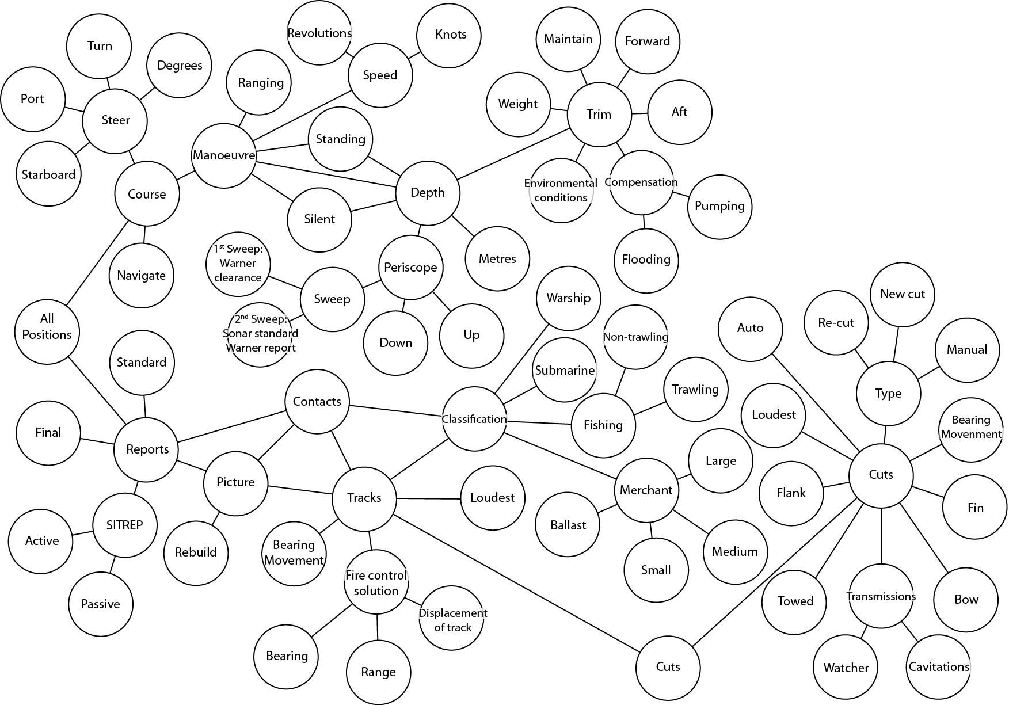

Figure 5. Information network for returning the submarine to periscope depth.

As Figure 5 shows, the information network has 68 nodes. Central nodes in the network (informally defined on the basis of the centrality in the network) appear to be ‘cuts’, ‘tracks’, ‘contacts’, ‘classification’, ‘reports’, ‘manoeuvre’, ‘depth’ and ‘trim’. The informational nodes coming off these more central key concept nodes provide the detail that would pertain to the situational specifics, such as the ‘bearing and ‘range’ for the ‘fire control solution’ or the type and nature of the vessel classification. The purpose of the information network was to identify the type of information required to return the submarine to periscope depth. A simplified version of the network was formed (abstracted from figure 5) for practical convenience of presenting the SNA metrics in this paper, as is shown in figure 6.

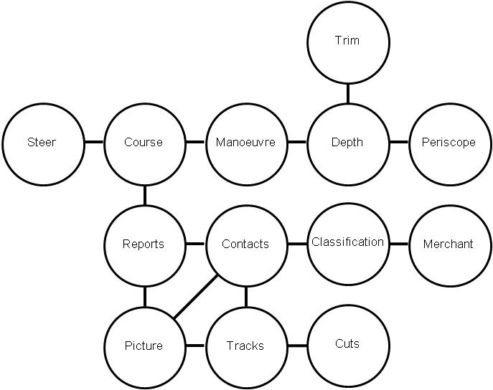

Figure 6. Simplified information network.

The metrics in table 5 suggest three classes of information in the network. ‘Contacts’ has the highest sociometric status and is probably the most important piece of information in the control room. Next are two clusters of information. One refers to information about the activities of the submarine (i.e., depth, manoeuvre and course) and one refers to the activities of other vessels (i.e., tracks, picture and reports). The network statistics are useful in highlighting the important underlying features of the relationships between information elements from the control room. The higher the value means the higher each task is scored on that metric.

Table 5. Analysis of simplified information network.
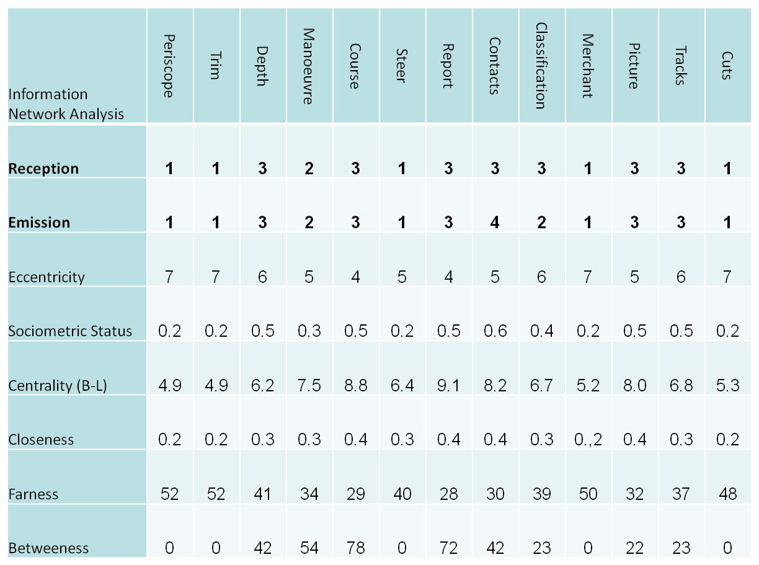

The network density was 0.18 (i.e., a low distribution network) and cohesion was 0.17 (i.e., a very low level of reciprocal links – suggesting very strict dependences in the information network, as shown in the task network diagram) with a diameter of 7 (i.e., seven hops from one side of the network to the other). The network can also be described as weighted (i.e., non-uniform) and asymmetric (i.e., unbalanced).

7. Combining Network Models
As stated in the introduction to the paper, the purpose of EAST is not only to consider the task, social and information networks in isolation of each other, but also to consider the relationships between the three networks. These relationships are explored in the following sections. As proposed earlier, the method presents a distributed cognition perspective within a multi-person–machine system, to show how information is used and parsed between people performing tasks. First, the combined task and social networks are presented, where the people are mapped onto the task network. Next, the information and social networks are presented where the people are mapped onto the information network. Finally, the three networks are integrated, where the information network is coded by the people and tasks.

7.1. Task and Social Networks
The relationships between the task and social networks show which agent is primarily involved in each aspect of the task network. These relationships are presented in Figure 7, in which the task network in Figure 3 has been colour coded by the social network to indicate which role is primarily responsible for each task. As Figure 7 shows, the role specialists are involved in different tasks throughout the RTPD. The OOW calls the outstation briefing. The Ships Control Officer (SCO) and Planesman clear the stern arcs and ballast the submarine. The Sound Room Controller (SRC), Sound Room Operators (SRO), Tactical Picture Supervisor (also called the Ops Officer, or OpsO) and SMCS are responsible for ranging contacts and reporting to the OOW. The OOW reports to the Captain that the submarine is ready to RTPD. The OOW receives final reports from the outstations. All are involved in the silent or standard routine. The OOW, SCO and Planesman are responsible for getting the submarine to periscope depth whilst the SRC and SRO are listening for close contacts (which if detected would lead the OOW to order the submarine back to a safe depth). The Warner is responsible for giving clearances at periscope depth. Then the OOW and Periscope Watch Keeper (PWK) are responsible for establishing the look at periscope depth. The first sweep is to search for close in contacts and the second sweep to contacts at greater distance. Any contacts on a potential collision course would lead the OOW to order the submarine back to a safe depth. If the submarine is safe at periscope depth, then the mission intentions can be carried out, in which all of the specialist roles will be performing their respective tasks.

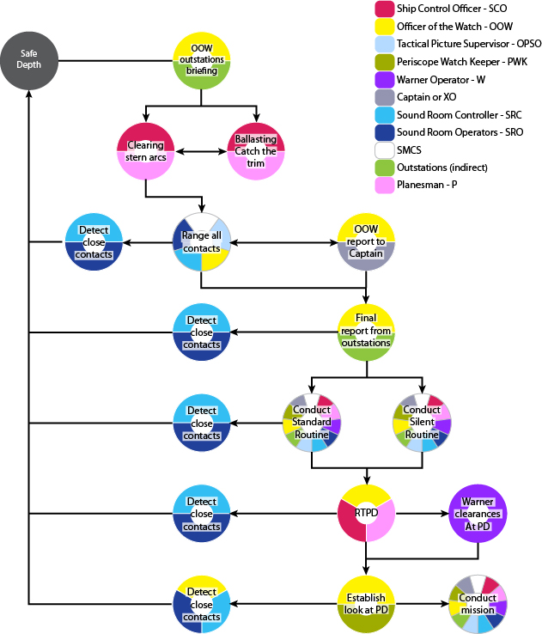

Figure 7. Task network coded by social agents.

7.2. Information and Social Networks
The dynamic nature of information communication means it is subject to change moment by moment, in light of changes in the task, environment and interactions (both social and technological). These changes need to be tracked if the phenomena are to be properly understood. As Figure 8 shows, the sound room and control room really do function as a distributed cognition system, with ownership of information flowing around the network. No one individual owns all of the information; rather the system works as a functional unit.

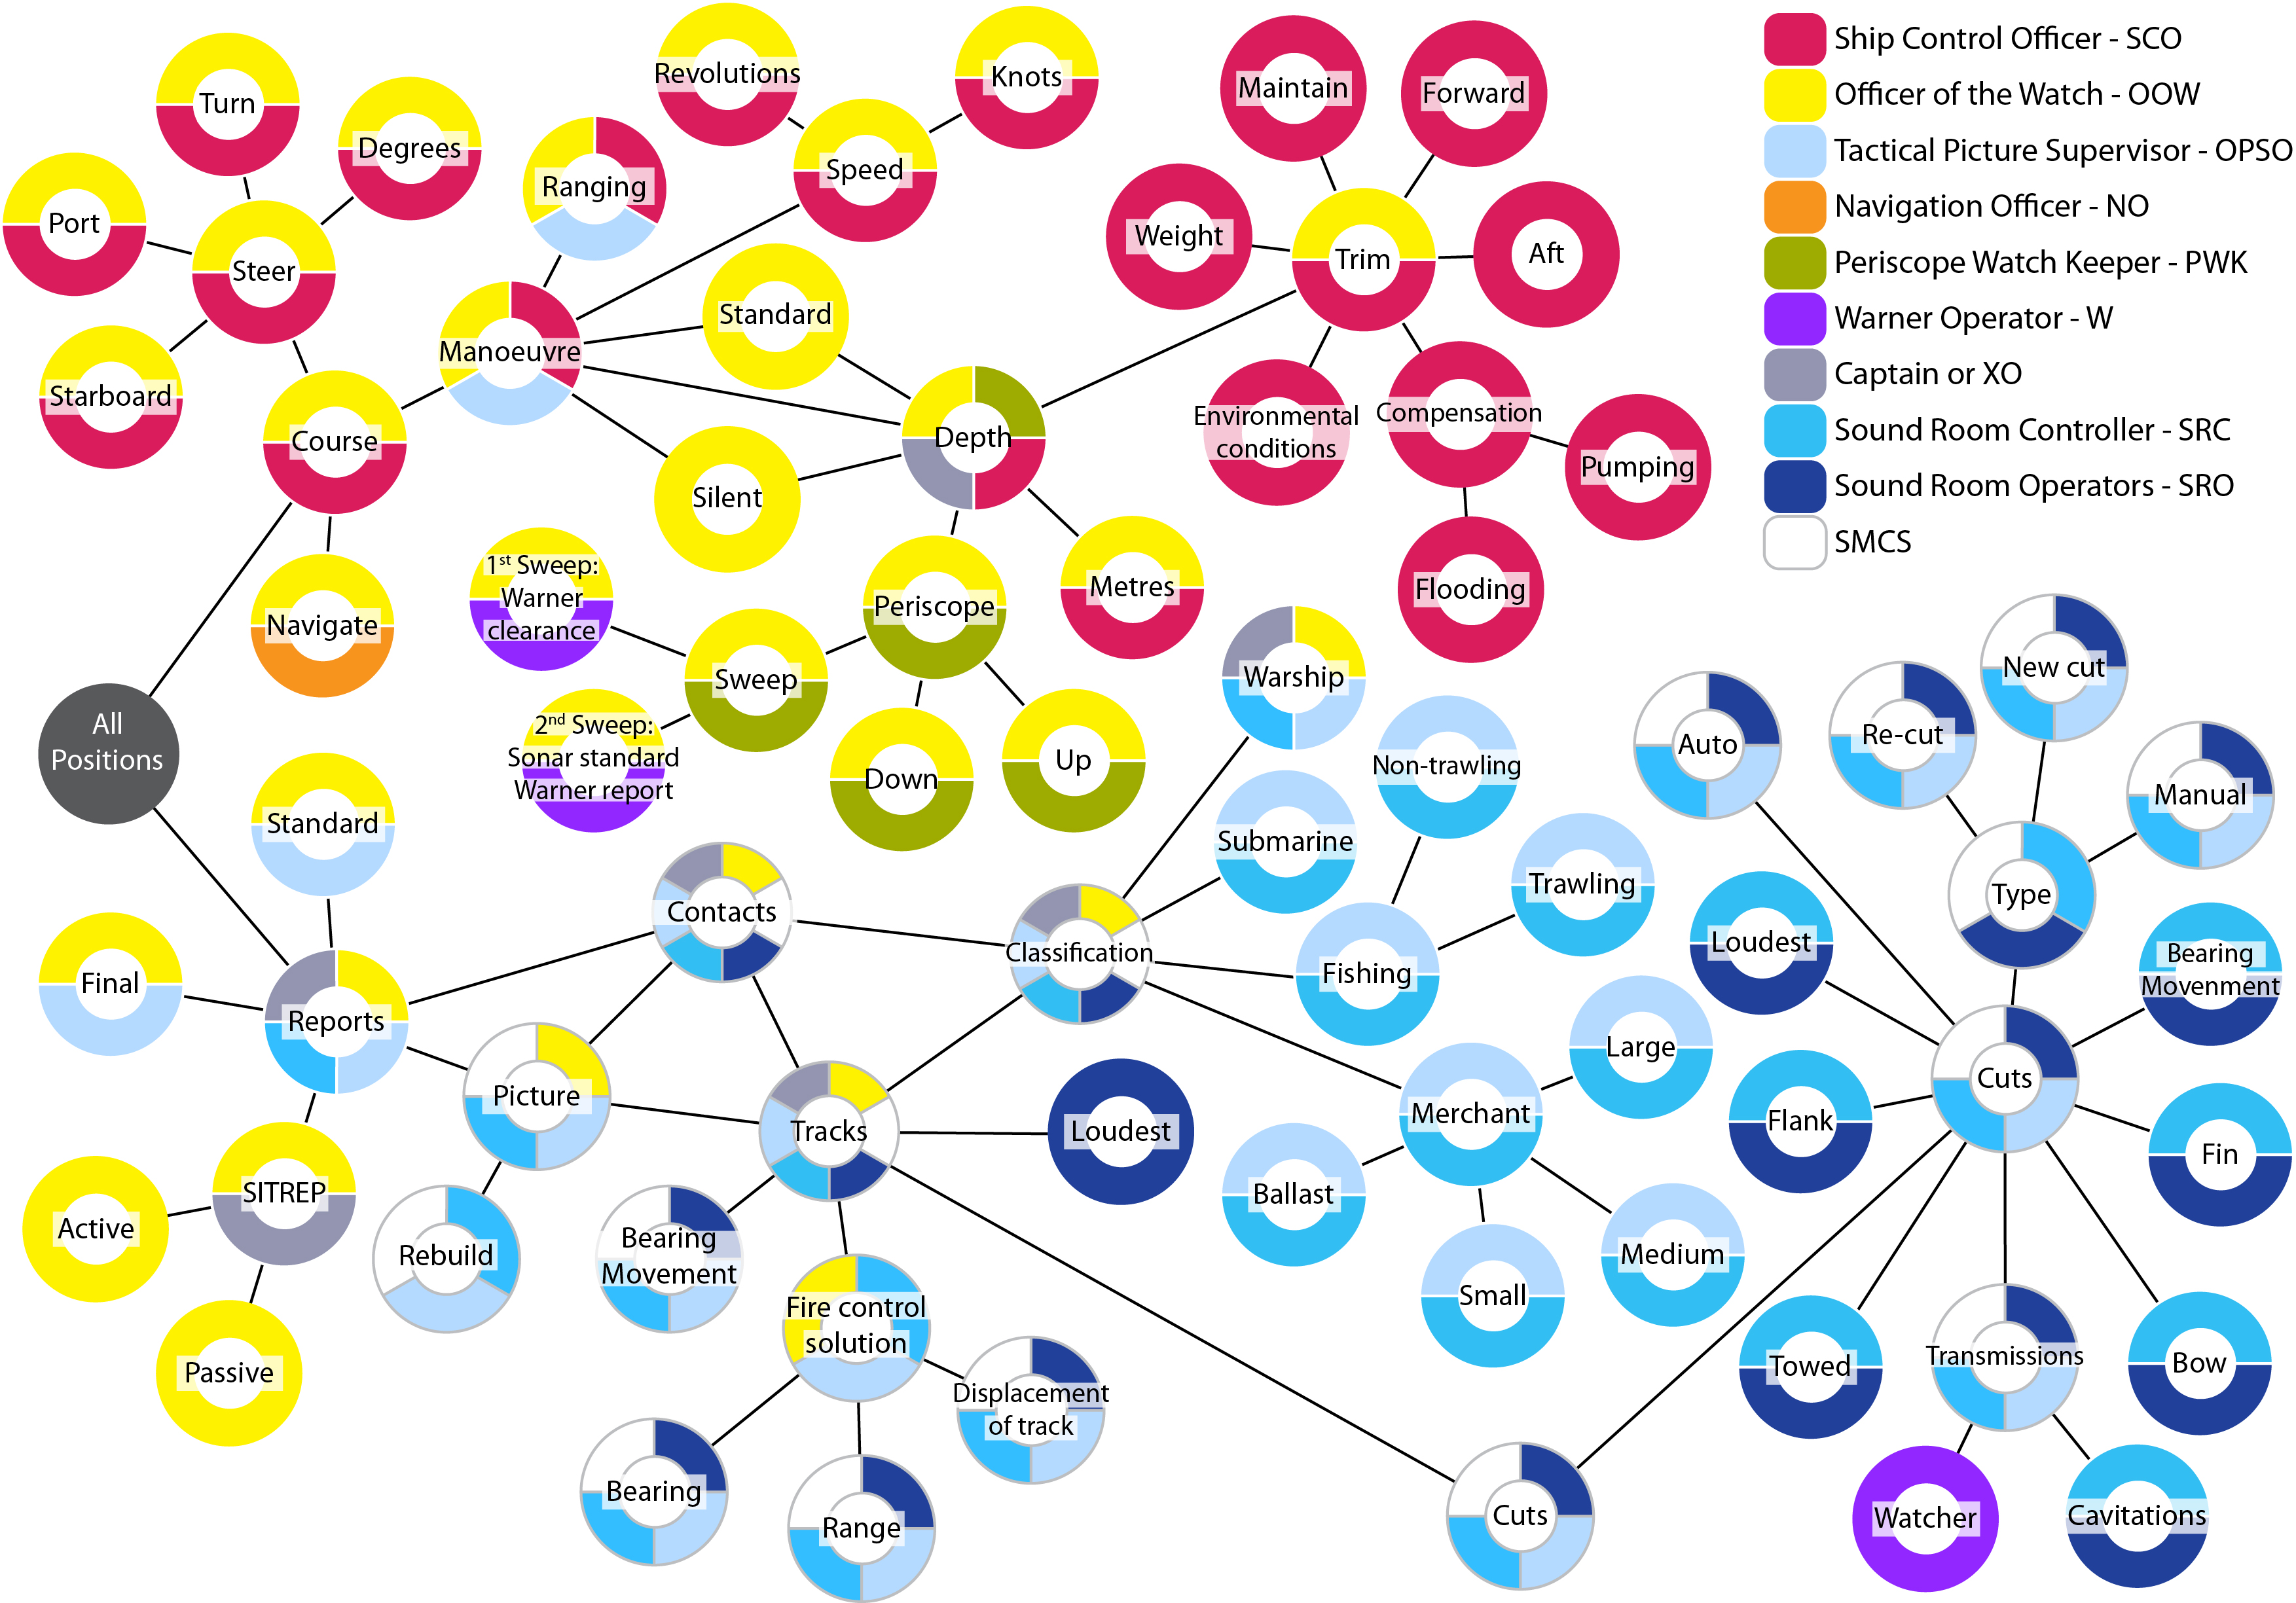

Figure 8. Information network coded by social agents.

The colour coding by the social agents reveals clusters of information that feature around the main information nodes identified in the section 5 on ‘information networks’ (i.e., cuts, tracks, picture, merchant, classification, contacts, reports, steer, course, manoeuvre, depth, trim and periscope). These are presented in Table 6.

Table 6. Analysis of concepts by social agents.
Key concept | XO | OOW | SCO | OPSO | SMCS | SRC | SRO | PWK
Cuts
Tracks
Picture
Merchant
Classification
Contacts
Reports
Steer
Course
Manoeuvre
Depth
Trim
Periscope

The relationships between the key concepts and the roles in Table 6 show the information exchanges that occur in the course of the submarine returning to periscope depth. These information exchanges are called transactions, as the information flows both ways. In a simple exchange, this may be a request, followed by an information transfer and ending with a confirmation (as revealed in the communication analyses). The transaction informs both the person requested and the requestor.

7.3. Information and Task Networks
The grouping of information networks by the tasks shows how different tasks use, distribute and share information are shown in figure 9. The groupings show the links between information and tasks, such that ‘cuts’ are linked to ‘tracks’, ‘tracks’ are linked to ‘contacts’, ‘contacts’ are linked to the ‘picture’ and ‘reports’ which are linked to the ‘course’ (via ‘all positions’ reports), the ‘course’ is linked to ‘manoeuvre’, which is linked to ‘speed’ and ‘depth’ and ‘depth’ is linked to ‘trim’ and ‘periscope’.
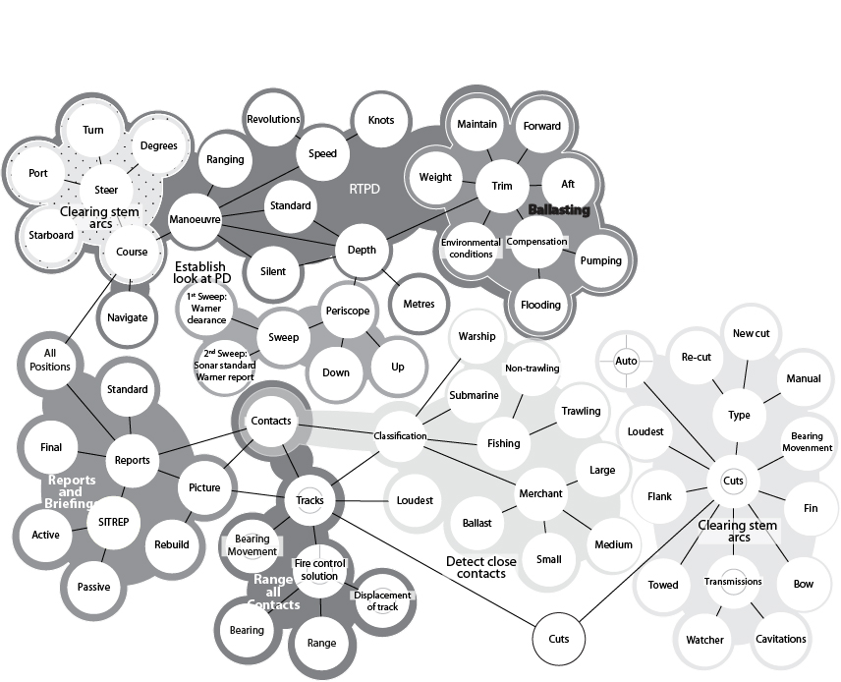
Figure 9. Combined information and task networks

7.4. Combined Task, Social and Information Networks
The final combined picture puts the task, social and information networks into one network as presented in Figure 10. The dependences between tasks cannot be represented in this view (the reader is referred back to Figure 3 and Figure 7 for those views). The integrated network model reveals the multi-modal nature of the work in the sound and control rooms in returning the submarine to periscope depth, i.e., how people utilise information to conduct tasks.

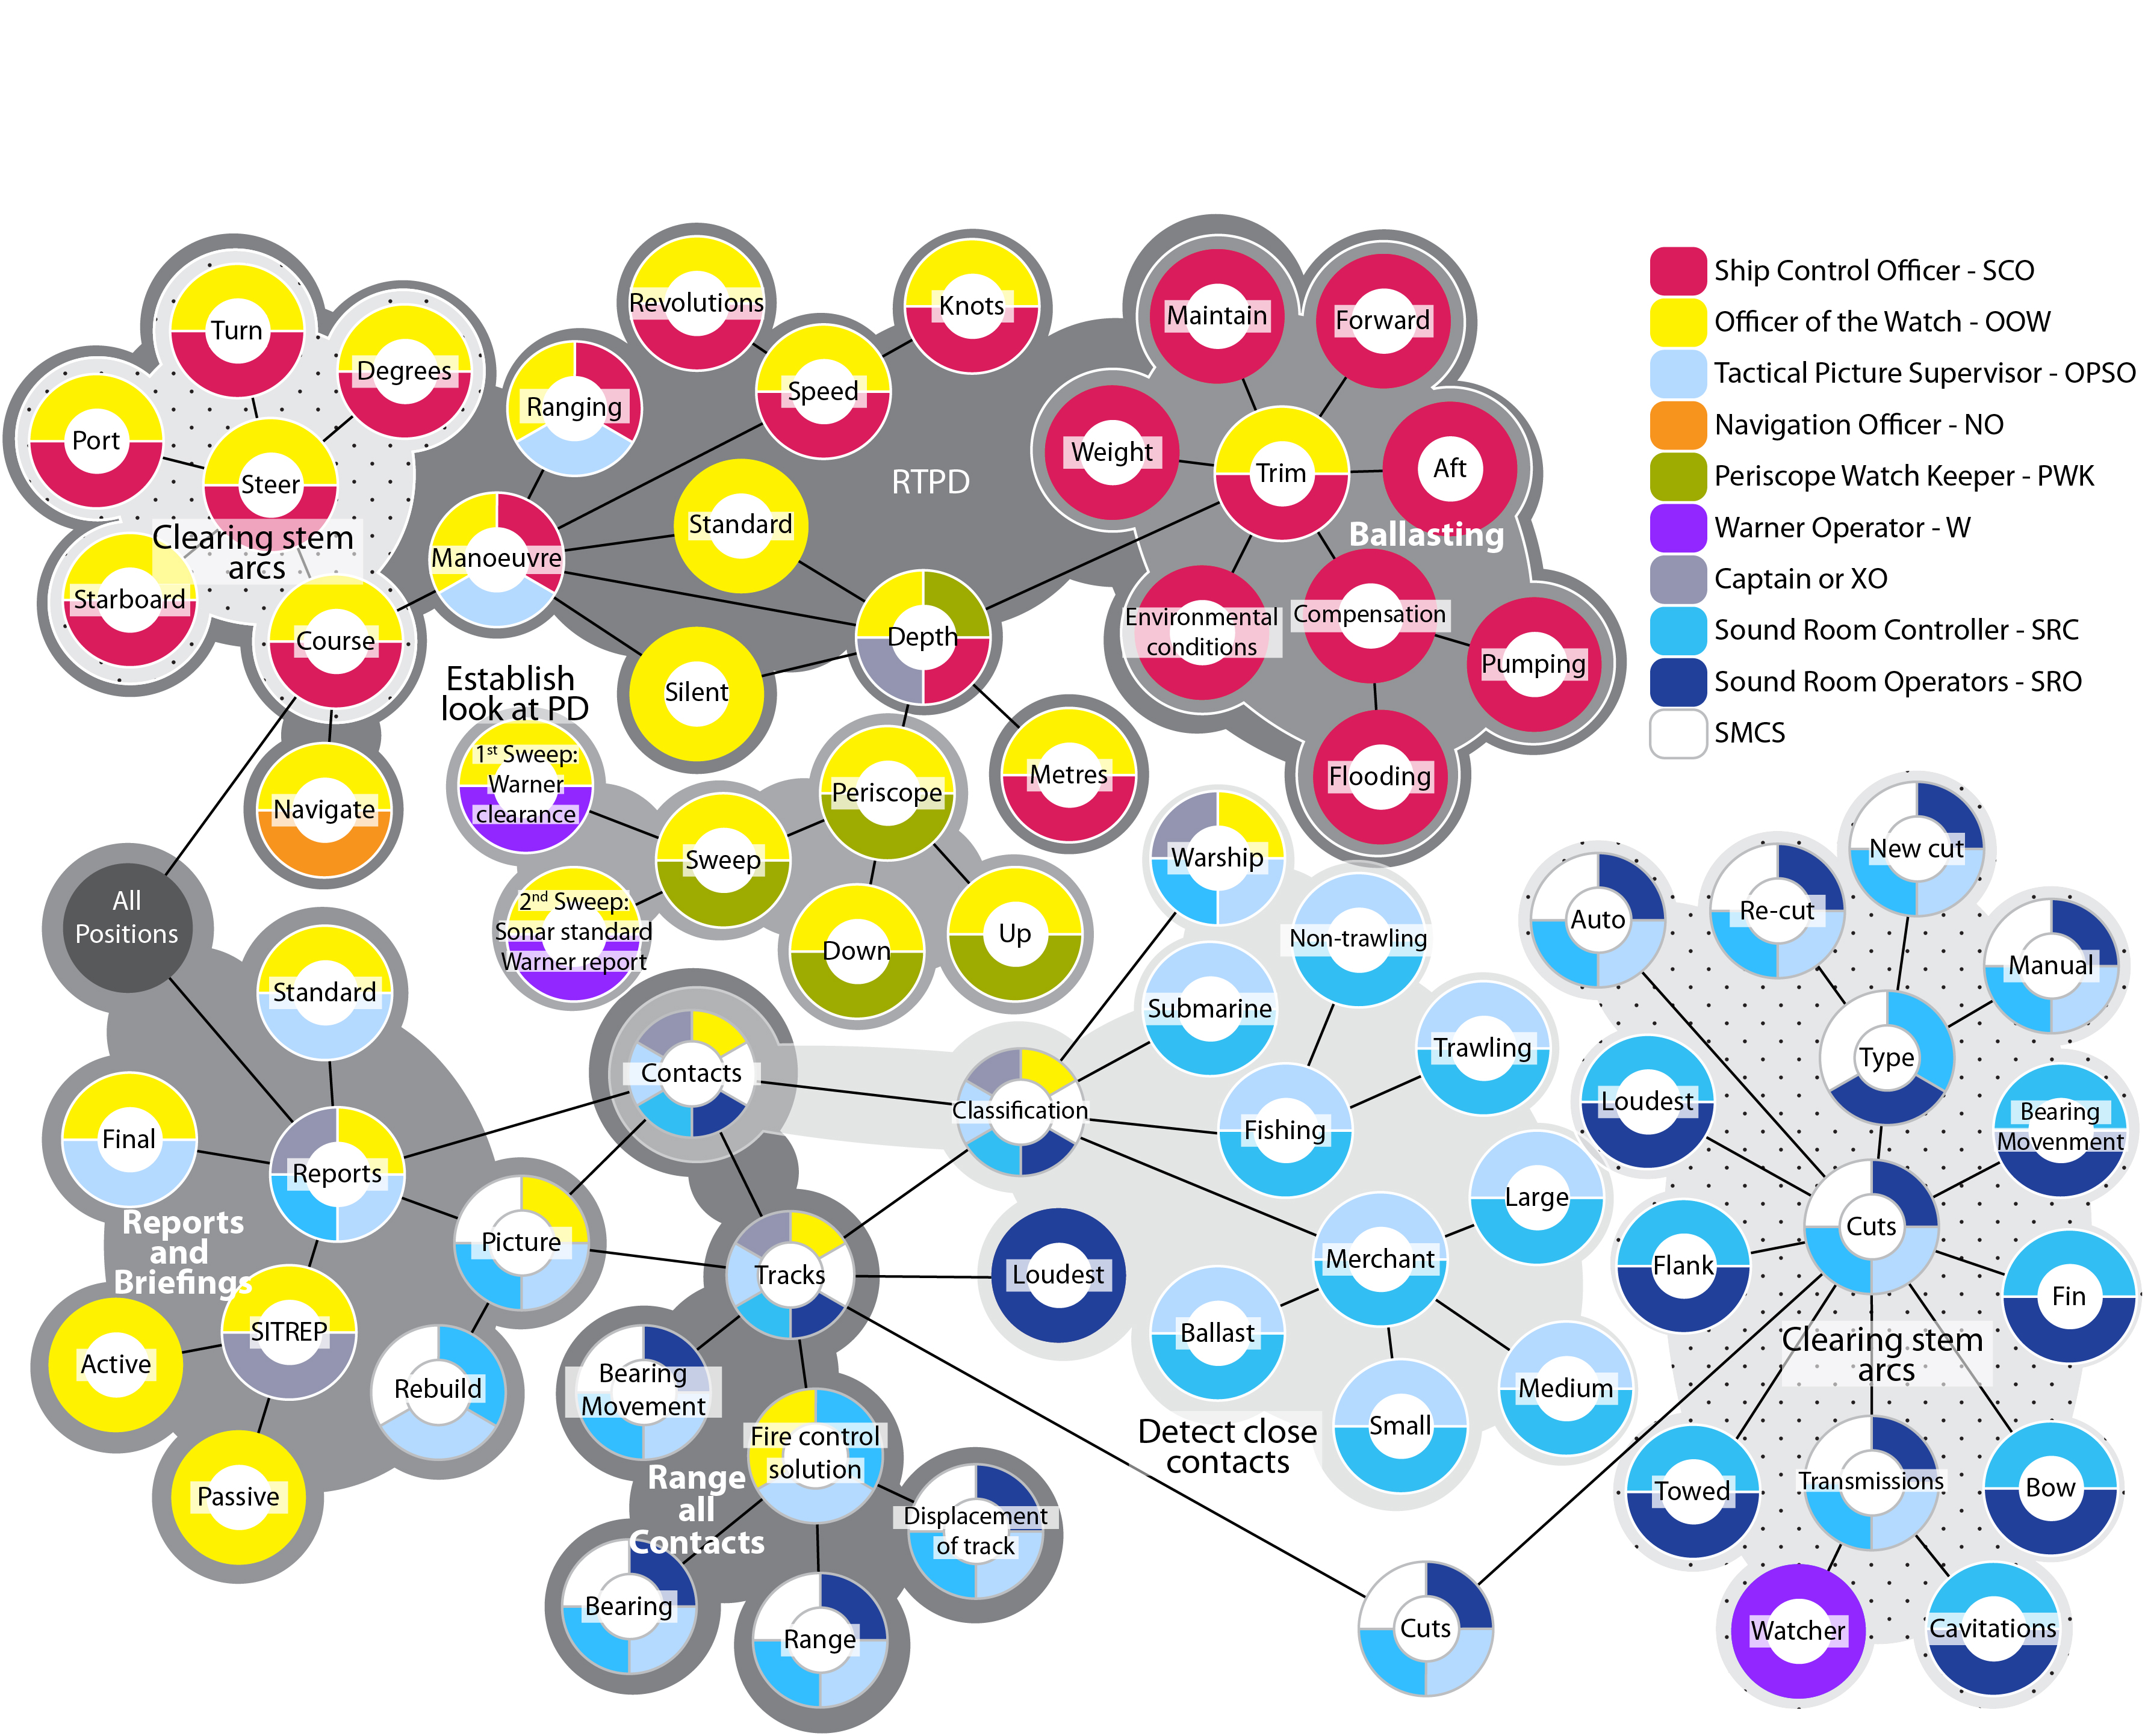

Figure 10. Integrated networks model.

As Figure 10 shows, no one individual possessed all of the information to perform the RTPD task. The tasks were distributed amongst the crew and artefacts they use. To understand how a submarine is returned to periscope depth, one needs to study the interactions within the socio-technical system. In this study of the sound and control room at least ten personnel had main roles in performing different tasks.

8. Summary and Conclusions
In summary, this analysis has reported on the application of the EAST to the analysis of the RTPD task in the control room of the Trafalgar class submarine. EAST acknowledges that systems are inherently complex and multiple perspectives on the problem are required to more fully appreciate the relationships between the social and technical aspects of the system. EAST accepts that systems are intertwined and analyse the system as a whole, rather than constituent parts. The research has shown that the network models are able to characterise the domain in different, but complementary, ways. The seven outputs, namely the individual task networks, social and information networks (and associated metrics), and the combined networks (i.e., task and social network, information and social network, information and task network, and task, social and information network) offer a graphical representation of distributed cognition (e.g., the sound and control room) from different perspectives. The different perspectives offered by the representations are an attempt to characterise the activities between the sound and control rooms in returning the submarine to periscope depth.

This paper extends the work of Walker et al (2010a) by applying metrics to all three task, social and information networks to provide insights into the structural integrity and the relative contribution of each of the nodes. It has also been shown that it is possible to construct the networks directly from the observational data. Walker et al (2010a) demonstrated the benefits of the network representations over the traditional ethnographic narratives and pictures (Hutchins, 1995) which has been reinforced in the current paper. It has been shown that the network models offer a useful way of considering distributed cognition in systems to reveal the interdependences between tasks, agents and information. There are some similarities between the approach taken by EAST and that of Actor Network Theory (ANT: Engestrom, 2000) but EAST represents the networks separately as well as together. Both EAST and ANT have, at their core, a conceptual triangulation between objects, actors and events. Both use networks of relationships to graphically display their analysis. Also, EAST goes further than ANT, to apply statistical analysis to the networks as well as identify network archetypes. Nevertheless, there are important similarities in the approach and representation. Arguably, ANT relies more heavily upon the skill of the analyst to identify themes in the networks, whereas the use of verbal protocol data and SNA metrics by EAST has reduced this subjectivity. The use of social network statistics may be one way of examining the potential resilience of networks (Hollnagel et al, 2006) – which may be particularly useful as metrics of distributed cognition. This is a new concept and methodology, so further studies are required to test its efficacy.

The representations in this paper revealed the clustering of tasks, social agents and information. These clusters show how the constituent parts of the networks have been bound together, either by chance or design. As the system has developed over a century of submarine operations, it reflects a high state of evolution, but that does not mean that the system cannot be improved upon. The representations afford both quantitative and qualitative structural analysis. The quantitative analyses have been presented at some length and offer insights into the potential integrity and resilience of the system. As a method for Resilience Engineering, EAST can be used to assess the potential weaknesses and points of failure in socio-technical structures. The qualitative analyses enable the network structures to be classified into archetypes (e.g., chain, circle, tree, star, mesh, small world and fully connected: Stanton et al, 2008; Stanton et al, 2012). In these terms, the task network appears to be a hybrid of a chain and circle archetype, the social network appears to be a hybrid of a star and circle archetype, and the information network appears to be a small world archetype. This analysis is somewhat speculative at this point and further research is needed to understand the relationship between the metrics for network resilience and the archetypes of network structure. There are some early indications that the small world networks offer greatest resilience and efficiency (Stanton et al, 2012).

EAST described the control room in terms of task, social and information networks as well as exploring the relationships between those networks. The individual networks were used to describe the respective relationships between the tasks (such as the task dependencies and sequences), between social agents (such as sociometric status of agents based on communications), and information (such as the interdependences between the concepts discussed). The combined task and social networks showed which roles were performing the tasks in series and parallel. The combined information and social networks showed which roles were communicating the information concepts. The three integrated networks described how information was used and communicated by people working together in the pursuit of tasks. Any new conceptualisation of the command system will need to consider the likely changes on these socio-technical networked structures.

EAST was able to characterise the activities in the control room of the Trafalgar class submarine. Thus it is capable of being applied to a complex socio-technical ‘system of systems’ to present ‘networks of networks’. EAST offered complementary descriptions of the requirements for the RTPD task using the current command system. The networks show multiple perspectives on the activities in the system which is a necessary requirement for socio-technical analysis. Further analysis should attempt to characterise future command systems so that the multiple perspectives can be compared and ‘so-what’ questions can be asked as ideas for design of the social and technical aspects of the system co-evolve (Clegg, 2000; Walker et al, 2010b; Stanton et al, 2012). EAST has the potential to map the task, social and information networks and their interdependencies. Adopting this socio-technical systems design approach would help to jointly optimise the whole system rather than the parts in isolation. This would require spending more time in the initial modelling and prototyping, working with end-users and SMEs with more focus on the social systems and ways of working (to redress the balance of focus on technical system development) than is currently the case. In the study reported in this paper, the benefit of the EAST method is that it helped understand what was going on between the sound and control room, and how people share information related to the tasks they were performing. The ultimate goal of the work will be to model alternatives and provide metrics for choosing one alternative over another.

Acknowledgements
The author would like to thank Kevin Bessell of BAE Systems for his assistance with recording and transcribing the verbal communication data.

This work from the Human Factors Integration Defence Technology Centre (HFI DTC) was part funded by the Human Capability Domain of the UK Ministry of Defence.

References

Clegg, C. W. (2000) Sociotechnical principle for system design. Applied Ergonomics, 31, 463-477.

Driskell, J. E and Mullen, B. (2005) Social network analysis. In: Stanton, N. A., Hedge, A., Salas, E., Hendrick, H. and Brookhaus, K. (Eds) Handbook of Human Factors and Ergonomics Methods. Taylor & Francis: London.

Engestrom, Y. (2000) Activity theory as a framework for analyzing and redesigning work, Ergonomics, 43 (7), 960-974.

Farrington-Darby, T., Wilson, J. R., Norris, B. J. and Clarke, T. (2006) A
naturalistic study of railway controllers. Ergonomics, 49 (12-13), 1370-1394.

Furniss, D. and Blandford, A. (2006) Understanding emergency medical
dispatch in terms of distributed cognition: a case study. Ergonomics, 49 (12-13), 1174-1203.

Griffin, T.G.C., Young, M.S. and Stanton, N.A. (2010) Investigating accident causation through information network modelling. Ergonomics, 53 (2), 198-210.

Hollnagel, E., Woods, D. D. and Leveson, N. (2006) Resilience Engineering: concepts and precepts. Ashgate: Aldershot.

Houghton, R.J., Baber, C., McMaster, R., Stanton, N.A., Salmon, P.M., Stewart, R. and Walker, G.H. (2006) Command and control in emergency services operations: A social network analysis. Ergonomics 49 (12&13), 1204-1225.

Hutchins, E. (1995) Cognition in the Wild. MIT Press: Cambridge.

Jenkins, D. P., Salmon, P. M., Stanton, N. A., Walker, G. H. and Rafferty, L. A. (2011) What could they have been thinking? How sociotechnical system design influences cognition: a case study of the Stockwell shooting. Ergonomics, 54 (2), 103-119.

McIlroy, R. C. and Stanton, N. A. (2011) Specifying the requirements for requirements specification: the case for Work Domain and Worker Competencies Analyses. Theoretical Issues in Ergonomics Science, 13 (4), 450-471.

Patrick, J., James, N. and Ahmed, A. (2006) Human processes of control: tracing
the goals and strategies of control room teams. Ergonomics, 49 (12-13), 1395-1414

Plant, K. L. and Stanton, N. A. (2012) Why did the pilots shut down the wrong engine? Explaining errors in context using Schema Theory and the Perceptual Cycle Model. Safety Science, 50 (2), 300-315.

Salmon, P.M., Stanton, N.A., Walker, G.H., Jenkins, D.P., Baber, C., and McMaster, R. (2008) Representing Situation Awareness in Collaborative Systems: A Case Study in the Energy Distribution Domain. Ergonomics, 51 (3), 367 – 384.

Sanderson, P., Verhage, A. G. and Flud, R. B. (1989) State-space and verbal protocol methods for studying the human operator in process control. Ergonomics, 32 (11), 1343-1372.

Stanton, N.A., Salmon, P.M., Walker, G.H., Baber C. and Jenkins, D. P. (2005) Human Factors Methods: A Practical Guide for Engineering and Design. Ashgate: Aldershot.

Stanton, N.A., Baber, C. and Harris, D. (2008) Modelling Command and Control: Event Analysis of Systemic Teamwork. Ashgate: Aldershot, UK.

Stanton, N.A., Stewart, R., Harris, D., Houghton, R.J., Baber, C., McMaster, R., Salmon, P.M., Hoyle, G., Walker, G.H., Young, M.S., Linsell, M., Dymott, R. and Green, D. (2006) Distributed situation awareness in dynamic systems: theoretical development and application of an ergonomics methodology, Ergonomics 49 (12-13), 1288-1311.

Stanton, N. A., Walker, G. H. and Sorensen, L. J. (2012) It's a small world after all: contrasting hierarchical and edge networks in a simulated intelligence analysis task. Ergonomics, 55 (3), 265-281.

Stewart, R., Stanton, N.A., Harris, D., Baber, C., Salmon, P.M., Mock, M., Tatlock, K. and Wells, L., (2008) Distributed situational awareness in an airborne warning and control aircraft: application of a novel ergonomics methodology. Cognition, Technology and Work, 10 (3), 221-229.

Vicente, K. J. (1999) Cognitive Work Analysis: Toward Safe, Productive, and Healthy Computer-Based Work. Mahwah, NJ: Lawrence Erlbaum Associates.

Von Bertalanffy, L. (1950) The theory of open systems in physics and biology. Science, 111, 23-29.

Walker, G.H., Gibson, H., Stanton, N.A., Baber, C., Salmon, P.M. and Green, D. (2006) Event Analysis of Systemic Teamwork (EAST): A novel integration of ergonomics methods to analyse C4i activity. Ergonomics, 49 (12&13), 1345-1369.

Walker, G.H., Stanton, N.A., Baber, C., Wells, L., Gibson, H., Salmon, P.M. and Jenkins, D.P. (2010a) From ethnography to the EAST method: A tractable approach for representing distributed cognition in Air Traffic Control. Ergonomics, 53(2) 184-197.

Walker, G. H., Stanton, N. A., Salmon, P. M., Jenkins, D. P. and Rafferty, L. A. (2010b) Translating concepts of complexity to the field of ergonomics. Ergonomics, 53 (10), 1175-1186.

Waterson, P. (2009) A systems ergonomics analysis of the Maidstone and Tunbridge Wells infection outbreaks. Ergonomics, 52 (10), 1196-1205.

Wilson, J. R. (2012) Fundamentals of systems ergonomics. Work, 41, 3861-3868.

