Analysis for ALL respondents
Federico De Luca, Postgraduate Researcher, Faculty of Social and Human Sciences, University of Southampton

Descriptive Analysis
* Time of questionnaire completion.
N | Valid | 40
 | Missing | 0
Mean |  | 911.53
Median |  | 851.00
Std. Deviation |  | 572.712
Minimum |  | 132
Maximum |  | 2497
The questionnaire took an average of almost 15 minutes (15:11) to be completed, with a minimum of 2:12 and a maximum of 41:37.
* Generate an overall index of confidence for "Planning data management".
N | Valid | 39
 | Missing | 1
Mean |  | 10.1538
Std. Error of Mean |  | 1.30324
Median |  | 8.0000
Std. Deviation |  | 8.13873
Minimum |  | .00
Maximum |  | 29.00
Percentiles | 25 | 3.0000
 | 50 | 8.0000
 | 75 | 14.0000
The index was built in order to go from 0 (minimum confidence) to 36 (maximum confidence) with a mean value of 18. More than 75% of respondents had a confidence of 14 or less, and the overall mean was only slightly higher than 10, thus implying that the confidence of the respondents over the items that define “Planning data management” is quite low. Moreover, the bottom 25% of respondents have an incredibly low confidence in these items (<=3).
The same conclusions can be drawn watching the graph reported in the following page.
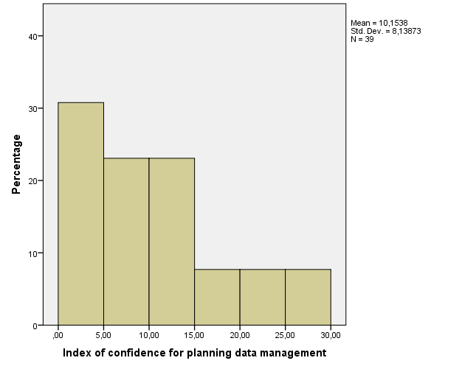
* Descriptive statistics of each component regarding Planning data management.
 |  | PDM-S1.Q1.1 | PDM-S1.Q1.2 | PDM-S1.Q1.3 | PDM-S1.Q1.4 | PDM-S1.Q1.5 | PDM-S1.Q1.6
N | Valid | 39 | 39 | 40 | 40 | 40 | 40
 | Missing | 1 | 1 | 0 | 0 | 0 | 0
Mean |  | 2.54 | 2.62 | 2.93 | 3.30 | 2.90 | 2.13
Median |  | 2.00 | 2.00 | 3.00 | 3.00 | 3.00 | 2.00
Std. Deviation |  | 1.847 | 1.830 | 1.607 | 1.786 | 1.646 | 1.453
Minimum |  | 1 | 1 | 1 | 1 | 1 | 1
Maximum |  | 7 | 7 | 6 | 6 | 6 | 6
Percentiles | 25 | 1.00 | 1.00 | 1.25 | 2.00 | 1.00 | 1.00
 | 50 | 2.00 | 2.00 | 3.00 | 3.00 | 3.00 | 2.00
 | 75 | 3.00 | 4.00 | 4.00 | 5.00 | 4.00 | 3.00
* Generate an overall index of confidence for "Data Management during the research process".
N | Valid | 39
 | Missing | 1
Mean |  | 6.6154
Std. Error of Mean |  | .91738
Median |  | 5.0000
Std. Deviation |  | 5.72904
Minimum |  | .00
Maximum |  | 19.00
Percentiles | 25 | 2.0000
 | 50 | 5.0000
 | 75 | 11.0000
The index was built in order to go from 0 (minimum confidence) to 24 (maximum confidence) with a mean value of 12. More than 75% of respondents had a confidence of 11 or less, and the overall mean was only slightly higher than 6, thus implying that the confidence of the respondents over the items that define “Data Management during the research process” is quite low. Moreover, the bottom 25% of respondents have an incredibly low confidence in these items (<=2).
The same conclusions can be drawn watching the graph reported below.
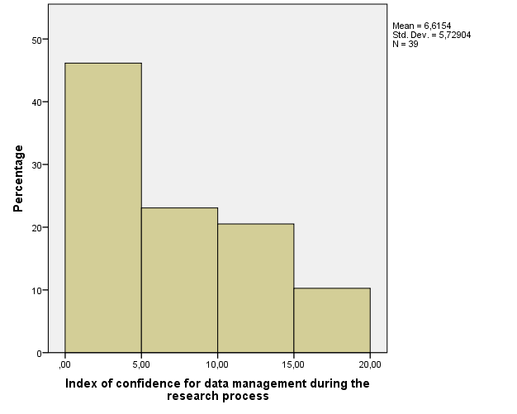
* Descriptive statistics of each component regarding Data Management during the research process.
 |  | DMRP-S1.Q2.1 | DMRP-S1.Q2.2 | DMRP-S1.Q2.3 | DMRP-S1.Q2.4
N | Valid | 39 | 39 | 39 | 39
 | Missing | 1 | 1 | 1 | 1
Mean |  | 2.54 | 2.82 | 2.67 | 2.59
Median |  | 2.00 | 3.00 | 3.00 | 3.00
Std. Deviation |  | 1.804 | 1.745 | 1.528 | 1.499
Minimum |  | 1 | 1 | 1 | 1
Maximum |  | 6 | 7 | 6 | 6
Percentiles | 25 | 1.00 | 1.00 | 1.00 | 1.00
 | 50 | 2.00 | 3.00 | 3.00 | 3.00
 | 75 | 4.00 | 4.00 | 4.00 | 3.00

* Generate an overall index of confidence for "Post Research Data Management".
N | Valid | 37
 | Missing | 3
Mean |  | 6.8378
Std. Error of Mean |  | 1.07001
Median |  | 4.0000
Std. Deviation |  | 6.50860
Minimum |  | .00
Maximum |  | 20.00
Percentiles | 25 | 2.0000
 | 50 | 4.0000
 | 75 | 12.5000
The index was built in order to go from 0 (minimum confidence) to 30 (maximum confidence) with a mean value of 15. More than 75% of respondents had a confidence of 12.5 or less, and the overall mean was only slightly lower than 7, thus implying that the confidence of the respondents over the items that define “Post Research Data Management” is quite low. Moreover, the bottom 25% of respondents have an incredibly low confidence in these items (<=2).
The same conclusions can be drawn watching the graph reported in the following page.
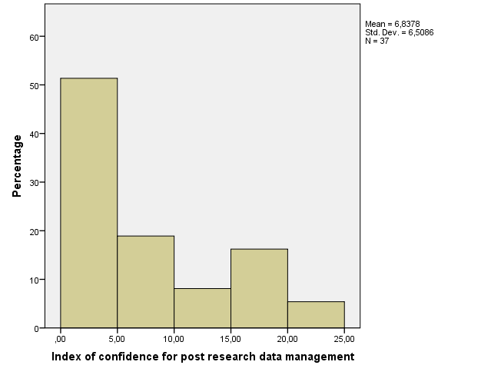
* Descriptive statistics of each component regarding Data Management during the research process.
 |  | PRDM-S1.Q3.1 | PRDM-S1.Q3.2 | PRDM-S1.Q3.3 | PRDM-S1.Q3.4 | PRDM-S1.Q3.5
N | Valid | 39 | 39 | 38 | 39 | 38
 | Missing | 1 | 1 | 2 | 1 | 2
Mean |  | 2.74 | 1.97 | 2.39 | 1.97 | 2.53
Median |  | 3.00 | 1.00 | 2.00 | 1.00 | 2.00
Std. Deviation |  | 1.681 | 1.478 | 1.516 | 1.495 | 1.656
Minimum |  | 1 | 1 | 1 | 1 | 1
Maximum |  | 7 | 6 | 6 | 7 | 6
Percentiles | 25 | 1.00 | 1.00 | 1.00 | 1.00 | 1.00
 | 50 | 3.00 | 1.00 | 2.00 | 1.00 | 2.00
 | 75 | 4.00 | 2.00 | 3.25 | 3.00 | 4.00
* Generate an overall index of confidence for "Directing researchers to the right person: Planning data management".
N | Valid | 39
 | Missing | 1
Mean |  | 3.6624
Std. Error of Mean |  | .29208
Median |  | 3.6667
Std. Deviation |  | 1.82401
Minimum |  | 1.00
Maximum |  | 7.00
Percentiles | 25 | 1.8333
 | 50 | 3.6667
 | 75 | 5.3333
The index was built in order to go from 1 (minimum confidence) to 7 (maximum confidence) with a mean value of 4. The overall mean was only slightly lower than 4, implying that the confidence of the respondents over the items that define “Directing researchers to the right person: Planning data management” is average. However, the bottom 25% of respondents have a fairly low confidence in these items (<=2).
The same conclusions can be drawn watching the graph reported below.
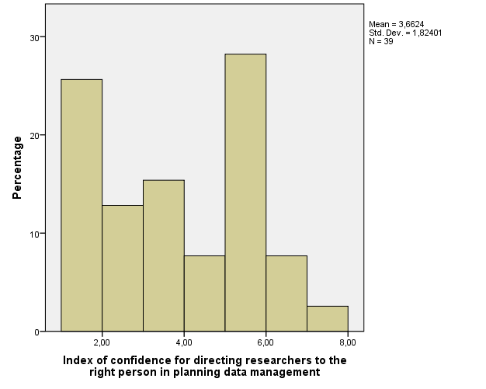
* Descriptive statistics of each component regarding Directing researchers to the right person in planning data management.
 |  | PDM-S2.Q1.1 | PDM-S2.Q1.2 | PDM-S2.Q1.3 | PDM-S2.Q1.4 | PDM-S2.Q1.5 | PDM-S2.Q1.6
N | Valid | 36 | 35 | 38 | 39 | 33 | 36
 | Missing | 4 | 5 | 2 | 1 | 7 | 4
Mean |  | 3.4167 | 3.3714 | 4.1053 | 3.9231 | 3.7273 | 3.5278
Median |  | 3.5000 | 3.0000 | 5.0000 | 5.0000 | 4.0000 | 3.0000
Std. Deviation |  | 2.04765 | 2.07344 | 2.23956 | 2.14457 | 2.19762 | 2.26130
Minimum |  | 1.00 | 1.00 | 1.00 | 1.00 | 1.00 | 1.00
Maximum |  | 7.00 | 7.00 | 7.00 | 7.00 | 7.00 | 7.00
Percentiles | 25 | 1.0000 | 1.0000 | 1.7500 | 2.0000 | 1.0000 | 1.0000
 | 50 | 3.5000 | 3.0000 | 5.0000 | 5.0000 | 4.0000 | 3.0000
 | 75 | 5.0000 | 5.0000 | 6.0000 | 6.0000 | 6.0000 | 5.7500
* Descriptive statistics of how many people replied that a single item identified their role.
 |  | PDM-S2.Q1.1 | PDM-S2.Q1.2 | PDM-S2.Q1.3 | PDM-S2.Q1.4 | PDM-S2.Q1.5 | PDM-S2.Q1.6
N | Valid | 39 | 38 | 40 | 40 | 38 | 40
 | Missing | 1 | 2 | 0 | 0 | 2 | 0
Mean |  | .0769 | .0789 | .0500 | .0250 | .1316 | .1000
More than 10% of respondents identified as their role items 5 and 6.
FREQUENCIES VARIABLES=myrole1
N | Valid | 40
 | Missing | 0
Mean |  | .4500
Median |  | .0000
Minimum |  | .00
Maximum |  | 4.00
* Descriptive statistics of areas respondents should be aware of in Planning data management.
 |  | PDM-S2.Q2.1 | PDM-S2.Q2.2 | PDM-S2.Q2.3 | PDM-S2.Q2.4 | PDM-S2.Q2.5 | PDM-S2.Q2.6
N | Valid | 40 | 40 | 40 | 40 | 40 | 40
 | Missing | 0 | 0 | 0 | 0 | 0 | 0
Mean |  | .48 | .43 | .70 | .65 | .63 | .65
Sum |  | 19 | 17 | 28 | 26 | 25 | 26
More than 60% of respondents believe they should be aware of items 3. 4. 5 and 6.
* Generate an overall index of confidence for "Directing researchers to the right person: Data management during the research process".
N | Valid | 39
 | Missing | 1
Mean |  | 3.4295
Std. Error of Mean |  | .28691
Median |  | 3.2500
Std. Deviation |  | 1.79175
Minimum |  | 1.00
Maximum |  | 6.75
Percentiles | 25 | 1.7500
 | 50 | 3.2500
 | 75 | 5.2500
The index was built in order to go from 1 (minimum confidence) to 7 (maximum confidence) with a mean value of 4. The overall mean was only slightly lower than 4, implying that the confidence of the respondents over the items that define “Directing researchers to the right person: Data management during the research process” is average. However, the bottom 25% of respondents have an extremely low confidence in these items (<=1.75).
The same conclusions can be drawn watching the graph reported below. Moreover, it can be seen that there are basically two different types of respondents: fairly confident and unconfident.
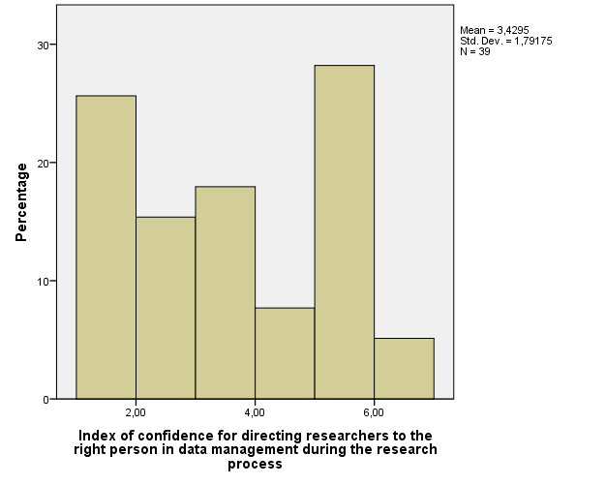
* Descriptive statistics of each component regarding Directing researchers to the right person in data management during the research process.
 |  | DMRP-S2.Q3.1 | DMRP-S2.Q3.2 | DMRP-S2.Q3.3 | DMRP-S2.Q3.4
N | Valid | 39 | 38 | 36 | 36
 | Missing | 1 | 2 | 4 | 4
Mean |  | 3.4615 | 3.4211 | 3.4167 | 3.3333
Median |  | 3.0000 | 3.0000 | 3.0000 | 3.0000
Std. Deviation |  | 2.12561 | 2.10060 | 1.79483 | 1.85164
Minimum |  | 1.00 | 1.00 | 1.00 | 1.00
Maximum |  | 7.00 | 7.00 | 7.00 | 7.00
Percentiles | 25 | 1.0000 | 1.0000 | 2.0000 | 2.0000
 | 50 | 3.0000 | 3.0000 | 3.0000 | 3.0000
 | 75 | 5.0000 | 5.2500 | 5.0000 | 5.0000

* Descriptive statistics of how many people replied that a single item identified their role.
 |  | DMRP-S2.Q3.1 | DMRP-S2.Q3.2 | DMRP-S2.Q3.3 | DMRP-S2.Q3.4
N | Valid | 39 | 39 | 39 | 39
 | Missing | 1 | 1 | 1 | 1
Mean |  | .0000 | .0256 | .0769 | .0769
Most of respondents did not identify themselves in any of these items. None of the respondents identified themselves in items 1.
COMPUTE myrole2=SUM(dmrp3r2.dmrp4r2.dmrp5r2.dmrp6r2).
N | Valid | 39
 | Missing | 1
Mean |  | .1795
Median |  | .0000
Minimum |  | .00
Maximum |  | 2.00

* Descriptive statistics of areas respondents should be aware of in Planning data management.
 |  | DMRP-S2.Q4.1 | DMRP-S2.Q4.2 | DMRP-S2.Q4.3 | DMRP-S2.Q4.4
N | Valid | 40 | 40 | 40 | 40
 | Missing | 0 | 0 | 0 | 0
Mean |  | .48 | .55 | .50 | .50
Sum |  | 19 | 22 | 20 | 20
About 50% of respondents stated that they should be aware of all these items.
* Generate an overall index of confidence for "Directing researchers to the right person: Post research data management".
N | Valid | 39
 | Missing | 1
Mean |  | 3.1449
Std. Error of Mean |  | .28768
Median |  | 2.7500
Std. Deviation |  | 1.79659
Minimum |  | 1.00
Maximum |  | 7.00
Percentiles | 25 | 1.4000
 | 50 | 2.7500
 | 75 | 4.8000
The index was built in order to go from 1 (minimum confidence) to 7 (maximum confidence) with a mean value of 4. The overall mean was only slightly higher than 3, implying that the confidence of the respondents over the items that define “Directing researchers to the right person: Post research data management” is slightly low. However, the bottom 25% of respondents have an extremely low confidence in these items (<=1.4).
The same conclusions can be drawn watching the graph reported below.
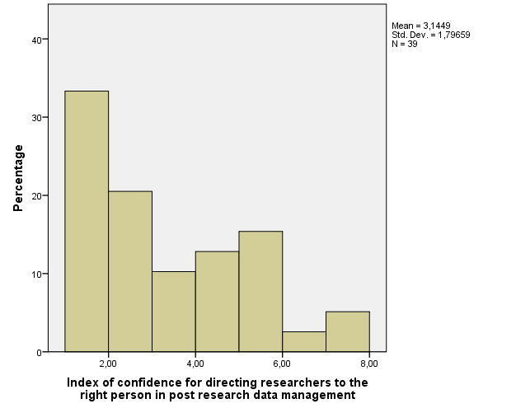
* Descriptive statistics of each component regarding Directing researchers to the right person in post research data management.
 |  | DMRP-S2.Q5.1 | DMRP-S2.Q5.2 | DMRP-S2.Q5.3 | DMRP-S2.Q5.4 | DMRP-S2.Q5.5
N | Valid | 37 | 38 | 38 | 39 | 35
 | Missing | 3 | 2 | 2 | 1 | 5
Mean |  | 3.0270 | 3.1316 | 3.4737 | 2.9744 | 3.1714
Median |  | 3.0000 | 3.0000 | 3.0000 | 2.0000 | 3.0000
Std. Deviation |  | 1.95059 | 2.02913 | 1.98286 | 2.00640 | 1.97761
Minimum |  | 1.00 | 1.00 | 1.00 | 1.00 | 1.00
Maximum |  | 7.00 | 7.00 | 7.00 | 7.00 | 7.00
Percentiles | 25 | 1.0000 | 1.0000 | 1.7500 | 1.0000 | 1.0000
 | 50 | 3.0000 | 3.0000 | 3.0000 | 2.0000 | 3.0000
 | 75 | 5.0000 | 5.0000 | 5.0000 | 5.0000 | 5.0000

* Descriptive statistics of how many people replied that a single item identified their role.
 |  | DMRP-S2.Q5.1 | DMRP-S2.Q5.2 | DMRP-S2.Q5.3 | DMRP-S2.Q5.4 | DMRP-S2.Q5.5
N | Valid | 39 | 38 | 39 | 39 | 39
 | Missing | 1 | 2 | 1 | 1 | 1
Mean |  | .0513 | .0000 | .0256 | .0000 | .1026

More than 10% of respondents identified as their role item 5. None of the respondents identified themselves in items 2 and 4.

COMPUTE myrole3=SUM(prdm4r2.prdm5r2.prdm6r2.prdm7r2.prdm8r2).
N | Valid | 39
 | Missing | 1
Mean |  | .1795
Median |  | .0000
Minimum |  | .00
Maximum |  | 3.00

* Descriptive statistics of areas respondents should be aware of in Planning data management.
 |  | PRDM-S2.Q6.1 | PRDM-S2.Q6.2 | PRDM-S2.Q6.3 | PRDM-S2.Q6.4 | PRDM-S2.Q6.5
N | Valid | 40 | 40 | 40 | 40 | 40
 | Missing | 0 | 0 | 0 | 0 | 0
Mean |  | .65 | .58 | .68 | .48 | .60
Sum |  | 26 | 23 | 27 | 19 | 24

More than 60% of respondents believe they should be aware of items1. 3 and 5.

String analysis

String analysis variable S2.FG
* Descriptive statistics of the questionnaire's final section.
Unit to which respondent belongs |  | Frequency | Percent | Valid Percent | Cumulative Percent
Valid |  | 1 | 2.5 | 2.5 | 2.5
 | iSolutions | 8 | 20.0 | 20.0 | 22.5
 | Library | 22 | 55.0 | 55.0 | 77.5
 | Research and Innovation Services | 9 | 22.5 | 22.5 | 100.0
 | Total | 40 | 100.0 | 100.0

String analysis variable AYS3.Q2.
Involved in carrying out research as a researcher
 |  | Frequency | Percent | Valid Percent | Cumulative Percent
Valid | No | 32 | 80.0 | 80.0 | 80.0
 | Yes | 8 | 20.0 | 20.0 | 100.0
 | Total | 40 | 100.0 | 100.0

Involved in carrying out research as part of an advanced postgraduate research degree
 |  | Frequency | Percent | Valid Percent | Cumulative Percent
Valid | No | 35 | 87.5 | 87.5 | 87.5
 | Yes | 5 | 12.5 | 12.5 | 100.0
 | Total | 40 | 100.0 | 100.0

Was never involved in carrying out research
 |  | Frequency | Percent |  | Valid Percent |  | Cumulative Percent
Valid | No | 12 | 30.0 |  | 30.0 |  | 30.0
 | Yes | 28 | 70.0 |  | 70.0 |  | 100.0
 | Total | 40 | 100.0 |  | 100.0
Asked for help related to research data management in the last 6 months
 |  |  |  | Frequency |  | Percent |  | Valid Percent |  | Cumulative Percent
Valid | No |  |  | 20 |  | 50.0 |  | 50.0 |  | 50.0
 | Yes between 2-5 times |  |  | 7 |  | 17.5 |  | 17.5 |  | 67.5
 | Yes more than 5 times |  |  | 7 |  | 17.5 |  | 17.5 |  | 85.0
 | Yes once only |  |  | 6 |  | 15.0 |  | 15.0 |  | 100.0
 | Total |  |  | 40 |  | 100.0 |  | 100.0

String analysis variable AYS3.Q4.1a.
Most essential area of training
 |  | Frequency | Percent | Valid Percent
Valid |  | 1 | 2.5 | 2.5
 | Data Management Plans | 9 | 22.5 | 22.5
 | Describing your data | 6 | 15.0 | 15.0
 | Funder requirements for research data | 6 | 15.0 | 15.0
 | Legal issues and research data | 7 | 17.5 | 17.5
 | Making data available for re-use | 2 | 5.0 | 5.0
 | Other please specify | 1 | 2.5 | 2.5
 | Security and storage of data | 8 | 20.0 | 20.0
 | Total | 40 | 100.0 | 100.0

