Analysis for Other respondents
Federico De Luca. Postgraduate Researcher, Faculty of Social and Human Sciences, University of Southampton

Descriptive Analysis
* Time of questionnaire completion.
N | Valid | 17
 | Missing | 0
Mean |  | 773.12
Median |  | 596.00
Std. Deviation |  | 505.142
Minimum |  | 132
Maximum |  | 1736
The questionnaire took an average of almost 13 minutes (12:53) to be completed, with a minimum of 2:12 and a maximum of 28:56.
* Generate an overall index of confidence for "Planning data management".
N | Valid | 16
 | Missing | 1
Mean |  | 8.3750
Std. Error of Mean |  | 1.65044
Median |  | 7.0000
Std. Deviation |  | 6.60177
Minimum |  | .00
Maximum |  | 24.00
Percentiles | 25 | 3.2500
 | 50 | 7.0000
 | 75 | 12.5000
The index was built in order to go from 0 (minimum confidence) to 36 (maximum confidence) with a mean value of 18. More than 75% of respondents had a confidence of 13 or less, and the overall mean was only slightly higher than 8, thus implying that the confidence of the respondents over the items that define “Planning data management” is quite low. Moreover, the bottom 25% of respondents have an incredibly low confidence in these items (<=3.25).
The same conclusions can be drawn watching the graph reported in the following page.
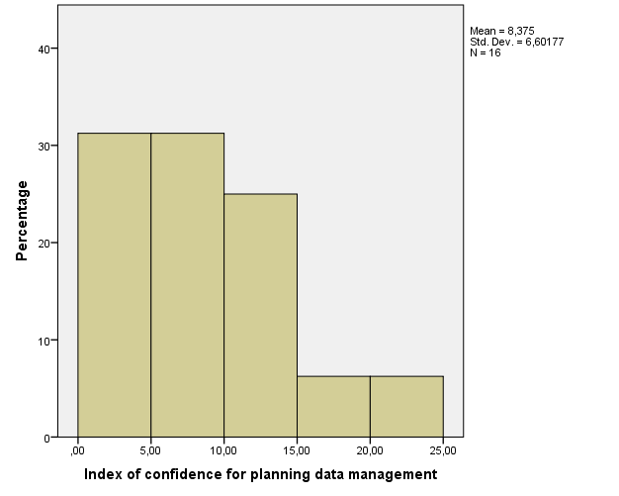
* Descriptive statistics of each component regarding Planning data management
 |  | PDM-S1.Q1.1 | PDM-S1.Q1.2 | PDM-S1.Q1.3 | PDM-S1.Q1.4 | PDM-S1.Q1.5 | PDM-S1.Q1.6
N | Valid | 16 | 16 | 17 | 17 | 17 | 17
 | Missing | 1 | 1 | 0 | 0 | 0 | 0
Mean |  | 1.94 | 2.19 | 2.94 | 3.41 | 2.65 | 1.88
Median |  | 1.00 | 1.50 | 3.00 | 3.00 | 3.00 | 2.00
Std. Deviation |  | 1.769 | 1.759 | 1.676 | 1.698 | 1.455 | 1.111
Minimum |  | 1 | 1 | 1 | 1 | 1 | 1
Maximum |  | 7 | 7 | 6 | 6 | 5 | 5
Percentiles | 25 | 1.00 | 1.00 | 2.00 | 1.00 | 1.00 | 1.00
 | 50 | 1.00 | 1.50 | 3.00 | 3.00 | 3.00 | 2.00
 | 75 | 2.75 | 2.75 | 5.00 | 4.00 | 4.00 | 2.50

* Generate an overall index of confidence for "Data Management during the research process".
N | Valid | 16
 | Missing | 1
Mean |  | 4.3125
Std. Error of Mean |  | 1.18925
Median |  | 3.0000
Std. Deviation |  | 4.75701
Minimum |  | .00
Maximum |  | 14.00
Percentiles | 25 | .0000
 | 50 | 3.0000
 | 75 | 8.2500
The index was built in order to go from 0 (minimum confidence) to 24 (maximum confidence) with a mean value of 12. More than 75% of respondents had a confidence of 8.25 or less, and the overall mean was only slightly higher than 4, thus implying that the confidence of the respondents over the items that define “Data Management during the research process” is quite low. Moreover, more than 50% of respondents have an incredibly low confidence in these items (<=3).
The same conclusions can be drawn watching the graph reported below.
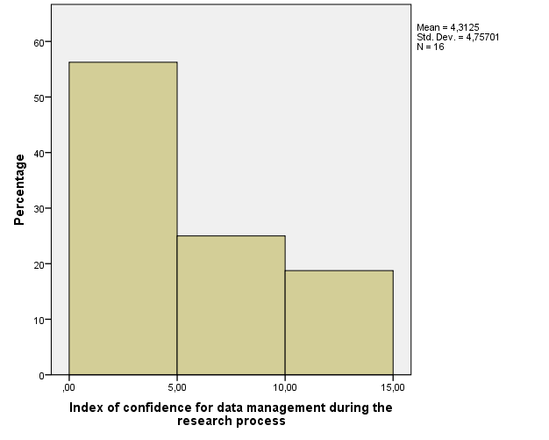
* Descriptive statistics of each component regarding Data Management during the research process.
 |  | DMRP-S1.Q2.1 | DMRP-S1.Q2.2 | DMRP-S1.Q2.3 | DMRP-S1.Q2.4
N | Valid | 16 | 16 | 16 | 16
 | Missing | 1 | 1 | 1 | 1
Mean |  | 2.31 | 2.69 | 1.69 | 1.63
Median |  | 1.00 | 3.00 | 1.00 | 1.00
Std. Deviation |  | 1.702 | 1.662 | 1.014 | .885
Minimum |  | 1 | 1 | 1 | 1
Maximum |  | 6 | 6 | 4 | 3
Percentiles | 25 | 1.00 | 1.00 | 1.00 | 1.00
 | 50 | 1.00 | 3.00 | 1.00 | 1.00
 | 75 | 3.75 | 3.75 | 2.75 | 2.75

* Generate an overall index of confidence for "Post Research Data Management".
N | Valid | 15
 | Missing | 2
Mean |  | 4.6000
Std. Error of Mean |  | 1.05469
Median |  | 4.0000
Std. Deviation |  | 4.08482
Minimum |  | .00
Maximum |  | 15.00
Percentiles | 25 | 2.0000
 | 50 | 4.0000
 | 75 | 6.0000

The index was built in order to go from 0 (minimum confidence) to 30 (maximum confidence) with a mean value of 15. More than 75% of respondents had a confidence of 6 or less, and the overall mean was only slightly lower than 5, thus implying that the confidence of the respondents over the items that define “Post Research Data Management” is very low. Moreover, the bottom 25% of respondents have an incredibly low confidence in these items (<=2).
The same conclusions can be drawn watching the graph reported in the following page.
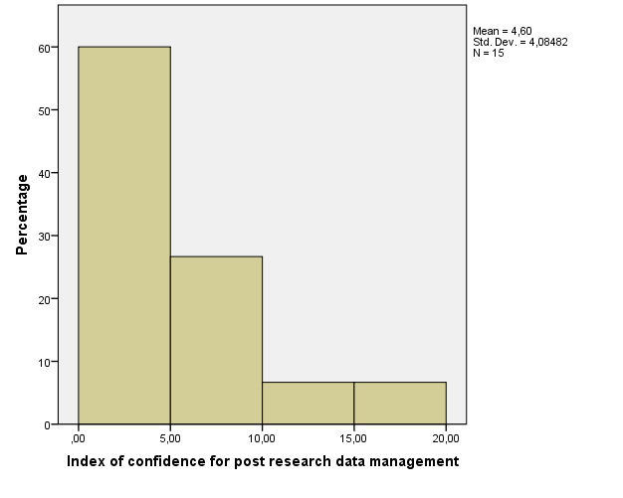
* Descriptive statistics of each component regarding Data Management during the research process.
 |  | PRDM-S1.Q3.1 | PRDM-S1.Q3.2 | PRDM-S1.Q3.3 | PRDM-S1.Q3.4 | PRDM-S1.Q3.5
N | Valid | 16 | 16 | 16 | 15 | 16
 | Missing | 1 | 1 | 1 | 2 | 1
Mean |  | 2.31 | 1.44 | 2.07 | 1.69 | 2.00
Median |  | 2.00 | 1.00 | 2.00 | 1.00 | 1.50
Std. Deviation |  | 1.195 | .814 | 1.438 | 1.078 | 1.414
Minimum |  | 1 | 1 | 1 | 1 | 1
Maximum |  | 5 | 4 | 6 | 4 | 5
Percentiles | 25 | 1.00 | 1.00 | 1.00 | 1.00 | 1.00
 | 50 | 2.00 | 1.00 | 1.00 | 2.00 | 1.50
 | 75 | 3.00 | 2.00 | 2.00 | 3.00 | 2.00
* Generate an overall index of confidence for "Directing researchers to the right person: Planning data management".
N | Valid | 16
 | Missing | 1
Mean |  | 3.5250
Std. Error of Mean |  | .45957
Median |  | 3.6667
Std. Deviation |  | 1.83830
Minimum |  | 1.00
Maximum |  | 6.00
Percentiles | 25 | 1.4583
 | 50 | 3.6667
 | 75 | 5.1250
The index was built in order to go from 1 (minimum confidence) to 7 (maximum confidence) with a mean value of 4. The overall mean was only slightly lower than 4, implying that the confidence of the respondents over the items that define “Directing researchers to the right person: Planning data management” is average. However, the bottom 25% of respondents have a fairly low confidence in these items (<=1.5).
The same conclusions can be drawn watching the graph reported below. Moreover, it can be seen that there are basically three different types of respondents: fairly confident, slightly unconfident, and extremely unconfident.
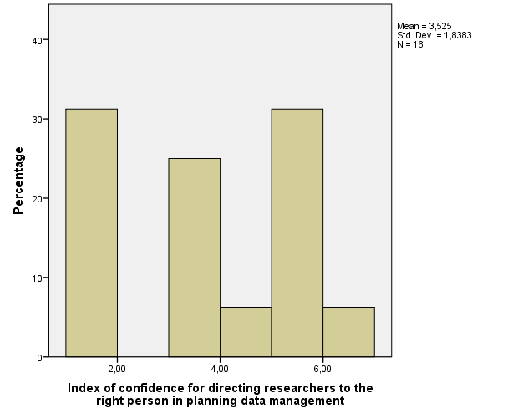
* Descriptive statistics of each component regarding Directing researchers to the right person in planning data management.
 |  | PDM-S2.Q1.1 | PDM-S2.Q1.2 | PDM-S2.Q1.3 | PDM-S2.Q1.4 | PDM-S2.Q1.5 | PDM-S2.Q1.6
N | Valid | 16 | 15 | 15 | 16 | 14 | 15
 | Missing | 1 | 2 | 2 | 1 | 3 | 2
Mean |  | 2.9375 | 2.8667 | 4.0667 | 4.5000 | 3.2857 | 3.2667
Median |  | 2.0000 | 2.0000 | 5.0000 | 5.0000 | 3.5000 | 3.0000
Std. Deviation |  | 2.04837 | 2.13363 | 2.46306 | 2.30940 | 2.23361 | 2.08624
Minimum |  | 1.00 | 1.00 | 1.00 | 1.00 | 1.00 | 1.00
Maximum |  | 7.00 | 7.00 | 7.00 | 7.00 | 7.00 | 7.00
Percentiles | 25 | 1.0000 | 1.0000 | 1.0000 | 2.2500 | 1.0000 | 1.0000
 | 50 | 2.0000 | 2.0000 | 5.0000 | 5.0000 | 3.5000 | 3.0000
 | 75 | 4.7500 | 5.0000 | 6.0000 | 6.7500 | 5.0000 | 5.0000

* Descriptive statistics of how many people replied that a single item identified their role.
 |  | PDM-S2.Q1.1 | PDM-S2.Q1.2 | PDM-S2.Q1.3 | PDM-S2.Q1.4 | PDM-S2.Q1.5 | PDM-S2.Q1.6
N | Valid | 16 | 15 | 17 | 17 | 16 | 17
 | Missing | 1 | 2 | 0 | 0 | 1 | 0
Mean |  | .0000 | .0000 | .1176 | .0588 | .1250 | .1176
More than 10% of respondents identified as their role items 3, 5 and 6. None of the respondents identified themselves in items 1 and 2.

FREQUENCIES VARIABLES=myrole1
N | Valid | 17
 | Missing | 0
Mean |  | .4118
Median |  | .0000
Minimum |  | .00
Maximum |  | 3.00

* Descriptive statistics of areas respondents should be aware of in Planning data management.
 |  | PDM-S2.Q2.1 | PDM-S2.Q2.2 | PDM-S2.Q2.3 | PDM-S2.Q2.4 | PDM-S2.Q2.5 | PDM-S2.Q2.6
N | Valid | 17 | 17 | 17 | 17 | 17 | 17
 | Missing | 0 | 0 | 0 | 0 | 0 | 0
Mean |  | .18 | .18 | .53 | .59 | .53 | .76
Sum |  | 3 | 3 | 9 | 10 | 9 | 13
More than 60% of respondents believe they should be aware of item 6.

* Generate an overall index of confidence for "Directing researchers to the right person: Data management during the research process".
N | Valid | 16
 | Missing | 1
Mean |  | 2.7969
Std. Error of Mean |  | .44266
Median |  | 2.6250
Std. Deviation |  | 1.77064
Minimum |  | 1.00
Maximum |  | 5.50
Percentiles | 25 | 1.0000
 | 50 | 2.6250
 | 75 | 4.7500
The index was built in order to go from 1 (minimum confidence) to 7 (maximum confidence) with a mean value of 4. The overall mean was only slightly lower than 3, implying that the confidence of the respondents over the items that define “Directing researchers to the right person: Data management during the research process” is slightly low. However, the bottom 25% of respondents have an extremely low confidence in these items (<=1).
The same conclusions can be drawn watching the graph reported below. Moreover, it can be seen that there are basically three different types of respondents: fairly confident, slightly unconfident, and extremely unconfident.
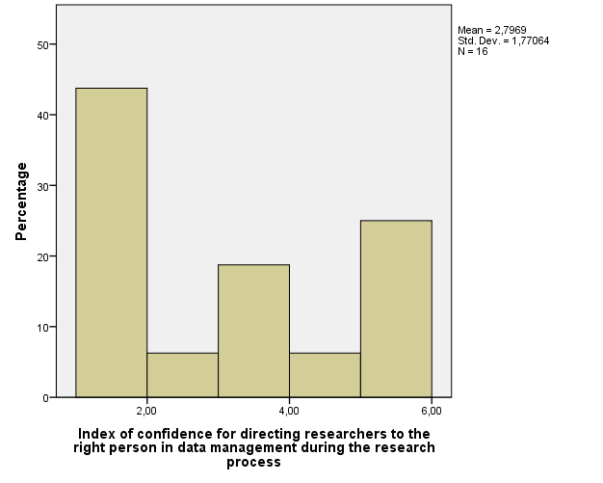
* Descriptive statistics of each component regarding Directing researchers to the right person in data management during the research process.
 |  | DMRP-S2.Q3.1 | DMRP-S2.Q3.2 | DMRP-S2.Q3.3 | DMRP-S2.Q3.4
N | Valid | 16 | 15 | 16 | 16
 | Missing | 1 | 2 | 1 | 1
Mean |  | 3.0625 | 3.3333 | 2.5000 | 2.4375
Median |  | 2.5000 | 3.0000 | 2.0000 | 2.0000
Std. Deviation |  | 2.11246 | 2.12692 | 1.67332 | 1.67207
Minimum |  | 1.00 | 1.00 | 1.00 | 1.00
Maximum |  | 7.00 | 7.00 | 5.00 | 5.00
Percentiles | 25 | 1.0000 | 1.0000 | 1.0000 | 1.0000
 | 50 | 2.5000 | 3.0000 | 2.0000 | 2.0000
 | 75 | 5.0000 | 5.0000 | 4.5000 | 4.5000

* Descriptive statistics of how many people replied that a single item identified their role.
 |  | DMRP-S2.Q3.1 | DMRP-S2.Q3.2 | DMRP-S2.Q3.3 | DMRP-S2.Q3.4
N | Valid | 16 | 16 | 16 | 16
 | Missing | 1 | 1 | 1 | 1
Mean |  | .0000 | .0625 | .0000 | .0000
Most of respondents did not identify themselves in any of these items. None of the respondents identified themselves in the other items.

FREQUENCIES VARIABLES=myrole2
N | Valid | 16
 | Missing | 1
Mean |  | .0625
Median |  | .0000
Minimum |  | .00
Maximum |  | 1.00

* Descriptive statistics of areas respondents should be aware of in Planning data management.
 |  | DMRP-S2.Q4.1 | DMRP-S2.Q4.2 | DMRP-S2.Q4.3 | DMRP-S2.Q4.4
N | Valid | 17 | 17 | 17 | 17
 | Missing | 0 | 0 | 0 | 0
Mean |  | .41 | .47 | .18 | .24
Sum |  | 7 | 8 | 3 | 4
About 40% of respondents stated that they should be aware of items 1 and 2.
* Generate an overall index of confidence for "Directing researchers to the right person: Post research data management".
N | Valid | 16
 | Missing | 1
Mean |  | 3.2063
Std. Error of Mean |  | .44445
Median |  | 2.9000
Std. Deviation |  | 1.77781
Minimum |  | 1.00
Maximum |  | 7.00
Percentiles | 25 | 1.5000
 | 50 | 2.9000
 | 75 | 4.9500
The index was built in order to go from 1 (minimum confidence) to 7 (maximum confidence) with a mean value of 4. The overall mean was only slightly lower than 4, implying that the confidence of the respondents over the items that define “Directing researchers to the right person: Post research data management” is slightly low. However, the bottom 25% of respondents have an extremely low confidence in these items (<=1.5).
The same conclusions can be drawn watching the graph reported below.
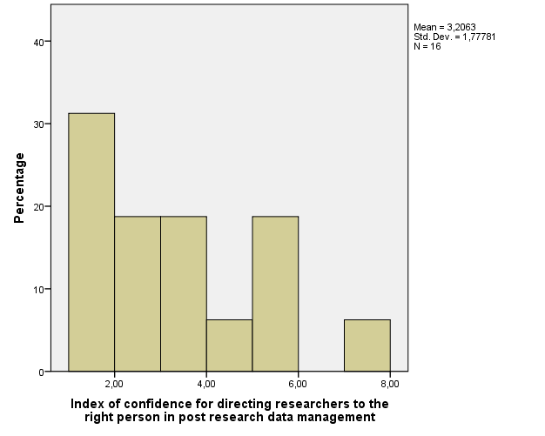

* Descriptive statistics of each component regarding Directing researchers to the right person in post research data management.
 |  | DMRP-S2.Q5.1 | DMRP-S2.Q5.2 | DMRP-S2.Q5.3 | DMRP-S2.Q5.4 | DMRP-S2.Q5.5
N | Valid | 16 | 16 | 16 | 16 | 14
 | Missing | 1 | 1 | 1 | 1 | 3
Mean |  | 3.0625 | 2.9375 | 3.6250 | 3.2500 | 2.8571
Median |  | 3.0000 | 3.0000 | 3.5000 | 3.0000 | 2.5000
Std. Deviation |  | 2.04837 | 2.01556 | 2.02896 | 2.04939 | 1.91581
Minimum |  | 1.00 | 1.00 | 1.00 | 1.00 | 1.00
Maximum |  | 7.00 | 7.00 | 7.00 | 7.00 | 6.00
Percentiles | 25 | 1.0000 | 1.0000 | 1.2500 | 1.0000 | 1.0000
 | 50 | 3.0000 | 3.0000 | 3.5000 | 3.0000 | 2.5000
 | 75 | 5.0000 | 5.0000 | 5.0000 | 5.0000 | 5.0000

* Descriptive statistics of how many people replied that a single item identified their role.
 |  | DMRP-S2.Q5.1 | DMRP-S2.Q5.2 | DMRP-S2.Q5.3 | DMRP-S2.Q5.4 | DMRP-S2.Q5.5
N | Valid | 16 | 16 | 16 | 16 | 16
 | Missing | 1 | 1 | 1 | 1 | 1
Mean |  | .0000 | .0000 | .0000 | .0000 | .1250
More than 10% of respondents identified as their role item 6. Moreover, they did not identify themselves in any of the other items.

FREQUENCIES VARIABLES=myrole3
N | Valid | 16
 | Missing | 1
Mean |  | .1250
Median |  | .0000
Minimum |  | .00
Maximum |  | 1.00

* Descriptive statistics of areas respondents should be aware of in Planning data management.
 |  | PRDM-S2.Q6.1 | PRDM-S2.Q6.2 | PRDM-S2.Q6.3 | PRDM-S2.Q6.4 | PRDM-S2.Q6.5
N | Valid | 17 | 17 | 17 | 17 | 17
 | Missing | 0 | 0 | 0 | 0 | 0
Mean |  | .47 | .47 | .53 | .47 | .53
Sum |  | 8 | 8 | 9 | 8 | 9
More than 50% of respondents believe they should be aware of items 3 and 5.

String Analysis

String analysis variable S2.FG.
* Descriptive statistics of the questionnaire's final section.
Unit to which respondent belongs |  | Frequency | Percent | Valid Percent | Cumulative Percent
Valid | iSolutions | 8 | 47.1 | 47.1 | 47.1
 | Research and Innovation Services | 9 | 52.9 | 52.9 | 100.0
 | Total | 17 | 100.0 | 100.0

String analysis variable AYS3.Q2.
Involved in carrying out research as a researcher
 |  | Frequency | Percent | Valid Percent | Cumulative Percent
Valid | No | 16 | 94.1 | 94.1 | 94.1
 | Yes | 1 | 5.9 | 5.9 | 100.0
 | Total | 17 | 100.0 | 100.0

Involved in carrying out research as part of an advanced postgraduate research degree
 |  | Frequency | Percent | Valid Percent | Cumulative Percent
Valid | No | 14 | 82.4 | 82.4 | 82.4
 | Yes | 3 | 17.6 | 17.6 | 100.0
 | Total | 17 | 100.0 | 100.0

Was never involved in carrying out research
 |  | Frequency | Percent | Valid Percent | Cumulative Percent
Valid | No | 3 | 17.6 | 17.6 | 17.6
 | Yes | 14 | 82.4 | 82.4 | 100.0
 | Total | 17 | 100.0 | 100.0

Asked for help related to research data management in the last 6 months
 |  | Frequency | Percent | Valid Percent | Cumulative Percent
Valid | No | 4 | 23.5 | 23.5 | 23.5
 | Yes between 2-5 times | 5 | 29.4 | 29.4 | 52.9
 | Yes more than 5 times | 5 | 29.4 | 29.4 | 82.4
 | Yes once only | 3 | 17.6 | 17.6 | 100.0
 | Total | 17 | 100.0 | 100.0

String analysis variable AYS3.Q4.1a.
Most essential area of training
 |  | Frequency | Percent | Valid Percent
Valid |  | 1 | 5.9 | 5.9
 | Data Management Plans | 3 | 17.6 | 17.6
 | Funder requirements for research data | 5 | 29.4 | 29.4
 | Legal issues and research data | 4 | 23.5 | 23.5
 | Security and storage of data | 4 | 23.5 | 23.5
 | Total | 17 | 100.0 | 100.0

String analysis variable AYS3.Q5.1a AYS3.Q5.1b RDMS3.Q6.

