Studies of High Current Arcs using an Optical Fiber Array based Imaging System

J.W.McBride1 and K.J Cross2

1University of Southampton, Engineering Sciences, UK.

2 Taicaan Research Ltd, 2 Venture Road, Southampton Science Park, Southampton, Hampshire, SO16 7NP, UK.

***Abstract-* A portable arc imaging system is presented for the study of high speed and high temperature unsteady plasma flows such as those found in the vicinity of high current switching arcs. The system permits direct measurement of arc light emission images with a capture rate of 1 million images per second (1MHz), and 8 bit intensity resolution. Novel software techniques are reported to visualise the arc motion and to measure arc trajectories. Results are presented on high current (2kA) discharge events where the electrode and arc runner surfaces are investigated using optical surface scanning methods; such that the position of the arc roots on the runner can be correlated to the measured trajectories. The results show evidence of the cathode arc root stepping along the arc runners.**

# Introduction

A portable 1MHz optical fiber imaging system for the analysis of high current arcing events has recently been described, [1,2]. This paper provided a review of the system with applications to arc root motion in a low voltage circuit breaker. Four types of cathode root tracks on arc runners have been observed and used to describe the mode of the arc motion [3-6].

In order to optimize the design and development of circuit breaker technology, it is essential to gain an understanding of the events that occur as the arc moves from a contact region, where the arc is initiated by opening contacts; through an arc chamber to the arc stack or splitter plates. Fig.1 shows an example system with the opening contact region at the top of the chamber and the splitter plates (arc stack) at the bottom of the chamber. In the figure the cathode is the fixed contact region on the right and the anode is the moving contact region of the left. The arc motion through chamber is the result of electro-magnetic forces driving the plasma column into the plates. The physics of the transfer process through the arc chamber is a complex multi-physics problem.

# The Arc Imaging System (AIS)

Fig.1. shows the test chamber, used to investigate the relationship between contact opening velocity and the cathode and anode arc root dynamics as the arc transverses the arc chamber, [6-11]. The arc chamber is mounted in the horizontal plane, and is designed to simplify the geometry of a typical chamber. The anode and cathode conductors are shown with a steel backing plate to enhance the electro-magnetic influence. The circles in Fig.1 show the positions of the optical fibers in the array; referred to as the optical head. The optical head is mounted behind a quartz glass section which seals the arc chamber. The technical specification of the system are detailed in [1], while a comparison between the old Arc Imaging system used in [7-11], and the new system used in [1,2], are covered in table 1. The system is further detailed in [11].

|  |  |  |
| --- | --- | --- |
| System | Old AIS | NewAIS |
| Maximum Framing or sample rate | 500kHz | 1MHz |
| Maximum Number of Optical Fibres | 90 | 1024 |
| Light Intensity Resolution | 6bit (0-63) | 8bit (0-255) |
| Memory Allocation | 4K | 512K |
| Data storage time at Maximum Framing rate | 8ms | 500ms |
| Sensitivity | No Control | x1 - x32 |

Table 1. System Specification

## Arc Light Intensity

Fig 2 shows an image of the arc chamber in Fig.1, with the address of each fiber position; it shows the contact region on the right and the splitter plates on the left. The fiber positions along the cathode arc runner, also shaded grey in Fig.1, are labeled in sequence from the moving contact region on the right: B, E, H, L, P, U, Z, AF, AL, AS, AZ, BH and BP. Fig.3 shows an example of the calibrated light intensity data from fiber positions E, L, and U for a single test in the arc chamber discussed in the results section. The light intensity levels from fiber E in the contact region increases to 100 at 2670µs; for fiber L and U the corresponding time are respectively 2850µs and 2870µs. The peak intensity for fiber E is 150 while the corresponding values for L and U are respectively 270 and 320. With E closest to the moving contact, this shows the progression of the arc root.

## Arc Imaging

There are two modes of arc imaging; mode 1 uses dynamic thresholds; while mode 2 uses fixed thresholds. With dynamic thresholds, the threshold values are defined with respect to the maximum light intensity across all the fibers at a given frame number or time. For the three fibers in Fig 3, at 2800µs the maximum intensity is 120 in fiber E. With fixed thresholds the maximum value is the maximum light intensity across all the fiber for all frames; for the data shown in Fig.3 the maximum value is 320. For the former the images are created with a different maximum intensity for each frame, this is best suited for viewing the arc when the light intensities are low; for example at the start of the arc. The latter is best suited for an overview of the arc process when the arc is in the chamber, as the image intensity scale will be fixed, allowing a systematic comparison of arcing events. In addition to the mode of imaging there are a number of methods for creating the images.

1. Schematic of the arc chamber with 68 fiber positions. The shaded fiber positions correspond to the fiber selected for arc root trajectory plotting. The cathode is connected to the fixed contact runner

*Method 1.**Group Contours.* Contours are grouped for the whole array which then creates an image of the arc. The method is ideally suited to the low intensity resolution data, [6], however with increased bit resolution from 6 to 8 (see table 1) a number of new methods of imaging have been developed.

*Method 2. Point Contours.*Each fiber position is illuminated with color coded concentric circles, where the color of each embedded circle is related to a percentage of the maximum light intensity level, using either mode 1 or 2 to define the maximum level. The key advantage over method 1 is that, with the increased bit resolution of the light intensity, multiple conducting paths are detectable.

*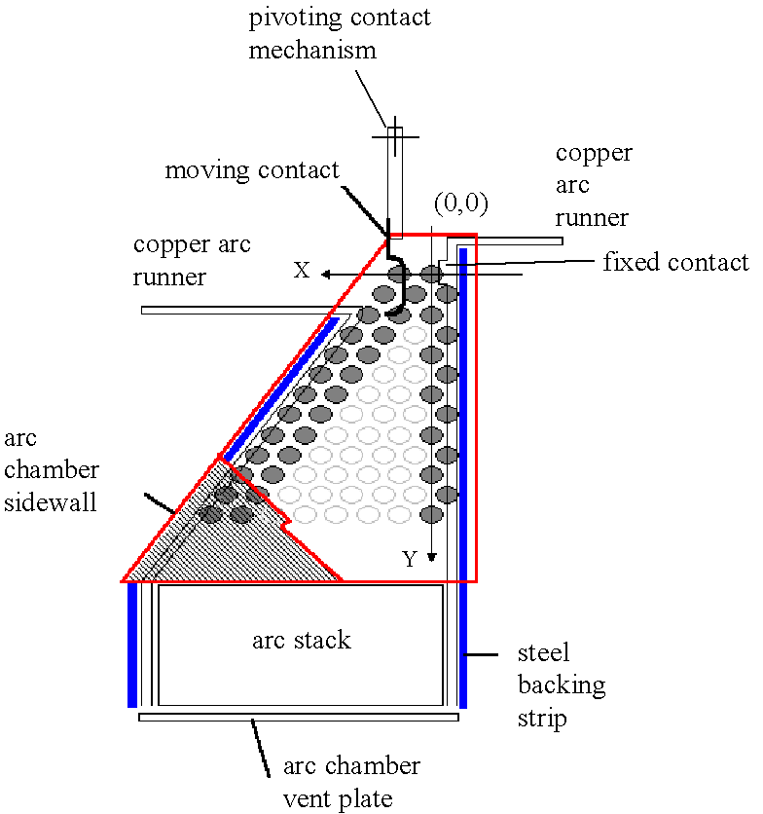Method 3. Simulated images****.*** This allows the creation of realistic images of the arc discharge process at sample rates not possible with conventional video or photographic methods. The fiber spots are interpreted as the nodes of a planar triangulation, which is automatically produced by means of the classical Delaunay algorithm [1].

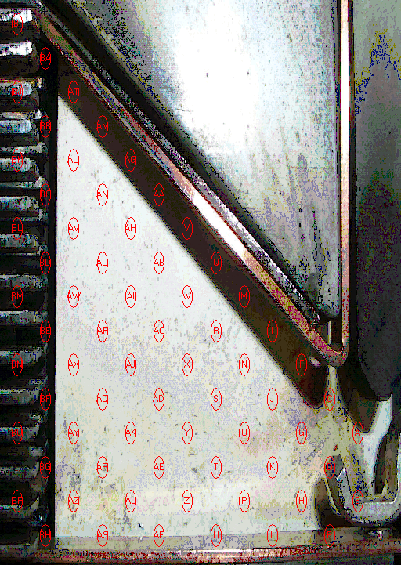

1. 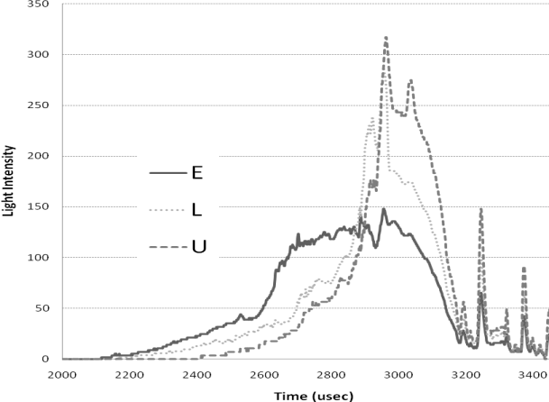The addressing of fiber positions in the optical array, with expanded fiber sequence along the cathode runner.

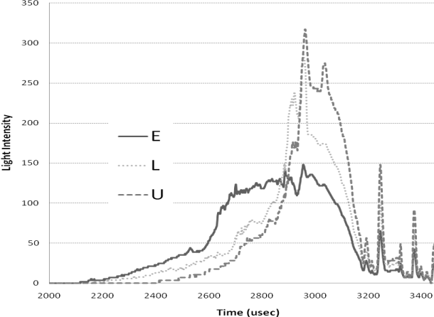Fig.3 Light intensity for selected fiber (experiment 1)

## Arc Root Plotting

The established method of arc root plotting [6-11] allows for the definition of parameters, for example the time taken for the arc root to transfer from the moving contact to the fixed runner; such that physical variables, for example the materials used in the chamber can be investigated and compared. The method is based on an intensity based position averaging technique over selected fiber positions near the surface of the runners (shaded fibers in Fig 1). A limitation of the method has been discussed in [1-2], and results from the influence of low light levels when X or Y are large. X and Y are the coordinates of the fiber positions as shown in Fig.1. When X or Y are large there is an error in the position of the arc root. To overcome this error, and to determine the positional resolution of the arc root, the additional intensity bit resolution (0-255) allows filter values to be used such that the position of the arc root is more clearly defined. In this new approach low level intensities are filtered such that the position of the cathode arc root can be accurately determined, and then correlated to physical processes.

# EXPERIMENTAL METHODS

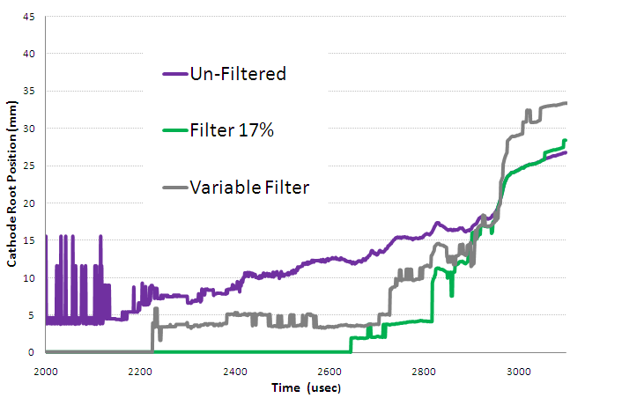The test system used has been described in [5]. In brief, the flexible test apparatus shown in Fig.1 is coupled with a capacitive discharge system, such that current starts to increase 2ms prior to the opening of the contacts; a peak short circuit current of approximately 2 kA occurs with a half cycle period of 10ms. New arc runners and contact materials were selected for each test. In all cases the cathode was consistent with Fig.1, the vent was 15% open, and the moving contact was connected to a high speed solenoid opening device, (>6 m/s). After tests the arc runners are removed from the apparatus. To correlate the arc images with the surface interaction along the arc runner surface, an optical surface profiler is used [12]. For the experiments conducted here there are three cathode runner samples. The sample for experiment 1, a single test, is shown on the right of Fig 4, it has AgC contact tip. Experiment 2 used the middle arc runner of Fig 4, the same conditions as experiment 1, but for two consecutive tests; and for experiment 3, the AgC tip is imbedded in the Cu surface as shown on the left in Fig.4. In this case two tests were conducted.

Fig. 4 The cathode arc runners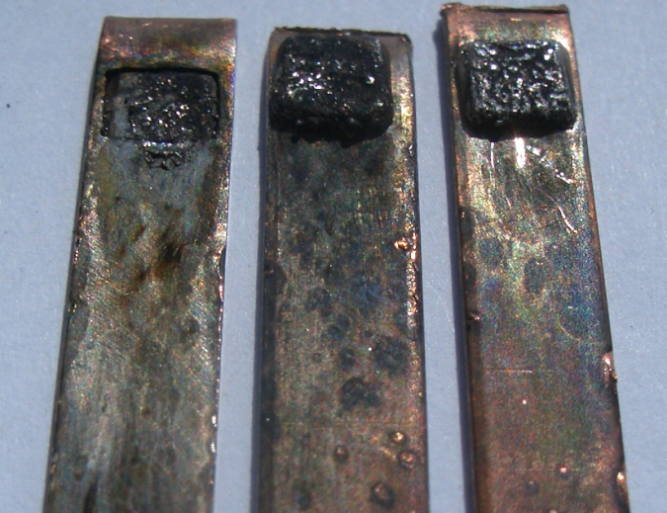.

# RESULTS

## Experiment 1

The arc voltage and current are shown in Fig.5. The time base for the data is referenced from the start of the short circuit current pulse. The cathode root position (17% filter) is scaled and shown on the same axis as the arc voltage. The maximum light intensity is also shown. The opening of the contacts corresponds to the step in arc voltage at 1.95ms, when the arc current is 1.3kA. The step in the arc voltage is followed by an increase in voltage as the plasma develops and is forced through the arc chamber towards the splitter plates. The arc voltage peaks at approximately 270V as it enters the splitter plates, at 3.3ms, leading to the reduction in the arc current. Fig.5 shows the maximum light intensity from the fibers selected to detect the cathode root motion (B to BF). The intensity rises after the opening of the contacts and reflects the corresponding increases in the arc power.

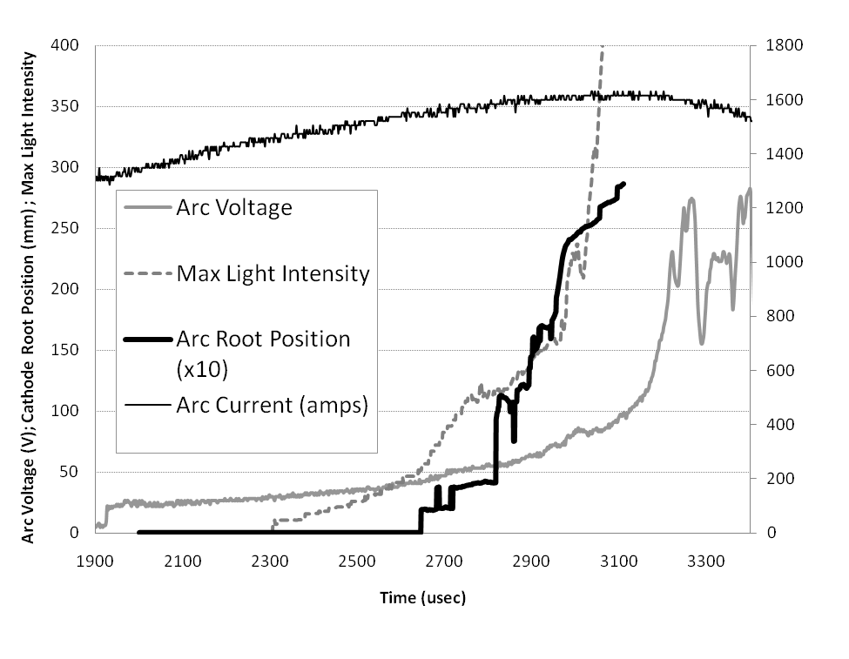 Fig . 5 Left Axis: Arc Voltage(V),with Maximum Light Intensity and Cathode Arc Root Position (x10mm), using a filter value of 17%; Right Axis: Arc Current (A)

Fig. 6. Arc Root Position using 3 filters

## Arc Root Motion for Experiment 1 and 3

It has been reported that the evaluation of the arc root position is influenced by low light levels on fiber positions at a distance from the zero position, for example at fiber positions AS and AF in Fig.2, [1,2]. To overcome this limitation a filter can be applied to the calculation such that light levels below the filter value are set to zero. The influence of the filter value on the cathode root position is shown in the Fig. 6 which shows the cathode root position determined using two filter values, 0 and 90 (17%).

The filter values are determined with reference to the highest light intensity (IMAX) for the selected fibers, for the total experiment. For experiment 1: IMAX = 509. Thus a filter of 90 is 17% of IMAX, as shown in Fig’s 5 and 6. With this filter any light intensity value below 90 is set to zero.

For the filter value 0, at 2ms that cathode is shown to be 5mm from the contact region, with an erratic position. This does not correspond to the visual image, shown in Fig 7 where the arc is shown to be present in the region of the contacts until approximately 2.8ms. By increasing the filter value to 17%, the cathode root passes the 5mm displacement line at 2.85ms.

Fig. 6 shows a new dynamic filter, labeled “variable filter”. In this filter the low light levels are removed below 1% of IMAX, for the selected fibers. In addition to this, a dynamic filter is used with a 50% I(t)MAX filter. In this filter the maximum light intensity is determined for a given time (t), as shown in Fig. 5; only values above 50% of that value used. This has the effect of improving the root plotting accuracy at low light values when the contacts are opening, as shown in Fig 5, where the I(t)MAX value is below 50 in the first 800µsec of the event.

Fig. 7, shows a close correlation between the visual data and the arc root plotting method.

## Wear Profiles of Arc Runner for Sample 1

Having established an accurate arc root plotting method we are now able to correlate with the damage on the arc runner. To enable a correlation with arc root plotting, Fig 8 shows a detailed image of the arc runner from experiment 1. It shows the Ag/C contact on the left and a number of regions where there is clear melting of the surface. These 4 positions are labeled a,b.c,d and are plotted as wear regions in Fig.7. They show a correlation with the periods when the cathode arc root is stationary. For the data presented after the single operation of the system the arc runners were removed for detailed analysis using optical profiling, [12]. The anode runner surface exhibits minimal surface damage, however the cathode surface exhibits significant damage. The image in Fig 8, shows the Ag/C contact surface on the left where there is substantial darkening of the Cu surface. The first region of wear is on the lower edge of the Cu runner at “a”. There then appears to be a track of arc steps moving diagonally across the runner shown by the dotted line. The arc root then appears to create a region of wear at “b”; from there the arc appears to have a preference for the upper edge of the runner, which is consistent with the thermal properties of the arc; as the arc chamber is in the horizontal plane for the experiments. Although of particular interest in this paper are the small regions for example “e” where there are a series of small surface irregularities associated with the stepping arc root.

Further inspection of surface area “e” is shown in Fig.9 with a CCD microscope camera view. The microscope image clearly shows the darkened area around the cathode spot. The green line and data value correspond to the vertical height in microns of the laser spot also shown as a cross-hair in the centre of the image. Fig. 10 is a 3D surface representation of the surface, where it is shown that region “e” is characterised by a melting of the surface, where the surface is depleted or cratered on the leading edge and built up on the trailing edge. Fig.10 shows the details of spot “e”. It also shows the dotted line used to generate the 2D section in Fig.11. This shows that although the region is easy to identify in Fig 9, surrounded by the blackened areas, the surface is only slightly deformed from the normal surface. In [2] it was shown that the by using thermodynamic modeling that the disruption to the surface can have occurred if the cathode root had been acting on the surface for a period of 4.7nsec. Fig 11, shows that the cathode root has melted the surface and as a result of the dynamic forces has pushed the molten metal in the direction of the cathode root motion. The rise in the surface as a result of this action is 6 microns.

There are a number of possible mechanism which could account for the observed data. A possible explanation is that the edges of the Cu runner are the main sources of the electrons once the arc moves from the contact region. This would be consistent with the electric field theory of field emission, [4,5]. The spotted regions are also apparent in sample 2 in Fig 4, however the patterns are lost as the runner has undergone 2 consecutive tests. The runner shown as sample 3 in Fig.4 again shows a different affect with the bottom and the upper edges of the runner showing equal preference for the cathode root.

The experimental data shows strong evidence of multiple arc root and multiple arc paths for a single switching operation. This has been evidenced in the arc imaging data where multiple arc paths have been identified.

# Conclusions

The results show that the arc imaging system is accurately able to predict the arc root motion and this has been verified with a visual record of the arc motion.

There is strong evidence that with a single operation the cathode root shows multiple paths, and that these paths are mainly focused on the edges of the Cu conductors.

The 3D surface characterizations allows for the determination of the amount of material melted in a selected arc spot on the cathode. From which we are able to determine the duration of the arc on that spot to cause the melting. This shows that the arc spot are created in a rapid stepping motion of the cathode root.

This paper shows that for the accurate characterization if the arc root motion, it is necessary to implement a dynamic filtering method. The results show that with this newly developed method we are able to correlate the visual record of the event and the wear regions where the cathode root has been stationary. This new result will allow a full and accurate methodology for the evaluation of parameters in the design of commercial circuit breaker devices. It also provides a solid base for the development of theoretical studies of arc motion, where it is notoriously difficult to verify computation and theoretical modeling methods.

##### References

1. J.W.McBride, A. Balestrero, L. Ghezzi, G. Tribulato, K.J. Cross, “Optical Fiber Imaging for High Speed Plasma Motion Diagnostics: applied to Low Voltage Circuit Breakers”, Review of Scientific Instruments, 2010.
2. J.W.McBride, K.J.Cross, “Cathode Root Motion Studies of High Current Arcs using an Optical Fiber Array based Imaging System”, IEEE Holm Conference, 2010,
3. Guile A.E., Sloot J.G.J., “Sudden Transitions in Velocity of Magnetically Driven Arcs”, Proc 3rd Int Conf on Gas Discharges 1974, IEE Conf Pub 118, pp544-548
4. Secker P.E., Guile A.E., “Arc Movement in A Transverse Magnetic Field At Atmospheric Pressure”, Proceedings of IEE Vol 106 Part A, pp311-320, 1959
5. Guile A.E., “Arc Electrode Phenomena”, Proc IEE, IEE Reviews, Vol 118, No9R, September 1971
6. J.W. McBride and P.M. Weaver, “Review of arcing phenomena in low voltage current limiting circuit breakers”, IEE Proceedings - Science, Measurement and Technology, Vol. 148, No. 1, pp. 1-7, 2001.
7. P.M.Weaver, K. Pechrach and J.W. McBride, “Arc root mobility on piezoelectrically actuated contacts in miniature circuit breakers”, IEEE Transactions on Components and Packaging Technologies, Vol. 28, No. 4, pp. 734-740, 2005.
8. P..M. Weaver, K. Pechrach and J.W. McBride, “The energetics of gas flow and contact erosion during short circuit arcing”, IEEE Transactions on Components and Packaging Technologies, Vol. 27, No. 1, pp. 51-56, 2004.
9. J.W. McBride, K. Pechrach and P.M. Weaver, “Arc motion and gas flow in current limiting circuit breakers operating with a low contact switching velocity”, IEEE Transactions on Components and Packaging Technologies, Vol. 25, No. 3, pp. 427-433, 2002.
10. J.W. McBride, K. Pechrach, and P.M. Weaver, “Arc root commutation from moving contacts in low voltage devices,” IEEE Transactions on Components and Packaging Technologies, Vol. 24, No. 3, pp. 331-336, 2001.
11. The commercial arc imaging system used. www.taicaanresearch.com
12. The non-contact surface scanning instruments. www.taicaan.com

**E-mail of authors:** jwm@soton.ac.uk