The Application of Reliability based Optimization of Tophat Stiffened Composite Panels subject to Bi-directional Buckling Loads

XUE Xiaoguang^{1*}, LI Guoxi¹, A.J. Sobey² and R.A. Shenoi²

1 School of Mechatronic Engineering and Automation, National University of Defense Technology, Changsha 410073, China

2 Faculty of Engineering and the Environment, University of Southampton, Southampton SO17 1BJ, UK

Abstract: Stiffened composite panels are used within many applications, from aerospace to marine applications. Stiffened panels are utilized for their high strength to weight ratio and flexibility of layups while counteracting the low stiffness exhibited by composites. Complications arise when attempting to utilize the full variability of layups in conjunction with reliability constraints creating a complex design problem when constrained by both buckling and material strength. To aid the process of optimizing the design of composite structures and layups, while ensuring a low mass, this paper presents a bi-level optimization scheme for minimization of the weight of tophat stiffened composite panels with probabilistic deflection constraints. To improve the computational efficiency, an energy based grillage method is formulated and applied for the investigation of buckling problems under bi-directional in-plane loads. The method is validated by comparing the results obtained from FE model calculations. The variables that have a large impact on the structural safety have been identified by both safety index and COV based reliability analysis. A parametric study of plate dimensions and loading ratios is conducted to investigate the coupling effects on critical buckling load. The method presented in this paper, makes it possible for engineers to improve their designs, at an early stage, with an integrated consideration between product performance and design parameters.

Key words: tophat-stiffened structures, energy based grillage method, bi-level optimization, reliability based optimization, bi-directional buckling loads

1 Introduction∗

Composite materials have been increasingly used in aircraft, space and marine applications due to their outstanding strength, corrosion and light-weight properties. In the construction of marine vessels, stiffened panels comprised of a plate, longitudinal stiffeners and transverse frame are the most commonly used structural elements, forming the deck, side shells and bulkheads. The design of such composite stiffened panels involves the optimization of a large number of variables such as stacking sequences of the laminates and widths of skin and stiffener panels. Further complications arise when the panel is subjected to practical laminate design rules and reliability constraints. This is particularly true in deck units which are subject to compressive loads by both longitudinal waves and transverse disturbance coupled bending of the ship hull.
The study of stiffened composite panels is therefore an important topic of research. Due to the importance of first ply failure composite stiffened plates has been analysed using the finite element method by a number of authors including Ray and Satsangi, Prusty et al. and Satish Kumar and Srivastava[1-3]. Previously Smith [4] had shown that computationally less costly analysis can be performed by smeared or discrete stiffener approaches such as Orthotropic Plate Method and Folded Plate Method, as well as Finite Element Method, in the case of the analysis of stiffened composite plates subject to lateral load. Maneepan et al. [5-7] developed a modified grillage model for multi-objective optimization of orthogonally tophat stiffened composite laminated plates. Eksik et al. [8, 9] generated an FE model of top-hat-stiffened plates, and outlines an experimental procedure devised to assess the strength. Raju et al. [10] characterized the mechanical strength of E-glass/vinylester composite tophat stiffeners subjected to transverse loading, in which the out-of-plane load transfer was studied and failure modes were identified for the three different composite layups. Bedair [11] used sequential quadratic programming to determine the magnitudes of the coefficient that minimize the total potential of the structural system.
For the optimization problem of stiffened composite structures, Miki [12] and Fukunaga and Chou [13] proposed a graphical optimization method using lamination parameters. Giles and Anderson [14] developed an optimization method for composite stiffened panels subject to combined loads of compression with pressure. Todoroki and Terada [15, 16] developed a deterministic optimization method for the stacking sequences of the composite laminates, in which the fractal branch-and bound (FBB) method is applied to buckling load maximization problems. Wodesenbet and Kidane [17] developed an improved smeared method to model the buckling problem of an isogrid stiffened composite cylinder. Sobey et al. [18-20] proposed a concurrent design and optimization principle for FRP boat structures. Liu et al. [21] carried out optimization of composite stiffened panels subject to compression and lateral pressure using a bi-level approach. In Awad et al.’s [22] recent review paper, an improved methodology, which considered experimental testing, numerical modeling, and design constraints, was proposed for design optimization of composite structures.
While deterministic analysis has proven successful in providing safety in past structural applications it has been shown that there is a random element to many of the variables associated with these problems. Reliability based design tries to ensure a low risk of failure by ensuring the satisfaction of probabilistic constraints. This method is more flexible and consistent than corresponding deterministic analysis as it provides more rational safety levels over various types of structures and takes into account more information that is not considered by deterministic analysis. Thompson et al. [23] utilized interlinked finite element, optimization, and reliability analysis procedures to solve the weight minimization problem with a deterministic strength constraint and two probabilistic constraints for fiber-reinforced polymer composite bridge deck panels. A calibrated strength formulation under combined loading which minimizes the model uncertainty factors was applied in the optimization study of a corner column of a TLP structure by Das et al. [24]. Shenoi et al. [25] proposed a stochastic approach for composite marine structures. Yang et al. [26] explored the use of stochastic approach to the design of stiffened composite panels in composite ship structures under in-plane load. And recently, Blake et al. [27] performed a reliability analysis on the tophat stiffened panel using grillage method.
The buckling loads of tophat stiffened structures considered in all of the above references deal only with longitudinal direction. However, the transverse loads arising from the water wave disturbance have a coupling impact on the composite panel’s buckling characters. Additionally, the abovementioned optimization methods have mainly considered the design parameters as deterministic variables but composite structural behavior exhibits wide scatter as a result of the inherent uncertainties in manufacture and design variables. Therefore, it is essential to take such uncertainties and variabilities into account during the optimization procedure. Furthermore, the currently available optimization methods take either geometric or laminate parameters as design variables. Realistically there is a coupling influence between the two kinds of design variables, and it is best to consider them together during the optimization procedure. In this paper, a bi-directional in-plane buckling load is taken into account during the optimization procedure of tophat stiffened composite panels. An energy based grillage method is developed for the investigation of buckling problems under bi-directional in-plane loads. A bi-level optimization strategy for minimizing the weight of tophat stiffened composite panels constrained by both reliability and buckling is presented. Finally results from a reliability analysis utilizing the grillage method are presented.
The paper is organized in the following manner. Section 2.1 presents a general configuration of the tophat stiffened composite panel. In section 2.2, an energy based grillage model is developed, and the theoretical critical buckling load is obtained inherently. Section 2.3 presents a reliability index based sensitivity analysis. In section 3 the optimization problem is formulated, and an integrated optimization procedure using a bi-level programming scheme is carried out. In section 4, an application of typical topology in the bottom panel of composite structures is demonstrated. Section 4.1 presents the finite element analysis validation comparing with the results obtained from analytical results. Section 4.2 presents the sensitivity and COV results of the design parameters. Section 4.3 presents a parametric study of the interaction between panel dimension ratio and in-plane load ratio. Finally, conclusions of the paper are presented in section 5.

2 Theoretical analysis

2.1 General configuration
The definition of the stiffened panel is plating bounded by, for example, transverse bulkheads, longitudinal bulkheads, side shell or large longitudinal girders. A typical stiffened panel configuration with the tophat-section stiffeners is shown in Fig. 1. The stiffened panel is referred to using an x- and y- axis coinciding with its longitudinal and transverse edges, respectively, and a z-axis normal to its surface. The length and width of the stiffened panel are denoted by L and B, respectively. The spacing of the stiffeners is denoted by a between longitudinal stiffeners and b between transverse stiffeners. The numbers of longitudinal and transverse stiffeners are N_{g} and N_{b}, respectively. The web, table, and flange structures forming a tophat-stiffener are made of FRP laminates and they are assumed to be orthotropic plates. The tophat can be comprised of many elements, such as the base plate, the webs and crown, each having different elastic properties. From Datoo [28], the membrane equivalent Young’s modulus values of a laminate in the x- and y- direction are as follows:

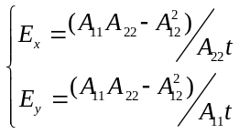, (1)

where the extension stiffness [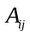] is expressed as:

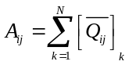. (2)

The expression of the transformed reduced stiffness of 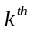layer, are

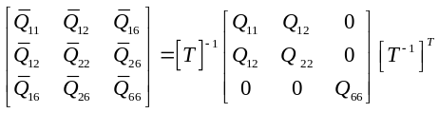 (3)

Where

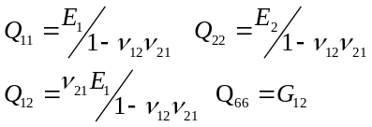, (4)

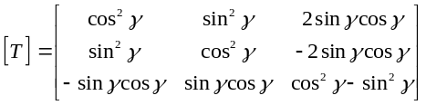, (5)

where is the angle measured from the stress axes to the material axis in an anti-clockwise direction.
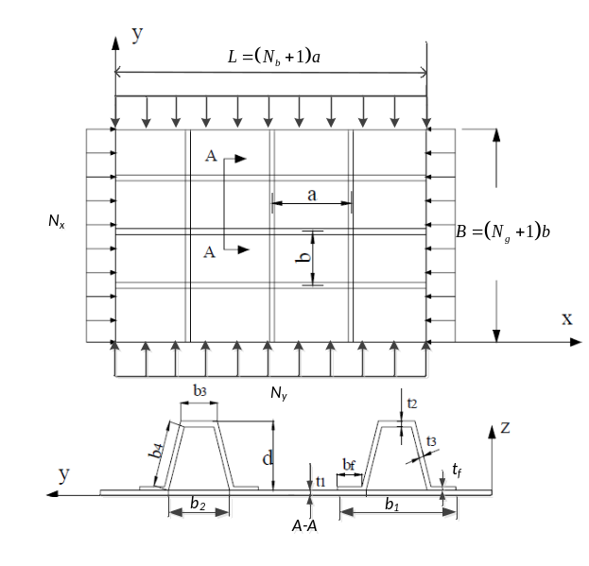 Fig. 1. Tophat stiffened panel configuration

2.2 Energy based grillage method
In this section, an energy based grillage analytical method is generated and applied to reduce the computational cost for buckling constrains during the optimization procedure. The plate is compressed by an in-plane load resultant of 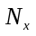and 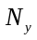in the x and y direction respectively. The deflection,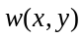, at any point of the grillage is expressed by the following double summation of trigonometric series to Navier’s energy method [11]:

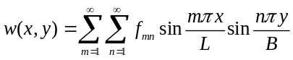, (6)

where m and n represent half-range sine expansions in the x and y directions, respectively. The potential energy, V, in a deflected grillage can be written as

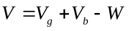, (7)

where 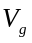 and 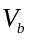 are the strain energies in the girders and beams respectively, which can be represented as:

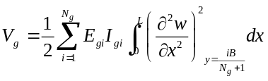. (8)

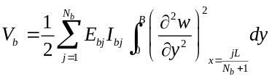. (9)

The work done  due to the bidirectional in-plane load, and, can be written as

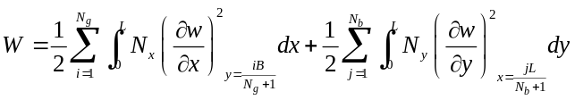(10)

By using the energy method in structural analysis the maximum buckling load (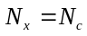, 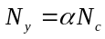) is often approximated using energy conservation

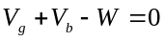. (11)

Substituting Eq. 8, Eq. 9 and Eq. 10 into Eq. 11, allows the numerical critical buckling load to be obtained

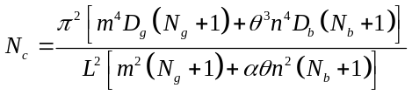, (12)

where 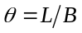 and 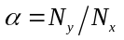 are the plate aspect ratio and the in-plane loading ratio, respectively; 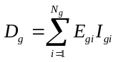 and 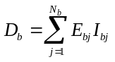 are the flexural rigidity of the girder and beam, respectively.

2.3 Reliability method
The reliability of a structure is defined as the probability that the structure will perform its intended function without failing. Defining a performance function, 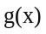, as the difference between structural “capacity” and “demand”, then the failure probability, 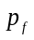, is defined as

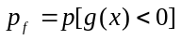. (13)

In engineering practice, when has a Normal distribution, the safety index β, has a one to one correspondence with , given by

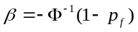. (14)

Sensitivity factor is generally considered as a measure of the sensitivity of the reliability index β with respect to the standard normal variable 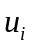. It provides some insight into the relative weight that each one has in determining the final reliability of the structures.

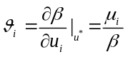. (15)

The deflection limit state function is defined as a function of the random variables,

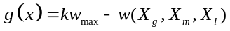, (16)

where  is the maximum displacement using the mean values of the design parameters; is the safety factor; 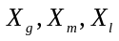 represent the geometry, material and loading properties.

3 Reliability based optimization

3.1 Optimization problem formulation
The design optimization problem considered in this research is that of the weight minimization of the tophat stiffened plate presented in Fig. 1. The Reliability based optimization (RBO) problem can be described mathematically as a search for the optimum values of design variables that would minimize panel weight subject to constraints on reliability and buckling, and is formulated as

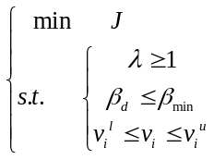, (17)

where the objective function J is the structural weight; is the buckling load ratio against the reference load; 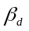 is the calculated reliability index in the stiffened panel; 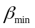is the minimum acceptable reliability index; 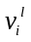and 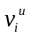are the lower and upper bounds of the design variables, respectively. The total weight of the structure is calculated simply from the dimensions of the stiffened panel:

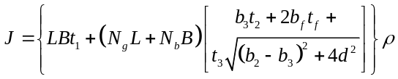, (18)

where B and L are the length and width dimensions of the base plate; a and b are the spans between transverse and longitudinal frames respectively; b₁ is the total width of the tophat stiffener; b₂ is the hat’s lower end width; b₃ is the hat’s upper end width; t₁, t₂, t₃ and t_{f} are the thickness parameters of the base plate and the stiffeners respectively; d is the stiffener height; is the equivalent density of the stiffened panel.

3.2 Optimization procedure
Based on the computational framework given by Awad et al. [29] and laminate design rules given by Niu [30] and replicated in Appendix B, an integrated optimization procedure using a bi-level optimization programming scheme is developed to manage the interactions between optimization directed buckling and probabilistic constrains. Optimization at the panel level finds optimum geometry parameters given minimum mass of tophat stiffened composite panels subject to structural buckling constraints. Laminate level optimization finds the optimum stacking sequences for maximizing the buckling factor satisfying reliability constraints. The flowchart of the general optimization procedure is given in Fig. 2.

- Analytical modeling
The simplified grillage based method, as shown in section 2.2, is applied for the buckling analysis of the stiffened composite panel during the bi-level optimization procedure.

- Numerical modeling
FE method was employed to simulate the FRP composite element. The major part of the simulation is to select the most appropriate material model and element type. A review of the available design standards, design guides, and previous structural data provided the inputs. This helped to identify the most suitable and critical design constraints. This model is compared to the analytical model to ensure the accuracy of the final optimized panel.

- Design constraints
Three kinds of constraints are mainly considered in the bi-level optimization process:
- Composite Design Rules: the composite design rules given by Niu [30] are applied for the laminate level optimization, the details of which have been replicated in Appendix B.
- Material / structural strength and buckling constraints: the values of these constraints are based on both tests and numerical data, and are taken into account for both the laminate level and panel level.
- Reliability / safety constraints: a reliability index method is applied for such constraints. Each design variable is defined by the mean value, coefficient of variation (COV) and distribution type. The reliability index of the structure is calculated based on the formulation of the statistical data on all random variables and the limit state function for deflection. Furthermore, a sensitivity analysis is implemented based on both the mean value and COV during the optimization history.

- Panel level optimization
The optimization problem at the panel level is formulated as finding the optimum geometry parameters of the tophat stiffened panel for a minimum mass subject to structural buckling constrains. The equivalent orthotropic properties E_{x}, E_{x}, v_{xy} and G_{xy} are selected from laminates that satisfy design rules. These properties are then used in the VICONOPT model [21] for gradient optimization. The geometry parameters of both base plate and stiffeners are initialized as the panel level optimization variables. The density of the stiffened panel is taken as constant here as it will be determined by the laminate level optimization. The design variables are set by the analyses at the start of the first optimization cycle. Each variable can be incremented up to 10 percent of their staring values in the subsequent cycles. The true objective function of the optimization problem (17) is simple and easily calculated when all dimensions of the stiffened panel are given. The buckling constrains, however, demand a large computational cost as it requires FEM analysis at each iteration step. Therefore, the simplified grillage method proposed in section 2.2 is used to reduce the computational cost for the buckling constrains during the optimization procedure.

- Laminate level optimization:
The optimization problem at the laminate level is formulated as finding the stacking sequences of the skin and stiffener laminates to maximize the buckling factor with reliability constraints and laminate design rules. Laminate level optimization starts with the geometric parameters obtained from the panel level. Additionally, the total number of layers depends on the ply thickness of the laminates. These values equal, to the nearest integer, the panel thickness divided by the ply thickness. The stacking sequences of the laminates are selected using a genetic algorithm (GA), which is well recognized as a global optimization tool in literature including studies by Maneepan et al. [6]. A reliability index method, the detail of which can be found in section 2.3, is applied for the reliability constraint in this level.

- Outputs:
We can get the following outputs as described in Fig. 2 from the optimization procedure:
- Values of design variables
- Objective value
- Constraints variations
- Relation between constraints and design variables
- Convergence checking:
The optimum solution is found when changes in objective function are less than 10e-3. Otherwise, the process is repeated until convergence is reached.
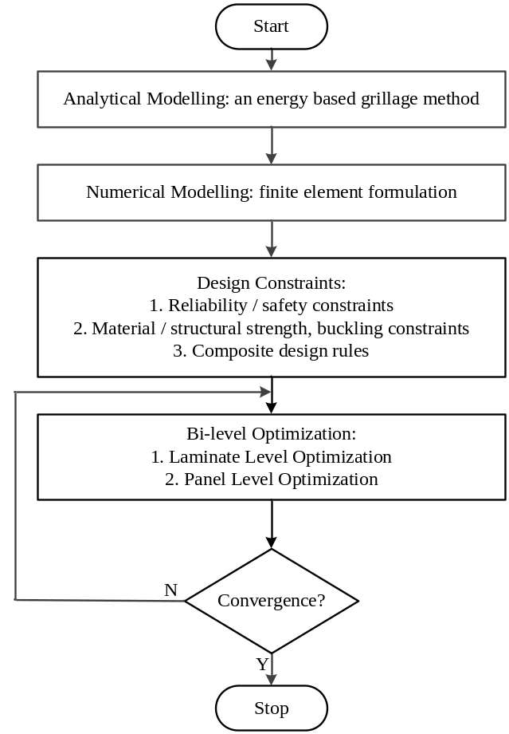Fig. 2. Flow chart of the optimization procedure

4 Results and discussions
In order to have confidence for the integrated optimization scheme described in section 3, the design of a stiffened composite panel under bi-directional compressive loads for ship structures is applied. The panel with rectangular tophat-sections consisting of webs, crown and base plate as shown in Fig. 1 has been selected from the hull bottom of a typical ship structures. Mechanical properties for a unidirectional layer are dependent on lay-up and fibre-volume fraction and calculated from Appendix C. The material properties of E-Glass and Epoxy are listed in Table 1.
Table 1 Material properties of resin and fibre [4]
 | Epoxy | E-glass
Young’s modulus (Gpa) | 3.0 | 72.0
Poisson’s ratio | 0.37 | 0.20
Shear modulus (Gpa) | 1.09 | 30
Tensile strength (MPa) | 85 | 2400
Compressive strength (MPa) | 130 | -
Tensile failure strain (%) | 5.0 | 3.0

4.1 Comparisons between Grillage and FE methods
In order to have confidence in the simplified analysis method described in section 2.2, verifications against results obtained with more accurate analysis tools are necessary. For this purpose, ultimate buckling load of stiffened composite panel subjected to bi-directional compression loads were carried out using the commercially available finite element program ANSYS 12.0, shown in Figure 3. The shell element SHELL181 is used with a mesh density set to provide an element aspect ratio close to 1.0. The layers of the tophat stiffener are modeled using an element per ply in the through-thickness direction. Uniform compressive loads were applied at the nodes at both the longitudinal and transverse panel ends.
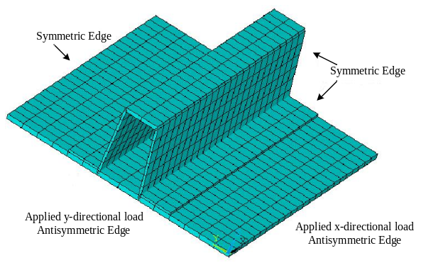
Fig. 3. Finite element model of tophat stiffened panel

The load ratio is compared with different plate dimension ratios for a range of 0, 0.5, 0.75, 1.0, 1.5 and 2.0 considered in this study, and the numerical results are compared with the analytical method summarized in Tab. 2. It is noticed that good agreement between the simplified method and finite element simulations was found when the model had a dimension ratio smaller than 1.0. However, the disagreement becomes more remarkable as the dimension ratio increases. It is also noted that the relative errors for lower load ratios are smaller than higher load ratios. This can be explained through the limits of the grillage method. The grillage method considers the strains in the girders and beams separately. As the load ratio is higher the coupling effect is larger and the errors increase. Thirdly, we can also see that the predicted values, from the simplified analysis, are slightly higher than the values obtained from FE analysis, in most cases. For the case of a panel of dimension ratio equals to 2.0 and load ratio equals to 1.0, the local buckling becomes the dominant mode. The occurrence of local buckling, which results in further reduction of the flexural rigidity of the panel, is not considered in the simplified method.
It was determined from these results that the grillage method had an acceptable level of accuracy to be used within the analysis though final results should be checked against FEA to ensure the resulting optimized panel did not fail.

Table 2 Comparisons of critical buckling load with different load ratio and different plate aspect ratio
Dimension  ratio, | Load ratio, | FE result (Mpa) | Grillage method (Mpa) | Relative  Error (%)
0.5 | 0 | 5.32 | 5.11 | 4.11
0.5 | 0.5 | 17.35 | 16.79 | 3.34
0.5 | 0.75 | 11.44 | 10.95 | 4.47
0.5 | 1 | 4.95 | 4.58 | 8.08
1.0 | 0 | 6.59 | 6.42 | 2.65
1.0 | 0.5 | 7.02 | 6.53 | 7.50
1.0 | 0.75 | 6.77 | 6.21 | 9.18
1.0 | 1 | 5.91 | 5.37 | 10.06
1.5 | 0 | 11.46 | 11.07 | 3.52
1.5 | 0.5 | 10.62 | 10.10 | 5.15
1.5 | 1.0 | 8.13 | 7.27 | 11.83
2.0 | 0 | 16.68 | 15.20 | 9.73
2.0 | 0.5 | 17.56 | 15.21 | 15.45
2.0 | 1 | 14.85 | 12.33 | 20.44

4.2 Sensitivity analysis
For simplicity, all the design variables are assumed as independent variables and they are randomly generated according to their assumed probability distribution as shown in Table 3.

Table 3 Statics for random variable
Symbol | Mean value | C.O.V  % | Distribution
L | 3810 | 3 | Normal
B | 3810 | 3 | Normal
t₁ | 12.7 | 3 | Normal
b₂ | 108 | 3 | Normal
b₃ | 92 | 3 | Normal
b_{f} | 54 | 3 | Normal
t₂ | 8.6 | 3 | Normal
t₃ | 4.0 | 3 | Normal
d | 132 | 3 | Normal
E_{f} | 826 GPa | 5 | Normal
E_{m} | 3.0 GPa | 5 | Normal
G_{f} | 413 GPa | 5 | Normal
G_{m} | 1.09 GPa | 5 | Normal
V_{f} | 0.6 | 5 | Normal
N_{x} | 0.5N_{c} | 15 | Weibull
N_{y} | 0.5αN_{c} | 15 | Weibull
k | 1.0 | 10 | Normal

The dominant variables in the limit state equation on the reliability of the composite stiffened panel can be seen in Fig. 4. It can be observed that the importance of the dominant variables, by order, is the safety factor k, in-plane load N_{x} and N_{y}, plate dimension L and B, fibre volume V_{f}, and so forth. Other variables that play relative small roles in contributing to the probability of failure can be replaced by deterministic values in the structural optimization procedure.

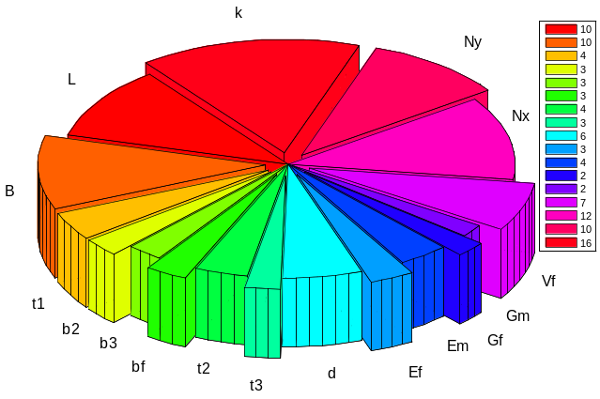
Fig. 4. Sensitivity factors of dominant variables

Reliability based method shows that not only the mean value but also COV play a significant role in the procedure of structural optimization. Therefore, it is necessary to study the effects of the statistical distribution of the dominant variables with larger sensitivity factors. The results are computed by varying each of the parameters in turn with other variables held the same as previous analysis. Fig. 5 shows the result of the safety factor of the deflection limit state function k, the x directional load N_{x}, and the fibre volume V_{f}. It is evident that the reliability indices are strongly dependent on the variation of V_{f}. The safety factor of k and the x-directional load N_{x} are also exhibit a strong influence on the safety index. The optimization can therefore be made more efficient by taking these variations into account.

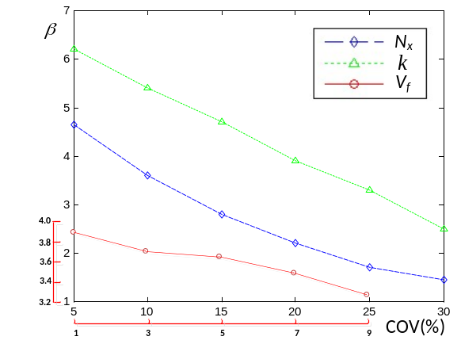
Fig. 5 Influence of COV of k, N_{x}, V_{f} on reliability,

4.3 Parametric study
In this section we focus on the interaction effects between the plate aspect ratio and in-plane loading ratio on the critical buckling load, which haven’t been studied in the published literature, but are necessary for the marine application.
The effects of plate aspect ratio and in-plane load ratio on the critical buckling load are investigated separately. Fig. 6 describes how the plate aspect ratio, , contributes to the optimum buckling load at a prescribed load ratio, . It can be observed that has different effects on the buckling load for different values of . In the case of 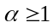, the value of 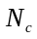 increases when 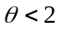; In the case of 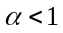, the value of decreases dramatically when 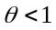, and increases when 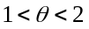. However, in both cases above, the value of remains almost unchanged for different values of . It is because N_{y} plays a dominant role in the buckling failure when ; while N_{x} becomes the dominant factor for the buckling failure mode when .

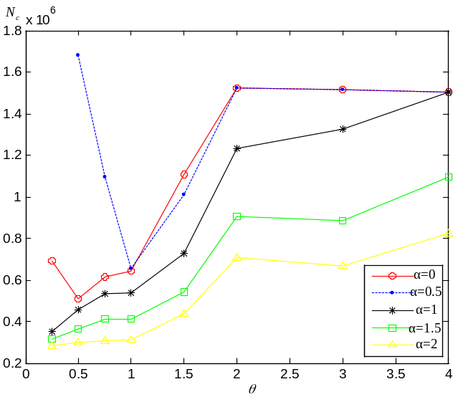
Fig. 6 Optimum buckling load with aspect ratio,

Fig. 7 describes how the in-plane load ratio contributes to the optimum buckling load at a prescribed plate aspect ratio. It can be observed that the critical load decreases with increasing for most cases. This is because is in the denominator position in the analytical model as shown in Eq. (12). It is also noticed that the wave shape alters dramatically for different plate aspect ratio , especially for the case =0.5. This is due to the changes in the buckling mode shape because of the stiffeners geometry and rigidity.

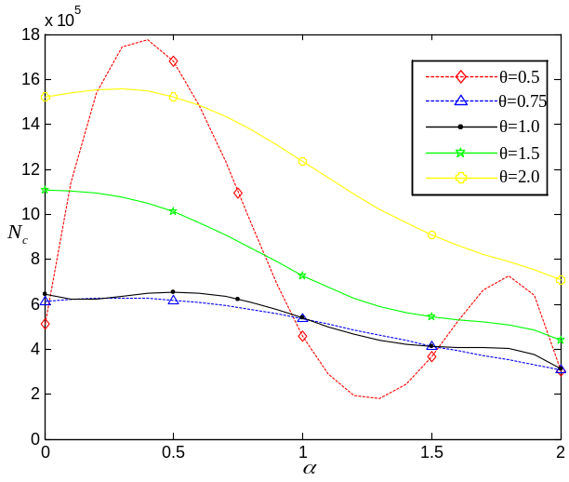
Fig. 7 Optimum buckling load with load ratio,

Fig. 8 shows the 3-d coupling effect of and on the buckling load. It can be observed that the peak value of the critical buckling load appears neither in the boundary of the plate dimension ratio nor in the boundary of the plate dimension ratio, but it appears in a coupling position of and . Therefore, it is quite necessary to take these coupling effects into consideration for the optimization design of such composite stiffened structures.

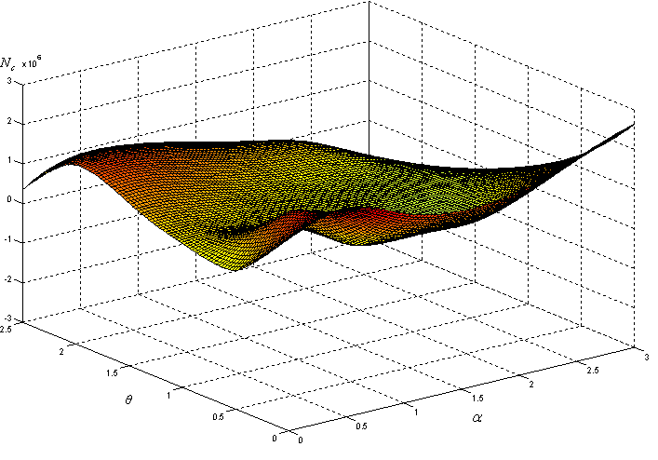
Fig. 8 Coupling effects on between and

5 Conclusions

Composite design, manufacture and processing have many random variables that should be addressed when considering the structural performance. Modern design approaches consider structural reliability as one of the essential criteria to be satisfied for structural integrity, which allow the engineer to reduce the probability of failure and lead to a balanced design.
In this paper, a bi-level optimization scheme is developed and applied to minimize the weight of tophat stiffened composite panels with both buckling and reliability constraints. The strategy not only designs stiffened composite panels efficiently by combining macro- (panel level) and micro- (laminate level) optimization but also takes into account practical design and reliability constraints. An energy based grillage analytical method is generated and applied to reduce the computational cost for buckling constrains during the optimization procedure. Such approximate formulation is validated by comparing the results from FE calculations. A reliability index method, giving good agreement with Lloyds Register Rules for Special Service Craft, has been validated [25], and can be applied to the reliability constraints during the optimization procedure.
With the method presented in this paper, further developments are now possible for engineers to improve their designs with an integrated consideration between product performance and design parameters.

References
- C. Ray, S.K. Satsangi SK. Laminated stiffened plate - a first ply failure analysis[J]. Journal of Reinforced Plastics and Composites, 1999, 18 (12).
- B. G. Prusty, C. Ray and S. K. Satsangi. “First ply failure analysis of stiffened panels - a finite element approach”. Composite Structures, vol. 51, no. 1, pp. 73-81, 2001.
- Y. V. Satish Kumar and Anand Srivastava. “First ply failure analysis of laminated stiffened plates”. Composite Structures, vol. 60, no. 3, pp. 307-315, 2003.
- C. S. Smith. “Design of marine structures in composite materials”. London, 1990.
- Maneepan K. “Genetic algorithm based optimization of FRP composite plates in ship structures”. Doctor of Philosophy, University of Southampton.
- Maneepan K, R.A. Shenoi, J.I.R. Blake, H.K. Jeong. “Genetic algorithms (GAs) based optimization of FRP composite plated grillages in ship structures”. Transactions of the Royal Institution of Naval Architects Part A: International Journal of Maritime Engineering, vol. 149, no. 3, pp. 1-19, 2007.
- Maneepan K, R.A. Shenoi, J.I.R. Blake, H.K. Jeong. “Multi-objective optimization of orthogonally tophat-stiffened composite laminated plates”. OMAE, 2006.
- Eksik, Ömer, Shenoi, R. Ajit, Moy, Stuart S.J. and Jeong, Han Koo. Finite element analysis of top hat stiffened panels of FRP boat structures. Marine Technology, vol. 44, no. 1, pp. 16-26, 2007.
- Ömer Eksik, R. A. Shenoi, Stuart S.J. Moy, and Han Koo Jeong. Experiments on top hat stiffened panels of FRP boat structures. Marine Technology, vol. 44, no. 1, pp. 1-15, 2007.
- Raju, B.G. Prusty, D.W. Kelly, D. Lyons, G.D. Peng. “Top hat stiffeners: A study on keel failures”. Ocean Engineering, vol. 37, pp. 1180-1192, 2010.
- O.K. Bedair. “Analysis of stiffened plates under lateral loading using sequential quadratic programming (SQP)”. Computer & Structures, vol. 62, no. 63, 1997.
- M. Miki. “Design of Laminated Fibrous Composite Plates with Required Flexural Stiffness”. American Society for Testing and Materials Special Technical Publication, vol. 864, pp. 387–400, 1985.
- H. Fukunaga and T. W. Chou, “Simplified Design Techniques for Laminated Cylindrical Pressure Vessels under Stiffness and Strength Constraints”. Journal of Composite Materials, Vol. 22, No. 12, pp. 1156-1169, 1988.
- Giles GL, Anderson MS. “Effects of eccentricities and lateral pressure on the design of stiffened compression panels”. NASA Langley, Hampton, VA, 1972.
- Todoroki, A., and Terada, Y., “Improved Fractal Branch and Bound Method for Stacking Sequence Optimizations of Laminated Composite Stiffener”. AIAA Journal, Vol. 42, No. 1, pp. 141-148, 2004.
- Todoroki, A., and Terada, Y. “Modified Efficient Global Optimization for a Hat-Stiffened Composite Panel with Buckling Constraint”. AIAA Journal, vol. 46, no. 9, pp. 141-148, 2008.
- Eyassu Wodesenbet, Samuel Kidane, Su-Seng Pang. “Optimization for buckling loads of grid stiffened composite panels”. Computers Structures, vol. 60, pp. 150-169, 2003.
- A. Sobey, J.I.R. Blake and R.A. Shenoi. “Optimization of FRP structures for marine vessel design and production”. OMAE, 2009.
- A. Sobey, J.I.R. Blake and R.A. Shenoi. “Optimisation approaches to design synthesis of marine composite structures”. Schiffsteknik, vol. 56, no. 1, pp. 24-30, 2007.
- A. Sobey. “Concurrent Engineering in the context of the composite leisure boatbuilding industry”. Doctor of Philosophy, University of Southampton.
- Wenli Liu, Richard Butler, H. Alicia Kim. “Optimization of composite stiffened panels subject to compression and lateral pressure using a bi-level approach”. Structural and Multidisciplinary Optimization, vol. 36 no. 3, pp. 235-245, 2008.
- Ziad K. Awad, Thiru Aravinthan, Yan Zhuge, Felipe Gonzalez. “A review of optimization techniques used in the design of fibre composite structures for civil engineering applications”. Materials and Design, 2011.
- Michel D. Thompson, Christopher D. Eamon and Masoud Rais-Rohani. “Reliability-based optimization of fiber-reinforced polymer composite bridge deck panels”. Journal of structural engineering, 2006.
- P.K. Das, Vedran Zanic, Douglas. “Reliability-based design procedure of stiffened cylinder using multiple criteria optimization techniques”. Proceedings of the Annual Offshore Technology Conference, 1993.
- R.A. Shenoi, P. Das, A.K. Nayak and J.I.R. Blake. “Safe design of a composite structure – A stochastic approach”. University of Southampton, 2006.
- N. Yang, P. K. Das, XL. Yao. “Reliability Analysis of stiffened composite panel”. 4th International ASRANet Colloquium, Athens, 2008.
- J.I.R. Black, R.A. Shenoi, et al. “The application of Reliability methods in the design of stiffened FRP composite panels for Marine vessels”. Journal of Ships and Offshore Structures, Vol. 4, No. 3, pp. 287-297, 2009.
- Datoo M.H. “Mechanics of fibrous composites”. Elsevier science publishers Ltd, 1991.
- Ziad K. Awad, Thiru Aravinthan, Yan Zhuge and Felipe Gonzalez. “A review of optimization techniques used in the design of fibre composite structures for civil engineering applications”. Materials and Design, 2011. doi:10.1016/j.matdes.2011.04.061
- Niu MCY. “Composite airframe structures: practical design information and data”. Conmilit, Hong Kong, 1992.

Appendix A: Nomenclature
Length of stiffened panel;
Width of stiffened panel;
Plate aspect ratio;
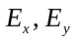 Membrane equivalent moduli of laminate in x-direction and y-direction, respectively;
The fibre angle measured from the stress axes to the material axis in an anti-clockwise direction;
Extensional stiffness;
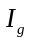 Moment of inertia of girder
Moment of inertia of beam;
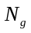 Number of longitudinal girders;
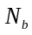 Number of transverse beams;
Uniform load in x direction;
Uniform load in y direction;
In-plane loading ratio;
The safety index;
Deflection of plate;
Elastic strain energy of the girders;
Elastic strain energy of the beams;
The work done due to external load.

Appendix B: Laminate design rules
- The thickness percentage of each orientation is controlled with respect to the total laminate thickness. For example, it is required that each laminate contains at least 10% of each orientation. This constraint ensures that laminates have sufficient damage tolerance, aeroelastic stiffness, bolted joint strength, and the capability to carry secondary loads. This rule is simplified by giving percentage targets for each orientation. For example, the target for the 0°, ±45°, and 90° materials in the skin laminate might be 44, 44, and 12% and in the stiffener laminate might be 60, 30, and 10%, respectively.
- The maximum number of successive plies in any orientation is limited. For example, it may be decided that four consecutive ply layers with the same orientation is acceptable, but five are not. This constraint is applied to reduce transverse shear stress and minimize edge splitting.
- The outer plies of the skin and stiffener laminates are forced to be ±45° plies. This constraint is to improve damage tolerance after impact.

Appendix C: Elastic properties of laminates
Longitudinal properties
The longitudinal properties are those in the fibre direction, i.e. E₁ and ν₁₂. It is assumed that ε₁ = ε_{f} = ε_{m}, the fibre can be anisotropic and the resin is isotropic, so that a standard rule of mixtures can be applied:
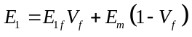, (B.1)
where 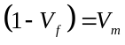.
Likewise the major Poisson’s ratio can be expressed as follows:
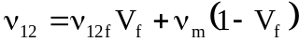. (B.2)
Transverse properties
In the transverse direction the fibre and the matrix are assumed to be subjected to a uniform stress, i.e. σ₂ = σ_{f} = σ_{m}, to give:
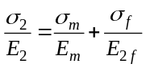. (B.3)
Making σ₂ = σ_{f} = σ_{m} = 1 and introducing the volume fractions results in:
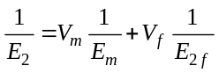. (B.4)
or
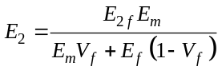. (B.5)
It should be considered that in the transverse orientation a large constraint is provided by the 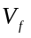 being much smaller to 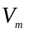. This is accounted for by a correction factor as follows:
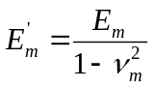. (B.6)
Substituting equation (6) into equation (5) gives:
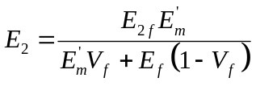. (B.7)
The minor Poisson’s ratio is calculated simply as follows:
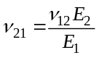. (B.8)
The in-plane shear modulus, G₁₂, is obtained in an identical fashion to 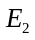 , i.e.
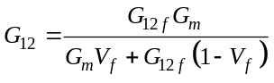. (B.9)

* Corresponding author. E-mail: xuexiaoguang1985@gmail.com

