Supplementary Appendix

**A familial disorder of altered DNA-methylation**

Almuth Caliebe,1 Julia Richter,1 Ole Ammerpohl,1 Deniz Kanber,2 Jasmin Beygo,2 Susanne Bens,1 Andrea Haake,1 Eva Jüttner,3 Bernhard Korn,4 Deborah Mackay,5 José I. Martín-Subero,1 Inga Nagel,1 Neil Sebire,6 Larissa Seidmann,7 Inga Vater,1 Constantin Sylvius von Kaisenberg,8,9 I Karen Temple,5 Bernhard Horsthemke,2 Karin Buiting,2 and Reiner Siebert1

A.C., J.R., O.A. and D.K. contributed equally to this work

K.B. and R.S. share senior authorship

Corresponding author:Dr. med. Almuth Caliebe,

Institute of Human Genetics

Christian-Albrechts-University Kiel & University Hospital Schleswig-Holstein, Campus Kiel

Arnold-Heller-Strasse 3, Building 10 (Schwanenweg 24), D-24105 Kiel, Germany

Phone: ++49 431 597-1776; FAX: ++49 431 597-1841

E-mail: caliebe@medgen.uni-kiel.de

Contents

|  |  |  |
| --- | --- | --- |
| I. | Supplementary Methods | page 2 |
| II. | Supplementary Results | page 11 |
| III. | Supplementary Tables | page 13 |
| IV. | Supplementary Figures | page 22 |
| V. | Supplementary References | page 28 |

**I. Supplementary Methods**

1. **Sample preparation**

DNA extraction was performed using standard methods. Total RNA was purified from EDTA blood using Qiagen´s RNeasy Kit and QIAshredder (Qiagen, Hilden, Germany) according to manufacturer´s protocol. Different tissues of a total of 9 family members were analysed by various chromosomal, genomic, and epigenomic methods (see Table S2). In addition according to used methods different sets of controls, e.g. tissue matched controls for DNA-methylation arrays were investigated.

Array based DNA-methylation analysis was applied to the samples presented in the following table.

|  |  |
| --- | --- |
| **patient / sample** | **controls** |
| III-1 muscle | muscle (fetal), n=2 |
| III-2 fibroblasts | fibroblasts, scrotal, n=16 |
| III-2 lymphoblastoid cell line | lymphoblastoid cell line, n=2 |
| III-2 peripheral blood | peripheral blood, adults, not related to patients, n=20  peripheral blood, father  peripheral blood, mother |
| III-3 lung | lung (fetal), n=1 |
| III-3 liver | liver (fetal), n=1 |
| III-3 muscle | muscle (fetal), n=2 |

DNA isolated from fetal control tissue samples (muscle, lung, liver) was obtained from BioCat GmbH (Heidelberg, Germany). DNA isolated from primary scrotal fibroblast tissue culture was provided by P.M. Holterhus (University Medical Center Schleswig-Holstein, Kiel, Germany). Peripheral blood controls were derived from adult healthy donors (10 male, 10 female).

1. **Cytogenetics and Fluorescence in situ hybridisation (FISH)**

Chromosome analyses were performed using standard GTG- and Q-banding techniques(1). FISH was performed according to standard protocols on interphase cells using alpha satellite probes for chromosomes X, Y, and 18 (CEP X, CEP Y, CEP 18), and single locus probes for chromosomes 13 and 21 (LSI 13, LSI 21) (all probes Abbott/Vysis, Downers Grove, IL).

1. **Microsatellite analysis**

Microsatellite analyses were performed according to standard protocols. Briefly, PCR products were amplified using the AmpliTaq Gold DNA Polymerase (Applied Biosystems). After agarose gel electrophoresis, HiDi formamide and 500 ROX size standard were added to the PCR products. Following denaturation, samples were separated on the ABI 3100 Avant Genetic Analyzer and analysed using the Gene Mapper software.

Primer sequences used for microsatellite analysis:

|  |  |  |
| --- | --- | --- |
| **microsatellite** | **orientation** | **5´-3´sequence** |
| D19S927 | forward | tgcaatcaaagtttaggctg |
| D19S927 | reverse | tgtgtgccaccatacctg |
| D19S926 | forward | tctggtgagaattcctaagtagttc |
| D19S926 | reverse | ggccttatgcgtgagtagtt |
| D19S418 | forward | accaggcatccagtgttt |
| D19S418 | reverse | caactatcccgcctttgt |

1. **Genomic Array analysis (Array-CGH, Custom Tiling Array-CGH, GeneChips)**

Array CGH was performed applying the Human Genome Microarray 244K and 105K platform (Agilent, Santa Clara, USA). The experimental procedures were performed according to the protocols provided by the manufacturers. For DNA labelling and clean up the Bio Prime Array-CGH Genomic Labeling Kit and Microcon YM-30 filters were used. Arrays were scanned with the GenePix4000B Scanner (Axon Instruments) and log ratios were obtained with the comparative genomic hybridisation (CGH) Analytics Version 3.5.14 software (Agilent).

Customized 4x44k Tilling arrays (Agilent) of all *NLRP* genes (hg18: *NLRP1* chr17:5340443-5433556; *NLRP3* chr1:245641098-245684029; *NLRP4, NLRP9, NLRP11, NLRP13, NLRP8* and *NLRP5* chr19:60906610-61269986; *NLRP6* chr11:263570-280304; *NLRP10* chr11:7932732-7946635, *NLRP12* chr19:58983667-59024460; *NLRP14* chr11:6993276-7054333; *NLRP2* and *NLRP7* chr19:60120428-60210000) were designed using Agilent´s eArray software. High definition (HD) and Tiling probes (average probe spacing 30nt) were generated for all regions. Array design was filled up with randomly selected oligos from the 44K Agilent Microarray that were scattered over the whole genome. Experimental procedures were performed according to manufacturer´s protocols with DNA from a normal placenta of a male fetus as reference DNA.

The GeneChip Human Mapping 50K XbaI array and the Genome-Wide Human SNP Array 6.0 (Affymetrix, Santa Clara, CA, USA) were used according to the protocols provided by the manufacturer (Affymetrix, Santa Clara, CA) and as described by Schwindt et al.,(2). Copy number and loss of heterozygosity (LOH) analyses of the 50K XbaI array was performed using the Chromosome Copy Number Analysis Tool (version 2.0.0.9, Affymetrix) applying a 0.5 Mb genome smoothing filter. For the SNP Array 6.0 copy number, LOH analyses and segmentation was calculated using Genotyping Console software version 3.0 (Affymetrix, Santa Clara, CA). Segments with aberrant copy number were considered as copy number aberration only if they consisted of at least 20 consecutive SNPs and comprised a minimal size of 100 kb.

1. **Sanger Sequencing**

Mutation analysis by Sanger sequencing was performed using standard protocols with primers, PCR reagents and annealing temperatures as shown in the list below. Sequencing was performed using ABI 3100 and ABI 310 automatic capillary genetic analyser. The coding regions of *NLRP2* (NM_001174081)*, NLRP7* (NM_001127255) and *KHDC3L* (NM_001017361)were investigated in the mother (II-4). Individuals I‑3, I-4, II-2, II-3, II-5 and III-1, III-2, III-3 were only investigated concerning the familial *NLRP7* mutation. The *DNMT1o* specific regions(3) were analysed in the parents (individuals II-3 and II-4) and individuals III-1 and III-2. Therefore, in an initial PCR with primers DNMT1o1.2_2FP and DNMT1o2_5RP the *DNMT1o* specific region (NM_001130823) was amplified and cloned in a TOPO TA pCR2.1 vector (Invitrogen, Darmstadt, Germany). *ZFP57* (NM_001109809) mutation analysis of individual III-2 on DNA isolated from peripheral blood was performed according to standard protocols.

Primer sequences and conditions used for *NLRP7* Sanger Sequencing (some of the primers were published by Qian et al.,(4):

|  |  |  |  |  |  |
| --- | --- | --- | --- | --- | --- |
| gene | Name | sequence (5´-3´) | Polymerase  /kit | annealing temperature (°C) | note |
| *NLRP7* | NLRP7_1FP | gcccaattacagccaaatccctgag | GoldStar | 65 | Qian et al., 2007 |
| NLRP7_1RP | ggccgaggcagacagattacctaaa |
| NLRP7_2FP | accgtgctgggccagattttcagt | 68 |
| NLRP7_2RP | caccttgcatgctctcaaacacca | own primer |
| NLRP7_3FP | ccaccatgcctggctgacactttat | 68 | Qian et al., 2007 |
| NLRP7_3RP | gcagaggttgcaatgagcagagacg |
| NLRP7_4.1FP | gtagtggctccgtctctgctcattg | 65 |
| NLRP7_4.1RP | aggccatcgaccacgaacaggattc |
| NLRP7_4.2FP | gacgacgtcactctgagaaaccaac | 65 |
| NLRP7_4.2RP | tgcagaggaaacgcaggaacagc |
| NLRP7_4.3FP | ccagaacacccaggaagcta | AccuPrime | 65 | own primer |
| NLRP7_4.3RP | ctgccctgggtaacatcttc |
| NLRP7_4.4FP | atctccaaagactggcctga | 65 |
| NLRP7_4.4RP | gcgttgctcctcattagctc |
| NLRP7_4.5FP | ctggggagtttgctgaagag | 65 |
| NLRP7_4.5RP | cagaggaaacgcaggaacag |
| NLRP7_4.6FP | atgcgtgcctttgagctaat | 65 |
| NLRP7_4.6RP | gaaactgctggaagctgagg |
| NLRP7_4.7FP | ctgttcctgcgtttcctctg | 65 |
| NLRP7_4.7RP | cgaggccgaataagaagtgt |
| NLRP7_4.8FP | ctacgccctggagaaggag | 60 |
| NLRP7_4.8RP | gctgaaggaacaatgcatca |
| NRLP7_4.9FP | atgtcaccggacatcaaaca | 65 |
| NLRP7_4.9RP | gccagagggaaattctgaca |
| NLRP7_4.10FP | accgacctgaaggaggtctt | 65 |
| NLRP7_4.10RP | cccaattcctaattgccaag |
| NLRP7_5FP | ggtctcagtttctagcccaagtt | GoldStar | 65 | Qian et al., 2007 |
| NLRP7_5RP | acacggtgaaaacctgtctatgc |
| NLRP7_5S | caagaagcttagtcatcgtt | sequencing |  |
| NLRP7_6FP | ccactgcacccggccaagaactt | GoldStar | 65 |
| NLRP7_6RP | gctgggggccactgcyatcaatc |
| NLRP7_6S | atacatgcctccacacaatgtgag | sequencing |  |
| NLRP7_7FP | gatcacgcctttgcattccagactg | GoldStar | 65 |
| NLRP7_7RP | agcaggtgtttatttcagcaagagg |
| NLRP7_8FP | ctcttttgtggccatgatgactc | TD 65-60 | own primer |
| NLRP7_8RP | aacaagtactttcatgtctctcctgct |
| NLRP7_9FP | gaggctgaggcagaagaatcgcttga | AccuPrime | 65 | Qian et al., 2007 |
| NLRP7_9RP | aagccgcagtgagccgtaatcacc |
| NLRP7_10FP | ctaatctttgtatttttagtagagatggggtttgacc | GoldStar | 65 |
| NLRP7_10RP | ggacatgttggcatgcctctag |
| NLRP7_11FP | ctgtcccccagaaaatcccaaaaac | 65 |
| NLRP7_11RP | caacygaatcatccctgaacttc | adapted from Qian et al., 2007 |
| NLRP7_11S1 | agaatgaatttctgggaacatttgtgttctc | sequencing |  | Qian et al., 2007 |

Primer sequences and conditions used for Sanger Sequencing:

|  |  |  |  |  |  |
| --- | --- | --- | --- | --- | --- |
| *gene* | Name | forward sequence (5´-3´) | reverse sequence (5´-3´) | polymerase/kit | annealing temperature (°C) |
| *NLRP2* | NLRP2_1 | cggtggatacaggaagtgctc | ccaactgtggaatggagaaa | GoldStar | 60 |
| NLRP2_2 | tggcatttgagacaggagtg | gcctggccttctgaatttcta | 65 |
| NLRP2_3 | caagtgatccagttctaagtgtcatct | cggcatttctttgcattctt | 60 |
| NLRP2_4 | ggtccaacttgagccatct | ttggagagagatggggttctt | 60 |
| NLRP2_5 | catcagcctgcctcctttt | aaagagaaatctgatcccaagc | 60 |
| NLRP2_6a | tggttttccctatgggtaactg | cctctgcccagtctagcatt | 60 |
| NLRP2_6b | tgctgatcccattcagcaac | agccgtcaatcacgaacaa | 65 |
| NLRP2_6c | agaggacaacctcatccacaa | ccttatgtagatcggctcctc | 65 |
| NLRP2_6d | ggagtttgctgaacagggt | tttccagatcctctcggtgaag | 65 |
| NLRP2_6e | cggaggagccgatctaca | gtggccgtccctatcctctt | 65 |
| NLRP2_6f | cgtgcttcaccgagaggat | gttagcgaggccaaaggagt | 65 |
| NLRP2_6g | aggatagggacggccaca | caggtttcgacagtgcttgac | 65 |
| NLRP2_6h | ttgtaagggtggacattcaacg | ccctaagccacagtgcat | 65 |
| NLRP2_7 | ggtgctaataagtgattacatggtc | gaatctgaatattgctccgatg | 65 |
| NLRP2_8 | cccctggtttccatttaagta | aagcttgtggtagcttatgtttg | 65 |
| NLRP2_9 | aaaatgacgtggtcctatttctcc | tcagcgagaggttccataca | 60 |
| NLRP2_10 | gctggcacttgtggagcta | cctactcaaacccggaggtg | 60 |
| NLRP2_11 | cacggctcaagagtcaaagg | ggaagtcggcttcactgatt | 65 |
| NLRP2_12 | cagatccccaacacacgag | tcctacagcaggtccatgtc | 65 |
| NLRP2_13a | ggaacactcctttgccacct | gagtcacaggcagttcacca | 65 |
| NLRP2_13b | catccctgggcagaaagg | ccccaggttctacccagtaag | 65 |
| *DNMT1o* | DNMT1o_del | aacatttytcagggccaggt | aagtgatccactcgcctca | AccuPrime | 60 |
| DNMT1o1.2 | ccagggatggccagttgt | tgctcagtgaagggaggaat | GoldStar | 68 |
| DNMT1o1_1FP | acaccaccaggcttgactaa |  | used for sequencing |  |
| DNMT1o1_1RP | cctgacaaggttgacaatgc |
| DNMT1o1_2RP | gtccagcttccttcaagtgc |
| DNMT1o2_1RP | ggtagcaggagcgtggataa |
| DNMT1o2_2RP | tgggtgtatcacaggtcagg |
| DNMT1o2_3RP | acctgggagatggaggtagc |
| DNMT1o2_4RP | tagctgggttgctgttgttg |
| DNMT1o2_4FP | caacaacagcaacccagcta |
| DNMT1o2_3FP | gtgtaagccaccgcaccag |
| DNMT1o2_2FP | caaacgcttcggctagaaag |
| DNMT1o2_1FP | agcttgacccatcttccaga |
| *KHDC3L* | C6orf_1 | gaaataaggcccaggcaga | ggaacgcagccagaatatgt | AmpliTaq | 60 |
| C6orf_2 | accagtagccaatgccctct | gactgggagggcgagact | 60 |
| C6orf_3 | gcttgggtgactgtcctttt | gtttgtgtttgcaaccatgc | 60 |
| *ZFP57* | ZFP_E1 | atgggaagcttgaccttgg | agtcagaggagtggggacaa | AmpliTaq | 65 |
| ZFP_E2 | ggcattccctgaccaaataa | acctgcaggcaggagtatgt | 65 |
| ZFP_E2_r | ggtttgatgtggcttcctgt |  | used for sequencing |  |
| ZFP_E2_f | gaggagaatttggacagcaga |
| ZFP_E3 | ttctctgaatcttgagactggatg | tccagggaaaccagatgttc | AmpliTaq | 65 |
| ZFP_E4 | gtagcctgttgtccccatca | ccaggctggacagaggtaca | 65 |
| ZFP_E5a | gccaagcctctgttggagt | cttgtcacagagcgtgcaac | 65 |
| ZFP_E5b | aacagctgcagtcagtgtgg | gccataggaccctcagttct | 65 |
| ZFP_E5c | agacacccatcgccagaa | gtgggtctgctggtgtctg | 65 |
| ZFP_E5d | acagagccgcccaactact | cgcacctgtctccctctact | 65 |

The analysed region of *DNMT1o* by Sanger sequencing was published by Hayward et al.,(3) as the oocyte specific isoform(3) AccuPrime Polymerase System (Invitrogen, Darmstadt, Germany), GoldStar DNA Polymerase (Eurogentec, Köln, Germany).

1. **Expression analysis of *NLRP2* and *NLRP7***

To test whether the variant (c.2156C>T) and the wildtype *NLRP7* alleles were expressed, PCR using primers published by Kou et al.,(5) (see list below), cDNA from the mother and a control (MegaMan TM Human Transcriptome Library (Stratagene, La Jolla, Calif)), and AccuPrime polymerase (Invitrogen) was performed according to standard protocol. Monoallelic expression of *NLRP2*(6) (rs1043673) was verified on a coding SNP (exon3, rs2217659) which was identified by conventional sequencing in individual II-4 as heterozygous and in individual II-3 as homozygous. Expression analyses were done as described for *NLRP7* (for primers and conditions see list below).

Primer sequences and conditions used for RT-PCR:

|  |  |  |  |  |  |  |
| --- | --- | --- | --- | --- | --- | --- |
| **gene** | **Name** | **sequence (5´-3´)** | **polymerase/kit** | **Annealing temperature (°C)** | **product lenght (bp)** | **note** |
| *NLRP7* | NLRP7_4f | Ggccccgttcaaggaaatt | AccuPrime | 55 | 860 | PCR |
| NLRP7_8r | Caatcagggtaactcaagccctcaca |
| NLRP_7r | Ggaagtgttttgggcgtgtcatggt |  |  |  | sequencing |
| NLRP7_5f | Caacctcaagtttctggaagtgaa |  |  |  | sequencing |
| *NLRP2* | NLRP2_RT_2F | Caccacccattgtgacagc | AccuPrime | 60 |  | two PCR reactions |
| NLRP2_RT_4R | Gtggtcgttctttccgtgtt | 180 |
| NLRP2_RT_6R | Tcagccataacctggacctc | 400 |

1. **DNA-methylation analysis**

**MS-MLPA, MSP and SeQMA:** Methylation-specific multiplex ligation-dependent probe amplification (MS-MLPA) using the MS-MLPA SALSA kits ME028-A1 and ME030-B1 was performed according to manufacturer´s protocol (MRC Holland, Amsterdam, Netherlands). DNA used for methylation-specific PCR (MSP) and sequence-based quantitative methylation analysis (SeQMA) was bisulfite converted using a protocol described previously(7). SeQMA was performed as described by Kanber et al.,(7) (primers not published by Kanber et al., 2009a are shown in the list below) and MSP was performedas described previously(8-13).

Primer sequences used for SeQMA, MSP and bisulfite-sequencing

|  |  |  |  |
| --- | --- | --- | --- |
| **method** | **gene** | **Name** | **sequence (5´-3´)** |
| **SeQMA** | IG-DMR *DLK1-MEG3* | IG-DMR-Ftag | cttgcttcctggcacga-ggtttattgggttgggttttgttag |
| IG-DMR-RM13 | caggaaacagctatgacac-caattacaataccacaaaattac |
| **bisulfite-sequencing** | *KCNQ1OT1* | LIT1-Not1-Ftag | cttgcttcctggcacgag-tttataggtttttatatygagggtttatagtag |
| LIT1-Not1-RM13 | caggaaacagctatgac-aaataaacyraaaacacraaccaattctctac |
| *SNRPN* | BisSNRPNfw | tgtaaaacgacggccagtggagggagttgggatttttgtattg |
| BisSNRPNrev | caggaaacagctatgaccccccaaactatctcttaaaaaaaaccac |
| *RB1* | RB1-Ftag | cttgcttcctggcacgag-tatatttggatggtttttttagtgt |
| RB1-RM13 | caggaaacagctatgac-aaacctcaaatccaaaatcac |
| **MSP** | *IG-DMR DLK1-MEG3* | IG-DMR-MF | Ggtttgttaattgttagcgatttgttaattgc |
| IG-DMR-MR | aaaaccgaaaaacctaaaaaacg (5’fam) |
| IG-DMR-UF | Attgttagtgatttgttaattgtga |
| IG-DMR-UR | aaaaaaccaaaaaacctaaaaaacaa (5’fam) |

**Bisulfite-pyrosequencing (BS-PS):** DNA was converted using the EpiTect Bisulfite Conversion Kit (Qiagen) according to manufacturer´s instruction. BS-PS was performed as described recently(2) (PCR and sequencing primers, PCR reagents and annealing temperatures are shown in the list below). All assays were optimised and validated using commercially available completely methylated DNA (Millipore, Schwalbach, Germany) and pooled DNA isolated from peripheral blood of 10 healthy male and female controls, respectively.

To define the “normal” range of DNA-methylation of imprinted genes we analysed 20 individual genomic DNA samples isolated from peripheral blood of 10 healthy male and female controls, respectively. For each sample the mean of methylation over all analysed CpGs, within the analysed region was calculated. The mean of methylation over all samples was calculated and defined the “normal” range of methylation confined by a minimum and a maximum (see list below, last columns). Technical deviations (error rate) for each assay were calculated using duplicated technical controls (*in vitro* methylated DNA and pooled DNA of peripheral blood). Hyper- and/or hypomethylation were identified if higher or lower methylation levels than the “normal” range plus/minus the technical deviation was observed, respectively.

Primer sequences and conditions used for bisulfite pyrosequencing:

|  |  |  |  |  |  |  |  |  |  |  |  |  |  |
| --- | --- | --- | --- | --- | --- | --- | --- | --- | --- | --- | --- | --- | --- |
| chr region | name | primer | | sequence (5'-3') | 5´-modification | annealing temperature (°C) | PCR Kit | product length (bp) | start (hg18) | end (hg18) | max | min | error rate  (+/-) |
| 1p31.3 | *DIRAS3/ ARH1* | FP |  | ttttaagttttataggaagattaga |  | 55 | 3 | 292 | 68,285,193 | 68,285,485 | 58 | 44 | 2.37 |
| RP |  | cttccaaaatttccttctta | biotin |
|  | seq1 | agttttataggaagattag |  |  |  |  |  |  |
| 6q24.2 | *PLAGL1_a* | FP |  | tgagaagggtattttttttagtgttgttgtgagga |  | 65 | 1 | 210 | 144,371,487 | 144,371,696 | 40 | 33 | 2.05 |
| RP |  | aaataaacccccaaaacccaatcacacat | biotin |
|  | seq 1 | atttatttgtaaagtgtttaggat |  |  |  |  |  |  |
| *PLAGL1_b* | FP |  | gggtagttgtatttgggagttgttggtataggaggtaa |  | 55 | 1 | 225 | 144,371,374 | 144,371,598 |
| RP |  | aacccaatcacccataaaaacaaaaccaaaatc | biotin |
|  | seq 1 | tagagttttttatgtgtgattg |  |  |  |  |  |  |
| 7p12.2 | *GRB10* | FP |  | aagattaaaaatggttatataatattgttttatggttgg |  | 55 | 1 | 265 | 50,817,365 | 50,817,630 | 40 | 20 | 5.26 |
| RP |  | ccccccctctccaaatactcaaat | biotin |
|  | seq 1 | ggtaggggtttttgtagtt |  |  |  |  |  |  |
| 7q32.2 | *MEST* | FP |  | ggaggggttttgaggagagtaagggagtag | biotin | 60 | 3 | 553 | 129,919,050 | 129,919,603 | 42 | 30 | 2.8 |
| RP |  | ccattaccaacaaaaataacaccccctcctcaaataaac |  |
|  | seq 1 | caacaactacaaccactc |  |  |  |  |  |  |
|  | seq 2 | aaaaatacccaaatatactaattac |  |  |  |  |  |  |
| 11p15.5 | *IGF2* | FP |  | ggatttagatttttagrtttatttagggtggtgtttgtgg |  | 60 | 1 | 309 | 2,125,859 | 2,126,168 | 51 | 38 | 3.31 |
| RP |  | aaaaaacccaaacccttctattaaacaaactaccctattc | biotin |
|  | seq1 | tatttttttaggaagtatagt |  |  |  |  |  |  |
|  | seq 2 | tttggaggtggagga |  |  |  |  |  |  |
| *H19_*  *6CTCF_1* | FP |  | ggtatttttggaggtttttttttaggttttatagtttggatggta |  | 55 | 2 | 239 | 1,977,625 | 1,977,864 | 36 | 10 | 2.3 |
| RP |  | ccacctaaaaatctaataccactcccataaatatcctattcc | biotin |
|  | seq 1 | ggttttatagtttggatggt |  |  |  |  |  |  |
|  | seq 2 | gtaggtttatatattatagtttgagt |  |  |  |  |  |  |
| *H19_*  *3CTCF* | FP |  | taatgaggtgtttttattttttggatgatrgggatt | biotin | 60 | 2 | 408 | 1,979,812 | 1,980,220 | 24 | 18 | 3.23 |
| RP |  | aaccataacactaaaaccctcaaaatataacctaaaacca |  |
|  | seq 1 | accctaccacacctaactta |  |  |  |  |  |  |
|  | seq 2 | acttaaactataatatataaacctacac |  |  |  |  |  |  |
| *KCNQ1* | FP |  | tgtatggattagttgggaggggggaaa | biotin | 60 | 3 | 414 | 2,677,972 | 2,678,386 | 30 | 15 | 2.05 |
| RP |  | ttttaataccbccccaactcaaattaacccaac |  |
|  | seq 1 | ccataaaacactaactaaatat |  |  |  |  |  |  |
|  | seq 2 | ctctacctaatatattcacca |  |  |  |  |  |  |
|  | seq 3 | cccaaaccaacccct |  |  |  |  |  |  |
| 14q32 | *MEG3* | FP |  | gtggtaggtttttggaaggttttttggttggt | biotin | 60 | 3 | 451 | 100,363,355 | 100,363,806 | 44 | 38 | 2.95 |
| RP |  | cttcccccccaaacatcaacatcac |  |
|  | seq 1 | aaccactaaaaatcaacta |  |  |  |  |  |  |
|  | seq 2 | tctcaaaactattccctctt |  |  |  |  |  |  |
| 15q11.2 | *SNRPN* | FP |  | ggtgagggagggagttgggatttttgtat | biotin | 60 | 1 | 250 | 22,751,098 | 22,751,348 | 42 | 35 | 1.5 |
| RP |  | cccctccccaaactatctcttaaaaaaaaccacc |  |
|  | seq 1 | cccacacaactaaccttac |  |  |  |  |  |  |
|  | seq 2 | ccccaacctacctcta |  |  |  |  |  |  |
| *SNRPN_2* | FP |  | ttttggagaattagattaggaatgtttagaggtttgttgttgtg | biotin | 65 | 1 | 235 | 22,751,429 | 22,751,664 |
| RP |  | aactacaatcaccctaatatacccacctccacccatatc |  |
|  | seq 1 | cacctccacccatatc |  |  |  |  |  |  |
| *NDN_1* | FP |  | agattttggttaggaattttatgatttgtattttggtga | biotin | 60 | 1 | 303 | 21,482,611 | 21,482,914 | 52 | 42 | 2.1 |
| RP |  | aacaaccccatacccataacaaacctcctact |  |
|  | seq 1 | tcataatcctaaacctcatctac |  |  |  |  |  |  |
|  | seq 2 | aaacactccaccttc |  |  |  |  |  |  |
| 19q13.43 | *PEG3* | FP |  | tgggtttgaggtaagaaggttattttggtttagagt | biotin | 55 | 1 | 398 | 62,043,666 | 62,044,064 | 41 | 34 | 2.7 |
| RP |  | cccccaaactattactataacaaccccaacctaattaacac |  |
|  | seq 1 | cataaaactactaattaactaacaca |  |  |  |  |  |  |
|  | seq 2 | aaaatatccaccctaaact |  |  |  |  |  |  |
|  | seq 3 | ccaacactaaaataaaataaatac |  |  |  |  |  |  |

Start and end position of the regions amplified by PCR are given based on the UCSC genome browser version hg18. PCR Kit 1: AmpliTaq DNA Polymerase (Applied Biosystems, Darmstadt, Germany), PCR Kit 2: AccuPrime Polymerase System (Invitrogen, Darmstadt, Germany), PCR Kit 3: PyroMark PCR Kit (Qiagen, Hilden, Germany), min: minimum, max: maximum

For pyrosequencing the normal range of DNA-methylation was estimated by analysing DNA from 10 healthy male and female peripheral blood samples, respectively. The minimum and the maximum of the mean of methylation over all samples were calculated and defined the “normal” range. The error rate for each assay was calculated using duplicated technical controls. All values are rounded up.

**LUminometric Methylation Assay (LUMA):** Using LUMA the methylation state of all genomic CpG sites within the restriction site of the used methylation sensitive enzyme were analysed(14). LUMA was done as described by Karimi et al.,(15) with some exceptions that were published by Ammerpohl et al.,(16).

**High-throughput methylation proﬁling:** DNA bisulfite conversion was performed using the Zymo EZ DNA-methylation Kit (Zymo Research, Orange, CA, USA) according to the manufacturer’s protocol with the modiﬁcations described in the Inﬁnium Assay Methylation Protocol Guide (Illumina Inc, San Diego, CA, USA). Subsequent analysis steps were performed according to the Inﬁnium II Assay Lab Setup and Procedures and the Inﬁnium Assay Methylation (http://www.illumina.com/technology/inﬁnium_methylation_assay.ilmn; accessed August 2009) Protocol Guide (http://www.illumina.com/products/inﬁnium_ humanmethylation27_beadchip_kits.ilmn#documentation; accessed August 2009) (Illumina Inc). The processed DNA samples were hybridised to the HumanMethylation27 DNA Analysis BeadChip (http://www.illumina.com/products/inﬁnium_humanmethylation27_ beadchip_leits.ilmn; accessed August 2009) (Illumina Inc), which allows assay at 27,578 CpG sites selected from more than 14,000 genes in parallel.

Raw hybridisation signals were achieved using GenomeStudio software (default settings; GenomeStudio ver. 2011.1, Methylation Analysis Module ver. 1.9.0; Illumina Inc). Samples with gene call rates <95% (n=3) and their corresponding controls were excluded from further analysis. Data obtained from samples analysed in duplicates were averaged. Additionally, all CpG-loci with detection p-values >0.001 in at least one sample analysed were excluded from further interpretation. To prevent sex related effects, CpG loci located on chromosomes X or Y were excluded from further analyses.

Subsequent differential methylation analysis was done using the R-package(17) and RStudio (ver. 0.94.102) based on raw data obtained from the GenomeStudio analysis. Colour balance adjustment and data normalisation (simple scaling normalisation) were performed using the lumi package for R(18-20). Finally, 25,206 CpG loci in 45 samples entered analysis. Subsequent hierarchical cluster analyses were performed using Qlucore’s Omics Explorer 2.1 (Version 2.1(25); Qlucore, Lund, Sweden). If not otherwise stated in the text, genes were considered being differentially methylated between two data sets if the false discovery rate (FDR) was below q<0.01 (t-test).

In a second approach methylation data (avg.beta values) obtained from the GenomeStudio software from each individual patient related sample was compared to the appropriate controls. If appropriate multiple samples were averaged. Differences in the methylation values between patient derived samples and controls >0.3 or <-0.3 were considered being diverse. A locus (TargetID-) specific score was calculated by counting all patient samples showing differential methylation at an individual locus.

*Bioinformatic characterisation of groups of differentially methylated genes*

To analyse whether promoter regions of differentially methylated genes showed different CpG compositions, we used a previously described classification into promoters with high (HCP), intermediate (ICP) and low (LCP) CpG content(21, 22). Imprinted genes were identified from publicly available databases (http://igc.otago.ac.nz/ home.html26 and http://www.geneimprint.com/site/genes-by-species27) and a previously published review(23). Gene ontology analysis was performed using GOrilla(24) with a list of genes present on the BeadChip acting as background list and the GATHER tool(25). Venn diagrams were built using "Gene List Venn Diagram" at http://genevenn.sourceforge.net/. To determine enrichment of genes with specific characteristics, Prism software (ver. 4.02; GraphPad Software, San Diego, CA) was used to calculate relative risk (RR), odds ratio (OR) and the corresponding p-value (chi-square test).

1. **Exome sequencing**

Exome sequencing on DNA of two affected children (III-2 and III-1), the father (II-3), the mother (II-4) and the maternal grandparents (I-3, I-4) was performed as described elsewhere[26]. Briefly, 1µg DNA was fragmented using a Covaris S220 (Covaris Inc.). Library preparation was conducted with the TruSeq Sample Preparation Kit v2 (Illumina) before exome enrichment was carried out with the NimbleGen Human SeqCap EZ v3.0 Kit according to the manufacturers’ protocols. Exome sequencing was performed on the Illumina HiSeq 2000 system. Between 1.0 and 8.9 (average 4.0) Gbp of on-target, non duplicate reads were obtained per exome, resulting in an average 10x coverage of 85.1% (55.7-96.1%).

Data analysis was carried out as described before(26). Sequence reads were mapped to the human genome reference assembly GRCh37. Present variants were filtered against our in-house database and dbSNP138 with the exception of SNPs classified as clinical, precious or present in a locus-specific database. Afterwards, all detected variants were manually inspected in the IGV browser and the latest SNP status checked against 1000 genomes (http://www.ncbi.nlm.nih.gov/variation/tools/1000genomes/). All variants known as SNPs were excluded. Using the Ensembl tool variant effect predictor (http://www.ensembl.org/Homo_sapiens/UserData/UploadVariations?db=core) the prediction of functional effects of missense mutations was checked in Polyphen and SIFT.

**II. Supplementary Results**

**Detailed clinical case reports of the three offspring**

Fetus III-1: Ultrasound at 21 weeks of gestation showed omphalocele and bilateral short femur. At 33 weeks shortening of all long bones, omphalocele, a narrow thorax, reduced estimated fetal weight, polyhydramnios and clover leaf skull were diagnosed. The pregnancy was terminated. Weight was 977 g (-7.23 SDS) and length 35.3 cm (-7.86 SDS). The female fetus had a relatively large cranium, a small triangular face with microretrogenia, suborbital skin folds, short first and 5th toes, and a partial cutaneous syndactyly of the 2nd -4th toes of the left foot. The lung to body weight ratio was reduced with 0.015 (normal: >0.18). Further anomalies were diagnosed at postmortem: abnormal lobulation of the right lung (4 incomplete lobules), anulare pancreas, polynesia and macronesia of islets of Langerhans, and gallbladder agenesis. The kidneys were asymmetrically enlarged with hydronephrosis. Evaluation of X-rays revealed proportionate growth retardation with marked shortening of the femora and humeri, clinodactyly of the 5th fingers, flexion contracture and ulnar deviation of the 2nd fingers. There was no evidence of craniosynostosis. Placental weight was increased (462 g). Histology showed marked maturational delay of chorionic villi.

Child III-2: Ultrasound at 12 weeks showed short limbs (femur length <5th centile) and an omphalocele. The placenta was thickened and molar. Maternal serum free β-human chorionic gonadotropin (β-HCG) was 397.20 IU/l (8,77 MoM). During pregnancy the mother developed ovarian cysts due to persistence of β-HCG elevation as well as hypertonus. Polyhydramnios was noted. Asymmetric growth retardation persisted. Because of a pathological heart trace pattern in the CTG a Cesarean section was performed at 32 weeks. Pathologic examination revealed placental mesenchymal dysplasia (Figure S1). The male child had a weight of 1150 g (-4.14 SDS), a length of 38 cm (-4.07 SDS), and a head circumference of 29.5 cm (-0.64 SDS). Postnatally the boy was hyperexcitable and had a stenosis of the hypopharynx. Hyperbilirubinemia required phototherapy. He developed respiratory distress syndrome II-III°. A patent ductus arteriosus required surgery. There was disproportionate growth retardation with relative macrocephaly and short limbs, umbilical hernia, dolichocephaly, multiple facial hemangioma, microretrognathia, telecanthus, low set ears, long deeply grooved and bowed philtrum and coarse facial features. A chest X-ray was unremarkable. Throughout the first two years body proportions harmonised. At the age 4 1/2 years he learned to walk. At six years length was 115 cm (P25), weight 22,5 kg (P75), and head circumference 52 cm (P50). He spoke a few single words, understood German and Turkish, obeyed simple tasks, and was able to dress and undress independently. He was continent during day time since 5 9/12 years. He received physiotherapy and an early intervention program. Regular ultrasound and blood tests for embryonal tumours are performed.

Fetus III-3: At 11 weeks of gestation β-HCG was elevated (6.5 MoM). The placenta appeared thickened, molar and contained lacunae. On detailed ultrasound biparietal diameter was on P50 for gestational age, femur length was on P5. Omphalocele and absent nasal bone were noted. Fetal demise was diagnosed one week later. The fetus had a weight of 7.7 g, a crown-rump length of 5.9 cm, and a head circumference of 5.5 cm (all below – 2 SDS). Additionally omphalocele containing small bowel was noticed. Pathologic examination of the placenta demonstrated no trophoblast hyperplasia but with patchy villous hydrops it was suggestive of early placental mesenchymal dysplasia (Figure S1).

**Genomic analyses**

All investigated family members showed regularly normal constellations in cytogenetic, FISH and genomic array CGH analyses (Table S3). No chromosomal imbalances were identified neither in the 50K Xba I data nor in the SNP 6.0 data of the mother (II-4) and child III-1. Furthermore, the detailed examination of the candidate genes *NLRP7, DNMT1, DNMT3L, UHRF1*, and *ZFP57* failed to identify tiny copy number alterations or stretches of homozygosity. CGH analysis using 244K and 105K arrays of child III-2 revealed a normal chromosomal constellation.

Regular allelic segregation between the investigated family members was verified by microsatellite analysis. All children carried the same paternal allele but different maternal alleles (mutated: III-1, III-2 and unmutated: III-3), which is in line with the *NLRP7* sequence variant pattern (Table S7). The segregation of microsatellites, *NLRP7* variant and the investigated promoter region of *NLRP2* and *NLPR7* analysis are shown in Table S7 and Figure 1. Mutation analyses of the analysed coding regions of *NLRP2*, *DNMT1o*, *ZFP57* and *KHDC3L* revealed wildtype sequences in the investigated family members. In contrast, individuals I-4, II-4, III-1 and III-2 showed a heterozygous variant in *NLRP7* (c.21656C>T, p.A719V) which was previously identified by Deveault et al.,(27) and Messaed et al.,(28) (Table S7, Figure S5). By RT-PCR the expression of both the variant and the wildtype *NLRP7* allele was observed in the mother (Figure S5). Postulated imprinting of *NLRP2* [6] could not be identified by RT-PCR and sequencing of a coding heterozygous SNP within exon 3 in index patient II-4 and III-1.

Combined results of microsatellite and mutation analysis of *NLRP7* and of the region containing the *NLRP7* and *NLRP2* promoters are shown in Figure 1. Custom Tilling Array CGH provided evidence for a small deletion (~300bp) in the promoter region in the index patient II-4. However we failed to identify the mutation in the brother (II-5) and the father (I-3) of the index patient which as identified by microsatellite analysis should also carry the deleted allele (data not shown). Furthermore detailed analyses to verify the deletion by independent methods (using Sanger sequencing and analysis of targeted next generation sequencing) failed to clearly identify the deletion. Within the bidirectional promoter region of *NLRP2* and *NLRP7* (lineage specific gene in primates which origins from a duplication of *NLRP2*(29)) we observed a simple tandem repeat (UCSC genome browser, hg19, chr19:55475919-55478100). This simple tandem repeat consists of two highly similar (98%) sequence parts which are unique in the human genome. Based on the results of the tiling array CGH we matched the potential deletion to this repeat.

**Locus-specific DNA-methylation analysis**

*Analysis of imprinted genes*

All DNA-methylation results of imprinted genes are summarised in Table 1.

We analysed 17 known imprinted regions which in case of aberrant DNA-methylation lead to different imprinting disorders (TNDM, Temple syndrome, UPD(14)pat-like phenotype, AS, PWS, BWS, SRS and PHPIB). Methylation analysis were performed with different qualitative (MSP), semi- (BIS) and quantitative (MS-MLPA, SeQMA, BS-PS) methods. Most of these genes were analysed by two separate techniques giving almost the same results. The only exceptions were *ARHI/DIRAS3, GRB10, PEG3* and *NDN* which showed tissue specific and/or method specific variances in one and two samples, respectively. In general, the parents showed normal methylation as compared to the healthy controls with one slight discrepancy in the *ARHI/DIRAS* pyrosequencing of the mother. All children showed differing patterns of aberrant hypomethylation affecting different maternal and paternal expressed loci. These patterns were not consistent between the children and affected all analysed loci. Hypermethylation for the *NESP* somatic DMR in all children is most likely caused by hypomethylation of the *GNAS* DMR.

Tissue specific imprinting alterations could be observed.

**III. Supplementary Tables**

**Supplementary Table S1:** Clinical features of the three offspring.

|  |  |  |  |
| --- | --- | --- | --- |
|  | **Fetus III-1** | **Child III-2** | **Fetus III-3** |
| *maternal age in pregnancy* | 30 ys | 33 ys | 34 ys |
| *Paternal age in pregnancy* | 29 ys | *32 ys* | *33 ys* |
| *manifestation in pregnancy* | 21 weeks | *12 weeks* | *11 weeks* |
| *β-human chorionic gonadotropin* | n.a. | elevated (8,77 MoM) | elevated (6.5 MoM) |
| *growth* | disproportionate growth retardation | disproportionate growth retardation | disproportionate growth retardation |
| *thorax* | narrow thorax, lung hypoplasia | no abnormalities detected | no abnormalities detected |
| *omphalocele* | present | present | present |
| *polyhydramnios* | present | present | not described |
| *prenatal diagnosis chorionic villi* | not performed | normal male karyotype | normal male karyotype |
| *prenatal diagnosis amniotic cells* | normal female karyotype | normal male karyotype | not performed |
| *placenta ultrasound* | no abnormalities detected | molar | molar |
| *placenta histology* | delay of maturation of chorionic villi | mesenchymal dysplasia | mesenchymal dysplasia |
| *outcome pregnancy* | feticide 33 weeks | premature live birth | miscarriage |
| *length at delivery* | -7.86 SDS | -4.14 SDS | below -2 SDS |
| *weight at delivery* | -7.23 SDS | -4.07 SDS | below -2 SDS |
| *head circumference at delivery* | not assessed, 32 weeks by ultrasound -1 SDS | -0.64 SDS | below -2 SDS |
| *malformation* | gall bladder agenesis, anulare pancreas | no abnormalities detected | no abnormalities detected |
| *abnormalities* | syndactyly of toes 2-4, polynesia and macronesia of islets of Langerhans, asymmetrical enlarged kidneys | PDA, hypopharynx stenosis, dolichocephaly, facial hemangioma, microretrognathia, telecanthus, long bowed deeply grooved philtrum | no abnormalities detected |
| *development* | not applicable | moderate developmental delay | not applicable |

**Supplementary Table S2:** Available materials and performed analysis of genome-wide and gene-specific methods.

|  |  |  |  |  |  |  |  |  |  |  |  |  |  |  |  |  |  |  |  |
| --- | --- | --- | --- | --- | --- | --- | --- | --- | --- | --- | --- | --- | --- | --- | --- | --- | --- | --- | --- |
| **Individual** | **material** | | | **chromosome** | | | **genomic arrays** | | | | | **DNA-methylation** | | | | | | | **DNA** |
| tissue | DNA | RNA | cytogenetic | FISH | micro-satellite | aCGH 105k | aCGH 244k | SNParray 100k | SNParray 6.0 | Tilling Array 44k | | high  throughput | LUMA | BS-PS | MS-MLPA | MSP | SeQMA | Exome |
| **II-3** | pb | x | x | x |  | x |  |  | x |  | x | | x | x | x | x | x | x | X |
| **II-4** | pb | x | x | x |  | x |  |  | x | x | x | | x | x | x | x | x | x | x |
| **III-1** | AC (22 wks) |  |  | x | x |  |  |  |  |  |  | |  |  |  |  |  |  |  |
| mu (33+2 wks) | x |  |  |  | x |  |  | x | x | x | | x | x | x | x | x | x | x |
| **III-2** | CVS (12 wks) |  |  | x |  |  |  |  |  |  |  | |  |  |  |  |  |  |  |
| AC (15+6 wks) |  |  | x | x |  |  |  |  |  |  | |  |  |  |  |  |  |  |
| pb | x |  |  |  | x | x | x |  |  | x | | x | x | x | x | x | x |  |
| pl (32 wks) | x |  |  | x |  |  |  |  |  |  | |  |  |  |  |  |  |  |
| fib cl | x |  |  |  |  |  | x | x |  |  | | x |  |  | x | x | x |  |
| bs | x |  |  |  |  |  |  |  |  |  | |  |  |  | x | x | x |  |
| lym cl | x |  |  |  |  |  |  |  |  |  | | x | x | x | x | x | x | x |
| **III-3** | CVS | x |  | x |  |  |  |  |  |  |  | |  |  |  | x | x | x |  |
| mu | x |  |  |  | x |  |  |  |  |  | | x |  | x |  |  |  |  |
| pl | x |  | x |  |  |  |  |  |  |  | |  |  |  |  |  |  |  |
| lu | x |  |  |  |  |  |  |  |  |  | | x |  |  |  |  |  |  |
| li | x |  |  |  |  |  |  |  |  |  | | x |  |  |  |  |  |  |
| ki | x |  |  |  |  |  |  |  |  | x | |  |  |  |  |  |  |  |
| **I-3** | pb | x |  |  |  | x |  |  |  |  | x | |  |  |  |  |  |  | x |
| **I-4** | pb | x |  |  |  | x |  |  |  |  | x | |  |  |  |  |  |  | x |
| **II-2** | pb | x |  |  |  | x |  |  |  |  |  | |  |  |  |  |  |  |  |
| **II-5** | pb | x |  |  |  | x |  |  |  |  | x | |  |  |  |  |  |  |  |

pb: peripheral blood, AC: amniotic cells, mu: muscle, CVS: chorionic villi, pl: placenta, fib cl: fibroblast cell line, bs: buccal swab, lym cl: lymphoblastoid cell line, lu: lung, li: liver, ki: kidney, LUMA: LUminometric Methylation Assay, BS-PS: bisulfite-pyrosequencing, MLPA: methylation-specific multiplex ligation-dependent probe amplification, MSP: methylation-specific PCR, SeQMA: sequence-based quantitative methylation analysis

**Supplementary Table S3:** Results of cytogenetic and molecular cytogenetic analyses

|  |  |  |  |  |  |  |  |
| --- | --- | --- | --- | --- | --- | --- | --- |
| **individual** | **material** | **cytogenetic** | **FISH** | **genomic arrays** | | | |
| **aCGH 105k** | **aCGH 244k** | **SNParray 100k** | **SNParray 6.0** |
| **II-3** | pb | 46,XY |  |  |  | normal |  |
| **II-4** | pb | 46,XX |  |  |  | normal | normal |
| **III-1** | AC | 46,XX | nuc ish Xcen (CEP X x2),13q14(LSI13 x2), 18cen(CEP 18 x2), 21q22.13~22(LSI 21 x2) |  |  |  |  |
| mu |  |  |  |  | normal | normal |
| **III-2** | CVS | 46,XY |  |  |  |  |  |
| AC | 46,XY | nuc ish Xcen (CEPX x1),Ycen (CEPY x1), 13q14(LSI13 x2), 18cen(CEP 18 x2), 21q22.13~22(LSI 21 x2) |  |  |  |  |
| pb |  |  | normal | normal |  |  |
| pl |  | nuc ish Xcen (CEPX x1), Ycen (CEPY x1), 18cen(CEP 18 x2) |  |  |  |  |
| fib cl |  |  |  | normal | normal |  |
| **III-3** | CVS | 46,XY |  |  |  |  |  |
| pl | 46,XY |  |  |  |  |  |

pb: peripheral blood, AC: amniotic cells, mu: muscle, CVS: chorionic villi, pl: placenta, fib cl: fibroblast cell line, norm: normal, ki: kidney

**Supplementary Table S7:** Results of microsatellite, mutation, expression, and intragenic duplication analysis.

|  |  |  |  |  |  |  |  |  |  |  |  |  |  |  |  |
| --- | --- | --- | --- | --- | --- | --- | --- | --- | --- | --- | --- | --- | --- | --- | --- |
| **individual** | **material** | **microsatellite analyses** | | | | | | **mutation analyses** | | | | | **RT-PCR** | | **intragenic duplication** |
| **D19S927** | | **D19S926** | | **D19S418** | | ***NLRP7*** | ***NLRP2*** | ***DNMT1o*** | ***ZFP57*** | ***KHDC3L*** | ***NLRP7*** | ***NLRP2*** | ***NLRP7*** |
| c.2156C>T | monoallelic expression described by  Bjornsson et a., [5]  (rs2217659) | described by Kou et al., [4] |
| **II-4** | pb | 126 | 134 | 88 | 100 | 79 | 79 | **c.2156C>T** | wt | wt |  | wt | C/T | both alleles | neg |
| **II-3** | pb | 135 | 135 | 96 | 100 | 80 | 82 | wt |  | wt |  |  |  | ref allele |  |
| **III-1** | mu | 134 | 135 | 88 | 96 | 80 | 79 | **c.2156C>T** |  | wt |  |  |  |  | neg |
| **III-2** | pb | 134 | 135 | 88 | 96 | 80 | 79 | **c.2156C>T** |  | wt | wt |  |  |  |  |
| **III-3** | mu | 126 | 135 | 96 | 100 | 80 | 79 | wt |  |  |  |  |  |  |  |
| pl |  |  |  |  |  |  | wt |  |  |  |  |  |  |  |
| **I-3** | pb | 126 | 144 | 98 | 100 | 79 | 83 | wt |  |  |  |  |  |  |  |
| **I-4** | pb | 126 | 134 | 88 | 104 | 79 | 79 | **c.2156C>T** |  |  |  |  |  |  |  |
| **II-5** | pb | 126 | 126 | 100 | 104 | 79 | 79 | wt |  |  |  |  |  |  |  |
| **II-2** | pb | 135 | 146 | 88 | 98 | 79 | 82 | wt |  |  |  |  |  |  |  |
| **100 cont** | pb |  |  |  |  |  |  | wt |  |  |  |  |  |  |  |

pb: peripheral blood, mu: muscle, pl: placenta, cont: control, wt: wildtype allele neg: negative

The familial *NLRP7* variant (c.2156C>T) was not present in 100 analysed controls and was published previously(26) in a woman with pregnancy history of partial hydatidiform moles, early fetal loss and normal pregnancy. Nevertheless, this variant is also listed in the 1000 Genome (http://www.1000genomes.org) and in the dbSNP database (build 137, rs104895526) with very low frequencies and always in a heterozygous state. In addition, we found two healthy controls (one female and one male) in our in-house exome data base with the same mutation/variant.

**Supplementary Table S8:** Results of exome sequencing.

|  |  |  |  |  |  |  |  |  |  |  |  |  |  |
| --- | --- | --- | --- | --- | --- | --- | --- | --- | --- | --- | --- | --- | --- |
| ***Gene*** | **Transcripts** | **Nucleotide** | **Codon** | **Acid** | **Type** | **GT** | **Region** | **Splice** | **Qual** | **Location** | **Ensembl Transcript ID** | **PolyPhen** | **SIFT** |
| **Query for paternally inherited mutations in the mother not present in the maternal grandmother and the cohort of healthy individuals of in-house data base** | | | | | | | | | | | | | |
| *ABCA13* | 1 | C → T | ACC→ ACT | T → T | Synonymous | Het | Coding | Splice | 1642 | 7:48269551 |  |  |  |
| *AGRN* | 1 | C → T | CGC→ TGC | R → C | Missense | Het | Coding |  | 1216 | 1:985922 | ENST00000379370 | benign (0.003) | deleterious (0.01) |
| *ANKRD26* | 001, 202, 201 | A → C | AAT→ AAG | N → K | Missense | Het | Coding |  | 1936 | 10:27323800 | ENST00000376070 | probably_damaging (0.992) | deleterious (0) |
| *ANO5* | 1 | CT → C |  |  | Deletion | Het | Coding |  | 1521 | 11:22271872 |  |  |  |
| *ARHGAP10* | 1 | CTAAT → C |  |  | Deletion | Het | Coding |  | 3007 | 4:148778749 |  |  |  |
| *BEND2* | 001, 201 | C → G | AGC→ ACC | S → T | Missense | Het | Coding |  | 800 | X:18195754 | ENST00000380030 | benign (0.032) |  |
| [*BMP1*](http://www.ensembl.org/id/ENSG00000168487) | 010, 202, 201, more | C → T |  |  |  | Het | Intron | Splice | 2381 | 8:22033832 |  |  |  |
| [*BRF1*](http://www.ensembl.org/id/ENSG00000185024) | 017, 010, 019, more | C → T | GTG→ ATG | V → M | Missense | Het | Coding |  | 993 | 14:105695209 | ENST00000440513 | benign (0.403) | tolerated (0.07) |
| [*C11orf1*](http://www.ensembl.org/id/ENSG00000137720) | 002, 004 | A → T | ATG→ TTG | M → L | Missense | Het | Coding |  | 1636 | 11:111752247 | ENST00000530799 | benign (0.01) | deleterious (0) |
| [*C15orf26*](http://www.ensembl.org/id/ENSG00000156206) | 004, 003, 001 | A → C | AGC→ CGC | S → R | Missense | Het | Coding |  | 3395 | 15:81428968 | ENST00000286732 | benign (0.39) | deleterious (0.04) |
| [*C17orf97*](http://www.ensembl.org/id/ENSG00000187624) | 002, 001, 003 | G → C | GAC→ CAC | D → H | Missense | Het | Coding |  | 101 | 17:260245 | ENST00000491373 | probably_damaging (0.96) | deleterious (0.01) |
| [*C1QC*](http://www.ensembl.org/id/ENSG00000159189) | 002, 003, 001 | G → A | GGG→ AGG | G → R | Missense | Het | Coding |  | 1137 | 1:22973737 | ENST00000374637 | benign (0.276) | tolerated (0.08) |
| [*C20orf26*](http://www.ensembl.org/id/ENSG00000089101) | 201, 005, 202, 004 | C → T | CGG→ TGG | R → W | Missense | Het | Coding |  | 3272 | 20:20243669 | ENST00000245957 | possibly_damaging (0.772) | tolerated (0.09) |
| [*CACNB2*](http://www.ensembl.org/id/ENSG00000165995) | 5 | G → T |  |  |  | Het | Intron | Splice | 3657 | 10:18803460 |  |  |  |
| [*CAPN11*](http://www.ensembl.org/id/ENSG00000137225) | 001, 005, 201 | C → A | AGC→ AGA | S → R | Missense | Het | Coding |  | 626 | 6:44137124 | ENST00000532171 | benign (0.218) | deleterious (0.03) |
| *CBL* | 1 | T → C | TAT→ TAC | Y → Y | Synonymous | Het | Coding | Splice | 2821 | 11:119146710 |  |  |  |
| [*CCDC77*](http://www.ensembl.org/id/ENSG00000120647) | 2 | T → C |  |  |  | Het | Intron | Splice | 173 | 12:498559 |  |  |  |
| [*CLEC5A*](http://www.ensembl.org/id/ENSG00000258227) | 001, 003, 006, 004 | G → A | CGT→ TGT | R → C | Missense | Het | Coding |  | 1876 | 7:141631551 | ENST00000546910 | possibly_damaging (0.896) | deleterious (0.01) |
| [*CRB1*](http://www.ensembl.org/id/ENSG00000134376) | 005, 201, 204, more | A → G | ACA→ GCA | T → A | Missense | Het | Coding |  | 839 | 1:197404117 | ENST00000367397 | benign (0.012) | tolerated (0.77) |
| [*CSDE1*](http://www.ensembl.org/id/ENSG00000009307) | 009, 007, 002, more | GA → G |  |  |  | Het | Intron | Splice | 104 | 1:115262366 |  |  |  |
| [*CTAGE5*](http://www.ensembl.org/id/ENSG00000150527) | 003, 006 | G → GA |  |  |  | Het | UTR | Splice | 5584 | 14:39736618 |  |  |  |
| [*DHRS4*](http://www.ensembl.org/id/ENSG00000157326) | 006, 203, 005, more | T → G | ATG→ AGG | M → R | Missense | Het | Coding |  | 962 | 14:24423068 | ENST00000313250 | benign (0.001) | tolerated (0.5) |
| [*DNAH17*](http://www.ensembl.org/id/ENSG00000187775) | 001, 201 | G → A | GCG→ GTG | A → V | Missense | Het | Coding |  | 1412 | 17:76446846 | ENST00000591369 | probably_damaging (0.993) | deleterious (0) |
| [*DNAJC10*](http://www.ensembl.org/id/ENSG00000077232) | 1 | G → A | CGG→ CAG | R → Q | Missense | Het | Coding | Splice | 1874 | 2:183621195 | ENST00000264065 | probably_damaging (0.988) | deleterious (0.02) |
| [*DNMBP*](http://www.ensembl.org/id/ENSG00000107554) | 001, 201 | G → A | CCT→ CTT | P → L | Missense | Het | Coding |  | 1693 | 10:101715393 | ENST00000324109 | probably_damaging (0.998) | deleterious (0) |
| [*DNMT3A*](http://www.ensembl.org/id/ENSG00000119772) | 012, 001, 011 | C → A |  |  |  | Het | UTR | Splice | 190 | 2:25537025 |  |  |  |
| [*DPP6*](http://www.ensembl.org/id/ENSG00000130226) | 1 | G → C | GCC→ CCC | A → P | Missense | Het | Coding |  | 1772 | 7:153584781 | ENST00000404039 | possibly_damaging (0.744) | tolerated (0.06) |
| [*DPYSL5*](http://www.ensembl.org/id/ENSG00000157851) | 002, 001 | A → C | ATC→ CTC | I → L | Missense | Het | Coding |  | 1440 | 2:27151168 | ENST00000288699 | benign (0.017) | deleterious (0.01) |
| [*EZR*](http://www.ensembl.org/id/ENSG00000092820) | 001, 201, 002 | G → A | CCC→ CTC | P → L | Missense | Het | Coding |  | 944 | 6:159188474 | ENST00000392177 | benign (0.017) | tolerated (0.67) |
| [*FAM129A*](http://www.ensembl.org/id/ENSG00000135842) | 1 | T → A | GAA→ GTA | E → V | Missense | Het | Coding |  | 1287 | 1:184859283 | ENST00000367511 | probably_damaging (0.916) | deleterious (0.01) |
| [*FAM171A1*](http://www.ensembl.org/id/ENSG00000148468) | 1 | G → A | GCG→ GTG | A → V | Missense | Het | Coding |  | 3113 | 10:15254930 | ENST00000378116 | possibly_damaging (0.644) | tolerated (1) |
| [*FAM83B*](http://www.ensembl.org/id/ENSG00000168143) | 1 | G → T | AGG→ ATG | R → M | Missense | Het | Coding |  | 771 | 6:54804926 | ENST00000306858 | probably_damaging (0.996) | deleterious (0) |
| [*FAT1*](http://www.ensembl.org/id/ENSG00000083857) | 001, 002 | G → A | CCT→ TCT | P → S | Missense | Het | Coding |  | 2276 | 4:187629997 | ENST00000509647 | benign (0.078) | tolerated (0.18) |
| [*FBXO10*](http://www.ensembl.org/id/ENSG00000147912) | 1 | C → A | GCC→ TCC | A → S | Missense | Het | Coding |  | 1431 | 9:37541207 | ENST00000276960 | benign (0.044) | tolerated (0.44) |
| [*FBXO46*](http://www.ensembl.org/id/ENSG00000177051) | 001, 004 | C → T | GCC→ ACC | A → T | Missense | Het | Coding |  | 2510 | 19:46216273 | ENST00000317683 | benign (0) | tolerated (1) |
| [*FMO2*](http://www.ensembl.org/id/ENSG00000094963) | 001, 201 | G → A | GTG→ ATG | V → M | Missense | Het | Coding |  | 1724 | 1:171165803 | ENST00000209929 | probably_damaging (0.994) | deleterious (0.01) |
| [*GCFC2*](http://www.ensembl.org/id/ENSG00000005436) | 004, 001 | T → G | GAA→ GCA | E → A | Missense | Het | Coding |  | 2192 | 2:75923353 | ENST00000409857 | possibly_damaging (0.704) | deleterious (0.01) |
| [*GEN1*](http://www.ensembl.org/id/ENSG00000178295) | 003, 201, 002, 001 | A → G | ATT→ GTT | I → V | Missense | Het | Coding |  | 1495 | 2:17941235 | ENST00000532257 | benign (0.082) | tolerated (0.25) |
| [*GOLGA4*](http://www.ensembl.org/id/ENSG00000144674) | 001, 005, 006, 007 | G → GT |  |  |  | Het | Intron | Splice | 306 | 3:37363378 |  |  |  |
| [*GPATCH8*](http://www.ensembl.org/id/ENSG00000186566) | 001, 201 | C → T | CGT→ CAT | R → H | Missense | Het | Coding |  | 1714 | 17:42476545 | ENST00000434000 | unknown (0) | tolerated (0.12) |

continued Supplementary Table S8

|  |  |  |  |  |  |  |  |  |  |  |  |  |  |
| --- | --- | --- | --- | --- | --- | --- | --- | --- | --- | --- | --- | --- | --- |
| [*GPRASP2*](http://www.ensembl.org/id/ENSG00000158301) | 202, 001, 201 | C → T | GCG→ GTG | A → V | Missense | Het | Coding |  | 3597 | X:101971992 | ENST00000535209 | possibly_damaging (0.573) | tolerated (0.23) |
| [*GTDC2*](http://www.ensembl.org/id/ENSG00000144647) | 001, 002 | G → A | CGG→ TGG | R → W | Missense | Het | Coding |  | 1800 | 3:43122251 | ENST00000441964 | probably_damaging (0.997) | deleterious (0) |
| [*GUCY2F*](http://www.ensembl.org/id/ENSG00000101890) | 1 | A → C | TTT→ TTG | F → L | Missense | Het | Coding |  | 1953 | X:108718965 | ENST00000218006 | benign (0.115) | tolerated (0.08) |
| [*IMPG1*](http://www.ensembl.org/id/ENSG00000112706) | 1 | C → T | GAC→ AAC | D → N | Missense | Het | Coding |  | 4583 | 6:76660692 | ENST00000369950 | benign (0.428) | tolerated (0.13) |
| [*INPP5F*](http://www.ensembl.org/id/ENSG00000198825) | 001, 201, 004 | C → A | CTG→ ATG | L → M | Missense | Het | Coding |  | 820 | 10:121551104 | ENST00000369083 | benign (0.018) | tolerated (0.17) |
| [*JAM3*](http://www.ensembl.org/id/ENSG00000166086) | 201 | G → C | GAC→ CAC | D → H | Missense | Het | Coding |  | 448 | 11:133938976 | ENST00000529443 | benign (0.389) | tolerated (0.18) |
| [*KLF11*](http://www.ensembl.org/id/ENSG00000172059) | 004, 002, 202, more | A → T | ACG→ TCG | T → S | Missense | Het | Coding |  | 1043 | 2:10187870 | ENST00000540845 | benign (0.039) | tolerated (0.75) |
| [*KREMEN2*](http://www.ensembl.org/id/ENSG00000131650) | 001, 006, 005, 002 | T → C | TGT→ CGT | C → R | Missense | Het | Coding |  | 414 | 16:3016739 | ENST00000303746 | probably_damaging (0.999) | deleterious (0) |
| [*KSR2*](http://www.ensembl.org/id/ENSG00000171435) | 201, 202, 001 | AAAG → A |  |  | Deletion | Het | Coding |  | 1652 | 12:118105343 |  |  |  |
| [*LAMA5*](http://www.ensembl.org/id/ENSG00000130702) | 1 | G → A | CCG→ CTG | P → L | Missense | Het | Coding |  | 1902 | 20:60909375 | ENST00000252999 | probably_damaging (1) | deleterious (0) |
| [*LAMB2*](http://www.ensembl.org/id/ENSG00000172037) | 003, 001 | G → C | CTG→ GTG | L → V | Missense | Het | Coding |  | 1993 | 3:49160931 | [ENST00000305544](http://www.ensembl.org/Homo_sapiens/Transcript/Summary?t=ENST00000305544) | benign (0.287) | tolerated (1) |
| [*LMBRD2*](http://www.ensembl.org/id/ENSG00000164187) | 1 | A → G |  |  |  | Het | Intron | Splice | 1252 | 5:36122944 |  |  |  |
| [*LMNB2*](http://www.ensembl.org/id/ENSG00000176619) | 201, 001 | A → G | GTC→ GCC | V → A | Missense | Het | Coding |  | 1301 | 19:2444411 | [ENST00000582871](http://www.ensembl.org/Homo_sapiens/Transcript/Summary?t=ENST00000582871) | benign (0.005) | tolerated (0.29) |
| [*LONP1*](http://www.ensembl.org/id/ENSG00000196365) | 003, 005, 002, more | A → C | TGC→ GGC | C → G | Missense | Het | Coding |  | 1062 | 19:5696169 | [ENST00000360614](http://www.ensembl.org/Homo_sapiens/Transcript/Summary?t=ENST00000360614) | probably_damaging (0.984) | deleterious (0) |
| [*MIS18A*](http://www.ensembl.org/id/ENSG00000159055) | 1 | A → G |  |  |  | Het | Intron | Splice | 711 | 21:33651382 |  |  |  |
| [*MRE11A*](http://www.ensembl.org/id/ENSG00000020922) | 002, 008, 006, more | G → A | ACG→ ATG | T → M | Missense | Het | Coding |  | 1728 | 11:94224045 | [ENST00000536754](http://www.ensembl.org/Homo_sapiens/Transcript/Summary?t=ENST00000536754) | probably_damaging (0.987) | deleterious (0) |
| [*MRPS9*](http://www.ensembl.org/id/ENSG00000135972) | 1 | C → G | CCT→ GCT | P → A | Missense | Het | Coding |  | 1365 | 2:105654656 | [ENST00000258455](http://www.ensembl.org/Homo_sapiens/Transcript/Summary?t=ENST00000258455) | benign (0) | tolerated (1) |
| [*MTMR14*](http://www.ensembl.org/id/ENSG00000163719) | 005, 012, 001, more | G → C | AGT→ ACT | S → T | Missense | Het | Coding | Splice | 1722 | 3:9724923 | [ENST00000353332](http://www.ensembl.org/Homo_sapiens/Transcript/Summary?t=ENST00000353332) | benign (0.002) | tolerated (0.37) |
| [*NCAPG*](http://www.ensembl.org/id/ENSG00000109805) | 005, 001 | G → T | GTA→ TTA | V → L | Missense | Het | Coding |  | 1022 | 4:17832653 | [ENST00000251496](http://www.ensembl.org/Homo_sapiens/Transcript/Summary?t=ENST00000251496) | benign (0.378) | deleterious (0.04) |
| [*NDUFS2*](http://www.ensembl.org/id/ENSG00000158864) | 001, 202, 201 | A → G | CTA→ CTG | L → L | Synonymous | Het | Coding | Splice | 2048 | 1:161179906 |  |  |  |
| [*NEFM*](http://www.ensembl.org/id/ENSG00000104722) | 201, 003, 001, 002 | T → C | TTT→ CTT | F → L | Missense | Het | Coding |  | 1342 | 8:24774611 | [ENST00000437366](http://www.ensembl.org/Homo_sapiens/Transcript/Summary?t=ENST00000437366) | possibly_damaging (0.57) | deleterious (0.03) |
| [*NPAS2*](http://www.ensembl.org/id/ENSG00000170485) | 012, 001, 201 | C → T | TCT→ TTT | S → F | Missense | Het | Coding |  | 999 | 2:101606767 | [ENST00000433408](http://www.ensembl.org/Homo_sapiens/Transcript/Summary?t=ENST00000433408) | possibly_damaging (0.665) | deleterious (0.01) |
| [*NT5C1A*](http://www.ensembl.org/id/ENSG00000116981) | 1 | A → G | TAT→ TAC | Y → Y | Synonymous | Het | Coding | Splice | 2000 | 1:40131194 |  |  |  |
| [*NT5DC3*](http://www.ensembl.org/id/ENSG00000111696) | 1 | G → C |  |  |  | Het | Intron | Splice | 1457 | 12:104187295 |  |  |  |
| [*NUP155*](http://www.ensembl.org/id/ENSG00000113569) | 003, 001, 004 | A → G | TTT→ TCT | F → S | Missense | Het | Coding | Splice | 1612 | 5:37298978 | [ENST00000231498](http://www.ensembl.org/Homo_sapiens/Transcript/Summary?t=ENST00000231498) | probably_damaging (0.999) | deleterious (0) |
| [*OTOGL*](http://www.ensembl.org/id/ENSG00000165899) | 201, 002, 001 | G → T | TGT→ TTT | C → F | Missense | Het | Coding | Splice | 1282 | 12:80749726 | [ENST00000298820](http://www.ensembl.org/Homo_sapiens/Transcript/Summary?t=ENST00000298820) | probably_damaging (0.999) | deleterious (0) |
| [*PACS1*](http://www.ensembl.org/id/ENSG00000175115) | 1 | G → A |  |  |  | Het | Intron | Splice | 2526 | 11:65998015 |  |  |  |
| [*PCDHGA1*](http://www.ensembl.org/id/ENSG00000204956) | 001, 201 | C → G | ACT→ AGT | T → S | Missense | Het | Coding |  | 519 | 5:140711735 | [ENST00000517417](http://www.ensembl.org/Homo_sapiens/Transcript/Summary?t=ENST00000517417) | benign (0.177) | tolerated (0.72) |
| [*PFKFB3*](http://www.ensembl.org/id/ENSG00000170525) | 015, 001, 202, more | A → C | GAA→ GAC | E → D | Missense | Het | Coding | Splice | 1472 | 10:6261534 | [ENST00000477914](http://www.ensembl.org/Homo_sapiens/Transcript/Summary?t=ENST00000477914) | benign (0.018) | tolerated (0.49) |
| [*PIBF1*](http://www.ensembl.org/id/ENSG00000083535) | 1 | A → T | AAT→ TAT | N → Y | Missense | Het | Coding |  | 966 | 13:73573104 | [ENST00000326291](http://www.ensembl.org/Homo_sapiens/Transcript/Summary?t=ENST00000326291) | benign (0.041) | deleterious (0.01) |
| [*PJA2*](http://www.ensembl.org/id/ENSG00000198961) | 201, 001 | T → C | AAA→ AGA | K → R | Missense | Het | Coding |  | 2095 | 5:108714469 | [ENST00000361189](http://www.ensembl.org/Homo_sapiens/Transcript/Summary?t=ENST00000361189) | benign (0.002) | tolerated (0.73) |
| [*PTK2B*](http://www.ensembl.org/id/ENSG00000120899) | 203, 015, 001, more | G → A |  |  |  | Het | Intron | Splice | 1829 | 8:27255306 |  |  |  |
| [*PTPRK*](http://www.ensembl.org/id/ENSG00000152894) | 018, 201, 020, more | C → T | GTA→ ATA | V → I | Missense | Het | Coding |  | 863 | 6:128385921 | [ENST00000368213](http://www.ensembl.org/Homo_sapiens/Transcript/Summary?t=ENST00000368213) | benign (0.083) | tolerated (0.47) |
| [*PYROXD1*](http://www.ensembl.org/id/ENSG00000121350) | 005, 001 | G → A | TGG→ TAG | W → * | Nonsense | Het | Coding |  | 2255 | 12:21615771 |  |  |  |
| [*RAB3GAP1*](http://www.ensembl.org/id/ENSG00000115839) | 201, 002, 001 | A → G | ATA→ GTA | I → V | Missense | Het | Coding | Splice | 2986 | 2:135881737 | [ENST00000442034](http://www.ensembl.org/Homo_sapiens/Transcript/Summary?t=ENST00000442034) | benign (0.008) | tolerated (0.87) |
| [*RAF1*](http://www.ensembl.org/id/ENSG00000132155) | 202, 001, 008, more | C → T | TGC→ TAC | C → Y | Missense | Het | Coding |  | 2354 | 3:12626050 | [ENST00000432427](http://www.ensembl.org/Homo_sapiens/Transcript/Summary?t=ENST00000432427) | possibly_damaging (0.456) | tolerated (0.55) |
| [*RASSF7*](http://www.ensembl.org/id/ENSG00000099849) | 201, 004, 001, more | C → A | GCA→ GAA | A → E | Missense | Het | Coding |  | 1257 | 11:562538 | [ENST00000344375](http://www.ensembl.org/Homo_sapiens/Transcript/Summary?t=ENST00000344375) | benign (0.355) | tolerated (1) |
| [*RCCD1*](http://www.ensembl.org/id/ENSG00000166965) | 4 | G → A |  |  |  | Het | Intron | Splice | 812 | 15:91505009 |  |  |  |
| [*RIPK1*](http://www.ensembl.org/id/ENSG00000137275) | 005, 202, 201 | C → A | AGC→ AGA | S → R | Missense | Het | Coding |  | 2127 | 6:3104536 | [ENST00000380409](http://www.ensembl.org/Homo_sapiens/Transcript/Summary?t=ENST00000380409) | probably_damaging (0.962) | tolerated (0.13) |
| [*RTEL1*](http://www.ensembl.org/id/ENSG00000258366) | 001, 011, 014, 201 | G → A | AAG→ AAA | K → K | Synonymous | Het | Coding | Splice | 1255 | 20:62309535 |  |  |  |
| [*S100PBP*](http://www.ensembl.org/id/ENSG00000116497) | 001, 002 | C → T | TCG→ TTG | S → L | Missense | Het | Coding |  | 1745 | 1:33318752 | [ENST00000373476](http://www.ensembl.org/Homo_sapiens/Transcript/Summary?t=ENST00000373476) | probably_damaging (0.989) | deleterious (0) |
| [*SAMD9*](http://www.ensembl.org/id/ENSG00000205413) | 001, 002 | C → A | GAA→ TAA | E → * | Nonsense | Het | Coding |  | 1545 | 7:92733436 |  |  |  |
| [*SCN7A*](http://www.ensembl.org/id/ENSG00000136546) | 001, 002 | T → C | ATT→ GTT | I → V | Missense | Het | Coding | Splice | 637 | 2:167300180 | [ENST00000409855](http://www.ensembl.org/Homo_sapiens/Transcript/Summary?t=ENST00000409855) | benign (0.013) | deleterious (0.01) |
| [*SCNN1G*](http://www.ensembl.org/id/ENSG00000166828) | 1 | C → T | GCC→ GTC | A → V | Missense | Het | Coding |  | 1346 | 16:23226744 | ENST00000300061 | benign (0.234) | tolerated (0.27) |
| [*SIPA1L3*](http://www.ensembl.org/id/ENSG00000105738) | 001, 012 | C → T | ACG→ ATG | T → M | Missense | Het | Coding |  | 1110 | 19:38673335 | [ENST00000222345](http://www.ensembl.org/Homo_sapiens/Transcript/Summary?t=ENST00000222345) | benign (0.001) | deleterious (0.05) |

continued Supplementary Table S8

|  |  |  |  |  |  |  |  |  |  |  |  |  |  |
| --- | --- | --- | --- | --- | --- | --- | --- | --- | --- | --- | --- | --- | --- |
| [*SIX5*](http://www.ensembl.org/id/ENSG00000177045) | 1 | G → A | TCA→ TTA | S → L | Missense | Het | Coding |  | 1494 | 19:46269006 | [ENST00000317578](http://www.ensembl.org/Homo_sapiens/Transcript/Summary?t=ENST00000317578) | possibly_damaging (0.628) | tolerated (0.05) |
| [*SLC24A6*](http://www.ensembl.org/id/ENSG00000089060) | 008, 201, 014, more | G → A | CGC→ TGC | R → C | Missense | Het | Coding |  | 391 | 12:113759120 | [ENST00000552014](http://www.ensembl.org/Homo_sapiens/Transcript/Summary?t=ENST00000552014) | probably_damaging (0.977) | deleterious (0.01) |
| [*SLC25A24*](http://www.ensembl.org/id/ENSG00000085491) | 2 | A → G | CTC→ CCC | L → P | Missense | Het | Coding |  | 2623 | 1:108735221 | [ENST00000370041](http://www.ensembl.org/Homo_sapiens/Transcript/Summary?t=ENST00000370041) | probably_damaging (0.997) | deleterious (0) |
| *SLC52A1* | 001, 002 |  |  |  |  | Het | Intron | Splice | 103 | 17:4935893 |  |  |  |
| [*SLC9A3R1*](http://www.ensembl.org/id/ENSG00000109062) | 001, 002 | A → C | AAG→ CAG | K → Q | Missense | Het | Coding |  | 3490 | 17:72759620 | [ENST00000262613](http://www.ensembl.org/Homo_sapiens/Transcript/Summary?t=ENST00000262613) | benign (0.191) | deleterious (0.03) |
| [*SMC1B*](http://www.ensembl.org/id/ENSG00000077935) | 003, 002 | C → T | GAA→ AAA | E → K | Missense | Het | Coding |  | 2231 | 22:45798262 | [ENST00000357450](http://www.ensembl.org/Homo_sapiens/Transcript/Summary?t=ENST00000357450) | possibly_damaging (0.736) | deleterious (0.01) |
| [*SORCS2*](http://www.ensembl.org/id/ENSG00000184985) | 001, 201 | G → C | TGC→ TCC | C → S | Missense | Het | Coding |  | 1220 | 4:7666113 | [ENST00000507866](http://www.ensembl.org/Homo_sapiens/Transcript/Summary?t=ENST00000507866) | benign (0.269) | deleterious (0.02) |
| [*SPR*](http://www.ensembl.org/id/ENSG00000116096) | 1 | G → T | GTG→ TTG | V → L | Missense | Het | Coding |  | 3536 | 2:73118520 | [ENST00000234454](http://www.ensembl.org/Homo_sapiens/Transcript/Summary?t=ENST00000234454) | benign (0) | tolerated (0.39) |
| [*ST6GALNAC3*](http://www.ensembl.org/id/ENSG00000184005) | 1 | A → C | AAT→ ACT | N → T | Missense | Het | Coding |  | 2116 | 1:76877976 | [ENST00000328299](http://www.ensembl.org/Homo_sapiens/Transcript/Summary?t=ENST00000328299) | benign (0.023) | tolerated (0.07) |
| [*STARD10*](http://www.ensembl.org/id/ENSG00000214530) | 020, 018, 008, more | G → A | CCC→ TCC | P → S | Missense | Het | Coding | Splice | 983 | 11:72468818 | [ENST00000537351](http://www.ensembl.org/Homo_sapiens/Transcript/Summary?t=ENST00000537351) | probably_damaging (0.999) | deleterious (0) |
| [*TBC1D8*](http://www.ensembl.org/id/ENSG00000204634) | 001, 011 | G → A | CTT→ TTT | L → F | Missense | Het | Coding |  | 2041 | 2:101654991 |  | probably_damaging (0.988) |  |
| [*TBK1*](http://www.ensembl.org/id/ENSG00000183735) | 1 | T → C | ATT→ ACT | I → T | Missense | Het | Coding | Splice | 563 | 12:64879235 | ENST00000331710 | benign (0.023) | tolerated (0.29) |
| [*TNIP3*](http://www.ensembl.org/id/ENSG00000050730) | 004, 201, 003, 001 | G → T | CCC→ CAC | P → H | Missense | Het | Coding |  | 2158 | 4:122063056 |  | probably_damaging (0.969) |  |
| [*TNIP3*](http://www.ensembl.org/id/ENSG00000050730) | 7 | G → T |  |  |  | Het | Intron | Splice | 2158 | 4:122063056 |  |  |  |
| [*TRAPPC12*](http://www.ensembl.org/id/ENSG00000171853) | 001, 002 | C → G | TTC→ TTG | F → L | Missense | Het | Coding |  | 407 | 2:3391487 | [ENST00000382110](http://www.ensembl.org/Homo_sapiens/Transcript/Summary?t=ENST00000382110) | benign (0.008) | tolerated (0.29) |
| [*TRIM25*](http://www.ensembl.org/id/ENSG00000121060) | 001, 201 | T → A | AGT→ TGT | S → C | Missense | Het | Coding | Splice | 1978 | 17:54978786 | [ENST00000316881](http://www.ensembl.org/Homo_sapiens/Transcript/Summary?t=ENST00000316881) | possibly_damaging (0.476) | tolerated (0.07) |
| [*TRIP11*](http://www.ensembl.org/id/ENSG00000100815) | 005, 001 | G → A | TCA→ TTA | S → L | Missense | Het | Coding |  | 1679 | 14:92487982 | ENST00000267622 | benign (0.039) | tolerated (0.25) |
| [*UBE2V1*](http://www.ensembl.org/id/ENSG00000244687) | 4 | C → A |  |  |  | Het | UTR | Splice | 448 | 20:48729710 |  |  |  |
| [*UNC50*](http://www.ensembl.org/id/ENSG00000115446) | 002, 001, 003 | A → G | TAC→ TGC | Y → C | Missense | Het | Coding |  | 2157 | 2:99226317 | [ENST00000409347](http://www.ensembl.org/Homo_sapiens/Transcript/Summary?t=ENST00000409347) | possibly_damaging (0.796) | tolerated (0.05) |
| [*USP29*](http://www.ensembl.org/id/ENSG00000131864) | 001, 004 | C → T | ACT→ ATT | T → I | Missense | Het | Coding |  | 252 | 19:57641233 | [ENST00000254181](http://www.ensembl.org/Homo_sapiens/Transcript/Summary?t=ENST00000254181) | possibly_damaging (0.734) | deleterious (0.02) |
| [*XPA*](http://www.ensembl.org/id/ENSG00000136936) | 1 | A → G | ATT→ ACT | I → T | Missense | Het | Coding |  | 1118 | 9:100455954 | [ENST00000462523](http://www.ensembl.org/Homo_sapiens/Transcript/Summary?t=ENST00000462523) | benign (0.005) | tolerated (0.76) |
| [*XYLT1*](http://www.ensembl.org/id/ENSG00000103489) | 1 | C → T | CGC→ CAC | R → H | Missense | Het | Coding |  | 2075 | 16:17228387 | [ENST00000261381](http://www.ensembl.org/Homo_sapiens/Transcript/Summary?t=ENST00000261381) | possibly_damaging (0.772) | deleterious (0) |
| [*ZNF195*](http://www.ensembl.org/id/ENSG00000005801) | 001, 006, 014, more | G → A | GCT→ GTT | A → V | Missense | Het | Coding |  | 417 | 11:3383101 | [ENST00000005082](http://www.ensembl.org/Homo_sapiens/Transcript/Summary?t=ENST00000005082) | benign (0) | tolerated (0.36) |
| [*ZNF837*](http://www.ensembl.org/id/ENSG00000152475) | 002, 001 | G → A | CAG→ TAG | Q → * | Nonsense | Het | Coding |  | 180 | 19:58879832 |  |  |  |
| [*ZSCAN29*](http://www.ensembl.org/id/ENSG00000140265) | 004, 003, 001, more | T → C | AAG→ GAG | K → E | Missense | Het | Coding |  | 1654 | 15:43661310 | [ENST00000566849](http://www.ensembl.org/Homo_sapiens/Transcript/Summary?t=ENST00000566849) | benign (0.081) | tolerated (0.51) |

Transcripts: based on Ensembl Transcripts, Acid: Amino acid exchange, GT: genotype (heterozygous), Qual: quality of the variant calling

The table shows the result of the homozygous mutation query in the first part and in the second part the results of the query against the in-house database and the grandmother. PolyPhen and SIFT predictions acquired via variant effect predictor (http://www.ensembl.org/Homo_sapiens/UserData/UploadVariations; see column 'Ensembl transcript ID' for corresponding transcript), with the exceptions of *TBC1D8* and *TNIP3*, which were checked manually in PolyPhen. A quality threshold of 100 and a max splice distance of 6 were used for analysis.

**Supplementary Table S9:** Results of exome sequencing - variants present in the father (II-3) and the two investigated siblings (III-2 and III-1).

|  |  |  |  |  |  |  |  |  |  |  |
| --- | --- | --- | --- | --- | --- | --- | --- | --- | --- | --- |
| **Gene** | **Transcript** | **Nucleotide** | **Codon** | **Acid** | **Type** | **GT** | **Region** |  | **Qual** | **Location** |
| [*AGL*](http://www.ensembl.org/id/ENSG00000162688) | 001, 002, 003, more | A → C | AAA→ ACA | K → T | Miss | Het | Coding |  | 2053 | [1:100330089](http://10.90.129.32/exomate2/variants?pos=1%3A100330089) |
| [*ALDH3A2*](http://www.ensembl.org/id/ENSG00000072210) | [017](http://www.ensembl.org/id/ENST00000580550) | G → A |  |  |  | Het | UTR | Splice | 514 | [17:19552282](http://10.90.129.32/exomate2/variants?pos=17%3A19552282) |
| [*BAIAP2*](http://www.ensembl.org/id/ENSG00000175866) | 001, 002, 003, more | A → G | ACT→ GCT | T → A | Miss | Het | Coding |  | 3452 | [17:79060264](http://10.90.129.32/exomate2/variants?pos=17%3A79060264) |
| [*BSN*](http://www.ensembl.org/id/ENSG00000164061) | [001](http://www.ensembl.org/id/ENST00000296452) | A → G | GAG→ GGG | E → G | Miss | Het | Coding |  | 1473 | [3:49691449](http://10.90.129.32/exomate2/variants?pos=3%3A49691449) |
| [*C10orf114*](http://www.ensembl.org/id/ENSG00000204682) | [001](http://www.ensembl.org/id/ENST00000377113) | C → A | CGC→ CTC | R → L | Miss | Het | Coding |  | 800 | [10:21785715](http://10.90.129.32/exomate2/variants?pos=10%3A21785715) |
| [*C2orf53*](http://www.ensembl.org/id/ENSG00000186143) | [001](http://www.ensembl.org/id/ENST00000335524) | TGTTA → T |  |  | Del | Het | Coding |  | 5593 | [2:27360681](http://10.90.129.32/exomate2/variants?pos=2%3A27360681) |
| [*C2orf53*](http://www.ensembl.org/id/ENSG00000186143) | [002](http://www.ensembl.org/id/ENST00000432962) | TGTTA → T |  |  |  | Het | Intron | Splice | 5593 | [2:27360681](http://10.90.129.32/exomate2/variants?pos=2%3A27360681) |
| [*C2orf78*](http://www.ensembl.org/id/ENSG00000187833) | [001](http://www.ensembl.org/id/ENST00000409561) | C → G | CCA→ GCA | P → A | Miss | Het | Coding |  | 2013 | [2:74043697](http://10.90.129.32/exomate2/variants?pos=2%3A74043697) |
| [*CCND3*](http://www.ensembl.org/id/ENSG00000112576) | 001, 002, 005, more | A → C | TGC→ GGC | C → G | Miss | Het | Coding |  | 4585 | [6:41908251](http://10.90.129.32/exomate2/variants?pos=6%3A41908251) |
| [*EBPL*](http://www.ensembl.org/id/ENSG00000123179) | [002](http://www.ensembl.org/id/ENST00000242827) | C → T | TGG→ TAG | W → * | Nons | Het | Coding |  | 1583 | [13:50235198](http://10.90.129.32/exomate2/variants?pos=13%3A50235198) |
| [*ERC2*](http://www.ensembl.org/id/ENSG00000187672) | [001](http://www.ensembl.org/id/ENST00000288221) | T → C | CAG→ CGG | Q → R | Miss | Het | Coding | Splice | 3233 | [3:55733407](http://10.90.129.32/exomate2/variants?pos=3%3A55733407) |
| [*ERCC6*](http://www.ensembl.org/id/ENSG00000225830) | [001](http://www.ensembl.org/id/ENST00000355832) | C → G | GAG→ CAG | E → Q | Miss | Het | Coding |  | 2520 | [10:50732410](http://10.90.129.32/exomate2/variants?pos=10%3A50732410) |
| [*FIGLA*](http://www.ensembl.org/id/ENSG00000183733) | [001](http://www.ensembl.org/id/ENST00000332372) | T → G |  |  |  | Het | UTR | Splice | 940 | [2:71004445](http://10.90.129.32/exomate2/variants?pos=2%3A71004445) |
| [*KCNN3*](http://www.ensembl.org/id/ENSG00000143603) | [001](http://www.ensembl.org/id/ENST00000271915) | C → T | GGC→ GAC | G → D | Miss | Het | Coding |  | 4116 | [1:154841641](http://10.90.129.32/exomate2/variants?pos=1%3A154841641) |
| [*KIAA2026*](http://www.ensembl.org/id/ENSG00000183354) | 002, 004 | GAAT → G |  |  | Del | Het | Coding |  | 5360 | [9:5921696](http://10.90.129.32/exomate2/variants?pos=9%3A5921696) |
| [*LRRTM4*](http://www.ensembl.org/id/ENSG00000176204) | 001, 002, 003, more | C → G | GTG→ CTG | V → L | Miss | Het | Coding |  | 1715 | [2:77745875](http://10.90.129.32/exomate2/variants?pos=2%3A77745875) |
| [*MMP15*](http://www.ensembl.org/id/ENSG00000102996) | [001](http://www.ensembl.org/id/ENST00000219271) | G → A | CGG→ CAG | R → Q | Miss | Het | Coding |  | 4676 | [16:58079205](http://10.90.129.32/exomate2/variants?pos=16%3A58079205) |
| [*MMS19*](http://www.ensembl.org/id/ENSG00000155229) | 005, 006, 018, more | C → T | GTG→ ATG | V → M | Miss | Het | Coding |  | 3193 | [10:99222395](http://10.90.129.32/exomate2/variants?pos=10%3A99222395) |
| [*MPHOSPH9*](http://www.ensembl.org/id/ENSG00000051825) | 001, 008, 201 | TGAC... → T |  |  | Del | Het | Coding |  | 4732 | [12:123647594](http://10.90.129.32/exomate2/variants?pos=12%3A123647594) |
| [*MYO15B*](http://www.ensembl.org/id/ENSG00000188126) | [201](http://www.ensembl.org/id/ENST00000293201) | G → A | GGG→ AGG | G → R | Miss | Het | Coding |  | 1541 | [17:73621224](http://10.90.129.32/exomate2/variants?pos=17%3A73621224) |
| [*NKD2*](http://www.ensembl.org/id/ENSG00000145506) | 001, 002, 202 | G → A |  |  |  | Het | Intron | Splice | 2382 | [5:1036368](http://10.90.129.32/exomate2/variants?pos=5%3A1036368) |
| [*PGBD3*](http://www.ensembl.org/id/ENSG00000243251) | 001, 002, 202 | C → G | GAG→ CAG | E → Q | Miss | Het | Coding |  | 2520 | [10:50732410](http://10.90.129.32/exomate2/variants?pos=10%3A50732410) |
| [*PRKG1*](http://www.ensembl.org/id/ENSG00000185532) | 001, 002, 005, 201 | A → G | GCA→ GCG | A → A | Syn | Het | Coding | Splice | 1323 | [10:54053567](http://10.90.129.32/exomate2/variants?pos=10%3A54053567) |
| [*PXN*](http://www.ensembl.org/id/ENSG00000089159) | 001, 004, 015, 202 | G → A | GCG→ GTG | A → V | Miss | Het | Coding |  | 281 | [12:120653442](http://10.90.129.32/exomate2/variants?pos=12%3A120653442) |
| [*RASA1*](http://www.ensembl.org/id/ENSG00000145715) | 001, 002, 003, 004 | C → T | CCC→ TCC | P → S | Miss | Het | Coding | Splice | 1394 | [5:86682646](http://10.90.129.32/exomate2/variants?pos=5%3A86682646) |
| [*RGMA*](http://www.ensembl.org/id/ENSG00000182175) | 001, 003, 004, more | G → A | CCG→ TCG | P → S | Miss | Het | Coding |  | 2858 | [15:93595477](http://10.90.129.32/exomate2/variants?pos=15%3A93595477) |
| [*RPLP0*](http://www.ensembl.org/id/ENSG00000089157) | 001, 002, 003, more | G → A |  |  |  | Het | Intron | Splice | 4330 | [12:120635271](http://10.90.129.32/exomate2/variants?pos=12%3A120635271) |
| [*SEL1L2*](http://www.ensembl.org/id/ENSG00000101251) | [002](http://www.ensembl.org/id/ENST00000284951) | C → T | GCC→ ACC | A → T | Miss | Het | Coding |  | 5787 | [20:13839958](http://10.90.129.32/exomate2/variants?pos=20%3A13839958) |
| [*SERPINA4*](http://www.ensembl.org/id/ENSG00000100665) | 001, 002, 003 | G → A | GAC→ AAC | D → N | Miss | Het | Coding |  | 3273 | [14:95030339](http://10.90.129.32/exomate2/variants?pos=14%3A95030339) |
| [*SLC24A1*](http://www.ensembl.org/id/ENSG00000074621) | 001, 002, 004, more | C → T | CCT→ TCT | P → S | Miss | Het | Coding |  | 2225 | [15:65943173](http://10.90.129.32/exomate2/variants?pos=15%3A65943173) |
| [*SYCE1L*](http://www.ensembl.org/id/ENSG00000205078) | [001](http://www.ensembl.org/id/ENST00000378644) | C → CG |  |  | Ins | Het | Coding | Splice | 2360 | [16:77246091](http://10.90.129.32/exomate2/variants?pos=16%3A77246091) |
| [*SYT6*](http://www.ensembl.org/id/ENSG00000134207) | 001, 002, 004, more | G → T | AAC→ AAA | N → K | Miss | Het | Coding |  | 1408 | [1:114682479](http://10.90.129.32/exomate2/variants?pos=1%3A114682479) |
| [*TET1*](http://www.ensembl.org/id/ENSG00000138336) | [001](http://www.ensembl.org/id/ENST00000373644) | T → C | TTA→ CTA | L → L | Syn | Het | Coding | Splice | 2344 | [10:70446461](http://10.90.129.32/exomate2/variants?pos=10%3A70446461) |
| [*TRAIP*](http://www.ensembl.org/id/ENSG00000183763) | [001](http://www.ensembl.org/id/ENST00000331456) | G → A | CGC→ TGC | R → C | Miss | Het | Coding |  | 2587 | [3:49866640](http://10.90.129.32/exomate2/variants?pos=3%3A49866640) |
| [*USP39*](http://www.ensembl.org/id/ENSG00000168883) | 001, 003 | TAAG → T |  |  |  | Het | Intron | Splice | 7107 | [2:85875982](http://10.90.129.32/exomate2/variants?pos=2%3A85875982) |
| [*ZNF80*](http://www.ensembl.org/id/ENSG00000174255) | [002](http://www.ensembl.org/id/ENST00000482457) | G → C | AGC→ AGG | S → R | Miss | Het | Coding |  | 2417 | [3:113955736](http://10.90.129.32/exomate2/variants?pos=3%3A113955736) |

Transcripts: based on Ensembl Transcripts, Acid: Amino acid exchange, GT: genotype (heterozygous), Qual: quality of the variant calling

The table shows the result for variants present in the father (II-3) and the two investigated siblings (III-2 and III-1) but not in the mother (II-4) or the maternal grandparents (II-2 and II-3). Filtering against the in-house database was performed and a quality threshold of 100 and a max splice distance of 6 were used for analysis.

**IV. Supplementary Figures**

B

A

B

A

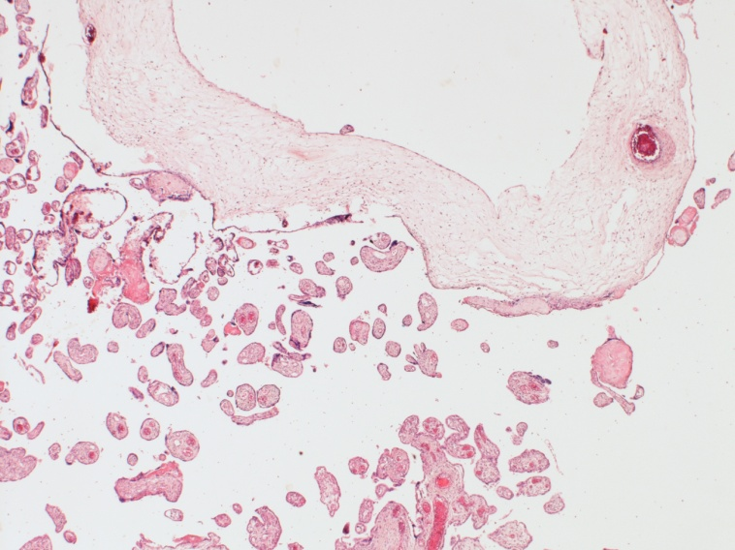

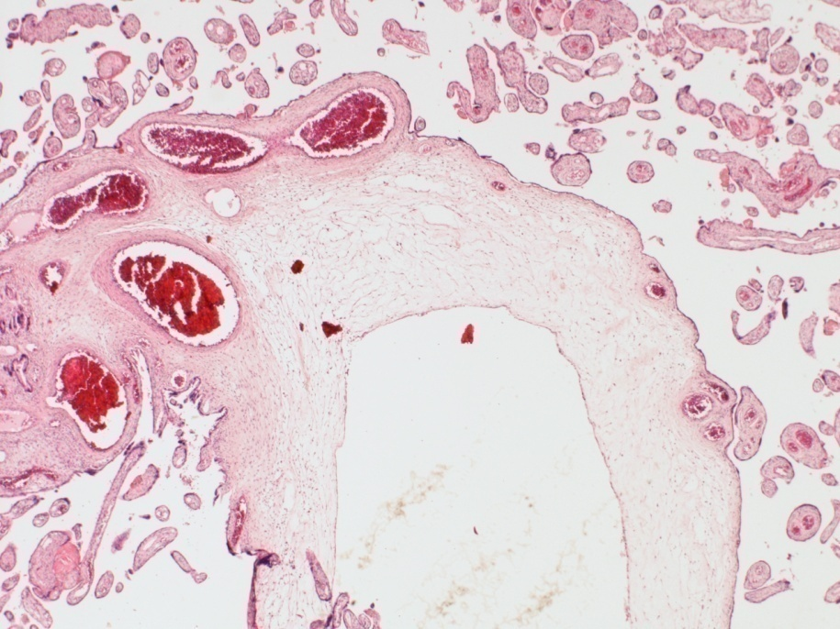

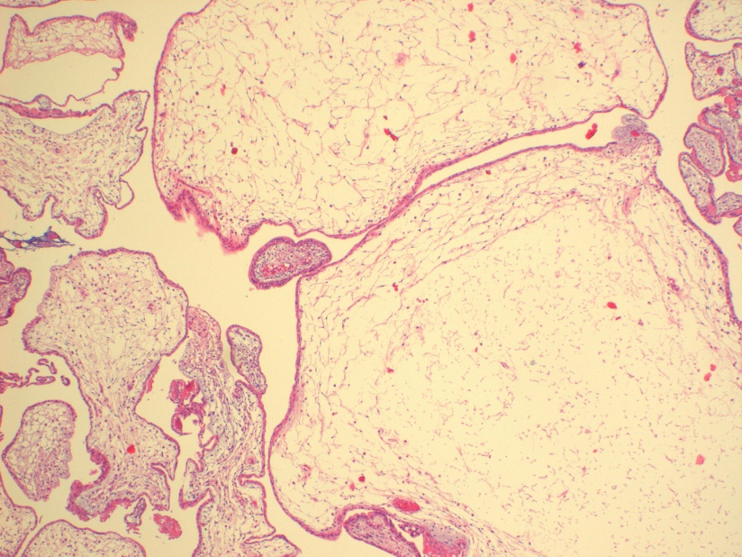

C

**Supplementary Figure S1**

**A** and **B**: Histology of the placenta of 2nd pregnancy (III-2) which ended at 33 weeks. Demonstrating normal third trimester terminal villi surrounding markedly enlarged stem villi showing peripheral muscular vessels and central cistern formation, characteristic of placental mesenchymal dysplasia**.**

**C:** Histology of the placenta of the third pregnancy (III-3) which ended at 13 weeks. One villus (marked by an arrow) shows a central cistern, one is enlarged with loose stroma while the others show a morphology according to the gestational age. No trophoblastic hyperplasia or trophoblast inclusions can be seen.

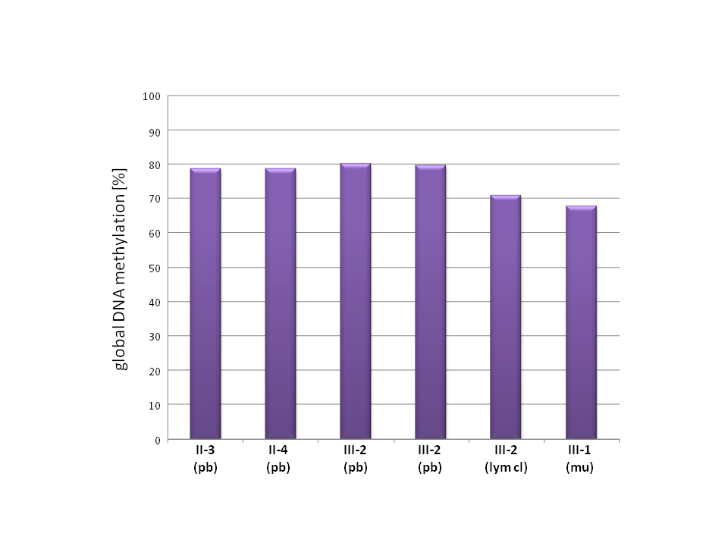

**Supplementary Figure S2:** To address the question whether child II (III-2) or the fetus (III-1) suffered from a genome wide hypomethylation syndrome, LUMA analysis has been performed. This analysis revealed no alterations of the global DNA level in the affected samples (III-1, III-2) as compared to the non affected parents (II-3, II-4). Two independent samples of peripheral blood were available from III-2 which were analysed separately. pb: peripheral blood, lym cl: lymphoblastoid cell line, mu: muscle.

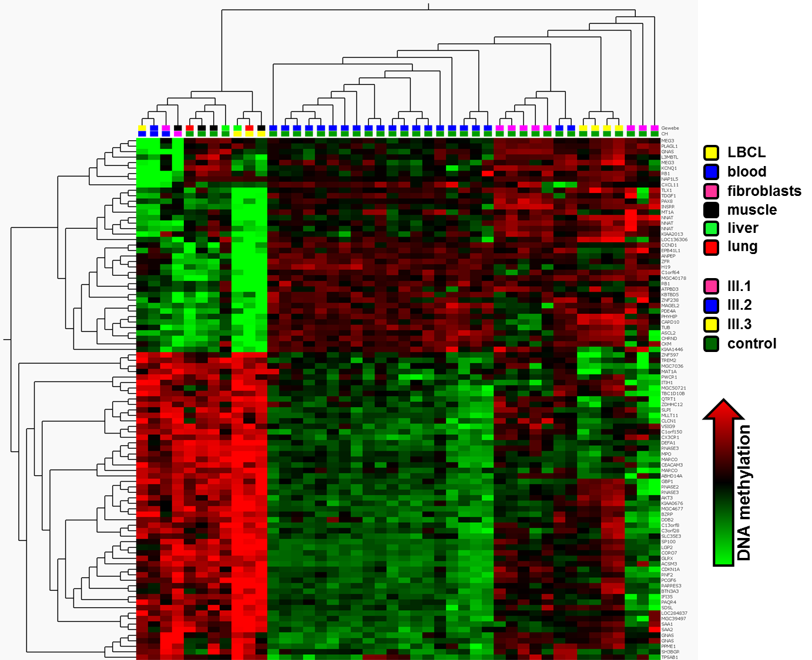

**Supplementary Figure S3:** Array based DNA-methylation analysis using the Infinium HumanMethylation27 Bead Chip. Hierarchical cluster analysis (average) of DNA-methylation data. Only CpG loci differentially methylated between the patients' samples and the controls were included (q < 0.01, t-test). For presentation, data were normalised (mean=0, variance=1). Tissue origin of the samples is encoded in the upper bar: yellow: lymphoblastoid cell line; blue: peripheral blood; pink: fibroblasts; black: muscle; green: liver; red: lung. The lower bar indicates the patients' material (pink: III-1; blue: III-2; yellow: III-3) and the controls (green square). In the heatmap green colour indicates low, black intermediate and red high DNA-methylation values (normalised data: mean = 0, variance = 1).



**Supplementary Figure S4:** Commonly aberrantly methylated CpG loci in 7 tissues of 3 donors. Aberrantly methylated CpG loci in 7 tissue samples from the three affected individuals (III-1, III-2, and III-3) were analysed for commonly altered loci (delta.beta >0.3 or <-0.3, total 7 comparisons). (A) The barplot presents the frequency of aberrantly methylated CpG loci ("number of CpG loci") in relation to the number of tissues in which the particular alteration has been detected ("score"). One CpG was differentially methylated in 6 of 7 comparisons, one CpG in 5 comparisons, 18 CpG loci (corresponding to 11 genes) in 4 comparisons, 41 CpG loci (30 genes) in 3 comparisons and 279 CpG loci (244 genes) in 2 comparisons. (B) Venn diagram showing the CpG loci which were found aberrantly methylated in at least one tissue of the individual donors as compared to appropriate normal controls. A total of 7 CpG loci were aberrantly methylated in at least one tissue of all three individuals, namely cg04456238 (*WT1*), cg05093686 (*MAB21L1*), cg10642330 (*NNAT*), cg18474934 (*TRPC3*), cg19107595 (*PEG10*), cg27119222 (*KCNQ1*), cg27443050 (*DLG7*).

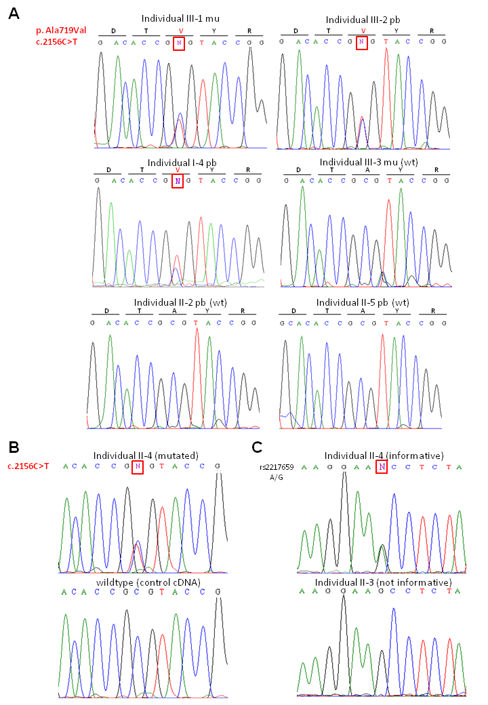

**Supplementary Figure S5:** Mutation analyses of the familial *NLRP7* variant in investigated family members. (A) The variant identified in the mother (II-4) was also identified in two children (III-1, III-2) and the grandmother (I-4). All other family members showed only the reference allele. (B) The variant and wildtype *NLRP7* alleles were expressed in the mother (II-4) compared to a control cDNA. (C) Monoallelic expression of *NLRP2* as described by Bjornsson et al.,(6) could not been verified on an informative SNP (rs2217659). pb: peripheral blood, mu: muscle, wt: wildtype.

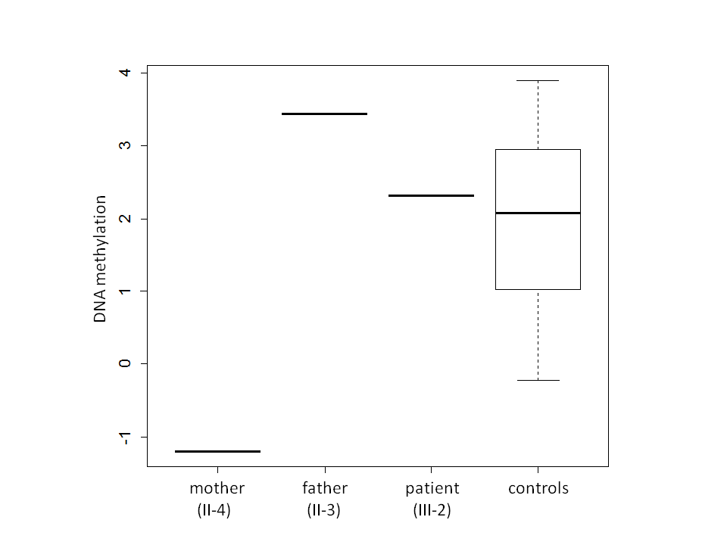

**Supplementary Figure S6:** By array-based methylation analysis of peripheral blood a strong hypomethylation at one CpG (cg16106497) in the region containing the 5’ ends of both genes *NLRP2* and *NLRP7* in the mother (II-4) of the affected offspring was noticed (normalised methylation value: -1.2) as compared to controls (mean: 2.0, range: -0.2 to 3.9).

**V. Supplementary References**

1. Schlegelberger B MS, Harder S, Zühlke- Jenisch R, et al. Classical and molecular cytogenetics of tumor cells. *Diagnostic Cytogenetics*. 1999:pp 151-85.

2. Schwindt H, Vater I, Kreuz M, et al. Chromosomal imbalances and partial uniparental disomies in primary central nervous system lymphoma. Leukemia. 2009;**23**:1875-84.

3. Hayward BE, De Vos M, Judson H, et al. Lack of involvement of known DNA methyltransferases in familial hydatidiform mole implies the involvement of other factors in establishment of imprinting in the human female germline. *BMC genetics*. 2003;**4**:2.

4. Qian J, Deveault C, Bagga R, et al. Women heterozygous for NALP7/NLRP7 mutations are at risk for reproductive wastage: report of two novel mutations. *Human mutation*. 2007;**28**:741.

5. Kou YC, Shao L, Peng HH, et al. A recurrent intragenic genomic duplication, other novel mutations in NLRP7 and imprinting defects in recurrent biparental hydatidiform moles. *Molecular human reproduction*. 2008;**14**:33-40.

6. Bjornsson HT, Albert TJ, Ladd-Acosta CM, et al. SNP-specific array-based allele-specific expression analysis. *Genome research*. 2008;**18**:771-9.

7. Kanber D, Buiting K, Zeschnigk M, et al. Low frequency of imprinting defects in ICSI children born small for gestational age. *European journal of human genetics : EJHG*. 2009;**17**:22-9

8. Mackay DJ, Temple IK, Shield JP, et al. Bisulphite sequencing of the transient neonatal diabetes mellitus DMR facilitates a novel diagnostic test but reveals no methylation anomalies in patients of unknown aetiology. *Human genetics*. 2005;**116**:255-61.

9. Mackay DJ, Boonen SE, Clayton-Smith J, et al. A maternal hypomethylation syndrome presenting as transient neonatal diabetes mellitus. *Human genetics*. 2006;**120**:262-9

10. Mackay DJ, Callaway JL, Marks SM, et al. Hypomethylation of multiple imprinted loci in individuals with transient neonatal diabetes is associated with mutations in ZFP57. *Nature genetics*. 2008;**40**:949-51.

11. Moore MW, Dietz LG, Tirtorahardjo B, et al. A multiplex methylation PCR assay for identification of uniparental disomy of chromosome 7. *Human mutation*. 2003;**21**:645-8.

12. Dietz LG, Wylie AA, Rauen KA, et al. Exclusion of maternal uniparental disomy of chromosome 14 in patients referred for Prader-Willi syndrome using a multiplex methylation polymerase chain reaction assay. *Journal of medical genetics*. 2003;**40**:e46.

13. Kanber D, Berulava T, Ammerpohl O, et al. The human retinoblastoma gene is imprinted. *PLoS genetics*. 2009;**5**:e1000790.

14. Karimi M, Johansson S, Ekstrom TJ. Using LUMA: a Luminometric-based assay for global DNA-methylation. *Epigenetics : official journal of the DNA Methylation Society*. 2006;**1;**45-8.

15. Karimi M, Johansson S, Stach D, et al. LUMA (LUminometric Methylation Assay)--a high throughput method to the analysis of genomic DNA methylation. *Experimental cell research*. 2006;**312**:1989-95.

16. Ammerpohl O, Martin-Subero JI, Richter J, et al. Hunting for the 5th base: Techniques for analyzing DNA methylation. *Biochimica et biophysica acta*. 2009;**1790**:847-62.

17. R Foundation Statistical Computing, Vienna, Austria. R: A language and environment for statistcal computing. 2011, ISBN 3-900051-07-0, URL http://wwwR-projectorg/.

18. Du P, Kibbe WA, Lin SM. lumi: a pipeline for processing Illumina microarray. *Bioinformatics*. 2008;**24**:1547-8.

19. Du P, Zhang X, Huang CC, Jafari N, et al. Comparison of Beta-value and M-value methods for quantifying methylation levels by microarray analysis. *BMC bioinformatics*. 2010;**11**:587.

20. Lin SM, Du P, Huber W. Model-based variance-stabilizing transformation for Illumina microarray data. *Nucleic acids research*. 2008;**36**:e11.

21. Weber M, Hellmann I, Stadler MB, et al. Distribution, silencing potential and evolutionary impact of promoter DNA methylation in the human genome. *Nature genetics*. 2007;**39**:457-66.

22. Martin-Subero JI, Ammerpohl O, Bibikova M, et al. A comprehensive microarray-based DNA methylation study of 367 hematological neoplasms. *PloS one*. 2009;**4**:e6986.

23. Murphy SK, Jirtle RL. Imprinting evolution and the price of silence. *BioEssays : news and reviews in molecular, cellular and developmental biology.* 2003;**25**:577-88.

24. Eden E, Navon R, Steinfeld I, et al. GOrilla: a tool for discovery and visualization of enriched GO terms in ranked gene lists. *BMC bioinformatics*. 2009;**10**:48.

25. Chang JT, Nevins JR. GATHER: a systems approach to interpreting genomic signatures. *Bioinformatics*. 2006;**22**:2926-33.

26. Czeschik JC, Voigt C, Alanay Y, et al. Clinical and mutation data in 12 patients with the clinical diagnosis of Nager syndrome. *Human genetics*. 2013;**132**:885-98.

27. Deveault C, Qian JH, Chebaro W, et al. NLRP7 mutations in women with diploid androgenetic and triploid moles: a proposed mechanism for mole formation. *Human molecular genetics*. 2009 ;**18**:888-97.

28. Messaed C, Chebaro W, Di Roberto RB, et al. NLRP7 in the spectrum of reproductive wastage: rare non-synonymous variants confer genetic susceptibility to recurrent reproductive wastage. *Journal of medical genetics*. 2011;**48**:540-8.

29. Tian X, Pascal G, Monget P. Evolution and functional divergence of NLRP genes in mammalian reproductive systems. *BMC evolutionary biology*. 2009;**9**:202.