Microstructural investigation on the grain refinement occurring in Cu-doped Ni-Ti thin films
M. Callisti ª, B. G. Mellor ^{b}, T. Polcar ª

ª National Centre for Advanced Tribology at Southampton, Faculty of Engineering and the Environment, University of Southampton, Southampton SO17 1BJ, UK
^{b} Materials Research Group, Faculty of Engineering and the Environment, University of Southampton, Southampton SO17 1BJ, UK

Abstract

The mechanism of grain refinement in Cu-doped Ni-Ti thin films have been investigated by transmission electron microscopy (TEM). Sputter deposited (Ni,Cu)-rich Ni-Ti-Cu thin films exhibited a columnar structure consisting of grains with a decreasing lateral size with increasing Cu content. Cu-rich grain boundary segregations were found to become prominent in films containing higher Cu contents. These segregations were attributed to a non-polymorphic crystallisation process which lowered the grain growth rate in relation to the Cu content in the films.

Keywords: Shape memory alloys (SMA), Physical vapour deposition (PVD), Grain boundary segregation, Transmission electron microscopy (TEM).

Sputter-deposited Ni-Ti thin films represent a suitable candidate for the fabrication of micro-electro-mechanical systems (MEMS) thanks to their ability to recover a large transformation strain. Moreover, they possess a high actuation rate and work output-to-volume ratio compared to other types of actuators [1]. Ni-Ti coatings are also investigated as self-healing surfaces [2, 3] and bonding layers for tribological applications [4, 5].
The functional and mechanical properties of sputter deposited Ni-Ti thin films can be modulated by co-sputtering Ni and Ti with a third element. Among the possible element candidates, Cu seems to be one of the most promising. In fact, Cu addition decreases the sensitivity of the transformation temperatures on chemical composition, decreases the temperature hysteresis, and increases the strength again plastic deformation [6].
The properties referred to above are strictly dependent on the grain size and on the formation and microstructural evolution of different types of metastable phases, which shape and size depend on the Cu content and on the post-deposition heat treatment [7]. The microstructural changes of these metastable phases for Ti-rich [8, 9] and (Ni,Cu)-rich [10] Ni-Ti-Cu thin films were reported for a wide range of Cu content and annealing temperatures. Moreover, it was also reported that Cu addition causes a grain refinement in Ni-Ti thin films regardless of the Ni/Ti content ratio and of the annealing temperature in the range 500-700°C [9-11]. Despite vital importance of the grain size when considering mechanical properties, no studies have been aimed at understanding the grain refinement mechanism in Ni-Ti-Cu thin films.
In this study, a microstructural investigation was performed to provide insight about the mechanism of grain refinement induced when Ni-Ti compositions are doped by Cu. Especially, a TEM investigation was aimed at understanding the role of Cu on the grain growth by analysing the grain boundary structure.
Amorphous Ni-Ti-(Cu) thin films were deposited on (100) Si wafers by a Plasma-Assisted Magnetron Sputtering system, and subsequently annealed in high vacuum for 1 hour at 500°C. A detailed description of the fabrication process can be found elsewhere [12].
The microstructure was characterised by transmission electron microscopy (TEM) using a FEI Tecnai F20ST/STEM scanning transmission electron microscope (STEM) at an accelerating voltage of 200 kV. Cross-sectional thin foils for TEM and STEM observations were prepared by mechanical grinding and polished down to a thickness of ~10 µm, followed by further thinning to an electron transparent thickness by a dual ion miller (Gatan PIPS, model 691).
Three (Ni,Cu)-rich Ni-Ti-Cu thin films (1.4 µm thick) were deposited with an approximately constant Ni/Ti ratio and different Cu contents with the resulting following chemical compositions: ${Ni}_{43.4}{Ti}_{49.6}{Cu}_{7}$, ${Ni}_{42.2}{Ti}_{47.9}{Cu}_{9.9}$ and ${Ni}_{38.1}{Ti}_{44.4}{Cu}_{17.5}$. The reference binary composition used as a base system to be doped by Cu was a Ti-rich composition (${Ni}_{48.1}{Ti}_{51.9}$), which is partially austenitic at ambient temperature [12]. The as-deposited films showed a fully amorphous and homogeneous structure. After annealing, ${Ni}_{48.1}{Ti}_{51.9}$ film exhibited an average lateral grain size almost three times larger than the film thickness. It indicated that the grain growth was obstructed by both the film/substrate interface and the film free surface, while lateral growth took place till neighbour grains impinged each other, as also found by A. Ishida et al. [13]. Much narrower columnar grains were clearly observed in Cu-doped Ni-Ti films. In particular, the average lateral grain size (L) scaled with Cu content according to an exponential model ($L=A∙e^{-\frac{X}{t}}+B$, with constants A = 3400, t = 3.4 and B = 200; X is the copper content in at.%). Thus, a significant grain size refinement compared to the binary system was induced in films with high Cu content (i.e., 17.5 at.% Cu $→$ L = 220 nm).
In all the Ni-Ti-Cu films many small and randomly distributed grains (10-40 nm) were observed close to the film free surface (Fig. 1), since the free surface was the most energetic location for crystal nucleation [14]. Such a heterogeneous crystallisation process was reported also for a near-equiatomic Ni-Ti film [15], although not as pronounced as for the Ni-Ti-Cu reported here. These nano-grains close to surface were denser and better distributed in films with higher Cu content. Larger columnar grains, whose lateral size (L) was strongly affected by Cu content, grew normal to the free surface just below nano-grains referred to above.
The grain boundaries with a thickness of 10-30 nm are clearly visible in Fig. 1. Several particles were distributed along the grain boundary and the higher contrast suggested an enrichment of heavier atoms within the particles. In fact, EDS measurements (inset in Fig. 1) performed across the grain boundary revealed a Cu enrichment, while no significant changes in Ni and Ti content were observed. It indicated that during the crystallisation process Cu atoms were preferentially segregated at the grain boundary.
Fig. 2 shows a representative case of the grain boundary for the ${Ni}_{43.4}{Ti}_{49.6}{Cu}_{7}$ film. In order to characterise the grain boundary microstructure, Fast Fourier Transform (FFT) was performed in different areas across the grain boundary and within the adjacent grains. The grain interior (Fig. 2 I) as well as the grain boundary particles (Fig. 2 II) exhibited a fully crystalline structure (see related FFTs). These particles were embedded in a composite structure consisting of randomly oriented nano-crystalline domains surrounded by an amorphous matrix (Fig. 2 III, IV). Although a partial coherency was observed at the interface between the particle and the adjacent grain (larger particle in Fig. 2), the formation of these crystalline particles was not correlated to the crystallisation of the B2 structure within the grains. This might suggests that a secondary crystallisation took place along the grain boundary once they were formed, although a partially amorphous boundary structure was always observed. Y. Xu et al. [16] reported that a small Cu addition (1.3 at.%) in Ni-Ti-Cu films did not produce any significant change in the crystallisation temperature and in the overall activation energy compared to pure Ni-Ti films. However, an in-situ TEM observations revealed that Cu addition decreased the activation energy for crystal growth and increased it for nucleation [16]. Therefore, the Cu enrichment observed along the grain boundary (inset in Fig. 1) can alter the kinetic of crystallisation of the amorphous structure observed in Fig. 2, although its effect is not completely understood.
Plate-like precipitates were found in the grain interior of the Ni-Ti-(Cu) after the heat treatment [12]. Therefore, the annealing was not sufficient to promote long range diffusion and metastable precipitates were formed in the grains interior as also reported in other studies [9-11]. These precipitates were found to be Ti(Ni,Cu)₂ for (Ni,Cu)-rich Ni-Ti-Cu compositions [12]. According to the Ostwald’s step rule [14] and to the precipitation process occurring in Ni-Ti-Cu thin films (for annealing temperature in the range 500-700°C) [8-10], it was deducted that the formation of prominent grain boundary precipitates represents one of the last steps of the precipitation process, occurring when Ni-Ti-(Cu) compositions are annealed at a temperature well above that of crystallisation. The Ni-Ti-(Cu) films studied here were annealed at a temperature very close to the narrow range of crystallisation temperatures reported for Ni-Ti-(Cu) compositions in independent studies [17-19]. Therefore we can conclude here that the co-existence of the Ti(Ni,Cu)₂ plate precipitates in the grain interior and the segregation at the grain boundaries was not a consequence of the precipitation process.
H. Ni et al. performed an in-situ TEM investigation to study the crystallisation behaviour of amorphous Ni-Ti thin films [20]. They reported that stoichiometric binary Ni-Ti films underwent a polymorphic crystallisation, while a more complex behaviour took place in off-stoichiometric compositions owing to the formation of precipitates, which made the crystallisation process sluggish. In our Ni-Ti-Cu films, the presence of a relatively large number of Cu-rich particles at the grain boundaries lead us to conclude that, in contrast to near-equiatomic Ni-Ti films [20], the crystallisation process in Cu-doped Ni-Ti film was not polymorphic.
In such a non-polymorphic crystallisation process, diffusion followed by grain growth played an important role in the grain refinement observed in Cu-doped Ni-Ti films. In particular, a transition volume covering the growing crystal formed and hence separated the growing crystal itself from the surrounding amorphous structure as schematically showed in Fig. 4b. Within this transition volume a diffusion of Ni, Ti and Cu atoms is required to start crystallisation process. Such a two-step mechanism consisting of diffusion followed by the formation of new crystals decreased the grain growth rate and prevented grain coarsening. Based on this mechanism and on TEM observations (Fig. 1), the crystallisation occurring in Ni-Ti-Cu thin films was subdivided in three stages. In the first stage several nano-grains nucleated underneath the film free surface (Fig. 4a), surrounded by an amorphous-like structure. In the second stage plate-like grains grew laterally till their transition volumes impinged each other (i.e. soft impingement – for more details see Ref. [21]) as schematically reported in Fig. 4c. At this stage, the expected lower grain growth rate owing to the above reported two-step process, was the cause of the formation of several smaller grains rather than a few very large grains like those observed for the ${Ni}_{48.1}{Ti}_{51.9}$Ni-Ti film.
After the impingement, the third stage, i.e. grain growth normal to the film free surface (Fig. 4d), became prominent promoting the formation of columnar grains. During this growth the transition volume surrounding the growing grains, particularly at the interface with neighbour grains, was likely to mitigate the competitive grain growth mechanism, which was observed in the early stage of columnar grain growth close to the film free surface (Fig. 3 a and c). This encouraged the formation of grains of similar size across the films thickness.
The grain boundary morphology and size depends on Cu content as demonstrated in Fig. 3, where the films containing 7 and 10 at. % Cu (referred as Cu-poor and Cu-rich respectively) were compared. The Cu-poor film exhibited a discontinuous distribution of spherical Cu-rich particles with an average diameter of ~25 nm (Fig. 3b) along the grain boundaries. On the contrary, the Cu-rich film showed continuous chains of Cu-rich particles, which exhibited a compressed shape across the grain boundary with an average size ~14 nm (see inset in Fig. 3d). This suggested that diffusion of a higher amount of Cu atoms took place within the transition volume during the grain growth in Cu-richer films, which further limited the grain boundary movement and thus promoted observed grain refinement.
In this study we addressed the grain refinement taking place during the crystallisation of amorphous Cu-doped Ni-Ti thin films. All the films exhibited a columnar grain structure regardless of the chemical composition, while a lateral grain refinement took place with increasing Cu content. The grain refinement of Cu-doped Ni-Ti films was attributed to a non-polymorphic crystallisation. This crystallisation is a two-step process: diffusion across a transition volume surrounding the growing grains followed by crystallisation, which takes place at the interface between the transition volume and already crystallised structure. The smaller grain size observed in films containing higher Cu at.% is attributed to the higher amount of excess atoms that have to diffuse before the crystallisation can take place.

This work was partially funded by the Ministry of Education of the Czech Republic (project MSM 6840770038). The authors would like to thank Dr. F. D. Tichelaar for the TEM analysis in the frame of the European Union Seventh Framework Programme under a contract for an Integrated Infrastructure Initiative (Reference 312483-ESTEEM2).

- S. Miyazaki, Y. Q. Fu, W.M. Huang, Thin film shape memory alloys: fundamentals and device applications. Cambridge (UK), New York: Cambridge University Press, 2009.
- W. Crone, G. Shaw, D. Stone, A. Johnson and A. Ellis, Proceedings of the SEM Annual Conference on Experimental Mechanics, Charlotte, NC, 127: 1-6 (2003).
- Y. Zhang, YT Cheng, D. S. Grummon, Surf. Coat. Technol., 202 (2007) 998-1002.
- Y. Fu, H. Du, S. Zhang, Surf. Coat. Technol., 167 (2003) 129-136.
- W. Ni, YT Cheng, M. Lukitsch, A. M. Weiner, L. C. Lev, D. S. Grummon, Wear, 259 (2005) 842-848.
- S. Miyazaki, A. Ishida, Mater. Sci. Eng., A 273-275 (1999) 166-133.
- A. Ishida, M. Sato, K. Ogawa, Mater. Sci. Eng. A, 481-482 (2008) 91-94.
- X. L. Meng, M. Sato, A. Ishida, Acta Mater., 56 (2008) 3394-3402.
- A. Ishida, M. Sato, Intermetallics, 19 (2011) 900-907.
[10] A. Ishida, M. Sato, K. Ogawa, Phil. Lett., Vol. 88, No. 16, June 2008, 2427-2438.
[11] A. Ishida and M. Sato, Philos. Mag., Vol. 87, No. 35, December 2007, 5523-5538.
[12] M. Callisti et al., Surf. Coat. Technol. (2013), http://dx.doi.org/10.1016/j.surfcoat.2013.06.040.
[13] A. Ishida and M. Sato, Acta Mater., 51 (2003) 5571-5578.
[14] E. S. Machelin, An Introduction to Aspects of Thermodynamics and Kinetics Relevant to Materials Science, Elsevier, Linacre House, Jordan Hill, Oxford (UK), Third Edition (2007).
[15] M. J. Vestel, D. S. Grummon, R. Gronsky, A. P. Pisano, Acta Mater., 51 (2003) 5309-5318.
[16] Y. Xu, X. Huang, A. G. Ramirez, J. Alloys Compd, 480 (2009) L13-L16.
[17] J. Z. Chen, S. K. Wu, J. Non-Cryst. Solids, 288 (2001) 159-165.
[18] P. Y. Hsu, J. M. Ting, Thin Solid Films, 420-421 (2002) 524-529.
[19] Y. Xu, X. Huang, A. G. Ramirez, J. Alloys Compd, 480 (2009) L13-L16.
[20] H. Ni, H. J. Lee, A. G. Ramirez, J. Mater. Res., Vol. 20, No. 7, Jul 2005.
[21] J. da Costa Teixeira, D. G. Cram, L. Bourgeois, T. J. Bastow, A. J. Hill, C. R. Hutchinson, Acta Mater. 56 (2008) 6109-6122.

Fig. 1 –Bright Field TEM image of the Ni_{42.2}Ti_{47.9}Cu_{9.9} thin film; the inset shows the chemical composition across the grain boundary (GB).
Fig. 2 – High resolution TEM image along grain boundary in the Ni_{43.4}Ti_{49.6}Cu₇ thin film annealed for 1 hour at 500°C. The yellow line indicates the interface between the grain and the grain boundary. FFT was performed in different areas as follow: (I) grain interior, (II) Cu-rich particle, (III)-(IV) grain boundary.
Fig. 3 –Bright Field TEM images of the (a) Ni_{43.4}Ti_{49.6}Cu₇ and (c) Ni_{42.2}Ti_{47.9}Cu_{9.9} thin film together with corresponding HAADF images of the films showing different grain boundary morphologies. The inset in (d) shows the continuous chain of Cu-rich particles.
Fig. 4 – Schematic representation (arbitrary shapes) of the non-polymorphic crystallisation taking place in Ni-Ti-Cu thin films.

Fig. 1
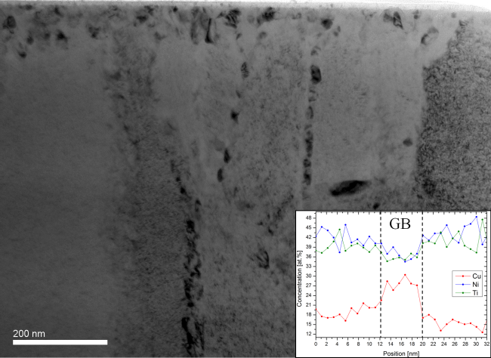

Fig. 2
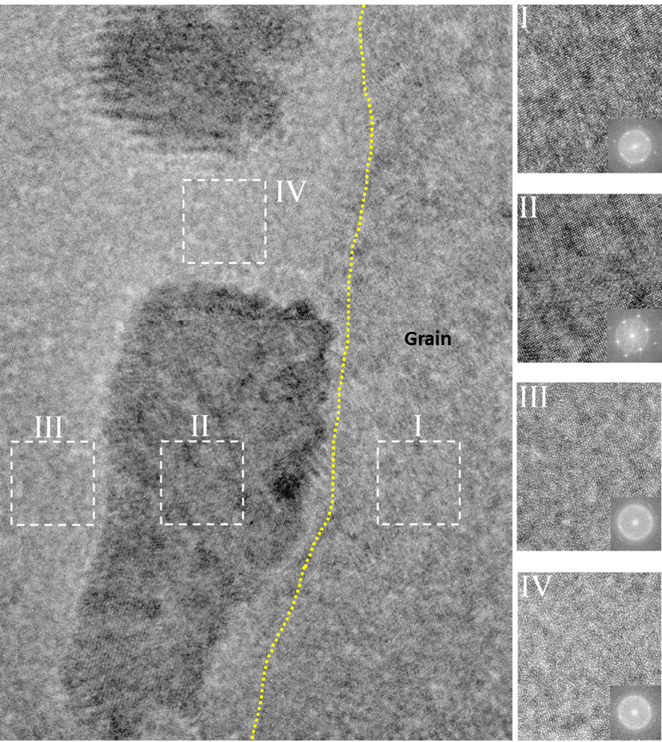

Fig. 3
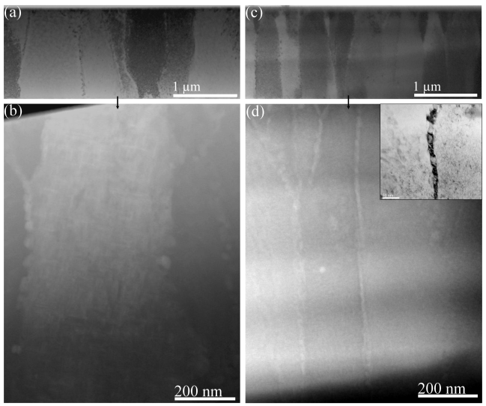

Fig. 4
