**Tribological analysis of thin films by pin-on-disc: evaluation of friction and wear measurement uncertainty**

R. Novaka and T. Polcara,b,*

*a) Department of Control Engineering, Faculty of Electrical Engineering, Czech Technical University in Prague, Technicka 2, Prague 6, Czech Republic*

*b) nCATS, Faculty of Engineering and Environment, University of Southampton, Highfield Campus, SO17 1BJ Southampton, UK*

*\*corresponding author: polcar@fel.cvut.cz*

Pin-on-disc is widely used to evaluate tribological properties of thin films. However, the results are often present without standard uncertainties; moreover, in many cases the standard uncertainty is replaced by standard deviation, which is strong underestimation of real uncertainty. In thus study we have followed ISO and NIST guidelines to investigate possible sources of uncertainties related to friction and wear rate measurement and to apply them on two selected coating systems – TiN and DLC. We show that influence of operator is a significant contribution to the uncertainty of the wear rate, particularly in the case of very low wear of DLC coatings. We discuss why variance should be used instead statistic deviation and suggest method to calculate uncertainties in case of small number of measurements. The paper could be used as a guide to evaluate friction and wear data of thin films and coatings using pin-on-disc technique.

**Keywords:** pin-on-disc; coatings; uncertainty; friction and wear

**1 Introduction**

The experimental evaluation of friction coefficient and wear rate using pin-on-disc is a common laboratory procedure. Despite the simplicity of measurement and calculation, there are practical challenges to quantify these basic tribological parameters accurately. Friction is a typical non-equilibrium process and sliding often leads to wear, which is highly stochastic. The values of friction coefficients and wear rates reported in the literature typically show wide variation even for nominally identical tests; the origin of these variations is often not known. To assess uncertainty of tribological measurement is thus a complex problem. Due to high spread of measured data, high number of identical measurements is required to estimate values of friction and wear. The tribological measurement is lengthy and expensive process; therefore, an optimum number of repetitive measurements must be found to satisfy both precision and economy of the testing. Moreover, in some cases the number of samples and thus number of available tests is limited.

Tribological analysis of thin protective films is in many ways different from that of bulk materials. The thickness of the film is in the range 0.1-10 µm with 1-3 µm being the typical value. The films are quite often composed of bonding interlayer improving adhesion (metals, carbides, nitrides, gradient interlayers) and top functional coating. To evaluate the latter the maximum wear depth is limited to approx. 80% of its thickness to avoid influence of bonding layer. As a consequence, the worn volume is very low and traditional measure of material mass loss cannot be used; thus, mechanical and optical profilometry is required. In some cases the wear is extremely low and the depth of the wear track is close to surface roughness, which leads to high uncertainty of the wear rate.

Unfortunately, the standard procedures [[1],[2]], which should be used to estimate measurement uncertainties, are not always followed. As a consequence, the friction and the wear rate values are often presented without measurement uncertainty; moreover, the uncertainty is sometimes replaced by standard deviation, which is misleading and significantly lower than standard uncertainty.

Uncertainty of tribological measurements has been addressed in several papers for various measurement conditions [[3],[4],[5]]. Detailed uncertainty analysis of low friction coefficient measurements with a reciprocating pin-on-disk tribometer has been shown in Ref. [[6],[7]]. In these studies the predominant source of variations originated from the misalignment of the force transducer axis relative to the specimen surface. Nevertheless, the scatter of friction coefficient values was larger than estimated uncertainties related to the experimental apparatus. Krick et al [[8]] examined the influence of the ratio of the wear track radius, *r*,and contact width, *2a*, on uncertainty of friction coefficient measured by pin-on-disc. They concluded that the increase of uncertainty was significant only for very small wear track radii. For , the relative uncertainty was lower than 1%.

In this paper we follow guidelines provided in Ref. [1,2] to analyze in detail uncertainty of friction coefficient measured by the standard pin-on-disc apparatus and corresponding coating wear rate. Then we report application of the method to two large set of substrates, one coated by titanium nitride (TiN), the second with hydrogenated diamond like carbon coating (DLC). We determine the most significant contributors to the overall measurement uncertainty, which could help to either re-design the experiment procedure to reduce the measurement uncertainty or to simplify it by neglecting some parameters. We show that estimation of uncertainties could help to distinguish between random value variation and true trends (i.e. dependence of measured values on selected variable or set of variables). Finally, we suggest an optimum process to estimate uncertainties.

**2. Measurement uncertainties**

The standard uncertainty of measurements is determined using Type A and Type B uncertainty evaluations [1,2]. To evaluate Type A uncertainty the measurement is repeated under the same conditions and the statistical methods are applied to the set of measured values. However, the tribological tests are destructive and the test cannot be repeated under the repeatability conditions stated in Ref. [1,2]. It is clearly demonstrated by the wear rate data dispersion for which orders-of-magnitude variations are common [[9]]. Thus, the results of the set of measurements cannot be (at least in general) treated with statistical methods; in other words, uncertainties Type A cannot be evaluated. Nevertheless, the testing procedure involves some steps, such as instrument calibration, which fulfil the repeatability conditions and therefore could be evaluated by means of a statistical methods and Type A uncertainty could be determined. The standard uncertainty of tribological measurement is dominated by Type B uncertainties. The uncertainty Type B is evaluated by an engineering and/or scientific judgment based on all available information. In our case it is the estimation of instrument and method errors and operator induced uncertainties.

**2.1 Standard uncertainty of the friction coefficient**

In this study we consider traditional pin-on-disc tribometer with a ball pressed against a rotating sample (Fig. 1a). The pin *1* is mounted on a stiff lever *2*, designed as a frictionless force transducer. The dead weight *3* produces the normal force *Fn*. The friction force *Ff* is evaluated from the deflection of the elastic arm *4* measured by inductive displacement transducers *5*; the calibration referred to above is used to calculate force from measured deflection.

If *uµA* and *uµB* denote the Type A and Type B uncertainties, the standard uncertainty *uµ* of the friction coefficient *µ* is given by [1,2]:

 . (1)

Since the friction measurement cannot be repeated under identical conditions due to progressive destruction of the surfaces in the contact, Type A uncertainty is related only to the calibration procedure. Calibration is provided by a dead weight (5N) applied to a ball holder (Fig. 1b) giving offset for frictional force gauge (zero load is obviously used as the second point). However, it should be pointed out that the calibration could be only considered as an uncertainty Type A provide it is carried out before any individual measurement. In normal testing practice it is not the case – the equipment is calibrated after certain number of tests or when the material couple is changed. This practice is reasonable when the friction offset (and thus uncertainty Type A) is much lower than total uncertainty of friction coefficient. We carried out number of calibrations giving statistical set of frictional force offsets; standard deviation of the data was then used to estimate uncertainty Type A denoted *uµA*.

Based on our experience in the field of tribological measurements we assume the uncertainty Type B consists of instrument uncertainty and uncertainty given by the dispersion of measured values. The origin of the latter is not known; however, it can be estimated on the basis of data difference. We can thus summarize that the Type B uncertainty *uµB* is given by

,  (2)

where *uµi* is the instrument uncertainty and *uµv* is the uncertainty due to data difference.

The coefficient of friction *μ* is defined as the ratio of the measured frictional force *Ff* and the normal force *Fn*:

. (3)

The friction and normal forces in the contact are measured separately using combination of force transducer and dead weight load, respectively. Since both *Ff* and *Fn* are measured independently and the combined standard uncertainty is a function of the standard uncertainties *uFf* and *uFn* and the associated sensitivity coefficients, the expression for the combined standard uncertainty *uμi* could be given as

 . (4)

Zero covariance, i.e. no correlation between the separate input variables, is assumed in our analysis. Combining of Eq. (4) and Eq. (1) yields

 . (5)

Eq. (5) can be simplified using relative standard uncertainties to

, (6)

where

.(7)

The friction force *Ff* is calculated from the elastic deformation of the arms measured by shift transducer. Since the value of force *Ff* depends linearly both on the transducer ratio and the arms deformation, the relative uncertainty *uFf,r* is

, (8)

where *ut,r* is the relative uncertainty of deformation transducer data, *ud,r* is the relative uncertainty due to vertical ball holder misalignment and *uh,r* is the relative uncertainty due to horizontal ball holder misalignment. The value of *ut,r* can be easily obtained from data given by the transducer manufacturer [1,2]. Thus, the *ut,r* value could be calculated as

 , (9)

where τ is the sensitivity tolerance (%), *δ* is the linearity deviation (%), and *μ0* is the tribometer range.

Manufacturing tolerances, sample shape and adjustment, and position of the pin holder in the lever (see points 1 and 2 in Fig. 1a) inevitably produce misalignment of the normal and tangential axes (Fig. 2). Firstly, we must treat the potential misalignment between the normal of the sample surface and the pin holder axis in the tangential plane (Fig. 2a). The arm of friction force *R´* is longer than *R*:

 , (10)

and the relative uncertainty due to this instrument misalignment is then

 . (11)

We proceed by calculating the first-order Taylor series approximation resulting in

. (12)

Secondly, incorrect adjustment of horizontal level of the stiff lever should be taken into account (Fig. 2b). It is evident that the length of friction force arm, *R//*, can be approximated as

$R"=R\cos{β}+a"\sin{β}$. (13)

The normal force *F//n* then differs from the dead load

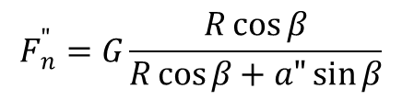 (14)

and the momentum *M//* of friction force *Ff* acting on the lever is

 (15)

The relative uncertainty *uh,r*created with this misalignment is determined as

 . (16)

Again we proceed by applying the first-order Taylor series approximationgiving

 . (17)

The Eq. (8) may be then written as

. (18)

The force *Fn*in Eq. (3) and (5) is the normal component of force acting on the pin and the uncertainty of this value is calculated using Eq. (19)

, (19)

where *um* is the uncertainty of the dead weight and *uγ* is the uncertainty caused by deviation of the normal of sample surface plain from the sample axis of rotation.

If *ε(m)* denotes the error of scales used for dead weight scaling and *g* for the gravity acceleration, the first term in Eq. (19) is

 . (20)

The relative uncertainty of gravity acceleration, given by latitude and altitude of the measurement place, is of the order 10-4 and could be neglected. The coefficient 1/√3 in Eq. 20 has been applied according to Ref. [1,2].

The effect of deviation of the normal of sample surface plain from the sample axis of rotation is illustrated in Fig. 3, where *γ* denotes the angle of deviation, *r* the radius of wear track, *R* the distance of the pin holder axis from the level axis of rotation, *J* the moment of inertia of the pin holder lever and *z* the instantaneous height of the pin over horizontal plane. The time dependence of *z* is described as

, (21)

where *ω* denotes the angular velocity of the sample. Due to the contribution of inertial forces to the weight *G,* the instantaneous force on the pin is

. (22)

Considering low deviation *γ* we can simplify

 (23)

to obtain

. (24)

In tribological tests linear speed *v* is traditionally used, *v = ω · r*. The sensitivity coefficient of *Fn* with respect to *γ* written as

 (25)

is time dependent with the period *T =* 2π*r/v.*  If the sampling frequency of friction data is high compared to frequency of rotation *ω/2π* and the measurement duration long enough, the mean value of the coefficient *∂Fn/∂γ* could be considered as zero. Nevertheless, this coefficient could be still responsible for the periodical fluctuation of the measured instantaneous value of friction coefficient, particularly for higher deviation angle *γ*. If the sensitivity coefficient of *Fn* is negligible, the relative instrument uncertainty of the friction coefficient *μ* is

. (26)

The uncertainty *uµi* is, however, only a part of *uµB*; its remaining component *uµv* is often predominant. To obtain *uµv* it is necessary to repeat the measurements with the same type of samples under identical conditions. The best estimation of the friction coefficient is the arithmetic mean of the registered values *µ1, µ2,..., µN*. The difference *Δµ* between highest and lowest values of *µi* should be used as a base for estimation of *uµv.*  Supposing the rectangular distribution of the probability of values *µi* in the interval between the highest and the lowest values, in agreement with [1,2] we obtain

. (27)

Then we combine Eq. (2), (26) and (27) giving

. (28)

The value of uncertainty of friction coefficient *uμ* is then given as

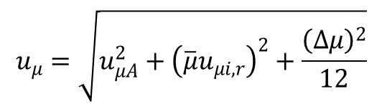 (29)

We should point out here that we do not consider any inertial effects caused by dead load. When the coating and/or ball surfaces are rough or have topographical defects, the load would vary during one rotation and thus calculated friction. However, these effects are negligible in the case of hard protective coatings. The surface roughness of the coatings is typically very low (substrates are polished) and counterparts are very smooth (bearing balls). Topographic features in the wear track could be produced by severe plastic deformation of the substrate or by localized accumulation of adhered wear debris. For hard coatings the plastic deformation is negligible and worn volume minimal; moreover, the wear debris is typically removed from the contact area to the wear track borders. In fact, the surface roughness measured in the wear track in direction parallel to sliding distance is often lower than that of as-deposited coating surface.

**2.2 Standard uncertainty of the wear rate**

Assessment of the wear rate uncertainty is more complicated due to necessity to evaluate the uncertainties of the normal force*,* the sliding distance, and the wear volume. Two methods are typically applied to calculate the wear volume: (i) the sample mass loss measured by a precise balance, and (ii) the evaluation of the wear track cross section area. The former does not take into account the plastic deformation and possible mass changes (i.e. oxidation, etc); its uncertainty is equal to the uncertainty of balance. The effect of the instrument related uncertainties on the wear rate was studied in Ref. [[10]]. Experiments with the reciprocating tribometer showed that the primary sources of uncertainty were the mass loss measurements and the length of the wear track, i.e. the uncertainties of the instruments. It is obvious that this method cannot be used to evaluate wear rate of thin films due to negligible mass of worn material compared to the mass of the sample. The second method, evaluation of the wear track shape, includes plastic deformation and its uncertainty depends on the uncertainty of the wear track cross sectional area and the uncertainty of the wear track radius.

The cross section area of the wear track is usually evaluated by contact (mechanical) or non-contact (optical) surface profilometers. We will focus here on the more progressive optical systems. The uncertainty of the cross section area depends both on lateral and vertical resolution of the instrument. Although these values are often provided by the profilometer manufacturer, it is necessary to review supplied data critically. While the lateral resolution is given by the optical characteristics of the objective and can be easily determined, the vertical resolution presents complex problem. In principle, the value of vertical resolution is limited by Heisenberg´s uncertainty principle and optical uncertainty principle [[11]]. The question of the best possible achieved vertical resolution regarding to the interferometer setup is discussed in Ref. [[12]]. The vertical resolution is also influenced by the sample surface roughness [[13]]. Moreover, there is another source of uncertainty, which is difficult to estimate. The wear track cross-section strongly depends on profilometer operator, who defines original surface line (i.e. surface before the wear test) and width of the wear track. The operator influence strongly increases in case of rough surfaces and irregular shape of the wear track. It is well demonstrated in Ref. [[14]], where the significance of errors due to the variations in the wear track irregularity are compared with the instrument error and the predominant role of the uncertainties of the cross section area scans is clearly shown. To achieve sufficiently low value of the wear volume uncertainty, a set of scans had to be carried out. As the number of scans increased, the estimated volume loss was closer to the true value and the associated uncertainty decreased. The probability that the true value was in the confidential interval was about 80% for 10 scans and nearly 100% for 50 scans [14]. Nevertheless, these quantitative conclusions should be assessed critically, since the authors applied the statistical methods considering individually scanned cross-sectional areas as identical, i.e. repeated measurement. However, they used the values obtained from different places of the wear track.

We will investigate here the uncertainty of the wear rate. The wear rate *w* is defined as

, (30)

where *V* is the worn volume during the wear test, *Fn* is the normal force and *d* is the total sliding distance. Applying the method of loss volumeevaluation based on the wear track cross section area *A [µm2]* and the wear track radius *r [m]*, the wear rate is given as

. (31)

where N is the number of sample revolutions (sometimes denominated as cycles or laps). Standard uncertainty *uw* is given as

. (32)

None of the quantities *A, Fn* and *N* can be measured repeatedly under identical conditions; thus the Type A uncertainty of the wear is zero and *uw =* *uwB*. To simplify the calculations the relative standard uncertainties *uw,r,* *uA,r, uFn,r*and *uN,r* are used. Since the pin-on-dics equipment provide precisely defined number of cycles *N*, the uncertainty *uN,r* could be ignored:

. (33)

The evaluation of the uncertainty *uFn,r* was discussed above and we will thus focus on the uncertainty of the cross-section area *A*. It can be calculated as

, (34)

where *uAi* denotes the instrument uncertainty, *uAo* the operator induced uncertainty and *uAv* the uncertainty caused by wear track irregularities.

The evaluation of the wear track area *A* is based on the wear track profile measured with an optical profilometer. Operator determinates original surface profile together with wear track boundaries; then the area *A* is computed. Fig. 4 illustrates problems related to identification of the wear track edges. This operator uncertainty, *uAo*, combines both inaccuracy of one operator (i.e. repetitive measurement of identical profile gives different results) and inaccuracy originated in operator practice and training. Its estimation is difficult – in present study the measurements of one particular wear track by 5 operators were used to analyze the difference of the values in order to estimate operator induced uncertainty.

The instrument induced uncertainty *uAi* depends on positioning uncertainty of particular profile points given by lateral and vertical resolutions *Δx* and *Δz* of the instrument. To evaluate the effect of *Δx* and *Δy* on the uncertainty of the cross-section area *uAi,* two extreme cases are considered: very shallow and wide wear track (Fig. 5a) and very narrow and deep wear track (Fig. 5b). If *b* denotes the wear track width and *h* its depth, we can write:

 (35)

. (36)

The relative instrument uncertainty *uAi,r* of the wear track area is then given as

. (37)

The resolution of a standard optical profilometer is *Δx* = (200-400) nm and *Δz* = (0.1-1) nm,  and  denote the arithmetic means of the quantities *h* and *b*, respectively.

Estimation of the operator induced uncertainty *uAo* depends on the experimenter choice and could be based e.g. on difference of the *A* value measured on the same sample several times by the particular operator or on the comparison of values taken on a sole sample by several operators.

Considering the irregularities of the wear track cross-section, the measurements are carried out in *n* positions along the wear track circumference resulting in a set of values *A1, A2,… An*. The arithmetic mean  of values *A1, A2,… An* as the best available estimate of expected value *A*. However, since the obtained data cannot be considered as a series of measurements repeated under the same conditions, the difference *ΔA* between the highest and the lowest values of *Ai* is used as a base for setting the value of *uAv.* Supposing the rectangular probability distribution of the *Ai* values in the interval between the highest and the lowest values we obtain

 (38)

and then

. (39)

If the time dependent component in Eq. (25) is maximal (i.e. cos *ωt* = 1), and the Eq. (20) is used, the uncertainty *uFn,r*  is given by Eq. (40) :

 (40)

The standard relative uncertainty of the wear rate *w* is calculated using Eq. (41)

 (41)

and the standard combined uncertainty  using Eq. (42)

 (42)

**3 Experimental details**

The experiments with repeated measurements of friction coefficient and wear rate were carried out with two hard coatings, TiN and DLC. To eliminate the effects of any laboratory preparation both series were deposited in large industrial deposition facilities, each in one batch. Thus, the uniformity of the coatings was guaranteed (total number of samples was 30 per deposition). The coatings were deposited on steel (ISO 4597: 1.2379 (X153CrMoV12) - AISI: D2) substrates polished to surface roughness Ra < 50 nm; the hardness of substrates was 61±2 HRC. All substrates were ultrasonically cleaned in alcalic bath, rinsed in deionized water and dried in vacuum before deposition. TiN coatings were deposited in HC4 apparatus (Hauzer Techno Coating) by cathodic arc evaporation from Ti target in Ar + N2 mixture. The deposition temperature was 350 °C, the working pressure was in the range 0.1 – 0.2 Pa and the substrate bias was – 70 V. The coating thickness was 2 μm. DLC coatings were deposited in Hauzer Flexicoat 1200. DLC coatings were deposited by PACVD using C2H2 (purity 99,6%) with substrate pulsed bias in frequency range (20 – 100) kHz. The coating thickness was 1.3 μm including thin titanium interlayer improving adhesion deposited by magnetron sputtering.

The tribological tests were performed with CSM Instrumens pin-on-disc tribometer (software TriboX 2.9 C). The instrument was repeatedly calibrated before and after measurements. The tests were carried out at room temperature (22 - 25 °C); the applied load was 5 or 10 N and the linear speed varied in the range 2-10 . Balls with a diameter of 6 mm were used as counterparts; high speed steel for TiN coatings and alumina for DLC. Both coatings and the balls were cleaned with isopropylalcohol and acetone before the tests.

To evaluate the Type A uncertainty of friction coefficient, the tribometer calibration was repeated before and after experiments in total twenty times using the calibration procedure suggested by the tribometer manufacturer. Obtained individual calibration coefficients slightly differed in value and the experimental standard deviation of their mean value was

 (43)

Type B uncertainty of friction coefficient was calculated from Eq. (26) and (29). According to the inductive displacement transducer specification, the sensitivity tolerance *τ* is 1% and the linear deviation *δ* is 0.2%. The highest measured friction force *Ff0* is limited by software to 10 N; thus, *μ0* from Eq. 9 is calculated from equal to *Ff0* = *μ0Fn*. Estimation of uncertainty components *ud,r* and *uh,r* is based on the presumption that the effect of manufacturing tolerances is negligible compared to the effect of the elastic deformations and clearances. Analyzing stiff lever positions in the unloaded and loaded state, the highest measured value *α,* 0.006 rad, was obtained for *a =* 50 mm and *R* = 90 mm (see Fig. 2a). The horizontal deviation of the stiff lever, *β,* which is adjusted by an operator, did not exceed 0.012 rad. The mass of dead weight *m =* 511.52 g was estimated with maximum error *ε(m)* = 0.03 g given by the digital balance manufacturer. Using Eq. (9) and (27), the instrument uncertainty of friction coefficient is

 (44)

Neglecting the second term in Eq. (44) related to stiff lever position, the uncertainty *uµi,r* could be simplified to

 (45)

and the combined standard uncertainty of the friction coefficientis then

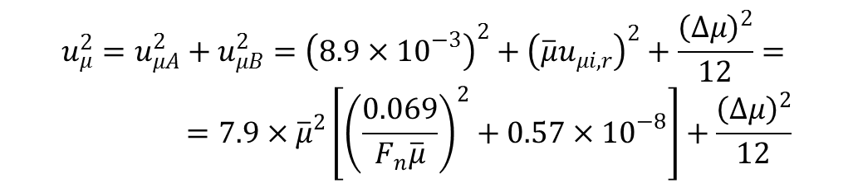 (46)

The ZYGO 7200 optical profilometer with 5x/Michelson objective and software MetroPro were used to measure the wear track width, depth and cross-section area. The samples were cleaned with isopropylalcohol; the free debris was thus removed from the surface. Each sample was positioned on rotating holder enabling precise positioning of the measured section. The cross sectional area *Ai* and the wear track width *bi*and depth *hi* were measured in eight points regularly spaced along the wear track circumstance.

Combining the profilometer data provided by manufacturer (vertical resolution *Δz* = 0.1 nm and lateral resolution *Δx* = 200 nm) and Eq. (41), the relative uncertainty *uw,r* could be given as

 (47)

where the wear track width  and depth ** are in nanometers.

**4 Results**

**4.1 Friction and wear of TiN coatings**

The experiments carried out with ten samples consisted in a set of measurements focused on estimation of (i) operator induced uncertainties of wear rate values, (ii) effect of air humidity and (iii) impact of the wear track radius *r* on friction coefficient *μ* and wear rate *w* values.

In order to find the operator induced uncertainties, the following pin-on-disk experiment was arranged: the load *Fn* = 5 N, the linear speed *v* = 10 cm.s-1 and the number of laps *N* = 3000. Then the cross section areas were measured in eight positions evenly distributed along the wear track. The measurements were performed by five operators with different laboratory skills. The comparison of their results, i.e. the arithmetic mean  and the difference *ΔA* of these eight values of cross section area measured by particular operators, is given in Table 1.

If all *A* values measured by these five operators are considered as one set, the mean value of the cross-section area and its relative uncertainty are

*A* = (119.5 ± 6.4) μm2; *uAo,r* = 0.053. (48)

To evaluate the effect of the humidity on the tribological properties, 10 samples were tested with identical parameters (*Fn, v, r, N)* except for air humidity, which was varied in the range 25 – 45%. Results of this experiment summarized in the Table 2 clearly demonstrate that there are no noticeable dependences of measured values on air humidity since all values are within the limits given by their standard combined uncertainties.

The standard combined uncertainties *uμ*and *uw* presented in the Table 2 were calculated using Eq. (51) and Eq. (53). By substituting the values of *Fn* and measured difference *Δµ*, we obtain

. (50)

By neglecting negligible terms in Eg. (50) we can write

 , (51)

where the first member is related to the instrument uncertainty *uμi*  of this particular tribometer using the normal force *Fn* and the second member corresponds to the variance of measured values of friction coefficient *μ*.

The standard combined uncertainties *uw* were calculated using Eq. (47) and Eq. (48) and measured values of and :

. (52)

It is apparent that all instrument uncertainties could be neglected in comparison with operator induced uncertainty and with variance of *A* values. Thus the uncertainty *uw*could be given as

. (53)

The last experiment was aimed to the investigation of the wear track radius effect on the friction coefficient and the wear rate. We varied radius *r* in the range 3 – 18 mm using set of five samples. The results of this experiment are presented in the in the Table 3 and summarized in Fig. 6. The friction coefficient *μ* slightly increases with radius; the increase in the wear rate *w* is even more evident.

We can conclude here that the relative humidity in the range 25-41% does not affect the tribological measurement. However, the radius is an important parameter significantly influencing the friction and, particularly, the wear rate.

**4.2 Friction and wear of DLC coatings**

The experiments carried out with ten samples consisted in repeated measurements focused on following parameters and their effect on friction and wear rate: (i) operator induced uncertainties of *w* values and further on determination of test parameters impact on values of *µ*, *w* and their uncertainties; (ii) relative humidity RH; (iii) normal force *Fn*; (iv) pin velocity *v*.

(i) This experiment was arranged in the same way as for TiN coatings referred to above. The pin-on-disk test with parameters *Fn* = 5 N, *v* = 10 cm/s and *N* = 3000 was carried out and five operators measured the wear track cross section area in eight positions evenly distributed along the wear track. The comparison of their results, i.e. the arithmetic mean  and the difference  of these eight values of cross section area, is shown in Table 4.

While the uncertainties achieved by particular operators are relatively low, the substantial difference in values  obtained by different operators originated from the different attitudes to estimate the wear track boundaries and this wear track width (see Fig. 4). If all *A* values measured by these five operators are taken as one set and the mean value and its uncertainty was evaluated, the result is

*A* = (1.85 ± 0.30) μm2 and  = 0.16 . (54)

Eq. (53) could be then modified to

.  (55)

(ii) The effect of air relative humidity in the laboratory environment was evaluated by means of measurements at seven different values *RH* whereas the tests conditions were held fixed. The results are presented in Table 5.

(iii) The effect of normal force *Fn* was investigated by means of five measurements with *Fn*= 5 N and five ones with *Fn* = 10 N. The results are shown in the Table 6.

(iv) The effect of pin velocity *v* was measured at *v* = 2.5 cm.s-1 (5 measurements) and *v* = 10 cm/s (5 measurements) and the results are shown in Table 7.

We can conclude that in this particular case the relative air humidity in the range 29 - 47%, the normal force 5 and 10 N and the pin velocity 2.5 and 10 cm.s-1 do not influence measured values of the friction and the wear rate.

**5. Discussion**

Although the measurement of friction and wear by pin-on-disc apparatus is relatively easy and straightforward, an estimation of uncertainties is a difficult task. We show that the misalignment between the normal of the sample surface and the pin holder axis in the tangential plane (see Fig. 2a) is negligible compared to other sources of instrument uncertainty (Eq. 26). In case of the wear rate, we have found that the major contribution to the uncertainty is the evaluation of the cross-section area of the wear track. If the wear track borders are not well defined and the wear track is shallow, the uncertainty of the cross-section area is dominated by operator. We compared 8 measurements of 5 experienced operators; although repeatability of each operator was reasonable, the difference between two operators could be as high as could be as high as 50% (Table 4). However, for deeper wear tracks, such as those of TiN coating in this study, the maximum difference between two operators dropped to acceptable 6% (Table 1).

Correct evaluation of measurement uncertainties is essential to interpret tribological results correctly. It helps as well to establish minimum number of measurements. Fig. 6 clearly illustrates the issue showing mean of five values obtained for friction and wear rate. It is evident that the friction and, particularly, the wear rate increase with radius. However, if we measure each point just once or even twice, we would obtain almost random results due to high uncertainties of measured parameters. For DLC coatings, we concluded that humidity, pin velocity and load in selected ranges did not influence the values of the friction and the wear rate. Such assessment would not be possible without precise estimation of measurement uncertainty.

It is evident that the uncertainty of the result of one-time measurement, given by *uµA* and *uµi* only, cannot characterize the true standard uncertainty. The measurement has to be repeated; however, how many measurements are required to estimate uncertainty? If the test duration and economy is not taken into consideration, the following procedure should be carried out: After every test the value of *Δµ* is evaluated. This value is increasing sharply during first tests but after certain number of the tests the increase will be negligible and *Δµ* could be consideredas *Δµmax*. Then *Δµmax* defines the full variance and

. (56)

Using Eq. (59) in Eq. (28), (29) or (30) the standard uncertainty *uµ* could be determined. The same procedure can be applied to the standard uncertainty *uw* of the wear rate.

However, this lengthy procedure is rarely applicable in practice and the number of measurements typically does not exceed five. Following the recommendation in [1,2], the expanded standard uncertainties *Uµv* or *UAw* given in Eq. (57) should be used instead the standard combined uncertainties *uµv* and *uAw* :

 (57)

The coverage factor *k* is in the range 2 to 3 [1,2] and the selection of the *k* value from this interval depends on the particular case and on the experimenter choice. Eq. (29) will be then modified and the value of expanded uncertainty *Uµ* will be given as

. (58)

Consequently, Eq. (42) will be transformed and the value *Uw* will be

. (59)

It is essential to note that the above described procedures of uncertainties calculations do not involve other phenomena affecting the results of friction coefficient and wear rate measurements. In our calculations we assumed constant friction coefficient during the test, or, more precisely, during steady-state wear regime. This conditions is fulfilled for many material combinations and sliding conditions; the friction value only oscillates regularly around mean friction values (here the mean means average from actual friction coefficient measured during one sliding test). However, sliding is a very complex process and sometimes the steady state wear with stabilized friction is not obtained. In such case the uncertainty of friction will be higher and must be further analyzed. Another possibility is regular oscillation of the friction value during one revolution of the disc. Local imperfection, such as pores, micro-cracks, or sudden wear debris release, could lead to local changes in the wear track and consequently local change in friction. The average value of friction could be still treated in the same way as above, but the uncertainty will again increase. We will deal with these phenomena in our future study.

Our analysis helps to calculate uncertainty of the most used tribological parameters, friction and wear rate. Although demonstrated on pin-on-disc system, the method could be easily adopted for similar techniques. The tribological analysis of thin film is typically comparative – different coatings tested at identical conditions are compared, or the effect of test conditions on one coating is studied. The knowledge of uncertainty helps to distinguish real difference (e.g. increase in friction) from random fluctuations and thus improve reliability of tribological measurements. We should stress here that uncertainty evaluation is a part of tribological measurement; therefore, brief description of uncertainty evaluation should be always.

Based on our analysis of the equipment, measurement practice and friction and wear results obtained for two fundamentally different coatings, we can suggest following simplification to the process of friction and wear rate uncertainty evaluation described above:

* sample and pin misalignment could be neglected and the instrument uncertainty of friction coefficient then depends on the tribometer range and sensitivity (Eq. 9).
* data difference, i.e. difference between the highest and the lowest value in the set of data measured at identical conditions, should be used to calculate variance. In general, the uncertainty of friction due to variance is significantly higher than the instrument uncertainty.
* to evaluate uncertainty of the wear rate, the most important are uncertainty of the wear track cross-section area (operator influence) and the difference between the highest and the lowest measured cross-section area. Other components in Eq. 42 could be neglected.
* single tribological measurement should not be used; the minimum of three identical measurement is required and coverage factor should be used to increase uncertainties estimates (see Eq. 58 and Eq. 59).

**6. Conclusion**

We evaluated standard uncertainty of the friction and the wear rate of thin films measured by pin-on-disc measurement. We strictly followed uncertainty guidelines (ISO and NIST) and analyzed different parts of standard uncertainties, such as the effect of pin holder misalignment or the role of operator in estimation of the wear track cross-section area. Due to nature of sliding process we suggest variance computed from the difference between maximum and minimum measured value instead of standard deviation. We applied standard uncertainty to set of measurements on two different coatings, TiN and DLC, and showed values of friction and the wear rate with corresponding uncertainties. We showed that many uncertainties could be neglected and the procedure to estimate the uncertainties for low number of measurement.

**Acknowledgements**

This work was supported by the Czech Science Foundation through the project 108/10/0218.

**References:**

**Tables and Figures:**

Table 1 Cross-section area measured by 5 different operators, TiN coating.



Table 2 Friction and wear rate of TiN coating as a function of relative air humidity.



Table 3 The effect of radius on friction and wear rate of TiN coatings.



Table 4 Cross-section area measured by 5 different operators, DLC coating.



Table 5 Friction and wear rate of DLC coatings vs. relative air humidity



Table 6 The friction and wear rate for two loads, DLC coating.



Table 7 The friction and wear rate for two sliding speeds, DLC coating.



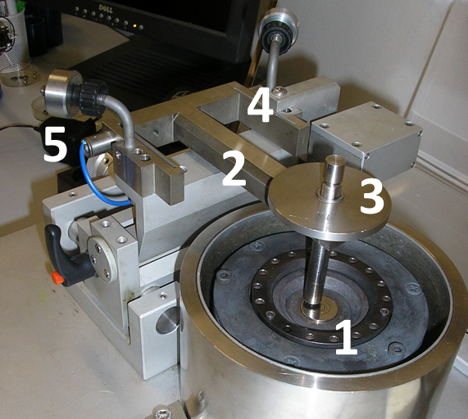

Fig. 1a

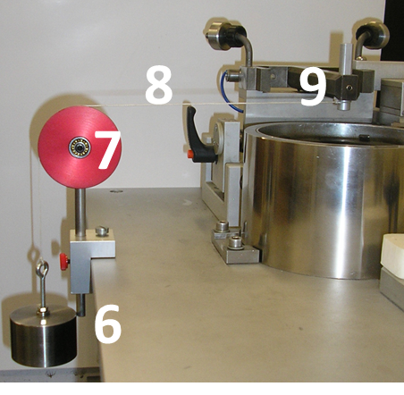

Fig. 1 b

Fig. 1 Tribometer measuring head and scheme of calibration: 1 - pin, 2 – stiff lever, 3 – dead weight, 4 – elastic arm, 5 – inductive displacemant transducer, 6- dead weight 5 N, 7 *–* pulley, 8 *­–* string, 9 – pin holder (stiff lever)

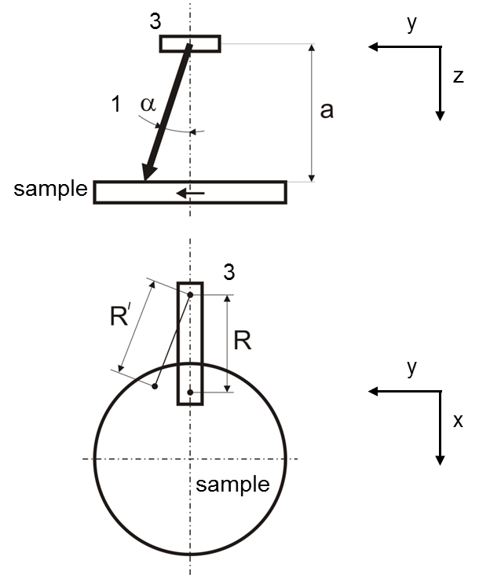

Fig. 2a

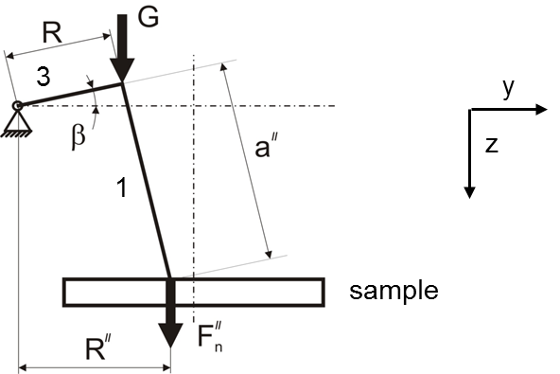

Fig. 2b

Fig. 2 Geometry of pin misalignments. G is the gravitation force produced by dead weight. The numbers corresponds to Fig. 1.

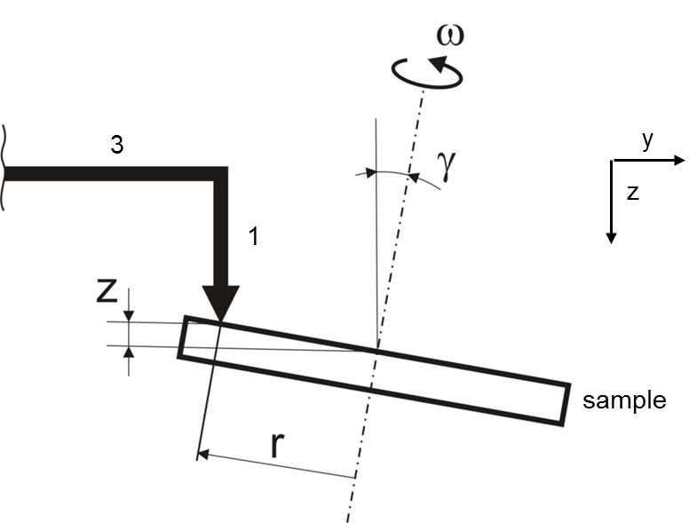

Fig. 3 Geometry of sample misalignment.



Fig. 4a



Fig. 4b

Fig. 4 Typical cross-sections of the DLC wear tracks measured by optical profilometer (offset applied) (a). Selected cross-section demonstrating that neither border of the wear track (R1 or R2) nor original profile (P1 or P2) could be easily defined.

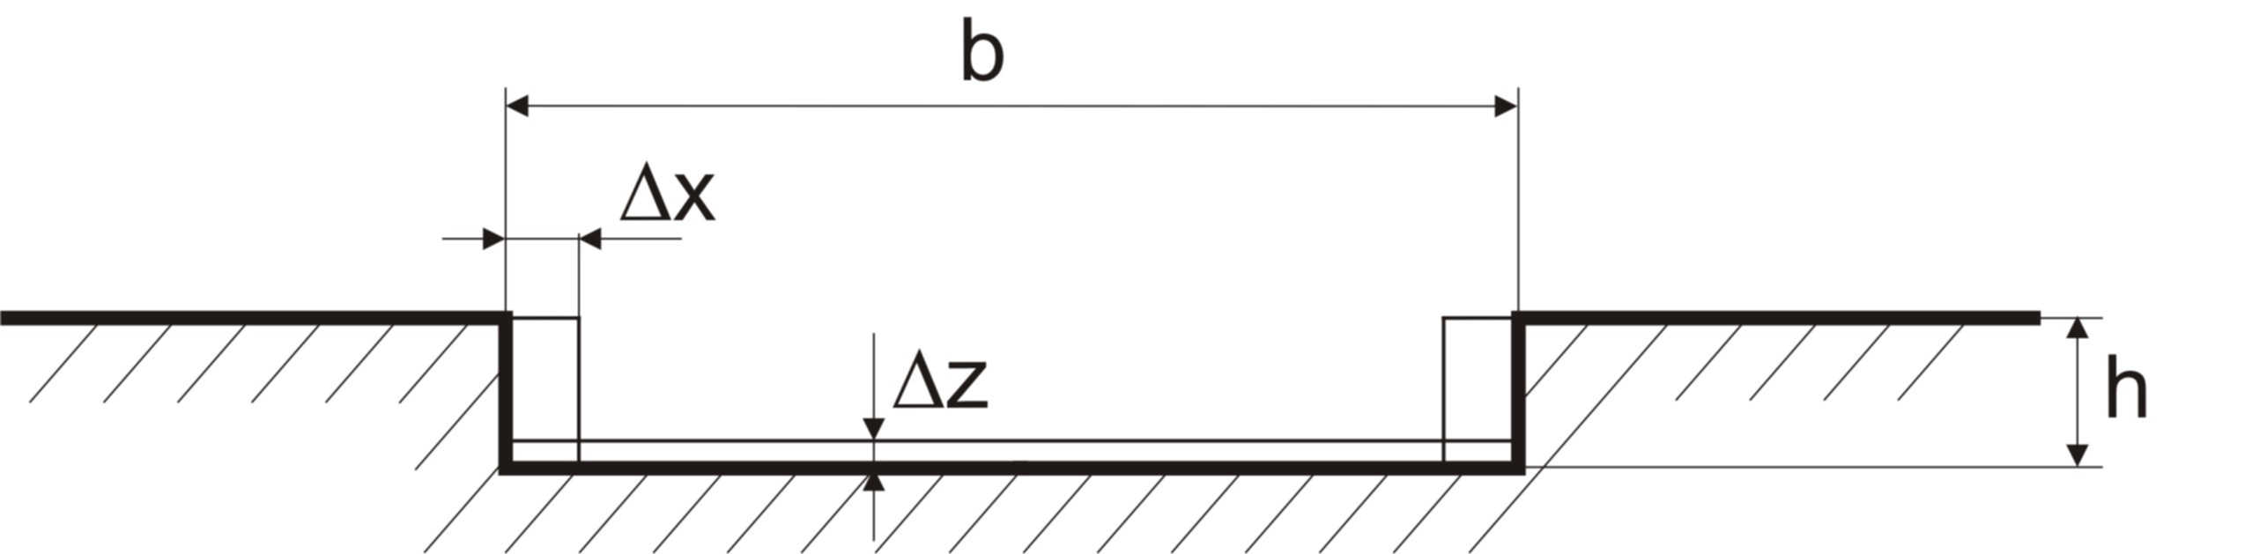

Fig. 5a

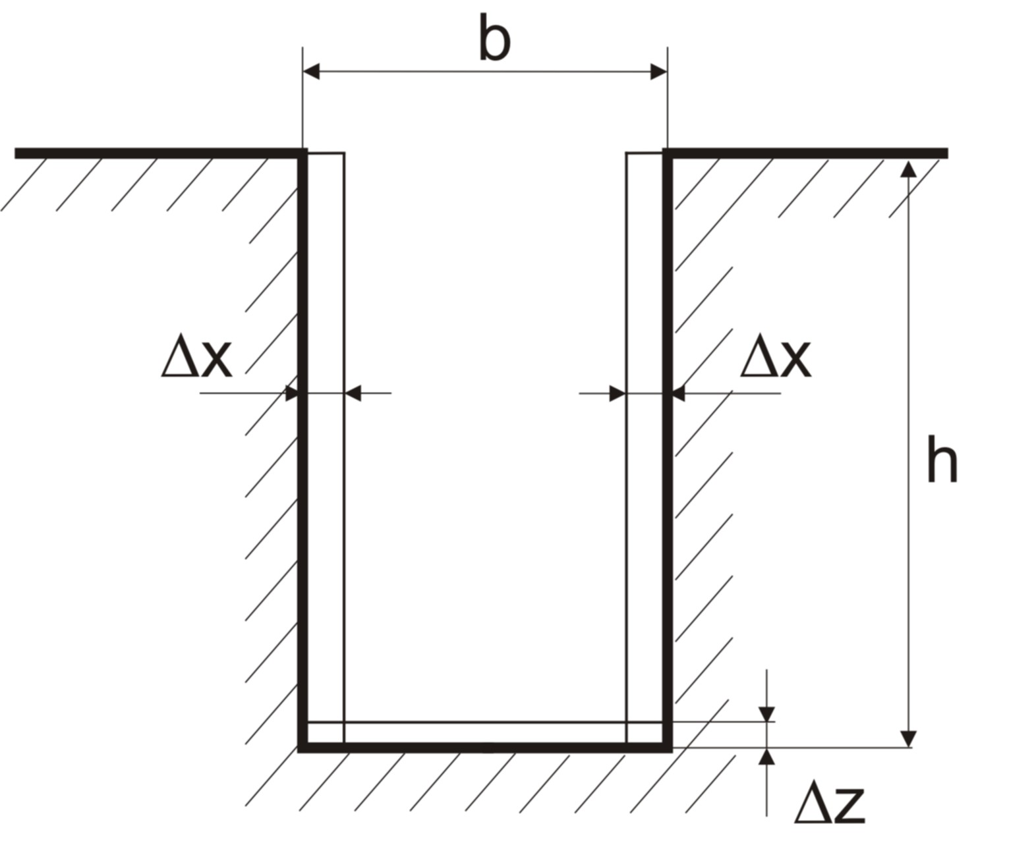

Fig. 5b

Fig. 5 Cross section of a) shallow and b) deep wear track.



Fig. 6 TiN – the effect of the wear track radius on friction coefficient *µ* and wear rate *w*.

1. [] ISO: Guide to the expression of uncertainty in measurement, Corrected and Reprinted

   1995
2. [] NIST Technical Note 1297, 1994 Edition
3. [] Sehgal, R., Gandhi, O.P., Angra, S., Wear evaluation and ranking of tribomaterials using

   a Haasse diagram approach, J. Tribol. 123 (2001) 486-493
4. [] Ransom, D., Li, J.L., Andres, L.S., Vance, J., Experimental force coefficients of a two-bladed labyrinth seal and a four-pocket damper seal, J. Tribol. 121 (1999) 370-376
5. [] Tieu, A.K.,Qiu, Z.L:, Experimental study of freely alignable journal bearings. 1. static characteristics, J. Tribol. 118 (1996) 498-502
6. [] Schmitz, T.L., Action, J.E., Ziegert, J.C., Sawyer, W.G., The difficulty of measuring low friction uncertainty analysis for friction coefficient measurements, J. Tribol. Trans. ASME 127 (2005) 673-676
7. [] Burris, D.L., Sawyer, W.G., Addressing practical challenges of low friction coefficient measurements, Tribol. Lett. 35 (2009) 17-23
8. [] Krick, B.A., Sawyer, W.G., A little analysis of errors in friction for small wear tracks, Tribol. Lett. 39 (2010) 221-222
9. [] Burris, D.L., Sawyer, W.G., Measurement Uncertainties in Wear Rates. Tribol. Lett. 36 (2009) 81–87
10. [] Schmitz, T.L., Action, J.E., Burris,D.L., Ziegert, J.C., Sawyer, W.G., Wear-rate uncertainty analysis, J. Tribol. Trans. ASME 126 (2004) 802-808
11. [] Dorsch, R.G., Häusler, G., Herrmann, J.M., Laser triangulation: fundamental uncertainty in distance measurement, Appl. Optics 33 (1994) 1306-1314
12. [] Fleischer, M., Windecker, R., Tiziani, H.J., Theoretical limits of scanning white-light interferometry signal evaluation algorithms, Appl. Optics 40 (2001) 2815-2820
13. [] Pavlicek, P., Soubusta, J., Theoretical measurement uncertainty of white-light interferometry on rough surfaces, Appl. Optics 42 (2003) 1809-1813
14. [] Colbert, R.S., Krick, B.A., Dunn, A.C., Vail, J.R., Argibaz, N.,Sawyer, W.G., Uncertainty in pin-on-disk wear volume measurements using surface scanning techniques, Tribol. Lett. 42 (2011) 129-131