Cite this: DOI: 10.1039/x0xx00000x
Received 00th January 2012,
Accepted 00th January 2012
DOI: 10.1039/x0xx00000x
www.rsc.org/
Anion sensing by small molecules and molecular ensembles
Philip A. Gale*^{,acd} and Claudia Caltagirone*^{,b}
This tutorial review provides a short survey of anion sensing by small molecule anion receptors, molecular ensembles and chemodosimeters. The review highlights the many different sensing mechanisms and approaches employed by supramolecular chemists and the wide structural variety present in these systems.

Introduction
The development of small molecule anion sensors has been an area attracting significant attention over the last 25 years. This has been driven by the important roles anions play in biology and industrial processes, in addition to the need to produce new methods of sensing anionic pollutants in the environment.
Three main approaches have been used. Early systems from pioneers such as Paul Beer consisted of an anion-binding site formed from hydrogen bond donor groups that are arranged close to a redox-active ‘reporter’ group such ferrocene or a fluorescent group such as ruthenium trisbipyridyl. When an anion bound to the hydrogen bond donor array, the electronic properties of the reporter group were perturbed resulting in a change in the redox or fluorescent properties of the receptor are perturbed so allowing the anion to be detected.¹ Many sensors for anions have been subsequently developed using these principles.
Another important approach used in anion sensing is to employ a displacement assay. This method, pioneered by Eric Anslyn,² involves forming a complex between an indicator and a receptor via non-covalent interactions. The target anionic guest binds to the receptor and so displaces the indicator. This changes the microenvironment around the indicator resulting in perturbations to its fluorescent properties and/or colour allowing the anion to be detected.
The other important mechanism by which anionic species can be sensed by small molecules is by chemical reaction generating a new species with different properties. So-called chemodosimeters can give very selective responses to particular anionic guests.³
As interest in this area has grown, the selectivity of sensors has improved and sensors have moved out of the laboratory finding application in a number of areas including in sensing anionic species in vivo. In this tutorial review we will examine a range of different small molecule anion sensors and the mechanisms by which they operate.

Hydrogen bonding sensors
As mentioned in the introduction coupling a reporter group to a hydrogen-bonding array is an effective strategy in designing an anion sensor.¹ Gunnlaugsson and co-workers have designed and synthesised a wide variety of colorimetric and fluorescent anion sensors using this approach⁴ and particularly, recently, based upon the 1,8-naphthalimide subunit.⁵ For example, compound 1 was designed as a fluorescent anion sensor that functions by a photoinduced-electron transfer (PET) mechanism. This compound contains a fluorescent 1,8-nathphalimide group tethered to an anion-binding thiourea.⁶ Upon addition of fluoride or acetate anions in DMSO solution the fluorescence of compound 1 is switched off. Gunnlaugsson proposed that this is due to photoelectron transfer from the receptor unit to the fluorophore due to anion complexation increasing the reduction potential of the receptor and so making PET more favourable. When methanol was added to the solution it disrupted the hydrogen bonds between the thiourea group and the anionic guest resulting in the fluorescence being restored. Interestingly when multiple equivalents of fluoride were added the colour of the solution in DMSO changed from a light yellow to deep purple colour. The authors showed that this was due to deprotonation of the 4-amino moiety on the naphthalimide group (due to formation of HF₂⁻). Thus this sensor can operate via a dual sensing action – at low equivalents of anions the fluorescence is quenched but at high fluoride concentration there is a colorimetric response.
In 2001 in a landmark paper Miyagi and Sessler reported that a series of commercially available or ‘off-the-shelf’ compounds can function as colorimetric anion sensors in organic solution.⁷ The authors demonstrated that a range of compounds containing hydrogen bond donor groups when dissolved in dichloromethane or DMSO would undergo significant naked-eye detectable colour changes in the presence of 100 equivalents of a tetrabutylammonium anion salt (Scheme 1). The most notable colour changes occurred upon addition of the most basic anions (Figure 1) suggesting that the compounds are interacting with the anions via hydrogen bonding interactions or are being deprotonated by the anionic guests. This work was important as it showed that very simple systems could be used as colorimetric sensors functioning via a charge transfer from the binding site to the chromophore.
Scheme 1 Examples of commercially available colorimetric anion sensors. A checked box indicates a naked-eye detectable change in colour is observed in the indicated solvents upon addition of 100 equivalents of the anionic analyte in question.

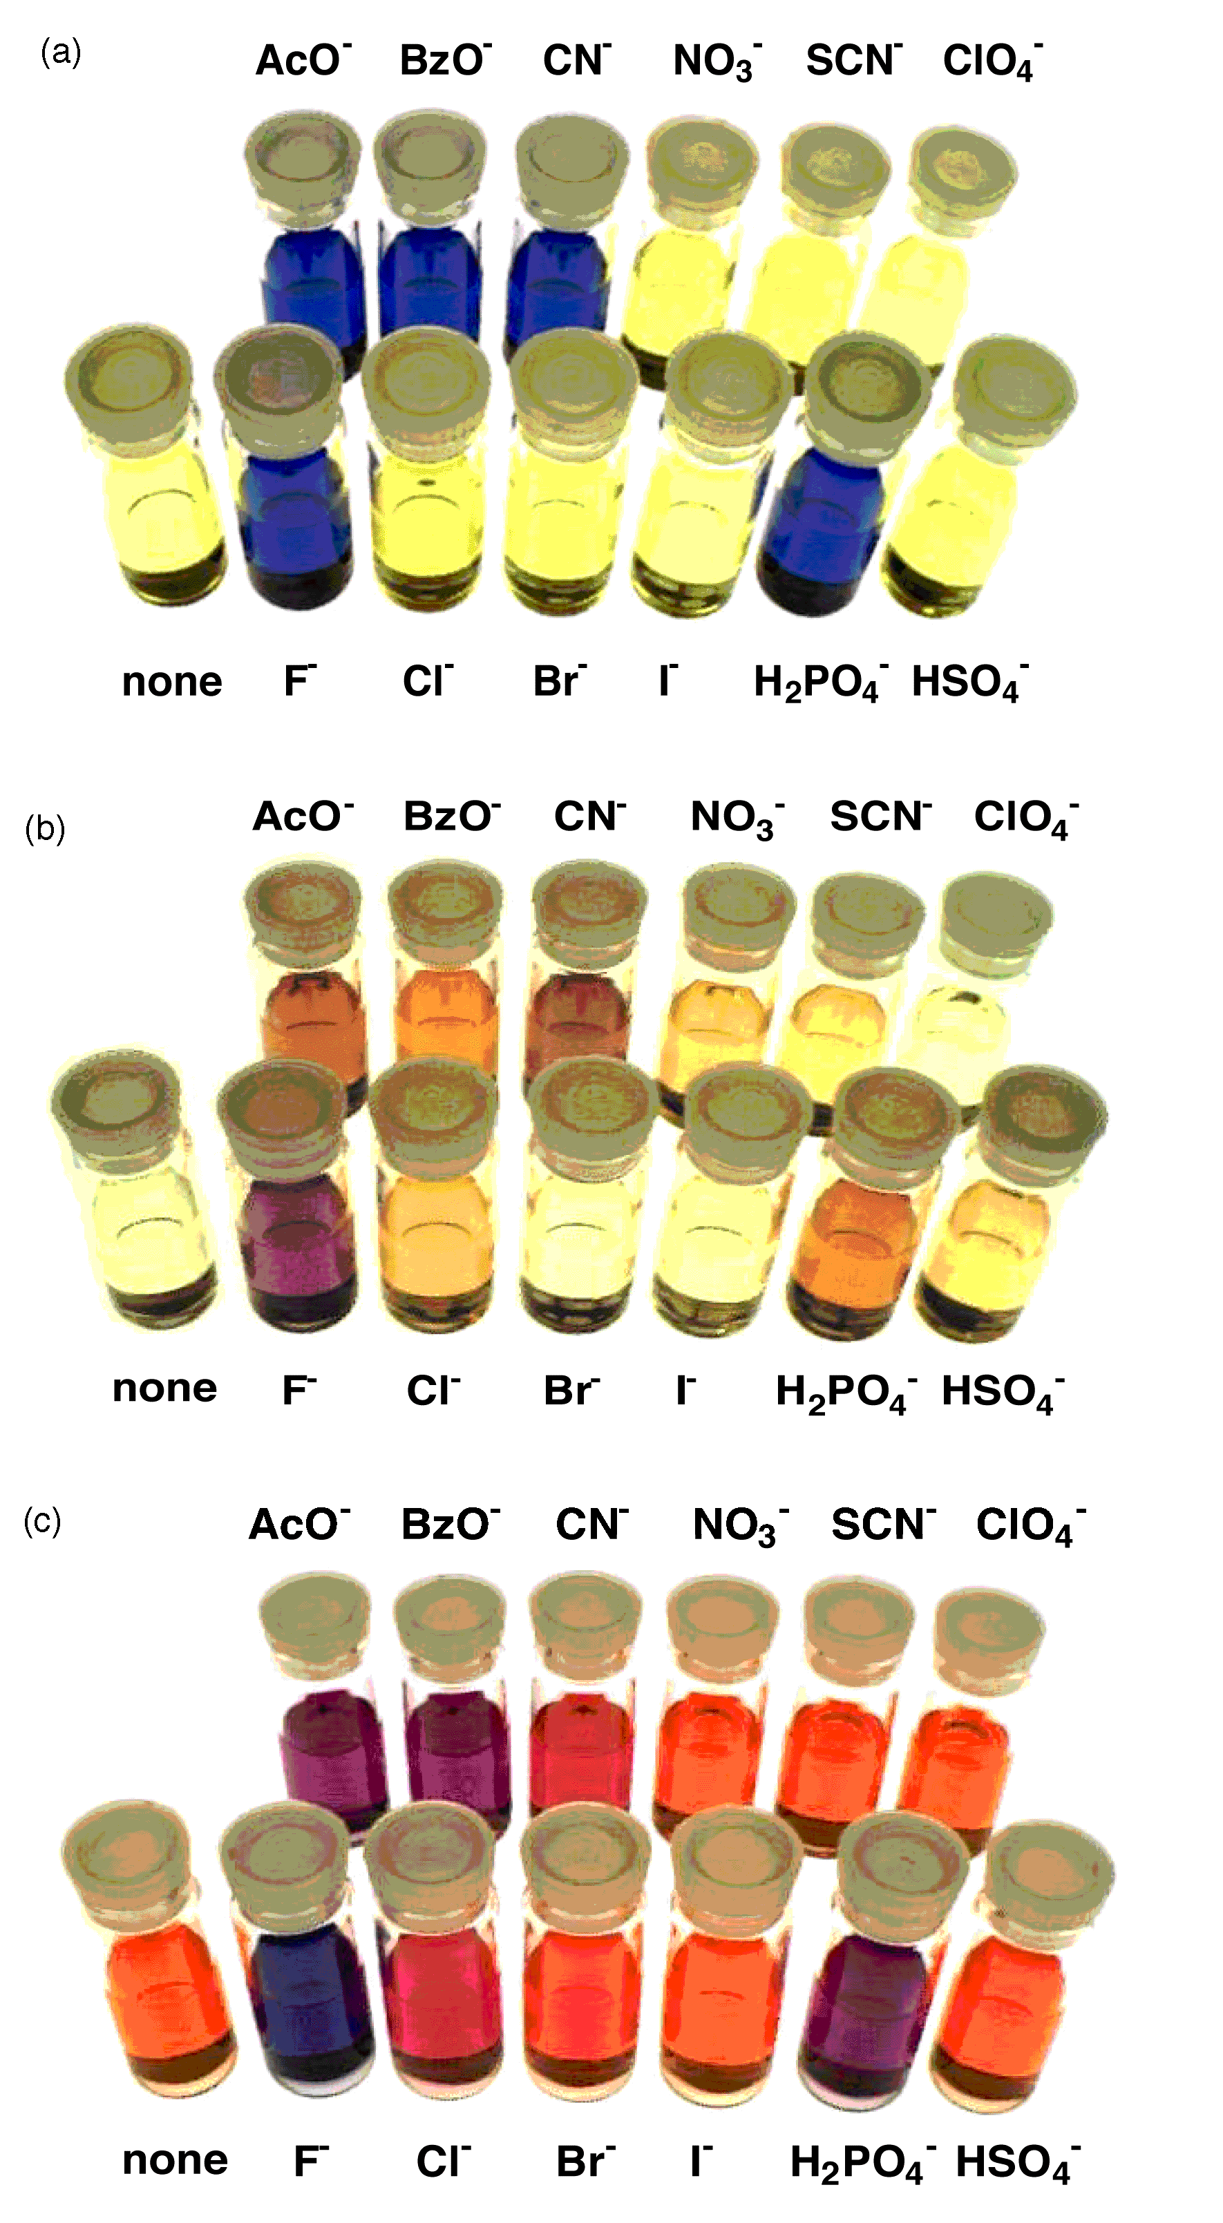
Figure 1 (a), Alizarin, (b) 2,2-bi(3-hydroxy-1,4-naphtoquinone and (c) 1,2-diaminoanthraquinone in acetonitrile (1 x 10⁻⁴ M) in the presence of 100 equivalents of tetrabutylammonium anion salt. Reproduced with permission from Angew. Chem. Int. Ed. Engl. 2001, 40, 154-157. Copyright 2001 Wiley-VCH.
Vilar and co-workers have used similar compounds to produce a cyanide sensor.⁸ The group synthesised compounds 2 and 3 both containing a thiourea group linked to an azophenyl group. The compounds were found to respond to anions in a similar fashion. The colorimetric response of compound 2 to a range of anions is shown in Figure 2 in methanol (top) and DMSO (bottom). Interestingly in methanol the compound was found to give a selective response to cyanide resulting from a shift of the π-π* transition of the 4-nitroazophenyl group from 390 to 414 nm).
Scheme 2 The synthesis of thioureas 2 and 3.
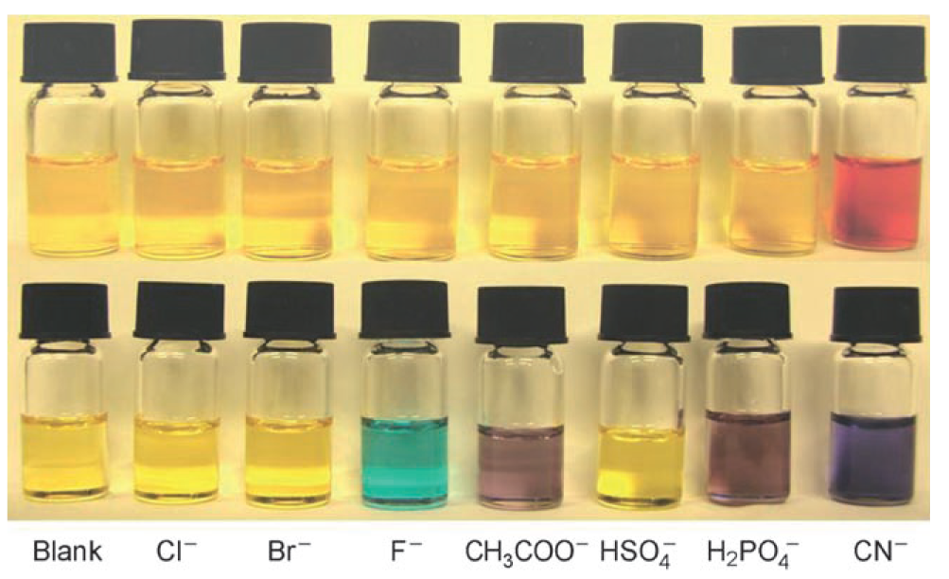
Figure 2 Solutions of compound 2 (0.5 mM) with different anions (30 equiv.) in methanol (top) and DMSO (bottom). Reproduced with permission from Chem. Eur. J. 2008, 14, 3006-3012. Copyright 2008 Wiley-VCH.

Mesoporous Al₂O₃ films were prepared and loaded with compound 2. Below pH 9 the surface of film is positively charged and hence can interact strongly with the carboxylate moiety present in compound 2. The film was immersed in 5mM aqueous solutions of different anions and once again a selective response to cyanide was observed (Figure 3) with a detection limit of 2.6 ppm.

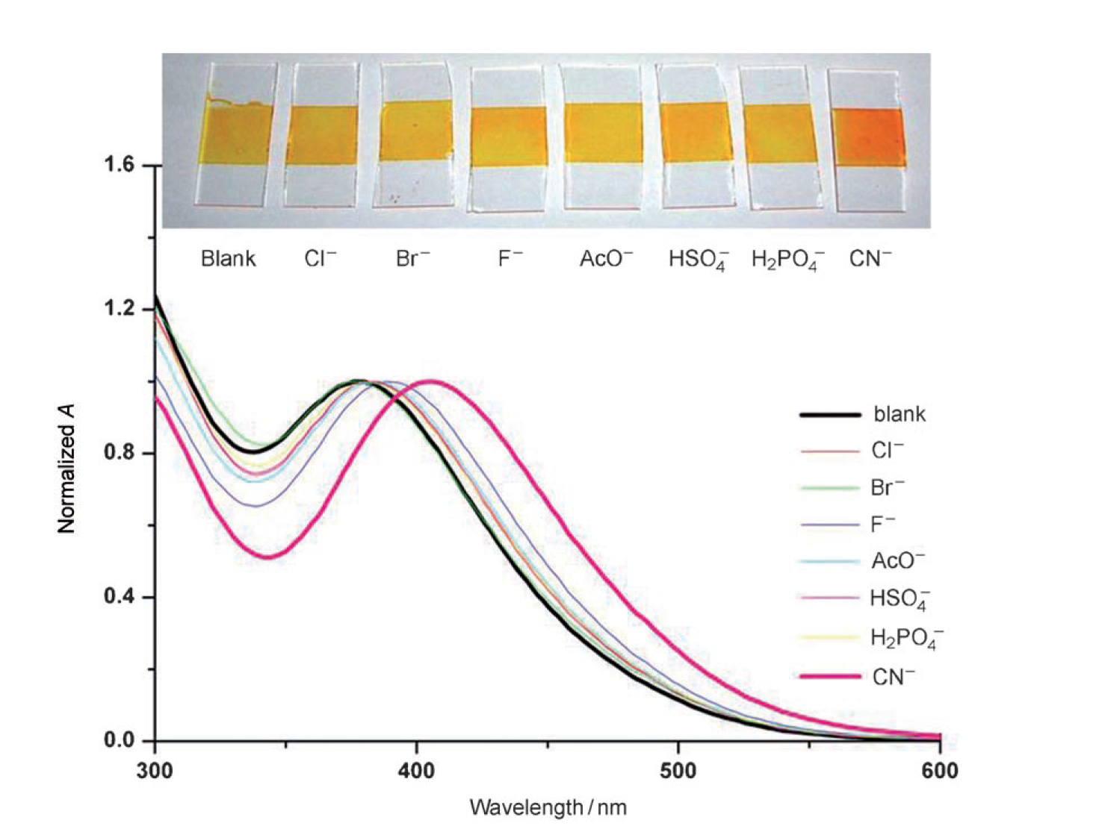
Figure 3 Normalised absorption spectra of 2/Al₂O₃ films immersed in 5 mM aqueous solutions of different anions. Reproduced with permission from Chem. Eur. J. 2008, 14, 3006-3012. Copyright 2008 Wiley-VCH.

Johnson, Haley and co-workers have explored the fluorescent properties of a series of sixteen differently substituted 2,6-ethynylpyridine bisphenylurea compounds containing a range of electron withdrawing and electron donating substituents (Scheme 3).⁹ From the library of compounds prepared, it was found that compound 13d containing electron-withdrawing pentafluorophenyl substituents was not emissive in its unbound state but in the presence of 1 equivalent of chloride the fluorescence was “switched on” (Figure 4). The authors are continuing to investigate the cause of this fluorescence.

Scheme 3 Synthesis of sixteen differentially substituted 2,6-ethynylpyridine bisphenylurea scaffolds.

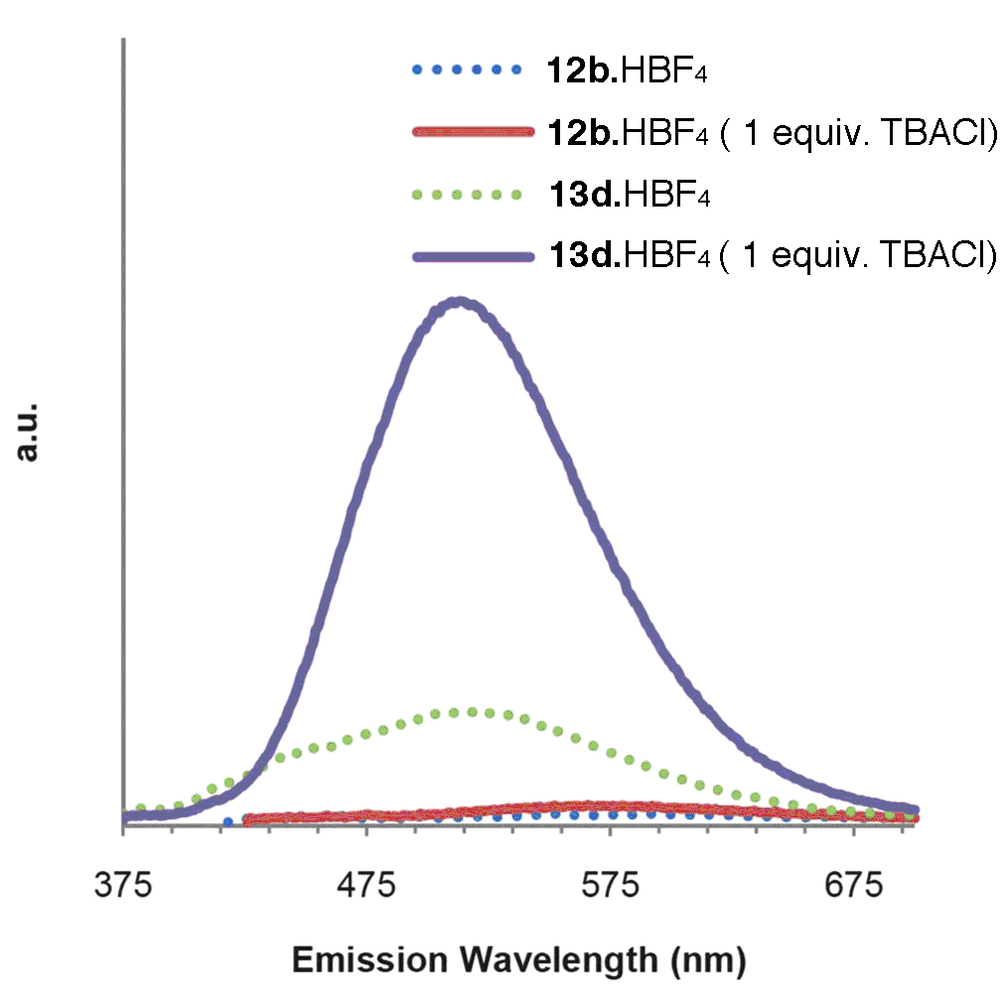
Figure 4 Emission spectra of 12b.HBF₄ and 13d.HBF₄ before addition of TBACl (dotted lines) and after addition of TBACl in acetonitrile solution. Compound 12b.HBF₄ was excited at 416 nm, and compound 13d.HBF₄ was excited at 365 nm. Reproduced with permission from Chem. Sci. 2012, 3, 1105-1110. Copyright Royal Society of Chemistry 2012.

Excimer formation
An excimer results from the interaction of fluorophores – one in an excited state and one in the ground state and can arise either from the association between two separate species or from two parts of the same molecule.¹⁰ The excited state energy of the resulting dimer is lower than that of the excited monomer, resulting in an emission band in the fluorescence spectrum at lower energies with respect the non-associated molecules or fragments of molecules. Excimers are often observed in the case of aromatic or heteroaromatic units containing extended conjugated π-systems, such as naphthalene, pyrene, acridine, and their derivatives,¹¹ which interact with one another via π-stacking pairing.
Teramae and co-workers have reported a pyrene-functionalised guanidinium receptor 16.¹² In methanol, in the presence of pyrophosphate (PPi), receptor 16 displays a broad emission band at 400 nm assigned to monomer emission and a structureless band at 476 nm due to the formation of an intermolecular excimer (Figure 5) as two of the guanidinium functionalised pyrene units complex to a single pyrophosphate anion (Scheme 4).
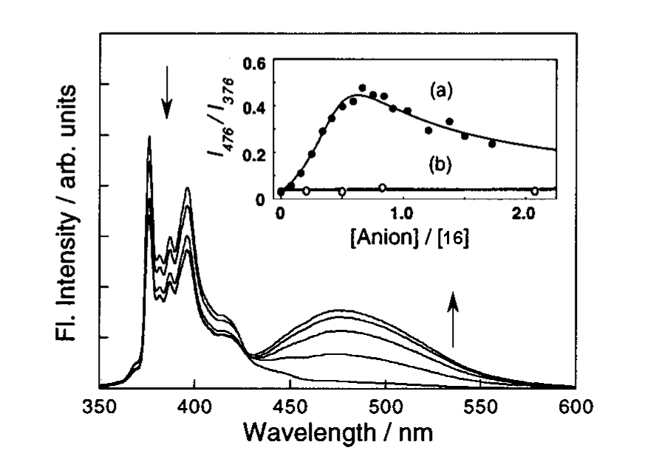
Figure 5 Fluorescence spectra of 16⁺ upon addition of pyrophosphate added as the [K+[18]crown-6] salt. [16⁺] = 8.0 x 10⁻⁴ M in non-degassed methanol. Excitation wavelength 312 nm. Inset: Dependence of I₄₇₆/I₃₇₆ on the concentrations of (a) PPi and (b) H₂PO₄⁻. Reproduced with permission of J. Am. Chem. Soc., 1999, 121, 9463. Copyright 1999, American Chemical Society).
Scheme 4 Formation of a 2:1 complex between cation 16 and pyrophosphate.
Suzuki and co-workers have synthesized a γ-cyclodextrin (CD) derivative 17 in which a triamine linker connects a pyrene residue to a γ-CD (Scheme 5). At pH 8.6 17 exhibits the typical fluorescence emission of pyrene around 370-400 nm with a strong excimer emission at 475 nm due to the formation of a dimer of two units of 17 causing a π-π interaction with two pyrene moieties in a parallel conformation (Scheme 5). Upon addition of different anionic species (Cl⁻, SO₄²⁻, HPO₄²⁻, AcO⁻, ClO₄⁻, NO₃⁻, and HCO₃⁻) only in the presence of bicarbonate does a new fluorescence band centered at 425 nm appear. The changes observed in the fluorescence properties of the association dimer of 17 were ascribed by the authors to a change of the relative position of pyrene rings of the dimer that pass from a parallel conformation to a twisted and imperfectly stacked conformation as bicarbonate binds to the protonated ammonium strap between the cyclodextrin and the pyrene unit (Scheme 5).

Scheme 5 The proposed mechanism of bicarbonate sensing by cyclodextrin 17 in water.

Interlocked systems

Various examples of anion sensing via interlocked systems, rotaxanes in particular, have been reported in the literature. A recent review by Beer and coworkers describes various examples of redox active or photoactive sensors.¹³
The first example of a redox-active interlocked system (18), able to act as an electrochemical sensor for anions was reported by Beer in 2011.¹⁴ This compound is a [2]rotaxane containing a ferrocene group attached to the isophthalamide moiety of the macrocyclic component of the rotaxane. Chloride was used as a template around which the components of the rotaxane were assembled. It was then removed in the final step of the synthesis. The rotaxane was shown to be selective for chloride over more basic oxoanions such as hydrogen sulfate and dihydrogen phosphate in CDCl₃:CD₃OD (1:1 v/v) by ¹H NMR spectroscopy with association constants of 4200 M⁻¹, 1560 M⁻¹ and 640 M⁻¹ for Cl⁻, HSO₄⁻, and H₂PO₄⁻, respectively. The chloride binds to the four amide groups in the tetrahedral cavity formed by the NH groups. A cathodic shift of 20 mV of the ferrocene/ferrocenium redox couple was observed upon addition of chloride in MeCN at a 1:1 18:Cl⁻ molar ratio (Figure 6a) with a negligible further shift on addition of further aliquots of chloride while addition of oxoanions causes a continuous shift in the ferrocene/ferrocenium redox couple (Figure 6b).

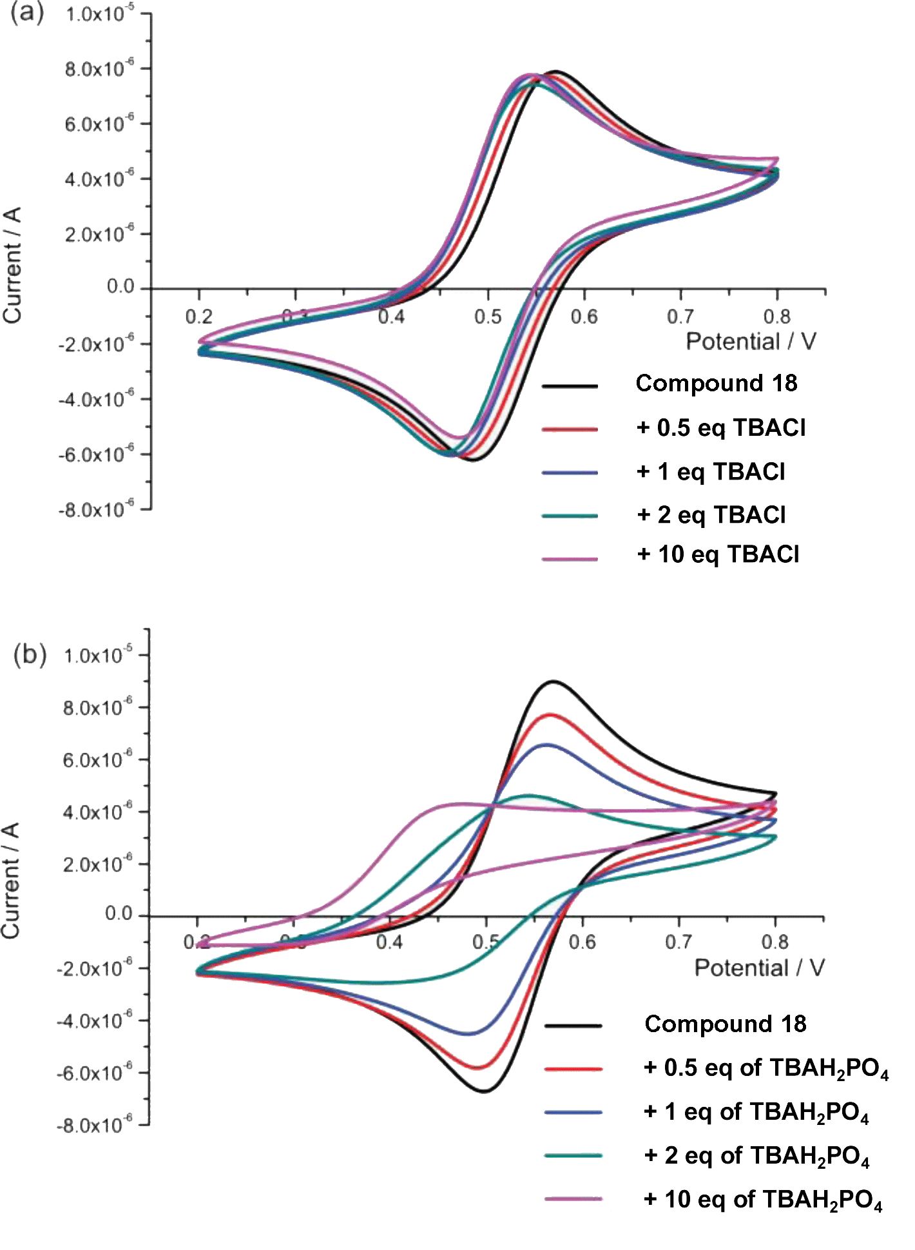
Figure 6 Cyclic voltamograms of rotaxane 18+PF₆⁻ in 0.1 M TBAPF₆/CH₃CN upon the addition of aliquots of (a) TBACl and (b) TBAH₂PO₄ (Ag/AgCl reference). Reproduced with permission Org. Biomol. Chem., 2011, 9, 92. Copyright 2011, RSC.
More recently the same research group have synthesized and studied the first examples of redox-active ferrocene catenanes sensors that selectively respond to chloride both in solution and on self-assembled monolayers (SAMs).¹⁵
Examples of photoactive sensors have also been recently reported.¹⁶ In particular Smith and coworkers have described the sensing properties of a squaraine rotaxane shuttle as a ratiometric chloride sensor (19).¹⁷ Rotaxane 19 shows a colour change from green to blue in the presence of chloride in acetone. The fluorescence emission band of free rotaxane at 698 nm decreases and a new band at 665 nm appears in the presence of chloride. Authors ascribe the observed changes in the emission properties of the 19 to the binding of chloride by the isophthalamide NH groups and the OH group present on the axle that induces a small-amplitude lateral displacement of the surrounding anthracene macrocycle away from the encapsulated squaraine station as shown in Figure 7. An analogous rotaxane was synthesized without the OH groups and this was found not to respond colorimetrically to the presence of chloride.

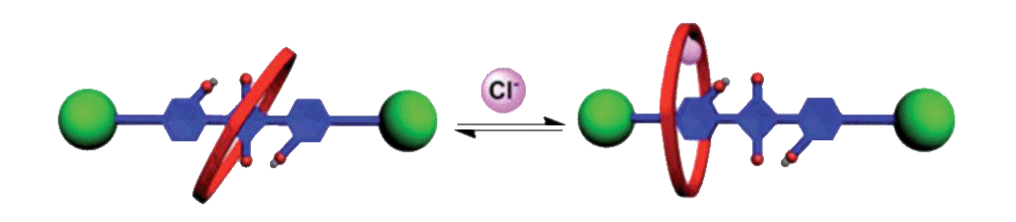
Figure 7 Schematic summary of the structural change induced 19 in the presence of chloride. Reproduced with permission Chem. Sci., 2013, 4, 2557. Copyright 2011, RSC.
A chloride-sensing dipstick was also fabricated by adsorbing rotaxane 19 onto C18-coated silica gel TLC plates. As shown in Figure 8 upon immersion of the dipstick in an aqueous solution of chloride a change both in the colour and in the emission of the system is observed. The observed changes are reversible.
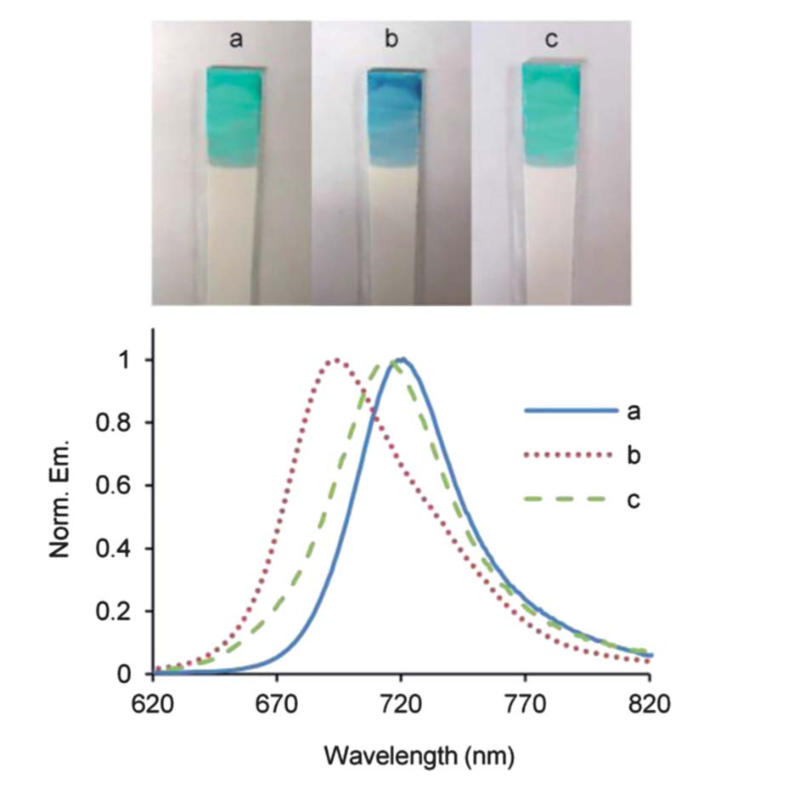
Figure 8 (Top) Photographs of the same dipstick treated with compound 19 during the following sequence: (a) before immersion, (b) after immersion in aqueous TBACl (1 M), (c) after aqueous washing. (Bottom) Fluorescence spectra (ex: 600 nm) of the dipstick surface at the same time points confirm the blue shift of emission maxima induced by TBACl and subsequent reversal after washing. Reproduced with permission Chem. Sci., 2013, 4, 2557. Copyright 2011, Royal Society of Chemistry.

Anion-pi interactions in sensing
The non-covalent interactions between an anion and an electron-deficient aromatic ring (anion-π interaction) have been theoretically described by Ballaster,¹⁸ Mascal,^{19a} Alkorta^{19b} and Hay²⁰ and, since then, various examples of recognition,²¹ transmembrane transport²² and sensing²³ based on this non-classical interaction have been reported.
In particular Saha and Guha have described the fluoride sensing via anion-π interaction and charge/electron transfer, CT/ET) by a π-electron deficient naphthalenediimide (NDI), 20. ²⁴ When a small amount of anion (0→5 equivalents) is added to a solution of 20 a colour change from colourless to orange is observed. This was ascribed by the authors to a F⁻ → 20 ET event depending on a strong interaction between lone pair electrons of the anion and the π∗ orbitals of the NDI. The orange colour was attributed to the formation of a radical species NDI^{•-}. Further addition of fluoride up to 30 equivalents causes a reduction of the receptor to the dianion NDI²⁻ resulting in a colour change from orange to pink as shown in Figure 9. Similar behaviour was observed with a bis-amide and tetra-amide receptors containing two NDI units. The presence of two NDI units allows a better selectivity and sensitivity for fluoride with the formation of a more efficient π-anion-π interaction.

Figure 9 (Top) An illustration of proposed anion-π and CT interactions between F⁻ and receptor 20 generating a colorimetric sensing (bottom). (Reproduced with permission of JACS, 2010, 132, 17674, Copyright 2010, ACS).

Metal complexes
One of the most useful strategies for binding anions and that allows anion sensing in competitive solvent media is the use of metal complexes. The metal can play two main different roles: it can induce a geometrical pre-organisation of the complex that results in a better host-guest complementarity, or it can act as binding site for the anion forming a strong coordinate bond.²⁵
An example of a colorimetric sensor for iodide and cyanide based on a coordinatively unsaturated copper(II) complex containing the tetradentate ligand 1-(2-quinolinylmethyl)-1,4,7-triazacyclononane) (21) was reported by Caltagirone and Lippolis.²⁶ This complex is able to recognise the presence of iodide and cyanide in MeCN because the anion is able to bind to the unsaturated copper centre and cause a colour change from light blue to dark blue, pink and green upon addition of 1 equivalent of CN⁻, two equivalents of CN⁻ and 1 equivalent of I⁻, respectively (Figure 10). Interestingly, in water only addition of cyanide results in a colour change.

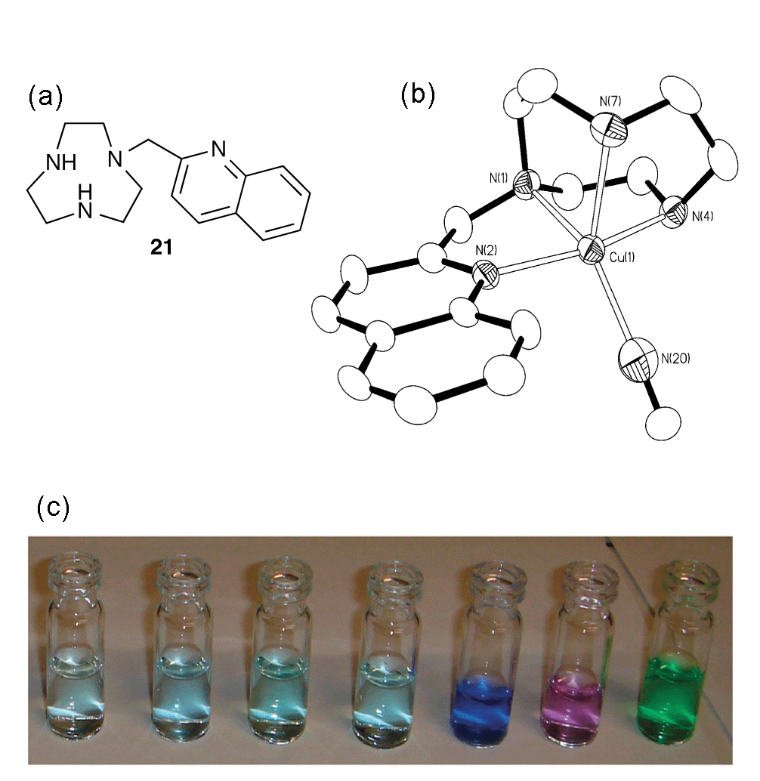
Figure 10 a) The structure of receptor 21, b) the single crystal X-Ray crystal structure of the complex cation [Cu(21)CN]⁺ (hydrogen atoms and BF₄⁻ counter ion have been omitted for clarity) and c) Colour change of the copper complex (1.00 x 10⁻³ M) after addition of different anions in MeCN. From left to right: 21, 21 + 1.0 equiv. F⁻, 21 + 1.0 equiv. Cl⁻, 21 + 1 equiv. Br⁻, 21 + 1 eq of CN⁻, 21 + 2 eq of CN⁻, 21 + 1 eq of I⁻. Reproduced with permission from Chem. Commun. 2011, 47, 3805. Copyright 2011 RSC.
Lanthanide complexes are very effective platforms for anion sensing in water. Anions can displace the water molecules that normally occupy the vacant coordination site on the lanthanide in heptadentate ligands. If the ligand bears a chromophore, anion binding to the lanthanide can cause a change in the spectral properties of the system that can be used to sense the anion.
Various examples of anion sensing via binding to lanthanide complexes have been recently reviewed by Parker.²⁷ For example, Parker and co-workers have described the behaviour of the europium complex 22 in sensing bicarbonate in water.²⁸ At pH 7.4 complex 22 is able to bind HCO₃⁻ with an apparent stability constant of log K = 3.85. Moreover, complex 22 is able to selectively stain the mitochondrial region of HeLa cells and to increase the image intensity upon increasing percentage of CO₂ as shown in Figure 11. The observed increase of Eu emission intensity with pCO₂ has been attributed to an increase in the steady state bicarbonate concentration in the mitochondrial region of the cells.
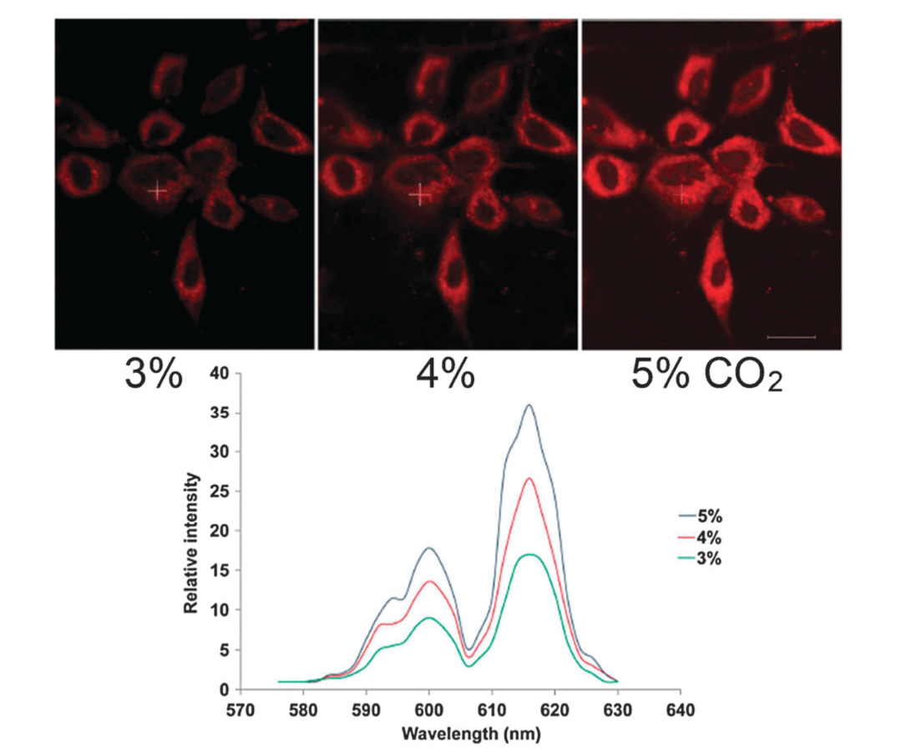
Figure 11 (Top) confocal microscopy image of HeLa cells showing mitochondrial region stained by 22 under 3, 4 and 5% of CO₂ (1 h incubation, 20 mM [complex], 30 min equilibration period between images); (bottom) Variation of lanthanide emission intensity from hyper-spectral analysis of microscopy images for HeLa cells stained with 22. Reproduced with permission Chem. Commun., 2011, 47, 7347. Copyright 2011, RSC.

Zinc-dipicolylamine-based sensors for phosphate
Several examples of synthetic zinc(II)-complexes able to work as receptors and optical sensors for phosphate anions have been reported in the literature. In particular, the dipicolylamino (DPA) moiety is one of the most commonly employed in such systems, due to the presence of three nitrogen donor atoms, allows a good selectivity for Zn²⁺ over other biologically relevant anions such as Na⁺, K⁺, Mg²⁺, and Ca²⁺, and leaves coordination sites free for anion binding. A review on anion recognition and sensing with Zn(II)–dipicolylamine complexes have been recently published by Jolliffe and co-workers.²⁹
A Zn(II)-DPA complex was used by Hamachi and co-workers was used as a fluorescent chemosensor (23) for phosphorylated peptides in neutral aqueous solution.³⁰ When the phosphorylated peptide-a, a Glu-rich peptide containing a p-Tyr residue (Glu-Glu-Glu-Ile-pTyr-Glu-Glu-Phe-Asp), was added in lower than 1 µM concentration to an aqueous solution of 23 at pH 7.2, an increase of 4 to 5-fold in the fluorescence emission of the anthracene moiety was observed (Figure 12). On the other hand, the control peptide, differing from peptide-a only in the lack of the phosphorylation of the Tyr residue, did not cause any change in the fluorescence properties of 23.
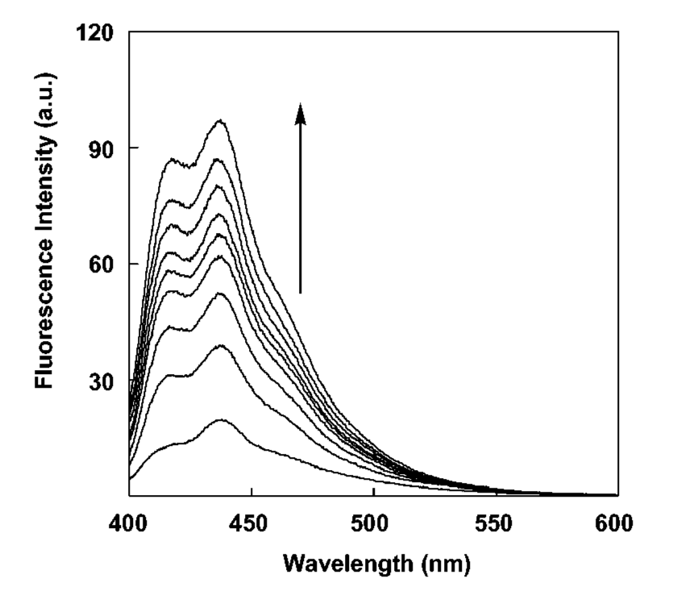
Figure 12 Fluorescent spectral change of 23 (0.5 μM) upon addition of peptide a: [peptide-a] = 0, 0.1, 0.2, 0.3, 0.4, 0.5, 0.75, 1.0, 1.5 μM in 50mM HEPES buffer (pH 7.2) at 20˚C, λ_{ex} = 380nm. Reproduced with permission J. Am. Chem. Soc., 2002, 124, 6256. Copyright 2002, ACS.

Yoon et al. have reported that fluorescent Zn(II)-DPA receptor 24 is able to recognize pyrophosphate over ATP, ADP, AMP, Pi, F⁻, Cl⁻, Br⁻, I⁻, AcO⁻, and HSO₄⁻ in aqueous solution at physiological pH.³¹ The recognition event depends on the formation of an excimer due (Figure 13) to the formation of a 2+2 type binding between 24 and PPi as shown in Scheme 6.
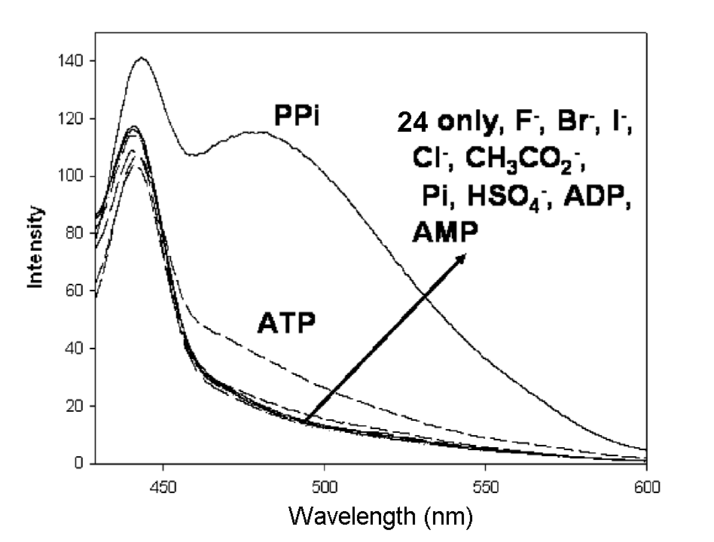
Figure 13 Fluorescent changes of 24 (6 μM) with various anions (10 equiv.) at pH 7.4 (0.01 M HEPES) (excitation at 383 nm). Reproduced with permission J. Am. Chem. Soc., 2007, 129, 3828. Copyright 2007, ACS.
Scheme 6 The proposed structure of the complex between of chemosensor 24 with PPi resulting in excimer formation.
Boron-based anion sensors

In 1967, Shriver and Biallas reported the first chelate complex between a chelating bis-boron compound and a methoxide anion.³² Since then, many examples of anion receptors containing Lewis acidic boron centres have been reported.³³ The first boron-based fluorescent chemosensors for fluoride recognition were reported in 1998 by James and coworkers. These compounds were aromatic boronic acids whose fluorescence is switched off upon addition of KF in 50% (w/w) methanol–water solution buffered to pH 5.5.³⁴ A more recent example reported by the same group of an OFF-ON fluoride sensor in water is based on a pyrene ring functionalized with a pyridyl boronic acid group (25).³⁵ The excimer emission of 25 is selectively enhanced upon addition of fluoride in dichloromethane (Figure 14). Sensor 25 in dichloromethane is also able to extract fluoride from aqueous solution, as shown in Figure 15), and can be used for fluoride detection in water at sub-ppm range.
Aldridge and co-workers have reported that ferrocenylboranes (26 and 27) allow colorimetric discrimination between fluoride and cyanide. ³⁶ Upon addition of tetrazolium violet (a redox-active dye) to a solution of 26 or 27 in the presence of fluoride or cyanide in MeCN/MeOH (>100:1 v/v) a colorimetric response can be observed. The choice of oxidant dye was made such that it will oxidise the anion adduct but not the free receptor. In particular the stronger Lewis acid 26 and tetrazolium violet gives a colorimetric response with both cyanide AND fluoride, whilst compound 27 and tetrazolium violet senses fluoride but NOT cyanide under the same conditions as shown in Figure 16.

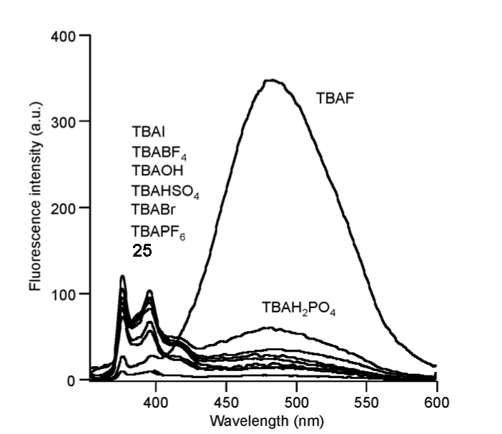
Figure 14 Fluorescence emission spectra of 25 (10 μM) upon addition of tetrabutylammonium salts of F⁻, Br⁻, I⁻, BF₄⁻, PF₆⁻, HSO₄⁻ and H₂PO₄⁻ (1.0 equiv., respectively) in dichloromethane. Reproduced with permission Chem. Commun., 2013, 49, 478. Copyright 2013 RSC.

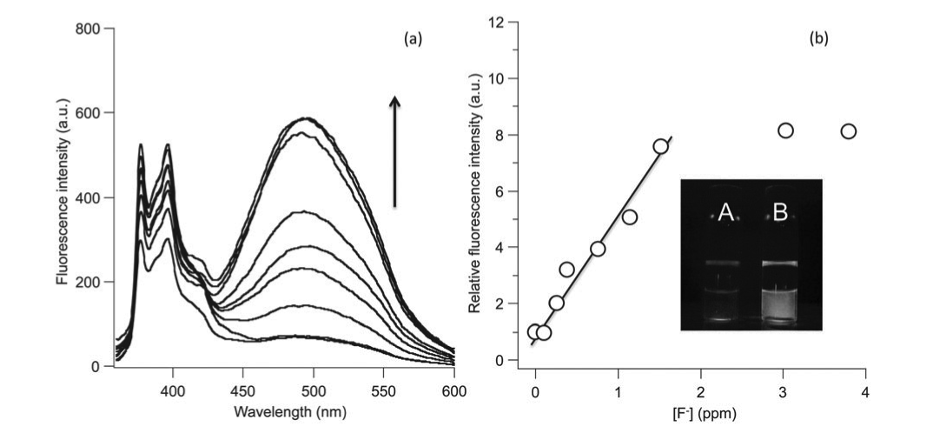

Figure 15 Biphasic extraction experiment of 25 (50mM) in dichloromethane with increasing concentration of NaF (0.10-3.80 ppm) in water. (a) The fluorescence profiles of 25. (b) The relative fluorescence intensity at 495 nm plotted against fluoride anion concentration. Inset: Photograph of vials containing sensor 25 (50 μM) exposed to aqueous solutions of NaF (52.6 μM, 1.0 ppm) before (A) and after shaking (B). Reproduced with permission Chem. Commun., 2013, 49, 478. Copyright 2013 RSC.

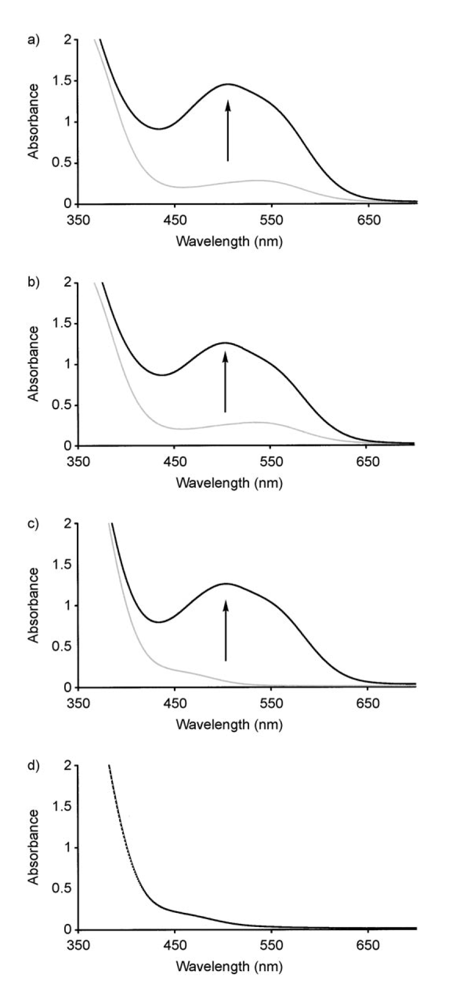
Figure 16 UV/Vis spectra of 26 and 27 and tetrazolium violet in the presence (black trace) or in the absence (grey trace) of fluoride or cyanide in MeCN/MeOH (>100;1 v/v): a) 26 + F⁻; b) 26 + CN⁻; c) 27 + F⁻; d) 27 + CN⁻. Reproduced with permission Chem. Eur. J., 2008, 14, 7525. Copyright 2008 Wiley-VCH.

Halogen bonding
Halogen bonding is increasing recognized as a fundamentally important interaction in supramolecular chemistry and has been employed by Beer and co-workers in a series of novel fluorescent anion sensors 28 that employ a combination of halogen bonding and electrostatic interactions to bind anionic guests.³⁷ Beer found that bromo-derivative 28c²⁺ and the syn conformation of the rotationally restricted iodo-derivative 28d²⁺ form strong 1:1 complexes with iodide and bromide anions in CD₃OD/D₂O (9:1). Binding was accompanied by a significant fluorescence enhancement making these compounds the first examples of halogen bond chemosensors to function in aqueous solvent mixtures. By contrast no evidence of anion sensing was observed by either the protic or chloro-analogues 28a2+ or 28b²⁺.

Chemodosimeters
The “chemodosimeter approach” for the design of chemosensors takes advantage of usually specific anion-induced reactions coupled with selective changes in fluorescence or colour.³⁸ When an anionic substrate reacts with a chemodosimeter it can remain covalently bound to it or the anion can catalyze a chemical reaction. In both cases the product formed is different from the starting material with changes in its optical properties allowing the anion to be detected.
Ahn and coworkers have synthesized an ortho-TFADA compound (29). The fluorescence of this compound is selectively switched on in MeCN in the presence of cyanide (Figure 15b) due to the formation of an intramolecular hydrogen bond in the host-guest adduct (Figure 17).³⁹ The authors propose the mechanism shown in Scheme 7 in which the reaction of CN⁻ with 29 causes the formation of the negatively charged carbonyl adduct stabilized by an intramolecular hydrogen bond between the carbonyl and the proton of the sulfonamide. This results in rigidification of the sensor and consequently a fluorescence enhancement.

Scheme 7
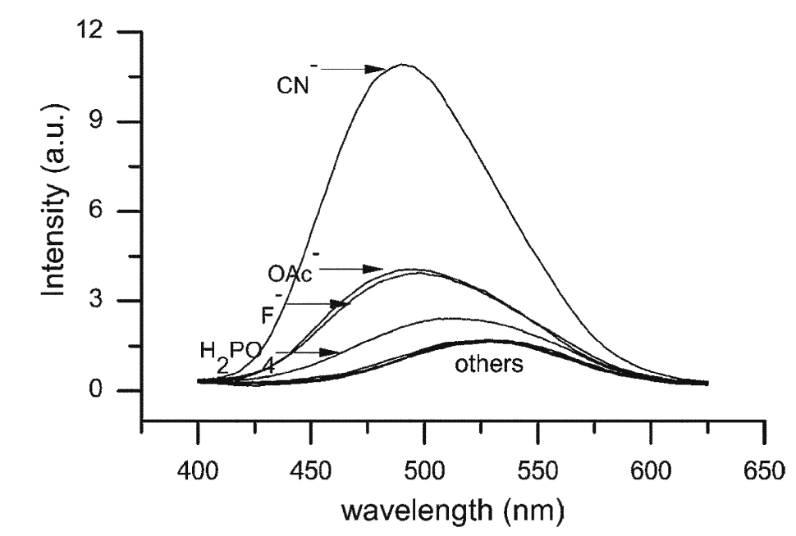
Figure 17 Changes in the fluorescent emission of 29 in the presence of different anions (equimolar mixture each component 20 μM). Reproduced with permission Chem. Commun., 2006, 186. Copyright 2006 RSC.
A simple colorimetric and fluorimetric chemodosimeter (30) for fluoride recognition containing a quinoline chromophore has been reported by Bai and co-workers.⁴⁰ A colour change from colourless to yellowish-green is observed upon addition of fluoride in THF and in wet organic solution. In the same solvent the blue fluorescence of 30 turns yellowish-green and it is switched on selectively by this anion. The addition of fluoride causes a desilylation of 30 (Scheme 8). An excited state proton transfer (ESPT) from the receptor to fluoride occurs that causes the optical changes observed. In the presence of other anionic guests no changes were observed (Figure 18).
A further example of a chemodosimeter (31a) for fluoride recognition containing a 1,8-naphthalimide moiety was reported more recently by Wu and co-workers.⁴¹ In this case, as shown in Scheme 9 when a moderate amount of fluoride is added to an acetonitrile solution of 31a the adduct [31a-F]⁻ is formed. A concomitant colour change from colourless to deep blue and the switching on of the fluorescence is observed. The addition of a large excess of fluoride causes the deprotonation of 31a.

Scheme 8 Desilylation of compound 30 by fluoride.

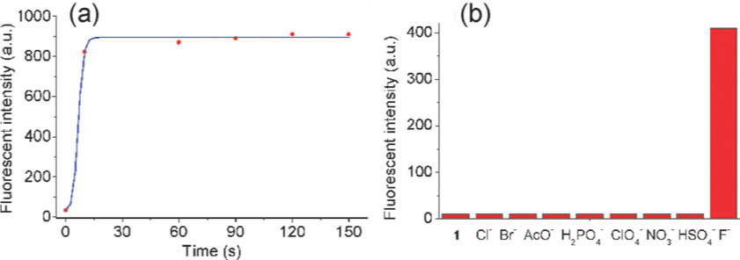
Figure 18 a) Effect of reaction time on the fluorescence intensity of the sensor system by F⁻: [30] = [F⁻]= 20 mM. (b) Fluorescence intensity of the sensor system at 520 nm in the presence of 10 equivalents of F⁻, Cl⁻, Br⁻, HSO₄⁻, ClO₄⁻ (TBA⁺ salts), NO₃⁻, AcO⁻, H₂PO₄⁻ (Na⁺ salts) in THF: [30] = 20 μM; λ_{ex} = 335 nm. Reproduced with permission Chem. Commun., 2011, 47, 3957. Copyright 2011 RSC.
At this point an in situ autoxidation occurs with the subsequent release of CN⁻. A new species 31b is formed which is colourless and not fluorescent. Thus, chemodosimeter 31a works as an OFF-ON-OFF ratiometric chromofluorogenic sensor for fluoride.
Scheme 9 Proposed mechanism for the spectroscopic changes of 31a in the presence of fluoride.

Displacement assays
Another strategy for anion sensing is the use of a displacement assay. In this approach the anion binding site is occupied by the signaling unit (such as a fluorescent or coloured dye) forming a molecular ensemble. The addition of the target anion to the solution containing the molecular ensemble causes the signaling unit to be displaced from the receptor. Consequently the signaling unit recovers its non-coordinating spectroscopic behaviour in solution. In order to design an efficient system the spectroscopic characteristics of the signaling unit should be different to those in its non-coordinating state; moreover the stability constant for the formation of the complex between the binding site and the signaling unit should be lower than that between the binding site and the analyte anion. This approach offers advantages such as the possibility to use a great variety of signaling units, depending on the purpose, as they are non-covalently attached to the binding site so a further functionalisation is not required. Moreover, they work well both in aqueous and organic solvents giving the possibility to tune the solvent media in order to obtain the desired K_{a} values for the signaling subunit and the analyte with the receptor. However, this type of sensor cannot be used to imaging tissues or cells because the signaling unit is present everywhere in the solution as it is not covalently attached to the receptor.² One of the first examples of a displacement assay for anions was reported by Anslyn and co-workers and it shown in Scheme 10.⁴² Receptor 32, based on 1,3,5-trisubstitued-2,4,6-triethylbenzene scaffold functionalised with three guanidinium moieties is able to form a molecular ensemble with 5-carboxyfluorescein 33 which has three negative charges and it is also a pH indicator. When citrate, which also have three negative charges and it is sensible to pH changes, is added to a solution of 32 and 33 in MeOH/H₂O 3:1 (v/v) buffered at pH 7.4, 33 was displaced from the binding pocket remarkable changes in the absorbance is observed as shown in Figure 19. This system was used to assay the concentration of citrate in soft drinks and sport drinks.

Scheme 10 Anslyn’s displacement assay for citrate recognition
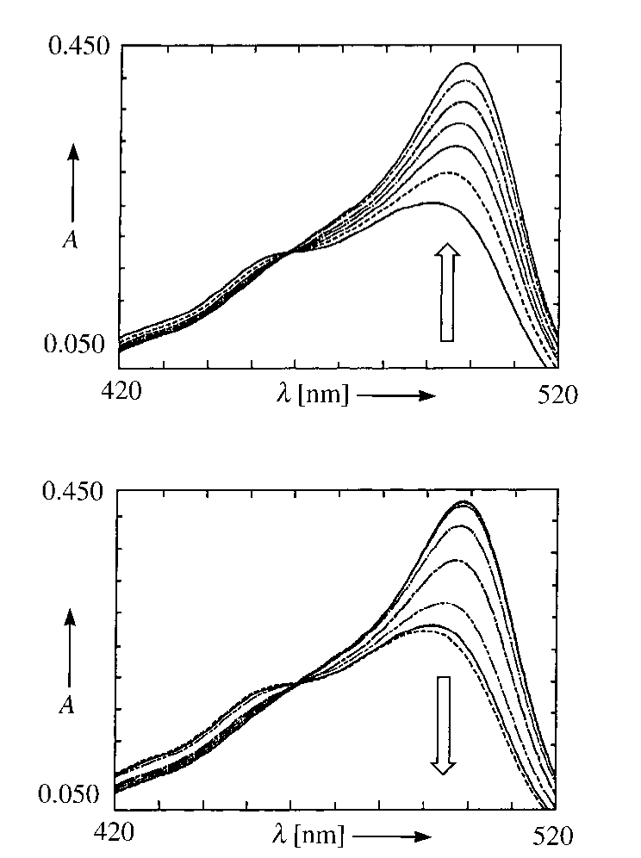
Figure 19 (Top) Changes in the absorbance of 32 upon addition of 33 in MeOH/H₂O 3:1 (v/v) buffered at pH 7.4; (bottom) changes in the absorbance of a solution of 32 and 33 upon addition of citrate in MeOH/H₂O 3:1 (v/v) buffered at pH 7.4. Reproduced with permission Angew. Chem. Int. Ed., 1998, 37,649. Copyright 1998 Wiley-VCH.
More recently displacement assays have been incorporated into nanopores. Martínez-Máñez and co-workers have produced a colorimetric sensor based on MCM-41 (34) that is able to detect phosphate in water.⁴³ The mechanism of this assay is schematically shown in Scheme 11. Nano-sized pores in MCM-41 are functionalized with an amine and loaded with a dye (methyl red, carboxyfluorescein or methylthymol Blue) able to bind to the amine. In the presence of phosphate the dye is released in solution with the resulting colorimetric detection of the guest. The best response was observed with carboxyfluorescein as a dye. When MCM-41 was replaced by non-porous silica gel no response was observed demonstrating the role of the mesoporous 3D organized surface of the material in the sensing protocol.
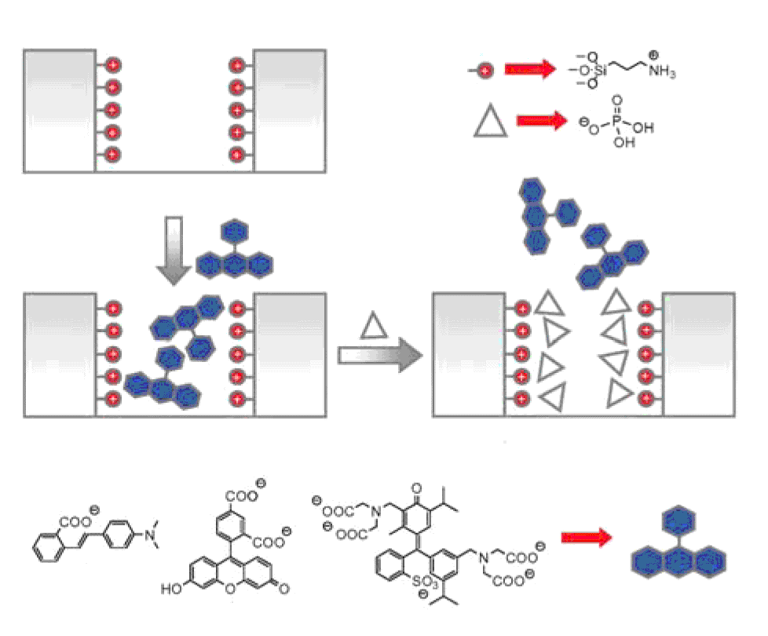
Scheme 11 Protocol for phosphate signaling in water using the displacement assay 34. Reproduced with permission Chem. Commun, 2008, 3639. Copyright 2008 RSC.

Gunnlaugsson and co-workers have synthesised gold nanoparticles with appended Eu(III) cyclen complexes 35 as sensors for biologically important phosphates including flavin monophosphate 37. The functionalised nanoparticles are complexed to β-diketone antennas 36 which is bound to the Eu(III) centre and switches on fluorescence. The antenna is displaced by phosphate species such as 37 resulting in fluorescence switching off (Scheme 12) in buffered aqueous solution.⁴⁴

Scheme 12 The self-assembly formation between the nonluminescent AuNP-35.Eu and 36 to give AuNP-35.Eu.36. The sensing of flavin 37 occurs by the displacement of 36 and the formation of AuNP-35.Eu-37.

Sessler, Lee and co-workers have decorated gold nanoparticles with calix[4]pyrrole derivative (38) (Scheme 13).⁴⁵ A fluorescent dye displacement assay using tetrabutylammonium-2-oxo-4-(trifluoromethyl)-2H-chromen-7-olate (39) as fluorophore allows the detection of fluoride in dichloromethane. When compound 39 is bound to the functionalized nanoparticle its fluorescence is quenched, but when fluoride is added, compound 39 is displaced by the anion and its fluorescence is restored, as shown in Figure 20 (bottom).

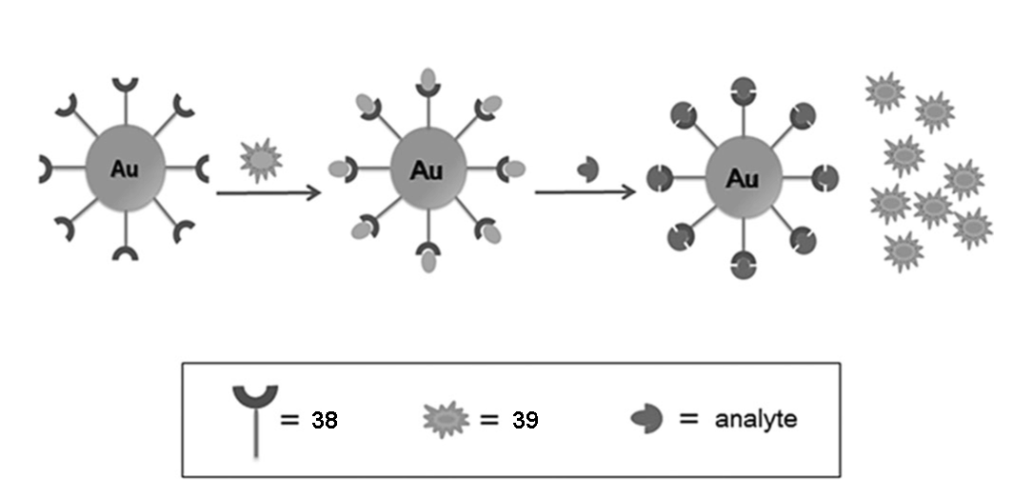
Scheme 13 Schematic representation of fluoride recognition via displacement assay of Au[38]_{n} in the presence of dye 39. Reproduced with permission Chem. Eur. J., 2013, 5860. Copyright 2013 Wiley-VCH.
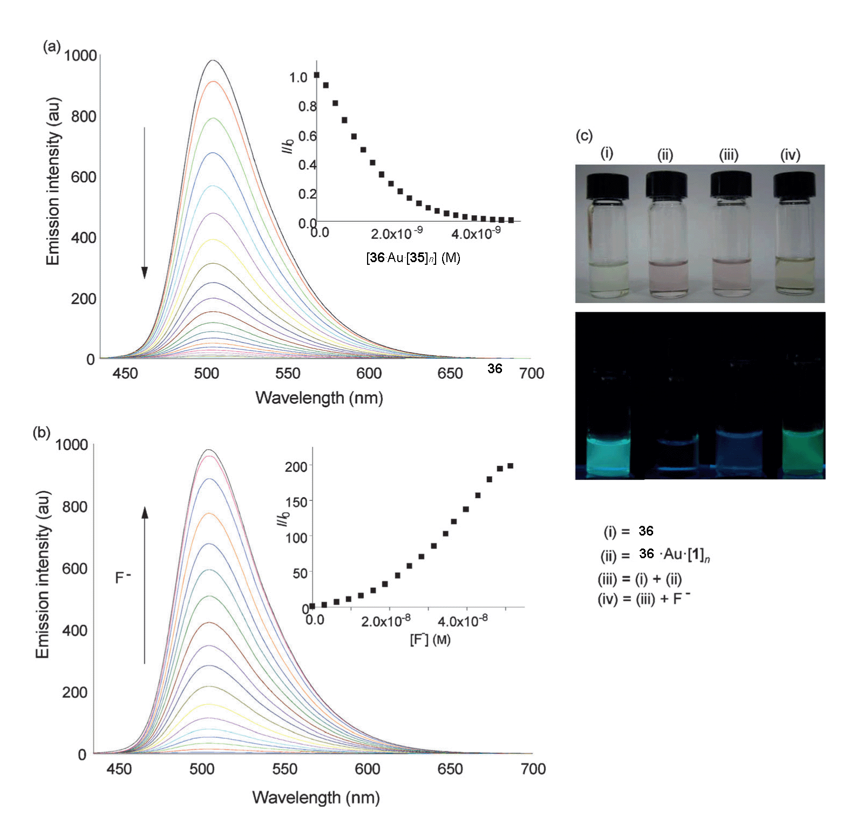
Figure 20 a) Changes in the fluorescence intensity of 39 (2.1 μM) observed upon titration with Au⋅ [38]_{n} (4.76 x 10⁻⁹ M) in dichloromethane at 25˚C (λ_{ex} = 410 nm). The inset shows the corresponding Stern-Volmer plot of the associated fluorophore (39)-dependent fluorescence quenching K_{sv} = 2.36 x 10⁷). b) Recovery of fluorescence upon titration of complex 39⋅ Au⋅ [38]_{n} with fluoride (as the TBA salt, 0 – 5.13 x 10⁻⁸ M) in dichloromethane (λ_{ex} = 410 nm). Inset shows a plot of I/Io versus fluoride concentration. C) Photos of the solutions indicated in these figures under (top) ambient light and (bottom) upon irradiation with a UV lamp (λ_{ex} =365 nm). Reproduced with permission Chem. Eur. J., 2013, 5860. Copyright 2013 Wiley-VCH.
Martínez-Máñez, Rurack and collaborators have proposed a modification of the conventional displacement assay concept describing a QDA (Quencher Displacement Assay) using terpyridine (40) and sulphorodamine B (41) anchored onto the surface of silica nanoparticles.⁴⁶ The idea is to use a mediator (i.e. a quenching metal ion) which is at the same time a good binder for the anion and a quencher for the fluorophore. As shown in Scheme 14, when a cation is bound to the terpyridine a quenching of the fluorescence of the fluorophore occurs. Upon addition of anions, as the metal cations have higher affinity for the anionic guest than for terpyridine, the fluorescence is restored. In particular, when Pb²⁺ is added to the system, only H₂PO₄⁻ is able to revive the sulforhodamine fluorescence in MeCN allowing the detection of this anion in concentrations as low as 5 ppm.
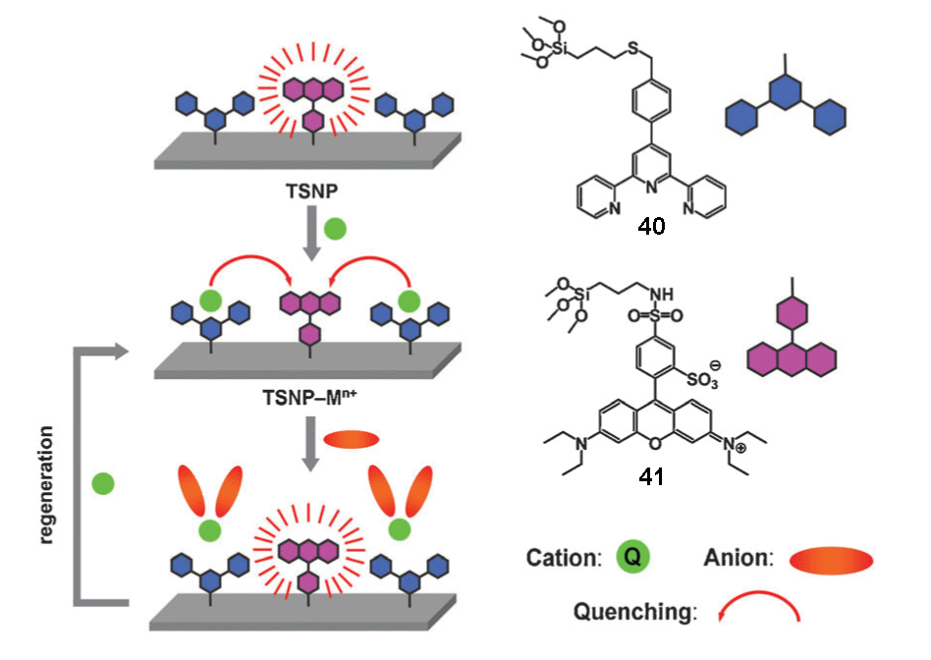
Scheme 14 A representation of the quencher displacement assay (QDA) based on terpyridine (40) and sulforhodamine (41). Reproduced with permission Chem. Commun, 2011, 47, 10599. Copyright 2011 RSC.
Anion sensing using arrays of receptors
One of the most exciting developments in molecular recognition and sensing in recent years involves the design of arrays and assays for pattern-based recognition of analytes in solution. Sensor arrays are based on the combination of different synthetic receptors, not necessarily selective for a specific substrate, that can give a combined fingerprint response unique for a given analyte.⁴⁷ Anzenbacher and co-workers have recently prepared an array for multianion detection in water using eight sensors based on N-confused calix[4]pyrrole (42), regular calix[4]pyrrole (43-48) and receptor 49.⁴⁸ In DMSO/0.5% water (MeCN for 49) the relative affinity for sensor 42 is acetate > fluoride > pyrophosphate. Sensors 43-48 show an affinity order of fluoride > pyrophosphate ∼ acetate and low affinity for phosphate, bromide, sulfate, and nitrate. In order to increase the selectivity in read-out information, sensor 49, which shows almost equal affinity for fluoride and pyrophosphate, and which does not bind any other anion strongly, has been included in the set. The sensors have been used to fabricate an array by embedding them in polyurethane hydrogel and a qualitative and quantitative response towards different anions in aqueous solution has been evaluated. As shown in Figure 22 the colorimetric response given by the array for each anion allows discrimination.

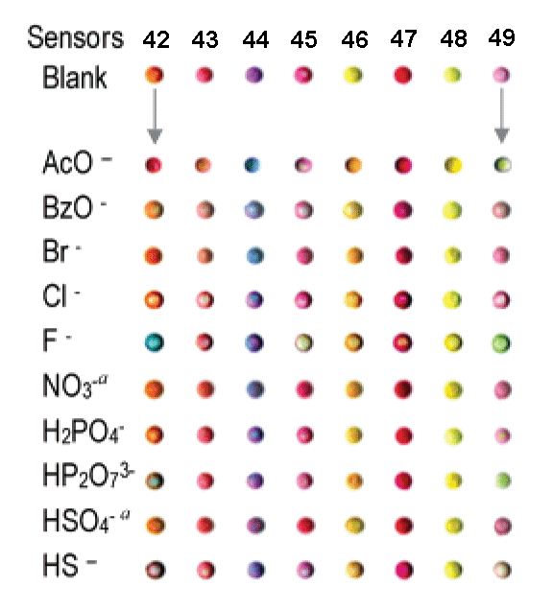
Figure 21 Eight-sensor array responses to aqueous anions solutions. Reproduced with permission J. Am. Chem. Soc., 2007, 129, 7538. Copyright 2007, ACS.
To demonstrate the utility of the system on a real-world example, identification of toothpaste samples was performed. Principal Component Analysis (PCA) and Hierarchical Clustering Analysis (HCA) permitted discrimination between different brands as shown in Figure 22. The fluoride-selective yet cross reactive array was shown by Anzenbacher to use the F⁻ content of the toothpastes as the main discriminatory factor with the other anionic components further differentiating the different samples. For more information on the use of principal component analysis and discriminant analysis in sensing see the recent review by Stewart, Adams Ivy and Anslyn in ChemSocRev.⁴⁹

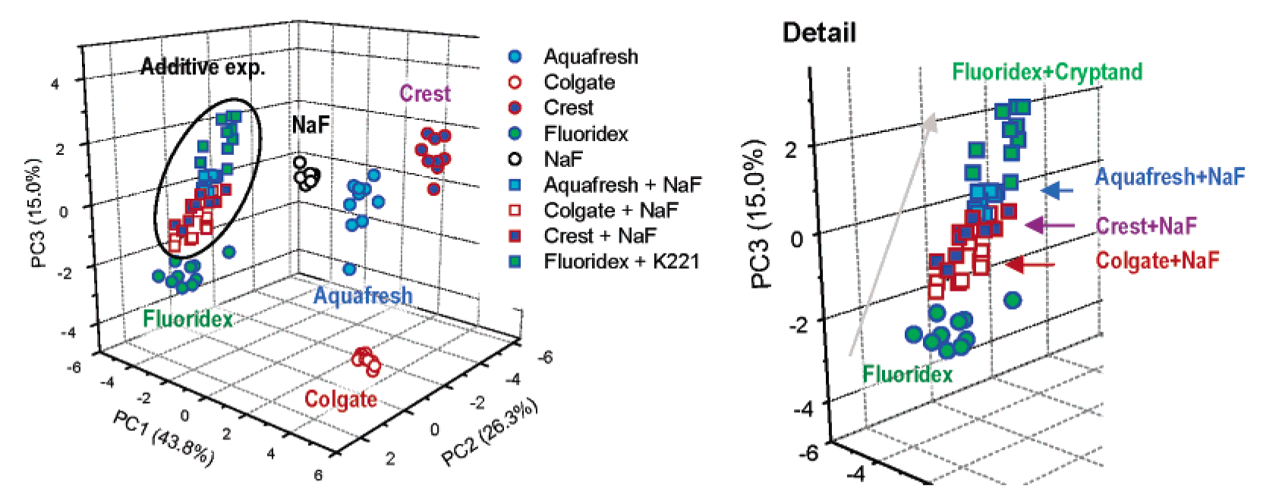
Figure 22 PCA score plot for four toothpaste brands and he results of NaF addition experiments. Right: Detail of the addition experiments showing that the addition of fluoride to the toothpastes results in increased similarity in response as shown by the clustering. Addition of Na⁺-binding cryptand to Fluoridex generation more naked fluoride resulted in a response shift to the top of the NaF addition cluster (grey arrow). Reproduced with permission J. Am. Chem. Soc., 2007, 129, 7541. Copyright 2007, ACS.
Conclusions
The aim of this tutorial review has been to illustrate the many different mechanisms and systems that have been employed to sense anions in solution using small molecules and molecular ensembles. Other supramolecular approaches including the design and synthesis of hydrogen-bonded anion-responsive gels⁵⁰ and sensing lipid bilayer anion transport using spin-labeled anions in parallel with paramagnetic metal cations⁵¹ whilst beyond the scope of this review offer further examples of the wide variety of techniques used to sense anionic species. Anion sensing continues to be an important goal and is being pursued by a number of research groups world-wide. We can expect the variety of methods used to sense anions to grow and the development of a wider range of anion detection methods in biological systems to be developed over the coming years.

Acknowledgements
PAG would like to thank the Royal Society and the Wolfson Foundation for a Royal Society Wolfson Research Merit Award. PAG additionally thanks the University of Canterbury for an Erskine Visiting Fellowship during which this review was completed in Christchurch. CC would like to thank Regione Sardegna (CRP-59699) for financial support.

Notes and references
ªChemistry, University of Southampton, Southampton, SO17 1BJ, UK. E-mail: philip.gale@soton.ac.uk; Fax: +44 (0)23 8059 6805; Tel:+ 44 (0)23 8059 3332
^{b}Università degli Studi di Cagliari, Department of Chemical and Geological Science, S.S.554 Bivio per Sestu, 09042 Monserrato (CA), Italy
^{c}Department of Chemistry, Faculty of Science, King Abdulaziz University, Jeddah, Saudi Arabia
^{d}Department of Chemistry, University of Canterbury, Private Bag 4800, Christchurch 8041, New Zealand.

- P.D. Beer and P.A. Gale, Angew. Chem. Int. Ed. 2001, 40, 486-516.
- S.L. Wiskur, H. Ait-Haddou, J.J. Lavigne and E.V. Anslyn, Acc. Chem. Res. 2001, 34, 963-972.
- J.L. Sessler, P.A. Gale and W.-S. Cho, Anion Receptor Chemistry, Ed. J.F. Stoddart, Monographs in Supramolecular Chemistry, Royal Society of Chemistry, Cambridge 2006.
- T. Gunnlaugsson, M. Glynn, G.M. Tocci, P.E. Kruger and F.M. Pfeffer, Coord. Chem. Rev. 2006, 250, 3094-3117.
- R.M. Duke, E.B. Veale, F.M. Pfeffer, P.E. Kruger and T. Gunnlaugsson, Chem. Soc. Rev. 2010, 39, 3936-3953.
- T. Gunnlaugsson, P.E. Kruger, T.C. Lee, R. Parkesh, F.M. Pfeffer and G.M. Hussey, Tetrahedron Lett. 2003, 44, 6575-6578.
- H. Miyaji and J.L. Sessler, Angew. Chem. Int. Ed. 2001, 40, 154-157.
- N. Gimeno, X. Li, R.R. Durrant and R. Vilar, Chem. Eur. J. 2008, 14, 3006-3012.
- J.M. Engle, C.N. Carroll, D.W. Johnson and M.M. Haley, Chem. Sci. 2012, 3, 1105-1110.
- B. Valeur and M.N. Berberan-Santos, Molecular Fluorescence: Principles and Applications, 2nd Ed. Wiley-VCH, 2013, Weinheim.
- J. B. Birks and L.G. Christophorou, Nature, 1963, 197, 1064-1065; J. B. Birks and L.G. Christophorou, Spectrochim. Acta, 1963, 19, 401-410.
- S. Nishizawa, Y. Kato and N. Teramae, J. Am. Chem. Soc., 1999, 121, 9463-9464.
- A. Caballero, F. Zapata and P. D. Beer., Coord. Chem. Rev., 2013, 257, 2434-2455.
- N.H. Evans and P.D. Beer, Org. Biomol. Chem., 2011, 9, 92-100.
- N.H. Evans, H. Rahman, A.V. Leontiev, N.D. Greenham, G.A. Orlowski, Q. Zeng., R.M.J. Jacobs, C.J. Serpell, N.L. Kilah, J.J. Davis and P.D. Beer, Chem. Sci., 2012, 3, 1080-1089.
- a) J.J. Gassensmith, S. Matthys, J.J. Lee, A. Wojcik, P.V. Kamat and B.D. Smith, Chem. Eur. J., 2010, 16, 2916-2921; b) L.M. Hancock, E. Marchi, P. Ceroni, and P.D. Beer, Chem. Eur. J., 2012, 18, 11277-11283.
- C.G. Collins, E.M. Peck, P.J. Kramer, and B.D. Smith, Chem. Sci., 2013, 4, 2557-2563.
- D. Quiñonero, C. Garau, C. Rotger, A. Frontera, P. Ballester, A. Costa, and P.M. Deyà, Angew. Chem. Int. Ed., 2002, 41, 3389-3392.
- a) M. Mascal, A. Armstrong, and M.D. Bartberger, J. Am. Chem. Soc., 2002, 124, 6274-6276; b) I. Alkorta, I. Rozas, and J. Elguero, J. Am. Chem. Soc., 2002, 124, 8593-8598.
- B.P. Hay and V.S. Bryantsev, Chem. Commun. 2008, 2417-2428.
- M. Mascal, I. Yakovlev, E. B. Nikitin, and James C. Fettinger, Angew. Chem. Int. Ed., 2007, 46, 8782-8784.
- R.E. Dawson, A. Henning, D.P. Weimann, D. Emery, V. Ravikumar, J. Montenegro, T. Takeuchi, S. Gabutti, M. Mayor, J. Mareda, C. A. Schalley, and S. Matile, Nature Chem., 2010, 2, 533-538.
- J. Yoo, M.-S. Kim, S. Hong, J.L. Sessler, and C.-H- Lee, J. Org. Chem., 2009, 74, 1065-1069.
- S. Guha, and S. Saha, J. Am. Chem. Soc., 2010, 132, 17674-17677.
- A. Bencini, V. Lippolis, and B. Valtancoli, Inorg. Chim. Acta., 2014, DOI:10.1016/j.ica.2014.01.003
- M. A. Tetilla, M. C. Aragoni, M. Arca, C. Caltagirone, C. Bazzicalupi, A. Bencini, A. Garau, F. Isaia, A. Laguna, V. Lippolis, and V. Meli, Chem. Commun., 2011, 47, 3805-3807.
- S.J- Butler, and D. Parker, Chem. Soc. Rev., 2013, 42, 1652-1666.
- D.G. Smith, G.-L. Law, B.S. Murray, R. Pal, D. Parker, and K.L. Wong, Chem. Commun., 2011, 47, 7347-7349.
- H.T. Ngo, X. Liu, and K.A. Jolliffe, Chem. Soc. Rev., 2012, 41, 4928–4965.
- A. Ojida, Y. Mito-oka, M. Inoue, and I. Hamachi, J. Am. Chem. Soc., 2002, 124, 6256-6258.
- H. N. Lee, Z. Xu, S.K. Kim, K.M.K. Swamy, Y. Kim, S.-J. Kim, and J. Yoon, J. Am. Chem. Soc., 2007, 129, 3828-3829.
- D.F. Shriver, and M.J. Biallas, J. Am. Chem. Soc., 1967, 89, 1078-1081.
- E. Gailbraith, and T. D. James, Chem. Soc. Rev., 2010, 39, 3831-3842.
- C. R. Cooper, N. Spencer, and T.D. James, Chem. Commun., 1998, 1365-1366.
- T. Nishimura, S.-Y. Xu, Y.-B. Jiang, J. S. Fossey, K. Sakurai, S. D. Bull, T. D. James, Chem. Commun., 2013, 49, 478-780.
- A. E. J. Broomsgrove, D. A. Addy, C. Bresner, I. A. Fallis, A. L. Thompson, and S. Aldridge, Chem. Eur. J., 2008, 14, 7525-7529.
- F. Zapata, A. Caballero, N.G. White, T.D.W. Claridge, P.J. Costa, V. Félix and P.D. Beer, J. Am. Chem. Soc., 2012, 134, 11533-11541.
- R.Martínez-Máñez, and F. Sancenon, Chem. Rev. 2003, 103, 4419-4476; R. Martínez-Máñez, and F. Sancenon, Coord. Chem. Rev. 2006, 250, 3081-3093.
- Y. M. Chung, B. Raman, D.-S. Kim, and K. H. Ahn, Chem. Commun., 2006, 186-188.
- Y. Bao, B. Liu, H. Wang, J. Tian, and R. Bai, Chem. Commun., 2011, 47, 3957-3959.
- J. Chen, C. Liu, J. Zhang, W. Ding, M. Zhou, and F. Wu, Chem. Commun., 2013, 49, 10814-10816.
- A. Metzger, E.V. Anslyn, Angew. Chem. Ed. Engl., 1998, 37, 649-652.
- M. Comes, M.D. Marcos, R. Martínez-Máñez, F. Sancenón, J. Soto, L.A. Villaescusa, P. Amorós, Chem. Commun., 2008, 3639-3641.
- J. Massue, S.J. Quinn and T. Gunnlaugsson, J. Am. Chem. Soc. 2008, 130, 6900-6901.
- P. Sokkalingam, S.-J. Hong, A. Aydogan, J.L. Sessler, and C.-H. Lee, Chem. Eur. J., 2013, 19, 5860-5867.
- P. Calero, M. Hecht, R. Martínez-Máñez, F. Sancenón, J. Soto, J.L. Vivancos, and K. Rurack, Chem. Commun., 2011, 47, 10599-10601.
- A.T. Wright, E.V. Anslyn, Chem. Soc. Rev. 2006, 35, 14-28.
- M.A. Palacios, R. Nishiyabu, M. Marquez, and P. Anzenbacher, J. Am. Chem. Soc., 2007, 129, 7538-7544.
- S. Stewart, M. Adams Ivy and E.V. Anslyn, Chem. Soc. Rev. 2014, 43, 70-84.
- G.O. Lloyd and J.W. Steed, Nature Chem. 2009, 1, 437-442.
- N. Busschaert, L.E. Karagiannidis, M. Wenzel, C.J.E. Haynes, N.J. Wells, P.G. Young, D. Makuc, J. Plavec, K.A. Jolliffe and P.A. Gale, Chem. Sci. 2014, 5, 1118-1127.

Key learning points
- Appreciate the mechanisms by which anions can trigger colour changes in small molecule receptors containing hydrogen bond donor groups
- Understand how excimer formation can be used to sense anionic guests by bringing about conformational change or aggregation in fluorescent receptors
- Understand the different roles metals and Lewis acids can play in selective anion sensing
- Appreciate how the displacement assay approach allows receptors that do not contain signalling groups to act as sensors for anions.
- Understand that receptors can be used in arrays together with pattern recognition techniques to distinguish mixtures of anions.

