Estimation of organic biocide leaching rate using a modified cavity jump diffusion model
L.R. Goodes¹, J.A. Wharton¹, S.P. Dennington¹, K.R. Stokes^{1,2}
¹ National Centre for Advanced Tribology at Southampton (nCATS), Engineering Sciences, University of Southampton, Highfield, Southampton, Hampshire, SO17 1BJ, UK
² Physical Sciences Department, Dstl, Porton Down, Salisbury, Wiltshire, SP4 0JQ, UK
Corresponding Author: lrg1d11@soton.ac.uk (07806580292)
Abstract
Estimation of biocide lifetime in marine antifouling coatings is of great use to improve and develop technologies. An existing model simulating the diffusion of molecules in polymer networks below glass transition temperature was employed to estimate leaching. This model was modified to allow for swelling due to water uptake and to permit evaluation of copolymer binders as well as homopolymers. This enabled prediction of biocide diffusion coefficients in polymeric coatings of various binder types, including pMMA, a pMMA/butylacrylate binder containing rosin, and a trityl copolymer, using usnic acid as a ‘model’ biocide. For comparison with modelling results, coatings fomulated using each binder type were also submitted to static and dynamic seawater immersion. Fluorescence microscopy techniques were used to quantify biocide leaching from these coatings relative to unimmersed coatings. Agreement of the modified diffusion model with experimental data was good for pMMA, reasonable for the rosin-based binder, and poor for the trityl binder. Comparison of predicted and experimental biocide profiles in the binder demonstrated deviation from the expected Fickian mechanism for the pMMA binder, despite the accurate rate prediction. This work demonstrates a first approach to predicting organic biocide diffusion, and highlights the areas for future attention.
Key Words
Leaching, Diffusion, Coatings, Modelling, Biocide, Antifouling
Nomenclature
D: diffusion coefficient, m² s⁻¹
E: Young’s modulus, Pa
E₀: critical energy, J
h: Planck constant, 6.6261 × 10^{–34} m² kg s^{–1}
h₀: initial height of transition state cavity, Å
k_{B}: Boltzmann constant, 1.381 × 10⁻²³ J K^{–1}
Q†/Q: ratio of the partition function of the transition state to that of the reactant state
r_{i}^{RS}: initial reactant state cavity radius, Å
r_{i}^{TS}: initial transition state cavity radius, Å
r_{ɸ}^{RS}: reactant state cavity radius with respect to swelling, Å
r_{ɸ}^{TS}: transition state cavity radius with respect to swelling, Å
T_{b}: boiling point, K
T_{g}: glass transition temperature, ˚C or K
v: Poisson’s ratio
V_{def}: deformation potential, kJ mol^{–1}
V_{LJ}: Lennard-Jones potential, kJ mol^{–1}
V₀^{RS}: initial reactant state cavity volume, Å³
V₀^{TS}: initial transition state cavity volume, Å³
ε: well depth, K
σ: Lennard-Jones diameter, Å
µ: Lamé constant
ɸ: percentage volume increase of film from swelling

- Introduction
The development of antifouling paint coatings to deter the attachment of marine organisms to ships’ hulls is of great economic interest. Coatings containing one or more biocidal agents continue to represent a majority of products available on the market. Often, large factorial design experiments must be carried out to assess a vast quantity of formulations and biocide loadings, owing to the complexity of the medium and difficulty in prediction of coating lifetimes. An understanding of the interaction of antifouling biocides within the binder matrix is crucial in predicting their capacity for leaching. The majority of work has focused on the delivery of large pigment biocides such as copper (I) oxide, which rely on reaction with the seawater at the interface in the paint film, owing to the common use of these in paint mixtures. Work by Yebra et al. focused on estimation of copper and rosin reaction rates in precisely calibrated model binders, including modelling of seawater and copper speciation within the coating leached layer, and produced accurate predictions of copper leaching rate and concentration profile in the leached layer. The authors highlighted the extreme difficulty in producing a global model for prediction of biocide leaching, noting that subtle changes in the binder composition would render the model inaccurate. Furthermore, the mechanics of delivery for evenly dispersed organic biocides are likely to be substantially different, but remain relatively unstudied in this medium.

The mechanics of molecular diffusion in polymers are significantly more complex than in true solids, liquids or gases, owing to the medium’s inherent physicochemical heterogeneity and variable conformation depending on temperature. Nonetheless, a good understanding of the key mechanics governing diffusion in polymers has been achieved in areas such as pharmaceutical applications for drug delivery, and in food packaging. Direct monitoring and measurement of diffusion rates is a lengthy and arduous procedure, particularly when considering materials with a low release rate. Antifouling coatings, in particular, present a highly complex multicomponent system; in addition, water ingress occurs into these coatings in the marine environment, resulting in a degree of plasticisation of polymer chains. The inclusion of large pigment particles, whose size scales are often within an order of magnitude of the total binder thickness, renders the medium effectively anisotropic. There is modelling and experimental evidence demonstrating the limitation of water ingress and diffusion below the pigment front in antifouling paints. As a result, simplifications must be made in order to treat the system as a traditional one-dimensional diffusion problem. In any case, the investigation of the accuracy of the modified cavity jump diffusion model provides a logical first step towards a ‘base’, from which other more complex scenarios can be modelled. In particular, the addition of intermolecular interactions of the binder with the biocide or other coating ingredients (via first principles or Hansen parameters) and the implementation of a binder polishing rate would be relatively simple adjustments to the model. Alternatively, the inclusion of more complex hydrodynamic phenomena and pigment dissolution within the same model would represent longer term goals.

In summary, the present study aims to assess the suitability of the best-suited present literature models for prediction of the lifetimes of integrated compounds in antifouling coatings. Unfortunately, literature efforts in modelling of diffusion have focused primarily on amorphous polymers above the glass transition temperature. Consideration of below T_{g} acrylic polymers is limited and models designed to estimate penetrant diffusion in glassy polymers have been found to have a significant degree of error for penetrants whose size scale differs from that of the repeating monomer unit. Despite these shortcomings these models have been applied to a various coatings in this current work, with some modification in an attempt to increase the accuracy for ternary and co-polymeric systems.

- Materials and methodology
A terrestrially derived dibenzofuran, usnic acid (hereafter termed furan derivative, FD), was selected as a promising natural product for integration into simple model antifouling coatings. Work was carried out herein to further our understanding of the biocide’s leach rate and behaviour alongside other studies within the project. To allow corroboration of the model results, pMMA (T_{g} = 90˚C – 100˚C) and a commercial binder (containing approximately 40 vol.% rosin) were immersed from a pontoon into the sea for a 10 month period at National Oceanography Centre (NOC), UK. This is a tidal basin in the docks of Southampton Water. The seawater quality is typical of that found in industrial estuarine conditions. A biocide loading of 10 wt.% FD was incorporated into the coatings to achieve saturation in the polymer solution. Natural seawater exposure at 1 m depth was chosen to provide a realistic in-service environment and eliminate inhibition of diffusion by accumulation of the active ingredient in the leachant solution. Replicate samples were placed on the shaded back side of exposed boards which experienced no direct sunlight.

Identical pMMA coatings and CDP (a rosin-based controlled depletion polymer) coatings were also immersed for accelerated rotor testing (25 °C, 17 knots at the rotor drum periphery where all panels were attached, equivalent to 8.7 m s–1) at TNO (Nederlandse Organisatie voor toegepast-natuurwetenschappelijk onderzoek) Maritime Material Performance Centre (Den Helder, the Netherlands) as described in Goodes et al. A 24 h static immersion period was observed before starting the accelerated testing, to allow stabilisation of coating water content. Rotor testing was intended to provide a realistic representation of ‘in-service’ conditions in terms of operational speed, whilst accelerating the kinetics of biocide depletion by maintaining a significantly higher temperature than would be encountered in most service locations. Owing to the complex hydrodynamics of the rotor cylinder within its tank, convection and turbulence are both likely to play a substantial role. In addition to the traditional antifouling binder types, a novel hydrolysable poly(triphenylmethacrylate)/butylacrylate (p(TrMA/BA)) coating (50:50 wt.% co-polymer) was also subjected to rotor testing only (this experimental coating was not prepared for the static immersion testing). Despite the use of a primer layer, the commercial CDP coating containing the additive separated from its primer within a day of immersion - during the 24 h static period - so it was not possible to analyse the amount of additive lost for comparison with other systems.

Aged coatings (i.e. those that were recovered after pontoon and rotor immersions) were analysed by taking multiple cryofracture cross-sections of paint chips, which were then thinly sliced with a microtome (in the case of rotor-aged samples) and by incremental polishing of cross-sectioned PVC panels with fine SiC paper down to 4000 grit (for pontoon-immersed samples). These were subjected to optical and fluorescence microscopy compared to identical unimmersed coatings as described in detail in Goodes et al. Finally, the water swelling (at saturation) of each of the polymer systems was determined gravimetrically at 18°C. pMMA and CDP binders had a low water content of 1 vol.% whereas the p(TrMA/BA) co-polymer was characterised by its very high water content (10.1 vol.%). The addition of the natural product did not significantly affect water uptake. Distilled water was used for this step. The surprisingly high water sorption determined for the trityl copolymer film is discussed later.

2.1. Selection of model for estimation of natural product diffusion
The Gray-Weale model was selected as the most promising for prediction of penetrant diffusion in below T_{g} polymers. This model is based on the calculation of critical energy required for cavity ‘jumps’ between gaps within the segments of glassy polymers. The activation energy required for each event depends on the deformation of side groups required to allow the penetrant molecule to bypass, and hence relies strongly on the estimation of molecular and cavity geometry. Estimation of the jump length is the basis for calculating bulk diffusion. The energy required for large penetrants to deform neighbouring side groups is higher, so their movement becomes slower and the overall flux decreases. Gray-Weale et al. reported a high degree of error for large molecules, those that significantly deviate from spherical structure, or those that are able to participate in strong intramolecular interactions with the polymer. This is because the attractive forces that constrain it near to the neighbouring polymer segments were neglected within this model. However, the model was found to give a good agreement for small-medium penetrants. Usnic acid has a molecular weight of 346 g mol^{–1} and contains three hydroxyl groups. Although the model is likely to underpredict the diffusion coefficients for this molecule owing to its potential for hydrogen bonding, it is intended as a starting point for consideration of this phenomenon.

2.2. Application of model and calculation of parameters
For the cavity jump model, calculation of the Lennard-Jones parameters and deformation potentials are required for each side group. pMMA is a logical starting point for estimation of diffusivity for a number of reasons: firstly, acrylic monomers such as MMA or butylacrylate form the basis of most polishing or erodible paints; secondly, work by Tonge and Gilbert focused on pMMA, allowing for comparison of results and use of the model validation in that work. The geometry of the reactant state and transition state cavities are represented by spheres (with four interacting groups) and cylinders (three interacting groups), respectively. The modelling of each group or penetrant entity as spherical unified atoms greatly simplifies the calculation.

For the purposes of the model, the acrylic side group of the pMMA and backbone methyl group are treated as separate homogeneous systems, i.e. diffusion of a penetrant molecule past between two methyl groups or two acrylate groups, respectively. Diffusion through uniform methyl groups is predicted to be considerably more rapid than diffusion via the uniform acrylate groups, owing to the larger size of the latter and the greater activation energy required for each ‘jump’.

In the Gray-Weale model a diffusion estimate is calculated from the mean jump length and jump frequency:
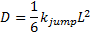
(Eq. 1)
where
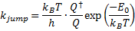
(Eq. 2)
and
(Eq. 3)
Where k_{B} is the Boltzmann constant, h is Planck’s constant, E₀ is the critical activation energy, r_{i}^{RS} is the radius of the reactant state cavity, and σ_{sg} is the Lennard-Jones diameter of the side group.

The critical activation energy E₀ is derived from the difference between the minima of the sum of deformation potentials and Lennard-Jones potentials:
(Eq. 4)
Calculation of the Lennard-Jones diameter, σ, for the usnic acid molecule is crucial for estimation of distances. Calculation of the large penetrant molecule by the method given in Gilbert and Smith as implemented in Tonge and Gilbert gives a value of 8.68 Å, compared to 6.04 Å for the repeating MMA unit. These values are in good agreement with predictions from Chemicalize simulations (www.chemicalize.org; accessed 2011) of molecular geometry. The σ values for CH₃ and CO₂CH₃ side groups were calculated as 3.56 Å and 4.72 Å, respectively. Estimation of potential well depth ϵ for the usnic acid molecule is determined by the following:
(Eq. 5)
Determination of the Lennard-Jones potentials for the interacting side groups and penetrant in the transition and reactant states are given by:
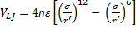 (Eq. 6)
Where n is the number of interacting side groups (four in reactant state, three in the transition state), ϵ is the potential well depth, r’ is the distance between the centre of each side group and that of the penetrant. The σ and ϵ values are derived from their values for the interacting side group A and penetrant B in the following manner:
(Eq. 7)
(Eq. 8)
The Lennard-Jones equation describes the interactive potential for a given distance between two molecules; the 12th power term encompasses Pauli repulsion at very short ranges of a few Å, whereas the 6th power term describes weaker interactive forces at greater distances, tending to zero.

Deformation potentials in the reactant and transition states are calculated by the following:
(Eq. 9)
(Eq. 10)
Where L_{n} = σ_{sg}, r_{i}^{TS} is the radius of the transition state cavity, r_{i}^{RS} is the radius of the reactant state cavity, and µ (shear modulus) can be expressed as follows:
(Eq. 11)
Where E is Young’s modulus and v is Poisson’s ratio for the polymer.

Deformation potentials and Lennard-Jones potentials were calculated for transition and reactant states and the difference in minima of these functions was determined for calculation of E₀. E₀ must be calculated separately for each side group (i.e. individual treatment of the methyl group and acrylic group for pMMA) to determine two diffusion coefficients; the ‘true’ coefficient was obtained by taking the logarithmic mean of the two values.

As a first attempt to simulate the effect of film swelling and plasticisation of the polymer chains, the radii of reactant and transition state cavity terms in the jump length and deformation potentials were allowed to vary with respect to the volume of a sphere and cylinder, respectively, for a given volume increase within the film. This represents the separation of chains and the lower critical energies required to achieve deformation of the side groups. The reactant state or transition state cavity radii at a given volume percentage increase are delineated by r_{ɸ}^{RS} and r_{ɸ}^{TS}, respectively:
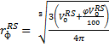 (Eq. 12)
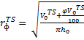 (Eq. 13)
Where V₀^{RS} and V₀^{TS} are the initial volumes of the reactant state cavities, derived from initial r_{i}^{RS} and r_{i}^{TS} values, and φ is the volume increase of the saturated binder resulting from water swelling expressed as a percentage, and h₀ is the initial height of the transition state cavity. At φ = 0, these values are equivalent to initial r_{i}^{RS} and r_{i}^{TS} values. These terms represent the increasing volume of the reactant and transition cavities, and result in a reduction in the deformation potentials and hence overall critical energy. The full sensitivity of the model to changes in reactant and transition state radii is detailed in Tonge and Gilbert. The effect of varying r_{ɸ}^{RS} and r_{ɸ}^{TS} to represent swelling of the polymer was tested across a range of swelling values, corresponding to the calculated swelling values for the binder systems employed (Fig. 1). These two terms replace r_{i}^{RS} and r_{i}^{TS} respectively in the original Equations 9 and 10.
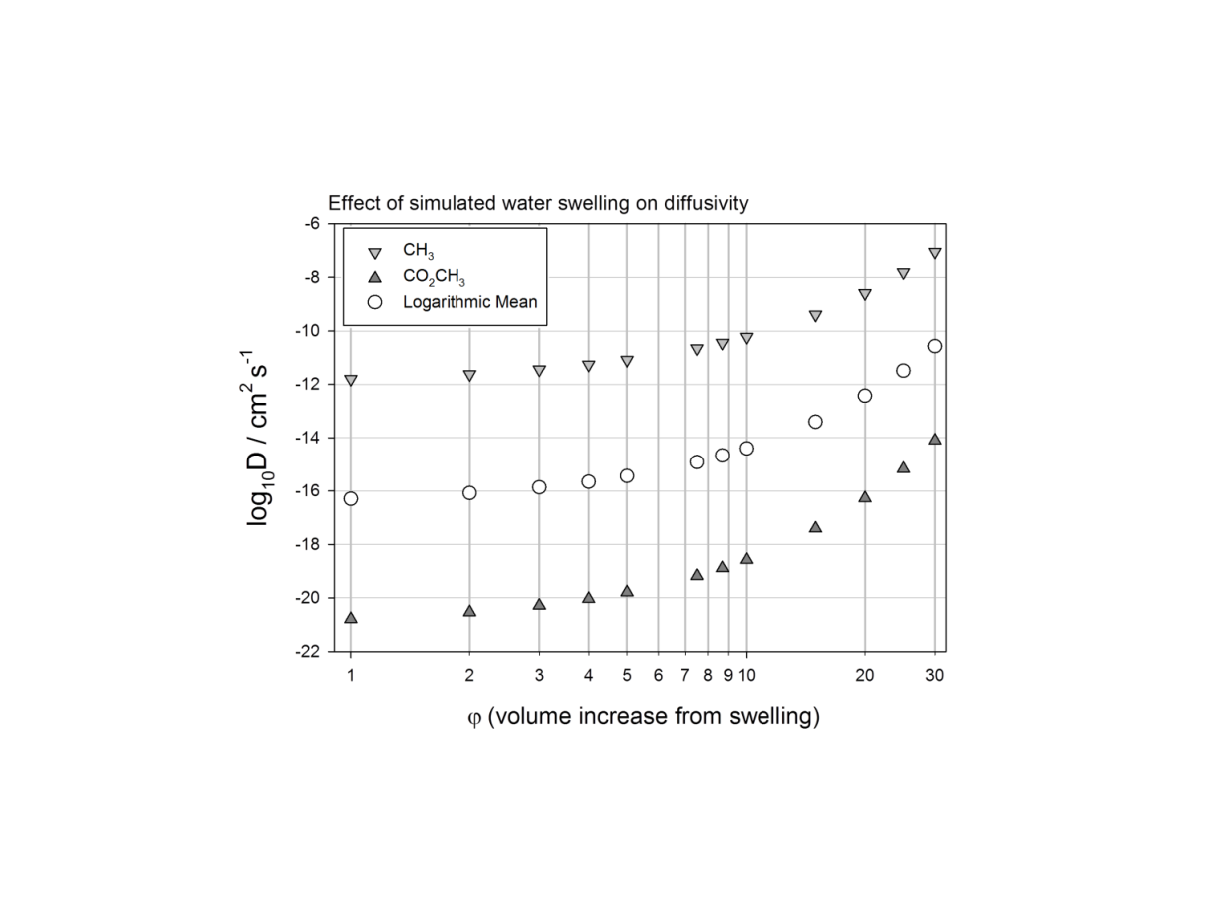
Figure 1: The effect of simulated swelling increase resulting from the variable transition and reactant state cavities parameter in athe simulated pMMA film.

The Gray-Weale model was applied to each of the side groups for consideration within the model corresponding to the polymer systems employed for immersion testing, and ‘true’ diffusion values were calculated for each polymer based on the occurrence of each side group. The variable cavity geometry was applied to each calculation based on the volume water swelling that was measured for each polymer type. The temperature value was estimated based on each immersion regime, i.e. 10 °C for pontoon immersion and 25 °C for rotor immersion. The possibility of rosin diffusion within the polymer chains, or its intermolecular interaction with the biocide (or polymer) was not considered at this point.

3. Results and Discussion
3.1 Results from modelling prediction
Diffusion coefficient values for D for every side group present in the investigated polymers were established using the modified Gray-Weale model as a function of the various temperature and swelling values corresponding to the measured water uptake for each polymer. The D values were calculated for each side group and environmental parameter combination and are summarised in Table 1. A modified diffusion coefficient can be obtained for usnic acid in pMMA and other binders, based on the variable transition and reactant state geometries in function of swelling. For example, estimation of diffusion coefficient by the Gray-Weale method yields a value of 3.08 × 10^{–17} cm² s^{–1} for usnic acid in pMMA at 10 °C. For a value of 1% swelling (obtained from gravimetric measurements) using variable cavity geometries, we obtain a modified D value of 5.08 × 10^{–17} cm² s^{–1}.

 | T / °C | Methyl DCH₃ |  | Butyl ester DCO₂C₄H₉ |  | Methyl ester DCO₂CH₃ | Triphenyl ester D[C₆H₆]₃CO₂
ɸ (%) |  | 1 | 10 | 1 | 10 | 1 | 10
 | 10 | 1.585 × 10^{–12} | 5.931 × 10^{–11} | 2.641 × 10^{–31} | 1.894 × 10^{–29} | 1.626 × 10^{–21} | 3.298 × 10^{–43}
 | 20 | 2.992 × 10^{–12} | 9.909 × 10^{–11} | 2.325 × 10^{–30} | 5.503 × 10^{–28} | 6.274 × 10^{–21} | 7.497 × 10^{–42}
 | 25 | 4.046 ×x 10⁻¹² | 1.264 x 10⁻¹⁰ | 6.531 x 10⁻³⁰ | 1.411 x 10⁻²⁷ | 1.191 x 10⁻²⁰ | 3.304 x 10⁻⁴¹

Table 1: Effect of 1% and 10% swelling from variable cavity geometry on diffusion coefficients (cm² s⁻¹) calculated for each side group type (left to right: methyl, butyl ester, methyl ester, triphenyl ester) at 10 °C, 20 °C and 25 °C.

Values for D for each side group can be utilised to calculate an overall diffusion coefficient for each repeating unit. The overall values for each repeating unit will contribute to the diffusion coefficient of the polymer in terms of the occurrence of each side group. For example, the p(TrMA/BA) is a 50:50 wt.% blend copolymer and in absolute terms there are 2.5625 butyl ester side units for every triphenyl ester side unit; thus, the relative contribution of the former is greater. Values for D, calibrated in terms of immersion temperature and measured swelling parameter, were employed in a mathematical model simulating the diffusion of a biocide from a 100 µm thick binder into water at one boundary, in order to generate predicted concentration profiles for FD in each binder system and condition.

The generated diffusion coefficients can be used to produce simulations of diffusion-driven biocide release over time from coatings. An example of these is given below, for FD release from pMMA at 10 °C (Fig. 2). The lifetime simulation predicts effective depletion (less than ~20% total biocide volume content remaining) after 3.16 years. After 12 days, a significant depletion of FD content in the surface 15-20 µm is observed; this is effectively a prediction of rapid leached layer formation.

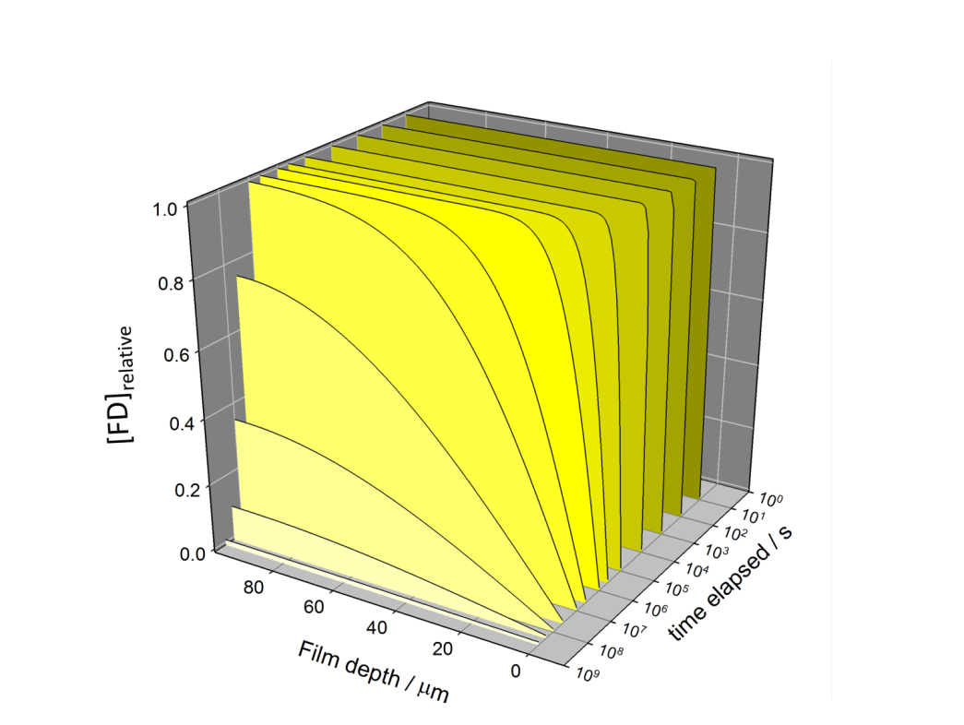
Figure 2: Modelled biocide depletion (relative FD concentration) from a static pMMA film 100 µm in thickness at 10°C.

3.2 Comparison of the modified Gray-Weale model with experimental data
The distribution and quantities of usnic acid in the aged coatings immersed in the sea at NOC and in the rotor at TNO were analysed using fluorescence microscopy as described in detail in Goodes et al. The quantities remaining were compared with the blank immersed coatings and non-immersed control coatings. Assuming diffusion from these hard coatings is the dominant mechanism of additive loss, it is possible to infer a diffusion coefficient from the known remaining quantities of biocide in the film bulk. In reality, a heterogeneous depletion of biocide within the surface is more likely because other mechanisms are at work. However, it can allow the agreement of the actual release rates compared to the estimated release rates to be assessed, and in addition, the deviation of the biocide profile in the film from a Fickian response can help to elucidate other dominant processes. Seeing as the resulting diffusion coefficient calculated for immersed aged coatings will also incorporate losses resulting from convection and hydraulic effects within binder pores, it is termed ‘release coefficient’ here. This is expected to create a greater discrepancy for the rosin-based binders, since the formation of pores and channels will result from rosin dissolution and removal of the depleted leached layer. It was noted that during rotor testing and static immersion tests, the thickness of the pMMA films did not decrease . CDP-based films in immersion demonstrated a small amount of thickness decrease in the order of 8-15 µm; the exact value was difficult to determine owing to the surface waviness of the film and heterogeneous erosion. The surface of the leached layer was selected for the reference datum for analysis of biocide profiles after removal from immersion sites.

For the statically immersed coatings the leaching occurred more rapidly on the front-mounted samples. This discrepancy may have resulted from a difference in fouling community, or a less aggressive hydrodynamic environment on the rear of the panels resulting from their placement under the pontoon. A representative example of biocide content profiles from the data set is shown in Fig. 3, for the case of CDP coating panels containing FD. Biocide profiles for other polymer types are described in more detail in Goodes et al.. The release coefficients derived from them are summarised in Table 2.

Figure 3: Biocide content profiles of 10 month immersed CDP coating samples from the front side (long dash) and rear side (short dash) compared to the unimmersed sample mean (solid line) and unimmersed blank sample without biocide. Both unimmersed samples were aged for 10 months during the trial to account for any aging effects.

As a result of the non-static nature of both tests (tidal and rotor hydrodynamic flow), the diffusion coefficients were expected to be larger than those obtained by the mathematical model. Overall release coefficients calculated from pre- and post-immersion analysis, and estimated diffusion coefficients derived from mathematical modelling based on the Grey-Weale method incorporating the swelling term, are summarised in Table 2.

 | Mathematical Modelling |  | Experimental
 | Diffusion Coefficient / cm²s⁻¹ |  | Release Coefficient / cm²s⁻¹
 | Pontoon | Rotor | Pontoon |  |  | Rotor
 | Pontoon | Rotor | Average | Front | Back | Rotor
pMMA | 5.08 × 10^{–17} | 2.2 × 10^{–16} | 5.52 × 10^{–17} | 1.11 × 10^{–16} | 1.9 × 10^{–17} | 6.22 × 10^{–17}
CDP | 1.44 x 10⁻¹⁷ | - | 3.25 x 10⁻¹⁷ | 8.35 x 10⁻¹⁷ | 4.78 x 10⁻¹⁸ | -
p(TRMA/BA) | - | 2.47 × 10^{–19} | - | - | - | 8.8 × 10^{–16}

Table 2: Release coefficients for immersed samples and estimated diffusion coefficients from mathematical modelling.

In the case of statically immersed coatings, it was observed for that leaching occurred more rapidly on the front-mounted samples. This discrepancy may have resulted from a difference in fouling community caused by the presence of phototrophic algae only on the sunlight illuminated, front-mounted panels, or a less aggressive hydrodynamic environment on the rear of the panels resulting from their position under the pontoon. Modelled data provided an excellent correlation for pMMA in the static immersion trials. However, the estimated diffusion coefficient for 25 °C compared poorly with observed samples from the rotor trials, with over an order of magnitude of discrepancy. Surprisingly, the modelled loss rate was faster than the actual loss rate, despite the former not taking the hydrodynamically accelerated aspect of rotor testing into account. It was observed that for the pMMA coatings, the calculated additive depletion rate in the rotor system was only about 13% greater than its depletion under static immersion. This is substantially less than would be predicted from the estimated Arrhenius plots of similar materials for the same 15 °C shift, whereby the diffusion coefficient is predicted to change by around an order of magnitude. It is possible that the low swelling and erodibility of the pMMA inhibited significant loss of additive by formation of channels and subsequent convection/hydraulic effects, negating the effect of increased ‘service’ speed. In that case, it might expected that a significant increase in the case of the erodible binder. Unfortunately this was not verifiable, as all CDP samples detached from their primer within 24 h of immersion. The calculated release coefficient for the pontoon-immersed samples was also influenced greatly by anomalously fast biocide depletion from all front-mounted panels; just taking the rear-mounted (shaded side) panels into account, a release coefficient of 1.9 x 10^{–17} cm² s⁻¹ is obtained for the pontoon-immersed pMMA. Using this release coefficient corresponds to a biocide depletion rate which is 225% more rapid in the rotor system, which is in line with similar comparisons between static and dynamic ageing regimes, although the correlation with the estimated D value from the model is less favourable. It is possible that, given the shallow immersion, the direct sunlight on the front-mounted panels either slightly increased the effective average temperature above the 10 °C (used as a base estimate for the calculation of diffusion coefficients), that the different composition of the fouling community on the front panels accelerated the release rate in some manner, or even subtle hydrodynamic differences could have caused this discrepancy. A higher release rate of additive was also observed for front-mounted CDP panels compared to the rear ones. The variance of release rate, assuming an exponentially decreasing nature, varied around an order of magnitude for identical formulations on the front and back of the boards. This highlights the difficulties in obtaining reproducible results for immersion trials, even within samples of a similar formulation, especially between shaded and sunlight-illuminated panels.

The modelled concentration profile at 10 months was plotted alongside the experimentally derived concentration profile (i.e. the quantity of biocide remaining relative to unimmersed samples is assessed, and the diffusion coefficient is calculated that would result in the same release rate with diffusion as the sole loss mechanism) as well the average real biocide concentration (n=12) that was determined from 10 month aged panels (Fig. 4).

[See images at end of .pdf]
Figure 4: Simulated biocide concentration profile at 10 months (dashed line), experimentally derived concentration profile (dash-dotted line), and real average biocide concentration profile after 10 months’ immersion, relative to unimmersed samples (blue solid line)

Estimation of overall release rate was moderately accurate for the CDP binder. The measured biocide concentration from 10 month aged panels demonstrated a slightly non-Fickian nature; the biocide concentration profile matches the simulated one well in the bottom half of the film, but demonstrates a greater than expected retention of biocide at the surface. This is likely to have resulted from the development of considerable amounts of fouling on the surface, as the efficacy of the coating in immersions was poor. In this case, biocide delivery at the surface would continue at a slower rate.

Contrary to the CDP binder, prediction of biocide release rate in the pMMA binder was very accurate. However, the measured biocide concentration profile bears no resemblance to the predicted behaviour. Again, it seems likely that the development of severe fouling on the panel surfaces acted to impede diffusion of the biocide towards the end of the experiment. In this situation, the concentration of biocide in the bulk binder would be expected to re-equilibrate over time owing to the concentration gradient. Given the accuracy of the rate prediction, this implies that the unimpeded diffusion must have been slightly faster than predicted.

Estimation of diffusion coefficient for the p(TrMA/BA) copolymer resulted in a simulated release that was three orders of magnitude slower than the experimentally determined one. Even allowing for a significant effect of swelling on the cavity geometries, the trityl side group is so large that the critical energy required to laterally deform the side group results in a diffusion coefficient in the order of 10^{–40} cm² s⁻¹ or slower, skewing the overall calculated coefficient considerably even when the group is present in a 1:2.56 ratio with the butyl ester side group. In fact, the rapid biocide loss observed experimentally may result from a different mechanism. The conformation of copolymer chains may be highly unusual as a result of the unusually large side group, and indeed a helical chain conformation for the TrMA homopolymer is well documented . A similar phenomenon for the 50:50 wt.% copolymer could explain its high water uptake for such hydrophobic material and could provide a more straightforward route for diffusive loss of dissolved biocide by means of an internal helix.

- Conclusions

1) The applicability of a transition-state theory diffusion model for molecules in below T_{g} polymers to antifouling binders was assessed and discussed. Minor modifications were made to improve accuracy for the intended systems and to allow for evaluation of copolymer binders.
2) The model provided a good prediction of the actual biocide lifetime in the example of pMMA, although biocide release appeared to be halted by the development of fouling, resulting in the re-equilibration of the biocide concentration profile. In the case of the rosin-based binder, the neglecting of rosin dissolution as a mechanism for biocide release was expected to result in a large discrepancy. In reality, the simulated release coefficient was quite close to the experimentally derived coefficient, providing a reasonable lifetime estimate. In addition, there was good agreement in terms of the shape of the predicted biocide concentration profile with the real one. The measured concentration profile deviated from the Fickian model in the surface, where there was an excess of biocide. This is explained by the attachment of fouling throughout the experiment . However, accounting for the potential intermolecular interaction between the rosin molecules and the biocide molecules would be beneficial to the model.
3) The model overpredicted the rate of release resulting from the temperature increase in the accelerated testing system.
4) In the case of p(TrMA/BA), the mechanistic model - assuming the lateral deformation of trityl side groups as a prerequisite to diffusion - significantly under-predicted release. The diffusion from this coating was surprisingly rapid, far more so than pMMA and the rosin-based binder.
5) The addition of the geometry swelling parameter to the original literature model improved its accuracy in all cases, particularly in the cases where low swelling was observed.
6) The experimental set-up highlighted the complex effect of fouling on the release rate of biocides. The use of traditional static diffusion testing in a controlled artificial seawater environment is advisable to avoid the restriction of diffusion by fouling, unless using biocides with a very high efficacy to prevent fouling.
7) Estimation of jump frequency with modern molecular simulation would allow for greater accuracy of some model aspects. In addition, other aspects affecting diffusion, such as intermolecular attraction between the binder and biocide, would be easily integrated into the model in this manner.

Acknowledgements

The authors acknowledge the financial support of the Defence Science and Technology Laboratory (DSTL), which is part of the UK’s Ministry of Defence, and the European Defence Agency. Crown Copyright 2013. In addition, we would like to thank TNO Den Helder for the use of their rotor system and collaboration.

References

[1] S. Kiil, K. Dam-Johansen, C.E. Weinell, M.S. Pedersen, S.A. Codolar, Estimation of polishing and leaching behaviour of antifouling paints using mathematical modelling: a literature review., Biofouling, 19 (supplement). (2003) 37-43.
[2] S. Kiil, C.E. Weinell, M.S. Pedersen, K. Dam-Johansen, Analysis of self-polishing antifouling paints using rotary experiments and mathematical modeling, Industrial & Engineering Chemistry Research, 40 (2001) 3906-3920.
[3] S. Kiil, K. Dam-Johansen, C.E. Weinell, M.S. Pedersen, Seawater-soluble pigments and their potential use in self-polishing antifouling paints: simulation-based screening tool, Progress in Organic Coatings, 45 (2002) 423-434.
[4] S. Kiil, C.E. Weinell, M.S. Pedersen, K. Dam-Johansen, Mathematical modelling of a self-polishing antifouling paint exposed to seawater: a parameter study, Chemical Engineering Research and Design, 80 (2002) 45-52.
[5] D.M. Yebra, S. Kiil, C.E. Weinell, K. Dam-Johansen, Dissolution rate measurements of sea water soluble pigments for antifouling paints: ZnO, Progress in Organic Coatings, 56 (2006) 327-337.
[6] D.M. Yebra, S. Kiil, K. Dam-Johansen, C.E. Weinell, Reaction rate estimation of controlled-release antifouling paint binders: rosin-based systems, Progress in Organic Coatings, 53 (2005) 256-275.
[7] D.M. Yebra, S. Kiil, K. Dam-Johansen, Mathematical modeling of tin-free chemically active antifouling paint behavior, American Institute of Chemical Engineers' Journal, 52 (2006) 1926-1940.
[8] D.M. Yebra, S. Kiil, C.E. Weinell, K. Dam-Johansen, Supplementary material to 'Analysis of chemically-active antifouling paints by mathematical modelling', (2006) 20 pp.
[9] R.K.S. Chan, K.J. Anselmo, C.E. Reynolds, C.H. Worman, Diffusion of vinyl chloride from PVC packaging material into food simulating solvents, Polymer Engineering & Science, 18 (2004) 601-606.
[10] A. Sanches Silva, J.M. Cruz Freire, R. Sendon, R. Franz, P. Pasiero Losada, Migration and diffusion of diphenylbutadiene from packages into foods, Journal of Agricultural and Food Chemistry, 57 (2009) 10225-10230.
[11] E. Canellas, M. Aznar, C. Nerin, P. Mercea, Partition and diffusion of volatile compounds from acrylic adhesives used for food packaging multilayers manufacturing, Journal of Materials Chemistry, 20 (2010) 5100-5109.
[12] E.A. Tehrany, S. Desobry, Partition coefficients in food/packaging systems: a review, Food Additives and Contaminants, 21 (2004) 1186-1202.
[13] S. Kiil, C.E. Weinell, D.M. Yebra, K. Dam-Johansen, K.M. Ng, G. R., Marine biofouling protection: design of controlled release antifouling paints, in: Computer Aided Chemical Engineering, Elsevier, 2007, pp. 181-238.
[14] L.R. Goodes, S.P. Dennington, H. Schuppe, J.A. Wharton, M. Bakker, J.W. Klijnstra, K.R. Stokes, Fluorescence microscopy techniques for quantitative evaluation of organic biocide distribution in antifouling paint coatings: application to model antifouling coatings, Biofouling, 28 (2012) 613-625.
[15] C.S. Coughlin, K.A. Mauritz, R.F. Storey, A general free volume based theory for the diffusion of large molecules in amorphous polymers above Tg. 3. Theoretical conformational analysis of molecular shape, Macromolecules, 23 (1990) 3187-3192.
[16] C.S. Coughlin, K.A. Mauritz, R.F. Storey, A general free volume based theory for the diffusion of large molecules in amorphous polymers above Tg. 4. Polymer-penetrant interactions, Macromolecules, 24 (1991) 1526-1534.
[17] C.S. Coughlin, K.A. Mauritz, R.F. Storey, A general free volume based theory for the diffusion of large molecules in amorphous polymers above Tg. 5. Application to dialkyl adipate plasticizers in poly(vinyl chloride), Macromolecules, 24 (1991) 2113-2116.
[18] K.A. Mauritz, R.F. Storey, S.E. George, A general free volume based theory for the diffusion of large molecules in amorphous polymers above Tg. 1. Application to di-n-alkyl phthalates in PVC, Macromolecules, 23 (1990) 441-450.
[19] K.A. Mauritz, R.F. Storey, A general free volume based theory for the diffusion of large molecules in amorphous polymers above Tg. 2. Molecular shape dependance, Macromolecules, 23 (1990) 2033-2038.
[20] O.J. Karlsson, J.M. Stubbs, L.E. Karlsson, D.C. Sundberg, Estimating diffusion coefficients for small molecules in polymers and polymer solutions, Polymer, 42 (2001) 4915-4923.
[21] A.A. Gray-Weale, R.H. Henchman, R.G. Gilbert, M.L. Greenfield, D.N. Theodorou, Transition-state theory model for the diffusion coefficients of small penetrants in glassy polymers, Macromolecules, 30 (1997) 7296-7306.
[22] M.L. Greenfield, D.N. Theodorou, Geometric analysis of diffusion pathways in glassy and melt atactic polypropylene, Macromolecules, 26 (1999) 5461-5472.
[23] M.P. Tonge, R.G. Gilbert, Testing models for penetrant diffusion in glassy polymers, Polymer, 42 (2001) 501-513.
[24] M. Salta, J.A. Wharton, P. Stoodley, S.P. Dennington, K.R. Stokes, Antifouling performance against marine bacterial attachment for three natural products: Chondrus crispus extract, usnic acid and juglone, Submitted, (2013).
[25] K. Ingólfsdóttir, Usnic Acid, Phytochemistry, 61 (2002) 729-736.
[26] L.R. Goodes, Observation and prediction of biocide release with fluorescence techniques and mathematical modelling in: National Centre for Advanced Tribology at Southampton, University of Southampton, 2013, pp. 218.
[27] Y. Yonehara, H. Yamashita, C. Kawamura, K. Itoh, A new antifouling paint based on a zinc acrylate copolymer, Progress in Organic Coatings, 42 (2001) 150-158.
[28] A.O. Valkirs, P.F. Seligman, E. Haslbeck, J.S. Caso, Measurement of copper release rates from antifouling paint under laboratory and in situ conditions: implications for loading estimation to marine water bodies, Marine Pollution Bulletin, 46 (2003) 763-779.
[29] C. Merten, L.D. Barron, L. Hecht, C. Johannessen, Determination of the helical screw sense and side-group chirality of a synthetic chiral polymer from Ramen optical activity, Angewandte Chemie International Edition, 50 (2011) 9973-9976.
[30] C. Merten, A. Hartwig, Structural Examination of Dissolved and Solid Helical Chiral Poly(trityl methacrylate) by VCD Spectroscopy, Macromolecules, 43 (2010) 8373-8378.
[31] D.M. Yebra, S. Kiil, C.E. Weinell, K. Dam-Johansen, Presence and effects of marine microbial biofilms on biocide-based antifouling paints, Biofouling, 22 (2006) 33-41.

