A Critical Analysis of Calcium Carbonate Mesocrystals

Yi-Yeoun Kim¹*, Anna S. Schenk¹, Johannes Ihli¹, Alex N. Kulak¹, Nicola B. J. Hetherington¹, Chiu C. Tang², Wolfgang Schmahl³, Erika Griesshaber³, Geoffrey Hyett⁴ and Fiona C. Meldrum¹*

¹School of Chemistry, University of Leeds, Woodhouse Lane, Leeds, LS8 2PA, UK.
²Diamond Light Source, Harwell Science & Innovation Campus, Didcot, Oxfordshire, OX11 0DE, UK.
³Ludwig-Maximilians-Universität München, Sektion Kristallographie, Theresienstrasse 41,80333 München, Germany.
⁴Department of Chemistry, Univerisyt of Southampton, Highfield, Southampton, SO17 1BJ, UK.

ABSTRACT
It is now established that single crystal nanostructures can form by the oriented assembly of crystalline nanoparticles rather than by classical ion-by-ion growth. The term mesocrystal developed from this model and has been widely used to describe 3D crystals that form by oriented assembly. Using calcite crystals co-precipitated with polymers as suitable examples, this article looks critically at the concept of mesocrystals and demonstrates that these calcite crystals do not grow via an assembly-based mechanism. Structural analysis shows that the nanoparticulate surface structures and high surface areas recorded do not conclusively demonstrate a nanoparticulate sub-structure and that the line-broadening in the XRD spectra is due to lattice strain. In turn, study of the formation mechanism demonstrates that morphologies characteristic of mesocrystals can form in the absence of amorphous calcium carbonate by overgrowth of rhombohedral calcite particles. A re-evaluation of some existing literature on mesocrystals may therefore be required.

INTRODUCTION
The last decade has seen enormous leaps in our understanding of solution–based crystallization processes. Together with non-classical mechanisms of nucleation¹⁻³ and the selective entrapment of inclusions within single crystals,⁴⁻⁶ it is now recognised that crystal growth can often occur by the aggregation of precursor units rather than by ion-by ion growth.⁷⁻⁹ Pioneering work from Banfield et al,¹⁰ in which it was shown that single crystal TiO₂ nanowires can form via the oriented attachment of crystalline nanoparticles inspired much of the current research into aggregation-based crystallization. Indeed, it is now known that single crystals of many materials including TiO₂/SnO₂,¹¹ goethite,¹² PbSe,¹³ iron oxyhydroxide¹⁴ can form by oriented attachment, where this process operates at the nanoscale to give 1D wires or irregular nanostructures.^{15,16}

Following early demonstration of crystal growth by oriented assembly, this concept was extended to the formation of larger, 3D crystals, where these were designated “mesocrystals”. The term mesocrystal was first applied to calcite and vaterite crystals (polymorphs of CaCO₃) that has been precipitated in the presence of polymer additives.¹⁷⁻²⁰ Mesocrystals were proposed to form via the oriented assembly of polymer-stabilised crystalline nanoparticles (Figure 1), where evidence for this mechanism was derived from structural analysis of the product crystals. These articles created an enormous amount of interest, and over four hundred examples of mesocrystals have now been proposed in the literature.²¹⁻²⁶ Looking critically at this mechanism of crystallization, however, the ability to achieve perfect crystallographic register of subunits over large length scales is clearly highly challenging. The term mesocrystal has therefore recently been refined to define these particles based on their structures, rather than their formation mechanism, such that “a mesocrystal ideally comprises a 3D array of iso-oriented single crystal particles of size 1–1000 nm”.²⁷ This definition is potentially far more general, and could encompass crystals which form by the assembly and subsequent crystallisation of amorphous precursor particles, provided that a memory of the precursor particles is retained in the product crystal.

This evolution of ideas about mesocrystal structure and formation has resulted in a marked lack of consensus in the literature, where this problem is further exacerbated by particles sometimes being designated as mesocrystals on the basis of rather superficial structural analyses. In this article, we look critically at the subject of mesocrystals, and use calcite crystals, precipitated in the presence of polymer additives, as a test case to investigate the validity of the characterisation methods commonly employed. Indeed, although it is now common-place to assign mesocrystal structures based on nanoparticulate surface structures and analyses of XRD data using the Scherrer equation, we demonstrate that both of these approaches are insufficient and unsafe. We then examine the mechanism of formation of these calcite mesocrystals and show that modifications in the crystal morphology only occur at later stages of growth. An amorphous calcium carbonate (ACC) precursor phase is also not a pre-requisite to the development of classic mesocrystal morphologies. Finally, electron backscatter diffraction (EBSD) is used to investigate the microstructures of synthetic mesocrystals, revealing a sector-like mosaic structure which contrasts dramatically with the uniform nanostructure seen for a biogenic mesocrystal – a sea-urchin spine.²⁷

RESULTS
A number of calcite precipitates which have previously been described as mesocrystals were analysed. CaCO₃ was precipitated in the presence of the polymeric additives poly(4-styrene sulfonate-co-maleic acid) (PSS-MA), poly(styrene-alt-maleic acid) (PS-MA) (Supplementary Figure 1) where they exhibited the anticipated morphologies of platonic/dodecahedral for PSS-MA and rod-shaped for PS-MA (Figures 2a and 2b). These crystals, which are designated as calcite/polymer throughout, were then characterised using powder X-ray diffraction (PXRD), small-angle X-ray diffraction (SAXS), surface-area analysis (BET), scanning electron microscopy (SEM), transmission electron microscopy (TEM) and electron backscatter diffraction (EBSD) and comparison was made with control samples. These include calcite precipitated in the presence of Co²⁺ ions, which exhibits a rod-shaped form comparable to calcite/ PS-MA and yet is widely accepted to be a single crystal (Figure 2c),^{28,29} and also calcite crystals produced by calcite overgrowth of ≈ 3 μm rhombohedral calcite seeds in the presence of the selected polymers. Finally, the mechanism of formation of these crystals was investigated and was considered in light of proposed routes to calcite mesocrystals. The overgrowth sample formed part of this study and was used to investigate whether classic mesocrystal morphologies could develop on overgrowth of a rhombohedral calcite core.

Analysis of Crystal Structure using High Resolution Synchrotron X-Ray Powder Diffraction (PXRD) and Small Angle X-Ray Scattering (SAXS)
PXRD has been widely employed to prove the existence of a mesocrystal structure, where this has always been achieved using the Scherrer equation to estimate the nanoparticle size from the peak broadening. X-ray diffraction peak broadening is caused by contributions from the instrument, the crystallite domain size and lattice distortion caused by microstrain.³⁰ Application of the Scherrer equation involves taking the peak full width half maximum (FWHM), removing the instrumental broadening and then assuming that all remaining broadening is caused by particle size effects alone. This has the virtue of being very straightforward and is suitable for samples where particle size is the major contributor to peak broadening (eg. nanoparticles). However, in most cases, ignoring strain effects is far too simplistic a model. Full analysis of PXRD patterns using Rietveld refinement or Williamson-Hall plots overcomes this problem and enables the individual contributions of particle size and lattice strain to the peak broadening to be determined. These approaches differ in that Rietveld refinement applies a sophisticated rigorous model and generates parameters which are refined to fit the whole pattern, while Williamson-Hall makes use of adjusted FWHM and integral breath values, separating out size and strain effects based on how they vary with the diffraction angle θ, and assuming that these effects are simply additive on the FWHM and intergral breath. Notably, in the analyses presented here, both methods validate each other by showing the same trends.

A detailed synchrotron PXRD analysis of the structures of control samples (pure calcite and Co²⁺-doped calcite) and calcite/PSS-MA, seeded calcite/PSS-MA and calcite/PS-MA crystals was carried out, where the recorded patterns were modelled using a Williamson-Hall plot, Rietveld refinement and the Scherrer equation. The results are presented in Tables 1 and 2, and analyses that assume size-only and strain-only broadening effects are shown for comparison. The calcite/PSS-MA samples were also studied after ageing for between 1 day and 2 months under air, and after annealing up to 400 ºC, to monitor potential changes due to crystallisation of ACC, or fusion of nanoparticle subunits. Rietveld Analysis of control calcite crystals, which were 20-30 µm in size and which were precipitated using comparable reaction conditions to those used for the calcite/polymer samples gave a best fit with a domain size of 870 nm and strain of 0.004 %, while Williamson-Hall plot yielded a size and strain of 678 nm and 0.006 % respectively. These crystals can be considered as virtually strain-free, and thus the Scherrer Equation predicts relatively large crystallite sizes of 798-825 nm (depending on the diffraction peak used for analysis). In the case of 40 µm Co-calcite crystals, Rietveld analysis using size-strain effects yielded a domain size of 300 nm and strain of 0.128 %, while Williamson-Hall gave an (unphysical) -1812 nm for the size and a strain of 0.21 %. Notably, application of the Scherrer equation yielded domain sizes of 92 nm. These diffraction data are therefore fully consistent with the description of a single crystal exhibiting considerable lattice strain, as arises from the inhomogeneous substitution of Co²⁺ for Ca²⁺ in the lattice.²⁸

Looking in turn at calcite crystals precipitated in the presence of the polymers, the calculated domain sizes and strain determined using the using the Rietveld and Williamson-Hall methods respectively were 553 nm/ 0.024 % and 1014 nm/ 0.049 % for calcite/PSS-MA, 612 nm/ 0.035 % and 3228 nm/ 0.072 % for seeded calcite/PSS-MA and 622 nm/ 0.016 % and 647 nm/ 0.021% for calcite/PS-MA crystals (Table 1). This demonstrates that the domain size makes a negligible contribution to the broadening. The domain sizes were also determined for these samples using the Scherrer equation, giving values of 321/ 228 nm, 278/ 185 nm and 368/ 435 nm for the {104} and {006} reflections respectively. The smaller sizes estimated for the {006} reflections are consistent with the greater strain present in the <001> direction, as demonstrated in the Williamson-Hall plots (Supplementary Figure 2). This can be attributed to preferential adsorption of the polymer additives on {001} planes. These data conclusively demonstrate that all of the mesocrystals examined show comparable domain sizes (≈ 500 nm), and that the primary source of line broadening is microstrain, where this can arise from organic occlusions within the crystals.^{4,5,31-33} Notably, the seeded calcite/PSS-MA crystals, which are 10-20 µm in size and which contain a 3 µm pure calcite core, gave comparable data to the calcite/PSS-MA crystals, suggesting that they have similar structures. It is also emphasised that even on the synchrotron beamline, the instrumental broadening is such that the upper limit in crystallite sizes which can be reliably measured is in the order of 500-1000 nm. The true domain sizes of these calcite/polymer crystals analysed may therefore actually exceed the values of ≈ 500 nm determined here.

It has been proposed that the structures of mesocrystals can change with aging due to fusion of the nanoparticulate subunits, or the crystallization of residual ACC within the structure.^{24,27} These possibilities were studied here by analysing annealed and aged calcite/polymer samples. Freshly prepared calcite/ PSS-MA crystals were isochronously heated for 30 mins at temperatures of 100 ºC, 200 ºC and 300 ºC, and synchrotron powder XRD patterns were recorded after cooling. A sample was also analysed after ageing in air for 2 weeks. No changes in the intensities of the diffraction peaks, the domain sizes (from 446 to 519 nm ) or microstrains (from 0.041 % to 0.046 %) were observed after any of these protocols (Table 2 and Supplementary Figure 3). These analyses were further confirmed using Raman microscopy, where no change in the peak shapes or broadening were recorded (Supplementary Figure 4). Even though there was no ACC phase observed at all in the pattern initially, As ACC sometimes required temperatures above 300 ºC to crystallize,^{34,35} additional ex-situ annealing experiments were performed over the temperature range ambient to 400 ºC. Only above 400 ºC were any changes in the diffractograms observed, where these were apparent in increases in domain size (from 708 nm to 1493 nm) and strain (from 0.025 % to 0.039 %) (Table 2 and Supplementary Figure 3c). This can be attributed to decomposition of the polymers at 350 ºC (Supplementary Figure 6), and similar behaviour has been observed for biogenic and synthetic calcite crystals occluding organic molecules.^{4,31} Therefore, these studies provide no evidence for ACC in the samples, or for epitaxial fusion of nanoparticle subunits.

Additional information on the internal structures of the calcite samples was obtained using small-angle X-ray scattering (SAXS). The Co-calcite gave rise to a scattering profile consistent with little structural complexity, as shown by its similarity to that of a control calcite sample (Figure 3a). The minor deviation from the pure calcite scattering curve is most likely due to increased surface roughness.³⁶ Looking in turn at the calcite/PS-MA and seeded calcite/PSS-MA samples, their radially-averaged intensity profiles were similar to those of calcite/poly(styrene sulfonate) (PSS) particles previously studied using SAXS³⁶ (Figure 3b). The curves can be divided into three regimes, where scattering at low Q (regime 1) is dominated by a steep linear decay, due to the large external facets of the powder grains, whereas smaller nanostructural features within the mineral particles give rise to a bent curve shape in regime 2. More detailed analysis of the scattering profile obtained from the calcite/PS-MA crystals based on the modified Gunier law shows that the nanostructural heterogeneities within these particles can be described as dilute platelets with average thicknesses of ≈2.9 nm (Figure 3c). This would be consistent either with a classic mesocrystal in which individual mineral units are separated by organic layers,²⁷ or with a single crystal containing organic occlusions; SAXS cannot distinguish between the two. Finally, in the limit of high Q values (regime 3) the profiles show a linear decay, which corresponds to smooth interfaces. A full evaluation of the SAXS data is provided in the SI.

TEM Analysis of the Internal Structures of Crystals
TEM has often been used to provide evidence for a nanoparticulate or porous sub-structure in mesocrystals. However, such structures can arise as artefacts, where these can be readily introduced into specimens during preparation of thin sections, or during imaging itself. Indeed, CaCO₃ occluding organic additives is particularly susceptible to beam-damage,³⁷ ³⁸ as demonstrated here by comparing images of thin sections of geological calcite and synthetic calcite containing organic inclusions (Figure 4 and Supplementary Figure 5 ); porous structures were generated if samples were not imaged with extreme care (Figure 4a vs 4b and 4c and Supplementary Figure 5). Surface roughness effects can also cause contrast variation in TEM images, which can be falsely interpreted as nanoparticulate subunits (Figure 4d vs 4e).³⁹ The internal structure of calcite/PSS-MA crystals grown under conditions [Ca²⁺] = 5 mM and 1.25 mM in the presence of [PSS-MA] = 125 μg mL⁻¹ were investigated using TEM of thin sections cut using Focussed Ion Beam (FIB), where samples were prepared immediately after removal of the crystals from solution. The calcite/PSS-MA crystals showed some differences in structure according to the supersaturations at which they were grown. At high supersaturations, the crystal exhibited a classic mosaic structure comprising 1-2 µm domains (Figure 4f), while no such structure was seen in crystals overgrown under low supersaturation conditions. It is emphasised that no evidence for a porosity (Figure 4a and 4d) and no discontinuity in lattice fringes was observed between the mosaic blocks, (Figure 4g) and that the mosaic block size observed is consistent with the >500 nm domain sizes identified by PXRD. The crystal grown under lower supersaturation, showed that the crystal comprised two distinct regions, namely a central core which appeared smooth, and a rougher outer layer (Figure 4h).

Analysis of Surface Areas and Structures
High surface areas provide a further feature that is considered characteristic of mesocrystals, although an enormous range of values (varying from 48 – 540 m² g⁻¹) has been quoted in the literature for calcite mesocrystals.^{17,40} It is also noted that an assessment of mesocrystal structure is very often made without measurement of the surface area, possibly due to the relatively large quantities of sample required for accurate analysis. The surface areas and structures of calcite/ PSS-MA and calcite/PS-MA crystals were determined and the calcite/ PSS-MA crystals were studied in detail (Supplementary Table 2). Comparison was also made with the surface areas of a number of reference samples including 20 -30 µm synthetic calcite rhombohedra (0.1 m² g⁻¹), ground sea urchin skeletal plates (1-2 m² g⁻¹), 50-100 nm calcite nanoparticles (22 m² g⁻¹) and calcite precipitated in the presence of Co²⁺ ions (0.5 m² g⁻¹). The very low surface area of the latter is consistent with their description as single crystals.^{28,29} The calcite/ polymer particles, in contrast, showed large variations in specific areas (2-57 m² g⁻¹) depending on the solution supersaturation, the polymer concentration and the ageing conditions. Crystals with higher surface areas were obtained at higher supersaturations (S_{calcite} = 1.490 – 1.809 gave surface areas of 1-4 m² g⁻¹ and S_{calcite} = 2.502 - 2.809 surface areas of 25-60 m² g⁻¹), while PSS-MA concentrations of 150 µg mL⁻¹ and 300 µg mL⁻¹ gave calcite crystals with surface areas of 40 m² g⁻¹ and 56 m² g⁻¹ respectively. Crystals generated by overgrowth of a rhombohedral calcite seed at lower supersaturations also exhibited high surface areas of 28 m² g⁻¹.

Ageing of dry calcite/PSS-MA samples in air had a dramatic effect on their surface areas, with reductions from 50–60 m² g⁻¹ to 5 m² g⁻¹ being observed after just 2 days under ambient humidity. In contrast, a much more gradual reduction in surface area was observed when samples were aged in the crystallization solution, with a comparable reduction in surface area being observed over ≈ 2- weeks. That significant changes in the surface area occur on ageing the crystals suggests that the surface must recrystallize, changing the roughness. Indeed, calcite surfaces are well known to undergo reconstruction in water,⁴¹ where this process will be modified in the presence of charged polymers.^{42,43} The surfaces of calcite/ PSS-MA crystals which had been freshly removed from the crystallization solution were therefore compared with crystals from the same batch after they had been aged in air for 2 days. The results are striking. The surfaces of the fresh crystals are covered with extremely small (< 5 nm) particles (Figure 5a), while the aged crystals exhibit much larger (30-40 nm) features (Figure 5b). Crystals from the same batch were also examined after ageing in the crystallization solution for 2 days. Significant recrystallization was again apparent from the 80-90 nm geometric features viewed (Figure 5c). That this occurs more rapidly in humid air than in the original crystallization solution suggests that the residual polymer in the solution inhibits recrystallization. This recrystallization process was also supported by thermogravimetric analysis (TGA) of calcite/ PSS-MA crystals. While crystals isolated after 1 day contained 4.1 wt% polymer, 10 day-old crystals occluded just 2.9 wt% polymer (Supplementary Figure 6).

The nanoparticles on the calcite/polymer crystal surfaces are therefore the origin of the high surface areas sometimes measured. Using back-of-the envelope calculations to illustrate, a 10 µm calcite crystal with a 50 nm outer shell comprising 5 nm particles would exhibit a specific surface area of 63 m² g⁻¹. That freshly-prepared calcite/polymer crystals typically showed surface areas of 50-60 m² g⁻¹ which reduced to 5-20 m² g⁻¹ on ageing in air for 3-5 days, is thus fully consistent with this model. It should also be noted that BET measurements are unreliable on small quantities of sample (Supplementary Table 3), which may also contribute to some of the variability observed in the literature.

Electron Backscatter Diffraction (EBSD)
Further information on the microstructures of the calcite/PSS-MA crystals was obtained using EBSD. The spine of the sea urchin Paracentrotus lividus (which has been described as a mesocrystal)²⁷ and pure synthetic calcite were also analysed for comparison. Figure 6 shows the EBSD maps of these samples, together with histograms which show the misorientation for each EBSD-measured pixel (width 280 nm) relative to the mean orientation of each crystal. The EBSD maps of the calcite/PSS-MA crystals clearly show that they typically display primary mosaic structures which comprise sectors that radiate from the centre of a crystal (highlighted i, ii and iii in Figure 6b). This leads to a distribution of misorientation in the order of 5-7 degrees. The growth sectors radiate from what appears to be a common substrate in the centre of the crystal, where the degree of mutual crystallographic misalignment is consistent with imperfect homoepitaxial overgrowth on a smaller calcite crystal. Interestingly, the orientational changes between the sectors are gradual rather than sharp and the distribution of orientations is diffuse in many places, which indicates orientation changes on a length-scale of ≈500 nm. This is consistent with the size of the coherently scattering domain as determined by PXRD. Each mosaic sector also has an internal secondary mosaic distribution, which is larger than that of the calcite single crystal (the latter corresponds to our experimental resolution) (Figures 6c and 6f). The sea-urchin spine (Figures 6d and 6f), in contrast, exhibits a misorientation spread of about 4 degrees and shows a gradual change of orientation over the mapped area rather than sectoring. It also occludes non-crystalline material in the form of pores and/or organic matrix, where these appear as the dark areas in the map.

These data demonstrate that the calcite/PSS-MA crystals do not grow by a continuous process, and that growth was interrupted and re-started several times. Further, as the misalignments present in these crystals are absent in the pure calcite control, they must be ascribed to the effect of the polymer, which disturbs growth. These data also provide a valuable opportunity to compare the microstructures of the calcite/polymer crystals with that of a calcite biomineral. As structure informs the mechanical properties of biominerals, organisms exert strict control over crystallization processes and classic sector-zoning and small-angle boundaries between large mosaic blocks are rare. Instead, the sea urchin spine exhibits a uniform nanoparticulate structures with ubiquitous small-angle-misorientation fluctuations on the 100-200 nm scale, where these are associated with intracrystalline organic matrix.⁴⁴⁻⁴⁶ This structure then imparts considerable fracture resistance. Similar nanotextures have been observed in a range of calcite biominerals, where they are employed to produce continuous orientation gradients and dendritic, interdigitation-fabrics.⁴⁴⁻⁴⁶

Analysis of Growth Mechanisms
While amorphous calcium carbonate (ACC) has often been observed as a precursor phase of calcite “mesocrystals” precipitated in the presence of anionic block copolymers,^{17,47,48} their full developmental pathway has remained unclear due to the problems associated with isolating rapidly-growing crystals at precise points in their development. To address this challenge, we investigated the morphological evolution of the calcite/PSS-MA crystals by performing the crystallization reaction within picolitre droplets formed on patterned self-assembled monolayers (SAMs).⁴⁹ Crystal growth terminates when the limited quantities of reagents within the droplets are depleted, revealing intermediate growth morphologies. Calcite/PSS-MA crystals were studied, and ACC was identified at early times (Figure 7). Rather surprisingly, however, the first crystalline particles formed were 200–500 nm calcite rhombohedra. Only when the crystals had grown to sizes of 0.5–1 µm did modifications in morphology become apparent, and further growth then gave the characteristic pseudo-dodecahedral morphology of the calcite/PSS-MA crystals. These later growth stages are consistent with those reported for the growth of calcite/PSS-MA crystals at low polymer concentrations by Song et al,⁴⁸ where a morphological transition from pseudo-dodecahedral morphologies to curved, concave surfaces was observed at particle sizes of ≈2-5 µm.

Further confirmation that the characteristic mesocrystal morphologies are not determined at early growth stages was demonstrated through crystal overgrowth experiments in which calcite/PSS-MA was precipitated on 3-5 µm rhombohedral calcite seeds (Figure 8). The final morphologies of the overgrown crystals and their rough surfaces – which appear to comprise nanoparticle units – were identical to those of crystals precipitated without seeds (Figures 8a to 8c). These crystals also exhibited high surface areas (Supplementary Table 2), and mechanical polishing of overgrown crystals embedded in epoxy resin confirmed the overgrowth structure (Figure 8d). The dimensions of the seed crystal itself also had some influence on its further morphological development, such that less change in morphology was observed when seeds >10 µm in size were employed (Supplementary Figure 7). This is readily explained as the larger the seed, the more material that is required to produce the same increase in thickness.

Finally, the influence of ACC as a precursor phase on the development of “classic” mesocrystal morphologies was investigated by precipitating calcite/PSS-MA crystals from solutions which were very undersaturated with respect to ACC.⁵⁰ (Supplementary Table 4) While very few crystals were precipitated at supersaturations of S_{acc} ≈ –1.591 to –0.973 and S_{calcite} ≈ 0.0496 to 1.114, particles with characteristic pseudo-dodecahedral morphologies began to emerge at supersaturation levels of –0.763 < S_{acc} < -0.217 and 1.324 < S_{calcite} < 1.870, although they did not show the typical “scales” on the surface which appear at higher supersaturations (Figure 8e and Supplementary Figure 8). The surface areas (1-4 m² g⁻¹) and polymer contents (1.3 wt%) of crystals grown under these conditions were also significantly lower than for those precipitated at higher supersaturations (Supplementary Table 2). That these crystals – which were produced in the absence of ACC – exhibited the curved surfaces often associated with this phase is particularly interesting, where this demonstrates that care must be taken in deducing crystal growth mechanisms on the basis of final morphologies alone. With further increase in the supersaturation (but keeping solutions undersaturated with respect to ACC), the calcite/PSS-MA crystals developed more defined pseudo-dodecahedral morphologies, and roughened surfaces (Figure 8f and Supplementary Figure 9). These experiments therefore provide a strong demonstration that development of these characteristic morphologies and rough surfaces does not depend on the operation of a particle-based assembly mechanism.

DISCUSSION
In light of the data presented here, it is valuable to return to the early published work on calcite/polymer mesocrystals. On the basis of structural data, a suggestion was made that these crystals formed by the assembly of crystalline nanoparticles, mediated by adsorbed polymers. Although this mechanism has never been proven experimentally, and the definition of a mesocrystal has now been relaxed such that it is made purely on the basis of structure and not formation,²⁷ it rather caught the imagination. As a result, the current literature is still dominated by a belief that large single crystals can form by the assembly of crystalline nanoparticles, where the external morphology reflects the shape of the basic building block. The extensive and rigorous analysis of the structure and formation of calcite/polymer crystals described in this article contradicts this picture.

Let us first consider the structural data. While it is tempting to view a single crystal as one in which every atom lies in its perfect position, the reality is that almost all crystals are imperfect. Imperfect crystals have been discussed since the early 1900s, when it was recognised that measured diffraction intensities depend on crystal perfection.⁵¹ While the diffraction intensities in a perfect crystal are proportional to the structure factor F and have angular spreads in the order of seconds of arc, most crystals give intensities orders of magnitude higher with angular spreads of minutes of arc. Attempts to rationalise these erroneous diffraction intensities were therefore made using a range of models to describe imperfect crystals. One of the earliest was that of a “mosaic crystal”,⁵² where this envisaged a crystal as a mosaic of perfect crystalline blocks that are slightly misaligned with respect to each other. These misorientations can destroy the coherence between radiation reflected from different depths of the crystal, resulting in an enhancement of the reflected intensity. Although originating as a mathematically-tractable model, the concept of a mosaic crystal appears to apply quite well to many natural crystals which comprise micron-sized blocks.⁵³

A significant advance in the understanding of imperfect crystals was then made with the recognition that crystals contain dislocations – atomic-scale defects – and that simple crystal boundaries can be described in terms of arrays of dislocations.⁵⁴ A complete description of a crystal and its diffraction behaviour thus depends on knowledge of the type and positioning of the imperfections present. Common defects/ sources of strain in crystals include dislocations, stacking faults, twinning, grain boundaries, chemical heterogeneities and inclusions, where these can manifest themselves in characteristic changes in peak positions, broadening and shape.⁵⁵ Full-pattern analysis, considering the position, width and shape of the peaks can provide some insight into the nature of imperfections in crystals, where dislocations, for example, can contribute to line broadening due to their mean separation (which is inversely proportional to their density) and microstrains arising from internal stress fields.⁵⁶ That line broadening due to structural errors can also vary with hkl according to the type of fault present (eg. stacking faults or twins) also provides a further source of information.

A further model of crystal imperfection is that of paracrystallinity, which has been used to describe structures that are intermediate between crystalline and amorphous.⁵⁷ Indeed, this model is often used to interpret the structure of polymers,⁵⁸ and bone has been described as a paracrystalline material.⁵⁹ Analysis of our diffraction data from the calcite/PSS-MA crystals provides no evidence for paracrystallinity, where this is entirely expected given that calcite is well-recognised to form exceptionally large, perfect crystals.⁵⁴ The detailed analyses of the high resolution synchrotron XRD data instead conclusively show that the observed line broadening arises from microstrains within the crystal lattice rather than small particle sizes. We attribute these to the incorporation of polymer within the crystal lattice, as is consistent with the SAXS data. This causes a distortion of the lattice in their vicinity, resulting in a distribution of tensile and compressive forces. Indeed, this effect has also been observed for calcite biominerals,³¹⁻³³ and for calcite single crystals occluding amino acids⁵ and 20 nm block copolymer micelles.⁴ Previous analysis of calcite/PSS crystals also yielded comparable data, which like the calcite/PSS-MA and calcite/PS-MA crystals demonstrated preferential adsorption of the polymer on {001} planes.³⁶ The absence of shifts in the peak positions demonstrates the absence of uniform macrostrains.

Considering then the mechanism of formation of the calcite/polymer crystals, our data again provides no evidence for the assembly of crystalline precursor particles. In showing that calcite rhombohedra form prior to the characteristic “mesocrystal” morphologies, and that these morphologies can also develop on overgrowth of calcite seed crystals, we demonstrate that the shape is not defined at nucleation. Instead, a morphological transition from smooth to rough crystal surfaces does not occur until the rhombohedra reach sizes of 500 nm–1 µm. This can be explained by the change in the solution conditions with time. The morphologies of calcite crystals precipitated in the presence of soluble additives are determined by both kinetic and thermodynamic factors, where changes in the shape and separations of the atomic terraces dictate the macroscopic changes in the crystal morphology.^{60,61} Further, it has also been observed that polymeric additives can modify the crystallization pathway of calcite from the typical step flow at dislocations which dominates at supersaturations of S < 0.8,⁶² to 2D nucleation and growth on the terraces.⁶³ As the polymer/Ca²⁺ ratio in the growth solution will increase with time due to the much higher rate of depletion of the Ca²⁺ ions than the polymer – while a near-constant supersaturation level is maintained³⁵ – the effect of the polymer will become more significant. A transition to growth by 2D nucleation is therefore expected and is consistent with the crystal morphologies and mosaic blocks observed.

Amorphous calcium carbonate (ACC) has also been frequently observed at early stages of formation of calcite/polymer mesocrystals, suggesting that ACC may be an essential precursor phase. Indeed, growth of crystals by transformation of an amorphous precursor phase has marked parallels with the formation of biogenic mesocrystals such as sea urchin spines.²⁷ Running counter to this argument, however, our data show that calcite crystals which morphologically resemble mesocrystals can be precipitated in the presence of polymer, in solutions that are well below the saturation level of ACC. Further, these crystals can exhibit asymmetric morphologies and curved surfaces, demonstrating that such morphologies can actually occur by classical growth mechanisms. This is fully consistent with alternative studies which have demonstrated that CaCO₃ particles with morphologies identical to reported vaterite mesocrystals can be formed below the ACC supersaturation level and in the absence of additives, through control of the supersaturation alone.⁶⁴ These studies also demonstrated that supersaturation values orders of magnitude higher would be required to generate sufficient numbers of nanoparticles to support an aggregation-based growth mechanism.⁶⁵

CONCLUSIONS
The detailed analysis of calcite crystals presented here provides a clear demonstration that great care needs to be taken when classifying particles as mesocrystals. Indeed, while observations of nanoparticulate surface structures, high surface areas, line broadening of PXRD spectra and characteristic morphologies are all routinely used to assign mesocrystal structure, none of these provide stand-alone evidence for the nanoparticulate sub-structure which is now considered to define a mesocrystal.²⁷ The mis-interpretation of PXRD is particularly widespread, and we re-emphasise that the Scherrer equation cannot be used to estimate particle size larger than 100 nm when lattice strain is also present (as is often the case when crystals are co-precipitated with additives). We also reiterate that our work demonstrates that the calcite/polymer crystals studied here do not form by an assembly-based growth mechanism and that morphologies that are considered signatures for mesocrystals can be generated in the absence of an amorphous calcium carbonate (ACC) precursor phase. In moving on, it is therefore essential that researchers are rigorous in their analyses of crystals, and that the many articles describing not only CaCO₃ but all other types of mesocrystals are re-examined, especially where assembly-based formation mechanisms have been proposed. To start by highlighting one of our own manuscripts, a series of crystals which range from polycrystalline to mesocrystal to single crystal were all proposed to form by a common mechanism: aggregation-based growth.²¹ In light of the results presented here we would suggest that the common mechanism was in fact classical crystal growth.

METHODS

A full description of all methods used is given in the Supplementary Information.

CaCO₃ Precipitation. CaCO₃ was precipitated in the presence of the soluble polymers poly(4-styrene sulfonate-co-maleic acid) (PSS-MA) and poly(styrene-alt-maleic acid) (PS-MA). Two precipitation methods were used, such that CaCO₃ was precipitated using either the ammonium carbonate diffusion method or by a double decomposition method (precipitation from a metastable solution). Of these, the ammonium carbonate method was principally used,⁴¹, and was employed unless stated otherwise. For comparison with the crystals generated in the presence of copolymers, CaCO₃ was also co-precipitated with cobalt (II) ions using the Kitano method. ⁶⁶

Overgrowth on Seed Calcite Crystals. Overgrowth experiments were performed on seed calcite crystals either 3 – 5 µm or 10 – 30 µm in size. Rhombohedral calcite seed crystals were precipitated on mica or glass substrates using the ammonia diffusion method, and were then transferred to a solution of 2.5 mM CaCl₂.2H₂O and the desired soluble polymer, and precipitation was carried out via ammonium diffusion. The over-grown crystals were isolated and were embedded in epoxy resin such that they could be mechanically polished and was examined using optical microscopy and SEM.

Precipitation of Calcite in Droplet Microarrays. Experiments were performed using established methods. Crystallization was performed within picolitre droplets of the CaCO₃/ polymer reaction solution created on 2D patterned substrates. The substrates comprised an array of 100 – 200 μm diameter circles with center-to-center spacings of 100 μm of the hydrophilic thiol mercaptohexadecanoic acid (MHA) in a background of the hydrophobic thiol 1H,1H,2H,2H perfluorodecane thiol (PDT), supported on a Cr/Au thin film.⁴⁹ CaCO₃ precipitation was then carried out within a sealed chamber in which the humidity was controlled at 100%. A solution of [CaCl₂.2H₂O] = 1.25 - 5 mM and [PSS-MA] = 125 - 500 µg mL⁻¹ was poured over a freshly prepared substrate, resulting in the formation of picoliter-volume droplets on the hydrophilic domains. The substrate was then placed in the equilibrated humidity chamber along with 0.1 g solid ammonium carbonate, and precipitation was allowed to proceed for 30 minutes, before removing the substrate, washing with ethanol and air-drying. Different growth stages were assessed by analyzing particles present within different droplets at the same time, and over a range of times.

Determination of Supersaturations. The supersaturations of the crystallization solutions were calculated using visual MinteQ software, where the supersaturation index is defined as:
SI$=\log{\frac{IAP}{Ksp}}$
where IAP = ion activity product, K_{sp} = solubility constant, K_{sp} (calcite) = 10^{-8.48} and K_{sp} (amorphous calcium carbonate) = 10^{-6.393}.

The actual Ca²⁺ concentrations in the reaction solutions containing PSS-MA polymers were measured with a Ca²⁺ ion-selective electrode (Metrohm). All solutions were freshly prepared prior to each experiment utilizing fresh Milli-Q water (resistivity 18 MΩ cm⁻¹ at 20°C) and the electrode was calibrated with four standard CaCl₂.2H₂O solutions with concentrations in the range 0.5 - 10 mM. The desired concentrations of pure CaCl₂.2H₂O solutions were first measured, then CaCl₂.2H₂O solutions containing PSS-MA polymer were measured after stirring for 30 minutes. The (Davies-extended) Debye-Huckel Equation was used to convert the measured Ca²⁺-activities into concentrations, for determination of the activity coefficients.

Characterisation of CaCO₃ Particles. The CaCO₃ particles were analysed using Scanning Electron Microscopy (SEM), High Resolution TEM (HRTEM), Optical microscopy, Raman microscopy, IR spectroscopy, Thermogravimetric analysis (TGA), surface area analysis, based on the method by Brunauer, Emmett and Teller (BET), Atomic absorption spectroscopy (AAS) and Electron Backscatter Diffraction (EBSD). Selected samples were also analysed using synchrotron X-ray powder diffraction and small angle X-ray scattering (SAXS). For SEM, samples were coated with 5 nm Pt/Pd and were examined using a LEO 1530 Gemini FEG-SEM operating at 3kV. For TEM analysis, an FEI Tecnai TF20 FEGTEM fitted with Oxford Instruments EDX system and operating at 200 kV was used. Raman microscopy and IR spectroscopy were used to further confirm the polymorph of individual particles, with Raman being carried out using a Renishaw 2000 Raman microscope operating with a 785 nm diode laser, and IR being performed with a Perkin Elmer ATR-IR. The Co content of samples was analyzed using a Perkin-Elmer Atomic Absorption Spectrometer, AAnalyst 400 with an air-acetylene flame after dissolving samples in dilute HNO₃. Surface area analysis was conducted using N₂ absorption with a Micromeritics-TriStar 3000 after degassing for 2 hrs and/or heating up to 80 ºC or 300 ºC. The surface area was calculated from the linear part of the BET plot while the pore-size distribution was determined using the Barrer–Jovner–Halenda (BJH) model.

Images of the lattice structure of the calcite particles was obtained using high resolution TEM (HRTEM) imaging of thin sections prepared by Focussed Ion Beam Milling (FIB). FIB to electron transparency was performed using an FEI Dual Beam system equipped with a 30 kV Ga-beam and a field emission electron gun operated at 5 kV. The samples were then analysed with a FEI Tecnai TF20 FEG-TEM operating at 200 kV.

Synchrotron Powder XRD Studies and Analysis. High-resolution X-ray powder diffraction measurements were carried out at the dedicated high resolution powder diffraction beamline (I11) at the Diamond Synchrotron Radiation Facility (Diamond Light Source Ltd, Didcot, UK). Instrument calibration and wavelength refinement were performed with silicon standards and instrumental contribution to the peak widths does not exceed 0.004º.⁶⁷ Powders for analysis were loaded into 0.7 mm borosilicate glass capillaries, and were rotated during measurements. Diffractograms were recorded both at room temperature and after in situ heating of specimens to temperatures of 100 ºC, 200 ºC and 300 ºC for 30 minutes using an internal heater. The structural parameters were refined by Rietveld analysis both using GSAS and using PANalytical X’Pert HighScore Plus software. Strain and size analysis was performed using line profile analysis. In order to quantify the broadening, Williamson–Hall plots were also prepared. Using this technique, βcos θ was plotted against sin θ for the (104), (001) and (100) families of planes, where β is the line broadening (FWHM or integral breadth). The average microstrains and size effects (or coherence lengths) of each sample were determined from the slope and intercept of the plot, respectively.

Small-angle X-ray Scattering (SAXS). SAXS profiles of powdered samples (control calcite, Co²⁺-doped calcite, seeded calcite/PSS-MA crystals and calcite/PS-MA crystals) were recorded using a Nanostar instrument (Bruker AXS) equipped with a single photon counting area detector using Cu-K_{α} (λ = 1.54 Å) radiation. All specimens were measured in borosilicate glass capillaries at a sample-detector distance of 105 cm, and data for the calcite/ polymer crystals were additionally recorded at a sample-detector distance of 26 cm in order to cover a larger range of accessible values for the scattering vector Q. The integrated profiles of the scattering intensity vs. the modulus of the scattering vector Q were corrected for instrument-related background and transmission as well as scattering attributable to the sample container. The Laue background obtained from a Porod fit of the profiles was subtracted from the data. For the crystal/polymer samples a T-parameter analysis was performed according to the method described by Fratzl et al.⁶⁸ However, due to the strong scattering contribution of the large external surfaces of the powder grains in the low Q limit, data points in this Q-range were approximated by a rectangle curve.

Electron Backscatter Diffraction (EBSD). Samples for EBSD were prepared by sectioning and polishing the crystals with an ultramicrotome (Leica) using a diamond knife, such that the thickness of the slices used for analysis was ≈ 5 nm. The section was then coated with 4-6 nm of carbon. EBSD maps were obtained at 15 and 20 kV on a FEG-SEM (JEOL JSM 6400) equipped with an Oxford Instruments NordlysNano EBSD detector and CHANNEL 5 software.

Author Contributions
Y.Y.K led the experimental work, preparing samples and carrying out TEM, BET and XRD analyses; A.S.S performed the SAXS experiments, analysed the SAXS data and participated in sample preparation for ESBD, JI participated in the BET study of surface areas, while A.N.K. carried out the FIB preparation of samples and assisted with the BET analysis. Chiu provided access to Beamline I11 at Diamond and assisted with the XRD experiments, G.H. assisted with analysis and discussion of the XRD data, E.G. and W.W.S. performed the EBSD studies and analyses, N.B.J.H. performed early studies which inspired this work. F.C.M. originated and supervised the project. All authors contributed to the preparation of the manuscript.

Acknowledgements
This work was supported by an Engineering and Physical Sciences Research Council Leadership Fellowship (FCM, YYK and JI, EP/H005374/1), and EPSRC grant EP/K006304/1 (FCM and ANK). FCM and ASS are also supported by an EPSRC Programme Grant (grant EP/I001514/1) which funds the Materials Interface with Biology (MIB) consortium. EG is supported by DFG grant GR1235/9-1. We would like to thank Dr Tim Comyn (Institute for Materials Research, University of Leeds) for helpful advice and discussion regarding the XRD data analysis, and Dr Andrew Andrew D'Amico and Dr. Jeff Kenvin (Micromeritics Instrumentation Corp. Norcross, GA USA) for helpful discussion on BET analysis and offering additional measurements of samples. We are also grateful to Prof Peter Fratzl and Dr. Barbara Aichmayer (MPI, Colloids and Interfaces, Gölm) for providing access to SAXS equipment and for fruitful discussions about the SAXS data, and Ingrid Zenke for running some of the SAXS samples. We would also like to thank other previous and current members of the Meldrum group for their valuable input and discussion over the many, many years occupied by this study.

Competing Financial Interests
The authors declare no competing financial interests.

REFERENCES

1 Sear, R. P. The non-classical nucleation of crystals: microscopic mechanisms and applications to molecular crystals, ice and calcium carbonate. Int. Mater. Rev. 57, 328-356, (2012).
2 Habraken, W. J. E. M. et al. Ion-association complexes unite classical and non-classical theories for the biomimetic nucleation of calcium phosphate. Nat. Commun. 4, 1507, (2013).
3 Gebauer, D., Volkel, A. & Colfen, H. Stable Prenucleation Calcium Carbonate Clusters. Science 322, 1819-1822, (2008).
4 Kim, Y. Y. et al. An artificial biomineral formed by incorporation of copolymer micelles in calcite crystals. Nature Mater. 10, 890-896, (2011).
5 Borukhin, S. et al. Screening the Incorporation of Amino Acids into an Inorganic Crystalline Host: the Case of Calcite. Adv. Func. Mater. 22, 4216-4224, (2012).
6 Asenath-Smith, E., Li, H. Y., Keene, E. C., Seh, Z. W. & Estroff, L. A. Crystal Growth of Calcium Carbonate in Hydrogels as a Model of Biomineralization. Adv. Func. Mater. 22, 2891-2914, (2012).
7 Nie, Z. H., Petukhova, A. & Kumacheva, E. Properties and emerging applications of self-assembled structures made from inorganic nanoparticles. Nature Nanotech. 5, 15-25, (2010).
8 Wang, L. B., Xu, L. G., Kuang, H., Xu, C. L. & Kotov, N. A. Dynamic Nanoparticle Assemblies. Acc. Chem. Res. 45, 1916-1926, (2012).
9 Dalmaschio, C. J., Ribeiro, C. & Leite, E. R. Impact of the colloidal state on the oriented attachment growth mechanism. Nanoscale 2, 2336-2345, (2010).
10 Penn, R. L. & Banfield, J. F. Imperfect oriented attachment: Dislocation generation in defect-free nanocrystals. Science 281, 969-971, (1998).
11 Ribeiro, C., Longo, E. & Leite, E. R. Tailoring of heterostructures in a SnO₂∕TiO₂ system by the oriented attachment mechanism. App. Phys. Letts. 91, 103105, (2007).
12 Yuwono, V. M., Burrows, N. D., Soltis, J. A. & Penn, R. L. Oriented Aggregation: Formation and Transformation of Mesocrystal Intermediates Revealed. J. Am. Chem. Soc. 132, 2163-2165, (2010).
13 Cho, K. S., Talapin, D. V., Gaschler, W. & Murray, C. B. Designing PbSe nanowires and nanorings through oriented attachment of nanoparticles. J. Am. Chem. Soc. 127, 7140-7147, (2005).
14 Li, D. S. et al. Direction-Specific Interactions Control Crystal Growth by Oriented Attachment. Science 336, 1014-1018, (2012).
15 Zhang, J., Huang, F. & Lin, Z. Progress of nanocrystalline growth kinetics based on oriented attachment. Nanoscale 2, 18-34, (2010).
16 Narayanaswamy, A., Xu, H., Pradhan, N. & Peng, X. Crystalline Nanoflowers with Different Chemical Compositions and Physical Properties Grown by Limited Ligand Protection. Angew. Chem. Int. Ed. 45, 5361-5364, (2006).
17 Wang, T. X., Colfen, H. & Antonietti, M. Nonclassical crystallization: Mesocrystals and morphology change of CaCO(3) crystals in the presence of a polyelectrolyte additive. J. Am. Chem. Soc. 127, 3246-3247, (2005).
18 Colfen, H. & Antonietti, M. Mesocrystals: Inorganic superstructures made by highly parallel crystallization and controlled alignment. Angew. Chem. Int. Ed. 44, 5576-5591, (2005).
19 Miura, T., Kotachi, A., Oaki, Y. & Imai, H. Emergence of acute morphologies consisting of iso-oriented calcite nanobricks in a binary poly(acrylic acid) system. Cryst. Growth Des. 6, 612-615, (2006).
20 Gehrke, N., Colfen, H., Pinna, N., Antonietti, M. & Nassif, N. Superstructures of calcium carbonate crystals by oriented attachment. Cryst. Growth Des. 5, 1317-1319, (2005).
21 Kulak, A. N. et al. Continuous structural evolution of calcium carbonate particles: A unifying model of copolymer-mediated crystallization. J. Am. Chem. Soc. 129, 3729-3736, (2007).
22 Xu, A. W., Antonietti, M., Yu, S. H. & Colfen, H. Polymer-mediated mineralization and self-similar mesoscale-organized calcium carbonate with unusual superstructures. Adv. Mater. 20, 1333-+, (2008).
23 Lenders, J. J. M. et al. High-Magnesian Calcite Mesocrystals: A Coordination Chemistry Approach. J. Am. Chem. Soc. 134, 1367-1373, (2012).
24 Oaki, Y., Hayashi, S. & Imai, H. A hierarchical self-similar structure of oriented calcite with association of an agar gel matrix: inheritance of crystal habit from nanoscale. Chemical Communications, 2841, (2007).
25 Zhou, G. T., Yao, Q. Z., Ni, J. & Jin, G. Formation of aragonite mesocrystals and implication for biomineralization. Am. Mineral. 94, 293-302, (2009).
26 Song, R. Q. & Colfen, H. Mesocrystals-Ordered Nanoparticle Superstructures. Adv. Mater. 22, 1301-1330, (2010).
27 Seto, J. et al. Structure-property relationships of a biological mesocrystal in the adult sea urchin spine. Proc. Natl. Acad. Sci. USA 109, 3699-3704, (2012).
28 Braybrook, A. L., Heywood, B. R., Jackson, R. A. & Pitt, K. Parallel computational and experimental studies of the morphological modification of calcium carbonate by cobalt. J. Cryst. Growth 243, 336-344, (2002).
29 Reeder, R. J. Interaction of divalent cobalt, zinc, cadmium, and barium with the calcite surface during layer growth. Geochim. Cosmochim. Acta 60, 1543-1552, (1996).
30 Danilchenko, S. N. et al. Determination of the bone mineral crystallite size and lattice strain from diffraction line broadening. Cryst. Res. Technol. 37, 1234-1240, (2002).
31 Pokroy, B., Fitch, A. N. & Zolotoyabko, E. The microstructure of biogenic calcite: A view by high-resolution synchrotron powder diffraction. Adv. Mater. 18, 2363-+, (2006).
32 Aizenberg, J., Hanson, J., Koetzle, T. F., Weiner, S. & Addadi, L. Control of macromolecule distribution within synthetic and biogenic single calcite crystals. J. Am. Chem. Soc. 119, 881-886, (1997).
33 Berman, A. et al. Intercalation of Sea-Urchin Proteins in Calcite - Study of a Crystalline Composite-Material. Science 250, 664-667, (1990).
34 Noel, E. H., Kim, Y.-Y., Charnock, J. M. & Meldrum, F. C. Solid state crystallization of amorphous calcium carbonate nanoparticles leads to polymorph selectivity. CrystEngComm 15, 697-705, (2013).
35 Ihli, J., Bots, P., Kulak, A., Benning, L. G. & Meldrum, F. C. Elucidating Mechanisms of Diffusion-Based Calcium Carbonate Synthesis Leads to Controlled Mesocrystal Formation. Adv. Func. Mater. 23, 1965-1973, (2013).
36 Schenk, A. S. et al. Hierarchical Calcite Crystals with Occlusions of a Simple Polyelectrolyte Mimic Complex Biomineral Structures. Adv. Func. Mater. 22, 4668-4676, (2012).
37 Page, M. G., Nassif, N., Borner, H. G., Antonietti, M. & Colfen, H. Mesoporous calcite by polymer templating. Cryst. Growth Des. 8, 1792-1794, (2008).
38 Reyes-Gasga, J., Garcia-Garcia, R. & Brès, E. Electron beam interaction, damage and reconstruction of hydroxyapatite. Physica B: Cond. Matt. 404, 1867-1873, (2009).
39 Williams, D. B. & Carter, C. B. Transmission Electron Microscopy. 2nd edn, (Springer Science and Business Media, 2009).
40 Kijima, M., Oaki, Y., Munekawa, Y. & Imai, H. Synthesis and Morphogenesis of Organic and Inorganic Polymers by Means of Biominerals and Biomimetic Materials. Chem. Eur. J. 19, 2284-2293, (2013).
41 Ihli, J., Bots, P., Kulak, A. N., Benning, L. G. & Meldrum, F. C. Elucidating Mechanisms of Diffusion-Based Calcium Carbonate Synthesis Leads to Controlled Mesocrystal Formation. Adv. Funct. Mater., DOI: 10.1002/adfm.201201742, (2013).
42 Aschauer, U., Ebert, J., Aimable, A. & Bowen, P. Growth Modification of Seeded Calcite by Carboxylic Acid Oligomers and Polymers: Toward an Understanding of Complex Growth Mechanisms. Cryst. Growth Des. 10, 3956-3963, (2010).
43 Donnet, M., Bowen, P., Jongen, N., Lemaître, J. & Hofmann, H. Use of Seeds to Control Precipitation of Calcium Carbonate and Determination of Seed Nature. Langmuir 21, 100-108, (2005).
44 Goetz, A. J. et al. Interdigitating biocalcite dendrites form a 3-D jigsaw structure in brachiopod shells. Acta Biomaterialia 7, 2237-2243, (2011).
45 Schmahl, W. W. et al. Towards systematics of calcite biocrystals: insight from the inside. Zeitschrift Fur Kristallographie 227, 604-611, (2012).
46 Griesshaber, E. et al. Crystal architecture of the tooth and jaw bone (pyramid) of the sea urchin Paracentrotus lividus. Bioinspired, Biomimetic and Nanobiomaterials 1, 133 –139, (2012).
47 Bolze, J., Pontoni, D., Ballauff, M., Narayanan, T. & Colfen, H. Time-resolved SAXS study of the effect of a double hydrophilic block-copolymer on the formation of CaCO3 from a supersaturated salt solution. J. Coll. Int. Sci. 277, 84-94, (2004).
48 Song, R. Q., Colfen, H., Xu, A. W., Hartmann, J. & Antonietti, M. Polyelectrolyte-Directed Nanoparticle Aggregation: Systematic Morphogenesis of Calcium Carbonate by Nonclassical Crystallization. ACS Nano 3, 1966-1978, (2009).
49 Stephens, C. J., Kim, Y. Y., Evans, S. D., Meldrum, F. C. & Christenson, H. K. Early Stages of Crystallization of Calcium Carbonate Revealed in Picoliter Droplets. J. Am. Chem. Soc. 133, 5210-5213, (2011).
50 Brecevic, L. & Nielsen, A. E. Solubility of Amorphous Calcium-Carbonate. J. Cryst. Growth 98, 504-510, (1989).
51 Azaroff, L. V. X-Ray Diffraction Studies of Crystal Perfection. Prog. Solid State Chem. 1, 347-379, (1964).
52 Darwin, C. G. The reflexion of X-rays from imperfect crystals. Phil. Mag. 43, 800-829, (1922).
53 Towe, K. M. Invertebrate Shell Structure and the Organic Matrix Concept. Biomin. Forschungsberichte 4, 1-14, (1972).
54 Hirsch, P. B. Mosaic structure. Prog. Metal Phys. 6, 236-339, (1956).
55 Ungar, T. Microstructural parameters from X-ray diffraction peak broadening. Script. Mater. 51, 777–781, (2004).
56 Langford, J. I. & Louer, D. Powder diffraction. Reports on Progress in Physics 59, 131-234, (1996).
57 Hosemann, R. & Hindeleh, A. M. Structure of crystalline and paracrystalline condensed matter. J. Macromol. Sci. Phys. B34, 327-356, (1995).
58 Buchanan, D. R. & Miller, R. L. X-ray line broadening in isotactic polystyrene. J. Appl. Phys. 37, 4003-4012, (1966).
59 Wheeler, E. J. & Lewis, D. X-ray study of paracrystalline nature of bone apatite. Calc. Tiss. Res. 24, 243-248, (1977).
60 Orme, C. A. et al. Formation of chiral morphologies through selective binding of amino acids to calcite surface steps. Nature 411, 775-779, (2001).
61 Qiu, S. R. & Orme, C. A. Dynamics of Biomineral Formation at the Near-Molecular Level. Chem. Revs. 108, 4784-4822, (2008).
62 Teng, H. H., Dove, P. M. & DeYoreo, J. J. Reversed calcite morphologies induced by microscopic growth kinetics: Insight into biomineralization. Geochim. Cosmochim. Acta 63, 2507-2512, (1999).
63 Kim, R., Kim, C., Lee, S., Kim, J. & Kim, I.-W. In Situ Atomic Force Microscopy Study on the Crystallization of Calcium Carbonate Modulated by Poly(vinyl alcohol)s. Cryst. Growth Des. 9, 4584–4587, (2006).
64 Andreassen, J. P., Beck, R. & Nergaard, M. Biomimetic type morphologies of calcium carbonate grown in absence of additives. Faraday Disc. 159, 247-261, (2012).
65 Andreassen, J. P. Formation mechanism and morphology in precipitation of vaterite - nano aggregation or crystal growth? J. Cryst. Growth 274, 256-264, (2005).
66 Kitano, Y., Hood, D. W. & Park, K. Pure Aragonite Synthesis. J. Geophys. Res. 67, 4873-&, (1962).
67 Fitch, A. N. The high resolution powder diffraction beam line at ESRF. J. Res. Nat. Inst. Stand. Technol. 109, 133-142, (2004).
68 Fratzl, P. Statistical moel of the habit and arrangement of mineral crystals in the collagen of bone. Journal of Statistical Physics 77, 125-143, (1994).

Table 1. Strain parameters and coherence lengths derived from line profile analysis of powder synchrotron XRD spectra of calcite crystals. The numbers on brackets are the standard deviations of the measurements, and the goodness of fitness of the Rietveld analysis and the chi square distributions of the Williamson-Hall plots are listed in Supplementary Table 1.

 |  | Calcite  Control  10 mM | Co calcite | PSS-MA | PSS-MA  Seeded | PS-MA
Rietveld  (pseudo-voigt) | Size only (nm) | 817(32) | 86(7) | 380(34) | 319(24) | 485(15)
 | Strain only (%) | 0.0010 (2) | 0.130 (3) | 0.030(4) | 0.039(3) | 0.022(4)
 | Size (nm) and strain (%) | 870(22)/  0.004(1) | 300(14)/  0.128(6) | 553(23)/  0.024(3) | 612(19)/  0.035(2) | 622(12)/  0.016(1)
Williamson-Hall plot | Size only (nm) | 446.4(27) | 54(5) | 141 (7) | 109 (5) | 243 (8)
 | Strain only (%) | 0.017(1) | 0.20 (2) | 0.057 (2) | 0.074 (2) | 0.0325(7)
 | Size (nm) and strain (%) | 678(19.3)/  0.006(5) | -1099(2532)/  0.21(1) | 1014(465)/  0.049(8) | 3228 (395)/  0.072(8) | 647(112)/  0.021(2)
Scherrer Eq (104) | Size only (nm) | 825 (89) | 92 (9) | 321(32) | 278(48) | 368(43)
Scherrer Eq (001) | Size only (nm) | 798 (56) | n/a | 228 (25) | 185(21) | 435(56)

Table 2. Strain parameters and coherence lengths derived from line profile analysis of powder synchrotron XRD spectra of three different batches of calcite/PSS-MA crystals precipitated from [Ca²⁺] = 5 mM and PSS-MA = 125 µg mL⁻¹ solution after in situ heating to 300 ºC, ex situ heating to 400 ºC and aging in air. The numbers on brackets are the standard deviations of the measurements, and the goodness of fitness of the Rietveld analysis and the chi square distributions of the Williamson-Hall plots are listed in Supplementary Table 1.

 |  | Sample 1 |  | Sample 2 |  | Sample 3
 |  | Fresh | In situ heating 300 ºC | Fresh | Ex situ heating 400 ºC | Fresh | Aged in air 24hrs
Rietveld  (pseudo-voigt) | Size only (nm) | 224(19) | 223(9) | 388.4(32) | 295.2(54) | 299.8(11) | 322(31)
 | Strain only (%) | 0.046(5) | 0.050(2) | 0.029(3) | 0.040(3) | 0.034(2) | 0.032(1)
 | Size (nm) and strain (%) | 446(23)/  0.041(5) | 519(48)/  0.046(1) | 708(55)/  0.025(2) | 1493(123)/  0.039(7) | 642.5(35)/  0.030(2) | 666(43)/  0.029(2)
Williamson-Hall plot | Size only (nm) | 82.6(5) | 74(4) | 141.2(7) | 102.2(5) | 112(5) | 114 (6)
 | Strain only (%) | 0.099(3) | 0.109 (3) | 0.057(1) | 0.079(1) | 0.072 (1) | 0.070(2)
 | Size (nm) and strain (%) | 2344(1159)/  0.10(1) | -1812(3087)-/  0.11 (1) | 1335 (609)/  0.051(5) | -1601(9513)- /  0.084(4) | 1011 (418)/  0.064(5) | 1036 (371)/  0.063(6)
Scherrer Eq (104) | Size only (nm) | 224.6 (12) | 223.2 (19) | 368 (45) | 299 (31) | 319 (27) | 319 (24)
Scherrer Eq (001) | Size only (nm) | 191.6 (21) | 188.6 (13) | 319.3 (32) | 257.5 (18) | 266 (14) | 266 (19)

Figure 1. Schematic diagram illustrating (a) the original mechanism proposed to lead to calcite mesocrystal formation, based on the oriented assembly of crystalline nanoparticles, and (b) the mechanism demonstrated in this paper, where a calcite rhombohedron initially forms, and subsequent growth in the presence of polymer results in a modified morphology and a rough, particulate surface.

Figure 2. SEM images of calcite crystals precipitated in the presence of polymer additives and Co²⁺ ions. (a) [Ca²⁺] = 5 mM and PSS-MA = 125 µg mL⁻¹, (b) [Ca²⁺] = 1.5 mM and PS-MA 250 µg mL⁻¹ (c) [Ca²⁺] = 7 mM, [Ca²⁺]:[Co²⁺] = 50:1.

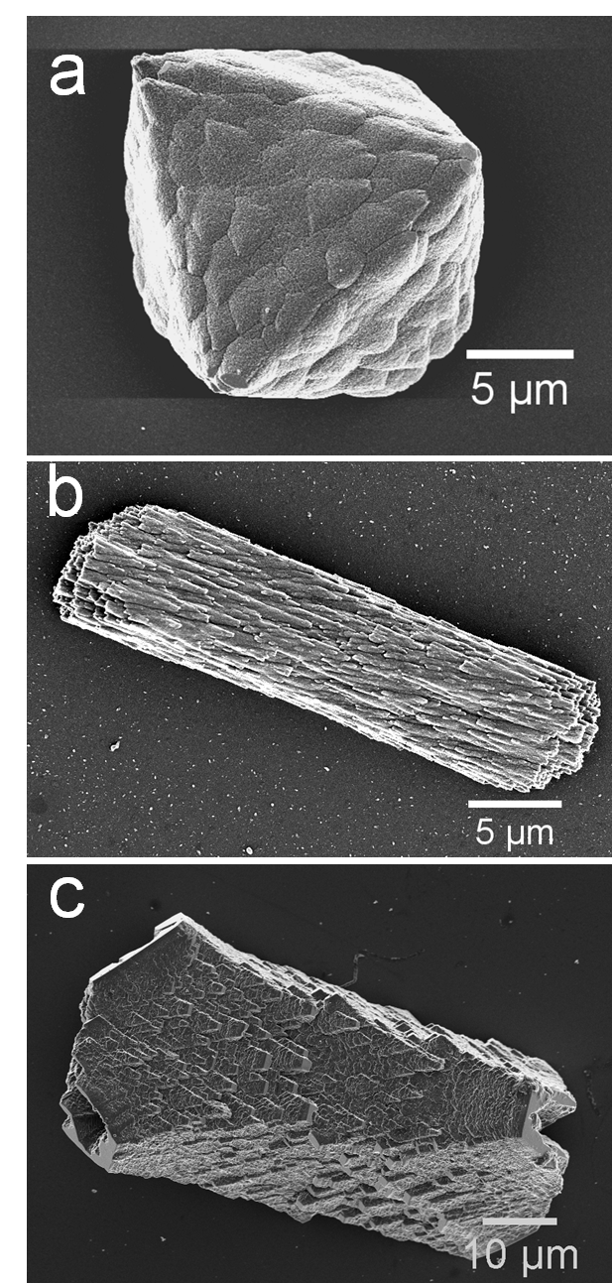

Figure 3. SAXS analysis. (a) Orientation-averaged plot of the scattering intensity versus the modulus of the scattering vector Q (log-log representation) recorded for powdered samples of control calcite (gray circles) and calcite crystals prepared in the presence of Co²⁺ ions (blue circles, [Ca²⁺]:[Co²⁺] = 50:1). The control sample shows an intensity decay proportional to Q⁻⁴ over the entire Q-range covered by the experiment, thus indicating the absence of structural complexity on the nanometer level. In the profile recorded for cobalt-doped calcite there is a deviation from Porod-like behaviour in the low-Q regime, which might be attributable to the rough-textured topography of the particle surfaces. (b) Orientation-averaged plots of the scattering intensity versus the modulus of the scattering vector Q (log-log representation) recorded for powdered samples of seeded calcite/PSS-MA crystals (light green circles) or calcite/PS-MA crystals (dark green circles). The profiles of both specimens provide indications for structural complexity at the length scale of nanometers. (c) Guinier plot ln(I(Q)·Q²) vs. Q² valid for dilute platelet-shaped scattering objects applied to the scattering curve of calcite/PS-MA crystals (dark green circles). The linear relationship in the Q-range 0.25 nm⁻¹ < Q < 1.3 nm⁻¹ (orange circles) points to a disc shape of the nanostructural heterogeneities. From the slope of the regression line (black) a mean thickness of the platelets of D = 2.9 nm can be calculated.

a
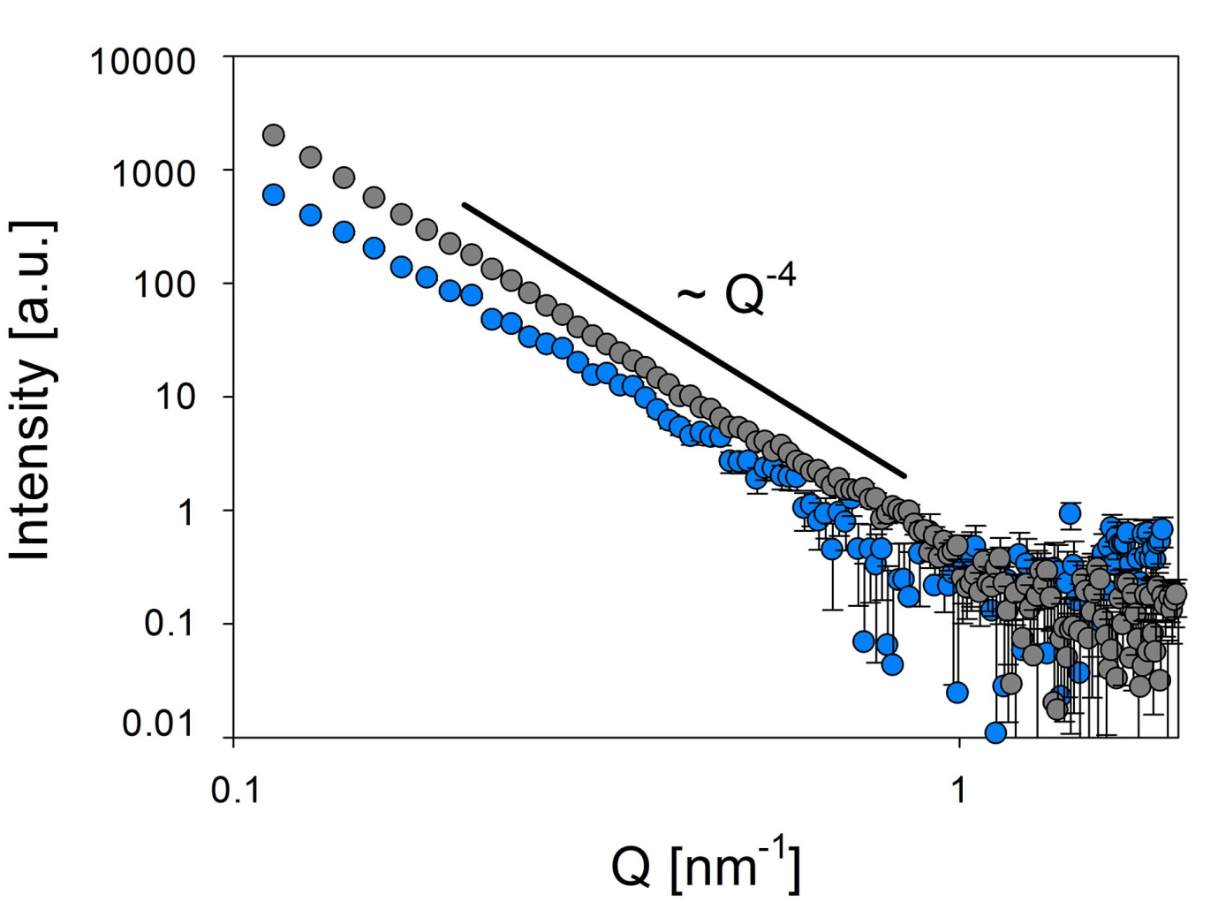
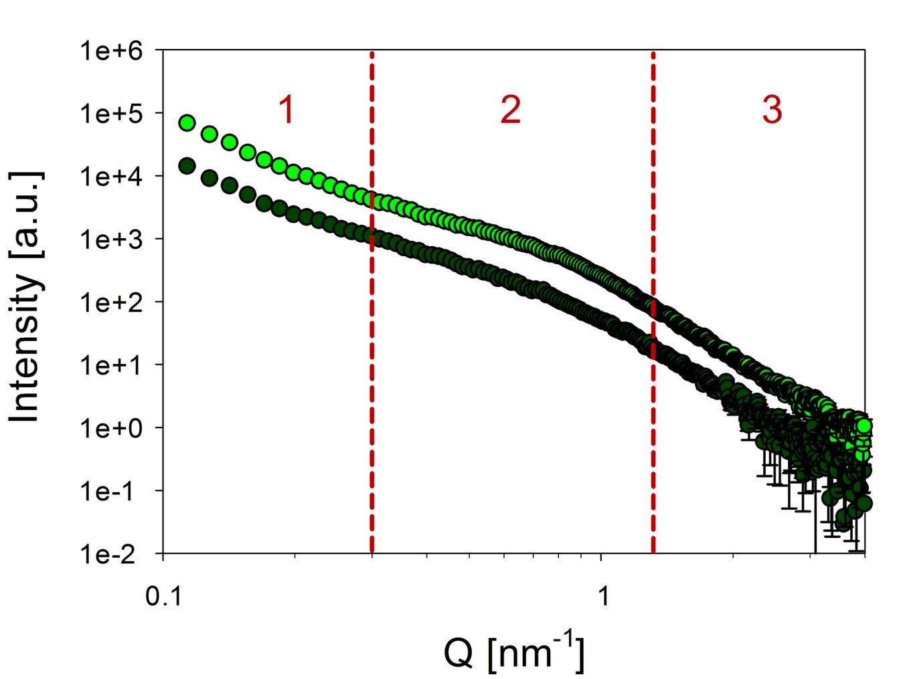
b
c
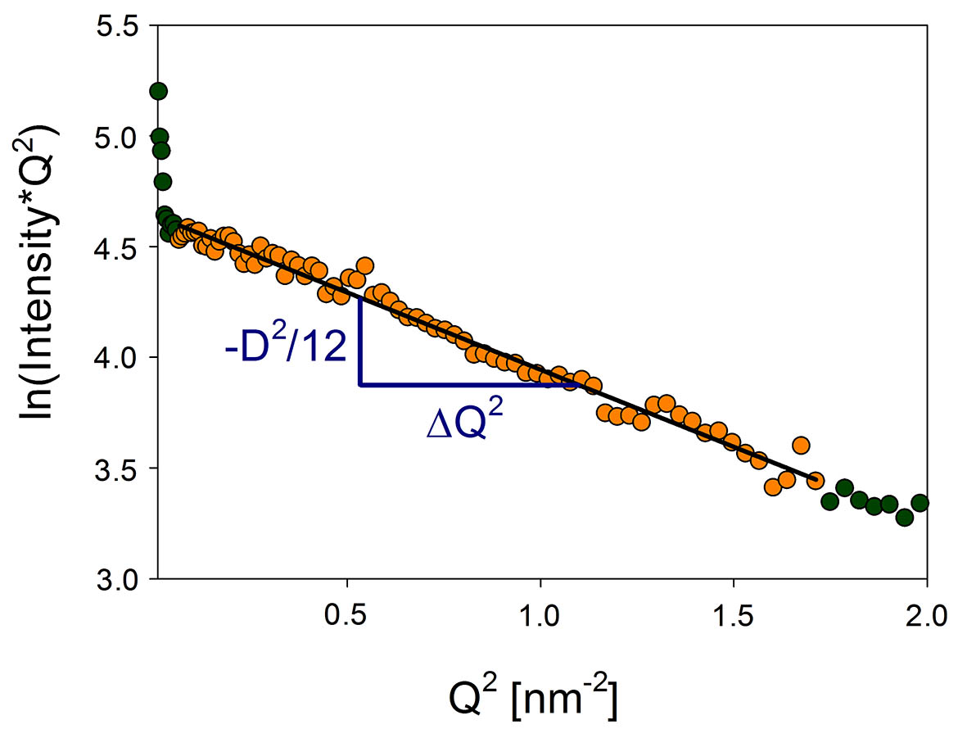
Figure 4. TEM image of thin section of a calcite/PSS-MA crystal. (a)-(g) the crystals were precipitated at [Ca²⁺] = 5 mM and [PSS-MA] = 125 μg mL⁻¹ (a) A high resolution magnification image of the area shown in the green box in (d) prior to beam damage and (b) the same area after it has been beam damaged, showing porosity. (c) A higher resolution image of the area shown in the blue box in (b), showing perfect lattice continuity. (d and e) High magnification images of the specimen area shown in the red circle in (f), where (d) is taken at focus and shows a continuous structure and (e) is taken under focus and shows an apparent nanoparticulate structure. (f) a low magnification image of a crystal grown at [Ca²⁺] = 5 mM and [PSS-MA] = 125 μg mL⁻¹ showing large mosaic blocks. (g) A series of selected area electron diffraction patterns taken across the whole area of a crystal grown as in (f) showing single crystal structures. (h) A crystal grown in the presence of [Ca²⁺] = 1.25 mM and [PSS-MA] = 125 μg mL⁻¹ showing a central core and overgrowth layer.

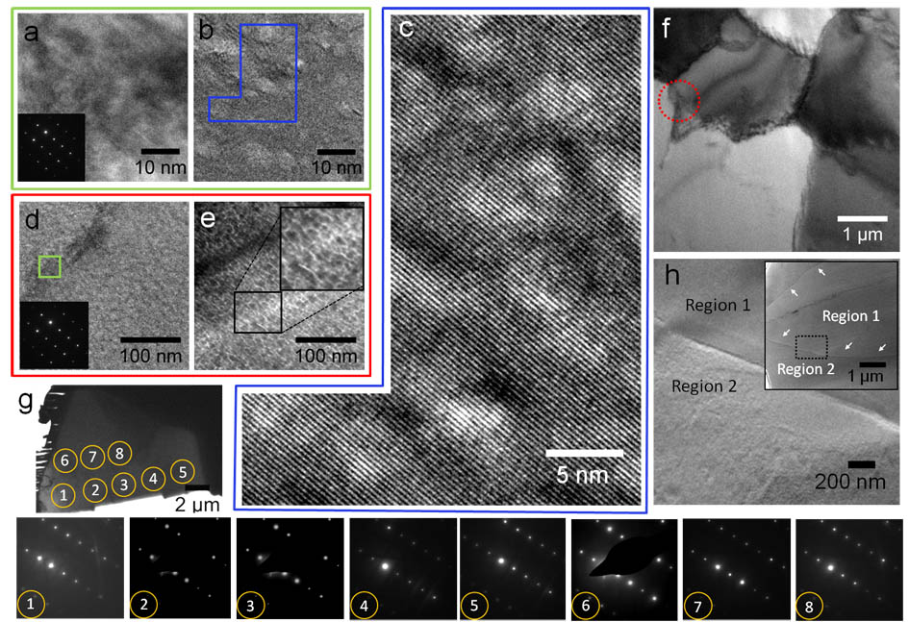
Figure 5. Effect of ageing on the surfaces of calcite/PSS-MA crystals. SEM images recorded immediately after (a) removing the crystals from the reaction solution after 1 day, (b) ageing the crystals for 2 days in air and (c) incubation in the reaction solution without carbonate source for 2 days. The precipitated was performed using the ADM and the carbonate source was then removed. The images show that the surfaces of the fresh crystals are covered with very small particles, which gives rise to a high surface area. On ageing these are replaced by much coarser features.
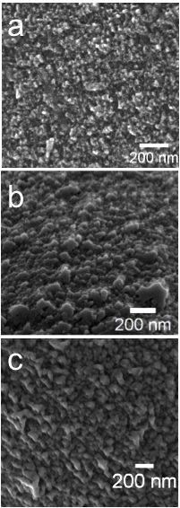

Figure 6. Electron Backscatter Diffraction (EBSD) Analysis. (a, b) EBSD maps of the calcite/PSS-MA crystals (measured with a raster step size of 280 nm) and (e) the histograms of the frequency distributions of misorientation for three selected calcite/PSS-MA individuals (i, ii, iii in b). These are compared with the EBSD maps and misorientation statistics for (c and f) a calcite single crystal and (d and f) the spine of the sea urchin Paracentrotus lividus. In (a) the colour codes are for the absolute orientations of the crystals. In (b, c and d) the colour codes for misorientation with the colour scale are defined on the right side of the maps and below the misorientation histograms (0 degree misorientation: dark blue, 10 degree misorientation: dark red). Superimposed on the colour maps is the EBSD band contrast, a grey scale component that gives the signal strength in each individual EBSD Kikuchi diffraction pattern. The band contrast highlights the grain-boundaries and boundaries between mosaic blocks. For the calcite single crystal (c) the misorientation histogram corresponds to our experimental resolution of +/- 0.3° standard deviation in crystal orientation.

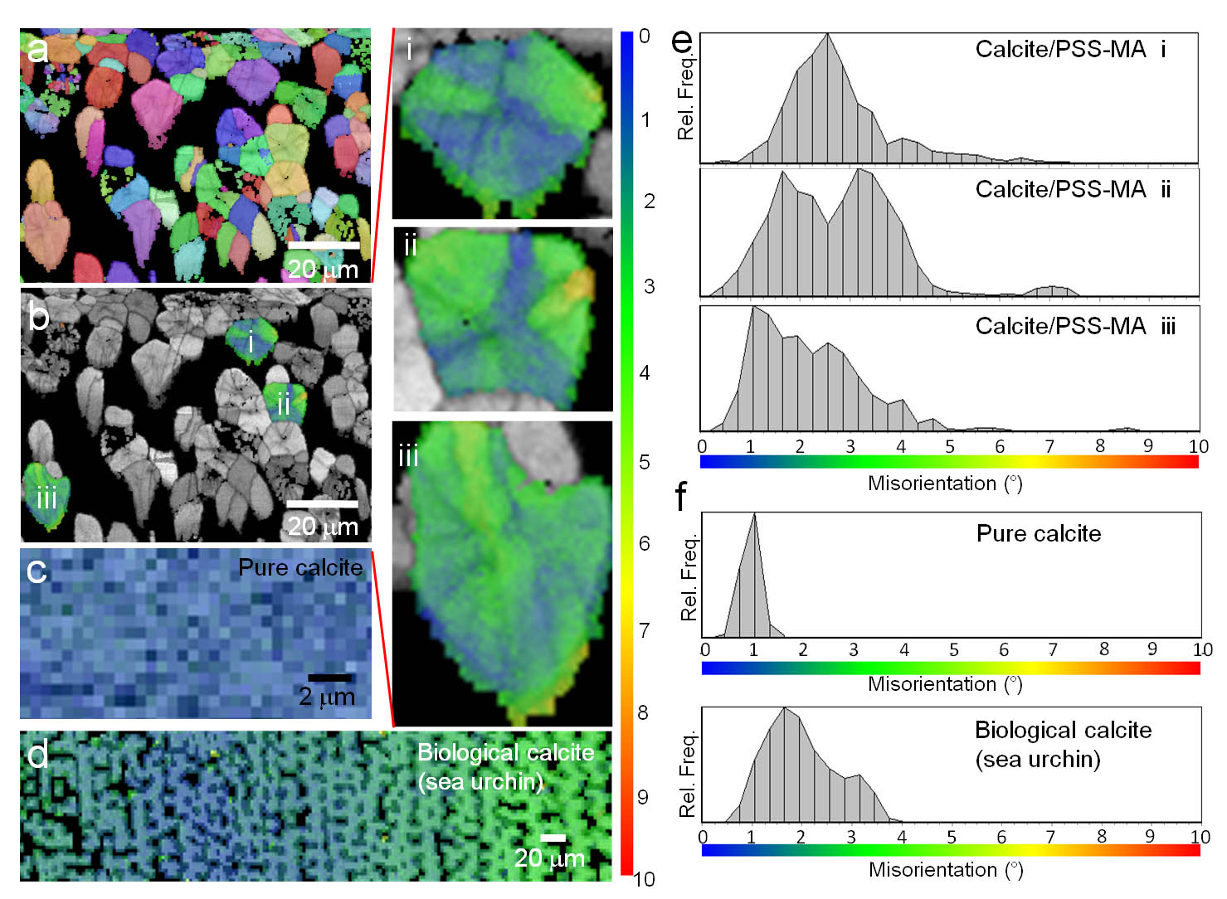
Figure 7. Morphological development of calcite/PSS-MA crystals. The crystals were precipitated in arrays of droplets formed on patterned self-assembled monolayers (SAMS) exhibiting arrays of 200 µm diameter circles, in the presence of [Ca²⁺] = 2.5 mM and [PSS-MA] = 100 μg mL⁻¹ .
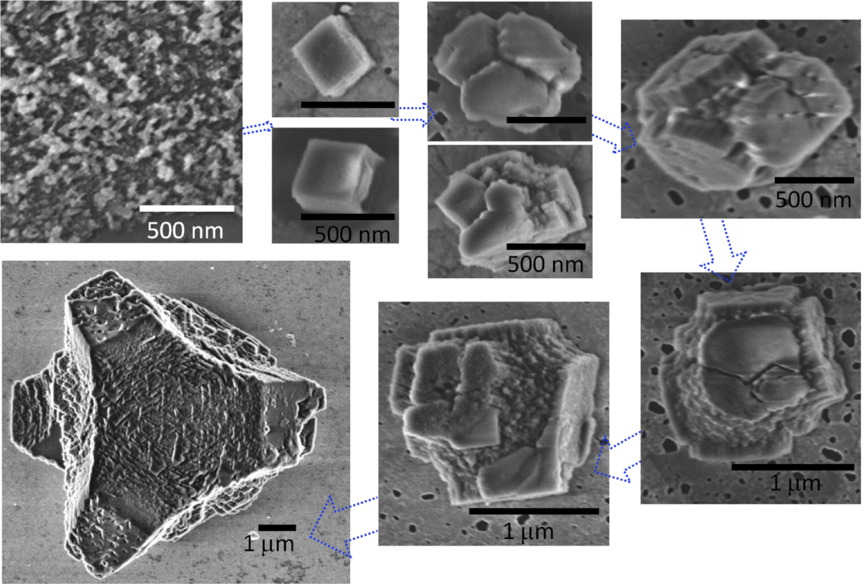

Figure 8. Crystal morphologies are not defined at early stages of growth. Images of calcite crystals produced by overgrowth of 3-5 µm calcite seeds at [Ca²⁺] = 2.5 mM in the presence of 125 μg mL⁻¹ PSS-MA. (a) Optical micrograph and (b) SEM image of a crystal produced by overgrowth and (c) high magnification SEM image of the surface of a crystal produced by overgrowth, showing a nanoparticulate structure. (d) Optical micrograph of mechanically polished crystals which had been embedded in resin, showing the overgrowth of calcite (labeled O) on rhombohedral cores (labeled S). Calcite crystals grown in the presence of PSS-MA from solutions which are undersaturated with respect to ACC. (e) [Ca²⁺] = 0.5 mM, [CO₃²⁻] = 10 mM and [PSS-MA] = 50 µg mL⁻¹, S_{calcite} = 1.515 and S_{acc} = - 0.572 and (f) [Ca²⁺] = 0.5 mM, [CO₃²⁻] = 200 mM and [PSS-MA] = 50 µg mL⁻¹, S_{calcite} = 2.04 and S_{acc} = - 0.083.
