Modulator Integration in High-Performance BiCMOS

L. Zimmermannª, D. Knollª, S. Lischkeª, H. Richterª, G. Winzerª, D. J. Thomson^{b}, F. Y. Gardes^{b}, Y. Hu^{b}, G. T. Reed^{b}, B. Goll^{c}, H. Porte^{d}, K. Voigt^{e} , B. Tillack^{e,a}
ª IHP, Im Technologiepark 25, 15236 Frankfurt (Oder), Germany
^{b} Optoelectronics Res. Centre, Univ. of Southampton, Southampton, Hampshire, SO17 1BJ, UK
^{c} Vienna University of Technology, EMCE, Gußhausstr. 25/354, A-1040 Vienna, Austria
^{d} PHOTLINE Technologies, ZI Les Tilleroyes – Trépillot, 16 rue Auguste Jouchoux, 25000 Besançon, France
^{e} Technische Universitaet Berlin, HFT4, Einsteinufer 25, 10587 Berlin, Germany
abstract
We present results for FEOL integration of Silicon electro-optic waveguides with high-performance BiCMOS technology. The new technology allows for dense co-integration of high-speed analogue RF circuits and Silicon modulators.

introduction
Frontend-of-line (FEOL) integration of photonics in high-performance microelectronics technologies is a key step towards complex receiver and transmitter devices for next generation metro and transport applications with line rates exceeding 100Gbit/sec that require increased complexity and close integration with high-speed digital signal processing. Silicon IC technologies meeting anticipated speed requirements are e.g. CMOS technologies beyond the 65nm node. However, FEOL integration of photonics in highly scaled CMOS comes with several disadvantages, in particular high reticle costs due to the use of 193nm lithography, but also analogue design issues of highly scaled CMOS transistors such as leakage and nonlinearity. In terms of existing IC technology an alternative to advanced CMOS is high-performance BiCMOS technology, offering significant advantages for integrated photonics-electronics applications with regard to cost and RF electronic performance. In this paper we shall present first results of FEOL integration of electro-optic (E/O) waveguides with a 0.25µm SiGe:C BiCMOS baseline technology. This technology allows for dense co-integration of 180 GHz bipolar transistors with depletion or injection type Silicon photonic modulators. Exemplifying application of the technology to a Mach-Zehnder depletion type modulator with driver circuit will be shown.

Substrate technology for photonic BiCMOS
Silicon photonics with high-performance waveguide optics relies on bespoke photonic Silicon-on-Insulator (SOI) substrates, typically with 220nm crystaline SOI thickness meeting single mode waveguide conditions, and 2000nm of buried oxide to limit substrate leakage of optical modes. Such SOI substrates are incompatible with advanced BiCMOS technology, which is realized on bulk-Silicon substrates. To reconcile these fundamentally different substrate requirements we developed a technology realizing on a single substrate local-photonic-SOI areas (reserved for photonic devices) and adjacent bulk-Silicon areas (reserved for BiCMOS devices). The starting substrate is photonic SOI, which is etched down to the handling wafer and then locally regrown by Si-epitaxy, finishing with polishing to obtain surfaces at the same height for local-SOI and for bulk Silicon. A cross section depicting the transition zone between photonic local-SOI and bulk-Silicon is shown in Fig. 1.

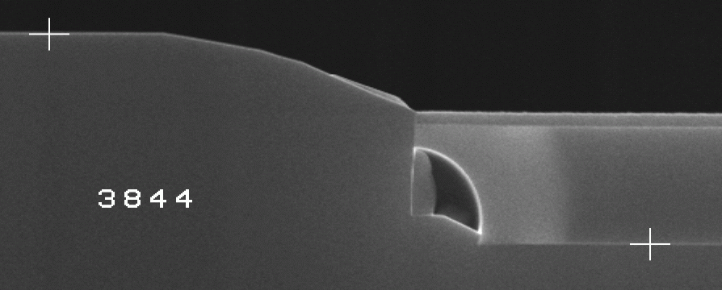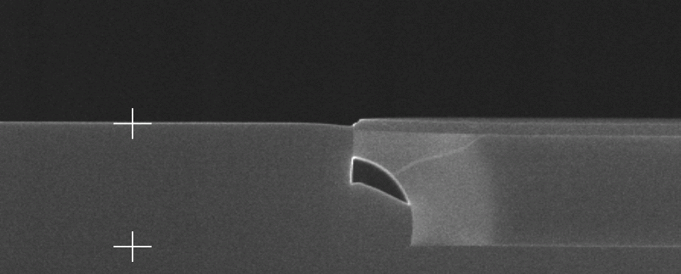
SiO
2
SOI
e
p
i
Bulk
SiO
SOI
Bulk
SiO₂
SOI
Bulk
SOI
After Si CMP
After selective Si epi
SiO₂
Figure 1: Cross-sections of a local-SOI area after Silicon selective epitaxy (left) and CMP (right). From [2].

High performance photonic BiCMOS Process
The process sequence for a fully fetched integration of E/O waveguides (modulator structures) and BiCMOS electronics is shown in Fig. 2. Details regarding the BiCMOS technology may be found in [1]. More information regarding compatibility of local-SOI and BiCMOS can be found in [2].
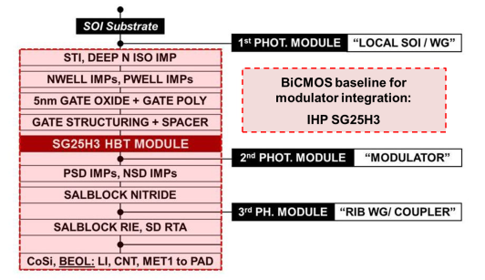
Figure 2: Global FEOL photonic-electronic integration flow combining the BiCMOS baseline SG25H3 with E/O waveguides (2nd photonic module) for modulator integration.
The BiCMOS flow of the baseline technology is complemented by photonic modules, which are:
LOCAL SOI/ WG: A first mask is used for partitioning the wafer or chips in SOI regions, foreseen for the fabrication of photonic components, and bulk Si regions, foreseen for the fabrication of BiCMOS devices.
E/O WAVEGUIDES (MODULATOR): Implantations and an intermediate etch-depth waveguide formation are used to fabricate the frontend structure of the silicon photonic modulator (lateral PN junction, depletion type). The electrode is later fabricated using standard backend metalization.
RIB WAVEGUIDE / COUPLER: One mask step is applied for etching shallow trenches in the top-Si layer of SOI regions to form low-loss waveguides simultaneously with grating coupler structures.
Results
A 10Gbit/sec Mach-Zehnder modulator (MZM) with corresponding driver was processed. A cross section of a finished die is shown in Fig. 3 depicting photonic as well as electronic (HBTs) structures. In Fig. 3 we also show a microscope image of the full device, i.e. MZM and driver. The modulator phase shifter was very similar to a previously published device [3]. The electronic driver was designed in IHP SG25H3 technology to drive the modulator in push-pull configuration. More details regarding driver design can be found in [4]. Device characterization is presently underway.
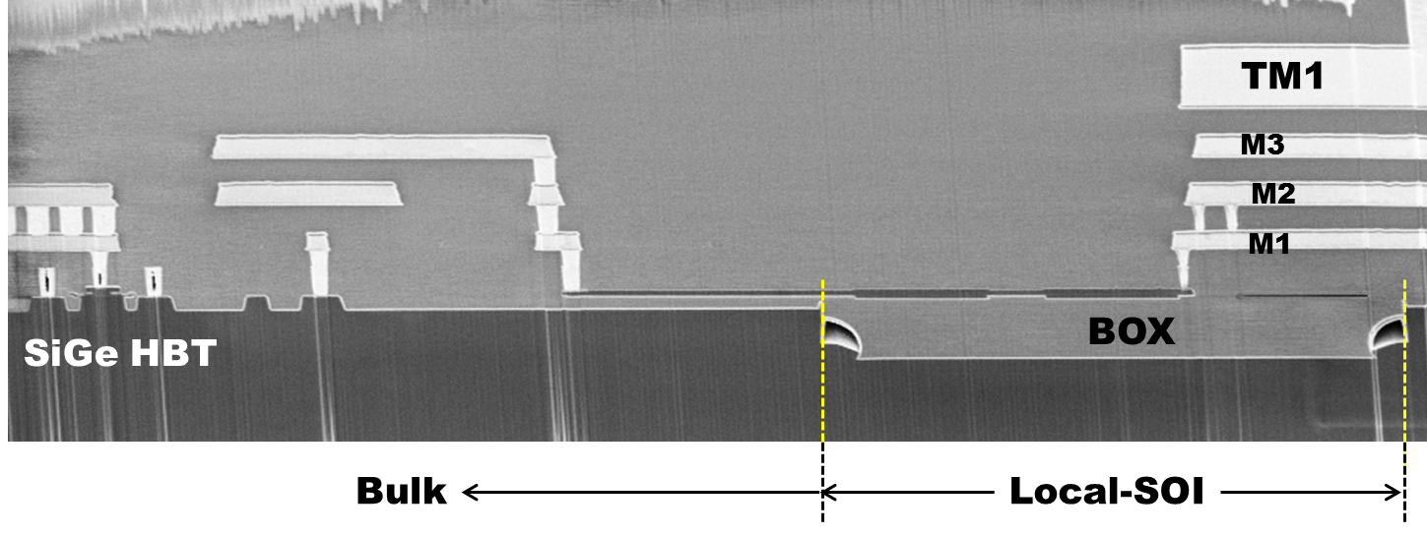 | 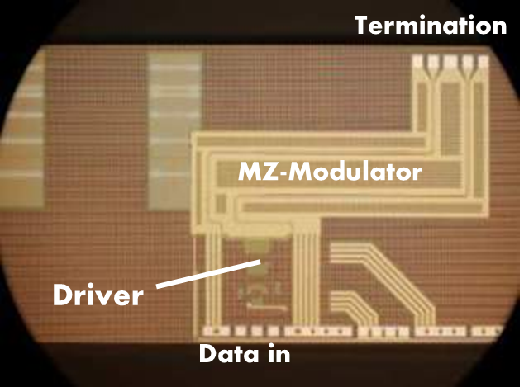
Figure 3: (left) Photonic E/O waveguide BiCMOS cross section showing local-SOI, i.e. photonic areas and bipolar transistor, i.e. SiGe HBT. (right) Microscope image of Mach-Zehnder modulator with driver.
Aknowledgment
We gratefully acknowledge partial support by European Commission, project HELIOS (FP7-224312), by German Ministry of Research and Education (BMBF), project SASER, and by an EPSRC funded project in the UK, “UK Silicon Photonics.”
References
- B. Heinemann, R. Barth, H. Rücker, D. Knoll, B. Tillack, and W. Winkler, Semiconductor Science and Technology, 22, 153–157 (2007)
- D. Knoll et al, "Substrate Design and Thermal Budget Tuning for Integration of Photonic Components in a High-Performance SiGe:C BiCMOS Process," 5th International SiGe, Ge and Related Compounds: Materials, Processing and Devices Symposium - ECS Conference, Hawaii, USA (2012)
- D. J. Thomson et al, "High contrast 40Gbit/s optical modulation in silicon," Opt. Express 19, 11507-11516 (2011)
- B. Goll, H. Zimmermann: "10 Gbit/s SiGe modulator driver with 37 dB gain and 680 mW power consumption," Electronics Letters, 48, 938 – 940 (2012).

