Monolithically Integrated 10Gbit/sec Silicon Modulator with Driver in 0.25µm SiGe:C BiCMOS

L. Zimmermann (1), D. J. Thomson (2), B. Goll (3), D. Knoll (1), S. Lischke (1), F. Y. Gardes (2), Y. Hu (2), G. T. Reed (2), H. Zimmermann (3), H. Porte (4)
(1) IHP, Im Technologiepark 25, 15236 Frankfurt (Oder), Germany
(2) Optoelectronics Research Centre, University of Southampton, Southampton, Hampshire, SO17 1BJ, UK
(3) Vienna University of Technology, EMCE, Gußhausstr. 25/354, A-1040 Vienna, Austria
(4) PHOTLINE Technologies, ZI Les Tilleroyes – Trépillot, 16 rue Auguste Jouchoux, 25000 Besançon - France
lzimmermann@ihp-microelectronics.com

Abstract: We present the first monolithic photonic integration in the electronic frontend of a high-performance BiCMOS technology. 10Gbit/sec operation of a Silicon Mach-Zehnder modulator device with 8dB extinction in dual-drive is demonstrated.
OCIS codes: (250.0250) Optoelectronics; (250.3140) Integrated Optoelectronic Circuits

1. Introduction
Monolithic photonic integration in the frontend of a Silicon IC technology requires devices such as detectors and modulators to be implemented in the immediate vicinity of transistors, allowing for the shortest possible electric interconnects between electronics and photonics. This eliminates the need for bondwires and bondpads that are usually detrimental for high-speed performance. Frontend integration of photonics has been pursued by several groups, however, chiefly based on CMOS technologies ([1-3]). Here we present a new approach to frontend photonic electronic integration. We show integration of a Mach-Zehnder modulator in the frontend of a high performance BiCMOS (bipolar and CMOS) technology. The advantages of BiCMOS are in achievable performance versus cost. High performance BiCMOS is frequently deployed for broadband applications, especially high-speed photonics. The key figure of merit is f_{T} × BV, i.e. maximum transit frequency × breakdown voltage. This figure of merit of bipolar transistors is higher than in comparable CMOS processes, so there is increased design flexibility and overall simpler analogue design at high speed (compared to CMOS with issues of leakage, transistor nonlinearity and low supply voltage). On the other hand, chip area in a highly scaled CMOS process is very costly, which prohibits frontend integration of larger photonic devices in such technologies. This tradeoff is much less critical for high performance BiCMOS, which mostly uses 248nm lithography only instead of 193nm lithography (used for highly scaled CMOS). Photonic BiCMOS is thus particularly interesting for broadband applications without the very large volume behind advanced CMOS.
In the following we shall present results of co-integration of a BiCMOS foundry technology (SG25H3) to integrate a SiGe dual complementary outputs RF driver amplifier working up to 10Gbit/s with a dual-drive carrier depletion Mach-Zehnder modulator. This configuration combining the driver and the modulator is of key importance because the driving voltage of the optical modulator is in the range of several volts, while the incoming signal is generally in the range of some hundreds of mV. A driver amplifier with typical gain of 20-25dB is thus required to make the modulator work with optimized dynamics, this in particular to improve the signal to noise (S/N) ratio.
2. Modulator and driver design
A diagram showing the schematic cross section of the RF phase shifter is shown in figure 1.
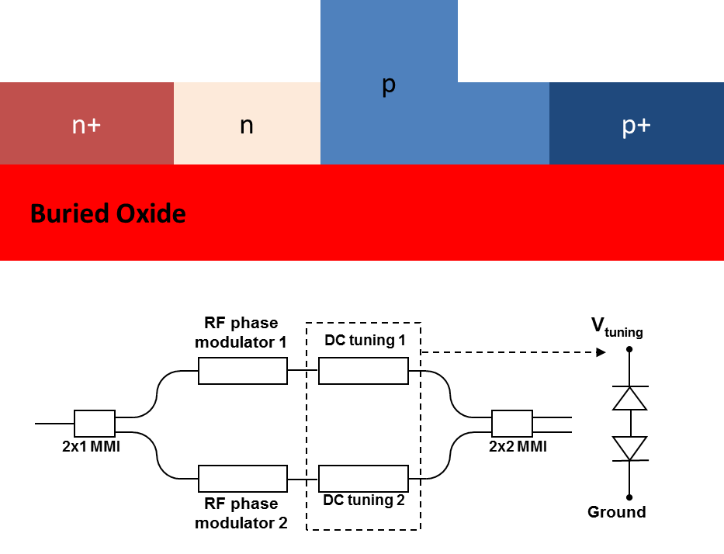 | 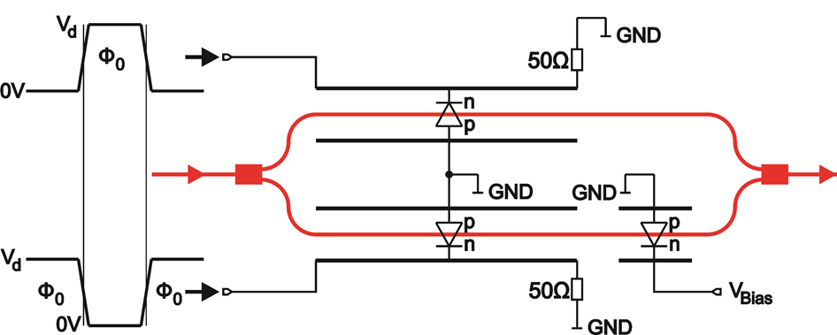
Fig. 1. Diagram of RF phase modulator cross section and schematic of MZM (left). Dual drive scheme of MZM with driver (right)
The optical modulator is based upon carrier depletion in a reverse bias PN junction which is integrated with an SOI rib-waveguide. The waveguide is of dimensions 220nm height, 400nm width and 100nm slab height. The modulator is formed using a self-aligned process similar to the one described previously [4]. The phase shifter electrodes are formed on the 3µm thick top metal 2 layer of the BiCMOS process. Phase shifters of 2mm length are inserted into both arms of a symmetrical Mach Zehnder Interferometer (MZI). DC Tuning sections (2.55mm) are included in both arms to allow the operating point to be adjusted electrically. The DC tuning element consists of the same PN junction as used for the high speed phase modulator however the n⁺ and p⁺ regions are separated from the waveguide edge by 1µm. The electronic driver is designed in IHP SG25H3 technology to drive the modulator in push-pull configuration, as shown in figure 1. The schematic of the driver and the simulated eye diagrams at 10Gbit/sec data rate are shown in figure 2.
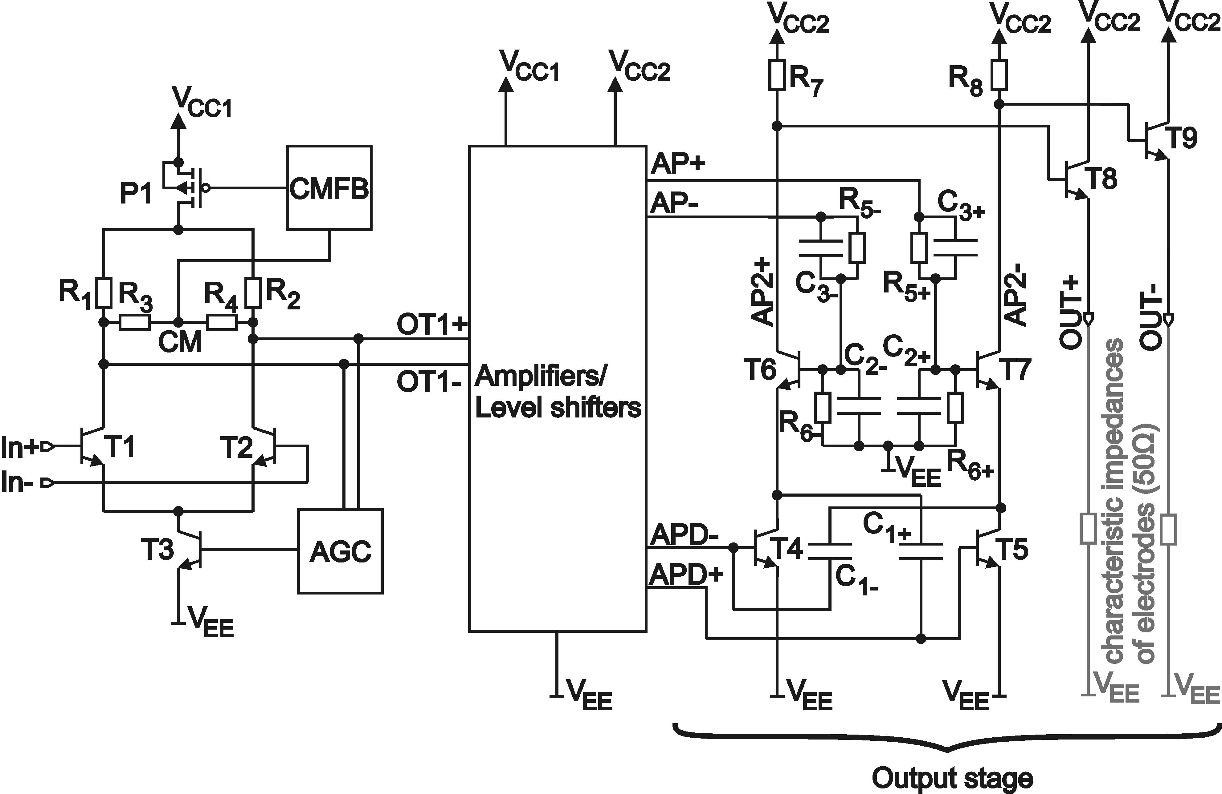 | 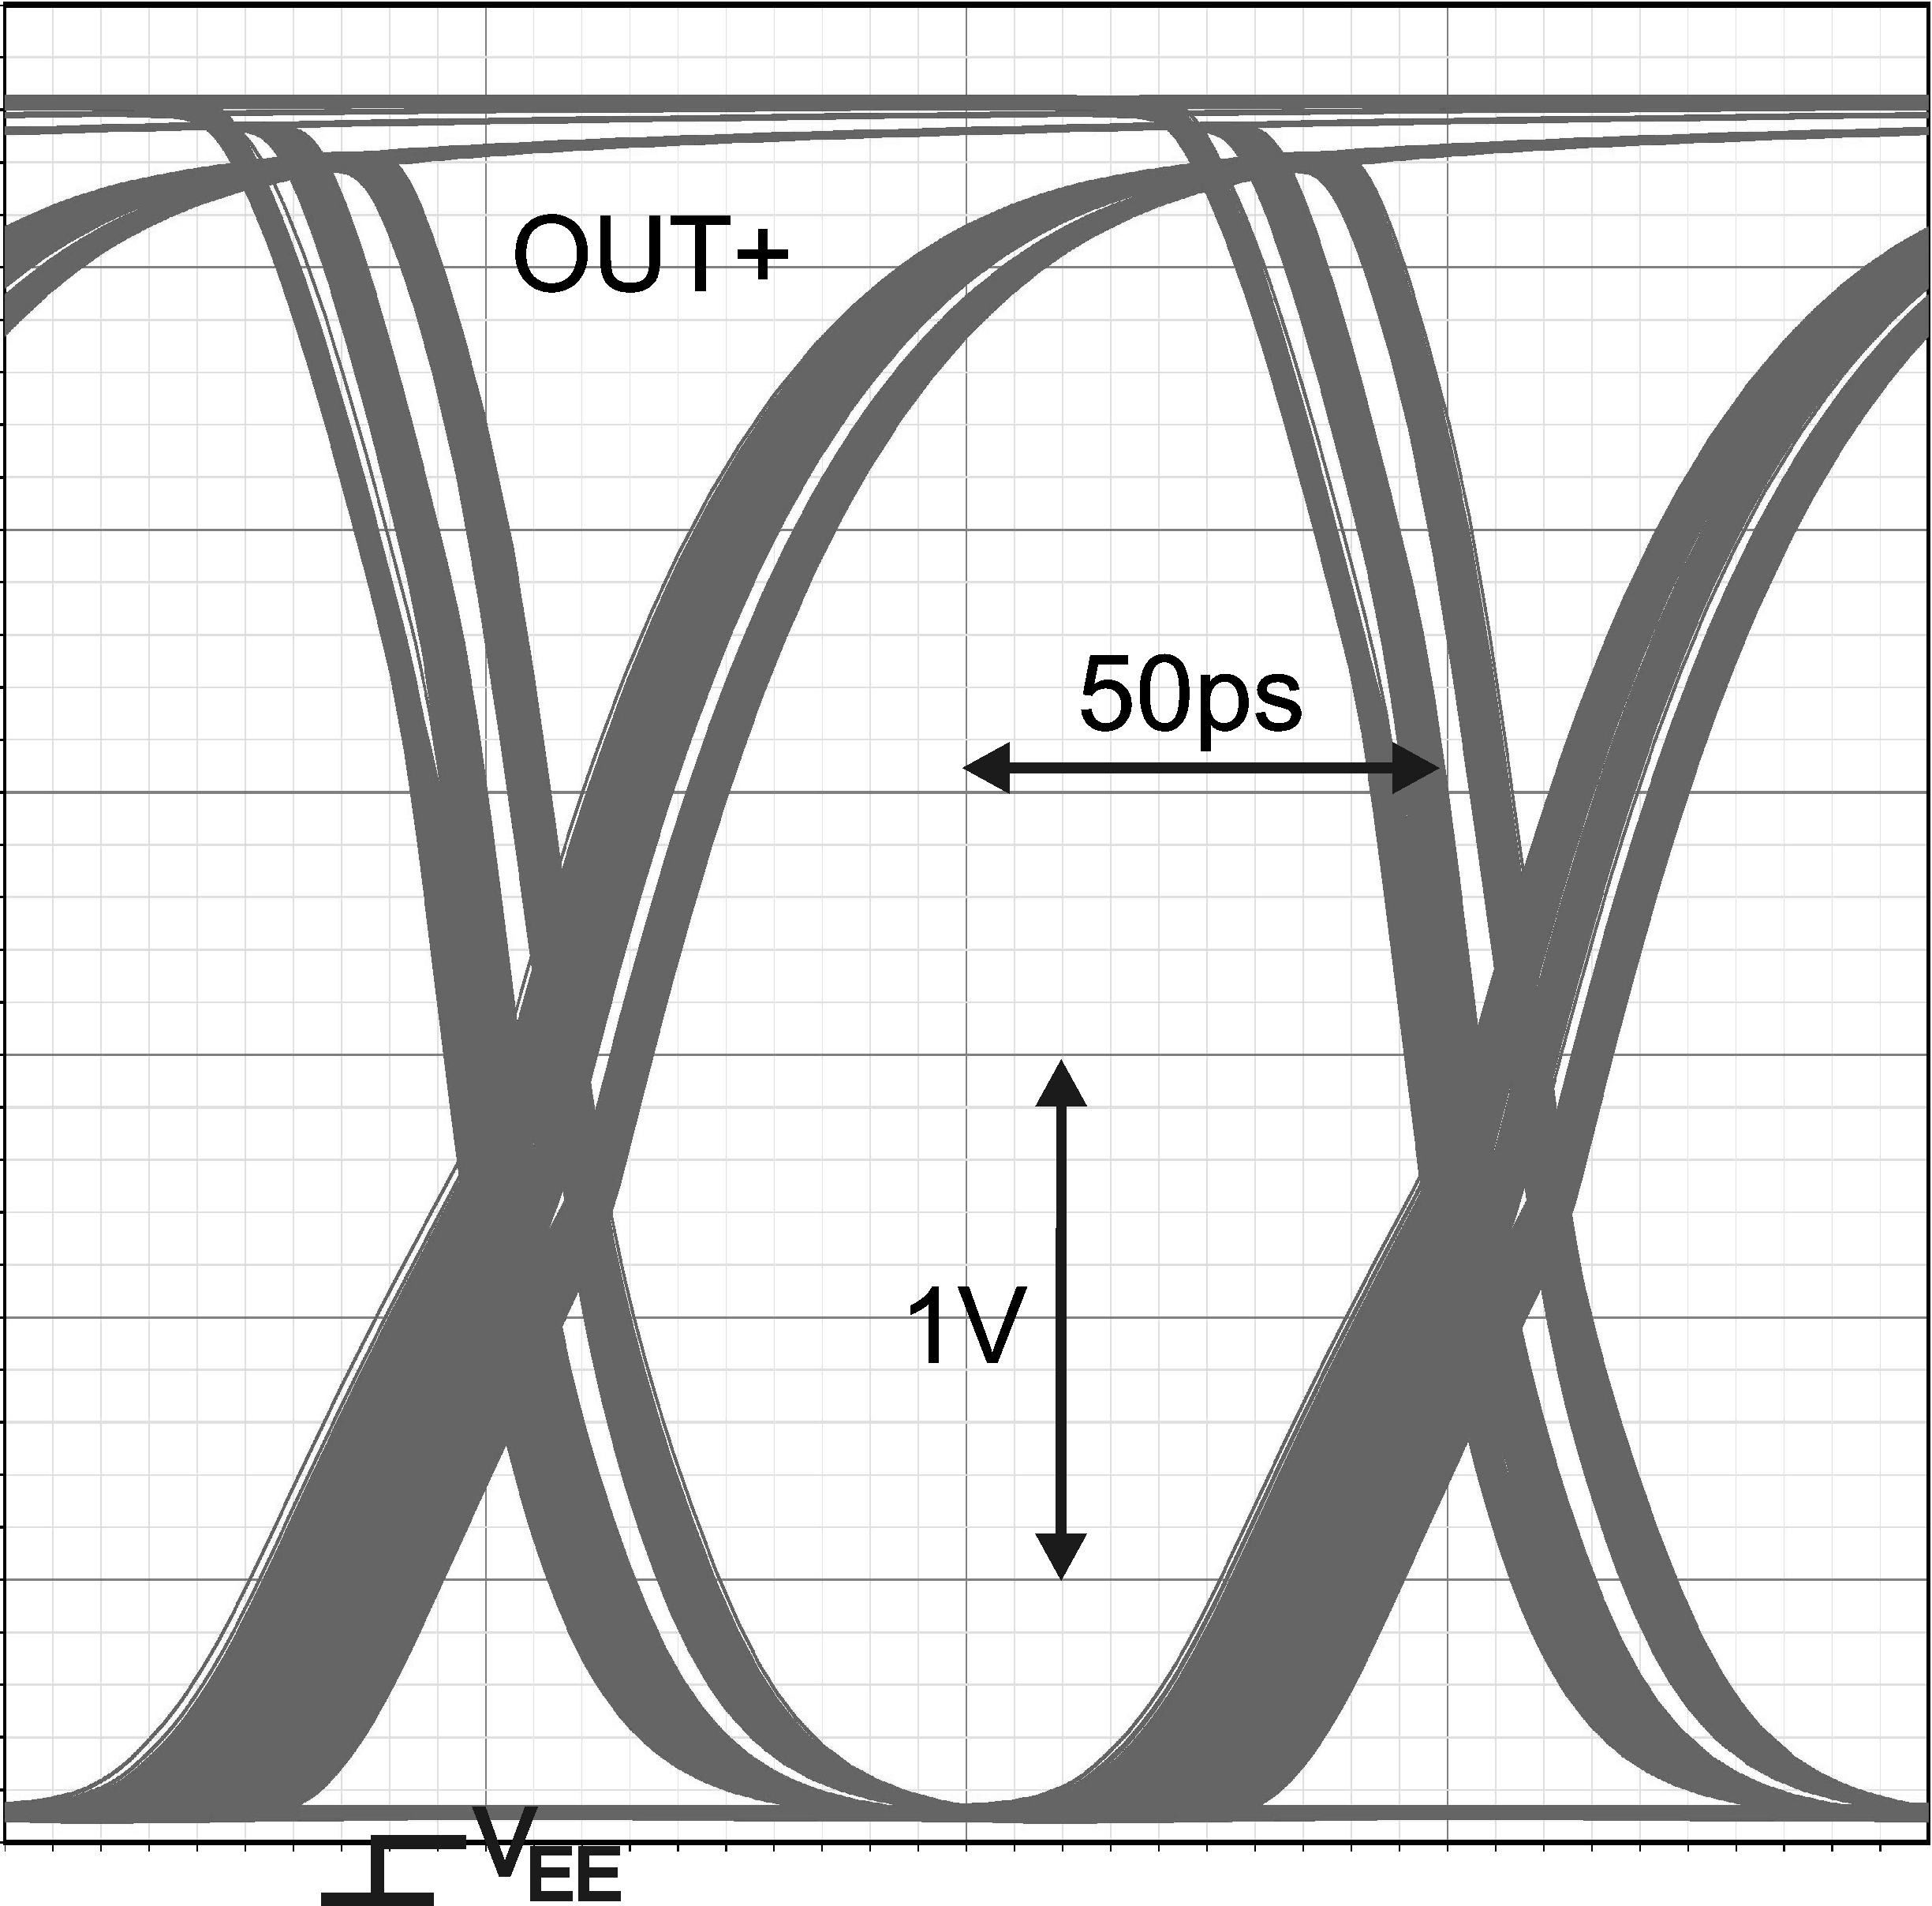 | 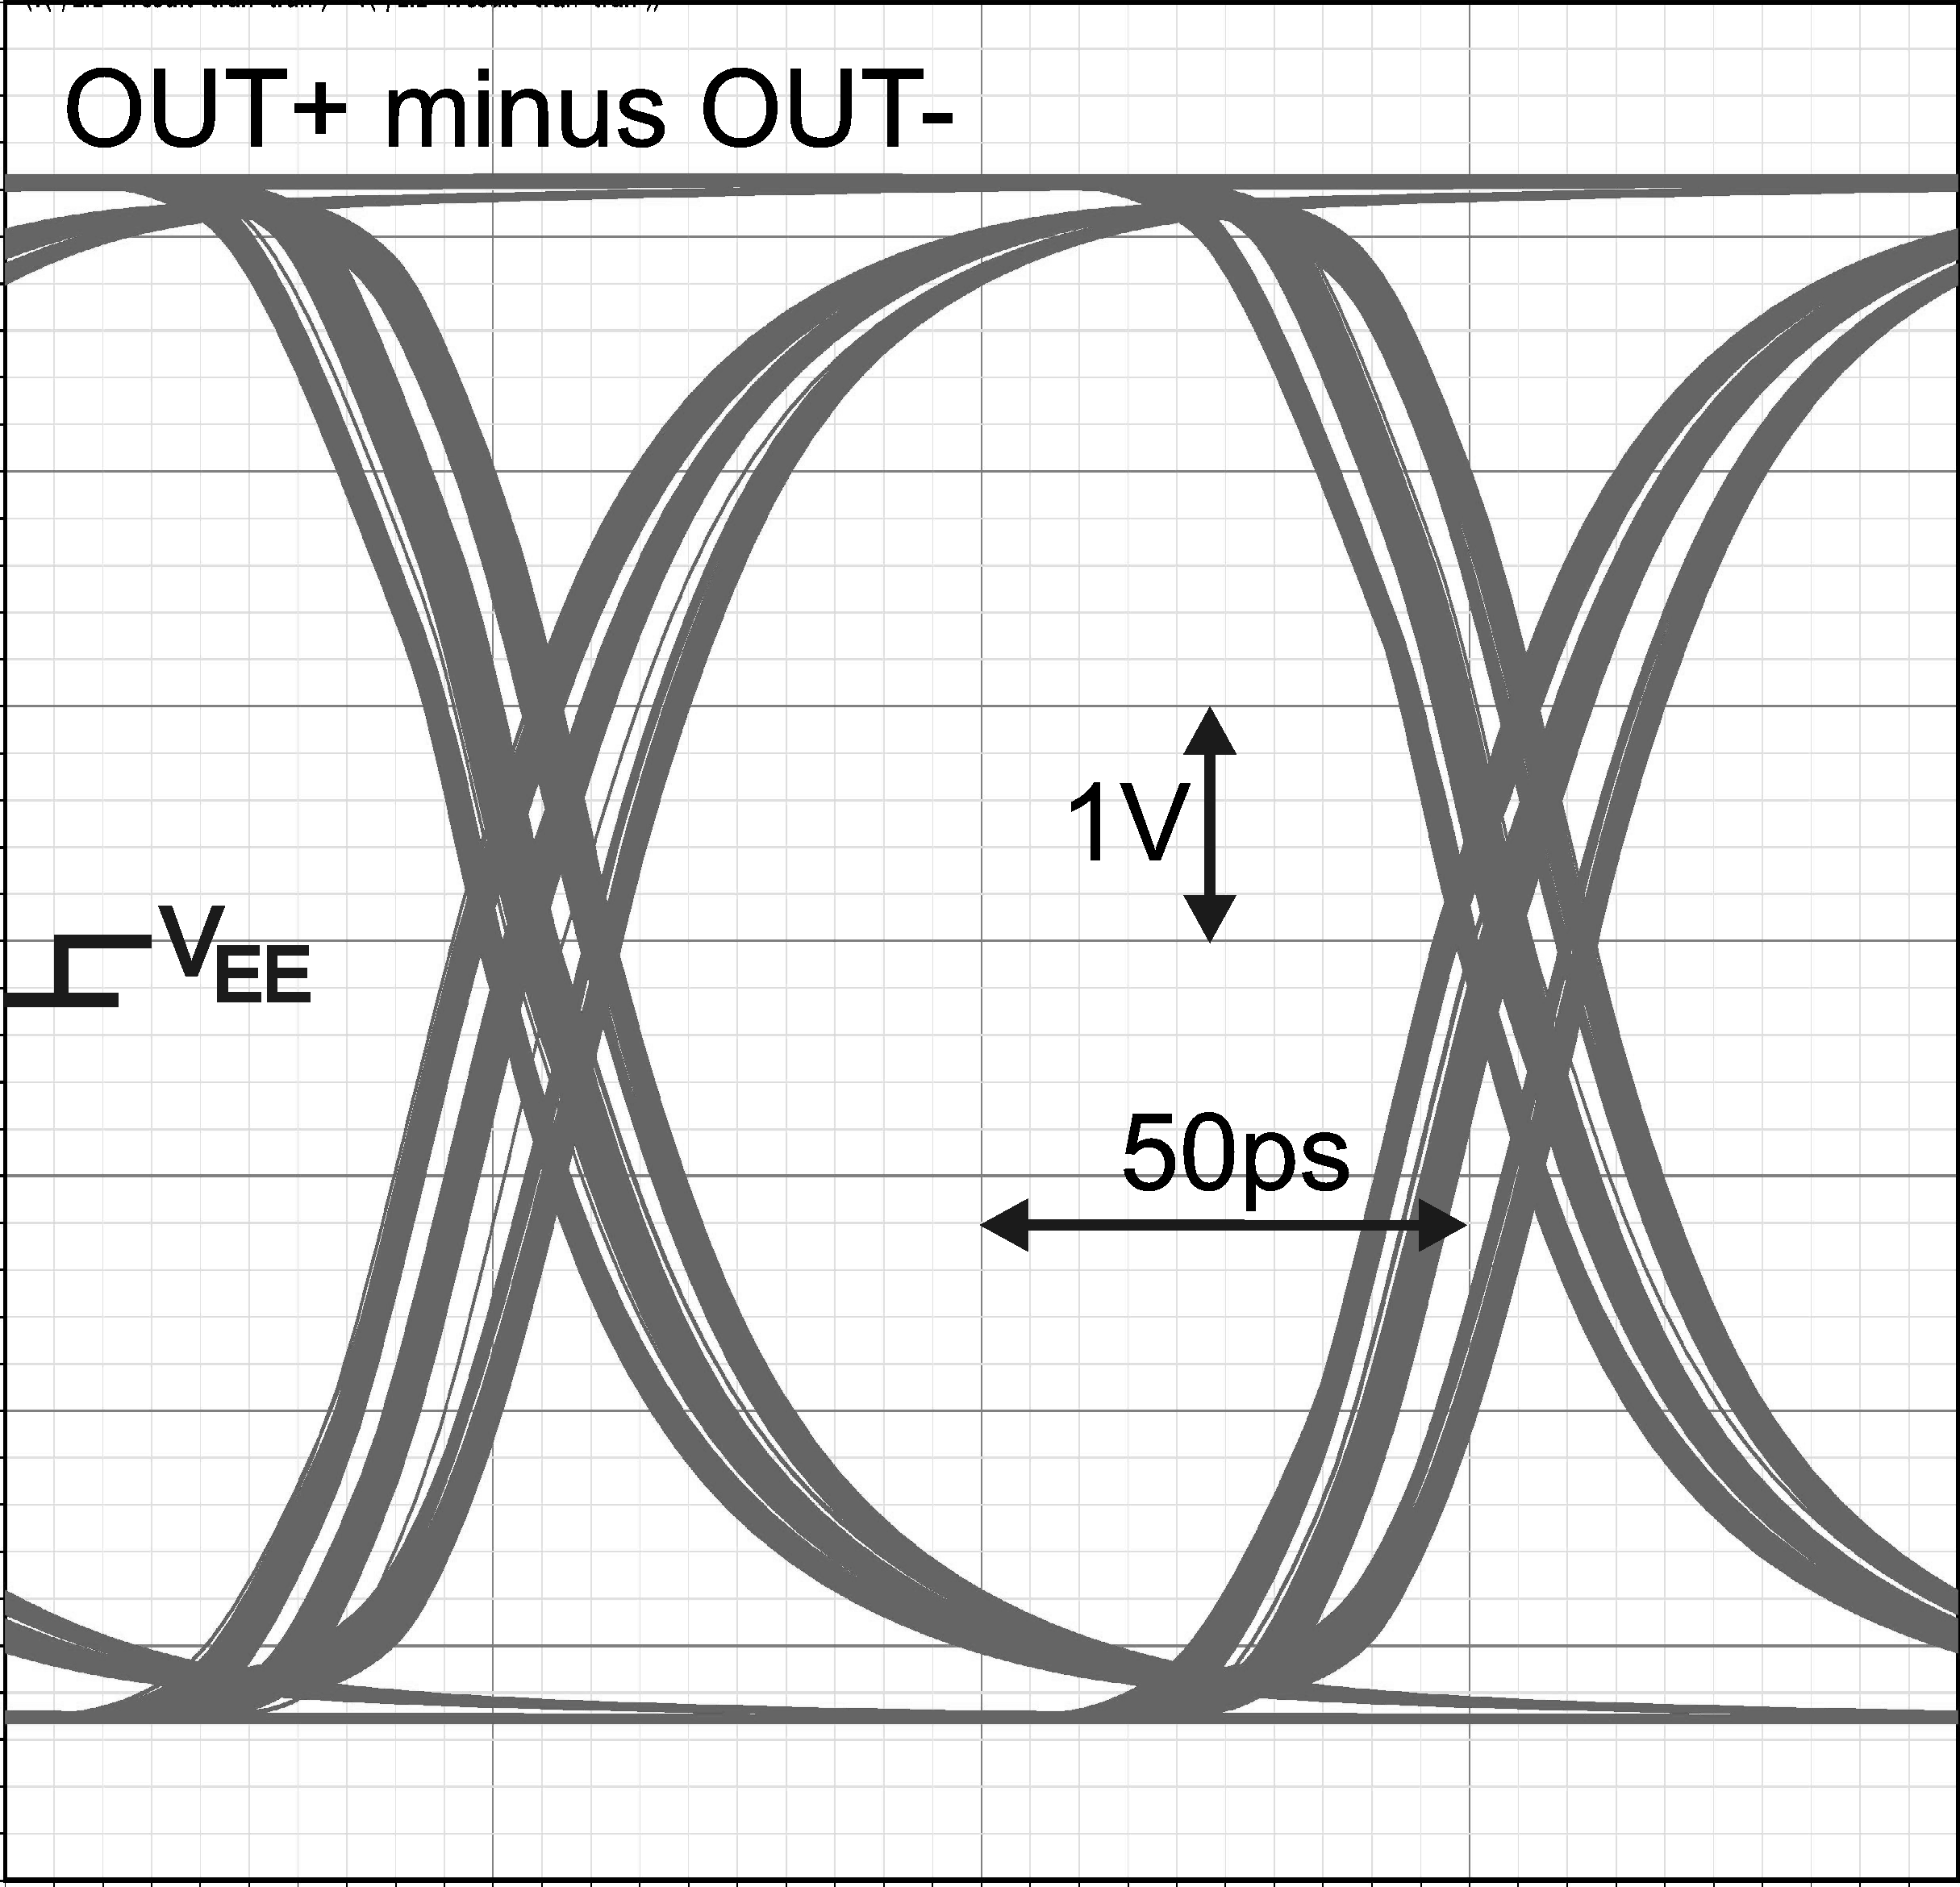
Fig. 2. Simplified schematic of the electronic driver (left) and simulated eye diagrams (right) of one single ended output OUT+ (0V to 2.8V) and the whole differential output (Vpp=5.6V) for 50mVpp at the input (10Gb/s)
The driver contains a differential amplifier (T1-T3, P1, R1-R4) for pre-amplification. The input common-mode voltage at In+/In- is ≈1.25V. A common-mode feedback circuit (CMFB) is implemented to set the optimal operation point. The input data signal is overlaid to the input common-mode voltage and can be applied either only at a single input (e.g. In+) or at both inputs (In+ and In+) as a fully differential signal. For high input amplitudes, an automatic gain control (AGC) is implemented for reduction of the voltage gain. Additional amplifiers and level shifters generate two data signals (AP+/AP- and APD+/APD-) at different common-mode voltage levels to drive transistors T6 in series to T4 (T7 and T5 resp.) with the help of RC-networks to overcome the limits set by the collector-emitter breakdown voltage BVCE0≈2.2V of these fast transistors. Transistors T8 and T9 with lower speed but higher BVCE0 drive the electrodes of the modulator with a characteristic impedance of 50Ω. The driver uses two supply voltages (VCC1=2.5V and VCC2=4.2V). So a maximum output differential voltage of Vpp=5.6V can be achieved. Measurements have shown that the driver has a maximum AC gain of 40dB (f-3dB=7.5GHz).
3. Technology
The global photonic BiCMOS flow is schematically depicted in figure 3. Photonic SOI of 220nm is not fit for integration with high-performance bipolar transistors. This is mainly for two reasons: incompatibility with collector fabrication and the higher thermal resistance compared to bulk Silicon substrates normally used for high-performance BiCMOS processes.
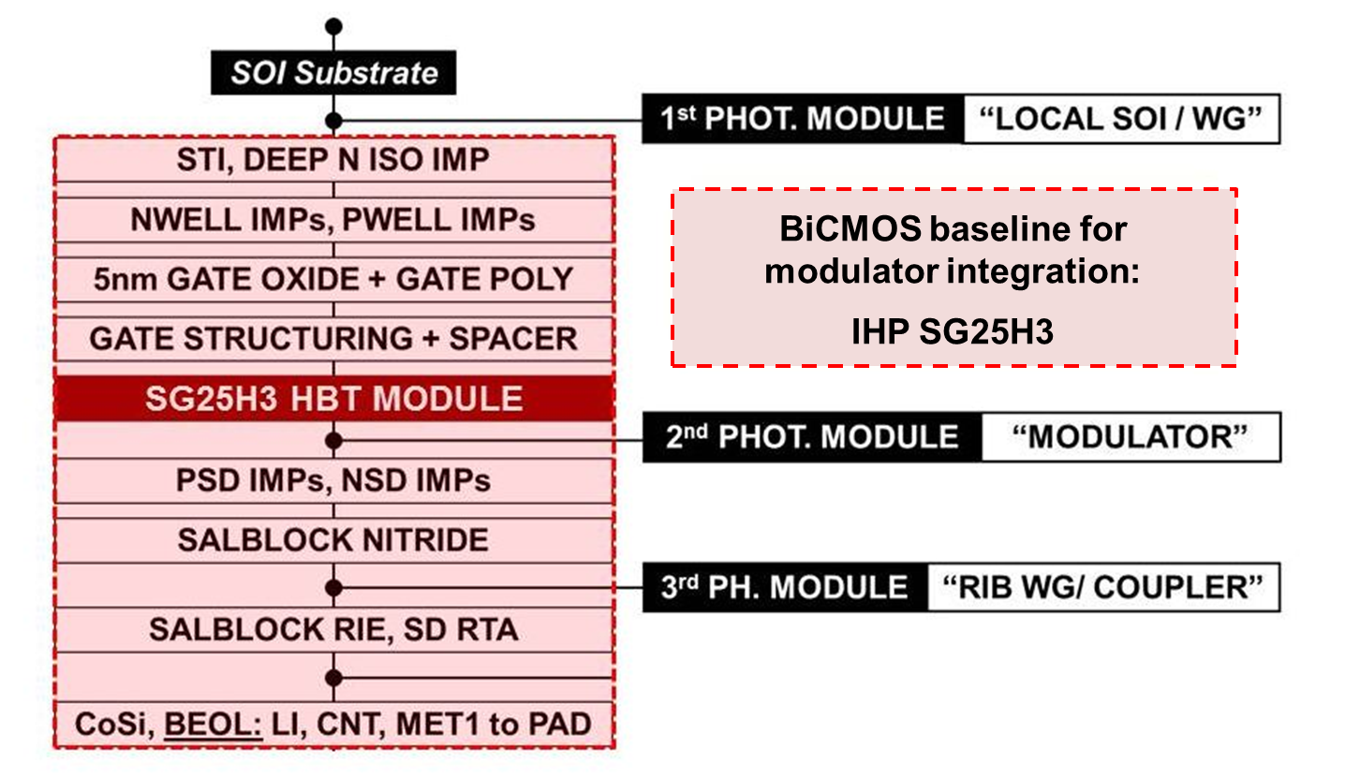 | 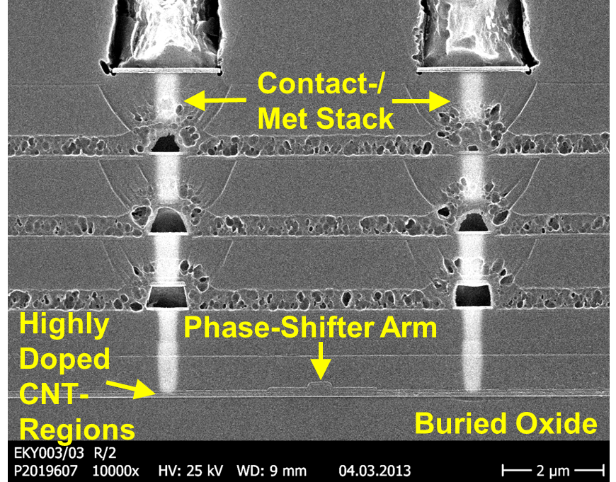 | 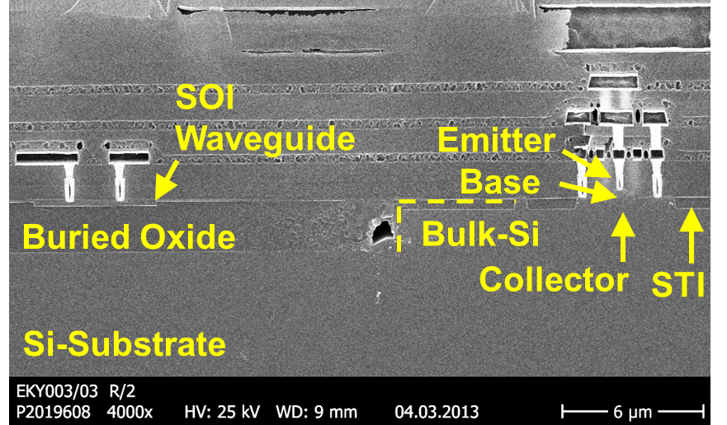
Fig. 3. Photonic BiCMOS global flow (left) & device cross sections: phase shifter with metal stack (middle) local SOI & bulk area (right)
Therefore we developed a process combining local-SOI areas with bulk-Si areas. The starting substrate is photonic SOI, which is etched down to the handling wafer and then locally regrown by Si-epitaxy, finishing with polishing to obtain surfaces at the same height for local-SOI and for bulk Silicon. After local-SOI fabrication and nanowaveguide structuring the BiCMOS process follows the standard flow. However, at specific points additional photonic process modules are inserted into the standard flow. Cross sections of photonic devices and high performance bipolar transistors on the same wafer die are also shown in figure 3.
4. Experimental results and discussion
Figure 4(a) shows an annotated optical microscope image of the device during testing. Light is coupled to and from the device via grating couplers. The DC power supply for the driver, DC tuning voltage, RF input signal and 50Ω terminations are applied to the device using custom designed probes. Firstly the DC tuning element is tested by monitoring the optical output power whilst a range of DC voltages between -10V and 10V are applied across the tuning element (fig 4(b)). An input wavelength of 1540nm is used during testing.
(a) 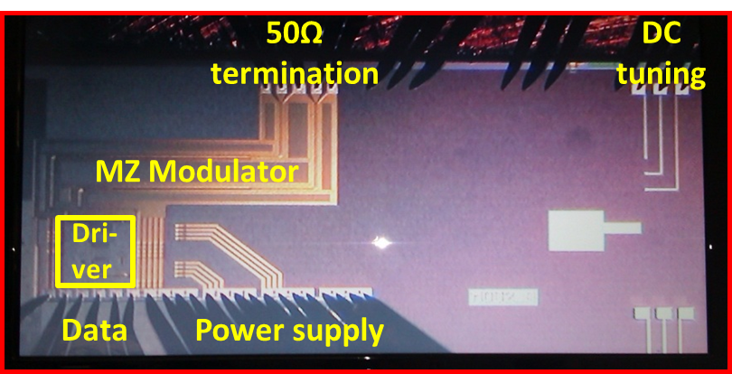 | (b)
(c) 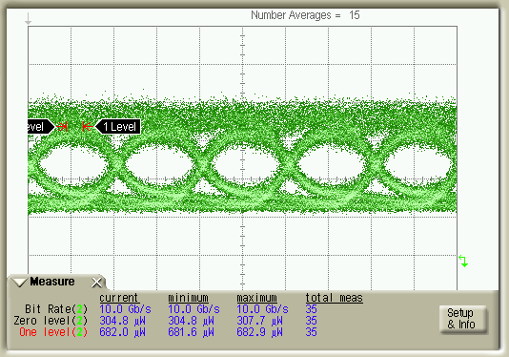 | (d)
Fig. 4. (a)Annotated optical microscope image of sample during testing (b) DC tuning curve, quadrature operation is achieved at approx. -3V and 7V. (c) optical eye diagram MZM with driver at 10Gbit/sec (d)optical eye diagram of single modulator (i.e. without driver) at 20Gbit/sec
High speed testing is performed by applying a 240mVpp PRBS data stream and DC power to the driver. The RF signal with 1.25V DC bias is applied to one input of the driver. A 1.25V DC level is applied to the other input. Two DC power levels of 2.5V and 4.2V are also applied to the driver. An EDFA is used to boost the signal and a filter used to reduce noise from surrounding wavelengths before the light is passed to a DCA for measurement. The 10Gb/s eye diagram is obtained with a 7V tuning voltage so the device is operated at quadrature. The extinction ratio in this case is approximately 8.4dB (accounting for EDFA noise). The major contributions of optical loss in the device are: high speed phase shifter (7.2dB), tuning section (3.6dB), 2x2 MMI combining (0.7dB), and passive waveguide loss (0.8dB). Total on-chip insertion loss is approx. 13dB, total power consumption is 830mW.
It should be noted that the speed of 10Gbit/sec is limited by the driver design, not the transistor speed. Our BiCMOS technology offers transistor speeds of f_{MAX} ≈ 180GHz. MZM modulators operating at >20Gbit/sec were already realized in IHP technology (figure 4d), and similar modulators have been reported at 50Gbit/sec [5]. Therefore, MZM modulators with driver circuits operating at >25Gbit/sec are possible with appropriate driver designs. Secondly, optical loss is high due to some design choices. However, this can be overcome by some minor design changes. A slight increase of the p+ and n+ region separations can be made to reduce loss by ~4dB. If thermal tuning were to be used instead of the depletion configuration employed the loss can be reduced by a further ~3dB. In total it is expected that on-chip insertion loss can be reduced to approximately 5dB.
5. Acknowledgements
We gratefully acknowledge partial support by European Commission, project HELIOS (FP7-224312), by German Ministry of Research and Education (BMBF), project SASER, and by an EPSRC funded project in the UK, “UK Silicon Photonics.”
6. References
[1] B. Analui, D. Guckenberger, D. Kucharski, A. Narasimha, “A Fully Integrated 20-Gb/s Optoelectronic Transceiver Implemented in a Standard 0.13-µm CMOS SOI Technology,” IEEE J. Solid State Circuits 41, 2945-2955 (2006)
[2] S. Assefa et al, “A 90nm CMOS Integrated Nano-Photonics Technology for 25Gbps WDM Optical Communications Applications,” in Proc. IEEE International Electron Device Meeting IEDM, 809-11 (2012)
[3] J. S. Orcutt et al, “Open foundry platform for high-performance electronic-photonic integration,” Opt. Express 20, 12222-12232 (2012)
[4] D. J. Thomson et al, "High contrast 40Gbit/s optical modulation in silicon," Opt. Express 19, 11507-11516 (2011)
[5] D. J. Thomson et al, “50-Gb/s silicon optical modulator,” IEEE Phot. Tech. Lett. 24, 234-236, 2012

