Impact of tide gates on the migration of juvenile sea trout, Salmo trutta

G.V. Wright^{a*}, R.M. Wright^{b**}, P.S. Kemp^{a***}

ª International Centre for Ecohydraulics Research, Faculty of Engineering and the Environment, University of Southampton, Highfield, Southampton, SO17 1BJ, UK. www.icer.soton.ac.uk
^{b} Environment Agency, Rivers House, Threshelfords Business Park, Inworth Rd, Feering, CO5 9SE, UK

*Corresponding author: Tel: +44 (0)2380595386 E-mail: gvw1e09@soton.ac.uk
**E-mail: ros.wright@environment-agency.gov.uk
*** E-mail: p.kemp@soton.ac.uk

Abstract

As part of flood protection and land reclamation schemes, tide gates allow rivers to discharge to sea when open, and prevent salt water intrusion when closed. Their impact on diadromous fish migration between essential spawning and rearing habitats, and the effectiveness of mitigation measures, have received little consideration. The River Meon, UK, discharges to sea through four top-hung counterbalanced tide gates. In March 2012, the gates were replaced with new ones of the same design, but with an orifice installed in two of them partly to improve fish passage. Sixty downstream migrating juvenile sea trout, Salmo trutta, were trapped approximately 4.9 km upstream of the tidal limit and tagged with acoustic transmitters in April 2011 (n = 30) and 2012 (n = 30). Tagged individuals were detected by acoustic receivers placed near the tide gates before (year 1) and after (year 2) orifice installation. Of the fish that approached the tide gates, 95.8% and 100.0% successfully passed in years 1 and 2, respectively. The speed of migration at the gates was slower than for upstream and downstream reaches, and was positively related to percentage of time the gates were open. Presence of the orifices did not influence delay. Overall, top-hung tide gates delayed migration, potentially increasing the risk of predation and energy expenditure during the vulnerable juvenile life stage.

Keywords: sea trout, smolt, tide gate, passage efficiency, migratory delay

1. Introduction

Anthropogenic development has fragmented freshwater and estuarine environments, disturbing biogeochemical cycles and habitat structure via modified discharge and temperature regimes (Im et al., 2011; Poff and Hart, 2002), and altered sediment and nutrient transport (Konrad, 2009). Infrastructure such as dams and barrages disrupt the movement of aquatic biota, including diadromous fish (Sheer and Steel, 2006) which migrate between marine and freshwater environments to spawn. The influence of estuarine obstructions on fish migration, particularly tide gated culverts used for flood prevention and land reclamation, has received substantially less consideration than river structures.

Tide gates form a temporal barrier to fish movement, closing when the tide floods and opening when hydraulic head differential becomes sufficient during the ebb (Giannico and Souder, 2005). Tide gates physically prevent fish migration when closed, whilst often increasing upstream water temperature (Giannico and Souder, 2005; Tonnes, 2007) and thus susceptibility of fish to disease (Dietrich et al., 2014; Rees et al., 2014), decreasing dissolved oxygen (Portnoy, 1991; Tonnes, 2007), and masking tidal cues (Russell et al., 1998). When tide gates are open, associated conditions such as accelerating flow velocities (Haro et al., 1998; Russon and Kemp, 2011), abrupt changes in salinity (Zaugg et al., 1985), sudden temperature gradients (Berggren and Filardo, 1993; Boyd and Tucker, 1998; Jonsson, 1991) and overhead cover (Kemp et al., 2005a) may cause stress and/or impede migration. This may explain why tide gates can limit fish abundance, richness (Boys et al., 2012; Pollard and Hannan, 1994) and movement (Doehring et al., 2011) when compared to un-gated channels. Previous studies have utilised nets (Boys et al., 2012; Easton and Marshall, 2000; Kroon and Ansell, 2006; Mouton et al., 2011; Pollard and Hannan, 1994; Roegner et al., 2010), mark-recapture (Halls et al., 1998) or Dual-frequency Identification Sonar (DIDSON) (Doehring et al., 2011) techniques primarily to study estuarine species native to the southern hemisphere (Boys et al., 2012; Doehring et al., 2011; Easton and Marshall, 2000; Kroon and Ansell, 2006; Pollard and Hannan, 1994) and USA (Raposa, 2002; Ritter et al., 2008; Rozas and Minello, 1998). Unfortunately, these methodologies cannot track individuals and fail to quantify the efficiency of tide gate structures to allow free passage of diadromous fish. Passage efficiency depends on: 1) attraction to an available route; 2) number of fish that pass as a proportion of those that approach; and 3) the time taken to pass, hereafter referred to as delay (Kemp and O'Hanley, 2010). Delayed migration and congregation of fish at structures can increase potential for predation (Schilt, 2007) and energy expenditure (Congleton et al., 2002; Osborne, 1961), resulting in decreased fitness (Geen, 1975) and survival (Raymond, 1979).

Mitigation options for improving fish passage at river and estuarine infrastructure include fishways and bypass systems (Katopodis and Williams, 2012; Larinier, 2002). Unfortunately, many of these are unsuitable at tide gates due to the cost of traversing high levees. Top-hung gates can be replaced with side-hung doors and self-regulating valves that open wider for longer, but also at relatively high expense. A variety of alternative gate modifications have been proposed, including counterbalances and retarders that allow them to remain open for longer, and orifices that maintain connectivity and water mixing when they are closed. To date, the effectiveness of these modifications for improving fish passage efficiency and reducing delay has not been reported.

This study aimed to assess the impact of 1) top-hung tide gates and 2) modifications on the downstream passage efficiency and delay of actively migrating juvenile sea trout (anadromous brown trout), Salmo trutta, commonly referred to as smolts. In the UK, stocks of socio-economically important sea trout have suffered serious declines in a number of regions (Harris and Milner, 2006). Therefore, sea trout provide a valuable model to study the impact of tide gates on the downstream migration of juvenile salmonids. Specific objectives were to use acoustic telemetry to determine smolt passage efficiency past top-hung tide gates pre and post orifice installation and to quantify and compare delay through unimpeded (control) and tide gate (treatment) reaches within a UK chalk stream. The results will help inform river managers of the impacts of tide gates on fish migration, and indicate how potential mitigation could be achieved.

2. Materials and methods

2.1. Study site

During the study period, the River Meon, located in Hampshire, UK (50° 49' N; -1° 14' E; Fig. 1), had a mean (± SD) daily discharge at Mislingford (13.0 km upstream of the tidal limit) of 0.85 (± 0.10) m³ s⁻¹ (April 2011) and 0.53 (± 0.22) m³ s⁻¹ (April 2012). Based predominately on a chalk aquifer, the river rises near East Meon and flows 31 km south to discharge into the Solent at Hill Head via four counterbalanced top-hung tide gates (each gate: height = 1.7 m, width = 2.3 m, Fig. 2a). The tide gates remained open for 5.2 ± 0.3 h (mean ± SD) and 5.1 ± 0.2 h each tidal cycle at an angle of 42.0 ± 9.8 º and 45.3 ± 10.3 º, in April 2011 and 2012, respectively. At Fishers Hill, approximately 4.9 km upstream from the tidal limit, the ‘Natural Channel’ bifurcates into a manmade ‘Canal’. The river is designated a Site of Importance for Nature Conservation, a Site of Special Scientific Interest at Titchfield Haven Nature Reserve (Fig. 1), and has an established annual sea trout smolt run during March and April (Environment Agency, pers. comm.). In March 2012, the Environment Agency replaced the tide gates, with the addition of a 300 mm diameter circular orifice in gates 1 and 4 (Fig. 2b) to prevent avian disease from Clostridium botulinum toxins by increasing tidal incursion upstream (Jubilo and Lamarque, 1999), and to aid diadromous fish passage. The orifices remained fully open throughout each tidal cycle.

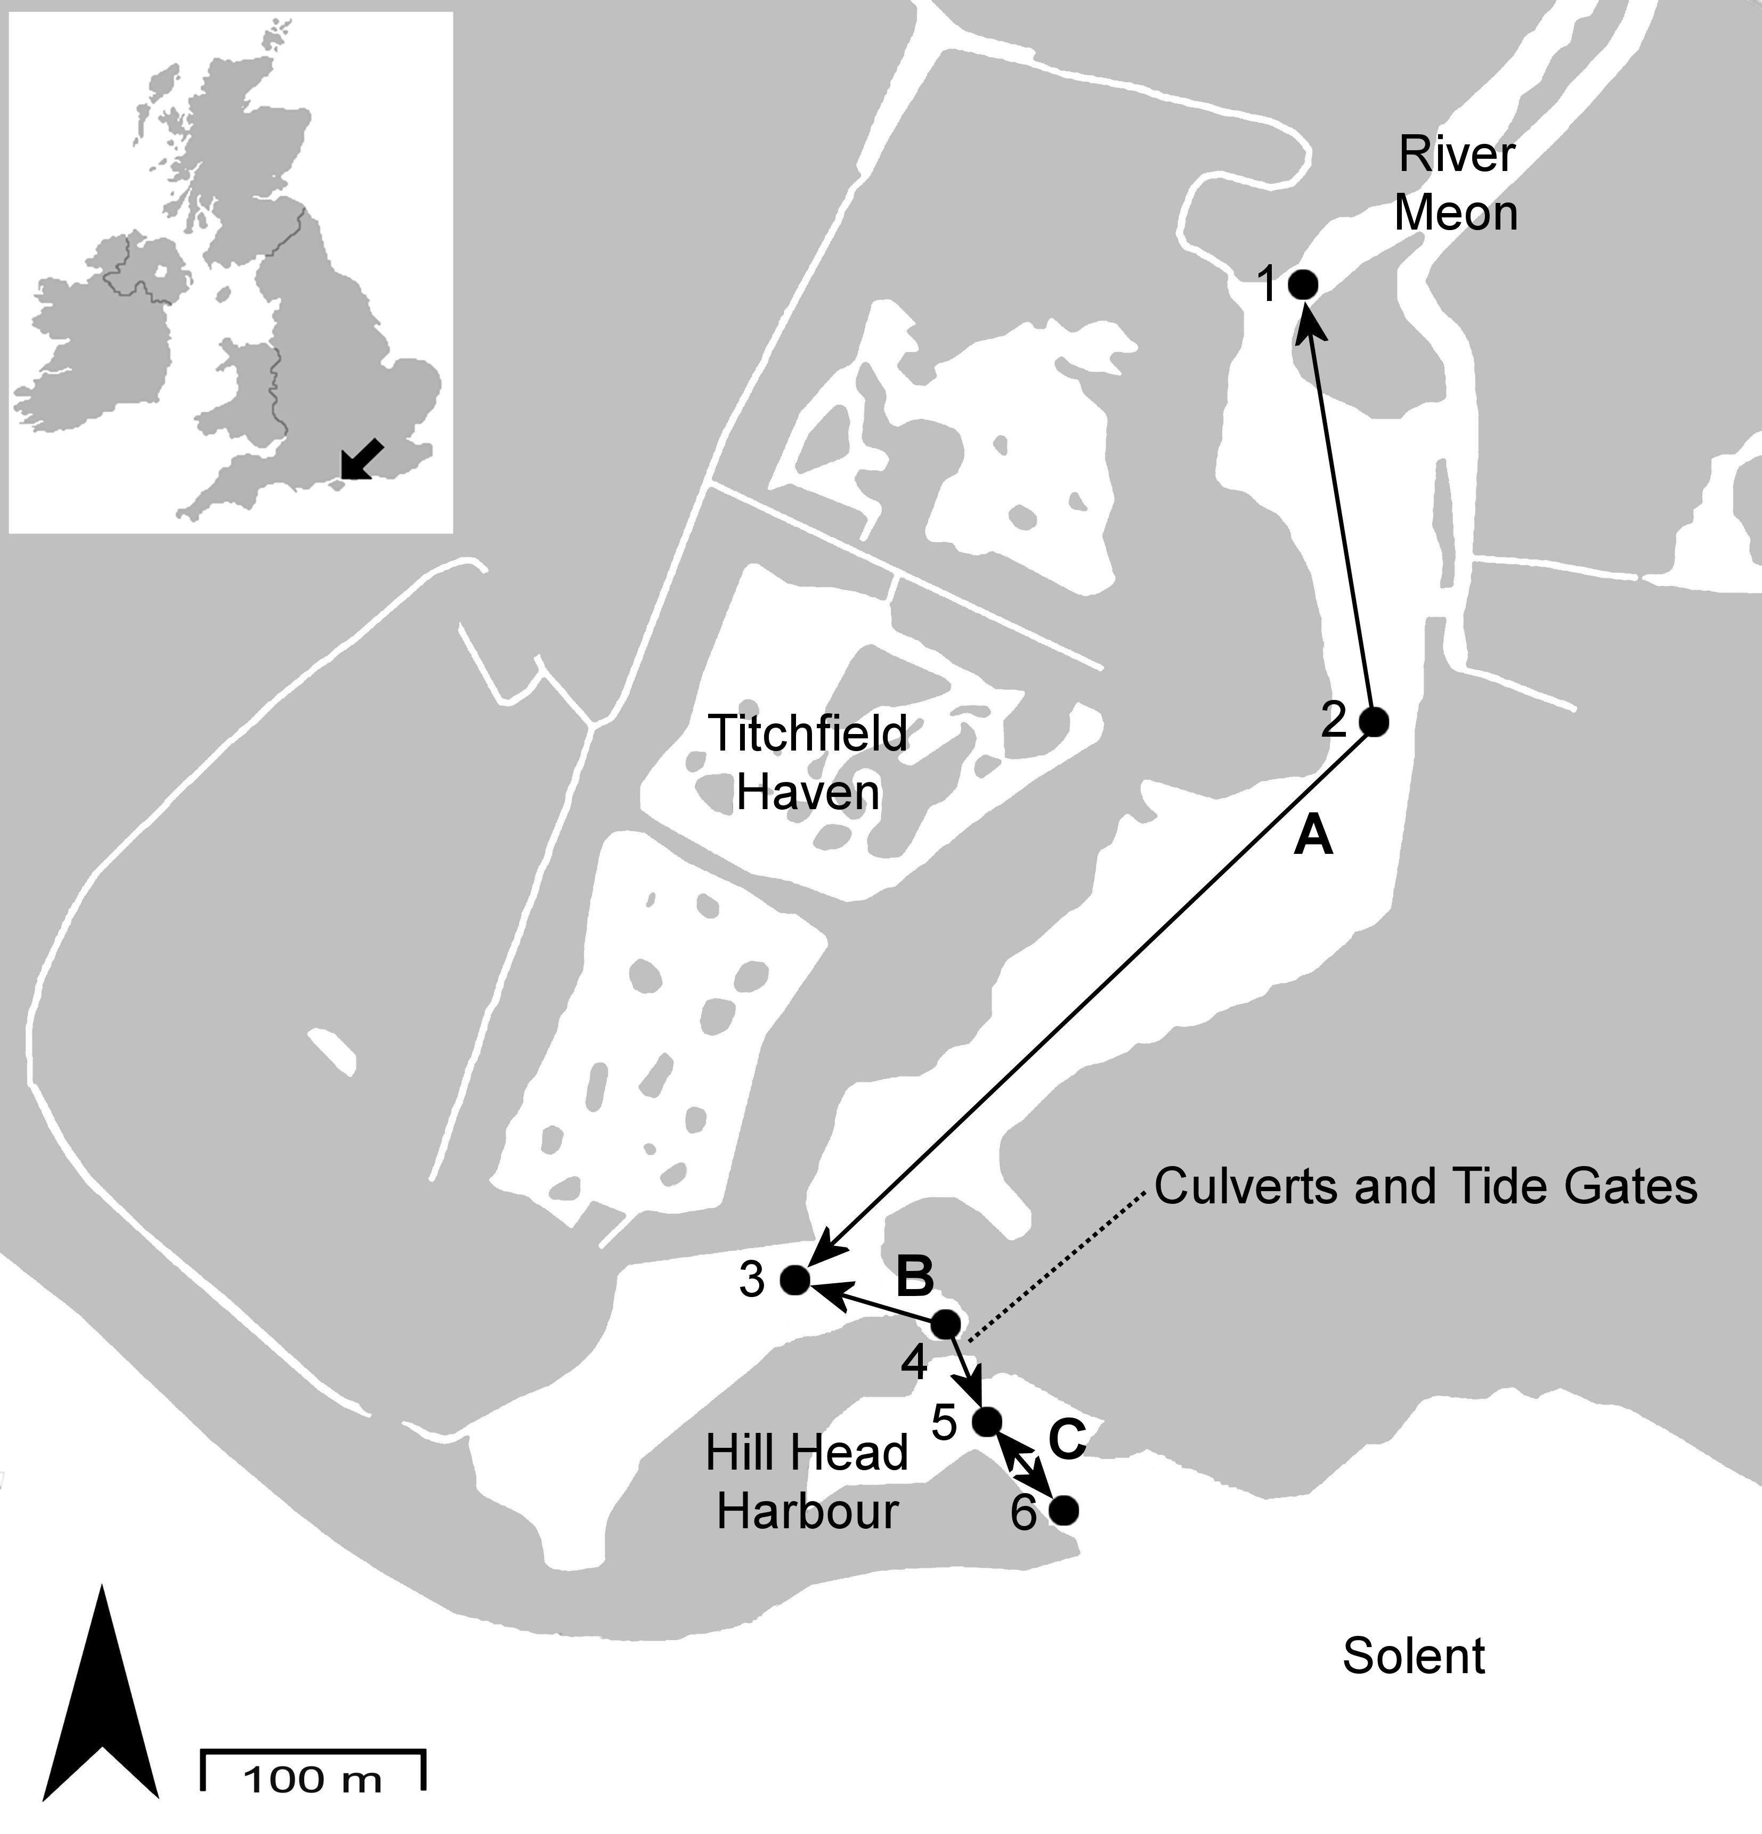

Fig. 1. The lower River Meon in Hampshire, UK, flowing through Titchfield Haven into the Solent. Acoustic receivers 1 – 6 ( ) were deployed to assess the passage efficiency and delay of seaward migrating juvenile sea trout (smolts) released approximately 4.9 km upstream of receiver 1 at Fishers Hill (not shown). The speed of migration through control reaches A (receivers 1-3) and C (receivers 5-6) in April 2011 and 2012 were compared with those through the treatment reach B (receivers 3-5) containing 4 tide gates, with the addition of 2 orifices in year 2.

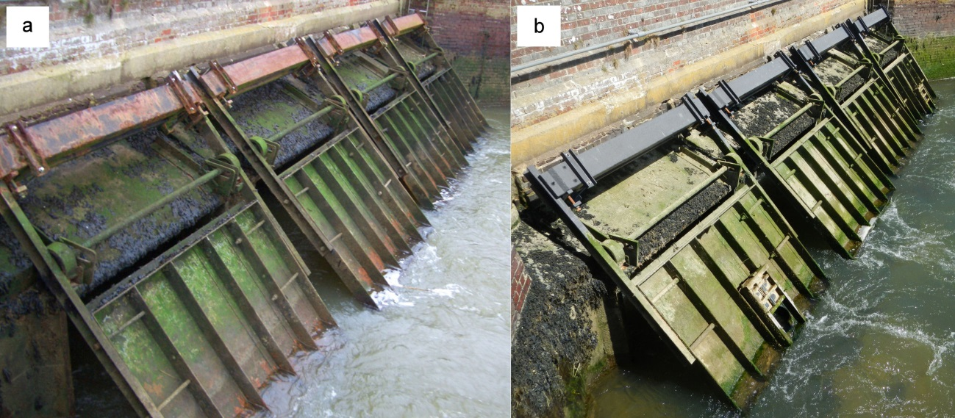

Fig. 2. (a) Four counterbalanced top-hung tide gates on the River Meon at Hill Head, Hampshire, UK in 2011 (year 1), pre installation of orifices; (b) orifices were installed in two of the gates in 2012 (year 2).

2.2. Fish capture and telemetry

Actively migrating wild smolts were caught at Fishers Hill during five nights between 6 and 12 April 2011 (year 1) and three nights between 3 and 5 April 2012 (year 2). Winged fyke nets with a fine mesh (1 mm) catch box (height = 1.0 m, width = 0.5 m, length = 0.5 m) at the distal end were deployed in the Canal and Natural Channel during darkness between 2100h and 0300h British Summer Time (BST) and checked every hour. In both years, a total of 30 smolts were retained for tagging, 10 and 11 from the Natural Channel and 20 and 19 from the Canal in years 1 and 2, respectively.

Smolts were held in aerated water at ambient river temperature for a maximum of 1 hour prior to being anaesthetised with MS-222 (100 mg L⁻¹; buffered to pH 7.0 with NaHCO₃) and mass and fork length (FL) measured (n = 30, FL [mean ± SD] = 195.3 ± 14.8 mm, mass = 77.3 ± 17.4 g in year 1; n = 30, FL = 202.0 ± 14.0 mm, mass = 78.7 ± 14.9 g in year 2). Smolts were then tagged with an acoustic transmitter (Vemco, Nova Scotia, Canada; Model V7-2L, 7 mm diameter, 18.5 mm length, 1.6 g mass, 0.75 g weight in water, 30 second pulse rate) via a ventral incision sutured with 5-0 coated Vicryl absorbable sutures (Ethicon, New Jersey, USA), in compliance with UK Home Office regulations under the Animals (Scientific Procedures) Act 1986. Mean (± SD) transmitter mass was 2.2% (± 0.5%) of smolt body mass in year 1, and 2.1% (± 0.3%) in year 2. Mean (± SD) transmitter length was 9.5% (± 0.7%) of FL in year 1 and 9.2% (± 0.6%) of FL in year 2. After surgery, smolts recovered from the effects of anaesthesia in an aerated water container for a maximum of 1 hour before being released downstream of the respective capture net during the hours of darkness.

To assess the impact of the tagging procedure on survival and to quantify tag retention, a separate sample of smolts (n = 20, FL = 193.2 ± 11.0 mm, mass = 75.9 ± 15.0 g in year 1; n = 12, FL = 204.5 ± 12.0 mm, mass = 81.6 ± 16.9 g in year 2) were implanted with ‘dummy tags’ (inactive tags with equivalent dimensions, mass and shape to the transmitters - Vemco, Model V7-2L) using the same method for active tagging. Smolts implanted with dummy tags were held in in-stream containers with a through-flow of river water for seven days and fed with mealworm once daily. Mean (± SD) dummy tag mass was 2.2% (± 0.4%) of smolt body mass in year 1, and 2.0% (± 0.3%) in year 2. Mean (± SD) dummy tag length was 9.6% (± 0.5%) of smolt FL in year 1, and 9.1% (± 0.5%) in year 2. Dummy tagged fish showed 100% tag retention (n = 32) and 3.1% mortality (n = 1).

Six stationary acoustic receivers (Vemco, Model VR2W, 69 kHz) were anchored to the river bed in Titchfield Haven Nature Reserve and Hill Head Harbour (Fig. 1), from 4 April to 23 August 2011 and 3 April to 25 June 2012. Floats were used to orientate the hydrophone upwards in the water column, except for Receiver 5 which was attached to a buoy and allowed to rise and fall with the tide whilst facing the river bed.

Detection range and efficiency were tested under the prevailing environmental conditions at all six receivers during the first week of April in both years. Range was defined as the maximum lateral (across the river width) and longitudinal (upstream to downstream) detection distance of tags submerged at approximately 30% and 60% water depth at regular intervals from each receiver whilst noting time and GPS coordinates. Lateral range extended to the river banks adjacent to each receiver. Maximum longitudinal detection radius was 118 m in year 1 and 125 m in year 2 (Table 1). Because fish may have actively swam past the receivers (Davidsen et al., 2005; Svendsen et al., 2007), tags submerged at approximately 30% and 60% depth were towed behind a motor boat at 1 m s⁻¹, similar to the sustained swimming speed of a 150 mm brown trout (1.17 m s⁻¹ at 10ºC) (Clough and Turnpenny, 2001). Detection efficiency, defined as the proportion of tags identified within maximum range of each receiver, was 100% at all receivers except receiver 4 where towed tags were not detected at the furthermost bank. Detection efficiency of tagged fish was 100% at all receives in both years with the exception of receiver 3 where efficiency was 95.7% in year 1 and 91.7% in year 2.

Table 1. The maximum tag detection range of 6 acoustic receivers deployed in the lower River Meon, UK, in April 2011 (year 1, pre orifice installation) and April 2012 (year 2, post orifice installation) with inaccessible areas (-).

 | Maximum Longitudinal Detection Range (m)
Receiver No. | Year 1 |  |  | Year 2
 | Upstream | Downstream |  | Upstream | Downstream
1 | 106 | 90 |  | 106 | 90
2 | 118 | 94 |  | 125 | 106
3 | 94 | - |  | 94 | -
4 | 75 | 15 |  | 75 | 15
5 | 38 | 62 |  | 38 | 75
6 | 56 | - |  | 63 | -

2.3. Environmental variables

Water conductivity, temperature, pressure and barometric pressure were logged (Solinst, Ontario, Canada; Models LTC Levelogger Junior 3001 and Barologger Gold 3001) at 10 minute intervals either side of the tide gate structure from April to June 2012. Due to logger malfunction, these variables were only recorded downstream of the gates from April to August 2011. Angle of tide gate opening was logged at 2 minute intervals during the same period using tri-axial static acceleration loggers (Onset, Massachusetts, USA; Model UA-004-64), and calibrated against manual angle measurements using a tape measure at low tide each week throughout April 2011 and 2012. Discharge in the River Meon was recorded at 15 minute intervals at the Environment Agency gauging station at Mislingford.

2.4. Data analyses

2.4.1. Passage efficiency

Passage efficiency was calculated as the number of fish detected at receiver 5 as a percentage of those recorded at receivers 3 or 4 (Fig. 1).

2.4.2. Delay

The lower River Meon was divided into control reaches A and C, respectively upstream and downstream of treatment reach B that contained the tide gates (Fig. 1). The speed of migration was calculated for each reach as the quotient of the distance (m) separating upstream and downstream receivers and duration (s) between first detection at each, with the exception of reach C where duration between first detection at receiver 5 and last detection at receiver 6 was used. When tags were not detected at receiver 3 (n = 3), first detection at receiver 4 was used to calculate speed of migration through reaches A and B. Mean discharge (Q_{fish}) and water temperature (Temp_{fish}) during passage through each reach were calculated for individual fish.

Kolmogorov-Smirnov tests indicated that speed of migration, Q_{fish}, and Temp_{fish} were not normally distributed. Due to being robust to deviations from normality when sample size is equal (Harwell et al., 1992), mixed-measures ANOVAs with Greenhouse-Geisser correction were used to test for differences in speed of migration, Q_{fish}, and Temp_{fish} between reach (controls: A and C; treatment: B) and year (year 1: pre modification; year 2: post modification). Levene's test indicated that variance was homogenous between years (P > 0.05). Bonferroni correction was applied when making pairwise comparisons between multiple groups.

Because the size of apertures did not vary considerably between gates, or throughout the period of opening, gates were classed as open or closed. The percentage of time gates were open (GO%) during passage through each reach was calculated for individual fish. Similarly, the influence of diurnal periodicity was considered by calculating the percentage of time it was night (N%) during the migration of individual fish through each reach.

To increase statistical power, data from both years were aggregated in multiple regression models developed to explore the relationships between speed of migration and the confounding variables (FL, Q_{fish}, Temp_{fish}, GO%, N%) in reaches A and B. Additional multiple regression models used data from each year separately to assess these relationships within years. Year and date/time of detection were omitted from regressions due to colinearity with discharge (Pearson’s r: r > 0.9). FL did not vary between years (t₄₆ = -1.61, P > 0.05), had no independent relationship with speed, and was thus excluded from further analysis. Where Kolmogorov-Smirnov tests indicated that standardised residuals were not normally distributed (P < 0.05), regressions with outliers removed corroborated the results. Regression analyses were reported as unstandardised B coefficients and 95% confidence intervals (CI) with variance (R²) indicated as percentages.

Independent t-tests were used to assess the influence of tide gate position (open or closed) and the time of day (day or night) when fish entered the treatment reach (B) (first detection at receiver 3 or 4) on the speed of migration, and to compare conductivity and water temperature up and downstream of closed tide gates in year 2.

3. Results

3.1. Passage efficiency

In total, 25 of the 30 tagged smolts were detected in Titchfield Haven in both years. Of these, one individual in year 1 exhibited anomalous detections indicating likely mortality and was excluded from further analysis. Of the fish caught and released in the Natural Channel, 90.0% (n = 9) in year 1 and 84.8% (n = 10) in year 2 reached the acoustic receivers at Titchfield Haven. For fish caught and released in the Canal, 75.0% (n = 15) in year 1 and 82.3% (n = 14) in year 2 were detected at Titchfield Haven. Passage efficiency at the tide gates was 95.8% and 100% in years 1 and 2, respectively.

3.2. Delay

Speed of migration was greater through the control reaches (A and C) than the treatment (B) (Table 2) (F_{2, 74} = 15.13, P < 0.001), with no difference between the control reaches within both years (P > 0.05) (Fig. 3). Speed of migration through each control reach did not differ between years (F_{1, 46} = 0.18, P > 0.05). Post entry to reach B (first detection at receiver 3 or 4), 60.9% and 62.5% of smolts were detected by receivers upstream, with 28.6% and 66.7% of these being detected as far upstream as receiver 1 in years 1 and 2, respectively.

Table 2. The mean ± SD speed and duration of migration, Qfish and Tempfish for acoustic tagged sea trout smolts migrating downstream in the River Meon, Hampshire, UK in year 1 (pre orifice installation, n = 23) and year 2 (post orifice installation, n = 25) through two reaches with no structures present (A and C) and one reach with tide gates (B) in April 2011 and 2012.

Year | Reach | Distance (m) | Structures | Speed (m s⁻¹) | Duration (h) | Q_{fish} (m³ s⁻¹) | Temp_{fish} (ºC)
1 | A | 581 | None | 0.15 ± 0.15 | 4.06 ± 4.89 | 0.88 ± 0.04 | 13.06 ± 1.29
 | B | 125 | Tide gates | 0.02 ± 0.04 | 6.48 ± 9.16 | 0.88 ± 0.05 | 13.38 ± 1.80
 | C | 50 | None | 0.17 ± 0.17 | 2.88 ± 11.99 | 0.88 ± 0.05 | 13.32 ± 1.94
2 | A | 581 | None | 0.12 ± 0.20 | 5.39 ± 4.47 | 0.43 ± 0.04 | 10.04 ± 0.45
 | B | 125 | Tide gates | 0.04 ± 0.09 | 23.74 ± 34.03 | 0.42 ± 0.03 | 10.36 ± 0.70
 | C | 50 | None | 0.22 ± 0.24 | 2.85 ± 8.65 | 0.42 ± 0.04 | 10.58 ± 1.20

Fig. 3. Mean ± SE speed of migration of 23 sea trout smolts in year 1 (pre orifice installation) ( ) and 25 smolts in year 2 (post orifice installation) ( ) through two control river reaches with no obstructions (A and C) and one treatment reach with tide gates (B) in the lower River Meon, Hampshire, UK in April 2011 and 2012.

Mean (± SD) Q_{fish} did not differ between reaches (F_{1.3, 60.16} = 1.68, P > 0.05) but did differ between years (F_{1, 46} = 1743.09, P < 0.001) with year 1 (0.88 [± 0.04] m³ s⁻¹) being higher than year 2 (0.42 [± 0.04] m³ s⁻¹) (Table 2). Mean (± SD) Temp_{fish} was lower in reach A (11.49 [± 1.79] ºC) than reach B (11.81 [± 2.02] ºC) (F_{1.6, 72.2} = 4.08, P < 0.05) and differed between years (F_{1, 46} = 72.71, P < 0.001) with year 1 (13.25 [1.68] ºC) being higher than year 2 (10.33 [± 0.86] ºC) (Table 2).

When data from both years were aggregated, Q_{fish}, Temp_{fish}, GO% and N% accounted for 19.8% of the variance in speed of migration through reach A and 40.8% through reach B, with GO% being the only significant correlate (reach A: B = 0.002, CI = 0.000 – 0.003, P < 0.05; reach B: B = 0.001, CI = 0.000 – 0.002, P < 0.001), with the exception of N% in reach B (B = 0.000, CI = 0.000 – 0.001, P = 0.05).

Q_{fish}, Temp_{fish}, GO% and N% explained 34.8% and 49.3% of the variation in speed of migration through reach A, and 46.9% and 64.8% through reach B, in years 1 and 2, respectively. GO% was the most significant correlate in reach B in both years (year 1: B = 0.001, CI = 0.000 – 0.001, P < 0.05; year 2: B = 0.002, CI = 0.001 – 0.003, P < 0.01) and reach A in year 2 (B = 0.004, CI = 0.002 – 0.007, P < 0.01). Speed of migration was positively related to N% through reach A in year 1 (B = 0.002, CI = 0.000 – 0.004, P < 0.05) and reach B in year 2 (B = 0.001, CI = 0.000 – 0.002, P < 0.05).

There was no difference in speed of migration through reach B between fish entering during day or night (year 1: t_{13.2} = -1.34, P > 0.05; year 2: t_{11.2} = 1.58, P > 0.05), or when the gates were open or closed (year 1: t_{8.3} = -1.72, P > 0.05; year 2: t_{13.0} = -1.84, P > 0.05). Four smolts (17.4%) that entered reach B at night whilst the tide gates were closed subsequently passed during the day.

When closed, mean (± SD) water temperature upstream of the tide gates in year 2 did not differ from downstream (10.2 ± 1.0 ºC, t₃₁₃₀ = -0.31, P > 0.05). Mean (± SD) conductivity upstream of closed gates in year 2 (29.9 ± 10.4 mS cm⁻¹) was marginally lower than downstream (31.6 ± 10.3 mS cm⁻¹) (t₃₁₃₀ = -4.53, P < 0.05).

Whilst in reach B, more fish were first detected by receiver 4 when the tide gates were open than closed in year 2 (84.0%) compared to year 1 (60.9%) (Table 3; Fig. 4). Fish that first approached when the gates were open were more likely to take longer than one tidal cycle to pass in year 2 (66.7%) than in year 1 (28.6%). When fish were first detected at receiver 4 when the gates were open, the mean (± SD) time taken to pass downstream was 4.73 (± 9.36) h in year 1, and 22.63 (± 34.25) h in year 2.

Table 3. Sea trout smolt delay before passage through the tide gate structure in the River Meon, UK in year 1 (April 2011, pre orifice installation) and year 2 (April 2012, post orifice installation) and gate position when first detected at receiver 4 (immediately upstream of the tide gates).

Category | Gate Position | Delay Before Passage | Fig. | Number of Fish
 |  |  |  | Year 1 | Year 2
1 | Open | < 1 h | 4a | 7 | 4
2 | Open | 1 h to end of tidal cycle | 4b | 3 | 3
3 | Open | > 1 tidal cycle | 4c | 4 | 14
4 | Closed | < 1 h | 4d | 6 | 1
5 | Closed | 1 h to end of tidal cycle | 4e | 2 | 1
6 | Closed | > 1 tidal cycle | 4f | 1 | 2

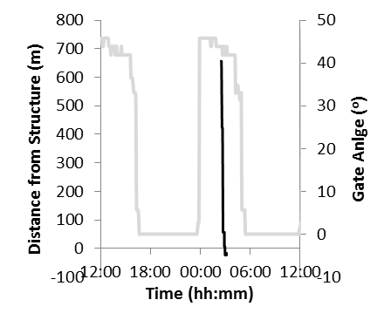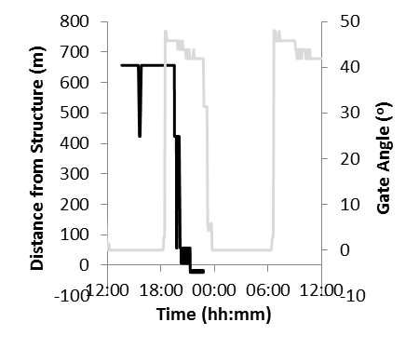
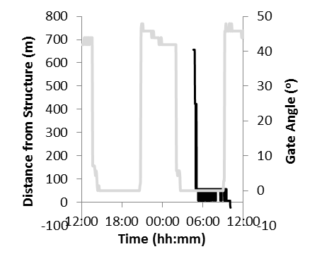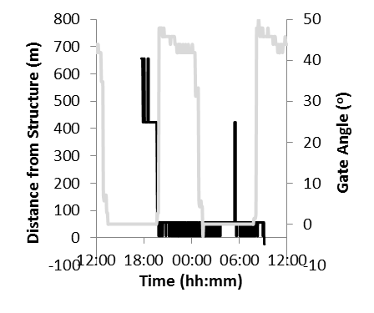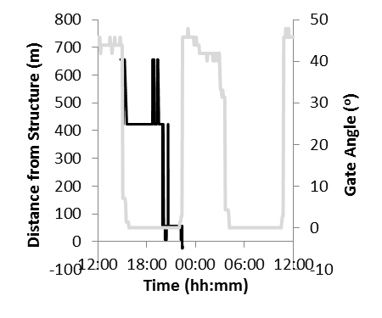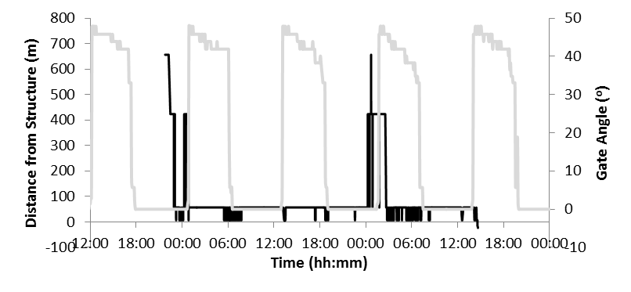
Fig. 4. Sea trout smolt movements ( ) during approach to, and passage through, the top-hung tide gate structure in the lower River Meon, Hampshire, UK, during gate angles ( ) that vary with the tidal cycle. Smolt movement patterns were classified into 6 groups, each demonstrated by an individual fish: (a) minimal delay before passage (within 1 h) with gate open on approach to structure (detection at receiver 4); (b) intermediate delay (passage after 1 h and within the same tidal cycle) with gate open; (c) extensive delay (passage after more than one tidal cycle) with gate open; (d) no delay before passage with gate closed on approach; (e) intermediate delay before passage with gate closed; (f) extensive delay before passage with gate closed.

4. Discussion

Although tide gates are used worldwide (e.g. Belgium, Mouton et al., 2011; North America, Giannico and Souder, 2005; Australia, Kroon and Ansell, 2006; New Zealand, Doehring et al., 2011), this study is the first to quantify their impact on diadromous fish passage efficiency and delay. While passage efficiency was high in both years (95.8% - 100.0%), sea trout smolts experienced considerable delay at the tide gates, and this was not reduced by installation of orifices designed to increase fluvial connectivity.

Mitigation of obstructions to fish passage is a key fisheries management challenge (Kemp and O'Hanley, 2010). While evaluation of the effectiveness of various mitigation measures, i.e. different fish pass and screen designs, are relatively common (e.g. Noonan et al., 2012), the impact of unmitigated infrastructure on downstream salmonid migration is seldom quantified (see Aarestrup and Koed, 2003, for an exception). Instead, assumptions of impact tend to be accepted based on anecdote or broad scale qualitative observation of changes in abundance and diversity of target species. In this study, the passage efficiency at temporal barriers to fish migration created by tide gates was high.

Passage via small-scale weirs and sluices at dams may represent an appropriate analogue with which to compare the results obtained, although comprehensive quantification of these structures is also scarce. Where such studies have been conducted, passage efficiencies are variable. For example, at the Hunderfossen dam in south-east Norway, 100% of radio tagged hatchery-reared sea trout smolts passed via bottom and surface release spill gates (Arnekleiv et al., 2007). For wild and stocked sea trout smolts, respectively, the passage efficiencies of low-head weirs ranged from 46 to 90% (low flows) and 92 to 100% (standard flows) on the River Tweed, UK (Gauld et al., 2013), and 29 to 82% for stocked sea trout smolts in two Danish rivers (Aarestrup and Koed, 2003). Even fewer studies consider salmonid passage efficiency at temporal estuarine barriers. In one example, 100% (1994) and 78.3% (1995) of Atlantic salmon, Salmo salar, and sea trout smolts passed the Tawe barrage, UK (Moore et al., 1996). As with tide gates, opportunities for fish to pass the barrage via a navigation lock or over weirs and a fish pass were intermittent. The high passage efficiencies recorded in the current study may to some extent be explained by the relatively large mean apertures of the gates when open (42 - 45 º). Lower passage efficiencies may be expected for alternative tide gate designs, including other top-hung gates that only open wide during the early stages of the ebb tide.

Despite high passage efficiency, smolts were substantially delayed at the tide gates. The temporal functioning of the gates exerted the greatest influence on speed of migration in both the upstream control and treatment reaches. Tide gates physically block the movement of fish when closed whilst modifying tidal migratory cues (Russell et al., 1998), flow velocities, and thermal and salinity gradients (Giannico and Souder, 2005), all of which may influence speed of migration. Changes in flow regimes (Arnell, 2004), increasing demand for abstraction (Weatherhead and Knox, 2000; Wilby et al., 2006), and sea level rise (Nicholls et al., 1999) will likely cause tide gates to remain closed for longer in the future.

Speed of migration in the present study was greater at night, supporting the results of a number of smolt studies (e.g. sea trout, Moore et al., 1998; Atlantic salmon, Thorstad et al., 2012). It is proposed that nocturnal migration may be an adaptive strategy to avoid visual predators (McCormick et al., 1998) and UV radiation damage (Zagarese and Williamson, 2001) in the absence of increased water depths and turbidity. A number of fish that approached closed tide gates at night were delayed until they were able to subsequently pass the open structures the following day.

Even when tide gates were open, the majority of smolts did not pass immediately, reflecting the influence of migratory behaviour. Salmonid smolts actively avoid continuous overhead cover (Greenberg et al., 2012; Kemp et al., 2005a) and accelerating flow (Haro et al., 1998; Kemp et al., 2005b), features commonly created at tide gates. Further, larger scale site specific characteristics may have been influential. Changes in direction of flow and water levels, as the tide gates open and close, may have the potential to cause disorientation.

Delay can have a number of negative impacts, such as increasing predation risk, particularly from piscivorous birds (Koed et al., 2006; McKay et al., 2003; Stewart et al., 2005) such as those which inhabit Titchfield Haven Nature Reserve. Delay can also increase energy expenditure (Congleton et al., 2002), susceptibility to disease (Plumb et al., 2006), and cause mismatch between the onset of oceanic feeding and productivity (Jonsson and Jonsson, 2004), decreasing post smolt survival (Budy et al., 2002).

Modification of tide gates through installation of the orifices did not increase speed of migration. However, river discharge varied between years, and therefore further assessment should be carried out to establish the orifices’ impact under a wider range of hydrological conditions. Saline intrusion upstream of the gates was high post modification. Enhanced opportunity for gradual acclimation to sea water upstream of tide gates will likely be advantageous, reducing the potential for osmotic shock when encountering an abrupt salinity transition, a condition that may reduce swimming performance (Brauner et al., 1992, 1994), ability to evade predators (Handeland et al., 1996) and overall survival (Otto, 1971).

4.1. Conclusions

In this study, the first to fully quantify the impact of tide gates on diadromous fish passage efficiency and delay, the following was found:

- Sea trout smolt passage efficiency at tide gates was high.
- Gates delayed smolt migration.
- The period of gate closure was the most significant factor in migratory delay, suggesting that smolts would benefit from the installation of modifications or gates that remain open for a longer proportion of the tidal cycle, such as retarders, side-hung doors, or self-regulating gates.
- Even in the vicinity of open gates, smolt migration was delayed, illustrating the influence of a behavioural component.
- The installation of orifices into tide gates to extend the period of connectivity and extent of saline intrusion did not reduce delay.
- Further research is needed to assess the impact of tide gates on other life stages and species. Assessment of the orifices would benefit from supplementary study across a variety of hydrological regimes, and fine-scale investigation into fish behaviour at tide gates is also required to improve development of appropriate environmental impact mitigation technology.

Acknowledgements

This project was funded by the University of Southampton, the Environment Agency and the Interreg IVB Living North Sea Project. The authors would also like to thank the Environment Agency, Titchfield Haven Nature Reserve, Abbey Farm, Park Gate Royal British Legion Angling Club and Hill Head Harbour Sailing Club for assistance with access and equipment deployment, Cefas for lending equipment and Ms Joana Nunes and Mr Ralph Wright for assistance in the field.

References

Aarestrup, K., Koed, A., 2003. Survival of migrating sea trout (Salmo trutta) and Atlantic salmon (Salmo salar) smolts negotiating weirs in small Danish rivers. Ecol. Freshwat. Fish 12, 169-176.
Arnekleiv, J.V., Kraabol, M., Museth, J., 2007. Efforts to aid downstream migrating brown trout (Salmo trutta L.) kelts and smolts passing a hydroelectric dam and a spillway. Hydrobiologia 582, 5-15.
Arnell, N.W., 2004. Climate-change impacts on river flows in Britain: The UKCIP02 scenarios. Water and Environment Journal 18, 112-117.
Berggren, T.J., Filardo, M.J., 1993. An analysis of variable influencing the migration of juvenile salmonids in the Columbia River basin. N. Am. J. Fish. Manage. 13, 48-63.
Boyd, C.E., Tucker, C.S., 1998. Pond aquaculture water quality management. Kluwer Academic Publishers, Boston.
Boys, C.A., Kroon, F.J., Glasby, T.M., Wilkinson, K., 2012. Improved fish and crustacean passage in tidal creeks following floodgate remediation. J. Appl. Ecol. 49, 223-233.
Brauner, C.J., Iwama, G.K., Randall, D.J., 1994. The effect of short-duration seawater exposure on the swimming performance of wild and hatchery-reared juvenile coho salmon (Oncorhynchus kisutch) during smoltification. Can. J. Fish. Aquat. Sci. 51, 2188-2194.
Brauner, C.J., Shrimpton, J.M., Randall, D.J., 1992. Effect of short-duration seawater exposure on plasma ion concentrations and swimming performance in coho salmon (Oncorhynchus kisutch) parr. Can. J. Fish. Aquat. Sci. 49, 2399-2405.
Budy, P., Thiede, G.P., Bouwes, N., Petrosky, C.E., Schaller, H., 2002. Evidence linking delayed mortality of Snake River salmon to their earlier hydrosystem experience. N. Am. J. Fish. Manage. 22, 35-51.
Clough, S.C., Turnpenny, A.W.H., 2001. Swimming speeds of freshwater fish: Phase 1. Environment Agency, Bristol.
Congleton, J.L., Wagner, T., Evavold, J., Fryer, D., Sun, B., 2002. Evaluation of physiological changes in migrating juvenile salmonids and effects on performance and survival. Report to the U.S. Army Corps of Engineers, Washington.
Davidsen, J., Svenning, M.A., Orell, P., Yoccoz, N., Dempson, J.B., Niemela, E., Klemetsen, A., Lamberg, A., Erkinaro, J., 2005. Spatial and temporal migration of wild Atlantic salmon smolts determined from a video camera array in the sub-Arctic River Tana. Fisheries Research 74, 210-222.
Dietrich, J.P., Van Gaest, A.L., Strickland, S.A., Arkoosh, M.R., 2014. The impact of temperature stress and pesticide exposure on mortality and disease susceptibility of endangered Pacific salmon. Chemosphere 108, 353-359.
Doehring, K., Young, R.G., Hay, J., Quarterman, A.J., 2011. Suitability of Dual-frequency Identification Sonar (DIDSON) to monitor juvenile fish movement at floodgates. N. Z. J. Mar. Freshwat. Res. 45, 413-422.
Easton, C., Marshall, A., 2000. Control of acidic drain-water-breeding mosquitoes in New South Wales, Australia, by installing controlled leakage holes in tidal flap gates. J. Am. Mosq. Control Assoc. 16, 19-21.
Gauld, N.R., Campbell, R.N.B., Lucas, M.C., 2013. Reduced flow impacts salmonid smolt emigration in a river with low-head weirs. Sci. Total Environ. 458, 435-443.
Geen, G.H., 1975. Ecological consequences of proposed Moran Dam on Fraser River. Journal of the Fisheries Research Board of Canada 32, 126-135.
Giannico, G., Souder, J.A., 2005. Tide Gates in the Pacific Northwest: Operation, Types, and Environmental Effects. Oregon State University, Oregon.
Greenberg, L.A., Calles, O., Andersson, J., Engqvist, T., 2012. Effect of trash diverters and overhead cover on downstream migrating brown trout smolts. Ecol. Eng. 48, 25-29.
Halls, A.S., Hoggarth, D.D., Debnath, K., 1998. Impact of flood control schemes on river fish migrations and species assemblages in Bangladesh. J. Fish Biol. 53, 358-380.
Handeland, S.O., Jarvi, T., Ferno, A., Stefansson, S.O., 1996. Osmotic stress, antipredator behaviour, and mortality of Atlantic salmon (Salmo salar) smolts. Can. J. Fish. Aquat. Sci. 53, 2673-2680.
Haro, A., Odeh, M., Noreika, J., Castro-Santos, T., 1998. Effect of water acceleration on downstream migratory behavior and passage of Atlantic salmon smolts and juvenile American shad at surface bypasses. Trans. Am. Fish. Soc. 127, 118-127.
Harris, G., Milner, N., 2006. Sea trout: biology, conservation and management. Blackwell Publishing, Oxford.
Harwell, M.R., Rubinstein, E.N., Hayes, W.S., Olds, C.C., 1992. Summarizing Monte-Carlo results in methodological research - the 1-factor and 2-factor fixed effects ANOVA cases. Journal of Educational Statistics 17, 315-339.
Im, D., Kang, H., Kim, K.-H., Choi, S.-U., 2011. Changes of river morphology and physical fish habitat following weir removal. Ecol. Eng. 37, 883-892.
Jonsson, B., Jonsson, N., 2004. Factors affecting marine production of Atlantic salmon (Salmo salar). Can. J. Fish. Aquat. Sci. 61, 2369-2383.
Jonsson, N., 1991. Influence of water flow water temperature and light on fish migration in rivers. Nord. J. Freshwat. Res. 66, 20-35.
Jubilo, K., Lamarque, F., 1999. Epidemiology and prevention of type C botulism: A literature survey. Gibier Faune Sauvage 16, 81-93.
Katopodis, C., Williams, J.G., 2012. The development of fish passage research in a historical context. Ecol. Eng. 48, 8-18.
Kemp, P.S., Gessel, M.H., Williams, J.G., 2005a. Seaward migrating subyearling chinook salmon avoid overhead cover. J. Fish Biol. 67, 1381-1391.
Kemp, P.S., Gessel, M.H., Williams, J.G., 2005b. Fine-scale behavioral responses of Pacific salmonid smolts as they encounter divergence and acceleration of flow. Trans. Am. Fish. Soc. 134, 390-398.
Kemp, P.S., O'Hanley, J.R., 2010. Procedures for evaluating and prioritising the removal of fish passage barriers: a synthesis. Fish. Manage. Ecol. 17, 297-322.
Koed, A., Baktoft, H., Bak, B.D., 2006. Causes of mortality of Atlantic salmon (Salmo salar) and brown trout (Salmo trutta) smolts in a restored river and its estuary. River Res. Appl. 22, 69-78.
Konrad, C.P., 2009. Simulating the recovery of suspended sediment transport and river-bed stability in response to dam removal on the Elwha River, Washington. Ecol. Eng. 35, 1104-1115.
Kroon, F.J., Ansell, D.H., 2006. A comparison of species assemblages between drainage systems with and without floodgates: implications for coastal floodplain management. Can. J. Fish. Aquat. Sci. 63, 2400-2417.
Larinier, M., 2002. Fishways - General considerations. Bull. Fr. Peche Piscic. 364 suppl., 21-27.
McCormick, S.D., Hansen, L.P., Quinn, T.P., Saunders, R.L., 1998. Movement, migration, and smolting of Atlantic salmon (Salmo salar). Can. J. Fish. Aquat. Sci. 55, 77-92.
McKay, H.V., Robinson, K.A., Carss, D.N., Parrott, D., 2003. The limitations of pellet analysis in the study of cormorant Phalacrocorax spp. diet. Vogelwelt 124, 227-236.
Moore, A., Ives, M., Scott, M., Bamber, S., 1998. The migratory behaviour of wild sea trout (Salmo trutta L.) smolts in the estuary of the River Conwy, North Wales. Aquaculture 168, 57-68.
Moore, A., Stonehewer, R., Kell, L.T., Challiss, M.J., Ives, M., Russell, I.C., Riley, W.D., Mee, D.M., 1996. The movements of emigrating salmonid smolts in relation to the Tawe Barrage, Swansea. In: Burt N., Watts J., (Eds.), Barrages: Engineering Design & Environmental Impacts. John Wiley & Sons Ltd, Chichester, UK, 409-417.
Mouton, A.M., Stevens, M., Van den Neucker, T., Buysse, D., Coeck, J., 2011. Adjusted barrier management to improve glass eel migration at an estuarine barrier. Marine Ecology-Progress Series 439, 213-222.
Nicholls, R.J., Hoozemans, F.M.J., Marchand, M., 1999. Increasing flood risk and wetland losses due to global sea-level rise: regional and global analyses. Global Environ. Change 9, S69-S87.
Noonan, M.J., Grant, J.W.A., Jackson, C.D., 2012. A quantitative assessment of fish passage efficiency. Fish Fish. 13, 450-464.
Osborne, M.F.M., 1961. The hydrodynamical performance of migratory salmon. J. Exp. Biol. 38, 365-390.
Otto, R.G., 1971. Effects of salinity on survival and growth of pre-smolt coho salmon (Oncorhynchus kisutch). Journal of the Fisheries Research Board of Canada 28, 343-349.
Plumb, J.M., Perry, R.W., Adams, N.S., Rondorf, D.W., 2006. The effects of river impoundment and hatchery rearing on the migration behavior of juvenile steelhead in the lower Snake River, Washington. N. Am. J. Fish. Manage. 26, 438-452.
Poff, N.L., Hart, D.D., 2002. How dams vary and why it matters for the emerging science of dam removal. Bioscience 52, 659-668.
Pollard, D.A., Hannan, J.C., 1994. The ecological effects of structural flood mitigation works on fish habitats and fish communities in the lower Clarence River system of South-Eastern Australia. Estuaries 17, 427-461.
Portnoy, J.W., 1991. Summer oxygen depletion in a diked New England estuary. Estuaries 14, 122-129.
Raposa, K., 2002. Early responses of fishes and crustaceans to restoration of a tidally restricted New England salt marsh. Restor. Ecol. 10, 665-676.
Raymond, H.L., 1979. Effects of dams and impoundments on migrations of juvenile Chinook salmon and steelhead from the Snake River, 1966 to 1975. Trans. Am. Fish. Soc. 108, 505-529.
Rees, E.E., Ibarra, R., Medina, M., Sanchez, J., Jakob, E., Vanderstichel, R., St-Hilaire, S., 2014. Transmission of Piscirickettsia salmonis among salt water salmonid farms in Chile. Aquaculture 428, 189-194.
Ritter, A.F., Wasson, K., Lonhart, S.I., Preisler, R.K., Woolfolk, A., Griffith, K.A., Connors, S., Heiman, K.W., 2008. Ecological signatures of anthropogenically altered tidal exchange in estuarine ecosystems. Estuaries and Coasts 31, 554-571.
Roegner, G.C., Dawley, E.W., Russell, M., Whiting, A., Teel, D.J., 2010. Juvenile salmonid use of reconnected tidal freshwater wetlands in Grays River, Lower Columbia River Basin. Trans. Am. Fish. Soc. 139, 1211-1232.
Rozas, L.P., Minello, T.J., 1998. Nekton use of salt marsh, seagrass, and nonvegetated habitats in a south Texas (USA) estuary. Bull. Mar. Sci. 63, 481-501.
Russell, I.C., Moore, A., Ives, S., Kell, L.T., Ives, M.J., Stonehewer, R.O., 1998. The migratory behaviour of juvenile and adult salmonids in relation to an estuarine barrage. Hydrobiologia 371-372, 321-333.
Russon, I.J., Kemp, P.S., 2011. Advancing provision of multi-species fish passage: Behaviour of adult European eel (Anguilla anguilla) and brown trout (Salmo trutta) in response to accelerating flow. Ecol. Eng. 37, 2018-2024.
Schilt, C.R., 2007. Developing fish passage and protection at hydropower dams. Appl. Anim. Behav. Sci. 104, 295-325.
Sheer, M.B., Steel, E.A., 2006. Lost watersheds: Barriers, aquatic habitat connectivity, and salmon persistence in the Willamette and Lower Columbia River basins. Trans. Am. Fish. Soc. 135, 1654-1669.
Stewart, D.C., Middlemas, S.J., Gardiner, W.R., Mackay, S., Armstrong, J.D., 2005. Diet and prey selection of cormorants (Phalacrocorax carbo) at Loch Leven, a major stocked trout fishery. J. Zool. 267, 191-201.
Svendsen, J.C., Eskesen, A.O., Aarestrup, K., Koed, A., Jordan, A.D., 2007. Evidence for non-random spatial positioning of migrating smolts (Salmonidae) in a small lowland stream. Freshwat. Biol. 52, 1147-1158.
Thorstad, E.B., Whoriskey, F., Uglem, I., Moore, A., Rikardsen, A.H., Finstad, B., 2012b. A critical life stage of the Atlantic salmon Salmo salar: behaviour and survival during the smolt and initial post-smolt migration. J. Fish Biol. 81, 500-542.
Tonnes, D.M., 2007. Fish use and water quality in select channels regulated by tide gates within the Snohomish River estuary. In: Giannico G., Cooper R., (Eds.), Proceedings of the West Coast Symposium on The effects of tide gates on estuarine habitats and fishes. Oregon State University: Oregon, 41-86.
Weatherhead, E.K., Knox, J.W., 2000. Predicting and mapping the future demand for irrigation water in England and Wales. Agric. Water Manage. 43, 203-218.
Wilby, R.L., Orr, H.G., Hedger, M., Forrow, D., Blackmore, M., 2006. Risks posed by climate change to the delivery of Water Framework Directive objectives in the UK. Environ. Int. 32, 1043-1055.
Zagarese, H.E., Williamson, C.E., 2001. The implications of solar UV radiation exposure for fish and fisheries. Fish Fish. 2, 250-260.
Zaugg, W.S., Prentice, E.F., Waknitz, F.W., 1985. Importance of river migration to the development of seawater tolerance in Columbia River anadromous salmonids. Aquaculture 51, 33-47.

