Near-Field Local Flame Extinction of Oxy-Syngas Non-Premixed Jet Flames: a DNS Study

K.K. J. Ranga Dinesh, J.A. van Oijen, K.H. Luo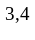, X. Jiang
Energy Technology Research Group, Faculty of Engineering and the Environment, University of Southampton, Southampton SO17 1BJ, UK.
Combustion Technology, Department of Mechanical Engineering, Eindhoven University of Technology, Eindhoven, The Netherlands.
Department of Mechanical Engineering, University College London, Torrington Place, London WC1E 7JE, UK.
⁴Center for Combustion Energy, Key Laboratory for Thermal Science and Power Engineering of Ministry of Education, Department of Thermal Engineering, Tsinghua University, Beijing 100084, China.
Engineering Department, Lancaster University, Lancaster, Lancashire LA1 4YR, UK.
Corresponding Author: K.K.J. Ranga Dinesh, Energy Technology Research Group, Faculty of Engineering and the Environment, University of Southampton, Southampton, SO17 1BJ, UK.
Email: Dinesh.Kahanda-Koralage@soton.ac.uk
Tel: +44 (0) 2380598301

Revised Manuscript Prepared for the Submission of Journal of Fuel

April 2014

ABSTRACT
An investigation of the local flame extinction of H₂/CO oxy-syngas and syngas-air nonpremixed jet flames was carried out using three-dimensional direct numerical simulations (DNS) with detailed chemistry by using flamelet generated manifold chemistry (FGM). The work has two main objectives: identify the influence of the Reynolds number on the oxy-syngas flame structure, and to clarify the local flame extinction of oxy-syngas and syngas-air flames at a higher Reynolds number.

Two oxy-syngas flames at Reynolds numbers 3000 and 6000 and one syngas-air flame at Reynolds number 6000 were simulated. The scattered data, probability density function distributions and fully burning probability provide the local flame characteristics of oxy-syngas and syngas-air nonpremixed jet flames. It is found that the H₂/CO oxy-syngas flame burns well compared to the syngas-air flame and the high Reynolds number causes more flow straining, resulting in higher scalar dissipation rates which lead to lower temperatures and eventually local flame extinction. The oxy-syngas flames burns more vigorously than the syngas-air flame with the same adiabatic flame temperature of approximately 2400K.

Key Words: DNS, Oxy-syngas flame, Syngas-air flame, Probability density functions, Fully burning probability

1. Introduction
The urgency of the climate challenge in carbon-conscious world demands the development of various low carbon energy technologies. In moving towards low carbon energy technologies, carbon capture and storage (CCS) is undoubtedly significant, which has the capability of removing CO₂ emissions from conventional carbon-intensive combustion-based energy generation techniques [1-4]. Oxy-fuel combustion is one such CCS technology in which air is replaced with oxygen or oxygen-rich oxidants using recycled flue gas (O₂ and CO₂), resulting in high proportions of CO₂ and H₂O as combustion products. CO₂ can then be separated by condensation, and high volume of relatively pure CO₂ can be captured. Oxy-fuel combustion and CO₂ capture from flue gases is a near-zero emission technology and represents an opportunity to improve the economics of CO₂ capture [5].

The use of syngas as a fuel in oxy-fuel combustion (oxy-syngas) systems becomes increasingly attractive for coal-derived fuels, particularly for Integrated Gasification Combined Cycle (IGCC) power plants. For example, employing oxy-syngas combustion process in IGCC systems has the potential to improve the overall thermal efficiency to the level that is equal to or greater than that of any other fossil fuel power generating techniques, which will enable the use of coal for clean power generation through IGCC. The oxy-syngas combustion process in IGCC system offers a major CCS-compatible solution via reheat combustor as a part of development of zero-emissions technology for coal combustion. Therefore, there is a significant interest in better understanding the fundamental flame characteristics of syngas under oxy-fuel conditions.

Various experimental and numerical investigations have been carried out to understand the characteristics of oxy-fuel combustion. For example, experimental results were reported for combustion instabilities in oxy-fuel flames [6], soot formation in laminar diffusion flame with application to oxy-fuel combustion [7], flame characteristics of lignite-fired oxy-fuel flames [8], impact of oxy-fuel combustion on flame characteristics through the application of digital imaging [9], nitric oxide formation during oxy-fuel combustion of pulverised coal [10], near field flame structures of oxy-fuel jet flames [11], NO formation of oil shale combustion using oxy-fuel technology and [12], and flame characteristics of pulverised oxy-coal combustion [13]. There have been a number of numerical studies on oxy-fuel combustion, which includes laminar co-flow methane-oxygen diffusion flame [14], pulverised fuel utility boiler under air, partial and full oxy-fuel conditions [15], chemical reactions and radiation in oxy-fuel flame [16], air and oxy-fuel pulverised coal combustion impact on flame properties [17], flame characteristics and NOx formation of Victorian brown coal combustion in a utility boiler under oxy-fuel-fired scenarios [18], oxy-natural-gas combustion in a semi-industrial furnace [19], effects of gasification reactions on char consumption under oxy-combustion conditions [20], and steady flamelet approach for use in oxy-fuel combustion [21]. Review of numerical modelling on oxy-fuel combustion has been also reported [22]. However, despite several investigations on oxy-fuel combustion reported in the literature, investigation of oxy-syngas combustion process is limited.

In recent decades, computational combustion has made remarkable advances due to its ability to deal with wide range of scales, complexity and almost unlimited access to data [23]. Direct numerical simulation (DNS), in which the complete spectrum of scales is resolved, is evolving as an extremely valuable computational tool from which much can be learned [24]. Interest in carbon capture relevant to syngas based oxy-fuel combustion has inspired an extension of the high-resolution DNS to investigate the comprehensive burning issues of oxy-syngas combustion. Local flame extinction is one such important issue for new alternative fuel burning, which depends on the heat loss from the flame in comparison with its energy release rate. Local flame extinction appears as a result of cumulative action of individual invents such as fuel burn-out, oxygen depletion, turbulence-chemistry interaction with strong effects of turbulent fluctuations on chemical reactions etc. Local flame extinction in turbulent flames is responsible for reduced level of the heat release rate with deviation from chemical equilibrium, and increased levels of emissions of products of incomplete combustion. The current research was motivated by two observations: (1) turbulence-chemistry interaction and the local flame extinction of CO₂-diluted oxy-fuel syngas combustion have not been fully understood (2) there is a lack of high resolution DNS data to gain new physical insights of turbulence-chemistry interaction and to facilitate model development for oxy-fuel syngas combustion. This work was aimed at clarifying the local flame extinction characteristics of fundamentally important oxy-syngas turbulent nonpremixed flames using unsteady compressible three-dimensional DNS and detailed chemistry with flamelet generated manifolds. This work is a continuation of our previous DNS investigations focused on influence of fuel variability on hydrogen-rich and hydrogen-lean syngas burning [25-27]. The goal of this work is to facilitate the fundamental understanding of the flame extinction of CO₂-diluted H₂/CO oxy-syngas nonpremixed jet flames and highlight the influence of the Reynolds number on CO₂-diluted oxy-syngas flames and demonstrate the differences between flame characteristics of CO₂-diluted oxy-syngas and syngas-air H₂/CO nonpremixed jet flames. The remainder of the paper is organised as follows: DNS details are presented in the next section followed by results and discussion. Finally, conclusions and recommendations for further work are presented.

2. DNS Equations and Numerical Methods
2.1 Governing Equations and Tabulated Detailed Chemistry
The oxy-syngas and syngas-air non-premixed turbulent jet flames have been simulated using DNS incorporating detailed chemistry. The three-dimensional DNS code solves the non-dimensional continuity equation, Navier-Stokes momentum equations, the energy equation, transport equations of the mixture fraction and the progress variable together with auxiliary equations such as the state equation for a compressible reacting gas mixture [26]. The progress variable has an additional model term which accounts for non-unity Lewis number to include the preferential diffusion effects [26-27]. The tabulated detailed flame chemistry used in the DNS is flamelet generated manifold reduction (FGM) developed at Eindhoven University of Technology [28]. For both oxy-syngas and syngas-air non-premixed flames, two nonpremixed FGM databases were constructed from steady counter-flow diffusion flamelets by using detailed chemistry and transport models with non-unity Lewis number assumption (). For example, Fig.1 shows the flamelet generated manifolds for oxy-syngas flame, which result from the one-dimensional flamelet calculations for a counter-flow nonpremixed flame and which serve as the input for the three-dimensional (3D) DNS. The resolution of the manifolds is 301 points in the mixture fraction direction and 101 points in the progress variable direction. The summation of the mass fractions of H₂O, CO and CO₂ was selected as the progress variable. Bilinear interpolation is employed when this manifold is accessed in the DNS calculation. The detailed H₂/CO kinetic model [29] incorporates the thermodynamic, kinetic, and species transport properties related to high temperature H₂ and 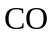 oxidation, consisting of 14 species and 30 reactions. For both oxy-syngas and syngas-air flame, the fuel stream is CO-rich H₂/CO mixture with 34% of H₂ and 66% of CO by volume. For oxy-syngas flame, the air has been replaced by an O₂/CO₂ mixture with 67% CO_{2.}
2.2 Simulation Details and Physical and Numerical Parameters
DNS calculations have been performed with three-dimensional higher order numerical code DSTAR developed by Luo [30] and later extended by Dinesh et al. [25-27]. Two oxy-syngas flames OSFRE1 and OSFRE2 are simulated with a Reynolds number of Re=3000 and 6000 respectively and, one syngas-air flame SARE2 is simulated with a Reynolds number of Re=6000 respectively. The spatial derivatives in all three directions are solved using a sixth-order accurate compact finite difference (Padé) scheme [31]. Solutions for the spatial discretised equations are obtained by solving the tri-diagonal system of equations. The spatial discretised equations are advanced in time using a fully explicit low-storage third-order Runge-Kutta scheme [32]. The time step was limited by the Courant number for stability.
Fig. 2 shows the geometry of the round jet flame configuration. The governing equations were numerically solved in a Cartesian grid with 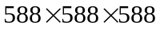 points resulting approximately 203 million nodes. The computational domain employed has a size of ten jet nozzle diameters in the streamwise direction (10D) and seven jet nozzle diameters (7D) in the cross-streamwise directions. The computational domain contains an inlet and a non-reflecting outlet in the streamwise direction. The flow field, mixture fraction and progress variable inside the domain are initialised with the inlet conditions. At the inflow, the flow was specified using the Navier-Stokes characteristic boundary conditions (NSCBC) [33] with the temperature treated as a soft variable (temperature was allowed to fluctuate according to the characteristic waves at the boundary). At the inlet, the mean streamwise velocity was specified using a hyperbolic tangent profile 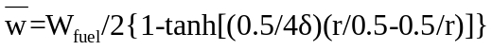 with 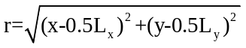 where stands for the radial direction of the round jet, originating from the centre of the inlet domain 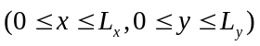 and the initial momentum thickness was chosen to be 10% of the jet radius. External unsteady disturbances were artificially added for all three velocity component at the inlet in sinusoidal form such that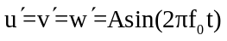, which were added to the mean velocity profile. Here we assigned the value 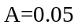 and the non-dimensional frequency of the unsteady disturbance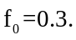 At the boundaries, non-reflecting characteristics boundary conditions are used. At the outlet boundary, the mixture fraction and progress variable are assumed to be zero-gradient. Numerical simulation, physical parameters and flame properties for oxy-syngas (OSFRE1, OSFRE2) and syngas-air (SARE2) flames are reported in Table 1.

3. Results and Discussion
In the present section results from DNS of two H₂/CO oxy-syngas flames at Reynolds number 3000 (OSFRE1) and 6000 (OSFRE2) and one H₂/CO syngas-air flame at Reynolds number 6000 (SARE2) are presented. The intention was to study the influence of the Reynolds number (Re=3000, 6000) on the local flame extinction of oxy-syngas jet flame and compare the flame extinction between oxy-syngas and syngas-air flames at the higher Reynolds number of Re=6000. We first examine the temporal evolution of streamwise temperature contour plots, scatterplots and probability density functions (pdf) of the flame temperature and the scalar dissipation rate. We then calculate the fully burning probability index based on the temperature distribution to further quantify the degree of localised extinction of oxy-syngas and syngas-air nonpremixed jet flames.

3.1 Temperature Variation and Local Flame Extinction
Fig. 3 illustrates the instantaneous 3D iso-contour plots of the flame temperature at a non-dimensional time instant t=30. Here non-dimensional time instant t=30 equal to 3 flow-through-times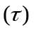, which is defined here as the time for a fluid element to propagate through the computational domain, i:e. 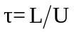, and 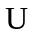are axial length of the computational domain and inlet bulk axial velocity respectively. For simulated turbulent jet flames in the radial direction, the concentric layers can be defined into three regions: the centreline region, the shear layer and the outer layer [34]. It can be seen that all three flames show similar behaviour in the near field potential core. The asymmetric behaviour is propagating downstream and differences occur in the centreline region for all three flames. The oxy-syngas flame OSFRE1 shows only inner vortical structures with predominantly laminar like behaviour at shear layer region and outer region layer. Furthermore, the flame OSFRE1 shows intense burning at the downstream region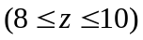. However, this behaviour changes with increased Reynolds number and the flame OSFRE2 develops highly vortical regions, particularly between 4 and 10 jet diameters downstream. The increased Reynolds number leads to the formation of vortices at the shear layer and the outer layer for the oxy-syngas flame. It can be also observed that the strongest vortices appear in SARE2 syngas-air flame. It is important to note that the different vortex structures form at the centreline region, the shear layer region and the outer layer region in OSFRE2 and SARE2 flames reflecting the different trends between the oxy-syngas and the syngas-air flame structure at a fix Reynolds number of 6000, which are attributed to thermo-physical-chemical effects such as density variation and heat release of oxy-syngas and syngas-air flames.

Fig. 4 shows scattered flame temperature of the full domain and the stoichiometric region for all three flames at a non-dimensional time instant t=30. The scattered data of oxy-syngas flame OSFRE1 exhibits little or no local extinction. However, with increased Reynolds number the scattered data of OSFRE2 show a wide range of temperature values for each mixture fraction around the stoichiometric mixture fraction region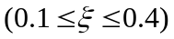 and on the fuel-rich side. Furthermore, the syngas-air SARE2 flame shows a similar pattern of a wide temperature scatter but the corresponding range of mixture fraction is different compared to the oxy-syngas OSFRE2 at the Reynolds number of 6000. This is because as the flame approaches the local extinction, the data points generally populate the domain between the flamelet profiles and the frozen limits. This behaviour is evident in both OSFRE2 and SARE2 flames, but the degree of extinction is higher in the syngas-air flame than in the oxy-syngas flame. However, there is a possibility of intermittent re-ignition at regions where the mixing rates are more relaxed, but this can only occur if there are burnt fluid parcels convected from the intense mixing region. In Fig. 4, another important observation is that high temperature occurs on the leaner side of the fuel mixture due to preferential diffusion effects of 34% of H₂ in H₂/CO the fuel mixture.

3.2 Scalar Dissipation Rate Variation and Local Flame Extinction
The observed temperature data scatter of flames OSFRE2 and SARE2 is highly correlated with the local flame extinction which greatly depends on the Reynolds number and the scalar dissipation rate. Therefore we now focus on the distribution of the scalar dissipation rate 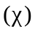of all three flames. Comparison of scatter plots and pdfs of at the flame front (within the box of stoichiometric mixture fraction region) at a non-dimensional time instant t=30 are shown in Fig.5. The observed scattered shows considerably lower values for OSFRE1 flame, but high values for high Reynolds number OSFRE2 and SARE2. It is seen that for all flames, the peak values in occur within the range 0.4-0.8 regardless of the stoichiometric mixture fraction and the location of peak temperatures. The scattered data of clearly indicate the influence of the Reynolds number on local mixing of the oxy-syngas flame. It is seen that increasing Reynolds number increases the scalar dissipation rate value which is an essential characteristic in the localised extinction mechanism. The pdf of at the flame front indicate that the flame OSFRE1 does not show peaks or spikes associated with higher values, and thus is far from extinction. However, the pdfs ofexhibit large peaks for both OSFRE2 and SARE2 flames in a spectrum between 600-1000, hence showing the essential character of high scalar dissipation rate for local flame extinction. Furthermore, Fig.6 presents the maximum flame temperature versusfor one-dimensional laminar oxy-syngas and syngas-air nonpremixed flames. This figure indicates that the temperature of syngas-air flame decreases faster with increasing than that of oxy-syngas flame. The figure also indicates that the extinction dissipation rate of syngas-air flame (2900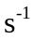) is lower than the oxy-syngas flame (4400) over the whole range of .

3.3 Fully Burning Probability and Local Flame Extinction
To further quantify the degree of localised flame extinction of simulated flames we now discuss the pdf distributions of the flame temperature. Fig. 7 shows the pdfs of the temperature for OSFRE1, OSFRE2 and SARE2 at three different axial locations (z=3, 6 and 9) at a non-dimensional time instant t=30. The pdfs of the temperature is calculated within a thin layer of the reaction zone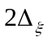centred on the location of maximum flame temperature, where the reaction zone width is 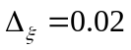[11]. The pdfs of the temperature were determined from the simulation results using, about 8000 samples at z=3, 10000 samples at z=6 and 15000 samples at z=9. In Fig.7, the top three plots show the influence of the Reynolds number on pdfs of the temperature for oxy-syngas flames and the bottom three plots demonstrate the differences between the oxy-syngas and the syngas-air flame at the same Reynolds number. Considering the oxy-syngas flames OSFRE1 at Re=3000 and OSFRE2 at Re=6000, the pdfs of temperature distribution show clear differences at z=3 and 6, although there exist a similarity of pdf shape distribution at z=9. The pdfs of the temperature of OSFRE2 flame show significant skewing compared to OSFRE1 flame, and the two oxy-syngas flame show highest bimodality at z=6, then shift towards delta function at z=9. For the pdf of the oxy-syngas flame and the syngas-air flame temperatures at Re=6000, the same trend can be observed, though less spikes are apparent at downstream z=9 for syngas-air SARE2 flame. This suggests that the syngas-air flame has decreased contribution from the higher temperatures to its heat release rate which influences the reaction rate, thus indicating a sign of local flame extinction throughout the flame. Generally, pdfs of the temperature of oxy-syngas flames OSFRE1 and OSFRE2 presented here indicate significant variation from Gaussian (z=3) to bimodal (z=6) to delta functions (z=9), though more skewing is observed at downstream for syngas-air flame SARE2. The extents of the bimodality of the pdfs indicate the temperature fluctuations, which can be either related to the inherent properties of the syngas fuel mixture or the Reynolds number.

Finally, in order to give a quantitative estimate of the onset of local extinction in oxy-syngas and syngas-air flames, we now determine a fully burning probability (FBP), within a thin layer of the reaction zonecentred on the location of the maximum flame temperature, which is one of several criteria to estimate the degree of local extinction [11][35-36]. FBP can be thought as an indicator function that has a value of unity when the flame is fully burnt, corresponding to the temperatures above a threshold temperature, and zero when those temperatures are below threshold temperature, i.e. it represents the fraction of burning during which a point is inside the fully burning state. In the present calculations, FBP is calculated using a summation of probability of the flame temperature values above a certain threshold temperature. FBP profiles derived from temperature pdfs for axial locations z=3, 6 and 9 at a non-dimensional time instant t=30 are shown in Fig. 8. Given the adiabatic flame temperature of approximately of 2400K for all three flames, we selected two temperature threshold values of 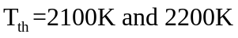 for the analysis of threshold sensitivity. It should be noted that selected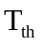values are reasonable and well below the adiabatic flame temperature for three flames and still reasonably high. As expected, the variation of the FBP values at z=3, 6 and 9 indicate that the oxy-syngas OSFRE1 flame burns very well with values close to fully burning state. However, as observed in flame OSFRE2, the increase of Reynolds number reduces the FBP values, and thus indicates the decrease of fully burning state over its whole computed length. Furthermore, it is observed that the FBP values of syngas-air flame SARE2 start to deviate more significantly with rapid variation with respect to two given threshold values. Fig. 8 also shows that all three flames burn reasonably well in the intermediate region (z=6), but indicate signs of local flame extinction in the near field (z=3) and the downstream region (z=9). Overall, the FBP values with respect to two different thresholds indicate that the localised flame extinction happed systematically between 3 and 9 jet diameters above the nozzle in oxy-syngas OSFRE2 and syngas-air SARE2 at Reynolds number of 6000.

3.4 Comparison with experimental measurements
In order to validate the present DNS results, we consider the closest possible experimental observations carried out by Sevault et al. [11]. Despite having a similar nozzle jet diameter of 5mm in numerical and experimental configuration, experimental study focused on CH₄/H₂ oxy-fuel jet flames at considerably higher Reynolds number of 15,000 and 18.000. However, it is important to note that our DNS results show some resemblance with their experimental findings. For example, as we discussed in our DNS results, Sevault et al. [11] also reported probability density functions of the flame temperature and fully burning probability at near field non-dimensional axial locations (3, 5 and 10 nozzle jet diameters). Although a few discrepancies are apparent, DNS results of pdf of the flame temperature show similar trends with the experimental data. DNS results and the experimental data of pdf of the flame temperatures display significant skewing with lower and higher values, in which higher values correspond to the fully burning mixtures (Fig.7). Based on FBP calculation, Sevault et al. [11] also concluded that the local flame extinction occurred in the near field of oxy-fuel flames (less than 10 jet diameters above the nozzle) and its effect disappeared at far downstream locations, which is consistent with the present DNS results (Fig.8). Given the complexity of the CO-rich H₂/CO syngas fuel mixture and its oxidation with O₂/CO₂ mixture, present DNS results are particularly useful for identifying sharp changes in local flame regions, where we can expect flame extinction behaviour.

4. Conclusions
DNS of oxy-fuel syngas and syngas-air turbulent nonpremixed flames at two different Reynolds numbers Re=3000 and 6000 have been performed using detailed chemistry. In order to investigate the local flame extinction occurs in these flames, the DNS results are analysed in terms of flame contours, scatter plots, probability density function distributions and fully burning probability. The main conclusions can be summarised as follows:

1. The oxy-syngas flame OSFRE1 at Re=3000 shows only inner vortical structures which appear to be dominated by large-scale structures. But with increased Reynolds number at Re=6000, OSFRE2 develops strong vortical regions, particularly between 4 and 10 jet diameters above the nozzle. The syngas-air flame SARE2 exhibits strongest vortical structures due to Kelvin-Helmholtz instability between 6 and 10 jet diameters above the nozzle.
2. The scattered data of temperature indicate that oxy-syngas flame OSFRE1 burn well without local extinction. However, the oxy-syngas flame OSFRE2 and the syngas-air SARE2 flame show extensive flame extinction over a wide range of mixture fraction.
3. The scattered data of the scalar dissipation rate shows small values for flame OSFRE1, but considerably higher values for flames OSFRE2 and SARE2. The peak values of the scalar dissipation rate occur at higher mixture fraction values.
4. The calculated fully burning probability within a thin layer of the reaction zone indicates that the oxy-syngas flame OSFRE1 burns well with values close to fully burning state with respect to two threshold values. However, it is observed that the localised flame extinction occurs between 3 and 9 jet diameters above the nozzle in both oxy-syngs OSFRE2 and syngas-air SARE2 at higher Reynolds number.

Finally, there are a number of important issues identified in the oxy-syngas flames which should be considered for the next phase of investigation. A natural continuation of the present work is the study of the influence of preferential diffusion at much higher Reynolds numbers by varying the H₂ percentage in the H₂/CO oxy-syngas mixture. Another important issue is to characterise the reactive radicals such as H, O, CH as well as pollutants such as CO, NO₂, and mechanisms of emission interactions such as NO-CO interactions of oxy-syngas flames. These issues will be reported in future studies.

Acknowledgement
Support from the UK Engineering and Physical Sciences Research Council under the project “Thermal and Reactive Flow Simulation on High-End Computers (Grant No. EP/J016381/1)” is gratefully acknowledged.

References
[1]. Rubin ES, Mantripragada H, Marks A, Versteeg P, Kitchin J. The outlook for improved carbon capture technology. Prog Energy Combust Sci 2012; 38: 630-671.
[2]. Bassano C, Deiana P, Girardi G. Modelling and economic evaluation of the integration of carbon capture and storage technologies into coal to liquid plants. J Fuel 2014; 116: 850-860.
[3]. Li L, Zhao N, Wei W, Sun Y. A review of research progress on CO₂ capture, storage and utilisation in Chinese academy of sciences. J Fuel 2013; 108: 112-130.
[4]. De Silva PNK, Ranjith PG, Choi SK. A study of methodologies for CO₂ storage capacity estimation of coal. J Fuel 2012; 91: 1-15.
[5]. Buhre BJP, Elliott LK, Sheng CD, Gupta RP, Wall TF. Oxy-fuel combustion technology for coal-fired power generation. Prog Energy Combust Sci 2005; 31: 283-307.
[6]. Ditaranto M, Hals J. Combustion instabilities in sudden expansion oxy-fuel flames. Combust Flame 2006; 146: 493-512.
[7]. Kumfer BM, Skeen SA, Axelbaum RL. Soot inception limit in laminar diffusion flames with applications to oxy-fuel combustion. Combust Flame 2008; 154: 546-556.
[8]. Hjartstam S, Andersson K, Johnsson F, Leckner B. Combustion characteristics of lignite-fired oxy-fuel flames. J Fuel 2009; 88: 2216-2224.
[9]. Smart J, Lu G, Yan Y, Riley G. Characterisation of an oxy-coal flame through digital imaging. Combust Flame 2010; 157: 1132-1139.
[10]. Shaddix CR, Molina A. Fundamental investigation of NOx formation during oxy-fuel combustion of pulverised coal. Proc Combust Inst 2011; 33: 1723-1730.
[11]. Sevault A, Dunn M, Barlow RS, Ditaranto M. On the structure of the near field of oxy-fuel jet flames using Raman/Rayleigh laser diagnostics. Combust Flame 2012; 159: 3342-3352.
[12]. Al-Makhadmeh L, Maier J, Al-Harahsheh M, Scheffknecht G. Oxy-fuel technology: An experimental investigations into oil shale combustion under oxy-fuel conditions. J Fuel 2013: 103: 421-429.
[13]. da Silva RC, Kangwanpongpan T, Krautz HJ. Flame pattern, temperatures and stability limits of pulverized oxy-coal combustion. J Fuel 2014; 115: 507-520.
[14]. Bhadraiah K, Raghavan V. Numerical simulation of laminar co-flow methane-oxygen diffusion flames: effects of chemical kinetic mechanisms. Combust Theory Model 2010; 15: 23-46.
[15]. Nikolopoulos N, Nikolopoulos A, Karampinis E, Grammelis P, Kakaras E. Numerical investigation of the oxy-fuel combustion in large scale boilers adopting the ECO-Scrub technology. J Fuel 2011; 90: 198-214.
[16]. Yin C, Rosendahl LA, Kaer SK. Chemistry and radiation in oxy-fuel combustion: A computational fluid dynamics modelling study. Fuel 2011; 90: 2519-2529.
[17]. Edge P, Gubba SR, Ma L, Porter R, Pourkashanian M, Williams A. LES modelling of air and oxy-fuel pulverised coal combustion-impact on flame properties. Proc Combust Inst 2011; 33: 2709-2716.
[18]. Al-Abbas AH, Naser J, Dodds D. CFD modelling of air-fired and oxy-fuel combustion in a large-scale furnace at Loy Yang A brown coal power station. J Fuel 2012; 102: 646-665.
[19]. Galletti C, Coraggio G, Tognotti L. Numerical investigation of oxy-natural-gas combustion in a semi-industrial furnace: Validation of CFD sub-models. J Fuel 2013; 109: 445-460.
[20]. Singer S, Chen L, Ghoniem AF. The influence of gasification reactions on char consumptions under oxy-combustion conditions: effects of particle trajectory and conversion. Proc Combust Inst 2013; 34: 3471-3478.
[21]. Prieler R, Demuth M, Spoljaric D, Hochenauer C. Evaluation of a steady flamelet approach for use in oxy-fuel combustion. J Fuel 2014; 118: 55-68.
[22]. Chen L, Yong SZ, Ghoniem AF. Oxy-fuel combustion of pulverised coal: characterisation, fundamentals, stabilisation and CFD modelling. Prog Energy Combust Sci 2012; 38: 156-214.
[23]. Westbrook CK, Mizobuch Y, Poinsot TJ, Smith PJ, Warnatz J. Computational combustion. Proc Combust Inst 2005; 30: 125-157.
[24]. Chen JH. Petascale direct numerical simulation of turbulent combustion- fundamental insights towards predictive models. Proc Combust Inst 2011; 33: 99-123.
[25]. Ranga Dinesh KKJ, Jiang X, van Oijen JA, Bastiaans RJM, de Goey LPH. Influence of fuel variability on the characteristics of impinging nonpremixed syngas burning. Proc Combust Inst 2013; 34: 3219-3229.
[26]. Ranga Dinesh KKJ, Jiang X, van Oijen JA. Direct numerical simulation of non-premixed syngas burning with detailed chemistry. J Fuel 2013; 107: 343-355.
[27]. Ranga Dinesh KKJ, Jiang X, van Oijen JA, Bastiaans RJM, de Goey LPH. Hydrogen-enriched nonpremixed jet flames: effects of preferential diffusion. Int J Hydrogen Energy 2013; 38: 4848-4863.
[28]. van Oijen JA, de Goey LPH. Modelling of premixed laminar flames using flamelet-generated manifolds. Combust Sci Tech 2000; 161: 113-137.
[29]. Davis SG, Joshi AV, Wang H, Egolfopoulos F. An optimised kinetic model of H₂/CO combustion. Proc Combust Inst 2005; 30: 1283-1292.
[30]. Luo KH. Combustion effects on turbulence in a partially premixed supersonic diffusion flame. Combust Flame 1999; 119: 417-435.
[31]. Lele SK. Compact finite difference schemes with spectral-like resolution. J of Comput Phy 1992; 103: 16-42.
[32]. Williamson JH. Low-storage Runge-Kutta schemes. J of Comput Phy 1980; 35: 48-56.
[33]. Poinsot TJ, Lele SK. Boundary conditions for direct simulations of compressible viscous flows. J of Comput Phy 1992; 101: 104-129.
[34]. Ball CG, Fellouah H, Pollard A. The flow field in turbulent round free jets. Prog. Aero. Sci. 2012; 50: 1-26.
[35]. Barlow RS, Ozarovsky HC, Karpetis AN, Lindstedt RP. Piloted jet flames of CH₄/H₂/Air: experiments on localised extinction in the near field at high Reynolds number. Combust Flame 2009; 156: 2117-2128.
[36]. Masri AR, Kalt PAM, Al-Abdeli YM, Barlow RS. Turbulence-chemistry interactions in non-premixed swirling flames. Combust Theory Model 2007; 11: 653-673.

Tables:
Table 1. Numerical simulation, physical parameters and flame properties for oxy-syngas and syngas-air flames.
Parameters and flame properties | OSFRE1 | OSFRE2 | SARE2
Jet Diameter 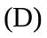 | 5mm | 5mm | 5mm
Domain size 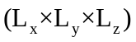 | 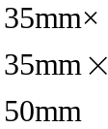
Number of grid points 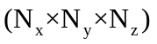 | 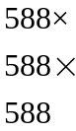
Mean inlet jet velocity 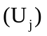 | 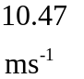 | 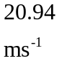
Jet temperature 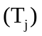 | 300K | 300K | 300K
Jet Reynolds number 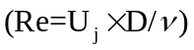 | 3000 | 6000 | 6000
Velocity fluctuation 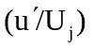 | 0.11 | 0.21 | 0.22
Integral length scale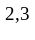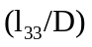 | 0.3 | 0.36 | 0.39
Turbulence Reynolds number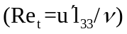 | 110 | 220 | 230
Stoichiometric mixture fraction | 0.24 | 0.24 | 0.22
Adiabatic flame temperature | 2405K | 2404K | 2400K

Kinematic viscosity at the inflow conditions,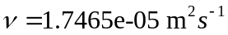 is used to calculate the Reynolds number.
The turbulence scales evolve from the artificial turbulence specified at the inflow. The 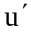value is evaluated at the 1/2 stream location along the jet centreline.
Integral length scale 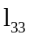is defined as the integral of the auto-correlation of the spanwise component of velocity in the spanwise direction. The value is evaluated at the 1/2 stream location along the jet centreline.
Figures
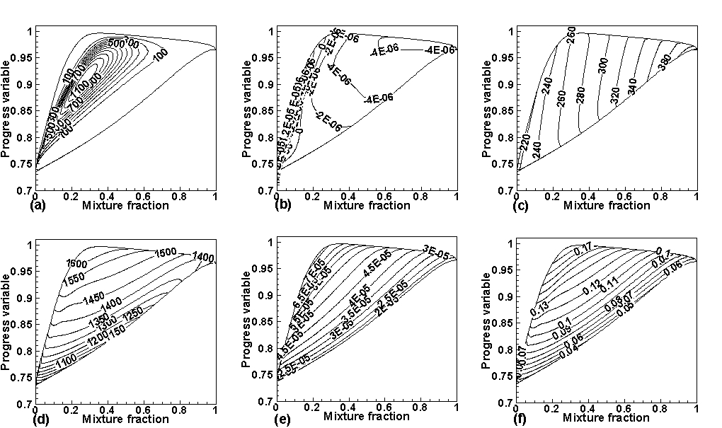

Fig.1. Oxy-syngas flamelet generated manifolds of chemical and transport variables as a function of mixture fraction and progress variable: (a) source term of the progress variable (b) non-unity Lewis number based diffusion coefficient, (c) gas constant, (d) specific heat at constant pressure, (e) viscosity, (f) thermal conductivity.

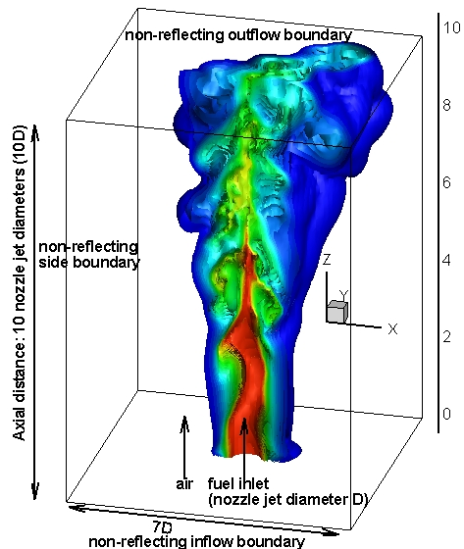
Fig.2. Geometry of the turbulent non-premixed syngas jet flame with dimensions of 10 jet diameters in the streamwise direction and 7 jet diameters in the cross-streamwise direction (here 3D iso-surface represents the mixture fraction at a non-dimensional time instant t=30).

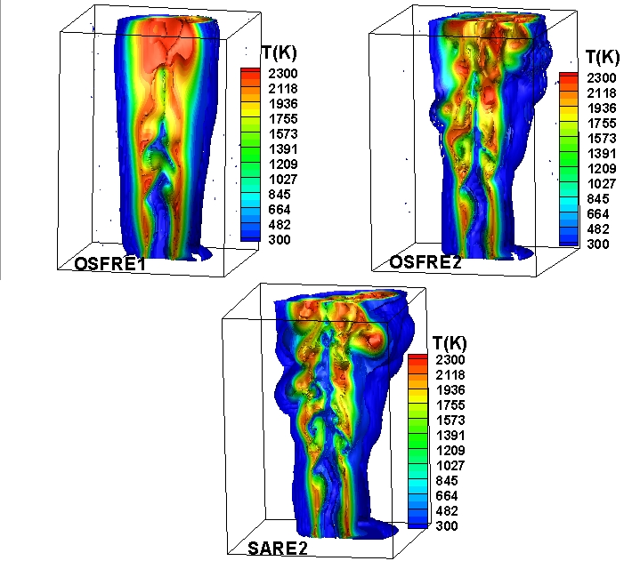
Fig.3. Iso-surfaces of three-dimensional flame temperature for oxy-syngas flames at Re=3000 (OSFRE1), Re=6000 (OSFRE2) and syngas-air flame at Re=6000 (SARE2) at a non-dimensional time instant t=30.

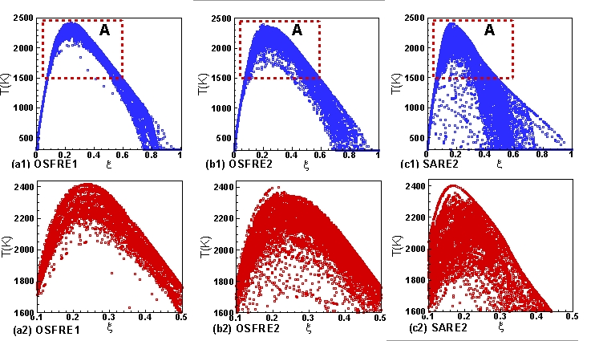
Fig.4. Scatter plots of flame temperature versus mixture fraction for oxy-syngas flames OSFRE1, OSFRE2 and syngas-air flame SARE2 at a non-dimensional time instant t=30. Here (a1), (b1) and (c1) show results for the full domain while (a2), (b2) and (c2) show results for the region A (stoichiometric region).

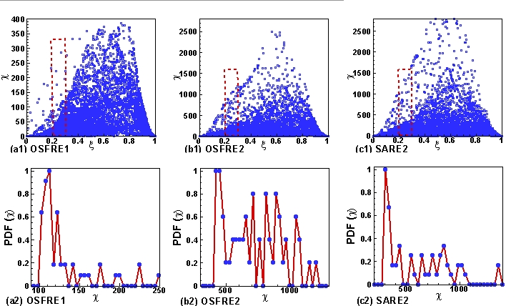

Fig.5. Scatter plots of scalar dissipation rate versus mixture fraction and PDF of the scalar dissipation rate at the flame front (region close to the stoichiometric mixture fraction) for oxy-syngas flames OSFRE1, OSFRE2 and syngas-air flame SARE2 at a non-dimensional time instant t=30.

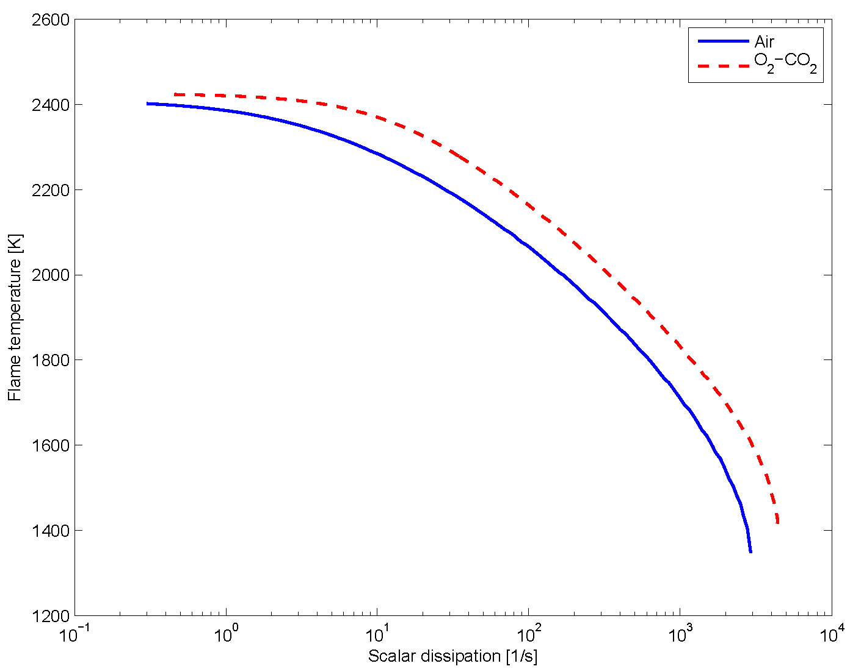
Fig.6. Maximum flame temperature versus scalar dissipation for one-dimensional steady counter-flow nonpremixed flames for oxy-syngas flame (dashed line) and syngas-air flame (solid line).

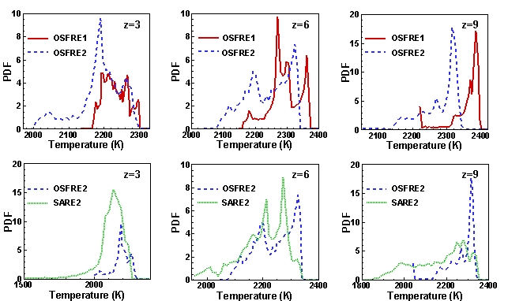
Fig.7. Temperature pdf at z=3, 6 and 9 within a thin layer of mixture fraction at the flame front for oxy-syngas flames OSFRE1, OSFRE2 and syngas-air flame SARE2 at a non-dimensional time instant t=30.

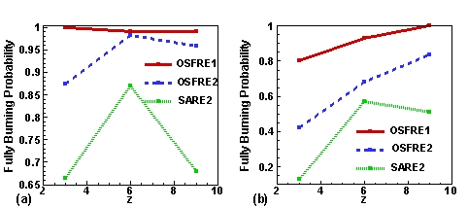
Fig.8. Fully burning probability at axial locations z=3, 6 and 9, based on the PDF of the temperature above (a) T (threshold) =2100 and (b) T (threshold) =2200 within a thin layer of mixture fraction at the flame front for oxy-syngas flames OSFRE1, OSFRE2 and syngas-air flame SARE2 at a non-dimensional time instant t=30.

Figure Captions
Fig.1. Oxy-syngas flamelet generated manifolds of chemical and transport variables as a function of mixture fraction and progress variable: (a) source term of the progress variable (b) non-unity Lewis number based diffusion coefficient, (c) gas constant, (d) specific heat at constant pressure, (e) viscosity, (f) thermal conductivity.

Fig.2. Geometry of the turbulent non-premixed syngas jet flame with dimensions of 10 jet diameters in the streamwise direction and 7 jet diameters in the cross-streamwise direction (here 3D iso-surface represents the mixture fraction at a non-dimensional time instant t=30).

Fig.3. Iso-surfaces of three-dimensional flame temperature for oxy-syngas flames at Re=3000 (OSFRE1), Re=6000 (OSFRE2) and syngas-air flame at Re=6000 (SARE2) at a non-dimensional time instant t=30.
Fig.4. Scatter plots of flame temperature versus mixture fraction for oxy-syngas flames OSFRE1, OSFRE2 and syngas-air flame SARE2 at a non-dimensional time instant t=30. Here (a1), (b1) and (c1) show results for the full domain while (a2), (b2) and (c2) show results for the region A (stoichiometric region).

Fig.5. Scatter plots of scalar dissipation rate versus mixture fraction and PDF of the scalar dissipation rate at the flame front (region close to the stoichiometric mixture fraction) for oxy-syngas flames OSFRE1, OSFRE2 and syngas-air flame SARE2 at a non-dimensional time instant t=30.

Fig.6. Maximum flame temperature versus scalar dissipation for one-dimensional steady counter-flow nonpremixed flames for oxy-syngas flame (dashed line) and syngas-air flame (solid line).

Fig.7. Temperature pdf at z=3, 6 and 9 within a thin layer of mixture fraction at the flame front for oxy-syngas flames OSFRE1, OSFRE2 and syngas-air flame SARE2 at a non-dimensional time instant t=30.

Fig.8. Fully burning probability at axial locations z=3, 6 and 9, based on the PDF of the temperature above (a) T (threshold) =2100 and (b) T (threshold) =2200 within a thin layer of mixture fraction at the flame front for oxy-syngas flames OSFRE1, OSFRE2 and syngas-air flame SARE2 at a non-dimensional time instant t=30.

