The 12th International Conference on Combustion & Energy Utilisation – 12ICCEU
The Scalar Structure of Turbulent Oxy-Fuel Non-Premixed Flames
K.K. J. Ranga Dinesh, E. S. Richardson, J.A. van Oijen, K.H. Luo, X. Jiang
Faculty of Engineering and the Environment, University of Southampton, Southampton, SO17 1BJ, UK.
Combustion Technology, Department of Mechanical Engineering, Eindhoven University of Technology, Eindhoven, The Netherlands.
Department of Mechanical Engineering, University College London, Torrington Place, London, WC1E 7JE, UK.
Engineering Department, Lancaster University, Lancaster, Lancashire, LA1 4YR, UK.
Abstract
This study addresses the scalar structure of turbulent oxy-fuel syngas non-premixed jet flame in the context of direct numerical simulation (DNS) and detailed chemistry. The main objective is to identify the influence of the Reynolds number on oxy-fuel flame structure, and to clarify the differences of scalar structures between oxy-fuel syngas and syngas-air flames at a similar higher Reynolds number. Two oxy-syngas flames at Reynolds numbers of 3000 and 6000 and one syngas-air flame at Reynolds number of 6000 were simulated. These studies show that the existence of CO₂ in the oxidant has a profound effect on scalar structure of oxy-fuel syngas flame compared to syngas-air flame.

© 2014 The Authors. Published by Elsevier Ltd.
Selection and/or peer-review under responsibility of 12ICCEU

Keywords: Oxy-fuel syngas, Direct Numerical Simulatio, FGM, Non-premixed combustion
- Introduction
Carbon capture and storage (CCS) facilities coupled to power plants offer a climate change mitigation approach that possibly permits the continued use of fossil fuels whilst decreasing the carbon dioxide (CO₂) emissions [1]. Oxy-fuel combustion is one such CCS technology in which air is replaced with oxygen or oxygen-rich oxidants using recycled flue gas (O₂ and CO₂), resulting in high proportions of CO₂ and H₂O as combustion products [2]. CO₂ can then be separated by condensation, and high volume of relatively pure CO₂ can be captured. In recent decades, computational combustion has made remarkable advances due to its ability to deal with wide range of scales, complexity and almost unlimited access to data [3]. Direct numerical simulation (DNS), in which the complete spectrum of scales is resolved, is evolving as an extremely valuable computational tool from which much can be learned [4]. Interest in carbon capture relevant to syngas based oxy-fuel combustion has inspired an extension of the high-resolution DNS to investigate the scalar structures of oxy-fuel syngas combustion. The present work focuses on scalar structures of oxy-fuel syngas jet flames at different Reynolds numbers and identifying the flame characteristics between oxy-fuel syngas and syngas-air flame. The remainder of the paper is organised as follows: DNS details are presented in the next section followed by results and discussion. Finally, conclusions are summarised.
- DNS Setup, Chemistry and Numerical Implementation
The system of governing equations to be solved is given by the mass, momentum, energy, mixture fraction and progress variable together with auxiliary equations such as the state equation for a compressible gas mixture. The detailed chemistry is represented by databases of flamelet generated manifold chemistry, accounting for both chemical and transport processes using the laminar flamelet concept. For both oxy-syngas and syngas-air flame, the fuel stream is CO-rich H₂/CO mixture with 34% of H₂ and 66% of CO by volume. For oxy-syngas flame, the air has been replaced by an O₂/CO₂ mixture with 67% CO₂. Simulations were conducted for two oxy-syngas flames at Reynolds number of Re=3000 (OSFRE1) and Re=6000 (OSFER2), and one syngas-air flame at Reynolds number of Re=6000 (SARE2). The spatial derivatives in all three directions are solved using a sixth-order accurate compact finite difference (Padé) scheme [5]. Solutions for the spatial discretised equations are obtained by solving the tri-diagonal system of equations. The spatial discretised equations are advanced in time using a fully explicit low-storage third-order Runge-Kutta scheme [6]. The time step was limited by the Courant number for stability. The governing equations were numerically solved in a Cartesian grid with points resulting approximately 203 million nodes. The computational domain employed has a size of ten jet nozzle diameters in the streamwise direction (10D) and seven jet nozzle diameters (7D) in the cross-streamwise directions.
- Results and Discussion
In this section we presents DNS results of two oxy-fuel H₂/CO syngas flames at Reynolds number of 3000 (OSFRE1) and 6000 (OSFRE2), and one H₂/CO syngas-air flame at Reynolds number of 6000 (SARE2). The intention was to study the influence of the Reynolds number (Re=3000, 6000) on the scalar structure of oxy-fuel syngas flame and syngas-air flame. We first examine the temporal evolution of streamwise mixture fraction and temperature contour plots, and then discuss the scatter distribution of the flame temperature.

Fig. 1 shows the instantaneous mixture fraction (top three contours) and flame temperature (bottom three contours) at a non-dimensional time instant t=30. Here non-dimensional time instant t=30 equal to 3 flow-through-times, which is defined as the time for a fluid element to propagate through the computational domain (10 nozzle jet diameters). For simulated turbulent oxy-fuel jet flames in the radial direction, the concentric layers can be defined into three regions: the centreline region, the shear layer and the outer layer. It can be seen that all three flames show similar behaviour in the near field potential core. The asymmetric behaviour is propagating downstream and differences occur in the centreline region for all three flames. The oxy-syngas flame OSFRE1 shows only inner vortical structures with predominantly laminar like behaviour at shear layer region and outer region layer. Furthermore, the flame OSFRE1 shows intense burning at the downstream region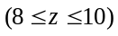, where z is the streamwise direction. However, this behaviour changes with increased Reynolds number and the flame OSFRE2 develops highly vortical regions, particularly between 4 and 10 jet diameters downstream. The increased Reynolds number leads to the formation of vortices at the shear layer and the outer layer for the oxy-syngas flame. It can be also observed that the strongest vortices appear in SARE2 syngas-air flame. It is important to note that the different vortex structures form at the centreline region, the shear layer region and the outer layer region in OSFRE2 and SARE2 flames reflecting the different trends between the oxy-syngas and the syngas-air flame structure at a fix Reynolds number of 6000, which are attributed to thermo-physical-chemical effects such as density variation and heat release of oxy-syngas and syngas-air flames.

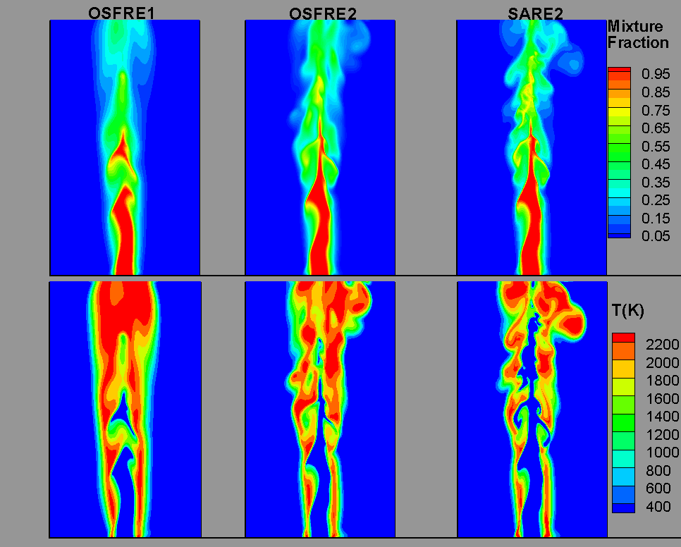

Fig.1. Contour plots of two scalars; mixture fraction (top three contours) and flame temperature (bottom three contours) for oxy-syngas flames at Re=3000 (OSFRE1), Re=6000 (OSFRE2) and syngas-air flame at Re=6000 (SARE2) at a non-dimensional time instant t=30.

Fig. 2 shows comparisons of the scattered temperature between OSFRE1, OSFRE2 and SARE2 for the full domain (a1, b1, c1), and for the stoichiometric region (a2, b2, c2) at a non-dimensional time instant t=30. The scattered data of oxy-syngas flame OSFRE1 exhibits little or no local extinction. However, with increased Reynolds number the scattered data of OSFRE2 show a wide range of temperature values for each mixture fraction around the stoichiometric mixture fraction region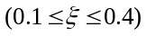 and on the fuel-rich side. Furthermore, the syngas-air SARE2 flame shows a similar pattern of a wide temperature scatter but the corresponding range of mixture fraction is different compared to the oxy-syngas OSFRE2 at the Reynolds number of 6000. This is because as the flame approaches the local extinction, the data points generally populate the domain between the flamelet profiles and the frozen limits. This behaviour is evident in both OSFRE2 and SARE2 flames, but the degree of extinction is higher in the syngas-air flame than in the oxy-syngas flame. However, there is a possibility of intermittent re-ignition at regions where the mixing rates are more relaxed, but this can only occur if there are burnt fluid parcels convected from the intense mixing region. In Fig. 2, another important observation is that high temperature occurs on the leaner side of the fuel mixture due to preferential diffusion effects of 34% of H₂ in H₂/CO the fuel mixture.
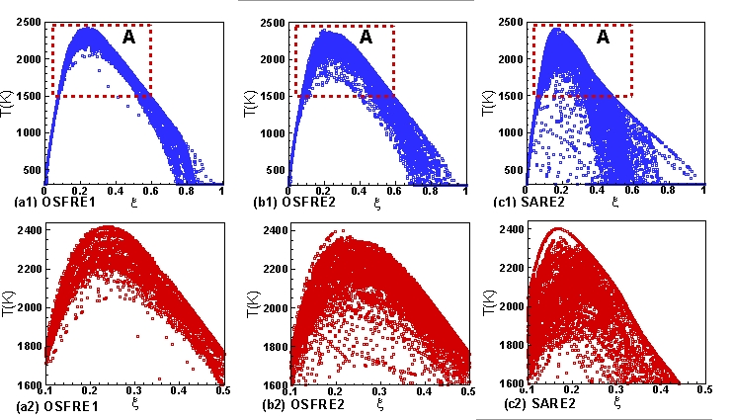

Fig.2. Scatter plots of flame temperature versus mixture fraction for oxy-syngas flames OSFRE1, OSFRE2 and syngas-air flame SARE2 at a non-dimensional time instant t=30. Here (a1), (b1) and (c1) show results for the full domain while (a2), (b2) and (c2) show results for the region A (stoichiometric region).
- Conclusions
The scalar structure of oxy-fuel syngas and syngas-air non-premixed flames at two different Reynolds numbers were investigated using direct numerical simulation and detailed chemical kinetics incorporated into the flamelet generated manifold chemistry. In order to identify the differences in scalar structures, DNS results were analysed in terms of instantaneous mixture fraction and flame temperature. The main conclusions are summarised as follows:
1. The oxy-syngas flame OSFRE1 at Re=3000 shows only inner vortical structures which appear to be dominated by large-scale structures. But with increased Reynolds number at Re=6000, OSFRE2 develops strong vortical regions, particularly between 4 and 10 jet diameters above the nozzle. The syngas-air flame SARE2 exhibits strongest vortical structures due to Kelvin-Helmholtz instability between 6 and 10 jet diameters above the nozzle.
2. The scattered data of temperature indicate that oxy-syngas flame OSFRE1 burn well without local flame extinction. However, the oxy-syngas flame OSFRE2 and the syngas-air SARE2 flame show extensive local flame extinction over a wide range of mixture fraction.

References
[1] T. Kuramochi, A. Ramirez, W. Turkenburg, A. Faaij, Prog. in Energy and Combust. Sci. 38 (2012) 87-112.
[2] B.J.P. Buhre, L.K. Elliott, C. D. Sheng, R.P. Gupta, T.F. Wall, Prog. in Energy and Combust. Sci. 31 (2005) 283-307.
[3] C.K. Westbrook, Y. Mizobuchi, T.J. Poinsot, P. J. Smith, J. Warnatz, Proc. Combust. Inst. 30 (2005) 125-157.
[4] J. H. Chen, Proc. Combust. Inst. 33 (2011) 99-123.
[5] S.K. Lele, J. of Comput. Phy. 103 (1992) 16-42.
[6] J.H. Williamson, J. of Comput. Phy. 35 (1980) 48-56.

