MANUSCRIPT ID: 201301-4

Experience the Difference: The Competitive Strategies of Food-Related Entrepreneurs in Rural Denmark

Isaac K. Arthur

Department of Geography and Resource Development, University of Ghana, Legon, Ghana

E-mail: ikarthur@ug.edu.gh

Brian J. Hracs

School of Geography, University of Southampton, Southampton, U.K.

Email: [b.j.hracs@soton.ac.uk](mailto:b.j.hracs@soton.ac.uk)

Experience the Difference:

The Competitive Strategies of Food-Related Entrepreneurs

in Rural Denmark

by

Isaac K. Arthur and Brian J. Hracs

ARTHUR, I. K. and HRACS, B. J. (2015): ‘Experience the difference: the competitive strategies of food-related entrepreneurs in rural Denmark’, *Geografiska Annaler: Series B, Human Geography* 97 (1): …–… .

ABSTRACT. As food production becomes increasingly integrated, globalized and competitive, small-scale food-related enterprises in many European countries are struggling to market and monetize their products. Although these struggles have been well documented, few studies have considered the ways in which food-related entrepreneurs in rural contexts are adapting to and overcoming these challenges. In particular, little is known about how they differentiate and add value to their products. This article focuses on the development and implementation of new and hybrid commercial strategies by food-related entrepreneurs in three rural communities in Denmark. These strategies add experiential elements to the long-standing practice of commodifying myths associated with rural settings and identities. Although harnessing culture and experiences to sell things is nothing new, we demonstrate that some Danish entrepreneurs are responding to market competition by tweaking and extending these concepts. In particular, it is argued that entrepreneurs use different experiences with varying levels of intensity and consumer engagement for different purposes. Whereas passive experiences such as storytelling are used to educate consumers about the specific qualities of products, more active and participatory experiences are sold as add-ons and standalone products. The findings contribute to our understanding of food-related entrepreneurship in rural contexts, consumption, value creation and the experience economy more broadly.

*Keywords*: experience economy, competition, food production, entrepreneurship, rural, Denmark

**Introduction**

As traditionally protected markets are liberalized, small-scale food-related enterprises struggle to compete with capital intensive and vertically integrated global firms (Cawley *et al*. 2003). In many European countries, the locus of added value has shifted from the farm to the larger food processing and retail sector. As a result, farmers have experienced a steady decline in their ability to sell their produce (Ilbery *et al*. 2005). In Denmark, the globally oriented agricultural sector plays a vital role in the economy. In 2013, farm products made up approximately 18 per cent of the country’s goods exports and the sector is one of the most high-tech and efficient in the world (Statistics Denmark 2014, Table 329; *The Economist* 2014). Between 2001 and 2011 food exports grew from EUR 4 billion to EUR 13.6 billion and the government expects it to rise by a further EUR 6.7 billion by 2020. (Statistics Denmark 2014, Table 329; *The Economist* 2014).

The profits of large Danish brands located in the central cluster, such as Danish Crown, Arla and Rose Poultry continue to grow (*The Economist* 2014), but smaller food-related enterprises in peripheral regions including Thisted (also known as Thy), Morsø (also known as Mors) and Bornholm are struggling. Unlike large global firms, these producers do not command the resources to drive research and development or roll-out expensive marketing campaigns. Without access to larger markets, these producers are constrained by the geographic remoteness and low population densities of the municipalities that they are located within (Baker *et al*. 2007). Indeed, unlike other independent producers, including musicians or authors, who can digitize their goods and services and use online retail platforms to promote and distribute them to consumers around the world, most small-scale food producers sell to local residents and international and domestic tourists (Hracs *et al*. 2013). To survive, these rural food producers must compete with local and global firms who operate in their market. According to Power, this requires differentiation which he defines as ‘establishing a unique position and relational status for the product (and the firm)’ (2010, p. 148). Yet, given their limited resources how do food-related entrepreneurs in rural locations achieve such differentiation and add value to their products?

Within the European Union, many countries including Denmark encourage local food-related enterprises to compete by developing high quality and niche rural food-related products. The quality discourse in Europe is inspired by the European Commission’s Common Agriculture Policy reform which advocates food security via food quality and environmental resource management. Under the policy, food-related enterprises are encouraged to inform consumers, through labels, about how their products are sourced and produced (including how animals and the environment are treated) (EU 2012). According to Cawley *et al*. (2003), quality can be derived from the details of the raw materials, their history, processing and presentation. By extension, quality, distinction and value can be generated by linking products to their place of origin or production. In his analysis of Newcastle Brown Ale (NBA), for example, Pike (2011) demonstrates how the product became geographically entangled with the place. As he explains (Pike 2011, p. 210):

Facing competition from Nottinghamshire’s Burton upon Trent ales, Colonel James Porter developed a distinctive, full-flavoured ale brand for Newcastle Breweries in 1927. The ‘production of difference’ was sought to create a brand distinct from the commodified, high-volume and low-margin ales and beers available in the late 1920s. The new dark ale was designed to offer consistent quality and taste, higher alcohol by volume, an attractive aesthetic and presentation, and be capable of commanding a premium price … its brewing process established NBA’s intrinsic material ties to the Tyne Brewery site in Newcastle upon Tyne. This attachment imbued NBA’s origin myth of distinctive ‘waters of the Tyne’ combined with locally particular yeast strains and raw materials (i.e. barley, hops, malt) brewed with locally idiosyncratic and variable brewing equipment and brewers’ skills.

Once a product is imbued with place-based or other symbolic elements of quality these agents of difference and value need to be communicated to consumers. As Ilbery *et al*. (2005, p. 118) indicate, for those operating at the production end of the food chain, the notion of difference becomes critical to what they call ‘the process of reconnection’. This process entails ‘creating a difference in “quality” between specific products and mass-produced products; creating a difference between geographical anonymity in food provenance and territorial specificity; and creating a difference in the way certain foods are produced’ (Ilbery *et al*. 2005, p. 118). Once such a difference has been achieved, it needs to be acknowledged, highlighted and marketed through such processes as accreditation and labelling.

Constructing labels and stories that celebrate specific product qualities are important mechanisms through which small-scale producers can market and monetize their products (Callon *et al*. 2002). However, few studies have assessed whether labels do reconnect producers and consumers, especially in rural contexts (Ilbery *et al*. 2005). Indeed, Goodman argues that the logic of territorial valorization is producing a ‘bewildering and counter-productive proliferation of competing quality schemes, labels and logos’ which results in ‘Label fatigue’ (2004, p. 10). Thus, while label-based sources of distinction appear promising they may not be sustainable over time as oversubscription can lead to a loss of prestige and pressure to develop new strategies of product differentiation (Ilbery *et al*. 2005).

This article focuses on the development and implementation of new and hybrid commercial strategies. Building on the well-documented practice of commodifying myths associated with rural settings and identities (Hopkins 1998; Mitchell 1998; Ray 1998; Hracs 2005), these strategies add experiential elements to communicate and exploit rural myths in new ways. In recent years the experience economy has gained currency (Lassen *et al*. 2009; Bille 2011; Freire-Gibb 2011; Lorentzen and Jeannerat 2013), yet little is known about how food-related entrepreneurs in rural contexts compete by developing and selling experience and culturally-infused niche food products. This article contributes to existing studies in geography by focusing on the experience-based strategies that food-related entrepreneurs in rural Denmark are using to differentiate and add value to their products. Although Sørensen *et al*. (2010) correctly note that using culture and experience to sell things is nothing new we demonstrate how some Danish entrepreneurs are responding to market competition by tweaking and extending these concepts. Our findings suggest that in addition to traditional passive experiences, such as storytelling and visiting days such as the popular Danish event “let the cows out” some producers are also offering more active experiences.

The aim of this article is not to prove that experience-based strategies constitute a widespread and generalizable trend or a sustainable source of value. Instead, it aims to explore the development and operationalization of passive, active and complementary strategies through a small qualitative study of three rural communities in Denmark. By exploring the ways in which food-related entrepreneurs tailor their experience offerings to cater to specific consumer desires for symbolic value and self-actualization, the article contributes to our understanding of consumption, differentiation and value creation. As these experiences are based on spatial, environmental, cultural, civic and historic qualities entangled within rural landscapes, it also considers whether the experience economy represents a ‘window of opportunity’ for small cities marginalized in the knowledge economy as argued by Lorentzen (2009). At a time when many rural communities in developed countries are suffering economic and social hardships caused in part by the decline of industry, the flight of capital and depopulation (Hracs 2005), the article highlights how entrepreneurs in rural areas can leverage local assets to remain competitive in a globalized marketplace. In so doing, it also nuances our understanding of rural development and rural-urban interaction.

The article is organized as follows. The first section reviews the literature on rural entrepreneurship and the experience economy. This is followed by a description of the research design and the three rural communities in Denmark where the research took place. The empirical section is divided into three parts which focus on three specific types of experience-based strategies (active, passive and complementary). The conclusion summarizes the key findings and considers the effectiveness and long-term sustainability of using experience-based strategies as sources of distinction and value.

**Rural entrepreneurship and food-related producers**

Rural entrepreneurship is defined as the creation of a new organization that introduces new products, creates a new market, or utilizes a new technology in a rural environment (Wortman 1990). Innovation is an important ingredient in entrepreneurship in both rural and urban contexts (Henderson 2002), however, rural entrepreneurs are understood to be more locally-rooted than their urban counterparts. Indeed, rural entrepreneurs typically draw on local geographic features and labour market skills to gain a competitive advantage (McElwee and Atherton 2011). Although studies demonstrate that rural entrepreneurs operate in all industries and that significant heterogeneity exists in the contemporary economic landscape of rural areas (Henderson 2002), activities related to tourism, food production and food processing remain central.

The rural entrepreneurial process is characterized by ‘the creation and extraction of value from an environment that involves the shift in value from an existing use value to a higher market value’ (Anderson 2000, p. 103). In other words, rural embedded values including business ideas are transformed into new business forms. Rural food-related enterprises including those involved in food production (Skuras *et al*. 2006) and gastronomy (Bessière 1998) have embraced this practice. In particular, they attach territorial images or identities to local and niche products (Ilbery and Kneafsey 1998; Stathopoulou *et al*. 2004). This entrepreneurial activity is also influenced by the desire of sophisticated consumers to experience the rural ideal and symbolic-laden quality foods – a trend described in the literature as the “quality turn” (Mitchell 1998; Ilbery and Kneafsey 2000; Goodman 2004). As Bessière (1998, p.25) explains:

The modern consumer tries to be thoroughly aware of the various elements in the food he eats. The ‘unidentified edible object’ must tell the story of its source, preparation and identity by labelling. The consumer demands a closer relationship with the producer of his food, whether it be real (as in buying straight from the farm), or imaginary (through rustic-looking labelling).

In this sense, the authenticity, security, assurance and learning experiences demanded by consumers shape the quality labels associated with food products. Crucially, these labels also create sources of differentiation and help to establish what Power (2010) calls a unique position and relational status for both the offerings and enterprises in saturated marketplaces. In effect, quality-laden offerings have the capacity to command a price premium for rural food enterprises, which by characterization have less capacity to compete on the basis of economies of scale (Cawley *et al*. 2003).

The rural farm sector is becoming more entrepreneurial, niche and diversified with the development of farm shops, food processing and other non-farm enterprises including bed and breakfasts and farm-based tourism (Marsden *et al*. 2002; North and Smallbone 2006). Although these non-farm activities coincide with rural tourism (Skuras *et al*. 2006), it suggests a new paradigm in rural economies that can be described as a form of ‘pluriactivity’ instituted to enhance growth and the survival of farming-related enterprises (Carter 1998, p. 18). In addition to increasing scope and generating higher values for goods and services, this practice also reflects the innovativeness of farm businesses, their ability to make use of the new practices and to respond to consumption trends in the rural marketplaces (Marsden *et al*. 2002). Indeed, rural identities are being ‘redefined’ and rural landscapes are becoming spaces of entertainment, leisure, consumption and living either as alternatives or complements to urban centres (Bessière 1998; Marsden and van der Ploeg 2008).

**The experience economy**

The recent rise of experiential products stems from shifting consumer behaviour and firm-based strategies to add distinction and value to new and traditional goods and services (Poulsson and Kale 2004). For Hirschman and Holbrook (1982, p. 92), experiences reflect the hedonistic desire of consumers and relate to the ‘multi-sensory, fantasy and emotive aspects of one’s experience with products’. Such experiences include ‘tastes, sounds, scents, tactile impressions and visual images’ (Blythe 2009, p. 115).

From a marketing perspective, experiences are defined as a type of offering that can be added to commodities, goods or services to create a fourth product category that satisfy and extract value from post-modern consumers (Pine and Gilmore 1999; Schmitt 1999; Gupta and Vajic 2000; Carù and Cova 2003). Specific examples include themed events and stories attached to food services for restaurant guests (Pine and Gilmore 1999). Qualitatively, the experience offerings signify an added value imbued into a product or service, which serves as the key differentiating element from other products. They are thus indicative of a ‘symbolic value’ (Sundbo and Darmer 2008, p. 1), which consumers will buy in addition to the main product, and subsequently pay a higher price for. Not all experience offerings are add-ons to utilitarian products as argued by Pine and Gilmore (1999), but rather constitute a core product such as leisure events, art, museums, festivals, theatre, opera, cityscapes, sporting and music events (Richards 2001; Sundbo and Darmer 2008; Sundbo 2009).

Similarly, not all experiences are created or consumed in the same way. For example, Pine and Gilmore (1999) outline a four-part typology of experience realms (entertainment, education, escapism and aesthetic) which feature varying levels of intensity and engagement from consumers. Whereas entertainment or aesthetic experiences often entail passive participation from consumers, escapist or educational experiences are often more active and participatory in nature. An entertainment experience may involve listening to a story about a product but an educational or escapist experience may involve taking a tour of a production facility or playing an active role in creating a personalized or entirely new product. Crucially, firms blur the boundaries between production and consumption and charge consumers to co-produce their own distinctive experiences (Prahalad and Ramaswanny 2004; Grabher *et al*. 2008). Therefore, firms endeavour to stage environments, artefacts and contexts that facilitate interaction and allow consumers to co-create their own experiences (Carù and Cova 2003; Hracs and Jakob in press).

From sailing trips around the Scottish islands in revitalized steamboats (Anderson 2000) to themed events at historic castles in Sweden (Bill 2007), experiences are being developed and offered in a range of spatial contexts that shape and enhance their value. These and similar examples demonstrate the innovativeness of rural entrepreneurs and their ability to convert local assets into experience-related offerings.

As experience-based strategies become more widespread, however, scholars have commented on the need to differentiate and enhance the experiences with authentic content (Hracs and Jakob in press). In *The Rise of the Creative Class* (2002), for example, Florida argues that members of the so-called creative class prefer authentic and participatory experiences to passive and staged experiences such as those provided by Disney. Gilmore and Pine (2007) contend that because contemporary consumers search for authenticity where and when they spend, authenticity is a new and crucial business imperative. Thus, obtaining a sustained competitive advantage entails shifting from ‘hyperreal’ to authentic experiences (Firat *et al*. 1995, p. 41) – eating seafood while overlooking a beautiful fjord in Norway vs eating in an artificially staged tropical forest at the Rain Forest Cafe restaurant chain (Morgan and Hemmington 2008).

Ultimately, the experience economy is linked with affluence (Toffler 1970) and spurred by high disposable incomes (Bourdieu 1984) and individuals who crave self-realization after the attainment of esteem, social and psychological needs (Maslow 1943). Accordingly, the experience economy suggests a response to the increasingly fetishized consumption excess in society (Harvey 2008) and the ‘modern need for enchantment’ in products (Richards 2001, p. 165).

**Research design**

The analysis presented in this article is based on qualitative interviews. This method of data collection was chosen because of the exploratory nature of the research questions, which sought to investigate why, and how food-related entrepreneurs in rural Denmark add distinction and value to their products with experiences. As our goal was to investigate poorly understood phenomena and to identify important variables, the use of open-ended interviews was an appropriate methodological choice (Baxter and Eyles 1997; Wolfe and Gertler 2004; Brink and Svendsen 2013). In total, we conducted 25 in-depth interviews (19 with enterprises and 6 with key informants)[1] in three rural communities (Thisted, Mors and Bornholm). After talking to local residents and officials at tourist offices and reading activity profiles (in pamphlets and on websites) a list of suitable enterprises was created. Each enterprise was located in one of the three rural communities, was small in size and focused on food-related products. In general terms, the respondents were educated and middle class individuals who had either been born in the local communities or had lived there for a long time. Table 1 contains a more detailed breakdown of the sample.

[TABLE 1 ABOUT HERE]

The interviews with entrepreneurs, which lasted between 45 and 90 minutes, provided rich data about local market conditions and specific experience-based strategies. To further contextualize this data, we also conducted 6 interviews with key informants who hold positions related to tourism, food branding and economic development in the three case communities.

Each interview was recorded, transcribed verbatim and coded according to dominant themes. Throughout this article, we include verbatim quotations as the best way to demonstrate how participants expressed meanings and experiences in their own words. These responses have been supplemented with personal notes from the interviews including impressions about places, products and respondents and observations about the internal and external environments of the businesses (Davidsen 2008). In some instances we also followed up with respondents via telephone and further contextualized the interview data by analysing documents such as municipality maps, enterprise brochures, flyers, posters, policy documents and photographs. As is common with qualitative interviews, our goal was not to establish statistical significance or representativeness but rather analytical plausibility and cogency of reasoning (James 2006). In line with our exploratory aims, the case study produced a more nuanced understanding of how some food-related entrepreneurs use experience elements in the production and sale of their products to generate value and distinction. The study also identified avenues for further research.

**The three case communities**

Thisted, Morsø and Bornholm are characterized as remote rural areas based on the Danish classification system of rurality (MFAF 2012. This section provides a brief description of each study area.

[FIGURE 1 ABOUT HERE]

The municipality of Thisted is located in the north western part of Denmark. The distance from Copenhagen is approximately 420 km and the travel time with public transport (train and bus) is about 5 hours. Thisted is flanked on the west by the North Sea and its southern and eastern edges are formed by the Limfjord. It covers a total area of approximately 1, 100 km2. As of 1 January 2014, Thisted had a population density of 41.2 inhabitants per square kilometre and a total population of 44,230 inhabitants, representing the fourth largest in the North Jutland Region (Statistics Denmark 2014, Table 6). The municipality is marked by various natural resources including Denmark’s first national park (National Park Thy) and sandy beaches including Klitmøller, or “Cold Hawaii”, which attracts surfers from both Denmark and abroad. The National Park contains lakes, a game reserve and a wide range of plants, animals and important sites of Danish history. These include grave mounds from the Bronze Age and several World War II German bunkers along the coast. The park’s unique scenery and captivating cultural history is also considered as a potential source for branding and marketing an array of high quality foods in the area (Landsbygruppen Thy 2008). The National Park is used by local food-related enterprises as part of their experience-based strategies. Hitherto, Thisted can be identified with Billomoria’s (1978, p. 27) description as ‘a region at the crossroads. Rural, sparsely populated, an area termed “developing” in its struggle to forge a viable economic and socio-cultural future of its own’.

There are about 1700 enterprises located in the municipality, providing employment for people in various sectors ([Thisted Kommune 2014](http://www.Thisted Kommune 2014)). The food sector has a total of 1164 enterprises providing 2493 full-time jobs (Danmarks Statistik 2006). Approximately 3 per cent of Denmark’s agricultural products are produced in Thy (Thisted Kommune 2007), which makes the area’s food sector a good net contributor to the national economy.

Morsø Municipality is also located in the north western part of Denmark and lies very close to the eastern part of Thy. The distance from Copenhagen is approximately 390 km and the travel time with public transport (train and bus) is between 5 and 6 hours. Although Morsø is marked as a small island it is the largest among all the islands on the Limfjord in Denmark. It covers an area of 367 km2 and has a total population of 21,003. As such, it is one of the least populated municipalities in the North Jutland Region. However, its population density of 57.3 inhabitants per km2 makes it the fifth largest in the whole of the North Jutland Region (Statistics Denmark 2014, Table 6). There are bridge connections to Morsø from Salling through the Sallingsund Bridge on south eastern part of the municipality and from Thy through the Vilsund Bridge on the island’s north western part. There are also ferry links to Thy from the south west of the island and from the north of Morsø. Morsø is famous for its distinctive and diverse landscape, with such features as dramatic molar slopes at locations such as Hanklit and Feggeklit in the north, and agricultural areas in the south. The island is famous for its artists and craftsmen and features furniture making and mussel fishing and processing but agriculture is the traditional source of livelihood on the island and farming still remains important (Morsø Turistbureau 2010).

The island of Bornholm is one of the municipalities forming the Capital Region of Denmark (Region Hovedstaden). It is situated in the Baltic Sea, close to the southern Swedish coast and about 160 km east of Copenhagen. The island covers an area of approximately 589 km2 and has a coastline of 158 km. The total population is 40,215 inhabitants with 68.4 inhabitants per square kilometre (Denmark Statistics 2014, Tables 6 and 401). There are connections to Copenhagen by ferry and the flight time from the Copenhagen Kastrup airport to Rønne airport in Bornholm is approximately 35 minutes. Bornholm is known for its unique natural landscape which is very different from mainland Denmark. It features hills, waterfalls, dramatic rocks, rocky coastlines, rift valleys, sandy beaches, harbours, lakes, wildlife, and exotic botanical species. It has various cultural heritage sites, including the medieval round church buildings; the iconic herring smokehouses visible in most towns and cities on the island; fortresses and the famous medieval Hammershus castle ruin. For centuries Bornholm has featured various craft arts and smoked herring production (Turist Bornholm 2010).

The richness of Bornholm’s natural, aesthetic and symbolic landscape forms a basis for its reputation as a tourist destination, attracting approximately 600,000 Danish and foreign visitors annually. The economic livelihoods in Bornholm include primary sector activities (agriculture, fishing, forestry and mineral extraction), industries and services (Ålands Statistik och Utredningsbyrå 2008). More recently, Bornholm has been building a reputation for its food enterprises through the offerings of culinary, gourmet foods, coupled with the emergence of new enterprises specialized in ‘small scale artisan/industrial processing of specialized food and drinks’ (Manniche 2009, p. 3). In general, the island is considered to have a robust brand that covers several enterprises with growth potential in smaller niche productions and larger exporting industries, as well as tourism and the experience economy. The latter is perceived as a potential model to revitalize the local economy and innovative competences to kindle growth and development on the island (Bornholm’s Growth Forum 2007).

**“Listen and learn” – storytelling and passive experiences**

In a marketplace characterized by oversupply and ubiquitous alternatives, producers use competing agents of difference and labels[2] such as quality, green, ethical or exclusive to attract consumers and convince them to pay a premium (Hracs *et al*. 2013). Yet regardless of the scheme and the properties of the product, consumers must somehow learn about what makes a particular commodity, good or service different and thus more valuable. Within our sample, 15 of the 19 enterprises provide learning experiences for their customers through storytelling. These stories focus on different symbolic elements and qualities of the products. In Bornholm, for example, Restaurant Bryghuset Svaneke,[3] Hallegård Gårdbutik og Pølsemageri and Vingården Lille Gadegård tell stories for entertainment. The stories are told during guided tours of their facilities, conversations with customers and on the internet (particularly in the case of the brewery). The brew master explained that he associates hilarious names and stories with the beer brands served in the restaurant and that this justifies the price of the tour and keeps consumers coming back to learn new stories. As a result, the restaurant’s owner described the brewery as a “lighthouse” for his business.

Our research suggests that storytelling is not only an effective way to communicate this information to consumers but that the experience of listening to these stories can also be commodified. As the owner of Thy Bondegårdsferie og Gårdbutik explained, ‘in an ordinary shop you just buy a product but here you can also buy a story if you are prepared to pay more.’ Unlike their mass-market counterparts, who often choose between competing products on the basis of price, sophisticated consumers will pay more[4] for products and experiences imbued with high levels of symbolic value that enhance their own cultural capital (Bourdieu 1984; Hracs *et al*. 2013; Hracs and Jakob in press). Rather than simply reading labels in a supermarket or online, these consumers are willing to invest time and energy to ‘see for themselves’ and value the experience of visiting farms and interacting with producers.

However, because these consumers are often knowledgeable and discerning, the stories need to be compelling and effective in accentuating the unique qualities of the products in question. For food producers this means talking about specific ingredients and production processes and linking them to unique territorial, cultural and historic features associated with the rural landscape (Hopkins 1998; Callon *et al*. 2002). As the owner of Spritfabrikken Thylandia ApS explains:

Storytelling is still a big thing in business today … Our competitive strength is the story. That is what we can focus on. I think we have a great product … It’s expensive … But mainly we have the story that is about hand-picked ingredients from the National Park … It is not only because of our ingredients but the main thing is to exploit the name ‘National Park Thy’ in a product as well … And we always push that forward by telling that story because that is something that no one else can do.

For Spritfabrikken Thylandia ApS in Thisted, using hand-picked ingredients from the National Park is a prime source of distinction and value. The brewery Thisted Bryghus also tells stories about hand picking Sweet Gail plants (bog-myrtle) from the Thy National Park and using it as an ingredient in their products. These examples provide evidence that products in competitive markets such as food can extract value from their geographic entanglements (Pike 2011). In other cases, attachments to place are combined with narratives of quality and sustainability. In marketing their organic meat products, for example, Thy Lam uses storytelling about their sheep grazing on local and protected sites including the historic grave mound sites within the Thy National Park. Similarly, Den Bornholmske Gårdbutik emphasizes that its sheep graze on the vegetation surrounding the medieval Hammershus castle ruins. Both respondents told us that the stories are meant to promote the quality and authenticity of the meat production and how animals are more natural maintainers of the local ecosystem than machines.

The sustainable, ethical and organic nature of these practices and the stories about animal welfare reflect Danish policies that promote greater food safety and sustainability in the production chain (DFAC 2012) and the growing desire of consumers to know where their food comes from and how it has been produced (Bessière 1998). As the manager of Fonfisk Hanstholm A/S argues:

A growing market trend is that when consumers go to the market to buy cut fillets of fish, they like to know where it has been caught, who caught it and where the boat landed. So you have to attach a story … it is part of the marketing of the products.

Much like the alcoholic beverage producers, by linking their products with the symbolic and aesthetic values of local heritage sites, these meat producers, restaurants and seafood dealers offer visitors learning experiences that enhance the attractiveness, distinctiveness and value of their products. Onsite storytelling is popular and effective but local food-related enterprises also offer learning experiences through themed events where visitors are given lectures about the origins of specific food products and tips about recipes and cooking techniques. In Bornholm, for example, Den Bornholmske Gårdbutik organizes a monthly farmers’ market day where many local food producers come to sell their products. Often the organizers develop themes such as “*du må godt vide hvor din mad kommer fra*” (you must know where your food comes from) and “*hvor din mad kommer fra*” (where does your food comes from?). Although these themes are meant to raise awareness about sustainable food production and consumption, they also provide a learning experience for consumers and source of differentiation for enterprises involved in the events. As one farm shop manager told us:

As part of the promotion we have the animals and we put up these signs about the cattle and sheep … So when people are out in the nature on Bornholm they see these signs and they say ‘OK that is a nice way to treat the nature here.’ We think it is a good way to produce meat because you raise the animals in the nature but they only travel a short distance to where they are slaughtered and sold. If we are talking about … Bornholm’s experience economy, this is part of it. This is part of the adventure and what you can experience.

It is clear that local food-related enterprises strategically stage interactions to educate consumers about a range of topics including local history and sustainable food practices while at the same time promoting the distinctiveness of their own products. This supports the recent work by Jeannerat (2013) who demonstrates that firms educate and initiate consumers through tours which allow them to experience the idealized origin of the product, which is then legitimized and appreciate as real. It is also clear that educational experiences help to attract visitors to shops and events and that attaching territorial identities to local and niche products generates price premiums (Pike 2011).

However, as more food-related enterprises embrace storytelling and begin to offer passive educational experiences, international and Danish tourists enjoy a greater range of alternatives and it becomes harder to attract the attention and patronage of consumers (Goodman 2004). Concomitantly, food-related enterprises have realized that some consumers are not satisfied by passive experiences such as merely listening to stories. Indeed, as Florida (2002) argues, many consumers consider immersive and participatory experiences more authentic and valuable. These consumers want to get their hands dirty and learn by trying things out for themselves. Therefore, as the effectiveness of storytelling is undermined by competition and its inherently passive nature, some food-related enterprises are offering more immersive, participatory and what we term active experiences.

“**Be the farmer” – immersive and participatory experiences**

Instead of encouraging visitors to passively listen to a farmer or guide talk about the origins and production of a food-related product, 3 of the 19 enterprises in our sample are allowing consumers to actively participate by playing the role of the farmer. In an attempt to stage a more immersive experience, Thy Lam offers a picnic where visitors enjoy the experience of taking the sheep outside their fences to graze on the historic landscape in Steinberg while also eating samples of the meat. In line with Pine and Gilmore (1999), who discuss the attractiveness of escapist experiences, these activities are memorable because they allow consumers to escape their daily lives and pretend to be something else for a few hours. These kinds of participatory experiences are innovative ways to promote the image of the farms and specific products but other examples demonstrate how the experience itself can generate economic value for the producer.

Nørhå Ørredbutik is a small fish farm originally established in 1969. Traditionally, the farm produced fresh and smoked fish which were sold in Denmark and exported to Germany. In the early 2000s the farm began to struggle financially and in 2004 it initiated a strategy to revitalize the business. The strategy took the form of a new farm shop and a “put and take” or active fishing experience where customers pay a fee to fish from the lake for specific durations. Between 2007 and February 2009 the farm received over 5000 visitors, including 4000 German tourists, and the fishing experience quickly became the farm’s main attraction. According to the farmer, the traditional operation of the farm was on the verge of collapsing due to stiff competition in the German export market from low-priced Turkish products and dwindling patronage by local residents, but introducing an immersive, active and escapist fishing experience has successfully increased consumer traffic and spending. Interestingly, although similar active fishing experiences exist in Germany, the quality of the fish on this farm in Denmark attracts German tourists. As the farmer explained:

There are lots of put and take fishing places in Germany but on a Saturday six or seven of them will drive here together. When we ask them why they come here: they say ‘because they can catch a fish which will taste good’. In Germany they can catch a fish (makes a gesture to signify big) but it will not taste good. Over here they can catch a fish (makes a gesture to signify small) but they still like it. They like the quality and taste and will come here for that … Even if they do not catch anything, they will still come because … they want the experience of fishing.

[FIGURE 2 ABOUT HERE]

This example hints at the commercial potential of active experiences and the ways in which other agents of difference, quality in this case, can be layered to generate greater distinctiveness and value. In other words, the form of the experience (passive or active) is important but so too are the qualities of the underlying good or service (Callon *et al*. 2002).

Sophisticated consumers who visit rural areas like to bring their children and prefer to patronize establishments that offer family-friendly learning opportunities and memorable experiences. Our research suggests that some food-related enterprises are recognizing and harnessing this demand by providing appropriate products and experiences. Thy Bondegårdsferie & Gårdbutik in Thisted, for example, opened a guesthouse aimed at attracting tourists with children to his existing business. To make staying in the guesthouse interesting, memorable and attractive, he provides recreational facilities for children and participatory experiences for the whole family. While the children engage in collecting eggs and feeding animals, the parents help with harvesting crops on the farm. Crucially, because the children can see some animals for the first time and can learn about when, how and what they eat, parents are willing to pay for this wholesome yet fun experience. The event of making pancakes on the farm is also a very strategic way for the owner to create and commodify a memorable experience while also promoting and selling his marmalades. As he put it:

Once a week the visitors gather in this hut with the children and they can have pancakes and marmalade … When these tourist are leaving some of them want to buy 10 boxes of marmalade for their homes to make pancakes. Making pancakes in this hut gets people to buy the marmalade from our shop … It is just a place for the people to feel cosy to feel at home and to have a good experience so that when they go back they can always talk about this place. When the kids go home they ask their parents, ‘when are we going to have pancakes again?’

Although only 3 of the 19 enterprises in our sample were offering active experiences at the time of our fieldwork, these cases illustrate the potential attractiveness and value of immersive and participatory experiences. They also demonstrate how specific active experiences can be tailored to meet the demands of specific consumer groups including fishing enthusiasts and families with young children.

**“What else can we do?” – connected and complementary experiences**

Attracting tourists is a challenge for many food-related enterprises who constantly search for ways to generate buzz and consumer traffic. One strategy involves identifying synergies with complementary businesses in the community and forging strategic networks and partnerships. As Brink and Svendsen (2013) point out, converting social networks into social capital and cooperative partnerships between entrepreneurs with complementary roles, skills and offerings can generate monetary rewards and greater competitiveness in rural areas.

Instead of acting alone, 5 of the 19 enterprises in our sample are working with other businesses in their local communities to attract visitors, from other countries and parts of Denmark, and to make sure that they know about specific products and experiences once they arrive in the area. According to the manager of Hotel Thinggaard, in addition to providing his own storytelling experiences, he promotes an established network of other tourist-related attractions. This network includes the Thy National Park, the local golf course, other hotels and the local fitness centre. As he explained:

Well when people come here they don’t come to Hotel Thingard alone they come to experience this area. There are many businesses in this area so we cooperate with the attractions, other restaurants and hotels. It is a new thing that we do in this cooperation … when a customer comes here I tell him you can sleep and eat here and also spend a day at the golf course, the fitness centre or the national park and through that we get people to stay here longer. In the same way when somebody goes to the golf course they tell him there is a hotel in the city where he can lodge. So we have cooperation and we send people around this area in that way. We all make money when they come to each other.

This business partnership also includes ProBus – a tourist transport group in Thisted that encourages tourists to make stops at several affiliated businesses when they are touring around the community. After being exposed to the landscape and vegetation of the fiord (Limfjord), for example, the bus strategically stops at the affiliated Købmandsgården restaurant where visitors can enjoy local food from a serene viewing spot. These initiatives enable and encourage cross-promotion between businesses while also allowing consumers to customize and create their own experiences in the area.

In another example, the Morsø-based café and caterer Tove Køkken promote a network of local musicians, authors and artists. Beyond the food, additional experiences are added by serving visitors with antique dining wares and offering special music concerts. Often, a local musician entertains visitors with his music and tells stories about his life and experiences performing around the world. The use of antique wares also allows visitors to learn about local cultural heritage or historic objects linked to a particular community and time period. According to the café owner the antique wares help to attract more visitors to the cafe. As she explained:

I can see it when people come here … They see these old dishes and some of these things [referring to antique plates, tea sets which she reached out for], and they say wow and they talk about it. They like it. There are different things available for them.

While displaying and selling the works of local creative people is not a new phenomenon (Hracs 2005), the practice is important in these cases because it signifies a conscious effort to provide visitors with additional learning experiences and to extract value from introducing consumers to new products and the people who made them (Hracs and Jakob in press). Moreover, while establishing strategic partnerships and an integrated network of complementary experiences requires time, social capital and resources, the resulting collective pull increase the competitiveness of all the partners and community more broadly (Dawe 2004; Hracs 2005).

In addition to linkages within rural communities, our research found synergistic partnerships between food-related enterprises in rural and urban areas. Thy Lam and Den Bornholmske Gårdbutik, for example, supply meat to restaurants in Copenhagen. These restaurants generate value by telling their customers about the idyllic rural environments where their suppliers are located and about the treatment of the animals. These stories are communicated by servers at the restaurants and on their websites. The following quote provides an illustrative example:

[The lambs we use] look after the Bornholm countryside with their mothers. They graze areas which would otherwise have to be mowed by machine or hand. When Koefoed’s own lambs are not at work, they are dining on lush, juicy grassy areas which, combined with a special feed blend – created by Koefoed’s own chef – contributes to the lambs’ fantastic meat quality and completely unique flavour.

Rural producers in our sample also partner with urban firms for other reasons. To cater to a larger urban market, Thy Lam sells meat through a retail outlet in Aarhus (the second largest city after Copenhagen). To overcome the difficulty of obtaining a permit and the cost of running its own distillery, Spritfabrikken Thylandia ApS outsources the production of its unique beverage recipes to a micro distillery in Køge (within Copenhagen). These forms of rural–urban interaction are beneficial for the enterprises involved but they also help to generate economic growth and sustainable development in Denmark more broadly. Indeed, despite a history of segregation, policies such as the European Spatial Development Perspective of 1994 are encouraging a more complex and integrated relationship between rural and urban economies (Caffyn and Dahlström 2005).

Taken together, these findings suggest that strategically producing and selling experience-related products not only generate value and differentiation, but also constitute a response to growing consumer demand for symbolic-laden and high-quality food products with rural associations.

[TABLE 2 ABOUT HERE]

As Table 2 demonstrates, it is important to point out that all of the enterprises in our sample that have developed active experiences and 3 of the 5 that have developed partnerships and complementary experiences are located in Thisted. Our research suggests that the different levels of competition in each community can explain this. In Bornholm, which is a more established tourist destination, enterprises can effectively market and monetize their products using storytelling. Yet, in the more competitive community of Thisted some enterprises are forced to experiment with active experiences, to cater to sub-groups including families with children and to pursue partnerships. These findings support the view that spaces are not mere containers of economic activity, but crucial shapers of specific commercial strategies and valuable inputs to specific products in their own right (Lorentzen and Jeannerat 2013).

**Conclusion: do experiences have an expiration date?**

This article considered the competitive strategies of food-related entrepreneurs in rural Denmark. Following Callon *et al*. (2002) who assert that ‘a product is a process’ and that specific qualities can be added to products at multiple stages of the value chain, it sought to identify the strategies through which these entrepreneurs are marketing and monetizing their products. Whereas most products are positioned based on material properties such as design, the production process or immaterial properties (symbolic elements, branding), we focused on the increasingly important role of experiences as agents of difference and value (Power 2010). This focus addresses recent research which states that, although experiences have often been used to help differentiate and add value to traditional goods and services, they need to be studied as products in their own right (Lorentzen 2009). Thus, this article nuances our understanding of food-related entrepreneurship in rural contexts, the evolving nature of consumer demand, mechanisms through which geographically entangled qualities produce symbolic value and the experience economy more broadly.

After establishing the competitive pressures that rural food producers face, the article put forward examples of experience-based strategies. It is argued that some local entrepreneurs develop and use specific experiences such as storytelling or self-harvesting to enhance the distinctiveness and value of existing food-related products but also that other experiences such as fishing are being commodified as stand-alone products. Building on Pine and Gilmore (1999) who introduce, but do not empirically test, a typology of experience realms comprised of entertainment, education, escapism and aesthetic we demonstrate that some entrepreneurs use different experiences with varying levels of intensity and consumer engagement for different purposes. Whereas passive experiences like storytelling are used to educate consumers about the specific qualities of products, more active and participatory experiences can be created and sold as add-ons and even standalone products. By extension, we argue that food-related entrepreneurs understand and tap into the demand for unique, personalized, memorable and authentic experiences by charging consumers to act out their escapist fantasies about being a farmer or chef in an idyllic rural setting.

The article also identifies the popularity of family-friendly experiences among rural tourists and highlights how food-related entrepreneurs can exploit the demand for wholesome and educational products and activities. Although much of the research dealt with the interactions between entrepreneurs and consumers, the article did outline efforts by entrepreneurs to forge crucial strategic networks within local communities. Indeed, to overcome the challenge of attracting and retaining tourists some of the entrepreneurs in our study worked with other local businesses who offered complementary experiences. These partnerships allow entrepreneurs to avoid direct competition, generate synergies and higher levels of consumer traffic for their businesses and the community as a whole.

Despite our small sample, it is clear that experienced-based strategies can help food-related entrepreneurs in rural contexts to attract consumers and extract more money from them. However, as with other branding and value creation strategies such as exclusivity (Hracs *et al*.2013), that rely on establishing a differentiated position in the marketplace it is important to question the long-term sustainability and effectiveness of offering experiences. For just as Goodman (2004) points to label fatigue, if every food-related business adds experiential elements consumers may be overwhelmed and the experiences will cease to distinguish specific products from others. We may also question how many times a tourist can hear the same story or pick the same berries before the act becomes inauthentic and the value of the experience is diluted. The dynamism of the contemporary marketplace may simply force entrepreneurs to constantly create new and fresh experience offerings but given their limited resources (time, energy, money, marketing skills and workers) this may be unrealistic (Hracs and Jakob in press). When asked, our respondents were optimistic that offering experiences could help them remain competitive in the future but many conceded that the strategies had not been in place long enough to know for sure.

This article has implications for current research and contributes to several on-going strands of research within geography. It extends existing studies on the experience economy (Lassen et al. 2009; Bille 2011; Freire-Gibb 2011; Lorentzen and Jeannerat 2013) both conceptually and empirically by introducing the framework of passive, active and complementary experiences and providing evidence of how specific activities are developed, practiced and consumed on the ground. In so doing, it supports Florida’s (2002) claim that members of the creative class prefer participatory to passive experiences and demonstrates how experiences allow contemporary consumers to create unique identities, display social status and pursue self-actualization through learning, doing, trying and making (Boggs 2009; Lorentzen and Hansen 2009; Hracs and Jakob In Press). Moreover, the article positions experiences as stand alone products instead of mere complements to existing goods and services or branding devices as Pine and Gilmore (1999) originally suggested.

Whereas existing studies tend to focus on the ways in which large global firms such as Prada or Newcastle Brown Ale generate distinction and value through experiences, branding and spatial entanglements (Crewe 2010; Pike 2011), this article focuses on food-related entrepreneurs in rural Denmark. As such it advances current research on understudied locations (Danish towns: Sørensen et al. 2010; Lorentzen 2012) and actors (independent cultural producers: Hracs *et al.* 2013) by demonstrating how entrepreneurs in rural areas can leverage local assets and rural-urban linkages to cope with the challenges of remoteness and market competition (Arthur 2011).

Moving forward, we believe that future research should focus on the long-term success of both the enterprises and the specific experience-based strategies. This could involve a larger, more representative, longitudinal study of similar enterprises and a more detailed comparative analysis to tease out the nature and value of different types of passive and active experiences. It would also be useful to interview consumers in order to investigate how they find, evaluate and ascribe value to specific food-related goods, services and experiences (Joosse and Hracs 2014). As the challenges facing small-scale producers of food, and other cultural products (especially those located in rural and remote areas) are likely to intensify with greater market integration and competition, further research on the topics outlined in this article will have theoretical and practical value for a range of stakeholders and should be pursued.

**Acknowledgements**

Funding for the research came from Erhvers-og Byggestyrelsen(Danish Enterprise and Construction Authority), Forskeruddannelsesudvalget(the Danish Board of Education of Researchers )-Forskningsstyrelsen(the Danish Research Agency) and the Department of Planning and Development at Aalborg University, Denmark. The authors would like to thank Örjan Sjöberg, Sofie Joosse and three anonymous reviewers for helpful comments and Zara Matheson for map design assistance. We owe a debt of gratitude to the participants who donated their time and their ideas to the research.

*Isaac K. Arthur*

*Department of Geography and Resource Development*

*University of Ghana*

*P. Box LG. 59, Legon*

*Accra, Ghana*

*E-mail:* ikarthur@ug.edu.gh

*Brian J. Hracs*

*School of Geography and Environment*

*University of Southampton*

*University Road*

*Southampton SO17 1BJ*

*United Kingdom*

*Email:* b.j.hracs@soton.ac.uk

**References**

ÅLANDS STATISTIK OCH UTREDNINGSBYRÅ (2008): Bornholm- Economic and innovative capacity: dealing with dichotomies. *ÅSUB Rapport 5*, [online]. URL http://www.asub.ax/files/Rapport2008.5.pdf, (accessed 20 July, 2014).

ANDERSON, A. R. (2000): ‘Paradox in the periphery: an entrepreneurial reconstruction?’, *Entrepreneurship and Regional Development* 12 (2): 91–109.

ARTHUR, I. K. (2011): Experience economy, innovation and traditional industries. Unpublished PhD thesis. Department of Planning and Development, Aalborg University, Aalborg.

BAKER, D., ABILDTRUP, J. and HEDETOFT, A. (2007): ‘Rural development policy and food industry development: investigations of small firms in Denmark’, in PETRICK, M. and BUCHENRIEDER, G. (eds): *Sustainable Rural Development: What is the Role of the Agri-food Sector?* Studies of the Agricultural and Food Sector in Central and Eastern Europe 39, Leibnitz Institute of Agricultural Development in Central and Eastern Europe, Halle (Saale), pp. 183–199.

BAXTER, J. and EYLES, J. (1997): ‘Evaluating qualitative research in social geography: establishing “rigour” in interview analysis’, *Transactions of the Institute of British Geographers* 22 (4): 505‐525.

BESSIÈRE, J. (1998): ‘Local development and heritage: traditional food and cuisine as tourist attractions in rural areas’, *Sociologia Ruralis* 38 (1): 21–34.

BILL, F. (2007): ‘Experiencing the diary: unlocking the value of peripheral traditions’, in HJORTH, D. and KOSTERA, M. (eds): *Entrepreneurship and the Experience Economy*.Copenhagen Business School Press, Copenhagen, pp. 209–228.

BILLIMORIA, R. R. (1978): *The Thy Project. Final Report*. Husets Forlag, Aarhus.

BLYTHE, J. (2009): *Key Concepts in Marketing*. Sage, London.

BOGGS, J. (2009) ‘Cultural industries and the creative economy: vague but useful concepts’, *Geography Compass,* 3: 1483-1498

BORNHOLM’S GROWTH FORUM (2007): *Business development strategy 2007–2010: the unique Bornholm growth through creativity and quality*. Bornholm’s Growth Forum, Bornholm.

BOURDIEU, P. (1984): *Distinction: A Social Critique of the Judgement of Taste*. Harvard University Press, Cambridge, MA.

BRINK, T. and SVENDSEN, G. L. H. (2013): ‘Social capital or waste of time? Social networks, social capital and “unconventional alliances” among Danish rural entrepreneurs’, *Business and Management Research* 2 (1): 55–68.

CAFFYN, A. and DAHLSTRÖM, M. (2005): ‘Urban–rural interdependencies: joining up policy in practice’, *Regional Studies* 39 (3): 283–296.

CALLON, M., MÉADEL, C. and RABEHARISOA, V. (2002): ‘The economy of qualities’, *Economy and Society* 31 (2): 194 –217.

CARTER, S. (1998): ‘Portfolio entrepreneurship in the farm sector: indigenous growth in rural areas?’, *Entrepreneurship and Regional Development* 10 (1): 17–32.

CARÙ, A. and COVA, B. (2003): ‘Revisiting consumption experience: a more humble but complete view of the concept’, *Marketing Theory* 3 (2): 267–286.

CAWLEY, M. E., GAFFEY, S. M. and GILLMOR, D. A. (2003): ‘A role for quality rural tourism services in rural development? Evidence from the Republic of Ireland’, in BEESLEY, K. B., MILLWARD, H., ILBERY, B. and HARRINGTON, L. (eds): *The New Countryside: Geographic* *Perspectives on Rural Change*. Brandon University/St Mary’s University, Brandon, MB/Halifax, NS, pp. 143–154.

CREWE, L. (2003): ‘Wear: where? The convergent geographies of architecture and fashion’, *Environment and Planning A,* 42: 2093–2108.

DANISH ARGICULTURE AND FOOD COUNCIL (or DFAC) (2012): Facts and Figures: Danish Agriculture and Food 2012. Danish Agriculture and Food Council, Copenhagen.URL <http://japan.um.dk/ja/~/media/japan/Danish%20Food%20Portal/Fakta%20om%20erhvervet2012-uk1.pdf> (accessed 12 January, 2015).

DANMARKS STATISTIK (2006): *General enterprise statistics- Food Sector*, Specialekørsel april 2009.

DAVIDSEN, A. (2008): ‘Experiences of carrying out talking therapy in general practice: a qualitative interview study’, *Patient Education and Counseling* 72 (2): 268‐275.

DAWE, S. (2004): ‘Placing trust and trusting place: creating competitive advantage in peripheral rural areas’, in HALSETH, G. and HALSETH, R. (eds): *Building for Success: Exploration of Rural Community and Rural Development*. Rural Development Instititute, Brandon University, Brandon, MB, pp. 223–250.

EU (2012): ‘Regulation (EU) No 1151/2012 of the European Parliament and of the Council of 21 November 2012 on quality schemes for agricultural products and foodstuffs’, *Official Journal of the European Union* L 343 (14 December): 1–31.

FIRAT, A. F., DHOLAKIA, N. and VENKATESH, A. (1995): ‘Marketing in a postmodern world’, *European Journal of Marketing* 29 (1): 40–56.

FLORIDA, R. (2002): *The Rise of the Creative Class: And How it’s Transforming Work, Leisure, Community, and Everyday Life*. Basic Books, New York.

FREIRE-GIBB, L. C. (2011): ‘The rise and fall of the concept of the experience economy in the local economic development of Denmark’, *European Planning Studies* 19 (10): 1839–1853.

GILMORE, J. H. and PINE, B. J., II (2007): *Authenticity: What Consumers Really Want*. Harvard Business School Press, Boston, MA.

GOODMAN, D. (2004): ‘Rural Europe Redux? Reflections on Alternative Agro-Food Networks and Paradigm Change’, *Sociologia Ruralis* 44(1): 3–16.

GRABHER, G., IBERT, O. and FLOHR, S. (2008): ‘The neglected king: the customer in the new knowledge ecology of innovation’, *Economic Geography* 84 (3):253–280.

GUPTA, S. and VAJIC, M. (2000): ‘The contextual and dialectical nature of experiences’, in FITZSIMMONS, J. A. and FITZSIMMONS, M. J. (eds): *New Service Development: Creating Memorable Experience.* Sage, Thousand Oaks, CA, pp. 33–51.

HENDERSON, J. (2002): ‘Building the rural economy with high-growth entrepreneurs’, *Economic Review*, *Federal Reserve Bank of Kansas City*, (3): 45-70 [Online]. URL <https://www.fedinprint.org/items/fedker/y2002iqiiip45-70nv.87no.3.html> [accessed 31 September 2013]

HARVEY, D. (2008): ‘The right to the city’, *New Left Review* 53: 23–40.

HIRSCHMAN, E. C. and HOLBROOK, M. B. (1982): ‘Hedonic consumption: emerging concepts, methods and preposition’, *Journal of Marketing* 46 (3): 92–101.

HOPKINS, J. (1998): ‘Signs of the post-rural: marketing myths of a symbolic countryside’, *Geografiska Annaler: Series B, Human Geography* 80 (2): 65–81.

HRACS, B. J. (2005). Culture and the Countryside: A Study of Economic Development and Social Change in Prince Edward County, Ontario. Unpublished Master’s thesis, Graduate Program in Geography, York University, Toronto, ON.

HRACS, B. J. and JAKOB, D. (In press): ‘Selling the stage: exploring the spatial and temporal dimensions of interactive cultural experiences’, in LORENTZEN, A., K. T., LARSEN and Schrøder, L. (eds): *Spatial Dynamics in the Experience Economy*. Routledge, London.

HRACS, B. J., JAKOB, D. and HAUGE, A. (2013): ‘Standing out in the crowd: the rise of exclusivity-based strategies to compete in the contemporary marketplace for music and fashion’, *Environment and Planning A* 45 (5): 1144–1161.

ILBERY, B. and KNEAFSEY, M. (2000): ‘Producer constructions of quality in regional speciality food production: a case study from south west England’, *Journal of Rural Studies* 16 (2):217–230.

ILBERY, B. and KNEAFSEY, M. (1998): ‘Product and place: promoting quality products and services in the lagging rural regions of the European Union’, *European Urban and Regional Studies* 5 (4): 329–341.

ILBERY, B., MORRIS, C., BULLER, H., MAYE, D. and KNEAFSEY, M. (2005): ‘Product, process and place: an examination of food marketing and labelling schemes in Europe and North America’, *European Urban and Regional Studies* 12 (2): 116–132.

JAMES, A. (2006): ‘Critical moments in the production of “rigorous” and “relevant” cultural economic geographies’, *Progress in Human Geography* 30 (3): 289–308.

JEANNERAT, H. (2013): ‘Staging experience, valuing authenticity: towards a market perspective on territorial development’, *European Urban and Regional Studies* 20 (4): 370–384.

JOOSSE, S. and HRACS, B. (2014). ‘Examining the Curation of Local Food in Sweden.’ Published in the Martin Prosperity Institute Working Paper Series November 2014. URL http://martinprosperity.org/2014/12/01/examining-the-curation-of-local-food-in-sweden/

LANDSBYGRUPPEN THY (2008): Landsbygruppen Thy samler trådene på fødevareområdet i Thy og på Mors, 4 April [online]. URL http://www.landsbygruppenthy.dk/?p=182 [accessed 14 July 2011].

LASSEN C., SMINK, C. K. and SMIDT-JENSEN, S. (2009): ‘Experience spaces, (aero)mobilities and environmental impacts’, *European Planning Studies* 17 (6): 887–903.

LORENTZEN, A. (2009): ‘Cities in the experience economy’, *European Planning Studies* 17 (6): 829–845.

LORENTZEN, A. B. (2012): The experience turn of the Danish periphery: The downscaling of new spatial strategies. *European Urban and Regional Studies*: 20(4) 460–472.

LORENTZEN, A. and JEANNERAT, H. (2013): ‘Urban and regional studies in the experience economy: what kind of turn?’, *European Urban and Regional Studies* 20 (4) 363–369.

MANNICHE, J. (2009): ‘Demographic trends and industrial change on the island of Bornholm’, paper presented at theNORA Conference on the Demographic Challenges of the North Atlantic Region, Alta, 20–21October.

MARSDEN, T. and van der PLEOG, J. D. (2008): ‘Some final reflections on rural social and spatial theory’, in van der PLOEG, J. D. and MARSDEN, T. (eds): *Unfolding Webs: The Dynamics of Regional Rural Development*. Van Gorcum, Assen, pp. 225–233.

MARSDEN, T., BANKS, J. and BRISTOW, G. (2002): ‘The social management of rural nature: understanding agrarian-based rural development’, Environment *and Planning A* 34 (5): 809–825.

MASLOW, A. H. (1943): ‘A theory of human motivation’, *Psychological Review* 50 (4): 370–396.

McELWEE, G. and ATHERTON, A. (2011): ‘Rural entrepreneurship’, in DANA, L.-P. (ed.): *World Encyclopaedia of Entrepreneurship*. Edward Elgar, Cheltenham, pp. 377–384.

MINISTRY OF FOOD, AGRICULTURE AND FISHERIES (or MFAF) (2012):The Danish Rural Development Programme 2007-2013, 8 November [online]. URL http://naturerhverv.dk/fileadmin/user_upload/NaturErhverv/Filer/Tilskud/Projekttilskud/Landdistrikter/LDP_Rev_proposal_Consolid_2007-2013f.pdf, (accessed 31 December, 2014).

MITCHELL, C. J. A. (1998): ‘Entrepreneurialism, commodification and creative destruction: a model of post-modern community development’, *Journal of Rural Studies* 14 (3): 273–286.

MORGAN, M. and HEMMINGTON, N. (2008): ‘From foodservice to food experience? Introduction to the topical focus papers’, *Journal of Foodservice* 19 (2): 108–110.

MORSØ TURISTBUREAU (2010): ‘Velkommen til Mors – Guide 2010’. Morsø Turistbureau, Mors.

NORTH, D. and SMALLBONE, D. (2006): ‘Developing entrepreneurship and enterprise in Europe’s peripheral rural areas: some issues facing policy-makers’, *European Planning Studies* 14 (1): 41–60.

PINE, B. J., II, and GILMORE, J. H. (1999): *The Experience Economy: Work is the Theatre and Every Business a Stage*. Havard Business School Press, Boston, MA.

POULSSON, S. H. G. and KALE, S. H. (2004): ‘The experience economy and commercial experiences’, *Marketing Review* 4 (3): 267–277.

POWER, D. (2010): ‘The difference principle? Shaping competitive advantage in the cultural product industries’, *Geografiska Annaler: Series B, Human Geography* 92 (2): 145–158.

PRAHALAD, C. K. and RAMASWAMY, V. (2004): ‘Co-creation experiences: the next practice in value creation’, *Journal of Interactive Marketing* 18 (3): 5–14.

RAY, C. (1998): ‘Culture, intellectual property and territorial rural development’, *Sociologia Ruralis* 38 (1): 3–20.

RICHARDS, G. (2001): ‘The experience industry and the creation of attractions’, in Richards, G. (ed.): *Cultural Attractions and European Tourism*. CABI International, Wallingford, pp. 55–69.

SCHMITT, B. (1999): ‘Experiential marketing’, *Journal of Marketing Management* 15(1–3): 53–67.

SKURAS, D., DIMARA, EFTHALIA, D. and PETROU, A. (2006): ‘Rural tourism and visitors’ expenditures for local food products’, *Regional Studies* 40 (7): 769–779.

SØRENSEN, F., FUGLSANG, L. and SUNDBO, J. (2010): ‘Experience economy, creative class and business development in small Danish towns’, *Urban Research and Practice* 3 (2): 177–202.

STATHOPOULOU, S., PSALTOPOULOS, D. and SKURAS, D. (2004): ‘Rural entrepreneurship, in Europe: a research framework and agenda’, *International Journal of Entrepreneurial Behaviour and Research* 10 (6): 404–425.

STATISTICS DENMARK (2010): *Statistical Yearbook 2010*. Danmarks Statistik, Copenhagen.

STATISTICS DENMARK (2014): *Statistical Yearbook 2014*. Danmarks Statistik, Copenhagen.

SUNDBO, J. and DARMER, P. (eds) (2008): *Creating Experience in the Experience Economy*. Edward Elgar, Cheltenham.

*THE ECONOMIST* (2014): ‘Bringing home the bacon’, *The Economist* 4 January: 51.

THISTED KOMMUNE (2007): Landdistriktspolitik Thisted Kommune (udkast oktober 2007). Thisted Kommune, Thisted.

THISTED KOMMUNE (2014): Fakta om kommunen, Thisted Kommune, Thisted 15 October [online]. URL http://www.thisted.dk/Kommunen/Information/Fakta%20om%20kommunen.aspx [accessed 31 December 2014].

TOFFLER, A. (1970): *Future Shock*. Random House, New York.

TURIST-BORNHOLM (2010): *Guide 2010*. Niveau2 and Bornholms Tidende, Rønne.

WOLFE, D. A. and GERTLER, M. S. (2004): ‘Clusters from the inside out: local dynamics and global linkages’, *Urban Studies* 41(5–6): 1071–1093.

WORTMAN, M. S., Jr (1990): *‘*Rural entrepreneurship research: an integration into the entrepreneurship field’, *Agribusiness* 6 (4): 329–344.

Table 1. Sample of food-related enterprises.

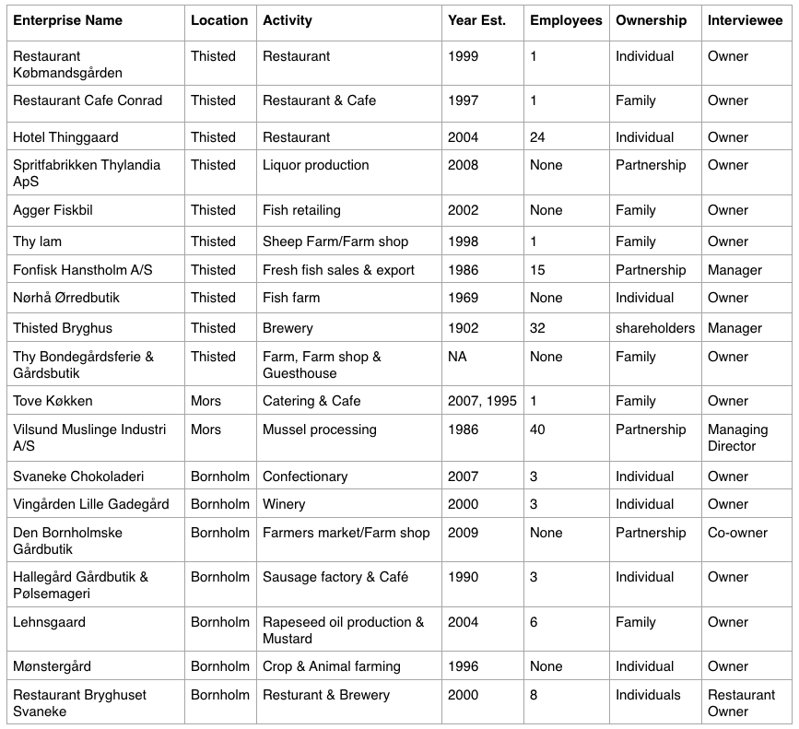

*Source*: …Authors

Table 2. Summary of experience strategies.

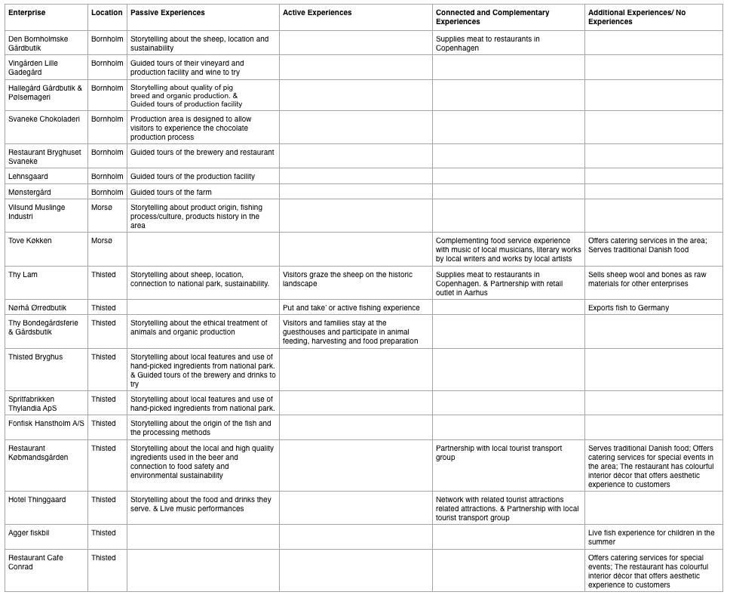

*Source*: …Authors

Figure 1. Map of Denmark indicating study areas.

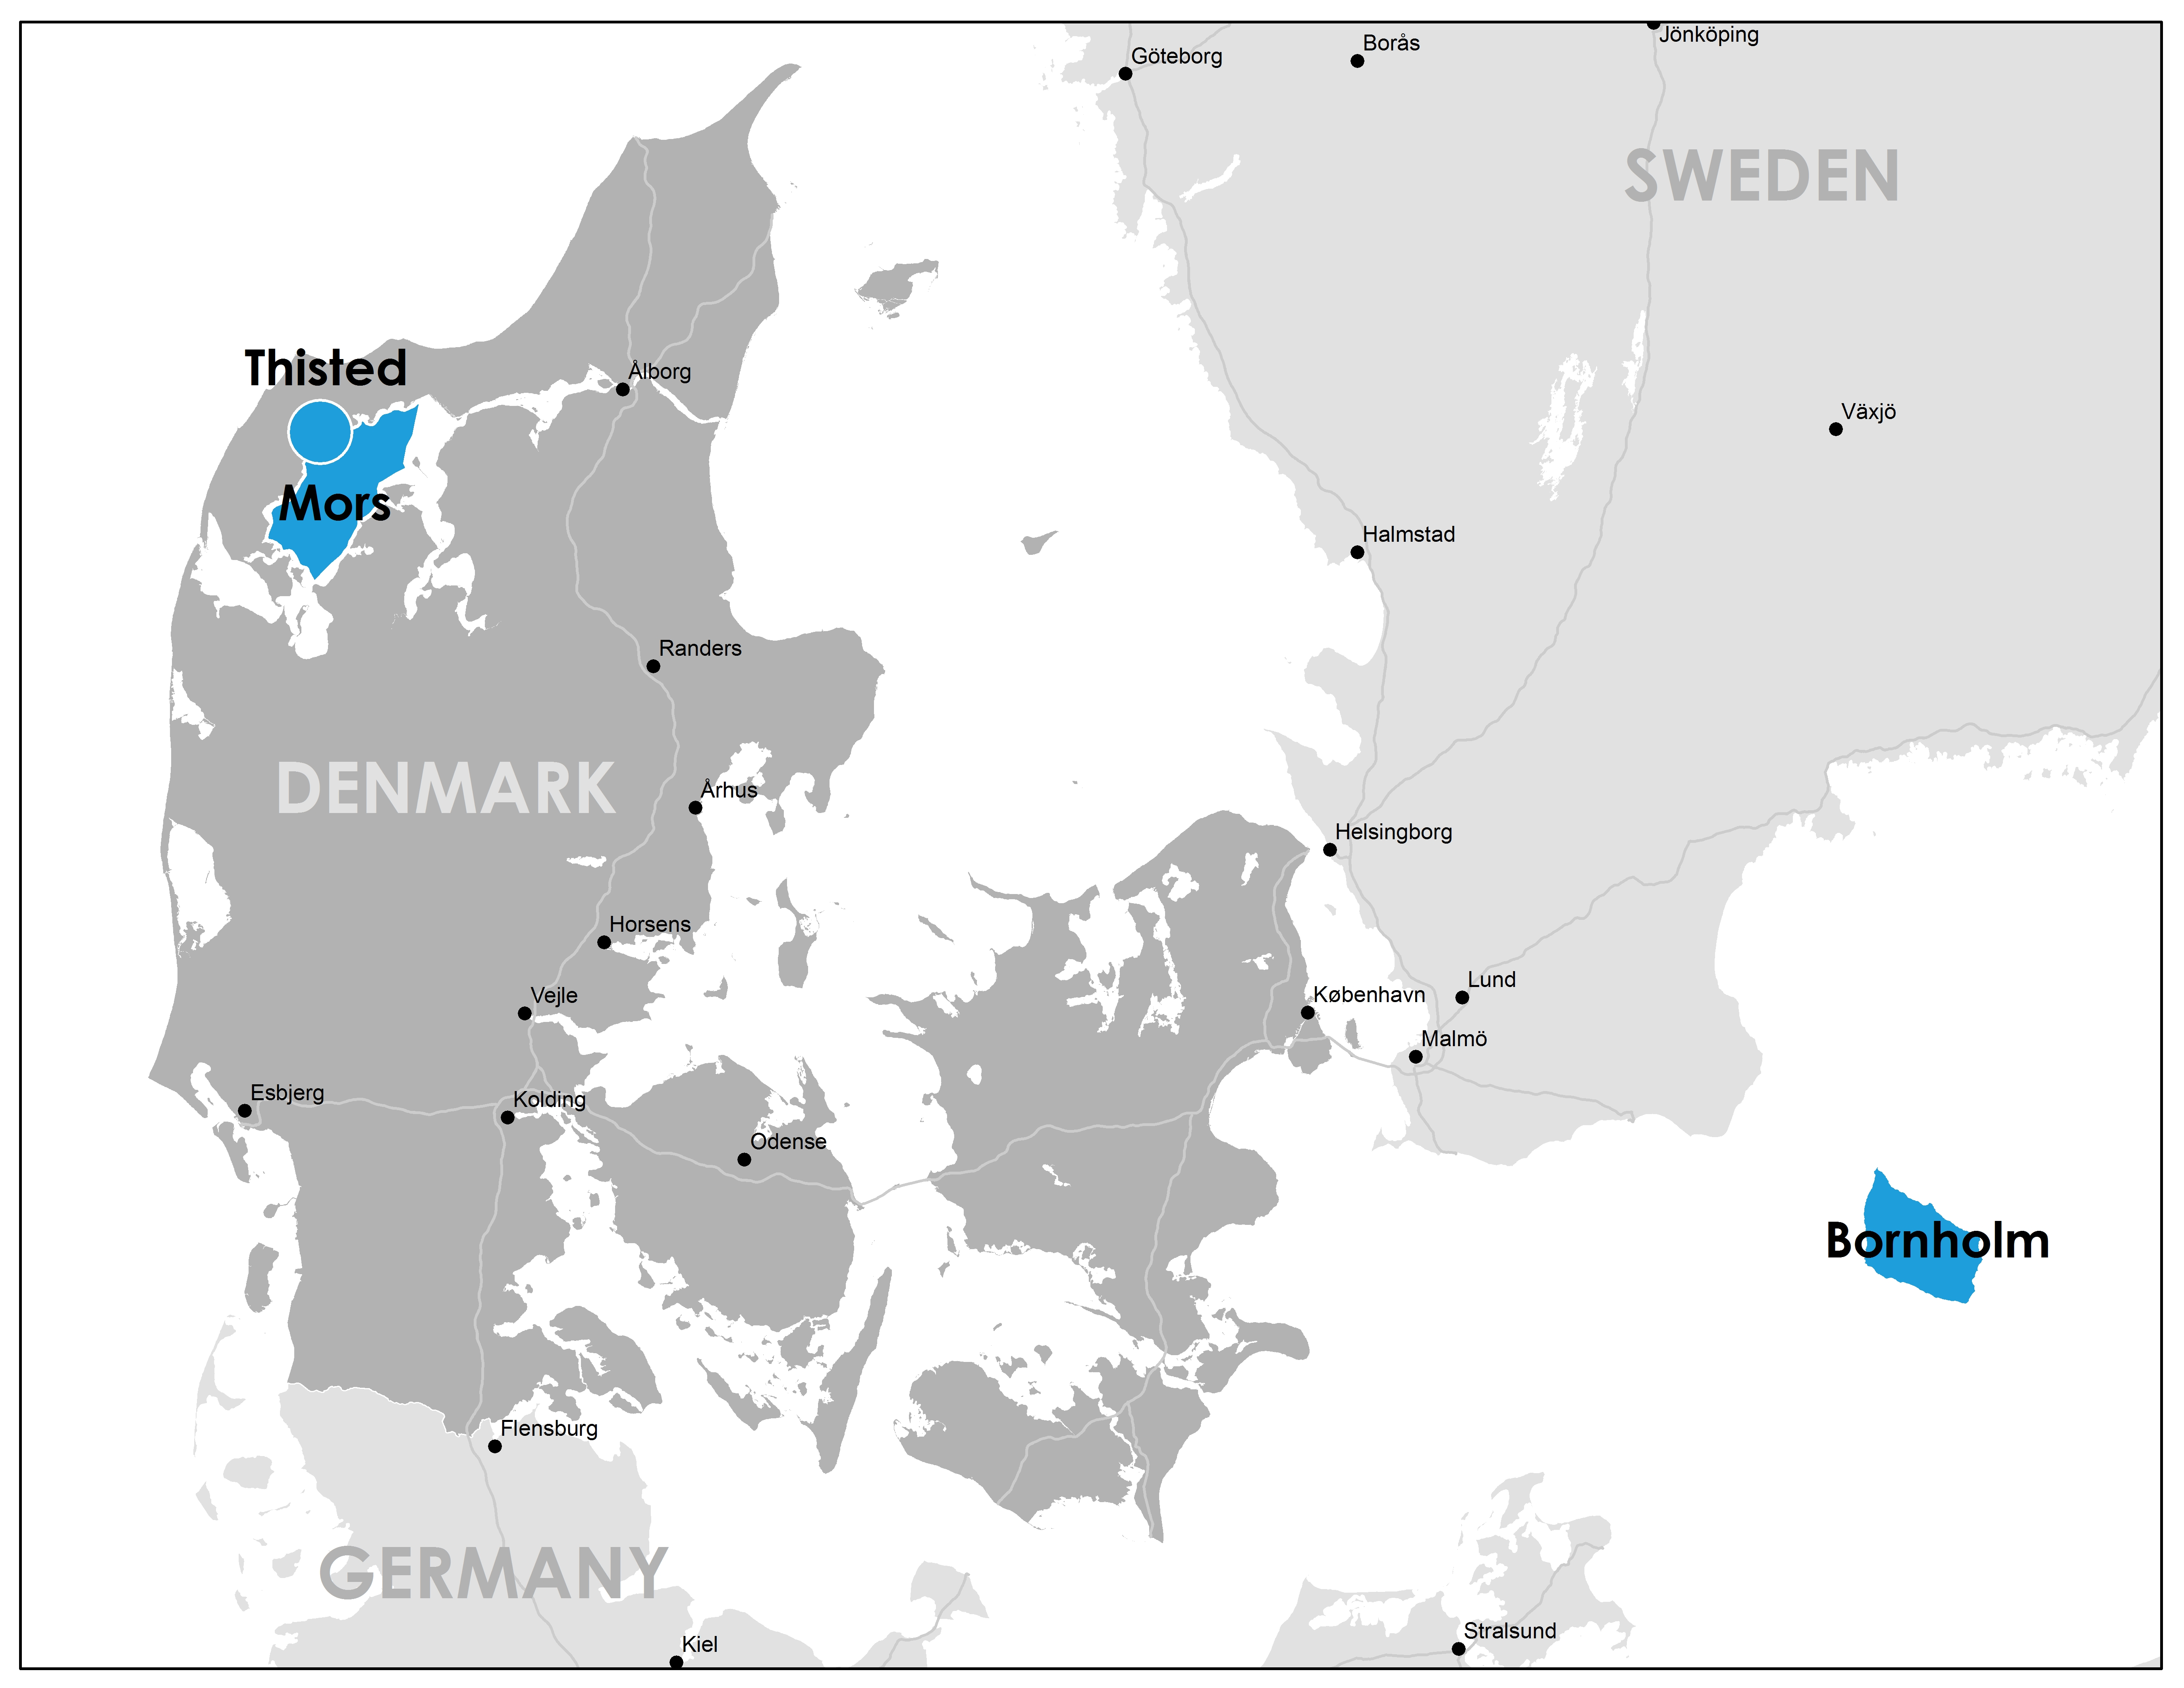

*Source*: …Authors

Figure 2. Put and take experience at Nørhå Ørredbutik.

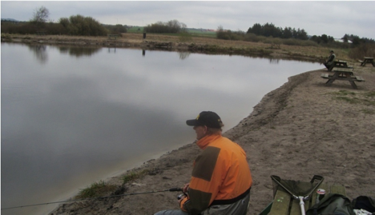

*Photo source*: Arthur 2009

1. Although we planned to conduct more than 19 interviews, we encountered a number of challenges during the fieldwork. Many potential respondents did not agree to grant interviews because they did not have the time, did not want to share their marketing strategies, or because they viewed us as foreigners and/or urbanites who lacked local credibility and adequate Danish language skills. In some instances we were treated rudely which was quite discouraging. To overcome these obstacles we worked with local intermediaries who helped us identify and contact more receptive individuals. However, this added step required additional time and resources which ultimately limited the total number of interviews that we could conduct.
2. As argued in Hracs *et al*. (2013) it is imperative that labels accurately describe the qualities and practices behind products because when consumers or the media discover false claims and instances of “greenwashing” or sweatshop labour, brands and sales are often irreparably damaged.
3. This restaurant and brewery are co-located and work closely, but are owned and managed by different individuals.
4. The price premium that the enterprises in our sample charge is typically 10–15% more than competing products at local supermarkets.