Energies 2014, 7, 1-x manuscripts; doi:10.3390/en70x000x
§
OPEN ACCESS
energies
ISSN 1996-1073
www.mdpi.com/journal/energies
Article
A novel dada-driven fast capacity estimation of spent electric vehicle lithium-ion batteries
Caiping Zhang ^{1,}*, Jiuchun Jiang¹, Weige Zhang¹, Yukun Wang¹, S.M. Sharkh ²，Rui Xiongc ³
¹ National Active Distribution Network Center, Beijing Jiaotong University, Beijing, 100044, China; E-Mails: jcjiang@bjtu.edu.cn (J.J.); weigezhang@bjtu.edu.cn (W.Z.); 11121687@bjtu.edu.cn (Y.W)
² School of Engineering and the Environment, University of Southampton, Highfield, Southampton,
SO17 1BJ, UK; E-Mail: S.M.Abu-Sharkh@soton.ac.uk (S.M. Sharkh).
³ National Engineering Laboratory for Electric Vehicles, School of Mechanical Engineering, Beijing Institute of Technology, Beijing, 100081, China; E-Mail: rxiong@bit.edu.cn (R.X).
* Author to whom correspondence should be addressed; E-Mail: cpzhang@bjtu.edu.cn; Tel: +86-10-5168-3907; Fax: +86-10-5168-3907.
Received: / Accepted: / Published:

Abstract: Fast capacity estimation is a key enabling technique for second-life of lithium-ion batteries attributed to the hard work for determining the capacity of a large number of EV used batteries. This paper tries to make three contributions to the existing literatures through robust and advanced algorithm. (1) A three layer back propagation artificial neural network (BP ANN) model is developed to estimate the battery capacity. The model employs internal resistance expressing the battery’s kinetics as the model input, which has realized fast capacity estimation. (2) Estimation error model is established to investigate the relationship between the robustness coefficient and regression coefficient. It is revealed that commonly used ANN capacity estimation algorithm is flawed in providing robustness of parameter measurement uncertainties. (3) The law of large numbers is used as the basis for a proposed robust estimation approach, which optimally balances the relationship between estimation accuracy and disturbance rejection. An optimal range of the threshold for robustness coefficient is also discussed and proposed. Experimental results demonstrate the efficacy and the robustness of the BP ANN model together with the proposed identification approach, which can provide an important basis for large scale applications of second-life of batteries.
Keywords: Lithium-ion batteries; second-life; fast capacity estimation; artificial neural networks; robustness

1. Introduction
The number of electric vehicles (EVs) and plug-in hybrid electric vehicles (PHEV) has been growing at a rapid rate in recent years driven by the need to curb air pollution caused by petroleum-based vehicles. As a result, it is expected that a large number of “spent” electric vehicle batteries will become available. These batteries will have capacities in the range of 70%-80% of their initial value, which may not be acceptable for electric vehicle use, but may be usable in other less demanding applications, in terms of energy density requirements, such as grid reinforcement or buffering of intermittent renewable energy sources. This could in turn help reduce the cost of power batteries used in EVs, thus paving the way for fast EVs development.
In recent years, research on the re-use of spent EV, PHEV batteries is focused on reliability estimation [1], optimal use strategy [2] and economic analysis [3-4]. Mukherjee et al. [1] presented a reliability calculation method for a battery energy storage system, and designed a battery-to-grid converter topology for robust and reliable second-life batteries. Rule-based control is used to manage the charging and discharging of second-life batteries to extend their lifetime in [2], and realize commercial building peak load management and maximize cost savings. Neubauer and Pesaran [3] assessed the impact of the use of second-life batteries on the initial cost of PHEV/EV batteries to automotive consumers. They concluded that although the battery re-use is not expected to significantly affect today’s PHEV/EV prices, it has the potential to transform markets in need of cost-effective energy storage.
Most of the above papers assume that the battery parameters are known. However, significant work is needed to characterize second-life batteries. Battery parameters including Ohmic resistance, polarization impedance and available capacity are needed. The available capacity, which describes the total capacity from a battery at a specified operation condition, is a key parameter in second-life battery applications.
The parameters of a second-life battery will in general depend on their usage history. Batteries with used in similar operating conditions and usage history tend to generally degrade at a similar rate and hence will have similar parameters. The battery capacity distribution characters used in two EV buses run at the same route are illustrated in Figure 1. It is shown that the parameters of the spent batteries used on EV buses applied in certain routes seem to have approximately identical statistical characteristics.
Commonly used methods for estimating available capacity include full charge-discharge method, open circuit voltage (OCV) [5], load voltage [6], internal resistance acquisition [7], chemistry dependent method [8] and model based estimation [9-12]. Among them, full charge-discharge measurement is an accurate and reliable method. It is however time consuming and costly, and difficult to achieve for a large number of spent EV batteries. The other methods usually depend on models and history data of the battery, which can be time consuming and costly.
Artificial neural networks (ANN) have been shown to be effective at estimating the parameters of complex non-linear systems [13-17]. ANN can be used for battery system without knowledge of battery internal structure and usage history, so long as training data is available [18]. This study aims to investigate the viability and effectiveness of ANN to estimating the available capacity EV spent second-life lithium ion batteries that have been used on EV buses.
Figure 1. Statistics of the battery capacity for two EV buses
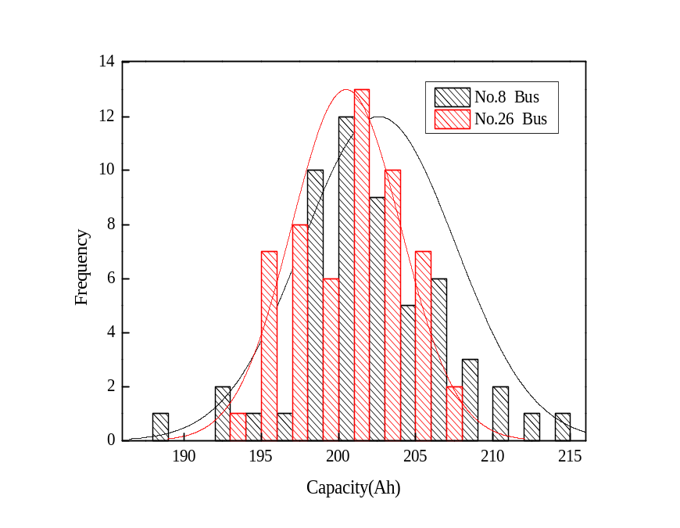
The paper is organized as follows: It demonstrates the used battery parameters had identical statistical properties for the EV buses with the same usage history described in section I, which is the basis for parameters estimation using ANN algorithm. A back propagation artificial neural network (BP ANN) model is then introduced as a basis for capacity estimation, in which the internal resistances with various currents at particular time points are used as inputs to the model. This part is discussed in section II. In section III, the BP ANN model is trained to get accurate estimation of the battery capacity. The robustness of the model is then discussed in detail. Taking model accuracy and robustness into consideration a robust BP ANN modeling method is proposed. The basic method and principle of choosing the robustness coefficient is also discussed. The verification of the proposed method is then presented in section IV. The conclusions are finally summarized in the section V.
2. BP Network Modeling of Battery System
2.1. The Model Structure
A BP neural network is a multi-layer feed-forward network that is trained by backward propagation of the error from the output nodes to the input nodes. It can achieve any nonlinear mapping from the input to the output [19]. A BP neural network with three layers is selected in this paper, comprising one input layer, one hidden layers and one output layer. The structure of the BP network is shown in Figure 2.
The impedance and capacity degradation of the batteries between EV buses are relatively analogous since the battery packs were placed in the same location in the EV buses. Researchers reported that the impedance of lithium-ion battery is related to its state of charge (SOC) and state of health (SOH) [20, 21], which is used to identify the battery aging mechanism. The internal resistance obtained from the voltage response of the battery at pulse current can in part describe the battery kinetics. This is consistent with the impedance obtained using an electrochemical impedance spectroscopy (EIS) test. It is therefore reasonable to estimate the capacity based on the internal resistance of the battery. Hence, the internal resistance, measured during pulsed current tests and at different sampling times, is employed as an input to the capacity estimating neural network.
Figure 2. The structure of BP ANN model
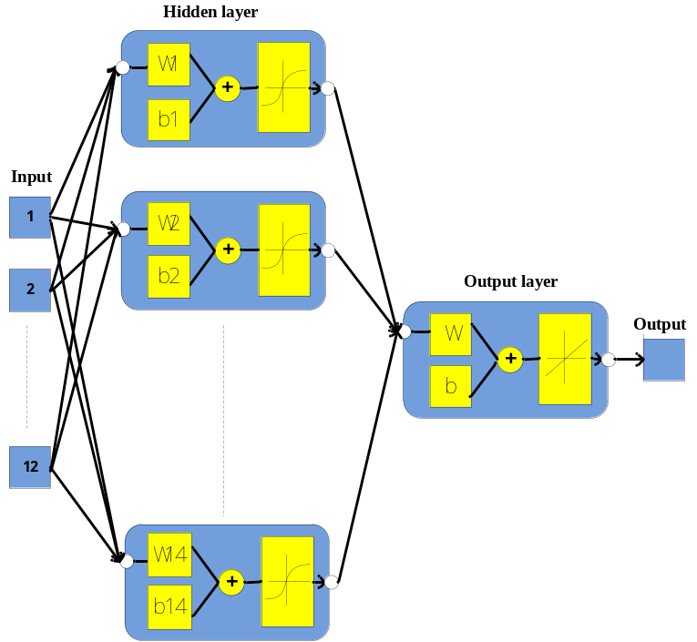
The ANN model in this study includes 12 training inputs, and each input is a column vector. The twelve vectors contain the batteries’ internal resistances acquired by pulse currents response of -200A, -300A and 100A (Discharge current is negative in this paper) at various sampling time which are 0.5s, 1s, 5s and 10 s. The output is the capacity of the batteries.
In the hidden layer, a bipolar sigmoid transfer function is used, since it is continuously differentiable, and in which the weights from input to hidden units can be adjusted based on backward propagation of errors learning algorithm. The bipolar sigmoid function is given by
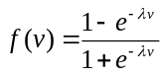 (1)
where 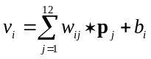, 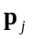represents the jth input vector, 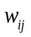 is the weights value of the input vector 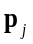, is biases values of the ith neuron. After analyzing the model input and output architecture, various numbers of neurons were trained; the neuron number in hidden layer was determined to be 14 taking model accuracy and generalization abilities [22].
The mean square error (MSE) of the network output compared to the target is adopted as the error function. The goal is to minimize the average of the sum of the square of the errors.
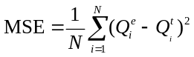 (2)
where 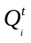is the experimental capacity value of cell i, 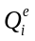is the estimated value of cell i, N represents the number of batteries used to train the ANN.
2.2. Input of the BP Model
As mentioned earlier, the battery internal resistances calculated at sampling time from 0.5s to 10s are employed as the model input since they can express battery dynamics such as Ohmic loss, activation polarization and concentration polarization. The dynamic resistance of the battery at the specified SOC and temperature can be determined experimentally based on the voltage response at the pulse current as illustrated in Figure 3.
Figure 3. Voltage response at the pulse current
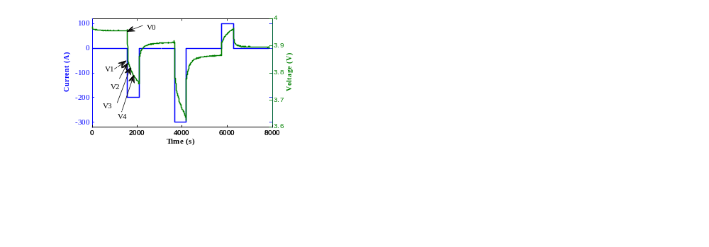

The battery’s dynamic resistance R_{i} can be calculated as
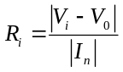 (3)
where I_{n} is the current measured at the sampling time. It is well known that the battery internal resistances in the middle range of SOC vary less than both ends of SOC [23]. Hence, the battery dynamic resistance in the middle range of SOC is applied in the study. Thus the kth input vector is given by
(4)
where n expresses the number of the tested batteries.
2.3. Method of BP Network Training
The basic principle of BP training relies on the gradient descent method, which can reduce the network error by altering the weights and bias values along the direction of the negative gradient [24]. In this study, the Levenberg–Marquardt (LM) algorithm, which is a variant of the gradient descent method, is used to optimize the network weight parameters. The LM method is a modification of classical Newton algorithm for optimum solution to a minimization problem, and is often described as a more stable and efficient method than a BP algorithm. It is also preferred due to its fast convergence and stability in training of ANN [24].
3. Available Capacity Estimation Using BP Neural Networks
3.1. Training Results Analysis
Ninety fours batteries that were used in a Beijing Olympic EV bus were chosen as the training sample in this paper. The capacity of the tested batteries ranged from 185Ah to 215Ah. The internal resistances, which were measured under 100A, -200A and -300A pulsed current tests at 50% SOC with sampling time at 0.5s, 1s, 5s and 10s, were used as inputs to the ANN, as mentioned earlier. The training parameters of the neural network model are set as: target error 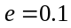, the maximum number of iterations is 1000 for once training, and the initial weights and biases are random values in [-0.1, 0.1].
The training error curve of the BP ANN model is shown in Figure 4. It can be seen that after 1000 iterations, the mean square error (MSE) does not achieve the designed target error 0.1; however, the error curve eventually becomes steady, indicating that the minimum stable MSE is approximately around 1. The error difference after training 600 times and 1000 times is negligible, 600 iterations were therefore sufficient to meet the BP neural network accuracy requirements.
Figure 4. Mean square error (MSE) of the model
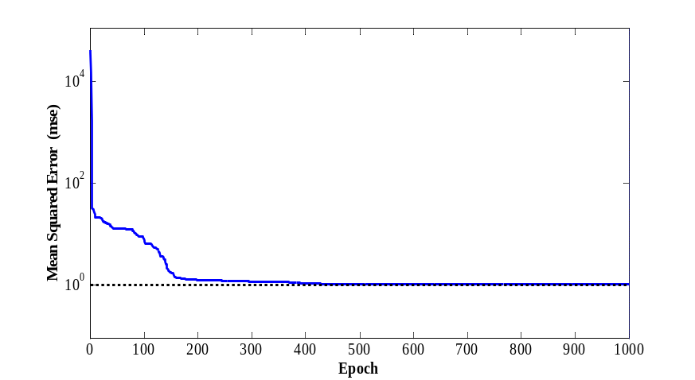

Figure 5. The statistics of MSE for 100 trainings
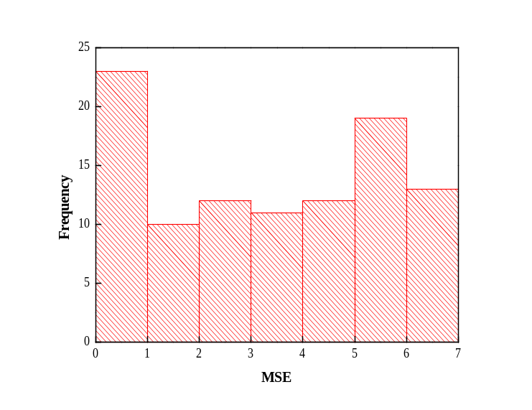
Figure 6. Linear regression relationship between model outputs and targets
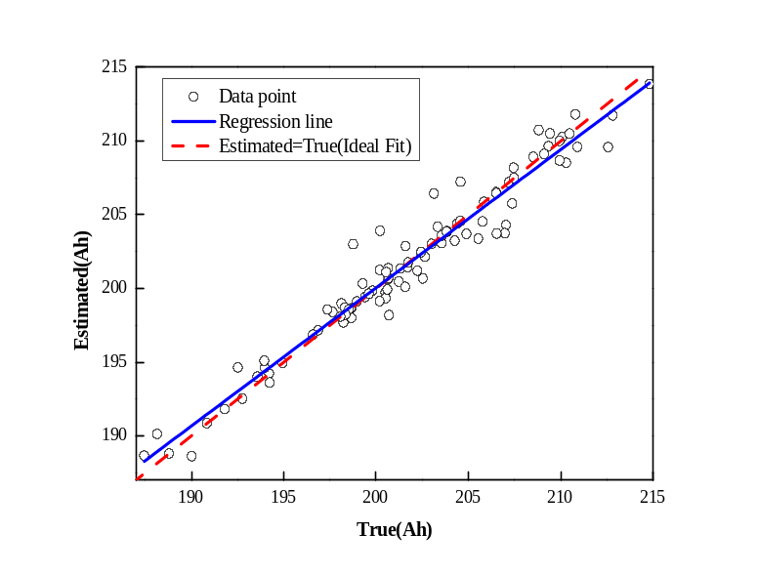
To summarize the statistics of the model accuracy, the weights are randomized and the entire training performed for 100 times. The statistics of MSE for 100 trainings is shown in Figure 5. It can be seen that the maximum MSE is around 7, suggesting that the average error is approximately 3.5%. The estimated and true values of the battery capacity and their linear regression relationship are shown in Figure 6. The true values were obtained using the full charge-discharge method. The abscissas of the data point in Figure 6 are the capacity true values (targets), and the corresponding ordinates are the capacity estimated values (model outputs). Ideally, the model output and the target values are equal to each other with all the data points fall on the straight line with slope equaling to 1. The training regression coefficient is theoretically 1, which is represented by dotted line in Figure 6. The calculated regression coefficient is 0.968 based on the data points. The more accurate the model estimates, the closer the scatter of the data points to the solid regression line. In this case, the training regression line and the ideal fit line almost coincide, which suggested that the model output is consistent with the true values, and the BP neural network model is valid.
Figure 7. Comparisons of the estimated and true values
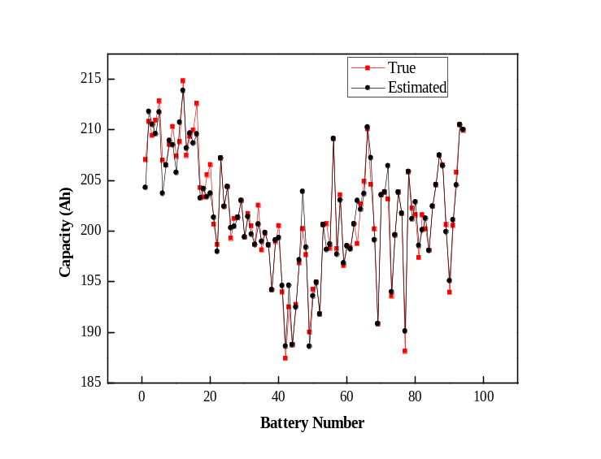

Figure 8. Statistical characters of absolute errors between model outputs and targets
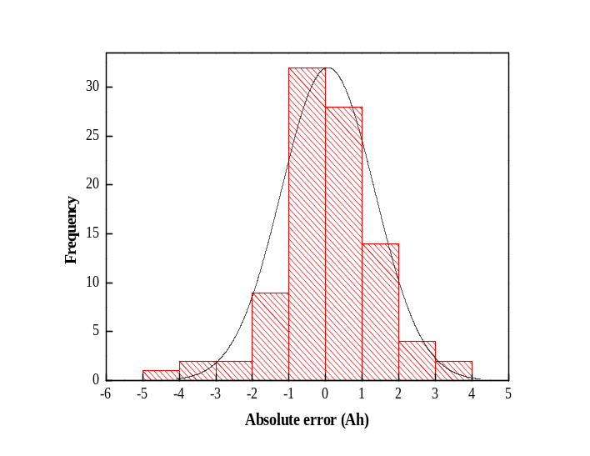

Figure 9. Comparisons of the trained and validated results
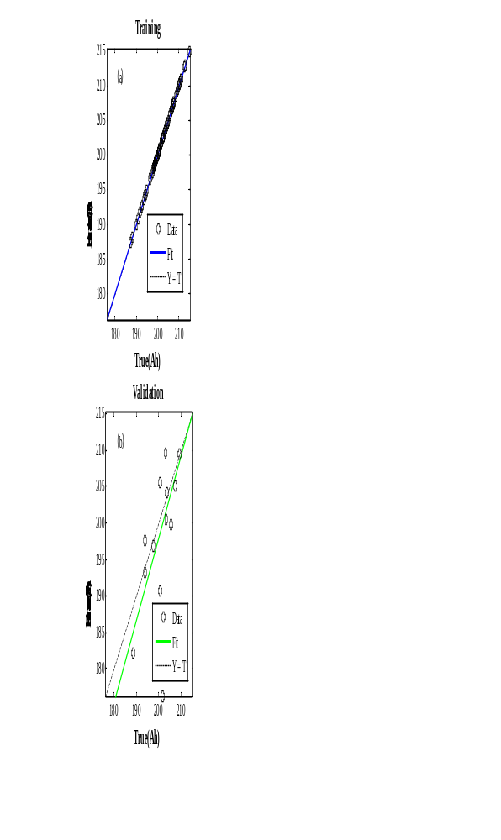
A comparison of estimated and true values is shown in Figure 7, and the absolute error distribution is illustrated in Figure 8, for 94 batteries. It can be seen in Figure 8 that the model absolute error approximately obeys a Gaussian distribution with an average of 0.899Ah and a variance of 2.034 Ah. The maximum absolute error is 4.23Ah, and the capacity estimation error is controlled within 2.5%. It indicates that the BP ANN has high estimation accuracy.
To test the model, 80% of the sample data is applied for training model, and 20% of the left data is used to validate the trained model. The comparisons of the trained and validated results are illustrated in Figure 9. It can be found that regression coefficient of validated results is around 0.91, having acceptable estimation accuracy.
3.2. Analysis of Robustness to Noisy Data
System parameters uncertainty is often inevitable in practice. Inaccurate measurements may cause that the parameters’ tested values to deviate from their true values. Robustness is measure of a system’s ability to maintain its expected performance under some kind of disturbance including model inaccuracy [25]. Due to the limited sensitivity and resolution of the measurement, the training data including internal resistance and capacity measurement may be different from the true value:
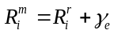 （5）
where 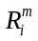is the measured value;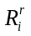is the true value of the internal resistance; and 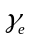 is a random testing error. Ideally 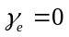 and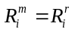, thus ANN outputs a true estimate of the capacity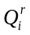:
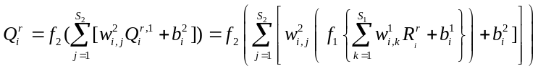 (6)
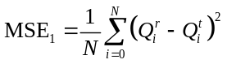 (7)
where 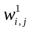 and are the weight and bias from the input layer to the hidden layer, respectively, 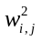and 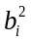are the weight and bias from the hidden layer to the output layer, respectively, 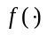represents the transfer function of these layers. The total error function is calculated using the equation (7). By using LM gradient algorithm the mean square error of the estimation 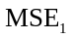 reduces and eventually reaches minimum value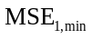.
If however, the measured internal resistance input to the ANN has an error, then the estimated value of battery capacity and the total error 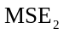 are given by
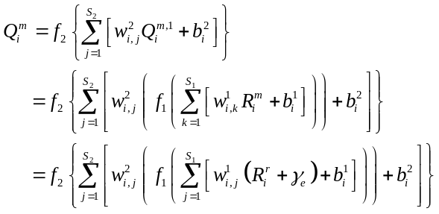 (8)
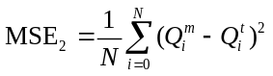 (9)
The error tends to its minimum value 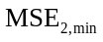 in the training process. After training, the total error in ideal situation and the total error in practical situation have a deviation, which is an estimation error resulting from measurement error of the neural network model’s input, the internal resistance.
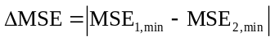 (10)
A random error is used to imitate the estimation error; this random error is also called accidental error or ambiguity error. Random errors occur due to a series of small random fluctuations of the relevant factors during the test. Its characteristics can be summarized as follows: amplitudes and directions are indeterminate, immeasurable and unable to calibrate and the average of the error tends to be zero over time.
The robustness of the BP ANN is examined by adding white Gaussian noise to the tested internal resistance to imitate random errors during the measurement process. Random numbers with Gaussian distribution are produced, with an average value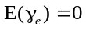. The variance can be calculated as
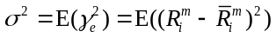 (11)
A variance of 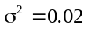is set. Assignment of the initial weights of the neural network model is done randomly and BP networks with different weights can be established. The regression coefficient is taken as an indicator of ANN’s precision; the bigger the coefficient the higher accuracy the model will be. To assess the ANN’s robustness, a robustness coefficient is defined as the reciprocal of output (capacity) error variance:
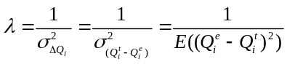 (12)
The bigger the coefficient, the better the ANN’s robustness is. One hundred times training with different weights was executed, respectively, and the relationship between the robustness coefficient and regression coefficient of the model is illustrated in Figure 10. Correlation between the two is inspected by using Pearson related coefficient, which is given by
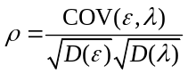 (13)
The Pearson related coefficient is found to be -0.805, which indicates that they have a significant negative correlation and the robustness coefficient is a decreasing function of the regression coefficient, i.e., the robustness coefficient decreases with the increase of the regression coefficient.
Figure 10. Relationship between the model regression coefficient and robustness coefficient
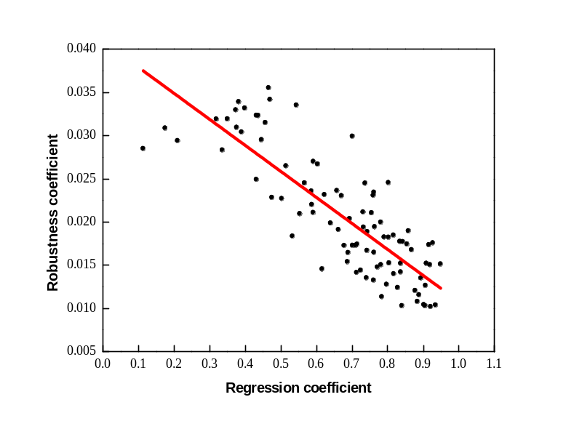
Employing the ANN established in section III, with a regression coefficient of 0.968, the output capacity estimated value with white noise added to the internal resistance input is illustrated in Figure 11. It can be seen that after adding the white noise to the input, the difference of the estimated and the true values increases significantly compared to Figure 7. The robustness coefficient of the model with high estimation accuracy significantly decreases. The scatter of the estimated capacity also increases significantly. The absolute estimation error statistics are illustrated in Figure 12. The maximum absolute error reaches 44Ah, and the estimation values reduced overall.
Figure 11. Estimated and true capacities when white noise is added to the measured internal resistance using an ANN with a regression coefficient of 0.968
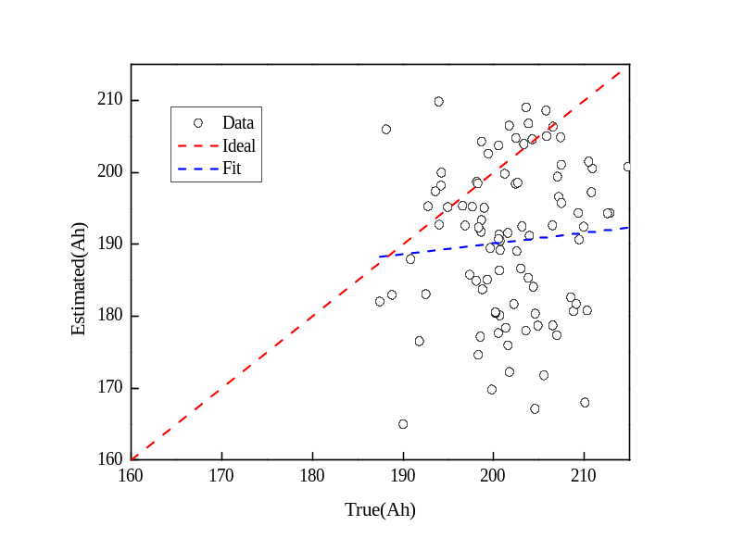
Figure 12. Statistical characters of absolute errors (△e) between ANN model outputs and true value when white noise is added to the input of an ANN with a regression coefficient of 0.968
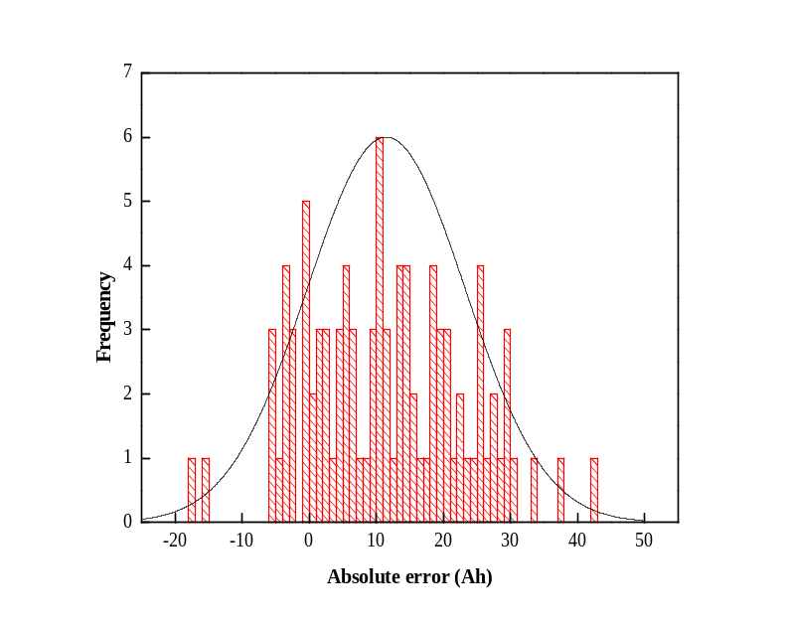
The reason for the above results is as follows: When an ANN model is highly accurate, it remembers not only the sample’s general features but also individual characteristics (such as random noise), and thus it doesn’t have tolerance to faults in the input internal resistance acquisition.
In the remainder of this paper, a method that can balance an ANN model accuracy and robustness is developed. The model can not only satisfy the accuracy requirements, but also has fault tolerance at the same time. Reducing the accuracy and using 0.75 as the model regression coefficient of the neural network model established in section 3.1, and inputting the internal resistance with white noise to the ANN model, we got a comparison of the output and the truth of the capacity, as shown in Figure 13, and its statistical characters of absolute errors (△e) between ANN model outputs and true value is shown in Figure 14. Compared with Figure 11, the scatter of this ANN model’s estimated capacity is obviously smaller than the ANN model with regression coefficient of 0.968, and the maximum estimation error is 15Ah, and 90% of the cells’ capacity estimation error is within 5%. It indicates that robustness can be improved by lowering the model’s accuracy.
Figure 13. Estimated and true capacities when white noise is added to the measured internal resistance using an ANN with a regression coefficient of 0.75 internal resistance with white noise and the true value
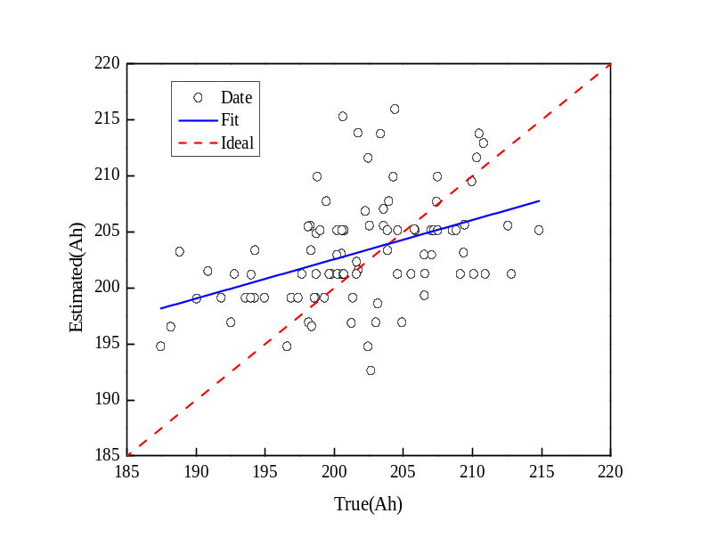
Figure 14. Statistical characters of absolute errors (△e) between ANN model outputs and true value when white noise is added to the input of an ANN with a regression coefficient of 0.75
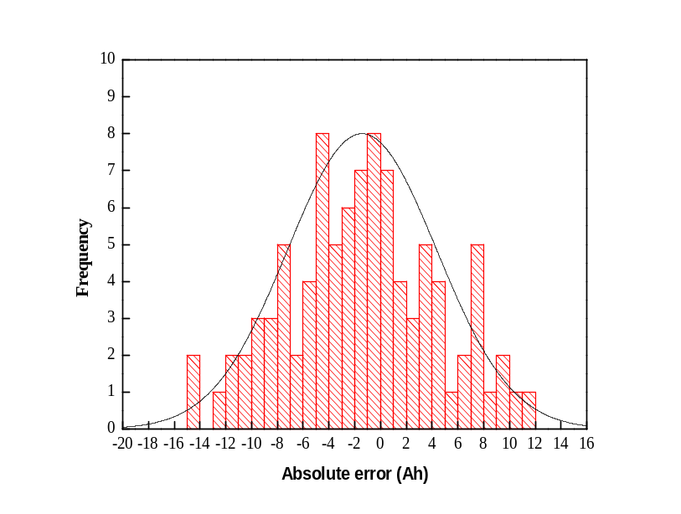
3.3. Proposed Robust BP ANN
The aforementioned analysis indicates that the robustness coefficient of the BP network model is correlated with the regression coefficient. Reducing the regression coefficient of the model will enhance the robustness of the estimate, but the estimation accuracy will decrease. It is necessary to find a method that optimally balances the relationship between the accuracy and robustness of the ANN capacity estimation model.
The law of large numbers is a theorem expressing the idea that the average of the results obtained from a large number of trials should be approaching the expected value, which is commonly used in noise attenuation and system identification [26, 27]. The main idea is that BP ANN modeling is to repeatedly perform in the process of training. The coefficients expressing robustness and regression performance of each model are calculated, respectively. The models will be preserved for capacity prediction if both coefficients are within the set values. The training is stopped till a specified number of models are selected. In the prediction, the chosen weights and neuron biases are then used as the predictor model parameters. The average of the estimated values is regarded as the predictive output.
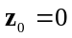
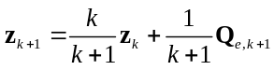 (14)
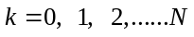
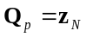 (15)
where 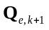represents the (k+1)th network output vector, 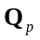is a vector expressing the final predicted output.
Figure 15. Flowchart of the proposed robust BP ANN training method
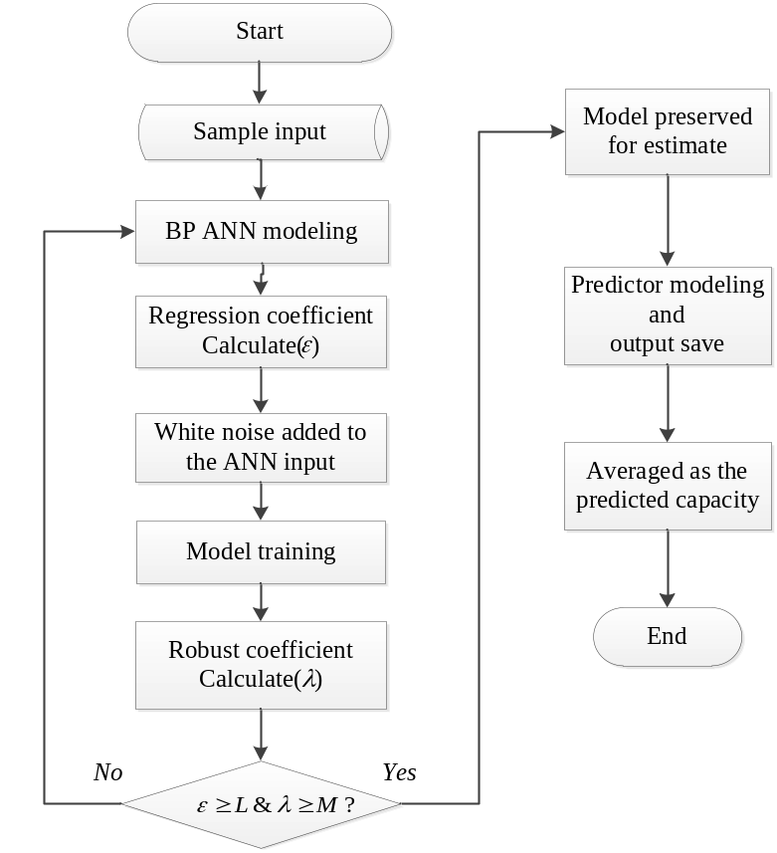
The flowchart of the proposed robust BP ANN training method for capacity prediction is illustrated in Figure15; in which andexpress calculated regression coefficient and the threshold, respectively; and represent calculated robustness coefficient and the threshold, respectively. The specific procedure is as follows: First, the internal resistance calculated at a variety of currents at various sampling time, and the measured capacities of the battery in one EV bus were used as training samples to build the BP ANN model. The model regression coefficient was computed to examine its estimation accuracy. Second, white noise was added to the model input, and the robustness coefficient based on equation (12) was calculated. The ANN model (with specific weighting factors), for which both regression and robustness coefficients meet the requirements, was ultimately chosen to estimate the capacity the battery of another EV bus. Finally, those networks’ capacity estimates outputs were averaged.
The basic principle of robust coefficient selection can be summarized as follows: The regression coefficient is first determined according to model accuracy. Using the specified regression coefficient, a reasonable range of robustness coefficient can be obtained after comparing the model simulation results.
4. Results and Discussion
Verification of the proposed robust BP ANN modeling method was performed by testing 50 EV buses used batteries. The threshold value of the regression coefficient is set to 0.65 based on the results. The effect of different threshold values of robustness coefficient on the estimate accuracy was investigated. The maximum relative estimated error as a function of the robustness coefficient is illustrated in Figure 16. The maximum relative estimate errors remain approximately constant when the liminal value of the robustness coefficient M ranges from 0.0125 to 0.017, suggesting that the fault tolerance capability of the model is poor in this range. The estimation error decreases significantly when 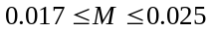, which indicates that the fault tolerance of the ANN model can improve the estimation accuracy in this range. M is rarely greater than 0.025. It is therefore concluded that a reasonable range of the liminal value of the robustness coefficient is [0.017, 0.025] at the specified limits of the regression coefficient.
Figure 16. The maximum relative estimate error as a function of the robustness coefficient
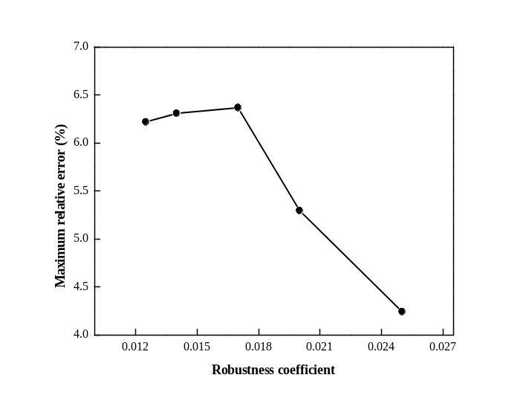
Figure 17. The measured capacity and the predicted capacity for different liminal values of the robust coefficient
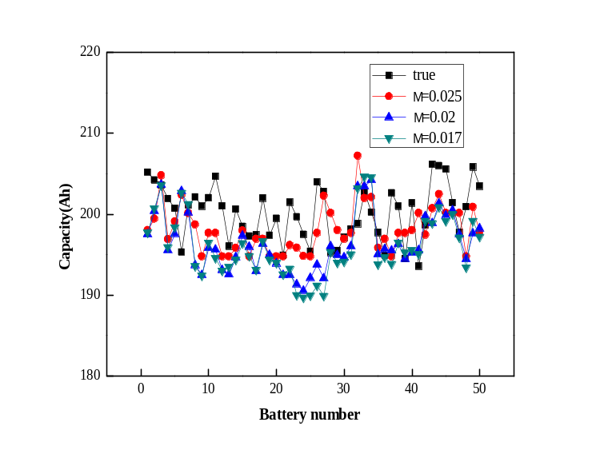
Figure 18. The statistical characters of the prediction error for different liminal values of robustness coefficient
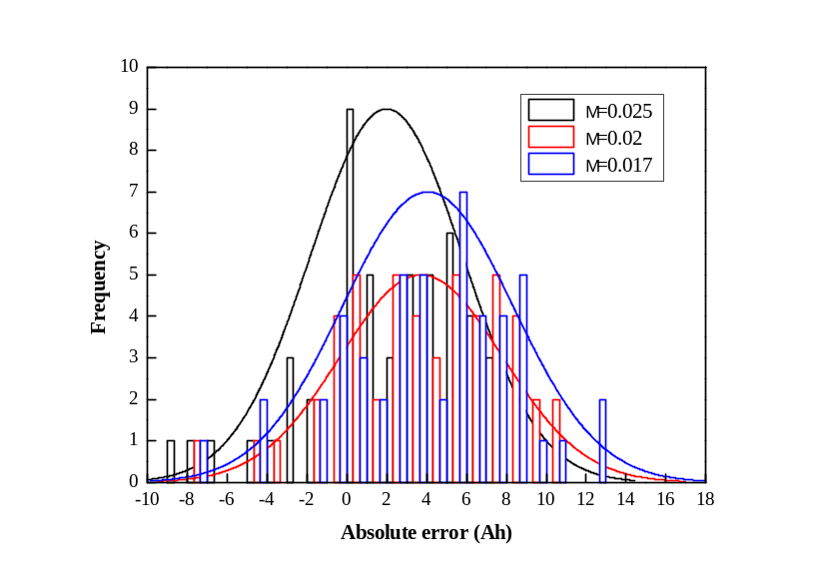
Table 1 Comparison of predicted results for different robustness coefficients
Liminal value of robust-ness coefficient | Maximum absolute prediction error  （Ah） | Maximum relative prediction error  （%） | Absolute average error  (Ah) | Relative average error  （%） | The percentage of relative error less than 5% | MSE
M =0.017 | 12.911 | 6.367 | 4.891 | 2.431 | 94 | 34.386
M =0.02 | 10.736 | 5.294 | 4.593 | 2.282 | 96 | 30.146
M =0.025 | 8.431 | 4.241 | 3.598 | 1.792 | 100 | 18.300
M=  0.03 | NA | NA | NA | NA | NA | NA
The true and the predicted capacity for different liminal values of the robust coefficient are shown in Figure 17, and the statistical characteristics of the prediction error are illustrated in Figure 18. From Figure 17 and Figure 18, it is clear that the difference between the predicted value and true value decrease as the robustness coefficient increases in the specified range. And the error of the mean gets closer to zero. A comparison of the predicted results for different robustness coefficients is shown in Table 1. It is suggested that the maximum prediction error is 6.8%, and 94% of battery samples’ prediction error is controlled within 5% when. The maximum prediction error when  decreases by 1.21% compared to, and 96% of the samples’ prediction error is within 5%. All the battery samples’ prediction error can be controlled within 5% when M = 0.025, and the average error reduces to 1.8%. It is suggested that none of the models can meet both requirements of L=0.65 and M=0.03.The optimal liminal value M = 0.025 of the robustness coefficient is ultimately chosen in this study. It is concluded that improving the robustness coefficient can increase the prediction accuracy over a certain range, and using the laws of large numbers can achieve better capacity prediction of the battery. The simulation results demonstrated the efficacy of the proposed modeling method.
5. Conclusions
Recognizing that measuring the capacity of a large number of EV used battery’s is time consuming, and that batteries with the same usage history exhibit approximately identical statistical characteristics, the BP ANN capacity estimation model with three layers was developed. The internal resistance of the battery, which expresses the kinetics of the battery related to the available capacity, calculated at several sampling times during pulsed current tests is used as the ANN model input. The proposed approach can not only achieve accurate states estimate, but also it is much faster than conventional methods like the full the charge-discharge one.
To optimally balance the relationship between the estimate accuracy and robustness to measurement uncertainty, a robust estimation approach is proposed in the paper. A regression coefficient and a robustness coefficient are introduced to comprehensively evaluate the ANN model’s estimate. And the law of large numbers is also employed in calculating the results of the model estimate.
The testing data of the battery retired from another EV bus was used to verify the proposed robust estimation approach. Experimental results demonstrate the efficacy of the BP ANN model with the proposed robust identification approach, providing foundations for applications of large scale second-life batteries.
Acknowledgements
We would like to thank Dr. Hongwen He in Beijing Institute of Technology for many helpful discussions. The work was supported by International S&T Cooperation Program of China (2013DFA60930).
Author Contributions
Caiping Zhang and Jiuchun Jiang built the ANN model of battery capacity estimation. Yukun Wang tested the battery parameters. All the authors did the simulation analysis and results discussions, and contributed to the paper writing work.
Conflicts of Interest
The authors declare no conflict of interest.
References
- N. Mukherjee; D. Strickland; A. Cross, W. Hung. Reliability Estimation of second life Battery System Power Electronic topologies for Grid Frequency Response Applications. In Proceedings of IET International Conference on Power Electronics, Machines and Drives, Bristol, UK., 27-29 March 2012; pp.1-6.
- Keeli A; Sharma R. K. Optimal Use of Second Life Battery for Peak Load Management and Improving the Life of the Battery. In Proceedings of IEEE International Electric Vehicle Conference, Greenville, SC, 4-8 March 2012; pp. 1-6.
- Neubauer J; Pesaran A. The ability of battery second use strategies to impact plug-in electric vehicle prices and serve utility energy storage applications. J. Power Sources2011, 196, pp. 10351– 10358.
- V. V. Viswanathan, M. K.-Meyer. Second Use of Transportation Batteries: Maximizing the Value of Batteries for Transportation and Grid Services. IEEE Trans. Veh. Technol. 2011, 60, pp. 2963-2970.
- Lee S; Kim J; Lee J; Cho B.H. State-of-charge and capacity estimation of lithium-ion battery using a new open-circuit voltage versus state-of-charge. J. Power Sources. 2008, 185, pp. 1367–1373.
- Pascoe P. E; Anbuky A. H. A unified discharge voltage characteristic for VRLA battery capacity and reserve time estimation. Energy Convers. Manage. 2004, 45, pp. 277–302.
- Huet F. A review of impedance measurements for determination of the SOC or state of health of secondary batteries. J. Power Sources 1998, 70, pp. 59-69.
- Aylor J.H; Thieme A; Johnso B.W. A Battery State-of-charge Indicator for Electric Wheelchairs. IEEE Trans. Ind. Electron. 1992, 39, pp.398-409.
- Xiong R, Sun F, Chen Z, He H. A data-driven multi-scale extended Kalman filtering based parameter and state estimation approach of lithium-ion polymer battery in electric vehicles. Appl. Energy 2014, 113, pp. 463-476.
- Kim J; Lee S; Cho B.H. Complementary Cooperation Algorithm Based on DEKF Combined With Pattern Recognition for SOC/Capacity Estimation and SOH Prediction. IEEE Trans. Power Electron. 2012, 27, pp. 436-451.
- Xiong R; He H; Sun F; Zhao K. Evaluation on State of Charge Estimation of Batteries with Adaptive Extended Kalman Filter by Experiment Approach. IEEE Trans. Veh. Technol. 2013, 62, pp.108-117.
- Agarwal V; Uthaichana K; DeCarlo R.A. and Tsoukalas L.H. Development and validation of a battery model useful for discharging and charging power control and lifetime estimation. IEEE Trans. Energy Convers. 2010, 25, pp. 821-835.
- Weigert T, Tian Q, Lian K. State-of-charge prediction of batteries and battery–supercapacitor hybrids using artificial neural networks. J. Power Sources2011. Apr.; vol.196, no.8, pp. 4061–4066.
- Eddahech A; Brlat O; Vinassa J.M. Adaptive Voltage Estimation for EV Li-ion Cell Based on Artificial Neural Networks State-of-Charge Meter. In Proceedings of IEEE International Symposium on Industrial Electronics (ISIE), Hangzhou, China, 28-31 May 2012, pp. 1318 – 1324.
- Yan Z and Wang J. Model Predictive Control of Nonlinear Systems with Unmodeled Dynamics Based on Feedforward and Recurrent Neural Networks. IEEE Trans. Ind. Informat. 2012, 8, pp.746-756.
- Dai S.L; Wang C; and Luo F. Identification and Learning Control of Ocean Surface Ship Using Neural Networks. IEEE Trans. IEEE Trans. Ind. Informat. 2012, 8, pp.801-810.
- Lin H.T; Liang T.J and Chen S. M. Estimation of Battery State of Health Using Probabilistic Neural Network. IEEE Trans. Ind. Informat.2013, 9, pp. 679-685,
- Shen Y. Adaptive online state-of-charge determination based on neuro-controller and neural network. J. Power Sources 2010, 51, pp.1093–1098.
- Xia C; Guo C; and Shi T. A Neural-Network-Identifier and Fuzzy-Controller-Based Algorithm for Dynamic Decoupling Control of Permanent-Magnet Spherical Motor. IEEE Trans. Ind. Electron.2010, 57, pp.2868-2878.
- Eddahech A; Briat O; Bertrand N; Delétage J.Y; Vinassa J.-M. Behavior and state-of-health monitoring of Li-ion batteries using impedance spectroscopy and recurrent neural networks. Int. J. Elec. Power 2012, 42, pp. 487–494.
- Mingant R; Bernard J; Moynot V. S; et.al. EIS Measurements for Determining the SoC and SoH of Li-ion Batteries. ECS Trans. 2011, 33, pp. 41-53.
- Wilamowski B.M. Neural network architectures and learning algorithms. IEEE Magazine. Ind. Electron. 2009, 3, pp.56-63.
- Zhang C.P; Zhang C.N; Liu J.Z; and Sharkh S.M. Identification of Dynamic Model Parameters for Lithium-Ion Batteries used in Hybrid Electric Vehicles. High Technol. Lett. 2009, 16, pp.6-12.
- Weigert T; Tian Q; Lian K. State-of-charge prediction of batteries and battery–supercapacitor hybrids using artificial neural networks. J. Power Sources 2011, 196, pp.4061–4066,
- Guo L. D; Gu H; Zhang D. Q. Robust stability criteria for uncertain neutral system with interval time varying discrete delay. Asian J. Control. 2010, 12, pp.739–745.
- Liu L.Z; Wang L.Y; Chen Z.Q; et.al. Integrated System Identification and State-of-Charge Estimation of Battery Systems. IEEE Trans. Energy Convers. 2013, 28, pp.12-23.
- Ljung L. System Identification: Theory for the User, 2nd ed.; Englewood Cliffs, NJ: Prentice-Hall, 1999.
© 2014 by the authors; licensee MDPI, Basel, Switzerland. This article is an open access article distributed under the terms and conditions of the Creative Commons Attribution license (http://creativecommons.org/licenses/by/3.0/).

