Accessible Collaborative Learning Using Mobile Devices

Mike Wald1, Yunjia Li1, E A Draffan1

mw@ecs.soton.ac.uk., yl2@ecs.soton.ac.uk, ead@ecs.soton.ac.uk

1 ECS, University of Southampton, Southampton, SO171BJ, UK

**Abstract.** This paper describes accessible collaborative learning using mobile devices with mobile enhancements to Synote, the freely available, award winning, open source, web based application that makes web hosted recordings easier to access, search, manage, and exploit for all learners, teachers and other users. Notes taken live during lectures using Twitter on any mobile device can be automatically uploaded into Synote and synchronised with a recording of the lecture. Syntalk, a mobile speech recognition application enables synchronized live verbal contributions from the class to also be captured on Synote through captions. Synote Mobile has been developed as an accessible cross device and cross browser HTML5 version of Synote. Synote Discussion supports commenting on Synote’s Synmark notes stored as discussions in its own database and published as Linked data so they are available for Synote or other systems to use.

**Keywords:**  learning; speech recognition, accessibility, captions, mobile

Introduction

This paper describes mobile enhancements to Synote (Wald et al., 2009), (Synote, 2014a), the freely available, award winning, open source, web based application that can make any public web hosted recording easier to access, search, manage, and exploit for learners, teachers and other users. Commercial lecture capture systems (e.g. Panopto (2014), Echo360 (2014), Tegrity (2014), Camtasia (2014)) can be expensive and do not easily facilitate mobile accessible student interactions. Synote overcomes the problem that while users can easily bookmark, search, link to, or tag the WHOLE of a recording available on the web they cannot easily find, or associate their notes or resources with, PART of that recording (Whittaker et al. 1994). As an analogy, users would clearly find a text book difficult to use if it had no contents page, index or page numbers. Synote can use speech recognition to synchronise audio or video recordings of lectures or pre-recorded teaching material with a transcript, slides and images and student or teacher created notes. Synote won the 2009 EUNIS International E-learning Award (Synote, 2009) and 2011 Times Higher Education Outstanding ICT Initiative of the Year award (Synote, 2011). The system is unique as it is free to use, automatically or manually creates and synchronises transcriptions, allows teachers and students to create real time synchronised notes or tags and facilitates the capture and replay of recordings stored anywhere on the web in a wide range of media formats and browsers. Synote has been developed and evaluated with the involvement of users and with the support of JISC (2014) and Net4Voice (2010).

Figure 1 shows the original Synote interface. The technical aspects of the system, including the Grails Framework and the Hypermedia Model used, have been explained in detail elsewhere (Li et al., 2011). The synchronised bookmarks, containing notes, tags and links are called Synmarks. When the recording is replayed the currently spoken words are shown highlighted in the transcript. Selecting a Synmark, transcript word or Slide/Image moves the recording to the corresponding synchronised time. The provision of text captions and images synchronized with audio and video enables all their communication qualities and strengths to be available as appropriate for different contexts, content, tasks, learning styles, learning preferences and learning differences. Text can reduce the memory demands of spoken language; speech can better express subtle emotions; while images can communicate moods, relationships and complex information holistically. Synote’s synchronised transcripts enable the recordings to be searched while also helping support non native speakers (e.g. international students) and deaf and hearing impaired students understand the spoken text. The use of text descriptions and annotations of video or images help blind or visually impaired students understand the visually presented information.

So that students do not need to retype handwritten notes they had taken in class into Synote after the recording had been uploaded notes taken live in class on mobile phones, tablets or laptops using Twitter (2009, 2014) can be automatically uploaded into Synote. The process is shown in Figures 2, 3 and 4.

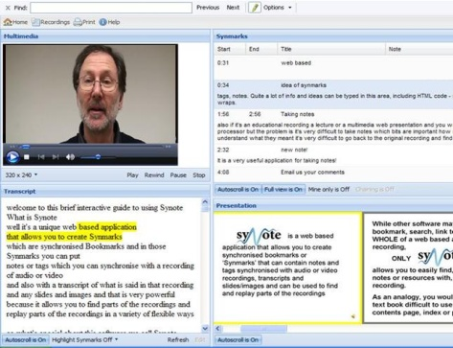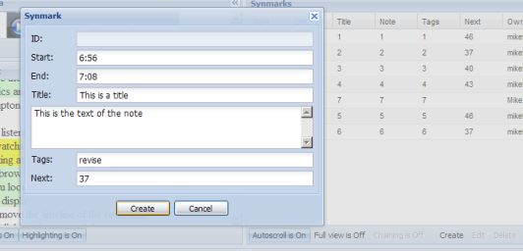

**Figure . Synote player and Synmark creation interface**

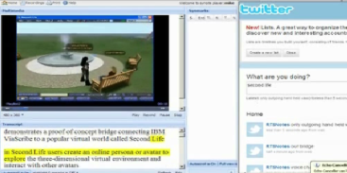

**Figure 2. Using Twitter to take live notes for Synote**

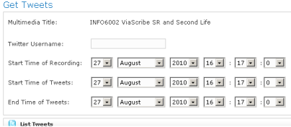

**Figure 3. Synote’s Twitter upload interface**

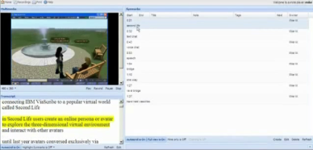

**Figure 4. Twitter notes displayed in Synote**

Synote builds on 14 years work on the use of speech recognition for learning in collaboration with IBM, and the international Liberated Learning Consortium (Leitch & MacMillan, 2003), (Wald & Bain, 2007). The integration of the speaker independent IBM Hosted Transcription System with Synote has simplified the process of transcription giving word error rates of between 15% - 30% for UK speakers using headset microphones. This compares well with the National Institutes of Standards and Technology (NIST) Speech Group reported WER of 28% for individual head mounted microphones in lectures (Fiscus et al., 2005).

The requirement of using headset microphones to obtain good speech recognition transcription accuracy means that contributions from students in the class are not easily recorded or transcribed. To address this problem Syntalk, a mobile transcription server, has been developed and is described in that section.

Synote Mobile (2014) was developed as a new mobile HTML5 version of Synote. While most UK students now carry mobile devices capable of replaying Internet video, the majority of these devices cannot replay Synote’s accessible, searchable, annotated recordings as Synote was designed in 2008 when few students had phones or tablets capable of replaying these videos. The use of HTML5 overcomes the need to develop multiple device-specific applications. Synote displays the recording, transcript, notes and slide images in four different panels, which uses too much screen area for a small mobile device and so Synote Mobile displays captions and notes and images separately from the video. Synote Mobile enables all students to work together on their coursework, projects and revision in more modern flexible environments than desktop computer rooms not designed for collaborative working. Students can for example collaboratively review and amend recordings and synchronised notes using their phones as well as creating and recording group audio and video presentations annotated with transcripts, indexes and notes. Section 3 explains Synote Mobile’s requirements and design.

Neither Synote nor Synote mobile support threaded discussions as their Synmarks are annotations of the recording timeline. Synote discussion was therefore developed to enable students to have a discussion about a topic raised in the recording in such a way that the discussion is linked to the particular part of the recording being discussed. The Synote Discussion section explains the requirements and design, while the Evaluation Section presents all the evaluations and results while the all the work is summarised in the conclusions section and future work is also indicated.

Example Use Case Scenario

During the lecture Susan takes short notes on her phone using Twitter and these are automatically uploaded into Synote with the lecture recording after the lecture allowing Susan to easily find relevant sections of the recording using Twitter’s ‘timestamps’. Susan also uses Syntalk on her mobile phone when she asks questions in the Lecture and these questions were automatically transcribed by speech recognition and synchronised with the lecture recording. Susan and her four friends then revise together in a small room in the library by writing on the whiteboard as they collaboratively go over previous Synote recordings and notes and questions using Synote mobile on their phones and add to and amend their own synchronised notes as appropriate. Susan and her friends also provide some comments on some of the teachers and other students’ questions using Synote Discussion. Using Synote Mobile and Synote Discussion in this way enhances their collaboration, discussion and learning compared to their previous use of five desktop computers in a line in the main computing laboratory with very little desk space and others objecting to their noise.

Captioning contributions from students using Syntalk

Syntalk consists of two applications: an Android application (Figure 5) which is used by students to capture and transcribe and if required also correct their utterances and a web application (Figure 6) which is used by lecturers for managing the system. Users can choose to use any of three different free server based speech recognition systems, Google, EML (2014) or iSpeech (2014). At the start of a lecture the lecturer makes their lecture ‘live’ using the Syntalk web application control panel. Users can then select this live lecture on their Syntalk mobile application. When the user talks into their mobile’s microphone the Syntalk mobile application sends the speech to the speech recognition server and when the transcribed text is returned by this server to the Syntalk application it is then sent to the Syntalk web server as well as being displayed on the mobile’s screen for editing. If the user chooses to edit any speech recognition errors the corrected text is then also sent to the Syntalk server which creates an XML file containing the text captions and timings which can be uploaded into Synote as synchronized annotations. If everybody in a class used the Syntalk application on their personal mobile phone it would be possible to transcribe all spoken interactions. The current Syntalk application does not capture the spoken audio for Synote to replay.

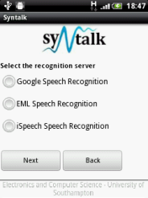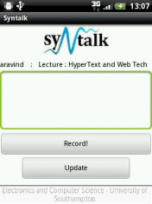

**Figure 5. Syntalk Android application**

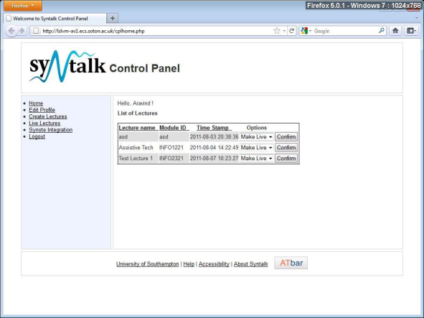

**Figure 6. Syntalk web site**

**Synote Mobile design issues**

A single ‘responsive’ HTML5 website was developed for all platforms and screen sizes rather than one for desktop/tablet and one for mobile phones which could have provided improved user experience on mobile phones but would have required more maintenance and development. Using HTML5 enables: Web browser access with automatic enhancements and no app store download or update needed; adaptive performance on most connections; Automatic adjustment of presentation depending on device screen size (Figure 7); Use of existing accounts.

*Responsive Design*

Responsive designs are required to cope with tablet screens as well as smaller smart phone screens. The narrowing of the viewing area meant Synote’s video, annotation and transcription windows could shrink and eventually be offered access via tabs. For mobile phones there was a need to rearrange the view to be totally linear.

Two designs of Synote Mobile were therefore required but with changes that would happen automatically depending on the metadata received. Responsive design also needs to provide fall forward and fall back options for embedding media players within web pages that will automatically adapt to the user’s chosen device. A challenge for HTML5 video in Synote is to embed different players not only based on the media type, but also the platform. As Flash is not well supported on mobile platforms the HTML5 native player needs to be controlled through JavaScript. MediaElement.js is a “fallforward” html player, which means it is based on the HTML5 native player and if the browser doesn’t support HTML5, MediaElement.js will embed the self-developed Flash and Silverlight player.  Comparisons of codecs and applicable browsers, including mobile devices (Mediaelementsjs, 2014) and HTML5 video players (Videosws, 2014) with available features were studied in detail. Three approaches to gather the metadata from the media so that the correct view and player can be selected (e.g. duration of the media, the format and coding and whether it is video or audio) are FFmpeg (2014), YouTube API and a link to the file itself.

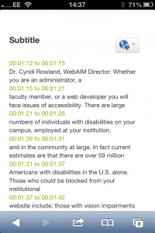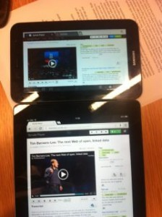

**Figure 7 Automated transcript shown on Synote Mobile on phone and small and large tablets**

*Captions*

Captions can be displayed on a desktop browser with the video but there appear to be no standards for displaying captions within web pages across all tablets and mobiles alongside transcriptions and annotations. At present if someone is deaf they have to read the caption and watch the video and then scroll down to the note-taking mode. It is not possible on the iPhone to display both the transcript window and the video due to the size of the screen. However, it will be possible to capture an image from the video and annotate this as part of the note taking process.

*Synote Mobile requirements*

* SCREEN SIZE ISSUES: work on mobile phone screens as well as tablets so should automatically detect the device and load the corresponding page or style sheet.
* DELIVERY OF THE VIDEOS: adaptive i.e. devices with low resolution and bandwidth need to download smaller file sizes. The player will take over the full screen when playing, so a thumbnail picture will be displayed alongside the transcript and annotations.
* FORMAT COMPATIBILITY: Different devices and browsers have different support mechanisms for HTML video codecs (Htmlgoodies, 2014) so delivery of multimedia resources has to be adaptable.
* TOUCH INTERFACE: Consideration needs to be given to the type of gesture driven / tap type controls. VoiceOver controls affect gestures used within player and web pages. There is a need to have a minimum of onscreen buttons and the design aimed to follow accessible and ease of use design concepts (Synotemobile, 2012)
* HTML5 VIDEO: Streaming video is easier on tablets than on mobile phones (Jwplayer, 2014a) and is the choice for delivering a cross platform service although when fullscreen viewing with iPhones (Apple, 2012) the video is no longer browser based and not presented within the webpage. This makes it impossible to add captions unless embedded when video is made and external files will be unable to be read with the method presently used by iPhones for rendering videos. The state of HTML5 and video is well explained by LongTail Video (Jwplayer, 2014b). An Apple streaming video server (Pantos, 2012) would now appear to allow for captioning on the iPhone whereas this is not possible with YouTube videos. HTML video.org offer a helpful comparison of players (Kaltura, 2011).

**Synote Discussion requirements & design**

To rapidly prototype a system a new database was created to hold these discussions and the users’ threads and comments rather than redesign Synote’s database to allow for this new form of discussion annotation. To ease the integration of Synote Discussion with the original Synote, the comments are further published as linked data using Resource Description Framework (RDF) (W3C, 2014a). Key requirements included:

* view Synote presentations as slides or video thumbnails and transcript with link to Synote video
* view list of Synmarks with presentation and a list of comments for each Synmark
* add Synmarks and add, edit or delete comments to Synmarks.
* notifications on comments posted on Synmarks and navigate directly to those Synmarks
* export discussions as linked data to be accessed and reused by other applications, especially Synote
* support main mobile devices, web browsers and screen sizes in both portrait and landscape modes.

The application was designed to be consistent so none of the features become hidden or removed on different screen sized devices with each page having the same base design and a similar layout for content. Figure 8 shows sketches of the designs and this section provides explanations behind the design decisions. Figure 8a shows the menu of the system, which is hidden until the user clicks on the menu button (located in the top left corner of the screen). When the button is selected, the main screen is shifted to the right and the menu bar is shown. This design has been inspired by a number of extremely popular web applications used by the target audience of students, including Facebook Mobile [2014], which has a similar sliding menu feature. These menu indicators have become a mobile standard, with this design approach being featured in most major utility mobile applications, not just Facebook. Figure 8b demonstrates the design of the main detailed view of a presentation in the application. This shows the transcript - a feature taken from Synote - in the bottom half of the screen. As the presentation’s slides are changed, the transcript is kept synchronised with the displayed slide so it is easier for users to follow the lecture.

Figure 8c also shows the main detailed view of a presentation, however, this time in the ’Annotations’ tab. This tab holds the Synmarks and Discussions (the top layer of threads). Like the transcript, the Synmarks are synchronised for every time frame (slide) of the lecture. The Synmark’s appearance has been made visibly obvious to show that a Synmark is ’clickable’ for the user to be redirected to the comments page for that Synmark (not shown in any of the wireframe figures). The page is where a user can view a list of their own Synmarks that they have started in the first tab, and their own comments in the other tab. Every Synmark and Comment in the list is ‘selectable,’ and directs the user to the presentation page that the content is related to and the Synmark within that presentation. A very similar design is used for Subscriptions and the users Notifications pages (Figure, 8d & 8e) If the user has any notifications, these are highlighted to the user in the sliding menu, with the number of notifications is in brackets in the menu.

Users can make two levels of annotations to a presentation, similar to the way an online forum works. At the top level are “discussions”, which are associated with part of a presentation. These are considered to be equivalent to Synmarks, which are comments on the presentation made in Synote. In order for the discussion to relate to a certain presentation, it stores a presentation ID. However, a discussion should only relate to a certain section of the presentation, so that it can be displayed when the user is viewing that part of the presentation. In order to allow this, a start time and optional end time are stored with the discussion. Since each presentation is split up into a number of sections with their own IDs, this could have been implemented by storing the section ID rather than the presentation ID. However, by implementing it with a start and end time, this allows a discussion to relate to multiple sections, thereby implementing a many-to-many relationship between sections and discussions without having to represent this in the database. Discussions also store an author ID and a timestamp, so that the application can determine when the discussion was created for ordering purposes and who created it. Comments are the second level of annotations, and can be posted in relation to either existing discussions or Synmarks. Since these two types of comments have to store different IDs, the database allows for this by implementing these two types as two different objects, which inherit from a generic Comment object. Therefore, three tables are required: a table for Synmark comments, which stores a generic comment ID and a Synmark ID, a table for Discussion comments, which is the same but stores a discussion ID, and finally a generic comment table, which stores the content of the comment, author and various other data about the comment. Rather than allowing users to actually delete comments completely, a deleted field is included instead, which allows a comment to be marked as deleted. This is so that a placeholder can be put in place of the comment so that users can see it is deleted. Users can subscribe to presentations, Synmarks and discussions to receive notifications when other users comment. Users are notified when either a discussion is posted to a presentation they are subscribed to or a comment is posted to a discussion/Synmark they are subscribed to.

The user navigates across the website using a sidebar (Figure 9) that appears on the left of the screen when a button is clicked. The sidebar also displays an indicator showing the number of notifications a user currently has. By only appearing when the user wants to navigate to a new page, this allows the front end to fully utilise the limited space available on a mobile device.

The front end uses a mobile-optimised navigation system where, when the user tries to navigate to a new page, the front end fetches the information from the back end and creates it in a page hidden from the user, which then slides into view upon completion, replacing the original page. A loading animation is presented to the user while the page is loaded (Figure 10), and notifies the user if an error has occurred that has prevented the new page from being loaded correctly. The main page of the website, the details page, which displays the presentation has two different display modes, one designed for a landscape aspect ratio (Figure 11) and one designed for a portrait aspect ratio (Figure 12). This is to allow the website to be displayed in an optimal fashion when a user rotates their mobile device. The presentations are designed to be displayed in as responsive a way as possible. Switching between slides will automatically scroll the transcript to the appropriate section for that slide, and selecting a Synmark will automatically scroll to the image that applies to that Synmark. Users can subscribe to presentations and Synmarks, allowing them to receive notifications when a new Synmark or comment is added. There is also a subscriptions page, where the user can see a list of all their current subscriptions, and remove or navigate to each individual subscription. There is a page where users can view a list of Synmarks and comments that they themselves have added and there is a page where users can view all their notifications, with options to remove individual notifications or clear all notifications.



(a) (b) (c)



(d) (e) (f)

**Figure 8. Wireframe sketches of the design.**

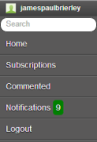

**Figure 9. Screenshot of menu sidebar bar**

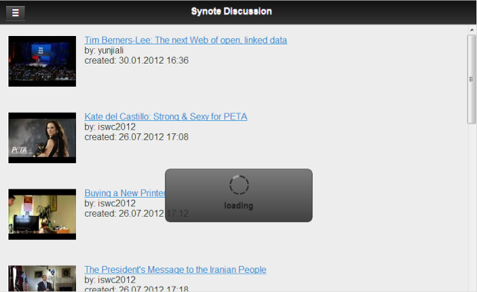

**Figure 10. Screenshot showing loading new page**

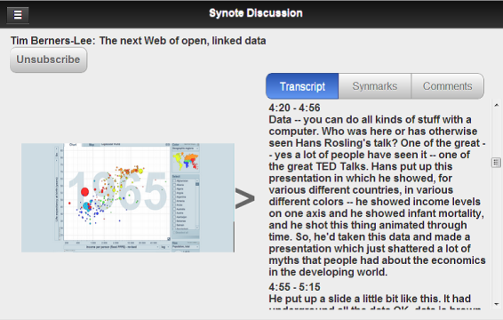

**Figure 11. Screenshots showing the presentations displayed in landscape mode.**

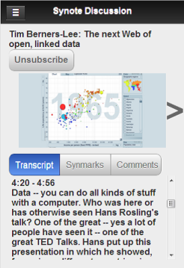

**Figure 12. Screenshots showing the presentations displayed in portrait mode.**

Evaluations

Since 2008 Synote has been used by teachers in universities in the UK, Italy, Germany, Pakistan, Australia, US and Canada with over 1000 recordings publically available on Synote (most with synchronised transcripts) for students to use for their learning. Analysis of questionnaire results from hundreds of students with a wide range of abilities and disabilities have been reported elsewhere (Wald, 2011) and confirmed that Synote successfully supports most browsers, is easy to use and improves learning, attention, motivation, efficiency, enjoyment, results and notetaking. Students also want all their lectures to be presented on Synote.

*Syntalk*

A qualitative evaluation of the Syntalk Android application conducted with 25 users having different levels of computer skills. Users were asked to download the application and use it for as long as was required and comment on the ease of use and their preference between the three server based speech recognition systems available (Google, Ispeech, and EML). Analysis of the results showed that the application was easy to use to capture and transcribe students’ contributions. Users preferred Google speech recognition because of recognition accuracy and transcription speed but users would like a reduced delay in receiving captions back from the Server.

*Synote Mobile Testing & Evaluation*

It is easy to navigate around a specifically designed mobile web site and most features can be used in the phones available as of September 2012. However, testing also showed it is possible to work with the videos on a smaller screen of 3.5 inches although it may take three scrolls to reach the bottom and require some horizontal scrolling depending on whether one is viewing in portrait or landscape mode. When it comes to outputs it is possible to add a transcript and annotations, although small fingers and delicate typing may be required.

Synote Mobile was evaluated by a group of users on a range of devices. The overall opinion of the website was good and the main purpose was to discover what further issues were arising and whether users had any other requests from the point of view of the look and feel as well as usability and accessibility. The iOS onscreen keyboard always stayed below edit boxes whereas the Android one covered them on the Samsung Galaxy.

The HTML5 video tag was proposed by Opera Software in 2007 but there are no systematic tests for the video compatibility on different mobile browsers. Tests were carried out on Android devices and iPhones with varied screen size to find out which video format could be played in which latest versions of mobile browsers. HTML5 video tag adds the track tag for subtitles which are very important for the accessibility of videos on the Web. Many standards have been around for a long time but Web Video Text Track (WebVTT) (W3C, 2014b) is a new developing standard for videos on the Web that can also be used for audio description, chapter navigation, etc. Tests were conducted to determine whether mobile browsers support WebVTT natively and the answer was that none of them did. There are HTML5 video players that support WebVTT on desktop browsers but they are all “polyfills” they use JavaScript and CSS to present WebVTT together with the video. MediaElement.js failed to display the WebVTT subtitles on iPhones but was successful on the iPad. The test for HTML5 video tag and WebVTT on mobile browsers is important. Developers should be clear what video could be played in the target device.

On the server side, the web applications need to host the best format compatible with the target device. Video sharing services, such as YouTube, must be adaptive enough to deliver videos to different devices and browsers. Subtitles are always important for videos, especially on mobile platforms, where the support for subtitles is not thorough yet. With each update or release of new versions of browsers, new codecs might be supported and old formats might be abandoned. WebVTT is currently is not well supported on mobile browsers and so we are still waiting for some break-through. The different devices, operating systems and browsers all produced different results testing with the mobile phone version of Synote despite the fact that the pages have been designed in HTML5 with MediaElement.js player and jQuery mobile.  The transcript, Synmarks and the PowerPoint slides all appear to display in the same way on the various browsers and devices but issues arose with videos and the MediaElement.js player.  The transcript has the thumbnail picture from the video and the start and end times for each transcript block.   The slides can be displayed in a row or line with start times and actual slides, the Synmarks are listed with title, description and tags plus start and end time and a thumbnail of the YouTube video for that time. At present there is also a huge variation between the way mobile phones show the captions as taken from the transcript because the players react differently to the selection of the caption button.   The iPhone would not play the YouTube closed captions whether we used Chrome, Opera or Safari despite having closed caption settings on and this appears to be a known problem (Kouznetsova, 2014).

A group of users provided qualitative feedback on the prototype of Synote Mobile using 7 and 9.7 inch tablets with Safari, Opera and Chrome browsers. CSS3 media query and viewing port size (Igloss, 2014) is used to decide when working with multimedia materials how they will be displayed on devices so the user automatically experiences a comfortable presentation. One issue that was discovered by taking screen size as a method for changing presentation of videos and transcripts is that the CSS3 media query is dependent on screen size and videos are dependent on pixel widths but result in different behaviours for continuous media and paged media. There is also an inconsistency in behaviour across devices and browsers. The controls are dependent on viewing modes, devices and browsers so when using landscape mode on the iPad it senses that it is in desktop mode. When playing the video and viewing the transcript the player controls are always seen but when using Portrait mode the CSS media query senses the reduced width and represents the web page without the player controls as you scroll down. It is possible to solve the problem on some devices, but because this does not work for all devices it has been decided that ‘width’ is probably the best method for defining when the controls will be shown. Bootstrap (2014) is being used, which is one of the most consistent environments across all devices when it comes to presenting media data. When discussing other user issues such as the look and feel, the Synote Mobile website was considered to be easy to use and attractive but there were one or two login issues on the iPhone. By using YouTube as the upload vehicle it is possible to have an automated transcript that can be corrected and annotated.

*Synote Discussion Usability Tests*

Usability testing involved 10 university students, the target group for the system, participating remotely. The participants were asked to test the application on any mobile, tablet or desktop web browser of their choosing. They were given directions as to where the application was located and were asked to use it freely for as long as they needed to get acquainted with it. Following this, they were each asked to perform a range of specified actions/tasks. After completing the tasks, they were each asked several questions about their experiences and were asked to give some feedback about the application. Tasks were:

1. Login;

2. Explore home page and navigate to a presentation;

3. Leave a comment on one of the slides;

4. Create their own discussion;

5. Subscribe to that presentation;

6. Subscribe to one of the discussions and leave a comment;

7. How would they quickly find out about a comment on their discussion;

8. Navigate to one of the discussions they are subscribed to and unsubscribe;

9. Navigate to a discussion they have left a comment on;

10. Edit and delete some of their comments.

Analysis of the qualitative results showed that most of the users said that before logging on they were not sure what the purpose of the application was. After they logged in and browsed around, it was slightly clearer that the application was a media store, although it was not clear what types of the media were stored (e.g., whether it was YouTube entertainment videos, or educational recordings from lectures). This may have been due to some of the test content used on Synote being unrelated to educational material. Some of the participants also expressed their hesitation with using their external authentication details, even though it had been explained how to revoke the access from the application to their details later on. All the participants said that it would have been more convenient for them to at least to have an option of being able to register with the system separately and hence not to give away their external details. Some participants found it was irritating that on some of their devices they encountered loading errors and the only fix offered was reloading the application. Although it did not cause any major test disturbance, it was concluded that this issue could put off the potential users from using the application. Most of the participants did not understand (until they were told) what the Synmarks were and why they could not add comments to a presentation without selecting a Synmark related to a slide. It was concluded that because most of the participants were not familiar with the original Synote system and terminology, they could not have been expected to understand this initially. The participants also expressed a slight confusion with the fact that the Synmarks were moving the presentation slides, although all of the participants agreed that synchronizing transcript and Synmarks according to the time frame of the related slide was one of the most useful features. One of the participants suggested that the notifications should constantly be visible to a user, no matter whether the sliding menu was in its hidden or visible state. All of the participants gave positive feedback on the design layout and overall design consistency and that the layout of the items and colours was generally reasonable and intuitive but was more pleasant to the eye on tablets and mobiles rather than desktop browsers. All of the participants agreed that because of the lack of distracting information, it was easier to perform the tasks and the application was very straightforward and intuitive to use. All of them also concluded that because the application has a very typical mobile platform look, it was very easy to learn how to navigate around whilst performing the tasks. It was agreed that none of the features were hidden from the view or were awkward to uncover in order to complete the test. One of the participants did, however, find it slightly irritating to keep checking the (hidden) menu bar for the notifications. It was suggested that the notifications should constantly be visible to a user, no matter whether the sliding menu was in its hidden or visible state. All of the participants gave positive feedback on the design layout and overall design consistency. It was agreed that the layout of the items and colours was generally reasonable and intuitive. It was admitted, however, that because the application was designed to be mainly served as a mobile application, its layout and components are more pleasant to the eye on tablets and mobiles rather than desktop browsers. The application also received positive feedback on how visually ”adaptable” it was as the screen size and platform the participant used did not have an effect. Most of the participants also agreed on the usefulness of such an application and its features in their studies, although some of them said that the unfamiliarity with the original Synote would put them off. Almost all of the participants agreed that there would not be any situations when the application would be hard or impossible to use. Only one participant suggested a weak point was the requirement to have a constant Internet connection in order to access and manipulate the data. There could be potential issues with the connection availability due to the content being available only online. All of the test participants concluded that the reason they had some difficulties with understanding what the system was for and what they were to do to complete the set tasks, was that there were no help messages provided for their learning. Participants also suggested there should be different user groups for the resource owners and so separate the lecturers/uploaders from the student resource users. In particular that feature would be useful during the discussions as it would be easier to distinguish lecturers from the students.

Overall the users had a positive experience with the system, referring to it as friendly, straightforward and, best of all, compatible with several platforms. The feedback proved useful and influenced the development of the system.

**Conclusions and future work**

Commercial lecture capture systems are expensive and do not easily facilitate accessible mobile cooperative educational student interactions. Synote has been shown to provide very well received enhancements to web based teaching and learning from recordings and to integrate well with other applications including, Twitter and Speech Recognition Software.

Syntalk provides a simple and free way to also capture and accessibly display the rich student interactions that can occur in classrooms.

Synote Mobile is a web application capable of working in the majority of browsers on mobile devices running an Android, Windows or Apple iOS system. It was found that one of the easiest ways to make videos suitable for Synote Mobile was to use YouTube with its captioning and transcription service that allowed for timed stamped data to be annotated and shared with others. While it might have been easier to have made a series of device specific apps offering more usability features in terms of button sizes, menu options and player modes, this would not have allowed for as many other access requirements, as was possible through the development of an HTML 5 version. A future approach could be a responsive delivery on the fly from a cloud storage system to a cloud transcoding service but this would once again come at a cost. The fall forward approach of MediaElement.js means that should the HTML5 player fail on the device Synote Mobile will present the user with Silverlight or Flash and vice versa in a fall back situation. The chosen solution appears to work with most browsers despite the lack of player access alongside the transcription on smaller mobile devices. It allows for accessibility with captions and transcriptions where the technology has allowed and provides the user with a way of interacting with others whilst working with video and audio files. This allows for video captured lectures to be not only more accessible to those who have hearing impairments but also allows all students to go back over content in a way that may suit their learning preferences whether they are in the university, at home or when travelling.

Synote Discussion has been developed as an accessible cross device and cross browser HTML5 web-based collaborative replay, annotation and discussion extension of Synote enabling students to have a discussion about a topic raised in the recording in such a way that the discussion is linked to the particular part of the recording being discussed. The usability tests showed that once users understood the purpose of the application, they found all of the features easily to use but accessing Synote Discussion through a link from Synote would make the relationship between the two applications clearer. It is planned to introduce this link from Synote and undertake further trials of Synote discussion in real classes with a larger number of users and including a wider range of mobile, tablet or desktop web browsers.

References

Apple (2012) Retrieved 23 March 2014, from http://developer.apple.com/library/safari/#documentation/AudioVideo/Conceptual/Using_HTML5_Audio_Video/Device-SpecificConsiderations/Device-SpecificConsiderations.html

Bootstrap (2014) Retrieved 23 March 2014, from http://getbootstrap.com/2.3.2/

Echo360 (2014) Retrieved 23 March 2014, from http://echo360.com/

Camtasia (2014) Retrieved 23 March 2014, from http://techsmith.com/Camtasia

EML (2104) Retrieved 23 March 2014, from http://www.eml-development.de

Facebook Mobile (2014) Retrieved 23 March 2014, from http://m.facebook.com

Ffmpeg (2014) Retrieved 23 March 2014, from http://ffmpeg.org/Htmlgoodies (2014) Retrieved 23 March 2014, from http://www.htmlgoodies.com/html5/client/how-to-embed-video-using-html5.html#fbid=MOq4FmNWQzi

Fiscus J, Radde N, Garofolo J, Le A, Ajot J, Laprun C. (2005) The rich transcription spring meeting recognition evaluation, National Institute Of Standards and Technology; 2005

Igloss (2014) Retrieved 23 March 2014, from http://www.lgloss.com/tutorials/learnmod2/mediaqueries.php

ISpeech (2014) Retrieved 23 March 2014, from http://www.ispeech.org Jwplayer (2014a) Retrieved 23 March 2014, from http://www.jwplayer.com/html5/

Jwplayer (2014b) Retrieved 23 March 2014, from http://www.longtailvideo.com/support/addons/captions-plugin/14974/captions-plugin-reference-guide

Kaltura (2011)Retrieved 23 March 2014, from http://html5video.org/wiki/HTML5_Player_Comparison

Kouznetsova, S. (2012) Retrieved 23 March 2014, from http://audio-accessibility.com/news/2012/02/youtube-apples-lack-of-caption-support/

Leitch D, MacMillan T. (2003) Liberated Learning initiative innovative technology and inclusion: Current issues and future directions for Liberated Learning research. Saint Mary's University, Nova Scotia. 2003 http://www.liberatedlearning.com/

Li Y, Wald M, Wills G, Khoja S, Millard D, Kajaba J, Singh P, Gilbert L.(2011) Synote: development of a web-based tool for synchronized annotations. *New Review of Hypermedia and Multimedia. 2011. p. 1-18.*

Mediaelementsjs (2014) Retrieved 23 March 2014, from http://mediaelementjs.com/

Net4Voice (2010) Retrieved 23 March 2014, from http://spazivirtuali.unibo.it/net4voice/default.aspx

Panopto (2014) Retrieved 23 March 2014, from http://www.panopto.com/

Pantos, R. (2012)Retrieved 23 March 2014, from http://tools.ietf.org/html/draft-pantos-http-live-streaming-09

Synote (2009) Retrieved 23 March 2014, from http://www.ecs.soton.ac.uk/about/news/2598

Synote (2011) Retrieved 23 March 2014, from http://www.ecs.soton.ac.uk/about/news/3874

Synote (2014a) Retrieved 23 March 2014, from http://www.synote.org Jisc (2014) Retrieved 23 March 2014, from http://www.jisc.ac.uk

Synotemobile (2012) Retrieved 23 March 2014, from SynoteMobile (2014) Retrieved 23 March 2014, from http://linkeddata.synote.org/synote/multimediaResource/listhttp://access.ecs.soton.ac.uk/blog/synotemobile/2012/03/23/research-planning-for-an-easy-to-use-and-accessible-mobile-app/

Tegrity (2014) Retrieved 23 March 2014, from http://www.tegrity.com/

Twitter (2014)Retrieved 23 March 2014, from http://twitter.com/synote

Twitter (2009) Retrieved 23 March 2014, from http://www.ecs.soton.ac.uk/about/news/2812

Videosws (2014) Retrieved 23 March 2014, from http://praegnanz.de/html5video/

W3c (2014a) Retrieved 23 March 2014, from http://www.w3.org/RDF/

W3C (2014b) Retrieved 23 March 2014, from http://dev.w3.org/html5/webvtt/

Wald M, Bain K. (2007) Enhancing the usability of real-time speech recognition captioning through Personalised displays and real-time multiple speaker editing and annotation. In proceedings of HCI International 2007: 12th international conference on human-computer interaction. 2007 p. 446-452.

Wald M, Wills G, Millard D, Gilbert L, Khoja S, Kajaba J, Li Y. (2009) Synchronised annotation of multimedia. Ninth IEEE International Conference on Advanced Learning Technologies. p. 594-596

Wald, Mike (2011) Synote: A Free Collaborative Multimedia Web Technology Helping Teachers and Students Transform Teaching and Learning in Schools, Colleges and Universities. 15th Biennial of the International Study Association on Teachers and Teaching

Whittaker S, Hyland P, Wiley M. (1994) Filochat handwritten notes provide access to recorded conversations. Proceedings of CHI. 1994. p. 271-277.

To cite this article: Wald, M., Li, Y., & Draffan, E.A. (2014). Accessible Collaborative Learning Using Mobile Devices *Themes in Science and Technology Education*, 5(1/2), xxx-xxx.

URL: http://earthlab.uoi.gr/theste