Evaluating the Long Term Impacts of Transport Policy: The Case of Bus Deregulation Revisited.

John Preston* and Talal Almutairi.

Civil, Maritime and Environmental Engineering and Science Academic Unit, Faculty of Engineering and the Environment, University of Southampton, UK.

* Corresponding author: Transportation Research Group, Civil, Maritime and Environmental Engineering and Science, Faculty of Engineering and the Environment, University of Southampton, Highfield, Southampton, SO17 1BJ, UK. Tel: +44(0)23 8059 4660. Email: jpreston@soton.ac.uk

Keywords: Local Bus, Deregulation, Welfare analysis

JEL codes: L9, R4.

Abstract

In a previous paper in this journal, we suggested that the bus reforms that were implemented in Britain from the mid-1980s onwards were welfare positive for both London and for the rest of Great Britain outside London (Preston and Almutairi, 2013). However, we cautioned that this work was preliminary and likely to be sensitive to various assumptions made. In this paper, we have undertaken more detailed sensitivity analysis as follows. First, we have developed separate demand models for London and for the rest of Great Britain. Secondly, we have developed cost models to determine the extent to which costs are determined by external factors (such as fuel prices) or partially external factors (such as labour costs). Thirdly, we have developed fares models to assess the impact of changes in subsidy, in terms of both revenue support and concessionary fare reimbursements. We have also changed the measurements of consumer surplus so as to be more consistent with underlying economic theory. This work confirms the sensitivity of the long term evaluation of transport policy to assumptions concerning the counterfactual and trends in demand, supply and prices. Any policy lessons inferred from these long term evaluations need to take these sensitivities into account.
- Introduction and Outline
The bus reforms that took place in Great Britain in the 1980s can be viewed as one of the greatest experiments in industrial re-organisation in the transport sector (see, for example, Mackie and Preston, 1996). As a result of the 1985 Transport Act, bus services outside London were deregulated and largely supplied commercially, whilst the industry was commercialised and subsequently privatised. Additional socially necessary services were provided by competitive tender (Banister, 1985). As a result of the 1984 London Regional Transport Act, control of bus services in London was transferred from local to central Government (this was subsequently reversed in 2000) and the services were gradually subjected to comprehensive competitive tendering (completed in 1994), whilst the industry was also privatised (Kennedy, 1995). These reforms attracted a lot of initial interest and there was a flurry of initial studies that undertook welfare analyses of various forms and with varying results (e.g., White, 1990, Mackie et al., 1995, Kennedy, op cit., Romilly, 2001) but there have been few studies in recent years. This is surprising as a feature of the bus reforms in Britain has been their longevity, with their main features broadly intact.
In order to fill this gap, in a previous paper in this journal, we presented a long run evaluation of the impact of bus reforms in Britain (Preston and Almutairi, 2013). However, we noted that such long run evaluations are plagued by difficulties and we address these by drawing on the recent doctoral thesis of one of the authors (Almutairi, 2013). In particular, we noted that a key issue was whether our models sufficiently differentiated between London and the rest of Great Britain. We address this by developing separate demand models in section 2. We also proposed to develop forecasting models for operating costs and fares, in order to carry out more detailed counterfactual analysis – the determination of what would have happened in the absence of the reforms. These models are presented in sections 3 and 4 respectively. A description of our more detailed treatment of the counterfactual is given in section 5. We suggested that our consumer surplus measures could be refined and this is done in section 6. As a result, our welfare findings are now different in a number of respects to those presented previously. The implications of this are presented in section 7, with some policy conclusions drawn in section 8.
- Demand Models
Data on the performance of the local bus industry are available from a number of sources, most notably the Department for Transport’s Transport Statistics Great Britain. Time series data-bases were created for five areas of Great Britain (English Metropolitan Counties, English Shire Counties, London, Scotland and Wales) for the years 1981 to 2008/9. We calibrated a time series model for London, whilst for Great Britain outside London we developed a pooled model of the four areas (the English metropolitan counties, the English Shires, Scotland and Wales).
For London, a time series model was estimated using Generalised Least Squares, with the Prais-Winsten (1954) estimator used to correct for serial correlation. The results are shown by Table 1.
Table 1 Dynamic time-series model for bus demand in London, Prais-Winsten AR(1) regression.
Variable | Coeff | p-values
Ln(Q_{t-1}) | 0.534 | 0.000
Ln(S) | 0.316 | 0.055
Ln(I) | -0.448 | 0.088
Ln(F) | -0.434 | 0.001
Ln (Motoring costs) | 0.472 | 0.020
Dummy for privatisation process* | -0.064 | 0.035
Time trend | 0.020 | 0.010
Constant | 2.667 | 0.323
R² | 0.990
R² (Adj.) | 0.987
Number of obs. | 30
Durbin-Watson d-statistic (transformed) | 1.838
Rho | 0.165
*Starts from 1991 onwards.
It can be seen that this model also has excellent goodness of fit, with an adjusted R squared of 0.987, with all parameter values statistically significantly at the 5% level, with the exception of the constant. The transformed Durbin-Watson statistic indicates that serial correlation has been dealt with. Demand in London appears to be relatively sensitive to service levels, with a short run elasticity of 0.32, rising to 0.68 in the long run, and to fares, with a short run elasticity of -0.43, rising to -0.93 in the long run. An important cross elasticity with respect to motoring costs is detected of 0.47 in the short run, rising to 1.01 in the long run. Bus travel is shown to be an inferior good, with a short run elasticity of -0.45, rising to -0.96 in the long run, although this is offset by secular growth of 2.0% per annum. Adjustment appears to take a relatively long period, with 99% of change occurring in 7.3 years. It was found that an impact on demand was associated with the privatisation of London Buses Limited from 1991 onwards, leading to a decline in demand of 6.2% in the short run, rising to 12.8% in the long run, with this effect having been substantially completed by 1999.
Outside London, after extensive testing of alternative functional forms and estimation methods, we found that a Partial Adjustment Model, estimated with Fixed Effects using the Panel Corrected Standard Error (PCSE-AR(1)) method (Beck and Katz, 1995, Reed and Ye, 2007, 2011), provided the best model in terms of goodness of fit and plausibility of the parameter estimates. The estimated model is shown by Table 2.
Table 2: Dynamic Panel Model of Bus Demand Outside London 1980-2008/9
Variables |  | Coeff. | p-value | LR Elasticity
Ln(Q_{t-1}) |  | 0.630 | 0.000
Ln(S) |  | 0.133 | 0.039 | 0.36
Ln(I) |  | -0.629 | 0.000 | -1.70
Ln(F) |  | -0.124 | 0.001 | -0.34
Deregulation dummy |  | -0.048 | 0.002
Time trend |  | 0.011 | 0.000
Mets DV |  | 0.247 | 0.000
Scot DV |  | 0.190 | 0.004
Wales DV |  | -0.026 | 0.046
R² |  | 0.998
Number of obs. |  | 101
Number of groups |  | 4
Rho (ρ) |  | 0.140
Dependent Variable: Ln (Q_{t}) where Q_{t} = number of bus passenger trips per capita in year t. Independent Variables: F = Receipts (excluding Concessionary Fares Reimbursement) per passenger in year t, S = Bus service (Vehicle Kilometres) in year t, I = Personal Disposable Income in year t, Q_{i-1} = Number of bus passengers per capita in year t-1, DV = Dummy Variable.
It can be seen that this model has excellent goodness of fit, with all parameters significant at the 5% level. This model implies an elasticity with respect to Vehicle Kilometre of 0.13 in the Short Run, rising to 0.36 in the Long Run and a Fares Elasticity of -0.12 in the Short Run rising to -0.34 in the Long Run. These are lower than in London and may seem low in comparison to other studies (e.g. Balcombe et al, 2004). However, the impact of national free concessionary fares in Wales from 2002, Scotland from 2006 and England from 2008 needs to be borne in mind. Surveys by Passengerfocus (2013) suggest that only 50% of bus users are paying fares in the English metropolitan counties, reducing to 41% in the English shires. By contrast, the income elasticity is relatively high (in absolute terms), particularly compared to London, at -0.63 in the short run and -1.70 in the long run, however it is again offset by a secular time trend, although in this case of only around 1.1% growth per annum. The lagged dependent variable indicates that 99% of change will occur within 10 years, which is slightly longer than for London. The deregulation dummy variable indicates a 4.7% reduction in demand in the short run and 12.2% reduction in the long run, with this likely to have been completed by 1996. The dummy variables indicate that, compared to the reference case of the English shires and based on the exponential of the estimated parameter value, bus journeys per capita are 28% higher in the English Mets, 21% higher in Scotland but 3% lower in Wales.
- Cost Models
In our earlier work, we had focussed purely on assessing the impact of the regulatory reforms on demand. However, the reforms had important impacts on operating costs and on subsidy levels, whilst the counterfactual assumptions concerning these two variables are crucially important. As a result we develop a recursive modelling system in order to take these factors into account (see also Figure 1). We first estimate total costs (described in this section) and then estimate fares as a function of costs and subsidy (see section 4) and then feed the estimates of fares into the demand model in order to determine the welfare implications of the reforms.
Following White (1990), it can be argued that some cost reductions, such as those related to fuel costs, are external to the regulatory reform process, whilst others, such as changes in labour costs can be viewed as a transfer. Data on costs only date back to 1985 and some key explanatory variables (such as wage rates) are not easily disaggregated by area. As a result, time-series models were developed for outside London and London, again using the Prais-Winsten estimator. The results are shown in Tables 3 and 4 respectively.

Table 3: Estimation results of cost models using VKM per staff as the productivity variable, the Prais-Winsten estimator.
Variables

 | Coeff. | Sig
Ln (Total VKM) | 1.272 | 0.000
Ln (Diesel price, excluding duty) | 0.259 | 0.000
Ln (Labour earnings per week) | 0.746 | 0.007
Ln(VKM per total no. of staff) | -0.387 | 0.001
Time trend | -0.023 | 0.000
Constant | 0.626 | 0.780
Overall R-squared | 0.982
Adjusted R-squared | 0.976
DW (transformed) | 1.830
Number of obs. | 22
Dependent variable: Ln (Total Costs). VKM = Vehicle Kilometres.
Once again, it can be seen that the model has excellent goodness of fit, with an adjusted R squared of 0.976, with all parameter values statistically significantly at the 5% level, with the exception of the constant, whilst the transformed Durbin-Watson statistic indicates that serial correlation has been dealt with. Outside London, this model suggests an elasticity of costs with respect to vehicle kilometres of 0.885 (1.272 – 0.387), suggesting slight increasing returns to scale. The elasticity of costs with respect to staff numbers is 0.387, with the elasticities with respect to wage rates and fuel prices being 0.746 and 0.259 respectively. The time trend indicates an annual cost reduction (in real terms) of 2.3% per annum which might be attributed to deregulation.
Table 4 Estimation results of cost model for London, using the Prais-Winsten estimator.
Variables | Coeff. | Sig
Ln (Total VKM) | 0.195 | 0.109
Ln (Diesel price, excl. duty) | 0.135 | 0.031
Ln(Total wages)¹ | 0.622 | 0.000
Year 1994 dummy² | -0.168 | 0.000
Year 2002 dummy³ | 0.213 | 0.000
Constant | 0.480 | 0.692
Adjusted R² | 0.999
DW (transformed) | 1.819
Number of obs. | 22
¹Equals labour earning per week multiplied by total staff employed. ² Captures the complete privatisation and tendering process. ³Captures the beginning of the extensive improvement of the London bus service in parallel with the road-pricing scheme and the Mayor’s plan (GLA, 2001).

The cost model for London also has excellent goodness of fit, although the constant is not significant. Table 4 suggests an elasticity of costs with respect to vehicle kilometres of only 0.195, suggesting strongly increasing returns to scale (although note also the impact of staff numbers and the dummy variables). An elasticity of costs with respect to staff numbers and wage rate of 0.622 is implied, along with an elasticity of 0.135 with respect to diesel prices. The completion of privatisation in 1994 is associated with a one-off reduction in costs of 15.5%, whilst the expansion of services in 2002 is associated with a 23.7% increase in costs.
- Fare Models
For determining the fares models, we have used the pooled time-series, cross-section data for outside London and the time-series data for London, and we use partial adjustment models to capture dynamics in both. The results are given by Tables 5 and 6 respectively.
Table 5: Dynamic model results using the PCSE estimator that includes fixed effect.
Variables |  | Panel excluding London*  PCSE (AR1)- Fixed
 |  | Coeff. | p-value | LR Elasticity
Ln(F_{t-1}) |  | 0.591 | 0.000
Ln(Cost per VKM) |  | 0.189 | 0.03 | 0.466
Ln(SUB per VKM)* |  | -.180 | 0.000 | -0.442
TT |  | 0.009 | 0.000
Mets DV |  | -0.107 | 0.002
Scot DV |  | -0.109 | 0.000
Wales DV |  | -0.048 | 0.036
Constant |  | -0.450 | 0.000
R2 |  | 0.977
Number of obs. |  | 89
Number of groups |  | 4
Rho |  | 0.130
Dependent Variable: Ln (F_{t}). SUB = Subsidy (Concessionary Fare Reimbursement (CFR) and Public Transport Support (PTS))
Outside London our model has excellent goodness of fit, with all parameters significant at the 5% level. Table 5 indicates for outside London a short run elasticity of fares with respect to unit costs of 0.19 and a short run elasticity with respect to subsidy of -0.18. In the long run, these values are found to be 0.47 and -0.44 respectively. Compared to the English shires, the fares in the English Mets are 10.1% lower, the fares in Scotland are 10.3% lower and the fares in Wales are 4.4% lower. The time trend indicates a 0.9% increase in real fares per annum.
Table 6: Estimation results of the time series fare model for London, using the Prais-Winsten estimator.
Variables |  | Preferred model
 |  | Coeff. | p-value | LR Elasticity
Ln(lagged fare) |  | 0.690 | 0.000
Ln(CFR per VKM) |  | -0.262707 | 0.033 | -0.85018
Ln(PTS per VKM) |  | -0.012932 | 0.024 | -0.04185
TT |  | -0.004929 | 0.027
Constant |  | -0.429749 | 0.000
Adj. R2 |  | 0.831
Number of obs. |  | 24
DW (transformed) |  | 1.8489
Rho |  | 0.08667

For London, it was not possible to establish a statistical relationship between fares and costs and, partly as a result, the goodness of fit is relatively modest, although all parameters are statistically significant at the 5% level. However, there appeared to be an important relationship between fares and subsidy. In particular, the elasticity of fares to concessionary fare reimbursement was found to be -0.26 in the short run, rising to -0.85 in the long run. By contrast, the short run elasticity of fares to public transport support was only -0.01 in the short run, rising to -0.04 in the long run. The time trend suggests a decrease in real fares of around 0.5% per annum.
5. Estimating the Counterfactual
We have established a recursive systems of equations in which there is ‘unidirectional dependency among the endogenous variables’ (Kennedy, 2003, 193). Our cost models have two key exogenous (or partly exogenous) variables – fuel price and labour price and two endogenous variables – staff numbers and vehicle kilometres. For our fare models, the key exogenous variable is subsidy, whilst the key endogenous variables are costs (at least for outside London) and vehicle kilometres. For the demand model, the key exogenous variable is income, whilst the key endogenous variables are fares and vehicle kilometres. For all three models, there are also time related variables. As the systems is recursive (see Figure 1), it is identified and the three equations can be estimated separately using Ordinary Least Squares or variants thereof (Kmenta, 1997, 719-720).

Demand
Total Cost
Fare
VKM (X₁)
Wages (X₂)
Staff
Income (X₇)
Subsidies (X₅)
Fare lagged (X₆)
Time trend (X₄)
Deregulation dummy (X₉)
Demand lagged (X₈)
Figure 1: Illustration of the structure of the recursive model system

For the key endogenous variables, it is necessary to determine the counterfactual – what would have happened without the reforms? We deploy two assumptions. The constant assumption keeps all key variables at their immediate pre-deregulation (1984/5) levels. The trend assumption establishes linear trends for the pre-deregulation period. This is illustrated by Figure 2 for vehicle kilometres which, based on data going back to 1970, suggests that the counterfactual would have been a strong downward trend, particularly outside London.

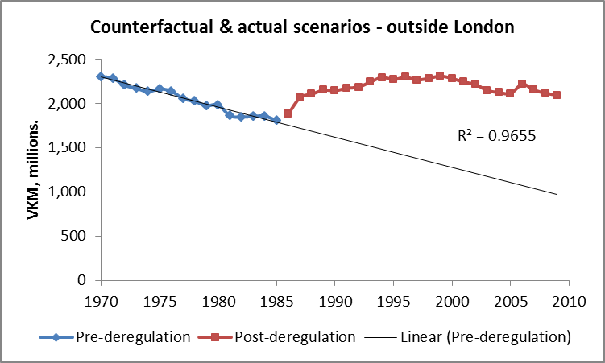
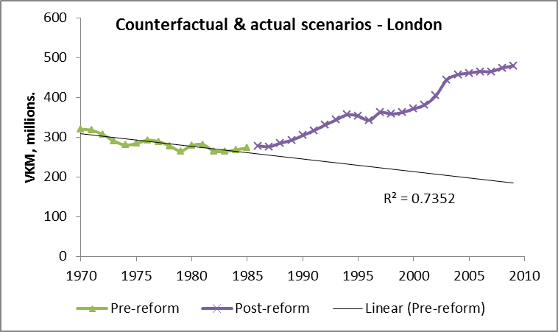

Figure 2: Actual and Counterfactual Trends in Vehicle Kilometres

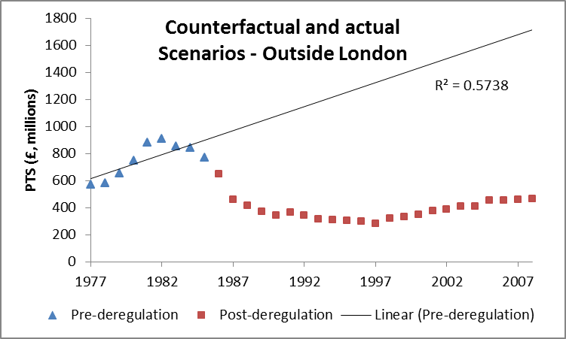
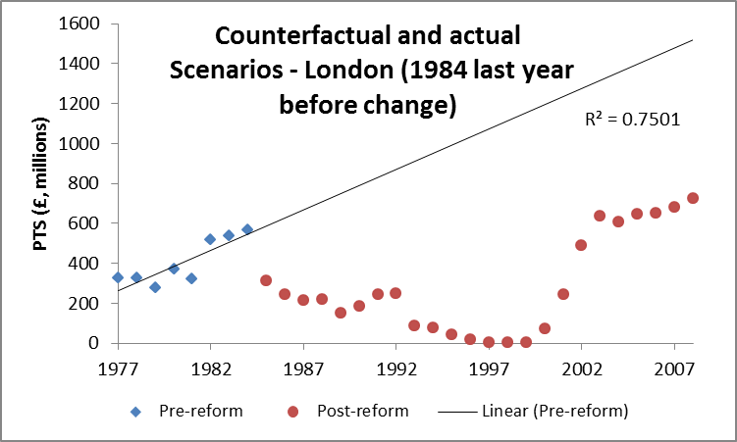

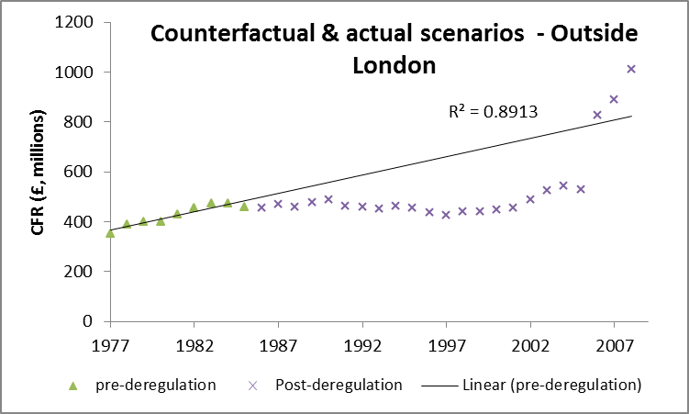
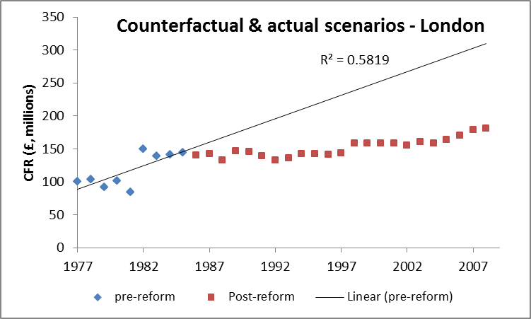
Figure 3: Actual and Counterfactual Trends in Subsidy: Concessionary Fares Reimbursement (CFR) and Public Transport Support (PTS)
For subsidy, Figure 3 shows that strong growth in both Public Transport Support and Concessionary Fare Reimbursement might have been anticipated, both outside London and in London. The introduction of free concessionary fares in England in 2006 can be seen to have had a dramatic effect, raising the subsidy bill outside London by almost £300 million in one year.
6. Welfare Analysis
Our measure of welfare changes for the main groups can be summarised by the following equations:
$∆ W_{t, bu}= ∆ {CS}_{t} (for bus users)$
$∆ W_{t, bo}= ∆ {TR}_{t}+∆{ SUB}_{t}-∆ {TC}_{t} (for bus operators)$
$$∆ W_{t, g}= - ∆{ SUB}_{t} (for the goverment and taxpayers)$$
$$∆ W_{t,bw}= ∆{TC}_{due to change in wages} (for bus workers)$$
Thus, the overall welfare changes is:
$∆ W_{t, overall}=∆ W_{t, bu}+∆ W_{t, bo}+ ∆ W_{t, g}+ ∆ W_{t, bw}+{DWEA}_{t}$
where W = welfare, CS = consumer surplus calculated using the rule of half (RoH), TR = total revenue, TC = total costs, SUB = total subsidies, DWEA = deadweight efficiency adjustment (calculated as 0.2 ΔW_{t,g} based on Dodgson and Topham, 1987), and t = year (1,2,..,T). Δ refers to the difference between the actual outcome and the counterfactual. The calculations based on previous equations are repeated for each year over the period of evaluation, 1986/7 to 2009/10, as well as during the first or second decade since the policy reforms. The key findings of our work are given by Table 7, with all calculations expressed as present values using the test discount rate of 3.5% (HM Treasury, 2011).
The changes in Consumer Surplus are estimated using the rule of half. We had originally calculated this as: $∆ CS=\frac{1}{2} \left(F_{1}- F_{2}\right) (Q_{1}+ Q_{2})$
where F₁ = counterfactual fares, Q₁ = counterfactual demand, F₂ = actual fares and Q₂ = actual demand. Although this approach is broadly consistent with the recommendations of WebTAG Unit 3.5.3 (Department for Transport, 2011) and the work of Jones (1977) and Sugden (1999), its use is debatable in circumstances where the demand curve shifts and the assumption of symmetry of substitution does not hold. In our modelling, we use fare rather than generalised cost as the numéraire. This partial measure fails to take into account changes in variables that might be expected to shift the demand curve outwards (such as increases in vehicle kilometres) or changes that might be expected to shift the demand curve inwards (such as perceived reductions in reliability and reductions in service integration). In line with earlier work (for example, Mackie et al., 1995), we find that outside London, the latter effect dominates. In such circumstances, we replace F₁ with the fare that would be expected to generate Q₁ given the inward shift in the demand curve. This fare might be expected to be below F₁ and hence the WebTAG method might be expected to underestimate the loss in consumer surplus. We have confirmed this with our empirical calculations.

Table 7: Summary of cost and benefits of British bus policy reforms (including or excluding the impacts of subsidy reductions) in GB, 1986/7 -2009/10 (£, million) at 2008/9 prices
Welfare change | Inclusion of subsidy reductions (as part of the bus policy reforms)? | Outside London (deregulation) |  |  |  |  |  | Within London (competitive tendering)
 |  | Constant assumption |  |  | Trend assumption |  |  | Constant assumption |  |  | Trend assumption
 |  | Since reform | 1st decade | 2nd decade | Since reform | 1st decade | 2nd decade | Since reform | 1st decade | 2nd decade | Since reform | 1st decade | 2nd decade
Consumer surplus (bus user) | Included | -24,044 | -11,741 | -9,006 | -16,299 | -7,086 | -6,647 | 399 | 0 | -340 | 451 | -386 | -273
 | Excluded | -15,560 | -8,190 | -5,049 | 7,358 | 1,669 | 4,680 | 2,363 | 811 | 886 | 4,348 | 707 | 1,943
Producer surplus (bus operator) | Included | 5,849 | -554 | 4,232 | -4,552 | -2,264 | -1,283 | -1,309 | -1,870 | -99 | -10,890 | -4,258 | -5,042
 | Excluded | 8,536 | 1,490 | 4,995 | 5,573 | 1,935 | 3,074 | 3,416 | 1,317 | 1,710 | 2,458 | 1,168 | 1,146
Bus labour (employee) | Both | -483 | -1,008 | -286 | -8,638 | -3,655 | -4,218 | -470 | -393 | -217 | -2,820 | -1,052 | -1,422
Government | Included | 5,929 | 3,071 | 2,376 | 17,152 | 6,526 | 7,782 | 4,825 | 3,281 | 1,820 | 13,556 | 5,559 | 6,248
 | Excluded | 0 | 0 | 0 | 0 | 0 | 0 | 0 | 0 | 0 | 0 | 0 | 0
Deadweight efficiency gains | Included | 1,186 | 614 | 475 | 3,430 | 1,305 | 1,556 | 965 | 656 | 364 | 2,711 | 1,112 | 1,250
 | Excluded | 0 | 0 | 0 | 0 | 0 | 0 | 0 | 0 | 0 | 0 | 0 | 0
Overall welfare change | Included | -11,563 | -9,618 | -2,209 | -8,907 | -5,174 | -2,765 | 4,410 | 1,674 | 1,528 | 3,008 | 975 | 761
 | Excluded | -7,507 | -7,708 | -340 | 4,293 | -51 | 3,536 | 5,309 | 1,735 | 2,379 | 3,986 | 823 | 1,667

Table 7 also assesses two scenarios with respect to subsidy. The first assumes that subsidy reductions are part of the deregulation package and are included in the analysis. The second argues, following Glaister (1997) and Romilly (2001) that the prime motivation of the reforms was a macroeconomic one – to reduce public expenditure on subsidies. To determine the microeconomic impact of the reforms the effect of subsidy changes needs to be isolated. This is done by establishing subsidy at either constant or trends levels and examining the impact on fares and consequently demand using the recursive equation system outlined above.
7. Discussion
Our revised calculations indicate that between 1986/7 and 2009/10, the bus deregulation package outside London led to a loss in welfare of around £11.5 billion if we use the constant assumption for the counterfactual, falling slightly to £8.9 billion if we use the trend assumption. These losses are concentrated in the first decade of the reforms (1986-1995), particularly for the constant assumption. If we separate out the impact of subsidy changes we find that, with the constant assumption, there is still a substantial loss (of £7.5 billion). These losses are again concentrated in the first decade. However, with the trend assumption there is a welfare gain of £4.3 million, but these gains are concentrated in the second decade (and thereafter). This appears to be indicating that the deregulated regime would make better use of increases in subsidy than the regulated regime.
Overall, we found outside London, consumer surplus losses dominate producer surplus and governmental gains, except in the scenario where increases in subsidy are assumed to reduce fares and lead to consumer surplus gains. Bus industry employees are found to be big losers, particularly under the trend assumption where real increases in wages might have been expected.
In London, there is a more consistent pattern of overall welfare gains under most of the scenarios examined, although these welfare gains seem particularly strong in recent years, which may be reflecting the large increases in subsidy and service levels. Where subsidy reductions are taken into account, the main losers appear to be bus operators, particularly under the trend assumption where reductions in vehicle kilometres might be anticipated. By contrast, bus operators gain if subsidy levels are maintained or increased. Bus industry employees also appear consistent losers. Both in London and outside, Government is the main gainer from the reforms, when subsidy reduction is considered to be part of the package.
In Table 8, we compare modified versions of our revised results with our original calculations. We find that for London the welfare results are broadly consistent, with the original estimation bounded by the two revised estimates. Outside London, we find dramatic differences. When consumer surplus changes are correctly calculated to account for shifts in demand and when cost changes are calculated to take into account changes in fuel prices and labour prices, bus deregulation in Great Britain outside London appears to be strongly welfare negative, particularly under the constant trend assumption, which was also the basis for our original estimates.

Table 8: Comparison of Original and Revised Welfare Analysis (2008/9 prices – analysis excluding impact of subsidy reduction in parentheses)
 | London |  |  | Outside London
 | Original | Revised |  | Original | Revised
 |  | Constant | Trend |  | Constant | Trend
ΔW_{bu} | +1,495 | +399  (+2,363) | +451  (+4,348) | -7,272 | -24,044  (-15,560) | -16,299  (+7,358)
ΔW_{bo} + ΔW_{g} | +1,797 | +3,516  (+3,416) | +2,676  (+2,458) | +11,638 | +11,778  (+8,536) | +12,630  (+5,573)
ΔW_{bu} + ΔW_{bo} + ΔW_{g} | +3,292 | +3,915  (+5,779) | +3,127  (+6,806) | +4,366 | -12,266  (-7,024) | -3,669  (+12,931)
Note: For consistency of comparisons, the revised results do not consider the welfare loss to bus workers nor the deadweight efficiency gains.
8. Conclusions
Overall, we have found that London shows a consistent pattern of welfare gains, although consumers have endured disbenefits when there have been subsidy reductions. Government has been a clear gainer when there have been subsidy reductions, with operators the main gainers when subsidy is maintained or increased. Excluding the impacts of subsidy reductions increases the welfare benefits of the reform package.
By contrast, outside London shows a more mixed pattern but under the most realistic assumptions the welfare impacts are negative and suggest that a policy response in term of some form of re-regulation similar to that which exists in London, such as the use of quality contracts, may be justified. Excluding the impacts of subsidy reductions, increases the welfare benefits of the reform package and suggests that if deregulation had been accompanied by increased subsidy levels it could have been welfare positive. The results confirm the benefits of subsidising bus services that have been illustrated by others, principally Glaister (1987, 2001).
Our models suggest that outside London, 99% of change occurred within 10 years, with this figure being 7% for London. Outside London, deregulation took place as a big bang in 1986, but privatisation was more gradual. The privatisation of the state owned National Bus Company was largely completed by 1988 and the privatisation of the major metropolitan Public Transport Company operators by 1994. In London, comprehensive tendering and privatisation of London Buses Limited was completed in 1994. Our work therefore suggests that the era of regulatory reform was completed sometime between 2001 and 2004. This was also a period when bus costs and subsidy started rising, concessionary fares policy started having an effect as did the creation of the Greater London Authority. A new era seems to have commenced but one in which the regulatory structure of the old era has remained.
However, this work also illustrates the sensitivity of the long term evaluation of transport policy to assumptions concerning the counterfactual and trends in demand, supply and prices. Any policy lessons inferred from these long term evaluations need to take these sensitivities into account.
Acknowledgement
Talal Almutairi’s PhD research was funded by the Government of Kuwait (2009-2013), supervised by Professor John Preston and Dr Birendra Shrestha. We are grateful for the comments of Dr Jeremy Toner of the University of Leeds and of two anonymous referees on earlier versions of this work but any mistakes are our own.
References
Almutairi, T. (2013) Evaluating the Long Term Impacts of Transport Policy: The Case of Bus Deregulation. PhD Thesis, Faculty of Engineering and the Environment, University of Southampton.
Balcombe, R. (Ed) et al. (2004) The Demand for Public Transport: A Practical Guide. TRL Report 593. TRL, Crowthorne.
Banister, D. (1985) Deregulating the Bus Industry in Britain – (A) The Proposals. Transport Reviews, 5, 2, 99-103.
Beck, N., and Katz, J. N. (1995). What To Do (And What Not To Do) With Time-Series Cross-Section Data. American Political Science Review 89, 3, 634-647
Department for Transport (2011) Transport User Benefit Calculation. TAG Unit 3.5.3. April. http://www.dft.gov.uk/webtag/documents/expert/unit3.5.3.php
Dodgson, J. and Topham, N. (1987) The Shadow Price of Public Funds: A Survey. In Glaister, S. (Ed) Transport Subsidy. Policy Journals, Newbury.
GLA (Greater London Authority) (2001) The Mayor’s Transport Strategy. GLA, London.
Glaister, S. (1987) Allocation of Urban Public Transport Subsidy. In Glaister, S. (Ed) Transport Subsidy. Policy Journals, Newbury.
Glaister, S. (1997) Deregulation and privatisation. British experience. In De Rus, G. and Nash, C. (Eds) Recent Developments in Transport Economics. Ashgate, Aldershot.
Glaister, S. (2001) The Economic Assessment of Local Transport Subsidies in Large Cities. In Grayling, T. (Ed) Any More Fares? IPPR, London.
HM Treasury (2011) The Green Book. Appraisal and Evaluation in Central Government. http://www.hm-treasury.gov.uk/data_greenbook_index.htm
Jones, I. (1977) Urban Transport Appraisal. Macmillan, London.
Kennedy, D. (1995) London bus tendering: a welfare balance. Transport Policy, 2, 4, 243-249.
Kennedy, P. (2003) A Guide to Econometrics. Fifth Edition. MIT Press, Cambridge, Mass.
Kmenta, J. (1997) Elements of Econometrics. University of Michigan Press, Ann Arbor.
Mackie, P., Preston, J. and Nash, C. (1995) Bus deregulation: ten years on. Transport Reviews, 15, 3, 229–251.
Mackie, P.J. and Preston, J.M. (1996) The Local Bus Market: A Case Study of Regulatory Change. Avebury, Aldershot
Passengerfocus (2013) Bus Passenger Survey. March. Passengerfocus, London. http://www.passengerfocus.org.uk/research/publications/bus-passenger-survey-full-report-march-2013
Prais, S.J. and Winsten, C.B. (1954) Trend Estimators and Serial Correlation. Cowles Commission Discussion Paper 383.
Preston, J. and Almutairi, T. (2013) Evaluating the Long Term Impacts of Transport Policy: An Initial Assessment of Bus Deregulation. Research in Transportation Economics, 39, 208-214.
Reed, W.R. and Ye, H. (2007). A Monte Carlo Evaluation of some common panel data estimators when serial correlation and cross-sectional dependence are both present. Working Paper No. 01/2007, Department of Economics and Finance, University of Canterbury.
Reed, W.R. and Ye, H. (2011) Which panel estimator should I use? Applied Economics, 43, 8, 985-1000.
Romilly, P. (2001) Subsidy and Local Bus Service Deregulation In Britain A Re-Evaluation. Journal of Transport Economics and Policy, 35, 2, 161-94.
Sugden, R. (1999) Review of cost/benefit analysis of transport projects. Department of Environment, Transport and the Regions, London.
White, P. R. (1990) Bus deregulation: a welfare balance sheet. Journal of Transport Economics and Policy, 24, 3, 311-332

Greater Manchester, Merseyside, South Yorkshire, Tyne and Wear, West Midlands and West Yorkshire.
This involves free fare concession for bus use for the over 60s and eligible disabled people. This statutory concession operates between 9:30am and 11:00pm Monday to Friday and all day on Saturdays and Sundays, In England, it originally covered travel within a Travel Concessions Authority (TCA) but in April 2008, a national scheme was introduced which extended free travel for concessionaires to any journey on a local bus in England, so as to be consistent with the earlier national schemes in Scotland and Wales.

