Figure 1: Radial high-resolution peripheral quantitative computed tomography (A) imaging procedure (B) HRpQCT of the distal radius (C) radial erosions in the third metacarpophalangeal joint in patients with RA (coronal plane)

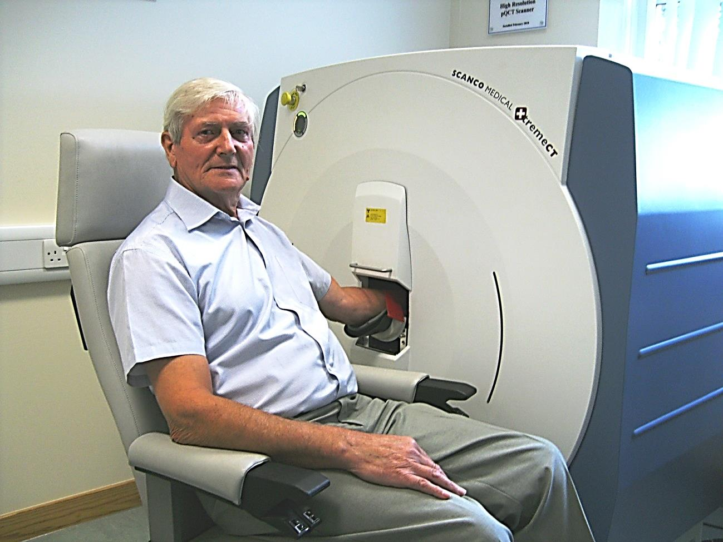 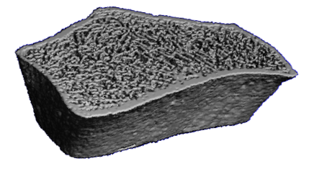

B

A



C