**Cite this: DOI: 10.1039/x0xx00000x**

Received 00th January 2012,

Accepted 00th January 2012

DOI: 10.1039/x0xx00000x

**www.rsc.org/**

Organophosphorus chemical warfare agent simulant DMMP promotes structural reinforcement of urea-based chiral supramolecular gels

Francesca Piana, Marco Facciotti, Giuseppe Pileio, Jennifer R. Hiscock, Wim Van Rossom, Richard C. D. Brown* and Philip A. Gale*

Six urea-based supramolecular gels have been obtained *in situ* by mixing either (*R*)-(–)-1-(1-naphthyl)ethyl isocyanate or (±)-1-(1-naphthyl)ethyl isocyanate with various amines. This allowed a comparative study on the effects of chirality on the response of the molecular gels to the presence of the neutral organophosphate guest dimethyl methylphosphonate (DMMP). The inversion test results show that the absence of enantiomeric purity causes marked instability of the gel network in presence of the guest. DSC and rheology measurements reveal the promotion of a structural reinforcement of the gels when 0.01 mL of DMMP interacts with the enantiomerically pure systems. This effect was investigated by means of electrostatic potential surface calculations and 31P-{1H} NMR spectroscopy.

Introduction

Supramolecular gels are hierarchical self-assembled materials, in which molecular-scale building blocks coalesce, usually into fibrillar structures, as a consequence of controlled non-covalent interactions.1 Low molecular weight organic compounds (< 2000 Da) are readily synthesised and used as network-forming components.2,3 When the gelator molecules are chiral, nanostructures formed are often endowed with chiral features, such as chiral twists, chiral tubes or one other.4 Molecular recognition within gels, as in crystals, relies on precisely organised intermolecular interactions, and the role of chirality should be significant.5 A requirement to induce supramolecular gelation is the presence of at least one functionality that is able to establish directional non-covalent chemical bonds.6 One of the most popular functional groups capable of achieving this is the urea moiety. The urea group is known to self-associate through the formation of N–H···O hydrogen bonds, to form stable 6-membered rings based on two donors and one carbonyl acceptor, as shown in Fig. 1.7



**Fig. 1** Aggregation of urea moieties via hydrogen bonding interactions.

Increasing attention has been given to supramolecular gels in recent years for a wide range of applications, particularly in sensing. This application relies on the gel’s response to both physical and chemical external stimuli, which disturb the metastable state.8 Physical stimuli are for example temperature, ultrasonic irradiation, mechanical forces or light.1 Chemical stimuli include but are not limited to pH,9,10 anions,11–13 redox reagents14,15 and neutral molecules.16,17 We have previously reported the perturbation of urea-based gels upon the addition of organophosphate chemical warfare agent (OPCWA) Soman and two of its simulants.18

OPCWAs are potent acetylcholinesterase (AChE) inhibitors. They differ from other chemical weapons because of their phosphorylating mode of action, which is able to irreversibly block AChE activity causing extreme neurological damage. The general structure of OPCWAs consist of a tetra-substituted phosphorus(V) centre linked to an oxygen atom, a leaving group and two variable substituents. Due to the grave toxicity of OPCWAs, they are typically replaced in laboratory studies by structurally related simulants with reduced toxicity, such as dimethyl methylphosphonate (DMMP).19



Despite the knowledge of physical and chemical properties of OPCWAs there still remains a lack of available data on their supramolecular characteristics. Knowledge of their non-covalent chemistry and how they interact with other materials can lead to the development of new functional systems that exploit these interactions.20

In this work, we report the synthesis of three new enantiomerically pure (*R,R*) urea-based gelators that were used to investigate the interaction between their gels and DMMP. The role played by the chirality of these molecules in the gelation process was also investigated comparing the enantiomerically pure gels **1**–**3** with the mixtures **4**–**6**, constituted from stereoisomeric mixtures of each gelator (two enantiomers *R,R* and *S,S* and the meso compound).

The goal of this work is to pinpoint the effects of the presence of neutral organophosphate molecules of DMMP on the supramolecular gel network. Gelation tests and thermo-mechanical characterization of the materials provided experimental evidence of the way such systems respond to this chemical stimulus.

Results and discussion

Three novel enantiomerically pure (*R,R*) chiral gelators **1**–**3** were synthesised by reaction between (*R*)-(–)-1-(1-naphthyl)ethyl isocyanate and various amines in dichloromethane. This resulted in the synthesis of two bis(urea) gelators with C6 and C9 methylene spacer and a third gelator with three urea groups appended from a tripodal scaffold.6,21 The urea-products precipitated as white solids and were isolated in good yields (80–87%; see ESI for details).

Gel formation studies



The minimum gelation concentration (MGC) for gelators **1**–**3** was established in a variety of solvents. This is defined as the lowest gelator concentration needed to form a stable gel, once at room temperature. The gels were prepared by heating the gelator in the solvent until the solid had completely dissolved and then allowing the solution to cool to room temperature. The formation of the gel was confirmed by an inversion test.1 The test was simplified to three possible outcomes: ‘gelation’, ‘partial gelation’ or ‘no gelation’ (Table S1–3, ESI). A partial gel is herein defined as an intermediate phase comprising both gel and solution domains. Table 1 shows the MGC values for gelators **1**–**3**.

Gelator **2** was found to be the most effective system, gelating in the widest range of solvents. Conversely, gelator **3** was only found to gelate in tetralin and only above the concentration of 15 mg mL-1. It was observed that the only gelation solvent in common between the three compounds was tetralin, henceforth used across all further comparative studies.

**Table 1** Minimum gelation concentration values for gelators **1**–**3** in different solvents.

|  |  |  |  |
| --- | --- | --- | --- |
|  | **MGC** (mg mL-1) | | |
| **Solvent** | **Gelator 1** | **Gelator 2** | **Gelator 3** |
| CH2Cl2 | 5 | 5 | - |
| Chloroform | 5 | 5 | - |
| Tetralin | 20 | 10 | 15 |

Even lower MGC values were obtained with the *in situ* syntheses of the gels at room temperature. This followed a previously established procedure in which both the reaction to synthesise the gelator molecules and the formation of the gel occur simultaneously.22,23 This approach allowed the reduction of the duration of the gelation process from tens of minutes to almost instantaneous. Instant gelation indicates that the energy barrier to solubilisation and self-assembling is very low, and the gel state can therefore be accessed even at room temperature.1

Amounts of amine and isocyanate in tetralin were chosen to obtain 1 mL of gel at the MGC of each gelator: gelator **1** (2.3 mg mL-1), gelator **2** (1.7 mg mL-1) and gelator **3** (3.7 mg mL-1). These molecules showed a significant improvement in their capability to gelate at low concentration (≤ 5 mg mL-1) when compared to our previous results.18

There is still an on-going discussion as to whether enantiomerically pure systems can promote a more efficient and well-oriented supramolecular organisation of the gelator molecules although some evidence came from comparative studies with racemic gels.5 Smith *et al.* observed how sometimes in absence of the enantiomeric purity of the gelators, gelation can be suppressed and the thermal stability of the gel reduced.24,25 Given all these structural consequences, it was hypothesised that the chirality of the gelators could also lead to gels with different responses to external stimuli, in this case DMMP. In order to test this hypothesis, six gels were prepared *in situ* (Table 2).

**Table 2** Summary of the *in situ* gels investigated.

|  |  |  |
| --- | --- | --- |
| **Gel** | **Amine** | **Isocyanate** |
| **1** | hexane-1,6-diamine | (*R*)-(–)-  1-(1-naphthyl)ethyl isocyanate |
| **2** | nonane-1,9-diamine |
| **3** | tris(2-aminoethyl)amine |
| **4** | hexane-1,6-diamine | (±)-1-(1-naphthyl)ethyl isocyanate |
| **5** | nonane-1,9-diamine |
| **6** | tris(2-aminoethyl)amine |

The same amines were used as starting materials while both the enantiomerically pure (*R*)-(–)-1-(1-naphthyl)ethyl isocyanate and racemic 1-(1-naphthyl)ethyl isocyanate were used. With respect to the gelation ability it was noted that the enantiomeric purity of the gelators did not affect their performance significantly. For gels **1**–**6** *in situ* gelation was almost instantaneous.

Gel perturbation tests

Since the aim of the work is to study the effects of the presence of DMMP on the gel network, the formation of a stable gel is essential. A systematic approach was used to define the maximum amount of DMMP that gels **1**–**6** could tolerate, by means of gel perturbation tests. The amount of DMMP had to be optimized in order to express maximum interactions with the gel network without disrupting it. DMMP was added in various aliquots (1.0 μL, 2.5 μL, 5.0 μL, 0.01 mL, 0.025 mL, 0.05 mL, 0.1 mL) in either one of the reagent solutions. Although gels were stable even with lower amounts, 0.01 mL of DMMP was considered the best compromise in order to match the sensitivity limits of the experimental techniques to be used (Table 3).

**Table 3** Effect of DMMP presence on gels **1**–**6**.

|  |  |  |  |
| --- | --- | --- | --- |
| **MGC**  (mg mL-1) | | **DMMP**  (mL) | **Delay in gel formation**  (s) |
| **1** | 2.3 | 0.01 | 0 |
| **2** | 1.7 | 0 |
| **3** | 3.7 | 20 |
| **4** | 2.3 | n/a (>600) |
| **5** | 1.7 | 150 |
| **6** | 3.7 | n/a (>600) |

Upon addition of 0.01 mL of DMMP gels **1**–**3** experienced no significant delay in gel formation. Conversely, gels **4**–**6** were much more affected by the presence of DMMP. According to these results, gels **4**–**6** appeared not suitable to the purpose of this work although they could be considered very good candidates for sensing applications through gel network disruption.18 All detailed results, with explicit numbers of equivalents guest/gelator added, are provided in the ESI (Table S4–15).

Differential Scanning Calorimetry (DSC)

Thermal characterization of gels 1–6 was performed to obtain the gel-sol transition temperature (Tgel). This temperature is characteristic of the material and it reflects structural stability, therefore it can be monitored to determine the effect of external stimuli (i.e. presence of DMMP). Each gel sample (around 20 mg) underwent a heating-cooling-heating cycle from -20 °C to 280 °C at a rate of 10 °C min-1 in sealed aluminium pans. Further details on gel preparation are available in the ESI. The first heating ramp was observed to feature up to three main events: Tgel ≈ 110 °C, degradation of gelator ≈ 200 °C (see mp values) and evaporation of tetralin ≈ 230 °C. Small typical amber-coloured residues were found in the pans after the DSC measurements, representing less than 1% of the original sample weight (see TGA data in ESI).

None of these thermal events were seen in gels 4–6 and for this reason, together with the outcomes of the perturbation tests, these systems were not investigated further by rheology. This supported the hypothesis of the superiority of stereoisomerically pure gelators with respect to their better self-association tendency once gelation is triggered.

A comparison between the Tgel values for gels **1**–**3** together with the effects of the presence of DMMP is shown in Fig. 2. An increase of the value of Tgel (meaning better thermal stability), however small, was observed in samples **1**–**3** when 0.01 mL of DMMP was incorporated in the gel network. This stability enhancement was experienced mainly by gel **2** with a 26 °C increase of Tgel, while gels **1** and **3** both showed minimal variations (< 10 °C). Tgel of gel **2** was found substantially unaffected by additions of lower amounts of DMMP (see ESI).



**Fig. 2** Comparison of the variations of Tgel in the presence and absence of DMMP for gels **1**–**3**.

Rheology of gels

In order to investigate whether the enhancement in thermal stability (observed by DSC) also reflected underlying changes of mechanical properties, rheological tests were performed. Details on gel preparation are available in the ESI. All gels showed a behaviour consistent with a solid-like material; the storage moduli (G’) were all systematically larger than the loss moduli (G’’) by at least one order of magnitude and parallel to each other as shown in the example in Fig. 3.26 It was observed in oscillation sweep experiments that the phase angle *δ* (measure of the delay between stress and strain) was found always around 3°, close to the ideal value for an elastic solid (*δ* = 0°). Additionally, the phase angle showed no significant variations across the frequency range investigated, indicating the ability of all gels to withstand stresses below their yield stress value without showing signs of mechanical fatigue.



**Fig. 3** Frequency sweep rheometry of gel **2** in the presence and absence of DMMP showing its solid-like nature based on the relationship between the complex moduli G’ and G’’.

Both stress and frequency sweep rheometry were performed demonstrating that the strength of the material was increasing in the sequence **2** > **1** > **3**, as confirmed by both intensity and position of the curves in Fig. 4. Interestingly, in all cases the presence of 0.01 mL of DMMP caused a shift of the curves towards higher oscillation stresses. This suggests that DMMP promotes strengthening of the gel network.

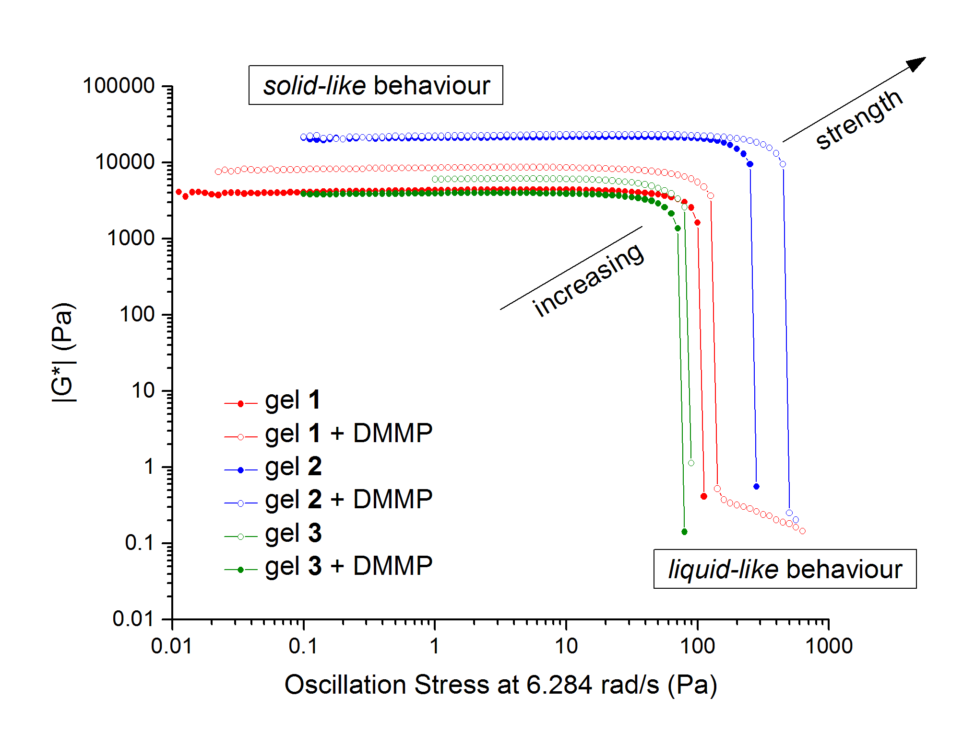

**Fig. 4** Stress sweeps of gels **1**–**3** with and without DMMP.

Further quantitative evidence of the strengthening of the gel structure, provided DMMP is present, can be seen in the yield stress values in Fig. 5 confirming again the ranking already discussed.

It is known that anion-binding bis(urea) gels have a characteristic anion-dependent decrease in gel strength and yield stress.27 In fact, the interactions with anions would be expected to be in competition with urea self-association because the anion can take the place of the urea carbonyl as hydrogen bond acceptor, disturbing the urea self-association and hence the bulk behaviour of the gels, particularly their rheology.7,28 However, in the case of neutral guests, the effect can be opposite, exemplified by the systems investigated here and as reported by Steed *et al.*29



**Fig. 5** Comparison of the values of yield stress for gels **1**–**3** with and without DMMP.

The main outcome of rheology measurements, in accordance with DSC observations, was showing gel **2** to be the most affected by the presence of DMMP, with a structural reinforcement expressed by an almost 80% increase of the yield stress.

The formation of gels depends on the self-association tendency of the solute (gelator) when interacting in a solvent. This tendency can have two main cooperative driving forces: solute-solute interactions and solvophobic effects, when poorly soluble moieties of the gelator contribute to gelation by reducing its overall solubility in the solvent to be gelled, as shown in Fig. 6.1 This latter case can be described as solvent-solvent interactions.

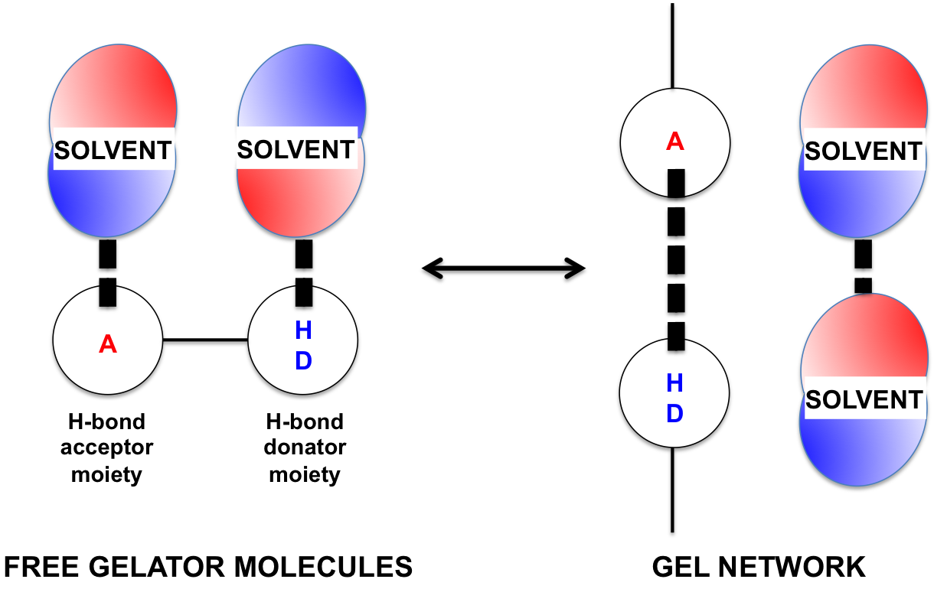

**Fig. 6** Competition between intermolecular interactions of H-bond acceptor and donator moieties of the gelator with the solvent in the formation of the gel network.

When these interactions dominate over solute-solute forces, gelation still occurs as gelator molecules find themselves encouraged to interact with each other since the solvent is preferentially available for interactions with itself.30

To investigate the intermolecular interactions that led to the observed properties of the materials, molecular electrostatic potential surfaces of gelators **1–3** were calculated to gain a better understanding their solute-solute interactions (generally hydrogen bonds). In a particular solvent, it can be imagined that the dominant electrostatic effects are pairwise interactions between maxima and minima regions of the electron density of each molecule. Following the approach outlined by Hunter, a quantitative evaluation of the intermolecular interactions was performed based on these electrostatic potentials.30 Calculations in tetralin showed that solute-solute interactions of gelators **1–3** dominate over solvent-solvent and solute-solvent forces. These predominant interactions can therefore be hypothesised as the main contribution in triggering gelation. Conversely, in DMMP, solvent-solvent interactions appear more important (see hydrogen-bond interactions profile in ESI).

This marked solvophobic effect expressed by DMMP is considered the main reason of the observed strengthening of the gel structures. Small amounts of this OPCWA simulant added in the tetralin gels can make solute-solute interactions even more favourable. However, it has also been observed that larger amounts of DMMP can be detrimental to the stability of the network, causing perturbation/delay in the gel formation (see ESI Table S4–15). In fact, when *in situ* gel formation was tested in 1 mL of DMMP with the highest concentration of gelators **1**–**3** (20 mg mL-1), gelation and partial gelation occurred for gel **2** and **1** respectively, after 24 h, while for **3** gelation was suppressed. In agreement with rheology observations, gelation ability decreased in the sequence **2** > **1** > **3**.

The molecular interaction between DMMP and gelator **2** was studied via 31P-{1H} NMR spectroscopy. It was observed that the majority of DMMP molecules does not establish hydrogen bonds with the gelator when present in small amount in the gel phase. No significant difference in the 31P chemical shift of DMMP was observed in toluene-*d8* and in gel **2**, suggesting the absence of dominant solute-solvent interactions in the gel phase. Conversely, when enough DMMP to prevent gel **2** formation was used, the DMMP signal shifted by +0.8 ppm, confirming that the perturbation of the gel was caused by the establishment of hydrogen bonds between the O=P acceptor and the urea N-H donor, as previously hypothesised.18 Supporting this theory, the chemical shifts of DMMP in presence of either urea or gelator **2** were found comparable (see NMR data in ESI).

Environmental Scanning Electron Microscopy (ESEM)

ESEM was used to identify differences in the morphology of xerogels obtained from gels **1–6**. Gels **4–6** were included for comparison. Details on gel and xerogel preparation are available in the ESI. Differences in the gel network structure between the two families were clearly visible. Gels **4**–**6**, from the mixture of stereoisomers, always appeared to lack many features otherwise present, such as ordered and fibrillar structures.5 Enhancement of these features was observed for gels **1**–**2** whenever 0.01 mL of DMMP was present in the gel network.

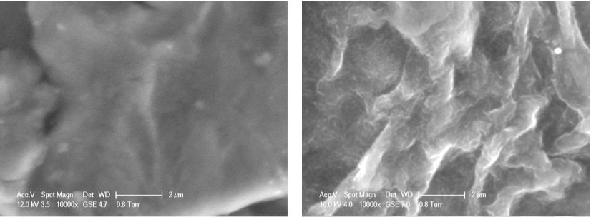

b)

a)

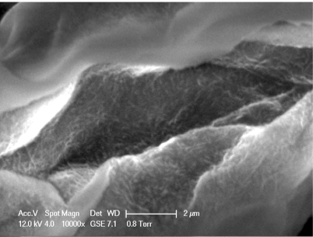

c)

**Fig. 7** ESEM images at 10000x magnification for xerogels from: a) gel **5**; b) gel **2**; c) gel **2** in presence of DMMP.

Fig. 7 shows results for gel **2** in the absence and presence of DMMP and for gel **5**. It is important to remember that gel **2** and gel **5** only differ in the stereoisomeric composition of the gelators (Table 2). Although these studies were performed on gels formed by constituents with defined absolute configuration none of the typical features such as the helicity of the fibres were observed.31 It is believed that the main reason was the resolution limit of the equipment used together with the absence of a conducting coating on the samples. Even without these features it is still clear that both absolute configuration and DMMP addition caused modifications, if only on the morphology of the xerogels.

Conclusions

Three novel enantiomerically pure (*R,R*) chiral gelators **1**–**3** were synthesized by reaction between (*R*)-(–)-1-(1-naphthyl)ethyl isocyanate and various amines. *In situ* gelation occurred, at room temperature, at remarkably low minimum gelation concentrations (down to 1.7 mg mL-1 for gelator **2**).

DSC and rheology measurements provided evidence of an interesting effect taking place with the chiral urea-based gels in the presence of DMMP. Enantiomerically pure gels **1**–**3** appeared structurally reinforced by the presence of small amounts of the neutral organophosphate guest, due to the solvophobic effect. This is particularly significant with gel **2**, which saw an increase of yield stress of almost 80% and an enhanced thermal stability (Tgel increased by 26 °C) in presence of 0.01 mL of DMMP. The presence of larger amounts of DMMP was observed to be detrimental for the gel network stability due to possible hydrogen bonds formation between the organophosphate guest and the urea moiety of the gelator, as shown by 31P-{1H} NMR.

Gels **4**–**6**, from the mixture of stereoisomers, were found to be less stable in the presence of DMMP and therefore unsuitable for host/guest studies in gel phase. However, these systems could be investigated as candidates for OPCWA sensing applications through gel network disruption.

**Acknowledgements**

F.P. thanks the A-I Chem Channel project, an European INTERREG IV A France (Channel) – England Cross border cooperation programme, co-financed by ERDF. W.VR. and P.A.G. thank the European Union for a Marie Curie Career Integration Grant. We thank EPSRC and Dstl for a KTS fellowship (JRH). P.A.G. thanks the Royal Society and the Wolfson Foundation for a Research Merit Award.

Notes and references

Chemistry, University of Southampton, Southampton SO17 1BJ, UK. E-mail: philip.gale@soton.ac.uk

Electronic Supplementary Information (ESI) available: materials and apparatus, procedure and results of gel formation and perturbation tests, DSC, TGA, rheology of gels, molecular electrostatic potential surfaces calculations, 31P-{1H} NMR spectra and ESEM pictures. See DOI: 10.1039/b000000x/

1. B. Escuder and J. F. Miravet, *Functional Molecular Gels - RSC Soft Matter Series*, The Royal Society of Chemistry, Cambridge, 2014.

2. P. Terech and R. G. Weiss, *Chem. Rev.*, 1997, **97**, 3133–3160.

3. L. E. Buerkle and S. J. Rowan, *Chem. Soc. Rev.*, 2012, **41**, 6089–6102.

4. P. Duan, H. Cao, L. Zhang, and M. Liu, *Soft Matter*, 2014, **10**, 5428–5448.

5. D. K. Smith, *Chem. Soc. Rev.*, 2009, **38**, 684–694.

6. J. van Esch, R. M. Kellogg, and B. L. Feringa, *Tetrahedron Lett.*, 1997, **38**, 281–284.

7. J. W. Steed, *Chem. Soc. Rev.*, 2010, **39**, 3686–3699.

8. P. Terech, *Langmuir*, 2009, **25**, 8370–8372.

9. J. W. Chung, B.-K. An, and S. Y. Park, *Chem. Mater.*, 2008, **20**, 6750–6755.

10. J.-L. Pozzo, G. Michel Clavier, and J.-P. Desvergne, *J. Mater. Chem.*, 1998, **8**, 2575–2577.

11. M. Yamanaka, T. Nakamura, T. Nakagawa, and H. Itagaki, *Tetrahedron Lett.*, 2007, **48**, 8990–8993.

12. C. Wang, D. Zhang, and D. Zhu, *Langmuir*, 2007, **23**, 1478–1482.

13. T. Becker, C. Yong Goh, F. Jones, M. J. McIldowie, M. Mocerino, and M. I. Ogden, *Chem. Commun.*, 2008, 3900–3902.

14. C. Wang, D. Zhang, and D. Zhu, *J. Am. Chem. Soc.*, 2005, **127**, 16372–16373.

15. J. Liu, P. He, J. Yan, X. Fang, J. Peng, K. Liu, and Y. Fang, *Adv. Mater.*, 2008, **20**, 2508–2511.

16. Q. Chen, D. Zhang, G. Zhang, and D. Zhu, *Langmuir*, 2009, **25**, 11436–11441.

17. P. Mukhopadhyay, Y. Iwashita, M. Shirakawa, S. Kawano, N. Fujita, and S. Shinkai, *Angew. Chem. Int. Ed.*, 2006, **45**, 1592–1595.

18. J. R. Hiscock, F. Piana, M. R. Sambrook, N. J. Wells, A. J. Clark, J. C. Vincent, N. Busschaert, R. C. D. Brown, and P. A. Gale, *Chem. Commun.*, 2013, **49**, 9119–9121.

19. K. Kim, O. G. Tsay, D. A. Atwood, and D. G. Churchill, *Chem. Rev.*, 2011, **111**, 5345–5403.

20. M. R. Sambrook and S. Notman, *Chem. Soc. Rev.*, 2013, **42**, 9251–9267.

21. M. de Loos, A. G. J. Ligtenbarg, J. van Esch, H. Kooijman, A. L. Spek, R. Hage, R. M. Kellogg, and B. L. Feringa, *European J. Org. Chem.*, 2000, **2000**, 3675–3678.

22. M. Suzuki, Y. Nakajima, M. Yumoto, M. Kimura, H. Shirai, and K. Hanabusa, *Org. Biomol. Chem.*, 2004, **2**, 1155–1159.

23. U. K. Das, D. R. Trivedi, N. N. Adarsh, and P. Dastidar, *J. Org. Chem.*, 2009, **74**, 7111–7121.

24. A. R. Hirst, D. K. Smith, M. C. Feiters, and H. P. M. Geurts, *Chem. Eur. J.*, 2004, **10**, 5901–5910.

25. A. R. Hirst, D. K. Smith, M. C. Feiters, H. P. M. Geurts, and A. C. Wright, *J. Am. Chem. Soc.*, 2003, **125**, 9010–9011.

26. H. A. Barnes, *A Handbook of Elementary Rheology*, The Institute of Non-Newtonian Fluid Mechanics, University of Wales, 2000.

27. M.-O. M. Piepenbrock, G. O. Lloyd, N. Clarke, and J. W. Steed, *Chem. Commun.*, 2008, 2644–2646.

28. M.-O. M. Piepenbrock, G. O. Lloyd, N. Clarke, and J. W. Steed, *Chem. Rev.*, 2010, **110**, 1960–2004.

29. J. A. Foster, P.-O. M., G. O. Lloyd, N. Clarke, H. A. K., and J. W. Steed, *Nature Chem*, 2010, **2**, 1037–1043.

30. C. A. Hunter, *Angew. Chem. Int. Ed.*, 2004, **43**, 5310–5324.

31. G. O. Lloyd, M.-O. M. Piepenbrock, J. A. Foster, N. Clarke, and J. W. Steed, *Soft Matter*, 2012, **8**, 204–216.