**Cite this: DOI: 10.1039/x0xx00000x**

Received 00th January 2012,

Accepted 00th January 2012

DOI: 10.1039/x0xx00000x

**www.rsc.org/**

Aromatic isophthalamides aggregate in lipid bilayers: evidence for a cooperative transport mechanism

Stuart N. Berry,*a* Nathalie Busschaert,*a* Charlotte L. Frankling,*a* Dale Salter,*a* and Philip A. Gale *a*

The synthesis and anion transport properties of a series of increasingly aromatic transmembrane anion transporters based on an isophthalamide scaffold are reported. Through anion transport studies using artificial vesicles, we note that these compounds have Hill coefficients > 1. This is indicative of higher order complex formation, which suggests that the compounds are not functioning solely as mobile carriers and that a cooperative transport mechanism is being observed. Fluorescence spectroscopy is used to show that the compounds aggregate in the phospholipid bilayer, which provides evidence that these compounds function as a self-assembled anion-conducting aggregate.

Introduction

The transport of anions across phospholipid bilayers is a fundamental process in cellular signalling, regulating biological pH values and maintaining osmotic balance. In Nature, transmembrane anion transport is mediated by protein channels that span the lipid bilayer membrane. Defects in these proteins can result in diseases known as “channelopathies,”1 examples of which include Cystic Fibrosis (CF), the renal disease Bartter’s syndrome, and some forms of myotonia. As a direct consequence of this, a considerable amount of research has been conducted in recent years to create artificial channels and carriers capable of anion transport.2–4

One of the key anion binding motifs in the supramolecular chemist’s arsenal is the isophthalamide group. Since this motif was first shown to bind halides by Crabtree and co-workers,5 the hydrogen bond donating properties of these systems have been employed in a variety of applications including anion sensing and transport.6–8

The anion transport properties of isophthalamide derivatives have been well established.8-10 Recently, Yang *et al*. reported an isophthalamide based on two bis(α-aminoxyamides) as a chloride transporter in both artificial vesicles and cell membranes.11 Furthermore, they propose that this compound functions by forming membrane-spanning channels. Remarkably, this compound was later shown to exhibit biological activity by restoring chloride conductance in human Cystic Fibrosis epithelial cells.12 Further to this, Gokel and co-workers recently reported a series of structurally simple anion transporters based on isophthalamides and their pyridine analogues and also proposed that these compounds were aggregating into membrane spanning pores.13 Presumably, for isophthalamides and related structures to function as anion conducting pores instead of as mobile anion carriers14 they would need to aggregate/self-assemble in the lipid bilayer into an organised channel, this has been suggested previously.13 Current explanations as to what drives pore formation by these compounds are limited however, and the apparent mechanism by which these compounds form pores is somewhat unexplored. π-Stacked architecture has been shown to be an important tool in the development and design of novel lipid bilayer spanning channels.15 It may be that these related isophthalamides are aggregating in the lipid membrane by π-π stacking interactions and, consequently, we decided to investigate the effects increasing the size of the central aromatic ring has on the transport mechanism for a series of structurally related isophthalamides. Increasing the aromatic ring size will increase the total area of the π-system of the compound, thereby presumably making them more likely to stack in the membrane. Herein, we report the synthesis and anion transport properties of a series of isophthalamide analogues **1-6**. The compounds increase across the series in the size of the central aromatic ring ranging from benzene to naphthalene to anthracene. The pendent side chains are either phenyl groups or butyl groups which vary both the lipophilicity, acidity of the hydrogen bonding NHs on the compounds and the total number of aromatic rings in the compounds π-system.

Using anion transport studies on artificial 1-palmitoyl-2-oleoyl-*sn*-glycero-3-phosphocholine (POPC) vesicles, we demonstrate that all transporting isophthalamides in this study have Hill coefficients > 1. This is an indication that multiple monomers are involved in the transport process.16 Further to this, we have used fluorescence spectroscopy to demonstrate that these compounds are able to aggregate in lipid bilayers. Finally, we observe that transport activity of the compounds is diminished in vesicles composed of POPC:cholesterol (7:3 molar ratio). As cholesterol decreases the fluidity of lipid bilayer membranes, this serves as evidence that these compounds function by diffusion into the membrane, then aggregating into an active transporting complex. Through the use of fluorescence spectroscopy, we observe a lower degree of aggregation in POPC:cholesterol vesicles than POPC vesicles alone and observe that Hill coefficients tend towards 1 in POPC:cholesterol vesicles. This is evidence that leads us to propose that these compounds are less likely to aggregate under these conditions and that aggregation is beneficial to the transport mechanism.



Results and Discussion

Synthesis

We have previously reported the synthesis of compounds **3**, **4** and **6.**8,17Compound **1** was synthesised according to literature procedures.18,19 Isophthaloyl dichloride was dissolved in acetonitrile and refluxed in the presence of triethylamine and aniline for 3 hours and the resultant precipitate collected by filtration affording compound **1** in 85% yield. Compounds **2** and **5** were synthesised by reacting diethyl naphthalene-1,3-dicarboxylate (synthesised according to literature procedures20,21) with the relevant amine in the presence of the coupling agent trimethylaluminium yielding **2** and **5** in 35% and 50% yields respectively. Further details of synthetic procedures carried out in this study can be found in the ESI.

Anion Binding in Solution

We assessed the ability of compounds **1-6** to bind anions in the solution state by using 1H NMR titration techniques in the competitive solvent mixture DMSO-d6/0.5% H2O with the anions added as either the tetrabutylammonium (TBA) or tetraethylammonium (TEA) salts (for solubility reasons). The binding studies were performed on anions relevant to our anion transport studies and to biological systems. Wherever possible, the chemical shift of the most downfield isophthalamide NH signal was fitted to a 1:1 receptor:anion binding isotherm using the WinEQNMR22 software. Table 1 contains a summary of the anion binding studies and anion transport assays. Fitted curves are available in the ESI.

In general, compounds **1-6** exhibit weak 1:1 binding to tetrabutylammonium chloride and slightly stronger 1:1 binding to tetraethylammonium bicarbonate. We also observed no significant interactions with tetrabutylammonium nitrate under the conditions of this experiment. The binding curve for compound **4** with tetrabutylammonium chloride was linear and could not be fitted to a 1:1 binding model. This could be due to inherently weak binding to this anion. We have previously reported 1:1 binding constants for this compound in less competitive solvent systems8 and based on its structural similarities to the other compounds in the series, it can be assumed that binding here is also 1:1. Significant amide NH peak broadening was observed for compounds **2** and **3** upon the addition of tetraethylammonium bicarbonate and an immediate, intense colour change from yellow to red was noted upon addition of tetraethylammonium bicarbonate to **3**. This suggests deprotonation of the acidic NH groups may be occurring and this may be the reason why these compounds act as poor bicarbonate transporters (see below). The association constant for **6** with tetrabutylammonium chloride was determined by following the change in chemical shift of the isophthalamide central CH instead of the amide NH resonances due to the overlapping of peaks in the aromatic region of the compounds 1H NMR. In all cases, this central aromatic CH was seen to exhibit some change in chemical shift upon the addition of tetrabutylammonium chloride and tetraethylammonium bicarbonate indicating that this proton, as well as the amide NH groups are involved in the 1:1 binding of the anions tested in the solution state. This is consistent with other reported binding data for similar compounds.5,23

Compounds **1-3** exhibit larger association constants for both binding anions than compounds **4-6**. This can be attributed to the increased acidity of the amide NH groups forming stronger association constants in the phenyl-substituted complexes as opposed to the butyl-substituted complexes.

Anion Transport Studies and Hill Analysis

We assessed the ability of compounds **1-6** to transport anions across phospholipid bilayers using an ion selective electrode. In a typical assay, unilamellar 1-palmitoyl-2-oleoyl-*sn*-glycero-3-phosphocholine (POPC) vesicles (200 nm diameter) were prepared containing an internal aqueous solution of sodium chloride (489 mM NaCl buffered to pH 7.2 with 5 mM sodium phosphate salts). The vesicles were dispersed in an aqueous external solution of sodium nitrate (489 mM NaNO3 buffered to pH 7.2 with 5 mM sodium phosphate salts). The internal and external salt solutions were kept isotonic to prevent the vesicles from bursting. Receptors **1-6** were loaded at an appropriate molar percentage relative to the moles of lipid as a DMSO solution at 0 s and the resulting chloride efflux from the vesicles detected by a chloride selective electrode (Accumet). At the end of the assay (typically after 300 s) the vesicles were lysed with a detergent (octaethylene glycol monododecyl ether). This was done to calibrate the electrode to 100% chloride release. Figure 1 shows the results of Cl-/NO3- antiport experiments for receptors **1-6** at 4 mol% receptor loading with respect to POPC concentration.

**Table 1** Overview of anion binding experiments, transport assays and clogP calculations for compounds **1-5**

|  |  |  |  |  |  |  |
| --- | --- | --- | --- | --- | --- | --- |
| Receptor | Cl-/NO3- EC50,270sa (mol %) | nb (Cl-/NO3-) | KaCl-  (M-1)c | KaHCO3‑ (M-1)c | KaNO3- (M-1)c | clogPd |
| 1 | 13.7e | 1.3 | 42.4 | 47.6 | <10k | 3.65±0.27 |
| 2 | 2.99 | 2.7 | 9.36 | 33.1h | <10k | 4.22±0.28 |
| 3 | 4.03f | 3.2 | 15.5 | 32.1h, i | <10k | 5.84±0.53 |
| 4 | -g | -g | -l | 15.8 | <10k | 3.10±0.35 |
| 5 | 10.9 | 3.9 | <10 | 9.19 | <10k | 3.68±0.31 |
| 6 | 2.43 | 3.4 | 8.72j | 13.8 | <10k | 5.31±0.67 |
| a EC50, 270s is the concentration in mol% of carrier with respect to lipid needed to obtain 50% chloride efflux in 270s from unilamellar POPC vesicles, obtained through Hill plot analysis using vesicles containing NaCl dispersed in NaNO3 solution (see Fig **1** and ESI). Each EC50 is an average of at least 3 repeated plots. b Hill coefficient for Cl-/NO3- experiments. c Association constant in M-1 for receptors **1-6** with either TBACl, TEAHCO3 or TBANO3 in DMSO-d6/0.5% H2O at 298K, fitted to a 1:1 binding model with most downfield NH unless stated. All errors < 15% d Calculated log patrician coefficient,average calculation from VCCLab24 e Max efflux only reaches 50%. f Average of 5 repeated Hill plots. g Not determined due to inactivity. h Significant broadening of isophthalamide NH’s observed. i Dramatic colour change upon addition of TMA bicarbonate. j Follows downfield shift of central isophthalamide CH. k No measurable interaction observed. l Binding constant could not be fitted to a 1:1 isotherm. | | | | | | |

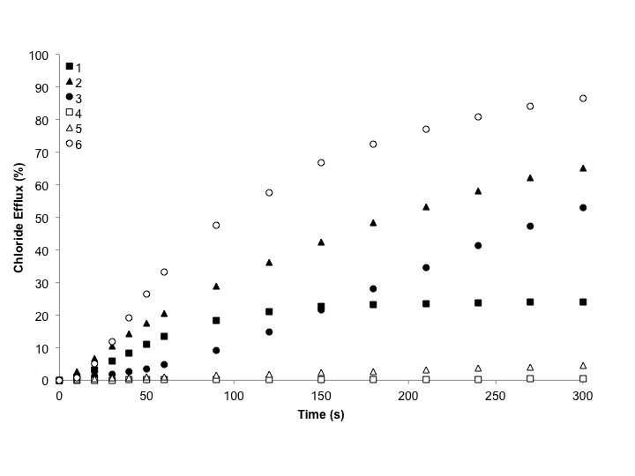

Figure 1: Chloride Efflux as a function of time promoted by addition of 4 mol% (with respect to lipid concentration) of receptors **1-6** from unilamellar POPC vesicles containing 489 mM NaCl buffered to pH 7.2 with 5 mM phosphate salts. The vesicles were dispersed in 489 mM NaNO3 buffered to pH 7.2 with 5 mM phosphate salts. The receptors were added as a DMSO solution. At the end of the experiment, the vesicles were lysed to calibrate the electrode to 100% efflux. Each point is an average of 3 repeated experiments; see ESI for a version of this graph with error bars.

Compounds **2**, **3** and **6** are the most active transporters under these conditions, and interestingly these compounds are the most aromatic of the series and contain the largest π-systems of the six transporters tested. Table 1 shows a calculated partition coefficient for the compounds used in this study (clogP, VCClabs24). clogP values provide an estimate of lipophilicity and therefore provide an estimate of how efficiently a compound is able to partition into the lipid bilayer.25 In a recent study on synthetic Tamjamine derivatives by Quesada and co-workers, it was suggested that the optimal lipophilicity range for an anion transporter is between 4.2-5.26 The most active compounds in this series lie either in or just outside this range. It is possible that compounds **1**, **4** and **5** are poor transporters because they are not lipophilic enough to partition into the lipid bilayer.

In general, the compounds with phenyl based side chains (**1-3**) are more active than the compounds with butyl based side chains (**4-6**). This could be due to the higher association constants observed for the phenyl-based compounds as shown in Table 1. There is one notable exception to this trend however, the anthracene based **6** is the most active compound in the series despite binding Cl- less strongly than its phenyl side-chained analogue **3**. It may be that the lipophilicity of compound **6** is a determining factor here. One would expect the phenyl side chained **3** to be more active than its counter-part **6** based on the other trends observed and its higher association constants however, it could be that compound **3** is too lipophilic and predominantly resides in the central portion of the lipid bilayer so disfavouring anion complexation at the lipid bilayer interface.

In order to quantify anion transport and examine higher order complex formation we performed a Hill analysis27 on this series of compounds, the results of which are summarised in Table 1. The Hill analysis was performed as follows: plots of receptor concentration *vs.* total chloride efflux 270 s after receptor addition were fitted to the Hill equation using Origin 9.1. More details on this analysis, including ISE calibration and data conversion from raw potentiometric values to % chloride efflux as well as representative Hill plots can be found in the ESI. Hill analysis provides two key parameters. The first is the effective concentration (EC50). This is the concentration of receptor loading (in mol% with respect to the lipid concentration) in which 50% of the chloride was transported from the vesicles over the time course of the experiment. This parameter therefore provides a measure of how efficient these compounds are at transport. In this case, EC50­ values for **1**-**6** confirm the trend suggested in Figure 1, that as the size of the central aromatic ring increases, the transport efficiency increases (with the exception of **3** for the reasons discussed above).

The second parameter and perhaps more importantly in this study is the Hill coefficient (n). The Hill coefficient is a measure of stoichiometry and n values > 1 indicate higher order complex formation.16 Typically, if a molecule functions purely as a mobile carrier, it will have an n value of 1. This implies 1 molecule of receptor interacts with one molecule of transported anion in a 1:1 receptor:anion fashion. For all compounds tested that were active enough to perform Hill analysis (compound **4** exhibited no chloride transport even at 15 mol% loading) we observed Hill coefficients > 1. In this study, n > 1 implies that for every molecule of anion transported across the lipid bilayer, n molecules of receptor are bound to the anion at any one time. This therefore suggests that these compounds function *via* a cooperative transport mechanism and do not function purely as individual monomers. Further to this, as the size of the central aromatic ring increases for the phenyl-side chained compounds **1-3**, the Hill coefficients also increase. This implies that the higher the degree of aromaticity in the compound, the higher degree of cooperation we observe, suggesting that the driving force for the cooperation that is occurring is due to π-π stacking in the lipid membrane. It should be noted however, that the compound with the highest Hill coefficient **5** is a poor transporter. This poor transport ability could be attributed to very low association constants with anions in the solution state (Table 1). It should also be noted that high Hill coefficients demonstrate unstable active transporting structures. This could be why transport efficiency does not increase with increasing Hill coefficient: although some cooperativity in this case is required for efficient transport, too much cooperativity requires the formation of more unstable higher ordered structures which are inherently less favourable to form, thereby decreasing transport efficiency.

Anion Transport Mechanism

In these transport experiments, anion transport occurs *via* a passive process as the anions run down concentration gradients. There are three possible mechanisms by which transport is occurring here. The first is Cl-/X- antiport where two anions are transported in opposite directions, the second is Cl-/Na+ symport and the third is Cl-/H+ symport where both an anion and a proton are transported. To exclude the possibility of Cl-/Na+ symport we performed cation exchange tests in which POPC vesicles were prepared containing either potassium chloride or caesium chloride. If Cl-/M+ symport is the transport mechanism, one would expect the rate of transport to be dependent on the internal metal counter cation. We observed that for all compounds tested, no change in transport rates was found for either vesicles containing potassium chloride, or caesium chloride. This effectively rules out this transport mechanism. Representative plots can be found in the ESI.

If transport is occurring *via* a Cl-/X- antiport process, the transport rate will be dependent on the external anion. Structurally similar isophthalamides have been shown to function *via* anion-anion antiport processes.28 To test this mechanism we repeated our standard transport assay but this time the vesicles were suspended in external solution containing sodium sulfate (150 mM buffered to pH 7.2 with 20 mM phosphate salts). The sulfate dianion is significantly more hydrated than nitrate and as such, is therefore much more difficult to transport.29 In these experiments, transported chloride detection was severely reduced, however, we still observed some chloride transport from this assay (the best receptor showed 20% efflux at the concentration tested, see ESI for this sulfate assay). This could suggest that these compounds function mostly as Cl-/X- antiporters but with a slight amount of Cl-/H+ symport mechanism, or that we are detecting some 2Cl-/SO42- antiport. We recently reported receptors capable of transporting sulfate.29 In that study, we noted that a minimum of 6-9 hydrogen bond donating groups were desired for sulfate transport. Compounds **2**, **3**, **5** and **6** all have Hill coefficients of ~3 or higher. If three equivalents of these compounds are interacting with one sulfate anion at one time, there would be a minimum of six hydrogen bond donating groups available to interact with the transported sulfate. In this sense, 2Cl-/SO42- is not unreasonable. Further, high Hill coefficients have also been observed for some transporters shown to transport sulfate and a cooperative transport mechanism was also suggested for these systems.30

As well as chloride/nitrate transport, we also decided to test these compounds for the biologically significant chloride/bicarbonate antiport.31–33 In this assay the POPC vesicles we used had the same internal and external conditions as the sulfate assay mentioned above, but this time, two minutes after receptor addition, a sodium bicarbonate ‘spike’ was added such that the extravesicular bicarbonate concentration was 40 mM. As stated above, these compounds function predominately as chloride/anion antiport agents, and this is further confirmed by this assay where we see an increase in chloride transport after the bicarbonate spike is added (Figure 2), this implies dependence on the external anion, suggesting predominately an anion-anion antiport process is responsible for transport.

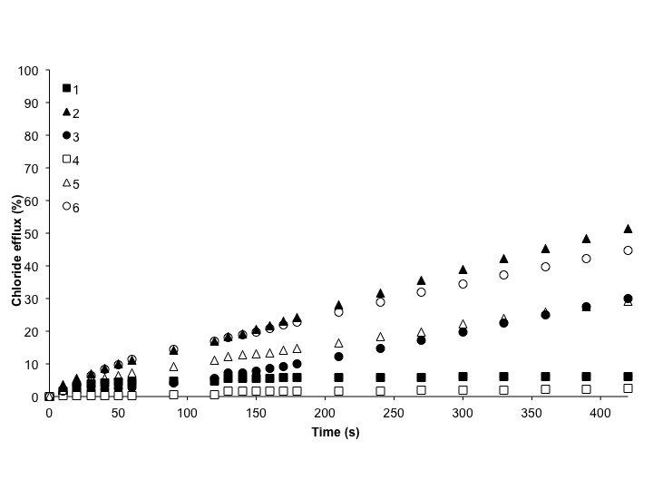

Figure 2: Chloride efflux promoted by a DMSO solution of compound **1-6** (5 mol% receptor concentration versus lipid) from unilamellar POPC vesicles loaded with 451 mM NaCl buffered to pH 7.2 with 20 mM sodium phosphate salts. At t = 120 s a solution of sodium bicarbonate was added such that the external bicarbonate concentration was 40 mM. At the end of the experiment, the vesicles were lysed to calibrate the electrode to 100% efflux. Each point is an average of 3 repeated runs, see ESI for a version of this graph with error bars.

Evidence for a Cooperative Transport Mechanism

Armed with evidence for higher order aggregate formation from the obtained Hill coefficients, we decided to employ the traditional experiments used to examine carrier, channel or pore formation.30 Classic U-Tube experiments were carried out where the membrane is modelled by two aqueous phases separated by an organic phase of nitrobenzene. The donating aqueous phase contained sodium chloride (489 mM, buffered to pH 7.2 with 5 mM sodium phosphate salts), the second, receiving phase contained sodium nitrate (489 mM, buffered to pH 7.2 with 5 mM sodium phosphate salts). The nitrobenzene organic phase contained 1 mM receptor and 1 mM TBAPF6 to act as a counter cation in the transport process. The chloride concentration in the receiving phase was monitored over a period of 96 hours using a chloride selective electrode. The large separation distances between the two aqueous phases rules out transport by a channel or pore formation process and therefore chloride transport observed in this experiment must occur from a mobile carrier transport process. We observed that only with compound **2** was more chloride was transported to the receiving phase than the control (no receptor in the nitrobenzene phase) (see ESI for data). This could suggest that these compounds function best when they are able to aggregate into an activated transporting unit and do not function well solely as mobile carriers. As structurally similar isophthalamides have been shown to function as mobile carriers34, there is no obvious reason to suggest why these compounds cannot function as a 1:1 carrier. However, the fact that the majority of these compounds function poorly in the U-tube suggests that their transport efficiency is greatly enhanced when individual monomers assemble into a higher ordered transporting unit. The slight chloride detection in the receiving phase in the control U-tube can be rationalised by ion-pairing transport. It is unclear why the addition of receptors **1**, **3**, **4-6** to the organic phase caused less chloride efflux than the control.

Further to the U-Tube experiments, we assayed the compounds ability to transport in vesicles composed of POPC:cholesterol (7:3 molar ratio). The presence of cholesterol in the vesicle bilayer decreases membrane fluidity and thus any transport mechanism that relies on diffusion would be expected to show a reduced transport rate under these conditions. We prepared POPC:cholesterol vesicles (7:3 molar ratio) containing sodium chloride (489 mM with 5 mM phosphate buffer, pH 7.2) and suspended them in an external sodium nitrate solution (489 mM with 5 mM phosphate buffer, pH 7.2) so as to be directly comparable to the Cl-/NO­3‑ assays previously run. For all compounds except **2**, we see a dramatic decrease in transport efficiency under these conditions than in POPC vesicles alone (see ESI for comparative plots). As **2** out-performed the other compounds in the U-Tube experiment and the cholesterol tests, perhaps this compound functions predominantly as a mobile carrier, possibly due to lipophilicity reasons (see Table 1).

A decrease in transport efficiency has been used in the past as evidence for a mobile carrier mechanism35, however, it could be argued that if these isophthalamides function by self-assembling into cooperative transporting aggregates, an increase in viscosity in the membrane could be preventing firstly the diffusion of individual monomers into the bilayer, and then secondly, disrupting any stacking interactions between monomers to form the conducting aggregate. Therefore, it is not surprising that we see reduced transport rates under these conditions. Certainly this experiment implies that the rate of diffusion of these monomers into the bilayer is important for transport efficiency, which is probably why the lipophilicity range also seems to play a role in defining the best transporter.

Evidence for Aggregation

Fluorescence experiments have been used previously to show evidence of aggregation, both in water and in phospholipid bilayers.36,37 Therefore, in order to find direct evidence for aggregation within the phospholipid bilayer and as such show evidence for stacking interactions between individual monomers, we performed fluorescence titrations with the anthracene based and intrinsically fluorescent compound **3**. Increasing amounts of **3** were added as methanol solutions into various external media as shown in Figure 3.

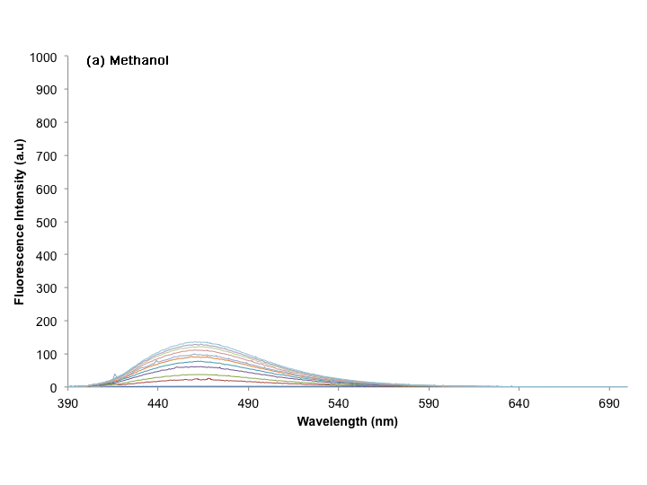

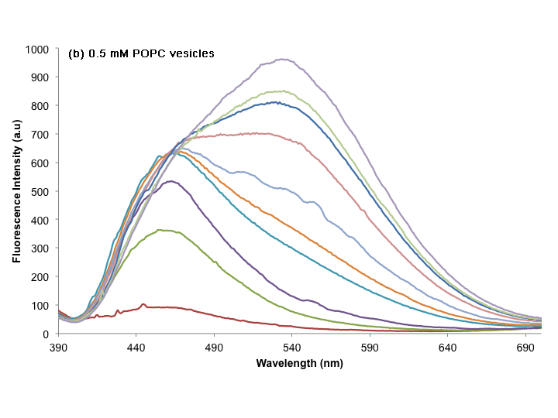

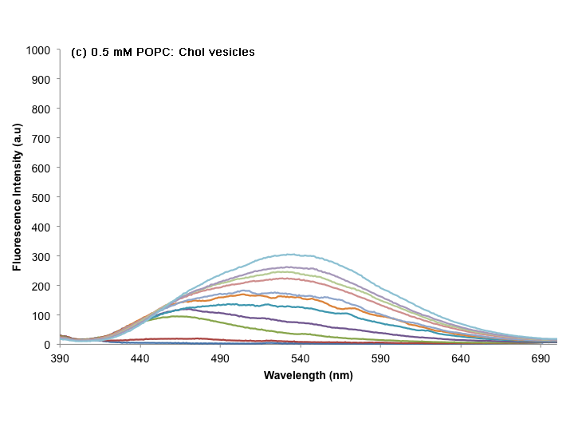

Figure 3: Fluorescence spectra of compound **3** in 10 M increments from 10 M – 100 M excitation wavelength 365 nm, emission wavelength 390-700 nm, 5 nm slits. The compound was added as a methanol solution to a) methanol, b) 0.5 mM unilamellar POPC vesicles suspended in aqueous solution, c) 0.5 mM unilamellar POPC:cholesterol vesicles (7:3 molar ratio) suspended in aqueous solution.

In homogeneous organic solution, the emission peak from the monomeric species of **3** occurs at ~456 nm (Figure 3a). We would not expect to see aggregation in homogenous organic solution, and hence this peak must be that of the compound interacting solely as an individual monomer. Further to this, the fluorescence spectrum of **3** in homogeneous organic solvent is similar to structurally similar analogues we have previously reported.17 When added to aqueous solution, the fluorescence spectra of **3** is shifted and we observe a singular peak centred around ~540 nm (ESI). This peak is formed due to aggregation in aqueous solution most probably due to the formation of excimers. The intensity of these excimer peaks decreases rapidly over time (~1 minute) as the compound precipitates out of solution.

When added to POPC vesicles (0.5 mM suspended in aqueous buffer, pH 7.2 with sodium phosphate salts) in increasing concentrations, we observed a shift from the monomer emission peak at 456 nm (lower concentrations) to the excimer emission peak at 540 nm (higher concentrations) (Figure 3b). The intensity of the emission spectra in vesicles is stronger at all concentrations tested than in methanol alone, which is consistent with other compounds which have been suggested to aggregate in lipid membranes.13 The shift from monomer emission to excimer emission as concentration increases implies that this compound is entering the lipid bilayer and then aggregating in the vesicles. To determine whether the excimer peak observed was formed due to aggregation in aqueous solution or in the phospholipid bilayer, we performed kinetic experiments that showed no change in the emission intensity of the monomer or excimer peaks over a 10-minute period (longer than any of the transport experiments run, see ESI for data). When the compound is first added to the lipid vesicles in solution, a spike of the excimer peak is observed, that is presumably due to the compound aggregating in the aqueous media. This spike of excimer emission rapidly decreases and the excimer and monomer emission peaks remain constant for the 10-minute duration of the experiment. This suggests the compound rapidly enters and aggregates in the lipid bilayer and diffusion into the membrane does not happen over a period of time as has been suggested for some self-assembled, aggregated pores.37

It is important to note that the fluorescence studies conducted herein are not directly comparable to the transport studies conducted. This is because the concentrations of receptor used in the fluorescence studies are higher than the concentrations used in the transport assays as high receptor concentrations are required to show significant aggregation in the fluorescence studies and high receptor concentrations in the transport studies were not. Nonetheless, the fact that evidence of aggregation in the lipid bilayer can be detected is still significant. This provides evidence that in the POPC bilayer π-π stacking interactions are occurring which supports the observed Hill coefficients and the hypothesis that transport is occurring *via* a cooperative transport mechanism.

To test the hypothesis that the presence of cholesterol in the POPC bilayer is hindering either partitioning of the compound into the membrane or self-assembly of the compound into an aggregated pore, we repeated the fluorescence titration in vesicles composed of POPC:cholesterol (0.5 mM 7:3 molar ratio, suspended in aqueous buffer, pH 7.2 with sodium phosphate salts). Interestingly we found that under the same conditions as the other titrations in this study, the spectra in the cholesterol containing vesicles are less intense for both the monomer emission and the excimer emission peak (Figure 3c). This suggests that under these conditions, aggregation in the lipid bilayer is less favourable. This could provide a reason as to why we observed a dramatic decrease in transport efficiency for this compound in POPC:cholesterol vesicles. Cholesterol is a non-aromatic compound and therefore would not be expected to contribute to any stacking interactions. It may however be possible that the less intense aggregation observed in this study is a consequence of hindered partitioning into the membrane as a result of decreased membrane fluidity and not of fewer stacking interactions in the membrane. As the compound is added to the vesicles externally, we would expect hindered partitioning into the lipid bilayer from individual monomeric units under these conditions. This could provide an explanation as to why the monomeric peaks are less intense in this titration than in the POPC vesicles alone. Perhaps the true explanation for this phenomenon is a complicated mixture of both hypotheses.

In order to examine further lesser cooperativity in more viscous lipid environments, we performed Hill analysis for **3** in POPC:cholesterol vesicles (see ESI for plot and calculations). Here we found not only had the EC50 dramatically increased (as expected) to 16.47 mol% but also, most importantly, the Hill coefficient decreases from 3.2 in POPC vesicles to 1.5 in POPC:cholesterol vesicles. This suggests the degree of cooperativity with the presence of cholesterol in the bilayer and that the Hill coefficient is tending towards n=1, which could mean that the only transport observed here is Cl-/NO3- antiport, mediated by monomers of **3** acting mostly as a mobile carriers. This could suggest that although these compounds can function as mobile carriers (albeit poorly), transport is greatly increased when compounds are acting cooperatively.

Conclusions

We have reported the anion binding and transport properties of a series of increasingly aromatic isophthalamides. We see that in the solution state, all compounds bind to tetrabutylammonium chloride and tetraethylammonium bicarbonate within similar orders of magnitude. Anion transport studies using POPC vesicles showed that these transporters function mainly as anion/anion antiporters. Hill analysis showed that in general Hill coefficients increase with increased number of individual aromatic rings on the molecule. This implies that the more aromatic the compound is, the higher the degree of aggregation in the lipid bilayer. Further to this, the more aromatic isophthalamides tend to be the most efficient transporters. We observed evidence of aggregation in the lipid bilayer through fluorescence studies, which showed the presence of an aggregated ‘excimer’ peak in POPC lipid that is not present in homogenous organic solvent but also noted that this observed aggregation was detected at higher concentrations than the transport studies. Finally, we observed reduced transport rates in vesicles which contain POPC:cholesterol. We hypothesised that the presence of cholesterol in the lipid bilayer could have prevented the diffusion and assembly of individual monomers into its active transporting unit. We observed lower aggregation intensities in the fluorescence spectra conducted in POPC:cholesterol vesicles and a Hill plot in POPC:cholesterol vesicles showed the Hill coefficient tends towards 1 under these conditions. Although hindered partitioning into the lipid bilayer would also cause less intense fluorescence spectra, this is still evidence to suggest that this compound functions as a self-assembled anion conducting aggregated unit within the phospholipid bilayers. Although the true transport mechanism is clearly very complicated and might be a mixture of cooperative and mobile carrier function, this work may prove useful in aiding the design of more potent transporters which function by self-assembling into transmembrane transporting pores, a feature which may be desirable in the treatment of biological diseases.

**Acknowledgements**

We thank the EPSRC (EP/J009687/1) for funding (NB). PAG thanks the Royal Society and the Wolfson Foundation for a Research Merit Award. SNB thanks the University of Southampton and A*STAR for funding. We thank the Royal Society of Chemistry and the Nuffield Foundation for a summer studentship (CLF).

Notes and references

*a* Chemistry, University of Southampton, Southampton, SO17 1BJ, UK. E-mail: philip.gale@soton.ac.uk

Electronic Supplementary Information (ESI) available: Synthesis and characterisation of new compounds **2** and **5** and characterisation spectra for all compounds; experimental details for ion-selective electrode transport studies including electrode calibration techniques, additional transport studies and Hill plots; experimental and analysis details for 1H NMR titrations; U-tube transport data; experimental details and additional spectra for fluorescence studies. See DOI: 10.1039/b000000x/

1. F. M. Ashcroft, *Ion Channels and Disease*, Academic Press, San Diego, 2000.

2. N. Busschaert and P. A. Gale, *Angew. Chem. Int. Ed. Engl.*, 2013, **52**, 1374–1382.

3. P. A. Gale, R. Pérez-Tomás and R. Quesada, *Acc. Chem. Res.*, 2013, **46**, 2801–2813.

4. S. Matile, A. Vargas Jentzsch, J. Montenegro and A. Fin, *Chem. Soc. Rev.*, 2011, **40**, 2453–2474.

5. K. Kavallieratos, S. R. de Gala, D. J. Austin and R. H. Crabtree, *J. Am. Chem. Soc.*, 1997, **119**, 2325–2326.

6. C. R. Bondy and S. J. Loeb, *Coord. Chem. Rev.*, 2003, **240**, 77–99.

7. S. O. Kang, R. A. Begum and K. Bowman-James, *Angew. Chem. Int. Ed. Engl.*, 2006, **45**, 7882–7894.

8. (a) P. V Santacroce, J. T. Davis, M. E. Light, P. A. Gale, J. C. Iglesias-Sanchez, P. Prados and R. Quesada, *J. Am. Chem. Soc.*, 2007, **129**, 1886–1887; (b) P. A. Gale, J. Garric, M. E. Light, B. A. McNally, B. D. Smith, *Chem Commun.*, 2007, **17**, 1736-1738.

9. P. A. Gale, *Acc. Chem. Res.*, 2011, **44**, 216–226.

10. J. L. Atkins, M. B. Patel, M. M. Daschbach, J. W. Meisel and G. W. Gokel, *J. Am. Chem. Soc.*, 2012, **134**, 13546–13549.

11. X. Li, B. Shen, X.-Q. Yao and D. Yang, *J. Am. Chem. Soc.*, 2007, **129**, 7264–7265.

12. B. Shen, X. Li, F. Wang, X. Yao and D. Yang, *PLoS One*, 2012, **7**, e34694.

13. C. R. Yamnitz, S. Negin, I. A. Carasel, R. K. Winter and G. W. Gokel, *Chem. Commun.*, 2010, **46**, 2838–2840.

14. A. P. Davis, D. N. Sheppard and B. D. Smith, *Chem. Soc. Rev.*, 2007, **36**, 348–357.

15. S. Bhosale, A. Sisson, N. Sakai and S. Matile, *Org. Biomol. Chem.*, 2006, **4**, 3031-3039.

16. S. Bhosale and S. Matile, *Chirality*, 2006, **18**, 849–856.

17. S.J. Brooks, C. Caltagirone, A. Cossins, P.A. Gale and M.E. Light, *Supramol. Chem.*, 2008, **20**, 349–355.

18. J. P. Larocca and M. A. Y. Sharkawi, *J. Pharm. Sci.*, 1967, **56**, 916–918.

19. M. P. Hughes and B. D. Smith, *J. Org. Chem.*, 1997, **62**, 4492–4499.

20. R. Santi, F. Bergamini, A. Citterio, R. Sebastiano and M. Nicolini, *J. Org. Chem.*, 1992, **57**, 4250–4255.

21. Y. J. Im, K. Y. Lee, T. H. Kim and J. N. Kim, *Tetrahedron Lett.*, 2002, **43**, 4675–4678.

22. M. J. Hynes, *J. Chem. Soc. Dalton Trans.*, 1993, 311-312.

23. K. Kavallieratos, C. M. Bertao and R. H. Crabtree, *J. Org. Chem.*, 1999, **64**, 1675–1683.

24. I. V Tetko, J. Gasteiger, R. Todeschini, A. Mauri, D. Livingstone, P. Ertl, V. A. Palyulin, E. V Radchenko, N. S. Zefirov, A. S. Makarenko, V. Y. Tanchuk and V. V Prokopenko, *J. Comput. Aided. Mol. Des.*, 2005, **19**, 453–463.

25. H. Valkenier, C. J. E. Haynes, J. Herniman, P. A. Gale and A. P. Davis, *Chem. Sci.*, 2014, **5**, 1128-1134.

26. V. Saggiomo, S. Otto, I. Marques, V. Félix, T. Torroba and R. Quesada, *Chem. Commun.*, 2012, **48**, 5274–5276.

27. A. V. Hill, *Biochem. J.*, 1913, 7, 471-480.

28. J. T. Davis, P. A. Gale, O. A. Okunola, P. Prados, J. C. Iglesias-Sánchez, T. Torroba and R. Quesada, *Nat. Chem.*, 2009, **1**, 138–144.

29. N. Busschaert, L. E. Karagiannidis, M. Wenzel, C. J. E. Haynes, N. J. Wells, P. G. Young, D. Makuc, J. Plavec, K. A. Jolliffe and P. A. Gale, *Chem. Sci.*, 2014, **5**, 1118-1127.

30. N. Busschaert, M. Wenzel, M. E. Light, P. Iglesias-Hernández, R. Pérez-Tomás and P. A. Gale, *J. Am. Chem. Soc.*, 2011, **133**, 14136–14148.

31. E. Cordat and J. R. Casey, *Biochem. J.*, 2009, **417**, 423-239.

32. S. J. Moore, C. J. E. Haynes, J. González, J. L. Sutton, S. J. Brooks, M. E. Light, J. Herniman, G. J. Langley, V. Soto-Cerrato, R. Pérez-Tomás, I. Marques, P. J. Costa, V. Félix and P. A. Gale, *Chem. Sci.*, 2013, **4**, 103-117.

33. J. L. Seganish and J. T. Davis, *Chem. Commun.*, 2005, 5781–3.

34. P. A. Gale, J. Garric, M. E. Light, B. A. McNally and B. D. Smith, *Chem. Commun.*, 2007, **48**, 1736–1738.

35. C. Kirby, J. Clarke and G. Gregoriadis, *Biochem. J.*, 1980, **186**, 591–598.

36. J. M. Moszynski and T. M. Fyles, *Org. Biomol. Chem.*, 2010, **8**, 5139–5149.

37. J. M. Moszynski and T. M. Fyles, *J. Am. Chem. Soc.*, 2012, **134**, 15937–15945.