Running head: SPEED OF REJECTION IN VISUAL SEARCH

Faster than the speed of rejection: Object identification processes during visual search for multiple targets

# Hayward J. Godwin1, Stephen C. Walenchok2, Joseph W. Houpt3, Michael C. Hout4 and

# Stephen D. Goldinger2

1University of Southampton

2Arizona State University

3Wright State University

4New Mexico State University

Author Note

Correspondence regarding this article should be addressed to Hayward J. Godwin, University of Southampton, School of Psychology, Highfield, Southampton, Hampshire, SO17 1BJ. Tel: +44(0)2380 595078; Email: [hayward.godwin@soton.ac.uk](mailto:hayward.godwin@soton.ac.uk).

Abstract

When engaged in a visual search for two targets, participants are slower and less accurate in their responses, relative to their performance when searching for singular targets. Previous work on this “dual-target cost” has primarily focused on the breakdown of attention guidance when looking for two items. Here, we investigated how object identification processes are affected by dual-target search. Our goal was to chart the speed at which distractors could be rejected, in order to assess whether dual-target search impairs object identification. To do so, we examined the *capacity coefficient*, which measures the speed at which decisions can be made, and provides a baseline of parallel performance against which to compare. We found that participants could search at or above this baseline, suggesting that dual-target search does not impair object identification abilities. We also found substantial differences in performance when participants were asked to search for simple versus complex images. Somewhat paradoxically, participants were able to reject complex images more rapidly than simple images. We suggest that this reflects the greater number of features that can be used to identify complex images, a finding that has important consequences for understanding object identification in visual search more generally.

*Acknowledgements:* H.J.G was supported by funding from the Economic and Social Sciences Research Council (grant ref. ES/I032398/1). J.W.H. was supported by the United States Air Force Office of Scientific Research (FA9550-13-1-0087). S.W. and S.D.G. were supported by NICHD grant 1R01HD075800-01.

*Keywords*: visual search, capacity coefficient, dual-target search

When searching for visual targets, people are able to reject non-target objects with remarkable speed. For example, suppose that you are searching for your car in a busy parking lot. When doing so, you are able to very rapidly reject dozens of potential cars in the area as not being your own. Part of this speed can be attributed to *guidance* (Wolfe, Cave, & Franzel, 1989), the process by which resources (attention, overt eye movements) are focused upon objects that could be the target. In practice, this involves searchers primarily examining objects that share visual (Becker, 2011; Luria & Strauss, 1975; Stroud, Menneer, Cave, & Donnelly, 2012) and semantic (Godwin, Hout, & Menneer, 2014; Schwarz & Eiselt, 2012) similarity to the target (Duncan & Humphreys, 1989), such as directing attention only to blue cars if your car is blue. Guidance processes save time and resources by enabling observers to ignore (or quickly discard) large numbers of target-dissimilar objects without detailed examination. When your attention lands on target-similar objects (e.g., such as a particular blue car), you then utilize finer-grained object identification processing to determine whether you have found the intended target (Kotowicz, Rutishauser, & Koch, 2010; Wolfe, 2007). You may use an array of diagnostic features, encapsulated in a “target template” (Duncan & Humphreys, 1989; Hout & Goldinger, 2014) to identify your own car. These features can range from major to minor, such as the precise color (e.g., light blue versus dark blue), the model of car, hood ornaments, fuzzy dice hanging from the rear-view mirror, and so on. You rely upon these individuating features to make a definitive identification.

Now, imagine that you are also searching for a second car: You and a friend are leaving a sporting event at a big arena, and neither of you remember where you parked. You decide to help one another by searching for both cars simultaneously. Compared to searching only for your vehicle, you will now have a longer list of diagnostic features that need to be considered when accepting or rejecting cars as being one of your targets. In the present study, we examined this type of scenario, asking the question: How does the visual system decide whether a given object is one of two potential targets? To address this question, we explored the speed at which distractors could be rejected in a simple image detection task. Rejection speed is a useful metric of identification processes since it measures the time taken to determine that a distractor is not *either* of two targets.

**Searching for Multiple Targets**

Although early work on multiple target search found that participants could readily search for as many as ten ‘overlearned’ alphanumeric targets simultaneously (Kaplan & Carvellas, 1965; Neisser, Novick, & Lazar, 1963), more recent work suggests that searching for two targets leads to a *dual-target cost*. Compared to single-target baselines, participants searching for two targets are slower and less accurate (Menneer et al., 2012; Menneer, Barrett, Phillips, Donnelly, & Cave, 2004, 2007; Stroud, Menneer, Cave, Donnelly, & Rayner, 2011), and this penalty cannot be eliminated with practice (Menneer, Cave, & Donnelly, 2009). Examinations of participants’ eye movements reveal that this is (at least in part) due to guidance breaking down in dual-target search (Hout & Goldinger, 2012; Menneer, Stroud, Cave, Donnelly, & Rayner, 2008). In comparison with single-target baselines, when searching for two targets, participants not only fixate objects that are similar to both targets, but also fixate objects that are *not* similar to either target.

An important question that arises from studies of multiple-target search, and one which is still under active debate, is whether multiple-target search leads to the creation of a search template with distinct target representations, or with single, unified representations. To address this question, Stroud, Menneer, Cave and Donnelly (2012) examined eye movements as participants performed single- and dual-target search for items defined by their color. The color difference between the two targets was varied systematically: When the colors were similar to each other (estimated via distance in RGB color space), there was no dual-target cost in performance, relative to single-target baselines. However, when the target colors were dissimilar, the cost once again emerged. Stroud et al. concluded that, when potential targets differ from each another, it is possible for two discrete representations to guide search simultaneously. Similar conclusions have recently been drawn from studies using alternative approaches (Barrett & Zobay, 2014; Beck, Hollingworth, & Luck, 2012).

The foregoing studies primarily focused upon how multiple visual working memory representations influence guidance during visual search. Guidance is important for placing one’s attention in locations that are likely to contain the target. But a second component is essential for efficient search behavior: Namely, object identification and decision-making processes – i.e., the route by which targets are detected and distractors are rejected (e.g., Wolfe, 2007). These have also been described in terms of being *scanning* and *detection* components (Moore & Osman, 1993), as well as *perceptual selection* and *perceptual identification* components (Cain, Adamo, & Mitroff, 2013; Godwin, Menneer, Riggs, Cave, & Donnelly, in press; Schwark, MacDonald, Sandry, & Dolgov, 2013).

In the present experiments, our goal was to explore such object identification processes in detail. Previous studies have shown that object identification can begin prior to the direct fixation (or directing of attention) to an object (Deubel & Schneider, 1996; Godwin, Benson, & Drieghe, 2013; Townsend, 1972). To accommodate this fact, we presented participants with trials containing only a single image, whereupon they were to quickly indicate whether each image was a target or a distractor. This enabled us to be certain that we were accurately gauging the speed of rejection when searching for multiple targets. A similar approach has been taken in previous studies that have also tested whether two targets can be searched for when embedded within rapid serial visual presentation (RSVP) streams. However, these studies have revealed conflicting results. Houtkamp and Roelfsema (2009), for example, found that response accuracy was reduced when people searched for dual targets in RSVP, relative to searching for a single target, and concluded that object identification processes were effectively limited to detecting only one target at any point in time. Conversely, Roper and Vecera (2012) also asked participants to search for targets within RSVP streams, but found that participants could, when instructed to do so, search for two targets simultaneously.

Here, we sought to resolve the conflicting findings of these previous studies by adopting a somewhat different approach. At the core, the question of whether a person can use object identification processes to compare a single object with one of two potential targets can be conceptualized in terms of *parallel* versus *serial* comparisons. In the parallel case, the to-be-identified object is compared in parallel to the target templates held in working memory. In the serial case, the to-be-identified object is compared to the target templates in a serial manner (Moore & Osman, 1993), which tends to be more limited capacity than parallel comparisons (although see Townsend & Nozawa, 1997). Rather than focus on response accuracy as in previous studies, in the present experiments, we examined RTs to reject non-targets. In doing so, we grounded our analyses in an existing framework and methodology for examining RT distributions and determining the degree to which participants were engaged in parallel comparisons: specifically, we used the *capacity coefficient* (Houpt & Townsend, 2012; Townsend & Nozawa, 1995; Townsend & Wenger, 2004).

**The Capacity Coefficient**

**Background**

A long-standing problem with examining the type of processing taking place in any given task is that parallel and serial processing can be difficult to distinguish from one another (Townsend, 1990). Indeed, in visual search tasks, it has been noted that search slopes that increase as a function of set size – which were described as evidence of ‘serial’ search (Treisman & Gelade, 1980) – could readily be produced by limited-capacity parallel processing (Townsend, 1972). The capacity coefficient (as well as the framework that is used to interpret the coefficient) aids us in distinguishing between the degree to which information-processing is parallel. The capacity coefficient has been used to examine a wide range of cognitive tasks, including face perception (Townsend & Wenger, 2004), threat detection (Richards, Hadwin, Benson, Wenger, & Donnelly, 2011), word identification (Houpt, Townsend, & Donkin, 2014), and attentional selection (McCarley, Mounts, & Kramer, 2007).

The starting point for the capacity coefficient is to determine an appropriate baseline that can be used for subsequent comparisons of serialism versus parallelism. It is here that the capacity coefficient and its framework provide an important first insight: Suppose we take a search task wherein participants search for single targets and compare its RTs to a search task wherein participants search for two targets. At the outset, we *expect* participants to be slower to respond in target-absent trials when searching for two targets, relative to searching for a single target. This should not be taken as evidence, however, that object identification is unable to handle dual-target search in parallel, or that object identification is impaired in dual-target search. The reason that we expect RTs in target-absent trials to be slower in dual-target search is that waiting for two random processes to finish (as in dual-target search) will require more time to complete than a single random process takes to finish(e.g,. Colonius & Vorberg, 1994). In other words, in dual-target search, the perceptual system is effectively assessing the question “*Is this object Target A?*”,as well as “*Is this object Target B?*” Because both of these questions will take varying time to answer, even if they are being answered in parallel, it is expected that waiting for both answers – which is required for a ‘target-absent’ response – will take more time than just asking “*Is this object Target A?*” or “*Is this object Target B?*” alone. This is a well-known statistical phenomenon, and, from the outset, it should be noted that this expectation in terms of the time required to complete two processes versus just one process is built on the notion that the two processes, when operating in parallel, are *independent* of one another (i.e., one does not influence the other), and there is no cost or benefit from processing the two together. To prelude the overall pattern of results that we find in the present set of experiments, we find surprising ways in which dual-target search does, in fact, benefit and increase in speed, compared to what would be expected of two, independent parallel processes.

If we expect target-absent RTs to be slower in dual-target search than single-target search, how can we interpret the differences in RTs between the two conditions? The answer is that the capacity coefficient can be used to evaluate the *extent* of the slow-down between single- and dual-target search. The capacity coefficient effectively provides a ratio, taking the time to reject an object as not being Target A and not being Target B in single-target search, and then dividing this value by the time taken to reject Target A and B in dual-target search (a more detailed and rigorous explanation is provided below). With that in mind, given the ratio involved in dividing dual-target RTs by the combination of the two single-target RTs, we can sketch out various possibilities that might be observed in dual-target search. In Figure 1, we present a simulated dataset, and in Figure 2, we present a sketch of how to interpret degrees of parallel/serial comparisons in dual-target search, depending upon the different values of the capacity coefficient.

When the capacity coefficient is at (or near) a value of 1, this means that participants are able to respond in dual-target search at the same level as would be expected if they were searching for the two targets separately. When this occurs, any RT increase in dual-target search can be attributed to the statistical slowdown expected when waiting for two random processes to finish (blue lines of Figure 1). With the capacity coefficient at 1, participants are said to be searching at the *UCIP* baseline (Unlimited Capacity Independent Parallel). In the context of our studies, this would mean that participants were able to reject a given distractor as being neitherof the two targets independently and in parallel. In other words, the speed of comparison for each potential target was independent and was unaffected by a second target was being considered simultaneously. Figure 2 shows schematic processes that may arise during identification of a single object, in this case a teddy bear (on the left) is being implicitly compared to two potential target bears, stored in visual working memory. As shown for the first teddy-bear being examined, two separate parallel processes compare each target to the incoming object.

An alternate possibility is that having to compare an object against two potential targets slows down and impairs processing. If that is the case, then the capacity coefficient should be below1 (see red lines of Figure 1), indicating *limited* capacity. Capacity coefficients below 1 in our studies would indicate that object identification processes took longer to complete than would be expected by the statistical slowdown associated with dual-target search, creating a cost in distractor rejection speed when searching for two targets. Such a cost would arise, for example, if each feature of a candidate image had to be compared to each potential target serially, or in a cascaded fashion (as schematically shown in the second row of Figure 2).

Finally, object identification may be slowed by searching for two targets, but less than would be expectedfor purely statistical reasons. If this occurs, then the capacity coefficient is above 1, indicating *super-capacity* (see green lines of Figure 1). This pattern would indicate that observers could perform better than an unlimited capacity, independent parallel search. Such super-capacity performance could result from taking advantage of any *shared features* across targets, and processing them together. For example, if color could be used to rule out an object as being either potential target (e.g., seeing a red car when neither target car is red), rather than compare color separately for each targets, the visual system might evaluate the color mismatch simultaneously for both targets. This would allow fast rejection of the object under scrutiny, without any cost associated with holding two potential targets in mind. In the bottom row of Figure 2, features of the examined object (e.g., color, shape) are compared to both targets simultaneously, resulting in faster rejection speed, relative to two independent comparisons.

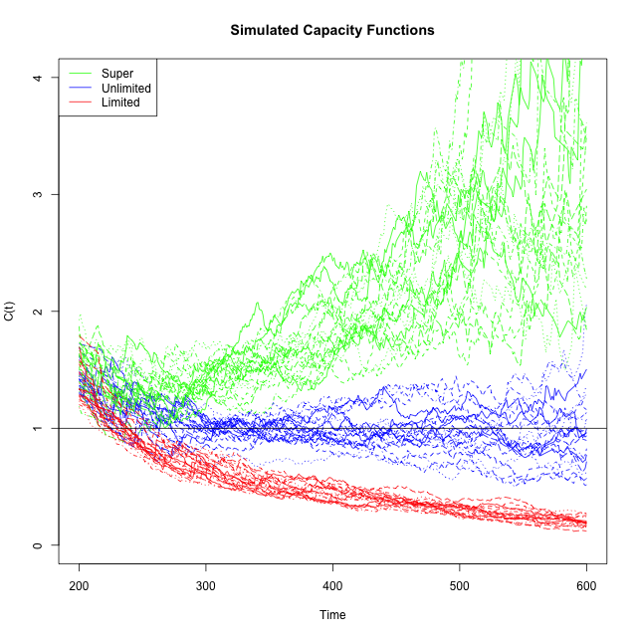

*Figure 1.* Simulated examples of different outcomes using the capacity coefficient measure, including the UCIP baseline (blue), super-capacity (green) and limited capacity (red).

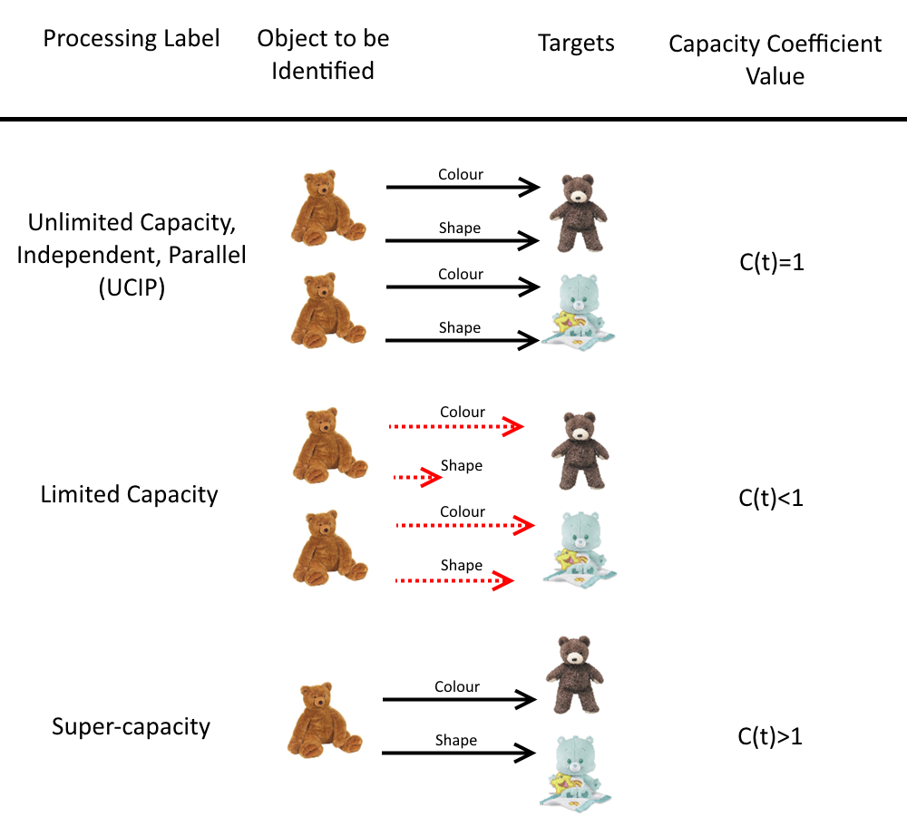

*Figure 2.* Schematic illustration of the processing that can elicit different capacity coefficient values. In the top row, Unlimited Capacity Independent Parallel processing is represented as a single object being identified by two separate processes (one for each target). In the second row, the slowdown in performance associated with limited capacity processing is represented via red dashed lines for sequentially processing of each feature. In the third row, Super-capacity processing is represented as simultaneously appreciating shared features between the two targets, such that any “double mismatch” will increase performance and the capacity coefficient.

**Calculating the Capacity Coefficient**

We will now provide further detail regarding the mathematical basis and conceptual framework surrounding the capacity coefficient. The baseline UCIP model for determining the stimulus is neither of the targets in the two-target block is estimated using RTs from target-absent trials when observers search for a single target. More formally, the baseline UCIP prediction is as follows: For any time *t*, the probability that an observer has determined an object is neither of the targets, , is equal to the product of the probabilities that, when the observer is searching for only one target, he or she would determine that each of the objects is not a target, . Hence, the mathematical equation for the UCIP model is,



The capacity coefficient is measured in terms of cumulative reverse hazard functions, the log of the cumulative distribution functions, . To get the baseline UCIP prediction in terms of the cumulative reverse hazard function, we take the logarithm of the equation above,



To get the UCIP prediction, we estimate  and  using target-absent RTs from single-target search. We then estimate the cumulative reverse hazard function from an observer’s RTs in target-absent trials during dual-target search, and take the ratio of the two,

|  |  |
| --- | --- |
| . | (1) |

From the derivation of the UCIP prediction, we see that, if the observer is able to reject distractors with unlimited capacity, independently and in parallel, then . If an observer has limited capacity and hence takes longer to respond than predicted by the UCIP model, then for a given ,  will be smaller. Because the logarithm is a monotonic function and probabilities are less than one, that means  will be more negative. This means the denominator of  will have a larger magnitude, so  would be less than one. By similar reasoning, we see that super-capacity performance (when the observer is faster to respond that an object is a distractor than predicted by the UCIP model) would lead to  larger than one. These potential outcomes are depicted in Figure 1.

Notice that the baseline of comparison predicts  for the whole time span. In our simulated data, the super-capacity functions are always above 1 and the limited capacity functions are nearly always below 1. The simulations show a bias toward 2 in the earliest range of RTs. The statistical tests deal with this bias by giving essentially no weight to the earliest time range (for details, see Houpt & Townsend, 2013). In our data reported below we do not plot the estimated  functions for the tails of the RT distributions.

More interestingly, the true  can be both above 1 for some range of time and below 1 for another range of time. On a surface level, this means that for some period, the log probability that a participant has responded with two sources of information is higher than that predicted by the model and for another period the ordering is reversed. The deeper question regarding what this crossover means about underlying processing is relatively unexplored. Nevertheless, even without full understanding of variations in  across time, we can still use tools for functional data analysis (e.g., Ramsay & Silverman, 1997), such as functional principle components, to assess variations in the form of the function across conditions (Burns, et al., 2013).

**Experiment 1**

In Experiment 1, our goal was to determine whether object identification processes were slowed when participants searched for two targets, over and above what would be predicted by a UCIP baseline, by using the capacity coefficient. Since previous work involving multiple-target search has found costs to both RTs and accuracy (e.g., Menneer et al., 2007), we anticipated that we would find similar costs to object identification. We predicted that costs to object identification that arose from dual-target search would be evidence in a capacity coefficient of less than 1 (i.e., limited capacity). For half of each experimental session, participants searched for Landolt C targets among Landolt C distractors. In the other half, they searched for teddy bear and butterfly targets among teddy bear and butterfly distractors, testing for generality by using both artificial and real-world stimuli. In order to test our predictions, we compared single-target search conditions to dual-target search. To preview our results, we found evidence of a dual-target cost; when participants looked for two targets, they were slower than when searching for one. But, importantly, searching for a second target did not hinder object identification abilities. This was evidenced by the fact that, when searching for Landolt Cs, participants performed around or only slightly below the UCIP baseline, and when searching for real-world pictures, they operated at super-capacity.

**Method**

**Participants.**

A group of 99 participants from Arizona State University took part in Experiment 1 for course credit. All experimental procedures were approved by the Arizona State University Institutional Review Board, and all participants gave informed consent to participate.

**Apparatus.**

We presented stimuli using 17-in. (43.18-cm) NEC-brand CRT monitors (16.0-in. [40.64-cm] viewable) at a resolution of 1024 × 768 pixels and a refresh rate of 75 Hz. Data were collected on up to seven computers simultaneously, each sharing identical hardware and software profiles (Gateway E4610 PC, 1.8 GHz, 2 GB RAM, each running Windows Vista). Participants responded (“target” or “distractor”) via a response box. The experiment was administered using E-Prime 2.0 stimulus presentation software (Schneider, Eschman, & Zuccolotto, 2012). Modeling and analyses were supported by Mindmodeling@Home (Harris, 2008).

**Stimuli.**

Two objects (per set) were arbitrarily designated Target 1 and Target 2 within both the Landolt C and real-world stimuli conditions, and remained fixed for participants through their particular testing session. For half of the experimental session, participants searched through Landolt C stimuli, and for the other half, they searched through object images, which are described in turn:

*Landolt Cs.* For the Landolt C stimuli, we used Cs as targets and distractors, defined as a conjunction of both a particular orientation and color. The orientation of each target was randomly selected, such that one target was oriented in the horizontal plane (i.e., the gap facing left or right) and the other was oriented in the vertical plane (i.e., the gap facing up or down). The colors were selected from a stimulus set taken from previous studies of dual-target search (Stroud et al., 2012) comprised of 16 colors, with each adjacent color forming equally distant “steps” in color space (see Figure 2). Target colors were randomly selected, with the constraint that they were maximally far apart in color space (i.e., eight “steps”) in order to prevent participants from using combined mental templates of similar colors during search. Distractors were randomly selected from all 62 possible color and orientation combinations (excluding, of course, those that identified the targets). Both targets and distractors subtended approximately 4° × 4° visual angle, from a viewing distance of 45 cm.

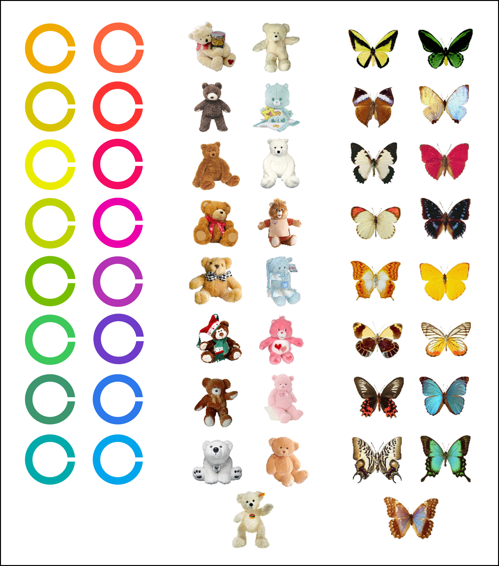

*Figure 3.* Landolt C, teddy bear, and butterfly stimuli.

*Real-world stimuli.* For the real-world stimuli, we used two categories of pictures: Teddy bears and butterflies, with 17 exemplars each (see Figure 3). All pictures came from the ‘‘Massive Memory’’ database (Brady et al., 2008, cvcl.mit.edu/MM/stimuli.html; see also Hout, Goldinger, & Brady, 2014). One exemplar was randomly selected from each category to be used as a target, and the remaining 16 stimuli from both categories were used as distractors. As before, both targets and distractors subtended approximately 4° × 4° visual angle, from a viewing distance of 45 cm.

**Design and Procedure.**

All participants took part in both the Landolt C and real-world stimuli conditions; the order of these conditions was counterbalanced between participants. Each condition consisted of three blocks of trials, the order of which was also counterbalanced. In one block, participants searched for Target 1, in a second block, they searched for Target 2, and in a dual-target block they searched for both simultaneously.

In the Landolt C condition, distractors were always other Cs of various color and orientation combinations. In the single-target blocks of real-world stimuli, participants searched for a target teddy bear among teddy bear distractors, or a butterfly among butterfly distractors, respectively. In the dual-target block, participants searched for both designated teddy bear and butterfly targets among teddy bear and butterfly distractors. These distractors consisted of an equal number of teddy bears and butterflies (16 exemplars of each). There were 600 total trials in each condition, broken down into 200 trials per block. Targets were presented in 25% of trials (50 trials) in each single-target search block. In the dual-target block, each target was presented in 12.5% of trials, leading to an overall prevalence rate of 25% (25 trials per target in the dual-target block).

Each participant completed 12 practice trials at the beginning of each condition—e.g., before beginning the Landolt C condition, they were given four practice trials representing each single-target block and four representing the dual target block. At the beginning of each block, participants were shown images of the target(s) and were instructed to hold the target(s) in memory. Due to the similar colors shared by some target and distractor Landolt Cs, the precise color identities were emphasized at the beginning of each block in all experiments (see Figure 4).

Each trial began with an image in the center of the display, and participants were instructed to respond using the appropriate button for “target” or “distractor” as quickly and as accurately as possible. Participants were given unlimited time to respond. After each response, a multi-colored mask was presented for a random interval between 300 and 600 ms before the onset of the next trial. The purpose of this random interval was to prevent participants from falling into a rhythmic pattern of pressing the “distractor” response button (e.g., see Fleck & Mitroff, 2007), thus reducing the possibility of motor errors. Following incorrect responses, participants received error feedback (a buzzer sound presented through headphones).

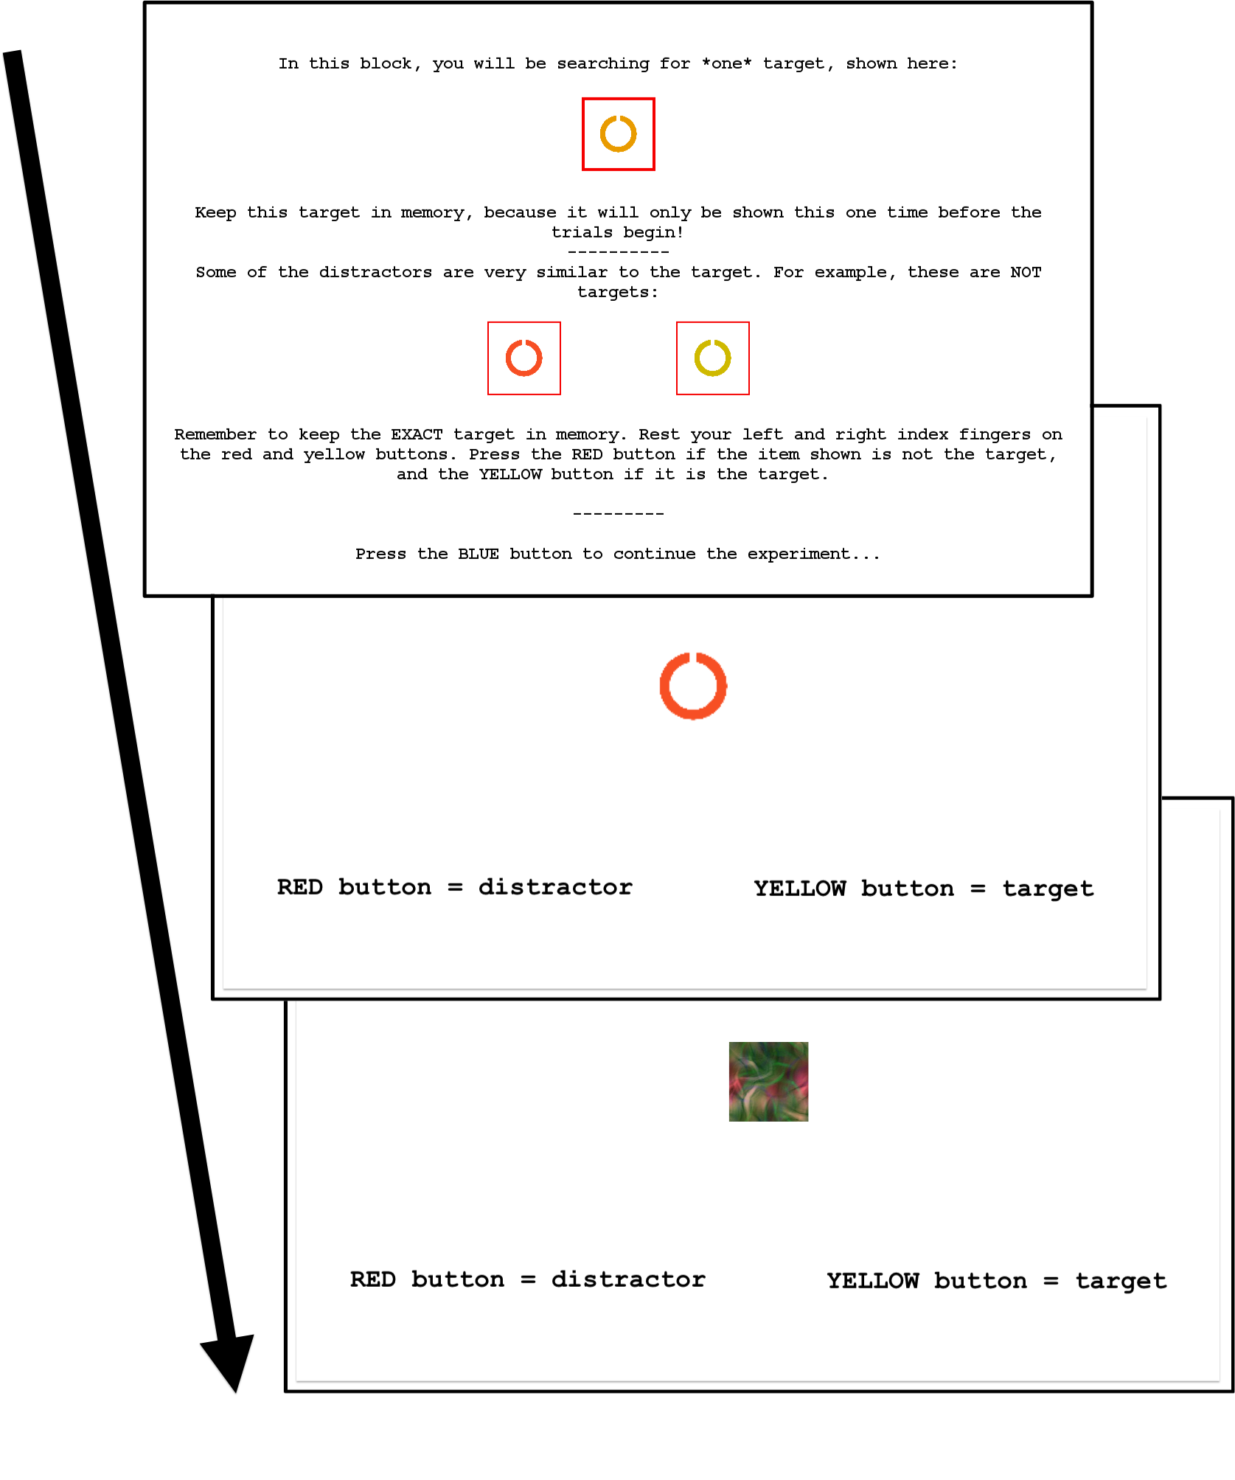

*Figure 4.* Instruction screen at the onset of each block, and the sequence of events in a trial.

**Results**

Seven participants were excluded from analysis due to overall low accuracy or slow RTs (> 2.5 *SD*s above or below the mean), for a total of 92 participants retained (47 males). Response accuracy was high overall (95% correct for Landolt Cs and 96% correct for real-world stimuli); as planned, our analyses therefore focused on RTs and their corresponding capacity coefficients. There was no evidence of a speed**-**accuracy trade-off.

**Analytic Approach**

The data were analyzed using R (R Development Core Team, 2013) with the *sft* package (Houpt, Blaha, McIntire, Havig, & Townsend, 2014), and the *BayesFactor* package (Rouder & Morey, 2014). Early uses of the capacity coefficient involved counting the number of participants at, above, or below the UCIP baseline to make comparisons between conditions and groups (e.g., Eidels, Townsend, & Pomerantz, 2008; Ingvalson & Wenger, 2005). More recent work has developed statistical tools and methods necessary to conduct formal statistical analyses of capacity coefficient functions (Burns, Houpt, Townsend, & Endres, 2013; Houpt & Townsend, 2012), and we used these methods to analyze our dataset.

In both Experiments 1 and 2, we used a Bayesian framework for data analysis wherever possible (e.g., Gelman et al., 2013), using Bayes Factors derived from Bayesian *t*-tests (Rouder, Speckman, Sun, & Morey, 2009) and Bayesian ANOVAs (Rouder, Morey, Speckman, & Province, 2012) to compare conditions. When interpreting the results, we followed convention, adopted from Jeffreys (1961): We interpreted Bayes Factors between 1 and 3.2 as *scarce* evidence against the null hypothesis; values between 3.2 and 10 as *substantial* evidence; values between 10 and 100 as *strong* evidence; and values > 100 as *decisive* evidence.

We analyzed the data in three stages. First, to determine whether there was an overall RT cost when participants were asked to search for two targets, relative to one target, we compared RTs for single- versus dual-target search. Second, we examined capacity coefficients at a group level. Finally, to gain fine-grained insights into the observed capacity coefficients, we examined capacity coefficients at the individual participant level.

**Response Times: Replicating the Dual-target Cost**

We examined RTs for participants in both conditions, testing whether we replicated the dual-target cost (e.g., Menneer et al., 2009). The effects of Condition (Landolt C vs. Butterfly-Bear), Search Type (single- vs. dual-target), and Object Type (target vs. distractor) were analyzed using a Bayesian version of repeated-measures ANOVA (Rouder & Morey, 2014). Bayes factors were calculated for:

1. The full model, including main effects, all two-way interactions and the three-way interaction.
2. A model for each subset of the two-way interactions and all main effects.
3. A model for each subset of the main effects.

Bayes Factors indicated that there were two-way interactions between Search Type and Condition and between Object Type and Condition along with main effects of Search Type, Condition and Object Type (BF ≥ 976 over all other models; BF=2.05x101148 over a model with only Participant as a factor). In the Bayesian ANOVA, cell means (in this case, the mean RTs from different conditions) are expressed as posterior estimated values, with confidence intervals assigned to each estimate (cf. Gelman et al., 2013). The mean RTs calculated directly from the data are shown in Figure 5, along with the 95% highest probability density region (HPD) for each. The mean posterior estimates and 95% HPD of the parameters in the best-fitting model are given in Table 1.[1]

To test for a dual target cost in the RTs, we compared the best model, which differentiated between the single- and dual-target conditions, to the best model that did not allow for different RTs as a function of the number of targets (this model included Object Type, Condition, and their interaction). This comparison indicated decisive evidence for an effect of single versus dual target conditions (BF=7.34x10493).

To test whether RTs to real-world stimuli were different from RTs to Landolt Cs, we compared the best model, which included a factor for Condition, to the best model that did not include Condition (main effects of search type and condition, but no interaction). This test indicated decisive evidence for an effect of Condition (BF= 4.98x10225).

We tested for a difference in RTs between target-present trials and target-absent trials by comparing the best model, which included a factor for presence/absence, to the best model that did not account for target presence/absence (Condition, Search Type and an interaction). There was decisive evidence for an effect of presence/absence on RTs (BF=4.73x10550), with absent trials exhibiting more rapid RTs than present trials.

It is important to note that, in the present experiments, the dual-target cost cannot be attributed to failures in attentional guidance (Stroud et al., 2012, 2011), as there was only one object centrally presented per trial. As shown in Figure 5, the dual-target cost was more substantial when participants were searching for Landolt Cs, a point to which we return later. The observed RT costs in distractor rejection were expected, even if object identification processes were not impaired by searching for two targets. As outlined above, rejecting distractors is expected to be slower in dual-target search for purely statistical reasons (Colonius & Vorberg, 1994), since the rejection decision must wait for two stochastic processes to complete, rather than just one (as is the case in single-target search). To resolve this issue, for the remaining analyses, we utilized the capacity coefficient, which accounts for statistical slow-down, to compare the speed of distractor rejection against the UCIP baseline.

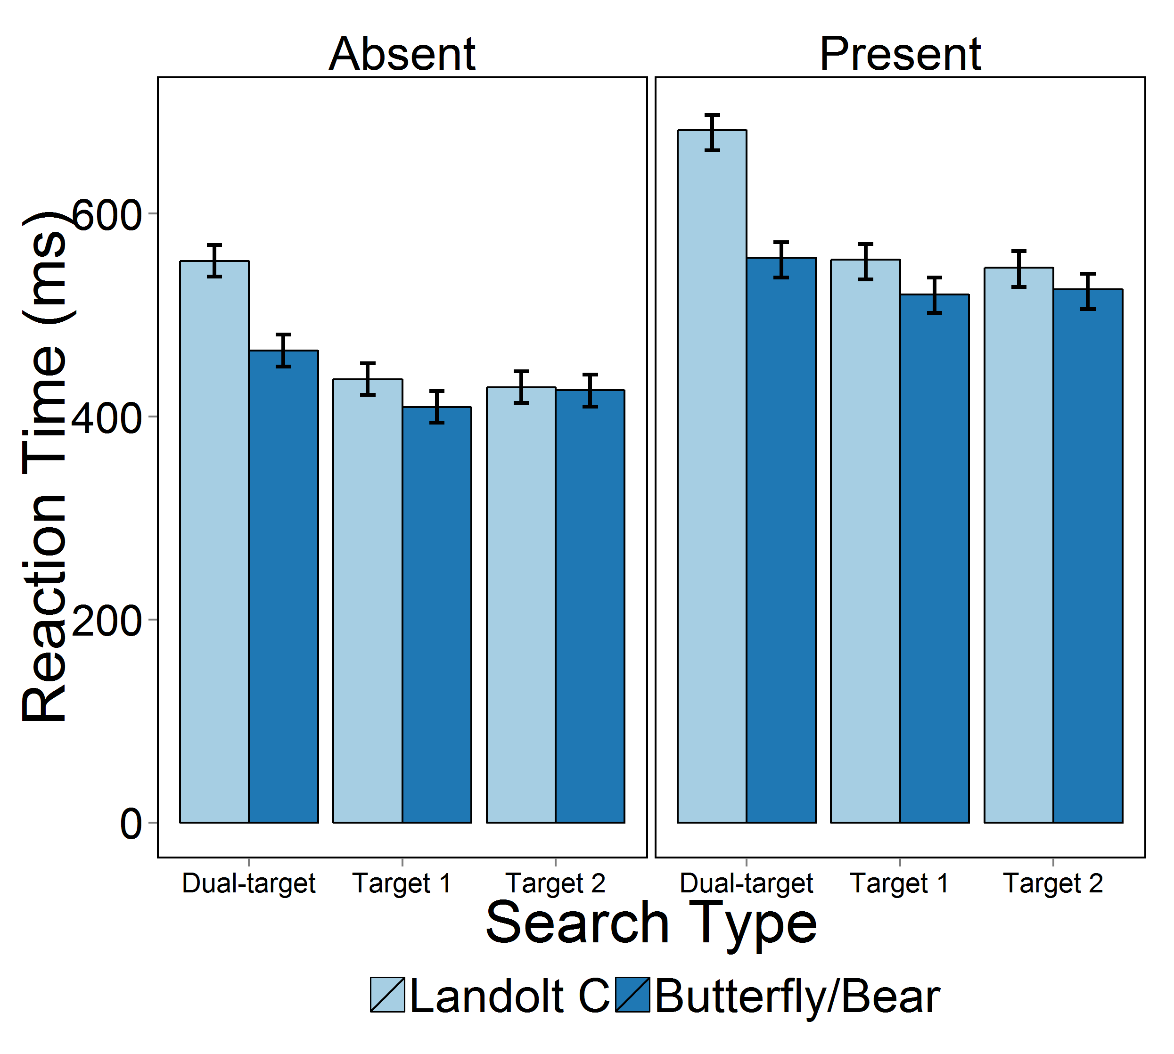

*Figure 5.* Group mean RTs for Experiment 1, broken down by target Presence (Absent and Present shown in the left and right panels, respectively), and Search Type (Dual-target, Target 1, Target 2). Error bars indicate 95% credible intervals.

**Table 1.**

Mean Posterior Estimates and 95% HPD of the Parameters for the Bayesian ANOVA of the RTs in Experiments 1.

|  |  |  |  |
| --- | --- | --- | --- |
|  |  |  |  |
| Parameter | Mean | 2.5% | 97.5% |
|  |  |  |  |
| Grand Mean | 507.8 | 492.5 | 522.9 |
| Two Targets | 55.7 | 53.2 | 58.2 |
| Single Target 1 | -29.3 | -31.8 | -26.7 |
| Single Target 2 | -26.4 | -28.9 | -23.9 |
| Bear/Butterfly | -24.9 | -27.0 | -22.8 |
| Landolt C | 24.9 | 22.8 | 27.0 |
| Target | 54.5 | 52.4 | 56.6 |
| Distractor | -54.5 | 56.6 | 52.4 |
| Two Target × Bear/Butterfly | -26.2 | -28.7 | -23.7 |
| Two Target × Landolt C | 26.2 | 23.7 | 28.7 |
| Target 1 × Bear/Butterfly | 7.8 | 5.3 | 10.3 |
| Target 1 × Landolt C | -7.8 | -10.3 | -5.3 |
| Target 2 × Bear/Butterfly | 18.4 | 15.9 | 20.9 |
| Target 2 × Landolt C | -18.4 | -20.9 | -15.9 |
| Distractor × Bear/Butterfly | 5.1 | 3.1 | 7.2 |
| Target × Bear/Butterfly | -5.1 | -7.2 | -3.1 |
| Distractor × Landolt C | -5.1 | -7.2 | -3.1 |
| Target × Landolt C | 5.1 | 3.1 | 7.2 |

**The Capacity Coefficient: Group Performance**

Our analyses of the capacity coefficient focused on comparing coefficients to the UCIP baseline at the *group* level. We did this by analyzing z-scores using the Houpt-Townsend capacity test (Burns, Houpt, Townsend, & Endres, 2013). Group-averaged capacity coefficients are shown in Figure 6.

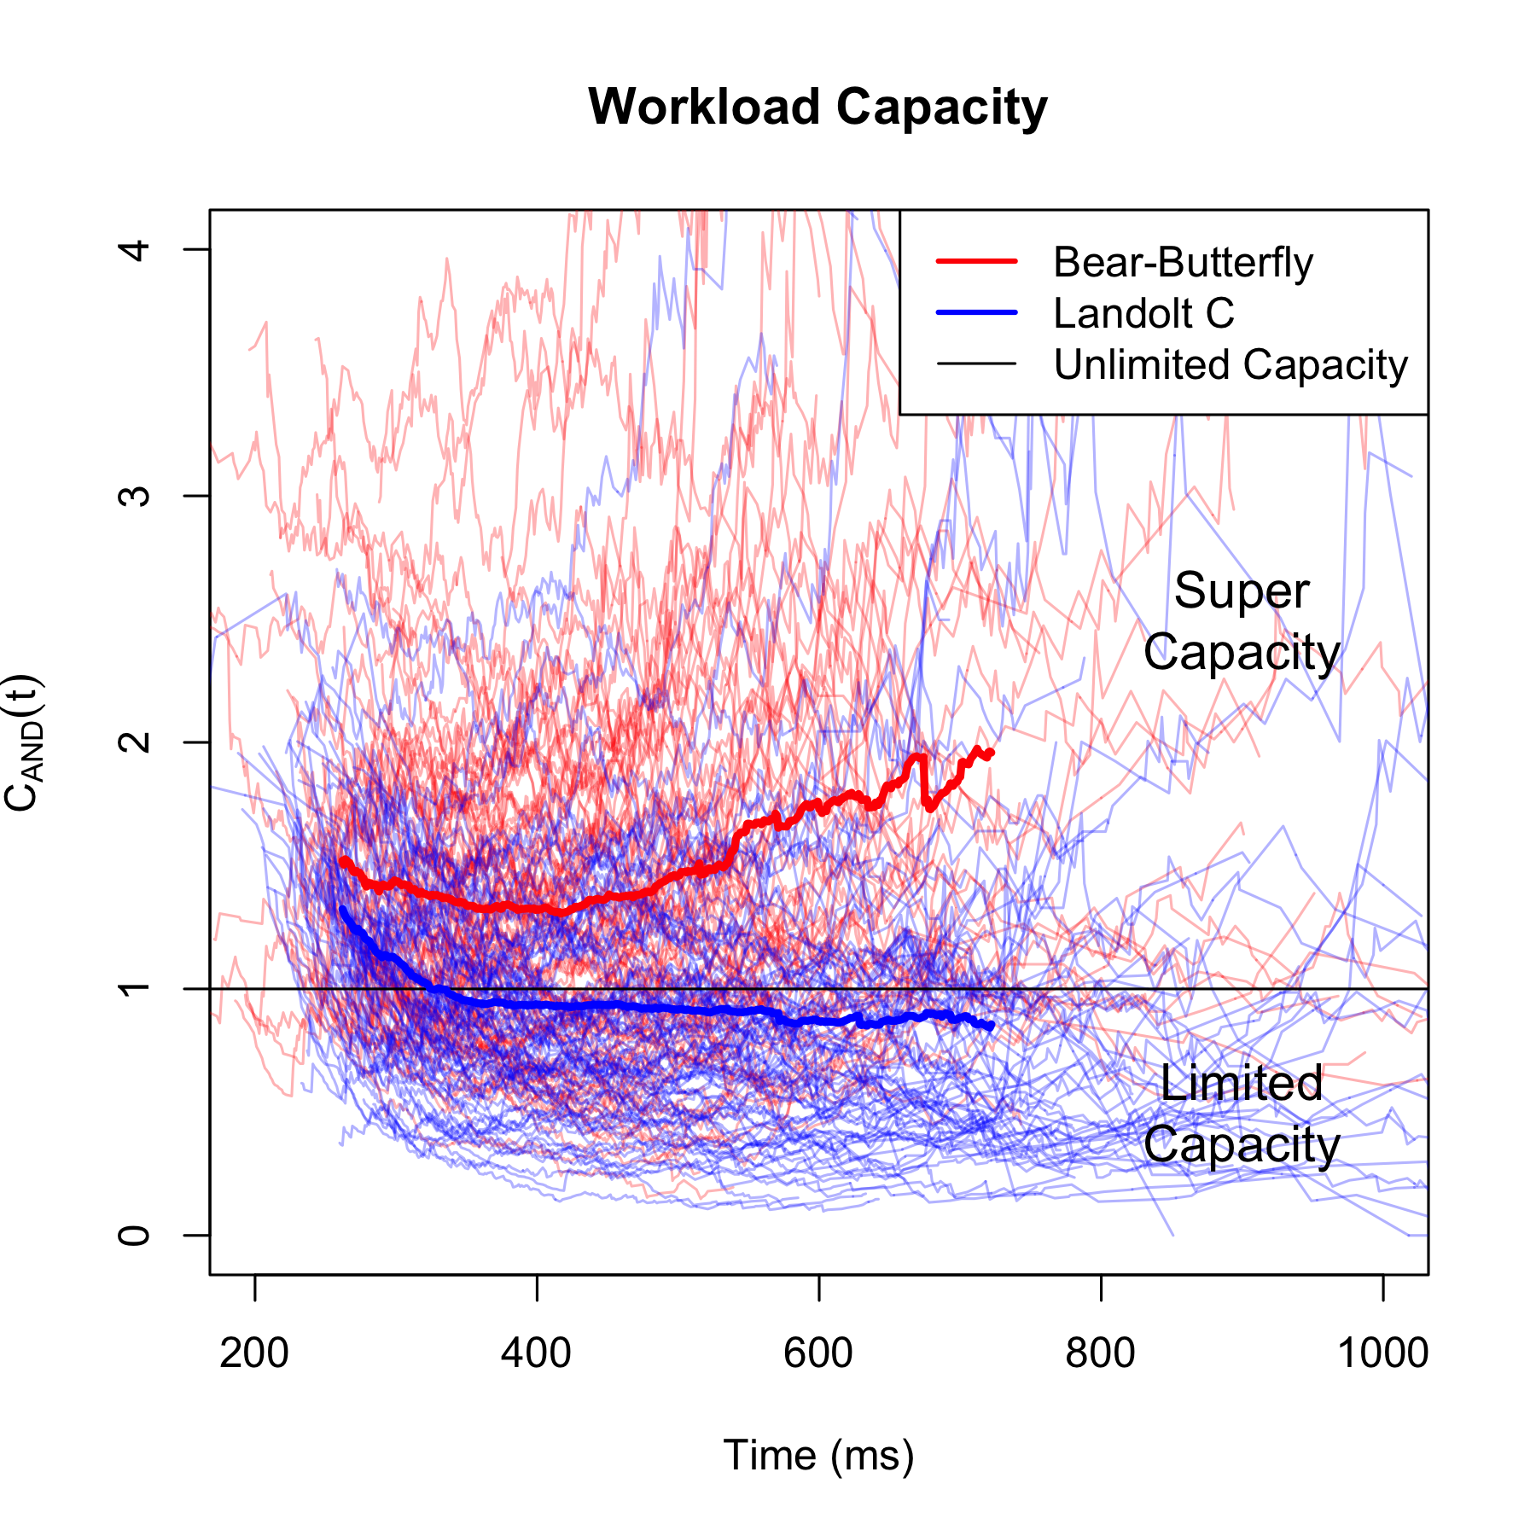

*Figure 6.* Capacity functions for each participant in both conditions. Capacity functions from the Bear-Butterfly condition are shown in red, with the group average capacity indicated by the thick red line. Capacity functions from the Landolt C condition are in blue. The black line at 1 indicates the UCIP baseline, above which is super-capacity and below which is limited-capacity.

We compared the capacity coefficient z-scores for the different conditions against the UCIP baseline using a series of Bayesian *t*-tests. These showed that the capacity z-scores were decisively non-zero in the Butterfly/Bear condition (BF=862889) implying that group-level performance was above the unlimited capacity baseline, but there was only scarce evidence that capacity z-scores were different from zero in the Landolt C condition (BF=1.91). The group average z-score in the Butterfly/Bear condition was fairly positive (mean=2.29, 95% HPD: [1.45,3.09]), and slightly negative in the Landolt C condition (mean=-0.937, 95% HPD: [-1.785,-0.0936]). Again using a Bayesian paired t-test, we found decisive evidence that capacity z-scores were higher in the Butterfly/Bear condition than the Landolt C condition (BF=1.58x108).

Together, these group-level results reveal a rather surprising pattern: When engaged in dual-target search for the more complex real-world images, rather than performing below the UCIP baseline, participants performed well above the UCIP baseline. This stands in contrast to searching the simple Landolt C images, wherein performance was slightly below the UCIP baseline. In addition to the contrasting results for the different stimulus types, it was also interesting to find that participants in either condition could perform above the UCIP baseline.

**The Capacity Coefficient: Individual Performance**

One advantage of capacity coefficient analyses is that they enable meaningful examination of individual performance, allowing fine-grained analysis of each person’s search performance. The lighter lines in Figure 5 show the capacity coefficients for each participant in Experiment 1. In order to compare each participant’s performance to the UCIP baseline, we used a statistic developed by Houpt and Townsend (2012). As yet, there are no Bayesian tests for the capacity coefficient, so we instead utilized null-hypothesis significance testing. The capacity coefficient assumes high accuracy, so four participants were removed from analysis for having accuracy below 90% in at least one cell of the design. In the Bear-Butterfly condition, 48 of the 88 remaining participants performed significantly better than UCIP (*p* < .05), 11 performed significantly worse than UCIP, and performance of the remaining 29 did not significantly differ from UCIP. These rates were reversed in the Landolt C condition: Only 24 of 88 participants performed significantly better than UCIP, whereas 40 performed significantly worse and the remaining 24 performed statistically equivalent to UCIP.

At the individual participant level, we found that, when searching for real-world stimuli, participants generally performed above the UCIP baseline. Conversely, when searching for Landolt Cs, participants generally performed below the UCIP baseline. These results perfectly mirror those obtained for the analyses of the capacity coefficient at the group level, suggesting a high degree of consistency in our analyses.

**Discussion**

In Experiment 1, our goal was to determine whether distractor rejection processes were slowed when participants searched for two targets, over and above expectations of a purely statistical slowdown effect that occurs when waiting for two random processes to finish, compared with waiting for a single random process to finish (Colonius & Vorberg, 1994). Given that previous work involving multiple-target search has found costs to both RTs and accuracy (Menneer et al., 2009), we expected a cost in the speed of distractor rejection in dual-target search. This was indeed observed: RTs were slower when participants searched for two potential targets, relative to one. This result extended previous research on dual-target costs by changing the manner of presentation. Whereas prior studies have used free-viewing search displays, we presented a single object on each trial (rather like RSVP studies, see, for example Hout & Goldinger, 2010 using multiple-target search). Therefore, although dual-target costs previously reported may have reflected failures of guidance (Stroud et al., 2012, 2011), Experiment 1 showed that, even when guidance is not required to locate objects, there is still a performance cost when participants must evaluate incoming images with respect to two potential targets simultaneously.

Although useful for detecting the dual-target cost, mean RT is a relatively coarse measure of performance in this task. As noted earlier, due to statistical reasons, it is expected that participants would be slower to reject distractors when searching for two targets, relative to one. To obtain a more detailed measure of object identification in dual-target search, we utilized the capacity coefficient, and compared it to the unlimited capacity, independent parallel (UCIP) baseline. Given that prior research has found costs to performance when searching for two-targets, we anticipated that we would also find a cost to performance, and predicted that the capacity would be *below* the UCIP baseline, with capacity coefficients below the UCIP baseline value of 1. When participants searched for butterflies and teddy-bears as targets, they performed *better* than the UCIP baseline. This was a surprising and unexpected result, suggesting that distractor rejection occurred faster than a parallel search for both targets. However, when participants searched for Landolt Cs as targets, they performed generally *below* the UCIP baseline, suggesting that searching for Landolt Cs produced a cost in rejecting distractors.

The mostly likely explanation for this divergent pattern of results is the respective stimulus sets. When searching for Landolt Cs, participants were searching for two specific target images, defined by conjunctions of shape and color, amongst a set of distractor objects with similar shapes and colors. When searching for teddy bears and butterflies, however, participants were searching for stimuli distinguishable by both category membership and a wider variety of features. Teddy bears and butterflies are characterized by multiple distinct colors, markings, and shapes both within and across categories. Although the inherent visual differences between real-world objects and the artificial Landolt Cs are prohibitive to control, we can remove uncontrolled categorical variation. In Experiment 2 we therefore presented bears and butterflies in conditions analogous to the Landolt C search condition from Experiment 1.

**Experiment 2**

We conducted Experiment 2 to examine the possibility that categorical or visual differences between bears and butterflies could account for the super-capacity search performance observed for these stimuli in Experiment 1. To rule out this potential explanation, we presented dual-target search conditions comparable to the Landolt C condition in Experiment 1—i.e., participants searched for two teddy bears among teddy bear distractors, and two butterflies among butterfly distractors, rather than allowing half the distractors in each trial to originate from an irrelevant category. As in Experiment 1, single-target trials allowed estimation of the UCIP baseline. Experiment 2 did not include a condition using Landolt Cs. Here we predicted that performance would be below the UCIP baseline, as was the case with the Landolt Cs used in Experiment 1.

**Method**

**Participants**

A different group of 99 participants from Arizona State University took part in Experiment 2 for course credit.

**Design and Procedure**

The design and procedure were identical to those from the bears/butterflies condition from Experiment 1, except for the designations for distractor objects. In one half of Experiment 2, participants searched for butterfly targets among butterfly distractors in two single-target search blocks and one dual-target search block. In the other half, they searched for teddy bear targets among teddy bear distractors, again in single- and dual-target blocks.

**Results**

Eight participants were excluded from analysis due to low overall accuracy or slow RTs (> 2.5 *SD*s above or below the mean), and one participant was excluded due to having a neurological disorder. The final sample was therefore 90 participants (43 males). The average accuracy for retained participants was 97% so analyses again focused on RTs.

**Analytic Approach**

The analytic approach was the same as in Experiment 1, involving three phases: We first examined the dual-target cost using RTs, then examined the capacity coefficient at the group level, and then, to gain a more fine-grained account of how dual-target search influences the speed of object identification, we examined capacity coefficients at the individual level.

**Response Times: Replicating the Dual-target Cost**

The group mean RTs along with the 95% highest probability density region (HPD) from the full model are depicted in Figure 7. The mean posterior estimates and 95% HPD of the parameters in the most likely model are given in Table 2. For RTs in Experiment 2, the highest Bayesian ANOVAs indicated only main effects of Search Type (single vs. dual) and Object Type (target vs. distractor) with a Bayes Factor of 1.93x10837 over the participant-only model. The most likely model had a Bayes Factor of 5.58 over the second most likely model, which also included a main effect of Condition (Butterflies vs. Bears), indicating substantial evidence against an effect of Condition. There was decisive evidence for an effect of Search Type when compared to a model with only a main effect of Object Type (BF=1.29x10364) and decisive evidence for an effect of Object Type compared to a model with only an effect of Search Type (BF=3.94x10480). Again, replicating Experiment 1 and previous studies of dual-target search, participants had longer RTs in dual-target search than single-target search (BF=4.36x10356). Participants also had longer RTs for target-present trials than target-absent trials (BF=1.54x10770), as in Experiment 1.

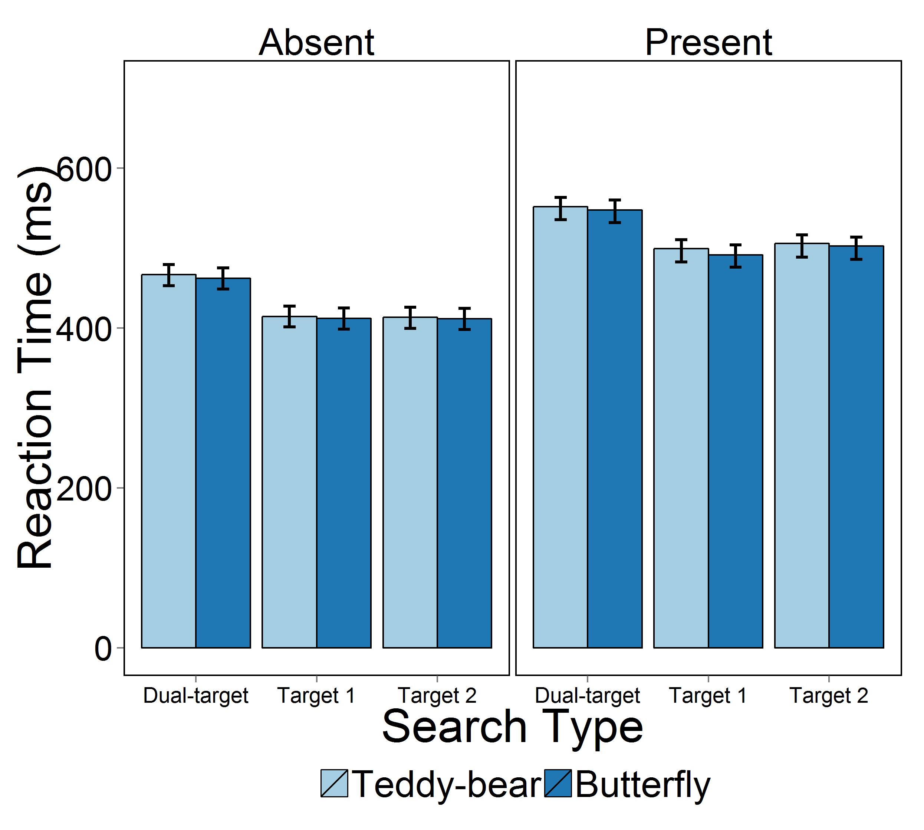

*Figure 7.* Group mean RTs for Experiments 2, broken down by Target Presence (absent and present shown on the left and right panels, respectively), and Search Type (Dual, Target 1, Target 2). Error bars indicate 95% credible intervals.

**Table 2.**

Mean Posterior Estimates and 95% HPD of the Parameters for the Bayesian ANOVA of the RTs in Experiment 2.

|  |  |  |  |
| --- | --- | --- | --- |
|  |  |  |  |
| Parameter | Mean | 2.5% | 97.5% |
|  |  |  |  |
| Grand Mean | 472.0 | 459.3 | 485.3 |
| Two Targets | 34.2 | 32.5 | 35.9 |
| Single Target 1 | -17.7 | -19.2 | -16.1 |
| Single Target 2 | -16.5 | -18.31 | -14.8 |
| Target | 42.1 | -43.6 | -40.8 |
| Distractor | -42.1 | 40.8 | 43.6 |

**The Capacity Coefficient: Group Performance**

We next examined capacity coefficients at the group level, comparing them to the UCIP baselines for the different object types (teddy bears, butterflies). Figure 8 shows the capacity coefficients for each individual, and also the average across participants (in heavier lines). The capacity z-scores were non-zero overall (BF=440; mean=1.23 [.653,1.79]). There was strong evidence that the capacity coefficient when searching for teddy-bears was non-zero (BF=80; mean=1.48 [.735,2.24]) but there was only scarce evidence that the capacity coefficient when searching for butterflies was non-zero (BF=1.37; mean=0.920 [0.150,1.72]). Despite differences in the strength of evidence for super-capacity, there was substantial evidence that capacity z-scores were no different in the teddy-bear and butterfly conditions (BF=4.80).

In Experiment 1, participants searching for these real-world stimuli were able to perform above the UCIP baseline. In Experiment 2, despite controlling for category-level differences between the stimuli, we found the same general group-level results. A Bayesian t-test was nearly equivocal with regards to whether there was a difference between the Bear/Butterfly capacity in Experiment 1 and the capacity across both conditions in Experiment 2 (BF=1.48; mean=1.12 [0.09,2.03]).

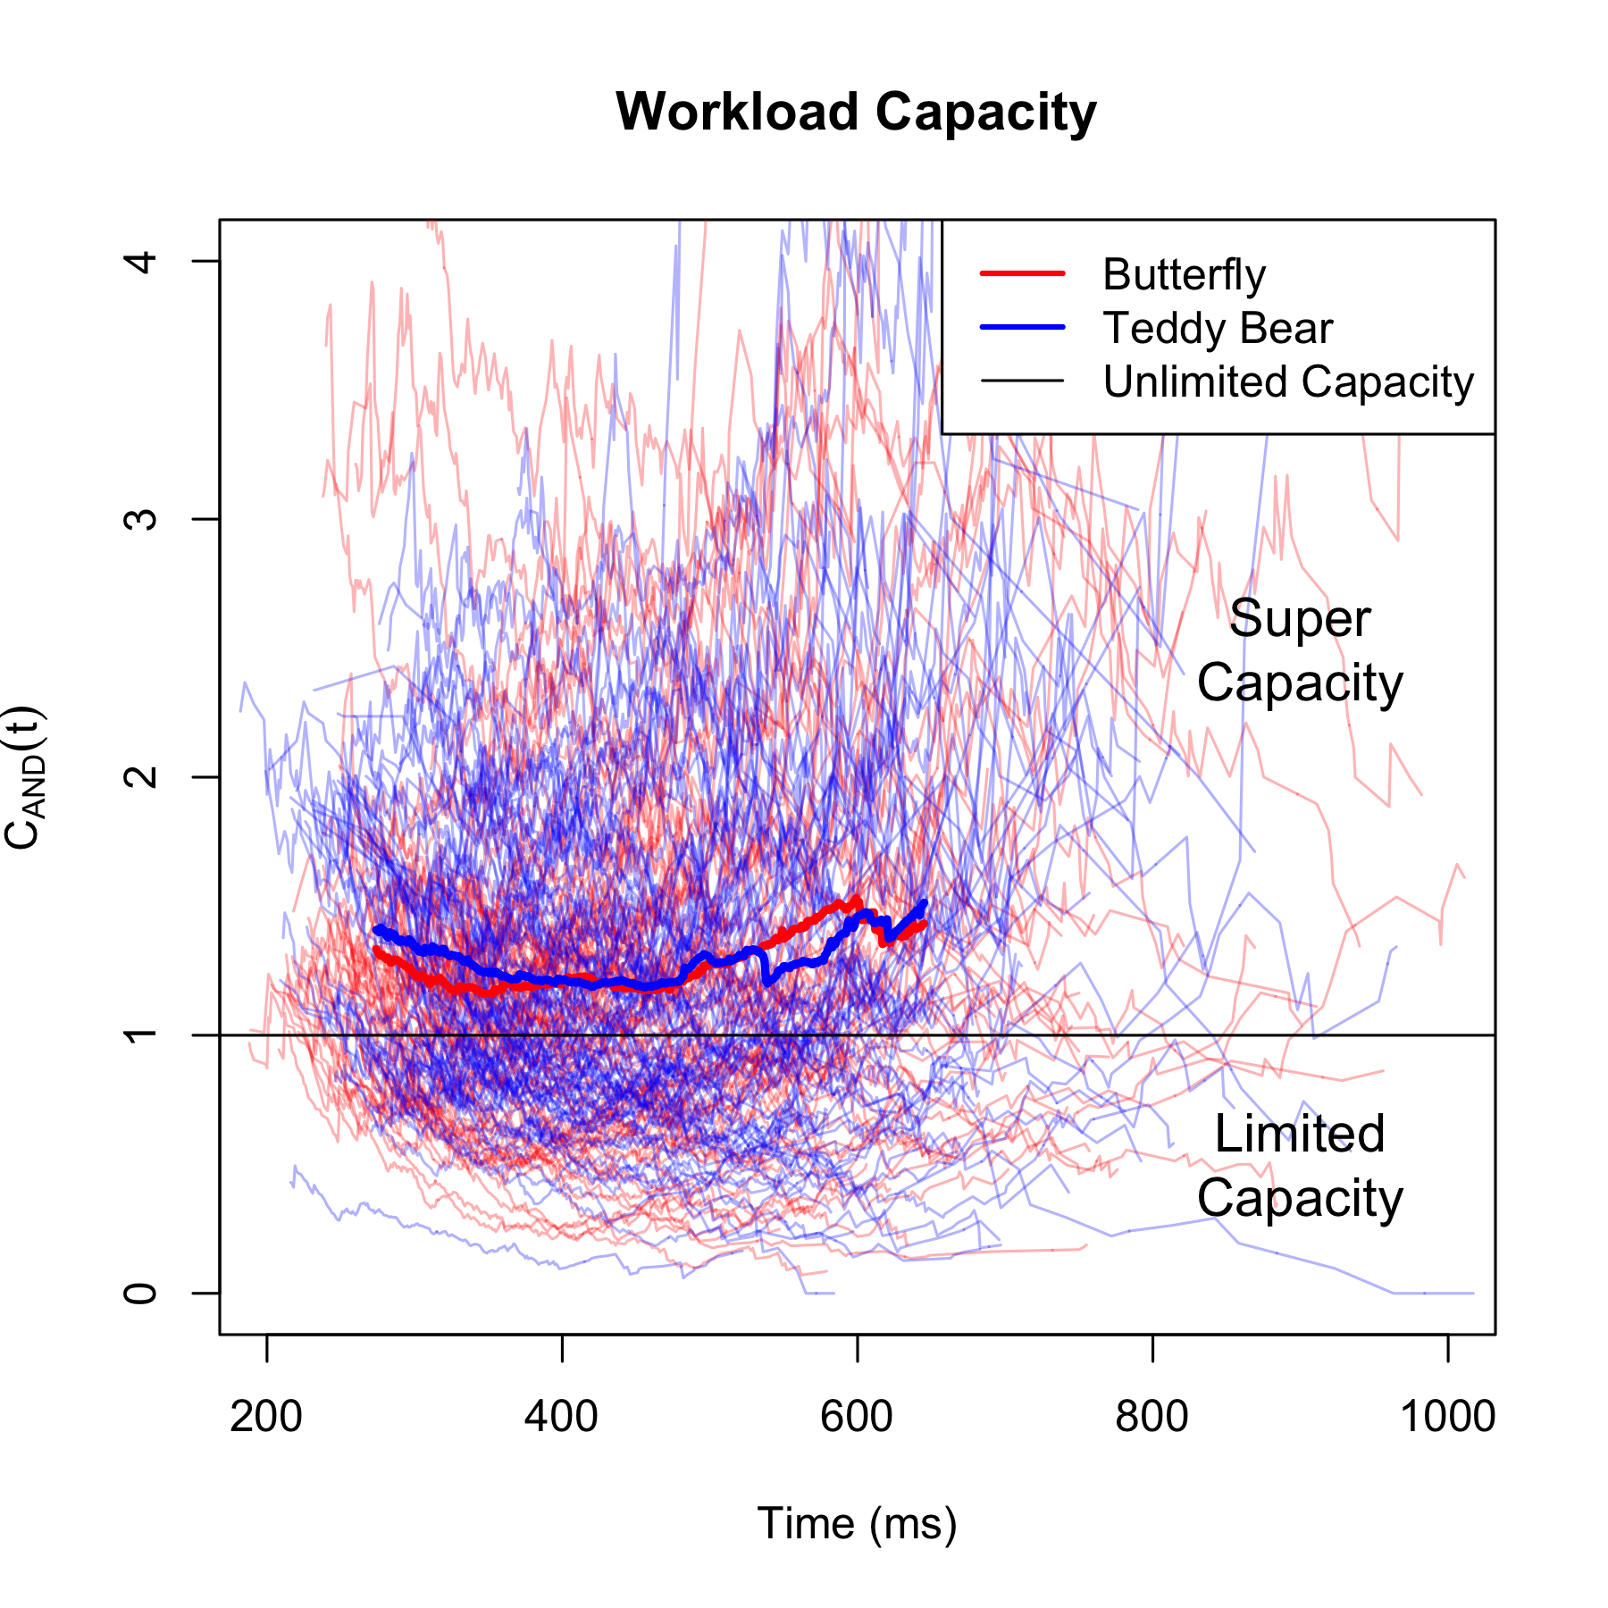

*Figure 8.* Capacity functions for each participant in both conditions. Capacity functions from the Butterfly condition are shown in red, with the group average capacity indicated by the thick red line. Capacity functions from the Teddy Bear condition are in blue. The black line at 1 indicates the UCIP baseline.

**The Capacity Coefficient: Individual Performance**

As in Experiment 1, we also examined capacity coefficients at the individual level. As shown in Figure 8, when searching for butterfly targets, 41 of the 90 participants performed significantly better than UCIP and 16 performed significantly worse than UCIP (*p* < 0.05). The rates were similar when participants were searching for teddy-bear targets: 44 of 90 performed significantly better than UCIP and 24 performed significantly worse. Overall, in line with group-level analyses of the capacity coefficient, individual participants were again generally able to perform better than the UCIP baseline, as they did for the same stimuli in Experiment 1.

**Discussion**

In Experiment 1, we found different results depending upon the stimuli presented to participants, with evidence of super-capacity for the real-world stimuli, but not for the Landolt Cs. These divergent results could have reflected differences between the Landolt C and real-world stimuli: specifically, that bears and butterflies entailed categorical variation, potentially allowing observers to reject half the distractors on any trial with only minimal processing. To address this concern, in Experiment 2, we asked participants to search for butterflies or bears among same-category distractors, mirroring the design used for the Landolt Cs in Experiment 1. Once again, RTs were slower when participants searched for two targets, relative to single targets, replicating previous studies of the dual-target cost (Menneer et al., 2009). Turning to the capacity coefficient, we predicted that performance would now be limited capacity, with the capacity coefficient below 1, as was the case in Experiment 1. Surprisingly, we again found that participants performed at a level of super-capacity. We therefore conclude that the real-world images used in the present study could be compared to potential targets above the UCIP baseline, even after the potential categorical differences from Experiment 1 were removed.

**General Discussion**

People regularly search their environments for multiple targets, such as searching for either of two cars in a busy parking lot, or airport X-ray screeners simultaneously searching for guns, knives and explosive devices in passenger baggage. Previous work has established that searching for multiple targets leads to a performance cost, relative to single-target baselines (Menneer et al., 2012, 2004, 2007; Stroud et al., 2011). Examination of eye movements has shown that visual search guidance breaks down when participants search for multiple targets (Stroud et al., 2011, 2012). However, these prior studies did not directly measure the influence of multiple-target search upon object identification processes (in particular, distractor rejection). This is because participants were presented with arrays containing many search objects, and therefore could begin perceptually processing objects prior to direct fixation (Deubel & Schneider, 1996; Godwin et al., 2013).

In the current investigation, our goal was to examine how searching for two targets influences object identification directly, offering a new perspective on dual-target search. Previous studies taking this approach have focused on response accuracy, and found differing results (Houtkamp & Roelfsema, 2009; Roper & Vecera, 2012), and did not examine RTs, and were thus unable to explore whether participants could search for two targets simultaneously in as direct a manner as reported here. In our experiments, we presented participants only with a single image on each trial, preventing any object previews, and we focused on the speed of distractor rejection, as a proxy for object identification. We compared capacity coefficients (Townsend & Wenger, 2004) against baselines derived from an unlimited capacity, parallel model (UCIP), estimated from single-target conditions. The use of this baseline is important because it is expected that people will be slower to determine whether any object matches two potential targets, relative to one, solely for statistical reasons (Colonius & Vorberg, 1994). To reiterate, it is important to note that the speed of rejection is *expected* to be slower in target-absent trials in dual-target search, relative to single-target search. Indeed, examining RTs revealed slower responses in dual-target search, consistent with previous work (Menneer et al., 2009).

Using capacity coefficients, however, allowed us to assess whether these increased RTs were larger (or smaller) than would be expected from statistical reasons alone. We found interesting and divergent patterns of results for capacity coefficients, depending upon the stimuli. In Experiment 1, when the objects were simple Landolt Cs, we found that participants performed at levels equivalent to (or slightly below) the UCIP baseline. When the objects were real-world stimuli – teddy bears and butterflies – observers performed *above* the UCIP baseline, reaching super-capacity performance in both Experiments 1 and 2.

Intuitively, we might have expected real-world objects to challenge observers, as they would have to process wider and more complex feature sets in real-time. However, these complex stimuli also provide participants with many more features to invalidate (and hence reject) potential target objects. Once any feature (e.g., the specific color of the butterfly wings, or the shape of a teddy bear’s eyes) is detected that does not match a feature belonging to either target, that stimulus can then be rejected as a distractor. Though it is difficult to provide a precise value on the number of features present within the real-world objects, it is clear that they have many more features than the Landolt Cs, which comprise a single shape and a single color. More features available to reject distractors leads to overall faster RTs, which we observed in comparing the main effect of Landolt C versus Bear-Butterfly RTs.

However, having more features alone will not necessarily increase the capacity coefficient. Instead, the benefit for real-world objects in terms of increased capacity coefficients arises because the two targets share more *individuating features* than the Landolt C stimuli. Individuating features are those that can determine whether a given object is a target or a distractor. For example, if Target A is red and Target B is blue, while distractors are neither red nor blue, then color can be used as an individuating feature. As sketched in Figure 2, one possible approach would be for visual processes to analyze an object, and compare its color separately, as part of two independent processes, with one process comparing color against Target A, and another process comparing color against Target B. However, this approach would be rather wasteful of resources. Indeed, in such a scenario, as in the top row of Figure 2, the capacity coefficient will be at (or near) 1. An alternative approach would be to determine object color and then compare its color to both Targets A and B together, in parallel. This approach would not treat each internal template comparison as an independent process, and could greatly increase efficiency if some tested feature mismatched all targets in visual working memory. In other words, this account is based on the notion that the computation of each feature for an object, and each feature’s comparison to the two targets being searched for is *not* an independent process. Rather than trying to identify whether an object is Target A or Target B in two entirely independent processes, where possible, there is overlap in the object identification. This is depicted in the bottom row of Figure 2, with the shared features of color and shape now being evaluated at once against both targets. The fact that the capacity coefficient is higher for the real-world stimuli, we argue, is a consequence of this shared evaluation of features across potential targets.

Because it is difficult (if not impossible) to precisely count the features in real-world objects, we performed several illustrative simulations to examine parallel and serial evaluation of object mismatches as described above. Our goal was to verify that the mathematical and statistical underpinnings of our claims hold true. The upper panel of Figure 9 shows simulated capacity coefficient values for conditions in which the number of features for both targets increases between 1 and 3. Importantly, in this case, the targets share no individuating features (i.e., each stored target is composed entirely of features not found in the other stored target).

For this first simulation, we included three trial types: Search for Target A, search for Target B, and search for Targets A and B together. Since the capacity coefficient is based on target-absent trials, we treated all simulated trials as being target-absent, and simulated 10,000 trials for each feature level and search type. In the trials, the time to finish processing each individuating feature was generated at random from an ex-Gaussian distribution. In the case of single-target trials, as soon as one of the individuating features has been identified, an object can be rejected as a distractor, and a “target-absent” response can be generated. As a consequence, the RT for single-target trials was set to be the time taken to process the fastest of the individuating features. For example, in the three-feature simulation, in one trial, suppose that the three processing of the three features each takes 400ms, 500ms, and 600ms. In that trial, the calculated RT will be 400ms, since it will take 400ms for the first feature that does *not* match the target to be processed. A similar procedure was adopted for each of the two targets in dual-target absent trials. However, there was a key difference, compared to single-target trials. We began, as with the single-target trials, by taking the fastest time to complete any feature as the time to reject a given target. Then, since participants can only make a ‘target-absent’ response once *both* targets have been rejected, we took the slower of these target rejection times as the trial RT. For example, again in the three-feature simulation, in one trial, Target A has features completed at 200ms, 400ms and 600ms, while Target B has features that complete at 300ms, 500ms, and 700ms. The fastest feature for Target A is processed 200ms, while for target B is processed at 300ms. The RT for this trial is the slower of these two times (300ms).

The results of this first simulation varying the number of features demonstrate that the capacity coefficient does *not* increase as the numbers of features increase. This suggests that simply having more features (for butterflies and bears, versus Landolt Cs) does not explain the results observed in our experiments. However, note that the RTs are generally faster as the number of features increases, which is shown by the coefficient beginning at earlier time-point as more features are added. We also observed a similar pattern, with the real-world objects having more rapid RTs than the Landolt Cs.

For our second simulation, the results of which are depicted in the lower panel of Figure 9, shows capacity coefficient values in a situation wherein the number of features is held (at three) for both targets, but we varied the number of *shared individuating features* between targets (from zero to three). For this simulation, the single-target trials were simulated in the same manner as the previous simulation. In the dual-target trials, the RTs were determined in a slightly different manner, depending upon the number of shared individuating features between the two targets. Now, when a feature is shared in the dual-target trials, the time taken to complete processing that shared feature is the same for both targets. As with the previous simulation, since participants can only make a ‘target-absent’ response once *both* targets have been rejected, we took the slower of the target rejection times as the trial RT. This can best be illustrated by an example. Suppose that the two targets share one feature. The single shared feature completed at 150ms. For Target A, the unshared features completed at 200ms and 300ms; for Target B, the unshared features completed at 250ms and 350ms. This gives rise to feature completion times for Target A of 150ms, 200ms and 300ms. Thus, the time to reject an object as not being Target A is 150ms. Similarly, for Target B, the feature completion times are 150ms, 250ms and 350ms. As with Target A, the time to reject an object as not being Target B is 150ms. This example particularly highlights the benefits of having shared features, and demonstrates the potential gains in speed of rejection in dual-target absent trials when individuating features are shared between the two targets.

As shown in Figure 9, capacity rises as the number of shared features increases. We believe this illustrates the primary reason for the high capacity coefficients that we observed for the real-world stimuli: Capacity increases because when individuating features are shared across targets, resources are saved by comparing each feature to both targets at once, rather than as parallel, independent processes. At an extreme, when *all* of the features of both targets are shared individuating features, then the two targets can be processed at or near the same speed as one of the targets alone. Although it is difficult to estimate the numbers of features available for discriminating complex objects, it is clear that bears and butterflies offer more avenues for distractor rejection, relative to Landolt Cs, which have few features that discriminate between stored targets and distractors.

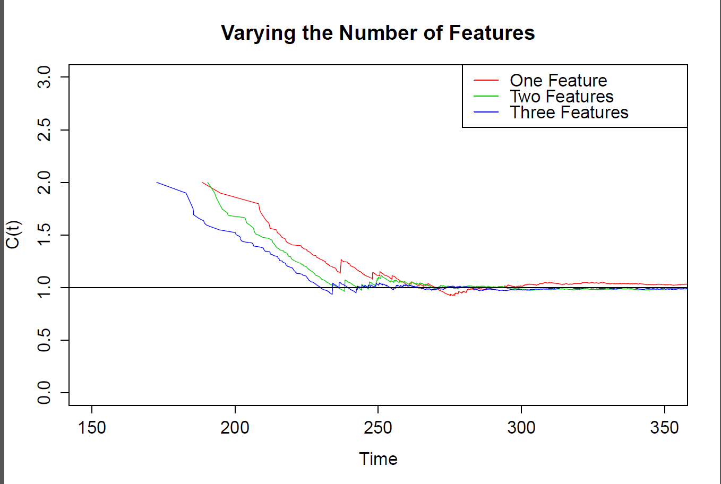

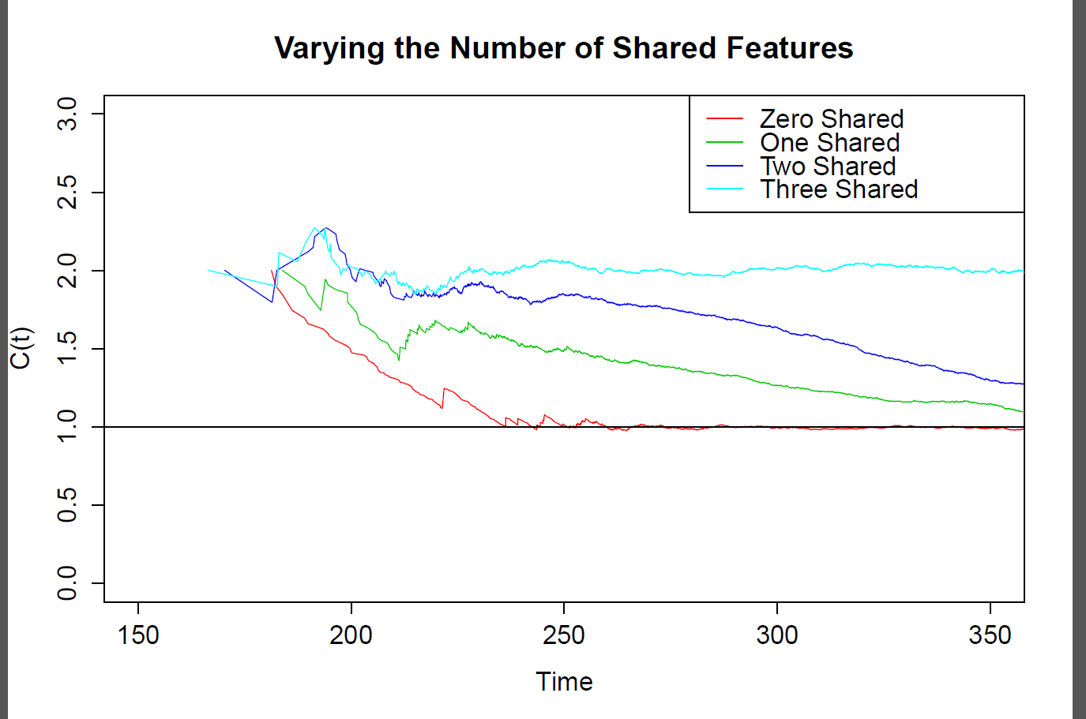

*Figure 9.* Illustrative output from simulations for the capacity coefficient. The capacity coefficient is based on the speed of rejection in target-absent trials, across single-target and dual-target searches. The upper panel shows a simulation wherein the number of features is varied from 1-3. The lower panel shows a simulation wherein the number of features is held at a constant of 3, but the number of shared features is varied (0-3). Further details of the simulations are provided in the General Discussion. ‘Time’ units are not intended to be reflective or meaningful in relation to real units (e.g., ms).

This insight into the differences in rejection speeds for natural objects versus simplistic, artificial ones is important for several reasons. First, there is extensive work demonstrating that the similarity between distractor and target objects in a display has a modulating influence on visual search (e.g., Duncan & Humphreys, 1989). Eye movement studies have found that fixation durations are longer for objects that resemble targets (Becker, 2011; Luria & Strauss, 1975; Stroud et al., 2012), suggesting that participants engage in a more detailed or extensive processing of these objects. The present results suggest that it may be more accurate to say that fixation durations are *shorter* for target-dissimilar objects during search, because participants can rapidly reject objects with many features that do not match the target (see also Hout & Goldinger, 2014). Though this may appear a subtle distinction, it is important for characterizing and understanding the basic function of object identification processes in visual search. Indeed, further work similar to the current study may be able to pin down these processes more precisely. It is also worth noting that a similar pattern of behavior arises in human memory. For example, in a classic study, Kolers and Palef (1976) found that RTs were longer for “yes” versus “no” responses when participants were asked if they had visited certain cities. That is, people can very quickly verify whether they have *not* had some specific prior experience, clearly without engaging in an exhaustive search of prior autobiographical memory. Future work along these lines could incorporate current theory regarding memory search to studying object identification during visual search.

To summarize, the present experiments examined whether dual-target search slowed object identification processes, relative to single-target search. Although RTs were indeed slower in dual-target search, analyses of the capacity coefficient revealed that performance was still higher than a UCIP baseline for real-world objects and at (or slightly below) the UCIP baseline for Landolt Cs. The fact that performance was not uniformly below the UCIP baseline demonstrates that object identification processes *per se* are not, in fact, slowed by searching for two targets. However, we did find important differences in performance dependent upon the stimuli presented to participants: When there were more shared features associated with the relevant objects (as was the case for natural stimuli), participants performed at a super-capacity level.

**References**

Barrett, D. J. K., & Zobay, O. (2014). Attentional Control via Parallel Target-Templates in Dual-Target Search. *PloS One*, *9*(1), e86848. doi:10.1371/journal.pone.0086848

Beck, V. M., Hollingworth, A., & Luck, S. J. (2012). Simultaneous control of attention by multiple working memory representations. *Psychological Science*, *23*(8), 887–98. doi:10.1177/0956797612439068

Becker, S. I. (2011). Determinants of dwell time in visual search: similarity of perceptual difficulty? *PLoS One*, *6*(3), 1–5. doi:10.1371/journal.pone.0017740

Burns, D. M., Houpt, J. W., Townsend, J. T., & Endres, M. J. (2013). Functional principal components analysis of Search Type capacity functions. *Behavior Research Methods*, *45*, 1048–1057. doi:10.3758/s13428-013-0333-2

Cain, M. S., Adamo, S. H., & Mitroff, S. R. (2013). A taxonomy of errors in multiple-target visual search. *Visual Cognition*, *21*(7), 899–921. doi:10.1080/13506285.2013.843627

Colonius, H., & Vorberg, D. (1994). Distribution Inequalities for Parallel Models with Unlimited Capacity. *Journal of Mathematical Psychology*, *38*(1), 35–58. doi:10.1006/jmps.1994.1002

Deubel, H., & Schneider, W. X. (1996). Saccade target selection and object recognition: Evidence for a common attentional mechanism. *Vision Research*, *36*, 1827–1837. doi:10.1016/0042-6989(95)00294-4

Duncan, J., & Humphreys, G. W. (1989). Visual search and stimulus similarity. *Psychological Review*, *96*(3), 433–458. doi:10.1037/0033-295X.96.3.433

Eidels, A., Townsend, J. T., & Pomerantz, J. R. (2008). Where similarity beats redundancy: The importance of context, higher order similarity and repsonse assignment. *Journal of Experimental Psyhcology: Human Perception and Performance*, *34*, 1441–1463.

Fleck, M. S., & Mitroff, S. R. (2007). Rare targets are rarely missed in correctable search. *Psychological Science*, *18*(11), 943–7. doi:10.1111/j.1467-9280.2007.02006.x

Gelman, A., Carlin, J. B., Stern, H. S., Dunson, D. B., Vehtari, A., & Rubin, D. B. (2013). *Bayesian Data Analysis*. Boca Raton, FL: CRC Press.

Godwin, H. J., Benson, V., & Drieghe, D. (2013). Using interrupted visual displays to explore the capacity, time course, and format of fixation plans during visual search. *Journal of Experimental Psychology. Human Perception and Performance*, *39*(6), 1700–1712. doi:10.1037/a0032287

Godwin, H. J., Hout, M. C., & Menneer, T. (2014). Visual similarity is stronger than semantic similarity in guiding visual search for numbers. *Psychonomic Bulletin and Review*, *21*(3), 689–95. doi:10.3758/s13423-013-0547-4

Godwin, H. J., Menneer, T., Riggs, C. A., Cave, K. R., & Donnelly, N. (in press). Perceptual Failures in the Selection and Identification of Low-Prevalence Targets in Relative Prevalence Visual Search. *Attention, Perception & Psychophysics*. doi:10.3758/s13414-014-0762-8

Harris, J. (2008). MindModelling@Home: A large-scale computational cognitive modelling infrastructure. In *Sixth Annual Conference on Systems Engineering Research* (pp. 246–252). Los Angeles, CA, USA.

Houpt, J. W., Blaha, L. M., McIntire, J. P., Havig, P. R., & Townsend, J. T. (2014). Systems factorial technology with R. *Behavior Research Methods*, *46*(2), 307–330. doi:10.3758/s13428-013-0377-3

Houpt, J. W., & Townsend, J. T. (2012). Statistical measures for workload capacity analysis. *Journal of Mathematical Psychology*, *56*(5), 341–355. doi:10.1016/j.jmp.2012.05.004

Houpt, J. W., Townsend, J. T., & Donkin, C. (2014). A new perspective on visual word processing efficiency. *Acta Psychologica*, *145*, 118–27. doi:10.1016/j.actpsy.2013.10.013

Hout, M. C., & Goldinger, S. D. (2010). Learning in repeated visual search. *Attention, Perception & Psychophysics*, *72*, 1267–1282. doi:10.3758/APP.72.5.1267.

Hout, M. C., & Goldinger, S. D. (2012). Incidental learning speeds visual search by lowering response thresholds, not by improving efficiency: Evidence from eye movements. *Journal of Experimental Psychology: Human Perception and Performance*, *38*(90-112). doi:10.1037/a0023894

Hout, M. C., & Goldinger, S. D. (2014). Target templates: The precision of mental representations affects attentional guidance and decision-making in visual search. *Attention, Perception & Psychophysics*. doi:10.3758/s13414-014-0764-6

Houtkamp, R., & Roelfsema, P. R. (2009). Matching of visual input to only one item at any one time. *Psychological Research*, *73*(3), 317–26. doi:10.1007/s00426-008-0157-3

Ingvalson, E. M., & Wenger, M. J. (2005). A strong test of the dual mode hypothesis. *Perception and Psychophysics*, *67*(1), 14–35. doi:10.3758/BF03195010

Jeffreys, H. (1961). *Theory of Probability* (3rd ed.). Oxford, UK: Oxford University Press.

Kaplan, I. T., & Carvellas, T. (1965). Scanning for multiple targets. *Perceptual and Motor Skills*, *21*(1), 239–243.

Kolers, P. A., & Palef, S. R. (1976). Knowing not. *Memory & Cognition*, *4*(5), 553–8. doi:10.3758/BF03213218

Kotowicz, A., Rutishauser, U., & Koch, C. (2010). Time course of target recognition in visual search. *Frontiers in Human Neuroscience*, *4*(April), 31. doi:10.3389/fnhum.2010.00031

Luria, S. M., & Strauss, M. S. (1975). Eye movements during search for coded and uncoded targets. *Perception and Psychophysics*, *17*(3), 303–308. doi:10.3758/BF03203215

McCarley, J. S., Mounts, J. R. W., & Kramer, A. F. (2007). Spatially mediated capacity limits in attentive visual perception. *Acta Psychologica*, *126*(2), 98–119. doi:10.1016/j.actpsy.2006.11.004

Menneer, T., Barrett, D. J. K., Phillips, L., Donnelly, N., & Cave, K. R. (2004). Search efficiency for multiple targets. *Cognitive Technology*, *9*, 22–25.

Menneer, T., Barrett, D. J. K., Phillips, L., Donnelly, N., & Cave, K. R. (2007). Costs in searching for two targets: Dividing search across target types could improve airport security screening. *Applied Cognitive Psychology*, *21*(7), 915–932. doi:10.1002/acp.1305

Menneer, T., Cave, K. R., & Donnelly, N. (2009). The cost of search for multiple targets: the effects of practice and target similarity. *Journal of Experimental Psychology: Applied*, *15*, 125–139. doi:10.1037/a0015331

Menneer, T., Stroud, M. J., Cave, K. R., Donnelly, N., & Rayner, K. (2008). Eye movements in search for multiple targets. In K. Rayner, D. Shen, X. Bai, & G. Yan (Eds.), *Cognitive and Cultural Influences on Eye Movements.* China: Tianjin People’s Press.

Menneer, T., Stroud, M. J., Cave, K. R., Li, X., Godwin, H. J., Liversedge, S. P., & Donnelly, N. (2012). Search for two categories of target produces fewer fixations to target-color items. *Journal of Experimental Psychology. Applied*, *18*(4), 404–18. doi:10.1037/a0031032

Moore, C. M., & Osman, a M. (1993). Looking for two targets at the same time: one search or two? *Perception & Psychophysics*, *53*(4), 381–90. doi:10.3758/BF03206781

Neisser, U., Novick, R., & Lazar, R. (1963). Searching for ten targets simultaneously. *Perceptual and Motor Skills*, *17*, 955–961.

R Development Core Team. (2013). R: A language and environment for statistical computing. (R. D. C. Team, Ed.)*R Foundation for Statistical Computing*. Vienna, Austria: R Foundation for Statistical Computing.

Richards, H. J., Hadwin, J. a, Benson, V., Wenger, M. J., & Donnelly, N. (2011). The influence of anxiety on processing capacity for threat detection. *Psychonomic Bulletin & Review*, *18*(5), 883–9. doi:10.3758/s13423-011-0124-7

Roper, Z. J. J., & Vecera, S. P. (2012). Searching for two things at once : Establishment of multiple attentional control settings on a trial-by-trial basis, 1114–1121. doi:10.3758/s13423-012-0297-8

Rouder, J. N., & Morey, R. D. (2014). BayesFactor: Computation of Bayes factors for common designs.

Rouder, J. N., Morey, R. D., Speckman, P. L., & Province, J. M. (2012). Default Bayes factors for ANOVA designs. *Journal of Mathematical Psychology*, *56*(5), 356–374. doi:10.1016/j.jmp.2012.08.001

Rouder, J. N., Speckman, P. L., Sun, D., & Morey, R. D. (2009). Bayesian t tests for accepting and rejecting the null hypothesis. *Psychonomic Bulletin and Review*, *16*(2), 225–237. doi:10.3758/PBR.16.2.225

Schneider, W., Eschman, A., & Zuccolotto, A. (2012). E-Prime User’s Guide. Pittsburgh: Psychology Software Tools, Inc.

Schwark, J. D., MacDonald, J., Sandry, J., & Dolgov, I. (2013). Prevalence-based decisions undermine visual search. *Visual Cognition*, *21*(5), 541–568. doi:10.1080/13506285.2013.811135

Schwarz, W., & Eiselt, A.-K. (2012). Numerical distance effects in visual search. *Attention, Perception & Psychophysics*, *74*(6), 1098–103. doi:10.3758/s13414-012-0342-8

Stroud, M. J., Menneer, T., Cave, K. R., & Donnelly, N. (2012). Using the dual-target cost to explore the nature of search target representations. *Journal of Experimental Psychology: Human Perception and Performance*, *38*(1), 113–122. doi:doi:10.1037/a0025887

Stroud, M. J., Menneer, T., Cave, K. R., Donnelly, N., & Rayner, K. (2011). Search for multiple targets of different colours: Misguided eye movements reveal a reduction of colour selectivity. *Applied Cognitive Psychology*, *25*(6), 971–982. doi:10.1002/acp.1790

Townsend, J. T. (1972). Some results concerning identifiability of parallel and serial processes. *British Journal of Mathematical & Statistical Psychology*, *25*(Nov), 168–199.

Townsend, J. T. (1990). Serial Vs Parallel Processing - Sometimes They Look Like Tweedledum and Tweedledee but They Can (and Should) Be Distinguished. *Psychological Science*, *1*(1), 46–54.

Townsend, J. T., & Nozawa, G. (1995). Spatio-temporal properties of elementary perception: An investigation of parallel, serial and coactive theories. *Journal of Mathematical Psychology*, *39*(4), 321–359. doi:10.1006/jmps.1995.1033

Townsend, J. T., & Nozawa, G. (1997). Serial exhaustive models can violate the race inequality: Implications for architecture and capacity. *Psychological Review*, *104*, 595–602.

Townsend, J. T., & Wenger, M. J. (2004). A theory of interactive parallel processing: New capacity measures and predictions for a response time inequality series. *Psychological Review*, *111*(4), 1003–1035. doi:10.1037/0033-295X.111.4.1003

Treisman, A., & Gelade, G. (1980). A feature-integration theory of attention. *Cognitive Psychology*, *12*(1), 97–136. doi:10.1016/0010-0285(80)90005-5

Wolfe, J. M. (2007). Guided Search 4.0: Current Progress with a model of visual search. In W. Gray (Ed.), *Integrated Models of Cognitive Systems* (pp. 99–119). New York: Oxford.

Wolfe, J. M., Cave, K. R., & Franzel, S. L. (1989). Guided search: an alternative to the feature integration model for visual search. *Journal of Experimental Psychology: Human Perception and Performance*, *15*(3), 419–433. doi:10.1037/0096-1523.15.3.419

1. In principle, it is possible that the means calculated directly from the data (depicted in Figure 5) might differ from the mean of the posterior (values in Table 1) due to the structure of the Bayesian ANOVA and the priors. However, because of the large number of trials each participant ran in each condition, these two values are essentially the same, the largest difference across all conditions in both Experiment 1 and Experiment 2 was 3.2ms.