Self-building Safe Havens in a Post-Service Landscape: How adults with learning disabilities are reclaiming the welcoming communities agenda
Andrew Powerª and Ruth Bartlett^{b}
ªGeography and Environment, University of Southampton, Southampton, UK; ^{b}Health Sciences, University of Southampton, Southampton, UK

With the increased commitment towards personalisation in adult social care, allied with more ‘austere’ funding of social services and day centre closures, support is increasingly becoming less placement-driven and woven into everyday spaces within the community. Consequently, support is being re-framed from ‘care’ in formal settings towards an effort at enabling meaningful lives in a post-service landscape nested in local neighbourhoods and ordinary spaces. This paper explores what it means to live in a ‘welcoming community’ within the context of day care centre closures from the perspective of adults with learning disabilities. It draws on empirical data collected from focus groups and photo diaries with adults with learning disabilities on their experiences of negotiating support arrangements. We identify a process of ‘self-building’ safe havens in ordinary British spaces, including allotments, marinas and ‘fish and chip shops’, and argue that adults with learning disabilities are reclaiming the welcoming communities agenda.
Keywords: austerity, disability, inclusion, welfare, care, personalisation.

Introduction

What does it mean to live in a ‘welcoming community’? This question frames the focus of this paper, which examines the experiences of adults with learning disabilities and their advocates in finding and negotiating welcoming spaces in their local neighbourhoods. The question is becoming increasingly relevant as more and more recipients of social care are being given little choice but to live in the community due to reductions in institutional forms of welfare. This is characterised by extensive closures of day care centres across the UK and other countries including Canada (Pedlar and Hutchison, 2000) and the Netherlands (Van Loon and Van Hove, 2001).
The changing context of day service provision is a ‘down-stream’ outcome of broader social care policy, which has become dominated over the last few years by the philosophy of personalisation (self-directed support) as well as being exacerbated by recent austerity policy, explored further below. The philosophy of personalisation has evolved from earlier ideas of de-institutionalisation, normalisation, and community care, which broadly sought to move social care users away from large segregated facilities towards a care service landscape in everyday communities (Glasby and Littlechild, 2009). With the rise of personalisation, there has been a move away from these care services, thus marking a shift from this earlier series of movements. This changing landscape has become pervasive across all social care users including people with learning disabilities (known in other jurisdictions as intellectual/developmental disabilities) – who form the focus of this paper – as well as people with physical disabilities, older people, and to a lesser extent people with mental health issues (Newbronner et al., 2011).
The lexicon of personalisation has become increasingly internationalised, with disability movements across multiple countries like Canada, the US, France, Sweden and Ireland demanding individualisation of services (Power, Lord and DeFranco, 2013). One of the leading countries in driving this reform agenda is England where a particularly distilled form of personalisation has unfolded. The focus of the paper is thus set within the context of English disability policy.
The rate of closure of day care services across England has been considerable. Mencap (2012), the national learning disability charity, has reported that nearly a third of local authorities have closed day services in the last three years, and one in four adults with a learning disability now spends less than one hour a day outside of their home due to cuts to day services. Reports across the country are revealing the extent of closures at local authority level. Liverpool has closed nine of its day services. Hampshire Council has reduced the number it runs from 12 to four. Bournemouth Council is combining two day centres. And West Berkshire Council plans to nearly halve the number it provides (Community Care, 2010; 2012).
One of the key reasons for this rapidly changing landscape has been the changing emphasis beyond what service people want, towards what kind of life people want, as espoused by personalisation. One of the drivers behind this change has been a growing dissatisfaction and stigma associated with specialist services (Emerson, et. al. 2012: 3). Day care centres are thus being replaced by ‘packages of care’, in the form of personal budgets to help people purchase their own support.
Previous care management practices, to ascertain eligibility, to devise care plans, and then to place people into pre-purchased ‘services’ is thus increasingly being supplanted by an emphasis on the cultivation of meaningful lives nestled in local welcoming communities, outside of formal place-based care services. Indeed, it would seem that many social care users are now in an era of the ‘post-service landscape’, where conventional place-based care sites are disappearing, with an increased emphasis on individualised support in inclusive ‘everyday spaces’ (O’Brien and Sullivan, 2005). With many adults with learning disabilities now out-living their parents (Coppus, 2013), the question of what it means to live in a ‘welcoming community’ (a term explored in more detail below) becomes ever more important, as many face living in their communities without the resources and support of their parents.
Moreover, the implementation of this guiding philosophy in England and elsewhere has occurred during difficult economic ‘austere’ conditions. In England, the Conservative-Liberal Democrat coalition government has invoked an agenda of austerity, with an explicit social care reform agenda aiming to significantly re-shape (read: withdraw from) the landscape of care. Austerity is taken to mean a political ideology grounded in liberal economics’ view of the need to reduce state spending with the belief that it purges the system and allows markets to adjust during adverse economic conditions (Lowndes and Pratchett, 2011). Austerity has emerged as a doctrine of late 20th Century neoliberalism. Yet austerity programmes remain controversial with counter-arguments centring on their inefficacy as a stimulus for economic growth, as well as their adverse impact on the poorest segments of the population (Global Unions, 2013).
In terms of how austerity is playing out in disability services, there have been significant cuts to social care budgets and related supports (e.g. housing) as well as eligibility restrictions and increased charges. The UK government 2010 Comprehensive Spending Review aims to significantly reduce the level of public expenditure in the UK by an overall cut of £63.4 billion by 2015, a reduction of 10.8%. Of these cuts, over 50% fall on two areas: Benefits (18.6%), which refer to minimal income protection for disabled people and people in poverty; and local government (41.9%) (Duffy, 2013). The latter cut is particularly relevant in this context as one of the primary functions of local authorities is to provide social care (making up 60% of all their spending). Whatever the outcome of the 2015 UK general election, this welfare transformation (and the associated cuts in local authority services and welfare benefits) is likely to continue.
Austerity has been flanked by a strong localism agenda in England, instituted by the Localism Act (2011), which seeks to relocate the provision of public services from central government to a range of ‘local’ actors who, it is assumed, are better placed to identify and resolve a range of ‘local’ social problems. These local actors include voluntary-run community organisations, private companies, and social enterprises that are expected to provide for local people’s welfare needs.
The extent to which adults with learning disabilities experience ‘ordinary’ communities as welcoming is thus a relevant question in this context. Indeed, much evidence suggests that people with learning disabilities, and anyone of difference for that matter, often face a difficult context of indifference, discrimination and in some cases harassment and violence. The aim of this paper is to inform and advance debates about the geographies of care by examining the contribution people with learning disabilities and their advocates make, to the building of more welcoming communities. While Featherstone et al (2012) recognises the surfacing of progressive localism – a term used to convey the emerging organic forms of local politics in the wake of austerity – most of the literature focuses on the role of professional organisations, government agencies, well-resourced community groups and others. People with learning disabilities rarely get considered in terms of their role or stake in making communities more welcoming. In this paper we argue for more attention to be paid to the self-building practices by people with learning disabilities and their advocates, and how these practices shed light on how spaces of ‘inclusion’ or ‘exclusion’ are renegotiated moment-by-moment, rather than being static. Self-building practices (explored further below) are taken to mean the progressive forms of ‘agency’ deployed by the participants to take control over their own lives and to negotiate access into the community. These findings offer important insights to inform a wider dialogue with older people and people with dementia in relation to their strategies for more age-friendly and dementia-friendly communities.

Welcoming communities

The term ‘welcoming communities’ is used in this paper to characterise efforts to cultivate greater connections between people with learning disabilities and people in their local communities. Such efforts reflect a new generation of values and discourses being developed by proponents of welfare reform and within disability policy since the early-2000s. This is linked to the promotion of a ‘good life’ for people with learning disabilities as advocated by Johnson and Walmsley (2010). It is acknowledged that the meaning of ‘communities’ is often left ambiguous in policy reports: indeed the wider literature on community proves that it is a heterogeneous and elusive concept (Crow and Allen, 1994). For the purposes of this paper, community is taken to mean ‘place community’, defined as sharing local geographically soft boundaries, where people occupy, use, and travel through, rather than as a close-knit group of people. It is recognised that within ‘place communities’, there are multiple cross-cutting and at times contested ‘interest communities’ and ‘communities of attachment’ shaping the different things that community members may have in common (Willmott, 1986). It is also recognised that there are exclusionary tactics both towards ‘outsiders’ and to those deemed non-conforming within othered communities (see for example an account of Muslim women in Britain by Valentine, 2001). These various contours and rhythms offer a platform for examining the lives of people with learning disabilities as they seek to occupy ‘welcoming spaces’ within their wider community.
The emergence of a discourse of welcoming communities is evident in a range of different jurisdictions, including British Columbia, Scotland and England, where proponents of independent living and personalisation have sought to develop active community connection programmes. These aim to either embed people with learning disabilities within local inclusionary spaces or else seek to cultivate disability-friendly communities more generally.
Evidence of the latter approach is seen in British Columbia, where the statutory agency for adults with learning disability services, Community Living BC, established a ‘Start with hi’ campaign with an explicit focus on trying to make communities more welcoming. This included a billboard and online advertisement campaign which sought to entreat people to reflect on ‘what do you say when you see [Justin/Rachel [an adult with learning disabilities]?’ ‘Start with hi’.
Community Living BC believes everyone should have good lives in welcoming communities. Part of a "good life" is feeling safe from harm. We all have a role in ensuring people with developmental disabilities feel as safe as the rest of us. And it doesn’t take much to help. You can start by saying a simple "Hi." (CLBC, 2010)

Meanwhile, in Scotland, disability policy has been influenced by the Australian model of Local Area Coordination (LAC). LAC is based on a model where co-ordinators work alongside communities that they know intimately, supporting them to become more welcoming and inclusive and with individuals and their families to help them to become more confident, supporting them to build independent lives. Co-ordinators are able to act as advocates and have more flexibility than care managers in how they support people (Hall and McGarroll, 2013).
In England, while there has been less specific emphasis on cultivating wider disability-friendly communities, the central government agenda of the ‘Big Society’ has invoked similar ideas to community cohesion and empowerment; ‘we want society – the families, networks, neighbourhoods and communities that form the fabric of so much of our everyday lives – to be bigger and stronger than ever before’ (gov.uk, 2009). This wider policy goal is reflected in its learning disability policy, which has emphasised four main principles: rights, independence, choice, and inclusion; emphasising the importance of allowing people a real say in what happens in their lives and enabling them to do ordinary things in mainstream society (Department of Health, 2001; 2008). This has been reinforced by the Department of Health government report, Caring for Our Future (2012: 22), which has emphasised: ‘Supporting active and inclusive communities and encouraging people to use their skills and talents to build new friendships and connections, is central to our vision for care and support’.
More particularly, although not widespread, pioneering disability services across England have sought to enable more people with learning disabilities take up positions of inclusion in their communities with an emphasis on befriending schemes, social enterprises, volunteering, and board member roles. Increasingly, the service sector has sought in various ways to cultivate more intentional friend networks between disabled people as well as with non-disabled people (Power, Lord and DeFranco, 2013).
These developments have occurred largely independently of and to a certain extent siloed from other welcoming communities’ initiatives, such as the World Health Organisation Global Network of Age-friendly Cities and communities (the Network) and the dementia friendly communities programme set out in the Prime Minister’s Challenge on Dementia (2012). These initiatives both aim to connect communities and cities and facilitate the exchange of information to help improve the lives of older people, and people with dementia. Cities and communities are invited to become members and to work towards raising public understanding and awareness. However, unlike the welcoming community programme within the disability field, the role older people, and people with dementia themselves, actually play in the building of them is not emphasised. Thus, there are frameworks and opportunities for participation, but at present older people and those with dementia are not in control of, or leading such initiatives. Instead, government ministers and charities (non-disabled people) are imbued with the resources and power to make inclusion happen.
The increased emphasis on supporting more people with disabilities to become valued active members of the community has contributed to the closures of day care centres across England. The closure of these sites is understandably a contentious issue and has led to protests across the country, as many families see day care centres as a vital service for their sons or daughters and a source of respite for the family. Academics such as Power (2013) and Hall (2009), whilst recognising the limits of day care services, have argued that these closures remove important collective forms of support. For adults with learning disabilities who have out-lived their parents the issue of living inclusively in local neighbourhoods becomes more pronounced, as they often lack the ongoing support by their families. It is thus evident that social care users are increasingly living within a new ‘post-service landscape’. This marks a shift from earlier geographies of care work, which examined collective place-based facilities such as community shelters (Conradson, 2003), ‘special needs’ housing (Wilton, 2000), HIV/AIDs clinics (Wilton, 1998) and inner city drop-ins (Parr, 2000).
In terms of more critical geographical work on the concept of inclusion, Hall (2005) has argued that there is an entangled geography of inclusion and exclusion for people with learning difficulties, where they can face a ‘double bind’ of experiencing exclusion from and discrimination within mainstream social spaces. Cresswell (1996) proposes that marginalised people are often deemed ‘in place’ or ‘out of place’ because of an elaborate but largely unconscious coding of space. Thus, spaces become regarded as ‘inclusionary’ or ‘exclusionary’ for certain groups in society.
This paper explores the ways in which people with learning disabilities negotiate such experiences of inclusion and exclusion and examines what kind of ‘self-build’ practices and strategies they have developed and use on an ongoing basis. Specifically, it reveals a range of spaces and places in which the participants have developed outside of designated care services, often to avoid experiences of harassment and isolation.

The Study

This one year study, funded by an interdisciplinary grant from the University of Southampton, was exploratory and participatory in design. Four adults with learning disabilities – three men and one woman – were recruited through a local advocacy service in Southampton and South West Hampshire (a separate service boundary but still within the city). We used a combination of repeat group interviews (meeting each participant four times), and photo diaries to help build an understanding of what a welcoming community means to them. We used photo diaries to gain a more dynamic and performative understanding of participants’ lives and to help them tell and show us what was important to them (Pink, 2007). Other researchers have used photo diaries with adults with a learning disability and found that it can help people speak for themselves and tell their story (Welsby and Horsfall, 2011).
Whilst not reported on within this paper, the study also included interviews with four advocates and three service managers. These provided important context data for the study. One of the interviews was with a local manager who had overseen the closure of one of the city’s large day care centres. One member of the research team also attended the local advocacy organisation’s Annual General Meeting to talk about the project to the stakeholders.
It is worth noting advocacy services are quite ad hoc and patchy across Britain (Townsley et al., 2013). In Southampton, when the city council was closing its day centre, they funded an advocacy organisation to ensure each former service-user had an advocate to help them in transitioning to the community. Since this time, this funding has reduced and the advocacy organisation now has a range of funders including the Primary Care Trust and private sector grants. At the time of the study, there was no statutory requirement to provide advocacy to people with learning disabilities.
The study was approved by the University of Southampton Research Ethics committee. All participants were provided with a plain language statement about the research and signed informed consent forms. All participants opted to have an advocacy worker present during the consenting process to explain what they were agreeing to. The interviews were audio recorded and the recorder was placed in the middle of the table to remind people that the conversation was being recorded. The names of participants have been changed to ensure their anonymity.
Four focus groups were conducted in total. The first, pre-photo diary focus group began to explore the notion of a welcoming community with participants and to provide an ‘information pack’ about keeping a photo diary. This focus group took place on university premises and lasted two hours approximately.
Following this meeting, the participants used the disposable cameras provided in their pack to record a photo diary of the places they found important for one month. A second, post-diary focus group was then conducted with participants and their advocates. These were conducted in the meeting room of the advocacy service. The purpose of this interview was twofold: to ask how they found the process, and to talk about the entries people had made. Photo-elicitation techniques were used with participants – that is to say, conversation was structured around the images and prompts were used, such as; tell me about this picture? What made you take this photo? What do you like about this photo? What does it mean to you? What are you doing here? How did you feel when this photo was taken? Questions were asked in a sensitive unhurried way and consultations with advocates were taken when necessary.
A third, follow-up focus group was conducted with the same participants to gain additional insights and build on earlier conversations. This repeat focus group was particularly useful to build a stronger rapport with participants from earlier meetings and to trigger further stories about the spaces in their community. A final (fourth) meeting was also organized to co-produce an exhibition and feedback event with the participants and the advocates.
The participants with learning disabilities were aged between 40 and 55 years. The authors did not use the terms severe, moderate or mild to make distinctions between the different levels of need of the participants, as it was recognised that these categories are not rigid and there are no clear dividing lines between the different groups. In the case of our study, we felt using these categories did not adequately describe the range of abilities and challenges that the participants experienced. This was particularly the case for the older age cohort where there was a context of low familial and professional expectations and low levels of education, which arguably had as much of an impact on the participants’ lives as the disability itself.
Participants were educated in non-mainstream schools and had low levels of reading, with three being illiterate, and one participant also having difficulty in oral communication. They all spent a large number of years in sheltered workshops and day centres. Sheltered workshops are facilities that employ people with disabilities exclusively or primarily and at often sub-minimum wages. They each were eligible for benefits and local authority support, with three of the participants receiving a small number of hours of support a week. The fourth participant had a live-in support worker, which he was entitled to through a provision of the Mental Health Act. One of the male participants was in paid part-time employment at the time of the study, thus we pay attention to his experiences of employment in the discussion of findings. It is also worth noting that two had access to a car. In one case, the participant owned the car through the mobility component of the Incapacity Benefit (due to be replaced by Personal Independent Payment in 2015) and was driven by the person’s carers; in the other case, the car was owned and driven by a close friend who lived with the person.
In terms of practical considerations, the use of advocates was a necessary part of the fieldwork. We found that their input was helpful in giving the participants the confidence to speak up for themselves and filling in some background context to some of their stories. Nonetheless, on occasion, we found that the conversation blurred between the advocates speaking and the participants. Meanwhile, the use of disposable cameras for photo-diaries offered an opportunity to capture places that were important in the participants’ lives. Whilst three of the participants enjoyed the experience, one found it quite stressful however and got harassed by a neighbour for taking photos of a house. We managed this by listening to his account of what happened and we and the advocates offered words of support. In the future, we will include this as a potential risk in information sheets for photo-diarists.
Analysis was conducted manually and involved viewing the content of photographs to identify key categories and sub-categories, and open and selective coding of visual and textual data using the general purpose tools on Microsoft Word. Given the relatively small sample and resultant dataset it was possible for us as researchers to oscillate between and simultaneously explore both visual and textual data to make sense of the topic. Our aim was to identify and code the data pertaining to what a welcoming community means to adults with a learning disability, before grouping the codes into salient themes and sub-themes. This involved scrutinising the subject matter of images to assess the frequency of people, places, and objects; and focusing on the words of participants (rather than advocates) in the analysis of interview data. Halfway through the analytical process we invited participants to feedback on the themes we had identified. This helped with the validation of data by ensuring the appropriate coding of themes and sub-themes.
As with any exploratory study there are number of limitations. Most notably here, the small sample size means that it is not possible to draw any generalized conclusions. Also, we did not ask explicit questions about the direct impacts of austerity, although some questions focused on the costs of activities they partook in. As a result, there is a lack of data to explore peoples’ experiences of the changing service landscape in any depth.

Uncovering Safe Havens

In the post-service landscape, people with learning disabilities are uncovering and creating ‘safe havens’ – places where they feel welcomed and free to be themselves. Importantly, given the wider context of day centre closures, these safe havens are not being discovered in conventional or designated spaces of care. Rather they are often unique, bespoke spaces created and negotiated by participants in their local neighbourhoods. The following section reveals the types of spaces identified and examines what processes are going on in these places, how the spaces are claimed, occupied, and used, and ultimately what they mean to the participants.
The idea of safe havens is situated within a broader finding from the study of the participants’ need to avoid harassment, which they reported, often within their immediate neighbourhoods. It is important to acknowledge that all the participants were living in low-income neighbourhoods, a finding that is consistent with the poverty rate for disabled adults in the UK (30%) being twice as high as that for non-disabled adults (Papworth Trust, 2012). In terms of their housing, the participants lived in either public (council) housing or shared a house with a parent’s friend or in another co-housing arrangement. Whilst they had outlived their parents, none of them lived with siblings. Many accounts were given of feeling excluded in neighbourhood settings, particularly with accounts of bullying from local ‘youths’.

‘people picks on people who are disabled because they think they are bums… they said I shouldn’t be living there because I am a sponger’ (Billy)

‘I used to have people throwing eggs and throwing stones and that and that annoyed me but even now I will not go down the road myself. I want to but I can’t. (Carla)

The range of sites identified in the photographs and the different accounts from the interviews reveal six different characteristic ‘types’ of safe havens each with varying attributes and dynamics. Firstly, relational spaces were identified as a type of safe haven. These offered participants opportunities to meet local people, characterised as “rays of light” by one participant, whom they trusted and share a conversation with on an on-going (often once a week) basis. For example, Billy, identified a local ‘fish and chip shop’ as an important welcoming place which he regularly used, which on questioning Billy further, was because of the personal connection and rapport built up with a woman who owned and worked at the site:

B. Yeah I have got a picture of my friend [Sarah] she comes from Northern, [or] Southern Ireland she is one of nine, a fishing family.
Q. how did you meet her?
B. In the chip shop in [our neighbourhood].
Q. So she works inside the fish and chip shop, do you go up there often?
B. … I go once a week Tuesday normally and we have a laugh and joke there because my friend goes there too she goes in there, she sits in the corner and we talk about old times you know.

In a similar vein, the local British Legion club offered another participant, Carla, a welcoming safe haven. The British Legion is a charity for members or past members or friends of the Armed forces. Carla’s local club has over 1000 members and offers social nights such as Bingo, Darts and Quiz nights. This particular site thus offered Carla relational opportunities to attend and enjoy ‘Bingo night’ every Wednesday night with her close friend. Other participants spoke of the people they enjoyed meeting and thus relational spaces became an identifiable theme in the dataset.
Secondly, many safe havens were places to rest. Perhaps surprisingly, the car was highlighted in some of the photographs (see fig. 1 below) and found to be a safe haven for two out of the four participants. As well as a form of transport, participants said they valued their car because of the space it gave them to be themselves. In effect, the car served as a mobile sanctuary, as it could take a person to other areas of the city and beyond relatively safely. One participant went for regular drives down to the local marina (dock for yachts and small boats) with a close friend, which was near a flight path, to sit and relax:

Normally I like to watch the aeroplanes go by, Monday not many aeroplanes go past, Tuesday there are a lot of aeroplanes I am counting them […]. If I don’t look out the window I go and take some sewing with me and do some sewing or knitting... (Carla)

The car was a particularly important safe haven for the individual, as she described being often harassed and had experienced eggs being thrown at her house. Thus the car provided a way to ‘be there’ and ‘be protected’ for this participant.

FIGURE 1 ABOUT HERE

A third type of safe haven identified was places of memory. There were numerous accounts of how the bricks and mortar of certain places can take on different meanings and can trigger stories and memories to connect a person to a particular time in their life or to kin which they had an important relationship with. For example, Carla, the member of the British Legion, took photographs of a local Second World War memorial in her local marina and identified it as a key site where she had a very strong connection. The site provoked many stories, which stemmed from her strong memories of her father being in the Territorial Army:

when dad was in the army he had to go the remembrance in a big hall […], a big, big hall with army people and other people can go there for meetings and that, and it was ever so good and I learnt such a lot. (Carla)

Similar accounts and images of different sites were offered by other participants, including unique places of memory such as houses in old neighbourhoods where family used to live and graveyards where deceased family members were buried.
Safe havens were also democratic spaces – that is, spaces where people can freely engage with a wide range of people. The allotment (community garden) was one such space, identified by two of the participants as places they occupied and were welcoming. Traditionally, the upkeep of an allotment was largely a working class activity. In the 19th Century, cities primarily started allotment gardens as the land available for personal cultivation was greatly diminished as a result of the enclosure of open fields and common land. This background context resonates with stories by Billy (see Fig. 2 below), who reminisced about his Dad, a war-time warden, working on the allotment, ‘our dad built a shed, built a shed out of old wood’. However, it was revealed by Billy that in more recent times, the allotment had become more democratic in terms of a growing diversity in backgrounds of the allotment residents. In asking Billy about who uses them and whether people were friendly, his response revealed an awareness of the changing usage and diversity of people who use allotments:

B. what can I say middle class people, different types of people they spend all sorts of money on their allotments.
Q. Do you have many conversations with them or?
B. Yeah, yeah we do yeah I talk to them a lot one is an engineer…

This space thus serves as an example of how spaces can change in nature and become democratic spaces over time. It offered Billy a level playing field, where he can share the same terms of use and common experiences of tending crops as the other allotment residents. Other democratic spaces identified in the data, included the local park where the participants regularly went for walks with their dogs, gadget shops, and football matches.

FIGURE 2 ABOUT HERE

Another safe haven was spaces of insider status. These were sites where the participants could develop a strong sense of belonging, and have a close collective identity with other occupants. These places were both relational and democratic. One such safe haven was the local football club. Given the locus of the study, Southampton F.C. (SFC) was the city’s team. Attending football games offers seasonal opportunities for regular outings to matches as well as the social interaction between fans.

yes I go there with my neighbour, both my neighbours go so I get a lift most weeks, if one is not going the other one is going and then I get a lift both there and back so it is quite handy (Mike)

More generally though, being a SFC supporter also bestows an important identity, an ‘insider’ status based on shared gestures such as language and humour, and shared social symbols associated with the club. There was a strong sense of place felt by one participant with the stadium and the supporter’s bars (‘Matt Le Tissier’s pub’). Also, the wearing of the jersey (kit) can give a person an important shared social emblem of collective identity. According to Mike:

I am a big Saints [SFC] fan so I like to go into the Saints shop and seeing the strip, I have the current one on my Christmas list, I have started that already even though it is less than six months away (Mike)

Finally some had found safe havens which were spaces of incognito. These were spaces where the participants could go to with friends and pass largely unnoticed and not be bothered by other people. These were primarily city bars which had greater flows of people, or shops which allowed the participants a freedom to negotiate other moments where they could freely meet with other disabled people without feeling excluded.

I think it depends because [the bar] is in town it tends to be mainly different people that go in whereas if it is of an area that you get the locals but because it is in the town it tends to be mainly people just going in after work or from college or whatever and they tend to me there in the evening but when we walk in we keep to ourselves and that.(Mike)

This quote reveals busy pubs in town can sometimes offer more of a safe haven rather than a local pub in the neighbourhood. The use of inner city pubs also reveals the extent to which each of the participants had different perceptions of safety, reflected in different uses of the city and their use of unique, bespoke safe havens. There was also a discernible gendered pattern emerge in some of the spaces the participants occupied, with the men feeling more confident accessing bars in town, whilst Carla preferred frequenting the local Bingo hall and quiet moments in the car.
Having explained and presented the notion of self-havens, the following section turns its attention to the underlying practices and attitudes behind the cultivation of some of these safe havens as well as participants’ responses to experiences of marginalisation and exclusion.

Self-building practices

The capacity of people with learning disabilities to influence their surroundings and assert agency is well-documented, particularly in the disability studies literature (Redley, 2009). In this study, participants provided accounts and images of how they found and negotiated with others within safe havens, which we describe as ‘self-building practices’. Through the analysis of data we identified four examples of ‘self-building practices’ – these related to dog-walking, making the home meaningful, seeking and finding friendship groups, and gardening and growing crops. These were ordinary, everyday activities, which for participants in this study provided a vital sense of security, safety, and belonging.
In this study, three participants had a dog or had one that they walked regularly (see Fig. 3), and each person referred to the opportunities to meet other dog-walkers, as well as dog-walking in the context of being safe and/or staying well generally. Take for example, the following exchange in response to the question do you meet other dog walkers?

yeah although [my dog] doesn’t like other dogs (laughs) there is one or two she does get on with, round the back of my brother’s house there is a guy who has got a Westie and a Jack Russell cross, but I think the Jack Russell seems to get on with them (Mike)

Having a dog thus provided this participant an opportunity to be sociable and feel safe. Another participant commented on how he liked to walk around the estate with his brother’s dog, which he said had been beneficial to his health, he said: ‘I will take her around the estate it has also helped me to lose I have lost a lot of weight since I have been taking her for a walk’. These key quotes show the capacity of participants to keep themselves safe and well.

FIGURE 3 ABOUT HERE

Another example of ‘self-building practices’ identified in the data was making the home meaningful. Much has been written in the academic literature about the various meanings of home and peoples’ experiences and use of domestic spaces (see for example, Mallet, 2004). In this study, inviting friends around and cooking for them, using the home as a conduit for socialising was interpreted as one way of making the home meaningful. Take for example, the extent to which Adrian enjoyed creating a personal ‘disco space’ for him and his friends to enjoy, while eating food he had made for them:

Q. And do you like inviting people over?
A. yeah I love it
Q. making tea for them and cooking for them
Advocate. Any excuse for a party
A. yeah I have got flashing lights and smoke machines… it is fantastic

This quote highlights how meaningful the home can become when it is used to socialise with others. It also shows the capacity of individuals to create and nurture their own healthy and inclusive environment, at home. It should be noted, however, that not everyone spoke about socialising within the home; in fact Adrian was the exception, as others referred to being ‘stuck at home’ (Billy) and Carla, the only female participant in the study, mentioned that without her good friend taking her out, ‘I would just be indoors’ as if it were meaningless.
A third example of ‘self-building practice’ identified in the data was seeking and finding friendship groups. Each participant spoke about belonging to some form of team or club, or took images of themselves attending a regular event (like a football match), or revisiting a favourite place (like the Marina) which provided opportunities for making friends with both disabled and non-disabled people. The following quotes show the range of friendship groups that people belonged to:

I go swimming I go to the penguin club…a swimming club for people with all forms of disabilities…we sort of mingle and talk…so it is quite very friendly’ (Mike).

I go to the Bingo at the club (Carla)

the men’s group, the tenants group and the social services staff learning disabilities staff were in another group called the ‘getting out group’ so we often meet there (Adrian’s advocate)

These quotes show the diverse range of clubs that participants were actively involved in, and the extent to which they sought and created opportunities to socialise.
During focus groups discussion, participants were asked about the kind of communities they found most welcoming. The notion and practice of ‘self-building’ is perhaps most evident when people responded to this question by recounting their experiences of adapting to ‘ordinary’ spaces (rather than designated spaces for people with disabilities). Take for instance, the following account by Mike of his time working for a major high street retailer, in which he emphasises the importance of people with disabilities being integrated with the local community (rather than segregated in separate spaces); he said,

you just feel part of the team you don’t feel like an odd number or that, when you are in sheltered workshop you are like (that)….I think it is better that people have a mixture and that, obviously it’s not that you don’t want to talk to your peers but sometimes it is nice for you and your peers to get in amongst your community, I think once everywhere becomes like that where they have to take on certain amounts of disabilities it will get, it will get accepted and that. (Mike)

This participant had had a positive experience of working on the high street and went on to suggest ‘I think everybody is happy to mingle’. The same participant recognised, however, that in certain other spaces it was not appropriate for everyone to be friendly and welcoming, like he said, ‘when we walk in (to the pub) we keep to ourselves and that’. Also, Carla, who did not work, as we saw earlier said how much she enjoyed activities like Bingo and sitting by the Marina to watch planes go overhead or simply sew and knit.
It should be noted that engaging in some of these activities could become expensive and at least two participants spoke of having to cut back because of the costs:

When I was working I would go and have a couple more in the local pub with my other neighbour so meet up with him and now but money is a bit tight these days can’t always, can’t stretch to that. (Mike)

We do Bingo on a Wednesday night but they do have bingo on a Sunday, we used to go on Sunday but we don’t bother any more now, can’t afford it. (Carla)

These key quotes highlight how financial resources are sometimes required to maintain friendships and access welcoming communities. Each of the participants mentioned how money was tight, and how they had to be very frugal with their benefit money.
A fourth example of ‘self-building practice’ identified in the dataset was gardening and growing crops either on an allotment – a key ‘safe haven’ offering an opportunity to meet non-disabled people identified above – or for a disability service gardens. For one participant, as we saw earlier, time spent on his allotment served to connect him to his childhood and the time he spent with his father, who also had an allotment.
In effect, the allotment was an extension of the home. All these data reveal the agency and capacity of people with learning disabilities to self-build a welcoming community. Their accounts reveal a high level of self-determination and agency and varied perceptions of safety and well-being.

The role of advocates in self-building safe havens

The role of advocates in supporting people with disabilities is well documented (see, for example, Abbott and McConkey, 2006). It was not surprising therefore to observe and discover through the process of data analysis that advocates are an essential element in the self-building of safe-havens. Each adult with a learning disability in the study had an advocacy worker, and the following analysis concerns the key role these individuals play in enabling participants to self-build safe havens.
Firstly, we found that advocacy workers play an empowering role. We discerned that their positiveness and clarification of issues enabled participants to gain confidence and find their voice. This was particularly evident when managing challenging situations related to welcoming communities such as money issues, choosing where to live and issues with services. The following statement from one of the participants powerfully articulates the benefits to participants of this empowering role: ‘I used to not have a voice, now people can’t stop me from talking’ (Carla). Having an advocate had given Carla the confidence to speak out. There were also moments during the focus groups when advocates helped participants to recall why they had taken a particular image or the significance of a particular place or person.
Second, we found that advocacy workers play a structural role in enabling participants to build safe havens. Interviews with the participants revealed a rich and elaborate network of local peer advocacy groups – where people with learning disabilities were advocating on behalf of each other in collective groups – including the Penguin swimming club, the ‘We Are The Ladies That Never Stop Talking’ group, the Men’s Group, the ‘Getting Out’ group, and ‘Have a Voice’. Each group seemed to have a different focus and decide their own rules and how new people become members, but they were all actively supported by the advocacy organisation which participated in the study. Without the investment of this organisation and support of advocacy workers it would not be possible for participants to meet up every month to talk about the things that are important to them.
One important finding was the extent to which groups are organic and grass-roots, and woven into everyday spaces in the community. For example, the tenants group meets in a local pub. Other places where groups meet include a local swimming club and a bowling alley. For the going out group, the site can alternate, depending on where the participants choose to visit:

We meet wherever the group wants to meet, it can be in the Frog and Parrot [pub], (unheard) or sometimes they will have, they will all have a trip to the cinema… (Mike)

Two of the participants had also carried out training with the professional advocacy service to help them become self-advocacy group leaders. This is another important self-building practice.
Such data reconfirm what has long been known – that is, advocacy workers play an empowering role in terms of connecting people to other sources of support and information (Braye and Preston-Shoot, 1995). However, in the post-service landscape this role takes on a new significance and presents advocacy workers with fresh challenges. During focus group discussions advocacy workers spoke of the barriers they experienced to fulfilling their role, which typically related to a lack of resources and infrastructure. The number of groups and the times which they can be facilitated are subject to cuts and dependant on numbers and volunteers. For example, a short time before this study commenced, some of the evening groups could no longer be facilitated by the advocacy organisation given the costs involved for advocacy workers. This can have knock on effects for many participants who may have work or other commitments during the day, as one of the participant noted:

We used to have a lot of meetings and now we don’t seem to have a lot, we used to have a Monday group but that stopped because we haven’t got any funding. (Carla)

Despite this lack of financial support, advocacy workers and adults with learning disability involved in this study sought to overcome the barriers together by finding alternative places to meet and self-build safe havens. The grassroots, organic nature of the groups offered the participants a rich network of opportunities to meet, particularly in the wake of day care closures, and situated within communities. This is distinctive, and more integrated in the local community than some dementia-friendly groups which are often led by local branch offices of a national charity.

Discussion

Given the erosion and diminishing appeal of formal day care services, the creation and negotiation of ‘safe havens’ in the community is a crucial aspect of peoples’ lives. The term ‘safe haven’ is often used in the context of asylum seekers and immigration policy to capture the way in which some places are desirable places to reside (see for example, Saraga 2008). We have used it in this article to encapsulate and extend understanding of what a welcoming community might feel like and mean for an adult with a learning disability. As a result of these findings, it is apparent that the cultivation of ‘safe havens’ both away from and within communities is important, given the context of exclusion in which they live. As such, these findings help to shift the focus onto the life experiences of people with learning disabilities rather than resources and service activities (Emerson, et al. 2012). This study has shown that the capacity of people with learning disabilities to create and nurture their own healthy and inclusive environments should not be underestimated. The value of their experiences and perspectives is relevant at a broad societal level and should be vital within the research agenda. Furthermore, the findings show the potential of photo diaries to legitimise and empower participants’ meaning-making in order to make space for their perspectives.
As identified, the safe havens which participants found and negotiated are not necessarily in places that are designed to be safe; plus, each person had very different perceptions of safety. The findings of where the safe havens were located reveal a complex tapestry of local spaces that would be arguably characteristic of British low-income, working-class urban neighbourhood life, namely, fish and chip shops, football club grounds, allotments, Bingo halls, marinas and parks. Each of these sites has an important sense of place for the participants, defined by Jackson (1994: 157-158) as ‘a certain indefinable sense of well-being [found in certain localities] and which we want to return to, time and again’. A welcoming place or ‘safe haven’ for one person might not therefore be experienced as such by someone else.
The everyday individual processes of self-building these safe havens is arguably set within what Amin (2002) refers to as the ordinary ‘micro-publics’, which are the prosaic, less official public spaces in which individuals occupy and come into contact with others. This distinctive geography reveals local worlds within the urban margins. For Hall (2012), it is these local worlds where there is much at stake for people who are less mobile, because for example, of their age, health, or economic status. The regular participation in these less official public spaces can help cultivate more informal memberships for these groups. Both convenience and purpose within these alternative publics, according to Hall, create more investment in the local and permit less self-conscious interactions.
As other researchers note, city centres thus offer opportunities for social inclusion but also structure exclusion, and so the ability of individuals to self-regulate their practices and behaviour becomes key to their safety and well-being when accessing urban spaces (McClimens, Partridge and Sexton, 2014). Rather than Cresswell’s (1996) account of feeling ‘in place/out of place’, portrayed as a binary between places which are inherently codified as inclusionary or exclusionary, a much subtler account of ‘moments of inclusion’ is evident in this study. Here the participants speak of finding and negotiating these moments with a wide cross-section of non-disabled people in different overlapping spaces in the community. Such people include neighbours, local shop owners, security guards, fellow SFC fans and dog walkers, members of the Royal Legion, allotment residents as well as advocacy workers. In doing so, people with learning disabilities are beginning, through their presence, to shift people’s expectations and knowledge of learning disability and so become, ever so slowly, more open to difference. In light of findings reported here, one might argue that mainstream social spaces can give rise to such experiences of ‘inclusion’ or ‘exclusion’ at different times and in unique ways based on the rationality of place and with reference to human and non-human elements within places. Think, for example, of participants’ relationship with their cars and pets. Thus, subtle ‘moments of inclusion’ may be found and negotiated at distinct times and in particular places in connection with others, the social context and materiality.
This finding resonates with work within the ‘inclusive’ education literature; for example Benjamin et al (2003), found that it was problematic to frame a school as an ‘inclusive’ school, rather they revealed the processes of inclusion and exclusion to be complex ones, renegotiated moment-by-moment by teachers and pupils. In their study, there existed constant production of inclusive and exclusive moments. However, this is not to suggest that those negotiations took place on a level playing field. To the contrary, it became evident that they were played out in classroom contexts framed by overlapping sets of micro-cultures. All of which points to the need for policy-makers and others to think more critically about how and whether a ‘welcoming community’ is achievable; instead it may make more sense to think in terms of bespoke spaces of care. Indeed, despite the diverse ways in which people with learning disabilities are reclaiming welcoming communities (at least for themselves), there is still a significant gap between what government would like to do in generating inclusive, welcoming communities of difference, and the reality that many people with learning disabilities have to seek out safe spaces within a largely hostile environment.
The emergence and identification of bespoke spaces of care – or ‘safe havens’ in the community – marks a shift from previous work on the geographies of care, which focuses on collective, place-bound and formal care settings as sites of care. For example, Conradson (2003) using homeless shelters as his focus, believes that designated spaces of care have a lot more to offer than basic survival; they allow a space for homeless people to just ‘be’ away from stigma. The work reported here reveals the extent to which such inclusionary processes can happen in ordinary spaces within the community; they are not necessarily place-bound or orchestrated by formal services.
Our study has revealed the variety of and at times overlapping, types of safe havens each with their own benefit: relational spaces, where repeated moments of interaction occur; spaces to rest, where moments of quiet and sanctuary can be found; places of memory, where the bricks and mortar of sites can trigger stories and memories; democratic spaces, where a feeling of equitable common rights can be shared; spaces of insider status, where a person can have a shared identity with others; and finally spaces of incognito, where individuals can be themselves and pass unnoticed. These findings build upon and illustrate earlier work by O’Brien and Lyle (1987) who made the distinction between community presence and participation to illustrate the degrees of being included in the community. Community presence is characterised as having increasing visibility - to be out and about in one’s neighbourhood and city. As our findings have shown, individuals were also able to participate in different spaces and create safe havens for themselves.
Other researchers highlight the role adults with learning disabilities play in building and sustaining ‘convivial service relationships’ (Redley, 2009). This work emphasises the contribution that adults with learning disability make to their local communities. For example, Hall (2010) describes the way in which people with intellectual disabilities seek to belong in artistic spaces such as learning disability theatre groups, which offer spaces of social inclusion and belonging, and Abbott and McConkey (2006) recognise the potential contribution adults with learning disabilities could make to the planning of local services. This study bolsters such evidence by identifying and discussing the ‘self-building’ practices of individuals in the post-service landscape, and through outlining the empowering and structural role of advocacy workers.
In many ways the practice of self-building safe havens can be seen as a form of ‘doing citizenship’ – individuals are seeking ways to belong and be members of their local community (Lewis, 2004: 171). Much has been written about the citizenship of adults with learning disabilities, especially in relation to voting and other legal rights (see for example, Redley, 2009). However, with few exceptions, the actual practice of citizenship in the sense of seeking to belong has received less attention. This maybe because researchers have been concerned with understanding peoples’ experiences of formal service provision, rather than the ordinary and everyday places of care, such as those identified and discussed in this article. Identifying the practice of ‘self-building’ in this small-scale study is significant then, for it highlights the possibilities of helping to realise the citizenship of adults with learning disability.
The closure of designated places of care is typically seen as detrimental to the welfare of vulnerable groups, but findings from this study show the capabilities of people with learning disabilities to build their own self havens. The practices of participants in this study (who would be deemed vulnerable in official policy terms) illustrate the other side to vulnerability – that is, the one in which vulnerability is shared by all and may be conceptualised as openness, susceptibility, and receptiveness, rather than as fragility or weakness (Wiles, 2011). Wiles argues that we should highlight the transformative effects of vulnerability, incorporating different collective and individual journeys, rather than framing it solely as weaknesses to be overcome.
Findings from this study have implications for service and policy development. First, the role of people with learning disabilities and their advocacy workers in self-building a welcoming community is often overlooked by policy makers, community agencies and others, but by paying attention to it here, the support and resources people with learning disabilities need, becomes clearer. Emphasis needs to remain focused on fostering self-advocacy and one-to-one connecting of people in local communities. Also, the study demonstrates the importance of acknowledging diversity in the inclusion agenda, which needs to go hand-in-hand with a range of community centred work to support the development of wider community connections and access.
Finally, the study raises questions about why there is not more ‘joined-up’ thinking in relation to welcoming communities’ programmes. As already indicated, the ‘disability-friendly’, ‘age-friendly’, and ‘dementia friendly’ community initiatives currently operate in silos and there is little dialogue between them: one does not refer to the other. This is unfortunate as each programme of work could potentially learn a lot from another. For example, the WHO age-friendly environments programme regard ‘safety from injury and security from crime’ as key determinants of active ageing (WHO, 2007: 9). Similarly, the Dementia Friendly Communities programme is concerned with improving inclusion and quality of life for individuals and families living with dementia and focuses on the building of enabling and supportive environments (Department of Health, 2013). If these approaches were more integrated then they could potentially build on one other and develop solutions to long-standing problems.
This small-scale interdisciplinary study emphasises the importance of communities learning from each other and building on what is already known. Plus, it highlights the illogical nature of developing policies and initiatives based on a single aspect of a person’s identity. For example, dementia is common in older adults with an intellectual disability (Strydom, 2008) – which type of community should these people live in – one that welcomes people with a learning disability? One that welcomes people with dementia or one that is age-friendly? More generally, what kinds of new collective spaces could be heralded with a joined-up focus? Further research and dialogue is needed that combines these various initiatives.

Conclusion

In this article we have explored the role that adults with learning disabilities and their advocates play in building welcoming communities in the post-service landscape. We have argued that individuals are self-building safe havens and finding and negotiating welcoming spaces in their local neighbourhoods, albeit nested within wider experiences of exclusion. The study offers important insights for work examining those in receipt of care that are similarly facing the impacts of ‘the age of austerity’ measures and a shrinking social care sector. Moreover, it confirms how citizen and advocacy work is going to be increasingly important in the post-service landscape. Given the loss of many collective and formal spaces of care, having opportunities and being supported to meet friends, tackle isolation, and avoid harassment will be crucial.
Acknowledgements
We would like to thank the advocates and self-advocates involved in the study and the reviewers for their helpful comments.

Notes

References
Amin, A. (2002). Ethnicity and the Multicultural City: Living With Diversity, Environment & Planning A, 34, 959-980.
Benjamin, S, Nind, M, Hall, K, Collins, J & Sheehy, K (2003). Moments of Inclusion and Exclusion: Children negotiating classroom contexts British Journal of Sociology of Education, 24(5), 547-558.
CLBC (2010). http://startwithhi.ca/ (accessed 24 March 2014).
Community Care (2010). Are day centres outdated in the personalisation era? http://www.communitycare.co.uk/2010/12/03/are-day-centres-outdated-in-the-personalisation-era/#.Uzu--D-7QXh (accessed 2 April 2013).
Community Care (2012). Personalisation may force day centre closures in Liverpool, http://www.communitycare.co.uk/2010/12/03/are-day-centres-outdated-in-the-personalisation-era/#.Uzu7wT-7QXg (accessed 2 April 2013).
Community Care, (2006). Professional advocacy is quite ad hoc and patchy across Britain.
Conradson, D. (2003). Geographies of care: spaces, practices, experiences. Social and Cultural Geography, 4(4),451-454.
Coppus, A. M. (2013). People with intellectual disability: What do we know about adulthood and life expectancy? Developmental Disabilities Research Reviews, 18, 6-16.
Cresswell, T. (1996).. In Place/Out of Place. Minnesota: Minnesota University Press.
Crow, G. and Allan,G. (1994). Community Life: An introduction to local social life. Hemel Hempstead: Harvester Wheatsheaf.
Department of Health (2001). Valuing People. London: HMSO.
Department of Health (2007). Valuing People Now. London: HMSO.
Department of Health (2013). The Prime Minister’s Challenge on Dementia: Delivering major improvements in dementia care and research by 2015: Annual Report of progress. London: HMSO.
Duffy, S. (2013). A fair society? How the cuts target disabled people, London: The Centre for Welfare Reform.
Emerson, E and Hatton, C. (2008). People with learning disabilities in England. Lancaster: Centre for Disability Research.
Emerson, E., Hatton, C, Robertson, J., Baines, S., Christie, A. & Glover, G. (2012). People with learning disabilities in England 2012. Improving Health and Lives: Learning Disability Observatory.
Ferguson I. (2007). Increasing user choice or privatizing risk? The antinomies of personalisation, British Journal of Social Work, 37(3), 387-403.
Featherstone, D., Ince, A., Mackinnon, D., Strauss, K., and Cumbers. A. (2012). Progressive localism and the construction of political alternatives, Transactions of the Institute of British Geographers, 37(2),177-182.
Goldsmith, S. and Burke, C. (2012). The Accomplished Community: Building Inclusive Communities. Kent: Community Futures.
Gov.uk (2009). Building the Big Society, https://www.gov.uk/government/uploads/system/uploads/attachment_data/file/78979/building-big-society_0.pdf (accessed 12 February 2014).
Hall, E. (2005). The entangled geographies of social exclusion/inclusion for people with learning disabilities, Health and Place, 11(2), 107-115.
Hall, E. (2009). 'Being in control: personal budgets and the new landscape of care for people with learning disabilities', Mental Health Review Journal, 14(2), 44-53.
Hall, E. and McGarrol, S. (2013). Progressive localism for an ethics of care: Local Area Co-ordination with people with learning disability, Social and Cultural Geography, 14(6), 689-709.
Hall, S. (2012). City, Street and Citizen: The measure of the ordinary. London: Routledge.
Hoffman. L. and Coffey, B. (2008). Dignity and indignation: How people experiencing homelessness view services and providers, The Social Science Journal, 45, 207-222.
Houston S. (2010). Beyond Homo economicus: Recognition and self-realization and social work. British Journal of Social Work, 40(3), 841-57.
Jackson, J.B. (1994). A Sense of Place, a Sense of Time. New Haven: Yale University Press.
Leece J.and Peace S. (2010). Developing new understandings of independence and autonomy in the personalised relationship. British Journal of Social Work, 40(6), 1847-65.
Lewis, G. (2004). Citizenship: Rights, belongings and practices of everyday life. In G. Lewis (ed.), Citizenship: Personal lives and social policy (pp. 162-176). Bristol: Policy Press.
Lowndes, V. and Pratchett, L. (2011). Local Governance under the Coalition Government: Austerity, Localism and the ‘Big Society’. Local Government Studies, 38(1), 21-40.
Mallett, S. (2004). Understanding home: A critical review of the literature, Sociological Review, 52(1), 62-89.
McClimens, A., Partridge, N. and Sexton, E. (2014). How do people with learning disabilities experience the city centre? A Sheffield Case Study, Health & Place, 28, 14-21
Mencap (2012). Stuck at home: the impact of day service cuts on people with a learning disability, London: Mencap.
Newbronner, L., Chamberlain, R., Bosanquiet, K., Bartlett, C., Sass, B. and Glendinning, C. (2011). Keeping Personal Budgets Personal: Learning from the experiences of older people, people with mental health problems and their carers. Adults Services Report, 40. London: Social Care Institute for Excellence.
O’Brien, P. and Sullivan, M. (2005). Allies in Emancipation: Shifting from Providing Service to Being of Support, Victoria: Thomson Dunmore Press.
Oliver, M. and Sapey, B. (2006). Social Work with Disabled People. New York: Palgrave.
Papworth Trust, (2012). Disability in the United Kingdom 2012: Facts and Figures. Cambridge: Papworth.
Parr, H. (2000). Interpreting the `hidden social geographies' of mental health: ethnographies of inclusion and exclusion in semi-institutional places, Health & Place, 6, 225-237.
Pedlar, A. and Hutchinson, P. (2000). Restructuring human services in Canada: Commodification of disability, Disability & Society, 15(4), 637-651.
Pink, S. (2007). Doing visual ethnography (2nd edn). London: Sage Publications.
Power, A. (2013). Making space for belonging: critical reflections on the implementation of personalised adult social care under the veil of meaningful inclusion. Social Science and Medicine, 88, 68-75.
Power, A., Lord, J. and DeFranco, A. (2013). Active Citizenship and Disability: Implementing the Personalisation of Support. Cambridge: Cambridge University Press.
Redley, M. (2009). Understanding the social exclusion and stalled welfare of citizens with learning disabilities, Disability & Society, 24(4),48-501.
Strydom, A. (2007). Prevalence of dementia in intellectual disability using different diagnostic criteria. The British Journal of Psychiatry, 191,150-157.
Townsley, R. Marriott, A. and Ward, L. (2013). Access to independent advocacy: an evidence review. Report for the Office for Disability Issues. Bristol: Norah Fry Research Centre.
Van Loon, J. and Van Hove, G. (2001). Emancipation and self-determination of people with learning disabilities and downsizing institutional care, Disability & Society, 16(2),233-254.
Johnson, K. and Walmsley, J. (2010). People with Intellectual Disabilities: Towards a Good Life, Bristol: Policy Press.
Waters, J. (1992). Community or Ghetto? An Analysis of Day Centres for Single Homeless People in England and Wales. London: CHAR.

Welsby, J. and Horsfall, D. (2011). Everyday practices of exclusion/inclusion: women who have an intellectual disability speaking for themselves? Disability and Society, 26(7): 795-807.
Wiles, J. (2011) Reflections on being a recipient of care: vexing the concept of vulnerability, Social & Cultural Geography, 12(6), 573-588.
Willmott, M. (1986). Social networks, informal care and public policy, London: Policy Studies Institute.
World Health Organisation (2007). Global age-friendly cities: a guide. Geneva: WHO
Wilton, R. (1998). The constitution of difference: space and psyche in landscapes of exclusion, Geoforum, 29, 173—185.

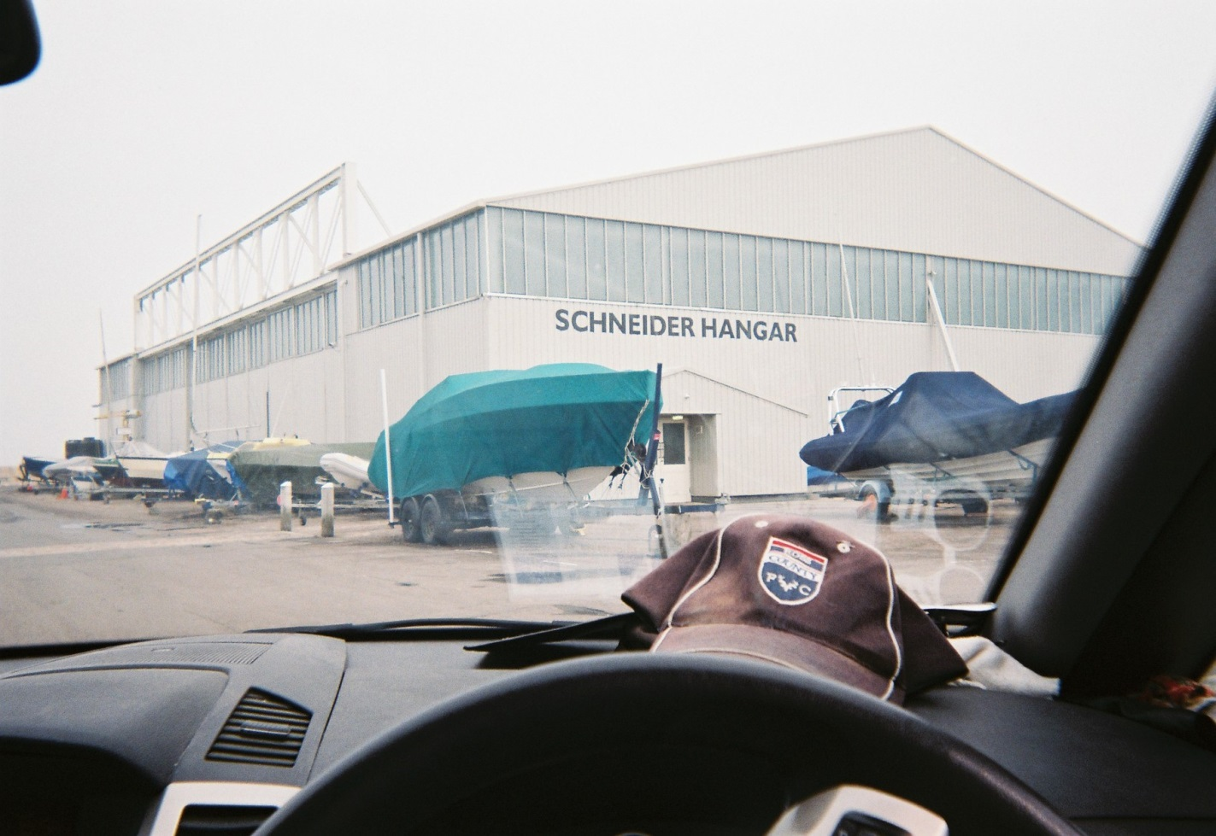
Fig. 1: View of Marina from car

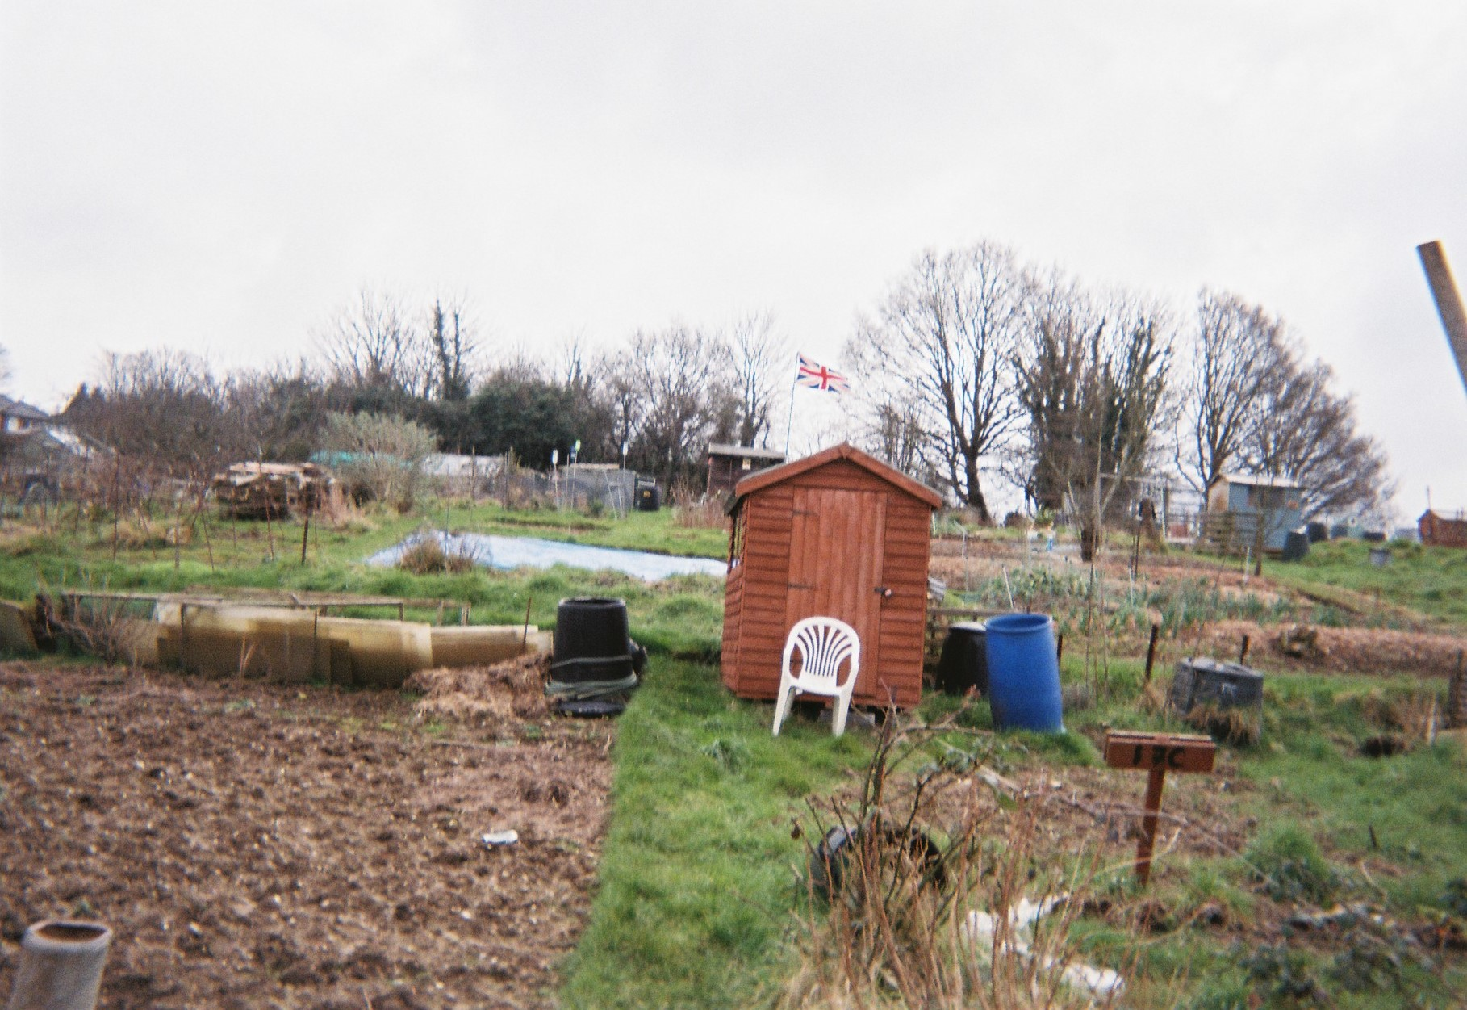
Fig. 2: Participant’s Allotment

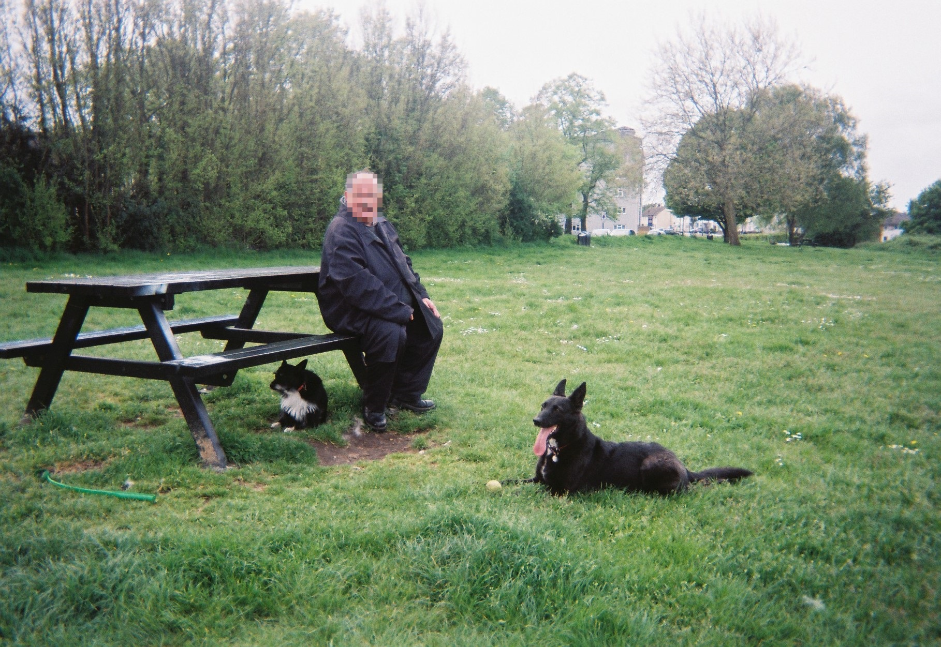
Fig. 3: Walking the Dogs

The authors use the term ‘learning disability’ in this paper as it the term that the Department of Health use within their policy documents. In Valuing People (2001) they describe a ‘learning disability’ as having: significantly reduced ability to understand new or complex information, to learn new skills; and reduced ability to cope independently which starts before adulthood with lasting effects on development. The authors acknowledge that other terms may be preferred in other contexts.
An allotment is a community garden where ‘allotment residents’ use a small plot of ground, owned and rented by the council, for gardening and non-commercial growing of food plants. The plots also often include a shed for tools and shelter.
An advocate is someone who speaks on behalf of another, and who has that other person's best interests in mind when they are speaking. An advocate can be a family member or friend or paid professional. Professional advocacy (otherwise known as citizen advocacy) is a service which performs many of these functions, and is bound by a professional code of conduct.

