Figure 1: Crossover trial design and progression through the study

Visit 1: Baseline assessment (Demographics, continence status, Barthel Score, MMSE and King’s Health Questionnaire (KHQ))
Testing order randomised centrally in blocks of 6

2nd Product Testing
3rd Product Testing
1st Product Testing
Week 1-3
Week 4-6
Week 7-9
Visit 2: PPQ + Interview + KHQ
Visit 3: PPQ + Interview + KHQ

Visit 4: PPQ + Interview + KHQ
End of testing: Self-reporting of Overall opinion for each device and usual pads, and plans for future product use (stated preference)
Week 9

Visit 5: Self-reporting of product use during previous 3 months (revealed preference), value for money for each of the 3 devices (sheath, BWU and clamp)
Postal Survey: Self-reporting of product use to establish on-going preferences.
3 months post-test
1 year post-test

KHQ = Kings Health Quality of Life questionnaire
MMSE = Mini Mental State Exam
PPQ = Product performance questionnaire

Figure 2: Details of products used in the study

Product type | Design | Brand (Dispensing Appliance Contractor (DAC))
Pad  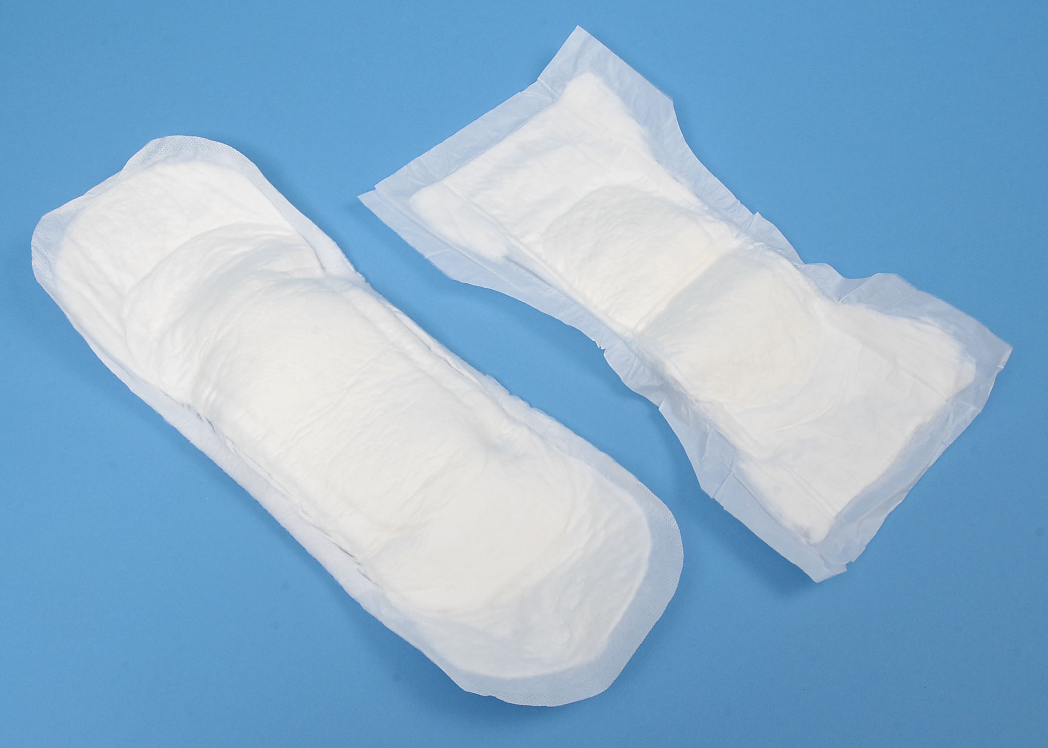 | Varied - Participant’s current pad | NHS Trust or self-purchase
Sheath  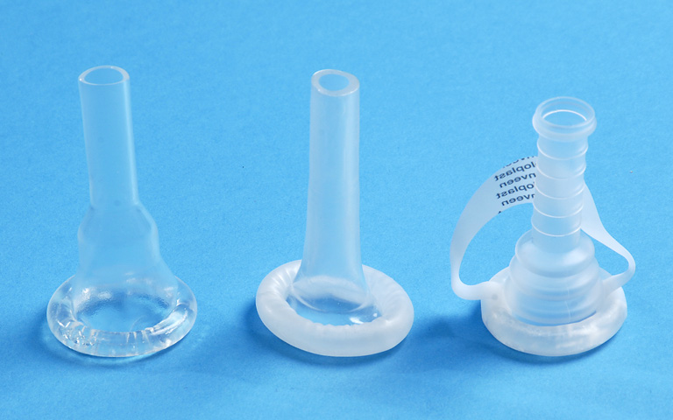 | One piece (integral adhesive):  - Attached to body-worn drainage bag or catheter valve  - Body-worn bag supported by straps / support garment  - Night bag + stand supplied as necessary | Conveen Optima (Coloplast Ltd.)  P-Sure (Manfred Sauer)  Clear Advantage (Rochester Medical)  (shorter length versions used when available)
BWU  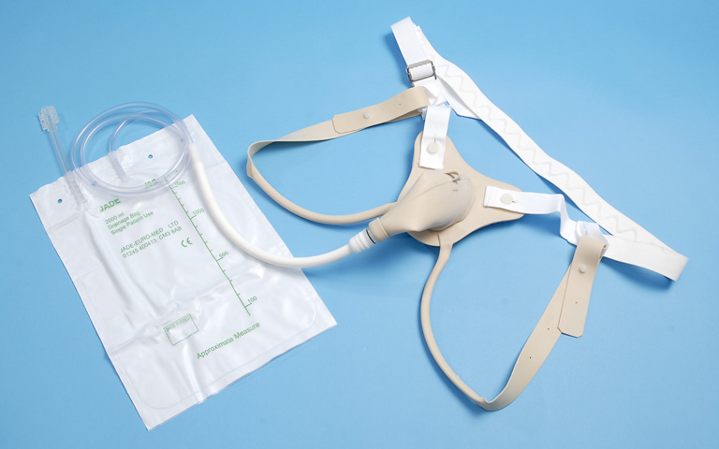 | Rubber cone + flange (One or two piece):  - Attached to body-worn drainage bag or tap  - Body-worn bag supported by straps / support garment  - Night bag + stand supplied as necessary | Mark 6 (SG & P Payne)  Model 101 & 106 (Jade Euro-Med)
Clamp  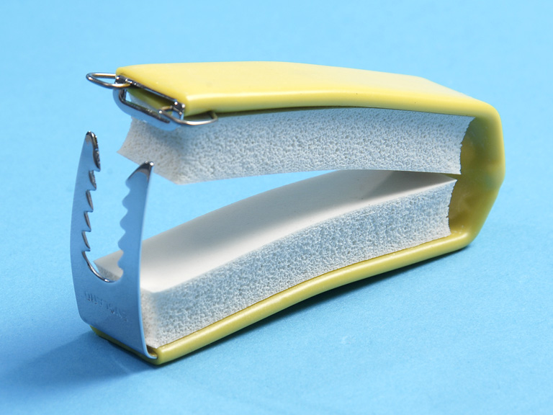 | Hinged clamp made from soft sponge rubber and metal. Available in two sizes. | Cunningham clamp (S G & P Payne Ltd.)

Figure 3: Consort Diagram
Mail out (post + email) to
N= > 3547 men
Southern counties of England (Continence Advisory Services - pad databases, Urology clinics, prostate cancer charities)

302 men assessed for eligibility

228 ineligible (see below for detail)

74 consented to take part
18 men withdraw after consenting to take part:

6 withdrew before testing started
- 1 man decided his incontinence was too light to bother with the products
- 1 man who had a job felt he was too busy to participate
- 2 men failed the mental test score at visit1
- 1 man was discovered not to have had prostate cancer after consenting
- 1 man declined to give a reason

12 withdrew during testing
- 8 due to ill health
- 1 incontinence cured following continence surgery
- 1 man lived alone, very frail and unable to manage the devices
- 1 man lived alone, depressed and unable to cope with the process
- 1 man tried BWU and clamp but he felt unable to cope with sheath

56 men completed

Reasons for ineligibility | N
No history of prostate cancer | 116
Non-surgical treatment only (prior to change in exclusion criteria to include men having non-surgical treatments only) | 5
Cognitive impairment | 9
Ill health | 13
Very light or no leakage | 30
Faecal incontinence | 9
Impaired bladder sensation | 1
Unwilling to try products (Clampx3;BWUx1;generallyx28) | 32
Not currently using absorbent pads | 6
Reason unknown | 7
Total | 228

Table 1: Participant characteristics
(N=56 men)
Continuous variables |  |  |  | Mean | SD
Age (years) |  |  |  | 72.2 | 6.6  (Range 54-85)
Barthel score. 0= total dependence, 100 = independent) |  |  |  | 92.5 | 3.6
KHQ max 100; high score = low continence-related QOL |  |  |  | 39.6 | 11.5
Time between first treatment and entering study (years) |  |  |  | 7.5 | 5.1
Frequencies: n (%)
Employment  N=41 responses | Retired  35 (85.4) |  | Full-time  1 (2.4) | Part-time  4 (9.8) | Seeking work  1 (2.4)
Type of incontinence | Stress Urinary Incontinence(SUI)  38 (67.9%) |  |  | Mixed  (SUI + Urge incontinence)  18 (32.1)
Severity of incontinence | Light  38 (67.9) |  | Moderate / heavy  18 (32.1) | Light = using small insert, pouch, leaf  Moderate/heavy if using medium/large insert, diaper, pull-up
Primary treatment for prostate cancer | Prostatectomy  47 (83.9) |  |  | Non-surgical  9 (16.1)
Typical product use: | Pads only |  |  | Sheaths and pads*
Day | 48 (85.7) |  |  | 8 (14.2)
Night (n= 38) | 35 (92.1) |  |  | 3 (7.9)
Previous product use: | Tried sheath? | Tried BWU? |  | Tried clamp? | Had help with fitting these products (N=34)
 | YES: 31 (55.4)  NO: 25 (44.6) | YES: 5 (8.9)  NO: 51 (91.9) |  | YES: 3 (5.4)  NO: 53 (94.6) | YES: 1 (2.9)  NO: 33 (97.1)
* Three of these men always used a sheath as their main product either during the day or the night; they were eligible for the study as they used a pad at other times.

Table 2: Summary of product performance (daytime)
N=56 unless stated |  | Pad  % | Sheath  % | BWU  % | Clamp  %
Security | Always feels secure vs. sometimes/always feels not secure | 46 | 38 | 32 | 68
Impact on clothing | Product never affects clothing  choice vs affects choice at least some of the time | 38 | 42 | 38 | 68
Pain during use | Never experience pain vs. experienced pain at least some of the time | 75 | 58 | 35 | 11
Leakage | Product never leaks vs. product leaks at least some of the time | 21 | 49 | 36 | 75
Impact on physical self-image | None vs. a little/a lot | 48 | 57 | 39 | 62
Impact on feelings of masculinity | None vs. a little/a lot | 55 | 74 | 63 | 62
Ease of putting on | Good vs. acceptable/poor | 84 | 43 | 25 | 51
Ease of taking off | Good vs. acceptable/poor | 84 | 24 | 32 | 48
Ability to keep skin dry | Good vs. acceptable/poor | 34 | 48 | 35 | 66
Kindness to skin | Good vs. acceptable/poor | 43 | 27 | 29 | 27
Comfort when dry | Good vs. acceptable/poor | 77 | 64 | 38 | n/a
Comfort when wet | Good vs. acceptable/poor | 5 | 45 | 24 | n/a
Discreetness to do with visibility | Good vs. acceptable/poor | 48 | 54 | 31 | 41
Discreetness to do with odour | Good vs. acceptable/poor | 38 | 69 | 53 | 70
Ease of disposal | Good vs. acceptable/poor | 38 | 65 | n/a | n/a
Ease of carrying | Good vs. acceptable/poor | 35 | 65 | 38 | 78
Storage of spare products | Good vs. acceptable/poor | 46 | 73 | 43 | 84
product performs significantly better for that characteristic than one, two or three of the other products
product performs significantly worse for that characteristic than one, two or three of the other products

Table 3: Product strengths and limitations based on summary of subjective comments

 | Pad | Sheath + bag | BWU | Clamp
Strengths | - Easy to apply & remove  - Comfortable when dry  - Kind to skin  - Best for night use | - Used for long periods without changing  - Easy to store, low risk of odour  - Discreet emptying | - Could be used for long periods without changing  - Washable | - Secure  - Simple to remove
Limitations | - Bulk, leakage, odour  - Shifts in clothing  - Frequent changing  - Disposal & change in public toilets  - Uncomfortable when wet | - Poor for penile retraction  - Can fall off  - Difficult to apply/painful to remove | - Cumbersome  - Chafing of straps  - Will leak in certain positions – esp. sitting down  - Penis can slip out | - Pain/discomfort  - Can only be worn for short periods

Table4: Views on value-for-money of products

a) PADS and SHEATHS
Information given to participants about costs | - Most men receiving continence products from the NHS are given only pads. On average, if they are only using pads during the day, they are given 3 pads per day. This costs the NHS about £15 per month  - The cost to the NHS of providing pads, and sheaths and accessories for use three time per week is about £42 per month  - The cost to the NHS of providing only sheaths and accessories for daily use is about £58 per month  - The cost of sheaths is based on manufacturers’ recommendations (i.e. one sheath per 24 hours) irrespective of whether sheaths are used exclusively or in combination with pads
Question asked | Bearing in mind the relative costs of these options, choose one option that you think the NHS should provide:
Responses  N=47 | Product for day use | Monthly cost to NHS | Number (%) choosing option
 | Only pads (no sheaths) | £15 | 19 (40.4%)
 | Sheaths on 3 days, pads on 4 days | £42 | 11 (23.4%)
 | Only sheaths (no pads) | £58 | 2 (4.3%)
 | Sheath + one pad every day | £63 | 15 (31.9%)
b) BWU
Information given on costs | To provide a man with a body worn urinal costs the NHS about £68 for a urinal plus about £1.80 per bag used; manufacturers state a BWU can be expected to last about 6-12 months if used regularly, longer if less frequently.
Question | Select the statement that best describes your views about BWU:
Responses  N=52 | I think the NHS should offer men only the body worn urinal for day use (i.e. The NHS should not provide pads or sheaths) |  | 1 (1.9%)
 | I think the NHS should offer men the body worn urinal for day use in addition to other products such as pads and sheaths |  | 36 (69.2%)
 | I think the NHS should NOT offer men the body worn urinal for day use |  | 15 (28.8%)
c) CLAMP
Information given on costs | To provide a man with a clamp costs the NHS about £30 per clamp, and manufacturers indicate that a clamp can be expected to last for up to 12 months or longer depending on frequency of use. They were reminded that the clamp is only for use in the day.
Question | Select the statement that best describes your views about the clamp:
Responses  N=51 | I think the NHS should offer men the clamp for day use in addition to other products such as pads and sheaths |  | 39 (76.5%)
 | I think the NHS should NOT offer men the clamp for day use |  | 12 (23.5%)
Notes on derivation of costs | All costs were rounded to make comparisons easier.  Pad cost was estimated using prices in the NHS Supply Chain catalogue,²⁰ and based on information from men recruited early in the study about the number and type of products they received from the continence services. The median price (14p per pad) in Rothwell absorbency bands 7-8 (light – moderate absorbency) was used. Most men reported using three pads per day (day use only). The cost of BWU, sheaths and clamps were taken from the Online Formulary data 2010,²¹ using average prices for available products. Sheaths assumed 1 per day @£1.55 each; leg bags assumed 1 per week @ £2.50; bag support garments assumed 1 every 2 weeks @ £2 each. Clamp (Cunningham): priced at £26. Fitting costs of sheaths and clamps were not included. This would usually be done by district nurses (NHS unit costs of home visit for 30 minutes, 2011: £35 ²⁸). BWU: mean of two available brands: £67, includes price of fitting by dispensing appliance producer. Leg bags and support garments are extra, as for sheaths.

