Investigation of the response to low velocity impact and quasi-static indentation loading of particle-toughened carbon-fibre composite materials
D.J. Bull^{1*}, S.M. Spearing¹, I. Sinclair¹
¹ Faculty of Engineering and the Environment, University of Southampton, Highfield, Southampton, SO17 1BJ, UK
*Corresponding author: daniel.bull@soton.ac.uk
Keywords: B. Impact behaviour, B. Delamination, C. Damage mechanics, X-ray computed tomography
This work investigates damage caused by low velocity impact and quasi-static indentation loading in four different particle-toughened composite systems, and one untoughened system. For impact tests, a range of energies were used between 25 to 50 J. For QSI, coupons were interrupted at increasing loading point displacement levels from 2 to 5 mm to allow for monitoring of damage initiation and propagation. In both loading cases, non-destructive inspection techniques were used, consisting of ultrasonic C-scan and X-ray micro-focus computed tomography. These techniques are complemented with instrumentation to capture force-displacement data, whereby load-drops are associated with observed damage modes. Key results from this work highlight particular issues regarding strain-rate sensitivity of delamination development and an earlier onset of fibre fracture associated with particle-toughened systems. These issues, in addition to observations on the role of micro-scale events on damage morphology, are discussed with a focus on material development and material testing practices.

Introduction
In addition to low velocity impact, composite structures may be susceptible to damage from non-transient out-of-plane point loads which can be represented using quasi-static indentation (QSI) experiments. It is reported in studies that the two loading conditions yield similar damage characteristics in both experimental and analytical cases due to the analogous loading and boundary conditions that arise . Controlled QSI loading may therefore present a valuable experimental strategy to imitate the chronology of processes occurring during impact, but without incurring the complexities of real-time observation during an impact test. The non-destructive inspection capabilities of micro-focus computed tomography (µCT) may then offer a powerful approach to monitor the evolution of damage, with the initiation and development of damage being measured as a function of the increasing applied displacements, and resultant loads . Despite the similarities between QSI and impact, it is of course clear that QSI does not introduce the same dynamic and time-dependent components of impact events. It has previously been debated within the literature as to the limits of utilising QSI to represent low velocity impact events, e.g. .
In studies that compare QSI to impact loads, similarities have been reported in C-scan damage area and load displacement curves . Whilst this provides an understanding of the general damage resistance response of such systems to loading, it neglects to identify if there are similarities in the interaction of different damage modes and if there are underpinning mechanistic similarities or indeed differences. Whilst previous studies have attempted to capture the micromechanisms of damage under increasing QSI loading, e.g. by using cross-sectional microscopy, no time-resolved 3D analysis has been reported. Such information may play a significant role in validating finite element models and guiding future toughening strategies, in which toughness may for example be targeted to certain ply interfaces .
This paper aims to highlight the importance of understanding damage mechanisms in order to guide material development and material testing practices under low velocity impact and QSI loading conditions. The vast majority of the work that has been done to date on impact and QSI loading has looked at characterisation of damage and definition of damage resistance and damage tolerance via relatively coarse measurements of overall damage areas, generally without definition of damage location and often without definition of damage type. In the present work, in order to characterise the response of composite systems more precisely, µCT is used to provide novel, detailed comparisons of damage under low velocity impact and interrupted QSI conditions, complementing ultrasonic C-scan and force-displacement data.
This work extends the understanding of the failure mechanisms operating in particle-toughened systems and builds upon previous work on the same material systems, including assessment of the role of particle-toughening micromechanisms in impact damage resistance , and observations of damage propagation in compression-after-impact tests .

Materials and test procedure

Materials
One untoughened (UT) and four particle-toughened (T1-T4) carbon-fibre prepreg systems were manufactured. The materials used are proprietary next generation prototype systems using an intermediate modulus carbon fibre. A quasi-isotropic layup [45/0/-45/90]_{3S} was used to create test coupons measuring 150 x 100 mm with a thickness of approximately ~4.6 mm. The toughened systems were labelled in order of impact damage resistance, as measured by the size of the projected delamination area obtained via ultrasonic C-scan (T1 being the largest projected damage area for a given impact energy and T4 the least).
For the particle-toughened systems, the matrix consisted of thermoplastic particles introduced to the base thermoset epoxy resin with varying sizes and chemistry used for each system. The particle-resin mixture was present at the interlaminar regions of the composite. Particle sizes were in the order of 4 to 30 microns in diameter. A particle-resin mixture was introduced to the surface of the prepreg during manufacture following a wetting process of the fibres with epoxy resin. The process of adding particles to the prepreg occurred sequentially on the same prepreg manufacturing line. The same particle to resin ratio (by weight) was used to form the matrix in the toughened systems. Regarding all the systems, the same fibre to matrix (resin plus particles) ratio by weight was used. The same intermediate modulus carbon fibre type and base epoxy resin system was used in all five material cases. The particle toughened systems shared the same lamina elastic modulus properties.
The interlaminar mode II fracture toughness of each composite system was supplied by the manufacturer and has been normalised by dividing individual fracture toughnesses by the largest measured toughness value. These values were measured from end notch flexure tests following ASTM D7905M standards. Corresponding normalised mode II fracture toughness values for UT, T1, T2, T3 and T4 systems are 0.4, 0.8, 0.3, 0.6 and 1.0 respectively.

Test procedure
Instrumented impact tests were conducted at 25, 30, 40 and 50 J and repeated three times for each material system. The exact impact energy was measured and in all cases was found to be within 3 J of the target energy. These tests were conducted in accordance with the ASTM D7136M standard using a 4.9 kg, 16 mm hemispherical tup and a base plate containing a 75 x 125 mm rectangular window. QSI experiments utilised the same tup geometry and base plate in order to achieve comparable boundary conditions as the impact experiment. QSI loading was applied at a cross-head displacement rate of 2 mm per minute; force-displacement data was recorded for the loading stage. Incremental displacement steps of 2, 2.5, 3, 4, and 5 mm were applied sequentially from the position where the tup contacted the coupon’s surface. The range of incremental displacements was selected to capture damage initiation and damage growth. The first displacement step of 2 mm was chosen based on the force-displacement load drop observed in the UT system. The final displacement step of 5 mm was chosen to match the peak displacement reached in the majority of 40 J impact tests. The formation of a dent after the initial loading condition resulted in a total out-of-plane displacement slightly greater than 2.5, 3, 4 and 5 mm. QSI tests were conducted on three specimens for each material system.
After impact or application of QSI load increments to the coupons, ultrasonic C-scans and µCT scans were carried out. It should be noted that these were achieved non-destructively, with no cutting of the samples. The ultrasonic C-scans were performed at a 1 mm resolution. Due to time restrictions on the µCT equipment, the T2 system was omitted for detailed µCT analysis. Coupons of the other four materials were scanned in pairs; an XTEKTM Benchtop µCT scanner was used to scan the contact region of the QSI samples subjected to 2-4 mm displacements. A larger NikonTM HMX system was used to scan the QSI samples subjected to 5 mm displacement and impacted coupons subjected to 25 J and 30 J for UT and particle-toughened systems respectively. Lower impact energy was chosen for the UT system to restrict the extent of damage to fit within the field-of-view. Samples were scanned using the following settings: 115 kV peak, 100 µA, 1301 projections, 2 frames per projection and 1 second exposures. This led to a voxel resolution of 12.6 and 14.2 µm for Benchtop and HMX scans respectively.

Results

Projected C-scan damage area
To assess damage resistance under quasi-static and impact loading conditions, C-scan damage areas have been plotted against the applied energies in Figure 1 for both loading conditions. The applied energies for QSI data were calculated by integrating the area under the force-deflection plots for the loading increments e.g. see Figure 2. The energies corresponding to each additional loading step were calculated by integrating the force-deflection beyond the deflection of the previous load step and adding this to the energy calculated from the previous loading stage to give the total energy applied. Applied energies for impact tests were based on the velocity at impact and the mass of the tup.
The plots in Figure 1 show a strong linear relationship between damage area and the applied energy for both impact and QSI loading conditions, with the exception of the T3 system where scatter in the order of a factor of two was observed at impact energies of 40 and 50 J. The gradients of the impact trend lines are reasonably consistent for UT, T1, and T2 systems with T4 showing a distinctly lower gradient trend line. Similarly, the gradients of the QSI trend lines are reasonably consistent between the UT and T2 system, and the T1, T3 and T4 systems with the former pair of systems exhibiting a steeper gradient of approximately a factor of two.
It is interesting to note the correlation between the QSI and impact loading conditions for each of the material systems. The UT, T2 and T4 systems show a good correlation between the QSI data and impact. However two of the systems, T1 and T3, show distinctly different correlations between the two loading conditions with a significantly lower damage area response under QSI conditions above 30 J, on the order of two to three times respectively, as circled in Figure 1. Furthermore, it should be noted that for the T3 system, the lower bound of the impact data which is particularly scattered above 30 J, does correlate closely with the QSI data.

Force-displacement comparisons
Force-displacement plots for quasi-static and impact loading conditions are shown in Figure 2. 40 J impact curves were plotted as a representative comparison with QSI due to similar resulting maximum displacements. Loading steps for each of the material systems are plotted together and show that the load-displacement response for each incremental load-step are consistent as the curves intersect or are in close proximity to the curves at the end of the previous load steps. The exception to this is for the T1 and T4 systems at the last load increment, for which a difference in load from the previous displacement on the order of 1.5 kN was observed, ~15% of the applied load at that point. Since the energy for each additional loading step was calculated by adding the energy applied beyond the previous displacement to the energy calculated from the previous loading stage, this may have ramifications for calculating the energy applied at the final load step which is likely to be underestimated.
Observed in figure 2, there are two distinct modes of load drops. A primary set of load drops which occurs earlier on in the loading path at displacements less than 2.0 mm and a secondary set of load drops occurring at the latter end of the loading curve above 3.5 mm displacement. The primary set of load drops occurred on the UT system under both QSI and impact loading conditions (i) and in the T3 system only for impact (ii). In both material and loading cases, this occurred at approximately 1.8 mm displacement and was consistent across all repeats.
At the highest displacement (4 or 5 mm), secondary load drops were observed across all material systems indicated in Figure 2 (iii) and (iv) for impact and QSI respectively. In the QSI test with the exception of T4, a smaller load drop (iv) preceded a significant load drop (v). This was consistent across all QSI tests when the load levels to cause this effect were reached. In the T4 system, the load drop indicated by (iv) was of a similar magnitude to the second load drop (v) in the other four material systems. The load drops in the impact case occurred at approximately the same load and displacement for 40 and 50 J cases across all the specimens tested.
Under QSI loading conditions, no primary load drops occurred on the toughened systems. Instead, the material exhibited non-linear load-displacement curves, as also observed in particle-modified composites in . With subsequent loading increments during the QSI tests, there is an increase in non-linearity in the loading stage of the force-displacement plots, most noticeable at 4 and 5 mm displacements. This was observed across all toughened material systems and was consistent across the repeats.

µCT comparison of QSI and impact
µCT cross-sections of damage from impact and QSI loading conditions are shown side by side in (as noted previously, the T2 system was not scanned due to time constraints). To achieve like-for-like comparisons, the cross-sections show coupons subjected to a peak out-of-plane displacement of approximately 4 mm for both impact and QSI loading conditions. In all cases, the energy and maximum displacement in these comparisons was marginally greater under QSI loads but within 10% of the impact loading case.
Both the impact and QSI loading conditions show similarities in damage behaviour. This consisted of a “cone” of essentially undamaged material immediately beneath the contact point of the tup with delaminations extending away from the impact region. In the T4 system, fibre fractures are observed below the mid-plane in both loading conditions. Fibre fracture was distinguished against other damage modes by observing fracture across plies oriented with the fibres parallel to the viewing plane.
The presence of significant bridging ligaments (circled in ) was only observed in the T1 and T3 systems under QSI loads. This is shown more clearly on an enlarged view of the T1 system in Figure 4.

Development of damage
The development of damage was captured from µCT scans through interrupted QSI tests for each increment of displacement. Cross-sections of the damage development are shown in Figure 5 for the T1 system and are representative of the damage evolution observed in the other particle-toughened material systems used in this study. The deflection and peak-force are indicated on each cross-section.
In the particle-toughened systems, it is revealed that matrix cracks initiate first (i), occurring predominantly below the sample mid-plane. With increasing displacements, delaminations are observed (ii) initiating at previously formed matrix cracks; in this case ligaments consisting of interconnected regions of material bridging the two ply interfaces are shown which are subsequently fractured at higher displacements (iii). At the highest displacement levels, fibre fractures occur (iv) which initiate below the mid-plane beneath the impact site due to tensile stresses, before growing in severity (v). In the UT system, matrix cracks and delaminations were present at the first loading stage, distributed across the thickness of the specimen.
Fibre fracture was distinguished from matrix cracks by orientating the CT data viewpoint. Cracks detected with the ply orientation positioned parallel to the page are fibre fractures. Additionally, by studying the topology of the plies as shown in Figure 7, fibre fracture (i) can be made out. In this particular viewpoint, 0 degree plies are seen towards the centre and 45 degree plies are seen towards the edges due to the permanent out-of-plane deflection bringing these features into the viewing plane. At the final loading stage, fibre fracture was present at all plies below the mid-plane across the four systems studied. Fibre fractures were shown to extend between pairs of matrix cracks (ii) and were typically 2-6 mm across.
The latter stages of the QSI test are shown in Figure 6 to highlight the development of fibre fracture across the other material systems. The presence of fibre fracture was observed at ~4 mm displacement in the toughened systems (T1, T3 and T4) and in the UT system this was only observed at 5 mm displacement. Taking the severity of fibre fracture into account, two categories of fibre fracture are represented; (iv) initial fibre fracture, and (v) substantial fibre fracture. Substantial fibre fracture was observed to occur at an earlier point in the T4 system (~4 mm displacement) compared to the other material systems (~5 mm displacement).

Discussion

Sensitivity of damage to loading rate
The value of QSI to probe material damage resistance under low velocity impact has been shown to be partially valid with close correlation between the extents of the damage area for a given applied energy under both loading cases, see Figure 1. At energies in excess of 30 J, the T1 and T3 systems exhibit a lower damage area under QSI conditions by an order of approximately two and three times respectively: in the first instance this may be attributed to strain-rate dependencies in these systems. The transition above ~30 J could also explain the substantial scatter in impact damage area observed at 40 and 50 J in the T3 system. This is interesting as the majority of work comparing QSI to low velocity impact cites similar behaviour between the two loading conditions, although these studies have focused on current and previous generations of composite systems that are typically untoughened .
An underlying role of the strain-rate sensitivity of the toughening phases would appear to be borne out of the varying micromechanisms and corresponding localised toughening seen in the T1 and T3 materials. The presence of larger-scale ligaments under QSI loads in the T1 and T3 systems provides a straightforward explanation of the load-rate sensitivity of these materials and why these systems exhibited a lower damage area under QSI loading conditions compared to low velocity impact above 30 J. This was observed with the preferential ligament-forming behaviour in the QSI case shown in and Figure 4 that diminished under low velocity impact.
From previous work on these material systems , the early stages of delaminations form through particle-resin debonding creating a discontinuous crack separated by ligaments within the interlaminar region. The extent of the ligaments near the crack tip was shown to scale with impact damage performance. It is understood that the ligaments, formed of uncracked particles and resin, can improve toughness through bridging the ply interfaces leading to a reduction in stresses at the crack tip, and energy absorption through particle-resin debonding and ligament failure . The reduction of these ligaments in the T1 and T3 system under low velocity impact, suggests a more brittle failure mechanism and a reduction on the effectiveness of these toughening mechanisms.
Considering that the same base resin, fibre type and mixture ratios was used across the different particle-toughened material systems, i.e. only particle type and size was varied, it is therefore likely that toughness loss with increase in strain-rate is directly linked to the particle-toughening micromechanisms at the ply interfaces. One suggestion is the stiffening of the thermoplastic particles that could increase the surrounding stress-state and a reduction in cohesion between the particle-resin interfaces reducing the load carrying capability across the particle . This would require further investigation, where for example the changes in stiffness of particles could be measured through nanoindentation with the addition of varying the loading-rate. Nonetheless, it is clear that adjustments to the particles used for toughening can have a significant influence on damage resistance at an increase in strain-rate from 10⁻⁴ s⁻¹ to 10 s⁻¹ for QSI and low velocity impact respectively , highlighting important concerns in material development.

Force-displacement behaviour and damage development
From load-displacement plots (Figure 2) and corresponding damage observed from the µCT scans (Figure 5 and Figure 6), the primary load drops on the UT and T3 systems are expected to be attributed to the onset of delaminations where a sudden occurrence of a delamination leads to a sudden drop in stiffness. The magnitude of load required to cause the load drop has in the past been demonstrated to correlate with interlaminar fracture toughness . Whilst this holds true for some material systems, it is important when studying load-displacement curves to understand that delaminations can exist even in the absence of a load drop, as demonstrated by the particle-toughened systems in this study. In the T3 system which saw the largest difference in damage resistance between the two loading conditions, primary load drops were only observed under low velocity impact and not during QSI loading. Based on the earlier discussion in section 4.1, the load drop is likely to correspond to the increase in brittleness of delamination formation at the increased loading rate.Combining the force-displacement plots with µCT scans, it is possible to associate the secondary load drops that occur towards the highest applied displacements (4 and 5 mm) with fibre fracture. Such fibre fractures were present below the mid-plane and in the vicinity of the loading point of the tup, see Figure 7 (i). The magnitude of the drop in load was observed to scale with the severity of the detected fibre fracture. Unlike the onset of delaminations, the compliance between load drop and fibre fracture was consistent and independent of the material toughness and apparently not dependent on the loading rate, at least for the materials used in this study.

Fibre fracture and matrix toughness
Significant fibre fracture was shown to occur at lower applied displacements in the T4 system, i.e. fibre fracture extending throughout the full through-thickness below the mid-plane at ~4 mm displacement in comparison to the other systems where this behaviour occurred at ~5 mm displacement. This earlier onset of significant fibre fracture appears to be independent of the peak-load reached: the T3 system which experienced a greater peak-load at ~4 mm displacement showed no significant fibre fracture. It is likely that the formation of a larger damage area observed in the other systems relieved the build-up of tensile stresses at the back-face of the material, delaying fibre fracture, as identified in other studies .
In systems that heavily suppress delamination formation, the earlier onset of fibre fracture presents a potential limitation. Considering that fibre fracture has a detrimental effect on the residual tensile strength ; this could be of particular concern and might be a significant trade-off for toughened systems between suppressing delamination growth to maintain compression-after-impact strength at the expense of an earlier formation of fibre fracture which may reduce residual tensile strength. It also highlights the need for higher strength fibres to complement the tougher resin systems.

Development of testing practices
It is necessary to define the details of the damage that occurs in initiation and propagation, both via location and type, in order to characterise properly the response of composite systems. This highlights a particular concern with regard to damage resistance and damage tolerance testing practices. Typically damage is measured using C-scan giving a two-dimensional view representative of the scale of delaminations. Whilst the overarching goal is to minimise such damage area e.g. for flexure and CAI performance, other critical damage modes that arise such as fibre fracture would not be captured through this method. Although it has been presented that the magnitude of load drops occurring at the latter stages of the load-displacement curve may give an indication to the extent and severity of fibre fracture, it is suggested that cross-sectional microscopy or µCT are essential to study the true extent of such mechanisms, particularly as tougher matrix systems are developed and deployed.
The link between mode II interlaminar fracture toughness and low velocity impact damage performance was not seen to correlate well in this study, i.e. the ranking order and magnitudes of mode II fracture toughness did not compare well with impact damage resistance performance for the T1, T2 and T3 systems. Under QSI loading conditions however, improved correlation was observed and was linked to the sensitivity of damage to strain-rate in the T1 and T3 material systems (see Figure 1). Therefore, the magnitude of mode II interlaminar fracture toughness is expected to be a function of the applied strain-rate; as such, certain material systems are more sensitive to variations in strain-rate than others, a phenomenon observed in a separate study . This is a particular area of concern for developing tougher particle-toughened systems, and integrating such toughness parameters into dynamic finite element models.
It is therefore recommended that modifications to the interlaminar mode II fracture toughness method be made to allow for the possibility of toughness variations as a function of loading-rate e.g. . One important future study would be to compare mode II fracture toughness calculated at comparable strain-rates (10¹ s⁻¹), with low velocity impact damage resistance performance to test if the two cases are strongly linked.

Conclusions
- The use of particle-toughened systems highlight particular issues regarding strain-rate dependency on delamination development and the associated earlier onset of fibre fracture with tougher materials. At energies above 30 J, degradation to damage resistance was observed in two material systems under low velocity impact which is attributed to a reduction in bridging ligament formation. It is therefore suggested that the micromechanisms associated with particle-toughening may be particularly sensitive to strain-rate. This highlights challenging aspects for material development in which the dynamic response is important, even under relatively modest low velocity impact conditions.
- Mode II fracture toughness does not necessarily translate well with the low velocity impact damage performance of the material system. This is likely related to the loading rate used (quasi-static) when obtaining mode II fracture toughness. A future study to obtain mode II fracture toughness values at comparable strain rates to low velocity impact is suggested to test if the two properties are linked.
- A particular trend is evidenced between toughness and fibre fracture. The toughest T4 system exhibited significant fibre fracture at a lower displacement (~4 mm) when compared with the untoughened system which delayed the behaviour until ~5 mm. This highlights a potential trade-off in terms of performance and also a practical limit in terms of the maximum impact damage resistance that can be achieved. The presence of fibre fracture also highlights the need to incorporate damage details beyond the projected damage area associated with C-scans through cross-sectional microscopy or µCT damage assessments for example.
- Load-deflection plots were compared to the observed damage modes in each material system. The UT system typically displayed a load drop associated with the onset of delamination. Particle-toughened systems typically did not display such a load drop despite the presence of delaminations. Load drops linked with fibre fracture however were consistent and independent of the material system tested.

Acknowledgments
The authors wish to thanks the µ-VIS computed tomography centre at the University of Southampton for providing the µCT facilities used in this study. The paper also acknowledges Cytec Engineered Materials Ltd for their sponsorship and supply of materials used in this project. The authors are particularly grateful for the help and support of Dr. Kingsley Ho, the technical point of contact at Cytec.

References
[1] Lagace PA, Williamson JE, Tsang PHW, Wolf E, Thomas S. A Preliminary Proposition for a Test Method to Measure (Impact) Damage Resistance. J Reinf Plast Comp. 1993;12(5):584-601.
[2] Wardle BL, Lagace PA. On the use of quasi-static testing to assess impact damage resistance of composite shell structures. Mech Compos Mater St. 1998;5(1):103-21.
[3] Bull DJ, Helfen L, Sinclair I, Spearing SM, Baumbach T. A comparison of multi-scale 3D X-ray tomographic inspection techniques for assessing carbon fibre composite impact damage. Composites Science and Technology. 2013;75:55-61.
[4] Tan KT, Yoshimura A, Watanabe N, Iwahori Y, Ishikawa T. Effect of stitch density and stitch thread thickness on damage progression and failure characteristics of stitched composites under out-of-plane loading. Composites Science and Technology. 2013;74(0):194-204.
[5] Swanson SR. Limits of Quasi-Static Solutions in Impact of Composite Structures. Compos Eng. 1992;2(4):261-7.
[6] Kaczmarek H, Maison S. Comparative Ultrasonic Analysis of Damage in Cfrp under Static Indentation and Low-Velocity Impact. Compos Sci Technol. 1994;51(1):11-26.
[7] Abdallah EA, Bouvet C, Rivallant S, Broll B, Barrau JJ. Experimental analysis of damage creation and permanent indentation on highly oriented plates. Compos Sci Technol. 2009;69(7-8):1238-45.
[8] Aoki Y, Suemasu H, Ishikawa T. Damage propagation in CFRP laminates subjected to low velocity impact and static indentation. Adv Compos Mater. 2007;16(1):45-61.
[9] Kwon YS, Sankar BV. Indentation-Flexure and Low-Velocity Impact Damage in Graphite-Epoxy Laminates. J Compos Tech Res. 1993;15(2):101-11.
[10] Lee SM, Zahuta P. Instrumented Impact and Static Indentation of Composites. J Compos Mater. 1991;25(2):204-22.
[11] Symons DD. Characterisation of indentation damage in 0/90 lay-up T300/914 CFRP. Compos Sci Technol. 2000;60(3):391-401.
[12] Sjoblom PO, Hartness JT, Cordell TM. On Low-Velocity Impact Testing of Composite-Materials. J Compos Mater. 1988;22(1):30-52.
[13] Yasaee M, Bond IP, Trask RS, Greenhalgh ES. Damage control using discrete thermoplastic film inserts. Compos Part a-Appl S. 2012;43(6):978-89.
[14] Bull D, Scott A, Spearing S, Sinclair I. The influence of toughening-particles in CFRPs on low velocity impact damage resistance performance. Composites Part A: Applied Science and Manufacturing. 2014;58:47-55.
[15] Bull DJ, Spearing SM, Sinclair I. Observations of damage development from compression-after-impact experiments using ex situ micro-focus computed tomography. Composites Science and Technology. 2014;97(0):106-14.
[16] Gao F, Jiao GQ, Lu ZX, Ning RC. Mode II delamination and damage resistance of carbon/epoxy composite laminates interleaved with thermoplastic particles. J Compos Mater. 2007;41(1):111-23.
[17] Borstnar G, Mavrogordato MN, Helfen L, Sinclair I, Spearing SM. Interlaminar Fracture Micro-Mechanisms in Toughened Carbon Fibre Reinforced Plastics Investigated via Synchrotron Radiation Computed Tomography and Laminography. Composites Part A: Applied Science and Manufacturing. (Accepted in press).
[18] Garcea SC, Sinclair I, Spearing SM. In situ synchrotron tomographic evaluation of the effect of toughening strategies on fatigue micromechanisms in carbon fibre reinforced polymers. Composites Science and Technology. (Accepted in press).
[19] Fu SY, Feng XQ, Lauke B, Mai YW. Effects of particle size, particle/matrix interface adhesion and particle loading on mechanical properties of particulate-polymer composites. Compos Part B-Eng. 2008;39(6):933-61.
[20] Vanhartingsveldt EAA, Vanaartsen JJ. Strain-Rate Dependence of Interfacial Adhesion in Particle-Reinforced Polymers. Polymer. 1991;32(8):1482-6.
[21] Yan WY, Pun CL, Wu ZH, Simon GP. Some issues on nanoindentation method to measure the elastic modulus of particles in composites. Compos Part B-Eng. 2011;42(8):2093-7.
[22] Hsiao HM, Daniel IM. Strain rate behavior of composite materials. Compos Part B-Eng. 1998;29(5):521-33.
[23] Davies GAO, Zhang X. Impact damage prediction in carbon composite structures. Int J Impact Eng. 1995;16(1):149-70.
[24] Schoeppner GA, Abrate S. Delamination threshold loads for low velocity impact on composite laminates. Composites Part A: Applied Science and Manufacturing. 2000;31(9):903-15.
[25] Cartié DDR, Irving PE. Effect of resin and fibre properties on impact and compression after impact performance of CFRP. Composites Part A: Applied Science and Manufacturing. 2002;33(4):483-93.
[26] Wisnom M. The trade-off between damage and strength: why weaker may mean stronger. Damage in Composites: Volume 5, ASC Series. 2012:211.
[27] Wisnom MR. The role of delamination in failure of fibre-reinforced composites. Philos T R Soc A. 2012;370(1965):1850-70.
[28] Cantwell WJ, Curtis PT, Morton J. An Assessment of the Impact Performance of Cfrp Reinforced with High-Strain Carbon-Fibers. Compos Sci Technol. 1986;25(2):133-48.
[29] Wang SX, Wu LZ, Ma L. Low-velocity impact and residual tensile strength analysis to carbon fiber composite laminates. Mater Design. 2010;31(1):118-25.
[30] Richardson MOW, Wisheart MJ. Review of low-velocity impact properties of composite materials. Compos Part a-Appl S. 1996;27(12):1123-31.
[31] Smiley AJ, Pipes RB. Rate Sensitivity of Mode-II Interlaminar Fracture-Toughness in Graphite Epoxy and Graphite Peek Composite-Materials. Composites Science and Technology. 1987;29(1):1-15.
[32] Kusaka T, Yamauchi Y, Kurokawa T. Effects of Strain-Rate on Mode-II Interlaminar Fracture-Toughness in Carbon-Fiber Epoxy Laminated Composites. J Phys Iv. 1994;4(C8):671-6.
[33] Sohn MS, Hu XZ. Impact and high strain rate delamination characteristics of carbon fibre epoxy composites. Theor Appl Fract Mec. 1996;25(1):17-29.
[34] Cantwell WJ. The influence of loading rate on the mode II interlaminar fracture toughness of composite materials. Journal of composite materials. 1997;31(14):1364-80.

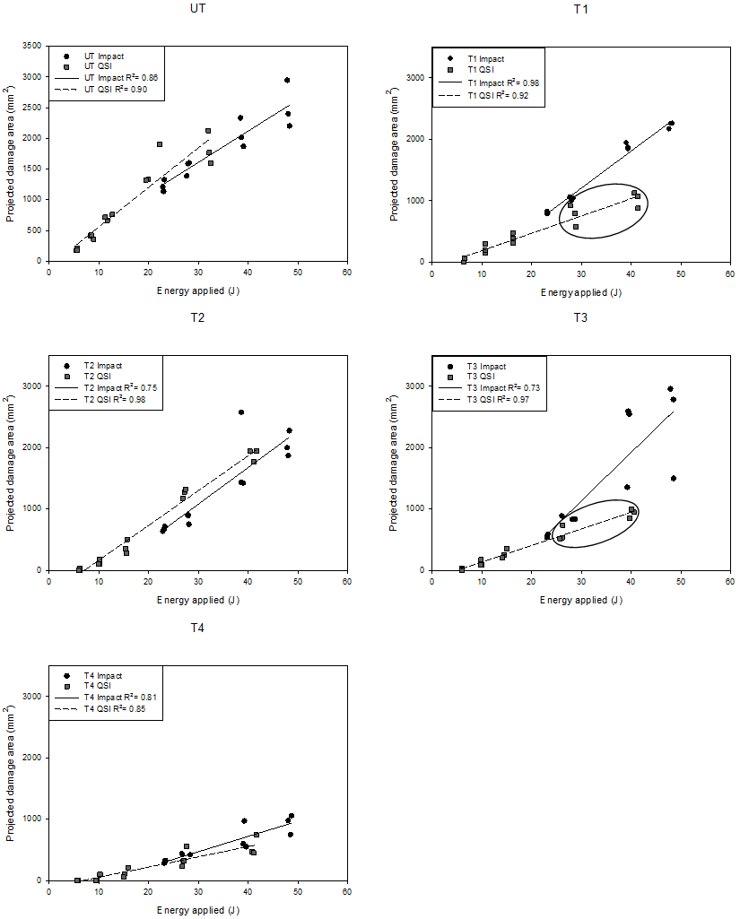
Figure 1: Graphs of C-scan damage areas against the energy applied for impact and quasi-static loading conditions. The T1 and T3 systems show different trends between QSI and impact loading above 30 J which are circled.
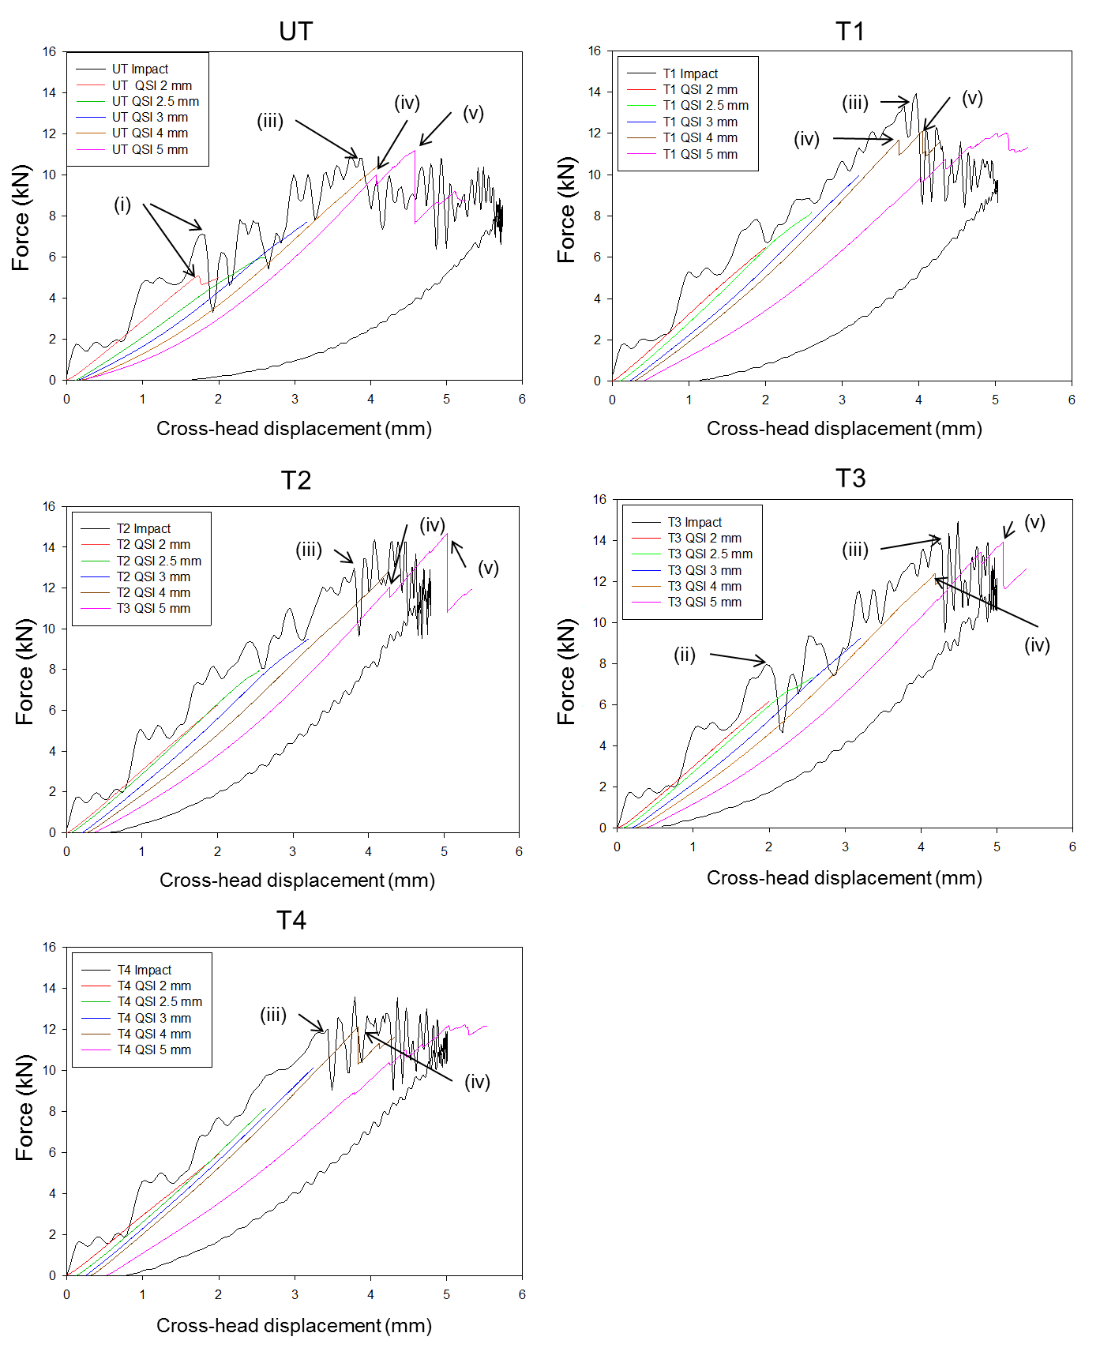
Figure 2: Force displacement curves for QSI and impact loading.
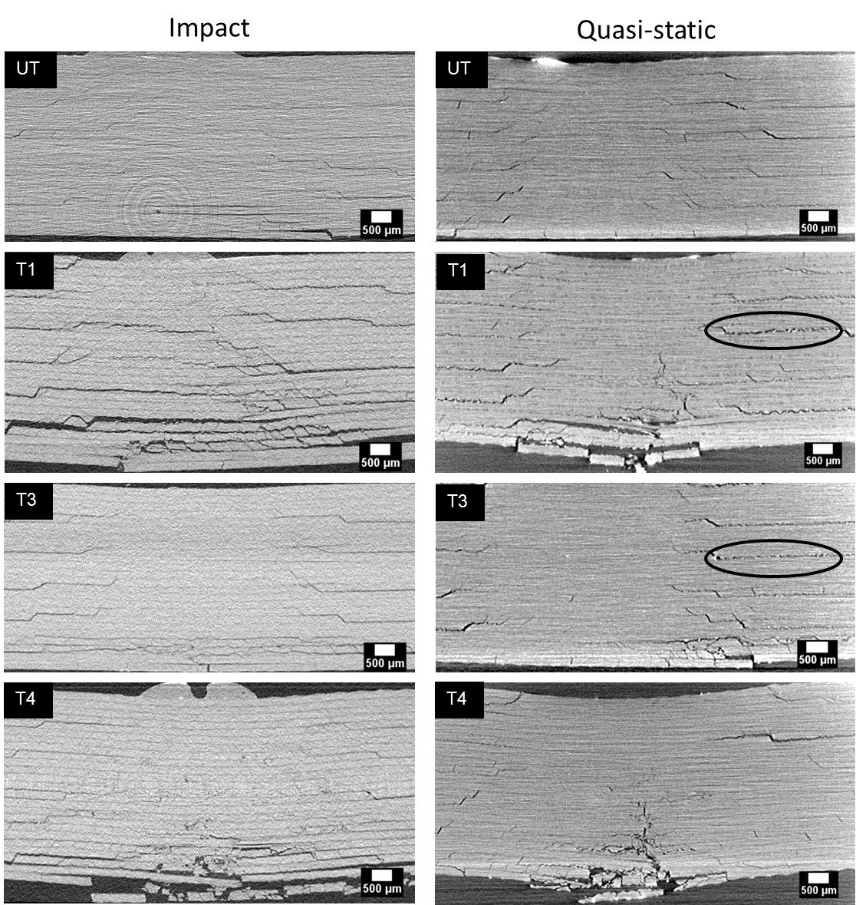
Figure 3: µCT cross-sections showing impact damage (left) and quasi-static indentation (right) at approximately the same maximum displacement. Observable bridging ligaments are circled.

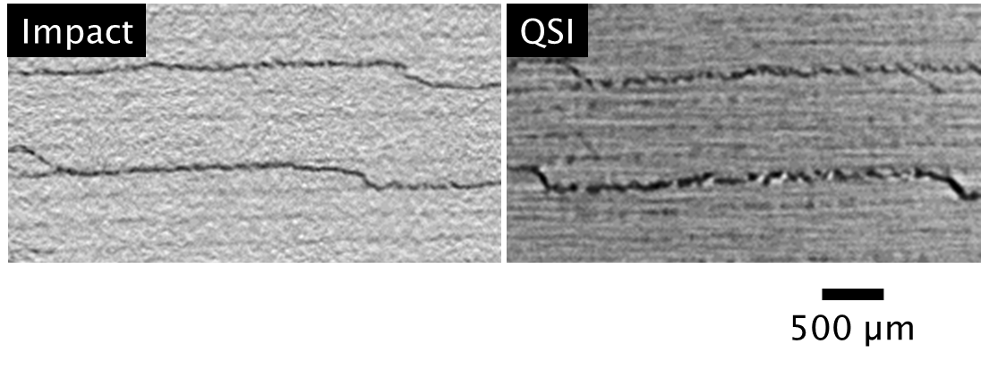
Figure 4: µCT cross-section comparing impact and QSI loading conditions of T1 system. More extensive bridging ligament behaviour is observed in the QSI loading condition.
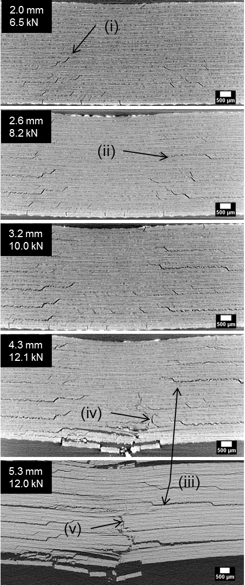
Figure 5: µCT cross-section of damage from the T1 system at increasing QSI displacements. Peak displacement and peak forces are indicated. Damage features are indicated consisting of (i) matrix cracks, (ii) delamination with bridging ligaments, (iii) failure of bridging ligaments, (iv) initial fibre fracture and (v) substantial fibre fracture.
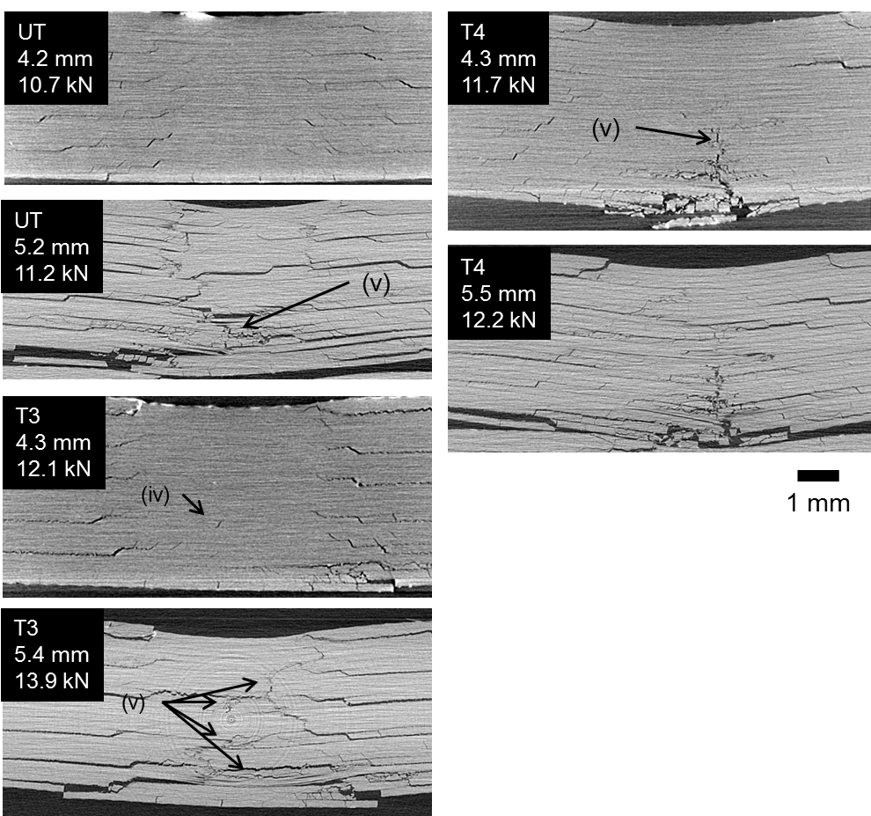
Figure 6: µCT cross-section of damage taken at ~4 and ~5 mm QSI displacements for the UT, T3 and T4 material systems showcasing (iv) initial fibre fracture and (v) substantial fibre fracture.
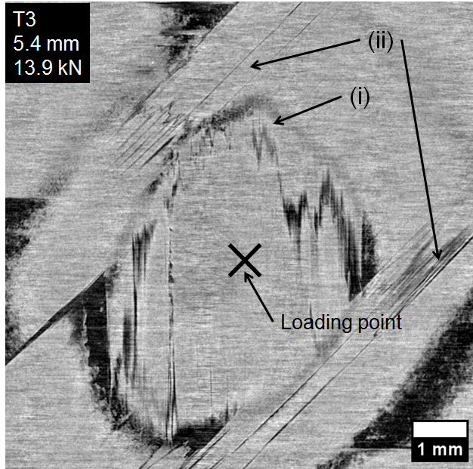
Figure 7: µCT topology cross-section of the T3 system at region (iv) in figure 6. Fibre fracture (i) is seen extending across two pairs of matrix cracks (ii).

