An Optimal Charging Method for Li-Ion Batteries using a Fuzzy Control Approach Based on Polarization Properties
Jiuchun Jiang^{a,}*, Caiping Zhangª, Jiapeng Wenª, Weige Zhangª, S.M. Sharkh^{b}
ª School of Electrical Engineering, Beijing Jiaotong University, Beijing 100044, China
^{b} Electro-Mechanical Research Group, Faculty of Engineering and the Environment, University of Southampton, Highfield, Southampton, SO17 1BJ, UK
Abstract Battery charging is growing in importance as it has direct influence on battery performance and safety. This paper develops a generalized online estimation method for charge polarization voltage based resistance-capacitance (RC) circuit model to simulate the charging behavior of Li-ion batteries. The effects of charging current, initial state of charge (SOC), initial polarization state and aging on charge polarization voltage are quantitatively analyzed in both time and SOC domains. It is demonstrated that the charge polarization voltage is nonlinearly related to these impact factors. In the SOC domain, the change of charge polarization voltage is also analyzed with the gradient analytical method, and the relations between current, polarization voltage amplitude at the inflection point, and SOC are quantitatively established. This can be used to estimate battery SOC and polarization voltage accurately. A constant polarization based fuzzy-control charging method is proposed to adapt current acceptance at different battery SOC stages, standing time and state of health. Experimental results demonstrate that the proposed charging method significantly shortens the charging time with no obvious temperature rise compared to the traditional constant current-constant voltage charging method.
Keywords：Battery charging; Li-ion batteries; on-line estimation; constant polarization; fuzzy-control.

* Corresponding author. Tel.: +86-10-5168-4056; fax: +86-10-5168-3907. E-mail address: jcjiang@bjtu.edu.cn
I. INTRODUCTION
Lithium-ion battery charging technology is being studied more than before since it has become an essential component of electric vehicles. Conventional charging methods include current control method, voltage control method, and Mas Law method. Current controlled charging [1-3] is a widely used charging method in which the battery is charged at a small current to avoid a sharp increase of battery voltage and temperature. In this method, it is however difficult to configure a suitable current rate to balance battery charging time and capacity, and to ensure safety. In the voltage controlled method the battery is charged at constant voltage to avoid over-voltage when it is close to the end of the charging process. The current at the beginning of charging process can however be too high which can reduce the life of the battery. The constant current - constant voltage method integrates the two control methods to improve charging performance and safety. Mas Law method can calculate current by “Mas Three Laws” to charge the battery [4-8], but it is designed for Lead-acid batteries, not for Li-ion batteries. Modern intelligent charging methods have been reported in recent years using fuzzy control, ant colony, genetic algorithm and others, which aim to improve the speed of battery charging by setting the charging current trajectory based on an intelligent control algorithms [9-13]. In [10], an Ant-Colony-System-based algorithm charging pattern for lithium-ion batteries was presented. In [13], a grey-predicted Li-ion battery charge system was designed to replace the general constant-voltage (CV) mode; the proposed charger can remarkably increase the charge speed and charge efficiency. However, the the cycle life issue was not addressed. In addition, these methods also require costly computations.
This paper investigates an alternative fast charging technique based on maintaining the polarization voltage constant. It proposes a generalized online estimation method of charge polarization voltage based on an RC circuit model that is used to simulate the charge behavior of Li-ion batteries. The effects of both linear factors and nonlinear factors on polarization voltage are analyzed. And then the effects of factors such as current, state of charge (SOC), standing time and degradation of battery on polarization voltage are quantitatively analyzed. The polarization voltage is established both in the time domain and in the SOC domain; the relationships between the polarization voltage at the inflection point, current and SOC are described. Finally, the paper proposed a fuzzy control charging algorithm based on polarization properties. The algorithm adapts the current acceptance depending on the SOC, standing time and state of health.
II. CHARGE POLARIZATION VOLTAGE PROPERTIES
A. Polarization voltage estimation
Equivalent circuit models, neural networks and simplified electrochemical models are widely used in battery simulation [14-19].The "Thevenin" equivalent circuit model, shown in Fig.1, describing the charge and discharge behavior of the Li-ion battery is used in this study. In the battery model, the electromotive force is equivalent to voltage source (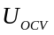), the inherent conductivity of the chemical structure and its polarization are expressed by Ohmic resistance (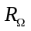) and RC network, respectively.
The electrical potential balance equation is given by:
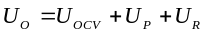 (1)
Where U_{o} represents battery terminal voltage, U_{p} expresses battery polarization voltage, and U_{R} is the Ohmic voltage drop. As described in the “potential balance equation”, if SOC is known, the polarization voltage can be expressed by:
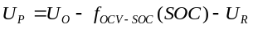 (2)
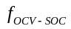 is the functional relationship between OCV and SOC. The OCV is assumed to be a linear function of the variable SOC in specified intervals; theequation based on curve fitting is described as follows:
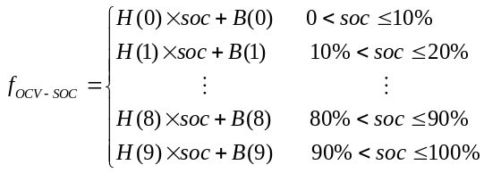 (3)
where H and B represent the slope and intercept of the linear equation, respectively.
As well known, battery current is kept constant in the process of normal charging, hence the SOC can be calculated accurately, and the OCV can be obtained based on equation (3). The U_{R} can be got by multiplying the battery current and resistance, and then the polarization voltage can be estimated based on equations (2).
A LiMn₂O₄ battery cell with an available capacity of 72 Ah was used to carry out the work in this paper. The cell was charged with CC-CV method to validate the polarization voltage estimation. In the experiment, the cell was first charged at constant current of 0.3 C from a fully discharged state. After 5% of its capacity was supplied, charging was stopped and the battery was left in open-circuit condition for 2h, and the open-circuit voltage (OCV) was observed. The cell was then charged at constant voltage when the cell terminal voltage reached 4.2V. The difference between the initial and the final values of the OCV was considered to be a true value of polarization voltage. The procedure was repeated and the polarization voltage was measured at 5% increments of the SOC, until it reached 100%.
A comparison between the actual values of the polarization voltage measured from the above experiment, and the estimated values are shown in Fig.2. The estimation error remains approximately constant around 5 mV from 10% to 70% SOC. And the estimation error increases ranging from 70% to 90% SOC since the polarization voltage changes rapidly in this range, resulting in the sampling delay error; the voltage was sampled before the accumulated SOC was calculated. From Fig 2, it can be found that the estimation of the charge polarization voltage using the proposed method agrees satisfactorily with the experimental results. The proposed method for calculating polarization voltage is only related to battery SOC, having nothing to do with variations of polarization parameters, and battery charge and discharge state, which could be used as a basis of analysis and control of battery polarization voltage.
- Polarization properties in time domain
- Linear factors
Based on the “Thevenin” Model, it is suggested that the establishment of polarization voltage amplitude is related to the resistance-capacitance (RC) parameters. An n-order RC model characterizing battery polarization is shown in Fig. 3.
The battery polarization voltage for the n-order RC model can be expressed as follows:
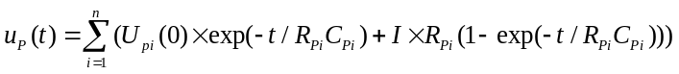 (4)
Where U_{pi}(0) express the initial polarization voltage of the ith order RC network, I represent the battery charge current. It is assumed that after a period time of charging, k-order RC networks reach saturation state. Equation (4) can then be rearranged as:
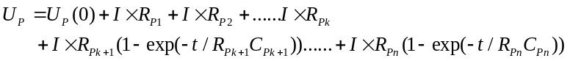 (5)
where U_{p}(0) represent the total initial polarization voltage of n-order RC networks. The time constant of saturation orders must be satisfied by:
(6)
where T represents total charging time. In the n-order RC model, the high-frequency lumped components get to the saturated state before the low-frequency ones at the non-saturated state time T. Equation (5) can then be simplified as:
(7)
Define 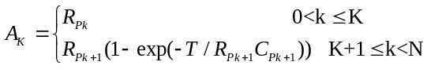
where 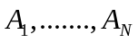represent linear impact factors of the polarization voltage, describing battery polarization effects of different orders of RC network at the same current.
Equation (7) describes the relationship between the polarization voltage and the RC impact factors. The RC network with different order responds to varying polarization effect at the same current, so the parameters of the RC network are impact factors for the polarization voltage. The polarization voltage at time T is made up of two parts: saturated parts and non-saturated parts. The polarization established by the saturated parts is determined by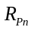, while the polarization established by non-saturated parts is determined by, T and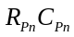.
As a first approximation a linear expressions between polarization voltage and charge current can be given by:
(8)
2）Non-linear factors
To investigate the effects of the charging current on battery polarization, the sample cell was charged at constant current ranging from 24A to 72A from a fully discharged state until the cell voltage reached the maximum charge voltage. The polarization voltage values were extracted at the 900th second using the proposed on-line estimation method. From the data in table 1 it is clear that the polarization voltage is significantly influenced by the charging current. The polarization voltage amplitude is a monotonically increasing function of the charge current. If we assume that the polarizing impedance of the battery is entirely determined by the parameters of RC model, then the polarization voltage is expected to have linear relationship with the charging current, that is, if 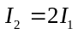, then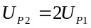. However, the data in table 1 suggests that 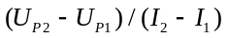does not equal to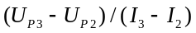, which indicates the polarizing impedance is not a linear function of the charging current. To take this non-linearity into account a current distortion coefficient, 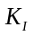is added to equation (8). The normalized coefficient is shown in table 1. The experimental results demonstrate that the distortion coefficient established by unit of current is small at low current, while it becomes larger at high charging currents.
Table 2 illustrates the sample battery’s initial polarization level at a particular time point at various initial SOC. In this experiment, the sample battery was first charged at the current of 0.3C (24 A) till 10% of the nominal capacity was supplied, and then left it open circuit half an hour to eliminate battery polarization. The battery was subsequently charged by a further 10% of the nominal capacity at the same current. The polarization voltage at T=900s was calculated based on equation (2) during the process, and the procedure was repeated to obtain the remaining data points shown in table 2. As demonstrated in table 2, for the same current the polarization voltage varies with the initial SOC. This can be accounted for by adding SOC distortion coefficient 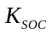in equation (8), and the normalized coefficient K_{SOC} is shown in table 2.
To investigate the effect of initial battery polarization state on the charging polarization voltage, a series of experiments were performed. The battery was charged for a specified period at the current of 0.3C under the conditions of 0h, 0.5h，1h，2h, 5h standing time after discharge; all the experiments were started with an initial SOC=0%. The charging polarization voltage at T=900s was extracted based on equation (2). The data are given in table 3. From table 3, it is inferred that for a given current, the polarization voltage decreases as the standing time after discharge is shortened. The polarization voltages established at the previous standing time between 0 hour and 1 hour are remarkably different, while the ones after over 1 hour standing time are almost the same. It is suggested that the polarization is basically eliminated after the battery kept in the open circuit state for one hour. Considering the effects of initial polarization state on battery charge polarization, the impact factor 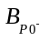 of the battery initial polarization state therefore needs to be added in equation (8). The standing time before charging commences reflects battery initial polarization state, can be divided as follows based on the battery operation condition:
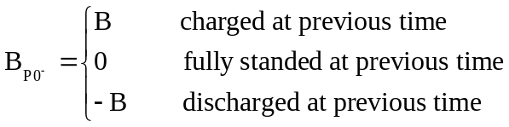
The previous polarization elimination state of the battery varies with different initial standing time according to the lagged effect of the polarization voltage, which affects the amplitude of the polarization voltage, exhibiting superposition effect of the current polarization state.
The charge polarization voltages of the battery at different number of cycles are illustrated in Fig. 4. From Fig.4, it can be seen that the charge polarization voltage of the battery becomes larger with the number of charge-discharge cycles. This is because the charge transfer impedance and mass transport impedance increase as a result of electrolyte decomposition, electrode corrosion, structure change of positive active material and other battery degradation. The battery aging factor therefore needs to be considered in calculating the polarization voltage. From Fig.4, it is seen that the increment seems to be approximately constant at a specified ageing state. We define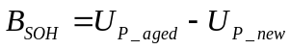, where 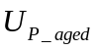represent polarization voltage at a specified aging state; 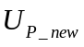describe the polarization voltage of a new battery. The non-linear function 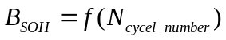 can be achieved by curve fitting based on experimental results.
As discussed above, the charge polarization is not only related with the RC parameters but also affected by the current, initial SOC, initial standing time and aging of the battery. Taking all the impact factors into consideration, the formulation of the charging polarization voltage established in time domain is stated in equation (9).
(9)
Where represents current coefficient; is initial SOC state coefficient; express battery aging coefficient; is initial polarization state coefficient.
From equation (9), we can find that the polarization voltage is influenced by various factors, and demonstrates significant nonlinear characters. The polarization voltage variation from time domain point of view is complex.
- Polarization properties in SOC domain
In order to analyze the polarization properties in the SOC domain, the polarization gradient with SOC is defined as:
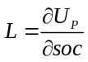 (10)
The polarization voltages established at different current, initial SOC, standing time or cycle life are different in the time domain based on the above discussions, and the time when the polarization voltage amplitude gets stable is also different. To investigate the charging polarization characteristics of the battery as the SOC changes, the polarization voltage gradient with SOC is extracted based on the experimental data in table 1, table 2, table 3 and Fig.4. The effects of charging current, initial SOC, initial polarization state and aging on battery polarization voltage gradient with SOC is illustrated in Fig.5 (a), (b), (c) and (d), respectively.
From Fig.5(a), it is seen that the initial charge polarization voltage gradient varies with the current. It is noticeable that an inflection point of the charge polarization voltage gradient appears almost at the same incremental SOC (approximately around 3%) at various charging current. The value of the battery polarization voltage gradient becomes relatively small when the SOC is greater than 5%. The figure also suggests that the inflection point of the polarization voltage gradient with SOC is independent of battery charging current if the other conditions including initial SOC, initial polarization state and degree of aging were the same. From Fig.5 (b), (c) and (d), it is similarly found that the inflection points of the polarization voltage gradient with SOC appear consistently at various initial SOC, various initial polarization states and different degree of aging, and the values of the polarization voltage gradients are getting to a very small steady state value when the state of charge is above 5%. In addition, Fig. 5 (c) suggests that the shorter the standing time after discharge, the smaller the initial value of the charge polarization voltage gradient with SOC. As demonstrated in Fig.5 (d), the amplitude of the charge polarization voltage gradient with SOC increases as the battery degrades, the inflection point is however almost unchanged. It is concluded that the charge polarization voltage gradient with SOC curve has an inflection point independent of current, initial SOC, initial polarization state and degree of aging. The polarization voltage gradient tends to be stable and maintains a small value after the appearance of the inflection point, which provides a foundation for charge polarization voltage and SOC estimation.
At the inflection of polarization voltage gradient with SOC, the polarization voltage amplitude is related with current and SOC. The quantitative relationship of charge polarization voltage amplitude as a function of current and SOC are shown in Fig.6 and Fig.7, respectively. From Fig.6, it is seen that the polarization voltage amplitude at the inflection point has an approximately linear relationship with current, which can be given by:
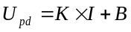 (11)
Where U_{pd} is the polarization voltage amplitude, K is 0.0005, and B is 0.0169.
From Fig.7, it is found that the polarization voltage amplitude at the inflection point is nonlinear function of SOC, which is expressed in equation (12) by curve fitting.
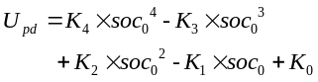 (12)
Where K₄=0.00000001, K₃=0.00003, K₂=0.0002, K₁=0.0048, K₀=0.04.
From equation (9), it is indicated that the initial polarization state and the degree of aging have superposition effects on the polarization voltage, and are not affected by battery current and SOC. The main effects on battery charge polarization voltage are therefore battery current and initial SOC.
III. PROPOSED BATTERY CHARGING METHOD
- Battery constant polarization charging control strategy
The overpotential including Ohmic loss and polarization is a main factor in determining battery charging performance. The Ohmic overvoltage generated by the resistance of electrolyte and the contact resistance between the active mass and current collector is related linearly to current; the polarization overpotential represents the differences of electrode reaction speeds and concentration at positive and negative electrode, thus it can be employed to quantify the battery charging efficiency and charging acceptance capability. From electrochemical point of view, the polarization voltage is an indirect measure of the chemical reaction rate.
Based on the above discussion, from electrochemical point of view, the battery electrolyte concentration and electrode reaction rate can be effectively controlled by controlling the polarization voltage. From an electrical point of view, the charging current can be controlled to maintain the polarization voltage at a specified value, thus controlling the charging energy efficiency while adapting to changes in charging conditions of different SOC, battery aging and initial polarization states, thus realizing automatic optimization of charge current based on the battery current state.
- Control reference value determination of the polarization voltage
Based on “Charge polarization properties” mentioned above, it is suggested that the establishment of polarization voltage amplitude is related to not only the RC model parameters, but also the current, initial SOC, initial standing time and aging of the battery. From equation (9), the current I during charging can be given by:
(13)
The proper charge current defined by initial SOC state, state of health, initial polarization state can be obtained based on equation (13). The charge energy efficiency can also be calculated with the current I_{cha} and terminal voltage. The charging capacity, charging time and charging life can be therefore optimized by controlling the charge polarization.
The maximum current law is employed to determine the largest current to adapt the polarization properties of battery in this paper. The polarization voltage gradient with SOC based on the equation (12) shows that the polarization voltage value at the inflection point is related by a fourth degree polynomial to the SOC. The battery polarization voltage is smaller in middle range of SOC than at both ends of SOC under the condition of the same charging current as shown in Fig.8. It is suggested that the battery acceptance ability to charging current depends on battery SOC, and the maximum charge current should occur at the SOC stage with minimum polarization voltage. The maximum current selection is a method that the battery is charged with max charging current at the moment of the maximum acceptance ability to determine the control reference value of the polarization voltage. This method can automatically search for the minimum polarization voltage when battery is charged with the maximum charging current at the initial charging period according to battery charging condition, and could reasonably increase the charging current thus shortening the charging time.
Considering the battery charging acceptance capability varying with SOC, the battery can be charged with the available highest current at the SOC ranges with the smallest polarization voltage established to determine the control value of the polarization voltage. The principle of the Maximum Current Selection Method is illustrated in Fig.9. The control value of the polarization voltage (U_{PC}) can be obtained when:
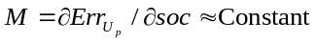 (14)
Where 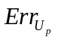 represent polarization voltage error between the target value and feedback value. Supposed the maximum charging current is I_{Max}, the control polarization voltage is U_{PG}. From Fig.8, it is seen that the sample interval time of polarization voltage is t from the time point P to (P+mN). Assuming the sample number of the real-time polarization voltage is m, then during {P ~ (P + mt)}, the average polarization voltage is stated in equation (15).
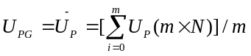, (15)
Thus we can control the polarization by tracking U_{PG}, adjusting charging current for different SOC stages.
- Constant polarization charging based fuzzy control algorithm
The factors affecting the charge polarization voltage contain not only linear parts, but also the nonlinear coefficient, as discussed earlier. And the nonlinear coefficients are variable. The traditional closed-loop control method like PID control will have difficulties in realizing polarization voltage control. To resolve above issue, a fuzzy control algorithm [20-23] is deployed to control the charge polarization voltage, aiming to regulate the charge current adaptively. By establishing the polarization voltage error (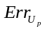) universe and its change rate (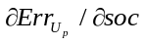) universe based on the fuzzy control method, the closed-loop control system is designed to find the corresponding relation between the polarization voltage and the output charge current. This aims to achieve the charge current adjustment with the polarization voltage tracking control for the target, realizing constant polarization charging control of the battery. The fuzzy control logic diagram is illustrated in Fig.10.

As demonstrated in Fig.10, the system output is the charging current I_{C}, and the control input is the polarization voltage U_{PG}. The feedback function from I_{C} to U_{PG} is known, the concrete transfer function from U_{PG} to I_{C} can not be obtained, which needs to be controlled by fuzzy logic. The polarization voltage error 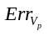between the target value and feedback value and its change rate with SOC are considered as the input variables of the fuzzy logic control. And then the output current I_{C} can be acquired based on the fuzzy rules. The feedback polarization voltage V_{PF} can be estimated based on the SOC, OCV and charge current.
Based on the basic principle, the polarization voltage error () can be divided into levels shown in table 4.
The polarization voltage errors can be classified by 5 levels: positive big (PB), positive small (PS), positive zero (PO), negative zero (NO), negative small (NS), negative big (NB), and the fuzzy sets can be expressed by:
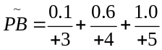
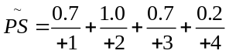
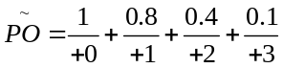
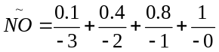
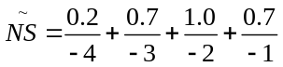
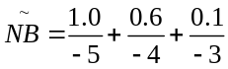
Similarly, the change rate of the polarization voltage error（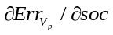）can be divided into different levels shown in table 5.
The degree of membership for every level can be described as follows:
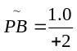，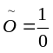，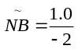。
The output current step frequency regulation method is used according to the hysteresis of the polarization voltage. Take minimum sampling rate of SOC as the basic time control unit (dsoc), the variation of output current () were quantitatively divided into 5 levels based on the definition of fuzzy set value range, which is illustrated in table 6.
Where n/m dsoc represents that the incremental of charging current is n A after m SOC sampling.
The charging current will be decreased to lower the value of the polarization voltage when or is high, and vice versa. The change frequency of the charge current needs also to be increased when or is very high, and vice versa. The specific control logic is shown in table 7. The charge current can be adaptively regulated by controlling the polarization voltage.
IV. RESULTS AND DISCUSSION
The battery was charged with constant polarization charging method based on the proposed control logic (Maximum Current Selection Method: I_{Max}=1C, U_{PG}=30mV). During the process of constant polarization charging mode, the polarization voltage can be maintained constant by adjusting the charging current after the initial polarization voltage is set to a certain value. It is suggested that the difference of the battery terminal voltage removed ohmic voltage and the OCV is kept constant. The battery charging curve is shown in Fig.11. It is found from Fig.11 that the charging current fluctuates remarkably at the initial charge stage (charge time ranging from 0s to 500s), has less fluctuation at the middle stage of charging(500s~3500s), and decreases rapidly at the end of charging(3500s~4500s). The regulation speed of the charge current is closely related to the polarization voltage gradient with SOC inferred from the determinants of the output control. The changing frequency of the charge current is high at both initial charging and the end of charging because the polarization voltage amplitude and its gradient with SOC are high at both ends. Fig.12 shows that the charge capacity is increasing with the chemical reaction carried out and lithium-ion embedded carbon at polarization voltage tracking control mode. The polarization however does not increase during charge, that is, the battery arrives at a new chemical equilibrium, and the charging curve is going up uniformly following the OCV-SOC curve in parallel, the battery terminal voltage rise corresponds to the energy increase only.
To validate the charge performance with the proposed charging method, three experiments were performed in this study. In the first experiment, the sample cell 1 was first charged with the proposed constant polarization method till charged 100% of the capacity, in which the control value of the polarization voltage is 30mV, and then was discharged at the current of 0.3C till the battery terminal voltage dropped to 3.0V, repeating above experiment for 100 cycles. In the second and third experiments, cell 2 and cell 3 were charged with widely used constant current – constant voltage charging method; and the constant currents were 0.3C and 1C, respectively. And then the sample cells were discharged with the same method as the first experiment, also repeating the two experiments for 100 charge-discharge cycles. All of the experiments were done at room temperature. The performance comparison of three charging modes is shown in table 8.
As demonstrated in table 8, all the charging modes can fully charge the battery, of which the temperature rise is the lowest by mode II, the charging time is however significantly increased in this mode. The mode III reduced the charging time remarkably, but it has higher temperature rise. Fig.13 shows the comparisons of capacity degradation at three charging modes. From Fig.13, it can be found that the charge life is significantly decreased when the constant current is going up to 1C. From table 8, it is also suggested that the control of CC-CV charging method is simple; however, this method has difficulty in solving the issues of the battery charging speed and battery life. The proposed charging method significantly shortened the charging time compared to mode II; and charge life is almost the same as the charging mode II. It is demonstrated that the constant polarization method can balance the charging time and charging life well.
V. CONCLUSIONS
The Thevenin model was employed to study the polarization properties of the battery in time and SOC domain. A quantitative examination was made of the effects of polarization voltage such as charge current, initial SOC, initial polarization state of the battery as well as battery aging. Based on the analysis of polarization properties in SOC domain, it is concluded that the charge polarization voltage gradient with SOC exists an inflection point independent of current, initial SOC, initial polarization state and degree of aging, and the polarization voltage gradient tends to be stable and maintains a small value beyond the inflection point, which provides foundations for charge polarization voltage and SOC estimation. The paper proposes constant polarization charging based fuzzy control algorithm in which the polarization voltage was regarded as the control target to improve the charge performance of the battery. Experimental results show that the proposed charging method significantly shortened the charging time and had not obvious life loss compared to traditional CC-CV charging method, realized the balance between charging time and charging life.
ACKNOWLEDGEMENTS
The work was supported by National Natural Science Foundation of China (No. 51277010) and the National High Technology Research and Development Program of China (No. 2011AA05A108).
REFERENCES
- T. Ikeya, N. Sawada, S. Takagi, et al. “Multi-step constant-current charging method for electric vehicle, valve-regulated, lead/acid batteries during night time for load-levelling,” J. Power Sources, vol. 75, no.1, pp.101-107, Sep.1998.
- T. Ikeya, N. Sawada, J. Murakami, et al. “Multi-step constant-current charging method for an electric vehicle nickel/metal hydride battery with high-energy efficiency and long cycle life,” J. Power Sources, vol. 105, no. 1, pp. 6-12, Mar. 2002.
- L.R. Chen, J.J. Chen, N.Y. Chu, G.Y. Han. “Current-pumped battery charger,” IEEE Trans. Ind. Electron, vol. 55, no. 6, pp. 2482-2488, Jun. 2008.
- L.R. Chen. “A Design of an Optimal Battery Pulse Charge System by Frequency-Varied Technique,” IEEE Trans. Ind. Electron., vol. 54, no. 1, pp. 398-405, Feb. 2007.
- T.K. Cheung, K.W.E. Cheng, H.L. Chan, et al. “Maintenance techniques for rechargeable battery using pulse charging,” in Proc. IEEE ICPES A, Nov. 2006, pp. 205-208.
- A. Kirchev, M. Perrin, E. Lemaire, F. Karoui, F. Mattera. “Studies of the pulse charge of lead-acid batteries for PV applications: Part I. Factors influencing the mechanism of the pulse charge of the positive plate,” J. Power Sources, vol. 177, no. 1, Feb. 2008, pp. 217-225.
- A. Kirchev, F. Mattera, E. Lemaire, K. Dong. “Studies of the pulse charge of lead-acid batteries for photovoltaic applications Part IV. Pulse charge of the negative plate,” J. Power Sources, vol.191, no. 1, Jun. 2009, pp. 191: 82-90.
- J.B. Wang, C.Y. Chuang. “A multiphase battery charger with pulse charging scheme,” In Proc. IEEE IECON, Nov. 2005, pp.1248-1253.
- E.L. Chan, N.A. Rahim, S. Mekhilef. “DSP-based Fuzzy Logic Controller for a battery Charger,” in Proc. IEEE TENCON, Oct. 2002, pp. 1512-1515.
- Y.H. Liu, J.H. Teng, Y.C. Lin. “Search for an Optimal Rapid Charging Pattern for Lithium–Ion Batteries Using Ant Colony System Algorithm,” IEEE Trans. Ind. Electron., vol. 52, no.5, Oct. 2005, pp.1328-1336.
- Y.H. Liu, C.H. Hsieh, Y.F. Luo. “Search for an Optimal Five-Step Charging Pattern for Li-Ion Batteries Using Consecutive Orthogonal Arrays,” IEEE Trans. Energy Convers., vol. 26, no. 2, Jun. 2011, pp. 654-661.
- H. Saberi, F.R. Salmasi. “Genetic optimization of charging current for lead-acid batteries in hybrid electric vehicles,” in Proc ICEMS, Oct. 2007, pp. 2028-2032.
- L.R. Chen, R.C. Hsu, and C.S. Liu. “A Design of a Grey-Predicted Li-Ion Battery Charge System,” IEEE Trans. Ind. Electron., vol. 55, no. 10, Oct. 2008, pp. 3692-3701.
- N. Watrin, R. Roche, H. Ostermann, et.al. “Multiphysical Lithium-Based Battery Model for Use in State-of-Charge Determination,” IEEE Trans. Veh. Technol., vol. 61, no. 8, Oct. 2012, pp. 3420 - 3429.
- C.R. Gould, C.M. Bingham, D.A. Stone, P. Bently. “New Battery Model and State-of-Health Determination Through Subspace Parameter Estimation and State-Observer Techniques,” IEEE Trans. Veh. Technol., vol. 58, no. 8, Oct. 2009, pp. 3905 - 3916.
- A. Szumanowski, Yuhua Chang. “Battery Management System Based on Battery Nonlinear Dynamics Modeling,” IEEE Trans. Veh. Technol., vol. 57, no. 3, May 2008, pp. 1425 -1432.
- P. Nelson, I. Bloom, K. Amine, G. Henriksen. “Design modeling of lithium-ion battery performance,” J. Power Sources, vol. 110, no. 2, Aug. 2002, pp. 437-444.
- L. Gao, S. Liu, R.A. Dougal. “Dynamic Lithium-Ion Battery Model for System Simulation,” IEEE Trans. Comp. Pack. Tech., vol. 25, no. 3, Sep. 2002, pp. 495-505.
- S. Buller , M. Thele, R.W.A.A. De Doncker , E. Karden. “Impedance-Based Simulation Models of Supercapacitors and Li-Ion Batteries for Power Electronic Applications,” IEEE Trans. Ind. Applicat., vol. 41, no.3, May/Jun. 2005, pp. 742-747.
- R.R. Yager, D.P. Filev. Essentials of Fuzzy Modeling and Control. Hoboken, New Jersey: Wiley-Interscience, 1994.
- N.J. Schouten, M.A. Salman, N.A. Kheir. “Fuzzy Logic Control for Parallel Hybrid Vehicles,” IEEE Trans. Control Syst. Technol., vol. 10, no. 3, May 2002, pp. 460-468.
- M.M.T. Ansari, S. Velusami. “DMLHFLC (Dual mode linguistic hedge fuzzy logic controller) for an isolated wind-diesel hybrid power system with BES (battery energy storage) unit,” ENERGY, vol. 35, no. 9, Sep. 2010; pp. 3827-3837.
- R.M. Kamel, A. Chaouachi, K. Nagasaka. “Wind power smoothing using fuzzy logic pitch controller and energy capacitor system for improvement Micro-Grid performance in islanding mode,” ENERGY, vol. 35, no. 5, May 2010, pp. 2119-2129.

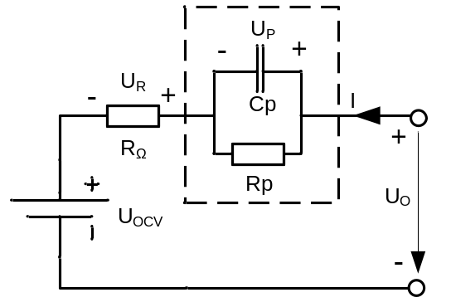

Fig.1.Battery “Thevenin”model

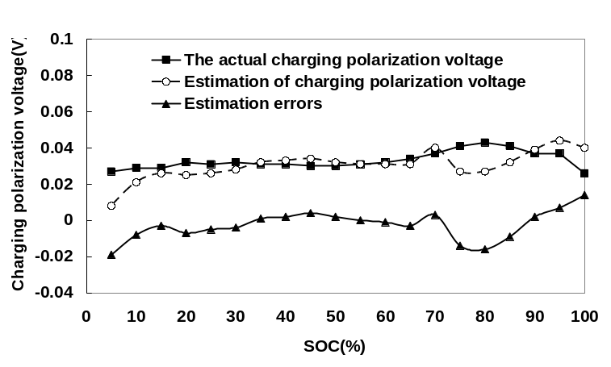
Fig.2.Estimation error of charge polarization voltage

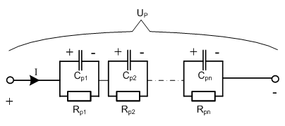
Fig.3.The n-order RC model of polarization

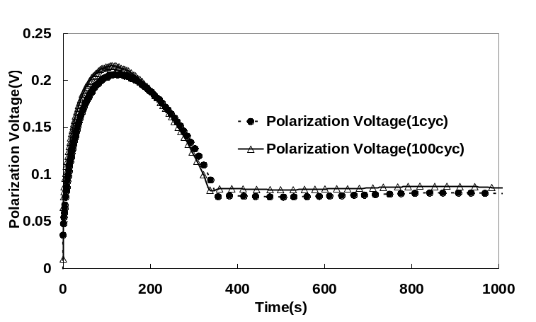
Fig.4. Charge polarization voltage characteristics of the battery at the first cycle and 100th cycle (charge current: 24A)
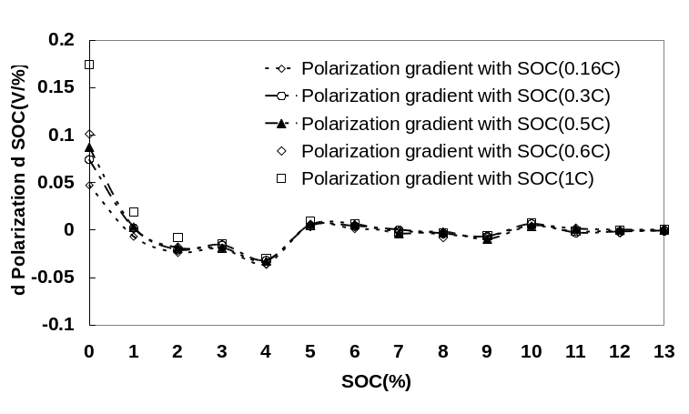
(a) Battery polarization voltage gradient as a function of SOC at various current
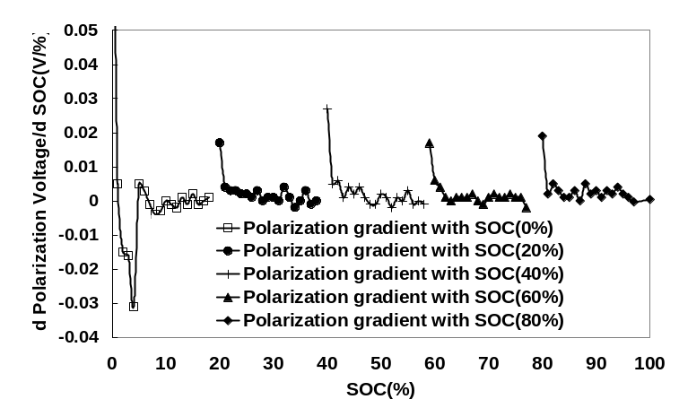
(b) Battery polarization voltage gradient as a function of SOC at various initial SOC
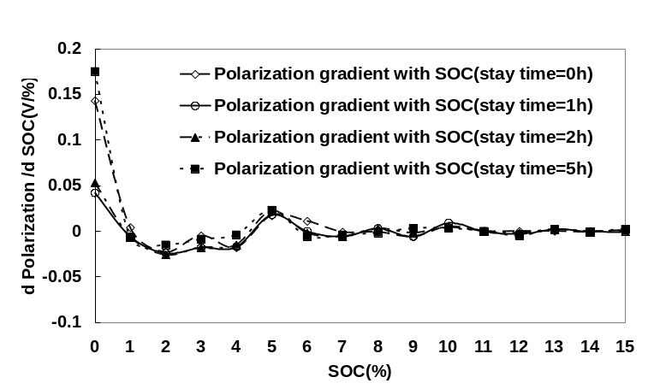
(c) Battery polarization voltage gradient as a function of SOC at different initial polarization states
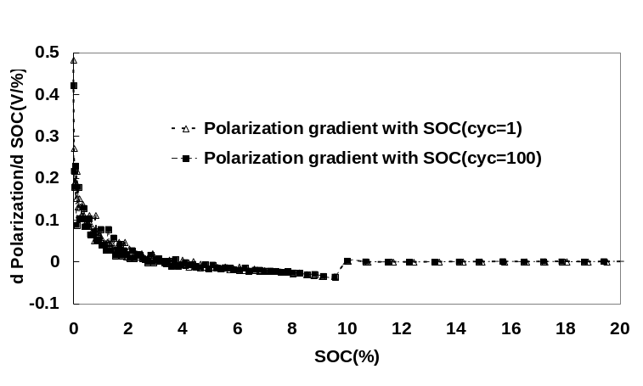
(d) Battery polarization voltage gradient as a function of SOC at different degree of aging
Fig.5.The characteristics of the charge polarization voltage gradient with SOC

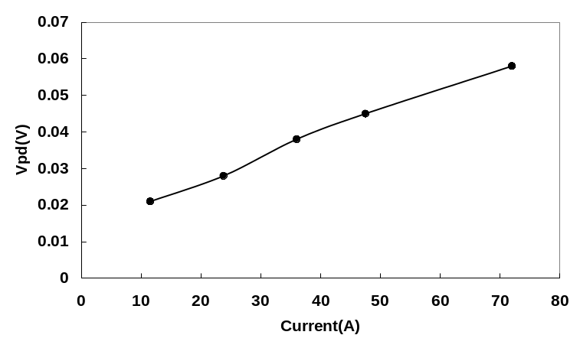
Fig.6. Amplitude of charge polarization voltage as a function of current at inflection point

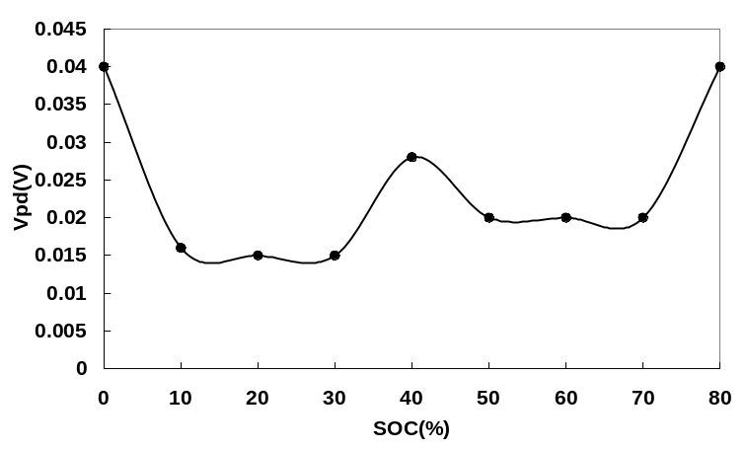
Fig.7. Amplitude of charge polarization voltage as a function of SOC at inflection point

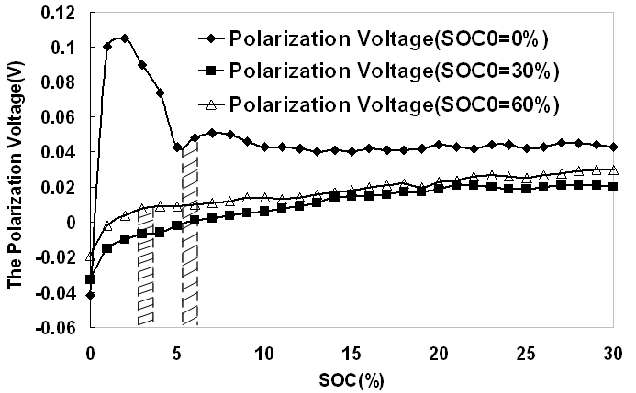
Fig.8.Characteristics of charge polarization voltage established at different initial SOC

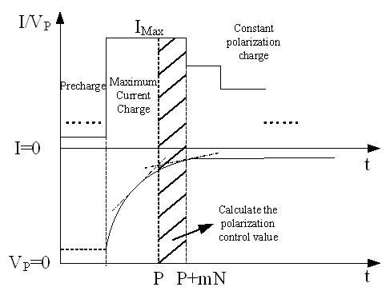
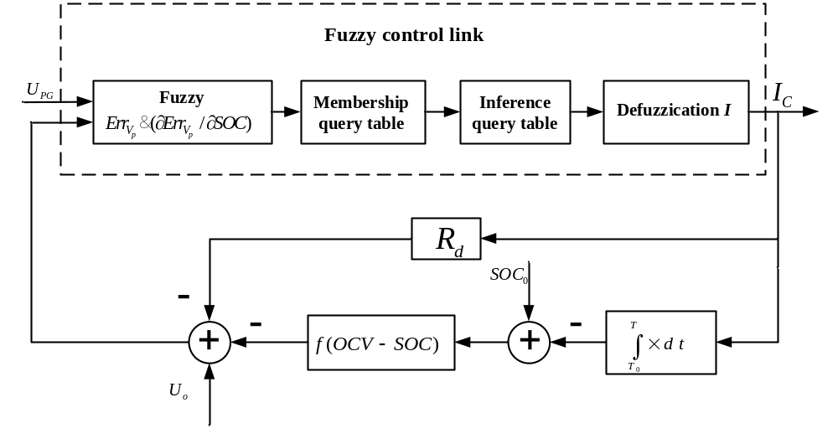Fig.9. Principle of Maximum Current Selection Method

Fig.10. Fuzzy control logic diagram

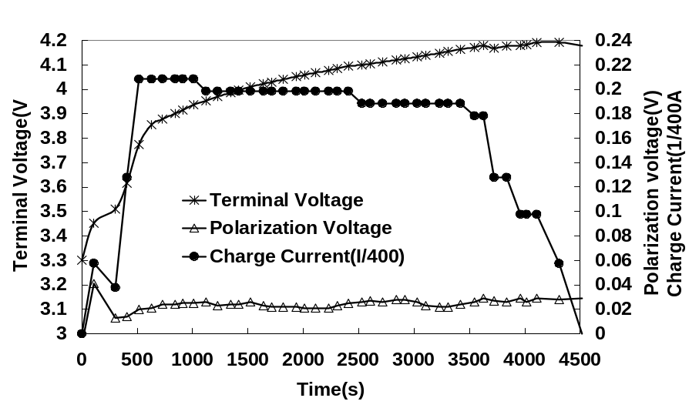
Fig.11. Battery charging curve at constant polarization control mode
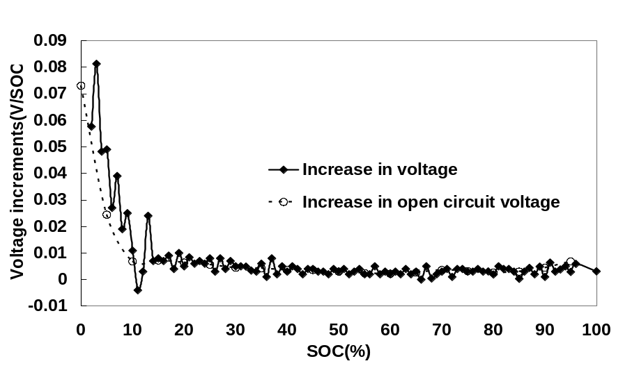
Fig.12. Comparisons of battery OCV and terminal voltage variation under constant polarization charging mode
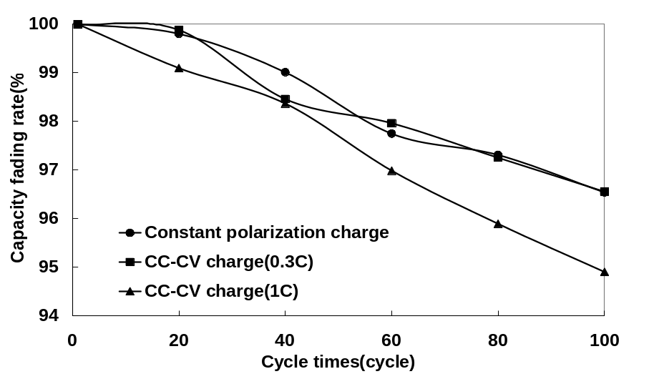
Fig.13. Comparisons of capacity degradation at different charging modes

Table 1 Charge polarization voltage at various currents (SOC₀=0%)
Current(A) | Voltage(V) | △Voltage/△Current(V/A） | K_{I}
24 | 0.030 | -
36 | 0.039 | 0.00075 | 1.3
48 | 0.046 | 0.00058 | 1
72 | 0.076 | 0.00125 | 2.1

Table 2 Charge polarization voltage at various initial SOC (I=0.3C)
Initial SOC (%) | Polarization Voltage at time T (V) | K_{SOC}
10 | 0.012 | 1
20 | 0.006 | 0.5
30 | 0.004 | 0.3
40 | 0.028 | 2.3
50 | 0.017 | 1.4
60 | 0.014 | 1.2
70 | 0.014 | 1.2
80 | 0.02 | 1.7
90 | 0.039 | 3.3

Table 3 Charge polarization voltage measured after various standing times
Standing time  after discharged (%) | Charge current (A) | Polarization Voltage(V)
0 | 24 | 0.012
0.5 | 24 | 0.015
1 | 24 | 0.025
2 | 24 | 0.026
5 | 24 | 0.025

Table 4 Levels divided for the polarization voltage error
Quantify level | -5 | -4 | -3 | -2 | -1 | -0
Value(mV) | -5 | (-5,-4] | (-4,-3] | (-3,-2] | (-2,-1] | (-1,0]
Quantify level | +0 | 1 | 2 | 3 | 4 | 5
Value(mV) | [0,1) | [1,2) | [2,3) | [3,4) | [4,5) | 5

Table 5 Levels divided for 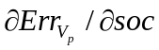
Quantify level | -1 | 0 | 1
Value(mV/soc) | -10 | (-10,10) | 10

Table 6 Levels divided for the output current gradient with SOC
Level | -2 | -1 | 0 | 1 | 2
Value(A/soc) | -4/dsoc | -4/3dsoc | 0 | 4/3dsoc | 4/dsoc

Table 7 Fuzzy Logic Control Table
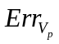 | NB | O | PB
NB | PB | PB | O
NS | PB | PS | O
NO | PS | O | O
PO | O | O | NS
PS | O | NS | NB
PB | O | NB | NB

Table 8 Comparisons of the battery charged at constant polarization mode and CC-CV mode
Cell number | Charge  mode | Charged  Capacity  (%) | Charge  Time  (h) | Maximum  Temperature  Rise  (℃) | Maximum  Current  (C)
1 | Constant  Polarization(mode I) | 100% | 5760 | 6 | 1
2 | CC-CV (mode II) | 100% | 11520 | 5 | 0.3
3 | CC-CV(mode III) | 100% | 4320 | 8 | 1

