Original paper

A visualisation tool to analyse usage of web-based interventions: The example of Positive Online Weight Reduction (POWeR)

Emily Arden-Close, PhDª, Emily Smith, PhD^{b}, Katherine Bradbury, PhD^{b}, Leanne Morrison, PhD^{b}, Laura Dennison, PhD^{b}, Danius Michaelides, PhD^{c}, Lucy Yardley, PhD^{b}

ªDepartment of Psychology, Faculty of Science and Technology, Bournemouth University

^{b}Academic Unit of Psychology, University of Southampton

^{c}Department of Electronics and Computer Science, University of Southampton

Correspondence should be addressed to Emily Arden-Close at: Department of Psychology, Faculty of Science and Technology, Bournemouth University Talbot Campus, Fern Barrow, Poole, Dorset, BH12 5BB.
E-mail: eardenclose@bournemouth.ac.uk
Tel: +44 1202 965529
Fax: +44 1202 962736

A visualisation tool to analyse usage of web-based interventions: The example of Positive Online Weight Reduction (POWeR)

Abstract
Background: Attrition is a significant problem in web-based interventions. Consequently, research aims to identify the relation between web usage and benefit from such interventions. We have developed a visualisation tool that enables researchers to more easily examine large data sets on intervention usage that can be difficult to make sense of using traditional descriptive or statistical techniques alone.
Objectives: This paper demonstrates how the visualisation tool was used to explore patterns in participants’ use of a web-based weight management intervention (POWeR: Positive Online Weight Reduction). We also demonstrate how the visualisation tool can be used to inform subsequent statistical analyses of the association between usage patterns, participant characteristics, and intervention outcome.
Methods: The visualisation tool was used to analyse data from 132 participants who had accessed at least one session of the POWeR intervention.
Results: There was a drop in usage of optional sessions after participants had accessed the initial, core POWeR sessions, but many users nevertheless continued to complete goal and weight review. POWeR tools relating to the food diary and steps diary were re-used most often. Differences in participant characteristics and usage of other intervention components were identified between participants who did and did not choose to access optional POWeR sessions (in addition to the initial core sessions) or re-use the food and steps diary. Re-use of the steps diary and the getting support tools was associated with greater weight loss.
Conclusions: The visualisation tool provided a quick and efficient method for exploring patterns of web usage, which enabled further analyses of whether different usage patterns were associated with participant characteristics or differences in intervention outcome. Further usage of visualisation techniques is recommended in order to 1) make sense of large data sets more quickly and efficiently, 2) determine the likely active ingredients in web-based interventions, and thereby enhance the benefit they may provide and 3) inform (re-)design of future interventions to promote greater use and engagement by enabling users to easily access valued intervention content/tools.
Keywords: Web-based interventions; data visualisations, usage

Introduction
Web-based interventions for weight management (weight loss or maintenance) have grown in popularity in recent years. There is evidence that such interventions lead to meaningful weight loss [1], particularly relative to no-intervention control groups or minimal interventions [2]. However, attrition is typically high in web-based interventions [3-5].

In any longitudinal eHealth study, there are two different types of attrition: dropout attrition, or losing participants to follow-up; and nonusage attrition (not using the intervention or low usage of the intervention). Determining nonusage and dropout attrition is an essential part of analysis of web-based interventions, as the attrition curve may indicate the underlying cause of attrition [3]. For example, there may be steady attrition, with a consistent proportion of users discontinuing usage. Alternatively, there may be an initial phase where usage is high, followed by rapid attrition, after which a stable group of ‘regular users’ remains. Further, even amongst ‘regular users,’ some webpages are used by almost all users who log on to the website, whereas others are never used. Although higher use of website features may be associated with weight loss, it is not clear which features improve this effect or reduce attrition [5]. It is also possible that not all users may need to complete an internet intervention in order to obtain positive results – different doses may be necessary for different people [6].

Several recent studies have attempted to identify the relationship between web usage and benefit from weight management interventions. For example, Funk and colleagues [7] categorized users of a web-based weight loss intervention as having ‘consistent usage,’ ‘some usage’ or ‘minimal usage.’ Mean weight change was significantly higher in the ‘consistent use’ category, and significantly more consistent users maintained clinically important weight loss than those in the other groups. Within Internet interventions, more logins, weight and exercise entries, and use of additional features of the website after weight entry have been associated with better weight outcomes [7,8]. More specifically, use of website feedback features, such as progress charts, have been shown to be the best predictors of initial 6 month weight loss, whereas social support features, such as web chats and participant profiles, have been related to weight maintenance at 12 months [9]. More recently, greater use of a weight tracker was associated with greater weight loss [10]. However, no study has assessed in detail whether certain web pages are more frequently used than others, or whether certain groups of people are more likely to use particular pages. This would enable researchers to refine the content of their web-based interventions, for example in order to enable easier access to the most useful webpages, or encourage greater use of useful but underused webpages by identifying and addressing barriers to usage.

Positive Online Weight Loss Intervention [11] was developed as a web-based weight management intervention for use in primary care that aimed to result in sustainable weight loss. It was tested in a feasibility trial that consisted of four groups (web only, web plus basic nurse support, web plus regular nurse support, and usual care), to assess the extent to which weight loss was maintained at 12 months follow-up. It was designed to provide support for self-management of weight based on either a low calorie or low carbohydrate eating plan. Analysis revealed that average website usage, defined as duration of page viewing, was similar across the intervention arms, but extremely variable within groups. Although participants completed a mean of nine goal and weight reviews, this ranged from none to 43 completed during the 12 month trial.

Usage log data has been used to examine the relationship(s) between use of specific intervention components and subsequent outcomes/effectiveness [12-14]. Such analyses can reveal useful insights about the impact and relevance of particular components over the time course of an intervention. However, such analyses typically rely on making a priori assumptions about the specific intervention components that are expected to have an effect on uptake, adherence, or outcomes. In contrast, visualisations use aspects of exploratory sequencing techniques to summarise and plot the participant’s usage of EVERY intervention component over time [15]. Using visual analysis allows differences in usage to emerge from the data and ensures that unanticipated relationships between usage and outcomes are not overlooked. Freely available visualisation tools have been developed and argued to be useful for: detecting patterns of usage and how they vary across individuals/ groups; detect usability or content issues, and thereby enable researchers to edit content for use in future web-based interventions; and enable exploratory analysis to support the design of statistical queries to summarize data regarding whether use of particular pages is related to benefit [15].

Existing visualisation tools provide a useful means by which to explore each individual participant’s usage of an intervention, or particular aspects of all participant’s usage of an intervention (such as days/dates of logins, start and end points of each login). However, to our knowledge, these tools do not allow a detailed comparison of how all components of an intervention have been used by all participants within one sequence plot. Our research team has therefore developed a visualisation tool to examine each individual participant’s temporal usage of a web-based intervention by illustrating what pages they have viewed, for how long, and in what order. Usage sequences for each individual are stacked within one visualisation plot to facilitate comparison across all participants. This makes analysis quicker and easier compared to standard data analysis.

This paper first describes how the visualisation tool works. We then illustrate the insights the visualisation tool can provide by means of a detailed analysis of usage of the POWeR intervention. This analysis had three main aims, which the visualisation tool was able to help us realise. These were:
- examine patterns of web usage to identify:
  - At what point usage of POWeR drops off;
  - Whether participants accessed both the core and optional content of the intervention;
  - What information, advice and tools were re-used after their initial presentation;
- carry out a moderator analysis of patient characteristics related to web usage;
- determine whether usage of specific intervention pages and sections were related to weight change.

Methods

Design
As reported elsewhere [11], a randomized non-blinded feasibility trial of a web-based weight management intervention (Positive Online Weight Reduction; POWeR) for obese patients in primary care was used to compare four parallel groups: usual care, website only, website with basic nurse support, and website with regular nurse support. The trial was approved by the UK National Health Service (NHS) National Research Ethics Service, and was registered with Current Controlled Trials (ISRCTN 31685626).

Participants and Procedures
Participants were recruited between May 2011 and December 2012 from five general practices in southern England. Inclusion criteria included being aged over 18, and having a BMI >=30 (or 28 with hypertension, hypercholesterolaemia or diabetes) documented in medical records. Exclusion criteria included being pregnant or breastfeeding, having current major mental or physical health problems, or self-reported inability to walk 100 metres. Participants were followed up at six months and one year.

Intervention
The POWeR intervention [11] consisted of twelve weekly online sessions, in which users were taught active cognitive and behavioural self-regulation techniques (e.g. “POWeR Tools”) and provided with evidence for their effectiveness and examples of how other users had successfully used them. The sessions did not differ between groups. Session 1 provided an overview of the intervention, advice on choosing the low calorie or low carbohydrate eating plan, helped users to set eating goals and plan how to implement them, asked users to identify personal reasons for losing weight, and explained how to use weekly weighing as a form of self-monitoring. All subsequent sessions began by asking the user to enter their current weight and report how often they had achieved each of the goals set the previous week (goal and weight review). Following this, users received automated advice based on their progress, and were able to set new goals and plans. This advice did not differ between groups. Session 2 covered getting support from the website (e.g., setting automated motivational messages), friends and family and the nurse. Session 3 helped users choose and implement a physical activity plan (walking or mixed physical activity). Sessions 1-3 were defined as core sessions, and became available weekly in sequence. After completing the first three sessions, users could then choose any one optional session each week after their goal and weight review from the following selection: cravings; slip ups; stretching physical activity; tough times (emotional eating); busy lives (eating when busy); setting up your environment (environment restructuring); alcoholic and non-alcoholic drinks; eating out; and maintaining weight loss. The final session was a review. In addition to the new weekly sessions, users could also re-access content from previous sessions at any time via the main home page, such as their POWeR Tools and a weight graph plotting their progress.

Data Collection and Analysis
All data was stored using the LifeGuide Intervention Authoring software [16], online software that enables researchers to create web-based interventions. This software automatically captures data regarding all web pages accessed, and length of time spent viewing each webpage. A visualisation tool was created using R to enable us to determine patterns of web usage. The tool enables researchers to visually compare when particular parts of the intervention were viewed, for how long, and in what order, across all participants. A web-based interface for the visualisation tool was developed using the Shiny web application for R (see Figure 1). A user guide for the visualisation tool will be made available shortly, and both the tool and user manual will be made available free of charge via the LifeGuide website.

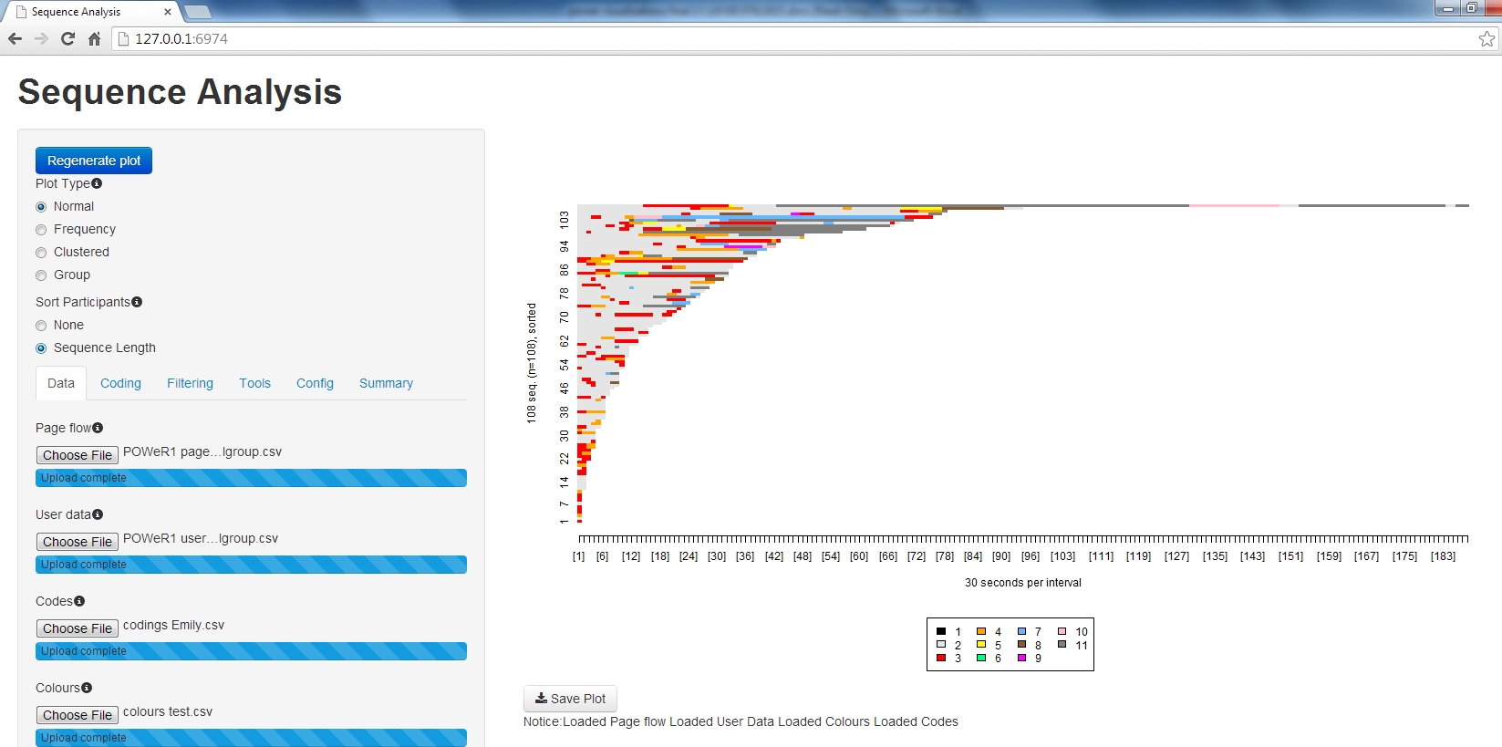

Figure 1: Screenshot of the visualisation tool

Briefly, to run the tool, you need to feed it four types of files: a page flow file (which shows the order in which participants have looked at pages and the time they have spent on them); a user data file (which contains data on participant characteristics and outcomes or data participants have entered into the intervention), a coding file (which assigns each intervention page a numerical code), and a colour file (which assigns each intervention page code a specific colour). At the top of all the interfaces, there is the option to sort participants by sequence length (the amount of time a participant has spent viewing the intervention) and choose what type of visualisation plot you would like.

Table 1. Different types of plots shown in a visualisation
Plot Type | What it shows
Normal | Default option, shows which pages were viewed by each individual participant, in which order
Frequency | Shows usage by all participants by groups of pages, so the researcher can see which groups of pages are most used
Clustered | Groups participants into statistically similar usage patterns
Group | Allows you to see two or more visualisations next to each other, split into different types of usage patterns or users

The visualisation can be filtered based on variables in the dataset (e.g., user characteristics or outcomes) or which groups of pages users have/have not seen. If you have run a visualisation that you want to follow up on through statistical analysis, the tool can create an Excel file that lists details of all users who have seen a particular group of intervention pages.

Statistical Data Analysis
Data analysis for the moderators (use of the optional sessions, food diary, and steps diary) was carried out using SPSS.

Results

Patterns of web usage

Overall, 195 participants consented to take part in the feasibility trial of POWeR. Sixteen were enrolled at a GP practice, but never used the website and therefore were not randomized. Participants assigned to usual care (n = 43) did not have access to the website after completing questionnaires, and their data was therefore not used. There were four participants who went online and were assigned to a group, but never used a session. To analyse web usage, the data from the 132 participants who had viewed at least one page of a session which comprised the groups ‘web only,’ ‘web + basic nurse support’ and ‘web + regular nurse support’ was included.

Participant characteristics for the overall sample are presented in Table 1. They are not broken down by group as this information is reported in the main POWeR paper [11].

Table 2: Baseline Characteristics of Participants
Characteristic | Mean (s.d.)
Age | 51.56 (12.96)
Age left education | 17.82 (2.93)
BMI | 35.49 (5.70)
Weight (kg) | 100.66 (21.02)
Male (n, %) | 46 (33.8%)

To analyse patterns of POWeR usage, we first carried out broad-level visualisations of how participants used the entire intervention and main components of interest (e.g. core versus optional sessions), followed by more fine-grained visualisations of regularly used components (e.g. eating plan tools) and subsequent statistical analyses.

Usage of the core and optional sessions

Usage of the core and optional sessions is presented in Figure 2.

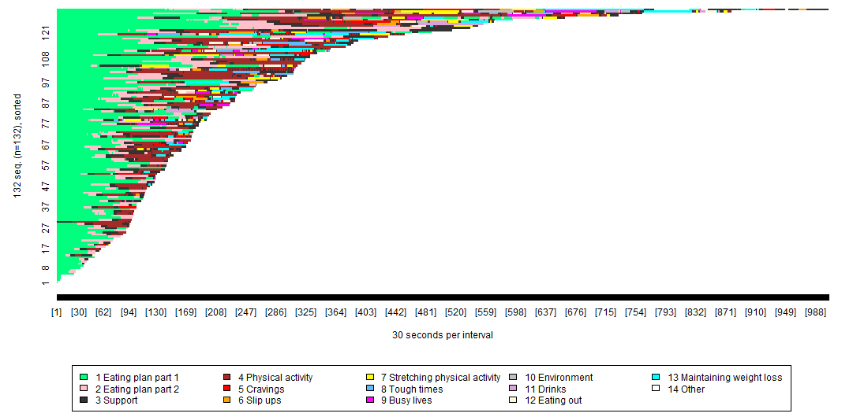
Figure 2: Visualisation of POWeR usage of sessions by all intervention participants

Each colour represents a separate group of pages, as shown above. For example, the light green shows usage of the first part of the eating plan pages (which introduced the eating plans), and the dark grey shows usage of the support pages. The X axis shows the length of time spent viewing each group of pages, broken down into blocks of 30 seconds. The Y axis can be thought of as a number of lines, each representing a specific participant. Participants are presented in order of how long they spent on the intervention, with those who spent less time nearer the bottom, and those who spent more time nearer the top.

We can see from Figure 2 that the core eating plan session (part 1 – light green and part 2 – pink) was the most widely used, followed by the core sessions on ‘support’ (session 2 – dark grey) and ‘physical activity’ (session 3 – brown). Table 3 provides a precise breakdown of the proportion of participants accessing each POWeR session (core and optional). Two thirds of the participants accessed all the core sessions. However, each optional session (excepting the final review session, which was made compulsory) was accessed by less than one in four of the participants. Thirty participants (16.8%) used all the core sessions but no optional sessions. Later sessions (e.g. 7-11) were viewed by only 48 (37%) participants. This contrasted with an average of 8.62 (SD = 10.46) goal and weight reviews per participant (range 0-43).

Table 3. Numbers (and percentages) of participants who used core and optional sessions
Session | Participants who viewed at least one page of the session
1 Eating plan part 1ª | 132 (100%)
1 Eating plan part 2 | 120 (91.6%)
2 Support^{b} | 104 (79%)
3 Physical activity | 90 (69%)
4 Cravings | 28 (21%)
5 Slip ups | 32 (24%)
6 Stretching physical activity | 25 (19%)
7 Tough times | 21 (16%)
8 Busy lives | 19 (15%)
9 Setting up your environment | 13 (10%)
10 Drinks | 13 (10%)
11 Eating out | 24 (18%)
12 Maintaining weight loss^{c} | 36 (27%)
ªCore sessions are shown in bold
^{b}The sessions are presented in the order in which they were listed.
^{c}This session was made compulsory
In order to further explore patterns of drop out we used the visualisation tool to compare the proportion of participants dropping out at different points during the first session. This revealed that 100% of participants used part 1 of Session 1, 120 (91.6%) used part 2 of Session 1, and 115 (87.8%) completed session 1 (reached the last page). Separate visualisations were also produced for each trial arm (web only, web + basic nurse support, and web + regular nurse support), but revealed no meaningful and substantial differences in attrition between groups.

In order to further explore how the optional POWeR sessions were used we filtered the visualisation plots to only contain participants who accessed at least one of the optional sessions (see Figure 3). This showed that following completion of the initial core sessions around half the participants (n= 62) accessed both the goal and weight review (yellow) and the optional sessions (brown) n=62) whereas just under half the participants continued to access the goal and weight review but not the optional sessions (n=58). A small number of participants did not use either the goal and weight review or the optional sessions following completion of the core sessions (n=4).

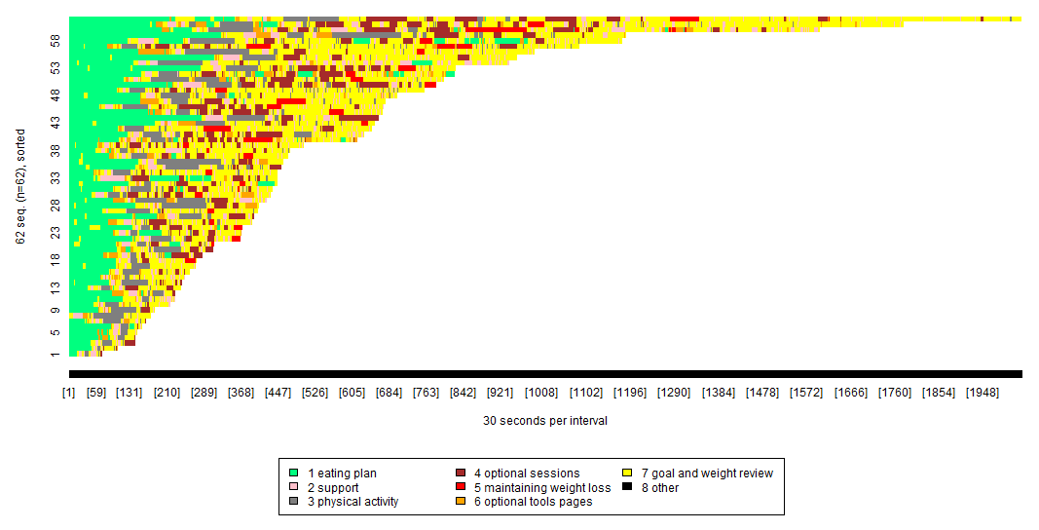

Figure 3: Visualisation of POWeR usage by participants who used the optional sessions

Each colour represents a separate group of pages, as shown above. For example, the green shows usage of the eating plan pages, and the yellow shows usage of the goal and weight review pages. The X axis shows the length of time spent viewing each group of pages, broken down into blocks of 30 seconds. The Y axis can be thought of as a number of lines, each representing a specific participant. Participants are presented in order of how long they spent on the intervention, with those who spent less time nearer the bottom, and those who spent more time nearer the top.

Figure 3 shows that fifty-eight participants used the optional sessions. It also shows that the most frequently viewed pages were those relating to part 1 of the eating plan session and the goal and weight review, but that the optional sessions and optional tools pages were not widely used.

Repeated use of POWeR tools

There were 107 participants who re-used at least one of the POWeR tools, as shown in Figure 4. This data is broken down as shown in Table 4.
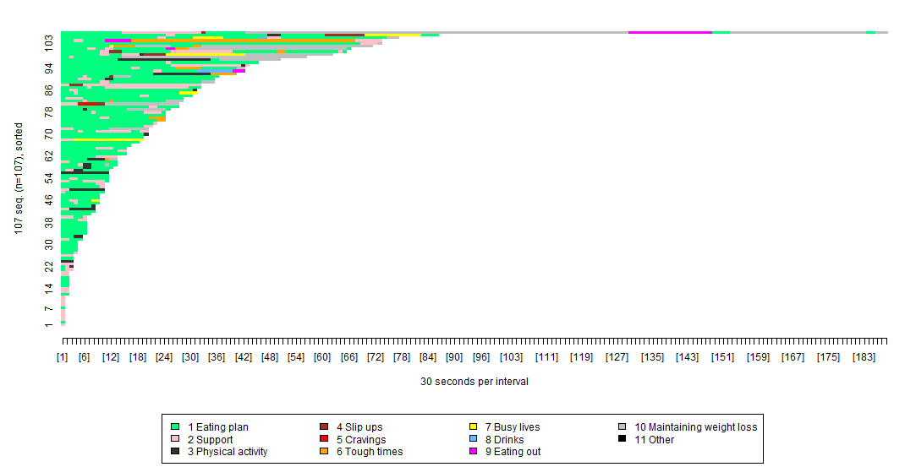

Figure 4: Visualisation of participants’ repeated use of optional tools pages

Each colour represents a separate group of pages, as shown above. For example, the green shows usage of the eating plan pages, and the pink shows usage of the support pages. The X axis shows the length of time spent viewing each group of pages, broken down into blocks of 30 seconds. The Y axis can be thought of as a number of lines, each representing a specific participant. Participants are presented in order of how long they spent on the intervention, with those who spent less time nearer the bottom, and those who spent more time nearer the top.

As shown in Figure 4, the POWeR tools participants re-used most related to the eating plan (green), support (pink), and physical activity plan (dark grey). Very few participants re-used the POWeR tools pages that related to the optional sessions.

Table 4. Numbers of participants who re-used POWeR tools– overview

Tool topic | Numbers viewed
Eating plan | 91 (69%)
Support | 68 (51.5%)
Physical activity plan | 21 (16%)
Slip ups | 7 (5%)
Cravings | 1 (0.8%)
Tough times | 10 (8%)
Busy lives | 7 (5%)
Drinks | 2 (1.5%)
Eating out | 4 (3%)
Maintaining weight loss | 17 (13%)

We used the visualisation tool to provide a detailed breakdown of the most regularly re-used Eating Plan tools (see Figure 5).
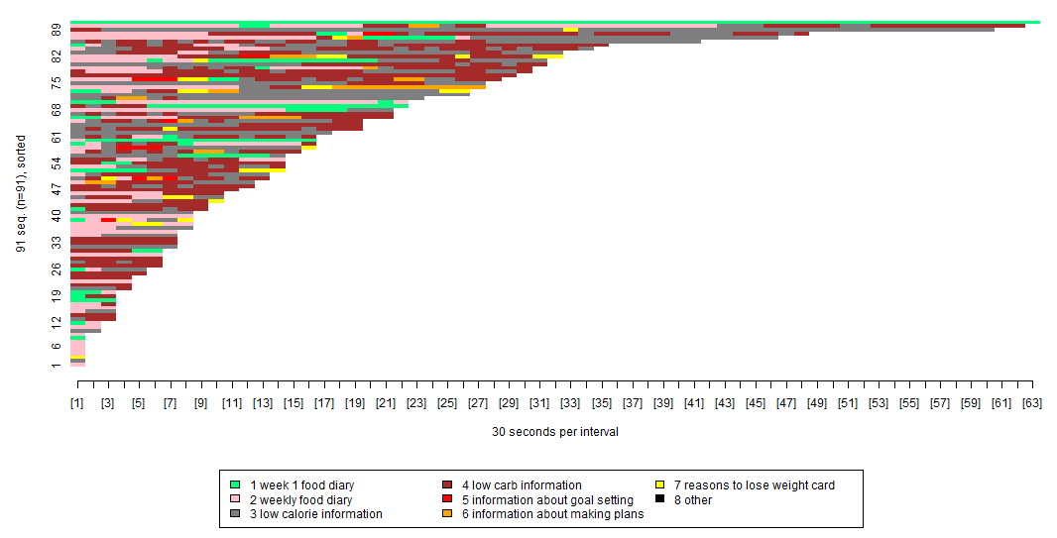

Figure 5: Visualisation of participants’ repeated use of eating plan tools
Each colour represents a separate group of pages, as shown above. For example, the pink shows usage of the weekly food diary, and the yellow shows usage of the reasons to lose weight card. The X axis shows the length of time spent viewing each group of pages, broken down into blocks of 30 seconds. The Y axis can be thought of as a number of lines, each representing a specific participant. Participants are presented in order of how long they spent on the intervention, with those who spent less time nearer the bottom, and those who spent more time nearer the top.

As shown in Figure 5, the specific tools that appeared to be re-accessed most often were those relating to the weekly food diary (light pink), and information about their eating plans (e.g. lists of foods that were low/high in calories or carbohydrates – grey and dark red).

The patterns observed in Figure 5 were used to inform a more precise breakdown of the proportions of participants viewing each of the eating plan tools. This confirmed that over 40% of the participants viewed the weekly food diary and information about the low calorie and carbohydrate eating plans (see Table 5).

Table 5. Numbers (and percentages) of participants who re-used the eating plan tools
Eating plan topic | Code | Numbers viewed
Week 1 food diary | 1 | 29 (22%)
A weekly food diary | 2 | 76 (58%)
Low calorie information | 3 | 71 (54%)
Low carb information | 4 | 57 (43%)
Information about goal setting | 5 | 9 (7%)
Information about making plans | 6 | 14 (11%)
My reasons to lose weight card | 7 | 18 (14%)

We also used the visualisation tool to provide a detailed breakdown of how the ‘support’ tools were re-used. Figure 6 reveals that 68 participants (65% of those who were able to re-access them) re-used the tools in the subcategory ‘Getting Support,’ which comprised information about the importance of getting support from others when trying to lose weight, and ways in which participants could get support from their nurse.

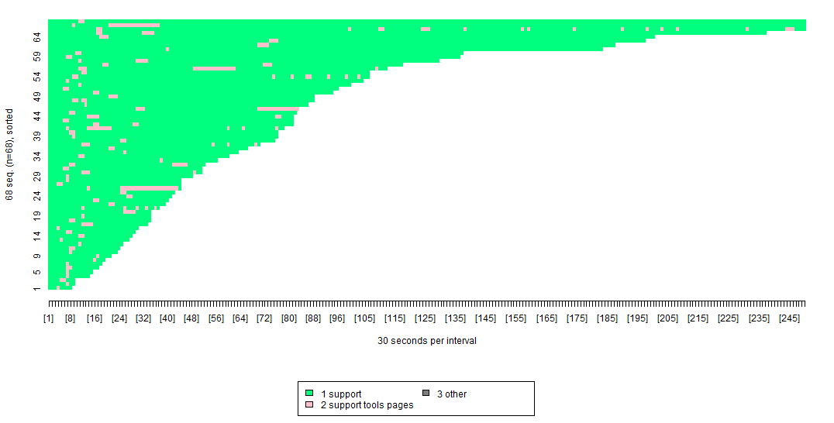

Figure 6: Visualisation of re-use of the support tools in relation to the session on getting support

Each colour represents a separate group of pages, as shown above. The light green stands for the support pages, and the pink stands for the support tools. The X axis shows the length of time spent viewing each group of pages, broken down into blocks of 30 seconds. The Y axis can be thought of as a number of lines, each representing a specific participant. Participants are presented in order of how long they spent on the intervention, with those who spent less time nearer the bottom, and those who spent more time nearer the top.

This visualisation shows that although some participants re-used the support tools all in one go after accessing the support session, it was more common to follow use of the support session with re-use of the getting support tools. Table 6 provides a precise breakdown of the proportion of participants using each of the support tools. .

Table 6. Numbers of participants who re-used the support tools
Support topic | Numbers viewed
Getting support | 68 (65%)
Sending motivational emails | 3 (3.8%)
Ask the nurse | 6 (5.8%)
Social times | 1 (0.96%)

Finally, we carried out a visualisation to examine how participants re-used the physical activity plan tools, as shown in Figure 7.

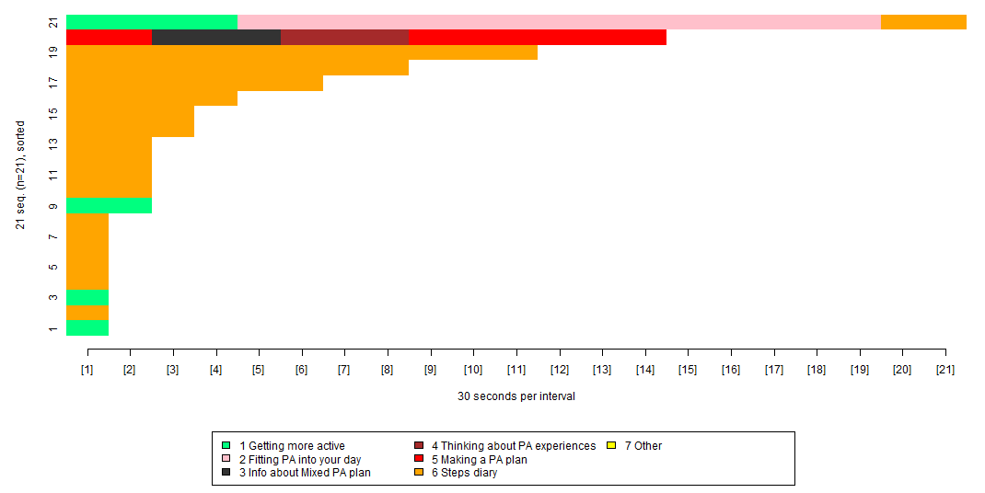
Figure 7: Visualisation of participants’ repeated use of the Physical Activity (PA) plan tools

Each colour represents a separate group of pages, as shown above. For example, the orange shows usage of the steps diary and the light green shows usage of pages on getting more active. The X axis shows the length of time spent viewing each group of pages, broken down into blocks of 30 seconds. The Y axis can be thought of as a number of lines, each representing a specific participant. Participants are presented in order of how long they spent on the intervention, with those who spent less time nearer the bottom, and those who spent more time nearer the top.

Figure 7 shows that the most widely re-used physical activity tools pages were the steps diary (orange) and the pages on getting more active (light green), but that some of the other tools were used only by one person. Table 7 provides a precise breakdown of the proportion of participants using each of the physical activity tools.

Table 7. Numbers (and percentages) of participants who used the physical activity tools
Physical Activity topic | Numbers viewed
Getting more active | 4 (3%)
Thinking about fitting physical activity into your day | 1 (0.8%)
Information about the walking plan | 0
Information about the mixed physical activity plan | 1 (0.8%)
Thinking about your walking experiences | 0
Thinking about your physical activity experiences | 1 (0.8%)
Making a detailed walking plan | 0
Making a detailed physical activity plan | 1 (0.8%)
Steps diary | 17 (13%)

Patient characteristics related to web usage
Using the visualisation tool, we were able to download the IDs of participants who followed particular usage patterns. This enabled the creation of a new usage variable that detailed who had/had not used particular intervention components and could be followed up with further statistical analysis using SPSS.

Usage of optional sessions
Sixty two participants used both the goal and weight review and the optional sessions, but 58 accessed the goal and weight review but not the optional sessions. Participants who did not use the optional sessions had a higher BMI at baseline (36.68 vs 34.60), were more likely to use the low carbohydrate plan (χ2 (3) = 8.71, P =. 03), and were more likely to use the walking plan (χ2 (2) = 2.08, P < .001). (For these analyses, participants were classified as using the last plan they used). There was no difference in weight loss in kilograms between those who used the optional sessions and those who did not (3.67, SD = 6.42) vs 2.14 (SD = 4.75); t (134) = 1.54, P = .13.

Repeated use of eating plan tools
Overall, 106 participants re-used the eating plan tools, of whom 76 re-used the weekly food diary. Participants who re-used the weekly food diary were older (53.62 vs 48.95, t (134) = -2.11, P = .04) and completed more goal and weight review sessions than those who did not re-use the diary (8.89 vs 3.23; t (125.34) = -3.64, P < .001). There was no difference in weight loss between those who did and did not re-use the food diary (2.95, SD = 5.53) vs (3.11, SD = 6.17), t (134) = .16, P = .87.

Repeated use of physical activity tools
Overall, 21 participants re-used the physical activity tools. Those who re-used the steps diary were older than those who did not (58.82 (SD = 14.44) vs 50.52 (SD = 12.45), t (134) = -2.52, P = .01. Participants who re-used the steps diary (physical activity plan tools; n = 17), lost more weight than those who did not (5.78kg (SD = 6.87) vs 2.63kg (SD = 5.56), t (134) = -2.12, P = .04).

Repeated use of getting support tools
Use of getting support tools was analysed for the nurse groups only (as the web group did not receive nurse support). Sixty eight participants re-used the getting support tools. There were no differences at baseline between those who did and did not use the getting support tools. However, those who used the getting support tools completed more of the sessions than those who did not (3.39 (SD = 1.14) vs 0.5 (sd = 0.59), t (77.48) = -15.68, p <.001), and more goal and weight reviews than those who did not (0 (SD = 0) vs 8.81 (SD = 10.65), t (66) = -6.77, p < .001). They also lost more weight than those who did not (4.03kg (SD = 6.93) vs 1.53kg (SD = 4.04), t (70.04) = -2.12, p = .038).

Discussion

Principal Results
This paper had three main aims, which the visualisation tool was able to help us realise. These were: 1) to see patterns of web usage, 2) to carry out a moderator analysis of patient characteristics related to web usage, and 3) to determine which pages were related to benefit from the web-based intervention. The results are discussed below in relation to these aims.

First, the visualisation tool was extremely helpful in enabling us to determine patterns of web usage. A first key observation is that the vast majority of participants who went online accessed the first session, but there was a drop of approximately 20% of participants from the first session to the second session. This is similar to the rapid attrition rate reported in similar web-based weight loss interventions [3-5]. Drop off then continued at a rate of approximately 10% per session. Breaking down the first session into two parts based on content covered (as it was very long and each part was a similar length to the other full sessions) and checking how many participants accessed the last page of session 1 enabled us to see that almost 90% of participants completed the first session. In order to ensure all essential information is covered, it should be presented as early as possible in the intervention. Interventions that aim to also prioritize physical activity should present this as early on as possible.

A second key observation is that only half the participants accessed any of the optional sessions, and each optional session was viewed by less than 25% of participants. Nevertheless, nearly half the participants continued to use the weekly goal and weight review, despite deciding not to access new optional content. In retrospect, this pattern of usage could have been unintentionally prompted by the design of the page following goal review, as the logout option was prominently placed. Alternatively, it could mean that participants felt the additional sessions were neither necessary nor particularly novel (since they covered topics that are commonly addressed by other weight management interventions). In support of this interpretation, there were no differences in weight loss between those who did and did not use the optional sessions, indicating that the optional content was indeed not necessary for weight loss, and those who chose not to access the optional content had a higher BMI at baseline (so may have been more likely to have encountered similar content in previous weight management attempts). This finding justifies the decision to make these sessions optional, and also suggests that for many participants the goal and weight review (which provided individualised progress-relevant feedback messages as well as a weight loss graph) was more important and rewarding to access than the generic weight management advice.
The eating plan tools were the most re-used, in particular the weekly food diary, and information about the low calorie eating plan, and the low carbohydrate eating plan. Thus, explorations of usage patterns using visualisation tools can help to identify the particular intervention tools that participants are keen to re-use online. Such insights can help to inform the design of hybrid interventions that enable access to selected intervention content through multiple digital devices (e.g. Smartphone apps). For example, a mixed-methods evaluation of a supplemental POWeR Smartphone app also showed that participants particularly valued being able to re-access food lists associated with their eating plans on the go via their mobile phone [17]. The eating plan tools were the most basic weight management tools and less essential tools such as the motivational ‘reasons to lose weight’ or ‘sending motivational emails’ support tools were not re-used. However, this does not necessarily mean that the less essential tools were not valued by participants. It could be that participants engaged with these tools at their first presentation during the core session (e.g. by printing out their reasons to lose weight card or setting up support emails there and then) and did not need to re-use them via the POWeR website.

Those who re-used the food diary were older and had completed more goal and weight reviews than those who had not. It is possible that these participants may have been more conscientious in their attitude to weight loss, or that younger participants could have been using alternative tools. However, it is important to note that those who re-used the food diary did not lose more weight than other participants. In order to minimise the intrusiveness and burden of weight management, POWeR specifically encourages users to employ food diaries only occasionally, as diagnostic tools when necessary, and not to rely on them for long-term weight management [18].

Those who re-used the getting support tools had completed more sessions and goal and weight reviews and lost more weight than those who did not. This suggests that the support tools were helpful in enabling weight loss. The challenge now is engaging with those users who did not use the support tools. Interestingly, very few people re-used the ‘ask the nurse’ function, which allowed users to send queries or messages to the nurse providing them with support. Some POWeR users have indicated in our follow-up interviews that they would like to be able to access human support when they feel the need [19], but it appears that the facility to send the nurse an email may not meet this need. This could be because email is an insufficiently personal medium by which to access support [20], but it could also indicate that the opportunity to contact the nurse should be presented differently in future interventions – for example, perhaps offered as an immediate option in goal feedback if participants are not meeting their goals (rather than requiring users to access the option from their tools). Alternatively, these findings may indicate that people did not feel the need to contact the nurse, although they felt it was helpful to have the option there.
Very few people re-used the physical activity tools, suggesting that physical activity may not have been seen as an important part of weight management by POWeR users. However, of the physical activity tools, the steps diary was much the most widely re-used, and was associated with greater weight loss. Users of the steps diary may have used pedometers. They may also have had increased levels of autonomous motivation as this has mediated the effect of self-monitoring and diary usage on weight loss in previous studies [21]. It may therefore be beneficial to find ways to increase repeated and regular usage of the steps diary [22]. It is important to note, though, that participants could only re-use the steps diary if they had chosen to follow the walking plan. From these results it is therefore not clear whether it was specifically the steps diary that was useful, or whether the walking plan was more beneficial than the mixed physical activity plan.

Limitations
This study had several limitations. First, the results described here are based on a single feasibility study, and it is unclear how widely they would apply to a wider population. In particular, the sample participating in POWeR included fewer men and very few members of ethnic minorities. However, the sample was not young or highly educated, and as such could be considered broadly representative of the population eligible to enrol in such an intervention in primary care [11]. Second, although our exploratory analyses identified a number of possible patterns in web usage and associations with outcome, further research is needed to confirm these patterns and test the hypotheses arising from this study. Fourth, the results regarding use of the steps diary and weight loss were based on a small number of users of the steps diary, and should therefore be interpreted with caution. This needs to be replicated with larger populations. Fourth, we considered the intervention groups from POWeR as a single population. It is possible that nurse support may have influenced web usage. We were not able to determine this due to the small numbers.

Conclusions
The visualisation tool provided a useful and efficient method for interpreting and exploring a very large data set on usage of a web-based weight management intervention. Specifically, the visualisation tool helped to determine aspects of the intervention design and content that seem to encourage and discourage repeated use. Insights gained from a visual analysis of usage data also informed subsequent statistical analyses to determine the associations between usage patterns, participant characteristics and weight change. The visualisation tool complements the work of Morrison & Doherty [15] by enabling in-depth analysis of all participants’ usage of EVERY intervention component within one sequence plot. Different visualisation tools are likely to be more or less useful depending on the intervention architecture and research questions of interest. The visualisation tool presented here may be particularly useful for inductive analyses of tunnelled interventions. In contrast, the toolkits developed by van Gemert-Pijnen and colleagues [12] may be particularly beneficial for usage analyses following a priori assumptions about key intervention components. The toolkit developed by Morrison and Doherty [15] may be particularly beneficial for individual level analyses or group level analyses of non-tunnelled interventions that do not have a clear start and end-point. Visualisation toolkits can be used as part of a mixed-methods approach to developing and evaluating digital interventions that seeks to arrive at a more complete picture of the differences in the way in which participants use an intervention, supplemented by qualitative insights about participants’ subjective experiences of using the intervention [23] and quantitative data on the effect of the intervention on health-related outcomes. Further usage of visualisation techniques is highly recommended in order to a) inform the (re-)design of future interventions so that they enable easy access to valued intervention content, and b) unlock the active ingredients in web-based interventions, so they can be enhanced in order to reach and engage the maximum eligible population.

Acknowledgements
The development of the visualisation tool was funded by the UK Economic and Physical Sciences Research Council (EP/I032673/1: UBhave: ubiquitous and social computing for positive behaviour change). We are grateful to Peter Smith, Mark Weal, Charlie Hargood and Matthew Taylor for their contributions to its development.

References

1. Neve M, Morgan PJ, Jones PR, Collins CE. Effectiveness of web-based interventions in achieving weight loss and weight loss maintenance in overweight and obese adults: a systematic review with meta-analyses. Obes Rev 2010 Apr 11; (4): 306-21. PMID: 19754633.
2. Wieland LS, Falzon L, Sciamanna CN, Trudeau KJ, Brodney S, Schwartz JE, Davidson KW. Interactive computer-based interventions for weight loss or weight maintenance in overweight or obese people. Cochrane Database Syst Rev 2012 Aug 15; 8: CD007675. PMID: 22895964.
3. Eysenbach G. The law of attrition. J Med Internet Res 2005 Jan-Mar; 7 (1): e11. PMID: 15829473.
4. Kelders SM, Kok RN, Ossebaard HC, Van Gemert-Pijnen JEWC. Persuasive system design does matter: A systematic review of adherence to web-based interventions. J Med Internet Res 2012 Nov-Dec; 14 (6): e152. PMID: 23151820.
5. Neve MJ, Collins CE, Morgan PJ. Dropout, nonusage attrition, and pretreatment predictors of nonusage attrition in a commercial Web-based weight loss program. J Med Internet Res 2010 Dec 14; 12(4): e69. PMID: 21156470.
6. Ritterband LM, Thorndike FP, Cox DJ, Kovatchev BP, Gonder-Frederick LA. A behavior change model for internet interventions. Ann Behav Med 2009 Aug 38 (1): 18-27. PMID: 19802647
7. Funk KL, Stevens VJ, Appel LJ, Bauck A, Brantley PJ, Champagne CM, Coughlin J, Harvey-Berino J, Hollis JF, Jerome GJ, Kennedy BM, Lien F, Myers VH, Samuel-Hodge C, Svetkey LP, Vollmer WM. Associations of internet website use with weight change in a long-term weight loss maintenance program. J Med Internet Res 2010 Jul 27; 12(3): e29. PMID: 20663751.
8. Cussler EC, Teixeira PJ, Going SB, Houtkooper LB, Metcalfe LL, Blew RM, Ricketts JR, Lohman J, Stanford VA, Lohman TG. Maintenance of weight loss in overweight middle-aged women through the internet. Obesity (Silver Spring) 2008 May; 16 (5): 1052-60. PMID: 18309301.
9. Krukowski RA, Harvey-Berino J, Ashikaga T, Thomas CS, Micco N. Internet-based weight control: the relationship between web features and weight loss. Telemed J E Health 2008 Oct; 14(8): 775-82. PMID: 18954247.
10. Brindal E, Freyne J, Saunders I, Berkovsky S, Smith G, Noakes M. Features predicting weight loss in overweight or obese participants in a web-based intervention: randomized trial. J Med Internet Res 2012 Dec 12; 14(6): e173. PMID: 23234759.
11. Yardley L, Ware LJ, Smith ER, Williams S, Bradbury KJ, Arden-Close EJ, Mullee MA, Moore MV, Peacock JL, Lean ME, Margetts BM, Byrne CD, Hobbs RF, Little P. Randomised controlled feasibility trial of a web-based weight management intervention with nurse support for obese patients in primary care. Int J Behav Nutr Phys Act 2014 May 21; 11: 67. PMID: 24886516
12. Van Gemert-Pijnen JE, Kelders SM, Bohlmeijer RT. Understanding the use of content in a mental health intervention for depression: an analysis of log data. J Med Internet Res 2014 Jan 31; 16 (1): e27. PMID: 24486914.
13. Kim HK, Niederdeppe J, Guillory J, Graham M, Olson C, Gay G. Determinants of pregnant women’s online self-regulatory activities for appropriate gestational weight gain. Health Commun 2014 Sep 10: 1-11. PMID: 25205417.
14. Hendricks MC, Ward CM, Grodin LK, Slifer KJ. Multicomponent cognitive-behavioural intervention to improve sleep in adolescents: a multiple baseline design. Behav Cogn Psychother 2014 May; 42 (3): 368-73. PMID: 25267109.
15. Morrison C, Doherty G. Analyzing engagement in a web-based intervention platform through visualizing log-data. J Med Internet Res 2014 Nov 13; 16 (11): e252. PMID: 25406097.
16. LifeGuide 2015. Retrieved from https://www.lifeguideonline.org/. Archived at b
17. Morrison L, Hargood C, Lin SX, Dennison L, Joseph J, Hughes S, Michealides DT, Johnston D, Johnston M, Michie S, Little P, Smith PW, Weal MJ, Yardley L. Understanding usage of a hybrid website and smartphone app for weight management: a mixed methods study. J Med Internet Res 2014 Oct 22; 16 (10): e21. PMID: 25355131.
18. Yardley L, Williams S, Bradbury K , Garip G, Renouf S, Ware L, Dorling H, Smith E, Little P. Integrating user perspectives into the development of a web-based weight management intervention. Clin Obes 2012 Oct; 2 (5-6): 132-41. PMID: 25586248.
19. Bradbury K, Dennison L, Little P, Yardley L. Using mixed methods to develop and evaluate an online weight management intervention. Br J Health Psychol 2015 Feb; 20 (1): 45-55. PMID: 25406436.
20. Renouf S, Bradbury K, Yardley L, Little P. The role of nurse support within an Internet-delivered weight management intervention: A qualitative study. Psychol Health Med 2014 Dec 2: 1-9. PMID; 25438990.
21. Webber KH, Gabriele JM, Tate DF, Dignan MB. The effect of a motivational intervention on weight loss. Int J Behav Nutr Phys Act 2010 Jan 22; 7: 4. PMID: 20157441.
22. Danaher BG, Seeley JR. Methodological issues in research on web-based behavioural interventions. Ann Behav Med 2009 Aug; 38 (1): 28-39. PMID: 19806416
23. Yardley L, Morrison L, Bradbury K, Muller I. The person-based approach to intervention development. J Med Internet Res. Doi: 10.2196/jmir.4055

