Modelling the optimal phosphate fertiliser and soil management strategy for crops
J. Heppell^{1, 3, 4, 5}, S. Payvandi^{2, 5}, P.Talboys⁶, K. C. Zygalakis^{3, 5}, J. Fliege^{3, 4}, D. Langton⁷, R.Sylvester-Bradley⁸, R.Walker⁹, D.L.Jones⁶ and T. Roose^{2, 5}
¹Institute for Complex Systems Simulation, University of Southampton, Southampton, UK. ²Faculty of Engineering and the Environment, University of Southampton, Southampton, UK. ³School of Mathematics, University of Southampton, Southampton, UK. ⁴CORMSIS, University of Southampton, Southampton UK. ⁵IFLS Crop Systems Engineering, University of Southampton, Southampton, UK. ⁶School of Environment, Natural Resources and Geography, University of Bangor, Bangor 57 2UW, UK. ⁷Agrii, UK. ⁸ADAS Boxworth, Cambridge CB23 4NN, UK. ⁹Scotland’s Rural College, Aberdeen, AB21 9YA.
Corresponding Author: jph106@soton.ac.uk (J. Heppell)
Abstract:
Aims The readily available global rock phosphate (P) reserves may be depleted within the next 50-130 years warranting careful use of this finite resource. We develop a model that allows us to assess a range of P fertiliser and soil management strategies for Barley in order to find which one maximises plant P uptake under certain climate conditions.
Methods Our model describes the development of the P and water profiles within the soil. Current cultivation techniques such as ploughing and reduced till gradient are simulated along with fertiliser options to feed the top soil or the soil right below the seed.
Results Our model was able to fit data from two barley field trials, achieving a good fit at early growth stages but a poor fit at late growth stages, where the model underestimated plant P uptake. A well-mixed soil (inverted and 25 cm ploughing) is important for optimal plant P uptake and provides the best environment for the root system.
Conclusions The model is sensitive to the initial state of P and its distribution within the soil profile; experimental parameters which are sparsely measured. The combination of modelling and experimental data provides useful agricultural predictions for site specific locations.

Keywords Mathematical modelling, phosphate, fertiliser strategy, barley field study, soil buffer power
Introduction
Within the agricultural industry, the management of soils and crops varies widely around the world (Jordan-Meille et al., 2012), and slight adjustments to reduce costs and/or increase crop yields can make substantial differences on the global scale. The demand for food is increasing; from 1992 to 2012 the production of cereals worldwide increased from 1.97 billion to 2.55 billion tonnes (http://faostat.fao.org/). In 2012 the UK alone produced 19.5 million tonnes of cereals, 5.52 million of which was barley. One of the most important nutrients for plant growth is phosphate (P), which is often the most limiting due to its low mobility in soils (Bucher 2007). The current world rate of P consumption for fertilisers is not sustainable, and there are warnings that readily available global rock P reserves may be depleted within the next 50-130 years (Déry and Anderson, 2007; Cordell, Drangert and White, 2009; Vaccari D, 2009).
European governments (DEFRA, 2010 and Lalor et al., 2013) are reducing the amount of P fertilisation in agricultural sites to reduce soil P content from a high Olsen P index 3 (26-45 mg l⁻¹) to either index 2 (16-25 mg l⁻¹) or index 1 (10-15 mg l⁻¹), as an attempt to increase the sustainable use of P. However, lower P content soils can lead to reduced yields (Withers et al., 2014). Therefore it is vital to identify optimal soil management strategies for more efficient use of P (Dungait et al., 2012). However, optimal strategies can depend upon the current climate and the distribution of P within the soil. The distribution of P is a feature which is generally unknown for field situations, but is becoming more regularly sampled (Vu et al., 2009 and Stutter et al., 2012).
Farmers implement a range of soil strategies based on information from a variety of sources. The fertiliser manual (RB209) published by the Department for Environmental, Food & Rural Affairs (DEFRA) provides a guide to farmers as to the amount of fertiliser to use for given soil types (DEFRA, 2009). Field-specific advice is also given by agronomists based on previous P use. Previous history of any specific site also remains an important factor as repeating cropping strategies for similar environments provides experience on which strategies perform best (Reijneveld et al., 2010). The general guidelines in the RB209 manual for applying fertiliser are based on soil P concentrations, often taken from spot measurements. The amount of P application recommended is classified into different categories. However, this classification means that soils can have entirely different fertiliser recommendations if they have similar soil P concentrations, but lie across the boundaries of the classification. This leads to a varying selection of treatments on similar plots of land and makes it difficult to reduce the amount of P in soils, as a recent study in Ireland showed (Lalor et al., 2012). Site-specific guidelines may provide a better basis to implement optimal fertiliser and soil cultivation strategies when it comes to cultivating crops. The aim is to more efficiently use applied P, not over-apply in cases where it is not needed or under apply it and not meet crop yield targets. Therefore, instead of having a table of discrete amounts of fertiliser to add, a simple linear or saturating continuingly graded expression could govern how much P to add. Also, a better classification of soils is needed; much like the varied descriptions of soils in Scotland (Soil Survey of Scotland Staff, 1981).
Increasing information collected about soil type and characteristics will provide a better understanding of fertiliser placement and amount to apply, resulting in a more successful crop for a given season. However, collecting detailed data about soils is expensive. In addition, it is difficult to ascertain how much data is actually needed to give the best prediction for a successful strategy (Kamprath et al., 2000). Mathematical models can provide the analysis needed to evaluate a large range of strategies that cannot all be tested at the field scale, due to time, money and location specific restrictions (Selmants and Hart, 2010; Jeuffroy et al., 2012). Once optimal strategies are found, they can be tested and evaluated among other strategies to prove their validity, in the hope to support evidence for a better understanding of applying P to soils.
Many models used to describe the root system consider a density of root mass for a given volume in soil. The root mass can be estimated from averaging a 3D growth approach (Lynch et al., 1997; Chen et al., 2013) or by considering a 3D growth model, for example L systems (Leitner et al., 2010). These approaches however cannot be easily assessed experimentally and can lead to numerical inaccuracies of up to 30% when compared to computed plant P uptake, when up-scaling to the field level (Roose & Schnepf, 2008). In this paper, we model the movement of P and water within the soil profile over time. We extend the models of Roose and Fowler (2004b) and Heppell et al. (2015) to estimate the uptake of P by crop roots for a given surface area of soil. This extended model is comparable to other density-based models (Dupuy et al., 2010), and accounts for the P depletion zone along all roots. We compare the extended model output, estimating plant P uptake (kg P ha⁻¹), against two sets of field trial data for barley. Following this, the extended model is used to predict the best fertiliser and soil cultivation strategy which maximises plant P uptake. As a result, the optimal strategy should also maximise ‘P-use efficiency’ within a low P environment.
In the Materials and Methods section we discuss P and water uptake models, looking more closely at Roose and Fowler (2004b) and Heppell et al. (2015) and our adaptations made to them. We then describe how the data are collected and the values used for the model. Modelling results are described in the results section followed by a discussion section describing our findings and future avenues for work.
Materials and Methods
Phosphate and water uptake model
It is expensive to experimentally determine the distribution and movement of water and P within the soil and the consequent uptake into the plant root system. The use of modelling in combination with experimental data allows us to predict optimal management strategies in agricultural systems. Many models exist that estimate water and P movement within soil. For example Dunbabin et al. (2013) developed a model that predicts plant P uptake by estimating the distribution of P in 3D. The 3D P information can be combined with other models, such as one that estimates the fractal geometry of simulated root systems in 1, 2 and 3D (Lynch et al, 1997). However, due to memory and computational limitations, these models are not appropriate for up-scaling to the field level (Roose and Schnepf, 2008). Other models focus on the root architecture and the uptake of P by the root system (Ge et al., 2000; Lynch and Brown, 2001; Grant and Robertson, 1997; Roose et al., 2001). Roose et al. (2001) capture the P depletion zone along all roots and obtain an analytical solution; their model estimates plant P uptake per soil surface area which can be used to predict plant P uptake on a field scale. Roose and Fowler (2004b) advanced the model by tracking the movement of water and P spatially. In this paper, for the first time, we extend the model of Roose and Fowler (2004b) and Heppell et al., (2015) by adding the effect of climate, via surface water flux and xylem pressures as in Heppell et al. (2014). This extension allows comparison of the model output, plant P uptake, against field study experimental data, for different environmental conditions. In addition, we incorporate temperature-dependent root growth so that the model can be used for winter crops, as there is little or no root/plant growth at low temperatures. Our mathematical model is based on well-known equations governing P and water movement within the soil (Roose et al., 2014), and the aim of this work is to see if the model can explain variations in P uptake observed at field sites. If not, this indicates that further development of the model or model inputs is required. We first describe details of the Roose and Fowler (2004b) model and then the adaptations made to it.
Roose and Fowler model
Roose and Fowler (2004b) model water and P flow through soil to calculate uptake into a surrounding plant root system using a Richards Equation coupled to a diffusion-convection equation describing P movement in the soil. The model assumes that the soil is homogeneous and neglects horizontal movement of water and P, since at the field scale the differences in the horizontal variation for the root length density are negligible compared to the vertical variation (Roose and Fowler, 2004a). For model simplicity we assume that there is a concentration of P available to the root system (P in solution, ‘available P’) and a concentration sorbed to the soil particles (P sorbed, ‘non-available P’). Many new papers use the term ‘available P’ to represent this state of P in the soil, for example Johnson et al., 2014. The Roose and Fowler model is described by the following two equations for water and P conservation, respectively,
$ϕ\frac{∂S}{∂t}=∇ ∙\left[D_{0}D\left(S\right)∇S-K_{s}k\left(S\right)\hat{k}\right]-F_{w}(S,z,t)$, Eqn. 1
$\frac{∂}{∂t}\left[\left(b+ϕS\right)c\right]+∇∙\left[cu\right]=∇∙\left[D_{f}ϕ^{d}S^{d}∇c\right]-F\left(c,S,t\right)$, Eqn. 2
where the speed of water movement in the soil, $u$, is given by Darcy’s law,
$u=-D_{0}D\left(S\right)∇S+K_{s}k\left(S\right)\hat{k}.$ Eqn. 3
In above equations S is the relative water saturation given by $S=ϕ_{1}/ϕ$, $ϕ_{1}$is the volumetric water content, and $ϕ$ is the porosity of the soil. $D_{0}$ (cm² day⁻¹) and $K_{s}$ (cm day⁻¹) are the parameters for water ‘diffusivity’ and hydraulic conductivity, respectively. $D\left(S\right)$ and $k(S)$ characterize reduction in water ‘diffusivity’ and hydraulic conductivity in response to the relative water saturation decrease, where the functional forms for partially saturated soil are given by Van Genuchten (1980). $\hat{k}$ is the vector pointing vertically downwards from the soil surface and $F_{w}$ is the water uptake by the plant root system per unit volume of soil as given by Roose and Fowler (2004a).
For the P mass conservation (Eqn. 2), c is the P concentration in pore water, b is the soil buffer power, $D_{f}$ is the P diffusivity in free water and $d$ is an impedance factor given by the range $1.5≤d≤3$ (Barber, 1984; Nye and Tinker, 1977). $F(c,S,t)$ describes the rate of P uptake by a surrounding root branching structure as in Roose et al. (2001). Both $F_{w}$ and $F$ are affected by the spatially and temporally evolving root structure. Water is only taken up by the main order roots while P is taken up by all roots.
For the soil surface boundary condition, Roose and Fowler (2004b) apply a flux of water at the soil surface denoted by$W_{dim}$ $(cm s^{-1})$, which is the volume flux of water per unit soil surface area per unit time;
$-D_{0}D\left(S\right)\frac{∂S}{∂z}+K_{s}k\left(S\right)=W_{dim} at z=0.$ Eqn. 4
The soil surface boundary condition for P, for a rate of fertilisation $Q_{dim}$ ($μmol cm^{-2}s^{-1}$), is given by
$-D_{f}ϕ^{d}S^{d}\frac{∂c}{∂z}+W_{dim}c=Q_{dim } at z=0.$ Eqn. 5
The boundary condition at the ‘bottom’ of the soil is assumed to be a zero flux boundary condition at a given level $l_{w}$, for both water and P, respectively,
$-D_{0}D\left(S\right)\frac{∂S}{∂z}+K_{s}k\left(S\right)=0 at z=l_{w},$ Eqn. 6
$-D_{f}ϕ^{d}S^{d}\frac{∂c}{∂z}=0 at z=l_{w}.$ Eqn. 7
Solving for relative water saturation ($S$) and P concentration ($c$) produces water and P profiles in depth and time.
The calculation of $F$ and $F_{w}$ depends on the plant root structure in the soil. The root growth rate equation used in the Roose et al. (2001) model assumes that the rate of growth slows down over time, i.e., the rate of growth is given by,
$\frac{∂l_{i}}{∂t}=r_{i}\left(1-\frac{l_{i}}{K_{i}}\right)$, Eqn. 8
where $l_{i}$ is the length of the order $i$ root, $r_{i}$is the initial rate of growth of the order $i$ root and $K_{i}$ is the maximum length of an order $i$ root.
Adaptations to the Roose and Fowler Model
To include climate effects within the Roose and Fowler (2004b) model, we let the flux of water into the soil ($W_{dim}$) be dependent upon rainfall, wind speed, temperature and humidity. This allows for a more accurate calculation of the plant transpiration rate and the movement of water inside the soil and within the plant. These adaptations are made in Heppell et al. (2014) and successfully capture the movement of water within the soil profile and plant transpiration rate.
To model the water saturation levels in the soil, the flux of water into the soil ($W_{dim}$) is estimated from a combination of environmental factors. These include rainfall ($R$), humidity ($H$), wind speed ($WS$), temperature ($T$) and a constant ($E$), using a linear expression,

$W_{dim}=δR+αH+βT+γWS+E$ , Eqn. 9

where the parameters $δ, α, β, γ$ and $E$ are determined from the optimal fit to the soil water saturation and climate data (Heppell et al., 2014). The flux of water ($W_{dim}$) can essentially be considered as a Taylor expanded version of any other non-linear soil surface water permeation relationship, for example the Penman-Monteith Equation (Beven, 1979). Therefore, the formulation of Equation (9) allows for easy comparison with other models, such as Cropwat (Clarke et al., 1998), should this be necessary.

The driving pressure, $P$ (Pa), inside the root is determined by the environmental conditions (humidity and temperature) causing the stomata in the leaves to open and close (Tuzet et al, 2003). When the air temperature is low and/or humidity is high, the plant opens its stomata to speed up the loss of water and cause cooling. This leads to a decrease in the pressure of water inside the roots. Thus the water pressure within the plant roots ($P$) is given by,
$P={(p}_{r}^{0}+λ_{3})+λ_{1}T+λ_{2}H$, Eqn. 10
where $p_{r}^{0}$ (Pa) is the baseline xylem pressure and $λ_{1}(Pa/degC), λ_{2}(Pa/\% humidity)$ and $λ_{3}(Pa)$ are determined by seeking the optimal fit to soil saturation data and are used to help calculate $F_{w}$ (Heppell et al., 2014).These parameters have been determined by Heppell et al. (2014) for a given geographical monitoring site.
A new feature is added to the model to match the root growth over the cropping season (where little growth is seen over the winter period) by making the rate of growth temperature dependent. This transforms Equation (8) into,
$\frac{∂l_{i}}{∂t}=r(T(t))\left(1-\frac{l_{i}}{K_{i}}\right)$, Eqn. 11
where $r(T(t))$ is taken from experimental data on temperature dependant root growth rates, Table 1.
In summary, the data needed for the adapted model to run includes: initial distributions of water and P concentrations in the soil, climate data for rainfall, humidity, wind speed and temperature values, fertiliser application and amount, soil cultivation strategy and temperature dependant root growth rates which are obtained from experimental data. Henceforth, when referring to the ‘model’ we mean the adapted model extended from the one by Roose and Fowler (2004b).
Data collection
From the literature
To run the adapted mathematical model a set of parameters were taken from Roose and Fowler (2004b), Heppell et al. (2014 and 2015) and Sylvester-Bradley et al. (1997), consisting of values for plant root dynamics and soil characteristics, Table 2.
Pot trials
To assess temperature effects on root growth rates in cereals Triticum aestivum seeds were soaked overnight in aerated de-ionised water to induce germination. They were then placed on filter papers, moistened with deionised water, put in parafilm sealed Petri dishes covered in aluminium foil and incubated at 20ºC. After 48 hours the root lengths of each emerged seminal root were measured non-destructively using a ruler. The filter papers were re-moistened and the Petri dishes were grouped into different controlled temperatures, heating at 5, 10, 20 and 30ºC. After another 24 hours the lengths of the seminal roots were measured with WINRHIZO, and the differences in root length for each root were recorded as the average root growth rate per day.
Plant root growth rates increased from 5ºC at which a zero growth rate was observed, Table 1. A straight line was fitted to the data such that the information could be translated into the mathematical model, for temperature $T$ we set the growth rate$R$ to be,
$R=\left\{\begin{matrix}0 & for & T≤5^{o}C \\ 0.053(T-5) & for & T>5^{o}C\end{matrix}\right.$. Eqn. 12
Barley and wheat root structures are genetically different but phenotypically similar (Kutschera et al., 2009). The mathematical model uses the root morphology not its genetics and therefore we assume, consistent with Kutschera, that experimental data from wheat roots is a good first approximation for barley roots in this instance.
Field trials
Two data sets were taken from field scale trials, which consisted of a set of scenarios for different fertiliser application techniques and measurement of plant P uptake values (offtake); one winter barley and one spring barley. A decimal code system is used to measure the growth stages of barley based on description stages (Broad, 1987). The winter barley data includes values for P offtake at two different periods, growth stages 39 and 92; 232 and 313 days respectively. The winter barley variety was Winsome winter malting barley. Differing amounts of triple superphosphate (TSP) were incorporated (0, 15, 30, 60, 90 and 120 kg P ha⁻¹) or banded (15 and 30 kg P ha⁻¹) in the soil. The trial was on a clay soil with a low P index, based in Stetchworth, UK. The spring barley data includes values for P offtake at three different periods, growth stages 31, 45 and 91; 61, 77 and 151 days respectively. The spring barley variety used was Shuffle, being grown from seed, with typical farm inputs used (e.g. fertiliser, herbicide, fungicide, etc.) except P which was imposed based on experimental requirements. Differing amounts of TSP were incorporated (0, 5, 10, 20, 30, 60 and 90 kg P ha⁻¹) or banded (10, 20 and 30 kg P ha⁻¹) in the soil. The trial was on a sandy clay loam soil with a low P index, based near Aberdeen in Scotland, approximately 57ºN. The trial was ploughed in January and ground power harrowed on the day of sowing (23-March-2011). The crop was rolled after sowing to consolidate the seedbed and reduce the risk of stone damage to harvesting equipment.
The field scale data only uses one Olsen P value for a given plot and there is no distinction concerning how P is distributed with depth. To provide a description of how plant-available P varies with soil depth, soil was collected from different depths within a spring wheat field trial located at Abergwyngregyn, North Wales. The soil there was classified as a free draining sand textured Eutric Cambisol. Samples were taken from four replicate plots (3 m x 12 m in size) at growth stage 39 at 10 cm intervals down the soil profile to a depth of 1 m. Three sets of soils were tested, Olsen P index 5, 3 and 2 (Fig. 1a). Plant-available P was determined by extracting the soil with 0.5 M acetic acid (1:5 w/v) for 30 min, centrifuging the extracts (4000 g, 15 min) and colorimetric determination of P according to Murphy and Riley (1962).
In addition to the soil sites in North Wales, six sites within the UK with a sandy clay loam were sampled for Olsen P (Fig. 1b). Soil samples were taken at 0-30 cm, 30-60 cm and 60-90 cm. The sites varied from a high Olsen P index of 6 to a low index of 2. A similar P distribution was seen at 4 sites (Olsen P index 5 and 3) where P concentration decays exponentially with depth as in the free draining sand in Wales, whereas the other two sites (Olsen P index 6 and 2) had a constant P profile. To represent the P profile data a constant P profile with depth and an exponentially decaying P profile with depth will be compared in the model simulations.
Fertiliser strategies
The model adapted in this paper is used to mimic field trials and to predict plant P uptake (kg P ha⁻¹). In addition to the scenarios used in the field trial experimental data, we analyse the effects of different environmental conditions for a range of fertiliser and soil cultivation strategies.
We estimate that on average the ploughing depth is 25 cm. In Heppell et al. (2014) we used climate data (hourly values for temperature, humidity, wind speed and rainfall) to calibrate a plant water uptake model; the same parameters and data are used within the current extended model.
The amount of fertiliser applied in an average cropping season ranges from 0 to 120 kg P ha⁻¹. Fertiliser, for example TSP, can be applied in two different ways, banded and broadcasted. The banded application involves injecting fertiliser pellets 5-10 cm below the soil and 5-10 cm away from the seed. This is represented in the model as fertiliser placed 9 cm below the seed. The aim of this strategy is to put fertiliser next to where most of the roots are likely to grow to try to maximise root P uptake. The broadcasted approach spreads fertiliser only on top of the soil.
The extended model predicts how different fertiliser strategies influence plant P uptake. The set of fertiliser strategies compared in the model are shown in Fig. 2. The soil is first cultivated and then fertiliser is applied. During the cultivation phase, different methods are used to mix P in the soil. Ploughing evenly mixes P to a specific depth between 10-25 cm, whereas a reduced till gradient distributes P into bands; 0-5cm, 5-10cm and 10-15cm with a P concentration ratio of 1.5:1:0.5 respectively; inverted plough inverts the P concentration between 0-15 cm; and lastly there is an option of no cultivation. We model top soil fertilisation, fertilisation applied at 9 cm below the seed or no fertilisation, and use climate data with or without an increased amount of rainfall. For each strategy the model predicts plant P uptake which is then compared to a control with no fertilisation or cultivation for a given soil type and climate data.
Results
Our adapted model in this paper is fitted against experimental field trial data to produce a site specific model. A selection of fertiliser strategies are then simulated using the model (Fig. 2), and values for plant P uptake are compared to predict which strategy might, under certain climate conditions, estimate the highest plant P uptake.
By looking at the experimental data we find that the initial P distribution in the soil has a high concentration at the top of the soil and then the concentration decays with depth; at 1 m there is very little P left (Fig. 1). This decay is much stronger for higher initial P concentrations, whereas at P index 1 there are almost indistinguishable changes in the P distribution (no decay). To assess the difference at P index 1 between a constant and an exponentially decaying P profile, we will model both profiles. In each case (constant and exponentially decaying P profiles) the total P down to 0.55 m is kept identical to represent similar amounts of P being available to the root system. The P profiles for a constant and exponentially decaying distribution are represented in Fig. 5a and 5c, respectively, for time = 0 days.
The model fits the winter barley data better at growth stage 39 (GS 39) compared with growth stage 92 (GS 92). At GS 39 the model predictions are within the error bars with the exception of the 30 kg P ha⁻¹ placed scenario (Fig. 3a). At GS 92 the model under predicts on all scenarios, but follows the trend of increasing plant P uptake values for increasing amounts of TSP applied (Fig. 3b). The main reason for the under prediction stems from the unknown parameters, which include soil buffer power and the initial P profile in the soil. Other plant factors, such as root exudates or mycorrhizae, could also have increased P availability and hence plant P uptake but are not taken into account within the model since they were not monitored and quantified in the experiments. Wheat is not thought to be strongly mycorrhizal (Li et al., 2005) and conceivably neither is barley. The initial P profile, at index 1, is depleted before the end of harvest and the final total plant P uptake is therefore capped. This depletion effect is also seen when modelling the spring barley data (Fig. 4b, 4c), and in addition at GS 31 the model fails to capture the effects between small and large amounts of TSP applied, fitting well at 0-20 kg ha⁻¹, but not at 30-90 kg ha⁻¹ (Fig. 4a). In regards to the spring barley crop, GS 31 is only a short time of 61 days and this is perhaps why little effects are seen between modelling different amounts of applied TSP. The amount of available P is unaffected by an additional supply as there is only a small root system generated by GS 31. The plant P uptake estimate from the model, on average decreases from a constant P distribution to an exponentially decaying P distribution. There is a decrease of 4.7% (GS 39) and 18.3% (GS 92) for winter barley, and -10.5% (GS 31), -12.3% (GS 45) and 5% (GS 91) for spring barley. The reason for a negative value (i.e. decrease as opposed to increase in plant P uptake) for spring barley at GS 31 and 45 is because the root system is small, and as a consequence the P deeper in the soil profile has not been utilised.
The depletion of P for different initial P profiles can be seen in Fig. 5. In a low P content soil (P1) with an exponentially decaying initial P distribution there is a reduction in the plant P uptake rate after 147 days. This is because the majority of the available P is taken up at an early growth stage. This effect is not seen with a constant initial P distribution as P is spread out more evenly with depth; however the available P is still all taken up by the end of the simulation (GS 92, 313 days). For a high P content soil (P3) there is no decrease in the plant P uptake rate and most of the available P is taken up by the root system.
We tested the sensitivity of the model output, plant P uptake, for two different parameters (soil buffer power and initial volumetric soil water content) to see if unknown or badly measured parameters would have an effect. We compared four different soil buffer power values 20, 23.28, 30 and 40 and found that plant P uptake is very sensitive to the soil buffer power value (Fig. 6a). Plant P uptake values at GS39 ranged between 8-12 kg P ha⁻¹, a large difference for only a small change in realistically measured soil buffer power values.
We also changed the initial volumetric soil water content , however little differences of 1% are seen between starting values of 0.1 to 0.5 (Fig.6b). Thus, the initial volumetric soil water content has little effect on plant P uptake. Instead, the climate conditions throughout the cropping season affect plant P uptake as discussed below.
We run the model for a range of fertiliser and soil cultivation strategies under wet and normal climate conditions at GS 92, for an initial low P Olsen index soil (P1 – 20 mg l⁻¹ P ‘decay’; Fig. 7a-normal, Fig. 7b-wet) and a high P Olsen index soil (P3 – 60 mg l⁻¹ P ‘decay’; Fig. 7c-normal, Fig. 7d-wet). Instead of considering different amounts of applied fertiliser, six cultivation techniques are simulated (mix 25, 20 and 10 cm, inverted plough, minimum tillage and no cultivation) alongside 3 fertiliser treatments (placed 90 kg P ha⁻¹, incorporated 90 kg P ha⁻¹ and no fertiliser). At GS 92 the highest plant P uptake is achieved from an inverted plough down to 15 cm and placing 90 kg P ha⁻¹, followed by mixing the soil to 25cm and placing 90 kg P ha⁻¹. Under a wet climate, plant P uptake values are increased on average by 2% across all fertiliser and soil cultivation strategies; the highest increase of 5% was seen when broadcasting fertiliser. When broadcasting fertiliser the increased water helped diffuse the top soil P and allowed more to be taken up by the plant. It should be noted that under field conditions, an increase in soil water content can lead to greater root growth which would increase plant P uptake more so than just via P diffusion. However, for this study the modelled root system is only temperature dependent, future studies may include additional root growth effects. In a high P index soil (P3) there is almost no response to plant P uptake values when adding P fertiliser, which is to be expected. For a low P index soil, plant P uptake is limited due to a lack of available P (depletion of P as seen in Fig. 5) and this results in little distinction between ploughing techniques. Root chemotropism (stimulation of root growth by the added P) was not considered within this model since it was not possible to quantify this in the experiments.
In summary, applying P near the rooting zone (inverted plough and mixing at 25 cm while placing fertiliser) provides the best chance for maximising plant P uptake; under certain conditions placing fertiliser (banding) rather than broadcasting can result in an 11% increase to plant P uptake.
Discussion
To determine the optimal strategy for maximising plant P uptake, a set of fertiliser and soil cultivation strategies are simulated in the model. The difference if broadcasting and banding fertiliser is chosen depends upon price, accessibility, soil cultivation etc. (Mahler, 2001). For example, applying fertiliser 20 cm away from the plant and at a depth of 10 cm in the soil gave optimal conditions for a certain Maize plant study (Owusu-Gyimah et al., 2013), and Randall and Hoeft (1988) found placing (banding) P better than broadcasting because of the enhanced P concentration within the rooting zone. However, similar yields were seen between applying large amounts of P fertiliser via broadcasting or banding, and it was effects from starter P with rates as low as 10 kg P ha⁻¹ that dramatically increased corn yields (Sultenfuss and Doyle, 1999). The model predicted that in a single harvest the ability to mix P in the rooting zone (inverted plough and mix at 25 cm) is highly desired over a minimum tillage gradient. In addition, placing fertiliser (banding) below the seed, rather than broadcasting, gave a sizeable increase of 11% to plant P uptake (6% for a wet climate). The effect of a heavy rainfall throughout the cropping season slightly increased average plant P uptake by 2% across all scenarios. The additional water could help increase the availability of P in the soil, and hence enhance plant P uptake.
The field trial data only had one Olsen P index to characterise the amount of available P in the soil. To represent this in the model, we let the P concentration in the soil have either an exponentially decaying or constant distribution with depth. By only knowing sparse information about the initial P concentration in the soil, a number of problems can arise. Firstly, if the concentration of P found in the soil is near a boundary (between Olsen P index 2 and 3, for example) then it is treated as an average in that category. Set amounts of fertiliser are prescribed to such soils and in certain cases this can cause a waste of resources (Hooda et al., 2001). In countries such as Ireland, there are stricter rules to the amount of applied P added to soils. Obtaining only one soil test for a field site can be misrepresentative and allow for more fertiliser to be added where perhaps it is not necessary. Secondly, there is a range between each Olsen P index and modelling a particular indexed soil can be ambiguous. For example, the model estimates that in a P index 1 soil, using an initial constant P distribution of 10mg P l⁻¹ will give a lower plant P uptake than 15mg P l⁻¹ by 33%. Perhaps further classification is needed when characterising soils, to more accurately prescribe an optimal amount of fertiliser to add. This is the case in Scotland, where soils are given extra classification (namely descriptive features including, colour, texture, structure, consistence, organic matter, roots, stones, moisture, mottles and thickness of the horizon) to help use fertiliser more efficiently (Soil Survey of Scotland Staff, 1981).
Current methods for calculating available P in soil are not consistent across Europe, with a wide range of techniques, each with their own methods, causing similar soils to have uncorrelated results (Neyroud and Lischer, 2002; Jordan-Meille et al., 2012). This provides confirmation that due to these current methods, site specific treatments are needed and one method cannot be used on all soils. However, new methods are being developed that calculate the amount of available P within the soil, that use more advanced methods compared to the very sensitive approach of Olsen P for example (Van Rotterdam et al., 2009). One method, Diffusive Gradients in Thin films (DGT) measures the diffusion of P taken from a soil sample to calculate the available P (Tandy et al., 2011). These new approaches are attempting to develop a robust method for all soils and if successful could result in a breakthrough and a better understanding of P dynamics within the soil.
Within some field sites there is little notion of how available P is distributed within the soil profile, with respect to depth. The idea that the majority of P added through fertilisers is given to the crop is partly true, as a set amount is sorbed to the soil particles. However, from the modelling work presented in this paper we can conclude that the distribution of initial P within the soil profile significantly affects total plant P uptake. There was an increase in plant P uptake, from a constant P distribution to an exponentially decaying P distribution, of 18.3% (GS 92) for winter barley, and 5.0% (GS 91) for spring barley. The field data for the distribution of P with depth, showed an exponential decay of available P, with the majority of P situated within the top 30 cm. The steepness of the decay differs from P index to P index, decreasing with lower P content. In addition, it has been shown that the steepness of decay for similar P content soils also differs from site to site (Jobbágy and Jackson, 2001) and this could alter the optimal fertiliser strategy. Data concerning the state and distribution of P within the soil is now becoming more available, as it can be used to save on fertiliser costs (Yang et al., 2013).
The soil buffer power value, a term used to describe the relationship between available and non-available P (in equilibrium), is very sensitive within the model. The higher the soil buffer power value the greater amount of P is sorbed to the soil (sorbed P is a combination of adsorbed and penetrated P). Small changes to the soil buffer power value cause plant P uptake values to vary by 50% (for soil buffer power values of 40 and 23.28, Fig. 5). Field trial data generally has at best one value for the soil buffer power for a plot of land, despite the fact that there is evidence to show that this values changes within plots, and even with depth (Bhadoria et al., 1991). The soil buffer power is not a single soil property but a combination of soil properties and P fertiliser history. Therefore, to accurately model the available P within the soil, the soil buffer power value should be validated for site specific data and this could affect the optimal fertiliser and soil cultivation strategy. Deriving relationships between soil P values and buffer power can help estimate fertiliser requirements to maximise crop yield and/or increase fertiliser efficiency (Moody, 2007). Improving P fertiliser recommendations follows from a better prediction of P availability in the soil. This can be achieved from just two soils tests (P-AL and P-CaCl₂) which approximate P intensity, P quantity and buffering capacity. The combination of these three values yields higher quality estimations of the soil P supply potential to an artificial P sink (Van Rotterdam et al., 2014).. Plant access to sorbed P depends on both the soil and the plant, where the strength of the soil P sorption site can greatly affect the amount of P released to the available P pool during a growing season. A plant root structure with significant numbers of root hairs can deplete solution P to low levels at the root surface, which can result in a greater P diffusion in response to the steeper concentration gradient. For a high soil buffer power value there is a lower chance of adding P and getting a response in plant P uptake. In addition, when P levels in soil are high, possibly due to over-fertilisation (Borda et al., 2011), there is an increased loss of P to surface water resulting in eutrophication (Hartikainen, Rasa & Withers, 2010).
The idea to run down sites from a high P index 3, to 1 and 2 is achievable, but happening at a much slower rate due to over fertilisation where it is not necessarily needed (Lalor et al., 2012). It is therefore important to study which processes can help improve crop yields in low P content soils and perhaps more information is needed in this area. For example, field tests and the collection of more data in conjunction with models are necessary for the future.
When a low-P soil is first fertilised, appreciable amounts of sorbed P penetrate the particle. That fertiliser therefore becomes less effective, and there is a sorption/desorption hysteresis (Okajima et al., 1983). However as a consequence of the penetration, the negative charge on the reacting particles increases and the buffering capacity therefore decreases. Consequently the effectiveness of further applications increases until the pathways become saturated. When this happens, the adsorption/desorption hysteresis disappears and P becomes more effective (Bolland and Baker, 1998). This hysteresis effect is of importance for models which simulate long term fertiliser strategies. However, for short term models (up to one crop season) it is adequate to use the buffer power to approximate the amount of added P that becomes sorbed to the soil.
Within this paper we have studied the effect of plant P uptake in barley for different fertiliser and soil cultivation strategies given certain initial conditions. However in reality, these initial conditions change from year to year and the best strategy in one year is not necessarily best in the following year. A sustainable strategy is needed as well as a way of estimating how this will affect the soil 5 or 10 years from now. As long term field trials are expensive, models provide the ability to simulate the effects of different strategies in silico. This work has given us a better understanding of the important factors concerning cultivation methods and fertiliser treatments, with the aim to guide future field studies on potential optimal strategies which can improve P efficiency in crops.
Acknowledgements
We would like to thank the BBSRC and DEFRA (BB/I024283/1) for funding S.P. and The Royal Society University Research Fellowship for funding T.R. K.C.Z. was partially funded by Award No. KUK-C1-013-04 of the King Abdullah University of Science and Technology (KAUST); J.F. by EPSRC and CORMSIS; J.H. by EPSRC Complexity DTC; and S.P., P.T., D.L., R.S-B., R.W., D.L.J. and T.R. by DEFRA, BBSRC, Scottish Government, AHDB, and other industry partners through Sustainable Arable LINK Project LK09136.
References
Barber S (1984) Soil nutrient bioavailability: a mechanistic approach. Wiley-Interscience.
Beven, K. 1979. A sensitivity analysis of the Penman-Monteith actual evapotranspiration estimates. Journal of Hydrology 44(3-4): 169-190.
Bhadoria P, Kaselowsky J, Claassen N, Jungk A (1991) Soil Phosphate Diffusion Coefficients: Their Dependence on Phosphorus Concentration and Buffer Power. Soil Science of America Journal 55(1): 56-60.
Bolland M, Baker M (1998) Phosphate applied to soil increases the effectiveness of subsequent applications of phosphate for growing wheat shoots. Australian Journal of Experimental Agriculture 38(8): 865-869.
Borda T, Celi L, Zavattaro L, Sacco D, Barberis E (2011) Effect of agronomic management on risk of suspended solids and phosphorus losses from soil waters. Journal of Soils and Sediments 11(3): 440-451.
Broad H (1987) The decimal code for the growth stages of cereals, with illustrations. Annals of Applied Biology. 110: 441-454.
Bucher M (2007) Functional biology of plant phosphate uptake at root and mycorrhiza interfaces. New Phytologist. 173 (1): 11-26
Chen Y, Dunbabin V, Postma J, Diggle A, Siddique K, Rengel Z (2013) Modelling root plasticity and responce of narrow-leafed lupin to heterogeneous phosphorus supply. Plant and soil. 372(1-2): 319-337.
Clarke D, Smith M, El-askari K (1998) New software for crop water requirements and irrigation scheduling. ICID Bulletin of the International Commission on Irrigation and Drainage. 47(2):45-48.
Cordell D, Drangert J, White S (2009) The story of phosphorus: Global food security and food for thought. Global Environmental Change. 19(2): 292-305.
Department for Environment, Food and Rural Affairs (DEFRA) (2010) Fertiliser Manual (RB209). The Stationery Office. ISBN 978 0 11 243286 9.
Déry P, Anderson B (2007) Peak phosphorus. In: Energy Bulletin, 08/13/2007. Post Carbon Institute. Available: energubulletin.net/node/33164.
Dunbabin V, Postma J, Schnepf A, Pages L, Javaux M, Wu L, Leitner D, Chen Y, Rengel Z, Diggle A (2013) Modelling root-soil interactions using three-dimensional models of root growth, architecture and function. Plant and soil. 372(1-2): 93-124. DOI 10.1007/s11104-013-1769-y.
Dungait J, Cardenas L, Blackwell M, Wu L, Wither P, Whitmore A, Murray P, Chadwick D, Bol R, Macdonald A, Goulding K (2012) Advances in the understanding of nutrient dynamics and management in UK agriculture. Science of the Total Environment. 434: 39-50.
Dupuy L, Gregory P, Bengough A (2010) Root growth models: towards a new generation of continuous approaches. Journal of Experimental Botany. 61(8): 2132-2143.
Ge Z, Rubio G, Lynch J (2000) The importance of root gravitropism for inter-root competition and phosphorus acquisition efficiency: results from a geometric simulation model. Plant and Soil 218(1-2): 159-171.
Grant R, Robertson J (1997) Phosphorus uptake by root systems: mathematical modelling in ecosys. Plant and Soil 118(2): 279-297.
Hartikainen H, Rasa K, Withers P (2010) Phosphorus exchange properties of European soils and sediments derived from them. European Journal of Soil Science 61(6): 1033-1042.
Heppell J, Payvandi S, Zygalakis K, Smethurst J, Fliege J, Roose T (2014) Validation of a spatial-temporal soil water movement and plant water uptake model. Geotechnique.64(7): 526-539.
Heppell J, Talboys P, Payvandi S, Zygalakis K, Fliege J, Withers P, Jones D, Roose T (2015) How changing root system architecture can help tackle a reduction in soil phosphate (P) levels for better plant P acquisition. Plant, Cell & Environment. 38:118-128
Hooda P, Truesdale V, Edwards A, Withers P, Aitken M, Miller A, Rendell A (2001) Manuring and fertilization effects on phosphorus accumulation in soils and potential environmental implications. Advances in Environmental Research 5(1): 13-21.
Jeuffroy M, Vocanson A, Roger-Estrade J, Meynard J (2012) The use of models at field and farm levels for the ex ante assessment of new pea genotypes. European Journal of Agronomy 42(October), 68-78.
Jobbágy E, Jackson R (2001) The distribution of soil nutrients with depth: Global patterns and the imprints of plants. Biogeochemistry 53(1): 51-77.
Johnson J, Fixen P, Poulton P (2014) The efficient Use of Phosphorus in Agriculture. Better Crops 98(4): 22-24.
Jordan-Meille L, RubӔk G, Ehlert P, Genot V, Hofman G, Goulding K, Recknagel J, Provolo G, Barraclough P (2012) An overview of fertilizer – P recommendations in Europe: soil testing, calibration and fertilizer recommendations. Soil Use and Management 28(4): 419-435.
Kamprath E, Beegle D, Fixen P, Hodges S, Joern B, Mallarino A, Miller R, Sims J, Ward R, Wolf A (2000) Relevance of Soil Testing to Agriculture and the Environment. Council for Agricultural Science and Technology. Issue paper, No. 15.
Kutschera L, Lichtenegger E, Sobotik M (2009) Wurzelatlas der kulturpflanzen gemabigter Gebiete mit Arten des Feldemusebaues. DLG-Verlag 201-229. ISBN: 978-3-7690-0708-4.
Lalor S, Wall D, Plunkett M (2013) Maintaining optimum soil fertility – focus on offtake. Proceedings of Spring Scientific Meeting 2013, The fertilizer association of Ireland. No. 48.
Leitner D, Klepsch S, Bodner G, Schnepf A (2010) A dynamic root system growth model based on L-systems. Tropisms and coupling to nutrient uptake from soil. Plant and Soil 332(1-2): 117-192.
Li H, Zhu Y, Marschner P, Smith F, Smith S (2005) Wheat responses to arbuscular mycorrhizal fungi in a highly calcareous soil differ from those of clover, and change with plant development and P supply. Plant and Soil 277: 221-232.
Lynch J, Nielsen K, Davis R, Jablokow A (1997) SimRoot: Modelling and visualization of root systems. Plant and Soil 188(1): 139-151.
Lynch J, Brown K (2001) Topsoil foraging – an architectural adaptation of plants to low phosphorus availability. Plant and Soil 237(2): 225-237.
Mahler R (2001) Fertilizer Placement. CIS 757. Soil Scientist, Department of plant, Soil, and Entomological Sciences, University of Idoha.
Moody P (2007) Interpretation of a single-point P buffering index for adjusting critical levels of the Colwell soil P test. Soil Research 45(1): 55-62.
Murphy T, Riley J (1962) A modified single solution method for the determination of phosphate in natural waters. Analytica Chimica Acta 27:31-36.
Neyroud J, Lischer P (2002) Do different methods used to estimate soil phosphorus availability across Europe give comparable results? Journal of Plant Nutrition Soil Science 166(4): 422-431.
Nye P, Tinker P (1977) Solute movement in the soil-root system. Blackwell science publishers.
Okajima H, Kubota H, Sakuma T (1983) Hysteresis in the phosphorus sorption and desorption processes of soils. Soil Science and Plant Nutrition 29(3): 271-283
Owusu-Gyimah V, Nyatuame M, Ampiaw F, Ampadu P (2013) Effect of depth and Placement Distance of Fertilizer NPK 15-15-15 on the Performance and Yield of Maize Plant. International Journal of Agronomy and Plant Production. 4(12): 3197-3204.
Randall G, Hoeft R (1988) Placement Methods for Improved Efficiency of P and K Fertilizers: A Review. Journal of Production Agriculture. 1(1): 70-79.
Reijneveld J, Ehlert P, Termorshuizen A, Oenema O (2010) Changes in the soil phosphorus status of agricultural land in the Netherlands during the 20th century. Soil Use and Management 26(4): 399-411.
Roose T, Fowler A, Darrah P (2001) A mathematical model of plant nutrient uptake. Mathematical biology, 42(4): 347-360.

Roose T, Fowler A (2004a) A model for water uptake by plant roots. Journal of theoretical
biology, 288(2): 155-171.

Roose T, Fowler A (2004b) A mathematical model for water and nutrient uptake by plant root systems. Journal of theoretical Biology, 288(2): 173-184.

Roose T, Schnepf A (2008) Mathematical models of plant-soil interaction. Philosophical transactions. Series A, Mathematical, physical, and engineering sciences 366(1885): 4597-611.

Selmants P, Hart S (2010) Phosphorus and soil development: Does the Walker and Syers model apply to semiarid ecosystems? Ecology, 91(2): 474-484.

Soil survey of Scotland Staff (1981) Soil maps of Scotland at a scale of 1:250 000. Macaulay Institute for Soil Research, Aberdeen.

Stutter M, Shand C, George T, Blackwell M, Bol R, Mackay R, Richardson A, Condron L, Turner B, Haygrath P (2012) Recovering phosphorus from soil – A root solution? Environmental Science and Technology. 46(4): 1997-1978.

Sultenfuss J, Doyle W (1999) Better Crops with Plant Food. Phosphorus Fertiliser Placement. A Publication of the International Plant Nutrition Institute (IPNI). 83(1): 34-39.

Sylvester-Bradley R, Scott R, Clare R (1997) The wheat growth guide. London: Home Grown Cereals Authority, http://www.hgca.com/media/185687/g39-the-wheat-growth-guide.pdf, last accessed 12/09/2014.

Tandy S, Mundus S, Yngvesson J, de Bang T, Lombi E, Schjoerring J, Husted S (2011) The use of DGT for prediction of plant available copper, zinc and phosphorus in agricultural soils. Plant and Soil 346(1-2): 167-180.

Tuzet A, Perrier A, Leuning R (2003) A coupled model of stomatal conductance, photosynthesis and transpiration. Plant, Cell & Environment 26(7): 1097-1116.

Vaccari D (2009) Phosphorus: a looming crisis. Scientific American 300(6): 54-49.

Van Genuchten M (1980) A closed-form equation for predicting the hydraulic conductivity of unsaturated soil. Soil Science Society of America Journal, 44(5): 892-898.

Van Rotterdam A, Temminghoff E, Schenkeveld W, Hiemstra T, Riemsdijk W (2009) Phosphorus removal from soil using Fe oxide-impregnated paper: Processes and applications. Geoderma 151(3-4): 282-289.

Van Rotterdam A, Bussink D, Reijneveld J (2014) Improved Phosphorus Fertilisation Based on Better Prediction of Availability in Soil. International Fertiliser Soceity, Proceeding 755, ISBN 978-0-85310-392-9.

Vu D, Tang C, Armstrong R (2009) Tillage system affects phosphorus form and depth distribution in three contrasting Victorian soils. Australian Journal of Soil Research. 47(1): 33-45.

Withers P, Sylvester-Bradley R, Jones D, Healey J, Talboys P (2014) Feed the crop not the soil: rethinking phosphorus management in the food chain. Environmental Science & Technology 48(12): 6523-6530.

Yang X, Post W, Thornton P, Jain A (2013) The distribution of soil phosphorus for global biogeochemical modeling. Biogeosciences Discussions. 9(11): 16347-16380.

List of Figures
Figure 1: The concentration of P with depth in the soil profile, a) taken at intervals of 10 cm down to 1 m, for three different sites (Olsen P index 2, 3 and 5), b) taken at intervals 0-30 cm, 30-60 cm and 60-90 cm for six different sites (Olsen P index 2, 3, 5 and 6).
Figure 2: A set of scenarios to test the mathematical model; ploughing at 25, 20 or 10 cm, an inverted plough or using the reduced till gradient, top soil fertilisation, no fertilisation or fertiliser applied at 5cm below and to the side of the seed, and finally using climate data with or without an additional constant heavy rainfall.
Figure 3: Experimental data and model predictions for winter barley at growth stages 39 (a) and 92 (b), for two modelled distributions for the initial P concentration, 10 mg P l⁻¹ ‘flat’ and 20 mg P l⁻¹ ‘decay’.
Figure 4: Experimental data and model predictions for spring barley at growth stages 31 (a), 45 (b) and 91 (c), for two modelled distributions for the initial P concentration, 16mg P l⁻¹ ‘constant’ and 30 mg P l⁻¹ ‘decay’.
Figure 5: Model predictions for winter barley P uptake and P concentration against depth at five different times, 0, 72, 146, 225 and 313 (GS92) days, for a) an initial P concentration of 10 mg P l⁻¹ ‘flat’ (P1-low), b) an initial P concentration of 30 mg P l⁻¹ ‘flat’ (P1-high), c) an initial P concentration of 20 mg P l⁻¹ ‘decay’ (P3-low) and d) an initial P concentration of 60 mg P l⁻¹ ‘decay’ (P3-high).
Figure 6: Model estimates for winter barley P uptake by the root system at growth stage 39 for a) four different soil buffer power values, 20, 23.28, 30 and 40; b) four different initial volumetric soil water content values, 0.1, 0.25, 0.45 and 0.55.
Figure 7: Model predictions for the set of scenarios described in Fig. 2, for 6 cultivation strategies (mix at 25, 20 and 10 cm, no cultivation, inverted plough and minimum tillage) and 3 fertiliser placement options (90 kg P ha⁻¹ incorporated (broadcast) or placed (banded) and no fertiliser), for a) and b) an initial P concentration of 20 mg P l⁻¹ ‘decay’ (P1-low) for a normal and wet climate respectively, and c) and d) an initial P concentration of 60 mg P l⁻¹ ‘decay’ (P3-high) for a normal and wet climate respectively.

List of Tables
Table 1: Wheat root growth rates at four different temperatures, 5, 10, 20 and 30ºC measured by WINRHIZO after 24 hours.

Temperature (ºC) | 5 | 10 | 20 | 30
Average root growth rate (cm day⁻¹) | 0 | 0.2340 | 0.8234 | 1.299
Standard deviation / number of samples | 0 | 0.0175 | 0.0150 | 0.0129

Table 2: Types of data used in the modelling and where it is sourced.* General strategies used on fields across the UK were provided by Argii.
Type of data | Parameter | Value | Units | Source
Model parameter | $$D_{f}$$ | 10⁻⁵ | cm² day⁻¹ | Roose and Fowler 2004b
Model parameter | $$d$$ | 3 | - | Roose and Fowler 2004b
Model parameter | $$l_{w}$$ | 200 | cm | Roose and Fowler 2004b
Model parameter | $$k_{0}$$ | 150 | cm | Sylvester-Bradley et al., 1997
Model parameter | $$k_{1}$$ | 7.9 | cm | Heppell et al., 2015
Model parameter | $$b$$ | 23.28 | - | Heppell et al., 2015
Model parameter | $$p_{r}^{0}$$ | 1 | Pa | Heppell et al., 2014
Model parameter | $$D_{0}$$ | 10 to 900 | cm² day⁻¹ | Heppell et al., 2014
Model parameter | $$K_{s}$$ | 0.05 to 0.5 | cm day⁻¹ | Heppell et al., 2014
Model parameter | m | 0.1 to 0.5 | - | Heppell et al., 2014
Model parameter | $$δ$$ | 2.69*10⁻² | - | Heppell et al., 2014
Model parameter | $$α$$ | 1.2*10⁻⁶ | m s⁻¹ of water | Heppell et al., 2014
Model parameter | $$β$$ | 2.22*10⁻⁶ | m s⁻¹ of water/degC | Heppell et al., 2014
Model parameter | $$γ$$ | 5.35*10⁻⁴ | m s⁻¹ of water/ m s⁻¹ of air | Heppell et al., 2014
Model parameter | $$E$$ | 5*10⁻⁴ | m s⁻¹ of water | Heppell et al., 2014
Model parameter | $$λ_{1}$$ | 2.7*10⁻³ | Pa/ degC | Heppell et al., 2014
Model parameter | $$λ_{2}$$ | 8.46*10⁻⁴ | Pa/% humidity | Heppell et al., 2014
Model parameter | $$λ_{3}$$ | 7.9*10⁻² | Pa | Heppell et al., 2014
Model input | $$ϕ$$ | 0.3 | - | Roose and Fowler 2004b
Type of data | Description |  |  | Source
Model parameter | Temperature dependant root growth as in Table 1 |  |  | Bangor pot experiment
Model input | Fertiliser strategies, Fig.2 |  |  | Agrii*
Model input | Cultivation methods, Fig. 2 |  |  | Agrii*
Model input | Climate values for rainfall, wind speed, temperature and humidity |  |  | Heppell et al., 2014
Model input | P concentrations at different depths, Fig. 1 |  |  | Bangor field experiment
Model output comparison | P uptake(kg P ha⁻¹) at GS39 and GS92 for Barley, Fig. 3 |  |  | ADAS field experiment
Model output comparison | P uptake(kg P ha⁻¹) at GS31, GS45 and GS91 for Barley, Fig. 4 |  |  | SRUC field experiment

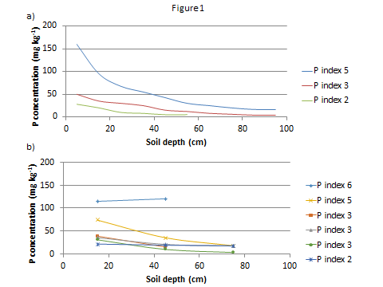
Figure 2: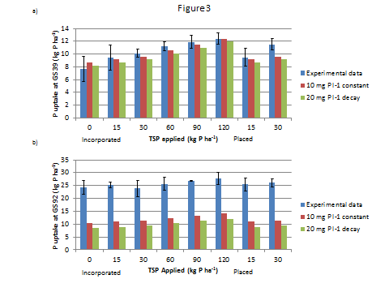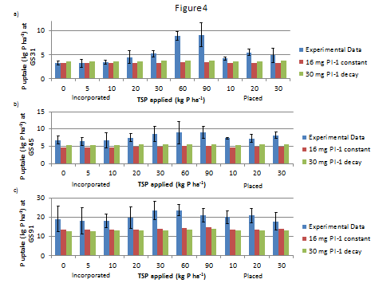
Cultivation
Fertiliser
Climate
A very wet climate
Site specific climate
Banded 5cm
Broadcasted
Plough at 25, 20 or 10 cm
Inverted plough
Min till gradient
No cultivation
No fertiliser

Figure 5: in order a, b, c and d.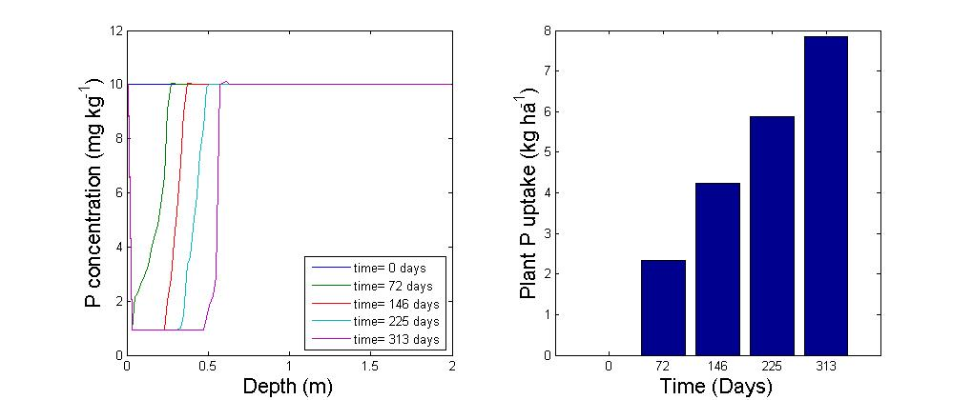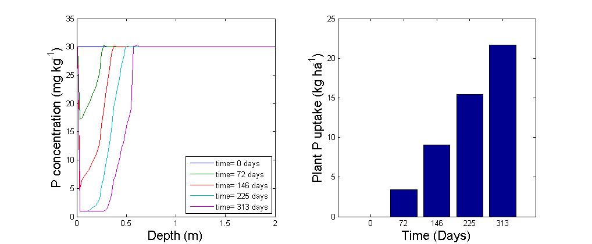 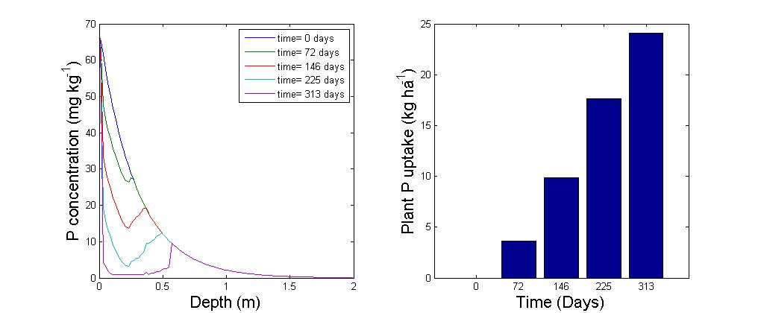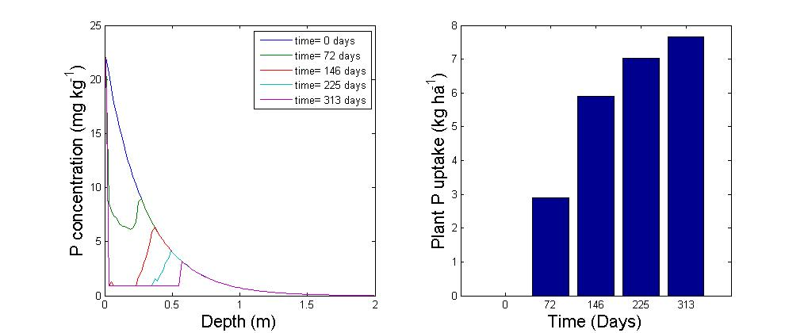
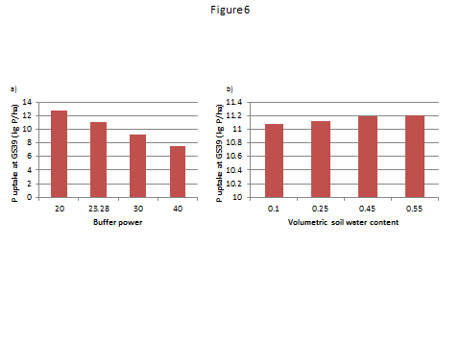
Figure 7: In order a, b, c and d.

