**Modelling of Acoustic Pressure Waves in**

**Bubbly Liquids with Application to Sonochemical Reactors**

By

Hakan Dogan

Thesis submitted in accordance with the requirements of the University of Wales for the degree of Doctor of Philosophy

August, 2013

Wessex Institute of Technology

University of Wales

# Abstract

This thesis investigates the acoustic wave propagation in bubbly liquids as part of the SONO project supported by the FP7 European Commission programme, which is aimed at developing a pilot sonochemical plant in order to produce antibacterial medical textile fabrics by coating of the textile with ZnO or CuO nanoparticles. The findings of this research are anticipated to aid the design procedures and also to provide better understanding of the micro scale physical and chemical events.

Propagation of acoustic pressure waves in a bubbly liquid is modelled by using Helmholtz equation in this thesis. Computational models are developed based on meshless approaches, i.e. radial basis integral equation (RBIE) and local boundary integral equation (LBIE) methods. A major part of the research focuses on improving the efficiency and the accuracy of the developed methods. For this purpose, numerical tests are carried out with several example problems in order to cross-verify the applicability of the methods. As a result of these tests, the optimal parameters which should be used to minimize the numerical error are suggested. Further, strategies are proposed in order to handle the thin inclusions, such as textile fabric, in the domain.

The wave propagation in bubbly liquids involves coupled effects of the sound field and bubble population field, such as dissipation of the acoustic energy by bubble oscillations. The problem is therefore non-homogeneous due to presence of bubbles and nonlinear due to coupled effects. The governing equations, derived from linearized or nonlinear theories, can be found in the literature. Examples of both linear and nonlinear wave propagation are solved in this study. Results related to a 3D sonoreactor including textile fabric are also presented. Effects of bubble size distribution and bubble volume fraction on the acoustic wave propagation are discussed in the example problems.

**Acknowledgements**

First and foremost I would like to thank my PhD supervisors Prof. Viktor Popov and Prof. Carlos Brebbia, for providing me this once in a life time opportunity to work together with them. Viktor is one of the friendliest and smartest people I have met, as well as having a good sense of humour. I will always remember him with his these qualities and also his excellent supervision and unconditional positive attitude. Prof. Brebbia has also been so profound and has supported every attempt for me to attend scientific courses, conferences and meetings.

I am grateful to the European Commission Framework Programme SONO project for financial support of my study and living expenses.

My sincere thanks also go to the WIT community; especially, to Dr. B. Blain for administrative support and guidance on the stages of my PhD thesis, to Mrs. P. Hodgson for unlimited help and assistance, and to Mr. A. Morgan for excellent technical support with the IT facilities. The WIT family provided me such a friendly environment.

I have been so fortunate to have had Zhiwei Fu and Dr Ean Hin Ooi as the other members of the project. They added so much to the social life in Ashurst Lodge and made me feel not lonely at all. Cycling, playing games, swimming, going for trips together will stay as the good memories forever. No need to say how clever they are and successful in their work.

Finally, this thesis is devoted to my parents Esma & Bayram and my brother Ferdi with the greatest thanks for their unconditional love and support. I am also indebted to my cousin Erkan for being concerned with my PhD, to my grandmother who wanted to me become a ‘Doctor’, and to my ‘online’ best friends Oruc, Serra and Turan. Of course; this thesis is also devoted to my little bee, niece Ceren with all the best wishes in her life.

**Table of contents**

Abstract i

Chapter 1 1

1.1 Motivation and objectives 1

1.2 Literature Survey 5

1.2.1 Physics of bubbly liquids 6

1.2.2 Bubble dynamics 13

1.2.3 Numerical Simulations 20

1.3 Outline of the thesis 22

Chapter 2 26

2.1 Mass and Energy Conservation 26

2.2 Governing Equation for the Radial Motion of a Single Bubble 29

2.3 Linear Pressure Waves 32

2.4 Energy dissipation per bubble 38

2.5 Global energy conservation in the bubbly liquid 42

2.6 Nonlinear Pressure Waves 43

Chapter 3 48

3.1 The Radial Basis Integral Equation Method 52

3.1.1 The mathematical formulation 52

3.1.2 Implementation of boundary conditions 56

3.2 The LBIE-RBF 58

3.2.1 Laplace fundamental solution 59

3.2.2 Helmholtz fundamental solution 61

3.2.3 Implementation of boundary conditions in the LBIE-RBF 63

3.3 Interpolation for the unknown values at the local sub-domains 65

3.4 Dispersion effect 69

3.4.1 LBIE-RBF formulation 70

3.5 Treatment of thin structures 72

3.6 Nonlinear solution procedures 78

Chapter 4 86

4.1 Accuracy of the RBIE 88

4.1.1 Parameters that affect the efficiency of the method 88

4.1.2 Selection of the RBF 95

4.2 Dispersion error for the LBIE-RBF 100

4.2.1 Dispersion error at a source node 101

4.2.2 Example problem in 1D 112

4.3 Wave propagation around thin structures 115

4.3.1 2D Example Problem 116

4.3.2 3D example problem 124

Chapter 5 135

5.1 Acoustic cavitation in a 1D problem 137

5.1.1 Linear wave propagation 139

5.1.2 Nonlinear wave propagation 142

5.2 2D acoustic wave propagation within a model reactor 145

5.2.1 Propagation through *x-y* plane 148

5.2.2 Propagation through y-z plane 154

5.3 3D model with textile 158

Chapter 6 166

6.1 Summary of the current research findings 166

6.2 Suggestions for future work 169

Appendix: Dispersion error for RBIE method 172

A.1 Further explanation to dispersion error 172

A.2 Mathematical formulation for RBIE 174

A.3 Numerical Results 175

A.4 Comparison of RBIE and LBIE in an example problem 178

References 182

**List of figures**

[Figure ‎2.1: Variation of speed of sound over bubble volume fraction for different bubble radii. 36](#_Toc374639786)

[Figure ‎2.2: Attenuation of sound wave with bubble volume fraction 37](#_Toc374639787)

[Figure ‎2.3: Thermal and viscous dissipation for a bubble with radius *R0* = 3µm. The thick solid line is the non-dimensional viscous dissipation; whereas thick dashed line represents the non-dimensional thermal dissipation. Note that the non-dimensionalization is done with respect to $p0V0ω$, i.e. $Πv*=Πv/p0V0ω$ and $Πth*=Πth/p0V0ω$. The thin vertical dashed-dotted line represents the Blake threshold. 40](#_Toc374639788)

[Figure ‎2.4: Thermal and viscous dissipation for a bubble with radius *R0* = 5µm. The thick solid line is the non-dimensional viscous dissipation; whereas thick dashed line represents the non-dimensional thermal dissipation. 41](#_Toc374639789)

[Figure ‎2.5: The real and imaginary part of the wavenumber used in the nonlinear wave propagation. 47](#_Toc374639790)

[Figure ‎3.1: Distribution of some of the circular sub-domains in the problem domain 50](#_Toc374639791)

[Figure ‎3.3: Interpolation of the values at the fictitious nodes. 67](#_Toc374639792)

[Figure ‎3.4: Influence domains of two associated points located at (q1, q2) and (q1+s1, q2+s2). 72](#_Toc374639793)

[Figure ‎3.5: Selection of influencing nodes for a source node at the bottom part of the thin body. 75](#_Toc374639794)

[Figure ‎3.6: Selection of influence nodes for a source node at the convex edge of the thin body. 76](#_Toc374639795)

[Figure ‎3.7: A sketch of the domain splitting procedure by using interface conditions. 78](#_Toc374639796)

[Figure ‎3.8: The ramp function used for updating the real and imaginary parts of the wavenumber from their initial value to their final profile given in Figure 2.5. 81](#_Toc374639797)

[Figure ‎4.1: L2 Norm error for different $RΩ$/h(N=10201, =24 and Nd=16). 90](#_Toc374639798)

[Figure ‎4.2: L2 Norm error for different **(**N=10201, Nd=16 and $RΩ$ = h). 92](#_Toc374639799)

[Figure ‎4.3: L2 Norm error for different Nd  **(**N=10201, =24and $RΩ$ = h). 93](#_Toc374639800)

[Figure ‎4.4: L2 Norm convergencewith increasing the number ofnodes (=24, Nd=16 and $RΩ$ = h). 95](#_Toc374639801)

[Figure ‎4.5: L2 Norm vs. λ/h for different values of h. RBF=*f1*, =24, Nd=16 and $RΩ$ = h. 99](#_Toc374639802)

[Figure ‎4.6: L2 Norm vs. λ/h for different values of h. RBF=*f2*, =24, Nd=16 and $RΩ$ = h. 100](#_Toc374639803)

[Figure ‎4.7: Interpolation of the values at the integration points. 103](#_Toc374639804)

[Figure ‎4.8: Optimal local subdomain radius for LBIE-RBF*-m=6* 104](#_Toc374639805)

[Figure ‎4.9: Optimal local subdomain radius for LBIE-RBF*-* 105](#_Toc374639806)

[Figure ‎4.10: Optimal local subdomain radius for LBIE-RBF*-* 106](#_Toc374639807)

[Figure ‎4.11: Difference between the non-dimensionalized exact and numerical wavenumber 108](#_Toc374639808)

[Figure ‎4.12: Dispersion error over the propagation angle; (a) and (b) . 109](#_Toc374639809)

[Figure ‎4.13: Dispersion error over and *kh*; (a) LBIE-RBF*-m=6*, (b) LBIE-RBF-and (c) LBIE-RBF-. 111](#_Toc374639810)

[Figure ‎4.14: LBIE-RBF*-m=6* solution within the range . 113](#_Toc374639811)

[Figure ‎4.15: LBIE-RBF-  solution within the range . 114](#_Toc374639812)

[Figure ‎4.16: LBIE-RBF-  solution within the range *kh=*[0, 2]. 115](#_Toc374639813)

[Figure ‎4.17: 2D sketch of problem geometry 117](#_Toc374639814)

[Figure ‎4.18: Wave propagation for *k=*20. Results obtained using: *(a)* COMSOL, *(b)* RBIE and *(c)* LBIE 119](#_Toc374639815)

[Figure ‎4.19: Calculated pressure for the three different solutions along the line *y=*150 mm for *k=*20. 120](#_Toc374639816)

[Figure ‎4.20: Calculated pressure for the three different solutions along the line *x=*0 for *k=*20. The discontinuity (the short line) around *y=*0.2 m represents the thin body and P is assigned as zero at this location. 121](#_Toc374639817)

[Figure ‎4.21: Wave propagation for *k=*60. Results obtained using: *(a)* COMSOL, *(b)* RBIE and *(c)* LBIE 122](#_Toc374639818)

[Figure ‎4.22: Calculated pressure for the three different solutions along the line *y=*150 mm for *k=*60. 123](#_Toc374639819)

[Figure ‎4.23: Calculated pressure for the three different solutions along the line *x=*0 for *k=*60. Similarly, the discontinuity around *y=*0.2 m represents the thin body and P is assigned as zero at this location. 124](#_Toc374639820)

[Figure ‎4.24: 3D sketch of the problem geometry. A thin square plate is located in a inside the domain. A square-shaped transducer is placed at the bottom surface. Dimensions are in millimetres. 125](#_Toc374639821)

[Figure ‎4.25: Wave profile on the top surface of the thin plate for *k*=5 and ht=0. 128](#_Toc374639822)

[Figure ‎4.26: Pressure wave profile along the line (*x=*[25 mm, 75 mm], y=50 mm, z=30mm) for *k*=5 and ht=0. 129](#_Toc374639823)

[Figure ‎4.27: Pressure wave profile along the line (*x=*[25 mm, 75 mm], y=50 mm, z=30.5 mm) for *k*=5 and ht=1. 130](#_Toc374639824)

[Figure ‎4.28: Pressure wave profile along the line (*x=*[25 mm, 75 mm], y=50 mm, z=30 mm) for *k*=5π and ht=0. 131](#_Toc374639825)

[Figure ‎4.29: Pressure wave profile along the line (*x=*[25 mm, 75 mm], y=50 mm, z=30.5 mm) for *k*=5π and ht=1. 133](#_Toc374639826)

[Figure ‎5.1: Initial pressure wave profiles in pure liquid for different excitation values. 138](#_Toc374639827)

[Figure ‎5.2: Pressure profiles with increasing bubble volume fraction, β. U0 = 5 µm and R0 = 5 µm. 140](#_Toc374639828)

[Figure ‎5.3: Pressure profiles for different bubble radii, R0. U0 = 5 µm and β= 0.005 %. 141](#_Toc374639829)

[Figure ‎5.4: Pressure profiles for *U0* = 0.5 µm. 143](#_Toc374639830)

[Figure ‎5.5: Pressure profiles for the cases: *U0* = 0.2 µm, *U0* = 0.5 µm and *U0* = 5 µm. 144](#_Toc374639831)

[Figure ‎5.6: A sketch of the sonoreactor. (a) *x-y* plane (b) *y-z* plane and (c) perspective view. 147](#_Toc374639832)

[Figure ‎5.7: Source node distribution near the surface of the transducer centred at *x=*165 mm and *y=*132.5 mm. 150](#_Toc374639833)

[Figure ‎5.8: Effect of bubble volume fraction (R=1-10 µm) 152](#_Toc374639834)

[Figure ‎5.9: Effect of bubble volume fraction (R=10-100 µm) 153](#_Toc374639835)

[Figure ‎5.10: Effect of bubble radius (β=0.001%). The pressure profile is plotted over the line *y=*180 mm. 154](#_Toc374639836)

[Figure ‎5.11: Displacement due to transverse vibrations along the transducer in the z –direction. 155](#_Toc374639837)

[Figure ‎5.12: Wave distribution for the *y-z* plane (p∞=101kPa). Effect of bubble volume fraction (R=1-10 µm). 156](#_Toc374639838)

[Figure ‎5.13: Wave distribution for the *y-z* plane (p∞=101kPa). Effect of bubble volume fraction (R=5-50 µm). 157](#_Toc374639839)

[Figure ‎5.14: Effect of bubble radius (β=0.001%) 158](#_Toc374639840)

[Figure ‎5.15: The sonoreactor designed by VIATECH. The sketch is imported from COMSOL model. 159](#_Toc374639841)

[Figure ‎5.16: Quarter model of the sonoreactor by VIATECH. 161](#_Toc374639842)

[Figure ‎5.17: Pressure distribution on the bottom and top surface of the textile in pure liquid. 162](#_Toc374639843)

[Figure ‎5.18: Pressure distribution on the bottom and top surface of the textile with bubble size range 1-10 µm. 163](#_Toc374639844)

[Figure ‎5.19: Pressure distribution on the bottom and top surfaces of the textile with bubble size range 5-50 µ. 164](#_Toc374639845)

[Figure ‎5.20: Pressure distribution on the bottom and top surface of the textile with bubble size range 1-100 µ. 165](#_Toc374639846)

**List of Tables**

[Table ‎3.1: Flow chart for the nonlinear solution procedure 85](#_Toc374439714)

[Table ‎4.1: L2 Norm error for different $R_{Ω}$/h(N=10201, =24 and Nd=44). 91](#_Toc374439715)

[Table ‎4.2: L2 Norm error comparison of *f1* and *f2* RBFs for k=6. 97](#_Toc374439716)

[Table ‎4.3: L2-Norm error obtained by using *f2* for higher wavenumbers. 98](#_Toc374439717)

**Notations**

**Roman**

*ai*  unknown coefficient at RBF

b damping coefficient

c speed of sound in the pure liquid

cm speed of sound in the bubbly mixture

eL2 L2 norm error

eRMS RMS error

 bubble population density function

F, F0 local RBF interpolation matrices

Gik stiffness matrix for pressure fluxes

h spacing between nodes

Hik stiffness matrix for pressure

 Hankel function of the zeroth order, second kind

 imaginary unit number

 Bessel function of zeroth order

*Jbn* number of fictitious nodes for boundary integrals

k wavenumber

kh numerical wavenumber

K thermal conductivity

Kl radial kinetic energy of the liquid

M momentum of the liquid

n local bubble density

$\vec{n}$ unit normal vector

Nb number of RBF points

q pressure flux

 hydrostatic pressure

p gas pressure inside the bubble

p\* fundamental solution

p’ test function

p\*\* modified test function

pL pressure at bubble location when the bubble is absent

ps sound pressure

P the difference of hydrostatic pressure and the sound pressure

*rinfl* radius of influence

r field variable

R bubble radius

RΩ radius of integration over the local sub-domain

$R_{Ωs}$ local sub-domain radius

t time

 polynomial basis vector

T period of bubble oscillations

s1, s2normalized distances

 bubble wall velocity

V bubble volume

 Bessel functions

**Greek**

 gas volume fraction

*γ* ratio of specific heats

γ1,2 discrete indices for locations

Γ integration boundary

 dispersion error

 field variable for integration over the domain

 propagation angle in the dispersion error

λ wavelength

$λ_{b}$ boundary integration constant

 viscosity of liquid

 integration variable over the boundary

Πth thermal dissipation per bubble oscillation

Πv viscous dissipation per bubble oscillation

 density of liquid

$ρ_{G}$ density of the gas inside the bubble

$ρ_{m}$ density of the bubbly mixture

 surface tension

 location of fictitious points

 linear variation of the pressure

χ thermal diffusivity

 angular frequency

Ω integration domain

# 

Introduction

## Motivation and objectives

One of the main application areas of ultrasound is sonochemistry. The high intensity acoustic sourcing determines the dynamics of the medium significantly, for example very high level pressure amplitudes may be achieved. The cavitation phenomenon, which is the formation of bubble clouds, occurs essentially when a certain pressure threshold is achieved. The dynamics of cavitation bubbles resemble highly chaotic behavior. The acoustic source field may lead to several physical effects on individual bubbles such as growth, collapse, jet forming and coalescence. On the other hand, bubbles pulsate under the effect of driving sound field. Some part of the ultrasonic energy delivered to the medium is restored in such oscillations of the bubbles. Thus, on collapse and jet motion of bubbles, this energy is revealed to the surrounding medium. In sonochemistry applications, such energy due to bubble collapse is taken advantage of in order to enhance chemical reactions. Other applications in which the outcomes of ultrasound are beneficial include cleaning of medical devices [1], treatment of waste water [2], and fragmentation of ureteric and kidney stones [3]. However, cavitation also causes damage to the setup of these applications.

This research is part of the SONO project within the 7th European Framework, which employs ultrasound energy for impregnation of textile materials with antibacterial nano-particles. In particular, this thesis focuses on the modeling of acoustic waves propagation in bubbly liquids inside the sonochemical reactor. The distribution of the pressure inside the tank is of main interest; this can be used to predict the regions of high energy where the bubble clouds form. The formation of bubble clouds occurs when the pressure of the liquid exceeds a pressure threshold that depends on the frequency of the driving sound field, ambient pressure and the material properties of the surrounding liquid [4]. Physical processes such as jet formation with collapse of bubbles contribute to the impregnation process of textile with nanoparticles (e.g. ZnO and MgO) [5, 6, 7].

In the SONO project, two different designs of sonochemical reactors were considered at the beginning, therefore numerical results have been produced relevant to these two designs in this work. The first reactor consists of three cylindrical transducers, each emitting pressure waves at 20 kHz. The textile fabric is fed into the system with rollers. The reactor is filled with liquid that may be ethanol, water or a mixture of the two. The second reactor works on similar principles; however the transducers are rectangular plates in this design.

As cavitation occurs, the medium exhibits inhomogeneity. Bubbly regions induce a local damping effect which decreases the speed of the travelling wave. Changes in the wave speed would alter the wavenumber and wavelength of the associated pressure waves. The objective of this research is to develop a computational model based on the meshless methods to predict the pressure distribution in such an inhomogeneous medium. Knowledge of the pressure distribution may then be used to optimize the geometry or mode of operations of the sonochemical reactor.

Propagation of the pressure waves will be modelled by solving the Helmholtz equation. This is a reasonable approach when one considers the following issues: *(i)* Before the coating process starts in the sonoreactor, the system is switched on for a while for the physical conditions, i.e. the temperature, to reach their optimal condition [8]. *(ii)* This allows sufficient time for the emergence of bubbly regions, and therefore the transient period is not of interest. *(iii)* Computational requirements are lower when solving in the frequency domain compared to the time domain. The above considerations are especially important when one considers the need for a repeated computational runs for optimization purposes.

The radial basis integral equation (RBIE) method, which was previously developed for the solution of the convection-diffusion equation [9], is applied in the present study to solve the Helmholtz equation [10]. In the RBIE, source nodes are located in the domain and circular sub-domains are formed around each source node. The main advantage of using the RBIE in this research is the capability of defining the wavenumber for each sub-domain. In the modelling of pressure in bubbly liquids, this feature allows one to modify the wavenumber which is a function of local pressure amplitude and bubble volume fraction. The local boundary integral equation (LBIE) [11] method is also used in this work. The main difference between RBIE and LBIE is the implementation of boundary conditions, which will be explained in detail in the following chapters. Some part of the numerical simulations are performed by using RBIE and the others by using LBIE, and the reasons for the choice of one rather than the other are explained where required.

Next, the developed methods should be tested to give the best accuracy, i.e. the optimal choice of the internal parameters such as integration radius for the sub-domains, influence of the neighbouring points on the interpolation, integration schemes in the local sub-domains, and the number of source nodes required per one wavelength.

Further, the presence of the textile fabric in the reactors is intended to be modelled. This fact adds complexity to the geometry, in the sense that it is treated as a thin body. The presence of such thin structures and sharp edges poses challenges to the numerical algorithms and requires the development of different strategies to handle it. Some such attempts may be found in the literature [12, 13, 14]. In this work, a strategy developed for use with meshless methods is presented. The fabric behaves as a reflector-transmitter boundary. It reflects the majority (about 96% [15] ) of the incident wave while a small fraction of the incident wave is transmitted. In fact, the percentage of reflected waves is higher when the fabric is completely wet (this is analogous to the case when the fabric is not fed with very high speeds). Therefore, the textile fabric is modelled as a reflecting boundary in this work.

## Literature Survey

Acoustics in bubbly liquids involves highly complex physical phenomena due to large variety of spatial and temporal scales. The motion of the bubbles as a population, being subjected to physical processes such as collapse and jet formation, has been investigated by many scientists over decades. Probably the most significant reason which makes the complete understanding and the derivation of a full theoretical model difficult is the coupled effects between the sound field and the bubble population. To talk in brief about the effects of one on the other; the sound field causes radial oscillations of bubbles and their translational motion is pushing them into organized bubble structures such as filaments and bubble clouds (cavitation), whereas on the other hand oscillating bubbles act as a dissipation mechanism for the acoustic energy and cause damping of the sound waves (attenuation).

### Physics of bubbly liquids

The physics of bubbly liquids, and therefore the wave propagation through such medium, can be very different from the case when each phase is considered individually. It was observed in the early work of Silberman [16] that speed of sound can be as low as 100m/s in water with 0.01% percent bubble volume fraction (β), which is approximately three times lower than the speed of sound in air and fifteen times lower than the speed of sound in water.

The problem can be observed at two different spatial scales, i.e. the microscopic scale and the macroscopic scale [17]. On the macroscopic scale, the medium can be considered using a continuum approach and solving a set of *effective* equations [17, 18, 19]. The description *effective* refers to the average or global properties of the mixture. On the microscopic scale, the fluid motion at each bubble interior and the surrounding is of concern, as well as the interaction of the two at the interface. The microscopic scale phenomena are usually evaluated by averaging, results of which are then used in the macro-scale equations. For example, bubble oscillations, bubble interactions and the bubble drift affect the speed of sound in the medium. There are several other *effective* parameters to be determined either theoretically or experimentally such as thermal conductivity, viscosity, temperature, and specific heat. Among them, the speed of sound (or the wavenumber) is of particular interest here since it is directly related to the acoustic wave propagation.

Among the parameters, some primary ones which define the length scales can be listed as follows: bubble radius (*R*), inter-bubble distance (*d*), wavelength (λ) and amplitude of driving pressure (*A*). The first two mainly constitute the bubble population characteristics of the medium (also does the bubble size distribution function) and the latter two describe the acoustic forcing field. The ratio of the former two gives idea about the amount of the gas content, whereas the scale between the former and the latter two provides information about the nature of the wave propagation, i.e. linearity vs. nonlinearity. The linearity and nonlinearity of the acoustic wave propagation is primarily related to the driving pressures. At low amplitude driving pressures, the dissipation by bubbles does not cause backward effects on the driving sound field itself. Thus it is modelled according to a linear perturbations theory. On the other hand, when such backward effects are present, the acoustic wave propagation occurs in a nonlinear fashion, thus it should be handled with appropriate mathematical methods. Further, the scaling between the above mentioned parameters should be analysed within the concept of the mathematical methods used. For example the ratio *R*/λ should be much smaller than one, in order to ignore second order contributions in the perturbation expansions. However it is beyond the scope of this text to give full comparison of the mathematical theorems used in the literature.

Some brief remarks on the bubble volume fraction, the bubble size distribution and the driving frequency can be given as follows. The bubble volume fraction is related to the compressibility of the liquid. This affects the dispersion equation, which in turn affects the travelling speed and the attenuation of the waves (which are given by the real and imaginary parts of the wavenumber, respectively). Given a certain amount of gas volume fraction, bubbles with larger radius dissipate more energy compared to smaller bubbles due to their higher inertia and larger surface contact area, per bubble, with liquid. Finally, bubbles produce very different responses to different orders of driving frequencies. At low frequencies, linear variations in the bubble radius and pressure fluctuations become highly dominant [20, 21]. When the driving frequency is at the order of bubble resonant frequency or larger amplitude driving is applied, the response of the medium changes significantly. In fact, the bubble radius may grow by several orders of magnitude. Further, the time scale for the response of the bubble oscillation may exceed the time scale of periodic oscillations. Therefore, when the averaged quantities at the microscale are revisited, i.e. the time averaged thermal and viscous dissipation by bubbles, the effect of these quantities on the macroscale may change significantly.

One of the earliest benchmark works on wave propagation in bubbly liquids is that of Cartensen and Foldy [22]. They used the classical acoustic approach where they assumed an incident wave on a bubble screen with certain thickness and assumed the bubbles as individual scatterers. The appropriate boundary conditions were imposed as the continuity of the pressure and its normal derivative at both ends of the bubble screen. Consequently, they derived the equations for reflection and transmission coefficients as well as the dispersion relation.

Van Wijngaarden [19, 21] investigated several physical aspects such as bubble drift velocity, comparison of damping parameters with experiments, added mass coefficient, shock wave formation and nonlinearity. Van Wijngaarden [21] showed that the governing equations are similar to Boussinesq equations for high gas content. For the waves propagating in one direction, they showed that the corresponding equation is similar to the Korteweg – de Vries equation.

In the paper on “Effective equations for wave propagation in bubbly liquids”, Caflish *et. al*. [18] derived a system of differential equations valid for small gas volume fractions. They used the Green’s theorem and obtained an integral equation for the velocity potential. In a further simplification of the integral equation, they refer to Foldy’s approximation. In the Foldy’s approximation, bubble centres resemble a continuum configuration, with a smooth bubble centre density, without interfering with each other. In this assumption, what is mathematically set is that individual bubbles do not feel the effects from the surrounding bubble population field. This work is significant for giving an energy conservation equation at the macroscopic scale. Further, it also states clearly how the changes at the microscopic scale yield nonlinearity at the macroscopic scale.

When the bubble volume fraction increases in the medium, pressure gradients inside the bubbles become important. Therefore the uniform pressure assumption for the bubble interior, as it forms the basis of many theoretical works, is not valid anymore. Further, the compressibility of the medium increases, the dominant mode of the bubble oscillations may become non-radial, bubble drift and interactions of bubbles become important. At this range of larger bubble volume fractions, Caflisch et al. discussed such effects using the method of multiple scales as the mathematical tool [23]. They derived an equation for the effective speed of sound valid for low frequency regime but with gas volume fractions up to 10%. They showed their formulation reduces to the well-known formula given by Crespo [24] for larger bubble volume fractions. They also showed that it accounts for bubble interactions up to second order (although, the pressure is varied linearly) for specific cases, i.e. periodic bubble configuration.

Miksis and Ting (1992) [25] proposed a set of equations by using the method of matched asymptotic expansions for the microscopic problem. Their formulation differs from the previous studies in the sense that it includes the stress tensor in the Navier-Stokes (momentum) equations. Integration of the stress tensor governs the bubble translational motion (drift) and asymmetric bubble oscillations. Therefore, global nonlinear contributions of these effects can be evaluated explicitly in the formulations.

The article by Commander and Prosperetti [20] proposed an elegant model by describing the sound field by the Helmholtz equation. The derivation was made under linear oscillations approximations and accounted for thermal, viscous and acoustical damping mechanisms. Most importantly, the dispersion relation allows the bubble size distribution which is important in order to realize the backward effects of bubble population field on the sound field. The model is complex in the sense that it allows the coupling of the sound field and the bubble population field and is rather simple in terms of numerical simulations since it deals with spatial variations for all fields.

Recently, Louisnard [26] has published a nonlinear wave propagation model. The derivation is based on the nonlinear Caflisch [18] model, mentioned above, which gives a set of effective equations in the time domain. The former author converts the model into the frequency domain which yields the Helmholtz equation. In addition, a conservation of energy formula is given for the bubble radial motion which allows an explicit definition of dissipation mechanisms upon performing cycle averaging. The latter point is highly important when defining more precisely the effects of bubble motion on the attenuation of waves. The thermal and viscous losses obtained by these cycle averaging procedures are much higher than that given by the linear theory (one may refer to the article for comparison plots). This points out to a certain extent the fact that wave attenuation is underestimated by other theories for large amplitude driving pressures. It is also discussed that this nonlinear damping was understood by Rosenberg [27] through experimental work, however a mathematical theory was not demonstrated explicitly.

It is also interesting to look into the wave phenomena in the light of experimental observations. Some benchmark experimental studies, by Silberman [16], by Fox *et. al.* [28], by Macpherson [29], were carried out in 1950s as they are referred even in very recent review papers [30]. In these studies, the wave speed could be determined from the distance between pressure antinodes, and the attenuation from the decrement in pressure at the antinodes. Bubbles were inserted by the use of hypodermic needles, by blowing air through porous filters, by using electrolysis etc. The general conclusion is that the wave speed is fairly well-predicted by the theory, although there remain some questions regarding the attenuation. Attenuation is predicted by the damping coefficient ($δ_{d}$) in the formulations. A review of damping coefficients used in the literature, up to their time, was given by Wijngaarden [21]. We should note that damping mechanisms during the bubble oscillations were not completely understood (or mathematically formulated) by then. Upon derivation of their rigorous mathematical theory on linear pressure waves, thus on attenuation coefficient, Commander and Prosperetti [20] compared their theoretical results with experimental studies (including the ones mentioned above) and drew highly important conclusions: *(i)* They found very good agreement with the results of Silberman, except the region where bubble resonance frequency is very close to the driving frequency ($ω_{B}/ω→1$). At this limit, the theory suggests a very sharp peak, which is usually not observed in the experimental studies. Instead, they suggested a truncated Gaussian distribution for the bubble radius with a standard deviation of 10-20 per cent, which gives a rather smooth profile for the attenuation at this limit. However, the deviation in the bubble radius was reported to be much less than that amount in the referred study of Silberman. *(ii)* Secondly, they obtained very good agreement with data by Fox. *et. al.* [28]. It is important to note that Fox et. al. had to increase artificially the theoretical value of the damping coefficient, $δ_{d}$, from 0.093 to 0.5 in order to fit their data. Such an arrangement was not needed by Commander and Prosperetti [20]. *(iii)* Finally, they compared their theory to the experimental results for very high frequencies (up to 20 MHz) by Kol’tsova *et. al.* [31] and for very large bubble volume fractions (up to 10%) by [32], and obtained good agreements within some specific regions.

### Bubble dynamics

The dynamics of the radial motion of bubbles in liquids have been investigated by many scientists. The equation of motion for the bubble in an unbounded medium was first derived by Rayleigh [33]. The foundation of the theory regarding the acoustics in two-phase flow dates back to 1930’s when Minnaert [34] derived the oscillation frequency of air bubble in water. The physics of the problem include many details such as the movement of the bubble centre, the compressibility of the surrounding liquid, the uniformity and non-uniformity of the pressure of the bubble interior, heat and mass transfer at the interface etc. As such, many researchers approached the problem with certain physical approximations and contributed to the development of the theory. The well-known Rayleigh-Plesset equation was derived for a spherically symmetric, irrotational and incompressible flow with the assumption of no heat and mass transfer through the bubble surface [35]. Further, the bubble interior was assumed to obey a simple polytrophic relation for *p-ρ* (pressure-density). In this case, the only dissipative mechanism is the viscous damping. There are certainly other damping mechanisms which affect the bubble such as thermal and acoustic damping [17]. Chapman and Plesset presented an analysis of the afore-mentioned three dissipative mechanisms [36]. Their comments were such that acoustic damping was dominant for large bubbles, thermal damping dominated for intermediate size bubbles and the viscous for small bubbles. Here, intermediate size bubbles refer to ones with radius R=10-6 m. The previously mentioned polytrophic relation does not account for heat and mass transfer across the interphase. In fact, for finite change in the bubble radius, the bubble volume does not change accordingly with the same amount which states that the gas does not behave according to ideal gas law. This further indicates that there is change in the temperature and dissipation through heat loss occurs [17]. Therefore, the thermodynamics and heat transfer effects have to be accounted for. The thermodynamic behaviour of the bubble interior has been examined in the earlier work of Plesset and Hsieh [37], i.e. at low frequencies the bubble behaves isothermally and at high frequencies adiabatically. In the work of Prosperetti [38], the perfect gas equation for the bubble interior was relaxed by the use of an *ad hoc* dissipative term and an effective polytrophic exponent was derived. It revealed that thermal damping constant and the effective polytrophic exponent itself are strongly dependent on the driving frequencies. In Prosperetti et. al. [39], they used an energy conservation equation for the bubble interior. They plotted the temperature and pressure variation from bubble surface to the bubble centre during the bubble growth and collapse. The variation in temperature was found to be confined in a thin thermal layer near the bubble surface. Applying an asymptotic expansion method which involves the thermal diffusion length, *lT/R* (*lT* being the length of the thermal layer), Miksis and Ting [40] were able to derive an integro-differential equation for the pressure variation inside the bubble. The integral part of their equation accounted for the cumulative effect of heat flux through the interface. They presented extensive numerical results including transient and steady state solutions in [41] and stated that heat transfer effects change the response of gas bubble significantly.

More recently, Stricker et. al. presented an ordinary differential equation (ODE) model for the evaluation of the temperature field within the bubble interior and the heat exchange with the liquid [42]. They reviewed previous approaches which attempted to model the same issue: A first approach was to assume adiabatic behaviour of the bubble interior with an artificially added viscosity term [43]. The additional term accounts for the energy loss and the thermal damping. Another approach was to model the gas transformation with an isentropic index, $γ(t)$, changing with the instantaneous Peclet number [38], Pe(t). They also discussed the drawbacks of these formulations. They observed good agreement with the partial differential equation (PDE) model given by Prosperetti et. al. [39], in the range in which the bubble is spherically symmetric.

The Rayleigh-Plesset equation was derived for incompressible liquids. Liquid compressibility effects become significant when the bubble radius is large (recall intermediate bubble radius size ~10-6 m). Keller and Kolodner [44] developed an equation which accounts for the liquid compressibility. The compressibility of the liquid is known to be highly related to the acoustic damping mechanism. Prosperetti and Lezzi [45] aimed to address the same problem of compressibility and acoustic radiation damping, drawing interest from the work of Lauterborn and Vogel [46]. Their theory was based on a perturbation method applied as a correction to the incompressible Rayleigh-Plesset equation. Keller and Miksis [47] developed the Keller-Kolodner equation for large amplitude oscillations. They included the effects of viscosity and acoustic radiation. They plotted frequency response curves for a bubble in water and compared their results to the ones obtained by using the incompressible theory by Lauterborn [48]. Further works on nonlinear oscillations, harmonics and subharmonics can be found in [49, 43].

In the last two decades, more detailed models for the physical and chemical processes during the bubble oscillations have been proposed. The need for this has arisen for better understanding of sonoluminescence and sonochemistry applications. A brief description for these two is given as follows [50]: Sonoluminescence results from the intense focusing of acoustic energy on a single cavitation bubble. Due to extreme temperatures during the bubble collapse, the bubble emits a brief flash of light. Sonochemistry is based on similar principles where high temperatures and pressures yield chemical activity within or near the bubbles. Such complete models introduce rather detailed formulations of physical processes, ruling out the simplified assumptions such as uniform bubble interior pressure. These processes include the gas dynamics (required especially when the bubble interior is a multi-component gas mixture), thermal and mass diffusion in the bubble interior, mass transport to the liquid, motion and energy transport in the liquid, evaporation and condensation at the interface, chemical kinetics etc. [50, 51, 52] . Each of these topics has been studied with different approaches by many researchers; however a review of these is not the scope of this text. Meanwhile, some remarks will be given as follows.

Storey and Szeri [51] presented a numerical model for the mass diffusion modelling inside a bubble. They set a mixture of two noble gases in the bubble and assumed no mass transfer occurs across the bubble interface. In such a setting, the gas drift within the bubble could be simulated accurately. In particular, they discussed the diffusion by temperature, pressure and concentration gradients. They stated that the temperature and pressure diffusion may lead to compositional inhomogeneity within the bubble.

In Storey and Szeri [50], they worked out the physics and the chemistry of strongly forced argon bubbles. They drew interest from similar facts on diffusion scales, as in their prior work, relaxing the assumptions on evaporation and condensation at the interface and chemical processes. Due to the short time scale of the bubble collapse, water vapour has insufficient time to escape the bubble. Subsequently, the trapped water vapour can go under chemical reactions reducing the temperature of the bubble interior. They presented results on the amount of the water vapour trapped, OH radicals produced and temperature changes during the bubble oscillations.

Recently, Hauke et. al. [52] has presented a complete model allowing radial variations of the fluid variables as the previously mentioned two articles by Storey and Szeri. They used a modified Rayleigh-Plesset equation which accounts for mass transfer. A detailed review of previous bubble dynamics models and their simplifying assumptions was given. They presented significant results on the radial dependence of chemical reactions and OH radicals’ production. Temperature distributions within the bubble, resulting from endothermic or exothermic nature of the chemical reactions, were also presented.

Storey and Szeri [53] presented a reduced model of their previous work. As in the temperature validation study by Sticker et. al., the basic concept of the reduced models is proposing a rather simpler relation (usually in ODE form) for the physical processes which can produce accurate results more efficiently. The model by Storey and Szeri was based on comparing the time scales of radial dynamics, heat diffusion and mass diffusion. The time scales of these three physical processes were determined per one bubble oscillation period. Then, the governing equations were essentially solved on the shortest time scale of the three scales defined. They reported that the model works very well provided that the dynamic and diffusive time scales have sufficiently different values, i.e. their values are not very similar. This is essential when determining the isothermal and adiabatic behaviour of the bubble in their model. Other reduced models can be found in references [54, 55].

Finally, one should note that these attempts on resolving the single-bubble dynamics are essential for complex multi-bubble sonochemistry applications. There are many unknowns in a multi-bubble field, such as bubble size distribution, bubble population density and bubble-bubble interactions [53]. These single-bubble models could be part of a more complete theory, if these unknowns could be characterized in detail [53].

### Numerical Simulations

Acoustic cavitation is the formation of bubble clouds due to acoustic pressure within liquids. The initial formation of the cavitation needs a pressure threshold which is dependent on the physical conditions. Subsequent cavity dynamics involve various phenomena such as bubble growth and collapse which is not of particular interest in this work, since these phenomena are significant only in the time scale they occur. A brief review of the research on acoustic cavitation can be found in a series of articles [56, 57, 58]. Cavitation bubbles may be classified into two main groups: fragmentary and repetitive transient bubbles. Fragmentary transient bubbles are mainly responsible for the mechanical activities such as collapse and shock wave formation to the surface. The repetitive ones are related to the enhancement of the chemical reactions [59]. The repetitive transient bubbles may collapse to form the high energy spots and disappear thereafter. In this work, these bubbles are considered not to play role in cavitation when the pressure drops below the level of the threshold for cavitation [26].

Numerical modelling of acoustic cavitation was studied by many scientists. It includes details such as the choice of bubble distribution, the bubbles, movement of the bubbles, the effects of bubble migration on the exciting sound field etc. In the state of numerical modelling for the pressure fields, the work so far can be classified into three groups as summarized by Servant et al. [59]:

(1) The first class of the research assumed non-moving bubbles which gives insight about the active zone of mechanical activity due to ultrasound [60, 61, 62].

(2) This second class of problems assumes moving bubbles. Researchers were able to model the chaotic dynamics and nucleation within bubble clouds by evaluating the exerted forces on cavitation bubbles [4].

(3) The final class of the research assumed moving bubbles but ignored the influence of bubbles on the driving sound field, hence the change of the sound velocity in bubbly liquid and the associated damping affects. The bubble migration was simulated based on the study of Bjerkness forces and the calculation of energy density gradient as the corresponding articles are cited in reference [59].

A remark on the time scales of the events in a bubbly liquid is given by Partlitz et al. [4]: the slowest time scale is specified by the nucleation and formation of filamentary structure which is in the range of 0.1 to several seconds, the growth and relaxation of the bubble takes place in the range of 10-2 – 10-3 s., whereas a strong bubble collapse may occur in 10-9 s. In this work, the pressure field will be solved in the frequency domain, therefore the events such as collapse and jet formation which occur in a small time scale compared to one acoustic cycle will not be considered. The period of the acoustic driving in the application part of this study is in the range of 40-50 μs.

One major goal of the numerical and experimental research in the field of ultrasound is the optimization of the sonoreactors. The simulations are carried out in order to determine the high intensity energy sites, possible locations of acoustic cavitation, prediction of mechanical and chemical active zones and formation of filamentary structures. For these purposes, the pressure fields for various designs of sonochemical reactors were examined by Dahnke and Keil [60, 61, 62], nonlinear ultrasonic propagation has been worked out by Vanhille and Pozuelo [63, 64] and the research group of Lauterborn has made outstanding observations on bubble nucleation and migration [4, 65, 66]. Servant et al. were able to predict the pressure distribution and verify their results with the corrosion of an aluminium foil by cavitation bubbles [59].

## Outline of the thesis

The outline of this thesis is as follows:

In Chapter 2, the theory of wave propagation in bubbly liquids is outlined. The acoustic wave propagation in bubbly liquids is governed by an Helmholtz equation. The formulations proposed by Commander and Prosperetti [20], and Louisnard [26] are considered as the basis; they will be referred as linear and nonlinear theory, respectively, hereafter in this thesis. In both formulations, the driving sound field is affected by the dissipation by the radial oscillations of the bubble field, though this dependence evolves in a nonlinear fashion for the latter. Therefore, there is a need for a bubble dynamics model for both cases. The linear theory is derived from the Keller-Kolodner equation for bubble dynamics; whereas for the nonlinear theory, the well-known Rayleigh-Plesset equation with an additional thermal dissipation term is used. The results for thermal and viscous dissipation show sufficient agreement with the results of previously published complete models, as will be seen later in this text.

In Chapter 3, the numerical method is explained. Two different meshless methods, namely RBIE and LBIE, are used in this thesis. For RBIE, the derivation is done by using the Helmholtz fundamental solution, which avoids domain integrals. For LBIE, the equations can be derived from either Laplace or Helmholtz fundamental solution; however both formulations encounter domain integrations over the local sub-domains. The formulation of dispersion error is given in this chapter. Dispersion error is the measurement of local value of the numerical wavenumber, and the mismatch between the exact and numerical value of the wavenumber is an indicator for the global error of the numerical algorithms. We should note that the dispersion error is measured only at a single source node; therefore the full solution of a boundary value problem is not necessary for this purpose. Further, the treatment of thin structures in the geometry, when using the meshless methods, is also explained. Finally, a solution procedure for the nonlinear problem is proposed. Some strategies, such as under-relaxation of the pressure distribution, increasing the bubble-volume fraction gradually, are developed in order to assure the convergence and the stability of the scheme.

In Chapter 4, results regarding the accuracy and efficiency of the method are presented. For the RBIE, the internal parameters of the algorithm are tested individually to give the best accuracy. These internal parameters include the radius of circular local sub-domains, the number of quadratic boundary elements to discretize the integration boundary, the number of influence nodes for each source nodes etc. In terms of these parameters, RBIE and LBIE show similar characteristics; hence the results obtained for one of the methods is transferrable to the other usually. Next, the results regarding the dispersion error for LBIE are presented. One key issue when solving wave related problems is the number of source nodes (or elements in finite element methods) required per one wave length. Both optimization tests and dispersion measurement are helpful in that sense to indicate the number of nodes required for one wave, thus for the simulation of the whole reactor. Further, 2D and 3D example problems involving thin bodies are presented.

In Chapter 5, example problems of wave propagation in bubbly liquids are presented. The problems are selected in such a way that they exemplify 1D, 2D or 3D cross-sections of actual reactors used in sonochemistry applications. The results governing the nonlinear propagation are presented only for 1D and 2D problems due to high computational costs. Linear acoustic wave propagation in a 3D sono-reactor with the textile fabric is presented, though a quarter of the actual reactor is simulated exploiting the symmetry properties of the original setup.

# 

Theoretical Background

The theoretical study of bubble dynamics has been developed for many decades. The governing equations are highly non-linear and need deep analytical workout. Over the years many scientists contributed to the development of the theory while approaching the problem with certain approximations. Here in this work, two different formulations are followed: *(i)* the linear theory of pressure waves developed by Commander and Prosperetti [20] and *(ii)* the theory for nonlinear acoustic wave propagation in bubbly liquids proposed by Lousinard [26]. The governing equations of both theories are summarized in this chapter. In both, the formulation is based on the Helmholtz equation where the wave number is dependent on the bubble volume fraction and bubble size distribution, though it is also dependent on the driving pressure in the latter.

## Mass and Energy Conservation

The equation of conservation of mass for a mixture containing bubbles and liquid can be written as [20],

 (2.1)

where $ρ_{m}$ is the average local density of the mixture and $\vec{u}$ is the average velocity. In terms of gas volume fraction β, the average mixture density can be written as

, (2.2)

where $ρ_{G}$ is the density of the gas and  is the density of the liquid.

For a mono-disperse bubble distribution, the bubble volume fraction can be defined by,

$β=\frac{4}{3}πR^{3}n,$ (2.3)

where *n* is the number of bubbles per unit volume and *R* is bubble radius. For different bubble sizes, it can be written as,

 (2.4)

The function *f* is called as bubble size distribution function.

Since $ρ_{G}≪ρ$, the density of the mixture is often approximated as [19, 20],

 (2.5)

Upon taking time derivate of equation (2.5) and inserting into (2.1) the mass conservation equation in the mixture becomes:

 (2.6)

Here, *P* denotes the average local pressure and *c* denotes the average speed of sound in the mixture. The derivation of (2.6) requires certain intermediate steps and physical approximations on the magnitude of orders of several variables such as $β≪1$ and $\left|\vec{u}\right|≪c$, as well as the acoustic relation $dρ=c^{-2}dP$. Caflisch et. al. [18] gives a rigorous derivation of the same relation using an integral representation for the velocity potential and a continuum configuration for the bubble centre density.

The momentum conservation equation in the mixture can be written as,

 (2.7)

Upon elimination of *u* between (2.6) and (2.7), one obtains

 (2.8)

The second order time derivative of *β* in the linear approximation is,

 (2.9)

so that

 (2.10)

In equations (2.9) and (2.10), the over dot denotes the time derivative. Equation (2.10), given by Commander and Prosperetti [20], is very useful for numerical simulations for the wave propagation in the time domain, provided that the bubble size distribution *f* is known (or can be approximated). Many simulation works have based their models on the linearized wave equation for bubbly liquids [57-60].

The mass and momentum conservation equations can be recast into an energy conservation equation [26], by using the volume of the bubbles *V* as a parameter instead of *R.* Multiplication of (2.6) by *P* and (2.7) by $\vec{u}$ yields:

|  |  |
| --- | --- |
| $$\frac{∂}{∂t}\left(\frac{1}{2}\frac{P^{2}}{ρc^{2}}+\frac{1}{2}ρu^{2}\right)+∇∙\left(P\vec{u}\right)=nP\frac{∂V}{∂t}$$ | (2.11) |

Equation (2.11) has the following interpretations. The first term on the left-hand-side (LHS) represents the time derivative of the sum of the kinetic and potential energy of the liquid and the second term represents the divergence of the acoustic intensity. The right-hand-side (RHS) term is related to the mechanical energy exchanged between the bubbles and the liquid during the bubble oscillations.

## Governing Equation for the Radial Motion of a Single Bubble

The well-known Keller-Kollodner equation for the radial motion of bubbles [44], accounting for the liquid compressibility, can be written as

 (2.12)

where σ is surface tension and μ is the viscosity of the liquid. Although, equation (2.12) is highly non-linear, it was derived with the following approximations: (i) the bubble centre is not moving, (ii) the liquid near the bubble surface is incompressible, (iii) the interior pressure is uniform and (iv) the bubble is located far from any other bubbles.

For the pressure relations between gas and liquid phase used in equation (2.12) and throughout this work, the following definitions and formulations are considered:

*pL*: the liquid pressure at the interface

*p* : the gas pressure inside the bubble (it is assumed to have spatially quasi-static uniform distribution)

*pS*: external pressure field due to sound

*p∞*: hydrostatic pressure

*P* : the difference of the hydrostatic and the sound pressure (*p∞*- *pS*)

The pressure *pL* refers to value of the average pressure at the location of a bubble if the bubble were absent. By definition, it coincides with the hypothesis of Foldy according to which bubbles do interact with the average pressure field but not with each other’s field. Note that the sound pressure is assumed to be harmonic, i.e. *pS* ~ .

The equation relating the liquid pressure to the gas pressure is given by

 (2.13)

which also yields the following equation for the equilibrium state:

 (2.14)

To complete the formulation, an equation for the internal pressure is needed. It could be either derived from the enthalpy equation [20],

 (2.15)

where *K* is the thermal conductivity or from the polytrophic equation for the expansion of perfect gas:

 (2.16)

where *γ* is the ratio of specific heats. When equation (2.16) is used for the thermal equation of state, it refers to an isothermal process for the value of *γ*=1 and adiabatic process when *γ* =1.4. Further *γ* can have complex values which describe other physical phenomena. A more detailed formulation regarding the thermal phenomena can be found in the work of Prosperetti [38]. Instead of using the polytrophic equation of the gas which does not account for the thermal losses, an ad hoc dissipative term is added to that equation by Prosperetti [38] in order to simulate thermal viscous losses. There is also a model for an additional 'effective' thermal viscous and acoustic component in work by Chapman and Plesset [36]. In both of these artificially damped models, the equations for the damping coefficient and the overall equation for the oscillation would be modified, though the derivations require a detailed work and are not shown here.

## Linear Pressure Waves

The bubble oscillations can be approximated as varying linearly, so that we can write the following;

 (2.17)

Further approximation is made for the pressure variation for the bubble interior as

 (2.18)

where the approximation $X\sim e^{iωt}$ is made in order to find harmonic components (*i* denotes the complex imaginary unit number). Equations (2.17) and (2.18) are set into the equation of state for internal pressure in order to find the variable Φ. Note that this would produce different results for different, previously mentioned, equations of state. For instance, when the enthalpy equation is used, one obtains [20, 39];

|  |  |
| --- | --- |
| $$Φ=\frac{3γ}{1-3(γ-1)iχ[{\left(\frac{i}{χ}\right)}^{\frac{1}{2}}coth{\left(\frac{i}{χ}\right)}^{\frac{1}{2}}-1]}$$ | (2.19) |

where $χ=D/ωR_{0}^{2}$ and *D* is the gas thermal diffusivity.

With the identities and , the Keller-Kollodner equation (2.1) is linearized to find the equation for the bubble radial motion, though the results slightly differ for the thermal model used for the bubble interior. The resulting equations are given in the following: *(i)* when the enthalpy equation is used,

 (2.20)

and, *(ii)* when the polytrophic equation of state is used;

 (2.21)

When the terms of order $c^{-2}$ are neglected, this yields

 (2.22)

where the $ω_{0}$ is the bubble resonance frequency and *b* is the damping coefficient. Again these quantities are given by different expressions for different thermal models for the bubble interior, i.e. when the enthalpy equation is used,

 (2.23)

 (2.24)

and when the polytrophic equation of state is used,

 (2.25)

 (2.26)

In fact, the physical meanings of equations (2.23)-(2.24) are very similar to that of equations (2.25)-(2.26) as the relation $γ_{eff}=Re(Φ)$ defines the *effective* polytrophic exponent when the enthalpy equation is used [39]. The damping coefficient *b* constitutes of three parts in (2.24) which arise from viscous, thermal and acoustic effects, respectively. As can be noticed, the thermal damping is not present in equation (2.26). To add the thermal effects when the polytrophic equation is used, an *ad hoc* dissipative term was used by several authors [36, 38, 19]. In this work, the formulation by Commander and Prosperetti [20] with the enthalpy equation is used when the results regarding the linear pressure waves are presented. For the nonlinear wave propagation results, the polytrophic equation with the thermal dissipation is used. Apparently, these two models produce slightly different results when the radial bubble dynamics is considered individually. However, for the nonlinear wave propagation, cycle averaged values for dissipation per one bubble is important, as will be explained in the next subsection, and this model provides satisfactory results. Further discussion on these effects is deferred in the results section.

Upon substitution of the expression for *X* in equation (2.22) into the wave equation (2.10), one obtains

 (2.27)

where the wavenumber in the mixture *km* is given by the relation

 (2.28)

Equation (2.28) is the expression for the wavenumber of the mixture, *km*, however, it would be also beneficial to introduce the parameters phase velocity and attenuation. The complex speed of sound in the mixture is given by $c_{m}=ω/k_{m}$. Upon multiplying (2.28) with *c2/ω2* [20];

 (2.29)

and setting

|  |  |
| --- | --- |
| $$\frac{c}{c_{m}}=u-iv$$ | (2.30) |

yields the expressions for phase velocity *V*

*V = c / u,* (2.31)

and attenuation *A* in dB per unit length

*A =* 8.6859 (ω*υ/c*). (2.32)

In Figure 2.1 and 2.2, the phase velocity and the attenuation of sound waves in a bubbly liquid are plotted. The mixture is assumed to have bubbles with same radius and distributed uniformly. Three different bubble radii values are considered, i.e. *R=*5, 50, 100 µm. In Figure 2.1, it can be observed that phase velocity decreases with bubble volume fraction and that, for the same volume fraction, larger bubbles alters the sound speed more.

\\soton.ac.uk\ude\personalfiles\users\hd1n12\mydesktop\speedSound.tif

Figure ‎2.1: Variation of speed of sound over bubble volume fraction for different bubble radii.

In Figure 2.2, it can be observed that, for the same volume fraction, bubbles with larger radius cause higher attenuation.

\\soton.ac.uk\ude\personalfiles\users\hd1n12\mydesktop\untitled22.tif

Figure ‎2.2: Attenuation of sound wave with bubble volume fraction

Note that the formulations shown in this chapter are for single frequency excitation. For the assumed linear regime of oscillations, the first harmonic part of the radial bubble oscillations is dominant. Higher order corrections to the wavenumber given by (2.28) may be done in principle. For instance, for the higher harmonics of the bubble oscillations, one may refer to the work by Prosperetti [49, 43]. For the completeness of such theory, higher order expansions for bubble radius and pressure should be taken into account instead of the linear approximation in equations (2.17)-(2.18). Further, the assumptions on the relative orders of magnitudes (scaling) for the derivation of conservation of mass and momentum equations should be revisited [18, 17, 21].

## Energy dissipation per bubble

The Rayleigh-Plesset equation, accounting for the effects of viscosity and surface tension, for an incompressible liquid is given as

 (2.33)

As proposed in the work of Louisnard, (2.33) can be multiplied by the time derivative of the bubble volume in order to get an energy interpretation during the bubble radial motion. Upon multiplication, one obtains;

|  |  |
| --- | --- |
| $$\frac{∂}{∂t}\left[2πR^{3}{\dot{R}}^{2}+4πR^{2}σ\right]=-16πμ_{l}R{\dot{R}}^{2}-P\frac{∂V}{∂t}+p\frac{∂V}{∂t}$$ | (2.34) |

The first term in the brackets on the LHS of (2.34) is the kinetic energy of the liquid surrounding the bubble, *Kl*, and the second term is the potential energy of the bubble-liquid interface.

The first term on the RHS of (2.34) represents the irreversible power loss due to viscous friction in the liquid and the second term is the power transferred to the liquid by the acoustic field. Finally, the last term of (2.34) is the heat lost by the bubble during its radial motion. It can be interpreted as the net mechanical power done by the bubble interior pressure in order to push the liquid during the expansion and the compression phases of the radial motion.

Assuming periodic oscillations of all the fields and taking cycle average of (2.34) yields:

|  |  |
| --- | --- |
| $$〈-P\frac{∂V}{∂t}〉=Π_{th}+Π_{v},$$ | (2.35) |

where the period averaged power loss by thermal, $Π_{th}$, and viscous, $Π_{v}$, dissipation are given as;

|  |  |
| --- | --- |
| $$Π_{th}=\frac{1}{T}\int_{0}^{T}{-p\frac{∂V}{∂t}dt,}$$ | (2.36) |

|  |  |
| --- | --- |
|  | (2.37) |

The period of averaging in equations (2.35)-(2.37), *T*, is the period of the driving sound field, i.e. $T=2π/ω$. A detailed analysis of these dissipation functions when the linear theory is used and corresponding comparisons are given in the article by Louisnard [26].

In Figure 2.3, the thermal and viscous dissipation from a bubble with radius *R0* = 3µm is shown. While obtaining this figure, Rayleigh-Plesset equation (2.33) for the bubble dynamics together with the equation of state (2.16) for the internal pressure is used. The dashed-dotted thin vertical line in the figure refers to the Blake threshold which is given by the relation $P_{B}=p_{∞}[1+{(\frac{4}{27}\frac{S^{3}}{1+S})}^{1/2}]$ where $S=2σ/p_{∞}R_{0}$. It can be observed that thermal dissipation may dominate for very low amplitude driving and viscous dissipation dominates for larger amplitude driving especially over the Blake threshold, where the difference between thermal and viscous dissipation is up to several orders of magnitude.

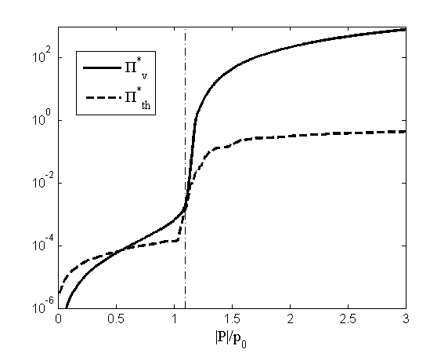

Figure ‎2.3: Thermal and viscous dissipation for a bubble with radius *R0* = 3µm. The thick solid line is the non-dimensional viscous dissipation; whereas thick dashed line represents the non-dimensional thermal dissipation. Note that the non-dimensionalization is done with respect to $p_{0}V_{0}ω$, i.e. $Π_{v}^{*}=Π_{v}/p_{0}V_{0}ω$ and $Π_{th}^{*}=Π_{th}/p_{0}V_{0}ω$. The thin vertical dashed-dotted line represents the Blake threshold.

The dissipation functions are evaluated similarly for a 5 µm bubble as shown in Figure 2.4. Similar behavior can be observed when the evolution of dissipation vs. driving pressure is considered. Upon comparison of two figures, one may observe that the amount of total dissipation under same conditions is less for a bubble with larger radius; which is in agreement with the results of Louisnard [26].

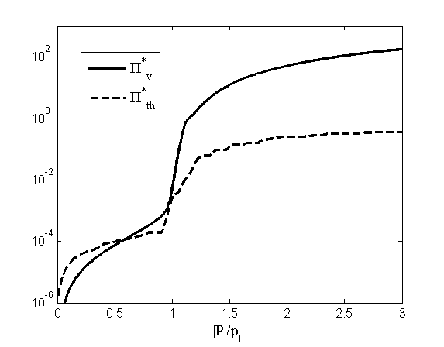

Figure ‎2.4: Thermal and viscous dissipation for a bubble with radius *R0* = 5µm. The thick solid line is the non-dimensional viscous dissipation; whereas thick dashed line represents the non-dimensional thermal dissipation.

## Global energy conservation in the bubbly liquid

In Section 2.4, an equation, (2.34), for the conservation of interfacial energy during the single bubble motion was given and in Section 2.1 an energy equation, (2.11), as in the Caflisch model, relating the divergence of acoustic intensity to the power transferred to bubbles by the sound field was given. As suggested by Lousinard [26], the acoustic power transferred to the bubbles (in the case of mono-disperse bubble distribution) can be eliminated between these two equations by multiplying the former with the number of bubbles (*n*), i.e.

|  |  |
| --- | --- |
| $$\frac{∂}{∂t}\left[\frac{1}{2}\frac{P^{2}}{ρc^{2}}+\frac{1}{2}ρu^{2}+2πnR^{3}{\dot{R}}^{2}+4πnR^{2}σ\right]+∇.(P\vec{u})=-16πnμ_{l}R{\dot{R}}^{2}+np\frac{∂V}{∂t}$$ | (2.38) |

Equation (2.38) represents the conservation of the global mechanical energy in the bubbly liquid. The first term (in brackets) of the LHS of the equation corresponds to the stored energy in the pure liquid and at the interfaces. In particular, the first two terms correspond to the potential and kinetic energy of a liquid volume, respectively, and the latter two represent the radial kinetic energy and the interfacial potential energy, respectively, as discussed in the previous sub-section. The divergence term on the LHS represents the intensity of the acoustic source.

Upon assuming the periodic oscillations of all the fields and performing the period averaging of (2.38) over one acoustic cycle, one obtains;

|  |  |
| --- | --- |
| $$∇.〈P\vec{u}〉= -n\left(Π_{th}+Π_{v}\right).$$ | (2.39) |

The dissipation functions on the RHS of (2.39) being always positive, equation (2.39) has the physical interpretation that part of the acoustic energy transmitted to the bubbly liquid is dissipated by the bubble population field (due to the negative sign on the RHS) by the viscous and thermal losses during the radial oscillations.

## Nonlinear Pressure Waves

As it is done in Section 2.3 for the linear wave propagation, a form of the Helmholtz equation can be obtained for the nonlinear wave propagation by using appropriate mathematical tools and assumptions. The nonlinear Caflisch model proposed a set of effective equations given in the time domain. Recently, Lousinard [26] derived a form of the Helmholtz equation starting from the Caflisch model. The derivation involves the frequency domain representation of the field variables. The effect of bubble population field on the sound field is given by the dissipation during bubble oscillations, which is evaluated by employing cycle averaging procedures. A detailed mathematical analysis of the derivation can be found in the afore-mentioned article. A brief outline of the derivation including important definitions and assumptions will be given as follows:

The pressure field can be decomposed into a sum of time-average pressure, *pm*, first harmonic component of the oscillating pressure field, *p1*, and *posc*,

|  |  |
| --- | --- |
|  | (2.40) |

where *posc* is the harmonic terms oscillating at the frequency *2ω* or higher frequencies.

The first harmonic component of the pressure field *p1* can be expressed as;

|  |  |
| --- | --- |
| $$p_{1}\left(\vec{r},t\right)=\frac{1}{2}\left({P(\vec{r})e}^{iωt}+\overline{P}{(\vec{r})e}^{-iωt}\right),$$ | (2.41) |

where the over-bar denotes the complex conjugate. Further, the primitive, *w*, of the first harmonic pressure is expressed as;

|  |  |
| --- | --- |
| $$w\left(\vec{r},t\right)=\frac{1}{2}\frac{1}{iω}\left({P(\vec{r})e}^{iωt}-\overline{P}{(\vec{r})e}^{-iωt}\right).$$ | (2.42) |

Upon multiplying the wave propagation equation (2.11) with $w$ and performing averaging over one acoustic cycle, one obtains;

|  |  |
| --- | --- |
| $$〈{w∇}^{2}p〉=\frac{1}{c_{l}^{2}}〈\frac{∂^{2}p}{{∂t}^{2}}〉-ρ_{l}〈\frac{∂^{2}β}{∂t^{2}}〉$$ | (2.43) |

Integrating by parts and using the definitions for *w* and *p* yields;

|  |  |
| --- | --- |
| $$〈{w∇}^{2}p〉=-\frac{1}{c_{l}^{2}}〈p_{1}\frac{∂p}{∂t}〉+ρ_{l}〈p_{1}\frac{∂β}{∂t}〉.$$ | (2.44) |

Using the decomposition for pressure (2.40), one can easily evaluate $〈{w∇}^{2}p〉=〈{w∇}^{2}p_{1}〉$ and $〈p_{1}{∂p}/{∂t}〉=0$. In the following, the last term in (2.44) will be re-arranged by using the identity that $〈p_{m}{∂β}/{∂t}〉=0$ and the assumption that $〈p_{osc}{∂β}/{∂t}〉$ is negligible, so that one obtains;

|  |  |
| --- | --- |
| $$〈{w∇}^{2}p_{1}〉=ρ_{l}〈p\frac{∂β}{∂t}〉.$$ | (2.45) |

Using equation (2.35), in order to interpret the RHS of (2.45), one can get;

|  |  |
| --- | --- |
| $$〈{w∇}^{2}p_{1}〉={-ρ}_{l}n\left(Π_{th}+Π_{v}\right).$$ | (2.46) |

Next, the harmonic expressions for *w* and *p1*can be used to obtain,

|  |  |
| --- | --- |
| $$\frac{i}{4ω}\left(\overline{P}∇^{2}P-P∇^{2}\overline{P}\right)={-ρ}_{l}n\left(Π_{th}+Π_{v}\right),$$ | (2.47) |

and dividing both sides of (2.47) by ${\left|P\right|}^{2}$, the following relation for *P* is found:

|  |  |
| --- | --- |
|  | (2.48) |

From equation (2.48), one can deduce that, if *P* were to fulfill the Helmholtz equation, the imaginary part of the wavenumber would satisfy;

|  |  |
| --- | --- |
|  | (2.49) |

From (2.49) it can be seen that the dispersion relation is a function of dissipation functions obtained from the bubble dynamics and the driving pressure field. This fact essentially leads us to the important result that the sound field attenuates in a nonlinear fashion. For the real part of the wavenumber the following equation will be used, as in the linear theory;

|  |  |
| --- | --- |
| $$Re\left(k^{2}\right)=\frac{ω^{2}}{c_{l}^{2}}+\frac{4πR_{0}ω^{2}n}{ω_{0}^{2}-ω^{2}}.$$ | (2.50) |

An intuitive justification of this approximation can be found in the article by Louisnard [26]. Also, relevant discussions were made in Section 1 on the same fact that real part of the wavenumber is well predicted by linear theory as also reported by experimental studies.

Finally, with the use of equations (2.49) and (2.50), the Helmholtz equation for the nonlinear wave propagation can be obtained as;

|  |  |
| --- | --- |
|  | (2.51) |

In Figure 2.5, the real and imaginary part of the wavenumber for the driving frequency 20 kHz, bubble volume fraction β=0.005 % and the distribution of bubbles with same radius R0=5 µm, is plotted. One can observe that the imaginary part of the wave number increases very quickly for the driving amplitudes over the Blake threshold and it can be as high as the real part for very large driving amplitudes.

**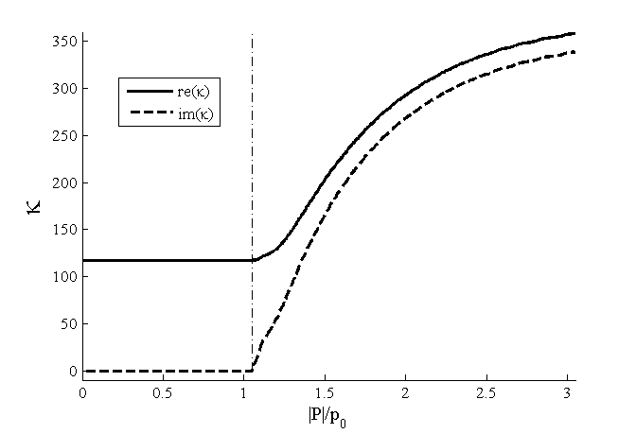**

Figure ‎2.5: The real and imaginary part of the wavenumber used in the nonlinear wave propagation.

# 

Numerical Methods

As mentioned in the previous chapters, the modelling of acoustic pressure within bubbly liquids requires the solution of the Helmholtz equation. In this chapter, two different meshless methods, i.e. radial basis integral equation (RBIE) method and local boundary integral equation (LBIE) method, for the solution of the Helmholtz equation are introduced. In the RBIE, source nodes are located inside the domain Ω and on the boundary Γ and one circular sub-domain is generated for each source node (See Figure 3.1). The method is an application of the boundary integral equation (BIE) in these local circular sub-domains. Three equations for two-dimensional (2D) or four for three-dimensional (3D) potential problems are required at each source node. The first equation is the integral equation arising from the application of the Green’s identities and the remaining equations are the derivatives of the first equation with respect to space coordinates. The fundamental solution of the Helmholtz equation is used and therefore domain integrals are not encountered. Singular or near singular integrals do not appear in the formulation since the source nodes are at the centre of the local sub-domains. The boundary of the local sub-domains is discretized by using quadratic boundary elements. For this purpose, fictitious nodes are placed on the boundaries of the local sub-domains. Recently, Ooi and Popov [67] proposed a more efficient way for the evaluation of the integrals in these circular sub-domains. The integrals can be evaluated by applying Gaussian integration procedure [67] without the necessity for boundary elements. In the earlier stages of this thesis, the computations were performed with the use of quadratic boundary elements. The Gaussian integration procedure is more efficient than the use of quadratic boundary elements [67], however sufficient number of quadratic boundary elements provides accurate results as well. This matter is quantified in Section 4.1.1.

The evaluation of the unknown values for the potential and the derivatives in the global system matrix involves two stages: The first one is the evaluation of the local boundary integrals by using fictitious points (as mentioned above) and second one is the interpolation of the unknown values at these fictitious points from the neighbouring nodes by using radial basis functions (RBF). Note that these fictitious points do not appear in the final system of equations. The procedure of the RBF interpolation is explained in Section 3.4. For the local boundary integrals, it is sufficient to perform the integration only once provided that local sub-domains with the same shape and size are used at each source node; for example circular sub-domains with same radius as in this work. The choice of circular sub-domains assures that the integral kernels are regular regardless of the order of the derivative. Further, it simplifies the evaluation of the integral kernels, which is a challenging task for the usual boundary element methods [68, 69, 70].



Figure ‎3.1: Distribution of some of the circular sub-domains in the problem domain

In the LBIE, similarly to the RBIE, one circular sub-domain is generated for each source node located inside the domain. One equation for the potential, both in 2D and 3D, is written at each source node which is the integral equation arising from the application of the Green’s identities. The ‘companion solution’ approach [11] is applied in order to eliminate the integral containing the gradient of the potential; however, the method encounters domain integrals even though the fundamental solution of the Helmholtz equation is used. This issue is highly significant when computational time requirements are considered, i.e. in 2D, a simple Gaussian integration over a line would require  operations whereas it would be  for domain integrals, *NG* being the number of Gauss points used in the discretization. The unknown values for the potential at these integration points are interpolated by using radial basis functions (RBF), similarly to the case of RBIE, although this is done by using the moving least squares (MLS) approach in the original formulation of LBIE [11, 71].

Two different formulations for LBIE, using the Helmholtz fundamental solution or the Laplace fundamental solution are presented in Section 3.2. Though they show similar accuracy, when solving problems in which the wavenumber is variable throughout the domain, such as bubbly liquids, the formulation with Laplace fundamental solution has to be used.

The differences between the RBIE and LBIE formulations can be summarized as follows [9]: (i) for the solution on the boundary, the LBIE replaces the circular domain with part of the global boundary and the remaining part of the circle, whereas the RBIE keeps the circular integration approach for the source nodes on the boundary; (ii) the LBIE uses the concept of “companion solution” in order to avoid the gradients/normal derivatives inside the solution domain while the RBIE solves for the potential and the partial derivatives at each source node including the global boundary of the domain; (iii) the boundary conditions in the RBIE are directly imposed at the source points on the global boundary, each replacing one of the three equations.

## The Radial Basis Integral Equation Method

### The mathematical formulation

Let us consider the following Helmholtz equation:

|  |  |  |
| --- | --- | --- |
|  |  | (3.1) |

where *p*(*r*) is a potential field and r is a position vector. Given a point r inside a domain Ω, by applying the Green integral formula, Equation (3.1) can be transformed into the following integral form:

|  |  |
| --- | --- |
| $$λ_{b}\left(r\right)p\left(r\right)+\int_{Γ}{q^{*}(r,ξ)p(ξ)dΓ_{ξ}}-\int_{Γ}{p^{*}\left(r,ξ\right)q\left(ξ\right)dΓ_{ξ}}=0$$ | (3.2) |

where *p*\*(*r*,*ξ*) is the fundamental solution of the Helmholtz problem,  and . For a 2D problem the fundamental solution is given by

|  |  |  |
| --- | --- | --- |
|  |  | (3.3) |

with

|  |  |  |
| --- | --- | --- |
|  |  | (3.4) |

where *J0*and *Y0* are zeroth order Bessel functions of first and second kind, respectively and *RΩ* is the distance from the point of application of the concentrated unit source to any other point under consideration, i.e.  = |*r* – *ξ*|. The derivative of the fundamental solution is given by

|  |  |  |
| --- | --- | --- |
|  |  | (3.5) |

The constant $λ_{b}\left(r\right)$ has a value between 0 and 1 being equal to 1/2 for smooth boundaries and 1 if the source point is inside the domain. For the RBIE method, since the source point is at the centre of the local sub-domain, $λ_{b}$ takes the value 1.

The proposed formulation solves in each interior node three integral equations in order to obtain the potential *p*, and the partial derivatives ∂*p*/∂*x*j, where *x*j are the components of *r*. Equation (3.2) is used to find the potential while the equations for derivatives ∂*p*/∂*x*j are obtained by differentiating (3.2) with respect to *x*j, i.e.

|  |  |  |
| --- | --- | --- |
|  |  | (3.6)‎ |

The derivatives of the fundamental solution in the integral kernels of Equation (3.6) can be evaluated analytically as given below:

|  |  |  |
| --- | --- | --- |
|  |  | (3.7) |

and

|  |  |  |
| --- | --- | --- |
|  |  | (3.8) |

Equation (3.2) can be discretized as:

|  |  |
| --- | --- |
|  | (3.9) |

where *Hik* and *Gik* are the matrix coefficients arising from the double layer and the single layer integrals, respectively, and *Jbn* is the number of fictitious nodes on the boundary. Note that in equation (3.9), *p*jand *q*jare the values of the potential and the flux, respectively, at the fictitious nodes on the boundary of local sub-domain, whereas *pi* is the potential value at the source node. Therefore, the parameters *pj* and *qj* do not appear directly in the global system matrix, though they are interpolated from the neighbouring source nodes (including the source node at which the equation is written) by using RBF, the procedure of which will be explained in detail in section 3.3. Also note that the coefficients *Hij* and *Gij*are evaluated from equations (3.5) and (3.3), respectively, thus they are functions of *k* and $R_{Ω}$.

One key feature of RBIE is that the normal derivative *qj* at the fictitious nodes in (3.9) is evaluated from the spatial derivatives of the potential field as:

|  |  |
| --- | --- |
|  | (3.10) |

where *nk* are components of the unit normal vector at each fictitious point *j*. Therefore, (3.9) can be written as

|  |  |
| --- | --- |
|  | (3.11) |

where *G*ijk = *G*ij*n*k.

Similarly to the procedure for *p*jand *q*j in (3.9), the fictitious values ∂*p*j/∂*x*k in equation (3.11) are interpolated from the values of potential derivatives at the surrounding source nodes, equations of which are given by (3.6). The discrete form of the equation for the partial derivatives ((3.6)) can be written as:

|  |  |
| --- | --- |
| $$\frac{∂p_{i}}{∂x_{k}}=-\sum_{j=1}^{J_{bn}}{{\overline{H}}_{ij}^{k}}p_{j}+\sum_{j=1}^{J_{bn}}{{\overline{G}}_{ij}^{k}}q_{j}$$ | (3.12) |

where the coefficients ${\overline{H}}_{ij}^{k}$ and ${\overline{G}}_{ij}^{k}$ are the evaluated by using $∂q^{*}/∂x_{k}$ and $∂p^{*}/∂x_{k}$, which are given by equations (3.8) and (3.7), respectively. The term *q*j appearing in the last term of (3.12) can be composed by using the relation (3.10) similarly as it is done for the potential. dasdsad

Equation (3.11) can be written in matrix form as

|  |  |
| --- | --- |
|  | (3.13) |

and equations (3.12) can be written as:

|  |  |
| --- | --- |
| $$\frac{∂p}{∂x_{k}}=-{\overline{H}}^{k}p+{\overline{G}}^{k}\frac{∂p}{∂x_{k}}$$ | (3.14) |

Note that the same subscript *k* is essentially used in equations (3.14) for the evaluation of ${\overline{H}}^{k}$**, ${\overline{G}}^{k}$** and $∂p/∂x_{k}$, since it sums over the same index; though it refers to the spatial derivative at the source node for ${\overline{H}}^{k}$**, ${\overline{G}}^{k}$** and the left hand side $∂p/∂x_{k}$ term, and to the spatial derivative at the fictitious node for the right hand side $∂p/∂x_{k}$ term. It should be also noted that when writing the global system of equations from (3.13) and (3.14), the contribution of RBF interpolations to the integral kernels **H**, **Gk**, and ${\overline{G}}^{k}$ should be included.

### Implementation of boundary conditions

In the RBIE, the implementation of the boundary conditions is as follows [9, 10]: Some of the source nodes are placed on the global boundary of the domain Ω, in order to define the geometry of the problem. The global boundary of the domain is not discretized and the boundary conditions are directly imposed at the source nodes on the boundary. Further, as can be seen in Figure 3.2, the circular shape of the local sub-domains is retained. If Dirichlet BCs are imposed on the part of the boundary where  is located, the following equation would be applied

 (3.15)

while the equations (3.14) for the derivatives with respect to the space coordinates would remain. If Neumann BCs are given on the part of the boundary where  is located, one of the partial derivatives would be eliminated depending on the direction of the outward unit normal vector. The following equation would be applied

 (3.16)

where  and  are the components of the unit outward normal at the location of the source node. If , equation (3.16) would replace the derivative of the BIE with respect to the *x* coordinate since the flux is mainly in that direction and vice versa.

C:\Users\refadult.SCC-PUB-LIBRARY.000\Desktop\Nodes.TIF

Figure ‎3.2: A sketch for the source nodes and local sub-domains placed in the solution domain, Ω, and on the global boundary, Γ.

## The LBIE-RBF

As mentioned before, the LBIE method is used with two different fundamental solutions, i.e. Laplace fundamental solution and Helmholtz fundamental solution, in this work. The derivations of these formulations will be outlined in this section. When optimising the LBIE method with respect to the dispersion error, a formulation based on the Helmholtz fundamental solution is used since the dispersion error itself is related to the sensitivity of the numerical algorithm to thewavenumber, *k*. Note that the Laplace fundamental solution is independent of the wavenumber. However, in the case of wave propagation in bubbly liquids, the wavenumber is not constant throughout the domain, and therefore, the use of Helmholtz fundamental solution is not applicable. Hence, a formulation based on the Laplace fundamental solution should be applied.

### Laplace fundamental solution

The integral representation of equation (3.1) can be rewritten as:

 (3.17)

where *p*\*(*r*,*ξ*) is the fundamental solution of the Laplace problem. For a 2D problem the Laplace fundamental solution is given by

 (3.18)

and the derivative of the fundamental solution is given by

 (3.19)

One of the key features of the LBIE is the elimination of the integral term containing ∂*p*/∂*n* from (3.17) when the source point is at the interior of the solution domain. This is achieved by the use of a solution which Zhu et al. [69] referred to as “the companion solution”, i.e. a solution associated with the fundamental solution and defined as the analytical solution of the following Dirichlet problem,

 on ,

 on . (3.20)

Recalling that circular sub-domains are used in this work, the companion solution (solution of (3.20)) is obtained as,

 (3.21)

where is the radius of the sub-domain.

Using *p\*\*=p\** - *p’* as the modified test function and by applying the Green integral formula over the local sub-domain, the integral representation (3.17) can be rewritten as:

 (3.22)

where  is the field variable over . Using (3.18) and (3.21), the explicit expression for *p*\*\*(*r*,*ξ*) reads;

|  |  |
| --- | --- |
| $$p^{**}\left(r,ξ\right)=-\frac{1}{2π}\ln\left(R_{Ω}\right)+\frac{1}{2π}\ln\left(R_{Ω_{s}}\right)$$ | (3.23) |

For a 3D problem, the Laplace fundamental solution is given by

 (3.24)

and the companion solution would be obtained accordingly as,

. (3.25)

Hence, the modified test function for a 3D problem is given by;

|  |  |
| --- | --- |
| $$p^{**}\left(r,ξ\right)=\frac{1}{4πR_{Ω}}-\frac{1}{4πR_{Ω_{s}}}$$ | (3.26) |

### Helmholtz fundamental solution

In the LBIE method, source nodes are distributed over the boundary and the interior of the solution domain. Centred at each node a circular subdomain, , is generated. Equation (3.2) should hold over each local sub-domain provided that it lies entirely within the global boundary of the problem, i.e.;

 (3.27)

where *p*\*(*r*,*ξ*) is the fundamental solution of the Helmhotz problem and is given by equation (3.3).

As it was done for the Laplace fundamental solution in the previous section, the integral term containing ∂*p*/∂*n* from (3.27) may be eliminated. Similarly to the previous case, the “companion solution” approach should be applied. Ideally, the companion solution should be associated with fundamental solution of the problem solved [69]. Therefore, it may be defined as the analytical solution of the following Dirichlet problem,

 on ,

 on . (3.28)

However, the solution of (3.28) is not available [11, 71].

Nevertheless, the integral containing the variable ∂*p*/∂*n* can be eliminated by adopting the analytical solution that satisfies,

 on ,

 on . (3.29)

Considering that circular sub-domains are used in this work, the solution of (3.29) is obtained as,

 (3.30)

where is the radius of the sub-domain.

Using *p\*\*=p\** - *p’* as the modified test function and by applying the Green integral formula over the local sub-domain, the integral representation (3.27) can be rewritten as:

 (3.31)

where  is the field variable over . Using (3.3) and (3.30), the explicit expression for *p*\*\*(*r*,*ξ*) reads;

|  |  |
| --- | --- |
| $$p^{**}\left(r,ξ\right)=-\frac{i}{4}H_{0}^{\left(2\right)}\left(kR_{Ω}\right)+\frac{i}{4}H_{0}^{\left(2\right)}(kR_{Ω_{s}})$$ | (3.32) |

Equation (3.31) is expressed purely in terms of the potential field and is free of the gradient. In order to complete the formulation of the proposed method, the boundary conditions should be implemented. This could be done by integration over the global boundary [11] or by applying some collocation techniques [72]. In this thesis, it is performed by integration over the global boundary, which will be outlined in Section 3.2.3.

As detailed in Section 3.4, dispersion error is measured for the potential field at the source nodes which are located entirely within the global domain and not affected by the acoustic forcing terms or any type of boundary conditions. In order to measure the dispersion error for the LBIE-RBF, equation (3.31) will be used which requires the integration of the function over the local sub-domains.

### Implementation of boundary conditions in the LBIE-RBF

The implementation of boundary conditions in the LBIE can be explained as follows. A set of source nodes are placed on the global boundary Γ in order to define the geometry of the problem and to be able to impose the BCs. When the local sub-domain,, is formed for a source node on the global boundary of the problem; the local sub-domain is not anymore a full circle but an area enclosed by the part of the global boundary intersecting the circle and the part of the local sub-domain/circle which lies inside the solution domain (See Figure 3.2, with the ‘LBIE’ label).

If Dirichlet BCs are imposed on the part of the boundary where a source node is placed, e.g. at location, *xξ*, the following equation would be applied at *xξ*

 (3.33)

If Neuman BCs are given on the part of the boundary where *xξ* is located, the integral containing the gradient of the potential has to be evaluated, as it does not vanish on the global boundary. This could be done by integration over the global boundary [11, 71] or by applying some collocation techniques [72]. Here in this work, integration over the global boundary is preferred as in [71], therefore the following equation is applied;



(3.34)

where *Ls* and *Gs* are the part of the boundary of the local sub-domain, inside the global domain and part of the global domain intersected by the local sub-domain, respectively (See Figure 3.2). Note that *Ls* is not a full circle anymore, and that $dΓ_{Gs}$ corresponds to infinitesimal integral element on the global boundary. The term on the right hand side of the equation (3.34) can be called as the acoustic source term. Note that all the terms on the RHS of (3.34) are known variables; so that the integration for that part of the equation can be performed to give a scalar value.

## Interpolation for the unknown values at the local sub-domains

In RBIE and LBIE, the boundary integral equation is applied in order to obtain the potential and the derivatives at the center local sub-domains. Although these sub-domains could be of any shape in principle, the choice of circles simplifies the procedure. In order to perform the integration over the local boundaries of the circular sub-domains, values of the potentials and partial derivatives must be known on these boundaries. The boundary of the sub-domains can be simulated in two different ways: *(i)* by using boundary elements or *(ii)* by applying Gaussian integration procedure as shown by Ooi and Popov [67]. In this work, the former one is used when the computations are performed with the RBIE and the latter when using the LBIE. In fact, the reason for this choice is that the latter [67] is a recently developed approach which was not available in the literature at the early stages of this thesis. For the integration with boundary elements, fictitious nodes were located on the local boundaries to form quadratic boundary elements. The sufficient number of fictitious nodes needed for accurate computations is discussed in Section 4.1.1. On the other hand, the use of the Gaussian integration procedure eliminates the necessity for the discretization of the local boundary. When the integration is performed over the boundary, the Gaussian integration can be applied over the polar angle and as for the domain integrals it must be performed both over the radial direction and the angular direction as shown by Ooi and Popov [67]. The unknown potential at one of these integration points is approximated by using radial basis functions (RBFs). In order to ensure the stability of the approximation, polynomial terms are inserted into the basis [73, 74]. The potential at any location  is approximated by *n* neighbouring nodes, *x*i, as follows (See Figure 3.3):

 (3.35)

where *f* is the RBF used, *t* is the polynomial basis vector with dimension *m*, and *ai*, *bj*are unknown coefficients to be determined. The second order augmented thin plate spline is used throughout this thesis in the computations. Note that here *Riϑ* refers to the distance from the integration point,, to the location of the neighbouring node, *x*i, i.e. *Riϑ* = |– *xi*| (See Figure 3.3).

The selection of the *n* neighbouring nodes can be done in two different ways: (i) defining a suitable radius around which would contain the desired number of interpolation nodes, (ii) defining the required number of interpolation nodes *n* as an input in the code and applying some sorting algorithms to find the nearest n nodes to . In this work option (ii) was employed. The selection of the neighbouring nodes was done for each of the source nodes, not for each fictitious node on the local boundary used in the evaluation of the integrals. Thereafter, this strategy reduces the computation time since the number of operations for the search and sorting is reduced.

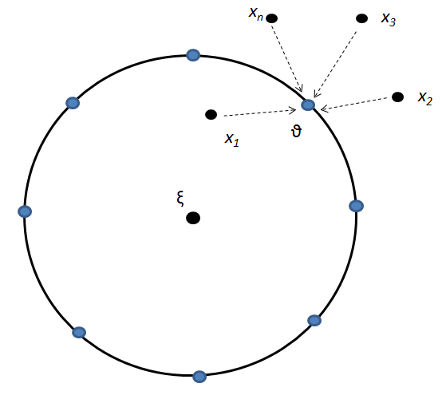

Figure ‎3.3: Interpolation of the values at the fictitious nodes.

The procedure for the RBF interpolation was outlined in the paper of Bui and Popov [9]. The choice of polynomial basis vector affects the solution significantly. As shown previously [67, 73], a simple polynomial basis with *m=6* can be used,

 (3.36)

which in combination with the LBIE will be called the LBIE-RBF*-m=6* hereafter. The use of frequency dependent polynomial basis vectors has been shown to produce accurate approximations for the Helmholtz problems [75, 76, 77, 78];

 (3.37)

with *m=5.* Here, *k* denotes the wavenumber and the angle of the plane wave propagation at the location (*x, y*). In this work, two different propagation angles are used when analysing the dispersion error of the method,  and .

Equation (3.35) can be written in matrix form as;

 (3.38)

Moreover, in order to have a unique approximation of a function, the condition:

 (3.39)

has to be fulfilled. Since is invertible (3.38) can be transformed as:

 (3.40)

Using (3.39), (3.38) yields

 (3.41)

with

 (3.42)

Using the expression (3.41) for in (3.40) yields;

 (3.43)

where

 (3.44)

Finally, by substituting (3.41) and (3.43) into (3.35), the potential at the point can be obtained:

 (3.45)

where *F*(,*xi*) = [*f*(,*x*1), *f*(,*x*2),…, *f*(,*xn*)] and .

## Dispersion effect

The solution of the Helmholtz equation suffers the so called pollution effect, which leads to inaccurate results for the case of high wave numbers. It has been mathematically shown that the pollution consists primarily of the dispersion effect which is defined as the mismatch between the actual wavenumber, *k*, and the numerical one, *kh*. For the FEM solutions of the Helmholtz equation an error estimate is given by [79],

  (3.46)

with *h* being the spacing between nodal points in an assumed uniform setting of the nodes and the constants *C1* and *C2* independent of *k* and *h.* The first term in (3.46) represents the approximation error and the second the dispersion error.

The reason for investigating the dispersion error is that when the dispersion error is minimized, the numerical methods give the most accurate results for the solution of wave propagation problems. Dispersion error is measured at *only* one source node in the solution domain. One can show that for most of the source nodes, the equations written in the global system matrix have the same coefficients, except that their column indices differ due to the global numbering of the source nodes. The basic principles lying behind dispersion concept are explained in more detail in a paper which is currently under review [80], which can be also found in the Appendix. The formulation for LBIE-RBF is given in the next sub-section, whereas the derivation for the RBIE and some comparison results are presented in the Appendix.

### LBIE-RBF formulation

Given a regular distribution of field points (with equal spacing *h* in *x* and *y* directions) with a constant size of influence domains, the wavenumber *kh* of the numerical wave propagating in the direction of  can be a priori determined as mathematically outlined in detail by Suleau et. al. [77] which will be repeated here for the LBIE-RBF method.

It is assumed that the nodal values of the potential field follow a harmonic evolution of the form

 (3.47)

where *q1* and *q2* (in *x* and *y* directions, respectively) are the discrete indices of the location of the field point being considered (See Figure 3.4). Assuming the harmonic evolution, the potential at an interior node  can be written as;

 (3.48)

where γ1 and γ2 are the discrete indices referring to the difference of the locations of the two field points considered (in *x* and *y* directions, respectively). In the LBIE-RBF, given a constant size of influence domain, a discrete form of the equation (3.30) is written for the interior nodes as;

 (3.49)

with *s1,s2* being the normalized (with *h*) distances of the furthest neighbouring nodal points which remain within the influence domain of (*q1,q2*) in *x* and *y* directions, respectively. Here, is the coefficient of the potential value  arising in the discretized form of the equation (3.30) written for the node at (*q1,q2*).

By assuming the harmonic evolution of the acoustic pressure of the nodal values given by (3.48), equation (3.49) becomes;

 (3.50)

For a non-zero distribution of the acoustic pressure, *uh,* it is evident from equation (3.50) that the numerical wavenumber can be determined, for given values of *k* and the angle of propagation, by solving;

 (3.51)

*Dispersion error:* Throughout this thesis the results for dispersion are presented as follows;

 (3.52)

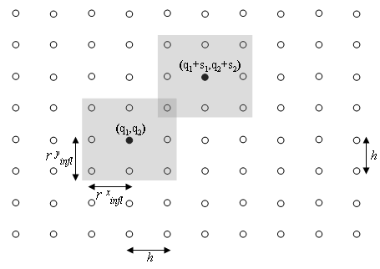

Figure ‎3.4: Influence domains of two associated points located at (q1, q2) and (q1+s1, q2+s2).

## Treatment of thin structures

Complicated geometries, such as sharp edges and thin bodies, are cumbersome to deal with within numerical algorithms. In the application part of this study, nanoparticle impregnation into textile fabric by using sonochemical reactors is employed as mentioned before. In particular, the acoustic wave propagation around the textile fabric, which is modeled as a thin body, is studied in this thesis.

The usual finite element methods apply a mesh refinement in order to resolve the complex geometry, which brings out increase in computational costs and the necessity for complex mesh generation algorithms. Boundary element methods are also capable of handling the thin body problem, e.g., the dual boundary element method [13] and the traction boundary element method [14]. Godinho and collaborators used the meshless method of fundamental solutions (MFS) for the wave propagation around thin structures [12].

In Figure 3.5, a sketch of a geometry involving a thin obstacle is given in part (a) and the magnified plot of the curved, right edge of the thin obstacle is given in part (b). The boundary of the thin obstacle is denoted by Ωt. The left end of the thin obstacle has convex edge and the wave propagation is investigated at the outer part of this obstacle, in the domain Ω. Therefore, the region enclosed by the boundary Ωt is not part of the domain, Ω, where wave propagation is investigated. When the source nodes on the boundary of the thin obstacle and the surrounding source nodes are considered, a strategy should be proposed when selecting the influence nodes. As a first approximation, a source node below the thin obstacle (see for example the node shown as a square in Figure 3.5b), cannot be influenced by the nodes above the thin body. We should recall that in the RBIE and LBIE, the nearest nodes are selected for the RBF interpolation. However, this rule cannot be used when dealing with the thin structures. For example, in the limit when the thickness of the thin body goes to zero, some nodes from the opposite side of the thin structure may get very close to the considered source node. However; they should not be included in the selection. For the influencing nodes on the left side of the considered source node in Figure 3.5b, only the ones with equal or lower y direction value are taken into account.

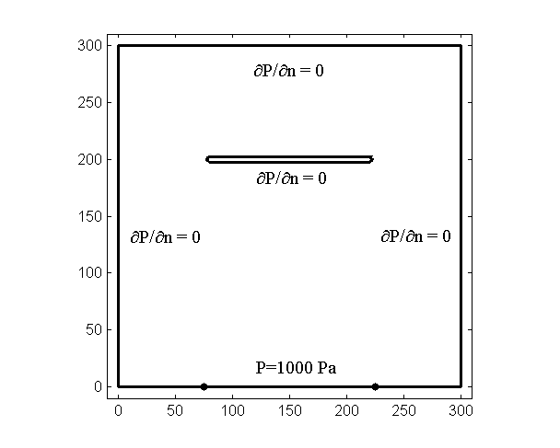

x (mm)

y (mm)

1. A schematic of a domain with a thin inclusion

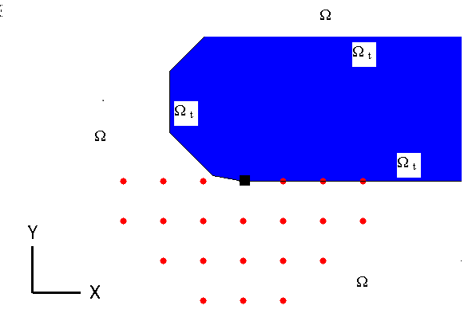

1. A zoom plot of the circled area in part *(a)*

Figure ‎3.5: Selection of influencing nodes for a source node at the bottom part of the thin body.

The situation is somewhat different when one considers a node at the curved edge of the thin body (See Figure 3.6). A strategy of choosing only equal and below the same level in one direction (as in the previous case) would not prove correct for this case. If the edge is of convex geometry, one can introduce the tangential line at the considered point in order to choose the influencing nodes. The nodes beyond the tangential line are omitted in the current implementation, when selecting the influence nodes as shown in Figure 3.6. The closest neighboring node on the boundary of the thin body can be included if the convex edge is being simulated by using constant boundary elements (which is the case for the numerical computations in this thesis).

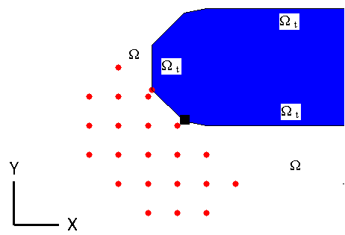

Figure ‎3.6: Selection of influence nodes for a source node at the convex edge of the thin body.

Another strategy can be applied when dealing with null thickness structures in the geometry. This is called domain splitting and the details of the procedure are explained as follows. Let us consider the sketch given in Figure 3.7. The thin object is located towards the right of the sketch as in previous example. In the limit $h_{t}→0$, the extension part to the thin structure (the dashed lines) can be considered as an interface; so that the problem can be solved in two split domains. This fact simplifies the selection of the neighboring nodes and the implementation of boundary conditions significantly. For example, the nodes numbered from 1 to 5 can be included in the RBF interpolation as they lie within the same domain (posterior to splitting), whereas the ones numbered from 6 to 10 can be considered in the other split domain.

In order to complete the above mentioned strategy, the boundary conditions at the interface should be implemented. This implementation will be accomplished here by choosing two illustrative nodes, e.g. node 1 and node 6 in Figure 3.7, which tend to the same location in the limit $h_{t}→0$. Consequently, the boundary conditions should read the continuity of the potential at the interface, i.e. $p_{1}=p_{6}$, and further the continuity of the potential derivative at the interface yields,

|  |  |
| --- | --- |
| $$\frac{∂p_{1}}{∂n_{u}}=-\frac{∂p_{6}}{∂n_{l}}$$ | (3.53) |

where *nu* and *nl* are the unit normal vectors at the upper side and the lower side of the interface, respectively. One should note that the relation $\vec{n_{u}}=-\vec{n_{l}}$ holds for the unit normal vectors at the interface in the limit $h_{t}→0$.

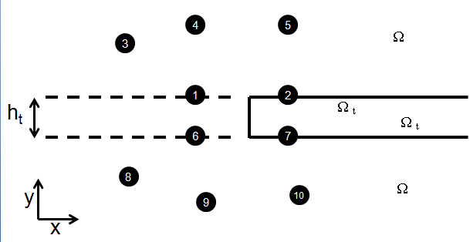

Figure ‎3.7: A sketch of the domain splitting procedure by using interface conditions.

## Nonlinear solution procedures

Several error measurement criteria are used throughout the computations in this thesis; the definitions of which are given below:

The L2-norm error for *p* is defined as

 (3.54)

where  is the potential at node *i* evaluated by the numerical scheme and *p*i is the ‘reference solution’ at node *i*.

The Root-mean-square error for *p* is defined as

 (3.55)

and the relative error at node *i* is defined as

 (3.56)

Note that the term ‘reference solution’ in the above equations will depend on the problem solved. If the analytical solution of the problem is known, then *pi* will refer to analytical solution at node *i*. In principal, any of the above error measures can be used for such problems. If an analytical solution to a given problem is not available the term ‘reference solution’ then may refer to the solution obtained by another numerical method or commercial software. Further, if a nonlinear solution procedure is required, the term reference solution may refer to solution in the previous step. In this thesis, the L2 norm error is used, in general, where the analytical solution of the problem is known (for instance, for the example problems in Section 4). When nonlinear problems are solved (as in Section 5.1.2), the RMS error and relative error measures are applied.

In the following, the procedure of the solution of nonlinear Helmholtz equation is detailed. For the solution of nonlinear wave propagation in a bubbly liquid, it is firstly essential to know the bubble volume fraction and bubble size distribution in the mixture. The nonlinear theory presented throughout Section 2 is based on the assumption that all the bubbles in the mixture have the same radius. Initially, the Rayleigh-Plesset equation for the radial dynamics of bubbles (2.33) is solved for a given bubble radius, a given driving frequency of the sound field, and for a range of sound pressure. Upon solution of (2.33), the thermal, $Π_{th}$, (2.36) and viscous, $Π_{v}$, (2.37) dissipation per bubble are evaluated for the given bubble radius, driving frequency, and the range of sound pressure. Multiplication of $Π_{th}$ and $Π_{v}$ by the number of bubbles present in the mixture, *n*, aids the evaluation of the imaginary part of the wavenumber (given by equation (2.49)) as a function of driving pressure. The real part of the wavenumber is given by (2.50).

At the next stage, the iterative solution of the nonlinear Helmholtz equation (2.51) should be detailed. An example wavenumber profile was given in Figure 2.5. The initial step of the nonlinear solution is solving the Helmholtz equation in the pure liquid (no bubbles case). The wavenumber for this case would be a constant (independent of sound pressure), real number and would be much smaller than the bubbly case (for instance, it is approximately 84 for the conditions given in Figure 2.5). For the obtained pressure wave profile (the non-dimensional values of |P|), the value of wavenumber can now be assigned at each source point by using Figure 2.5. The ultimate aim is to solve the Helmholtz equation with the distribution of wavenumber given by Figure 2.5. However, one should note that the use of such high values of wavenumber at early stages of the solution may result in very high damping of the initial pressure wave profile. In fact, it may result in a completely damped wave profile below Blake threshold, which indicates going back to the initial step, since the wavenumber below the Blake threshold is taken as equal to the pure liquid case, and indicates an oscillatory behaviour in between few stages. Therefore, an iterative process should be proposed which starts from the initial wavenumber in the pure liquid and reaches the final wavenumber profile gradually. This is achieved in this thesis by using a ramp function centred at Blake threshold, *PB*, the value of which below *PB*, *Re(k)*or *Im(k)*, is a constant and the slope of which above *PB*,, is increased at each step of the solution process (See Figure 3.8). In Fig. 3.8, $β_{s}$ refers to the value of the bubble volume fraction at the solution step *s* and it reaches gradually to its final value $β$ during the iterative nonlinear solution process. Note that two different ramp functions are required for the real and imaginary parts of the wavenumber since their profile below and above *PB* are different, though the same value of *m* is required for both of them to reach their final corresponding values.

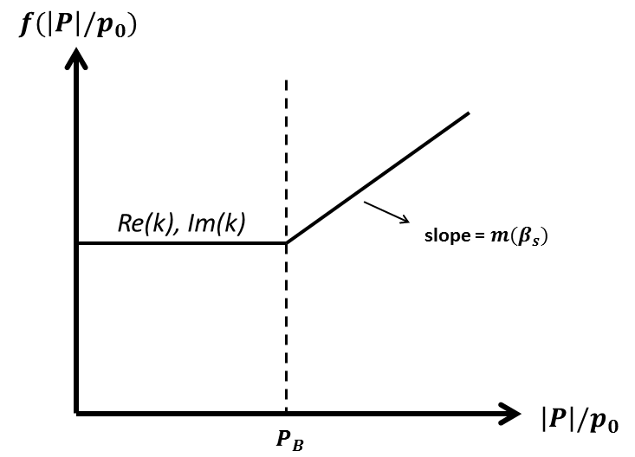

Figure ‎3.8: The ramp function used for updating the real and imaginary parts of the wavenumber from their initial value to their final profile given in Figure 2.5.

A flow chart for the nonlinear solution procedure is given in Table 3.1. As mentioned above, the final value of the bubble volume fraction is reached by gradual increments. This can be done in two ways: (i) the number of total steps (*Ns*) to reach the final solution can be chosen, i.e. *s=*1, 2, 3, …, *Ns*. In this case, the increments ($∆β$) of bubble volume fraction (β) would be $∆β=β/N_{s}$, and (ii) a value of $∆β$ can be chosen so that the bubble volume fraction at each step ($β_{s}$) would follow $β_{s}=∆β,2∆β, 3∆β, …, β$. In each of the choices, one should assure small increments such that drastic changes to the wave profile during the iterations are avoided. Once the total number of steps (*Ns*) (or equivalently $∆β$) is chosen, the wavenumber profile at any iteration step (*s*)is evaluated by a simple interpolation procedure as follows: Let $k_{i}^{s}$ denote the wavenumber at the source node *i*, at the iteration step *s*. Then the real part of $k_{i}^{s}$ will be given as

$Re\left(k_{i}^{s}\right)=Re\left(k_{0}\right)+(s/N_{s})\left(Re\left(k_{i}^{f}\right)-Re\left(k_{0}\right)\right)$ (3.57)

and similarly the imaginary part of will be given as

$Im\left(k_{i}^{s}\right)=Im\left(k_{0}\right)+(s/N_{s})\left(Im\left(k_{i}^{f}\right)-Im\left(k_{0}\right)\right)$ (3.58)

In above equations, $k_{0}$ is the wavenumber in the pure liquid (the imaginary part of which is zero) and $k_{i}^{f}$ is the wavenumber at the source node *i* evaluated for the final value of the bubble volume fraction, β, the real and imaginary parts of which are essentially obtained from Figure 2.5. One should note that, due to the interpolation procedure mentioned above, the intermediate values, $β_{s}$, of the bubble volume fraction are not necessarily physical values, i.e. the evaluated wavenumber profile $k_{i}^{s}$ for given values of *s=*1, *Ns=*100 and β=%0.01 would not necessarily be equal to the wavenumber profile $k_{i}^{f}$ evaluated for β=%0.01/100=%0.0001.

Some details regarding the algorithm given in Table 3.1 will be given as follows:

First, the general approach to the iterations should be explained. As mentioned above, the solution in the pure liquid case is obtained. This first solution and the first update to the wavenumber can be regarded as the operation in line 1. Starting from *s=*1, the solution at each step *s* (and equivalently for each value of $β_{s}$) requires a number of inner iterations (NI) to converge to an acceptable solution ${|P|}^{s}$, i.e. *j=*1, 2,…, *NI*;each of these can be called as ${|P|}_{j}^{s}$. Therefore, the overall algorithm essentially consists of two *do while* loops where the outer loop runs over the indice *s* and the inner loop runs over the indice *j*. The convergence of the *j-loop* at each step *s* is checked with an *if* statement by computing the RMS error of the solution at the *j*th iteration with respect to solution at the (*j*-1)th iteration. This is given in the lines 15-19. Note that the total number of inner iterations (*NI*) within the *j-loop* is a priori unknown. However, as it will be exemplified in the results section, *NI* tends to increase significantly towards the later stages of the solution, i.e. when *s* tends to approach *Ns*.

Secondly, the *stability* issue should be addressed. As mentioned above, the later stages of the solution are more cumbersome, one of the reasons being the increase in the $k_{i}^{s}$. Typically, given a value of $β_{s}$, drastic jumps with the pressure wave profile, ${|P|}_{j}^{s}$, are observed which may require a few hundred inner iterations (*NI*) without obtaining a RMS error within the specified tolerance value. In order to avoid such unstable behaviour of the solution, an under-relaxation procedure is applied which are given by the lines 6-7 of Table 3.1. According to this, the relative error, at each source node, with respect to the previous iteration step is measured. If the maximum relative error within the solution domain exceeds the prescribed tolerance value, the under-relaxation is applied as in line 7. In the computations in this thesis, a maximum relative error of %3 is allowed.

Finally, the repetitive oscillations of the solution should be addressed. Regardless of the stability and under-relaxation procedures mentioned above, the nonlinear solution suffers from the repetitive oscillations at certain stages. That is, given a value of $β_{s}$, the solution returns to one of the states within the iterations of the *j-loop* and keeps repeating the same set of solutions ${|P|}_{j}^{s}$, which would cause *NI* to tend to infinity if not controlled. This can be avoided by keeping record of the previously obtained RMS errors within the ­*j-loop* and checking whether the RMS error obtained at the current iteration is equal to any of previously obtained (*NI*-1) RMS errors. This is illustrated within the lines 9-14 of the flow chart given below. In such a case, the solution proceeds to the step *s*+1 as indicated in line 12.

Table ‎3.1: Flow chart for the nonlinear solution procedure

|  |
| --- |
| 1 set the assembly    2 do while ($β_{s}< β$)    3 solve for the system    4 normalize the Pressure (p = /p0)    5 find max(p) and avg(p)  6 find percentage error  7 restrict the solution if  (i.e. apply under-relaxation procedure )  8 find *RMS* error  9 check the *RMS* error with the previous inner iterations, i.e.  10 do j=1, (NI) - 1  11 if *eRMS* = *eRMS,j*  12go to 16  13 end if  14 end do    15 if () then  16 write the solution  17 increase the bubble volume fraction($β_{s+1}=β_{s}+∆β$)  18 set the inner solution RMS errors to zero  19 end if    20 evaluate the wavenumber ()    21 set previous solution to new solution()    22 end do |

# 

Results

In this chapter numerical results are presented which were used to check the accuracy and the efficiency of the numerical algorithms developed as well as their applicability to practical problems. Several error measurement criteria, such as L2-norm, Root-mean-square error and relative percentage error, are used. The definitions of these errors are given in the previous section.

Initially the emphasis is on the accuracy and efficiency of the numerical algorithms developed. The RBIE and LBIE formulations have some common internal parameters used in their implementation, such as the radius of the local sub-domain, number of neighboring nodes included in the interpolation, number of quadratic boundary elements used in the integration over the boundary of the local sub-domain (or number of Gauss points used in the integration for the LBIE case) and the type of the radial basis functions. In Section 4.1, for the RBIE, an approach based on numerical tests is applied. For instance, one parameter is varied over a range in order to determine the optimal value of it while others are kept constant. In Section 4.2, for the LBIE, an accuracy study is performed in terms of measuring the dispersion error which is defined as the sensitivity of the numerical algorithm to the wavenumber.

In Section 4.3, examples investigating the wave propagation around thin structures in both 2D and 3D are presented. The strategies about how to treat thin structures were explained in Section 3.5. For 2D example, results are presented for both RBIE and LBIE. For the 3D example, only LBIE results are presented due to computational memory requirements of the solved problem.

The built-in Fortran functions *getri* and the direct solver *pardiso* were used to compute the inverse matrix formed in RBF interpolation and to solve the overall sparse system, respectively, while solving with complex numbers. However the iterative solver *gmres* from Matlab is used for very large scale problems when direct solvers are not capable to cope with the size of the system matrix. The models of sizes up to 361,201 source nodes have been solved in 2D domain with uniform distribution, equivalent to 1,083,603 degrees of freedom (DOF) for the example problem in Section 4.1 where RBIE is used. For the measurement of the dispersion error presented in Section 4.2, computational requirements are not excessive as it is measured at one source node *only.* In Section 4.3, LBIE models with sizes up to 800,000 nodes have been used. All the computations have been done on an Intel Xeon 3.2 GHz workstation.

## Accuracy of the RBIE

The Helmholtz equation is solved in order to verify the validity of the approach. A square domain with length *L=1* is considered. The following boundary conditions are applied:

** (4.4)

 (4.5)

 (4.6)

 (4.7)

where *k* is the wavenumber, J0 and J1 are Bessel functions and $r=\sqrt{x^{2}+y^{2}}$*,* which yield the solution .

### Parameters that affect the efficiency of the method

In this sub-section, the parameters that affect the efficiency and accuracy of the algorithm are investigated. Although the results obtained for are presented here, these optimal values show the same behaviour when tested individually with the functions *Re*(*p*) and *Im*(*p*) , where *Re*(*p*) and *Im*(*p*) represent the real and imaginary part of *p*. The effect of two major components: (i) the RBF approximation and (ii) the circular integration around nodes, on the numerical error are analysed. Keeping the number of nodes used in the computations sufficiently large, numerical experiments are performed in order to determine the optimal values for each of the parameters. The results are examined by calculating the L2-norms for the components *Re*(*p*), *Re*(), *Re*(), *Im*(*p*), *Im*() and *Im*(). Hereafter *N* will denote the total number of nodes, λ the wavelength,  the number of fictitious points used in the circular integration around each node; $R_{Ω}$ the radius of the circular sub-domain in the domain, Nd the number of points used in the RBF interpolation in the domain, and his thedistance between two neighbouring nodes in the *x* and *y* directions for the case of a uniform distribution. As the base case values we set N=10201, = 24, Nd=16 and $R_{Ω}$ = h*.*

To investigate the effects of the parameters $R_{Ω}$ and h on the performance of the RBIE the influence of the wavelength λ must be considered. For this purpose the following two ratios are introduced: $R_{Ω}$/hand $R_{Ω}$/λ. The analysis of the influence of the $R_{Ω}$/h on the accuracy of the solution suggests that a value of $R_{Ω}$/h = 1 leads to accurate results, as can be seen in Figure 4.1. The ratio of $R_{Ω}$/h can be increased by increasing the number of nodes used in the RBF interpolation. As shown in Table 4.1, when 44 nodes (Nd) are used in the RBF interpolation, the ratio of $R_{Ω}$/h = 2.5 also produces the most accurate results. The choice of the smaller $R_{Ω}$/h would yield lower computational cost as discussed further in this section.

The choice of the ratio $R_{Ω}$/λ is a key issue due to the physical properties of the problem. The radius of the circular sub-domains, $R_{Ω}$, should be much smaller than the wavelength to avoid large variations of the field variables within the subdomain. Once $R_{Ω}$ and $R_{Ω}$/h are selected, the minimum number of nodes used per one wavelength can be determined. In a similar analogy to the FEM; h refers to the stepsize, and it should be within a certain range. The results concerning the optimal choice of the $R_{Ω}$/λ are shown in the Section 4.1.2 since the results are also dependent on the choice of the RBF.

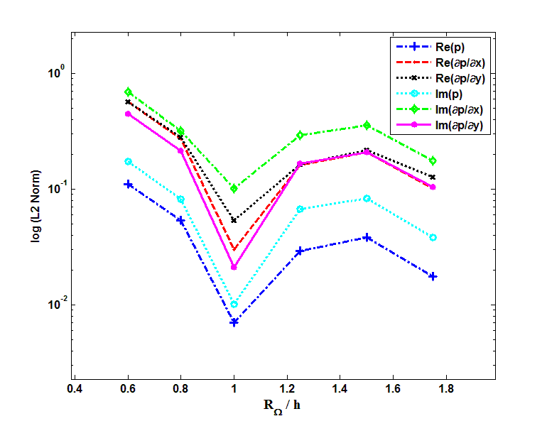

Figure ‎4.1: L2 Norm error for different $R_{Ω}$/h(N=10201, =24 and Nd=16).

Table ‎4.1: L2 Norm error for different $R_{Ω}$/h(N=10201, =24 and Nd=44).

|  |  |  |
| --- | --- | --- |
| $R_{Ω}$*/h* | **L2 Norm *Re*(***p***)** | **L2 Norm *Im*(***p***)** |
| 0.6 | 0.01348 | 0.03456 |
| 0.8 | 0.00365 | 0.01758 |
| 1 | 0.00580 | 0.00478 |
| 1.25 | 0.01288 | 0.01343 |
| 1.5 | 0.01728 | 0.02425 |
| 1.75 | 0.01788 | 0.02845 |
| 2 | 0.01353 | 0.02251 |
| 2.25 | 0.00598 | 0.00934 |
| 2.5 | 0.00516 | 0.00566 |
| 2.75 | 0.00922 | 0.00759 |
| 3 | 0.01032 | 0.00538 |
| 3.25 | 0.00640 | 0.03362 |
| 3.5 | 0.01278 | 0.09019 |
| 3.75 | 0.03391 | 0.17390 |
| 4 | 0.06113 | 0.27844 |

Next, the effects of the number of fictitious points on the circle of integration are investigated. Quadratic boundary elements are used for the representation of the circular boundary of the sub-domains. Note that the correlation between the neighbouring nodes is achieved via the RBF interpolation at the fictitious nodes which are then used in the integration over the sub-domain to obtain the influence of the surrounding nodes on the node in the centre of the circular sub-domain. The results reach a stable behaviour for  ≥ 24 (see Figure 4.2).

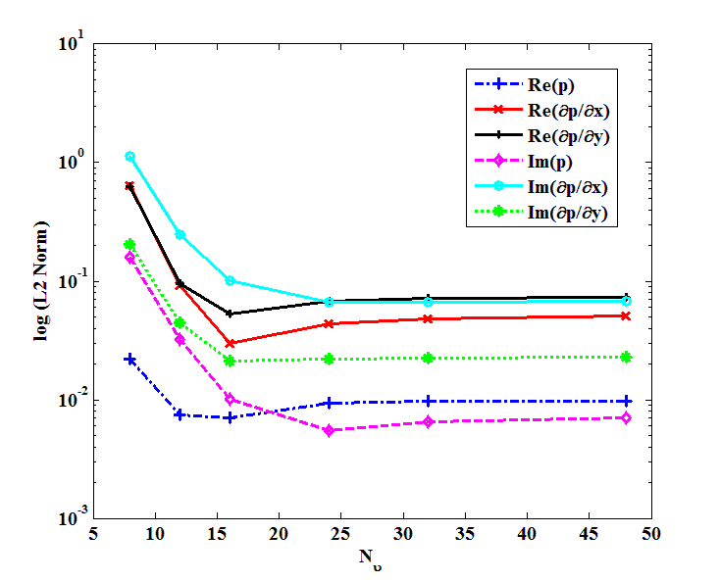

Figure ‎4.2: L2 Norm error for different **(**N=10201, Nd=16 and $R_{Ω}$ = h).

The number of neighbouring nodes used in the RBF interpolation is also investigated. The accuracy of the results increased as the number of nodes increased to 48, after which the interpolation errors begin to dominate. The results reach a nearly stable behaviour when Nd ≥ 28 (see Figure 4.3). Nevertheless, a choice of 16 nodes provides the best accuracy and therefore this number is preferred due to the significant increase in the sparseness of the overall matrix and the reduction in computational time.

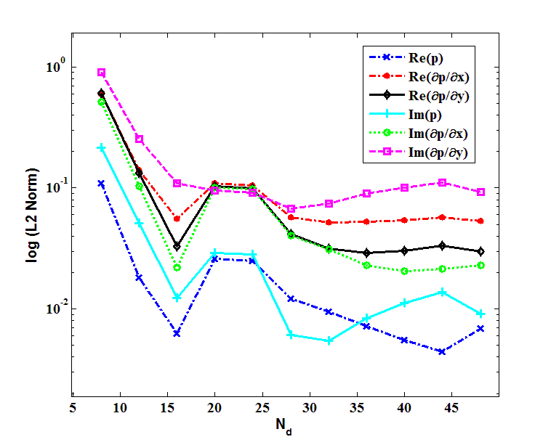

Figure ‎4.3: L2 Norm error for different Nd  **(**N=10201, =24and $R_{Ω}$ = h).

The performance of the method in terms of accuracy is investigated near the boundaries by varying the integration radius Rb and the number of nodes in the RBF approximation for the nodes on the boundary, Nb. Note that keeping the same value for Rb would decrease the computation time since the circular integration results in the same coefficients for fixed radius. Reducing the Rb and Nb produces slightly more accurate results; however, the improvement is not significant.

The overall convergence of the method can be observed in Figure 4.4 where the computations are carried out by distributing up to 360201 nodes in the solution domain.

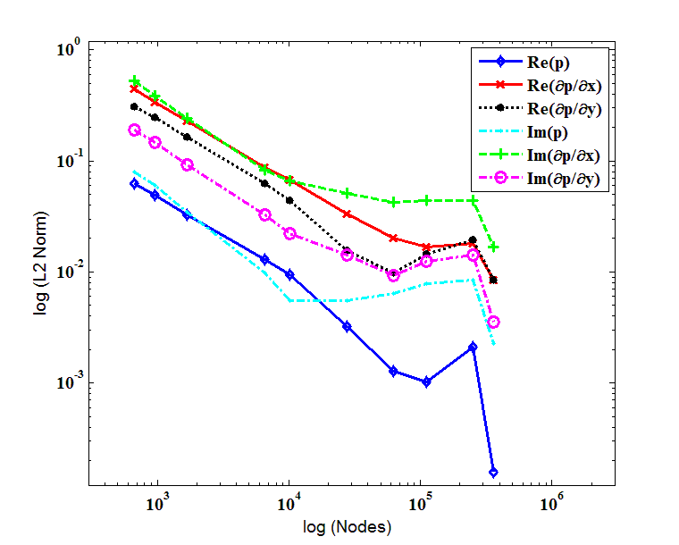

Figure ‎4.4: L2 Norm convergencewith increasing the number ofnodes (=24, Nd=16 and $R_{Ω}$ = h).

### Selection of the RBF

Another solution to the Helmholtz equation is used in order to test the effect of use of different RBFs. A square domain with length *L=1* is considered. The following boundary conditions are applied:

** (4.8)

** (4.9)

 (4.10)

 (4.11)

which yield the solution *p* = sin  sin .

Two different RBFs are used:

(i)  (4.12)

(ii)  (4.13)

where *f*1 is augmented with the first order polynomial 1 + *x* + *y,* while *f*2 is augmented with the second order polynomial 1 + *x* + *y* + *x*2 + *xy* + *y*2. The tests related to the selection of the best parameters (see Section 4.1.1) are performed for the second RBF, *f2*. Two of the optimum parameters are found to be the same as for the case of the first RBF, i.e. Nd=16and $R_{Ω}$ = h. For the choice of the number of fictitious nodes on each circle of integration, =24 produces slightly better results than =16. For the sake of brevity, related figures are not presented here. As can be seen in Table 4.2, the solution converges more rapidly when using *f2* compared to *f1.* Therefore, the use of *f2* allows one to solve the Helmholtz equation with higher wavenumbers for the same number of nodes used in the domain. In Table 4.2, one may also notice that the increase in the number of nodes, therefore a smaller value of *h*/λ, yields lower values of L2 Norm error, hence more accurate solutions.

Table ‎4.2: L2 Norm error comparison of *f1* and *f2* RBFs for k=6.

|  |  |  |  |
| --- | --- | --- | --- |
| ***f1*** | ***f2*** |  |  |
| ***Re*(p)**  **L2 Norm** | ***Re*(p)**  **L2 Norm** | **Number of Nodes** | **Time**  **(Sec)** |
| 2.4937 | 0.1624 | 441 | 1 |
| 0.7906 | 0.0348 | 1681 | 4 |
| 0.2887 | 0.0024 | 6561 | 16 |
| 0.1849 | 0.0033 | 10201 | 28 |
| 0.0237 | 0.0071 | 40401 | 162 |
| 0.0149 | 0.0075 | 63001 | 283 |
| 0.0280 | 0.0081 | 160801 | 903 |
| 0.0624 | 0.0078 | 251001 | 2344 |

The results obtained for higher wavenumbers using *f2* are shown in Table 4.3. The results are acceptable up to *k=78.29*. The resonant frequencies were avoided as much as possible while choosing the wavenumbers.

Table ‎4.3: L2-Norm error obtained by using *f2* for higher wavenumbers.

|  |  |  |  |  |
| --- | --- | --- | --- | --- |
| ***k*** | ***Re*(p)**  **(L2 Norm)** | ***Re*(∂p/∂*x*)**  **(L2 Norm)** | ***Re*(∂p/∂*x*)**  **(L2 Norm)** | **Nodes** |
| 20 | 0.0156 | 0.0242 | 0.0207 | 63001 |
| 36.2 | 0.0557 | 0.0489 | 0.0536 | 251001 |
| 43.18 | 0.0543 | 0.0515 | 0.0480 | 361201 |
| 50.02 | 0.0457 | 0.0541 | 0.0506 | 361201 |
| 61.36 | 0.0573 | 0.0554 | 0.0543 | 361201 |
| 72.05 | 0.0962 | 0.0989 | 0.1039 | 361201 |
| 78.29 | 0.2180 | 0.2163 | 0.2156 | 361201 |

As mentioned in Section 4.1.1, the optimum value of λ/h should be determined in order to complete the analysis related to the parameters $R_{Ω}$ and h. In Figures 4.5 and 4.6, L2 norms are plotted when the RBFs *f1* and *f2* were used, respectively. The plots indicate the required number of nodes per one wavelength. In Figure 4.5, the L2-norm decreases and becomes more stable for values higher than 80, whereas in Figure 4.6 the same is achieved for values higher than 40. The very high values of the L2 norm are set to 5 in the plots in order to provide visual clarity. The accuracy increases with increasing wavelength for any particular value of h. The observed peak values for some discrete values of λ/h are due to eigenfrequencies. For example, when h=0.01 and λ/h=100 it corresponds to k=2π which is the third lowest eigenvalue. Note that the combination of h=0.0125 and λ/h=80 would yield the same eigenvalue, which can be observed in the figures, and similarly for the other combinations. Lower values of λ correspond to higher eigenfrequencies in Figures 4.5 and 4.6. Overall, it can be concluded that the use of *f2* gives more accurate results compared to *f1*; and less nodes are required per one wavelength to obtain accurate results.

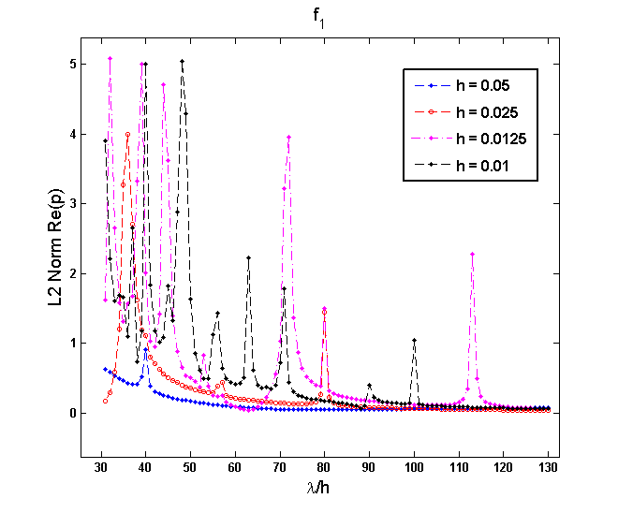

Figure ‎4.5: L2 Norm vs. λ/h for different values of h. RBF=*f1*, =24, Nd=16 and= h.

\\soton.ac.uk\ude\personalfiles\users\hd1n12\mydesktop\Post2\LvsDxf2.tif

Figure ‎4.6: L2 Norm vs. λ/h for different values of h. RBF=*f2*, =24, Nd=16 and $R_{Ω}$ = h.

## Dispersion error for the LBIE-RBF

The dispersion error for the solution of the Helmholtz equation with LBIE-RBF is investigated in this section. One should note that the dispersion error is measured and displayed for one source only in sub-section 4.2.1. The outcomes of the results from the sub-section 4.2.1 are used in the Sections 4.2.2 where the method is used in order to evaluate the wave propagation in a 2D example problem.

The motivation behind these computations is similar to what has been done for the RBIE method in Section 4.1. For example, the effect of local subdomain radius, , will be investigated for the LBIE, as it is done in Figure 4.1 and Table 4.1 for RBIE. Secondly, the behaviour of the error with respect to the variable *kh* is investigated. The variable *kh* is commonly referred to in this context; which is exactly the same measure as λ/hused in Section 2. It refers to how many source nodes per one wavelength are used. For example, let us assume a spacing of *h=*0.1 and a wavenumber *k=*1. This would yield a wavelength λ=2π, which means λ/h equals approximately 63. Thus, approximately 63 nodes will be used for one wavelength. Finally, a 2D numerical example will be presented in Section 4.2.2 which will allow one to investigate the overall L2 norm error. It will be observed that L2 norm error reduces significantly when the dispersion error at the source nodes is minimized.

### Dispersion error at a source node

Dispersion error depends mainly on the choice of the following parameters: (i) the radial basis function *f(R)*, (ii) the polynomial basis vector , (iii) the radius, , of the local subdomain and (iv) the radius of influence, *rinfl*, in the RBF interpolation. Throughout this section, the second order polyharmonic spline of the form  is used. Three different polynomial basis vectors are examined as mentioned through equations (3.32) - (3.33), namely LBIE-RBF*-m=6*, LBIE-RBF- and LBIE-RBF- . Square influence domains are considered with varying radius of influence *r*inf*l* = *h*, 2*h*, 3*h*, 4*h*.. An optimized local subdomain radius, which minimizes the dispersion error for each particular combination of the rest of the parameters, has been used.

In the LBIE, the radius of the local subdomain affects the solution significantly. To explain this issue, we shall refer to Figure 4.7. In Figure 4.7, a radius of influence domain *rinfl = h* is used and an arbitrary radius of circular sub-domain, , is sketched. One can realize that the modified test function, *p\*\**, given in Section 3.2 is a function of  and the radial basis function *f* in (3.31) is a function of *Riϑ*, i.e. *f=f(Riϑ)*. Therefore a variation in would affect both *p\*\** and *f*, thus the coefficients appearing in the global system matrix. Hence, an optimized value of the, which minimizes the dispersion error, should be determined within the range [0, *rinfl*]. In the following, results regarding the optimized values of radius are plotted for three different implementation of LBIE-RBF.

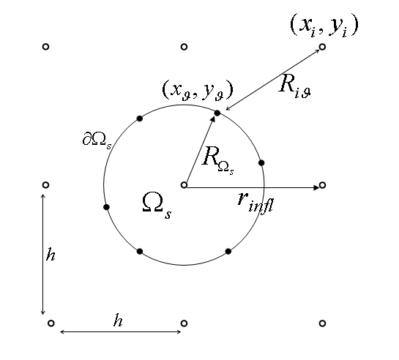

Figure ‎4.7: Interpolation of the values at the integration points.

Figure 4.8 shows the determined optimal values of according to the dispersion error using LBIE-RBF*-m=6*. It is observed that in the range , different values for the optimal are obtained for different *rinfl*; although for large values of *rinfl*, i.e. *rinfl=*4*h,* a larger is required. In the range , the optimal  values are close to each other for different values of *rinfl*. It is interesting to note that the optimal  tends to get smaller for all values of *rinfl* in the range; though this is an unexpected result, since the ratio $R_{Ω_{s}}/r_{infl}$ tends to very small values especially for *rinfl=*4*h.*



Figure ‎4.8: Optimal local subdomain radius for LBIE-RBF*-m=6*

Figure 4.9 shows the determined optimal values of according to the dispersion error using LBIE-RBF-. In the range , all three methods achieve the minimal dispersion error with a radius of integration, , approximately equal to 1.2 x *h*. It can be seen that in the range , for the large value of *rinfl=*4*h,* tends to 2.2 x *h*. Note also that in the range , the larger values of  produce more accurate results.



Figure ‎4.9: Optimal local subdomain radius for LBIE-RBF*-*

In Figure 4.10, where the results are plotted for LBIE-RBF*-*, an interesting behaviour can be observed for *rinfl=*4*h* in the range . The optimal value changes between two possible values, i.e. 1.2 x h and 2.2 x h. In fact, either of the two values can be used in the computations; since the computations show that any of the two values produces as low dispersion error as the other, though the minimal one is plotted in the figure. In the range , the optimal  values show significantly different behaviour. Finally, in the range the results are similar to the ones in the previous two figures: first one is the decreasing value of  with increasing *kh* and the second one is the necessity of large for *rinfl=*4*h.*



Figure ‎4.10: Optimal local subdomain radius for LBIE-RBF*-*

Figures 4.8-4.10 allow us to draw some conclusions. Provided that square-shaped influence domains are used in the methods, one should use the suggested values in order to get more accurate results when using LBIE-RBF for solving the Helmholtz equation. This is due to the fact that these suggested values minimize the dispersion error and the dispersion error is the major component of the overall pollution effect for numerical algorithms. It is highly important that these figures suggest a particular value of for each value of *rinfl* in the range , i.e. 1.2 x h for *rinfl* =2h and *rinfl* =3h and 2.2 x h for *rinfl* =4h. In most practical applications, the numerical computations are performed in this range and the exact value of *kh* is not necessarily known a priori. Further comments about the range  will be made below in this sub-section.

Figures 4.11 and 4.12 show the dispersion for the LBIE-RBF*-m=6* for the propagation angle. In Figure 4.11, the difference between the numerical wavenumber and the exact wave number (both in non-dimensionalized form) is plotted vs. the nondimensional exact wavenumber. This standard dispersion error plot shows that the discrepancy in those two variables increases with the wavenumber. This makes it difficult to obtain solutions for high wavenumber problems. Notice that increasing the *rinfl*leads to improved results for this particular case.



Figure ‎4.11: Difference between the non-dimensionalized exact and numerical wavenumber

From now on, the effect of plane wave propagation angle (), described within the harmonic evolution theorem in Section 3, will be investigated. Figure 4.12 shows the dispersion error over the propagation angle for *rinfl=3h* and two different values of *kh,* 1 and 2*.*

Numerical methods, in general, are called ‘dispersion-free’ in the literature, when the angle of propagation () coincides with the angle of the polynomial basis vector (). This can be observed in Figures 4.12 and 4.13 for the methods LBIE-RBF- and LBIE-RBF-.

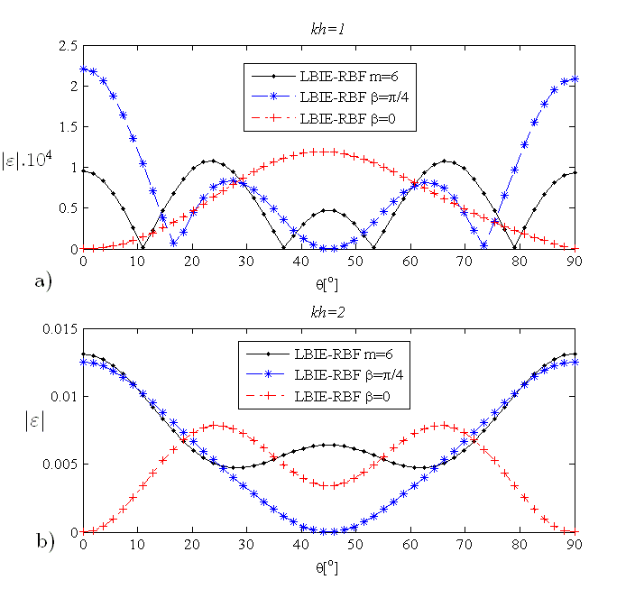

Figure ‎4.12: Dispersion error over the propagation angle; (a) and (b) .

In Figure 4.13, an overall measure of dispersion is shown for the varying range of and and for various values of *rinfl=2h, 3h, 4h*. Note that increasing *rinfl* leads to more accurate results, which is consistent with the previous results. It can be observed that the results get distorted when . We should note that for most numerical algorithms this range is already very inaccurate since the number of elements (or source nodes) per one wavelength is not sufficient. This can be illustrated as follows: let us assume the case *kh*=2. Further, we can choose two values for *k* and *h* as 2 and 1, respectively. This would yield a value of wavelength λ=π. Therefore, approximately three nodes per one wavelength would be used only. This kind of configuration is insufficient to produce accurate results for almost every numerical algorithm. If we recall equation (3.42), the overall pollution error scales with powers of *kh*; thus it increases significantly in this range. In practical applications, the simulations are carried out in the range *kh* < 0.5. It would be worthwhile at this point to compare the results obtained here, in terms of dispersion error, to the ones obtained in the previous section, which were presented in terms of the parameter λ/*h.* One may re-visit Figure 4.6 to observe that a value of λ/*h $≈$* 30 – 40 is required for accurate solutions when using second order RBF. Therefore, using the relation $=2π/λ$, one may evaluate that this indicates $kh ≈0.15-0.20$.

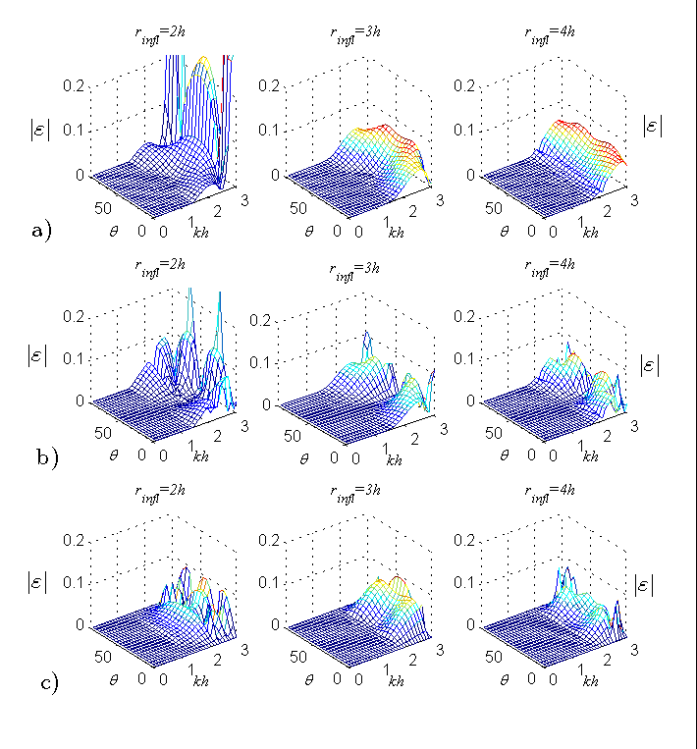

Figure ‎4.13: Dispersion error over and *kh*; (a) LBIE-RBF*-m=6*, (b) LBIE-RBF-and (c) LBIE-RBF-.

### Example problem in 1D

A numerical solution of the Helmholtz equation is presented in this sub-section in order to verify the validity of the approach. A rectangular domain is considered with side lengths *Lx=*1mand *Ly=*0.4m*.* The following boundary conditions are applied:

** (4.14)

 (4.15)

 (4.16)

with *k* being the wavenumber, which yield the solution *p* = 10cos*kx*.

In Figures 4.14-4.16, the results obtained by using LBIE-RBF-*m=6*, LBIE-RBF-  LBIE-RBF- are shown, respectively. The L2 norm error is plotted in order to visualize the accuracy of the three methods. The spacing, *h*, between nodes used in the solution is fixed at the particular value 0.1 and the wavenumber *k* is varied in a range [0 – 20], thus the range  is examined in the computations. Three different values of influence domain are investigated, namely *rinfl=2h,3h,4h*.

In Figure 4.14, L2 norm errors are plotted for LBIE-RBF*-m=6*. The *kh* values are varied within the range 0.01-2 and the magnitude of order of the obtained L2 norm error is in the range 10-6 to 102. Within the range *kh=*0.01-0.1, one can notice that the use of *rinfl*=2h and *rinfl*=3h produces more accurate results in comparison to *rinfl*=4h. Some peak values are observed in the plots which are due to the resonant wavenumbers for the solution domain considered. If we disregard those resonance effects, the L2 norm error increases with *kh* value for all three methods. This is an expected behaviour due to the previously mentioned pollution effect.



Figure ‎4.14: LBIE-RBF*-m=6* solution within the range .

Figure 4.15 presents the L2 norm errors for LBIE-RBF. Same range of *kh* values are used as in the previous case; though the magnitude of order of the obtained L2 norm error varies in the range 10-3 to 102 for this method. Within the range *kh=*0.01-0.1, *rinfl*=3h performs better than the other two *rinfl* values.

****

Figure ‎4.15: LBIE-RBF-  solution within the range .

In Figure 4.16, the results obtained with LBIE-RBF- are shown which are superior to the previous two methods. The L2 norms are as low as 10-10-10-8 in the range *kh=*0.01-0.1. The explanation to this fact is quite straightforward. As shown in Section 4.2.1, the frequency dependent basis functions prove to be ‘dispersion-free’ when the plane wave propagation angle, β, of the inserted basis coincides with the angle, θ, of wave propagation in the domain. For this example problem, the solution is given as *u=*10cos(*kx*) which is propagating in the direction θ=0. Therefore it is expected that the results will be more accurate than the other two methods. It is important to observe that the overall L2 norm error is very low when the dispersion error is low.

****

Figure ‎4.16: LBIE-RBF-  solution within the range *kh=*[0, 2].



## Wave propagation around thin structures

Next, wave propagation around thin structures will be investigated. For the 2D example problem considered, the principles explained in Section 3.5 regarding the selection of the neighboring nodes around curved and sharp edges are applied. For the 3D example problem, the technique of splitting domains is applied. The results with the direct implementation (without domain splitting) are also presented, which agree quite well with the domain splitting results. The results obtained by this technique are labeled as ‘LBIE-interface’ in the figures.

For both 2D and 3D example problems, the results are compared with those from the COMSOL software.

### 2D Example Problem

A sketch of the considered 2D example problem is given in Figure 4.17. A square domain with side lengths 300 mm x 300 mm is considered. A thin object, such as a thin plate with round, circular edges is placed in the interior of the domain the center of which is at the location (*x=*150mm, *y=*200mm). The thin plate has a length of 150 mm and a thickness 5 mm, and both ends of the rod have circular edges with radius 2.5 mm. For the boundary conditions the potential, *p* = 1000 Pa, is prescribed on the part of the boundary where *x=* [75 mm, 225mm], *y=*0 and $∂p / ∂n=0$ elsewhere on the outer boundary and on the surface of the thin plate (See Figure 4.17).



y (mm)

x (mm)

Figure ‎4.17: 2D sketch of problem geometry

When using the LBIE, these edges are simulated with constant elements, similarly as the sketches given in Figures 3.5 and 3.6. When using the RBIE, the boundary conditions are implemented according to equation (3.16). For this case, the direction of the unit normal vector is required, which is straightforward to obtain for a circular edge. For both RIBE and LBIE methods, the source nodes are placed 1mm apart and uniformly in the domain, thus approximately 900 source nodes are used. Note that the source nodes at the location of the thin body are omitted and the uniform node distribution is remained near the curved edges of the thin body as illustrated in Section 3 through Figures 3.5 and 3.6.

1. Case of *k=*20

The results obtained for *k=*20 are presented in Figure 4.18. The wave propagation patterns are very similar for the three solutions; however RBIE under-estimates the maximum pressure amplitude obtained in the domain, in comparison to COMSOL and LBIE.

|  |
| --- |
| C:\Users\HAKAN\Desktop\THESIS\radius5mmk20.bmp  (a) |
| C:\Users\HAKAN\Desktop\THESIS\compK20r5.png  (b) (c) |

Figure ‎4.18: Wave propagation for *k=*20. Results obtained using: *(a)* COMSOL, *(b)* RBIE and *(c)* LBIE

In order to obtain more accurate comparison, the plots over two lines/profiles selected in the domain are given. The propagation along line *y* = 150 mm is plotted in Figure 4.19. It can be observed that RBIE and LBIE produce similar results and COMSOL predicts a higher value of the peak amplitude for this particular profile.

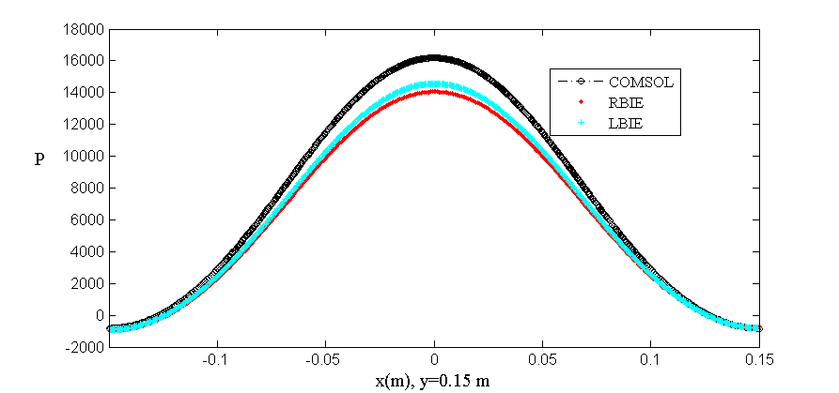

Figure ‎4.19: Calculated pressure for the three different solutions along the line *y=*150 mm for *k=*20.

In Figure 4.20 the results along the *y* direction are displayed along the line *x=*0. In this figure it can be observed that RBIE and LBIE produce similar results. The overall agreement of LBIE and RBIE with COMSOL in both figures is good.

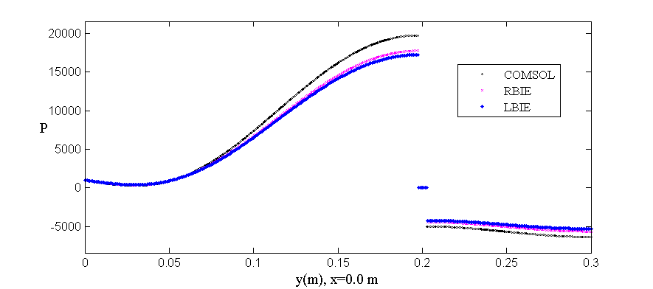

Figure ‎4.20: Calculated pressure for the three different solutions along the line *x=*0 for *k=*20. The discontinuity (the short line) around *y=*0.2 m represents the thin body and P is assigned as zero at this location.

1. Case of *k =* 60

In this section, the wavenumber is increased to 60, which requires higher number of nodes to be used in the computations. For the LBIE and RBIE computations uniformly distributed source nodes with 0.5 mm distance between them are used, which results in approximately 361,000 nodes. In Figure 4.21, the wave propagation results obtained using the three methods are presented. Good agreement is found.

|  |
| --- |
| C:\Users\HAKAN\Desktop\THESIS\radius5mmk60.bmp  (a) |
| C:\Users\HAKAN\Desktop\THESIS\compK60r5.png  (b) (c) |

Figure ‎4.21: Wave propagation for *k=*60. Results obtained using: *(a)* COMSOL, *(b)* RBIE and *(c)* LBIE

Similarly as in the previous case, additional plots are given in Figures 4.22 and 4.23 along the lines varying in *x* or *y* directions, respectively. In Figure 4.22, where the results are plotted along the line *y=*150 mm. It can be observed that RBIE agrees with COMSOL better than LBIE in the region *x=*[-0.10, -0.050] and *x=*[0.050, 0.10]; whereas LBIE agrees better in the range *x=*[-0.050, 0.050], and also *x=*[-0.15, -0.10] and *x=*[0.10, 0.15].

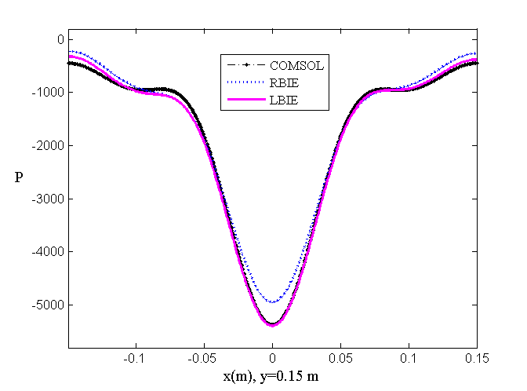

Figure ‎4.22: Calculated pressure for the three different solutions along the line *y=*150 mm for *k=*60.

In Figure 4.23, the results are plotted along the line *x=*0. It is observed that LBIE shows good agreement with COMSOL; so that the difference is not visible in the given plot. RBIE also shows a good agreement overall.

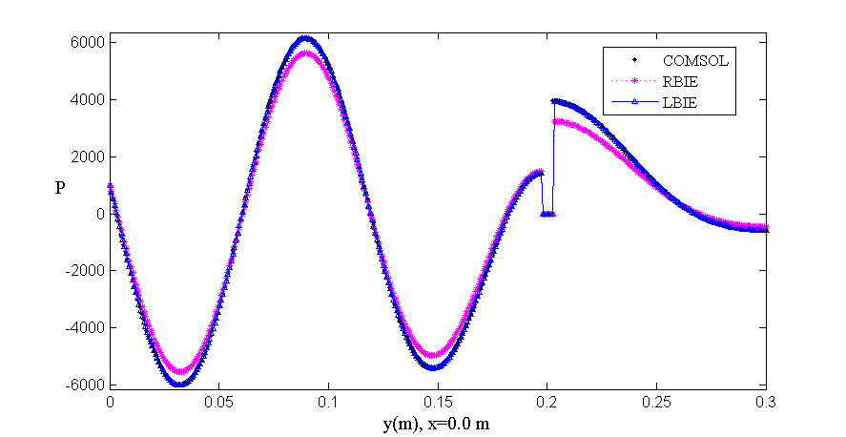

Figure ‎4.23: Calculated pressure for the three different solutions along the line *x=*0 for *k=*60. Similarly, the discontinuity around *y=*0.2 m represents the thin body and P is assigned as zero at this location.

### 3D example problem

In this sub-section, the acoustic wave propagation around a thin plate immersed in a liquid is investigated for a 3D problem. A solution domain with dimensions 100mm x 100mm x 60mm is considered, 60mm being the height (See Figure 4.24). A thin plate with 50mm x 50mm cross-section is placed at the center of the domain, i.e. at the coordinates (50mm, 50mm, 30mm). Two different cases are considered for the thickness of the thin plate, ht, i.e. ht = 1mm and the null thickness (denoted as ht =0 in the figures). For the boundary conditions; $∂p / ∂n=0$ is prescribed on the boundary of the thin plate and on the side walls. On the top surface, i.e. z = 60 mm plane, the condition *p=*0 is prescribed. Acoustic source is placed at the bottom of domain, on the *z=*0 plane. A square-shaped transducer, with dimensions 60mm x 60mm, is located on this plane, its center being at the location (50 mm, 50mm, 0). A constant pressure amplitude *p=*10 Pa is prescribed on the surface of the transducer and $∂p / ∂n=0$ is prescribed on the remaining part of the bottom surface. For the computations in this sub-section, source nodes are placed with 1 mm distance between them which results in approximately 600,000 source nodes. Note that source nodes are placed only at the top and bottom surfaces of the thin structure (not at the sides) without any mesh refinement towards the edges.

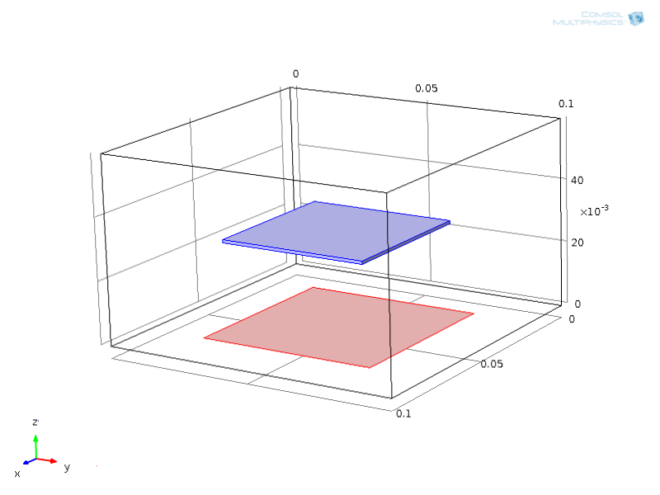

Figure ‎4.24: 3D sketch of the problem geometry. A thin square plate is located in a inside the domain. A square-shaped transducer is placed at the bottom surface. Dimensions are in millimetres.

All the results in this sub-section are plotted for the wave propagation profile on the top surface of the thin plate. Note that the results include both 1mm and null thickness cases, which are denoted as ht=1 and ht=0 in the figure captions, respectively. Further, note that the value of *z* coordinate will be either 30.5 mm or 30 mm for the cases ht=1mm and ht=0, respectively, when plotting the pressure profiles on the top surface of the thin body. The wave profiles obtained using different implementations of LBIE are compared to COMSOL results. For the COMSOL results, two different models are also built, i.e. with a plate thickness 1 mm and 0 mm. In the COMSOL model, the domain is handled with finite element mesh, e.g. tetrahedrons. COMSOL produces gradually refined mesh near the edges of the thin body when the 1 mm thick case is built. For the null thickness case, it is convenient to apply domain splitting method also with COMSOL in order to implement the boundary conditions in an appropriate way. The legend notations are as follows: ‘LBIE – interface’ denotes the solution obtained by using the domain splitting method described in Section 3.5. ‘LBIE-R3’ denotes the method where polynomial basis is used in the RBF interpolation, and ‘LBIE-sin/cos’ refers to the case where the previously mentioned frequency dependent basis is used in the RBF interpolation. For LBIE-R3 and LBIE-sin/cos, the selection of the influence nodes is performed without introducing the ‘interface’. For these two cases a simple condition is applied. For example, for the nodes on the top surface of the thin body, the influence nodes above the level *z=*30.5 mm are considered and for the nodes on the bottom surface of the thin body, the influence nodes below the level *z=*29.5 mm are considered, for the 1 mm thickness case. For null thickness, the plane *z=*30 mm is considered as a reference during the selection. We should note that the explicit formulas for the polynomial and frequency dependent basis functions are different in 3D problems than in 2D problems. An orthogonal frequency dependent basis may be written as follows [78],

|  |  |
| --- | --- |
| $$\vec{t}\left(x,y,z\right)=[ 1 \cos\left(kx\sin{θ}\cos{∅}+ky\sin{θ}\sin{∅}+kz\cos{θ}\right) \sin\left(kx\sin{θ}\cos{∅}+ky\sin{θ}\sin{∅}+kz\cos{θ}\right) \cos\left(-kx\sin{θ}\cos{∅}+ky\sin{θ}\sin{∅}+kz\cos{θ}\right) \sin\left(-kx\sin{θ}\cos{∅}+ky\sin{θ}\sin{∅}+kz\cos{θ}\right) \cos\left(kx\sin{θ}\cos{∅}+ky\sin{θ}\sin{∅}-kz\cos{θ}\right) \sin\left(kx\sin{θ}\cos{∅}+ky\sin{θ}\sin{∅}-kz\cos{θ}\right) \cos\left(-kx\sin{θ}\cos{∅}+ky\sin{θ}\sin{∅}-kz\cos{θ}\right) \sin{(-kx\sin{θ}\cos{∅}+ky\sin{θ}\sin{∅}-kz\cos{θ})}$$ | (4.17) |

where ϕ is the polar angle and θ is the azimuthal angle.

In Figure 4.25, the wave profile obtained by using LBIE for *k=*5 and ht=0 is given. In the subsequent figures, the wave profile on the same surface is plotted along the line *x=*[25 mm, 75 mm], y=50 mm.

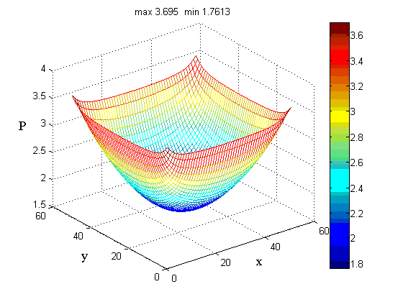

Figure ‎4.25: Wave profile on the top surface of the thin plate for *k*=5 and ht=0.

In Figure 4.26, the pressure wave profile along the line *x=* [25 mm, 75 mm], y=50 mm is plotted for the null thickness case. It can be observed that the LBIE methods produce very similar results. The COMSOL result indicates slightly higher wave amplitude.

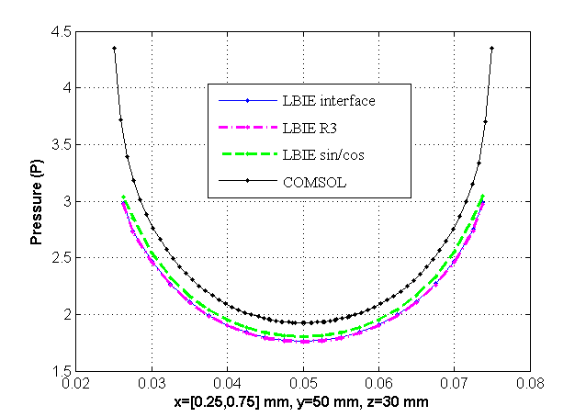

Figure ‎4.26: Pressure wave profile along the line (*x=*[25 mm, 75 mm], y=50 mm, z=30mm) for *k*=5 and ht=0.

In Figure 4.27, the pressure wave profile along the line *x=* [25 mm, 75 mm], y=50 mm is plotted for 1mm thick plate. It can be observed that the LBIE methods agree with COMSOL result better than the null thickness case. Overall agreement is good.

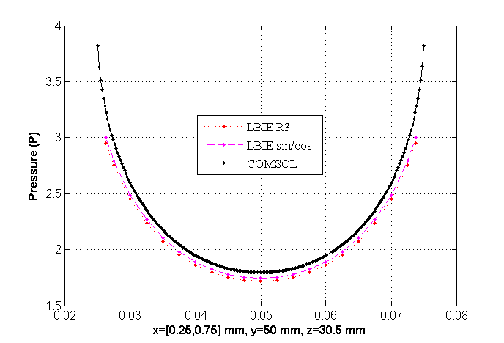

Figure ‎4.27: Pressure wave profile along the line (*x=*[25 mm, 75 mm], y=50 mm, z=30.5 mm) for *k*=5 and ht=1.

In Figure 4.28, the pressure wave profile along the line *x=* [25 mm, 75 mm], y=50 mm is plotted for the null thickness case and wavenumber *k=* 5π. In addition to the previous computations, a finer distribution of source nodes is included in order to visualize the convergence of the LBIE solution. In Figure 4.28a, it is seen that the three different LBIE methods produce very similar results as in the previous case. Further, we can notice that the finer mesh produces a result which is closer to the COMSOL result. This fact can be better visualized in Figure 4.28b, where a zoomed plot on the same result is given. It can also be observed that ‘LBIE-sin/cos’ method performs better than other LBIE methods.

|  |  |
| --- | --- |
| (a) | \\soton.ac.uk\ude\personalfiles\users\hd1n12\mydesktop\re\k5pih0.png |
| (b) | \\soton.ac.uk\ude\personalfiles\users\hd1n12\mydesktop\re\k5pih0zoom.png |

Figure ‎4.28: Pressure wave profile along the line (*x=*[25 mm, 75 mm], y=50 mm, z=30 mm) for *k*=5π and ht=0.

In Figure 4.29, the wave profile along the line *x=* [25 mm, 75 mm], y=50 mm is plotted for the null thickness case and wavenumber *k=* 5π. One can notice that better agreement is obtained overall in comparison to null thickness case. Further, the ‘LBIE-sin/cos’ methods agrees very well with the COMSOL method near the corners of the thin plate; though there is still some discrepancy between results in the middle of the plate where the lowest values for the pressure is observed. Similarly as in Figure 4.28b, a zoomed plot on the same result is given in Figure 4.29b. It is seen that ‘LBIE-sin/cos’ method performs better than ‘LBIE-R3’ method.

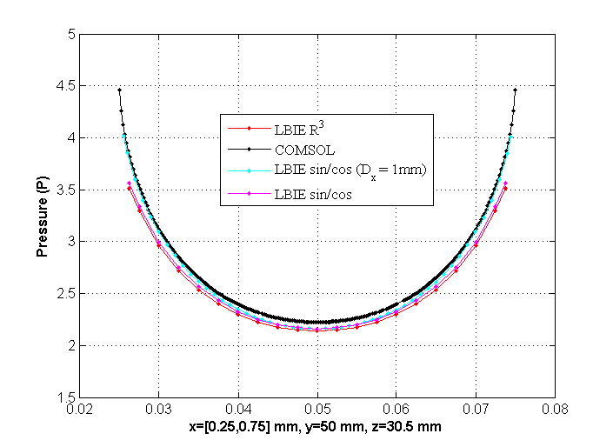

(a)

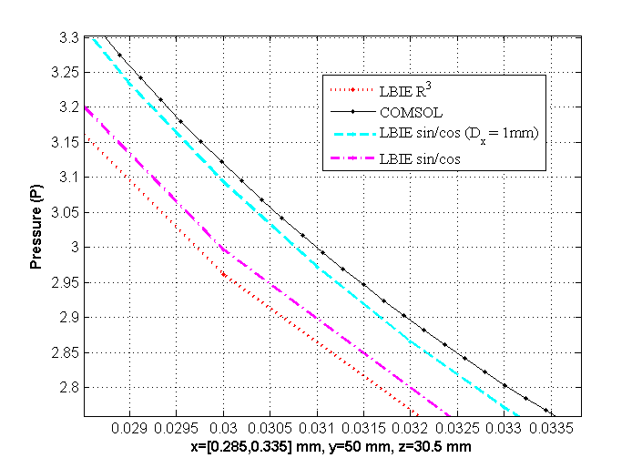

(b)

Figure ‎4.29: Pressure wave profile along the line (*x=*[25 mm, 75 mm], y=50 mm, z=30.5 mm) for *k*=5π and ht=1.

Regarding the parameters used within the numerical models, based on the solved example problems in this chapter, some recommendations can be given as follows: For the sub-domain radius, $R_{Ω}$, a value equal to the distance between source nodes, *h*, should be used in both 2D and 3D computations. For the integration over the boundary of the local sub-domain, in 2D, 8 quadratic boundary elements (16 fictitious points) are used in the implementation of RBIE and 10 Gauss points were used for each (radial and polar) integration variable in the Gaussian quadrature integration in the implementation of LBIE. In 3D, Gaussian quadrature integration is applied for both methods which required, similarly to the 2D case, 10 Gauss points for each (radial, polar and azimuthal) integration variable for accurate computations. For the number of influencing nodes in the RBF interpolation, at least 16 nodes in 2D and 40 nodes in 3D are required for both methods. For the number of source nodes, approximately 30 nodes are required per one wavelength, in each dimension, for computations involving high frequency; though this number can be reduced for low frequency example problems. For wave propagation around thin structures; in 2D, 3-4 are required along the thin edge of the thin slit in order to resolve the geometry of the problem, which is sufficient without the necessity for mesh refinement. Recall that in 3D, the high computational memory requirements do not allow to use such a fine distribution of source nodes. Instead, a domain splitting method is applied in which case the separation between two consecutive source nodes can be taken as approximately equal to the thickness of the thin structure, i.e. 1 mm for the computations in this thesis.

# 

Applications of methods in bubbly liquids

In this chapter, the developed numerical models are applied to actual sonoreactors which is the ultimate aim of this thesis. The developed numerical algorithms, RBIE and LBIE, are both capable of solving the Helmholtz equation in a non-homogeneous medium where the wave number changes due to presence of bubbles. In addition, both of them are capable of dealing with the nonlinearity which is caused by the effects of bubble population field on the sound field. Further, the presence of the textile fabric in the domain is taken into account by solving the wave propagation around thin structures.

The examples in this chapter are as follows: In Section 5.1, a tube filled with water, containing bubbles, is considered. A moving piston on the left end of the tube supplies the acoustic forcing. For the bubble population field, a homogeneous distribution is considered, with constant bubble radius, i.e. mono-disperse distribution. Both linear and nonlinear wave propagation is solved, so that one may compare the results in order to anticipate the corresponding attenuation of the waves. Further, the bubble volume fraction or the bubble radius is varied in order to display the corresponding effects of each parameter. In Section 5.2, a sonoreactor design suggested by CEDRAT TECHNOLOGIES S.A., a participant in the SONO project, is examined. In this case 2D cross-sections of the actual sonoreactor are examined, and the effect of bubble size distribution is discussed. The following Gaussian type of distribution function is considered,

 (5.1)

where the range of bubble radii is from R1 to R2, R0 is the mean bubble radius and $τ$ is the standard deviation. The parameter *d* is determined by the criteria to match the bubble volume fraction *β*. To see the dependence of bubble volume fraction β on the distribution function *f*, one may re-visit equation (2.4). Finally, a 3D sonoreactor example including textile fabric is considered, the design of which is provided by VIATECH Ltd., a participant in the SONO project. Due to symmetry conditions in the sono-reactor, a quarter model of the actual reactor is built and solved. In this example, and what is, in fact, the ultimate aim of this thesis, the wave distribution and amplitude on the textile surface is highly important in order to interpret the activity of nanoparticle impregnation. For this purpose, the wave propagation on the textile surface is examined for various configurations of bubble size range. In all examples, air bubble – water mixture is considered. Therefore, following material properties in the mixture are used: ρ = 1000 kg/m3, μ = 0.001003 kg/ms, σ = 0.0725 N/m and the sound velocity in water is 1500 m/s. We shall note that the nonlinear wave propagation is solved only for the 1D example, due to high computational requirements. For the nonlinear wave propagation case, approximately 16,000 nodes are used and the solution required 150,000 iterations which required approximately 7 days. For the 2D example, 180,000 and 290,000 nodes are used during the simulations in *x-y* plane and *y-z* plane, respectively. Finally, for the 3D quarter model, the solution domain is simulated by using 800,000 source nodes.

## Acoustic cavitation in a 1D problem

In this section, the solution of linear and nonlinear wave propagation is investigated in a 1D problem. In this case a tube of length *L=*0.1m*,* filled with water, is considered. Air bubbles are assumed to be uniformly distributed within the tube. Further, bubble radius is assumed to be constant for the computations in this section. At the left end of the tube, a piston with harmonic oscillations *U=U0 cos(ωt)* is considered where *U0* is the displacement amplitude and ω is the angular frequency of the driving sound field. The driving frequency is set at *f=*20 kHz. On the right end of the tube, an infinitely soft boundary is assumed which yields zero acoustic pressure. This particular setup allows us to investigate the standing wave profiles in liquid filled tube.

Initially, the results for pressure amplitude in the tube are presented for the case when the bubbles are absent. In Figure 5.1, the pressure amplitudes for three different excitation values, *U0* = 0.2µm, *U0* = 0.5 µm and *U0* = 5 µm, are presented. Thereafter, in Sections 5.1.1 and 5.1.2 the wave profiles are plotted for several bubbly liquid cases so that one may see the effects of bubble population on the sound propagation by comparing those results to the results obtained in Figure 5.1.

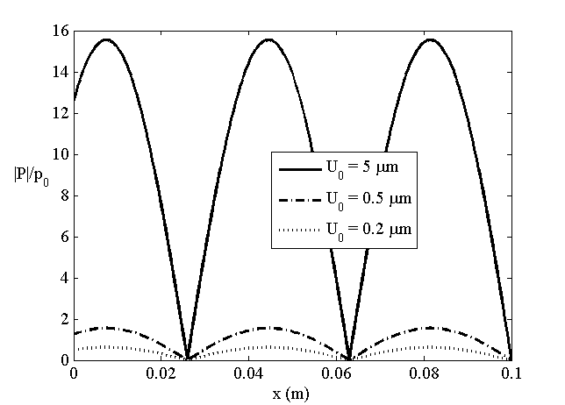

Figure ‎5.1: Initial pressure wave profiles in pure liquid for different excitation values.

The results throughout this chapter are presented in terms of pressure distribution; in particular the absolute value of the pressure is plotted in most figures. When interpreting the results, the distance between subsequent pressure nodes (or antinodes) will give an insight about the wavelength, λ. From the relation between phase velocity, *V,* and wavelength, λ, one can draw conclusions about the two, since the phase velocity in the mixture is given by *V=λ/T* with *T* being the period of oscillations. Further, a drop in the pressure amplitude will indicate an attenuation of the sound wave, since attenuation of the sound wave scales with the quantity *log (P1/P2) (x1-x2)* where *x1* and *x2* are arbitrary locations and *P1* and*P2* are the pressure amplitudes at these locations respectively.

### Linear wave propagation

The wavenumber of the mixture is given for the linear theory by equation (2.28) and it is dependent on the following physical properties: the driving frequency of the sound field (ω), equilibrium pressure in the liquid (*p∞*), surface tension (σ), liquid viscosity (μ), liquid density (ρ), velocity of sound in liquid (*c*) and distribution of the bubbles (*f(R)*). Since constant bubble size assumed in this section, for a given value of the bubble volume fraction, number of bubbles, *n,* is evaluated from equation (2.3).

In Figure 5.2, the pressure profiles are shown for a mixture containing 5 µm radius bubbles for the case of excitation *U0* = 5 µm. The bubble volume fraction, β, is increased from 0.005 % to 0.012 % which would yield an increase in the number of bubbles present in the mixture. Two facts can be observed with the increasing bubble volume fraction: *(i)* the phase velocity of the mixture decreases, therefore the wavelength decreases, and *(ii)* the attenuation of wave gets larger, so that the initial pressure wave amplitude gets smaller. Both effects are commented below. As mentioned in the Introduction chapter, the presence of bubbles alters the wave speed, thus the phase velocity decreases. The latter fact is directly related to the damping caused by the bubble oscillations. As the number of bubbles increases in a mixture, one may expect larger amount of dissipation thorough bubble oscillations.



Figure ‎5.2: Pressure profiles with increasing bubble volume fraction, β. U0 = 5 µm and R0 = 5 µm.

In Figure 5.3, the effect of bubble radius on the pressure profiles is investigated. For this purpose, the bubble volume fraction, β, is kept constant at 0.005 % and the same excitation on the piston boundary is applied, i.e. *U0* = 5 µm. Since the bubble volume fraction in the mixture is kept constant, one can notice that the mixture with smaller bubble radius will contain more amount of bubbles, i.e. larger *n.* One can observe in the figure that with increasing bubble radius, the phase velocity of the mixture decreases and the wave gets more attenuated. The reason for the further decrease and higher attenuation with increasing bubble size is that bubbles with larger radii dissipate more energy during the oscillations. Therefore, the decrease in the number of bubbles is compensated by the dissipation by larger bubbles yielding an overall effect of increased dissipation. One may realize that Figures 2.1 and 2.2 also support the conclusions drawn in this sub-section.



Figure ‎5.3: Pressure profiles for different bubble radii, R0. U0 = 5 µm and β= 0.005 %.

### Nonlinear wave propagation

In this section, the case of nonlinear wave propagation is investigated. The governing Helmholtz equation is given through equations (2.44)-(2.46). The bubble radius and the bubble volume fraction are kept constant at R0 = 5 µm and β=0.005 %, respectively. For these values, the thermal and viscous dissipation are given in Figures 2.1 and 2.2, and the corresponding wavenumber profile as a function of driving pressure is in Figure 2.3.

In Figure 5.4, the results for *U0=*0.5 µm are presented. The solid line gives the standing wave profile in water without bubbles, whereas the dashed line represents the case with bubbles. It can be observed that the wave profile is damped at the pressure antinodes; further the dissipation by bubbles yields a nonzero acoustic pressure at the pressure nodes



Figure ‎5.4: Pressure profiles for *U0* = 0.5 µm.

In Figure 5.5, a comparison of pressure profiles for *U0* =0.2 µm, *U0* =0.5 µm and *U0*=5 µm are given. The lowest excitation case corresponds to a wave profile where the maximum pressure amplitude is below the Blake threshold. For this case, cavitation is not expected to occur. The medium excitation case was investigated above and is plotted here again for comparison. For the highest excitation, it can be observed that the wave is highly attenuated near the emitter. For the rest of the tube, the profile is similar to that of a standing wave, as such the peaks occur at the same locations as the *U0*= 0.2 µm and U0 = 0.5 µm cases. The high amplitude of pressure waves near the emitter indicates a high cavitation zone near the emitter surface.



Figure ‎5.5: Pressure profiles for the cases: *U0* = 0.2 µm, *U0* = 0.5 µm and *U0* = 5 µm.

For both computations, bubble volume fraction is increased by 0.000005% at each step to its final value β=0.005% (which corresponds to 1000 steps in total). In addition, a maximum of 3% change is permitted for the relative error, over which an under-relaxation is applied for the whole pressure profile. This step is important for the convergence process due to following reasons. When the bubble volume fraction increases in the mixture, the solution gets highly oscillatory which brings out instability. As mentioned above, in the nonlinear solution procedure given by the flow chart in Table 3.1, a number of inner iterations are permitted for each increment of bubble volume fraction. For the high values of bubble volume fraction (which corresponds to the later stages of the overall solution) this number of inner iterations increases to 200-250. The maximum number of inner iterations for each increment of bubble volume fraction was limited to 400 and in some cases the solution did not converge within the prescribed 400 iterations. Typically, it was observed that the solution exhibits large oscillations which yield either an increase or decrease in the overall pressure amplitude. Therefore, an under-relaxation is proposed in order to ensure the stability and convergence. For the under-relaxation parameter, *α=*0.2, is used in the computations. The tolerance value 10-6 for the *RMS* error was employed. The overall solution required approximately 150,000 iterations.

## 2D acoustic wave propagation within a model reactor

In this section, the 2D acoustic wave propagation in a model sonoreactor is examined. A sketch of the reactor is given in Figure 5.6. The reactor has three transducers and two heaters, all of which are of cylindrical shape. The transducer and heater locations in the *x-y* plane are marked as ‘T’ and ‘H’, respectively (See Figure 5.6.a). The textile fabric rolls over cylindrical cages mounted at the outer of the transducers. The transducers produce vibrations in z-direction and the motion is transverse into both *x-y* plane and *y-z* plane. The heaters are used to maintain the mixture temperature at around 60oC. The reactor has eight inlets and an outlet for the recirculation of liquid. A perspective view sketch of the sonoreactor is given in Figure 5.6.c, and the *x-y* ad *y-z* plane cross-sections are given in Figure 5.6.a and 5.6.b, respectively. One should note that in the cross-section figures, small details due to fluid inlets and outlets are omitted for simplification of the computations.

|  |  |
| --- | --- |
| (a) | C:\Users\stnadult.SCC-PUB-LIBRARY.003\Desktop\x-y_plane.png |

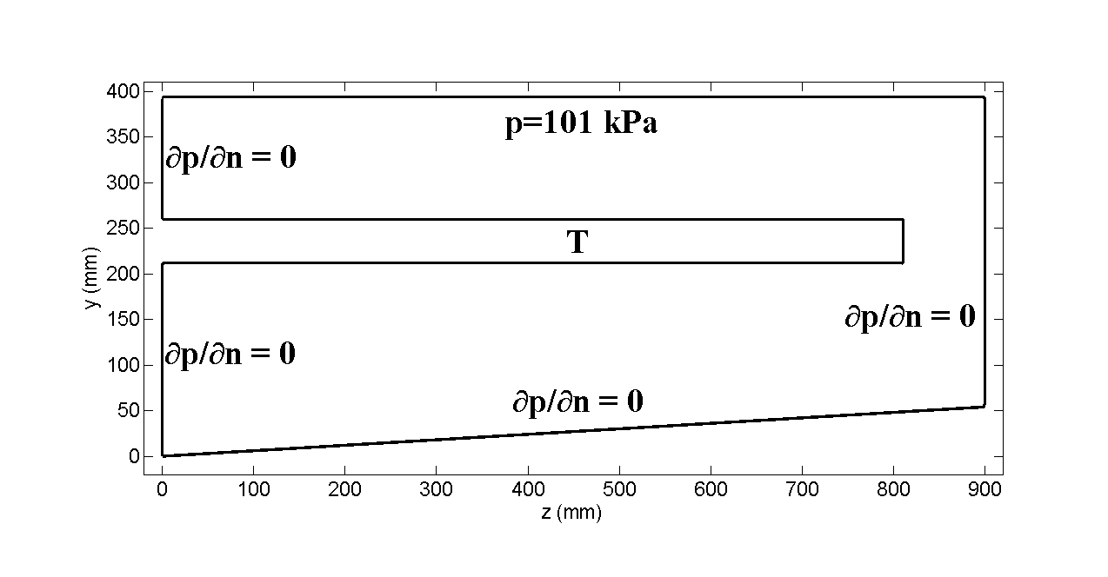

(b)

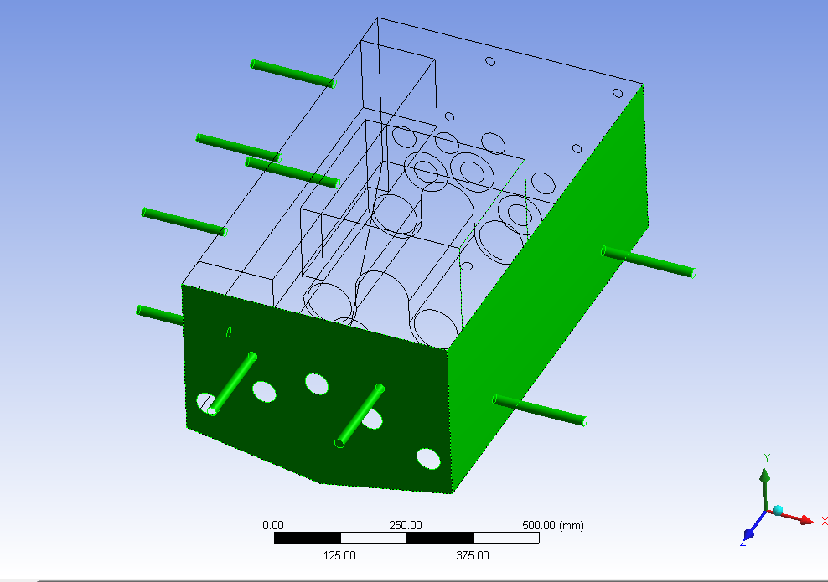

(c)

Figure ‎5.6: A sketch of the sonoreactor. (a) *x-y* plane (b) *y-z* plane and (c) perspective view.

The linear wave propagation is examined; therefore the governing equations are similar to those used in Section 5.1.1. Note that only the uniform bubble size case was investigated in the former section, whereas the results regarding the effects of bubble size distribution are presented here. The wavenumber of the mixture is given for linear theory by equation (2.28) and distribution of the bubbles is represented by the function *f(R)* given by equation (5.1). Therefore, for a given bubble volume fraction, one can evaluate the unknown constant *d* in (5.1) by using equation (2.4) for the bubble volume fraction. The transducer frequency is 20 kHz and the wave propagation through 2D cross sections (*x-y* and *y-z* planes) of the reactor is solved using the RBIE. Throughout this section, the normalized (with respect to atmospheric pressure) values of pressure are plotted.

### Propagation through *x-y* plane

The following boundary conditions are applied on the surfaces of sonochemical reactor model:

(5.2)

 (5.3)

 (5.4)

 (5.5)

The boundary conditions on the transducer surface were applied as follows:

(5.6)

in which the velocity vector is known by the formula:

(5.7)

where *A* is the maximum displacement on the transducer surface. *A* is chosen to be 0.5 µm during the simulations for the simulations in the *x-y* plane. One should note that in the actual sonoreactor cylindrical transducers are used and the displacement on the transducer surface varies along the *z-*direction. The variation of the displacement, *A*, will be presented in the next sub-section where it will be of paramount importance for the wave distribution. Here in this sub-section, we choose a constant value for *A,* and investigate the effects of other parameters. Note that for the above mentioned geometry and the applied boundary conditions in the *x-y* plane, the wave propagation should be symmetric with respect to the line *x=*275 mm. However, as will be seen through the results shown below, the symmetric wave propagation is not obtained in all cases. This is mainly due to the source node distribution and interpolation errors which arise during the RBF interpolations. In this work uniform source node distribution is applied, the source nodes at the locations of transducers and heaters are omitted, and the circular boundary of the heaters and transducers are represented with an additional set of source nodes. Therefore, the symmetric nature of the problem is broken when the local interpolations are considered. An example of source node distribution near a transducer can be found in Figure 5.7.

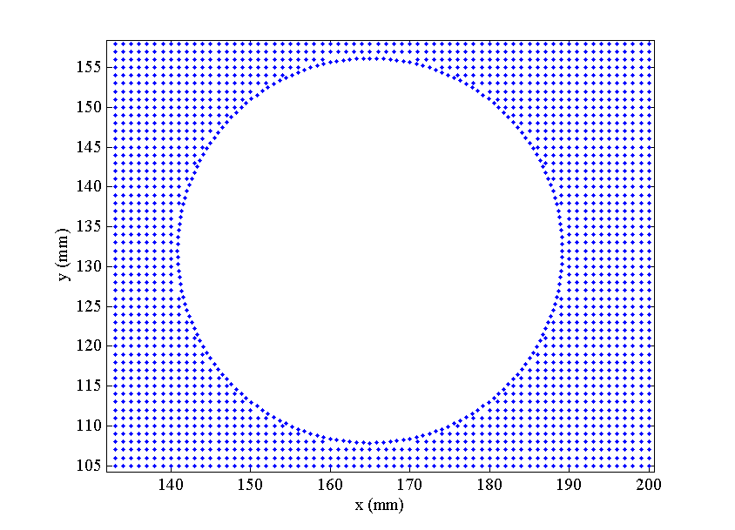

Figure ‎5.7: Source node distribution near the surface of the transducer centred at *x=*165 mm and *y=*132.5 mm.

In Figures 5.8 and 5.9, the pressure profiles are investigated according to increasing values of bubble volume fraction. In both figures, the first sub-plot refers to the pure liquid case (where there is no bubble). As can be seen in the first sub-plot, the maximum pressure reads approximately 28 *p∞* (~ 3 MPa) where *p∞* is the atmospheric pressure. In Figure 5.8, a radius range from 1-10 µm is employed. It can be observed that the pressure amplitude can be as low as 3-4 *p∞* when the bubbles are present. It is interesting to see that maximum pressure amplitude, P, increases from the case β=0.005% to β=0.02%. It is expected that the latter case should have caused more damping. However, the reason for such an amplification of the waves can be due to other reasons such as superposition due to geometry. Zhang and Prosperetti [81] also reported such amplification of waves, though in their study the reasons for that were other physical phenomena such as the effect of bubble interactions and translational motions. Meanwhile, it is worth to observe that the wavelength decreases with increasing β.

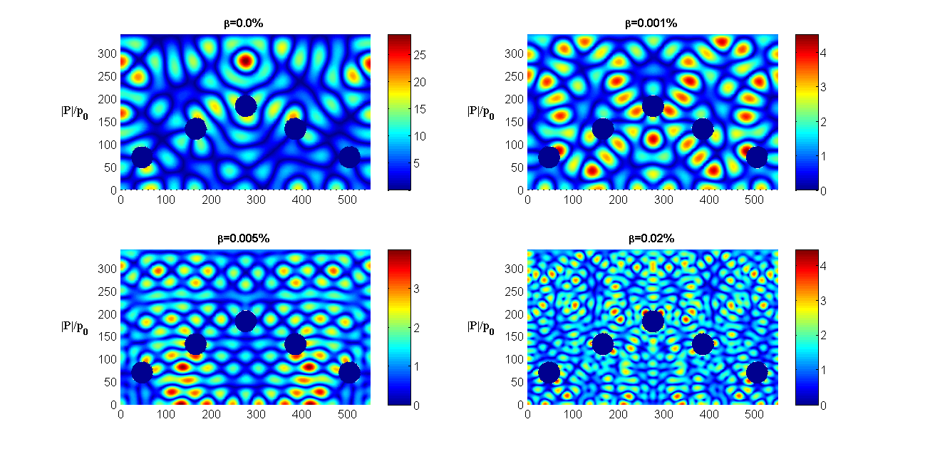

Figure ‎5.8: Effect of bubble volume fraction (R=1-10 µm)

In Figure 5.9, the results with a radius range from 10-100 µm are shown. Similarly to the previous case, the wavelength decreases and the attenuation gets larger with increasing bubble volume fraction β. It can be noticed, by comparing the sub-plots individually with Figure 5.8, that the damping of the acoustic energy is higher for this case. For example, the maximum pressure amplitude in Figure 5.9 with β=0.02 % is around 1 *p∞*; whereas it is over 4 *p∞* in Figure 5.8. This result is similar to the one obtained in the 1D example problem; where it was observed that larger bubbles cause higher attenuation. Similarly in this case, the attenuation gets higher when a bubble size distribution with larger bubbles is chosen.

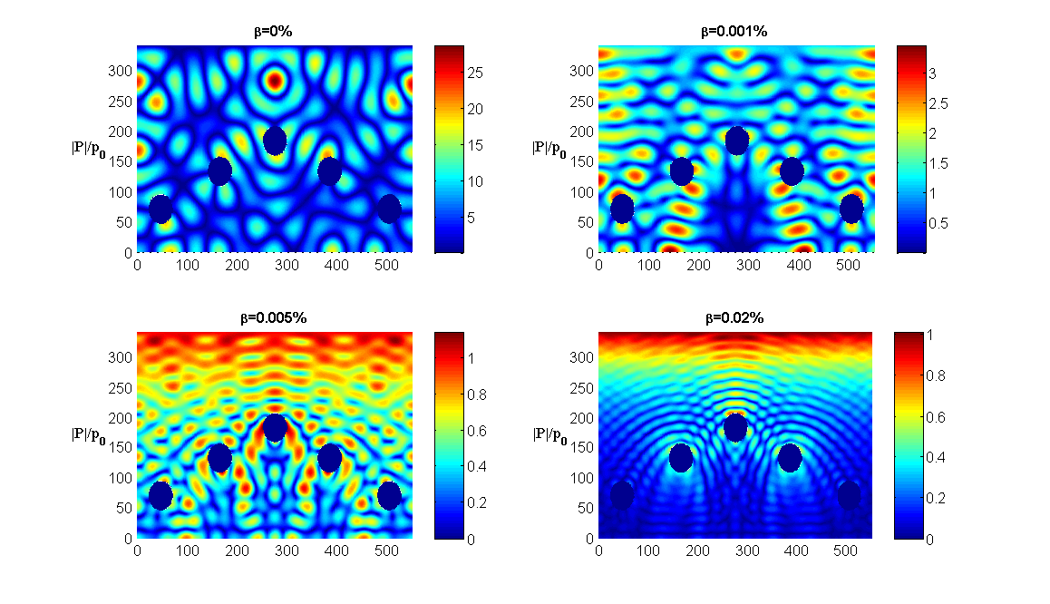

Figure ‎5.9: Effect of bubble volume fraction (R=10-100 µm)

The effect of bubble radius is further investigated in Figure 5.10. The bubble volume fraction is kept constant at β=0.001% and there different bubble size range is considered. The pressure amplitude is higher than the other cases when a bubble size range 0.5 – 5 µm is used; though the other two cases produce similar results. Figure 5.10 indicates further conclusions: For the case of constant bubble size, the total dissipation was higher for larger bubbles. However, it may be noticed that the cases of *R=* 5 – 10 µm and *R=* 10 – 100 µm produces similar results, which may be due to other effects such as the number of bubbles near resonance.

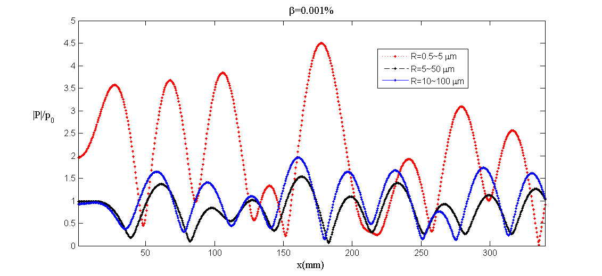

Figure ‎5.10: Effect of bubble radius (β=0.001%). The pressure profile is plotted over the line *y=*180 mm.

### Propagation through y-z plane

In this section the propagation through *y-z* plane is investigated. For the boundary condition on the transducer surface along z-direction, the pressure gradient was prescribed by applying equation (5.6) where the displacement input *A* is given by Figure 5.11. The input displacement varies along the z-direction as can be seen in the figure. For the other boundary conditions, similarly as the previous case  is applied on the side walls and at the bottom of the reactor and atmospheric pressure is prescribed at the liquid surface, i.e. .



Figure ‎5.11: Displacement due to transverse vibrations along the transducer in the z –direction.

In Figure 5.12, the wave propagation on the *y-z* is investigated. The radius distribution range is 1-10 µm, whereas the bubble volume fraction is increased. Similar conclusions to the one made regarding the results in Figure 5.8 can be made. The wavelength decreases with increasing the bubble volume fraction and the attenuation gets higher. The cases β=0.005% and β=0.01% produce similar peak amplitude values; though the pressure profiles are significantly different.

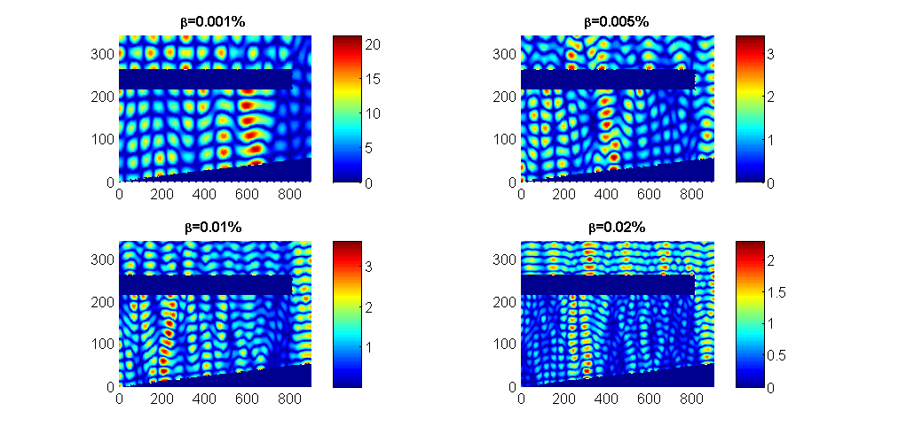

Figure ‎5.12: Wave distribution for the *y-z* plane (p∞=101kPa). Effect of bubble volume fraction (R=1-10 µm).

In Figure 5.13, the results are presented for the case of bubble radius range 5-50 µm. High damping is observed for larger values of bubble volume fraction. For example, the pressure amplitude decreases down to O*(p∞)* for β=0.02%. In comparison with Figure 5.12, one can notice that the amount of dissipation is higher for this distribution of bubbles.

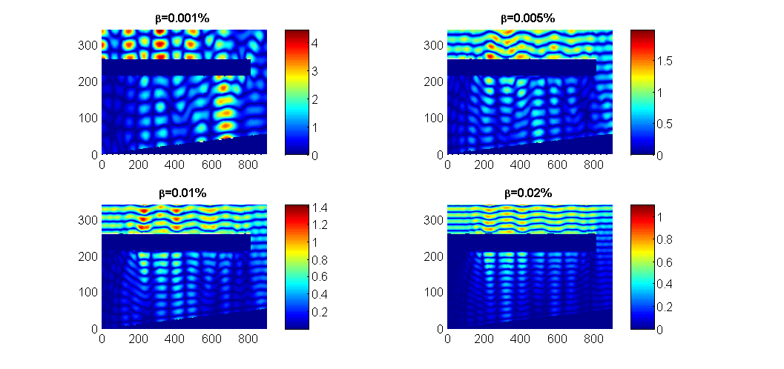

Figure ‎5.13: Wave distribution for the *y-z* plane (p∞=101kPa). Effect of bubble volume fraction (R=5-50 µm).

The effect of bubble radius is plotted on the line (x=100 mm, y) for constant β in order to better visualize its effect on the pressure wave propagation. It can be observed that a distribution with larger bubbles yields higher damping and smaller wavelength. The wave profile is highly attenuated for the case R=10-100 µm, even though the bubble volume fraction is not very large.

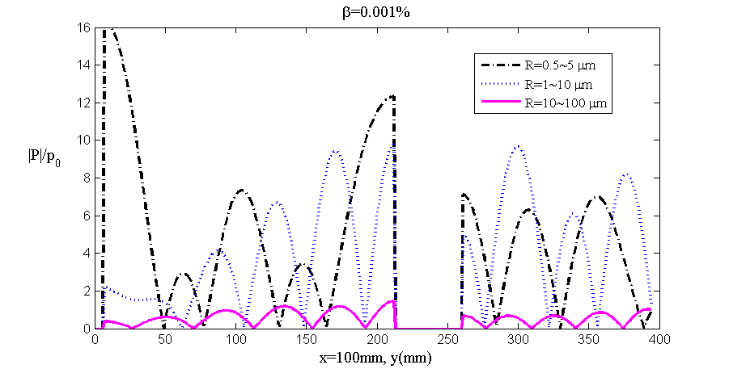

Figure ‎5.14: Effect of bubble radius (β=0.001%)

## 3D model with textile

In this section, wave propagation in a 3D sonoreactor is studied. The design principals of the sonoreactor are as follows. The textile is fed into the reactor vertically and then the motion is converted into horizontal direction with the aid of rollers. A rectangular transducer, operating at 10 kHz, is located at the center of the bottom of the sonoreactor and the textile fabric passes over the transducer. The impregnation activity within the tank is expected at highest level near the surface of the transducer since the cavitation zone is usually near the emitter surface. The depth of the liquid in the medium is 60 mm and the width of the textile is 500 mm. Two rectangular plate shaped transducers are located at the bottom of the reactor in order to cover the whole width of the fabric (See Figure 5.15).

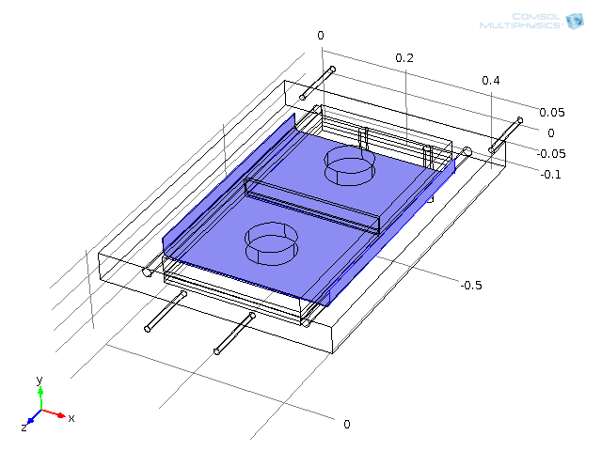

Figure ‎5.15: The sonoreactor designed by VIATECH. The sketch is imported from COMSOL model.

Due to the symmetry conditions in the sonoreactor given in Figure 5.15, a quarter model of the reactor can be built and studied in order to reduce computational requirements. The resulting model is given in Figure 5.16 where the thin structure with the curved edge represents the textile fabric and the shaded area at the bottom of the tank represents the transducer. Note that the resulting model introduced in Figure 5.16 includes the part of the sonoreactor (Figure 5.15) within the limits *x=*[0, 265 mm], *y*=[0, 60 mm], *z=*[350 mm, 700 mm]. Thus the axes of symmetry are *x=*265 mm plane and *z=*350 mm plane. For the boundary conditions, *p=*101 kPa is applied on the surface of the liquid (*y=*60 mm) and ∂p/∂n=0 elsewhere except on the transducer surface. In order to implement the boundary conditions on the transducer surface, the displacement values should be known. Therefore, the boundary condition on the transducer surface is implemented according to the formula:

|  |  |
| --- | --- |
| $$\frac{∂p}{∂n}=-ρω^{2}A(x,z)$$ | (5.8) |

where measurements regarding the displacement provided by VIATECH indicated (see Reference [82] for details)

|  |  |
| --- | --- |
| $$A\left(x,z\right)=A_{0}cos⁡(2πx/0.1)cos⁡(2πz/0.081)$$ | (5.9) |

with $A_{0}=5{x10}^{-6}$.

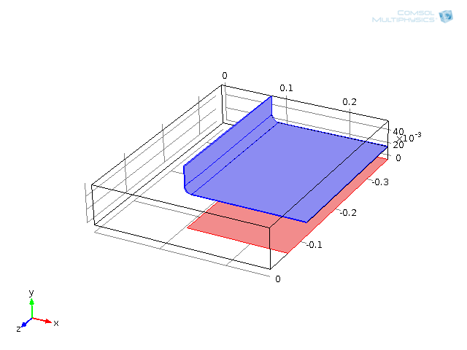

Figure ‎5.16: Quarter model of the sonoreactor by VIATECH.

The results plotted from now on are obtained at the top and bottom surfaces of the textile fabric which lie on the *x-z* plane at height *y=*30.5 mm and *y=*29.5 mm, respectively. Therefore, referring to the Figure 5.16, the definition top surface indicates the area within the limits *x=*[92 mm, 265 mm], *y*=30.5 mm, *z=*[100 mm, 350 mm]; whereas bottom surface indicates the area within the limits *x=*[92 mm, 265 mm], *y*=29.5 mm, *z=*[100 mm, 350 mm].

In Figure 5.17, the pressure distribution on the bottom and top surfaces of the textile is presented for the pure liquid case. The maximum pressure obtained at the bottom and top is approximately 2 MPa and 1.1 MPa, respectively. In the following figures, the pressure profiles in the presence of bubbles are presented so that the amount of damping can be visualized.

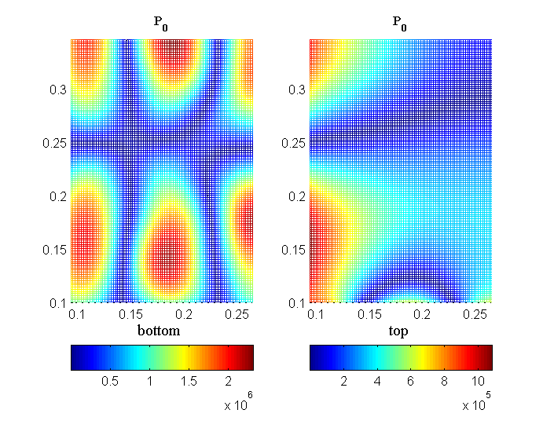

Figure ‎5.17: Pressure distribution on the bottom and top surface of the textile in pure liquid.

In Figure 5.18, pressure distributions at the bottom and top surface of the textile are presented for the bubble volume fraction β=0.001% and the bubble radius range 1-10 µm. It can be observed that maximum pressure amplitude is damped down to 0.8 MPa and 0.4 MPa at the bottom and top surfaces, respectively.

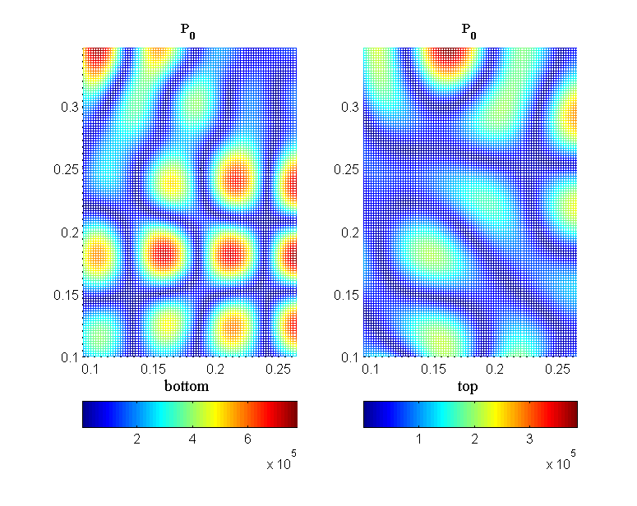

Figure ‎5.18: Pressure distribution on the bottom and top surface of the textile with bubble size range 1-10 µm.

In Figure 5.19, pressure distributions at the bottom and top surfaces of the textile are presented for the bubble radius range 5-50 µm. Bubble volume fraction is kept at β=0.001%. The maximum pressure amplitude further drops to 0.45 MPa and 0.13 MPa at the bottom and top surface, respectively, in comparison to Figure 5.18.

**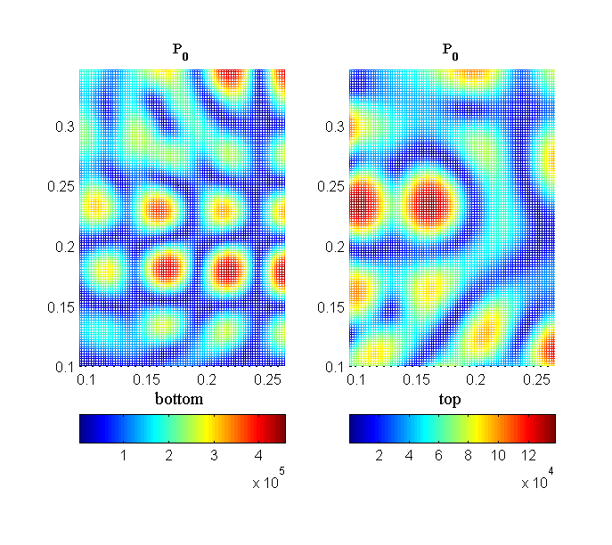**Figure ‎5.19: Pressure distribution on the bottom and top surfaces of the textile with bubble size range 5-50 µ.

In Figure 5.20, pressure distributions at the bottom and top surface of the textile are presented for the bubble radius range 1-100 µm. Bubble volume fraction is kept at β=0.001% similarly as the previous two cases. The maximum pressure amplitude is observed at its lowest as 0.4 MPa and 0.1 MPa at the bottom and top surface, respectively.

**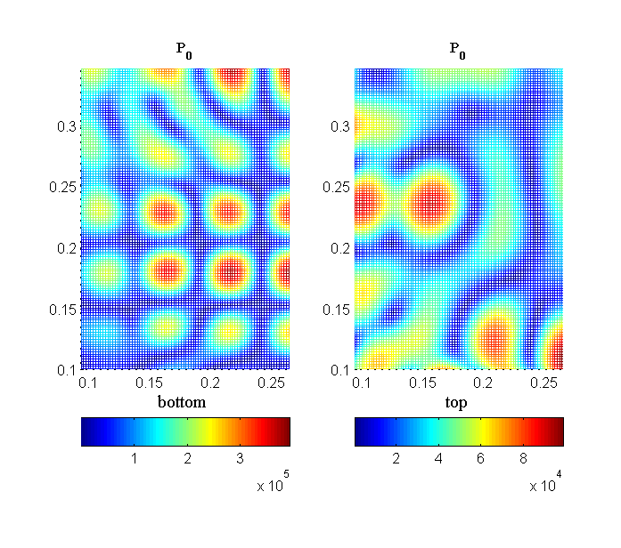**

Figure ‎5.20: Pressure distribution on the bottom and top surface of the textile with bubble size range 1-100 µ.

These results clearly indicate that dissipation of the acoustic energy increases when bubbles with larger size distribution are present in the liquid.

# 

Conclusions

Acoustic wave propagation in bubbly liquids is investigated. The governing equations are expressed by the Helmholtz equation where the wavenumber depends on the bubble population field and also on the driving pressure for the nonlinear case. The problem is non-homogeneous since the emergence of bubbles occurs in space where the pressure exceeds the pressure threshold. The developed numerical models are capable of solving non-homogeneous and nonlinear Helmholtz equation. Further, the presence of the textile fabric in the domain is simulated by adapting the algorithms with appropriate strategies. The findings of this research are summarized below and also possible future improvements are suggested.

## Summary of the current research findings

The RBIE and the LBIE methods are implemented for the solution of the Helmholtz equation. Optimizations tests show that a radius of local sub-domain radius *R* equal to the spacing between nodes *h* (in the case of uniform nodes distribution)produces the most accurate results for the 2D case. Further, the integrals over the boundary of the local sub-domains can be evaluated accurately using 8 quadratic elements (or ~ 10-12 Gauss points when performing Gaussian integration). The use of 16 neighbouring nodes in the RBF interpolations is also sufficient for accurate computations. For the RBF, second order augmented thin plate spline is used in most of the computations which produces accurate results. Some other RBFs were tested at earlier stages of this work, and can be found in the literature; though, to our knowledge, there is no particular one which is superior to others. For the augmentation of the interpolation functions, frequency dependent polynomial basis are chosen which is essential when solving wave-type problems.

The solution of wave-type problems suffers from a high numerical error especially when the wavenumber is high. One major reason for that is the dispersion error. The dispersion error has been investigated for some other meshless methods in the literature, such as radial point interpolation method [75] and element-free Galerkin method [83]. In this thesis, the dispersion error results are presented for RBIE and LBIE methods. One can find out that these two methods have dispersion errors of the same order of magnitude by comparing the results with previously published articles cited above. It is demonstrated through an example problem that the global error decreases significantly when the dispersion error is minimized.

One of the major contributions of this study is the solution of the nonlinear acoustic wave propagation. The problem is also non-homogeneous since the emergence of bubbles is dependent on the Blake threshold. One should note that there is discontinuity in the value of wavenumber in bubbly regions and void regions which creates difficulties for the numerical methods. A nonlinear solution procedure is proposed in this thesis by defining several convergence and stability criteria. Further, the discontinuity with the wavenumber is handled by using a ramp function centred at Blake threshold. The bubble volume fraction is increased gradually to its final value. This overall solution procedure is used to solve an example problem previously published by Lousinard [26] and a good agreement is obtained. To the knowledge of the author of this thesis, a numerical scheme capable of solving this problem has not been reported in the literature.

Another important finding reported in this thesis is on the solution of wave propagation around thin structures. This problem is often known to create singular integrals or ill-conditioned system matrices. When using meshless methods for the solution of such problems, one should develop a method for selection of neighbouring nodes, in order to take into account the influence of source nodes on each other around such inclusions or sharp edges. This is exemplified in this thesis and good agreement is obtained in comparison to results obtained using COMSOL commercial package. Splitting the domains by defining interfaces can produce accurate results, as was shown in this work.

Finally, the algorithms are applied for the solution of wave propagation in 3D sonoreactors. The nonlinear wave propagation is investigated only for the 1D example case due to excessive CPU time requirements. The effects of bubble volume fraction and bubble size distribution are discussed in detail. The results indicate that an increase in the bubble volume fraction or presence of bubbles with larger radius yields stronger damping of acoustic waves. As a result, phase velocity of the waves decreases and the attenuation becomes higher. The pressure amplitudes and profiles are shown on textile surfaces which is one of the ultimate aims of this thesis.

## Suggestions for future work

As displayed through examples, the implemented RBIE method is efficient and accurate for the solution of wave problems. However, when dealing with complex numbers and thin structures the condition number of the global system matrix becomes high in certain cases. One of the major difficulties that was experienced is the lack of fast and efficient solvers for complex system matrix. In fact, in this work the *pardiso* direct solver in INTEL FORTRAN compiler has been used and there is not any iterative solver for complex numbers that the author is aware of. The difficulty with using MATLAB iterative solvers is that one is unable to see the convergence history during the computations; though it can be displayed at the end of the run. There were several attempts on solving thin body problems, however, convergence could not be obtained within 5-6 days of continuous computation for some problems, even though the solution of could be obtained more quickly with direct solvers. This is also related to some ill-conditioning which will be mentioned below. Finally, the iterative solver provided by the research group of Yousef Saad at University of Minnesota [84] is coded in mixed C/FORTRAN language, the import of which into the code was a challenging task. Therefore, there is certainly a need for fast and efficient solvers for complex numbers in order to improve the research in this area.

Further some comments on the preconditioning issue should be made. Apparently, most of the efficient and accurate preconditioning techniques ought to be numerical algorithm specific. The author has not come across many articles on preconditioning methods when solving the problems with meshless methods. In addition, the solutions of wave problems are particularly ill-conditioned due to oscillatory nature of the integral kernels. Hence, there is certainly a need for research on preconditioning methods for the solution of wave-like problems with meshless methods. The author has tried the incomplete LU (*ilu*) and incomplete LU with pivoting (*ilup*) within the SPARSKIT package; though it was not possible to obtain a significant improvement for the problems solved.

Finally, due to the large scale of sonoreactors (at the order of meters) used in the textile coating process; a high computational memory requirements were experienced. Therefore, the 3D example is solved at 10 kHz (which would require less source nodes in the solution domain). However, this simulation can easily be extended to larger scales and larger frequencies provided that sufficient computational power is available.

# Appendix: Dispersion error for RBIE method

## A.1 Further explanation to dispersion error

Let us consider two arbitrary source nodes located at (*xs, ys*) and (*xg, yg*), and their influencing nodes entirely lying within the domain Ω without any overlapping (See Figure A.1). We shall consider the case that the nodes are ‘sufficiently far from the global boundary Γ’ so that the selection of the influencing nodes for each of them is exactly the same provided that the same *rinfl* is used. This is illustrated in Figure A.1, i.e. both source nodes have 9 nodes in the set of neighbouring nodes. Further, if one assumes the same radius of local sub-domains for each of these source nodes; one would obtain exactly the same setup for each of the source nodes. When the global system of equations is constructed, one can notice that exactly same coefficients are written for such two nodes in the rows of the system matrix; except that the column indices would be different due to the global numbering of the source nodes in the domain. One can realize that such a case would be valid for most of the source nodes which are sufficiently far from the boundary of the domain.

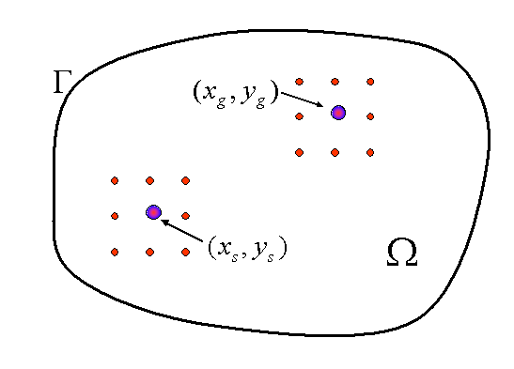

Figure A. 1: Two arbitrary source nodes and their influencing neighbouring nodes lying entirely inside the domain Ω.

Next, consider one row of the global system matrix which is written by employing the LBIE for such a node, e.g. the one located at (*xs,ys*), lying entirely inside the domain. A typical row in the system matrix would read the following type of equation for the potential:

|  |  |
| --- | --- |
| $$α_{1}p_{1}+α_{2}p_{2}+…+ α_{s}p_{s}+…+α_{n}p_{n}=0$$ | (A.1) |

where *n* is the number of influencing nodes (including the source node for which the equation is written) and *p* is the potential, i.e. *ps=p(xs, ys)*. The coefficient αi’s are evaluated from the boundary integral equation (3.31) and RBF interpolation, which is explained in Section 3.3. Note that the right hand side of (A.1) is zero since the equation is written for a node entirely within the domain, i.e. there is no acoustic sourcing term (unlike equation (3.34)). In the following, we will refer to the harmonic evolution theorem [77] for dispersion error measurement in order to interpret the potential values, *pi, (i=1,2,…,n)*, in (A.1) in terms of the potential at the source node, *ps*. According to harmonic evolution theorem, the potential at any point *i* can be written in terms of the potential at point *s*;

|  |  |
| --- | --- |
| $$u_{i}=τ_{i}p_{s}$$ | (A.2) |

though the coefficients τi will be left un-evaluated for now (the explicit expressions are given in equation (3.48)). Using the relation (A.2), equation (A.1) can be re-written as;

|  |  |
| --- | --- |
| $$α_{1}τ_{1}p_{s}+α_{2}τ_{2}p_{s}+…+ α_{s}τ_{s}p_{s}+…+α_{n}τ_{n}p_{s}=0$$ | (A.3) |

Equation (A.3) has the following interpretation. For an acoustic problem within the domain Ω, the rows of the system matrix for the nodes lying entirely within the domain are identical. Further, for a non-trivial solution of the problem, i.e. non-zero values of *ps*, the following equation is being solved numerically;

|  |  |
| --- | --- |
| $$α_{1}τ_{1}+α_{2}τ_{2}+…+ α_{s}τ_{s}+…+α_{n}τ_{n}=0$$ | (A.4) |

where the coefficients αi and τi are functions of the wavenumber. Therefore, one can solve an equation of type (A.4) by using root-finding algorithms, for one source node *only*, in order to find out the numerical wavenumber. Hence, the discrepancy between the numerical wavenumber and the exact wavenumber can be determined in order to assess the accuracy of the numerical methods. In the following sub-sections, further definitions for the dispersion error of RBIE will be outlined.

## A.2 Mathematical formulation for RBIE

In the RBIE, the discrete form of (3.2) for the interior node at (*q1,q2*) can be written as;

 (A.5)

where,andare evaluated from the boundary integral equation and RBF interpolations. Note that the spatial derivatives of the harmonically evolving potential field appear in (A.5). However, with the use of (3.47), those terms would be given by;

 (A.6)

 (A.7)

Further, following (3.48) at an interior node , the spatial derivatives can be evaluated as ;

 (A.8)

 (A.9)

By employing expressions (A.6) to (A.9), (A.5) becomes;

 (A.10)

For a non-zero distribution of the acoustic pressure *ph* in (A.10), one can obtain the numerical wavenumber *kh* by solving the real part of the following equation

 (A.11)

As in the LBIE, the dispersion error for the RBIE is calculated using (3.52).

## A.3 Numerical Results

As detailed in Section A.2, RBIE has a different formulation which yields different dispersion errors. In Figure A.2, the dispersion error for the RBIE with the second order polynomial approximation (RBIE-*m=6*) is shown for the propagation angle . It can be observed that an increase of the radius of influence domain leads to more accurate results in the range . For *kh=2*, the error still remains less than 10-2 which indicates lower dispersion in comparison to LBIE for this particular case (See Figure 4.12b). In the range , *rinfl=4h* is preferable to the other two cases.

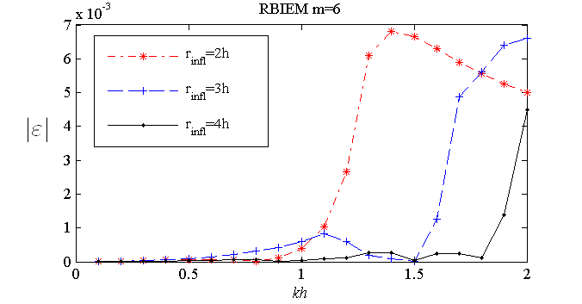

Figure A.2: Dispersion error vs. the non-dimensionalized exact wavenumber for the propagation angle .

In Figure A.3, the results obtained for RBIE-*m=6*, RBIEand RBIE-RBF- for *kh=1*, are shown. Recalling Figure 4.12a, RBIE perform at the same order of accuracy with the LBIE methods, when *rinfl=*3h or *rinfl=*4h,however RBIE produces less accurate results by one order of magnitude when *rinfl=*2h. RBIE-is the most accurate of the RBIE methods in general with the exceptions obviously occurring when the propagation angle  is very different from.

**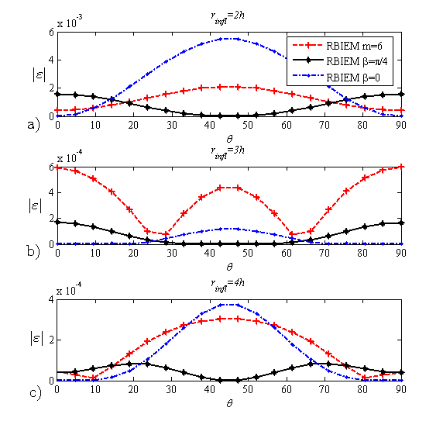**

Figure A.3: Dispersion error over the propagation angle for the non-dimensional wavenumber; (a) *rinfl=2h*, (b) *rinfl=3h* and (c) *rinfl=4h*.

## A.4 Comparison of RBIE and LBIE in an example problem

In this section, the accuracy of the LBIE and the RBIE is compared by using a 2D problem. As explained in Chapter 3, these two methods have slightly different formulations of the dispersion error; they will be compared in this section by using the same RBF interpolation and the same number of nodes in the RBF interpolation. Thus, the only difference, in terms of dispersion error, will be due to their original mathematical formulations. A square domain, centred at the location (x=0.5m, y=0.5m), is considered with side lengths *Lx=*1mand *Ly=*1m*.* The following boundary conditions are applied:

|  |  |
| --- | --- |
|  | 1. 12) |
|  | (A.13) |
|  | (A.14) |
|  | (A.15) |

where *k* is the wavenumber, which yields the solution $p=sin⁡(kx/\sqrt{2})sin(ky/\sqrt{2}).$

The results obtained via LBIE and RBIE are presented in Table A.1 and Table A.2, respectively. L2 Norm error for each case, being measured by (3.54), is displayed. Solutions with LBIE and RBIE are performed for all three choices of basis vectors, i.e. polynomial basis with *m=6,* frequency dependent basis with and . Further, for the RBIE and LBIE same setups are used; i.e. source nodes are placed uniformly in the domain with *h=*2.5 mm and the wavenumber *k* is varied from 4 to 20 with increments of 4,which yields a non-dimensional wavenumber *kh=*0.1-0.5 with 0.1 increments*.*

In Table A.1, results are presented for the LBIE. LBIE- performs better than the other two interpolation functions. LBIE-and LBIE-*m=6* perform with comparable accuracy for all cases. The use of *rinfl=*4hproduces less accurate results than *rinfl=*2h and *rinfl=*3hunless the frequency dependent basis with  is used.

Table A.1: L2 Norm values of LBIE for .

|  |  |  |  |  |
| --- | --- | --- | --- | --- |
|  | ***kh*** | ***rinfl* =2H** | ***rinfl* =3H** | ***rinfl* =4H** |
| **LBIE-m=6** | 0.1 | 4.32E-02 | 4.55E-02 | 0.128046446 |
| 0.2 | 0.209026281 | 0.219450684 | 0.230061903 |
| 0.3 | 0.406927273 | 0.426985075 | 0.432398351 |
| 0.4 | 0.768285359 | 0.754844855 | 0.766320632 |
| 0.5 | 1.327513019 | 1.287975488 | 4.794797747 |
|  |  |  |  |  |
| **LBIE-β=π/4** | 0.1 | 3.76E-02 | 3.89E-02 | 3.89E-02 |
| 0.2 | 0.151839202 | 0.157183747 | 0.157183746 |
| 0.3 | 0.339876997 | 0.358203948 | 0.370700707 |
| 0.4 | 0.612242736 | 0.623225515 | 0.645499549 |
| 0.5 | 0.952102845 | 1.022434531 | 1.022434531 |
|  |  |  |  |  |
| **LBIE-β=0** | 0.1 | 7.35E-02 | 6.30E-02 | 9.15E-02 |
| 0.2 | 0.240589361 | 0.234752399 | 0.253745655 |
| 0.3 | 0.505535823 | 0.401196415 | 0.581333376 |
| 0.4 | 1.168639618 | 1.610827889 | 1.412659869 |
| 0.5 | 1.444479716 | 4.012841654 | 4.158223488 |

In Table A.2, results obtained by using RBIE are presented. One can realize straightaway that the RBIE - performs better than the other two interpolation functions. This fact has the same reasoning as the results obtained in Section 4.2.2 for the LBIE method. In that section, a case was examined where the angle of plane wave propagation used in the frequency dependent basis coincided with the angle of the propagating wave in the domain. Similarly, for the example problem presented in this section, the solution of the problem is given by an analytical function propagating in the direction of θ=π/4. Therefore, the use of the frequency dependent basis with  is expected to produce more accurate results. Upon comparison of RBIE-*m=6* and RBIE –, one can observe that the former one produces slightly more accurate results.

Table A.2: L2 Norm values of RBIE for .

|  |  |  |  |  |
| --- | --- | --- | --- | --- |
|  | ***kh*** | ***rinfl* =2H** | ***rinfl* =3H** | ***rinfl* =4H** |
| **RBIE-m=6** | 0.1 | 1.28E-02 | 1.96E-02 | 2.57E-02 |
| 0.2 | 0.124335867 | 0.215412985 | 0.329308371 |
| 0.3 | 0.39435717 | 0.600880624 | 0.950160932 |
| 0.4 | 0.60338031 | 1.280135236 | 2.506081136 |
| 0.5 | 1.935546903 | 4.15740456 | 6.268704048 |
|  |  |  |  |  |
| **RBIE- β=π/4** | 0.1 | 5.15E-11 | 3.70E-10 | 1.18E-09 |
| 0.2 | 8.62E-11 | 3.90E-10 | 1.49E-09 |
| 0.3 | 2.24E-10 | 1.20E-10 | 9.31E-10 |
| 0.4 | 6.51E-11 | 1.67E-10 | 7.08E-10 |
| 0.5 | 5.92E-11 | 3.09E-10 | 7.70E-10 |
|  |  |  |  |  |
| **RBIE- β=0** | 0.1 | 9.91E-02 | 8.58E-02 | 7.19E-02 |
| 0.2 | 0.808605067 | 0.967171163 | 1.059523413 |
| 0.3 | 1.979076465 | 3.242584814 | 11.84152074 |
| 0.4 | 7.064734316 | 6.265971757 | 3.789844845 |
| 0.5 | 5.09268296 | 14.53237859 | 15.7757014 |

Upon comparison of the results produced by the LBIE- and the RBIE in Tables A.1 and A.2, respectively, one can raise the question of why RBIE obtains more accurate results than the LBIE by several orders of magnitude. The reason for this behaviour is due to the different implementation procedures of the two methods. As can be seen from equation (3.16), RBIE imposes the spatial derivatives of the potential directly as a boundary condition, where Neumann BCs are prescribed, whereas LBIE performs global integration on the boundary via equation (3.34). Therefore, RBIE provides more accurate information on the boundary for this particular case. Further comparisons can be made between the results in Table A.1 and Table A.2. For example, RBIE – with *rinfl*=2h performs better than LBIE-RBFwith *rinfl* =2h etc., though the difference is not as significant as for the case of .

# References

|  |  |
| --- | --- |
| [1] | W. D. Song, M. H. Hong, B. Lukyanchuk and T. C. Chong, “Laser-induced cavitation bubbles for cleaning of solid surfaces,” *J. Appl. Phys.,* vol. 95, no. 6, p. 2952–2956, 2004. |
| [2] | P. R. Gogate and A. M. Kabadi, “A review of applications of cavitation in biochemical engineering/biotechnology,” *Biochemical Engineering Journal,* vol. 44, pp. 60-72, 2009. |
| [3] | T. G. Leighton and R. O. Cleveland, “Lithotripsy,” *Proceedings of the Institution of Mechanical Engineers, Part H: Journal of Engineering in Medicine,* vol. 224, no. 2, pp. 317-342, 2010. |
| [4] | U. Parlitz, R. Mettin, S. Luther, I. Akhatov, M. Voss and W. Lauterborn, “Spatio-temporal Dynamics of Acoustic Cavitation Bubble Clouds,” *Phil. Trans. R. Soc. Lond. A,* vol. 357, pp. 313-334, 1999. |
| [5] | K. Suslick and G. J. Price, “Applications of ultrasound to material chemistry,” *Annu. Rev. Mater. Sci.,* vol. 29, pp. 295-326, 1999. |
| [6] | N. Perkas, G. Amirian, G. Dubinsky, S. Gazit and A. Gedanken, “Ultrasound assisted coating of nylon 6,6 with silver nanoparticles and its antibacterial activity,” *Journal of Applied Polymer Science,* vol. 104, pp. 1423-1430, 2007. |
| [7] | I. Perelshtein, G. Applerot, N. Perkas, G. Guibert, S. Mikhailov and A. Gedanken, “Sonochemical coating of silver nanoparticles on textile fabrics (nylon, polyester and cotton) and their antibacterial activity,” *Nanotechnology,* vol. 19, no. 24, p. 245705, 2008. |
| [8] | O. V. Abramov, A. Gedanken, Y. Koltypin, N. Perkas, I. Perelshtein, E. Joyce and T. J. Mason, “Pilot scale sonochemical coating of nanoparticles onto textiles to produce biocidal fabrics,” *Surface & Coatings Technology,* vol. 204, pp. 718-722, 2009. |
| [9] | V. Popov and T. T. Bui, “A meshless solution to two-dimensional convection-diffusion problems,” *Engineering Analysis with Boundary Elements,* vol. 34, pp. 680-689, 2010. |
| [10] | H. Dogan, V. Popov and E. H. Ooi, “The Radial Basis Integral Equation Method for the Solution of 2D Helmholtz Problems,” *Engineering Analysis with Boundary Elements,* vol. 36, no. 6, pp. 934-943, 2012. |
| [11] | T. Zhu, J. -D. Zhang and S. N. Atluri, “A local boundary integral equation (LBIE) method in computational mechanics, and a meshless discretization approach,” *Computational Mechanics,* vol. 21, no. 3, pp. 223-235, 1988. |
| [12] | L. Godinho, A. Tadeu and P. Amado Mendes, “Wave Propagation around Thin Structures using the MFS,” *CMC: Computers, Materials, & Continua,* vol. 5, no. 2, pp. 117-128, 2007. |
| [13] | K. H. Chen, J. T. Chen, C. R. Chou and C. Y. Yueh, “Dual boundary element analysis of oblique incident wave passing a thin submerged breakwater,” *Engineering Analysis with Boundary Elements,* vol. 26, no. 10, pp. 917-928, 2002. |
| [14] | J. Antonio, A. Tadeu and P. Amado Mendes, “A 2.5D traction boundary element formulation applied to the study of wave propagation in a fluid layer hosting a thin rigid body,” *Journal of Computational Acoustics,* vol. 16, no. 2, pp. 177-198, 2008. |
| [15] | G. V. Datar, P. Banks-Lee and P. L. Grady, “Acoustical Properties of Fabrics in Low-Intensity Ultrasound,” *Applied Acoustics,* vol. 47, pp. 345-350, 1996. |
| [16] | E. Silberman, “Sound velocity and attenuation in bubbly mixtures measured in standing wave tubes,” *J. Acous. Soc. Am. ,* vol. 29, pp. 925-933, 1957. |
| [17] | M. J. Miksis and L. Ting, “Effective Equations for Multiphase Flows - Waves in a bubbly liquid,” *Advances in Applied Mechanics,* vol. 28, pp. 141-260, 1992. |
| [18] | R. E. Caflisch, M. J. Miksis, G. C. Papanicolaou and L. Ting, “Effective equations for wave propagation in a bubbly liquid,” *J. Fluid Mech. ,* vol. 153, pp. 259-273, 1985. |
| [19] | L. van Wijngaarden, “On the equations of motion for mixtures of liquid and gas bubbles,” *J. Fluid Mech.,* vol. 33, no. 3, pp. 465-474, 1968. |
| [20] | K. W. Commander and A. Prosperetti, “Linear pressure waves in bubbly liquids: Comparison between theory and experiment,” *J. Acoust. Soc. Am.,* vol. 85, pp. 732-746, 1989. |
| [21] | L. van Wijngaarden, “One-Dimensional Flow of Liquids Containing Small Gas Bubbles,” *Annual Review of Fluid Mechanics,* Vols. 369-396, p. 4, 1972. |
| [22] | E. L. Cartensen and L. L. Foldy, “Propagation of sound through a liquid containing bubbles,” *J. Acoust. Soc. Am. ,* vol. 19, pp. 481-501, 1974. |
| [23] | R. E. Caflisch, M. J. Miksis, G. C. Papanicolaou and L. Ting, “Wave propagation in bubbly liquids at finite volume fraction,” *J. Fluid Mech. ,* vol. 160, pp. 1-14, 1985. |
| [24] | A. Crespo, “Sound and shock waves in liquids containing bubbles,” *Phys. Fluids,* vol. 12, pp. 2274-2282, 1969. |
| [25] | M. J. Miksis and L. Ting, “Wave Propagation In a Bubbly Liquid at a Small Volume Fraction,” *Chem. Eng. Comm.,,* vol. 118, pp. 59-73, 1992. |
| [26] | O. Louisnard, “A simple model of ultrasound propagation in a cavitating liquid. Part I: Theory, nonlinear attenuation and traveling wave generation,” *Ultrasonics Sonochemistry,* vol. 19, no. 1, pp. 56-65, 2012. |
| [27] | L. D. Rosenberg, High Intensity Ultrasonic Fields, New York: Plenum, 1971. |
| [28] | F. E. Fox, S. R. Curley and G. S. Larson, “Phase velocity and absorbtion measurements in water containing air bubbles,” *J. Acoust. Soc. Am.,* vol. 27, pp. 534-546, 1955. |
| [29] | J. D. Macpherson, “The effect of gas bubbles on sound propagation in water,” *Proc. Phys. Soc. London Sec. B,* vol. 70, pp. 85-92, 1957. |
| [30] | C. E. Brennen, Fundamentals of Multiphase Flows, Cambridge University Press, 2005. |
| [31] | I. S. Kol'tsova, I. G. Krynskii, I. G. Mikhalov and I. E. Pokrovskaya, “Attenuation of ultrasonic waves in low-viscosity liquids containing gas bubbles,” *Akust. Zh.,* vol. 25, pp. 725-731, 1979 [English translation: Sov. Phys. Acous. 25, 409-413 (1979)]. |
| [32] | A. E. Ruggles, H. A. Scarton and R. T. Lahey, “An investigation of the propagation of pressure perturbations in bubbly air/water flows,” in *International Multiphase Fluid Transients Symposium, edited by H. H. Safwat, J. Braun, and U. S. Rohatgi (American Society of Mechanical Engineers)*, New York, 1986. |
| [33] | L. Rayleigh, “On the pressure developed in a liquid during the collapse of a spherical void,” *Philos. Mag,* vol. 34, pp. 94-98, 1917. |
| [34] | M. Minnaert, “On musical air-bubbles and the sound of running water,” *Philosophical Magazine,* vol. 16, no. 104, pp. 234-248, 1933. |
| [35] | M. S. Plesset, “The dynamics of cavitation bubbles,” *ASME J. Appl. Mech,* vol. 16, pp. 228-231, 1949. |
| [36] | R. B. Chapman and M. S. Plesset, “Thermal effects in the free oscillation of gas bubbles,” *J. Basic Eng.,* vol. 93, pp. 373-376, 1971. |
| [37] | M. S. Plesset and D. Y. Hsieh, “Theory of Gas Bubble Dynamics in Oscillating Pressure Fields,” *Physics of Fluids,* vol. 3, no. 6, pp. 882-892, 1960. |
| [38] | A. Prosperetti, “Thermal effects and damping mechanisms in the forced radial oscillations of gas bubbles in liquids,” *J. Acoust. Soc. Am.,* vol. 61, no. 1, pp. 17-27, 1977. |
| [39] | A. Prosperetti, L. Crum and K. Commander, “Nonlinear bubble dynamics,” *J. Acoust. Soc. Am.,* vol. 83, pp. 502-514, 1988. |
| [40] | M. J. Miksis and L. Ting, “Nonlinear radial oscillations of a gas bubble including thermal effects,” *J. Acoust. Soc. Am.,* vol. 76, pp. 897-905, 1984. |
| [41] | M. J. Miksis and L. Ting, “A numerical study of thermal effects on nonlinear bubble oscillations,” *J. Acoust. Soc. Am. ,* vol. 81, pp. 1331-1340, 1987. |
| [42] | L. Stricker, A. Prosperetti and D. Lohse, “Validation of an approximate model for the thermal behavior in acoustically driven bubbles,” *J. Acous. Soc. Am. ,* vol. 130, no. 5, Pt. 2, pp. 3243-3251, 2011. |
| [43] | A. Prosperetti, “Nonlinear Oscillations of Gas Bubbles in Liquids: steady-state solutions,” *J. Acoust. Soc. Am,* vol. 56, no. 3, pp. 878-885, 1974. |
| [44] | J. B. Keller and I. I. Kolodner, “Damping of Underwater Explosion Bubble Oscillations,” *J. Appl. Physics,* vol. 27, pp. 1152-1161, 1956. |
| [45] | A. Prosperetti and A. Lezzi, “Bubble dynamics in a compressible liquid. Part 1. First-order theory,” *Journal of Fluid Mechanics,* vol. 168, pp. 457-478, 1986. |
| [46] | W. Lauterborn and A. Vogel, “Modern Optical Techniques in Fluid Mechanics,” *Annual Review of Fluid Mechanics,* vol. 16, pp. 233-244, 1984. |
| [47] | J. B. Keller and M. J. Miksis, “Bubble oscillations of large amplitude,” *J. Acoust. Soc. Am.,* vol. 68, no. 2, pp. 628-633, 1980. |
| [48] | W. Lauterborn, “Numerical investigation of nonlinear oscillations of gas bubbles in liquids,” *J. Acoust. Soc. Am.,* vol. 59, no. 2, pp. 283-296, 1976. |
| [49] | A. Prosperetti, “Nonlinear Oscillations of Gas Bubbles in Liquids,” *Cal. Inst. of Tech. Rep. No: 85,* p. 62, 1973. |
| [50] | B. D. Storey and A. J. Szeri, “Water vapour, sonoluminescence ans sonochemistry,” *Proc. R. Soc. London A,* vol. 456, pp. 1685-1709, 2000. |
| [51] | B. D. Storey and A. J. Szeri, “Mixture segregation within sonoluminescence bubbles,” *J. Fluid Mech.,* vol. 396, pp. 203-221, 1999. |
| [52] | G. Huake, D. Fuster and C. Dopazo, “Dynamics of a single cavitating and reacting bubble,” *Physical Review E,* vol. 75, pp. 066310 (1-14), 2007. |
| [53] | B. D. Storey and A. J. Szeri, “A reduced model for cavitation physics for use in sonochemistry,” *Proc. R. Soc. Lond. A,* vol. 457, pp. 1685-1700, 2001. |
| [54] | W. Kreider, L. A. Crum and M. R. Bailey, “A reduced-order, single-bubble cavitation model with applications to therapeutic ultrasound,” *J. Acoust. Soc. Am.,* Vols. 5, Pt. 2, p. 3511–3530, 2011. |
| [55] | A. T. Preston, T. Colonius and C. E. Brennen, “A reduced-order model of diffusive effects on the dynamics of bubbles,” *Physics of Fluids,* vol. 19, pp. 123302 (1-12), 2007. |
| [56] | A. Prosperetti, “Bubble phenomena in sound fields: part one,” *Ultrasonics,* pp. 69-77, 1984. |
| [57] | A. Prosperetti, “Bubble phenomena in sound fields: part two,” *Ultrasonics,* pp. 115-124, 1984. |
| [58] | R. E. Apfel, “Acoustic cavitation inception.,” *Ultrasonics,* pp. 167-173, 1984. |
| [59] | G. Servant, J.-L. Laborde, A. Hita, J.-P. Caltagirone and A. Gerard, “ Spatio-temporal Dynamics of Cavitation Bubble Clouds in a Low Frequency reactor : comparison between theoretical and experimental results,” *Ultrasonics Sonochemistry,* vol. 8, pp. 163-174, 2001. |
| [60] | S. Dahnke and F. J. Keil, “Modelling of Linear Pressure Fields in Sonochemical Reactors Considering an Inhomogeneous Density Distribution of Cavitation Bubbles.,” *Chem. Eng. Sci.,* vol. 54, pp. 2865-2872, 1999. |
| [61] | S. Dahnke and F. J. Keil, “Modelling of Three-Dimensional Linear Pressure Fields in Sonochemical Reactors with Homogeneous and Inhomogeneous Density Distributions of Cavitation Bubbles,” *Ind. Eng. Chem. Res.,* vol. 37, pp. 848-864, 1998. |
| [62] | S. Dahnke, K. M. Swamy and F. J. Keil, “Modelling of Three-Dimensional Linear Pressure Fields in Sonochemical Reactors with an Inhomogeneous Density Distributions of Cavitation Bubbles : Comparison of theoretical and experimental results,” *Ultrasonics Sonochemistry,* vol. 6, pp. 31-41, 1999. |
| [63] | C. Vanhille and C.-F. Pozuelo, “Numerical and experimental analysis of strongly nonlinear standing acoustics waves in axisymmetric cavities,” *Ultrasonics,* vol. 43, pp. 652-660, 2005. |
| [64] | C. Vanhille and C.-F. Pozuelo, “Nonlinear Ultrasonic Propagation In Bubbly Liquids : A Numerical Model.,” *Ultrasound in Med. And Biol.,* vol. 34, no. 5, pp. 792-808, 2008. |
| [65] | R. Mettin, I. Akhatov, U. Parlitz, C. D. Ohl and W. Lauterborn, “Bjerknes forces between small cavitation bubbles in a strong acoustic field,” *Phys. Rev. E,* vol. 56, pp. 2924-2931, 1997. |
| [66] | D. Krefting, R. Mettin and W. Lauterborn, “High speed observation of acoustic cavitation erosion in multibubble systems.,” *Ultrasonics Sonochemistry,* vol. 11, pp. 119-123, 2004. |
| [67] | E. H. Ooi and V. Popov, “An efficient implementation of the radial basis integral equation method,” *Engineering Analysis with Boundary Elements,* vol. 36, no. 5, pp. 716-726, 2012. |
| [68] | A. J. B. Tadeu, P. F. A. Santos and E. Kausel, “Closed-form integration of singular terms for constant, linear and quadratic boundary elements. Part 1. SH wave propagation.,” *Engineering Analysis with Boundary Elements,* vol. 23, pp. 671-681, 1999. |
| [69] | A. J. B. Tadeu, P. F. A. Santos and E. Kausel, “Closed-form integration of singular terms for constant, linear and quadratic boundary elements. Part 2. SV-P wave propagation,” *Engineering Analysis with Boundary Elements,* vol. 23, pp. 757-768, 1999. |
| [70] | D. Elliot and P. R. Johnston, “Gauss-Legendre quadrature for the evaluation of integrals involving the Hankel function.,” *Jour. of Computational and Applied Mathematics,* vol. 2008, pp. 23-35, 2008. |
| [71] | J. Sladek, V. Sladek and N. S. Atluri, “Application of the local boundary integral equation method to boundary-value problems,” *International Applied Mechanics,* vol. 38, no. 9, pp. 1025-1047, 2002. |
| [72] | W. L. Nicomedes, R. C. Mesquita and F. J. S. Moreira, “A meshless local Petrov-Galerkin method for three-dimensional scalar problems,” *IEEE Transactions on Magnetics. 2011; 47(5): 1214-1217.,* vol. 47, no. 5, pp. 1214-1217, 2001. |
| [73] | C. Wenterodt and O. von Estorff, “Optimized meshfree methods for acoustics,” *Computer Methods in Applied Mechanics and Engineering. 2011; 200(25-28): 2223-2236.,* vol. 200, no. 25-28, pp. 2223-2236, 2011. |
| [74] | E. H. Ooi, V. Popov and H. Dogan, “Three dimensional solution for acoustic and transport problems using the radial basis integral equation method,” *Applied Mathematics and Computation,* vol. 218, no. 18, pp. 9470-9488, 2012. |
| [75] | C. Wenterodt and O. von Estorff, “Dispersion analysis of the meshfree radial point interpolation method for the Helmholtz equation,” *International Journal for Numerical Methods in Engineering,* vol. 77, no. 12, pp. 1670-1689, 2009. |
| [76] | S. Suleau and P. Bouillard, “One-dimensional dispersion analysis for the element-free Galerkin method for the Helmholtz equation,” *International Journal for Numerical Methods in Engineering,* vol. 47, no. 6, pp. 1169-1188, 2000. |
| [77] | S. Suleau, A. Deraemaeker and P. Bouillard, “Dispersion and pollution of meshless solutions for the Helmholtz equation,” *Computer Methods in Applied Mechanics and Engineering. 2000; 190(5-7): 639-657.,* vol. 190, no. 5-7, pp. 639-657, 2000. |
| [78] | T. Strouboulis and R. Hidajat, “Partition of unity method for Helmholtz equation: q-convergence for plane-wave and wave-band local bases.,” *Applications of Mathematics. 2006; 51(2): 181-204.,* vol. 51, no. 2, pp. 181-204, 2006. |
| [79] | F. Ihlenburg and I. Babuška, “Finite element solution to the Helmholtz equation with high wavenumber part I: the h-version of the FEM.,” *Computers & Mathematics with Applications,* vol. 30, pp. 9-37, 1995. |
| [80] | H. Dogan, V. Popov and E. H. Ooi, “Dispersion analysis of the meshless local boundary integral equation and radial basis integral equation for the Helmholtz equation,” *(submitted).* |
| [81] | D. Z. Zhang and A. Prosperetti, “Ensemble phase‐averaged equations for bubbly flows,” *Phys. Fluids,* vol. 6, pp. 2956-2970, 1994. |
| [82] | A. Abramova, A. Gedanken, V. Popov, E. H. Ooi, T. J. Mason, E. M. Joyce, J. Beddow, I. Perelshtein and V. Bayazitov, “A sonochemical technology for coating of textiles with antibacterial nanoparticles and equipment for its implementation,” *Materials Letters,* vol. 96, pp. 121-124, 2013. |
| [83] | P. Bouillard and S. Suleau, “Element-Free Galerkin solutions for Helmholtz problems: formulation and numerical assessment of the pollution effect,” *Computer Methods in Applied Mechanics and Engineering. 1998; 162(1-4): 317-335.,* vol. 162, no. 1-4, pp. 317-335, 1998. |
| [84] | “Yousef Saad (personal webpage),” http://www-users.cs.umn.edu/~saad/software/ . |