**Cite this: DOI: 10.1039/x0xx00000x**

Received 00th January 2012,

Accepted 00th January 2012

DOI: 10.1039/x0xx00000x

Nanoparticles for inhibition of *in vitro* tumour angiogenesis: synergistic actions of ligand function and laser irradiation

Dorota Bartczak,*a,b* Otto L. Muskens, *a,c* Simone Nitti,*d* Timothy M. Millar*b* and Antonios G. Kanaras\**,a,c*

Careful design of nanoparticles plays a crucial role in their biomedical applications. It not only defines the stability of nanoparticles in a biological medium but also programs their biological functionality and specific interactions with cells. Here, an inorganic nanoparticulate system engineered to have a dual role as anti-angiogenic and hyperthermic agent is presented. The inorganic rod-shaped core is designed to strongly absorb near-infrared laser irradiation through the surface plasmon resonance and convert it into localized heat, while a peptide coating acts as an anti-angiogenic drug, altogether inhibiting vascular growth. The synergistic dual action provides an improved inhibition of the *in vitro* tumour angiogenesis, offering new possibilities for the development of nano-engineered anti-angiogenic drugs for therapies.

1. Introduction

Tumour angiogenesis – the proliferation of blood vessels in the vicinity of a cancerous site – plays an important role in cancer progression.1-3 Blood vessels supply tumours with oxygen and nutrients and remove product wastes facilitating cancer growth.4 Thus, blocking the supply of blood to the tumour has been suggested as an approach to fight cancer.1-10 Although several methods to inhibit vascular growth have been reported,4-7 their efficacy is limited as tumour angiogenesis is particularly dynamic and heterogeneous.6 When blood supply to tumours is limited, the cancer cells react to this change by releasing a large number of growth factors to activate the surrounding vasculature, which leads to blood vessel proliferation.1-4,7 Thus, the development of new methods to efficiently inhibit tumour angiogenesis is of critical importance, complementary to current chemotherapies.

Several approaches have been developed to inhibit tumour angiogenesis, mainly based on the use of anti-angiogenic drugs to prevent the proliferation of endothelial cells (the building units of blood vessels).4-10 Although sometimes temporarily effective, in many cases these drugs (often small organic molecules, proteins or antibodies) must be introduced in large quantities leading to unexpected toxicities.11 Further strategies show an effect of heating on the ability of the endothelium to undergo angiogenesis.12 For example, nonlethal heating treatments in endothelial cells were shown to inhibit the expression of adhesion molecules, potentially suppressing tumour growth by perturbing the vascular supply,13 whilst in malignant cells, an increase in temperature prevented the expression of various pro-angiogenic stimuli, resulting in the inhibition of endothelial cell proliferation.14 However, the heating in these cases was non-specific and led to collateral damage to the surrounding tissue, which is undesirable.

Gold nanoparticles offer the opportunity to combine local plasmonic laser treatment and multifunctional targeting ability15-20 and could serve as unique agents to inhibit tumour angiogenesis. Whilst gold nanoparticle properties can be tuned by altering the morphology of the inorganic core,21-24 the surface of the nanoparticles can act as an anchoring template for functionalisation with biomolecules.25-27 The ability to associate a large number of biomolecules with the small volume of a nanoparticle results in greater functional and targeted reactivity of the engineered nanomaterial in the local microenvironment.28 Moreover, nanoparticles offer the advantage of localised increased delivery in the tumour sites by the Enhanced Permeability and Retention effect.20 Although these advantages make inorganic nanoparticles competitive candidates for the manipulation of angiogenesis only few studies have so far employed such systems.29-35

In our previous work we have studied the interactions between peptide-coated gold nanospheres and primary human umbilical endothelial cells (HUVECs) with the aim to understand how nanoparticles influence the functions of HUVECs.28,36,37 We also investigated how nanoparticle-induced laser treatment influences HUVECs in respect to nanoparticle morphology and function.37,38 However, all these studies were done under conditions that did not stimulate the formation of vasculature. Recently, we showed that the specific biological functionality of peptide-coated gold nanospheres can be employed to deliberately activate or inhibit *in vitro* angiogenesis, evidenced from gene and protein expression studies.29

Here, we show for the first time that peptide-containing gold nanorods can act as both, an active anti-angiogenic drug inhibiting tumour angiogenesis, as well as an agent for the selective plasmonically-mediated conversion of light in a localised heat treatment. Gold nanorods efficiently absorbing light in the near-IR region, where biological tissue has the highest transmissivity, were employed in for this study. Their surface was functionalised with peptides engineered to selectively bind to neuropilin-1 (NRP-1) surface receptors expressed by endothelial cells and inhibit angiogenesis29. These two individual nanoparticle functions (light conversion into heat and peptide functionality) are combined to sufficiently inhibit angiogenesis as demonstrated in a three dimensional co-culture model where the capillaries formation by HUVECs is stimulated by cancer cells in a dynamic environment. A window of experimental conditions where the synergistic response leads to temporal suppression of *in vitro* angiogenesis is identified.

1. Experimental
   1. Peptide functionalised gold nanorods

***Nanoparticles:*** Gold nanorods of 47 ± 2 nm length and 15.5 ± 2 nm diameter were synthesised using a previously reported seed mediated growth method.39 In detail, gold seeds were prepared by reduction of sodium tetrachloroaurate (III) dehydrate (5 mM, 1 ml) in hexadecyl trimethyl ammonium bromide (CTAB) (0.2 M, 1 ml), upon the addition of an ice cold solution of sodium borohydride (0.01 M, 0.5 ml). 16 µl of these seeds were added to a growth solution consisting of: CTAB (0.2M, 7.12ml), sodium tetrachloroaurate (III) dehydrate (5 mM,2 ml), silver nitrate (5 mM, 0.17 ml) and freshly prepared L-ascorbic acid (0.0788 M, 0.16 ml). The mixture was shaken gently and left overnight at 35 ºC. The nanorods were purified by centrifugation (2 x 10,400 rpm, 10 minutes) and redispersed in Milli-Q water. Subsequently, the gold nanorods were coated with (monocarboxy (1-mercaptoundec-11-yl) hexaethylene glycol (OEG). A freshly prepared solution of OEG (5 mg/ml, 200 µl, MW = 527) was injected into an aqueous solution of gold NRs (5 ml; optical density, OD = 0.5), while sonicating at 4 ºC. Then sodium borate buffer (0.5 ml, 0.1 M, pH 9) was added immediately and the solution was sonicated for another 2 h at room temperature. Then it was stored at 4 oC, overnight. The OEG forms a stable non-toxic organic shell around the nanoparticle and contains a carboxylic group that allows chemical bonding with amine terminated peptides.

***Peptides***: Two peptides were employed to functionalise gold nanorods following our previous work.29 Both of these peptides were engineered to be of similar size and charge but different biological functionality. KATWLPPR (denoted as P3 peptide) is a peptide that selectively binds to NRP-1 surface receptors expressed by endothelial cells and inhibits *in vitro* angiogenesis, as we have previously demonstrated through its down-regulating effect on the selected pro-angiogenic and hypoxic genes, as well as cell adhesion.29 P3 peptide capped particles were shown to be non-toxic to cells with no effect on free radicals levels, mitochondrial membrane potential or plasma membrane integrity.29 KPRQPSLP (denoted as P2 peptide) does not interact with the specific receptor or has any pro- or anti-angiogenic activity, as previously shown,28 thus represents nonspecific uptake and absence of biological functionality. For consistency in nomenclature with our previous work, we will refer to this peptide a ‘mutant’. Prior to peptide coupling, the particles were purified three times by centrifugation (10,400 rpm, 10 minutes) and redispersed in sodium borate buffer (10 ml, 0.01 M, pH 9). KATWLPPR or KPRQPSLP peptide solution (100 µl, 1 mg/ml in 0.1 M borate buffer pH 9) was added to the particle solution (5 ml, OD = 0.3 in 0.1 M borate buffer pH 9) and mixed. To this solution, freshly prepared aqueous solutions of coupling agents: (1-(3-(dimethylamino) propyl)-3-ethyl-carbodiimidemeth- iodide (EDC), (50 μl, 0.2 M) and N-hydroxy sulfosuccinimide (sulfo-NHS), (100 μl, 0.2 M) were introduced rapidly and the reaction mixture was stirred for 24 h at room temperature. Conjugates were purified by centrifugation (3 x 10,400 rpm, 10 minutes) and redispersed in the appropriate media.

Peptide functionalised gold nanorods were characterised for their physicochemical and extrinsic properties with TEM, zeta-potential, UV-vis spectroscopy and FluoroProfile assay, as shown in ESI section S1.

* 1. Laser irradiation of confluent layers of cells

Confluent monolayers of HUVECs, MCF-7 and MDA-MB-231 (in a 12-well microplate) were treated with P2-OEG-NRs or P3-OEG-NRs (1 ml/well, 3 nM) in 20 % HS M199 media (for HUVECs) or 10 % HS DMEM (for MDA-MB-231 and MCF-7) for 4 h and then washed with PBS. Individual wells were exposed to 5, 10 and 20 W/cm2 power laser density (Fianium, 680-720 nm band gap), 200µm spot, for 5 minutes. Then cells were returned to the incubator for additional 4 h incubation in fresh growth media and stained with Calcein Green (2 µM, 15 minutes at 37 ºC). The cells were washed with PBS and imaged with IX81 Olympus microscope. The overall number of remaining adherent cells was quantified with ImageJ software.

* 1. **Stimulated angiogenesis using cancer cell conditioned media**

A basement membrane matrix (10 µl, Geltrex, Gibco) was formed at the bottom of each well (µ-Slide Angiogenesis, ibiTreat) according to manufacturer’s specifications. Serum and phenol free M199 media was conditioned following 24 h incubation with MDA-MB-231 or MCF-7 (50,000 cells/ well/ 200 µl; 96-well format) and then centrifuged for 5 minutes at 5,000 rpm to remove any floating cells and cell debris. This solution was then mixed (1:1) with fresh media (5 % HS phenol free M199) prior to use in experiments. P2-OEG-NRs or P3-OEG-NRs (0.75, 1.5 and 3 nM) suspended in 40 µl conditioned media were added onto the gel matrix and endothelial cells were seeded (10,000 cells in 10 µl of 2.5% HS phenol free M199 media). Slides were then incubated for 4 h at 37ºC, washed once with fresh media (2.5% phenol free HS M199) and then exposed to laser treatment. Individual wells were exposed to 5, 10 and 20 W/cm2 power laser density (Fianium, 680-720nm band pass filter), 200 µm spot diameter, for 5 minutes. Slides were returned to the incubator for an additional 4 h, then stained with Calcein Green (2 µM, 15 minutes at 37 ºC), washed with PBS and imaged with IX81 Olympus inverted microscope. Images were taken from the bottom of the well and the focal plane was adjusted to cover the vascular network. To determine the level of angiogenesis the overall tube length, total area fraction of capillaries and the number of junctions formed were analysed with AngioQuant v1.33 software.40

* 1. **Tumour angiogenesis stimulated by cancer cells**

MDA-MB-231 or MCF-7 (5,000 cells/well) were seeded on porcine gelatine (0.2 % in 0.9 % NaCl solution) coated µ-Slide (Angiogenesis, ibiTreat) in 10 % HS DMEM media and allowed to attach for 24 h. Basement membrane matrix (10µl, Geltrex, Gibco) was layered on to the top of cancer cell monolayers, according to manufacturer’s specifications. The slides were then incubated for 24 h in serum free M199 media. Next, the media was gently removed and replaced with P2-OEG-NRs or P3-OEG-NRs (0.75, 1.5 and 3 nM) suspended in fresh 2.5 % HS phenol free M199. In each well HUVECs (10,000 cells in 10 µl of 2.5 % HS phenol free M199 media) were seeded on to the upper surface of the gel. The slides were then incubated for 4 h at 37 ºC, washed once with fresh media (2.5 % HS phenol free M199) and treated with laser. Individual wells were exposed to 5, 10 and 20 W/cm2 power laser density (Fianium, 680-720 nm band gap), 200 µm spot, for 5 minutes. Slides were returned to the incubator for an additional 4 h, then stained with Calcein Green (2 µM, 15 minutes at 3 7ºC), washed with PBS and imaged with IX81 Olympus microscope. To determine the degree of angiogenesis the overall tube length total area fraction of capillaries and the number of junctions formed were analysed with AngioQuant.

* 1. **Image analysis**

Fluorescence images were converted to grayscale, inverted and thresholded to obtained binary images (Figure S9). The images were subsequently processed using the Angioquant Toolkit for Matlab (standalone version) following the procedure developed by Niemistö *et al*.40 In short, the binary image was reduced to a single-pixel wide skeleton, which was subsequently analysed for total length and number of nodes.

1. Results and Discussion
   1. Sensitivity of cells to laser irradiation in the presence and absence of NRs

3.2.1. Intracellular localisation of uptaken nanorods. The first step in this set of experiments was to verify if peptide coated gold nanorods are taken up by the three types of cells incorporated in this study (primary human cells HUVECs as well as MDA-MB-231 and MCF-7 cancer cells) and are confined to intracellular organelles. For this purpose, we used transmission electron microscopy (TEM), which is a qualitative approach to studying the interactions of nanoparticles with cells. This is due to the very small fragment of cell imaged at a time, in this case accounting for not more than 0.01 – 0.05% of the whole cell. Nonetheless, TEM can be used to identify the localisation of nanoparticles within subcellular structures.41 Cells were incubated with P2-OEG-NRs or P3-OEG-NRs for 4 h at 37 °C, then, fixed, sectioned and stained before imaging, following a protocol described in ESI section S2. We have chosen 4 h time point based on our previous work, where we have identified that the inhibitory effects of P3 peptide coated nanospheres on capillaries formation by HUVECs grown on a matrix gel becomes significant after 4 h treatment.29 Figure 1a demonstrates that both types of peptide-coated nanorods were taken up by cells. TEM images of cross-sectioned cells containing nanorods show that the nanorods are confined to intracellular organelles (i.e. endosomes), similarly to our previously reported studies with peptide coated nanospheres28 and OEG-coated nanorods.37

3.2.2. Cellular uptake of gold nanorods. To quantify the number of particles taken up by each cell type we analysed the total gold content present within the cells using ICP-OES and calculated the average number of gold nanorods per cell from three independent measurements. Figure 1b shows that both of the peptide coated nanorods were taken up by cells in large numbers (ranging from 80,000 – 250,000 particles per cell, and in agreement with TEM images accounting for only up to 0.05% of the whole cell), with only small variations in the uptake of P2-OEG-NRs by the studied cell types. P3-OEG-NRs on the other hand, were internalised in greater numbers in cancer cells when compared to HUVECs. Since the two types of nanoparticles have similar physicochemical characteristics we attribute these observations to the functionality of P3-peptides, directly correlated with particular cell type. P3 peptides preferentially bind to NRP-1 receptors (expressed by both

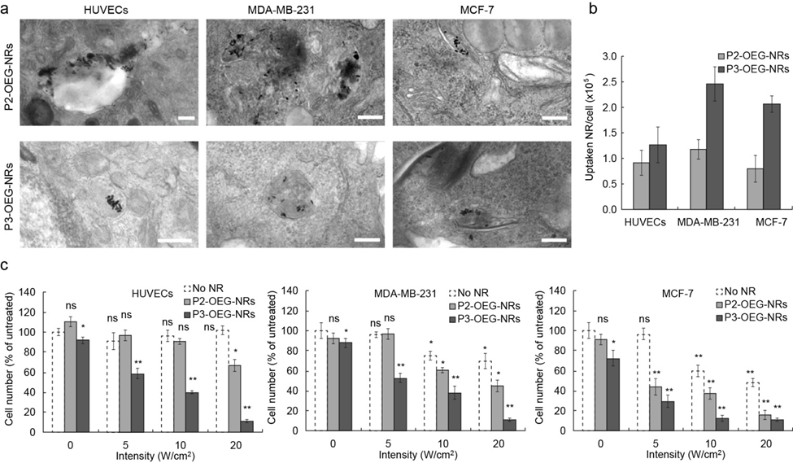

Figure 1. Interaction of peptide coated gold nanorods and cells. (a) Representative TEM images showing the presence of P2-OEG-NRs and P3-OEG-NRs inside HUVECs, MDA-MB-231 and MCF-7 cells; scale bars are 200nm. (b) Quantitative analysis of peptide coated gold nanorod internalization levels; n=3, average ± stdev. (c) The effect of laser-irradiation on cell adherence; n=3, average ± stdev; *p≤0.05, **p≤0.01, ns is not significant.

endothelial cells and cancer cells42) and follow a receptor-mediated internalisation path, as described in our previous studies.28

3.2.3. Sensitivity of cells to laser irradiation. To study the sensitivity of selected cell types to the laser exposure, we irradiated cell monolayers for 5 minutes with laser powers varying between 0 and 20 W/cm2. In our previous work we have shown that HUVECs are not compromised by the laser light for up to 20 W/cm2.38 Here, we have confirmed these findings through imaging Calcein green (viability stain) stained cell monolayer after laser irradiation (Figure S3, ESI) and calculating percent decrease in viable cell number compared to untreated controls (Figure 1c) . Figure 1c also shows the effect of laser light alone on MDA-MB-231 and MCF-7 cancer cells, as well as the effect of laser-induced nanorods-mediated hyperthermia in cells loaded with P2-OEG-NRs and P3-OEG-NRs. Since, all cell types used in our experiments are adherent in nature, a decrease in cell number is indicative of increased sensitivity to laser and/or laser-induced nanorods hyperthermia. This could be explained by downregulation of genes (ILAM, ICAM) involved in cell adhesion under laser induced heat stress, as we have demonstrated in our previous work38. This is because all counted, hence attached, cells remained viable (stained positive with Calcein green). In the absence of peptide-coated gold nanorods (white bars), laser light alone did not have any effect on HUVEC, but LPD of 10 W/cm2 and higher affected the number of cancer cells. This reflects an increased sensitivity of cancer cells compared to healthy, primary cells, as reported in the literature.43 For cells loaded with P2-OEG-NRs (light grey bars) the effect was stronger. A decrease in cell number was observed also for HUVEC at 20 W/cm2 LPD, owning to nanorods-mediated heating. Much stringer effects were observed on cells loaded with P3-OEG-NRs (dark grey bars). In case of cancer cells, the pronounced influence of P3-OEG-NRs on the adherence of cells is consistent with their increased uptake compared to P2-OEG-NRs and the concomitantly stronger laser-induced effects. In addition, the biological activity of the P3 peptide involves a reduction of cell adherence through NRP-1 signaling, as we have previously observed and discussed extensively.29 For HUVECs, differences in nanorods’ uptake are smaller, thus, the observed effects of P3 are most likely related to the functionality of these particles alone. Comparing the two cancer cell lines, higher laser sensitivity of the MCF-7 cells than MDA-MB-231 was observed, which could in turn influence the level of inhibition of particular cancer cell type induced *in vitro* angiogenesis.

* 1. Laser induced inhibition of *in vitro* tumour angiogenesis

**3.3.1. Angiogenesis stimulated with cancer cell conditioned media.** In a first step of studying the effects of laser-induced nanorods-mediated inhibitory effects on capillaries formation we used a system of reduced complexity. More specifically, we stimulated angiogenesis with MDA-MB-231 or MCF-7 cells conditioned media, containing constant levels of cancer cell secreted pro-angiogenic cytokines, as we have previously reported.29 We have monitored the development of capillaries by HUVECs in the presence of P2-OEG-NRs or P3-OEG-NRs and with varying doses of laser irradiation. To identify the optimal conditions for angiogenesis inhibition, HUVECs were exposed to varied doses of P2-OEG-NRs or P3-OEG-NRs (0-3nM). HUVECs were initially incubated with nanorods for 4h to allow for particles internalisation, as well as triggering the inhibitory effects associated with the P3 peptide functionality. Then cells were, washed, placed in fresh nanorods-free media and laser irradiated (with laser intensities ranging from 0-20 W/cm2) for 5 minutes. HUVECs were allowed to form capillaries for a further 4 h (to a total of 8 h, in line with our previously published work29) before being stained with Calcein Green and imaged. It is important to highlight that the capillaries formation on matrix gel is a quick process, in which cells change their morphology and stretch in order to form junctions with neighbouring cells. For this proliferation is not required. This should not be confused with blood vessels formation *in vivo*, which involves development of structures with cylindrical geometry. As we have previously reported, *in vitro* capillaries formation is complete after 8 h stimulation.29

Figure 2a and b shows images of capillaries developed. The ‘mutant’ P2-OEG-NRs (Figure 2a) did not inhibit capillary formation in the absence of laser irradiation. On the contrary, P3-OEG-NRs alone significantly inhibited angiogenesis at concentrations above 1.5 nM (Figure 2b). When laser irradiation was applied, a greater reduction in the ability of HUVECs to form capillaries was observed. These effects were stronger in case of P3-OEG-NRs, especially at lower nanoparticle concentrations and laser powers when compared to P2-OEG-NRs, which is due to the biological activity of P3 peptides.

To quantify these observations we statistically analysed three major aspects of *in vitro* angiogenesis as shown in Figure 2c,d. These are the total length of capillaries formed, the number of junctions between individual capillary branches and the fraction of surface area covered by tubules. The coloured three regions correspond to the individual anti-angiogenic effects caused from the peptide-coated gold nanorods without laser (red), the effect (or additional effect) of laser treatment (yellow) and the unaffected vascular network (blue). Red region is only observed for the P3-OEG-NRs as discussed above. The additional anti-angiogenic effect of laser treatment, when the P3-OEG-NRs are present, is observed only for the lower nanoparticle dose of 0.75 nM, as the biological activity of the particles already suppresses most of the vascular growth for higher nanoparticle dose (see regions yellow and blue in Figure 2d). Similar trends were observed when angiogenesis was stimulated using MCF-7 conditioned media (see ESI-Figure S4).

3.3.2. Angiogenesis induced by cancer cells. In order to better model the tumour microenvironment, we designed the set-up shown in Figure 3. We co-cultured MDA-MB-231 cells (or MCF-7 see figure S5) underneath the layer of gel matrix with HUVECs subsequently seeded on the top of the gel. Cancer cells grown underneath the gel, continuously release pro-angiogenic factors, which diffuse through the gel and induce capillaries formation by HUVECs, as evident from the image in Figure 3b. Compared to the experiment with conditioned media, the presence of cancer cells provides a more dynamical environment with a continuous stream of fresh stimuli, therefore presenting a more challenging milieu for angiogenesis inhibition. The relevant images in Figure 3b and their quantitative analysis in Figure 3c show that in the absence of laser irradiation angiogenesis yet again develops irrespective of the concentration of P2-OEG-NRs and it is only inhibited in the presence of higher concentrations of P3-OEG-NRs. However, compared to conditioned media stimulation, here the P3-OEG-NRs were not as effective in angiogenesis inhibition. Even at the highest dose of 3.0 nM, vascular networks with an area fraction of up to 50% (in respect to particle-free cells) are present. This network is not fully developed, as shown by the low number of junctions. It consists of clustered cells indicating increase levels of angiogenic activity most likely related to the complex interplay of the

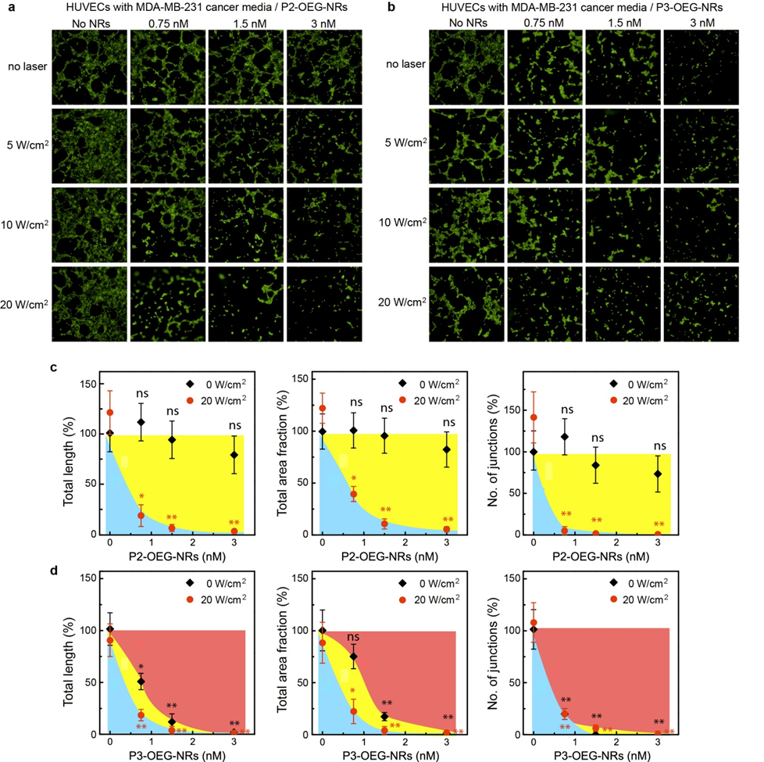

Figure 2. Inhibition of angiogenesis stimulated with MDA-MB-231 cancer cell conditioned media. Fluorescent images and quantification of capillaries stimulated with MDA-MB-231 conditioned media and treated with various doses of P2-OEG-GNRs (a) or P3-OEG-NRs (b) and laser irradiation. In (c, d) a quantitative analysis of the vascular network is shown; tubule length, fraction area and number of junctions; n=3, average ± stdev; *p≤0.05, **p≤0.01. Colored regions indicate anti-angiogenic biological activity in the vascular network (red), additional effect of laser irradiation (yellow), and unaffected network (blue) and were interpolated from the experimental data points using spline curves connecting the experimental data points.

cancer cells with the endothelial cells, providing constant stimuli of pro-angiogenic cytokines. Furthermore, it cannot be excluded that specific molecular interactions exist between the HUVECs and the cancer cells, which trigger a dynamic response when angiogenesis is inhibited, as in a real tumour microenvironment. A full investigation of this interaction goes beyond the scope of the present work and in fact, is the topic of ongoing studies in cancer therapy.44 The synergetic effect deriving from anti-angiogenic nanoparticles and laser treatment becomes a key factor to augment the effectiveness of angiogenesis inhibition. Indeed, application of laser intensities of up to 20 W/cm2 results in a strong inhibition of capillaries formation.

Figure 3 shows that at the highest laser power density and a moderate concentration of anti-angiogenic particles, the tumour angiogenesis is inhibited very effectively (the intermediate laser powers are presented in Figure S6). A direct comparison of the anti-angiogenic P3-OEG-NPs with the experiment where ‘mutant’ nanoparticles (P2-OEG-NRs) were used, leads us to the conclusion that when, both, the anti-angiogenic functionality and laser irradiation are employed the tumour directed capillaries



Figure 3. Inhibition of angiogenesis stimulated with co-cultured MDA-MB-231 cancer cells; (a) A schematic illustration of the experiment. Anti-angiogenic gold nanorods and laser irradiation are employed to inhibit angiogenesis; (b) Fluorescent images of capillaries stimulated from MDA-MB-231 cancer cells and treated with various doses of peptide coated gold nanorods and laser irradiation; (c) A quantitative analysis of the vascular network; tubule length, area fraction and number of junctions; n=3, average ± stdev; *p≤0.05, **p≤0.01. Colored regions indicate anti-angiogenic biological activity in the vascular network (red), additional effect of laser irradiation (yellow), and unaffected network (blue).

formation is inhibited much more efficiently. The laser irradiation is critical to the sufficient inhibition of tumour angiogenesis and acts synergistically with the presence of the selected nanoparticles.

The pronounced anti-angiogenic effect of nanoparticle laser treatment may be attributed to a direct irradiation of the HUVECs, as shown in Figure 1c, resulting in suppression of angiogenesis through a combination of cell adherence and laser-induced changes in cellular functions.38 An additional contribution may arise from local treatment of the cancer cells in the area of the irradiation spot, leading to reduced cancer cell viability in the irradiation spot. However, this area (200 μm) is small compared to that of the total surface area of a culture dish and the effect of this small spot on the overall release of growth factors is assumed to be low. We emphasise that our *in vitro* model does not represent the full complexity of a real tumour environment, where the tumour itself relies on the vascular network for its growth and supply of nutrients, and will correspondingly react to an inhibition of vascular growth. In our system, the cancer cells are supported by the medium and therefore will continue to release growth factors at a normal rate.

The complete investigation of a range of gold nanorod doses and laser intensities for the two types of peptides allows us to map out the useful parameter space of individual and synergistic effects (Figure S7 and S8). The maps identify a useful window in which the nanoparticle dose can be traded-off against laser intensity and vice versa, thus allowing for an application-dependent optimisation of dose parameters. The effects of combined anti-angiogenic and laser treatment targeting the vasculature can thus be individually tuned with respect to other laser-induced therapies directly aimed at tumour cells. While the presented data allows us to identify a global trend, a natural variation exists in the angiogenesis process (taken into account by the error bars) results in some intrinsic variations at intermediate dose conditions (Figure S7 and S8).

While the current studies demonstrate the effectiveness of synergistic ligand and laser treatment in *in-vitro* models of increasing complexity, a next level of studies will need to establish functionality under *in-vivo* conditions. Eventually, it is anticipated that the nanoparticle-peptide platform has the potential to add improved selectivity and targeting to anti-angiogenic therapies, which are traditionally not very compatible with a systemic approach due to the ubiquity of angiogenesis in the human body. A synergistic ligand- and laser-induced approach would be of interest as complementary strategy (or second-line therapy) for conventional cancer treatments. Similar to other laser hyperthermia methods, the use of laser-induced effects will pose certain limitations in the type and location of tumours that can be optically addressed, including superficial tumour sites, such as breast cancer, melanoma, head and neck. Future advances in technology may overcome these limitations, by extending the penetration depth of light in tissue using methods of wavefront shaping, or delivering laser irradiation inside the body using optical fibre probes in minimally invasive laparoscopic keyhole surgery.

1. Conclusions

In summary, we have developed a functional nanoparticulate system that inhibits *in vitro* tumour angiogenesis through a combinatorial approach based on the biological activity of the ligand shell and the unique properties of the inorganic core. By tuning the nanoparticle dose and the laser irradiation we were able to identify the optimum conditions for the efficient inhibition of *in vitro* vascular growth. Our results are a step towards the development of new categories of combinational therapy that exploit both biological and physical activity of gold nanoparticles and that are specifically designed to target complex environments such as tumour angiogenesis.

**Acknowledgements**

The University of Southampton, Royal Society and EPSRC (EP/K503575/1) are gratefully acknowledged for partial support of this project. A.G.K. would also like to thank the EU COST actions MP1005, MP1202, TD1003 and TD1004 for networking opportunities associated with this work. O.L.M. acknowledges financial support from EPSRC through grant EP/J016918/1. Dr Anton Page and Dr David Johnston from the Biomedical Imaging Unit in Southampton General Hospital are gratefully acknowledged for their assistance with the experimental set-up.

Notes and references

*a* Physics and Astronomy, Faculty of Applied and Physical Sciences, University of Southampton, Southampton, SO17 1BJ, UK.

*b* Faculty of Medicine, Southampton General Hospital, University of Southampton, Southampton, SO17 1BJ, UK.

*c* Institute for Life Sciences, University of Southampton, Southampton, SO17 1BJ, UK.

*d* Istituto Italiano di Technologia, Via Morego 30, 16163 Genova, Italy.

* Corresponding author: a.kanaras@soton.ac.uk.

† Electronic Supplementary Information (ESI) available: nanorods characteristics, cell sensitivity to light, full quantification of capillaries, effect of laser induced hyperthermia on MCF-7 conditioned media and MCF-7 cells induced angiogenesis, binding to cell receptors and image analysis. See DOI: 10.1039/b000000x/

1. Carmeliet, P. Angiogenesis in life, disease and medicine. *Nature* **2005**, *438***,** 932-936.
2. Carmeliet, P.; Jain, R. K. Angiogenesis in cancer and other diseases. *Nature* **2000***, 407*,249-257.
3. Folkman, J. Role of angiogenesis in tumour growth and metastasis. *Semin. Oncol.* **2002***, 29*, 15-18.
4. Hanahan, D.; Weinberg, R. A. Hallmarks of Cancer: The Next Generation. *Cell* **2011**, *144*, 646-674.
5. Ferrara, N. Vascular endothelial growth factor: basic science and clinical progress. *Endorcing Reviews* **2004**, *25*, 581-611.
6. Sitohy, B.; Nagy, J. A.; Dvorak, H. F. Anti-VEGF/VEGFR therapy for cancer: reassessing the target. *Cancer Res*. **2012**, *72*, 1909-1914.
7. Jain, R. K.; Duda, D. G.; Clark, J. W.; Loeffler, J. S. Lessons from phase III clinical trials on anti-VEGF therapy for cancer. *Nature Clin. Pract. Oncol.* **2006**, *3*, 24-40.
8. Albini, A.; Tosetti, F.; Li, V. W.; Noonan, D. M.; Li, W. W. Cancer prevention by targeting angiogenesis. *Nat. Rev. Clin. Oncol.* **2012**, *9*,498-509.
9. Roodink, I.; Leenders, W. P. J. Targeted therapies of cancer angiogenesis inhibition seems not enough. *Cancer Lett.* **2010**,*299*,1-10.
10. D’ Andrea, L. D.; Del Gatto, A.; Pedone, C., Benedetti, E. Peptide-based molecules in Angiogenesis. *Chem. Biol. Drug Des.* **2006**, *67,* 115-126.
11. Ferrara, N.; Kerbel, R. S. Angiogenesis as a therapeutic target. *Nature* **2005**, *438,* 967-974.
12. Roca, C.; Primo, L.; Valdembri, D.; Cividalli, A.; Declerck, P.; Carmeliet, P.; Gabriele, P.; Bussolino, F. Hyperthermia inhibits angiogenesis by a plasminogen activator inhibitor 1-dependent mechanism. *Cancer Res*. **2003**, *63*, 1500-1507.
13. Brand, K.; Lubbe, A. S.; Justus, D. L. Hyperthermia decreases cytokine-mediated adhesion molecule expression on human umbilical vein endothelial cells. *Int. J. Hyperthermia* **1996**, *12*, 527-538.
14. Sawaji, Y.; Sato, T.; Takeuchi, A.; Hirata, M.; Ito, A. Anti-angiogenic action of hyperthermia by suppressing gene expression and production of tumour-derived vascular endothelial growth factor in vivo and in vitro. *Br. J. Cancer* **2002***, 86,* 1597-1603.
15. Riahi, R.; Wang, S.; Long, M.; Li, N.; Chiou, P. Y.; Zhang, D. D.; Wong, P. K. Mapping photothermally induced gene expression in living cells and tissues by nanorods-locked nucleic acid complexes. *ACS Nano* **2014***, 8,*3597-3605.
16. Ren, F.; Bhana, S.; Norman, D. D.; Johnson, J.; Xu, L.; Baker, D. L.; Parrill, A. L.; Huang, X. Gold nanorods carrying paclitaxel for photothermal-chemotherapy of cancer. *Bioconjug. Chem.* **2013***, 24,* 376-386.
17. Chen, R.; Zheng, X.; Qian, H.; Wang, X.; Wang, J.; Jiang, X. Combined near-IR photothermal therapy and chemotherapy using gold-nanorod/chitosan hybrid nanospheres to enhance the antitumor effect. *Biomater. Sci.* **2013**, *1,* 285-293.
18. Ungureanu, C.; Kroes, R.; Petersen, W.; Groothuis, T. A. M.; Ungureanu, F.; Janssen, H.; van Leeuwen, F. W. B.; Kooyman, R. P. H.; Manohar, S.; van Leeuwen, T. G. Light interactions with gold nanorods and cells: Implications for photothermal nanotherapeutics. *NanoLett.* **2011**, *11,* 1887-1894.
19. Au, L.; Zheng, D.; Zhou, F.; Li, Z. Y.; Li, X.; Xia, Y. A quantitative study on the photothermal effect of immune gold nanocages targeted to breast cancer cells. *ACS Nano* 2008, *2,*1645-1652.
20. Danhier, F.; Feron, O.; Préat, V. To exploit the tumor microenvironment: Passive and active tumor targeting of nanocarriers for anti-cancer drug delivery. *J. Control. Release* **2010**, *148*, 135-146.
21. Wang, Y.; Black, K. C. L.; Luehmann, H.; Li, W.; Zhang, Y.; Cai, X.; Wan, D.; Liu, S.-Y.; Li, M.; Kim, P.; Li, Z.-Y.; Wang, L. V.; Liu, Y.; Xia, Y. Comparison study of gold nanohexapods, nanorods and nanocages for photothermal cancer treatment. *ACS Nano* **2013**, *7,*2068-2077.
22. Tsai, M. F.; Chang, S.-H. G.; Cheng, F.-Y.; Shanmugam, V.; Cheng, Y.-S.; Su, C.-H. Yeh, C.-S. Au nanorod design as light-absorber in the first and second biological near-infrared windows for in vivo photothermal therapy. *ACS Nano* **2013,** *7,*5330-5342.
23. Pustovalov, V. K.; Astafyeva, L. G.; Galanzha, E.; Zharov, V. P. Thermo-optical analysis and selection of the properties of absorbing nanoparticles for laser applications in cancer nanotechnology. *Cancer Nano* 2010, *1*,35-46.
24. Day, H. A.; Bartczak, D.; Fairbairn, N.; Mcguire, E.; Ardakani, M.; Porter, A. E.; Kanaras, A. G. Controlling the three-dimensional morphology of nanocrystals. *CrystEngComm* **2010**, *12***,** 4312-4316.
25. Webb, J. A., Bardhan, R. Emerging advances in nanomedicine with engineered gold nanostructures. *Nanoscale* **2014***, 6,*2502-2530.
26. Sapsford, K. E.; Russ Algar, W.; Berti, L.; Boeneman Gemmill, K.; Casey, B. J.; Oh, E.; Stewart, M. H.; Medintz, I. L. Functionalizing nanoparticles with biological molecules : Developing chemistries that facilitate nanotechnology. *Chem. Rev.* **2013***, 113,*1904-2074.
27. Heuer-Jungemann, A.; Harimech, P.; Brown, T.; Kanaras, A. G. Gold Nanoparticles and Fluorescently-Labelled DNA as a Platform for Biological Sensing. *Nanoscale* **2013**, *5,* 9503-9510.
28. Bartczak, D.; Sanchez-Elsner, T.; Louafi, F.; Millar, T. M.; Kanaras, A. G. Receptor-mediated interactions between colloidal gold nanoparticles and human umbilical vein endothelial cells. *Small* **2011**, *7,* 388–394.
29. Bartczak, D.; Muskens, O. L.; Sanchez-Elsner, T.; Kanaras, A. G.; Millar, T. M. Manipulation of in vitro angiogenesis using peptide-coated gold nanoparticles. *ACS Nano* **2013**, *7,* 5628–5636.
30. Chung, E.; Ricles, L. M.; Stowers, R. S.; Nam, S. Y.; Emelianov, S. Y.; Suggs, L. J. Multifunctional nanoscale strategies for enhancing and monitoring blood vessel regeneration. *NanoToday* **2012***, 7,* 514-531.
31. Banerjee, D.; Harfouche, R.; Sengupta, S. Nanotechnology-mediated targeting of tumour angiogenesis. *Vascular Cell* **2011**, *3,*1-13.
32. Yoncheva, K.; Momekov, G. Antiangiogenic anticancer strategy based on Nanoparticulate systems. *Expert. Opin. Drug. Deliv*. **2011**, *8,*1041-1056.
33. Patra, C.R.; Bhattacharya, R.; Patra, S.; Vlahakis, N. E.; Gabashrili, A.; Koltypin, Y.; Gedanken, A.; Mukherjee, P.; Mukhopadhyay, D. Pro-angiogenic properties of europium (III) hydroxide nanorods. *Adv. Mater*. **2008**, *20,* 753-756.
34. Bhattacharya, R.; Mukherjee, P. Biological properties of “naked” metal nanoparticles. *Adv. Drug Del. Rev*. **2008**, *60,* 1289-1306.
35. Mukherjee, P.; Bhattacharya, R.; Wang, P.; Wang, L.; Basu, S.; Nagy, J. A.; Atala, A.; Mukhopadhyay, D.; Soker, S. Antiangiogenic properties of gold nanoparticles. *Clin. Cancer Res*. **2005**, *11,* 3530-3534.
36. Bartczak, D.; Nitti, S.; Millar, T. M.; Kanaras, A. G. Exocytosis of peptide functionalized gold nanoparticles in endothelial cells. *Nanoscale* **2012**, *4,* 4470-4472.
37. Bartczak, D.; Muskens, O. L.; Nitti, S.; Millar, T. M.; Sanchez-Elsner, T.; Kanaras, A. G. Interactions of Human Endothelial Cells with Gold Nanoparticles of Different Morphologies. *Small* **2012**, *8*, 122-130.
38. Bartczak, D.; Muskens, O. L.; Millar, T.; Sanchez-Elsner, T.; Kanaras, A. G. Laser-Induced Damage and Recovery of Plasmonically Targeted Human Endothelial Cells. *NanoLett.* **2011**, *11*, 1358-1363.
39. Nikoobakht, B.; El-Sayed, M. A. Preparation and growth mechanism of gold nanorods using seed-mediated growth method. *Chem. Mater.* 2003, *15*, 1957-1962.
40. Niemistö, A.; Dunmire, V.; Yli-Harja, O.; Zhang, W.; Shmulevich, I. Robust quantification of in vitro angiogenesis through image analysis. *IEEE Transactions on Medical Imaging* **2005**, *24,* 549-553.
41. Rothen-Ruthishauser, B.; Kuhn, D. A.; Ali, Z.; Gasser, M.; Amin, F.; Parak, W. J.; Vanhecke, D.; Fink, A.; Gehr, P.; Brandenberger, C. Quantification of gold nanoparticle cell uptake under controlled biological conditions and adequate resolution. *Nanomedicine* **2014**, *9*, 607-621.
42. Soker, S.; Takashima, S.; Miao, H. Q.; Neufeld, G.; Klagsbrun, M. Neuropilin-1 is expressed by endothelial and tumor cells as an isoform-specific receptor for vascular endothelial growth factor. *Cell* **1998**, *92*, 735-745.
43. Levine, E.M.; Robbins, E.B. Differential temperature sensitivity of normal and cancer cells in culture. *J. Cellular Physiol.* **1970**, *76*, 373-380.
44. Chen, Y.; Gou, X.; Ke, X.; Cui, H.; Chen, Z. Human tumor cells induce angiogenesis through positive feedback between CD147 and insulin-like growth factor-I. *PLoS ONE* 2012, *7*,1-11.