Novel approaches to the diagnosis of sarcopenia
Mark Edwards¹, Bjoern Buehring^{2,3}

¹MRC Lifecourse Epidemiology Unit, Southampton General Hospital, Tremona Road, Southampton, SO16 6YD, UK.
²University of Wisconsin Osteoporosis Research Program, Division of Geriatrics and Gerontology, Department of Medicine, School of Medicine and Public Health, University of Wisconsin-Madison, 2870 University Ave, Suite 100, Madison, WI, 53705, USA
³GRECC, William S. Middleton Memorial Veterans Hospital, 2500 Overlook Terrace, Madison, WI, 53705, USA

Correspondence and reprint requests to:
Dr Mark Edwards, MRC Lifecourse Epidemiology Unit, Southampton General Hospital, Tremona Road, Southampton, SO16 6YD, UK
Telephone 023 8077 7624 Fax 023 8070 4021 email: me@mrc.soton.ac.uk

Abbreviated title: The diagnosis of sarcopenia

Keywords: Sarcopenia, dysmobility, grip strength, gait speed, physical performance, epidemiology

Disclosures: The authors have no conflicts of interest.

Abstract
Sarcopenia is common in older people and is associated with disability, reduced mobility, hospitalisation, and various comorbidities. Although it has been recognised for over a quarter of a century, we do not currently have a universally adopted definition. This limits our ability to compare results from different studies and impedes the development of novel therapies. Although sarcopenia was initially defined purely based on low muscle mass, the importance of measures of muscle function has been realised and these have been included in recent operational definitions. These continue to develop with some including an assessment of adiposity and others adding further components of musculoskeletal health in a score-based approach.

This review describes the importance of reaching a widely accepted method of defining sarcopenia in both research and clinical practice. It details the ways in which the definition has changed since its initial inception and explores how it may continue to evolve in the future. The different methods by which components of sarcopenia can be measured are described and the various advantages and disadvantages of these techniques are evaluated. Clearly, there are several other similar syndromes in older people, such as frailty and cachexia, and their relationships and overlap with sarcopenia are also explored.

Key messages
- Sarcopenia is common in older people and associated with significant morbidity.
- There is currently no universally accepted definition of sarcopenia.
- Most operational definitions include assessments of muscle mass and muscle function.
- Score-based approached may be used in the future to provide a wider evaluation of musculoskeletal health.

Introduction
The term sarcopenia was first introduced a quarter of a century ago in 1989 by Irwin Rosenberg to describe the loss of muscle mass with age. Over the intervening years, the definition has evolved to acknowledge the significance of a concurrent decline in muscle function. However, there is still no universally accepted operational definition of sarcopenia for use in research or clinical practice. Sarcopenia is an important clinical problem by virtue of its considerable prevalence within the older population along with its associations with adverse health outcomes. The prevalence of sarcopenia was initially estimated at around 50% in individuals over the age of 80 years of age. However, more recent studies have shown rates of to be lower but still of the order of 10-20% when assessed in terms of muscle mass alone (1).

Specific risk factors for developing sarcopenia include advancing age, female gender, adverse developmental factors in early life, dietary issues, a lack of physical activity, and chronic diseases. It is associated with frailty, disability, reduced mobility, hospitalisation, and specific comorbidities including poorer bone health/osteoporosis, obesity, and type 2 diabetes (2, 3). Most importantly, a decline in muscle health, particularly strength, has also been shown to predict future mortality from middle-age into later life (4). It has been estimated that, in the United States, sarcopenia resulted in additional healthcare costs of over $18 billion in 2001 (5) and given current changes in population demographics with increasing longevity, this figure is likely to continue to increase.

The importance of defining sarcopenia
Clearly, if the presence of sarcopenia is a predictor of premature death, it is necessary to identify individuals at risk in order to assess the natural history of the condition and to provide treatment where appropriate. Interventions may include dietary manipulation, exercise-related therapies and, in the future, pharmaceutical agents. Any definition to be used in clinic practice must be practical, acceptable to patients and not prohibitively expensive. Within a research framework, it may be possible to use more intricate methods to obtain the diagnosis. However, ideally a uniform definition would be used in both settings in order to allowed generalizability of studies to clinical practice.

Furthermore, there is currently no widely accepted sarcopenic outcome measure, the achievement of which would invariably support regulatory approval. Consequently, this may limit the development of new medications in this area and it is therefore important to produce relevant outcomes that are easily measurable and clinically important that can be adopted on a large scale.

Current operational definitions of sarcopenia
Over the last 5 years, three main consensus definitions for sarcopenia have been suggested (1, 6, 7). Although they all differ to some degree, each includes a measurement of muscle size and another of muscle function (Table 1). The rationale for utilising muscle function, in addition to muscle size, is that the latter alone would provide too narrow a definition which may limit clinical value and that the relationship between muscle mass and strength is not linear (6). Like muscle mass, muscle functional parameters also start reducing at the age of 35 years (8). Interestingly, evidence from the Health ABC study suggests that muscle strength and power decrease with advancing age at a greater rate than muscle mass (9) which may suggest they are more sensitive measures of muscle decline.

Furthermore, Studenski and colleagues concluded from recent studies that muscle mass is weakly or not associated with function and disability. However, low muscle mass does relate to low muscle strength which is in turn strongly associated with impaired function and disability (10). The age-associated loss of muscle strength alone has been termed by some as dynapenia (11) which is clearly different from the definitions of sarcopenia proposed.

In both the International Working Group on Sarcopenia (IWGS) and ESPEN Special Interest Groups (ESPEN SIG) definitions, the measure of muscle function is that of usual gait speed which can be measured using a 4 metre walk test. The IWGS uses a cut off of under 1 m/s whereas the ESPEN SIG suggests a more stringent value of less than 0.8 m/s. In contrast, the European Working Group on Sarcopenia in Older People (EWGSOP) propose sarcopenia to be present in those individuals with low muscle mass along with either low physical performance (gait speed) or low muscle strength (grip strength) (6). It was proposed that the latter could be measured using a hand-held dynamometer such as the Jamar device. If both grip strength and gait speed were deficient in an individual with low muscle mass, they would be deemed to have severe sarcopenia. Conversely, the term “presarcopenia” would be applicable in those individuals with low muscle mass in the absence of low muscle strength or physical performance. The inclusion of these additional terms would allow staging of sarcopenia which may permit selection of participants for research trials in particular phases of their disease. The EWGSOP also advocated consideration of “primary” (or age-related) sarcopenia when no other cause was evident but “secondary” when one or more causes were identified (6).

Current overlap with other syndromes
Although sarcopenia is a geriatric syndrome in its own right, features of the condition are also found in other disorders such as frailty and cachexia. Frailty occurs due to an age-related decline in several physiologic systems. It can lead to a reduction in the individual’s ability to withstand an insult resulting in their increased vulnerability to adverse health outcomes including mortality. Although others have been developed, one of the most widely used operational definitions of frailty was proposed by Fried and colleagues (12). In this method, the patient is assessed for unintended weight loss, exhaustion, weakness, slow gait speed and low physical activity. A diagnosis of frailty is supported when three or more of these features are present. Clearly, weakness and slow gait speed are both included in the EWGSOP definition of sarcopenia and the latter alone in the other two definitions. Consequently, a frail individual is more likely to be sarcopenic and vice versa.

Cachexia has been defined as a complex metabolic syndrome associated with underlying illness and characterised by loss of muscle with or without loss of fat mass (13) with common aetiologies including cancer, cardiac failure and end-stage renal failure. Important factors that may contribute to the onset of cachexia include anorexia, systemic inflammation, and impaired metabolism of protein, carbohydrate and lipid. Although, based on the current definition, many individuals with cachexia may be sarcopenic, the same is rarely true in reverse. The reason for this is usually the absence of the underlying complex metabolic cause that accompanies cachexia. Although it is not always possible to distinguish sarcopenia from cachexia clinically, those that lack significant systemic inflammation, anorexia and weight loss are more likely to be sarcopenic and not cachectic.

Methods of measuring muscle size, strength and physical performance
Various methods of assessing body composition including muscle mass exist (14, 15). These include traditional approaches using anthropometric measurements, air displacement plethysmography, underwater weighing and dilution techniques. These methods all have limitations, for example, they are not precise (anthropometric measures) or they are very equipment or time intensive (plethysmography, underwater weighing). D₃ creatine dilution is a promising method that is under investigation but has not been used in large studies so far (16).

Currently, both bioelectrical impendence analysis (BIA) and dual-energy x-ray absorptiometry (DXA) are regularly used in observational studies, intervention trials and clinical practice. They too have limitations, including that they estimate lean mass based on calculated fat mass or combined fat mass and bone mass respectively (14). Furthermore, lean mass is a soft tissue that contains water. However, neither BIA nor DXA can distinguish between extracellular and intracellular water which makes these methods more prone to error in populations with a changing hydration status (such as the elderly or athletes) (14, 15). Bioelectrical impendence spectroscopy (BIS) represents an advance from BIA as it is able to distinguish between extra and intracellular water. This may explain why initial studies suggest that BIS demonstrates better correlation to muscle function tests than BIA (17). At present, DXA is the most widely used method to assess lean mass (as a surrogate for muscle mass) in research studies. This is mainly because it has good precision and is easy and safe to administer (14). As a result, appendicular lean mass by DXA is used in all current sarcopenia definitions (1, 6, 7, 9).

The muscle mass assessment methods mentioned so far estimate total mass or regional mass. Cross-sectional imaging techniques such as MRI, CT, and pQCT are able to measure muscle cross-sectional area or, if multiple imaging slices are analyzed, muscle volume. These methodologies are limited by higher radiation exposure (CT), costs, availability, and positioning on repeated imaging but have the advantage that they can distinguish well between muscle tissue and other surrounding soft tissue structures. Furthermore, they are also able to estimate muscle density or muscle fat content which have been shown to independently predict adverse outcomes (18).

Multiple methods exist which allow assessment of muscle function and overall physical performance (15). When evaluating these different methods, it is important to understand broadly what they are examining. For example, they can be categorized by their level of complexity (i.e. whether multiple organ systems are involved and the number of muscle groups that need to be coordinated) and how intensive the procedure is (i.e. how much muscle force or power is required).

Physical function tests such as gait speed during usual walking assess the global function of an individual. The task is very complex with multiple systems being involved and is of low intensity. Conversely, muscle function tests, such as grip strength, are very simple tasks that only involve one muscle group and require a maximal voluntary contraction to be performed (high intensity). Figure 1 shows graphically how different assessments rate in terms of complexity and intensity. It is important to note that in general there are no gender differences in tests of physical function, for example, men and women have similar gait speeds, but there can be marked differences in muscle function tests as men tend to produce higher maximal forces than women.

The remaining tests tend to fall between the two extremes (Figure 1). Repeated chair rises has features of both a physical function test and a muscle function test, as it is complex but requires a higher degree of muscle power than gait speed. The NIH developed a short physical performance battery (SBBP) that combined gait speed, chair rise time and a balance assessment into a score (0-12) which predicts health outcomes and is often used in research studies (19). It is quick, simple to administer, and can be used clinically. Alternatively, jumping mechanography is a test that combines a relatively complex movement with high intensity. We and others have shown that countermovement jumps can be safely performed in those with sarcopenia and that jumping mechanography is a reliable and sensitive test that may be superior to some traditional physical function tests (20).

The current sarcopenia definitions use gait speed measured at usual pace (in contrast to walking as fast as possible) with or without maximal grip strength (1, 6, 7). These tests clearly differ in terms of complexity and intensity. However, both predict health outcomes, such as morbidity and mortality, in large observational cohort studies (21, 22). Many studies have shown that walking speeds below either 1 m/s or 0.8 m/s are related to an increased risk of falling and other adverse outcomes. As such it is understandable that these two cut-offs have been used in the current sarcopenia definitions (1, 6). Similarly, cut-offs for grip strength have been established; the EWGSOP definition specifies values of below 20 kg for women and 30 kg for men (6). Both of these tests are easy to perform and require little equipment, which makes them suitable for use in large trials and population studies, as well as for clinical use. Because walking speed is influenced by many different factors, such as vision impairment or joint disease and pain, and only requires lower levels of intensity it may, however, have limited usefulness in the assessment of an intervention that aims to improve muscle strength or power.

Novel methods of defining sarcopenia
The most recently proposed definition of sarcopenia was developed by researchers that came together under the umbrella of the Foundation of the National Institute of Health (FNIH) sarcopenia project (10). This group had access to data from nine large observational studies with more than 25,000 participants in total. After analysing this large data set they recommended defining sarcopenia based on three components. Two of these, muscle mass and grip strength, were already included in previous definitions mentioned above. The third component was the body mass index (BMI) as a measurement of obesity. The FNIH sarcopenia definition uses a simple adjustment for obesity by dividing appendicular lean mass (ALM) (kg) by BMI (kg/m²). The diagnosis of sarcopenia then requires the presence of both low ALM/BMI ratio and low grip strength.

Using their large observational dataset the FNIH sarcopenia project established cut-off values of <0.789 for men and <0.512 for women for the ALM/BMI ratio, which predicted mobility impairment as assessed by a gait speed of <0.8 m/s. In a similar manner they also established grip strength cut-off values of <26kg for men and <16 kg for females. These are lower values than those used in the EWGSOP definition and may explain why rates of sarcopenia with the FNIH definition were significantly lower than using the other consensus definitions (23). Interestingly, the FNIH definition also appeared to identify a different cohort of individuals as sarcopenic (23).

Adjusting muscle function and mass for overall body weight or fat makes sense intuitively, as an obese individual is likely to need more muscle mass and greater muscle function to perform tasks, such as walking or getting up from a chair, than a non-obese individual. Consequently, the term sarcopenic obesity has also been suggested to describe the combination of low muscle mass/function and excess fat, and there is growing evidence that this condition has a greater adverse effect on health outcomes than either sarcopenia or obesity alone. A further sarcopenia definition that adjusts for height and body fat mass regression residuals has also been proposed, which again identifies a different group of individuals as sarcopenic, particularly in women (9). However, its added complexity does make it more difficult to implement and might limit its utilisation clinically.

All current sarcopenia definitions require low muscle mass. Therefore, without a deficiency in this facet of muscle health, an individual cannot be sarcopenic based on the current definitions. However, over recent years studies have shown that muscle function and physical performance are likely to be better predictors of poor outcome than muscle mass itself. In a similar vein, osteoporosis could not be diagnosed without a T-score of below -2.5. However, it has become apparent that more than 50% of individuals with fragility fractures have bone densities above this threshold. This lead to the development of fracture risk calculators, such as FRAX®, which gives a better understanding of the individuals likelihood of developing the adverse outcome of interest.

Similarly, it was felt by Binkley and colleagues that sarcopenia (defined as low muscle mass and/or function) could be put into a risk factor context that might better predict adverse health outcomes (24). Using the FRAX® calculator and the 2010 American College of Rheumatology rheumatoid arthritis criteria as models, as both contain different risk components that are characteristic of the disease they are associated with, they arbitrarily chose six factors that were felt to be associated with poor musculoskeletal health – osteoporosis, falls, obesity, low muscle mass, low physical function and low muscle strength. It was decided that having three or more of these would classify somebody as having a condition which they named “dysmobility syndrome”. Similar to the concept of “metabolic syndrome” the combination of various adverse factors is usually worse than having one alone. Within this definition, no single component, such as low muscle mass, is needed to support the diagnosis but it is the overall score that determines whether the syndrome is present or not. The authors accept that dysmobility syndrome is currently only a concept and that further studies are necessary to find which factors best predict poor musculoskeletal health outcomes and perhaps then move to determining a “dysmobility” risk or score needed to make the diagnosis. However, an initial small study showed that this syndrome is common in older adults age 70 and over (prevalence of 34%) and provided some evidence for the validity of the current definition of “dysmobility syndrome”, as individuals with the condition more commonly reported falls than in other sarcopenia definitions (24). More recently, Looker applied the dysmobility syndrome concept to the 1999 – 2002 NHANES dataset and found that dysmobility syndrome prevalence was approximately 22% and that it was associated with an increased risk of mortality in males and females age 50 years and older (25).

Conclusion
It is clearly important to endeavour to reach a universally accepted definition of sarcopenia that is based on meaningful health outcomes associated with the disease and find consensus on which tests can best be used as surrogate markers to measure improvement with therapy. This would allow consistency between studies and in clinical practice, and facilitate the development of new treatments. Over the last 25 years, we have moved from definitions based purely on muscle mass to those that include both mass and function. There are several ways of assessing the various facets of muscle health and we should favour those that are simple, acceptable to patients, and reproducible. More recently, the importance of obesity in sarcopenia has also been recognised, with most of the newest definitions including an assessment of adiposity. In the future, score-based approaches to musculoskeletal health assessment may be developed, akin to “dysmobility syndrome”, which would allow a wider evaluation of the individual’s risk.
Table 1 – Current operational definitions of sarcopenia
Definition | Muscle mass | Muscle function
EWGSOP ª (6) | Low muscle mass*  Various methods including CT, MRI and DXA proposed | Low muscle strength#  or  Low performance#
IWGS ^{b} (1) | Low muscle mass*  DXA  aLM/ht² ≤7.23 kg/m² in men  ≤5.67 kg/m² in women | Low gait speed  < 1 m/s
ESPEN SIG ^{c} (7) | Low muscle mass* | Low gait speed  < 0.8 m/s⁺
FNIH ^{d} (10) | Low muscle mass*  DXA  aLM/BMI  < 0.789 in men  < 0.512 in women | Low muscle strength  Grip Strength  < 26 kg in men  < 16 kg in women

Key: ªEuropean Working Group on Sarcopenia in Older People; ^{b}International Working Group on Sarcopenia; ^{c}ESPEN Special Interest Group. ^{d}Foundation of the National Institute of Health *Defined as ≥2 SD below mean of young adults of the same sex and ethnic background. #Various methods and cut points defined(6). ⁺Can be replaced by one of the well-established functional tests utilized locally as being part of the comprehensive geriatric assessment(7). DXA, dual energy x-ray absorptiometry; CT, computed tomography; MRI, magnetic resonance imaging.

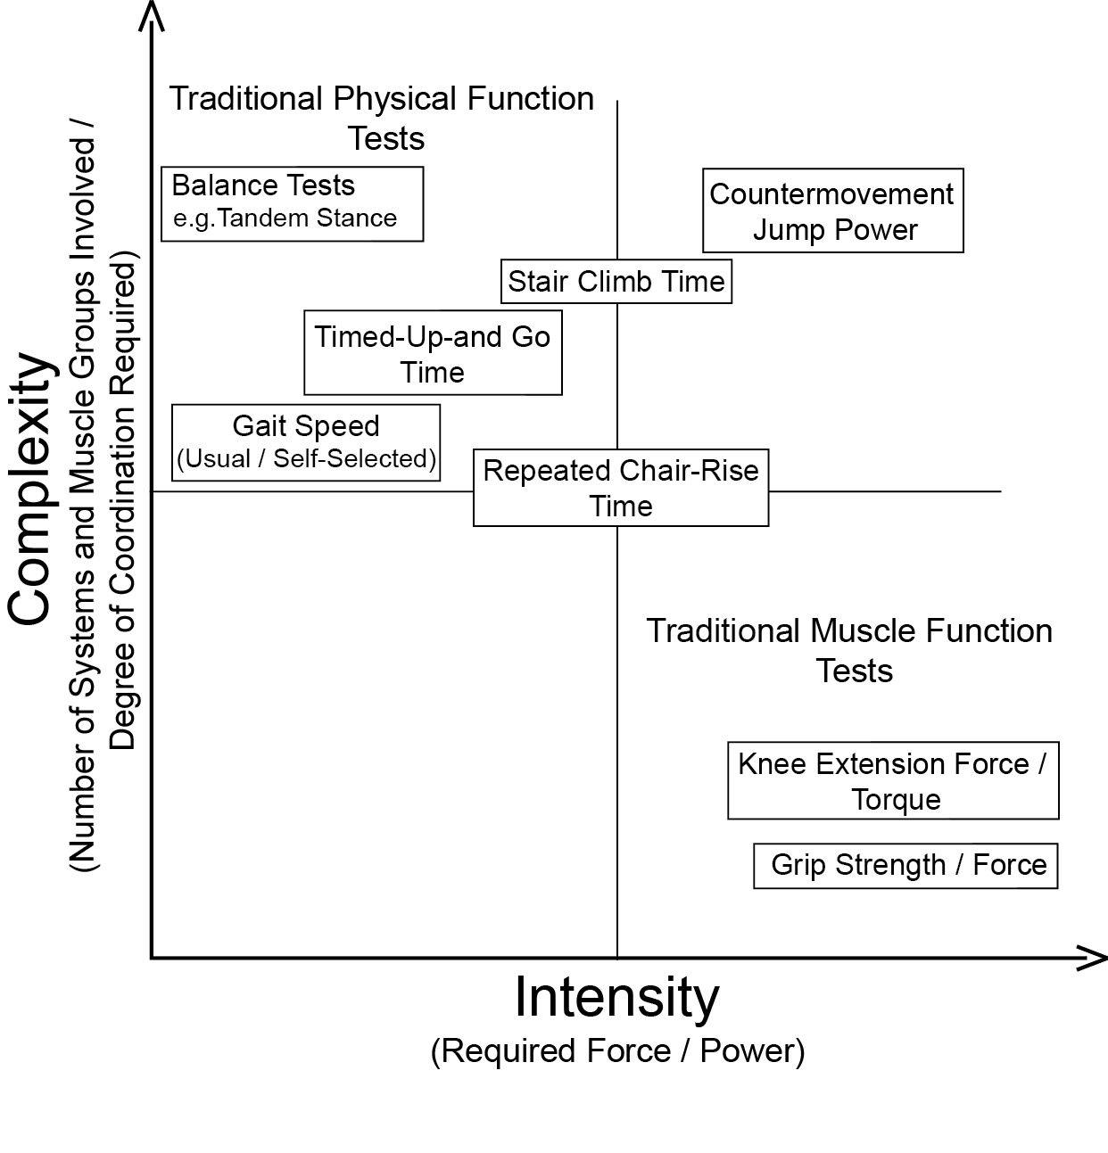
Figure 1: Classification of physical and muscle function tests based on complexity and intensity. Traditional muscle function tests such as gait speed are characterized by a high degree of complexity and lower degree of intensity. Classical muscle function test on the other hand require maximal intensity but have low complexity. Countermovement jumps combine high levels of complexity and intensity.

References
1. Fielding RA, Vellas B, Evans WJ, Bhasin S, Morley JE, Newman AB, et al. Sarcopenia: an undiagnosed condition in older adults. Current consensus definition: prevalence, etiology, and consequences. International working group on sarcopenia. J Am MedDirAssoc. 2011;12(4):249-56.
2. Edwards M, Gregson C, Patel H, Jameson K, Harvey N, Sayer AA, et al. Muscle size, strength and physical performance and their associations with bone structure in the Hertfordshire Cohort Study. J Bone MinerRes. 2013;28(11):2295-304.
3. Sayer AA, Dennison EM, Syddall HE, Gilbody HJ, Phillips DI, Cooper C. Type 2 diabetes, muscle strength, and impaired physical function: the tip of the iceberg? Diabetes Care. 2005;28(10):2541-2.
4. Cooper R, Kuh D, Hardy R. Objectively measured physical capability levels and mortality: systematic review and meta-analysis. Bmj. 2010;341:c4467.
5. Janssen I, Shepard DS, Katzmarzyk PT, Roubenoff R. The healthcare costs of sarcopenia in the United States. Journal of the American Geriatrics Society. 2004;52(1):80-5.
6. Cruz-Jentoft AJ, Baeyens JP, Bauer JM, Boirie Y, Cederholm T, Landi F, et al. Sarcopenia: European consensus on definition and diagnosis: Report of the European Working Group on Sarcopenia in Older People. Age Ageing. 2010;39(4):412-23.
7. Muscaritoli M, Anker SD, Argiles J, Aversa Z, Bauer JM, Biolo G, et al. Consensus definition of sarcopenia, cachexia and pre-cachexia: joint document elaborated by Special Interest Groups (SIG) "cachexia-anorexia in chronic wasting diseases" and "nutrition in geriatrics". Clin Nutr. 2010;29(2):154-9.
8. Frontera WR, Hughes VA, Fielding RA, Fiatarone MA, Evans WJ, Roubenoff R. Aging of skeletal muscle: a 12-yr longitudinal study. Journal of applied physiology (Bethesda, Md : 1985). 2000;88(4):1321-6.
9. Newman AB, Kupelian V, Visser M, Simonsick E, Goodpaster B, Nevitt M, et al. Sarcopenia: alternative definitions and associations with lower extremity function. Journal of the American Geriatrics Society. 2003;51(11):1602-9.
10. Studenski SA, Peters KW, Alley DE, Cawthon PM, McLean RR, Harris TB, et al. The FNIH sarcopenia project: rationale, study description, conference recommendations, and final estimates. The journals of gerontology Series A, Biological sciences and medical sciences. 2014;69(5):547-58.
11. Clark BC, Manini TM. Sarcopenia =/= dynapenia. The journals of gerontology Series A, Biological sciences and medical sciences. 2008;63(8):829-34.
12. Fried LP, Tangen CM, Walston J, Newman AB, Hirsch C, Gottdiener J, et al. Frailty in older adults: evidence for a phenotype. The journals of gerontology Series A, Biological sciences and medical sciences. 2001;56(3):M146-56.
13. Evans WJ, Morley JE, Argiles J, Bales C, Baracos V, Guttridge D, et al. Cachexia: a new definition. Clin Nutr. 2008;27(6):793-9.
14. Lee SY, Gallagher D. Assessment methods in human body composition. Current opinion in clinical nutrition and metabolic care. 2008;11(5):566-72.
15. Mijnarends DM, Meijers JM, Halfens RJ, ter Borg S, Luiking YC, Verlaan S, et al. Validity and reliability of tools to measure muscle mass, strength, and physical performance in community-dwelling older people: a systematic review. Journal of the American Medical Directors Association. 2013;14(3):170-8.
16. Clark RV, Walker AC, O'Connor-Semmes RL, Leonard MS, Miller RR, Stimpson SA, et al. Total body skeletal muscle mass: estimation by creatine (methyl-d3) dilution in humans. Journal of applied physiology (Bethesda, Md : 1985). 2014;116(12):1605-13.
17. Yamada Y, Watanabe Y, Ikenaga M, Yokoyama K, Yoshida T, Morimoto T, et al. Comparison of single- or multifrequency bioelectrical impedance analysis and spectroscopy for assessment of appendicular skeletal muscle in the elderly. Journal of applied physiology (Bethesda, Md : 1985). 2013;115(6):812-8.
18. Cawthon PM, Fox KM, Gandra SR, Delmonico MJ, Chiou CF, Anthony MS, et al. Do muscle mass, muscle density, strength, and physical function similarly influence risk of hospitalization in older adults? Journal of the American Geriatrics Society. 2009;57(8):1411-9.
19. Guralnik JM, Simonsick EM, Ferrucci L, Glynn RJ, Berkman LF, Blazer DG, et al. A short physical performance battery assessing lower extremity function: association with self-reported disability and prediction of mortality and nursing home admission. JGerontol. 1994;49(2):M85-M94.
20. Buehring B, Krueger D, Binkley N. Jumping mechanography: a potential tool for sarcopenia evaluation in older individuals. Journal of clinical densitometry : the official journal of the International Society for Clinical Densitometry. 2010;13(3):283-91.
21. Bohannon RW. Hand-grip dynamometry predicts future outcomes in aging adults. Journal of geriatric physical therapy (2001). 2008;31(1):3-10.
22. Peel NM, Kuys SS, Klein K. Gait speed as a measure in geriatric assessment in clinical settings: a systematic review. The journals of gerontology Series A, Biological sciences and medical sciences. 2013;68(1):39-46.
23. Dam TT, Peters KW, Fragala M, Cawthon PM, Harris TB, McLean R, et al. An evidence-based comparison of operational criteria for the presence of sarcopenia. The journals of gerontology Series A, Biological sciences and medical sciences. 2014;69(5):584-90.
24. Binkley N, Krueger D, Buehring B. What's in a name revisited: should osteoporosis and sarcopenia be considered components of "dysmobility syndrome?". Osteoporos Int. 2013;24(12):2955-9.
25. Looker AC. Dysmobility syndrome and mortality risk in US men and women age 50 years and older. Osteoporos Int. 2014.

