Participatory design of a music aural rehabilitation programme

Authors and affiliations
Rachel M. van Besouw^{1,2}, Benjamin R. Oliver³, Sarah M. Hodkinson³, Richard Polfreman³,
Mary L. Grasmeder^{1,4}

¹Institute of Sound and Vibration Research, University of Southampton, Southampton, UK
²Institute for Life Sciences, University of Southampton, Southampton, UK
³Department of Music, University of Southampton, Southampton, UK
⁴University of Southampton Auditory Implant Service, Southampton, UK

Funding/acknowledgement statement
We wish to thank the University of Southampton Auditory Implant Service, David Nicholls, Magnus White, Mike Wald, Heidi Solheim, Joe Brett, Louise Johnson, Stuart Nelson, Christopher Wickham, Ross Mackenzie, Alex Hudd, Tapio Lokki, Martino Panizza, Harriet Mackenzie, Kate Brown, Michael Solomon Williams, Ben Jameson, Dan Priest, Robin Grey, 10cc (in particular, Eric Stewart), Philip Selway, Cliff Richard, WoodField, Blue Swerver, Madelaine Hart, Zoë Bestel, STOMP and all of the cochlear implant users who contributed to the development of the IMAP. This research was funded by the UK Arts & Humanities Research Council (AHRC) grants AH/H039392/1 and AH/K002880/1.

Conflicts of interest
There are no conflicts of interest that we are aware of.

Abstract
Objectives: Many cochlear implant (CI) users wish to enjoy music but are dissatisfied by its quality as perceived through their implant. Although there is evidence to suggest that training can improve CI users’ perception and appraisal of music, availability of interactive music-based aural rehabilitation for adults is limited. In response to this need, an ‘Interactive Music Awareness Programme’ (IMAP) was developed with and for adult CI users.
Methods: An iterative design and evaluation approach was used. The process began with identification of user needs through consultations, followed by use of mock-up applications in workshops. Feedback from these were used to develop the prototype IMAP; a program of 24 interactive sessions, enabling users to create and manipulate music. The prototype IMAP was subsequently evaluated in a home trial with 16 adult CI users over a period of 12 weeks.
Results: Overall ratings for the prototype IMAP were positive and indicated that it met users' needs. Quantitative and qualitative feedback on the sessions and software in the prototype IMAP were used to identify aspects of the programme that worked well and aspects that required improvement. The IMAP was further developed in response to users' feedback and is freely available online.
Conclusions: The participatory design approach used in developing the IMAP was fundamental in ensuring its relevance, and regular feedback from end users in each phase of development proved valuable for early identification of issues. Observations and feedback from end users supported a holistic approach to music aural rehabilitation.

Keywords: Participatory design, music aural rehabilitation, cochlear implant, interactive learning, computer-based training

INTRODUCTION
Problem statement
Acquired hearing loss in adults with an interest in music may impact especially on their quality of life if it means that they are no longer able to, or are confident in, participating in music-related activities and pursuits. Severely or profoundly deaf adults with a cochlear implant (CI) are likely to perceive gross temporal aspects of music, such as the pulse (tactus) and rhythm (Gfeller et al. 1997; Kong et al. 2004). However, fine temporal and spectral cues are not conveyed well, if at all, and as a result, many CI users find it difficult to rank and distinguish between pitches (Looi et al. 2004; Sucher & McDermott, 2007), follow a melodic contour (Galvin et al. 2009), recognise the timbre of musical instruments (Gfeller et al. 1998; Heng et al. 2011; Kong et al. 2011) and separate the sound sources in a mix (Galvin et al. 2009; Zhu et al. 2011). CI users with memories of how music sounded prior to their hearing loss additionally experience the unique challenge of having to relearn the timbres of musical instruments as they sound through their implant (Gfeller et al. 2002; Driscoll, 2012).

There is evidence to suggest that structured training can benefit CI users’ appraisal of music as well as their music perception abilities, particularly for melodic contour and timbre recognition (Gfeller et al. 2000; Fujita & Ito, 1999; Gfeller et al. 2002; Galvin et al. 2007; Fu & Galvin, 2007; Petersen et al. 2012; Driscoll et al. 2012). However, availability of music-based aural rehabilitation, particularly for adults, is limited (Plant, 2006; Sweetow & Palmer, 2005) and the focus of the training reported in the previous studies has largely been on perceptual accuracy, meaning activity limitations and participation restrictions relating to music go unaddressed.

In the UK CI users are required to travel to their nearest CI centre for services and few of these have the resources and expertise to provide regular, dedicated music therapy sessions and workshops. CI users are also relatively few in number and sparsely located. A computer-based music rehabilitation programme could provide a cost-effective solution, potentially leading to increased participation in music related activities and improvement in quality of life (Boothroyd, 2007). Such a resource could be used at a time and in a place convenient to CI users, and in support sessions offered by CI centres.

Related research
Computer training programmes intended for improving adult CI users’ perception and appraisal of music have been reported in a handful of studies. The first programme for adult CI users was developed by Gfeller et al. (1999) (see also Gfeller et al. 2000, 2002) with the goals of providing structured listening exercises, determining aspects of music that are accessible to CI users, and determining the extent to which the training programme improved music perception and enjoyment. The programme was intended for post-lingually deafened adult CI users and was designed based on prior knowledge of adult aural rehabilitation and learning, prior knowledge of music cognition and pedagogy, and previous data obtained through surveys and interviews with adult CI users. An early version of the programme comprising cassette tapes and a workbook was piloted with eight adult CI users, who gave feedback on it in terms of its clarity, content and format (Gfeller et al. 1999).

The programme contained written information including listening tips previously compiled from CI users, simple pitch sequences with accompanying music notation, samples of instruments with corresponding images, simple computer generated familiar and unfamiliar melodies, real-world music excerpts, and self-directed exploratory tasks. Although CI users provided feedback on the prototype, the extent to which they were directly involved in the development of the content is unclear. However, the concept of the self-directed exploratory task to help the user "generalize the information learned … to real-life situations" (Gfeller et al. 1999) arguably begins to address the user's engagement with music beyond perceptual training.

Galvin et al. (2007) developed a Melodic Contour Identification (MCI) assessment and training tool, requiring users to identify different melodic contours by selecting from nine graphical representations and reported some improvement in identification of familiar melodies following training. Driscoll (2012) developed an online musical instrument recognition training programme to investigate the effect of three types of feedback condition: correct/incorrect feedback, correct/incorrect feedback, followed by the answer, and directed instruction on the instrument presented, followed by correct/incorrect feedback. These tasks described by Galvin et al. (2007) and Driscoll (2012) are examples of results-focussed training, where the goal is to improve a specific aspect of music perception (i.e. melody recognition or instrument identification). The correct/incorrect nature of these tasks could potentially preoccupy the user with hearing music correctly as opposed to endorsing their individual experience of music, and the extent to which such specific training holds the attention of the user is unclear. This contrasts with a more “holistic” approach to music aural rehabilitation, whereby, in addition to training a range of music perception skills, the user develops awareness of aspects, arrangements and styles of music that are accessible through their CI, empowering them to make self-enhancing decisions and supporting their re-engagement with music.

In a recent study, Petersen et al. (2012) combined one-to-one musical ear training by a professional music teacher with computer-based training. Participants attended weekly 1-hour sessions for a period of six months and were instructed to use the computer applications (comprising slideshows in Microsoft PowerPoint) for 30 minutes per day. This included pitch, rhythm and timbre listening exercises and one-to-one rhythm training, whereby the participant reproduced rhythmic patterns through clapping, tapping or drumming. The extent to which participants used the computer applications is unclear as this was not recorded. There also appears to have been no involvement of CI users in developing or formally evaluating the training programme; nonetheless, the high attendance rate for the one-to-one sessions and positive anecdotal feedback suggests that the personal coaching aspect and combination of music making and listening exercises were particularly motivating and helpful.

The early work of Gfeller et al. (1999, 2000) and the training approach used by Petersen et al. (2012) come closest to a holistic approach to music aural rehabilitation. However, in both cases, the interactivity of the self-administered computer-based training is limited to a set of listening exercises that test fundamental aspects of music perception and it is not known whether such programmes fully meet the needs of users. Sweetow & Sabes (2006, 2007) propose that rehabilitation programmes should be interactive, practical and accessible, difficult enough to maintain interest and yet easy enough to minimize frustration and fatigue. In addition to these recommendations, we propose that in order to develop successful aural rehabilitation programmes and protocols that address the users’ needs and aspirations, a participatory design approach is essential from the outset.

The aim of this paper is to demonstrate the use of a participatory design approach for the development of an aural rehabilitation programme with end users. Specifically, we describe how iterative cycles of design and evaluation were used to develop a computer-based music aural rehabilitation programme with adult CI recipients. The project was motivated by demand for music advice/workshops from CI users at the University of Southampton Auditory Implant Service (USAIS) and a lack of specialised music resources for adult CI users to use at home. Initially it was not known what form the rehabilitation programme would take (CD, DVD, software etc) and so the project began with consultations.

METHODS
Participatory design
Participatory design is a process that involves close collaboration with end users in the development and evaluation of novel technologies to ensure that the technologies meet users’ needs and “can be understood and handled in practice by the users” (Clemensen et al. 2007). The process is characterised by "multiple cycles of implementation, adaptation and evaluation driven by stakeholders" (Sharma et al. 2008) and often involves the use of existing technologies, mock-ups/simulations and prototypes to help the end user envision how the technology will look and function (Clemensen et al. 2007; Sharma et al. 2008). The participatory design approach assumes that neither researchers, manufacturers, clinicians nor end users alone have a complete understanding as to what is required in terms of the technology and it typically involves a multidisciplinary team of researchers and stakeholders working closely throughout design, development, testing and deployment (Ding et al. 2007).

For this project the team comprised a musician, music therapist, hearing research scientist, music technologist, programmer, clinical (audiological) scientist and end users, ensuring representation from professionals with clinical and technical competences (Clemensen et al. 2007). An iterative design and evaluation approach analogous to the participatory action research spiral proposed by Kemmis et al. (2014) was used (Figure 1). The process began with identification of user needs through consultations with end users in the initial “plan” stage (phase 1), which included discussion of existing resources. This was followed by the development of mock-up applications (‘apps’) and their evaluation in a series of music exploration workshops (phase 2). Feedback and observations from the workshops were used to further develop the apps and incorporate them into a prototype music rehabilitation programme, which was evaluated in a home trial (phase 3). Further feedback from the trial and observations from focus groups piloting online sessions were used to improve the programme before it was deployed online (phase 4).

These research activities were approved by the Institute of Sound and Vibration Research Human Experimentation Safety and Ethics Committee (reference 1159 and 1250). The trial that formed part of phase 3 was additionally approved by the University of Southampton Research Governance Office (reference RGO 8306) and by the National Research Ethics Service (reference 11/SC/0436).

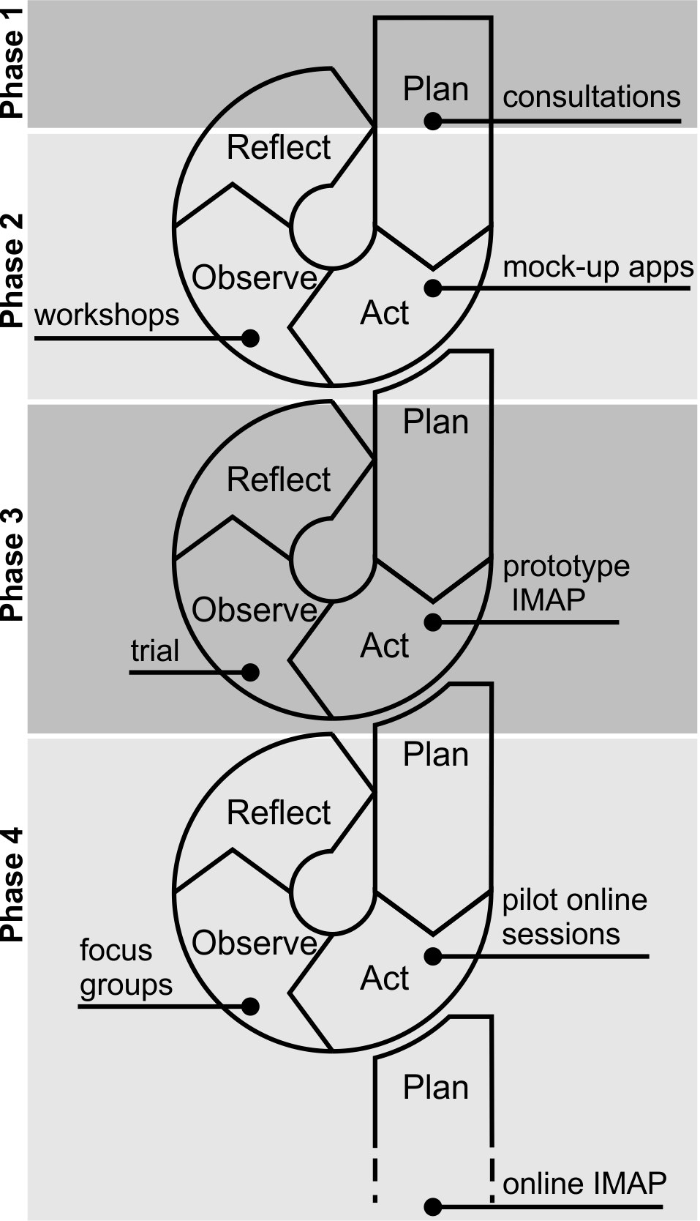
Figure 1. Iterative design and evaluation approach used to develop an Interactive Music Awareness Programme (IMAP) with and for adult CI users. Adapted from Kemmis et al. (2014, pp.18-21), but also see Clemensen et al. (2007).

Phase 1: Identification of users’ needs
Two consultation meetings were held with the research team and five long-term postlingually deafened adult CI users from the USAIS who had previously expressed an interest in music. The small group size ensured that everybody had the opportunity to contribute towards the discussion. The objectives of these consultation meetings were to establish the CI users’ aspirations; issues of music perception that they considered important; and activities, information, and resources that would be relevant. The meetings were transcribed, coded into themes, and summarised by the music therapist (see van Besouw et al. 2014 for a summary). Here we focus on the specific needs and design ideas that emerged from the consultations.

Initial ideas
Initial suggestions given by the CI users for music rehabilitation resources included:
- a resource (booklet or internet site) with information about listening to music through a CI
- tools to “help with choosing CDs to buy, or radio stations to listen to”
- “somewhere to go and try different musical instruments”, with guidance on accessing equipment and/or recorded music
- software that can “take a piece of normal music and transform it into a [pitch] range that cochlear [sic] patients appreciate”
- a resource that displays a “visual interpretation of music”

All five CI users had previously searched for strategies and technology to help with music listening, demonstrating motivation and resolve to control or to improve their experiences. Subtitles were unanimously reported to be helpful for recalling familiar music. One CI user reported that using a virtual (online) keyboard with various instrument timbres had been particularly useful and another CI user brought a portable sound-to-light sensor bar with him to demonstrate the usefulness of visual feedback indicating the loudness of sounds.

HOPE Notes
Following the discussion of initial ideas, the tracks The Thing with Scales, Twinkle Twinkle Little Star and Someone Else’s Heartache from the HOPE Notes DVD (Reed, 2010) were presented to demonstrate a range of music listening exercises in an existing music (re)habilitation resource. HOPE Notes is a programme comprising a DVD, CD and user guide created by musician and CI user, Richard Reed, for the CI manufacturer Cochlear Ltd. It is intended for use by CI and hearing aid users and there are currently no published studies of this resource.

The Thing with Scales introduces 12 instruments playing major scales in different keys, separated by a simple drum interlude. The CI users described this as, “surprisingly enjoyable”, “quite pleasant” and “a musical experience”. The simplicity of the concept, the visual cues illustrating the rise and fall of the scales and the regularity of the tempo were found to be particularly useful. Twinkle Twinkle Little Star presents either the melody notes, the bass notes, or combinations of the melody and bass. It features an animation indicating the relative pitches of the notes, which was noted as helpful; however, the bass notes were reported to be “hard to pick up” and “confusing”. Someone Else’s Heartache is a song in the country genre for male vocalist, with a simple melody and clear arrangement. Two CI users found the tune pleasing, one CI user remarked that it had “no redeeming features” and another commented that it reminded him of his tinnitus. Despite this mixed reaction, being able to see subtitles and the instruments being played was noted as helpful. When asked to suggest improvements to these exercises, the CI users wished to be able to control the speed of playback, the amount of information being communicated and the introduction of instruments.

GarageBand
A brief demonstration of the feature Magic GarageBand in GarageBand was given to solicit views on interactive music software. Magic GarageBand enables the user to select an excerpt or entire song from one of a selection of genres and adjust the arrangement of instruments in real-time. The interactive nature of this software and the potential to gradually increase the complexity by adding more instruments was reported to be interesting and helpful. There was a positive response to the idea of being able to create a personal mix of previously known and unknown music, which could be saved and listened to at a later date.

Phase 2: Use of mock up apps
Mock-up app design
The suggested activities of being able to create a personal mix of a piece of music, transform music in a different frequency range, try out different musical instruments and explore visual cues using animations and subtitles, were incorporated into three Max/MSP mock-up software apps; the Timbre Player, the Environmental Rhythm Machine (ERM) and the N-Machine.

The mock-up apps were piloted throughout a series of nine music exploration workshops. Workshop attendees were given a brief demonstration of each app as a group before experimenting with it on individual computer workstations. To support use of the apps, attendees were given worksheets with instructions and suggested exercises. The first three workshops also included group listening exercises using selected tracks from the HOPE Notes DVD. The therapeutic value of the workshops was concurrently investigated and is reported in van Besouw et al. (2014). A total of 28 adult CI users from the USAIS attended at least one workshop (see van Besouw et al. for further details). Here we describe workshop attendees’ use of, and reactions to the mock-up applications and HOPE Notes DVD listening exercises.

HOPE Notes
To encourage the exchange of ideas and opinions, the interactive response system TurningPoint was used to enable the attendees to rate the exercises anonymously, followed by facilitated discussion. Attendees generally found the visual cues used in this resource (comprising subtitles, animations and video) very helpful, but were often overwhelmed by the amount of information presented and the initial pace of the exercises. HOPE Notes is intended for repeated listening and most of the attendees agreed that the level of difficulty and pace were unlikely to be issues with practice. However, some suggested that the limited interactivity of the DVD would soon become frustrating. The overall opinion of this resource was very favourable and its use in a group listening activity helped attendees to appreciate the differences and similarities in how they each perceive music.

Timbre Player
The Timbre Player enabled the user to select a melody and to listen to it using a solo instrument of their choice. The user could also manipulate the speed of playback and transpose the melody. During playback the app provided the user with a choice of visual cues including an animated representation of the pitch contour, music notation and video of the instrument being played. For the workshops the mock-up app included two well-known melodies and a new tune composed specifically for CI users with large pitch intervals. Nearly all of the attendees appeared to use and understand the Timbre Player with ease. The interactivity of this app was commented on by attendees in the workshops and in unsolicited emailed feedback following the workshops: “I was pleased to have the opportunity to ... change speed, pitch etc to find out what was best for me.”

The ERM
The ERM was developed to encourage re-engagement with music by taking advantage of the rhythm cues that are accessible to most CI users. The ERM used short clips of familiar environmental sounds such as a car horn, door slam, or telephone ring, and enabled the user to build up polyphonic rhythmic loops. The complexity of the music could also be determined by the user, as individual rhythmic phrases could be heard in isolation or with others. The user could change the sound used for each track and create new phrases by tapping them in using the computer keyboard, allowing potential for open-ended experimentation. The mock-up app also provided visual cues indicating the presence, absence and volume of each track, and pre-set arrangements, which enabled a graded approach to ensure early success.

The pre-set arrangements in the ERM were particularly effective in helping the workshop attendees to understand the app, and they were soon able to create and listen to new loops using different combinations of sounds. A few attendees were initially puzzled by the concept of making music out of environmental sounds, but after further experimentation with the ERM, they began to discover and appreciate that conventional instruments are not necessarily requisite for creating music. Following a workshop, one attendee emailed: “The ERM was splendid and I look forward to eventually taking this home with me? I liked the way I could build up the different rhythms - composing them before listening - by a gradual process able to pick out all three at the same time. Having a lot of different everyday items made this easier for me as a CI user.”

The N-Machine
The N-Machine was developed in response to the desire expressed by CI users in the consultation meetings to “create a personal mix of a song in order to hear out individual instruments”. Three versions of the N-machine were developed for the workshops, each providing the user with controls to adjust the mix of different pieces of classical and popular music. Users were able to fade in/out individual instruments and additionally transpose the music to a preferred pitch range. Sound level displays provided visual cues to indicate the contribution of each instrument in the mix (Figure 2a).

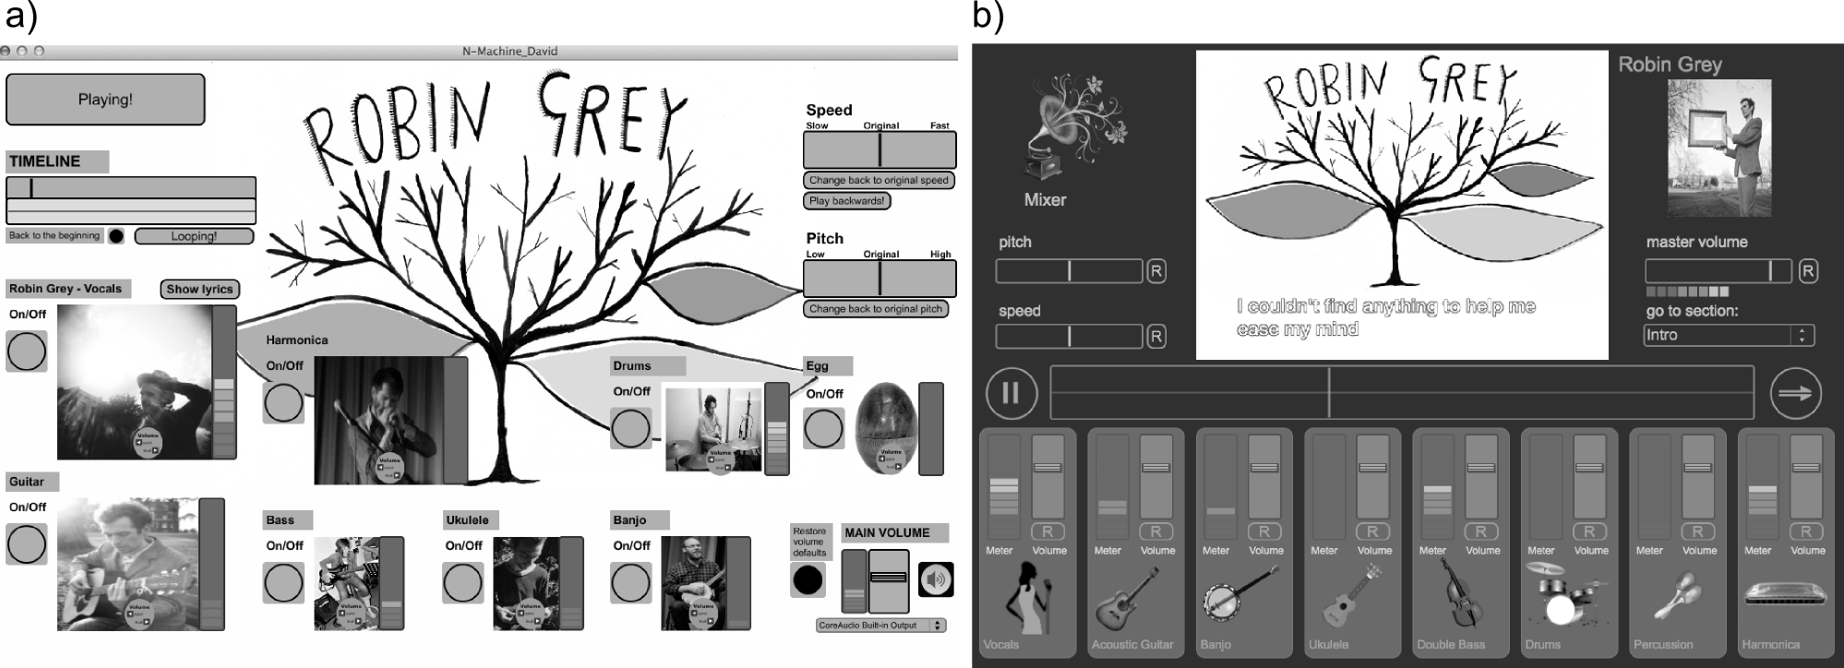
Figure 2. a) Example N-Machine interface enabling users to create their own mix of a piece of music by turning on and off individual instruments, fading in/out individual instruments and transposing the music to a preferred pitch range. b) Mixer interface with standardised controls and subtitles synchronised with the lyrics.

The N-Machine was well received by the attendees and they were keen to try all three versions, regardless of the genre of the music. From observing attendees’ engagement with the app it was clear that this activity encouraged experimentation with combinations of instruments, much like the ‘trial and error’ approach advocated by Gfeller et al. (2001), in order to determine what is readily perceptible and how the polyphony affects instrument and song recognition. Following a workshop, one attendee emailed: “I enjoyed listening through the ear phones with the ability to mix the sounds and various instruments and could have spent a lot more time doing so.”

Phase 3: Development and evaluation of an Interactive Music Awareness Programme
IMAP design criteria
Using the ideas, observations and feedback from the consultations and workshops, the research team agreed the following design criteria for the development of an IMAP:

Interactive: The positive reaction of the workshop attendees to the mock-up apps and recommendations made by Sweetow & Sabes (2006; 2007) indicated that the IMAP should be interactive, engrossing the user and promoting thoughtful experimentation.
Creative: A desire to create and manipulate music was evident in the workshop attendees’ engagement with the ERM to compose new loops and the N-Machine to create personal mixes.
Visual: Feedback from the consultations and workshops reinforced the importance of including visual representations (indicating the pitch, loudness and onset of sounds, showing the instrument being played, lip cues and subtitles) for helping CI users interpret music and verifying their perception of it.
Educational: Workshop attendees appreciated the opportunity to learn more about how their implant works, tips for listening to music through a CI, and about music in general. Following a workshop, one attendee wrote “It has given me a view into how music is composed. You don't have to have formal music training to enjoy some composing.” Another emailed to say that the workshop had “enlightened me of the processing and it explain[ed] a lot as to why my memory of speech/music differs so much from my implanted hearing”. This feedback supported the view that the IMAP should be educational.
Open-ended: The issue raised in the consultations of “choosing CDs to buy, or radio stations to listen to” was echoed by a workshop attendee, who commented that the “biggest problem is not knowing what music is out there and how to find it”. This feedback indicated that the IMAP should help CI users discover music beyond that included in the programme.
Intuitive: Each app used in the workshops had a graphical user interface (GUI) with all sound controls and visual displays in the same window. This is considered to be easier for users than accessing controls in different windows (Cooper, 1995, p.75), but made the GUI appear ‘busy’. In the workshops computer literacy was also noted to vary considerably. Instructions were provided on paper and were also included in the app GUIs. However, attendees were often eager to explore the apps without reading instructions, which meant that they were not always aware of the full functionality of the app. These observations indicated that app GUIs in the IMAP should be intuitive, with video tutorials supporting use of the apps.

Prototype IMAP
The prototype IMAP was housed on a USB memory stick and could be used on Windows or Apple platforms. The user was guided through 24 half-hour sessions by means of a html template that linked to six interactive Max/MSP standalone apps, enabling users to create and manipulate music (Oliver et al., 2012). The length and number of sessions was based on the assumption that users would undertake two half-hour sessions per week over ~3 months; a compromise between the training programme format used by Gfeller et al. (1999) and findings of a music perception survey study with postlingually deafened adult CI users by Looi & She (2010). Gfeller et al. intended their programme to be used over a 3-month period to “ensure distributed practice”, with users completing four half-hour sessions per week. However, the majority of respondents in the survey study of Looi & She indicated that they would be willing to undertake 2-3 half-hour music training sessions per week.

In addition to the Timbre Player, three versions (basic, intermediate and advanced) of the ERM and five versions of the N-Machine (featuring works by various artists), apps included the Pulse Tapster, the Rhythm Tapster and the Audio Visual Player (AVP). The Pulse Tapster was designed to help users identify the pulse in excerpts of music, providing visual feedback on the user’s ability to tap (with a computer keyboard or mouse) in time to the excerpt. The selection of excerpts ranged from a simple metronome pulse to more complex pieces written and sequenced by composer and co-author, Benjamin Oliver. The Rhythm Tapster was designed to help users replicate rhythms with the aid of visual feedback. Rhythm is one of the most accessible aspects of music through a CI and the rhythm activities included in the workshops proved to be particularly successful (van Besouw et al. 2014). It was therefore anticipated that CI users would find the Pulse Tapster and Rhythm Tapster activities motivating and rewarding. The AVP was designed to enable CI users to creatively combine audio and video clips to explore how music contributes to the mood, meaning and aesthetics of a film.

The apps were introduced through text or video instructions. Each odd numbered session concluded with an online directed listening task (DLT), ultimately encouraging users to discover music on sites such as YouTube (similar to the self-directed exploratory tasks used by Gfeller et al. 1999). Each even numbered session concluded with a music perception test, which informally tested users’ abilities in pulse detection (PD), melodic contour (MC) perception and instrument recognition (IR). The accessibility of rhythm was assumed to be an ideal starting point and so the first session of the IMAP focused on pulse.

Prototype IMAP evaluation
The prototype IMAP was evaluated in trial with 21 adult CI users recruited from the USAIS. The primary objective of the trial was to evaluate the efficacy of the prototype IMAP, with the specific aims of determining if the programme was beneficial for music perception, if this benefit generalised to speech in noise perception and if the programme had a positive impact on ratings of sound quality and music listening habits. The outcomes relating to this objective are reported in full in van Besouw et al. (in press) and are therefore only briefly summarised below. The secondary objective was to obtain feedback on the prototype IMAP in order evaluate its viability and to further improve it. Here we report the findings for the secondary objective and how these data informed phase 4 of the participatory design process.

For the trial, participants were instructed to undertake two half-hour sessions per week at home over 12 weeks. Participants were shown how to access and use the IMAP on a computer before taking the software home and were emailed by the experimenter every four weeks to check that they were not experiencing technical difficulties. Each participant was given a pamphlet with additional instructions, a troubleshooting guide, tips on listening to audio on a computer using loudspeakers, headphones or direct connection with an isolation cable, and space to make observations regarding their own progress.

At the end of each session in the IMAP participants were prompted to complete a password protected online survey, where they were asked to enter how long they had spent on the session, rate the session, rate the software, and give optional free-response feedback. Ratings were made using a 5-point Likert scale to rate how fun, difficult, interesting, confusing, useful and boring the session was, and to rate how easy to use, frustrating and reliable the software was. At the end of the trial, participants were asked by the experimenter to give ratings for the questions “What is your overall opinion of the Interactive Music Awareness Programme” , “Did the Interactive Music Awareness Programme meet your needs?” and “What could we do to improve the Interactive Music Awareness Programme?”.

RESULTS
Attrition and adherence
During the trial of the prototype IMAP, two participants withdrew due to the time commitment involved, one withdrew due to difficulties using a computer and another a week before the end of the trial due to a bereavement. A further participant withdrew before receiving the software, leaving 16 participants in total. Of these 16, ten participants completed all 24 IMAP sessions, five completed 19-23 sessions, and one completed ten sessions during the 12-week period. The average time spent using the IMAP across the 16 participants was 911.3 minutes ±246.4 SD. The average time spent per session was 41.2 minutes ±6.1 SD (Figure 3a). Outcomes and feedback are reported below for these 16 participants.

Summary of outcome measures
Prior to, and following training, participants undertook speech perception, melodic contour identification and instrument recognition tests that did not feature in the IMAP. Participants were also asked to rate five pieces of music in terms of sound quality, and indicate their music listening habits. Following training participants showed improved instrument recognition, consistent with the findings of previous studies (Fujita & Ito, 1999; Gfeller et al. 2002a, 2002b; Petersen et al. 2012; Driscoll, 2012). Results for melodic contour identification were inconclusive due to unexpected ceiling effects for this test. Improvements post-training for speech perception in noise and sound quality ratings were observed for some participants, but not all, potentially reflecting prior differences in participant characteristics that were not measured. A general, but non-statistically significant increase in music listening habits was observed throughout the trial, with further feedback suggesting that the IMAP had a positive impact on participants’ lives not captured by the outcome measures (van Besouw et al. in press).

Prototype IMAP session feedback
Median session ratings for fun, difficult, interesting, confusing, useful and boring are shown in Figure 3b. Median software ratings for easy to use, frustrating and reliable are shown in Figure 3c. These quantitative data were used to pinpoint sessions and software that were rated more positively or negatively overall and the corresponding qualitative (free-response feedback) data were interrogated to determine why. Examples of more positively and negatively rated sessions and software, and feedback supporting these ratings are discussed below.

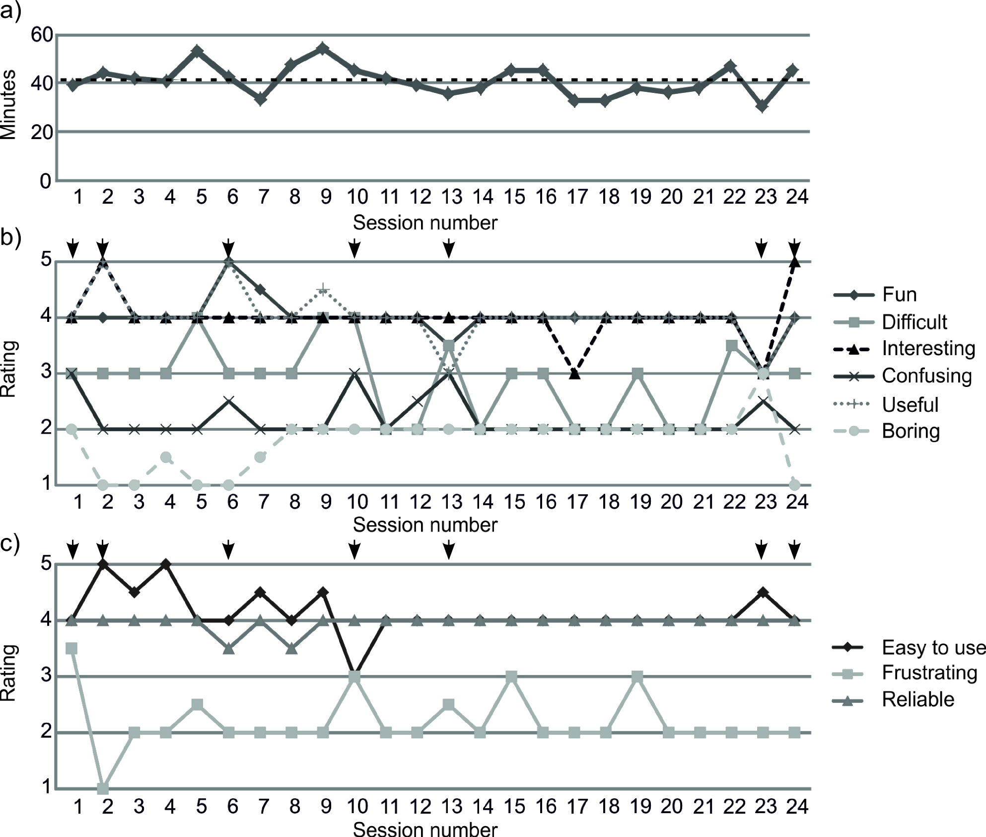

Figure 3. a) Average time spent on each session (dashed line: mean across all sessions). b) Median session ratings, and c) median software ratings (5 = strongly agree, 4 = agree, 3 = neither agree nor disagree, 2 = disagree and 1 = strongly disagree). Arrows indicate examples of more positively and negatively rated sessions and software.

Session 1
Median session ratings were 3.5 for difficult and 3 for confusing, with a median software rating of 4 for frustrating. Users reported initial problems starting the Pulse Tapster app and getting audio playback, and difficulties with the sensitivity of the interface (computer keyboard, mouse or touchpad) for tapping in time to the music excerpts:

“I found using the software a bit confusing at the start - I wasn't sure how to get it going and some sound, but OK once I had clicked around a bit!”

“My touchpad wouldn't allow me to tap properly, so used the buttons - slight problem there is there is both a 'down' and 'up' click to the button which was a little confusing at times.”

Session 2
Median session ratings were 5 for interesting and useful, 4.5 for fun, and 1 for boring. Median software ratings were 1.5 for frustrating and 4.5 for easy to use. Users reported that they found the video tutorial of the Timbre Player app useful and that they enjoyed experimenting and practising with the various instrument and melody combinations:

“This was better than session one as I liked the video tutorial of the timbre player.”

“I really enjoyed this session and liked playing around with the various instruments in the first section and trying different settings and variations, it is a very clever piece of software and I am definitely going to return to it and keep practising my listening skills with it.”

Session 6
Median session ratings were 5 for fun and useful, and 1 for boring. Users reported that they enjoyed listening to different arrangements of Ravel’s Boléro and appreciated the visual cues in this version of the N-Machine:

“I really enjoyed playing around with the N-Machine and listening to Bolero in a variety of ways, taking out various instruments and listening to others on their own and trying to remember what they sounded like.”

“I like the way you can see the changing pitch looking at the moving graph.”

Session 10
Median session ratings were 2.5 for confusing and 4 for difficult, with a median software rating of 3 for frustrating and easy to use. Users reported that the instructions for, and the purpose of the ERM were not clear enough, the interface was not intuitive and that the ERM did not fit on the screen:

“I do not like the ERM as I am not sure what I am gaining or listening from it.”

“I am beginning to find there are too many buttons, knobs, dials etc! ... I have a widescreen laptop and couldn't fit all of the screen on.”

Session 13
Median session ratings were 3 for useful and confusing, and 4 for difficult, with a median software rating of 3 for frustrating. Users reported further difficulties with saving mixes and settings in the ERM and disliked a DLT where the lip cues in the video were obscured:

“I still am grappling with the storing & retrieving music. I do like the layout & the way you can create music, but trying to store it puts me off. Not clear! I cannot seem to find my original stored music from previous session.”

“I'm not sure if it was a good one to select as he had a microphone right in front of his mouth, but I could make out some words and hear the harmonica play.”

Session 23
A median session rating of 3 was given for boring, useful and interesting. Users also spent the least amount of time on this session. Reactions towards revisiting the AVP were mixed and the DLT, which featured vocalists who talk or rap, was reported to be uninteresting:

“I thought I would find the AVP boring as I didn't enjoy it overly last time. But this time round, I found the music easier to listen to and paid more attention to the music than the film clips.”

“I didn't like either of the listening videos... I wouldn't have been able to hear the words if I hadn't looked at the lyrics but they didn't seem to have much point anyway. Visually, I found them uninteresting.”

Session 24
Median session ratings were 5 for interesting and 1 for boring. Users reported that they enjoyed listening to and comparing different styles of music, and that the DLT music videos with clear visual cues and subtitling were particularly helpful:

“It was very interesting listening to the different types of music in close succession... I think this programme has been a really useful introduction to different types of music.”

“Found listening to the videos useful … it has made me more confident in using Youtube to find songs I like and to look at other recommendations.”

End of trial feedback
At the end of the trial, participants gave a median overall rating for the prototype IMAP of 4 (IQR = 1), where 1 = very dissatisfied and 5 = very satisfied. In response to the question “Did the IMAP meet your needs?”, participants gave a median rating of 4 (IQR = 1), where 1 = strongly disagree and 5 = strongly agree. The most frequent suggestions for improving the prototype IMAP were: more music variety (9 requests), more opportunity to listen to individual instruments (8 requests) and more instruction/explanation (5 requests). Other, more specific suggestions for improvement included “an interactive application for pitch training” and “exercises involving listening to scales”.

DISCUSSION
The mixed method approach used to collect quantitative and qualitative feedback on the sessions and software in the prototype IMAP proved to be an effective way of determining aspects that worked well and aspects that required improvement. The ratings helped pinpoint issues with sessions and software that were common across users, and the qualitative data provided context, facilitating interpretation. In addition, the method used to collect feedback during the trial (an online survey completed by users at the end of each session) also resulted in ‘honest’ feedback that captured the users’ immediate and unrestrained reactions to the session and software. The nature of this feedback notably contrasted with the more positive comments and suggestions for improvement given by participants at the end of trial and in the presence of a researcher.

For each session and app in the prototype IMAP, a list of recommendations was drawn up based on the users’ feedback. The IMAP was subsequently further developed as an online resource to make it more widely accessible and to facilitate updates and maintenance. Prior to launching the complete IMAP online, two sessions were piloted in two focus groups with 11 adult CI users from the USAIS and UK National CI Users Association. Observations and feedback from these focus groups were used to improve the navigability of the website and app download manager, identify bugs and optimise the GUI functionality of the apps.

Phase 4: Further development of the IMAP
The following key changes to the IMAP were made in response to users’ feedback prior to making it available online:

Session structure, objectives and themes
Each session has been given a clearer name and brief description that feature in the menu on the ‘IMAP Sessions’ page of the website. Users are able to select any session from the menu, or navigate from one session to the next. Learning objectives are explicit at the start of each session to ensure that the user is clear about the purpose of the activities and the focus of each session has been revisited to ensure that the DLTs and tests at the end of each session are aligned with the activities. The theme of the session is also now indicated by one of five icons with mouseover text for Rhythm/Pulse, Timbre, Pitch/Melody, Arrangement, and Mood/Emotion. Sessions contain no more than one app in response to the average time spent on each session during the trial and feedback indicating that 30 minutes was insufficient to complete all the activities. DLTs that proved unpopular in the trial of the prototype IMAP have been replaced with links to music videos recommended by CI users who participated in the trial and focus groups.

App names, interfaces and tutorials
More meaningful names have been given to the apps in the IMAP; for example, the N-Machine is now the Mixer, the ERM is now Looper, the Timbre Player is now Tune Explorer and the AVP is now SoundTrack. GUI controls and displays have been standardised across the apps thereby minimising the number of controls that the user has to learn and all apps are supported with subtitled video tutorials. In the case of the Mixer app, which formerly had a different GUI for each artist featured, the GUI now has a uniform and more intuitive appearance (Figure 2b).

Music perception tests
The informal music perception tests in the prototype IMAP were not well controlled or necessarily directly related to the session, which limited their usefulness in terms of providing feedback on performance. The IR test in the prototype IMAP comprised a 12 alternative forced choice (AFC) task with instrument samples that were short excerpts idiosyncratic to the instrument. This has been replaced with a 3AFC task, with three choices provided out of a set of eight instruments, and with a focus on instruments that feature in the session. Excerpts in the new version of the IR test all consist of the same melody. Similarly, the MC task, which previously comprised excerpts of real-world monophonic piano melodies, with a graphic symbol that traced out the shape of the contour as it played, has been simplified to a 3AFC task using 3-note falling, flat and rising contours, with intervals decreasing as the test progresses. The PD test, a test in which the user had to identify which out of three metronomes was in time with the pulse of excerpts of music, was initially reported to be confusing by participants in the trial of the prototype IMAP and so has been replaced with a 3AFC rhythm discrimination task.

Variety of music
In response to CI users’ requests to “get more music to break down” audio and video contributions have been obtained with permission from various signed and unsigned artists, resulting in six new Mixer apps in addition to the five previous versions in the prototype IMAP. New recordings have also made using a selection of instruments for the Tune Explorer, resulting in four versions of this app featuring simple musical scales, pop song excerpts, film themes and advert tunes.

Session text and further information
The text in each session has been reduced to smaller, digestible chunks, with definitions of musical terms, further information about artists and works, and app video tutorial reminders available to users by clicking on information buttons to open popup windows.

Online implementation issues
There were two main technical problems implementing the IMAP online: the size of audio-video data and the availability of audio processing functions. The prototype IMAP was large, 16GB delivered on USB memory stick. To reduce the download size, audio-video data has been optimised and split between apps that are downloaded and material streamed from the web, resulting in a total download size of 6.5GB. If downloaded as a whole, this can still lead to long waiting times, even for those with fast internet connections. Therefore, the apps in the online IMAP are downloaded and launched on demand from a small host management program (the ‘IMAP manager’), limiting individual download size. The IMAP manager communicates with the website to ensure that it lists the current set of apps and the sessions they belong to. The session webpages then indicate when the user should go to the IMAP manager and which app to run, while the apps themselves can return the user to the referring webpage, helping to integrate the two.

Max/MSP has been used for developing the interactive sessions, leveraging both its robust audio/visual processing and also what had been learned during the prototype development. In future the Web Audio API may provide sufficient functionality for the IMAP to be hosted entirely within a browser, but this will require significant development and testing on different browsers and platforms. Web Audio API is also currently not supported by Internet Explorer on Windows.

Relevance of corpus and music copyright
Throughout the development of the IMAP, users contacted the research team with music suggestions for the N-Machine/Mixer app, eager to remix a past favourite. The Mixer requires 'stems' (the unmixed audio tracks), which are rarely in the public domain. Stem and video contributions were therefore sought directly from a range of signed and unsigned artists with varying success, which limited the corpus of music for the Mixer app.

Audio and video materials obtained directly from artists or artist representatives (e.g. record or management companies) were licensed for use in the IMAP through the creation of specific licensing contracts. In addition, Creative Commons licensed video was used in the SoundTrack app and a Limited Online Music License (LOML) was obtained from the Performing Right Society (PRS), which allowed the inclusion of copyrighted melodies in Tune Explorer.

Current usage and further research
The IMAP is currently available online at www.morefrommusic.org (van Besouw et al. 2013). For music licensing purposes, users are required to register and indicate if they are deaf or hard of hearing, if they are an aide to a person who is deaf or hard of hearing, or if they are a professional working with individuals who are deaf or hard of hearing. Since launch of the IMAP in 2014, 203 individuals have registered to use the IMAP; 94 of these are CI users and 79 are professionals.

Research is now needed to gain a deeper understanding as to how and when users engage with the IMAP when they are not participating in a trial where usage is 'prescribed', whether they continue to use the IMAP in the long term, and factors that affect usage. Further evaluation of the IMAP is also required to fully document its efficacy and effectiveness in terms of music perception and wider impact on quality of life, so that CI users and professionals can make an informed decision regarding how much time to spend undertaking music aural rehabilitation.

CONCLUSIONS
The participatory design approach taken in the development of the IMAP has been fundamental in ensuring its relevance to end users. A key observation made early in the design process was that CI users were eager to receive more than perceptual training, which supports the case for a more holistic approach to music aural rehabilitation. Users had a desire to learn more about their abilities to perceive music through their CI so they could make informed decisions about their music experiences, and there was demand for support in finding and interacting with music. Regular user feedback in each phase of development proved valuable for early identification of issues with instruction, website navigability and GUI functionality, enabling the research team to immediately address these problems.

The participatory design approach additionally helped foster a sense of ownership by the CI users involved in this project, who recognised and appreciated that their feedback counted; one CI user contacted the research team to say “I look forward to Ben's future software developments and I can only hope I am able to continue to take part and be of help somehow in this wonderful research.”

The IMAP is available online at www.morefrommusic.org and comprises 24 sessions with interactive apps that enable users to create music and manipulate music from a range of genres, and evaluate their music perception abilities. Session activities are introduced through text-based instruction and subtitled video tutorials. Each session concludes with either a directed listening task to support users in discovering music online, or an informal music perception test enabling users to gauge their progress. The next stages of this research will be to investigate how and when users engage with the IMAP, and to further evaluate its efficacy and effectiveness as a music aural rehabilitation program.

References
Clemensen, J., Larsen, S.B., Kyng, M. and Kirkevold, M. 2007 ‘Participatory design in health sciences: using cooperative experimental methods in developing health services and computer technology’, Qualitative Health Research, 17: 122-130, doi: 10.1177/1049732306293664.

Cooper, A. 1995 About Face: The Essentials of User Interface Design. Foster City, CA: IDG Books Worldwide.

Ding, D., Cooper, R.A. and Pearlman, J. 2007 ‘Incorporating participatory design action into research and education’, In proceedings: International Conference on Engineering Education 2007, Coimbra, Portugal, viewed 13 February 2015, http://ineer.org/Events/ICEE2007/papers/553.pdf.

Driscoll, V.D. 2012 ‘The effects of training on recognition of musical instruments by adults with cochlear implants’, Seminars in Hearing 33: 410-418, doi:10.1055/s-0032-1329230.

Fujita, S. and Ito, J. 1999 ‘Ability of Nucleus cochlear implantees to recognize music’, Annals of Otology, Rhinology, and Laryngology, 108: 634-640.

Galvin III, J.J., Fu, Q-.J. and Oba, S.I. 2009 ‘Effect of a competing instrument on melodic contour identification by cochlear implant users’, Journal of the Acoustical Society of America, 125: EL 98-103. doi: 10.1121/1.3062148.

Gfeller, K., Knutson, J.F., Woodworth, G., Witt, S. and DeBus, B. 1998 ‘Timbral recognition and appraisal by adult cochlear implant users and normal-hearing adults’, Journal of the American Academy of Audiology, 9: 1-19.

Gfeller, K., Witt, S., Adamek, M., Mehr, M., Rogers, J., Stordahl, J. and Ringgenberg, S. 2002a ‘Effects of training on timbre recognition and appraisal by postlingually deafened cochlear implant recipients’, Journal of the American Academy of Audiology 13: 132-145.

Gfeller, K., Witt, S.A., Kim, K.-H., Adamek, M. and Coffman, D. 1999 ‘Preliminary report of a computerized music training program for adult cochlear implant recipients’, Journal of the Academy of Rehabilitative Audiology 32: 11-27.

Gfeller, K., Witt, S., Stordahl, J., Mehr, M. and Woodworth, G. 2000 ‘The effects of training on melody recognition and appraisal by adult cochlear implant recipients’, Journal of the Academy of Rehabilitative Audiology 33: 115-138.

Gfeller, K., Witt, S., Woodworth, G., Mehr, M. and Knutson, J. 2002b ‘Effects of frequency, instrumental family, and cochlear implant type on timbre recognition and appraisal’, Annals of Otology, Rhinology, and Laryngology, 111: 349-356.

Gfeller, K., Woodworth, G., Robin, D.A., Witt, S. and Knutson, J.F. 1997 ‘Perception of rhythmic and sequential pitch patterns by normally hearing adults and adult cochlear implant users’, Ear & Hearing, 18: 252-260.

Heng, J., Cantarero, G., Elhilali, M. and Limb, C.J. 2011 ‘Impaired perception of temporal fine structure and musical timbre in cochlear implant users’, Hearing Research, 280: 192-200. doi:10.1016/j.heares.2011.05.017

Kemmis, S., McTaggart, R. and Nixon, R. 2014 The Action Research Planner: Doing Critical Participatory Action Research. Singapore: Springer.

Kong, Y-.Y., Cruz, R., Jones, J.A. and Zeng, F-.G. 2004 ‘Music perception with temporal cues in acoustic and electric hearing’, Ear & Hearing, 25: 173-185, doi: 10.1097/01.AUD.0000120365.97792.2F.

Kong, Y-.Y., Mullangi, A., Marozeau, J. and Epstein, M. 2011 ‘Temporal and spectral cues for musical timbre perception in electric hearing’, Journal of Speech, Language, and Hearing Research, 54: 981-994, doi: 10.1044/1092-4388(2010/10-0196).

Looi, V., McDermott, H., McKay, C. and Hickson, L. 2004 ‘Pitch discrimination and melody recognition by cochlear implant users’, International Congress Series, 1273: 197-200, doi:10.1016/j.ics.2004.08.038.

Oliver, B.R., van Besouw, R.M. and Nicholls, D.R. 2012 ‘The ‘Interactive Music Awareness Program’ (IMAP) for cochlear implant users’, In proceedings: International Conference on New Interfaces for Musical Expression, University of Michigan, Ann Abor, viewed 13 February 2015, http://www.nime.org/proceedings/2012/nime2012_109.pdf.

Petersen, B., Mortensen, M.V., Hansen, M., and Vuust, P. 2012 ‘Singing in the key of life: a study on effects of musical ear training after cochlear implantation’, Psychomusicology: Music, Mind, and Brain 22: 134-151, doi: 10.1037/a0031140.

Plant, G. 2006 ‘Adult rehabilitation’. In Cooper, H.R. and Craddock, L.C., eds. Cochlear Implants: A Practical Guide. 2nd ed. London: Whurr Publishers, 299-321.

Reed, R. 2010 HOPE Notes DVD. Cochlear (Re)Habilitation Resources. Centennial: Cochlear Americas.
Sharma, V., Simpson, R.C., LoPresti, E.F., Mostowy, C., Olson, J., Puhlman, J., Hayashi, S., Cooper, R.A., Konarski, E. and Kerley, B. 2008 ‘Participatory design in the development of the wheelchair convoy system’, Journal of NeuroEngineering and Rehabilitation 5:1, doi:10.1186/1743-0003-5-1.

Sucher, C.M. and McDermott, H.J. 2007 ‘Pitch ranking of complex tones by normally hearing subjects and cochlear implant users’, Hearing Research, 230: 80-87, doi:10.1016/j.heares.2007.05.002.

Sweetow, R. and Palmer, C.V. 2005 ‘Efficacy of individual auditory training in adults: a systematic review of the evidence’, Journal of the American Academy of Audiology 16: 494-504.

van Besouw, R.M, Nicholls, D.R., Oliver, B.R., Hodkinson, S.M. and Grasmeder, M.L. 2014 ‘Aural rehabilitation through music workshops for cochlear implant users’, Journal of the American Academy of Audiology 25: 311-323, doi: 10.3766/jaaa.25.4.3.

van Besouw, R.M., Oliver, B.R., Grasmeder, M.L., Hodkinson, S.M. and Solheim, H. (in press) ‘Evaluation of an interactive music awareness program for cochlear implant recipients’. Music Perception.

van Besouw R.M., Oliver B.R., Grasmeder M.L., Nicholls D.R., Hodkinson S.M., Polfreman R., White M.P. and Wald M. 2013 ‘The Interactive Music Awareness Programme (IMAP)’, University of Southampton, available online: www.morefrommusic.org.

Zhu, M., Chen, B., Galvin III, J.J. and Fu, Q-.J. 2011 ‘Influence of pitch, timbre, and timing cues on melodic contour identification with a competing masker (L)’ Journal of the Acoustical Society of America, 130: 3562-3565, doi: 10.1121/1.3658474.

Boothroyd (2007) defines adult aural rehabilitation holistically as “the reduction of hearing-loss- induced deficits of function, activity, participation, and quality of life through a combination of sensory management, instruction, perceptual training, and counselling”. We use this definition.
GarageBand is a music software application for Mac OS X and iOS developed by Apple Inc. Full documentation available at: https://www.apple.com/uk/mac/garageband/
Max/MSP is a visual programming language by developer, Cycling ‘74, for working with multimedia. Full documentation available at: https://cycling74.com/products/max/
Developed by Turning Technologies and distributed in the UK by Reivo Ltd.
A high-level JavaScript programming interface for integrating audio processing in Web applications.

