Exposure to welding fumes and lower airway infection with
Streptococcus pneumoniae

Reetika Suri, PhD,a Jimstan Periselneris, MB BS,b Sophie Lanone, PhD,c Patti C. Zeidler-Erdely, PhD,d
Geoffrey Melton, BSc,e Keith T. Palmer, MD,f Pascal Andujar, MD,c James M. Antonini, PhD,d Vanessa Cohignac, MSc,c Aaron Erdely, PhD,d Ricardo J. Jose, MB BS,b Ian Mudway, PhD,g Jeremy Brown, MD,b and Jonathan Grigg, MDa London, Cambridge, and Southampton, United Kingdom, Cre'teil, France, and Morgantown, WV

Background: Welders are at increased risk of pneumococcal pneumonia. The mechanism for this association is not known. The capacity of pneumococci to adhere to and infect lower airway cells is mediated by host-expressed platelet-activating factor receptor (PAFR).
Objective: We sought to assess the effect of mild steel welding fumes (MS-WF) on PAFR-dependent pneumococcal adhesion and infection to human airway cells in vitro and on pneumococcal airway infection in a mouse model.
Methods: The oxidative potential of MS-WF was assessed by their capacity to reduce antioxidants in vitro. Pneumococcal adhesion and infection of A549, BEAS-2B, and primary human bronchial airway cells were assessed by means of quantitative bacterial culture and expressed as colony-forming units (CFU). After intranasal instillation of MS-WF, mice were infected with Streptococcus pneumoniae, and bronchoalveolar lavage fluid (BALF) and lung CFU values were determined. PAFR protein levels were assessed by using immunofluorescence and immunohistochemistry, and PAFR mRNA expression was assessed by using quantitative PCR. PAFR was blocked by CV- 3988, and oxidative stress was attenuated by N-acetylcysteine. Results: MS-WF exhibited high oxidative potential. In A549 and BEAS-2B cells MS-WF increased pneumococcal adhesion and infection and PAFR protein expression. Both CV-3988 and
N-acetylcysteine reduced MS-WF–stimulated pneumococcal adhesion and infection of airway cells. MS-WF increased mouse lung PAFR mRNA expression and increased BALF and lung

From athe Blizard Institute, Queen Mary University of London; bthe Centre for Inflam- mation and Tissue Repair, Department of Medicine, Royal Free and University Col- lege Medical School, Rayne Institute, London; cInserm U955 E'quipe 4, Facult'e de
pneumococcal CFU values. In MS-WF–exposed mice CV-3988 reduced BALF CFU values.
Conclusions: Hypersusceptibility of welders to pneumococcal pneumonia is in part mediated by the capacity of welding fumes to increase PAFR-dependent pneumococcal adhesion and infection of lower airway cells. (J Allergy Clin Immunol 2015;nnn:nnn-nnn.)
Key words: Occupational disease, welding fumes, platelet-activating factor receptor, Streptococcus pneumoniae, pneumonia, bacterial adhesion and infection

Occupational data from England and Wales for 1970 to 1972 report there were 66 deaths among welders compared with 42 expected deaths.1 Similar data for 1990 to 2000 suggest that excess deaths among welders are due to pneumonias other than broncho- pneumonia, principally lobar pneumonia, and are present in other occupations associated with exposure to metal fumes.2 Hypersus- ceptibility to pneumonia appears to be reversible because excess deaths are limited to welders of less than the normal retirement age,2 and a recent United Kingdom (UK) case-control study found that hospital admissions for community-acquired pneumococcal pneumonia in working-age men were associated with occupa- tional exposure to metal fumes in the past year but not in earlier periods.3 Increased risk of pneumonia in welders has also been found outside the UK. For example, in a cohort of more than 30,000 Swedish construction workers with exposure to metal fumes, Toren et al4 reported that mortality from lobar pneumonia was 3.7-fold higher and mortality from pneumococcal pneumonia was 5.8-fold higher relative to their peers. By contrast, deaths from pneumonia in retired metal workers were only marginally increased.4 Although these findings suggest that inhalation of welding fumes (WF) increases the risk of pneumococcal infection,

M'edecine, Cr'eteil;
dthe Health Effects Laboratory Division, National Institute for
e

the high prevalence of other exposures in welders associated with

Occupational Safety and Health, Morgantown;
the Welding Institute, Cambridge;

fthe MRC Lifecourse Epidemiology Unit, University of Southampton; and gthe
MRC-PHE Centre for Environment and Health, Analytical & Environmental Sciences Division, Faculty of Life Sciences & Medicine, King’s College London.
Supported by Colt Foundation grant number CF/05/12. R.J.J. is supported by Wellcome Trust grant 097216/Z/11/Z, and J.P. is supported by Medical Research Council grant MR/K00168X/1.
Disclosure of potential conflict of interest: G. Melton is exclusively funded by the Welding Institute (an independent research organization, limited by guarantee), which is funded by member subscriptions (about 800 members worldwide), single-client and joint industry projects, and European Union– and United Kingdom–funded projects. The rest of the authors declare that they have no relevant conflicts of interest.
Received for publication February 11, 2015; revised May 29, 2015; accepted for publi-
cation June 29, 2015.
Corresponding author: Jonathan Grigg, MD, Blizard Institute, London E1 2AT, United Kingdom. E-mail: j.grigg@qmul.ac.uk.
0091-6749/$36.00
© 2015 American Academy of Allergy, Asthma & Immunology http://dx.doi.org/10.1016/j.jaci.2015.06.033

increased risk of pneumococcal disease, such as smoking,5,6 and the lack of a biologically plausible mechanism result in uncer- tainties about causality. However, animal studies reporting that WF impair pulmonary clearance of Listeria monocytogenes7-9 suggest that WF have the potential to adversely affect the pulmo- nary innate immune system.
Adherence of pneumococci to lower airway cells is a first step in the development of airway infection leading to pneumonia.10 For Streptococcus pneumoniae (and other phosphorylcholine- expressing bacteria, such as nontypeable Haemophilus influen- zae11 and Acinetobacter species12), adhesion and infection of lower airway cells is facilitated by an interaction between bacterial phosphorylcholine and the platelet-activating factor receptor (PAFR; 10-alkyl-2-acetyl-glycerophosphocholine PAF) expressed on host cells.13 Because previous studies report that inhaled toxins,

1

2 SURI ET AL
J ALLERGY CLIN IMMUNOL
nnn 2015

the respiratory tract lining fluid assay (50 mg/mL) to generate 2 separate mea- sures of OP: glutathione-dependent OP (OPglutathione) per microgram and ascorbate-dependent OP (OPascorbate) per microgram. In addition, an aggregate sum of the 2 measures was calculated (OPtotal per microgram),20 previous work having shown that ascorbate and glutathione oxidation is sensitive to different panels of oxidants.16,17

Abbreviations used
BALF: Bronchoalveolar lavage fluid CFU: Colony-forming units
IPD: Invasive pneumococcal disease
LDH: Lactate dehydrogenase MS-WF: Mild steel welding fumes
NAC: N-acetylcysteine OP: Oxidative potential
PAFR: Platelet-activating factor receptor PM: Particulate matter
StS-WF: Stainless steel welding fumes UK: United Kingdom
WF: Welding fumes

including fossil fuel–derived particulate matter (PM) and ciga- rette smoke,14,15 through induction of oxidative stress, upregulate PAFR-dependent adhesion of pneumococci to airway epithelial cells, we hypothesized that hypersusceptibility to pneumonia in welders is mediated through PAFR-dependent pneumococcal adhesion. Therefore in this study we sought to assess the oxidative potential (OP) of mild steel welding fumes (MS-WF), the effect of MS-WF on PAFR-dependent pneumococcal adhesion and infec- tion in human lower airway cells in vitro, and PAFR-dependent pneumococcal airway infection in a mouse model. We also as- sessed PAFR in stored lung tissue from a study in which mice were exposed to aerosolized stainless steel welding fumes (StS- WF) and from a study of particles in welders’ lungs.16

METHODS
WF: Generation and composition
MS-WF were a gift from the Welding Institute (Cambridge, UK). MS-WF were obtained by using a standardized method in accordance with the International Standard 15011-1:2009, as previously described.17 Briefly, manual metal arc welding electrodes (mild steel E7018 basic type) were run to produce a weld bead inside a fume collection system. MS-WF with a mode particle diam- eter of 6.8 mm18 were extracted through the hood on top of the box, collected on a filter paper, removed by brushing, and stored in airtight glass containers. The composition of MS-WF was determined after digestion in nitric/hydrochloric acid in a high-temperature, closed-vessel, microwave-assisted dissolution sys- tem. Analysis was done by using inductively coupled plasma–atomic emission spectroscopy. Before use, MS-WF were suspended in PBS.

WF: OP
The OP of MS-WF was determined based on their ability to oxidize antioxidants from a validated in vitro respiratory tract lining fluid model con- taining equimolar (200 mmol/L) and physiologically relevant concentrations of ascorbate, urate, and glutathione.19 Incubations were performed with parti- cle suspensions at a final concentration of 50 mg/mL for 4 hours at 378C (pH 7.4) in parallel to particle-free and PM controls (an oxidatively inert carbon black [M120] and an oxidatively active urban PM [NIST1648a]). At the end of this period, particles were removed by means of centrifugation (13,000 rpm at 48C), and samples were acidified with metaphosphoric acid (final concentration 5%) before determination of the remaining antioxidant concentrations by using reverse-phase HPLC with electrochemical detection (for ascorbate) and the glutathione disulphide-reductase-5, 59-dithio-bis (2- nitrobenzoic acid) recycling assay (for glutathione).19 OP was determined based on the percentage loss of ascorbate and glutathione over the 4-hour in- cubation period relative to a 4-hour particle-free control (reflecting back- ground auto-oxidation rates). Under these conditions, urate losses are not significant.16,17 The percentage loss of ascorbate and glutathione over the 4- hour incubation was then normalized to the particle concentration used in
Pneumococcal adhesion and infection: Human airway cells
A549 cells, a type II pneumocyte cell line (Sigma-Aldrich, Poole, UK), were
maintained in Dulbecco modified Eagle medium supplemented with FBS, L-glutamine, and antibiotics (Lonza, Basel, Switzerland). Passage number was less than 20. BEAS-2B, a bronchial epithelial cell line, was a gift from Dr Nicolas Mercardo (National Heart and Lung Institute, Imperial College London, London, UK). BEAS-2B cells were maintained in RPMI-1640 medium containing HEPES (Life Technologies, Warrington, UK) supplemented with FBS L-glutamine and antibiotics. Passage number was less than 20.
Cell viability was assessed by using the lactate dehydrogenase (LDH) assay (Sigma-Aldrich), according to the manufacturer’s instructions. Cells treated with distilled water (indicating 100% LDH release) were used as a positive control. Primary human bronchial epithelial cells (purchased from Promocell, Heidelberg, Germany; lot no. 4032402) were maintained according to the manufacturer’s instructions. Passage number was less than 4. The type 2 S pneumoniae encapsulated strain D39 was purchased from the National Collec- tion of Type Cultures (NCTC 7466; Central Public Health Laboratory, Lon- don, UK) and grown in liquid culture brain-heart infusion broth (Oxoid, Basingstoke, UK) to the midlogarithmic phase (OD600 5 0.4-0.6) before use. Pneumococcal adhesion and infection, and infection alone of airway cells were assessed by using a standard in vitro assay.14,15 Briefly, airway epithelial cells were cultured with MS-WF for 2 hours, washed, and infected with S pneu- moniae at a multiplicity of infection of 100 for 2 hours to assess the combina- tion of pneumococcal adhesion and infection of cells. Cells were then vigorously washed, detached, and lysed with sterile distilled water. Serial dilu- tions of the samples were plated on brain-heart infusion agar containing 5% horse blood (Oxoid), and colony-forming units (CFU) per milliliter were as- sessed. In this assay CFU values after cell lysis reflect both pneumococci attached to the surfaces of airway cells (ie, the adherent fraction) and pneumo- cocci that penetrate into cells (ie, the infective fraction). The adherent fraction was first killed with gentamicin (200 mg/mL) and penicillin G (10 mg/mL), to assess the infective fraction alone. Intracellular pneumococci that were protected from antibiotics were recovered by means of cell lysis with ice- cold sterile water, and CFU values were determined.15 The functional role of PAFR was assessed by adding a specific PAFR blocker, (RS)-2-methoxy-3- (octadecylcarbamoyloxy)-propyl2-(3-thiazolio) ethylphosphate (CV-3988),21 at a final concentration of 20 mmol/L. The role of oxidative stress was assessed by adding the thiol antioxidant N-acetylcysteine (NAC; Sigma-Aldrich)22 at a
final concentration of 5 mmol/L at the same time as MS-WF.

Pneumococcal infection: Mouse model
Four- to 6-week-old female CD1 mice (Charles River, Welwyn Garden City, UK) were exposed to MS-WF in 50 mL of PBS (administered either as a single 600-mg dose or as divided doses) through intranasal installation after achievement of isoflurane anesthesia. Twenty-four hours after instillation of MS-WF, animals were intranasally infected with 5 3 106 S pneumoniae strain D39 in 50 mL of PBS. Animals were killed at 24 hours after pneumococcal infec- tion by using a pentobarbital overdose. Pneumococcal CFU values in bronchoal- veolar lavage fluid (BALF), lung tissue (done after BAL), and blood were assessed by plating serial dilutions on brain-heart infusion agar containing 5% horse blood (Oxoid). Mouse experiments were approved by University College London’s Biological Services Ethical Committee under UK Home Office Proj- ect License PPL70/6510 and performed according to UK national guidelines for animal use and care under UK Home Office license in accordancewith European Union Directive 2010/63/EU. Animals received 30 mL of 5 mg/kg of the PAFR blocker CV-3988 (Sigma-Aldrich) administered by means of tail vein injection 1 hour before pneumococcal infection to assess the effect of blocking PAFR.

J ALLERGY CLIN IMMUNOL VOLUME nnn, NUMBER nn
SURI ET AL 3

PAFR expression: Human airway cells
Expression of PAFR protein by airway cells in vitro was quantified by means of florescence microscopy. Briefly, 4 3 105 cells were grown on cover- slips in 24-well plates and cultured with MS-WF. Cells were fixed in ice-cold 4% paraformaldehyde for 10 minutes at room temperature and washed with PBS with 10% FCS (wash buffer). Cells were exposed overnight at 48C to either a mouse anti-human PAFR IgG2a antibody (1:100, CAY160600; Cayman Chemicals, Ann Arbor, Mich) or a mouse IgG isotype control (Bio- Legend, San Diego, Calif). Cells were washed with wash buffer and an Alexa Fluor 488–conjugated goat anti-mouse antibody applied (1:1000; Invitrogen, Grand Island, NY) at room temperature for 30 minutes under aluminum foil. Cells were washed with wash buffer and 49, 6-Diamidino-2-Phenylindole, Di- lactate (1:1000, Invitrogen) applied at room temperature for 15 minutes under aluminum foil. Finally, cells were washed with wash buffer, and the coverslips were mounted on glass slides and sealed. Slides were left to air dry under foil for 4 hours and stored overnight at 48C for analysis. Images were taken with an epifluorescence microscope and analyzed by using ImageJ software (National Institutes of Health, Bethesda, Md). The isotype control confirmed that inter- actions between the anti-human PAFR antibody and the secondary antibody detected by using immunofluorescence microscopy were specific. Images were obtained from 3 randomly selected areas of each slide and analyzed blind to exposure status. By using the software, a florescence intensity threshold was set to discount background nonspecific florescence. The area of specific flores- cence was then measured for each image, with 1 to 3 images analyzed in each experiment and expressed as square micrometers.

PAFR mRNA expression: Mouse model
Expression of mouse lung PAFR mRNA was assessed by means of quantitative PCR. Briefly, lungs were removed and stored in RNAlater (Qiagen, Manchester, UK) at 2808C. RNA was extracted with the RNeasy Kit (Qiagen). First-strand cDNA synthesis was carried out with SuperScript VILO MasterMix (Life Technologies). Real-time PCR was carried out with TaqMan Gene Expression MasterMix (Life Technologies). mRNA analysis was carried out according to the manufacturer’s instructions by using relative quantification involving normalization to a reference gene. Primer/ probe sets used were as follows: mouse reference gene b2-microglobulin, Mm00437762_m1; mouse PAFR, Mm02621061_m1 (Life Technologies). All primer/probe sets spanned exon-exon boundaries to control for genomic DNA contamination.

PAFR: Stored samples
The effect of aerosolized WF on mouse lung PAFR mRNA expression was assessed by using tissue samples from mice exposed to aerosolized StS-WF. Mouse lung tissue was obtained from 6-week-old C57BL/6J mice (Jackson Laboratory, Bar Harbor, Me) exposed by means of whole-body inhalation to 40 mg/m3 StS-WF for 3 hours per day for up to 10 days. Lung PAFR mRNA expression was compared between air-exposed and StS-WF–exposed controls at both 4 hours and 28 days after the last dose. The design and construction of the aerosol generator and the characterization of StS-WF have been previously described.23 Full details are provided in the Methods section in this article’s Online Repository at www.jacionline.org.
The distribution of airway PAFR in a nonsmoking welder and a nonsmoking non–WF-exposed control subject was assessed by immunostain- ing samples from a study in which normal tissue was obtained at the time of a clinical biopsy for suspected cancer.16 Full details are provided in the Methods section in this article’s Online Repository. Previous sampling and present anal- ysis of human lung tissue was approved by an institutional review board for human studies.16

Statistical analysis
Statistical analysis was done with GraphPad Prism software (version 5.03; GraphPad Software, La Jolla, Calif). Data were obtained from at least 3 separate experiments performed at different times, with each data point representing the mean of at least 3 replicates, unless otherwise stated. Data
TABLE I. Composition of MS-WF
Total weight of sample (%)
Aluminum 0.3
Barium <0.1
Bismuth <0.1
Calcium 8.9
Cobalt <0.1
Chromium <0.1
Copper <0.1
Iron 12.4
Potassium 23.6
Lithium 0.4
Magnesium 5.3
Manganese 3.8
Molybdenum <0.1
Sodium 2.6
Nickel <0.1
Lead <0.1
Silicon 2.1
Titanium 0.6
Vanadium <0.1
Zinc 0.2
Fluoride ions 17.9
Chromium (VI) <0.1

Each element is represented as a percentage of the total weight of the sample provided. The composition of MS-WF was determined by using inductively coupled plasma–atomic emission spectroscopy.

from in vitro airway epithelial experiments were analyzed by using either the t test or 1-way ANOVA and the Tukey multiple comparison test and are summa- rized as means (SEMs). Data from animal experiments are summarized by me- dians and analyzed either by using the Mann-Whitney test or Kruskal-Wallis test and the Dunn multiple comparison test. A P value of less than .05 was considered significant.

RESULTS WF: OP
MS-WF contained iron, manganese, titanium, aluminum, and
zinc (Table I). The OP of MW-WF for ascorbate and glutathione was increased compared with that of carbon black, and the total OP of MS-WF was increased compared with that of urban PM (Fig 1).

Pneumococcal adhesion and infection: Human airway cells
We first performed dose-response experiments with A549 and
BEAS-2B cells to determine the optimal concentration of MS- WF that stimulated adhesion without causing cytotoxicity. MS- WF at concentrations between 200 and 400 mg/mL for 2 hours increased pneumococcal adhesion and infection of both airway cell lines (Fig 2) without causing cytotoxicity, as assessed based on LDH release (see Fig E1 in this article’s Online Repository at www.jacionline.org). A lower concentration of MS-WF (10 mg/mL) stimulated pneumococcal adhesion and infection, but this required extending culture duration to 24 hours (see Fig E2 in this article’s Online Repository at www.jacionline.org). Thus we chose to expose cells to MS-WF for 2 hours at
275 mg/mL (145 mg/cm2) for A549 cells and 200 mg/mL (105 mg/cm2) for BEAS-2B cells. By adding antibiotics to kill the fraction of pneumococci adherent to cell surfaces, it was determined that MS-WF for 2 hours also increased the infective

4 SURI ET AL
J ALLERGY CLIN IMMUNOL
nnn 2015

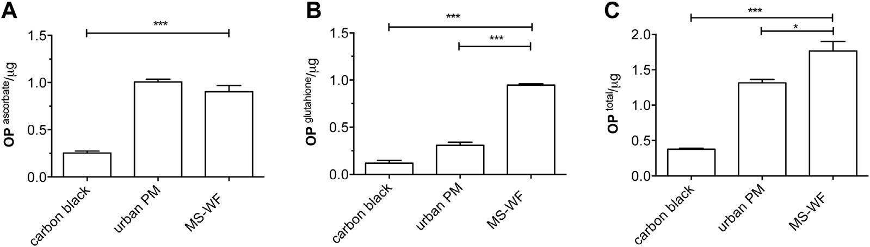

FIG 1. The OP of MS-WF assessed based on their in vitro capacity to deplete antioxidants over 4 hours. Par- ticle standards included in the assay are as follows: (1) low-OP carbon black (M120) and (2) high-OP urban air PM (NIST1648a). The OP of MS-WF (OP per microgram of PM) is given for ascorbate (A), glutathione (B), and total values (C). Data are from 3 experiments and presented as means (SEMs). Comparisons are performed by using 1-way ANOVA with the Tukey post hoc multiple comparison test. *P < .05 and ***P < .001.

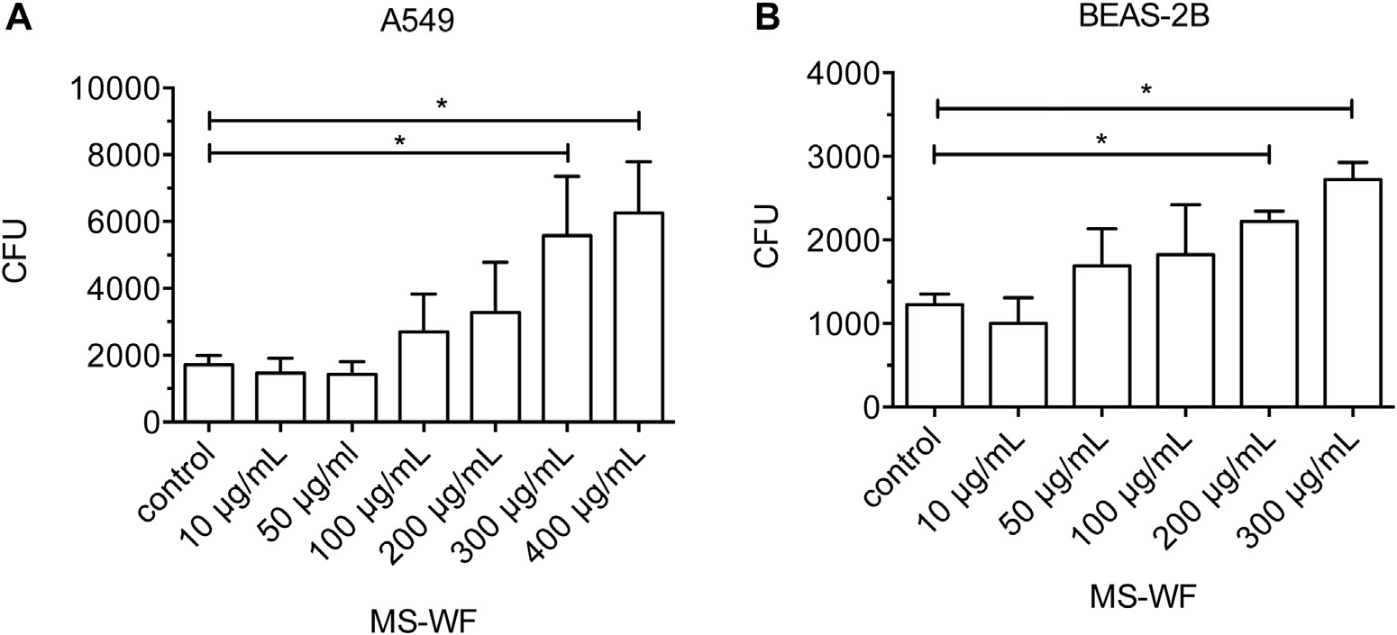

FIG 2. Effect of 2 hours of exposure of human airway cells in vitro to MS-WF on pneumococcal adhesion and infection. Cells were infected with S pneumoniae for 2 hours at a multiplicity of infection of 100. A, A549 cells. B, BEAS-2B cells. Increased pneumococcal adhesion and infection are reflected by increased CFU values determined by means of quantitative bacterial culture. Data are from 3 to 4 separate experi- ments, each with 3 technical replicates, and presented as means (SEMs). Data are compared by using 1- way ANOVA and the Tukey post hoc multiple comparison test. *P < .05.

fraction of pneumococci (Fig 3). MS-WF did not directly stimu- late pneumococcal growth (data not shown).

Pneumococcal infection: Mouse model
Intranasal instillation of a single 600-mg dose of MS-WF in mice 24 hours before pneumococcal infection resulted in an increase in BALF and lung pneumococcal CFU values at 24 hours after pneumococcal infection (Fig 4). BALF and lung pneumo- coccal CFU values were also increased when MS-WF was admin- istered as 6 separate 100-mg doses once a day for 6 days (total, 600 mg), followed by infection 24 hours after the last dose (see Fig E3 in this article’s Online Repository at www.jacionline. org). In this model pneumococci were not isolated from the blood.

PAFR-dependent adhesion and infection: Human airway cells
A549 and BEAS-2B cell culture with MS-WF for 2 hours
increased PAFR protein expression (Fig 5). The addition of CV- 3988 to MS-WF–exposed cells reduced pneumococcal adhesion and infection of A549 and BEAS-2B cells and of human primary bronchial epithelial cells (Fig 6). Adding NAC at the same time as
MS-WF attenuated pneumococcal adhesion and infection of A549 and BEAS-2B cells (Fig 7).

PAFR-dependent infection: Mouse model
A single intranasal dose of 600 mg of MS-WF increased lung PAFR mRNA expression at 24 hours (Fig 8). Pretreatment of MS- WF–exposed mice with CV-3988 1 hour before infection attenu- ated BALF CFU values. Pretreatment of MS-WF–exposed mice with CV-3988 did not reduce lung CFU values (Fig 9). In PBS- treated animals CV-3988 had no effect on either BALF or lung CFU values (data not shown).

PAFR: Stored samples
A 10-day course of 40 mg/m3 of aerosolized StS-WF for 3 hours per day increased mouse lung PAFR mRNA expression compared with that seen in air-exposed control subjects at both 4 hours and 28 days after the last dose (see Fig E4 in this article’s Online Re- pository at www.jacionline.org).
Lung biopsy tissue was available from a single nonsmoking welder and a single nonsmoking control subject. Specific PAFR

J ALLERGY CLIN IMMUNOL VOLUME nnn, NUMBER nn
SURI ET AL 5

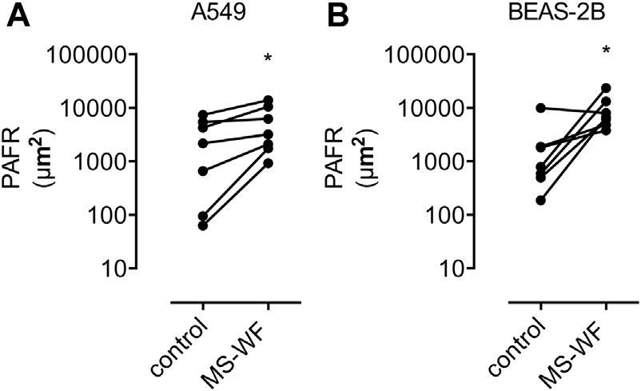

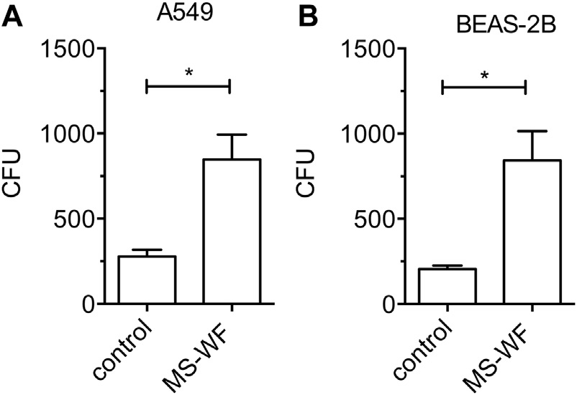
FIG 3. Effect of exposure of human airway cells in vitro to MS-WF for 2 hours on the infective fraction of S pneumoniae. Cells were infected with S pneumoniae for 2 hours at a multiplicity of infection of 100. Pneumo- cocci that were adherent to cell surfaces were first killed by antibiotics to assess the infective fraction. Intracellular bacteria that were protected from antibiotics were then recovered by means of cell lysis, and CFU values were assessed by means of quantitative culture. A, A549 cells cultured with 275 mg/mL (145 mg/cm2). B, BEAS-2B cells cultured with 200 mg/mL (105 mg/ cm2). Data are from 3 separate experiments, with 3 technical replicates per experiment, and presented as means (SEMs). Data are compared by using t tests. *P < .05.

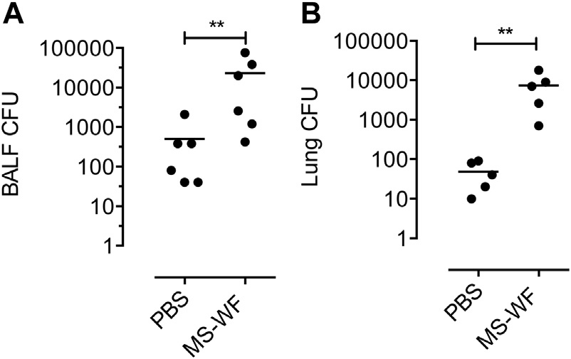

FIG 4. Effect of exposure of mice to a single 600 mg intranasal dose of MS- WF on S pneumoniae CFU values. Mice were infected 24 hours after instil- lation of MS-WF, and CFU values were assessed by means of qualitative culture 24 hours after infection. A, BALF CFU values. B, Lung tissue CFU values. Dot plots are from 6 animals per group and compared by using the Mann-Whitney U test. Bars represent medians. **P < .01.

immunostaining of bronchial and alveolar epithelial cells was present in the nonsmoking welder. Less intense specific bronchial epithelial PAFR was present in the nonsmoking control subject (see Fig E5 in this article’s Online Repository at www.jacionline.org).

DISCUSSION
In this study we sought to identify a mechanism for the hypersusceptibility of welders to bacterial pneumonia reported in epidemiologic studies.2,4,24 We focused on S pneumoniae because this bacterium is the most common cause of community-acquired pneumonia in adults.10 In addition, a review of all patients present- ing with invasive pneumococcal disease (IPD) in Alberta (Canada) from 2000 to 2004 by Wong et al25 reported a 2.7-fold greater inci- dence of IPD in welders; of the 18 welders with IPD, 17 had bacter- emic pneumococcal pneumonia, 1 had meningitis, and 1 died of pneumococcal infection. Pneumococcal infection in welders re- mains a problem. For example, in April 2015, the Northern Ireland Health Protection Service investigated an outbreak of IPD in ship- yard workers and identified WF exposure as a possible risk factor.26
FIG 5. Effect of exposure of MS-WF on PAFR protein expression by human airway cells. Images were taken by using an epiflorescence microscope and analyzed with ImageJ software. A florescence intensity threshold was set to discount background florescence. The area of florescence (in square micrometers) was then measured for each image. A, A549 cells cultured with MS-WF (275 mg/mL) for 2 hours. B, BEAS-2B cells cultured with MS- WF (200 mg/mL) for 2 hours. Data are from 3 to 4 separate experiments, with 3 replicates per experiments. Control PAFR expression in separate ex- periments is highly variable, and data are therefore compared by using paired t tests. *P < .05 versus control subjects.

In the present study we found that intranasal instillation of MS-WF in mice, followed by infection with S pneumoniae, resulted in a 50- to 175-fold increase in airway and lung CFU values.
We also found that MS-WF–induced hypersusceptibility to pneumococcal infection is mediated in part by PAFR (a host receptor used by pneumococci to adhere to and infect lower airway cells13) because MS-WF increased mouse lung PAFR mRNA expression and that treatment of mice with the PAFR blocker CV-3988 before pneumococcal infection significantly reduced lower airway bacterial load. Additional evidence for a role of PAFR was provided by in vitro experiments. First, MS-WF stimu- lated PAFR-dependent adhesion and infection of human lower airway cells. Second, CV-3988 attenuated MS-WF–stimulated pneumococcal adhesion and infection of human airway cell line cells and primary bronchial epithelial cells. Pneumococcal adhe- sion and infection stimulated by MS-WF is likely to be mediated by cellular oxidative stress because this is blocked by the antioxi- dant NAC. Indeed, these data are compatible with previous reports of induction of cellular oxidative stress by WF27 and the capacity of NAC to attenuate pneumococcal adhesion and infection stimulated by fossil-fuel PM.14 Furthermore, increased glutathione peroxidase and total antioxidants in the serum of active welders provides evi- dence that WF induce oxidative stress in vivo.28
To date, the role of PAFR in mediating vulnerability to pneumococcal pneumonia in human subjects is not fully defined.29 However, this role is well established in animal models. For example, reduced PAFR expression by lower airway epithelial cells decreases mortality from pneumococcal infection in mice.30 Conversely, increased airway epithelial PAFR causes hypersus- ceptibility of mice to pneumococcal infection.31 Indirect evidence that airway PAFR is important in human subjects is provided by our previous observation that bronchial epithelial PAFR expres- sion is increased in smokers.15 In the present study PAFR was more strongly expressed by lower airway epithelial cell counts in the nonsmoking welder compared with the nonsmoking, non– WF-exposed control subject. To determine whether epithelial PAFR expression is increased in welders requires further lung bi- opsy samples from nonsmoking welders and nonsmoking control subjects, but to date, these have not been obtained.

6 SURI ET AL
J ALLERGY CLIN IMMUNOL
nnn 2015

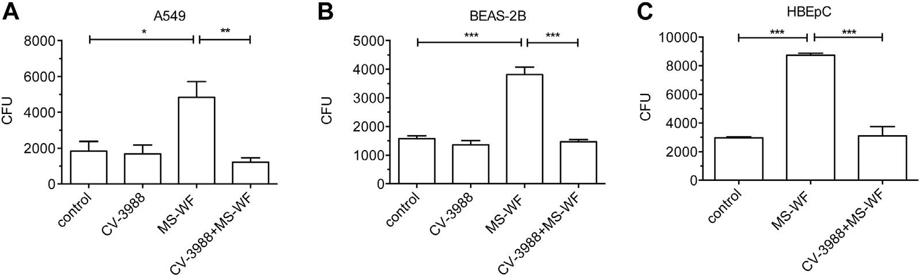

FIG 6. Effect of the PAFR blocker CV-3988 (20 mmol/L) on S pneumoniae adhesion and infection to A549 cells cultured with MS-WF (275 mg/mL; A), BEAS-2B cells cultured with MS-WF (200 mg/mL) for 2 hours (B), and hu- man primary bronchial epithelial cells cultured with MS-WF (200 mg/mL) for 2 hours (C). Data are from 3 or more separate experiments, with 3 replicates per experiment, and presented as means (SEMs). Data are compared by using 1-way ANOVA and the Tukey multiple comparison test. *P < .05, **P < .01, and ***P < .001.

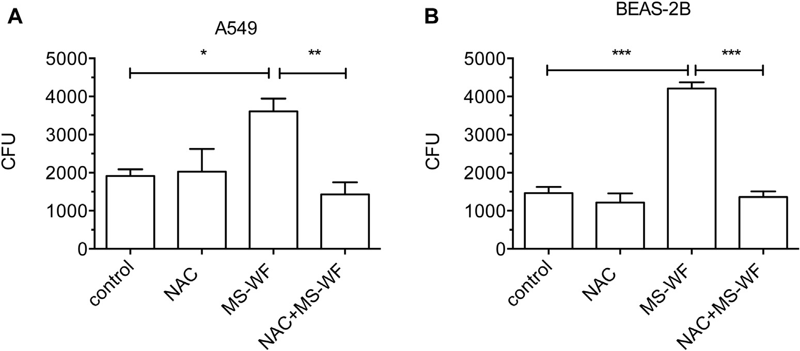

FIG 7. Effect of the antioxidant NAC on adhesion and infection of S pneumoniae to airway cells. NAC was added to cells at the same time as MS-WF. A, A549 cells cultured with MS-WF (275 mg/mL) for 2 hours. B, BEAS-2B cells cultured with MS-WF (200 mg/mL) for 2 hours. Data are from 3 separate experiments, with 3 technical replicates per experiment, and presented as means (SEMs). Data are compared by using 1- way ANOVA and the Tukey post hoc multiple comparison test. *P < .05, **P < .01, and ***P < .001.

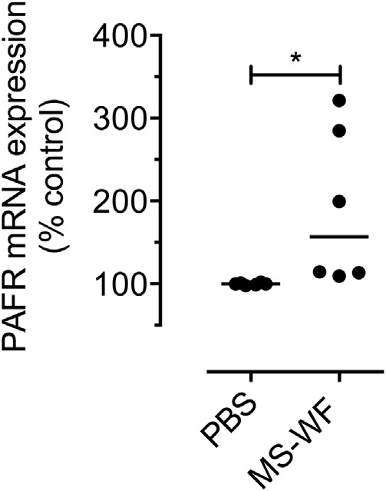

FIG 8. Effect of a single 600 mg intranasal dose of MS-WF on mouse lung PAFR mRNA expression assessed at 24 hours after instillation. Lung PAFR mRNA expression was assessed by means of real-time PCR with relative quantification by using normalization to the reference gene b2-microglobu- lin. Dot plots are from 6 mice per group and compared by using the Mann- Whitney test. The bar represents the median. *P < .05.

The limitations of this study are as follows. First, it is unclear whether the concentrations of MS-WF used in vitro reflect expo- sure of airway cells in vivo. However, concentrations of MS-WF
used in the adhesion and infection assays are similar to those esti- mated by Phalen et al32 (85 mg/cm2) for hot spots of inhaled PM deposition on airway cells. Furthermore, we found that lower concentrations of MS-WF (ie, 5 mg/cm2) stimulated pneumo- coccal adhesion and infection but required prolonged culture duration.
Second, it is unclear whether a single 600 mg intranasal dose of MS-WF in the mouse reflects the dose inhaled by welders. However, there is evidence that welders inhale very high concentrations of PM. For example, Kim et al33 reported mean daily exposures of welders to inhalable PM of 1660 mg/m3 compared with 40 mg/m3 in nonexposed control subjects.
Third, we did not assess the effect of aerosolized MS-WF, a more physiologic delivery method. However, using stored samples, we found that exposure of mice to aerosolized StS-WF stimulates lung PAFR mRNA expression. Furthermore, our pilot data suggest that StS-WF also stimulates PAFR-dependent pneumococcal adhesion and infection to lower airway cells in vitro (see Fig E6 in this arti- cle’s Online Repository at www.jacionline.org). Finally, it is un- clear why pretreatment of MS-WF–exposed mice with the PAFR blocker CV-3988 attenuates airway (BALF) CFU values but does not attenuate lung tissue CFU values. We speculate that although PAFR-dependent adhesion is important in establishing airway

J ALLERGY CLIN IMMUNOL VOLUME nnn, NUMBER nn
SURI ET AL 7

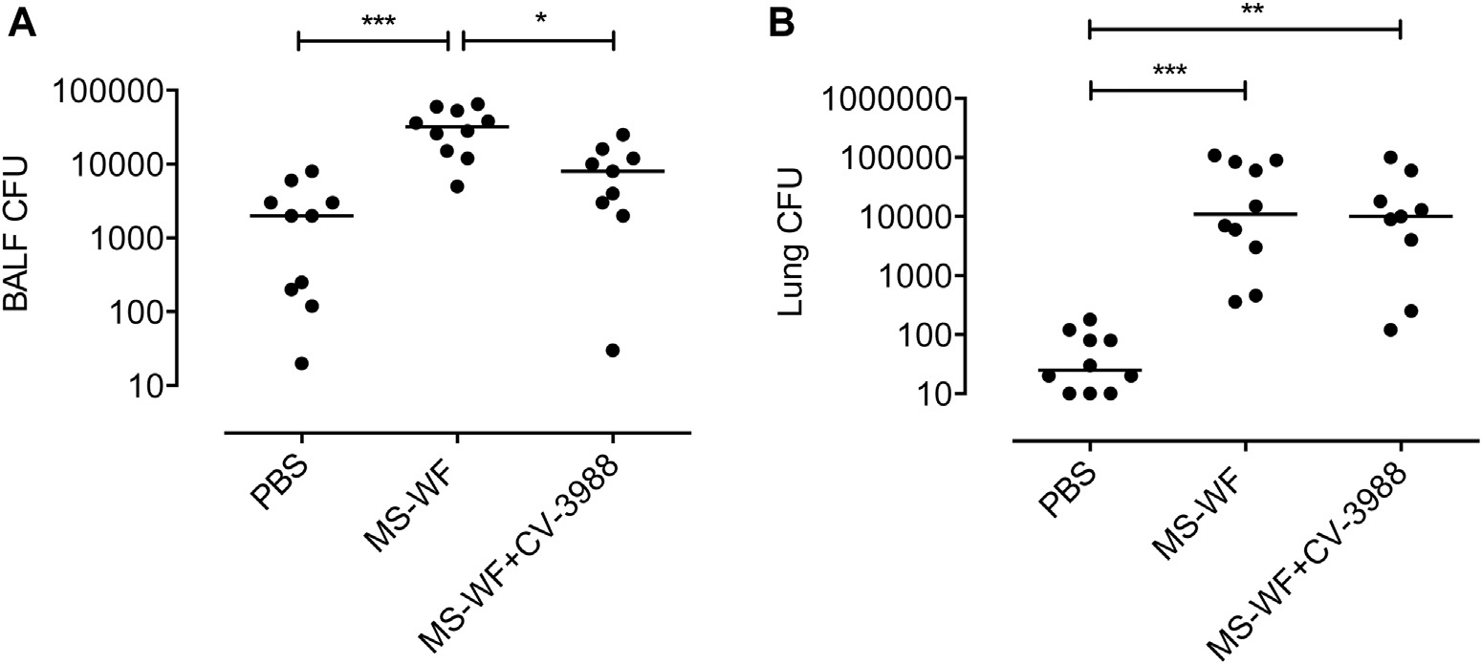

FIG 9. Effect of intravenous treatment of mice with the PAFR blocker CV-3988 (5 mg/kg) administered 1 hour before infection with S pneumoniae in animals exposed to a single 600 mg intranasal dose of MS-WF. A, BALF pneumococcal CFU values. B, Lung pneumococcal CFU values. Data are representative of 2 separate experiments and compared by using the Kruskal-Wallis test and Dunn multiple comparison test. Bars repre- sent medians. *P < .05, **P < .01, and ***P < .001.

infection, PAFR-independent mechanisms contribute to the devel- opment of pneumococcal infection in the lung tissue compartment. In summary, we found that MS-WF increases PAFR-dependent pneumococcal adhesion and infection of human lower airway cells in vitro and pneumococcal airway infection in mice. This study suggests a mechanism for the increased vulnerability of welders to pneumococcal pneumonia reported in epidemiologic studies. Therefore these data provide biological plausibility for the UK Health and Safety Executive Guideline that the 23-valent pneumococcal polysaccharide vaccine ‘‘should be considered for people whose work exposes them to frequent or continuous exposure to metal fume (e.g. welders), taking into
account the exposure control measures in place.’’34

We thank Professor David Coggon for his advice in developing this study and Esmie Purdie for performing the oxidative stress experiments.

Key messages

d Exposure of human lower airway epithelial cells to WF in vitro results in hypersusceptibility to platelet- activating factor–dependent pneumococcal adhesion and infection.
d Exposure of mice to WF results in hypersusceptibility to pneumococcal airway infection.
d The increased risk of pneumococcal pneumonia in welders reported in epidemiologic studies is biologically plausible.

REFERENCES
- Registrar General. Decennial Supplement England and Wales 1971: Occupational Mortality Tables. London: HMSO; 1971.
- Palmer KT, Cullinan P, Rice S, Brown T, Coggon D. Mortality from infectious pneumonia in metal workers: a comparison with deaths from asthma in occupa-
tions exposed to respiratory sensitisers. Thorax 2009;64:983-6.
- Palmer KT, Poole J, Ayres JG, Mann J, Burge PS, Coggon D. Exposure to metal fume and infectious pneumonia. Am J Epidemiol 2003;157:227-33.
- Toren K, Qvarfordt I, Bergdahl IA, Jarvholm B. Increased mortality from infec- tious pneumonia after occupational exposure to inorganic dust, metal fumes and chemicals. Thorax 2011;66:992-6.

- Suri R, Mallia P, Martin JE, Footitt J, Zhu J, Trujillo-Torralbo MB, et al. Bronchial platelet-activating factor receptor in chronic obstructive pulmonary disease. Respir Med 2014;108:898-904.
- Koh DH, Kim JI, Kim KH, Yoo SW, Korea Welders Cohort Group. Welding fume
exposure and chronic obstructive pulmonary disease in welders. Occup Med (Lond) 2015;65:72-7.
- Antonini JM, Roberts JR, Stone S, Chen BT, Schwegler-Berry D, Frazer DG. Short-term inhalation exposure to mild steel welding fume had no effect on lung inflammation and injury but did alter defense responses to bacteria in rats. Inhal Toxicol 2009;21:182-92.
- Antonini JM, Stone S, Roberts JR, Chen B, Schwegler-Berry D, Afshari AA, et al.
Effect of short-term stainless steel welding fume inhalation exposure on lung inflammation, injury, and defense responses in rats. Toxicol Appl Pharmacol 2007;223:234-45.
- Antonini JM, Taylor MD, Millecchia L, Bebout AR, Roberts JR. Suppression in lung defense responses after bacterial infection in rats pretreated with different welding fumes. Toxicol Appl Pharmacol 2004;200:206-18.
- van der Poll T, Opal SM. Pathogenesis, treatment, and prevention of pneumococcal pneumonia. Lancet 2009;374:1543-56.
- Swords WE, Buscher BA, Ver Steeg Ii K, Preston A, Nichols WA, Weiser JN, et al. Non-typeable Haemophilus influenzae adhere to and invade human bronchial epithelial cells via an interaction of lipooligosaccharide with the PAF receptor. Mol Microbiol 2000;37:13-27.
- Smani Y, Docobo-Perez F, Lopez-Rojas R, Dominguez-Herrera J, Ibanez-Martinez
J, Pachon J. Platelet-activating factor receptor initiates contact of Acinetobacter baumannii expressing phosphorylcholine with host cells. J Biol Chem 2012;287: 26901-10.
- Cundell DR, Gerard NP, Gerard C, Idanpaan-Heikkila I, Tuomanen EI. Strepto- coccus pneumoniae anchor to activated human cells by the receptor for platelet- activating factor. Nature 1995;377:435-8.
- Mushtaq N, Ezzati M, Hall L, Dickson I, Kirwan M, Png KM, et al. Adhesion of Streptococcus pneumoniae to human airway epithelial cells exposed to urban par- ticulate matter. J Allergy Clin Immunol 2011;127:1236-42.e2.
- Grigg J, Walters H, Sohal SS, Wood-Baker R, Reid DW, Xu CB, et al. Cigarette smoke and platelet-activating factor receptor dependent adhesion of Streptococcus pneumoniae to lower airway cells. Thorax 2012;67:908-13.
- Andujar P, Simon-Deckers A, Galateau-Salle F, Fayard B, Beaune G, Clin B, et al.
Role of metal oxide nanoparticles in histopathological changes observed in the lung of welders. Part Fibre Toxicol 2014;11:23.
- McNeilly JD, Heal MR, Beverland IJ, Howe A, Gibson MD, Hibbs LR, et al. Sol- uble transition metals cause the pro-inflammatory effects of welding fumes in vitro. Toxicol Appl Pharmacol 2004;196:95-107.
- Zimmer AT, Baron PA, Biswas P. The influence of operating parameters on
number-weighted aerosol size distribution generated from a gas metal arc welding process. J Aerosol Sci 2002;33:519-31.
- Kelly F, Anderson HR, Armstrong B, Atkinson R, Barratt B, Beevers S, et al. The impact of the congestion charging scheme on air quality in London. Part 2. Anal- ysis of the oxidative potential of particulate matter. Res Rep Health Eff Inst 2011; 155:73-144.

8 SURI ET AL
J ALLERGY CLIN IMMUNOL
nnn 2015

- Godri KJ, Green DC, Fuller GW, Dall’Osto M, Beddows DC, Kelly FJ, et al. Par- ticulate oxidative burden associated with firework activity. Environ Sci Technol 2010;44:8295-301.
- Robertson DN, Smith GM. CV3988 inhibits in vivo platelet aggregation induced by PAF-acether and collagen. Eur J Pharmacol 1986;123:91-7.
- Messier EM, Day BJ, Bahmed K, Kleeberger SR, Tuder RM, Bowler RP, et al. N-acetylcysteine protects murine alveolar type II cells from cigarette smoke injury
in a nuclear erythroid 2-related factor-2-independent manner. Am J Respir Cell Mol Biol 2013;48:559-67.
- Antonini JM, Afshari AA, Stone S, Chen B, Schwegler-Berry D, Fletcher WG, et al. Design, construction, and characterization of a novel robotic welding fume generator and inhalation exposure system for laboratory animals. J Occup Environ Hyg 2006;3:194-203, quiz D145.
- Coggon D, Inskip H, Winter P, Pannett B. Lobar pneumonia: an occupational dis-
ease in welders. Lancet 1994;344:41-3.
- Wong A, Marrie TJ, Garg S, Kellner JD, Tyrrell GJ, Group S. Welders are at increased risk for invasive pneumococcal disease. Int J Infect Dis 2010;14:e796-9.
- Patterson L, Irvine N, Wilson A, Doherty L, Loughrey A, Jessop L. Outbreak of invasive pneumococcal disease at a Belfast shipyard in men exposed to welding fumes, Northern Ireland, April-May 2015: preliminary report. Eurosurveillance
2015;20(21).
- Badding MA, Fix NR, Antonini JM, Leonard SS. A comparison of cytotoxicity and oxidative stress from welding fumes generated with a new nickel-, copper-based

consumable versus mild and stainless steel-based welding in RAW 264.7 mouse macrophages. PLoS One 2014;9:e101310.
- Han SG, Kim Y, Kashon ML, Pack DL, Castranova V, Vallyathan V. Correlates of oxidative stress and free-radical activity in serum from asymptomatic shipyard welders. Am J Respir Crit Care Med 2005;172:1541-8.
- Iovino F, Brouwer MC, van de Beek D, Molema G, Bijlsma JJ. Signalling or bind- ing: the role of the platelet-activating factor receptor in invasive pneumococcal dis-
ease. Cell Microbiol 2013;15:870-81.
- Duitman J, Schouten M, Groot AP, Borensztajn KS, Daalhuisen JB, Florquin S, et al. CCAAT/enhancer-binding protein delta facilitates bacterial dissemination during pneumococcal pneumonia in a platelet-activating factor receptor- dependent manner. Proc Natl Acad Sci U S A 2012;109:9113-8.
- Miller ML, Gao G, Pestina T, Persons D, Tuomanen E. Hypersusceptibility to inva- sive pneumococcal infection in experimental sickle cell disease involves platelet-
activating factor receptor. J Infect Dis 2007;195:581-4.
- Phalen RF, Oldham MJ, Nel AE. Tracheobronchial particle dose considerations for in vitro toxicology studies. Toxicol Sci 2006;92:126-32.
- Kim JY, Chen JC, Boyce PD, Christiani DC. Exposure to welding fumes is associated with acute systemic inflammatory responses. Occup Environ Med 2005;62:157-63.
- Health and Safety Executive (HSE). Pneumonia vaccination for employees exposed to welding and metal fume. 2014. Available at: http://www.hse.gov.uk/ pubns/eis44.pdf, 2014. Accessed May 29, 2015.

J ALLERGY CLIN IMMUNOL VOLUME nnn, NUMBER nn
SURI ET AL 8.e1

METHODS
PAFR expression: Stored mouse lung tissue
Mice inhaled StS-WF composed of (weight percentage) iron (57%), chromium (20%), manganese (13%), nickel (8%), and copper (0.2%) with trace amounts of silicon, aluminum, and vanadium. The particle diameters ranged from ultrafine (0.01-0.1 mm) to coarse (1.0-10 mm), with the majority of particles in the fine size range (0.1-1.0 mm). The mass median aerodynamic diameter was 0.255 mm, with a geometric SD of 1.35. RNA from mice exposed to aerosolized StS-WF was isolated from whole-lung homogenates by using TRIzol (Invitrogen) and then cleaned according to the manufacturer’s instructions with an RNeasy Mini Kit (Qiagen). A 2 mL aliquot of each RNA sample was quantified by using a NanoDrop ND-1000 spectrophotometer (NanoDrop Technologies, Wilmington, Del). Briefly, RT-qPCR reactions were carried out by using StepOne (Applied Biosystems, Foster City, Calif) with predesigned Assays-on-Demand TaqMan probes and primers (Applied Biosystems). By using 96-well plates, 1 mg of total RNA was reverse transcribed with random hexamers (Applied Biosystems) and Superscript III (Invitrogen). Hypoxanthine-guanine phosphoribosyltransferase was used as the reference gene. Relative gene expression was calculated by using the
comparative cycle threshold (DDCT) method. All procedures and protocols were approved by the Animal Care and Use Committee of the National Insti- tute for Occupational Safety and Health.

PAFR expression: Stored human lung tissue
PAFR antigen retrieval in human lung biopsy tissue was carried out on 3- mm paraffin wax–embedded sections dried down overnight at 608C. Slides were placed in an EDTA buffer of pH 8.1 and microwaved at full power for 35 minutes. Slides were then transferred to a DAKO autostainer (DAKO, Glostrup, Denmark), where they were treated with a 3% peroxidase block followed by using the R.T.U Vectastain Kit (PK-7200; Vector Laboratories, Burlingame, Calif), according to the manufacturer’s recommendations. The working dilution of the human anti-PAFR mAb CAY160600 (Cayman Chem- ical) was used at 1:100, and the incubation time was 40 minutes. The signal was visualized by using DAKO DAB1 Chromogen Solution (K3468) applied for 5 minutes. A Gills hematoxylin nuclei counterstain was used for 2 minutes. A negative control using tonsil tissue without the anti-PAFR antibody showed no nonspecific diaminobenzidene signal.

8.e2 SURI ET AL
J ALLERGY CLIN IMMUNOL
nnn 2015

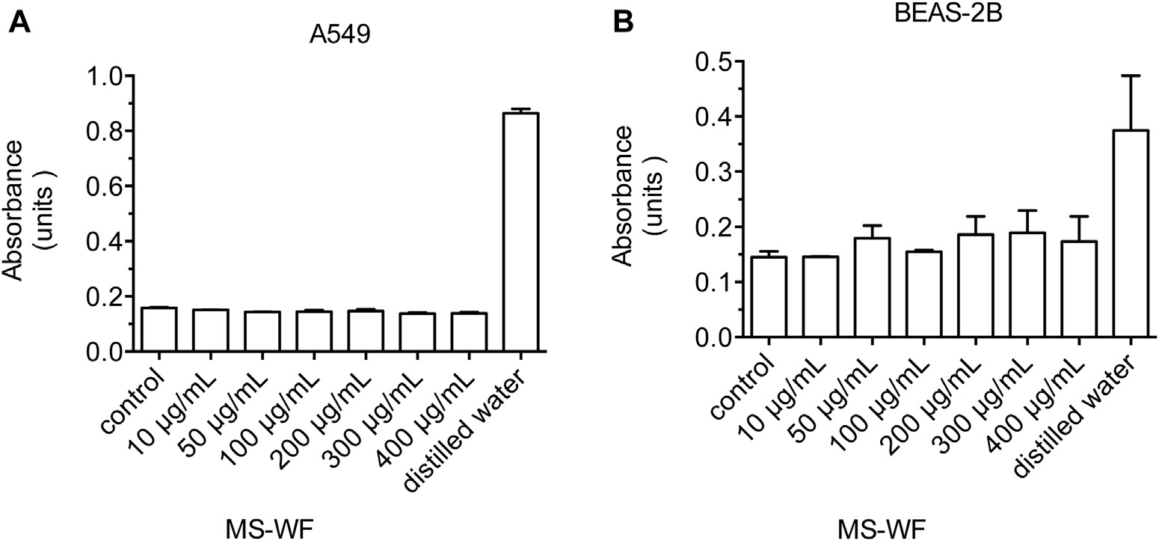

FIG E1. LDH release from A549 cells exposed to 2 hours of MS-WF (A) and BEAS-2B cells exposed to 2 hours of MS-WF (B). Data are from a single experiment, with 3 technical replicates. The positive control is assessed after total cell lysis by using distilled water. MS-WF at concentrations of 400 mg/mL or less do not cause cyto- toxicity in this assay.

J ALLERGY CLIN IMMUNOL VOLUME nnn, NUMBER nn
SURI ET AL 8.e3

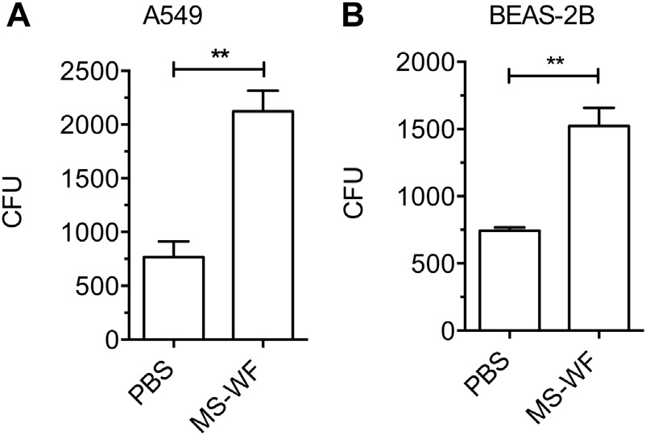

FIG E2. Effect of exposure of airway cells to 10 mg/mL (5 mg/cm2) MS-WF in vitro for 24 hours on the adhesion of S pneumoniae to A549 cells (A) and BEAS-2B cells (B). Increased CFU values determined by using quantita- tive culture reflect increased pneumococcal adherence. Data are from 3 separate experiments, described as means (SEMs), and compared by using the t test. **P < .01 versus medium control.

8.e4 SURI ET AL
J ALLERGY CLIN IMMUNOL
nnn 2015

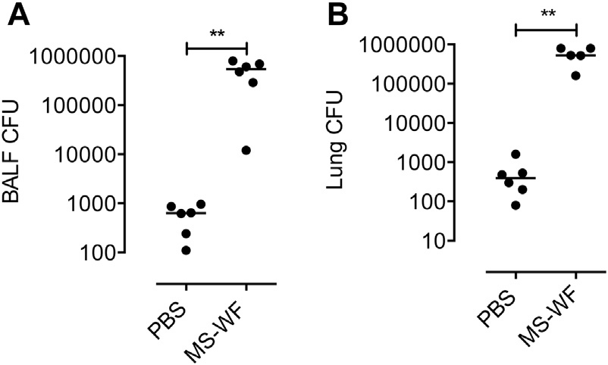

FIG E3. Effect of exposure of mice to 600 mg of intranasal MS-WF administered as 100-mg doses once a day for 6 days on S pneumoniae CFU values in BALF (A) and lung tissue (B). Mice were infected 24 hours af- ter instillation of the last dose of MS-WF, and CFU values were assessed by means of qualitative culture. Data are from 6 animals per group and compared by using the Mann-Whitney U test. Bars represent medians.
**P < .01.

J ALLERGY CLIN IMMUNOL VOLUME nnn, NUMBER nn
SURI ET AL 8.e5

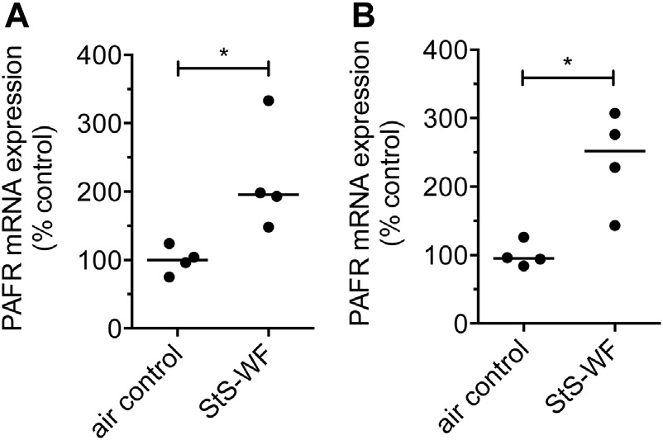

FIG E4. Effect of aerosolized StS-WF on mouse lung PAFR mRNA expres- sion. PAFR mRNA expression was assessed by using real-time quantitative PCR with hypoxanthine-guanine phosphoribosyltransferase as the refer- ence gene. Relative gene expression was calculated by using the DD cycle threshold method. A, Four hours after a 10-day course of aerosolized StS- WF (40 mg/m3) for 3 hours. B, Twenty-eight days after a 10-day course of 3 hours per day of aerosolized StS-WF (40 mg/m3). Dot plots are from 4 mice per group. Data are compared by using the Mann-Whitney test. Bars represent medians. *P < .05.

8.e6 SURI ET AL
J ALLERGY CLIN IMMUNOL
nnn 2015

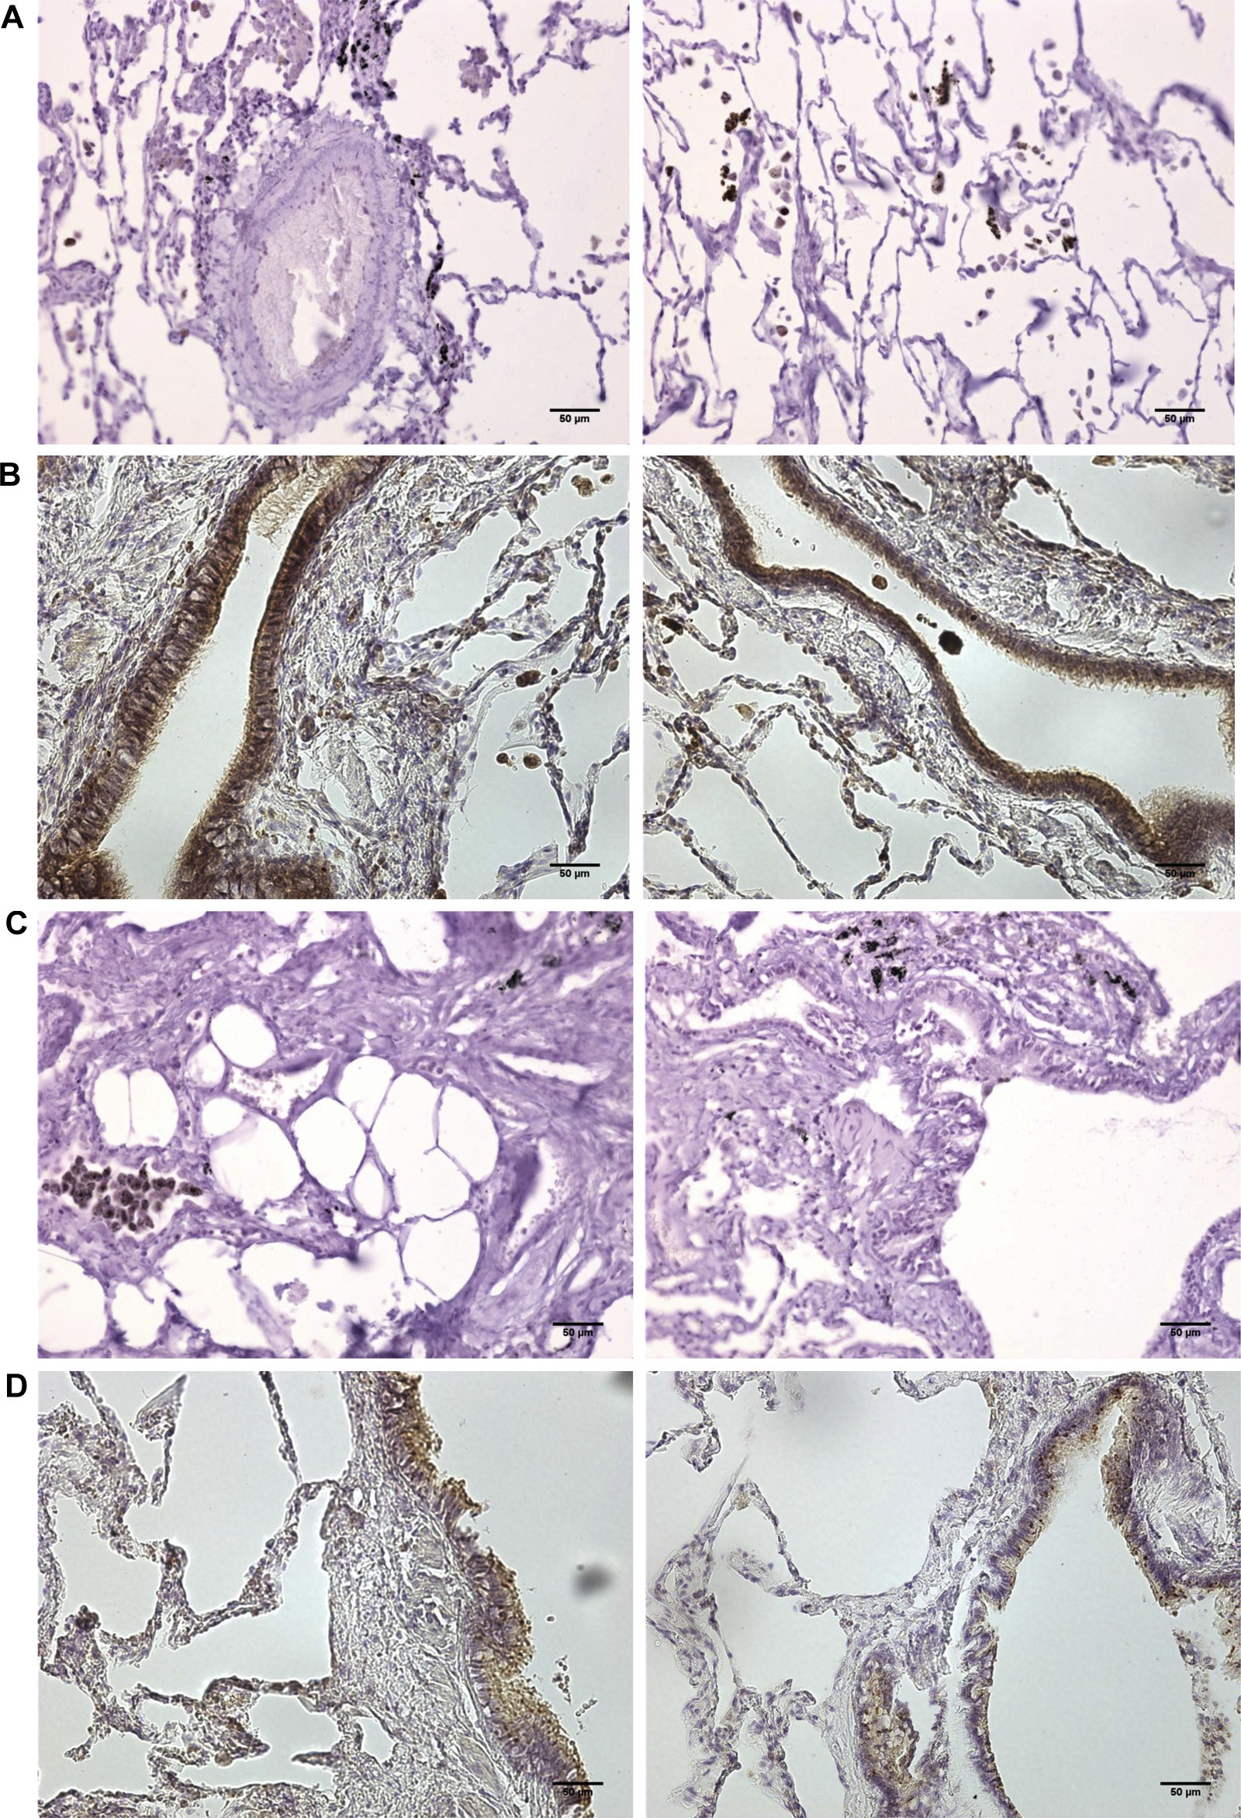

FIG E5. PAFR immunostaining in the human lung. A biopsy specimen of normal tissue was obtained at the time of biopsy for malignancy. A, Lung tissue from a nonsmoking welder stained with an isotypic control mAb. There is no specific (brown) staining of epithelial cells. B, Lung tissue from a nonsmoking welder stained with a PAFR mAb. There is marked specific staining of bronchial epithelial cells and some specific staining of alveolar epithelial cells. C, Lung tissue from a nonsmoking, non–WF-exposed control subject stained with an isotypic control mAb. D, Lung tissue from a nonsmoking, non–WF-exposed control subject stained with a PAFR mAb. There is specific PAFR staining of bronchial epithelial cells (brown).

J ALLERGY CLIN IMMUNOL VOLUME nnn, NUMBER nn
SURI ET AL 8.e7

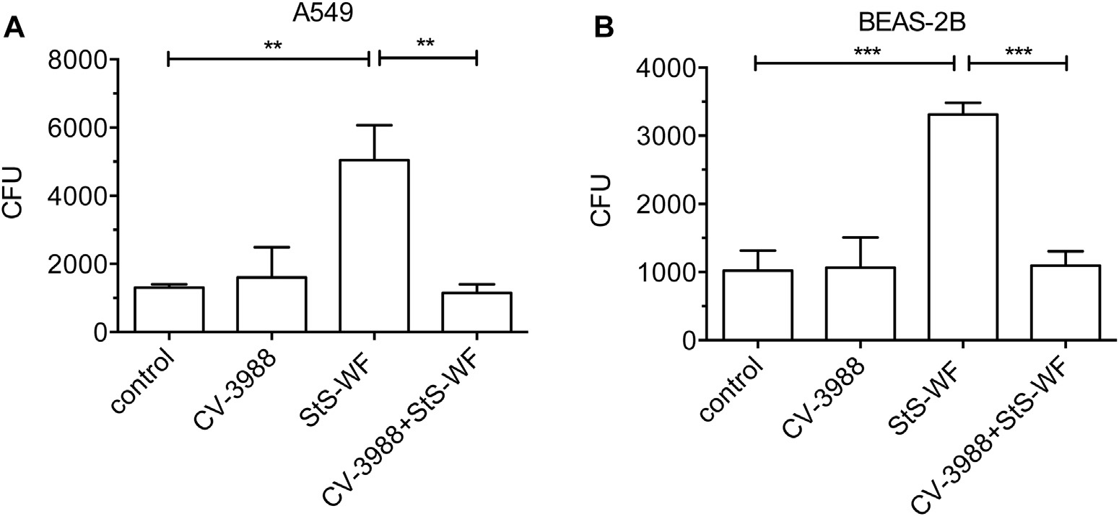

FIG E6. Effect of the PAFR blocker CV-3988 (20 mmol/L) on adhesion of S pneumoniae to airway cells after 2 hours of exposure to StS-WF. StS-WF (chromium, 4.1%; iron, 3.9%; manganese, 2.7%; and titanium, 1.5%) were generated as described in the Methods section by using E308L manual metal arc welding electrodes. Increased CFU values determined by using quantitative culture reflect increased pneumococcal adhesion and infection. A, A549 cells plus 275 mg/mL StS-WF. B, BEAS-2B cells plus 200 mg/mL StS-WF. StS-WF stim- ulates pneumococcal adhesion, and this is attenuated by CV-3988. Data are from 4 separate experiments, with 3 replicates per experiment. Data are described as means (SEMs) and compared by using 1-way AN- OVA and the Tukey multiple comparison test. *P < .05, **P < .01, and ***P < .001.

