Hollow Core Large Mode Area Fiber Employing a Zero Contrast Subwavelength Grating Reflector
Natasha Vukovic¹ and Michalis N. Zervas¹

Abstract – We propose a hollow core large mode area fiber with a new type of guiding mechanism. The fiber is based on a zero contrast high refractive index subwavelength grating embedded on a silica cladding. The hollow core exhibits guided mode resonance for incident waves on a circular grating, thus acting as a highly reflective circular mirror. Finite element simulations are utilized to demonstrate low leakage loss near the guided mode resonances and to investigate the corresponding mode profiles and the reflectivity spectra. We also present alternative high-contrast self-suspended grating and compare the results.
Keywords – Diffraction Gratings, Subwavelength Structures, Optical Fiber, Fiber Laser.
- Introduction

Guided mode resonance (GMR) is a useful phenomenon for controlling the resonance characteristics of a broad range of optical devices, including circular cavities. GMR occurs as a result of resonant coupling between an incident plane wave and leaky guiding modes supported by the periodic grating waveguide [1, 2].
Numerous GMR-based devices have been demonstrated from the silicon-on-insulator (SOI) platform, where silicon grating is typically lithographically defined on a SOI wafer with a layer of buried oxide, before etching [3-5]. Diverse strategies to achieve high reflectivity performance have been investigated, such as controlling grating filling ratio and thickness [6-8]. The GMR gratings have been intensively studied in applications which include optical mirrors [9-11], filters [12-14], grating modulators [15], and lasers [4]. More recently, attempts have been made to extend the GMR concept to curved substrate structures [16,17]. Specifically, a solid core microstructured optical fiber with GMR-based waveguiding mechanism has been proposed [18].
Recent advances in fiber lasers technology have accelerated interest in the manufacture of novel design of microstructured optical fibers [19]. Hollow core large mode area fibers are ideal candidates to guide light at high powers while avoiding non-linear effects and, as such, they are generating much scientific interest. Numerous designs of hollow core fibers have been investigated over several decades. Typically, they are based on photonic bandgap guidance (PBG), such as tube lattice PBG fibers, or on a combination of inhibited coupling to low density of states cladding modes and antiresonance, including Kagomé-latticed photonic crystal fibers [20]. One of the major challenges in obtaining low loss hollow core fibers is related to the unavoidable perturbations induced by the coupling between the core and cladding modes, which is responsible for the increase of leakage loss.
¹Natasha Vukovic and Michalis N. Zervas are with the Optoelectronics Research Centre, University of Southampton, Southampton SO17 1BJ, U.K.
E-mail: ntv@orc.soton.ac.uk
Recent approach based on the insertion of additional antiresonant elements demonstrates the significance of fiber geometrical parameters and shows leakage loss of an order of ~10⁻⁴ dB/m [20, 21]. Despite this loss reduction with respect to a simple hollow core tube fiber, the shape of the fiber must be carefully controlled during the fabrication process and losses of the fabricated fibers can be significantly higher than when numerically investigated. Therefore, design and development of ultra low loss large mode area fiber remains an important challenge.
In this paper, an account of the efforts to advance the area of hollow core large mode area fibers for high power applications will be given. We present results of a novel approach to fibers that guide light in a large hollow core, starting from the subwavelength grating reflector platform. Specifically, owing to the GMR resonance mechanism, we will demonstrate how the guided mode resonance effect can be used to enhance the reflectivity at the particular wavelength and consequently decrease the leakage loss of the fiber.
- Subwavelength grating optical fiber modelling

The simplest case of diffraction grating is a binary structure of finite thickness which varies in one dimension. Grating consists of periodic layers which exhibit strong resonance effect that results in leaky waveguide modes. The incident light is reflected or transmitted into one of several diffraction orders, which depends on the angle of incidence, and grating characteristics, including the refraction indices of materials surrounding the grating. Theoretically, at the wavelength and angle of incidence where all of the radiated waves interfere constructively, a high reflectivity occurs. Generally, there are two types of one-dimensional gratings, i.e. high-contrast grating (HCG) [2], and zero-contrast grating (ZCG), in which a reflective interface from the HCG grating has been removed [10]. Our investigations are based on a ZCG subwavelength grating, shown in Fig. 1 (a). The parameters of a grating are: Λ is grating period, t_{g} is grating thickness, t_{h} is the homogeneous layer thickness, n is refractive index of a grating bar, n_{s} is refractive index thickness of the substrate, F is the fill factor, and θ is the angle of incident beam. Typically, grating bars are produced from a relatively high refractive index material on a silica substrate, and are surrounded by air. Subwavelength gratings have dimensions such that the grating period Λ is subwavelength i.e. Λ<λ, but remains larger than λ/n, which implies that the diffraction order of interest is 0th [2].
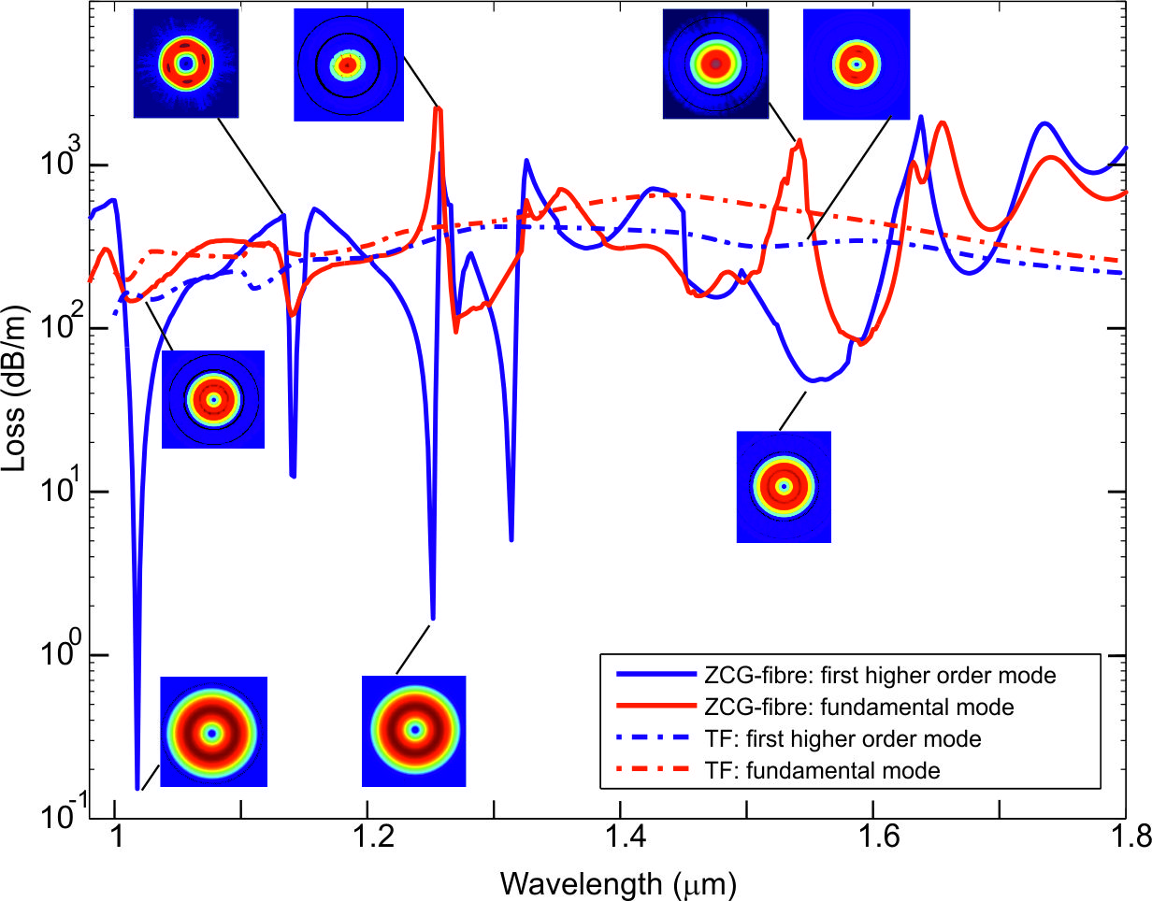
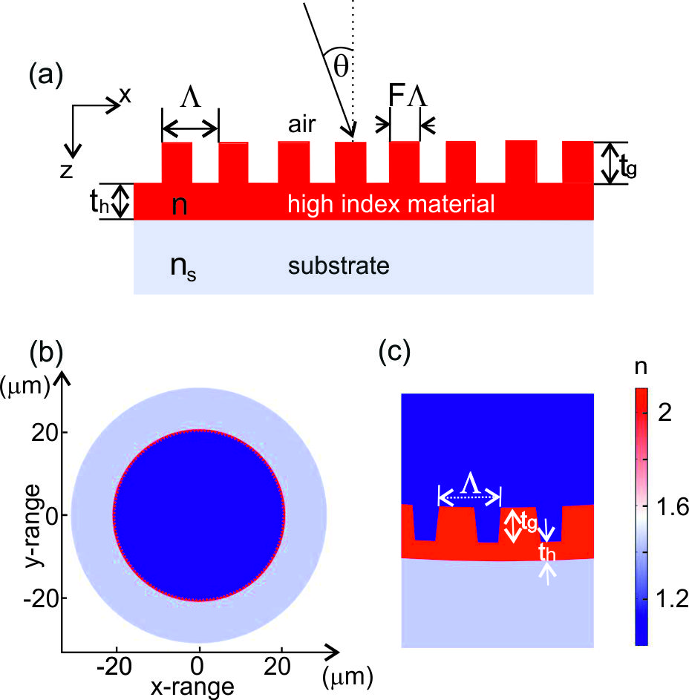
Starting from the simplest case of a diffraction grating as a binary structure which varies in one dimension, we form an equivalent structure in a fiber, which is shown in Fig. 1 (b) and in Fig. 1 (c). To determine the parameters of the grating we used the rigorous coupled wave analysis (RCWA) to investigate the reflectivity feature of a planar ZCG grating, as shown in [10]. By using the RCWA method, the reflectance of the planar subwavelength grating with respect to different geometrical and physical parameters, including the grating period, the grating thickness, the fill factor, the refractive index of the materials, the incident angle, can be studied. The results of the RCWA analysis could be used to determine optimum grating parameters to achieve maximum reflectance, for TM and TE polarizations of the incident wave in the planar structure. Importantly, it has been demonstrated [17] that the GMR peak features calculated in the flat (planar) structure, appear in the finite curvature structures at the same wavelengths. Therefore, we will use RCWA calculations for the flat structure to establish the parameters of the curved grating, which will be implemented in a large mode area hollow core fiber that could be manufacturable.

Fig. 1. (a) Schematic of the subwavelength zero contrast grating.
(b) The proposed morphology of the ZCG in a hollow core fiber.
(c) Enlarged proposed ZCG structure in a hollow core fiber.

We based our investigations on a large mode area hollow fiber with the 20 μm radius, and a silica cladding layer of 10 μm thickness. The refractive index of the core is 1, the refractive index of the grating bars is n=2.1 (assuming soft glass materials), and silica cladding with n_{s}=1.45. Other design parameters for the structure are chosen to be: period of the grating Λ=827 nm, grating thickness t_{g}=470 nm, thickness of the homogeneous layer t_{h}=255 nm, fill factor of the grating F=0.623.
To investigate modal properties and their associated leakage loss of the proposed fiber, we used the cylindrical version of the finite element method implemented in Comsol Multiphysics. Firstly, we analysed a ZCG grating embedded in a fiber (ZCG-fiber), with the morphology shown in Fig. 1 (b) and Fig. 1 (c). Calculating the leakage loss of the core propagating modes and their corresponding intensity profiles, shown in Fig. 2, reveals the sharp resonances associated with the guided mode resonance effect [22], of the first higher order mode (TE01-like). Fig. 2 shows higher leakage loss of the fundamental mode and strong wavelength dependence of these curves. Importantly, due to the guided mode resonance for cylindrical waves arriving from the core into the surface of the grating, the grating functions as a highly reflective circular mirror, reflecting the energy back into the core, as in Ref. [18]. From this figure it is also clear that the leakage loss is up to three orders of magnitude smaller compared to the loss calculated for the structure resembling a hollow core, annular tube (tubular fiber TF) with the same refractive indices and of the same thickness as the grating. In particular, in the proposed structure, the minimum leakage loss was estimated as ~0.15 dB/m at λ∼1018 nm. In addition, at resonances, the first higher order mode is characterized with few orders of magnitude lower loss than loss of the fundamental mode, which is

Fig. 2. Computed leakage losses and mode intensity profiles (insets) of the fundamental mode and the lowest higher order mode for the ZCG-fiber and a corresponding tubular fiber (TF).
attributed to normal angle of incidence required along the whole curvature of the grating [17], and which can’t be achieved by the fundamental mode. Apparently, due to the evanescent diffraction order in the direction parallel to the grating period, all the energy goes into the reflected order, rather than into the transmitted wave of the grating, leading to the high reflection, i.e. low loss capabilities [17,18]. If a ZCG-fiber is excited by a circular or point source, a concentric convergent wave is returned back toward the center of the curvature. Fig. 3 shows the field profiles at the resonance wavelength 1018 nm, in case of TM-mode resonance, i.e. magnetic field normal to the plane. Figs. 3 (a) and (b) show a z-component of the magnetic field, and its enlarged view, respectively. Figs. 3 (c) and (d) show a radial component of electric field and its enlarged view, respectively. From these plots it is clear that the fields are located both in the grating and in the homogeneous layer, forming the azimuthal standing wave pattern. The concentric pattern implies that the main direction of radiation is radial.
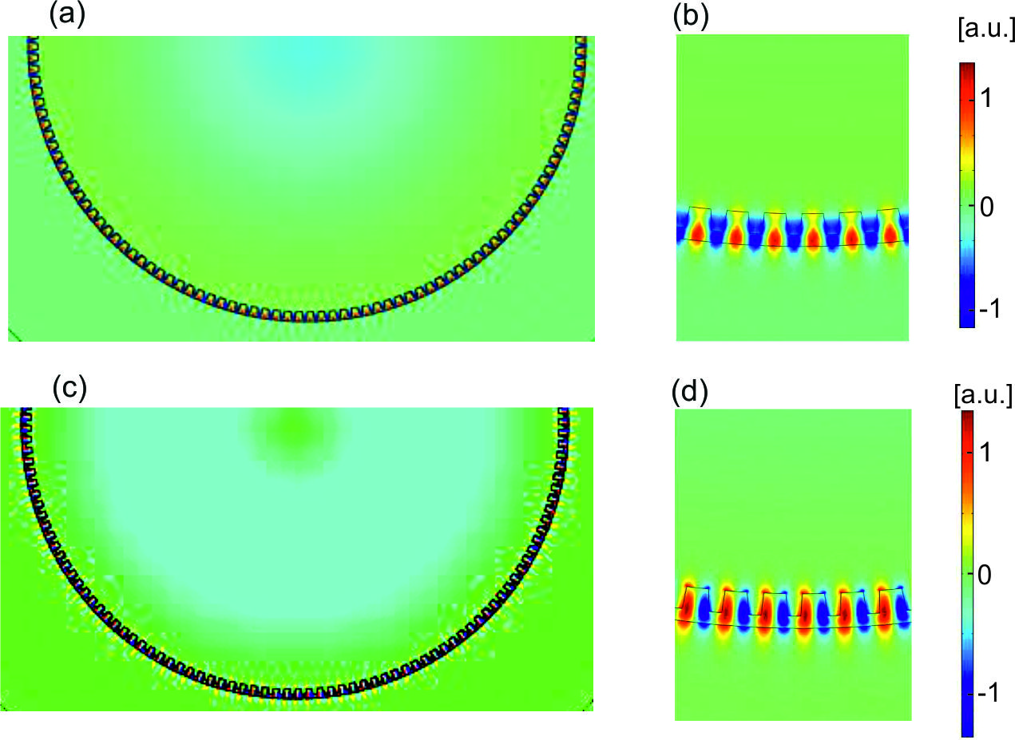
Fig. 3. Field pattern of the ZCG-fiber at the resonance wavelength λ=1018 nm. (a) z₋component of the magnetic field, and (b) enlarged view of a z₋component of the magnetic field. (c) Radial component of electric field, and (d) enlarged view of a radial component of electric field.
To investigate the resonance behaviour of the ZCG-fiber we calculated the reflectivity spectra for the same parameters of the grating and materials as we used for the modal analysis. We used a “unit-cell” in the cylindrical version of the finite element method in Comsol Multiphysics with the Floquet periodic boundary conditions for the TM–polarized wave, as shown in the inset of Fig. 4.
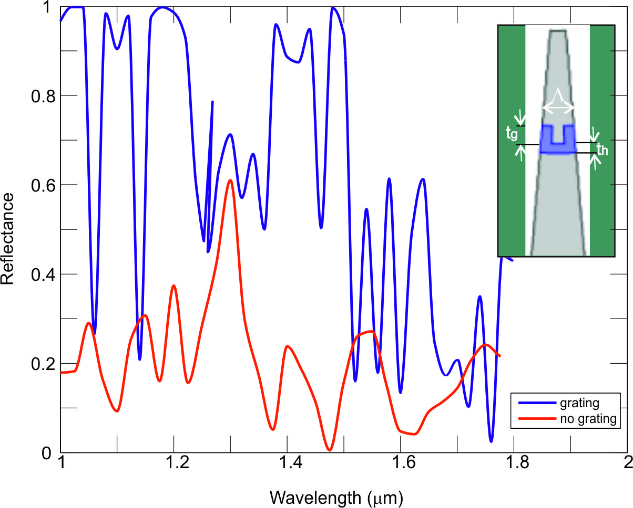
Fig. 4. Theoretical reflectivity spectrum when a curved grating is illuminated with a normal incidence. Also shown is calculated reflectivity spectrum for a uniform curved high index layer on a silica substrate. Inset: Schematic of a unit cell used for the reflectivity calculation.
The reflectivity spectra calculated for normal incidence is shown in Fig. 4. We find that the high reflectance is observed at the wavelengths that correspond to the sharp resonances from Fig. 2. We attribute the small discrepancy in the resonance wavelength shown in Fig. 2 and the reflectivity spectrum shown in Fig. 4 to that the curved “unit-cell” grating is illuminated with a planar wave, which degrades the spectrum [17]. The reflectivity spectrum calculated for the equivalent uniform structure (no grating) with the same dimensions and material properties, reveals low reflectivity when compared to the curved grating spectrum.
Next, to explore the conditions for the broad reflectivity spectrum and the low leakage loss, we analysed an alternative HCG-fiber structure, shown in the inset of Fig. 5. (a). We based our investigations on a hollow antiresonant fiber i.e. on a tube in air with the 20 μm diameter, and a larger solid cladding with an optimised distance (t_{opt}), in accordance to Poletti’s [20] approach to minimise losses by optimising Fresnel reflections from the outer solid jacket (t_{opt}=0.65r, where r is the core radius). However, in our analysis we replaced a continuous tube with the subwavelength grating. The parameters of the grating are: n_{h}=3.21, the grating period Λ=0.787 μm, fill factor 0.77, grating thickness 0.508 μm and the distance between the external solid silica cladding and the annular core 6.5 μm. This configuration is analogous to a self-supported wavelength grating on the planar platform, i.e. its main characteristic is that high refractive index rods are completely surrounded by air. The effective indices of the two lowest order modes in the hollow core are calculated in case of the grating fiber and compared to the tube fiber with the same design parameters for refractive index and thickness, and can be seen in Fig. 5. (a). We attribute the discontinuities in the dispersion curves of the modes of the grating fiber to the azimuthal resonances i.e. coupling between the airy modes and grating modes, which causes anti-crossings and high leakage loss. Calculating the leakage loss of the core propagating modes reveals the sharp drop of the first higher order mode TE01-like and the leakage loss of ~7x10⁻⁴ dB/m at λ~850 nm, as shown in Fig. 5. (b), which is a few orders of magnitude lower than loss of the fundamental mode. This is attributed to the guided mode resonance effect which appears for particular design parameters and angles of incidence. Due to the evanescent diffraction order in the direction parallel to the grating period, all the energy goes into the reflected order, rather than into the transmitted wave of the grating, leading to the high reflection, i.e. low loss capabilities.
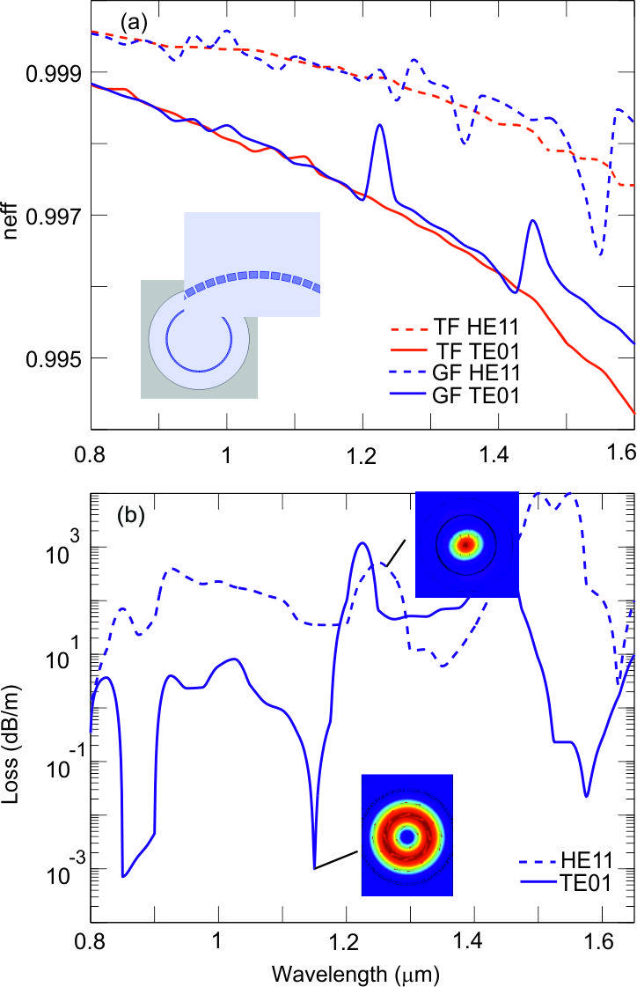
Fig. 5. (a) Effective index as a function of wavelength for the two lowest order core modes of the tubular fiber and the HCG grating fiber (no homogeneous layer under the grating bars). Inset is showing a schematic cross section and an enlarged view of the grating structure. (b) Computed leakage loss of the fundamental mode and fist higher order mode for the grating fiber.

III. Conclusion

The results presented above represent a novel approach to address loss performances of hollow core large mode area fibers. We demonstrate how by carefully designing parameters of the fiber, leakage loss can be as low as ~10⁻⁴ dB/m. Importantly, the preliminary observations open up the potential for this new class of fiber to find use in a range of applications, including fiber lasers and beyond, even into the THz technology. However, there are still many challenges to be overcome, in terms of the grating design that can be easily supported in the fiber hollow core. Ongoing research will focus on the means to practically realize these structures, as we anticipate that they can potentially be of the greatest impact.
Acknowledgement
The authors acknowledge EPSRC for financial support.
References
[1] S. Fan and J. D. Joannopoulos, “Analysis of guided resonances in photonic crystal slabs”, Phys. Rev. B, vol. 65, pp. 235112, 2002.
[2] V. Karagodsky and C. J. Chang-Hasnain, “Physics of near-wavelength high contrast gratings”, Opt. Express, vol. 20, pp. 10888-10895, 2012.
[3] C. F. R. Mateus, M. C. Y. Huang, Y. Deng, A. R. Neureuther and C. J. Chang-Hasnain, “Ultra-boadband mirror using low index cladded subwavelength grating”, IEEE Photon. Technol. Lett., vol. 16, pp. 518-520, 2004.
[4] M. C. Y. Huang, Y. Zhou and C. Chang-Hasnain, “A surface-emitting laser incorporating a high-index-contrast subwavelength grating”, Nature photonics, vol. 1, pp. 119-122, 2007.
[5] A. Ricciardi, S. Campopiano, A. Cusano, T. F. Krauss and L. O’Faolain, “Broadband mirrors in the near-infrared based on subwavelengths gratings in SOI”, IEEE Photonics journal, vol. 2, pp. 696-702, 2010.
[6] D. W. Peters, S. A. Kemme and G. R. Hadley, “Effect of finite grating, waveguide width, and end-facet geometry on resonant subwavelength grating reflectivity”, J. Opt. Soc. Am. A, vol. 21, pp. 981, 2004.
[7] M. Shokooh-Saremi and R. Magnusson, “Wideband leaky-mode resonance reflectors: Influence of grating profile and sublayers”, Opt. Express, vol. 16, pp. 18249-18263, 2008.
[8] M. Shokooh-Saremi and R. Magnusson, “Leaky-mode resonant reflectors with extreme bandwidths”, Opt. Lett.,pp. 35, pp. 1121-1123, 2010.
[9] C. F. R. Mateus, M. C. Y. Huang, Y. F. Deng, A. R. Neureuther and C. J. Chang-Hasnain, “Ultrabroadband mirror using low-index cladded subwavelength grating”, IEEE Photon. Technol. Lett., vol. 16, pp. 518-520, 2004.

[10] R. Magnusson, “Wideband reflector with zero-contrast gratings”, Opt. Lett, vol. 39, pp. 4337, 2014.
[11] M. Shokooh-Saremi and R. Magnusson, “Properties of two dimensional resonant reflectors with zero-contrast gratings”, Opt. Lett., vol. 39, pp. 6958, 2014.
[12] S. S. Wang and R. Magnusson, “Theory and applications of guided-mode resonance filters”, Appl. Opt., vol. 32, pp. 2606-2613, 1993.
[13] J.-S. Ye, Y. Kanamori, F.-R. Hu and K. Hane, “Narrow-bandwidth tunable bandstop filters with circularly cylindrical self-suspended silicon gratings, Optik, vol. 121, pp. 1389, 2010.
[14] T. Sang, H. Zhao, S. Cai, and Z. Wang, “Design of guided-mode resonance filters with an antireflective surface at oblique incidence”, Opt. Communications, vol. 285, pp. 258, 2012.
[15] O. Solgaard, F. S. A. Sandejas and D. M. Bloom, “Deformable grating optical modulator”, Opt. Lett., vol. 17, pp. 688-690, 1992.
[16] M. Lu, H. Zhai and R. Magnusson, “Focusing light with curved guided-mode resonance reflectors, Micromachines, vol. 2, pp. 150-156, 2011.
[17] Y. Othera, S. Iijima and H. Yamada, “Guided-mode resonance in curved grating structures”, Opt. Lett., vol. 36, pp. 1689, 2011.
[18] Y. Ohtera, H. Hirose and H. Yamada, “Resonantly guided modes in microstructured optical fibers with a circular array of high-index rods”, Opt. Lett., vol. 38, pp. 2695, 2013.
[19] M. N. Zervas and C. A. Codemard, “High power fiber lasers: a review”, IEEE J. of Selected Topics in Quantum Electronics, vol. 20, pp. 0904123, 2014.
[20] F. Poletti, “Nested antiresonant nodeless hollow core fiber”, Opt. Express, vol. 22, pp. 23807-23828, 2014.
[21] W. Belardi and J. C. Knight, “Hollow antiresonant fibers with reduced attenuation”, Opt. Lett. vol. 39, pp. 1853-1856, 2014.
[22] Y. Ohtera, S. Iijima and H. Yamada, “Cylindrical resonator utilizing a curved resonant grating as a cavity wall”, Micromachines, vol. 3, pp. 101-113, 2012.

