The Use of Quaternary Ammonium Bromides to Control the Microstructure of Zinc Oxide Films Formed Using Aerosol Assisted Chemical Vapour Deposition

Karl Kaye¹, and Geoffrey Hyett^{1*}
¹Department of Chemistry, University of Southampton, Southampton, UK, SO17 1BJ
*Corresponding Author
e-mail: g.hyett@soton.ac.uk

Date of Submission: 29th May 2015
Date of Acceptance: 3rd September 2015

Abstract
A method in which the microstructure of thin films of zinc oxide can be controlled through the use of readily available additives is presented. This paper will discuss the use of a range of tetra-alkyl quaternary ammonium bromides as additives during the aerosol assisted chemical vapour deposition of zinc oxide, synthesised primarily from a solution of zinc acetate in methanol. Using a combination of single and dual source aerosol assisted chemical vapour deposition and analysis using scanning electron microscopy, we will present a range of morphologies, including plates with rough edges, plates with well-defined hexagonal structures, and organised stacks growing perpendicular to the substrate. Powder X-Ray diffraction techniques reveal that films grown in the presence of the additives also display high levels of preferred orientation when compared to zinc oxide films formed in the absence of any quaternary ammonium bromides. We will also demonstrate the influence of additives on the thickness of the films.
Introduction
Zinc oxide is a semi-conductor with a wide, direct band-gap (3.37 eV¹) and a large exciton binding energy of 60 meV.² It is used in dye sensitised solar cells,³ self-cleaning coatings and photocatalytic devices.^{4, 5} Zinc oxide has also seen considerable use as a gas sensor.^{6, 7} Because of these applications and the functional properties of the material there is a continued interest in zinc oxide thin films. It has also been shown that control over the microstructure of zinc oxide – that is the size and shape of the crystallites, their orientation and spacing – is a desirable objective. This is often due simply to increased surface area allowing improved interaction with solution or gas phase species but additionally many studies have found that particular crystallographic faces have enhanced activity for specific properties, such as 0001 vertically aligned nanorods providing a 10 fold increase in activity when used in a dye sensitised solar cell,⁸ or in the case of catalytic conversation of carbon dioxide to methanol, where activity has been shown to be proportional to the available surface area of the 0001 face.⁹ Solution based synthetic techniques, eg. hydrothermal synthesis, have been successfully used to make zinc oxide with organised microstructure such as nanorods.¹⁰⁻¹³ Chemical vapour techniques have also seen success in forming zinc oxide films with controlled microstructure, through variation of reaction conditions.¹⁴ However, they often require high temperatures or low pressures to vaporise the precursors, or need catalysts or seed layers to direct the structures.¹⁵⁻¹⁸
One of the most successful routes to controlling the microstructure of zinc oxide is through templates or structure directing additives. These are chemical additives that preferentially bind to specific crystallographic faces of nucleating crystals, blocking surface sites and preventing growth on those faces, and therefore promoting growth along the unbound crystallographic faces. Previous research has shown structure directing additives can play a key role in controlling zinc oxide microstructure in solution based chemistry, for example, citric acid and poly(vinyl alcohol) have been shown to act as capping molecules during the growth of zinc oxide through hydrothermal synthesis methods.^{19, 20} Additives such as sodium dodecylsulfate and cetyltrimethylammonium bromide have also been shown to direct zinc oxide growth during electrodeposition.²¹ Despite the success of structure directing additives in solution growth of zinc oxide, there has been little attempt to investigate their use in the growth of thin films in a chemical vapour deposition (CVD) process. We published the first systematic example in McNally et al, 2012, showing the effect of cetyltrimethylammonium bromide at different concentrations in an aerosol assisted chemical vapour deposition (AACVD) of a zinc oxide film.²² In aerosol assisted CVD the film precursor, in this case zinc acetate, is dissolved in a suitable solvent and delivered to the reaction chamber as an aerosol mist where it then vaporises, rather than direct delivery in the vapour phase. This provides the opportunity to dissolve a structure directing additive alongside the film precursor. McNally et al found that with cetyltrimethylammonium bromide as the structure directing additive the film was formed of hexagonal plate-like crystals with uniform diameter, and preferential orientation that could be controlled by varying the concentration of the additive. Follow up work also demonstrated similar effects with tetraoctylammonium bromide, tetramethylammonium bromide and sodium dodecyl sulphate as structure directing additives.²³
This prior work indicated that it was possible to combine the benefits of structural control seen in solution based techniques, with the scalable low cost film formation available with CVD, and that the quaternary ammonium bromides are the most promising class of additives for influencing the structure of zinc oxide in AACVD. In this paper we will present the results of a systematic investigation of the effect of carbon chain length of the ammonium bromide additive on the microstructure of the resultant zinc oxide thin film, considering the particle size and morphology using SEM, preferred orientation determined using X-ray diffraction, and the film thickness. It will highlight the change in structure from hexagonal plates to aggregated stacks as the chain length of the additives increase. We will also attempt to shed light upon the mechanism by which the additives influence the growth of zinc oxide, through rationalisation of these results and by additional experiments to determine at which point during reagent delivery and deposition the interaction between precursor and additive occurs.
Experimental Details
Materials
Zinc acetate (99.99% trace metals) was supplied by Sigma-Aldrich and was used as purchased. Tetramethylammonium bromide (98%) and cetyltrimethylammonium bromide (99+%) were purchased from Acros Organics. All other additives were purchased from Sigma-Aldrich and used as purchased, these include; tetraethylammonium bromide (ReagentPlus, 99%), tetrabutylammonium bromide (ReagentPlus, ≥99.0%), tetrahexylammonium bromide (99%), tetraoctylammonium bromide (98%), tetrakis (decyl) ammonium bromide (≥99.0%, AT). Methanol (HPLC Grade) was supplied by Fisher.
Zinc Oxide Thin Film Formation
Prior to deposition the substrates were cleaned to remove surface contamination, particularly organic grease. This was performed initially by rinsing with deionised water followed by acetone and finally by polishing using paper towel and isopropyl alcohol. All depositions were carried out under argon (Pureshield from BOC) with a flow rate of 0.42 litre min⁻¹, inside a cold walled CVD reactor (internal area: 170 x 55 mm²) on to float glass (dimensions: 150 x 45 x 4 mm³) which was supplied by Pilkington NSG. The carrier gas flow was directed by two way taps to initially pass directly into the reaction chamber during heating, before being diverted through the precursor aerosol once the substrate has reached the desired temperature. The substrate was seated on a carbon block heated by a cartridge heater while the temperature was monitored and regulated by two chromel-alumel type K thermocouples. For all depositions the substrate temperature was maintained at 350 °C. A top plate was positioned parallel to the substrate, c.a. 10 mm above the surface to maintain a laminar flow of gas through the chamber.
In each reaction, zinc acetate (0.5 g / 2.72 mmol) was dissolved in methanol (40 cm³) inside a flat bottomed reagent flask. To this solution, a selected quaternary ammonium bromide (2.72 mmol) was added. The aerosol was generated using a piezoelectric humidifier (Maplin, Mini Fogger Mist Generator, L38AK). Once all of the solution had been transported, which typically takes 90 minutes, the reactor was allowed to cool. Once the temperature had dropped below 80 °C the sample was removed and analysed in air.
Analytical Techniques
Scanning electron microscopy (SEM) was carried out using a JEOL JSM-6500F thermal field emission scanning electron microscope, along with the assistance of the Leeds Electron Microscopy and Spectroscopy (LEMAS) Centre. Once mounted onto specimen stubs the samples were prepared by coating the surface with a thin layer of platinum/palladium and by adding a coat of carbon paint to the edges, this was performed to increase surface conductivity and to provide a conductive pathway between the film surface and the metal base.
Sample preparation for ultraviolet-visible-near infrared spectroscopy (UV-Vis-NIR analysis) consisted of cutting a small strip of the substrate with a width 10 mm; data collection was then carried out by using a Perkin Elmer UV-Vis-NIR Lambda 19 Spectrophotometer by measuring the absorption between 250-2750 nm. In these spectra interference between light transmitted through the thin film and the fraction reflected from film-substrate interface produces an oscillation in the transmission with maxima and minima at frequencies which can be related to the materials’ refractive index and the film thickness. Use of the Swanepoel method allows the film thickness to be calculated from this interference effect.²⁴ The thickness value was then used alongside the spectroscopic data to calculate the band gap using the Tauc method.²⁵
Powder X-ray diffraction (XRD) was carried out using a Bruker GADDS C2 diffractometer; no prior sample preparation was required. The data were collected by utilising a grazing incidence method with an angle of incidence of 5°, and modelled using Rietveld refinement with the Spherical Harmonic Preferred Orientation model to determine the extent of crystallite orientation.²⁶ This refinement gave a texture index (J) which is a quantitative representation of the extent of preferred orientation based on the degree of devition from the expected relative intensities of different hkl peaks. J values of 1.0 indicate random orientation, with values typically between 2 to 4 indicating strong preferred orientation. The direction of preferred orientation cannot be trivially determined using the Spherical Harmonic model, but is instead inferred by inspection of the peak intensity.
Results and Discussion
Zinc oxide thin films were prepared using aerosol assisted chemical vapour deposition from a solution of zinc acetate in methanol, in the presence of a range of quaternary ammonium bromide structure directing additives. The resulting films were characterised using SEM, XRD and UV-vis-NIR spectroscopy allowing determination of film thickness, morphology and preferred orientation. The results for all of the films are shown in table 1.
In order to establish a baseline, an initial control reaction was carried out using an aerosol of zinc acetate in methanol without any structure directing additive. This formed a thin film of zinc oxide, as determined by X-ray diffraction, where the pattern could be indexed to match that for zinc oxide in the Wurtzite structure, the most common and room temperature stable polymorph, crystallising in the space group P6₃mc. Rietveld refinement of this pattern found that the film had almost no preferred orientation, with a texture index of J = 1.2 (where 1.0 is random orientation), as determined with the spherical harmonic model. From the SEM image of this film, figure 1(a), it can be seen that the zinc oxide forms irregular sized clusters composed of aggregated crystallites, which is in contrast to the ordered plate-like crystallites which will be seen with the structure directing additives. UV-Vis-NIR spectroscopy allowed the band gap to be calculated as 3.30 eV from a tauc plot, and also the film thickness estimated as 2380 ± 30 nm using the Swanepoel method,²⁴ which takes advantage of the relationship between the wavelength position of interference maxima and minima in the spectrum, and the film thickness and refractive index.
In solution phase growth it is possible for the structure directing additive to bind with specific crystallographic faces after crystal nucleation, as the precursor and additive are in the same solution and in contact with the growing crystal. However when considering AACVD, although the precursor and additive are in solution together only in the aerosol droplet, while crystallite growth occurs on the substrate activated by thermal energy, with precursor diffusing from the gas phase after evaporation of the aerosol droplets. In order to investigate this more complex process two experiments were conducted to determine at which stage the crucial interaction occurs between the additive and precursor. In the first, the additive and film precursor were dissolved together in methanol, and delivered to the reactor in the same aerosol droplets. In the second, separate solutions were used for the precursor and additive, delivered simultaneously to the reaction chamber, and therefore preventing any interaction in the solution phase, while still allowing both to be present in the gas phase after solvent evaporation.
Our prior work has already established that cetyltrimethylammonium bromide is an effective structure directing additive for zinc oxide in AACVD,²² and so this was chosen as the test additive. The film formed when the zinc acetate precursor and cetyltrimethylammonium bromide were supplied from an aerosol of a single solution in methanol was composed of thin plates, many of which exhibited a hexagonal structure and ranged in size between c.a. 200 – 400 nm, as can be seen in Figure 1(b). The SEM image also indicates that many of the crystallites are aligned roughly parallel to the substrate, which is confirmed by the X-ray diffraction results showing a texture index of J = 2.7 from the Rietveld refinement, and it is clear by inspection of the diffraction pattern shown in figure 2 that this is due to a favourable alignment of the 0001 axis perpendicular to the substrate. The results are in line with previous work and confirm that the slight adjustments in synthetic conditions have not impacted the depositions. The results from UV-Vis-NIR show that the film formed is much thinner than that of a film made from just zinc acetate, only one tenth as thick (233 ± 15 nm). However, the band gap remains unchanged at 3.30 eV.
In the second reaction the zinc acetate and cetyltrimethylammonium bromide were kept separate until the aerosols reached the reaction chamber. To achieve this two solutions were made up, one composed of zinc acetate (0.5 g / 2.72 mmol) and the other cetyltrimethylammonium bromide only (0.993 g / 2.72 mmol), both in methanol (40 cm³). The solutions were added to separate round bottom flasks. A single line of argon was used which was split using a Y-junction prior to reaching the round bottom flasks so as to travel through both simultaneously. The separate aerosol laden flows then converged just before reaching the deposition chamber. The gas flow used was 0.84 l min⁻¹; all other conditions remained the same. As is observable from the SEM image, figure 1(c), the zinc oxide film grows with individual hexagonal plates, much in the same was as it did when the zinc acetate and cetyltrimethylammonium bromide were supplied combined from a single aerosol source, although with a smaller average particle size, which we have previously shown is strongly correlated to the reaction time.²³ Assuming there is no, or only limited, mixing between the aerosol droplets prior to entry to the reactor, these experiments show that there is no crucial interaction between the additive and precursor in the aerosol droplets, and therefore unlikely to be any nucleation of zinc oxide occurring in the solution phase in the aerosol. Instead the result strongly suggests that the cetyltrimethylammonium bromide influences the microstructure on the surface of the substrate after vaporisation of the solvent and precursors. Here the thermal energy of the substrate is sufficient to decompose zinc acetate to zinc oxide, while cetyltrimethylammonium bromide diffusing from the gas phase must interact with 0001 crystallographic phase, blocking growth sites and encouraging formation of the observed plate like crystals. However due to the thermal energy this interaction must be transitory and require continual replacement, with transfer of cetyltrimethylammonium bromide between the gas phase and zinc oxide surface, as the reactor temperature of 350 °C is considerably higher than the decomposition temperature of cetyltrimethylammonium bromide which is approximately 240 °C – although due to the cold walled reactor design the actual substrate temperature can be up to 50 °C lower than the recorded reactor value measured inside the carbon block.
To investigate the effect of different molar ratios of additives on film growth, experiments with the additive tetraoctylammonium bromide were carried out using three different concentrations (2.176, 2.72 and 3.264 mmol). At the lowest concentration of tetraoctylammonium bromide the films formed were composed of thin plates of zinc oxide, many of which were hexagonal in nature. These ranged in size between c.a. 100 – 300 nm. A large proportion of these plates appeared to be aligned parallel to the substrate. As the concentration of tetraoctylammonium bromide was increased to 2.72 mmol, the microstructure changed to show stacks of layered plates. This change was reversed as the quantity increases to 3.264 mmol. The structure reverted back to being formed of single plates, with many crystallites adopting a hexagonal shape. The film formed from 2.72 mmol appeared to have a porous surface; this could potentially increase the accessible surface area of the film which in turn could have implications towards its efficacy as a photocatalyst. X-ray diffraction results showed that the films made using 2.176 and 3.264 mmol of tetraoctylammonium bromide had a larger degree of preferred orientation compared to that formed with 2.72 mmol (J = 2.9, 3.0 versus 2.1, respectively).
As we have shown previously that tetramethylammonium bromide has a profoundly different effect on the microstructure of thin films of zinc oxide than that observed using tetraoctylammonium bromide,²² our next series of experiments investigated systematically the effect of carbon chain length in these tetra-alkylammonium bromide additives, [CH₃(CH₂)_{n}]₄N Br. A sequence of depositions was carried out using the more readily available quaternary ammonium bromides with alkyl groups ranging from methyl groups through ethyl, butyl, hexyl, octyl to decyl, or carbon numbers of 1, 2, 4, 6, 8 and 10. In each deposition the concentration of the additive and the concentration of zinc acetate were equal at 2.72 mmol. The SEM images for these samples are shown in figure 3, highlighting the changes in the crystallite morphology as the chain length increases. In the case of tetramethylammonium bromide and tetraethylammonium bromide the microstructure is composed of individual plates (Figures 3(a) and 3(c) respectively), which are roughly hexagonal in shape. As the chain length increases to tetrabutylammonium bromide the plates begin to congregate into small stacks while still retaining their hexagonal shape, Figure 3(e). Once the chain length reaches tetrahexylammonium bromide this hexagonal structure is mostly lost and the plates have coalesced into larger stacks, figure 3(g). This trend continues with tetraoctylammonium bromide as the microstructure shows stacks of layered plates with irregular shapes, many of which appear to be growing perpendicular to the substrate, figure 3(i). However, this trend is not observed in the case of tetrakis (decyl) ammonium bromide. Once the carbon chain length reaches 10 the microstructure reverts to being composed of individual plates which exhibit partial hexagonal character, figure 3(k).
A similar trend was observed for the thickness of the films, mirroring the changes seen for the microstructure with different chain lengths. The film synthesised with tetramethylammonium bromide had a thickness that was too thin to be measured by the Swanepoel analysis – there were no interference maxima or minima in the available spectroscopic range. This indicates a film of < 100 nm thick. When tetraethylammonium bromide was used the thickness was found to be 207 nm, with values steadily increasing with carbon chain length up to 802 nm for tetrahexylammonium bromide. The film thickness values begin to drop again from tetraoctylammonium bromide (498 nm) to tetrakis (decyl) ammonium bromide (342 nm). A plot of the film thickness against additive carbon chain length can be seen in figure 3(l). For all the film synthesized with an additive the thickness was considerably lower than the 2400 nm observed in zinc oxide without the additive.
Analysis of the X-ray diffraction patterns of these films showed in each case significant enhancement in the relative intensity of the 0002 peak combined with a relative decrease in intensity along the 100 and 101 planes, indicative of preferential orientation of the crystallites with the 0001 face parallel to the substrate. Quantifying this using the spherical harmonic model showed a proportional relationship between the preferred orientation and increase in chain length, peaking at tetrabutylammonium bromide (J = 3.3) with tetrahexylammonium bromide and tetrakis (decyl) ammonium bromide producing films with a slightly lower but still high texture value of J = 3.0.
In the experiments detailed above, with the exception of tetramethylammonium bromide, the carbon chain length of the alkyl is even – due to the limited availability of the quaternary ammonium bromides with odd numbers of carbon atoms in the alkyl chain. Instead, to investigate the intermediate chain lengths, mixtures of the above quaternary ammonium bromides were used as additives in the formation of zinc oxide films. For each deposition two quaternary ammonium bromides were used with the molar quantities of each being equal while the total additive to zinc acetate ratio was kept at 1:1. All other conditions were identical to previous depositions. The five different mixtures used are highlighted in table 1, but combine the tetra-alkylammonium bromide additives such that the average carbon chain lengths are 1.5, 3, 5, 7 and 9. The SEM images show that in some of the mixtures an intermediate microstructure is formed compared to the microstructures of the individual additives; this is particularly observable in the mixture of tetraethylammonium bromide and tetrabutylammonium bromide, figure 3(d) compared with figure 3(c) and figure 3(e). Here the zinc oxide has grown into single, well defined hexagonal plates which are beginning to show evidence of the stacking present in films formed with just tetrabutylammonium bromide and zinc acetate. This hybridisation is not apparent in the film formed using a mixture tetraoctylammonium bromide and tetrakis (decyl) ammonium bromide, figure 3(j). However as discussed above, switching from tetraoctylammonium bromide to tetrakis (decyl) ammonium bromide leads to a significant change in the microstructure from clustered stacks of plates reverting to the individual plates observed with shorter alkyl chains. Also as discussed above, the microstructure of staked plates is only observed at this concentration with tetraoctylammonium bromide, we can therefore conclude that for the stacked plates structure tetraoctylammonium bromide represents an ‘inversion point’ easily disrupted in this case by either a change in concentration or mixing with the longer alkyl chain additive tetrakis (decyl) ammonium bromide.
The analysis of the UV-Vis-NIR spectra of the mixed additive films using the Swanepoel method indicate the same trend in film thickness as the films synthesised using individual tetra-alkylammonium bromides, with increasing thickness of film correlating to longer average carbon chain length from 1.5 to 5 followed by a decline in thickness for carbon chain lengths of 7 and 9. A combined plot of both datasets showing the variation of film thickness with alkyl chain length can be seen in figure 2(l). Tauc analysis showed no observable change in the band gap.

The experiments conducted using single and dual delivery of the precursor and cetyltrimethylammonium bromide highlight that the mechanism of microstructural control occurs at the point of crystal growth on the substrate. Due to the high thermal energy this will involve transitory interaction between the zinc oxide crystal faces and the quaternary ammonium bromide diffusing through the boundary layer from the gas phase, alongside the zinc acetate precursor, after evaporation of the aerosol solvent. It is also significant that all of the samples synthesized using a structure directing additive are considerably thinner than the film grown from zinc acetate alone, ranging from 8% to 34% of the ~2400 nm film observed with no additive. The presence of the additive blocks specific crystallographic faces leading to preferential growth, but also to lower overall growth and a reduction in precursor efficiency.
Investigation of the effect of increasing the additive alkyl chain length showed similar results across both the experiments with the mixed and single quaternary ammonium bromides - in both sets the microstructure and film thickness showed an inversion in their trends around an alkyl chain length of 6-8 carbon atoms. The microstructure showed a progression from individual hexagonal plates through to stacked clusters of plates for alkyl chain lengths of 6 to 8, before reverting to the individual plates for longer chain lengths. The film thickness was observed to increase steadily with increasing chain length up to tetrahexylammonium bromide before starting to decrease again for longer chain lengths. The film thickness data is plotted in figure 3(l), although the mixed additive films tend to be slightly thinner than expected by approximately 100 nm. Together these indicate that there must be least two competing factors affected inversely by the alkyl chain length that reach equilibrium in the range 6-8. We can speculate that shorter alkyl chain length ammonium bromides are able to pack more closely on the zinc oxide crystal surface, but may be less effective at blocking growth due to their smaller steric bulk. However confirmation of this hypothesis would require more direct investigation of the surface of the zinc oxide in situ during reaction and is beyond the scope of this work.

Conclusion
In this paper we have investigated the use of readily available additives in aerosol assisted chemical vapour deposition to form thin films of zinc oxide with different microstructures. We have shown that a range of tetra-alkyl ammoniumbromide additives are able to induce a preference for growth along the 0001 crystal planes and the orientation of these planes to lie parallel to the surface. The combined scanning electron microscopy and X-Ray diffraction results obtained from using tetraoctylammonium bromide in differing quantities show that in the case of certain additives, small changes in molar ratio can have a profound impact on the microstructure and orientation of the resulting film. Results from the UV-Vis-NIR analysis show that the band-gap for the films is not altered by interaction with additive; however, there are clear signs that the additives inhibit the formation of thicker films of zinc oxide when compared to blank samples. This could potentially be exploited as a way to produce thinner films with greater optical transparency. The overall results highlight the potential to control the surface morphology of zinc oxide films using AACVD in a similar way to those already shown in solvent based synthetic procedures.
References
1. T. Zhang, W. Dong, M. Keeter-Brewer, S. Konar, R. N. Njabon and Z. R. Tian, J. Am. Chem. Soc. 128 (33), 10960 (2006)
2. L. Schmidt-Mende and J. L. MacManus-Driscoll, Mater. Today 10 (5), 40 (2007)
3. B. O'Regan, D. T. Schwartz, S. M. Zakeeruddin and M. Grätzel, Adv. Mater. 12 (17), 1263 (2000)
4. I. P. Parkin and R. G. Palgrave, J. Mater. Chem. 15 (17), 1689 (2005)
5. D. Barreca, A. Gasparotto, C. Maccato, E. Tondello, S. U. Lavrencic and S. R. Patil, Surf. Coat. Technol. 203 (14), 2041 (2009)
6. D. P. Norton, Y. W. Heo, M. P. Ivill, K. Ip, S. J. Pearton, M. F. Chisholm and T. Steiner, Mater. Today 7 (6), 34 (2004)
7. S. O'Brien, M. G. Nolan, M. Çopuroglu, J. A. Hamilton, I. Povey, L. Pereira, R. Martins, E. Fortunato and M. Pemble, Thin Solid Films 518 (16), 4515 (2010)
8. R. Zhang, S. Kumar, S. Zou and L. L. Kerr, Cryst. Growth Des. 8 (2), 381 (2008)
9. S. A. French, A. A. Sokol, S. T. Bromley, C. R. A. Catlow, S. C. Rogers, F. King and P. Sherwood, Angew. Chem. Int. Ed. 40 (23), 4437 (2001)
10. M. A. Verges, A. Mifsud and C. J. Serna, J. Chem. Soc., Faraday Trans. 86 (6), 959 (1990)
11. L. M. Al-Harbi, E. H. El-Mossalamy, H. M. Arafa, A. Al-Owais and M. A. Shah, Mod. Appl. Sci. 5 (2), 87 (2011)
12. P. Hu, X. Zhang, N. Han, W. Xiang, Y. Cao and F. Yuan, Cryst. Growth Des. 11 (5), 1520 (2011)
13. R. Zhang, S. Kumar, S. Zou and L. L. Kerr, Cryst. Growth Des. 8 (2), 381 (2007)
14. S. Miyamoto, T. Hasegawa, H. Takahashi, T. Yonezawa, H. Kiyono, T. Yanase, T. Nagahama and T. Shimada, Bull. Chem. Soc. Jpn. 85 (12), 1287 (2012)
15. P. Yang, H. Yan, S. Mao, R. Russo, J. Johnson, R. Saykally, N. Morris, J. Pham, R. He and H. J. Choi, Adv. Funct. Mater. 12 (5), 323 (2002)
16. X. Wang, C. J. Summers and Z. L. Wang, Nano Lett. 4 (3), 423 (2004)
17. WangWang, Song, P. Li, J. H. Ryou, R. D. Dupuis, C. J. Summers and Z. L. Wang, J. Am. Chem. Soc. 127 (21), 7920 (2005)
18. N. S. Ramgir, D. J. Late, A. B. Bhise, M. A. More, I. S. Mulla, D. S. Joag and K. Vijayamohanan, J. Phys. Chem. B 110 (37), 18236 (2006)
19. X. Qin, G. Shao and L. Zhao, Mater. Sci. Eng., B 177 (18), 1678 (2012)
20. H. Zhang, D. Yang, D. Li, X. Ma, S. Li and D. Que, Cryst. Growth Des. 5 (2), 547 (2005)
21. H. Usui, Electrochim. Acta 56 (11), 3934 (2011)
22. C. S. McNally, D. P. Turner, A. N. Kulak, F. C. Meldrum and G. Hyett, Chem. Commun. 48 (10), 1490 (2012)
23. K. Kaye, D. Turner, D. McKenna, A. Cackett and G. Hyett, Physics Procedia 46 (0), 21 (2013)
24. R. Swanepoel, J. Phys. E. Sci. Instrumen. 16 (12), 1214 (1983)
25. R. López and R. Gómez, J. Sol-Gel Sci. Technol. 61 (1), 1 (2012)
26. D. R. B. Von, J. Appl. Crystallogr. 30 (4), 517 (1997)

Table 1. Results for the zinc oxide film depositions using zinc acetate in methanol as precursor solution. For each additive (with quantity listed) the table gives the texture index, J, derived from XRD, and the film thickness and band gap determined using analysis of spectroscopic data.

Experimental Additive (and average alkyl chain length) | Additive Formula | Quantity / mmol | Texture Index | Film Thickness / nm | Band Gap / eV
None (0) | No Additive | - | 1.16 | 2382 ± 29 | 3.3
Cetyltrimethylammonium bromide (1,1,1,16) | ((C₁₆H₃₃)N(CH₃)₃Br | 2.720 | 2.68 | 233 ± 15 | 3.3
Tetraoctylammonium bromide (8) | [CH₃(CH₂)₇]₄N Br | 2.176 | 2.86 | 453 ± 6 | 3.3
Tetraoctylammonium bromide (8) | [CH₃(CH₂)₇]₄N Br | 2.720 | 2.14 | 498 ± 19 | 3.3
Tetraoctylammonium bromide (8) | [CH₃(CH₂)₇]₄N Br | 3.264 | 2.96 | 674 ± 45 | 3.3
Tetramethylammonium bromide (1) | [CH₃]₄N Br | 2.720 | 1.86 | N/A | N/A
Tetraethylammonium bromide (2) | [CH₃CH₂]₄N Br | 2.720 | 2.58 | 207 ± 22 | 3.3
Tetrabutylammonium bromide (4) | [CH₃(CH₂)₃]₄N Br | 2.720 | 3.25 | 585 ± 12 | 3.3
Tetrahexylammonium bromide (6) | [CH₃(CH₂)₅]₄N Br | 2.720 | 3.01 | 802 ± 7 | 3.3
tetrakis (decyl) ammonium bromide (10) | [CH₃(CH₂)₇]₄N Br | 2.720 | 2.98 | 342 ± 18 | 3.3
Tetramethylammonium bromide + Tetraethylammonium bromide (1.5) | See above | 1.36 each | 1.96 | 137 ± 2 | 3.3
Tetraethylammonium bromide + Tetrabutylammonium bromide (3) | See above | 1.36 each | 2.81 | 237 ± 1 | 3.3
Tetrabutylammonium bromide + Tetrahexylammonium bromide (5) | See above | 1.36 each | 3.02 | 742 ± 6 | 3.3
Tetrahexylammonium bromide + Tetraoctylammonium bromide (7) | See above | 1.36 each | 3.50 | 564 ± 7 | 3.3
Tetraoctylammonium bromide + tetrakis (decyl) ammonium bromide (9) | See above | 1.36 each | 2.80 | 290 ± 4 | 3.3

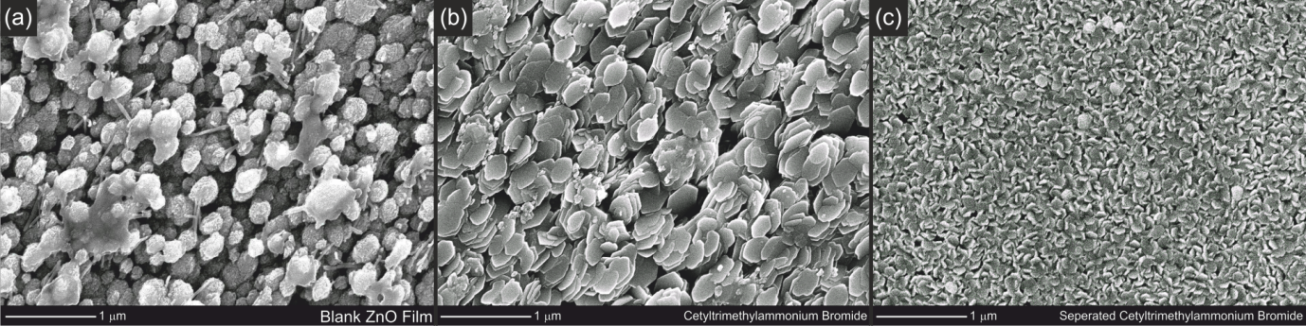
Figure 1. SEM images of representative sections of the each of the films of zinc oxide, grown with the following structure directing additives: a) none, b) cetyltrimethylammonium bromide, single source and c) cetyltrimethylammonium bromide, supplied separately from zinc acetate in a dual source deposition.

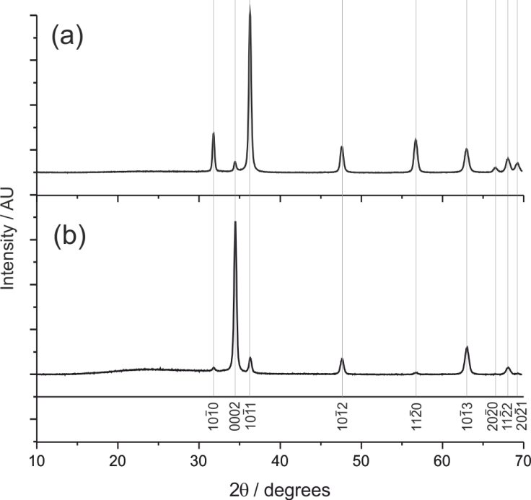

Figure 2. X-ray diffraction patterns of zinc oxide thin films collected using CuK_{α} radiation. The only peaks observed in either pattern can be indexed to the Wurtzite phase of zinc oxide. (a) Pattern collected on a film grown without additive, and (b) pattern of a film grown using cetyltrimethylammonium bromide as structure directing additive.

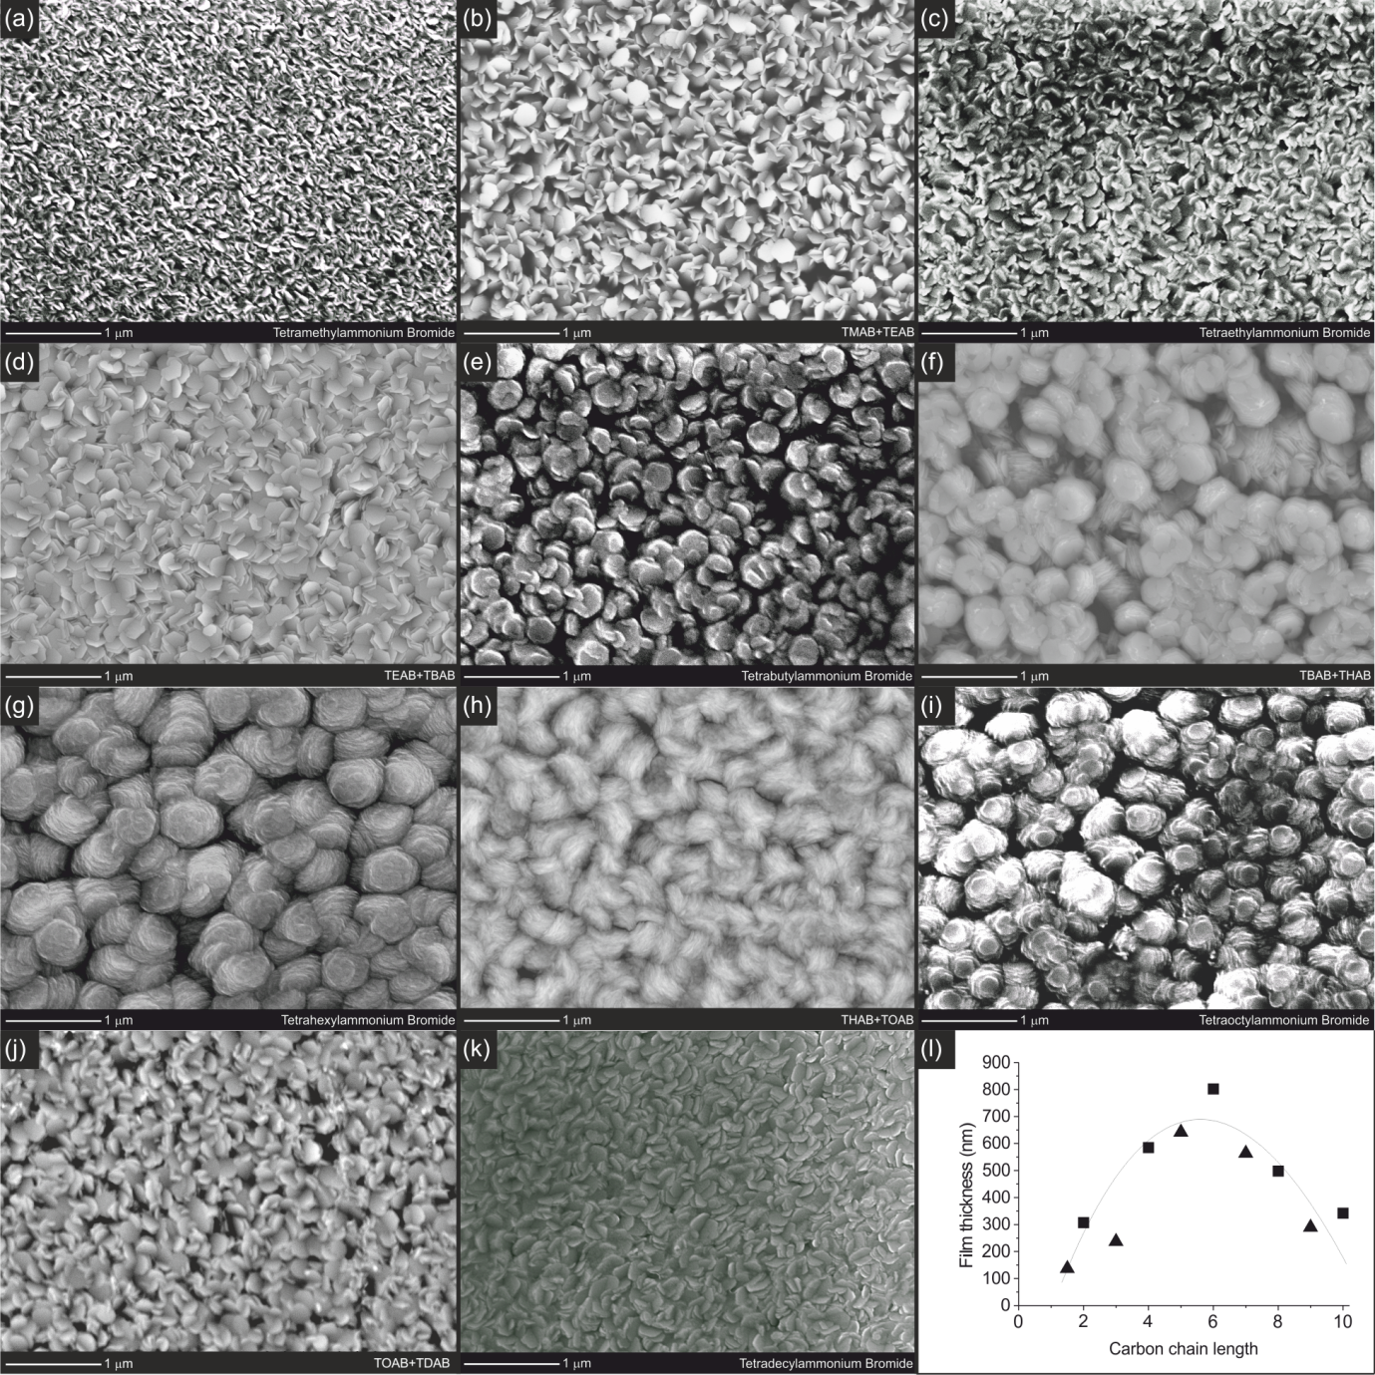
Figure 3. SEM images of films generated using 2.72 mmol of quaternary ammonium bromide, [C_{n}H_{2n+1}]₄N Br as an additive, with values of carbon chain length n of 1, 2, 4, 6, 8 and 10 shown in (a), (c), (e), (g), (i) and (k) respectively. Intermediate values of n representing ‘1.5’,’3’,’5’,’7’ and ‘9’ synthesised using equimolar mixtures of the higher and lower ammonium bromides are shown in figures (b), (d), (f), (h) and (j) respectively. Figure (l) shows a plot of the film thickness as a function of the carbon chain length in the additive used during growth, with squares representing single additives and triangles the mixtures.

Graphical Abstract

