- SYNTHESIS AND CHARACTERIZATION
  - Overview of compounds
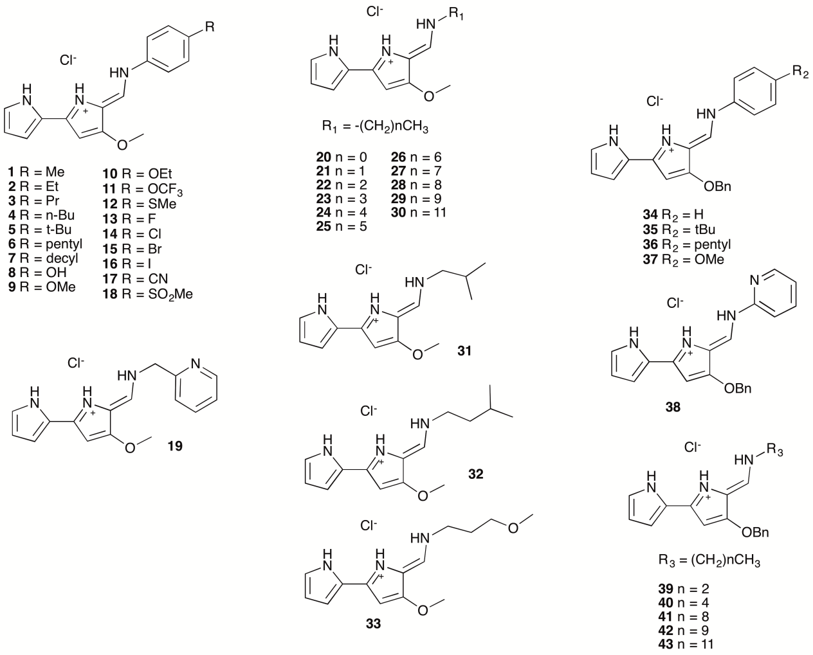

Chart S1. Overview of tambjamine derivatives included in this study.

  - Experimental procedures
General. NMR spectra were recorded on Varian Mercury-300 MHz and Varian Unity-400 MHz spectrometers. Chemical shifts (δ) are reported in parts per million (ppm) and calibrated to the residual solvent peak in CDCl₃ and DMSO-d₆. High resolution mass spectra (HRMS) were recorded on a MicromassAutospec S-2 spectrometer using EI at 70 eV. Commercial reagents were used as provided by the supplier. 4-methoxy-1H,1'H-[2,2'-bipyrrole]-5-carbaldehyde and 4-(benzyloxy)-1H,1'H-[2,2'-bipyrrole]-5-carbaldehyde were prepared as described in the bibliography. Compounds 5, 9, 34, 35, 37, 38 and 20, 21, 22, 23, 24, 25, 26, 27, 28, 29, 30, 31, 32, 39, 40, 42 were previously reported by us.

Compounds 1–43 were synthesized using modifications of the previously reported method. 4-methoxy-1H,1'H-[2,2'-bipyrrole]-5-carbaldehyde (190 mg, 1 mmol) or 4-(benzyloxy)-1H,1'H-[2,2'-bipyrrole]-5-carbaldehyde (266 mg, 1 mmol) and the corresponding amine (1.6–8 mmol, 1.6–8 mmol equivalents) were dissolved in 10 ml chloroform (or 1,2-dichloroethane; compounds 11, 13, 14, 15, 16, 17, 18, 30, 31 and 32), 40 µL of acetic acid were added. The mixture was stirred at 60 ºC until TLC showed disappearance of the staring material. The reaction mixture was diluted with 40 mL of dichloromethane and washed with HCl 1M (3 × 25 mL). The organic fraction was dried over Na₂SO₄ and the solvent evaporated to yield 1–43 as yellow–orange solids in good to excellent yields.

4'-methoxy-5'-((p-tolylamino)methylene)-1H,5'H-[2,2'-bipyrrol]-1'-ium chloride (1). Yield: 100%; ¹H NMR (300 MHz, CDCl₃): δ = 13.86 (s, 1H), 11.17 (d, J = 14.5 Hz, 1H), 10.67 (s, 1H), 7.75 (d, J = 14.7 Hz, 1H), 7.31–7.10 (m, 5H), 6.80 (s, 1H), 6.30 (d, J = 3.7 Hz, 1H), 5.98 (d, J = 2.1 Hz, 1H), 3.96 (s, 3H, OCH₃), 2.33 (s, 3H); ¹³C NMR (75 MHz, CDCl₃): δ = 165.09 (C), 144.12 (C), 136.18 (C), 136.04 (C), 130.53 (2CH), 130.31 (CH), 125.34 (CH), 122.64 (C), 117.19 (2CH), 114.77 (CH), 113.29 (C), 111.39 (CH), 92.01 (CH), 58.85 (OCH₃), 21.09 (CH₃); HRMS (EI) m/z [M]⁺ calcd for [C₁₇H₁₇N₃O] 279.1372; found: 279.1376.

5'-(((4-ethylphenyl)amino)methylene)-4'-methoxy-1H,5'H-[2,2'-bipyrrol]-1'-ium chloride (2). Yield: 95%; ¹H NMR (300 MHz, CDCl₃): δ = 13.90 (s, 1H), 11.20 (d, J = 14.3 Hz, 1H), 10.69 (s, 1H), 7.76 (d, J = 14.7 Hz, 1H), 7.41–7.10 (m, 5H), 6.81 (s, 1H), 6.32 (s, 1H), 5.99 (s, 1H), 3.97 (s, 3H, OCH₃), 2.64 (app q, 2H), 1.22 (t, J = 7.6 Hz, 3H); ¹³C NMR (75 MHz, CDCl₃): δ = 165.07 (C), 144.05 (C), 142.38 (C), 136.32 (C), 130.29 (CH), 129.31 (2CH), 125.21 (CH), 122.63 (C), 117.26 (2CH), 114.73 (CH), 113.26 (C), 111.35 (CH), 92.04 (CH), 58.84 (OCH₃), 28.42 (CH₂), 15.62 (CH₃); HRMS (EI) m/z [M]⁺ calcd for [C₁₈H₁₉N₃O] 293.1528; found: 293.1521.

4'-methoxy-5'-(((4-propylphenyl)amino)methylene)-1H,5'H-[2,2'-bipyrrol]-1'-ium chloride (3). Yield: 92%; ¹H NMR (300 MHz, CDCl₃): δ = 13.55 (s, 1H), 11.08 (d, J = 14.6 Hz, 1H), 10.61 (s, 1H), 7.62 (d, J = 14.7 Hz, 1H), 7.26–7.06 (m, 4H), 7.01 (d, J = 1.2 Hz, 1H), 6.75 (s, 1H), 6.21 (d, J = 3.7 Hz, 1H), 5.95 (d, J = 2.1 Hz, 1H), 3.86 (s, 3H, OCH₃), 2.50 (t, J = 7.1 Hz, 2H), 1.65–1.49 (m, 2H), 0.89 (t, J = 7.3 Hz, 3H); ¹³C NMR (75 MHz, CDCl₃): δ = 164.97 (C), 143.87 (C), 140.65 (C), 136.20 (C), 130.05 (CH), 129.75 (2CH), 124.93 (CH), 122.51 (C), 117.00 (2CH), 114.62 (CH), 113.08 (C), 111.24 (CH), 92.06 (CH), 58.78 (OCH₃), 37.41 (CH₂), 24.49 (CH₂), 13.75 (CH₃); HRMS (EI) m/z [M]⁺ calcd for [C₁₉H₂₁N₃O] 307.1685; found: 307.1690.

5'-(((4-butylphenyl)amino)methylene)-4'-methoxy-1H,5'H-[2,2'-bipyrrol]-1'-ium chloride (4). Yield: 97%; ¹H NMR (300 MHz, CDCl₃): δ = 13.59 (s, 1H), 11.08 (d, J = 14.6 Hz, 1H), 10.62 (s, 1H), 7.64 (d, J = 14.7 Hz, 1H), 7.26–7.09 (m, 4H), 7.06–7.01 (m, 1H), 6.83–6.71 (m, 1H), 6.23 (d, J = 3.8 Hz, 1H), 5.95 (d, J = 2.2 Hz, 1H), 3.88 (s, 3H, OCH₃), 2.54 (t, J = 7.8 Hz, 2H), 1.61–1.46 (m, 2H), 1.37–1.24 (m, 2H), 0.89 (t, J = 7.3 Hz, 3H); ¹³C NMR (75 MHz, CDCl₃): δ = 164.99 (C), 143.90 (C), 140.93 (C), 136.18 (C), 130.10 (CH), 129.73 (2CH), 125.01 (CH), 122.53 (C), 117.06 (2CH), 114.65 (CH), 113.10 (C), 111.26 (CH), 92.06 (CH), 58.79 (OCH₃), 35.09 (CH₂), 33.57 (CH₂), 22.33 (CH₂), 13.98 (CH₃); HRMS (EI) m/z [M]⁺ calcd for [C₂₀H₂₃N₃O] 321.1841; found: 321.1841.

4'-methoxy-5'-(((4-pentylphenyl)amino)methylene)-1H,5'H-[2,2'-bipyrrol]-1'-ium chloride (6).
Yield: 100%; ¹H NMR (300 MHz, CDCl₃): δ = 13.58 (s, 1H), 11.08 (d, J = 14.6 Hz, 1H), 10.62 (s, 1H), 7.62 (d, J = 14.6 Hz, 1H), 7.26–7.05 (m, 4H), 7.01 (s, 1H), 6.75 (s, 1H), 6.21 (d, J = 1.6 Hz, 1H), 5.94 (s, 1H), 3.86 (s, 3H, OCH₃), 2.51 (t, J = 7.7 Hz, 2H), 1.62–1.47 (m, 2H), 1.30–1.20 (m, 4H), 0.86 (t, J = 6.5 Hz, 3H); ¹³C NMR (75 MHz, CDCl₃): δ = 164.96 (C), 143.86 (C), 140.91 (C), 136.17 (C), 130.06 (CH), 129.68 (2CH), 124.90 (CH), 122.53 (C), 117.01 (2CH), 114.59 (CH), 113.08 (C), 111.24 (CH), 92.05 (CH), 58.77 (OCH₃), 35.33 (CH₂), 31.43 (CH₂), 31.07 (CH₂), 22.52 (CH₂), 14.06 (CH₃); HRMS (EI) m/z [M]⁺ calcd for [C₂₁H₂₅N₃O] 335.1998; found: 335.1981.

5'-(((4-decylphenyl)amino)methylene)-4'-methoxy-1H,5'H-[2,2'-bipyrrol]-1'-ium chloride (7). Yield: 95%; ¹H NMR (400 MHz, CDCl₃): δ = 13.90 (s, 1H), 11.20 (d, J = 14.5 Hz, 1H), 10.68 (s, 1H), 7.75 (d, J = 14.6 Hz, 1H), 7.32–7.16 (m, 4H), 7.12 (s, 1H), 6.81 (s, 1H), 6.31 (d, J = 3.6 Hz, 1H), 5.99 (d, J = 2.1 Hz, 1H), 3.97 (s, 3H, OCH₃), 2.58 (t, J = 5.7 Hz, 2H), 1.64–1.52 (m, 4H), 1.30–1.24 (m, 12H), 0.87 (t, J = 6.7 Hz, 3H); ¹³C NMR (75 MHz, CDCl₃): δ = 165.03 (C), 143.98 (C), 141.09 (C), 136.25 (C), 130.23 (CH), 129.81 (2CH), 125.14 (CH), 122.61 (C), 117.15 (2CH), 114.69 (CH), 113.21 (C), 111.32 (CH), 92.03 (CH), 58.82 (OCH₃), 35.47 (CH₂), 31.99 (CH₂), 31.51 (CH₂), 29.70 (2CH₂), 29.57 (CH₂), 29.42 (CH₂), 29.33 (CH₂), 22.78 (CH₂), 14.23 (CH₃); HRMS (EI) m/z [M]⁺ calcd for [C₂₆H₃₅N₃O] 405.2780; found: 405.2776.

5'-(((4-hydroxyphenyl)amino)methylene)-4'-methoxy-1H,5'H-[2,2'-bipyrrol]-1'-ium chloride (8). Yield: 38%; ¹H NMR (300 MHz, DMSO-d₆): δ = 13.09 (s, 1H), 12.52 (d, J = 14.1 Hz, 1H), 11.96 (s, 1H), 9.74 (s, 1H), 8.17 (d, J = 13.9 Hz, 1H), 7.46 (d, J = 8.4 Hz, 2H), 7.19 (s, 2H, OH), 6.83 (d, J = 8.4 Hz, 2H), 6.56 (s, 1H), 6.31 (s, 1H), 3.98 (s, 3H, OCH₃); ¹³C NMR (75 MHz, DMSO-d₆): δ = 164.36 (C), 155.85 (C), 142.16 (C), 132.53 (CH), 130.45 (C), 124.39 (CH), 122.24 (C), 119.09 (2CH), 116.20 (2CH), 111.95 (CH), 111.89 (C), 110.81 (CH), 92.19 (CH), 58.75 (OCH₃); HRMS (EI) m/z [M]⁺ calcd for [C₁₆H₁₅N₃O₂] 281.1164; found: 281.1166.

5'-(((4-ethoxyphenyl)amino)methylene)-4'-methoxy-1H,5'H-[2,2'-bipyrrol]-1'-ium chloride
(10). Yield: 92%; ¹H NMR (300 MHz, CDCl₃): δ = 13.75 (s, 1H), 11.23 (d, J = 14.7 Hz, 1H), 10.61 (s, 1H), 7.69 (d, J = 14.8 Hz, 1H), 7.31 (d, J = 9.0 Hz, 2H), 7.13–7.07 (m, 1H), 6.88 (d, J = 9.0 Hz, 2H), 6.82–6.75 (m, 1H), 6.38–6.22 (m, 1H), 5.97 (d, J = 2.2 Hz, 1H), 4.01 (q, J = 7.0 Hz, 2H), 3.95 (s, 3H, OCH₃), 1.40 (t, J = 7.0 Hz, 3H); ¹³C NMR (75 MHz, CDCl₃): δ = 164.75 (C), 157.40 (C), 143.54 (C), 131.83 (C), 130.59 (CH), 125.04 (CH), 122.71 (C), 118.73 (2CH), 115.71 (2CH), 114.40 (CH), 112.99 (C), 111.29 (CH), 91.91 (CH), 63.98 (CH₂), 58.79 (OCH₃), 14.88 (CH₃); HRMS (EI) m/z [M]⁺ calcd for [C₁₈H₁₉N₃O₂] 309.1477; found: 309.1483.

4'-methoxy-5'-(((4-(trifluoromethoxy)phenyl)amino)methylene)-1H,5'H-[2,2'-bipyrrol]-1'-ium chloride (11). Yield: 95%; ¹H NMR (300 MHz, CDCl₃): δ = 13.68 (s, 1H), 11.18 (d, J = 14.1 Hz, 1H), 10.64 (s, 1H), 7.66 (d, J = 14.3 Hz, 1H), 7.36 (d, J = 8.8 Hz, 2H), 7.17 (d, J = 8.5 Hz, 2H), 7.10 (s, 1H), 6.82 (s, 1H), 6.29 (s, 1H), 5.94 (s, 1H), 3.89 (s, 3H, OCH₃); ¹³C NMR (75 MHz, CDCl₃): δ = 165.71 (C), 146.51 (q, J = 1.7 Hz, C), 145.27 (C), 137.32(C), 129.65 (CH), 125.97 (CH), 122.70 (2CH), 122.43 (C), 120.5 (q, J = 256.0 Hz, CF₃) 118.30 (2CH), 115.69 (CH), 114.06 (C), 111.72 (CH), 92.34 (CH), 58.94 (OCH₃); HRMS (EI) m/z [M]⁺ calcd for [C₁₇H₁₄F₃N₃O₂] 349.1038; found: 349.1039.

4'-methoxy-5'-(((4-(methylthio)phenyl)amino)methylene)-1H,5'H-[2,2'-bipyrrol]-1'-ium chloride (12). Yield: 87%; ¹H NMR (300 MHz, DMSO-d₆): δ = 13.16 (s, 1H), 12.52 (d, J = 14.1 Hz, 1H), 12.06 (s, 1H), 8.27 (d, J = 14.2 Hz, 1H), 7.58 (d, J = 8.4 Hz, 2H), 7.34 (d, J = 8.4 Hz, 2H), 7.25 (s, 2H), 6.60 (s, 1H), 6.35 (s, 1H), 4.01 (s, 3H, OCH₃), 2.50 (s, 3H); ¹³C NMR (75 MHz, DMSO-d₆): δ = 165.21 (C), 143.58 (C), 135.94 (C), 135.40 (C), 131.90 (CH), 127.29 (2CH), 125.10 (CH), 122.15 (2C), 118.02 (2CH), 112.79 (CH), 111.14 (CH), 92.54 (CH), 58.92 (OCH₃), 15.06 (CH₃); HRMS (EI) m/z [M]⁺ calcd for [C₁₇H₁₇N₃OS] 311.1092; found: 311.1098.

5'-(((4-fluorophenyl)amino)methylene)-4'-methoxy-1H,5'H-[2,2'-bipyrrol]-1'-ium chloride (13). Yield: 82%; ¹H NMR (300 MHz, DMSO-d₆): δ = 13.19 (s, 1H), 12.58 (d, J = 14.1 Hz, 1H), 12.05 (s, 1H), 8.25 (d, J = 14.0 Hz, 1H), 7.72–7.59 (m, 2H), 7.38–7.16 (m, 4H), 6.59 (s, 1H), 6.34 (s, 1H), 4.00 (s, 3H, OCH₃); ¹³C NMR (75 MHz, DMSO-d₆): δ = 165.53 (C), 159.78 (C, d, J = 241.5 Hz ), 143.87 (C), 135.30 (C, d, J = 2.3 Hz), 132.58 (CH), 125.21 (CH), 122.12 (C), 119.35 (2CH, d, J = 8.3 Hz), 116.60 (2CH, d, J = 23.1 Hz), 112.92 (CH), 111.83 (C), 111.20 (CH), 92.61 (CH), 58.99 (OCH₃); HRMS (EI) m/z [M]+ calcd for [C₁₆H₁₄FN₃O] 283.1121; found: 283.1130.

5'-(((4-chlorophenyl)amino)methylene)-4'-methoxy-1H,5'H-[2,2'-bipyrrol]-1'-ium chloride (14). Yield: 74%; ¹H NMR (300 MHz, DMSO-d₆): δ = 13.21 (s, 1H), 12.55 (d, J = 13.8 Hz, 1H), 12.08 (s, 1H), 8.25 (d, J = 13.5 Hz, 1H), 7.63 (d, J = 8.8 Hz, 2H), 7.48 (d, J = 8.8 Hz, 2H), 7.26 (s, 2H), 6.59 (s, 1H), 6.35 (s, 1H), 4.00 (s, 3H, OCH₃); ¹³C NMR (75 MHz, DMSO-d₆): δ = 165.66 (C), 144.33 (C), 137.72 (C), 131.85 (CH), 129.58 (2CH), 129.32 (C), 125.41 (CH), 122.03 (C), 118.95 (2CH), 113.18 (CH, C), 111.22 (CH), 92.66 (CH), 58.94 (OCH₃); HRMS (EI) m/z [M]+ calcd for [C₁₆H₁₄ClN₃O] 299.0825; found: 299.0828.

5'-(((4-bromophenyl)amino)methylene)-4'-methoxy-1H,5'H-[2,2'-bipyrrol]-1'-ium chloride (15). Yield: 95%; ¹H NMR (300 MHz, DMSO-d₆): δ = 13.06 (s, 1H), 12.37 (d, J = 12.1 Hz, 1H), 12.07 (s, 1H), 8.18 (d, J = 8.9 Hz, 1H), 7.62–7.48 (m, 4H), 7.23 (s, 2H), 6.56 (s, 1H), 6.34 (s, 1H), 3.97 (s, 3H, OCH₃); ¹³C NMR (75 MHz, DMSO-d₆): δ = 165.84 (C), 144.55 (C), 138.19 (C), 132.58 (2CH), 131.65 (CH), 125.58 (CH), 122.11 (C), 119.33 (2CH), 117.59 (C), 113.34 (CH, C), 111.39 (CH), 92.80 (CH), 59.09 (OCH₃); HRMS (EI) m/z [M]+ calcd for [C₁₆H₁₄BrN₃O] 343.0320; found: 343.0328.

5'-(((4-iodophenyl)amino)methylene)-4'-methoxy-1H,5'H-[2,2'-bipyrrol]-1'-ium chloride (16). Yield: 72%; ¹H NMR (300 MHz, DMSO-d₆): δ = 13.19 (s, 1H), 12.47 (d, J = 14.1 Hz, 1H), 12.08 (s, 1H), 8.24 (d, J = 13.8 Hz, 1H), 7.76 (d, J = 8.7 Hz, 2H), 7.43 (d, J = 8.7 Hz, 2H), 7.26 (s, 2H), 6.59 (s, 1H), 6.35-6.33 (m, 1H), 4.00 (s, 3H, OCH₃); ¹³C NMR (75 MHz, DMSO-d₆): δ = 165.70 (C), 144.42 (C), 138.56 (C), 138.28 (2CH), 131.52 (CH), 125.49 (CH), 122.04 (C), 119.43 (2CH), 113.25 (CH, C), 111.27 (CH), 92.69 (CH), 89.79 (C), 58.97 (OCH₃); HRMS (EI) m/z [M]+ calcd for [C₁₆H₁₄IN₃O] 391.0182; found: 391.0179.

5'-(((4-cyanophenyl)amino)methylene)-4'-methoxy-1H,5'H-[2,2'-bipyrrol]-1'-ium chloride (17). Yield: 100%; ¹H NMR (300 MHz, CDCl₃): δ = 13.99 (s, 1H), 11.34 (d, J = 13.7 Hz, 1H), 10.72 (s, 1H), 7.71 (d, J = 13.9 Hz, 1H), 7.65 (d, J = 8.7 Hz, 2H), 7.46 (d, J = 8.8 Hz, 2H), 7.24–7.18 (m, 1H), 6.96–6.89 (m, 1H), 6.43–6.32 (m, 1H), 6.03 (d, J = 2.0 Hz, 1H), 4.02 (s, 3H; OCH₃); ¹H NMR (300 MHz, DMSO-d₆): δ = 13.28 (s, 1H), 12.56 (d, J = 13.7 Hz, 1H), 12.19 (s, 1H), 8.32 (d, J = 0.6 Hz, 1H), 7.89 (d, J = 8.5 Hz, 2H), 7.77 (d, J = 8.4 Hz, 2H), 7.34 (s, 2H), 6.64 (s, 1H), 6.39 (s, 1H), 4.03 (s, 3H; OCH₃); ¹³C NMR (75 MHz, DMSO-d₆): δ = 166.52 (C), 145.92 (C), 142.69 (C), 133.97 (2CH), 130.70 (CH), 126.39 (CH), 121.86 (C), 118.77 (C), 117.58 (2CH), 114.47 (C), 114.20 (CH), 111.65 (CH), 106.61 (C), 93.09 (CH), 59.13 (OCH₃); HRMS (EI) m/z [M]⁺ calcd for [C₁₇H₁₄N₄O] 290.1168; found: 290.1165.

4'-methoxy-5'-(((4-(methylsulfonyl)phenyl)amino)methylene)-1H,5'H-[2,2'-bipyrrol]-1'-ium chloride (18). Yield: 66%; ¹H NMR (300 MHz, DMSO-d₆): δ = 13.32 (s, 1H), 12.60 (d, J = 13.7 Hz, 1H), 12.20 (s, 1H), 8.34 (d, J = 13.6 Hz, 1H), 7.95 (d, J = 8.6 Hz, 2H), 7.82 (d, J = 8.6 Hz, 2H), 7.33 (s, 2H), 6.65 (s, 1H), 6.39 (s, 1H), 4.04 (s, 3H, OCH₃), 3.23 (s, 3H); ¹³C NMR (75 MHz, DMSO-d₆): δ = 166.49 (C), 145.80 (C), 143.04 (C), 136.37 (C), 130.89 (CH), 128.95 (2CH), 126.31 (CH), 121.89 (C), 117.35 (2CH), 114.34 (CH), 114.13 (C), 111.64 (CH), 93.08 (CH), 59.14 (OCH₃), 43.70 (CH₃); HRMS (EI) m/z [M]⁺ calcd for [C₁₇H₁₇N₃O₃S] 343.0991; found: 343.0986.

1-(4'-methoxy-1H,5'H-[2,2'-bipyrrol]-5'-ylidene)-N-(pyridin-2-ylmethyl)methanamine (19). Yield: 19%; ¹H NMR (300 MHz, CDCl₃): δ = 13.70 (s, 1H), 10.67 (s, 1H), 9.83 (s, 1H), 8.57 (d, J = 4.8 Hz, 1H), 7.73 (td, J = 7.9, 1.5 Hz, 1H), 7.58–7.45 (m, 2H), 7.30–7.20 (m, 1H), 7.06 (s, 1H), 6.80–6.71 (m, 1H), 6.31–6.24 (m, 1H), 5.95 (s, 1H), 4.73 (s, 2H), 3.92 (s, 3H, OCH₃). ¹³C NMR (75 MHz, CDCl₃): δ = 164.63 (C), 155.37 (C), 149.91 (CH), 143.34 (C), 140.75 (CH), 137.61 (CH), 124.63 (CH), 123.41 (CH), 122.71 (C), 122.51 (CH), 113.86 (CH), 111.79 (C), 111.04 (CH), 91.46 (CH), 58.66 (OCH₃), 55.19 (CH₂). HRMS (EI) m/z [M]⁺ calcd for [C₁₆H₁₆N₄O₄] 280.1324; found: 280.1325.

4'-methoxy-5'-(((3-methoxypropyl)amino)methylene)-1H,5'H-[2,2'-bipyrrol]-1'-ium chloride (33). Yield: 88%; ¹H NMR (300 MHz, CDCl₃): δ = 13.63 (s, 1H), 10.61 (s, 1H), 9.40 (s, 1H), 7.35 (d, J = 14.4 Hz, 1H), 7.05 (td, J = 2.7, 1.4 Hz, 1H), 6.76–6.71 (m, 1H), 6.31–6.25 (m, 1H), 5.94 (d, J = 1.9 Hz, 1H), 3.92 (s, 3H, OCH₃), 3.61 (app q, 2H), 3.50 (t, J = 5.7 Hz, 2H), 3.35 (s, 3H, OCH₃), 1.99 (app quin, 2H). ¹³C NMR (75 MHz, CDCl₃): δ = 164.00 (C), 142.51 (C), 140.79 (CH), 124.23 (CH), 122.77 (C), 113.32 (CH), 110.97 (C), 110.87 (CH), 91.24 (CH), 68.50 (CH₂), 58.83 (OCH₃), 58.60 (OCH₃), 47.77 (CH₂), 30.13 (CH₂). HRMS (EI) m/z [M]⁺ calcd for [C₁₄H₁₉N₃O₂] 261.1417; found: 261.1475.

4'-(benzyloxy)-5'-(((4-pentylphenyl)amino)methylene)-1H,5'H-[2,2'-bipyrrol]-1'-ium chloride (36). Yield: 95%; ¹H NMR (300 MHz, CDCl₃): δ = 13.90 (s, 1H), 11.26 (d, J = 14.7 Hz, 1H), 10.70 (s, 1H), 7.76 (d, J = 14.4 Hz, 1H), 7.53–7.35 (m, 5H), 7.33–7.12 (m, 4H), 7.09 (s, 1H), 6.79 (s, 1H), 6.29 (s, 1H), 6.06 (s, 1H), 5.19 (s, 2H), 2.57 (t, J = 7.6 Hz, 2H), 1.58 (app quin, 2H), 1.36–1.24 (m, 4H), 0.89 (t, J = 6.6 Hz, 3H). ¹³C NMR (75 MHz, CDCl₃): δ = 163.90 (C), 144.04 (C), 141.26 (C), 136.34 (C), 134.91 (C), 130.64 (CH), 129.87 (2CH), 129.08 (CH), 129.00 (2CH), 128.22 (2CH), 125.29 (CH), 122.67 (C), 117.40 (2CH), 114.75 (CH), 113.57 (C), 111.35 (CH), 92.98 (CH), 73.84 (CH₂), 35.47 (CH₂), 31.50 (CH₂), 31.17 (CH₂), 22.62 (CH₂), 14.14 (CH₃). HRMS (EI) m/z [M]⁺ calcd for [C₂₇H₂₉N₃O] 411.2311; found: 411.2310.

4'-(benzyloxy)-5'-((nonylamino)methylene)-1H,5'H-[2,2'-bipyrrol]-1'-ium chloride (41). Yield: 74%; ¹H NMR (300 MHz, CDCl₃): δ = 13.44 (s, 1H), 10.48 (s, 1H), 9.37 (d, J = 14.9 Hz, 1H), 7.37–7.08 (m, 6H), 6.85 (s, 1H), 6.60 (s, 1H), 6.14–6.07 (m, 1H), 5.89 (d, J = 2.0 Hz, 1H), 4.96 (s, 2H), 3.28 (app q, 2H), 1.58 (app quin, 2H), 1.28–1.03 (m, 12H), 0.72 (t, J = 6.6 Hz, 3H). ¹³C NMR (75 MHz, CDCl₃): δ = 162.55 (C), 142.11 (C), 140.55 (CH), 135.05 (C), 128.85 (CH), 128.82 (2CH), 128.02 (2CH), 123.96 (CH), 122.72 (C), 113.11 (CH), 111.01 (C), 110.74 (CH), 92.10 (CH), 73.43 (CH₂), 51.04 (CH₂), 31.82 (CH₂), 30.31 (CH₂), 29.40 (CH₂), 29.23 (CH₂), 29.12 (CH₂), 26.53 (CH₂), 22.66 (CH₂), 14.13 (CH₃). HRMS (EI) m/z [M]⁺ calcd for [C₂₅H₃₃N₃O] 391.2624; found: 391.2530.

4'-(benzyloxy)-5'-((undecylamino)methylene)-1H,5'H-[2,2'-bipyrrol]-1'-ium chloride (43). Yield: 59%; ¹H NMR (300 MHz, CDCl₃): δ = 13.61 (s, 1H), 10.62 (s, 1H), 9.51 (d, J = 14.7 Hz, 1H), 7.43–7.31 (m, 6H), 7.01 (s, 1H), 6.72 (s, 1H), 6.29–6.21 (m, 1H), 6.01 (d, J = 1.9 Hz, 1H), 5.11 (s, 2H), 3.43 (app q, 2H), 1.72 (app quin, 2H), 1.41–1.17 (m, 18H), 0.86 (t, J = 6.6 Hz, 3H). ¹³C NMR (75 MHz, CDCl₃): δ = 162.60 (C), 142.21 (C), 140.59 (CH), 135.09 (C), 128.93 (CH), 128.89 (2CH), 128.07 (2CH), 124.10 (CH), 122.76 (C), 113.18 (CH), 111.07 (C), 110.79 (CH), 92.11 (CH), 73.49 (CH₂), 51.12 (CH₂), 31.98 (CH₂), 30.38 (CH₂), 29.68 (2CH₂), 29.64 (CH₂), 29.51 (CH₂), 29.41 (CH₂), 29.19 (CH₂), 26.60 (CH₂), 22.76 (CH₂), 14.20 (CH₃). HRMS (EI) m/z [M]⁺ calcd for [C₂₈H₃₉N₃O] 433.3093; found: 433.3112.

  - Characterization data

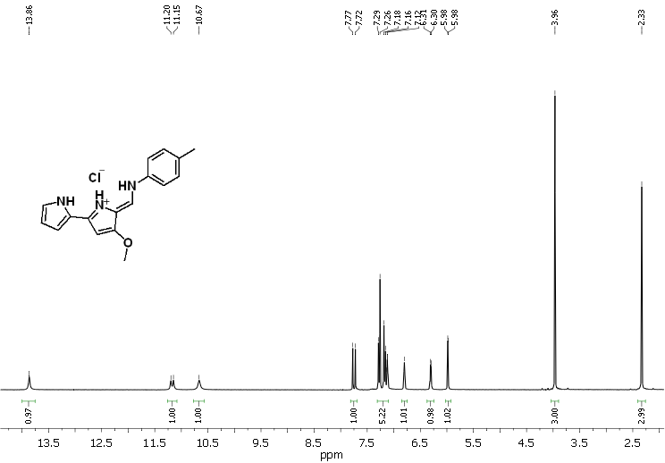
Figure S1. ¹H NMR (CDCl₃) of compound 1. HCl.

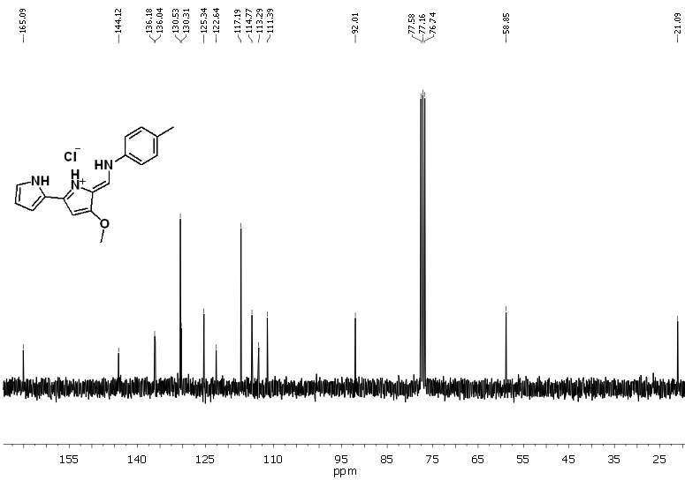
Figure S2. ¹³C NMR (CDCl₃) of compound 1. HCl.
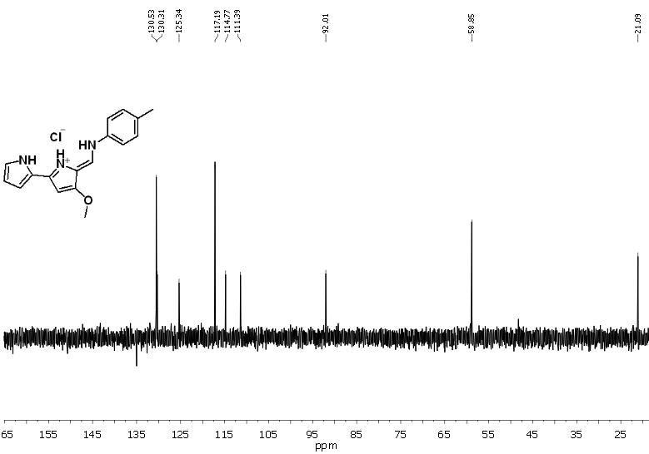
Figure S3. DEPT ¹³C NMR (CDCl₃) of compound 1. HCl.

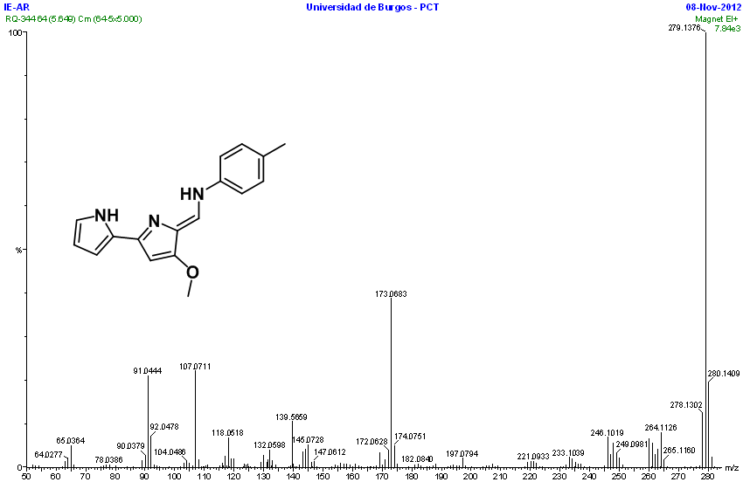Figure S4. HRMS (EI) of compound 1.

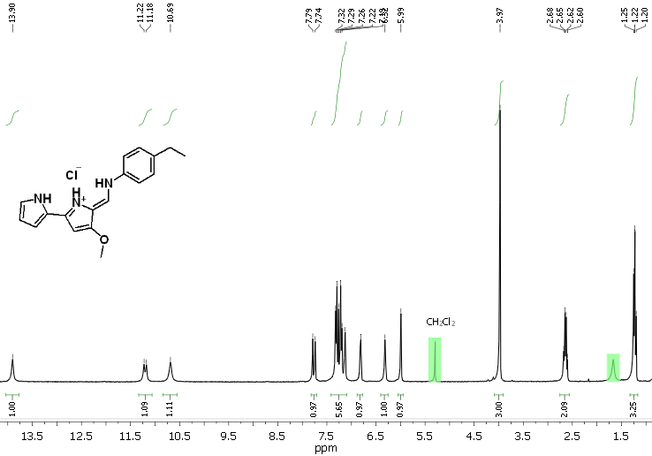 Figure S5. ¹H NMR (CDCl₃) of compound 2. HCl.

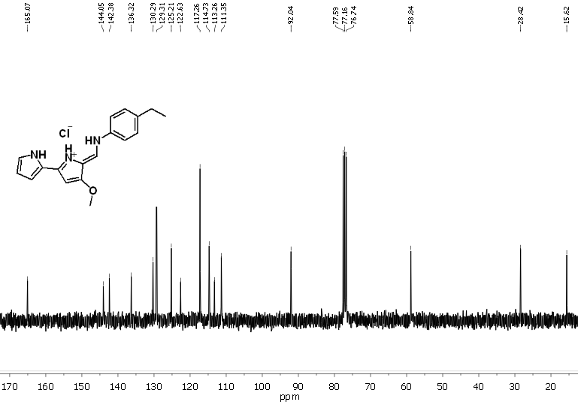Figure S6. ¹³C NMR (CDCl₃) of compound 2. HCl.
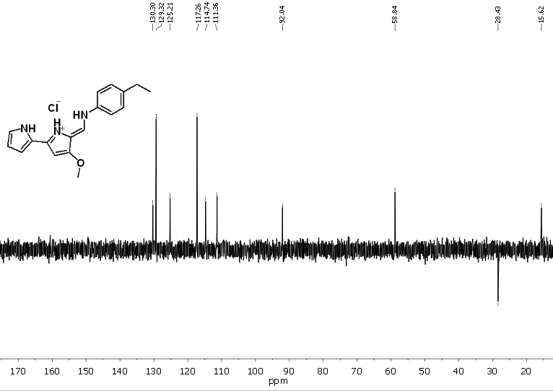Figure S7. DEPT ¹³C NMR (CDCl₃) of compound 2. HCl.

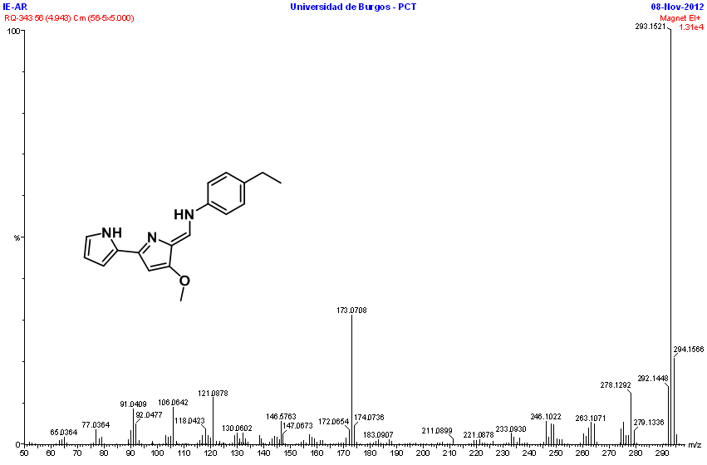Figure S8. HRMS (EI) of compound 2.

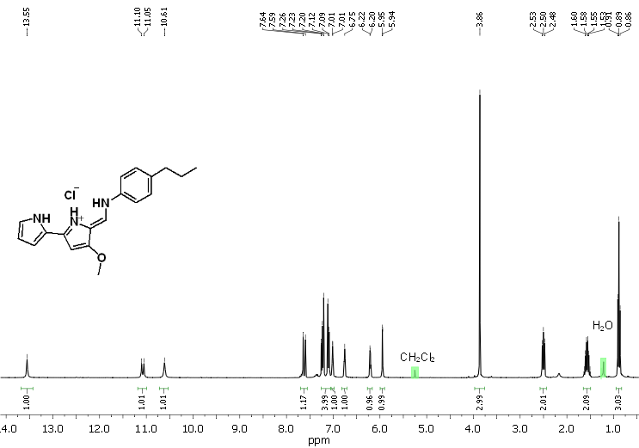
Figure S9. ¹H NMR (CDCl₃) of compound 3. HCl.

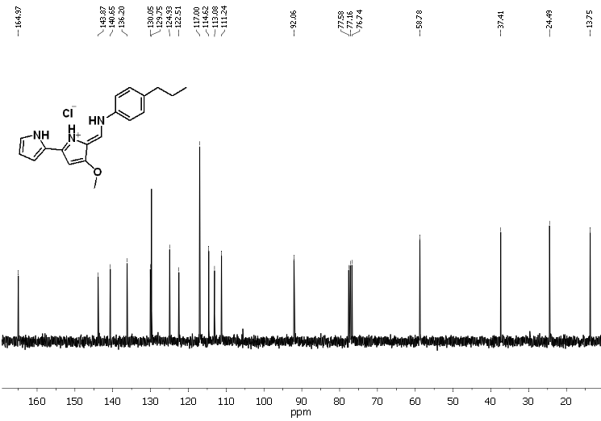 Figure S10. ¹³C NMR (CDCl₃) of compound 3. HCl.
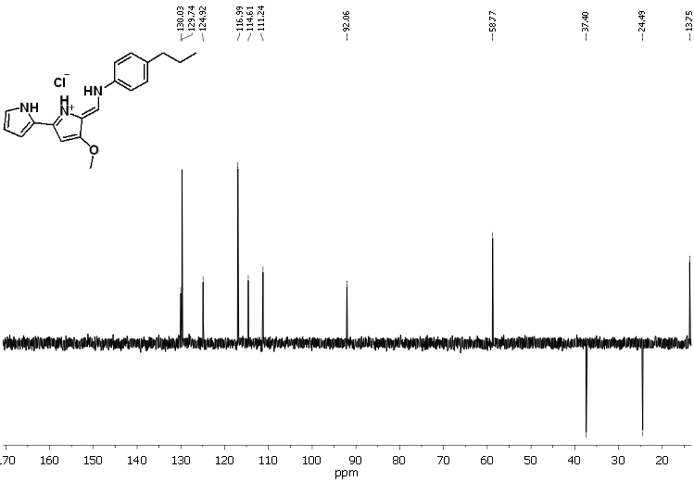 Figure S11. DEPT ¹³C NMR (CDCl₃) of compound 3. HCl.

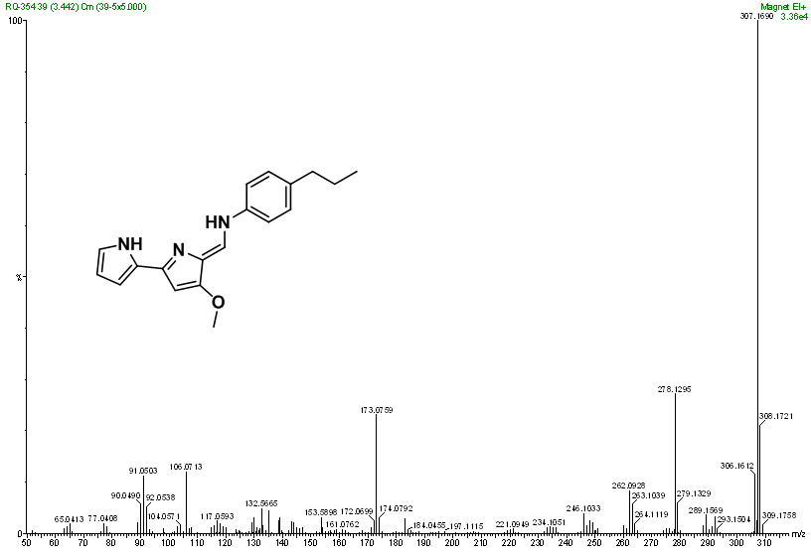Figure S12. HRMS (EI) of compound 3.

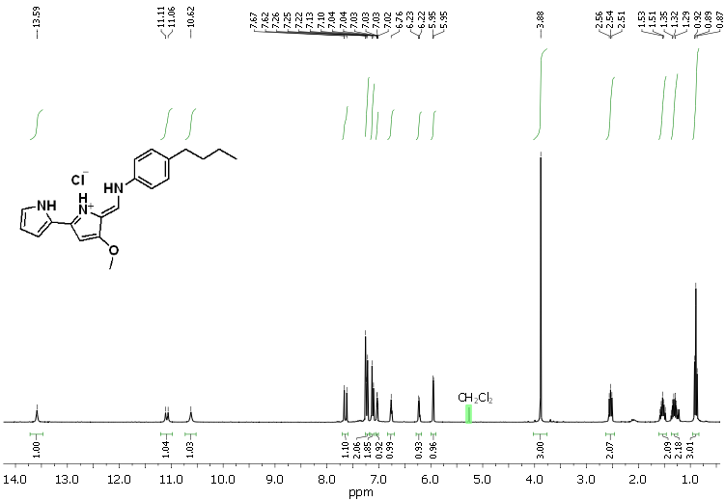
Figure S13. ¹H NMR (CDCl₃) of compound 4. HCl.

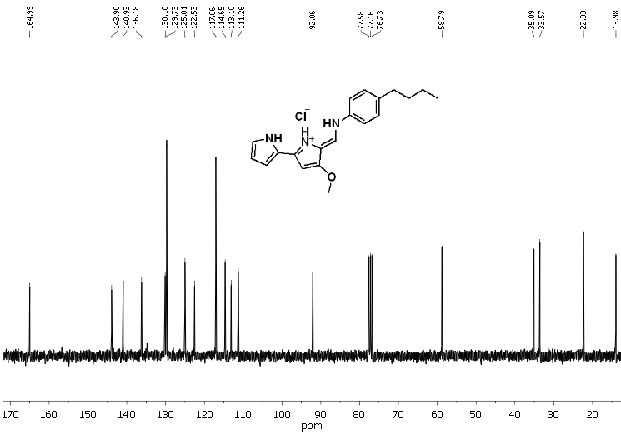 Figure S14. ¹³C NMR (CDCl₃) of compound 4. HCl.

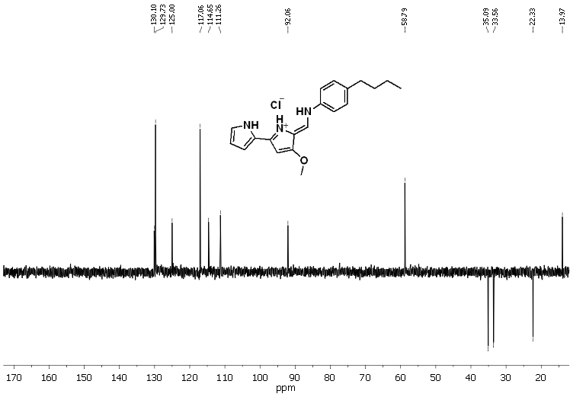 Figure S15. DEPT ¹³C NMR (CDCl₃) of compound 4. HCl.

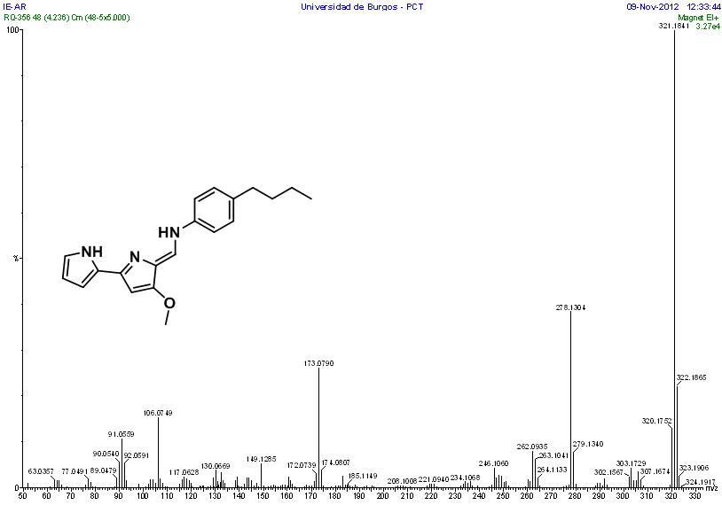Figure S16. HRMS (EI) of compound 4.

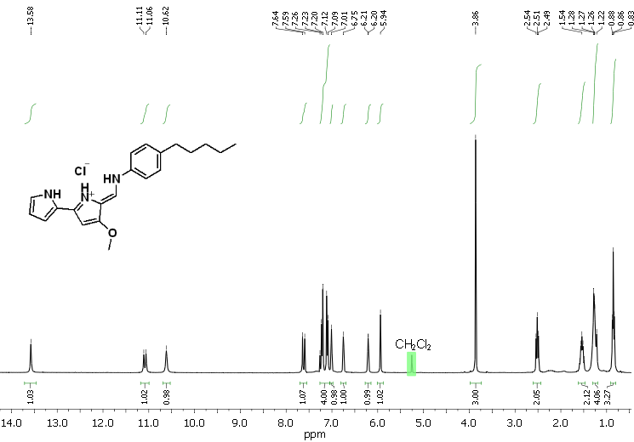
Figure S17. ¹H NMR (CDCl₃) of compound 6. HCl.

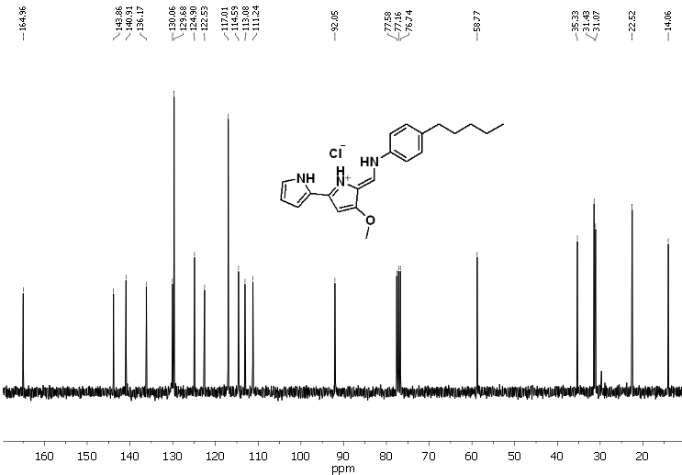
Figure S18. ¹³C NMR (CDCl₃) of compound 6. HCl.
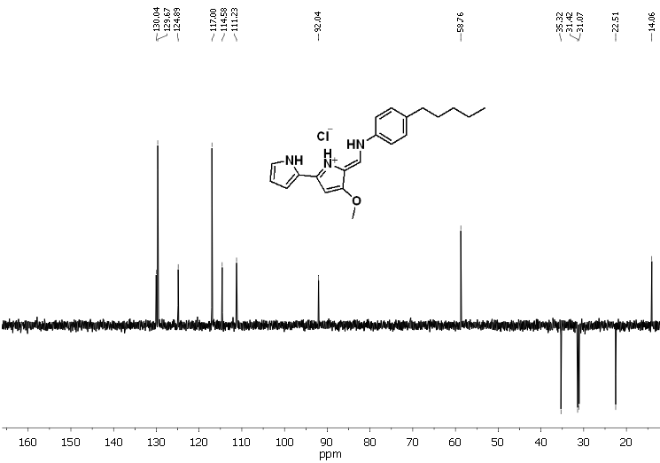
Figure S19. DEPT ¹³C NMR (CDCl₃) of compound 6. HCl.

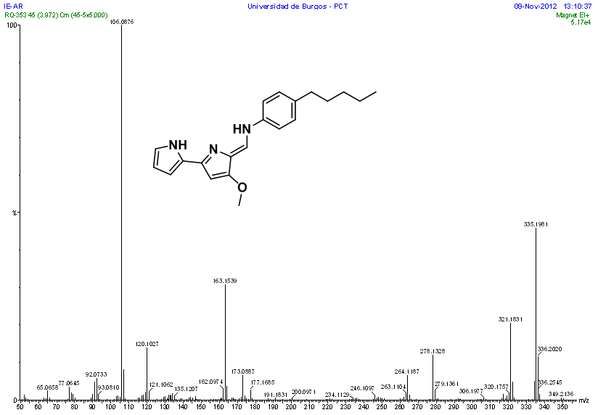Figure S20. HRMS (EI) of compound 6.
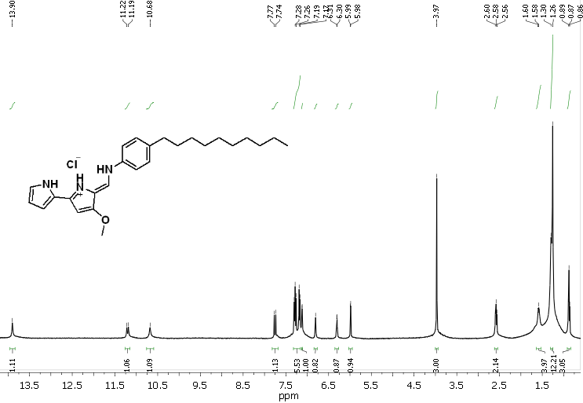Figure S21. ¹H NMR (CDCl₃) of compound 7. HCl.

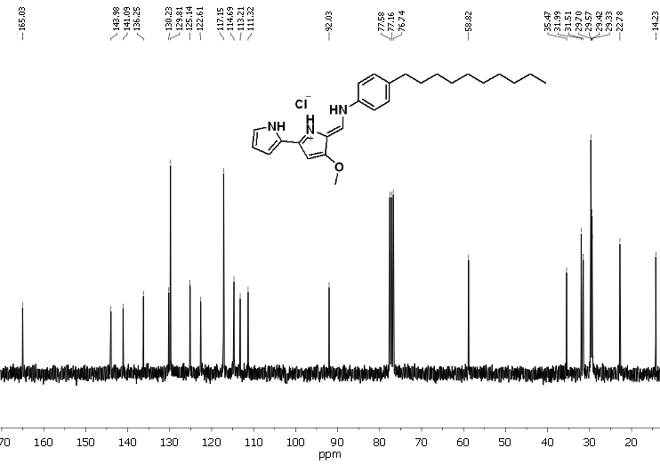 Figure S22. ¹³C NMR (CDCl₃) of compound 7. HCl.

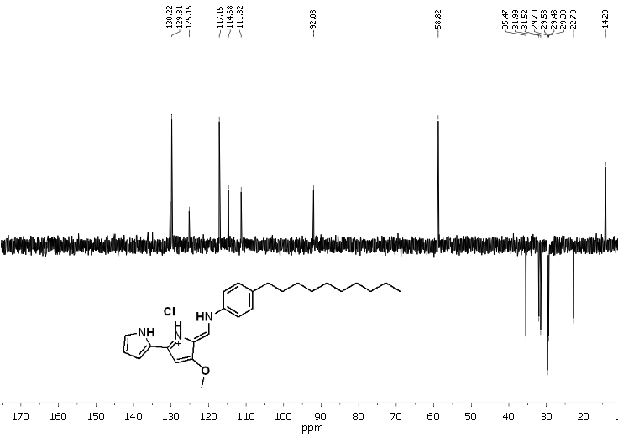 Figure S23. DEPT ¹³C NMR (CDCl₃) of compound 7. HCl.

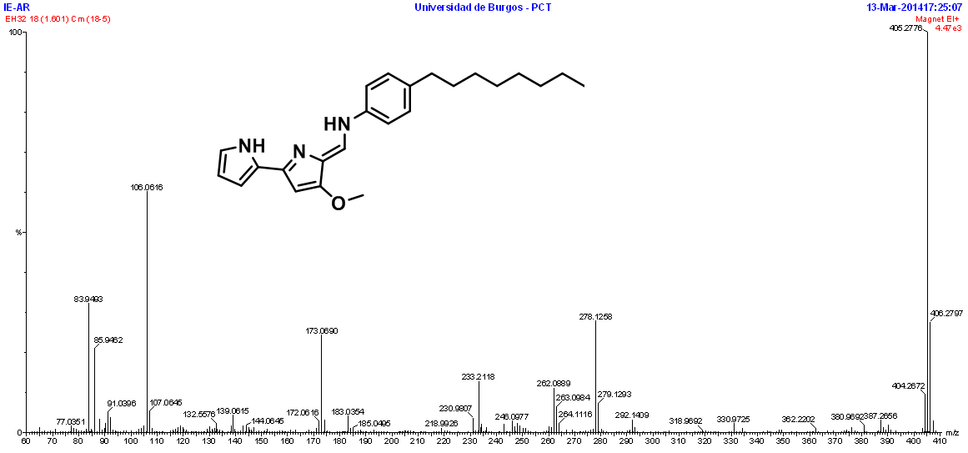
Figure S24. HRMS (EI) of compound 7.

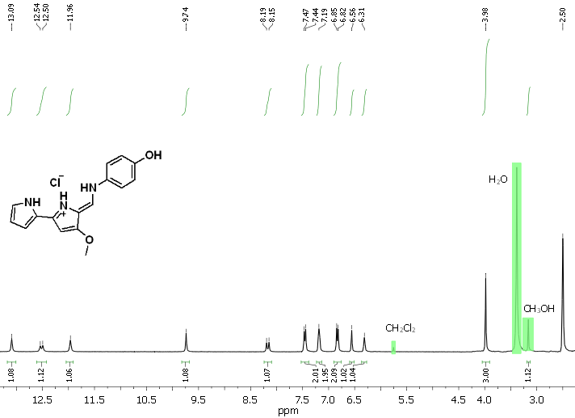 Figure S25. ¹H NMR (DMSO-d₆) of compound 8. HCl.

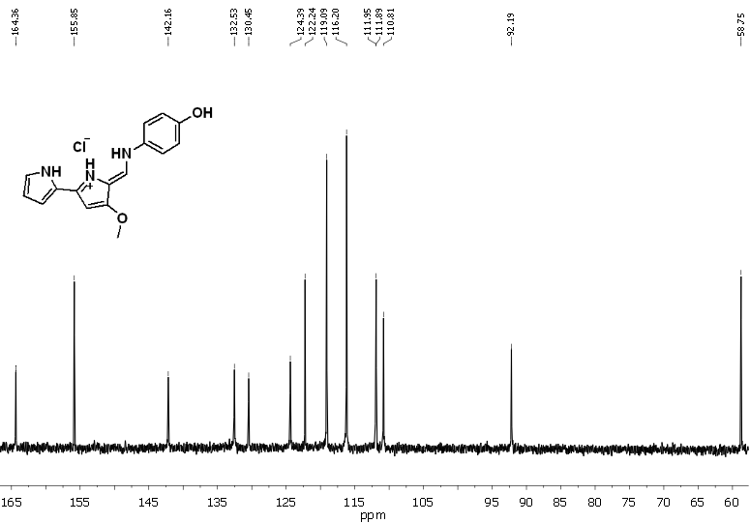Figure S26. ¹³C NMR (DMSO-d₆) of compound 8. HCl.
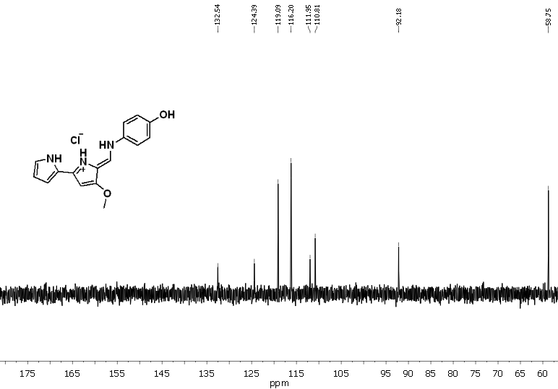Figure S27. DEPT ¹³C NMR (DMSO-d₆) of compound 8. HCl.

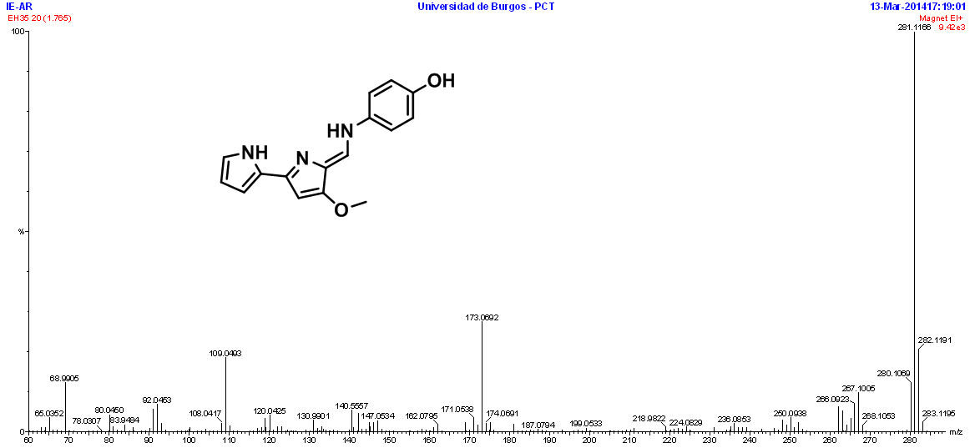Figure S28. HRMS (EI) of compound 8.

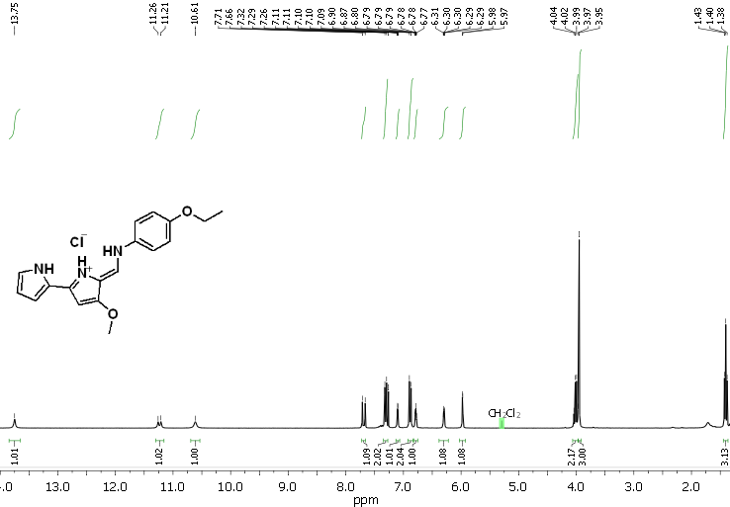
Figure S29. ¹H NMR (CDCl₃) of compound 10. HCl.

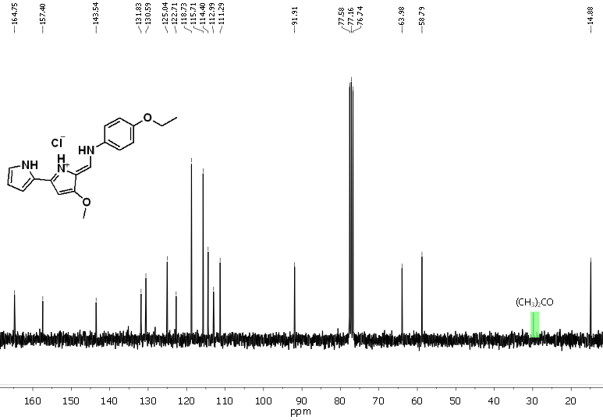Figure S30. ¹³C NMR (CDCl₃) of compound 10. HCl.

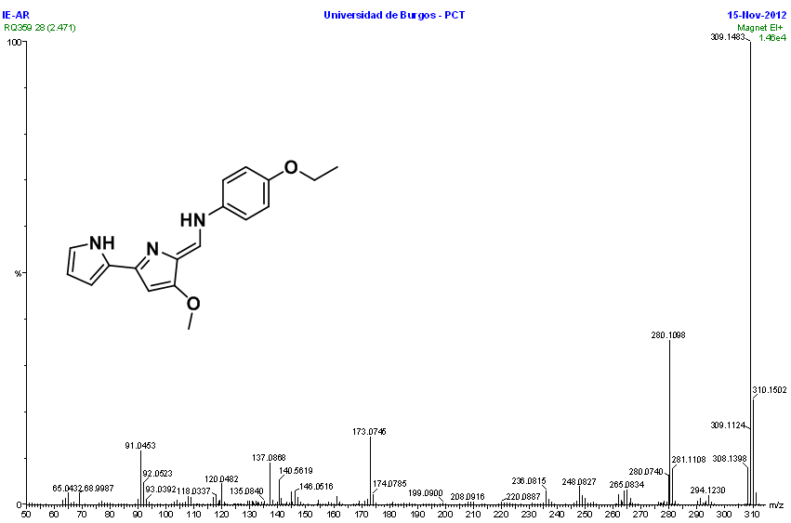Figure S31. HRMS (EI) of compound 10.

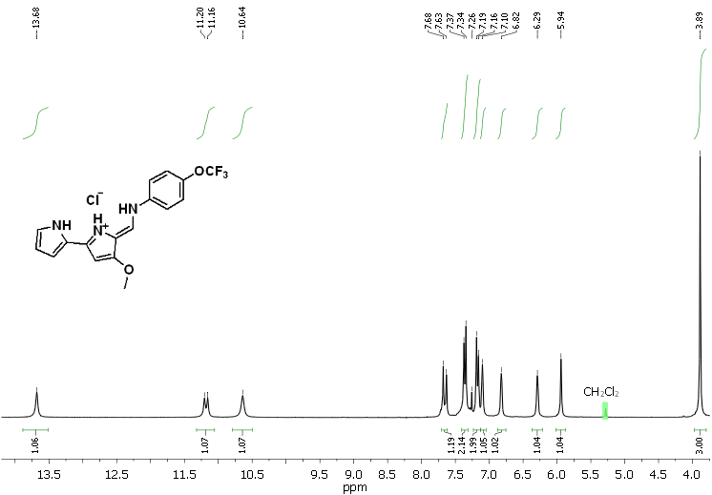
Figure S32. ¹H NMR (CDCl₃) of compound 11. HCl.
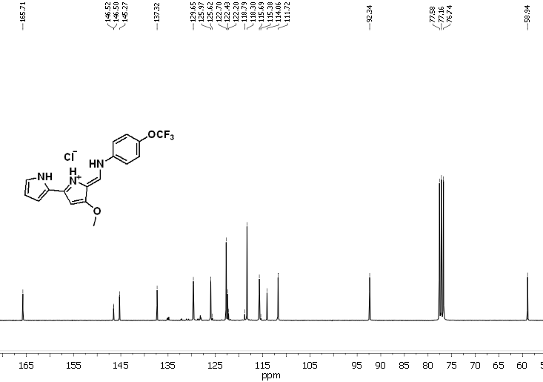
Figure S33. ¹³C NMR (CDCl₃) of compound 11. HCl.

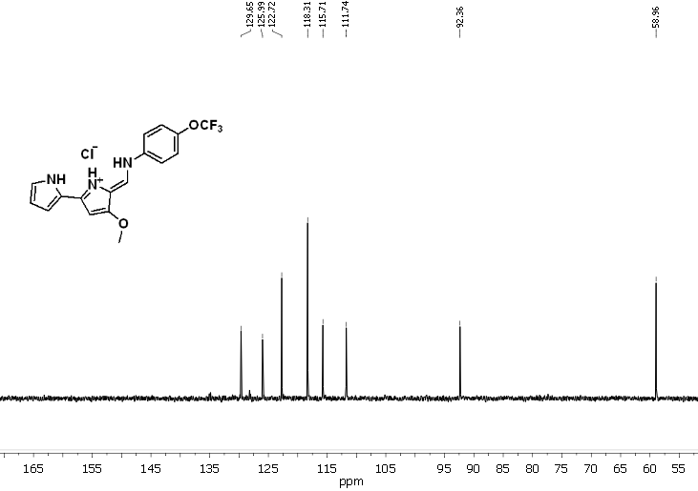Figure S34. DEPT ¹³C NMR (CDCl₃) of compound 11. HCl.
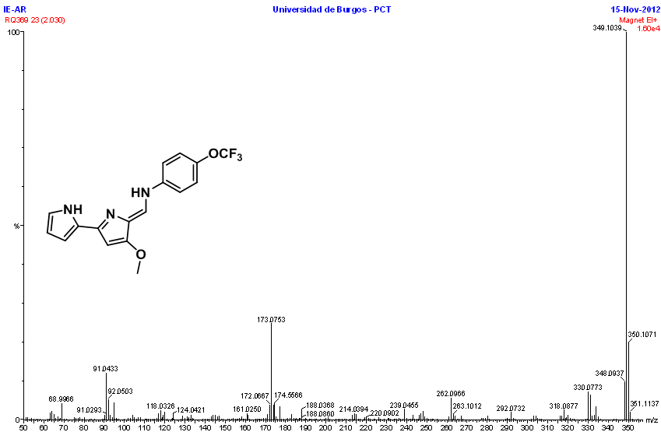
Figure S35. HRMS (EI) of compound 11.

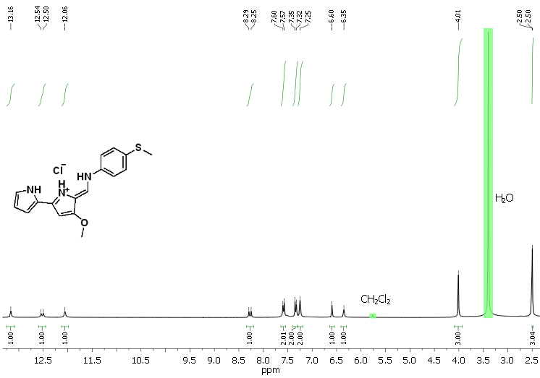
Figure S36. ¹H NMR (DMSO-d₆) of compound 12. HCl.

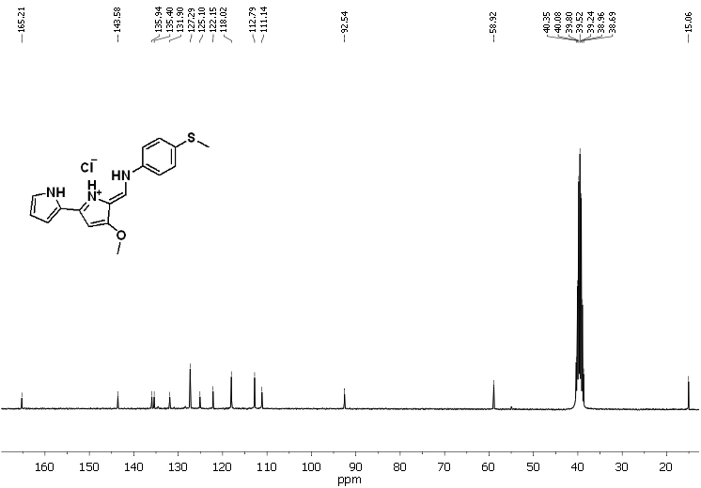 Figure S37. ¹³C NMR (DMSO-d₆) of compound 12. HCl.

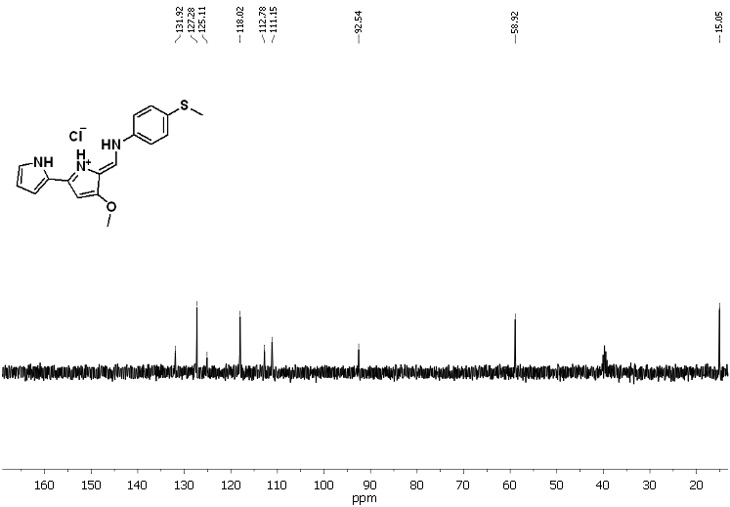
Figure S38. DEPT ¹³C NMR (DMSO-d₆) of compound 12. HCl.

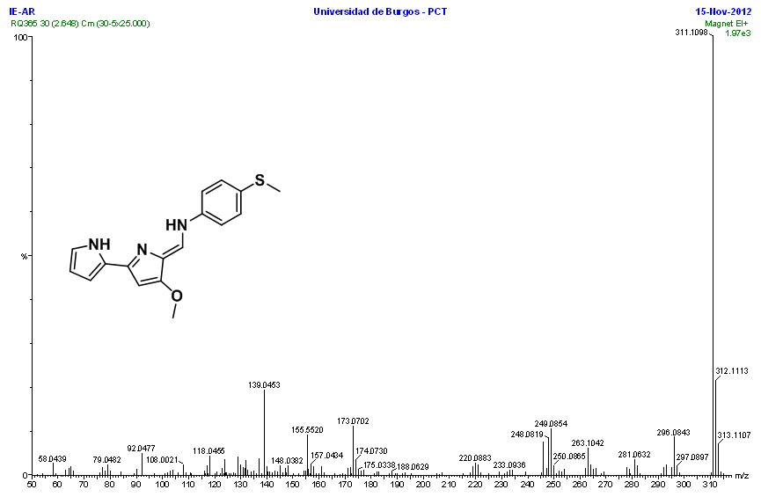Figure S39. HRMS (EI) of compound 12.

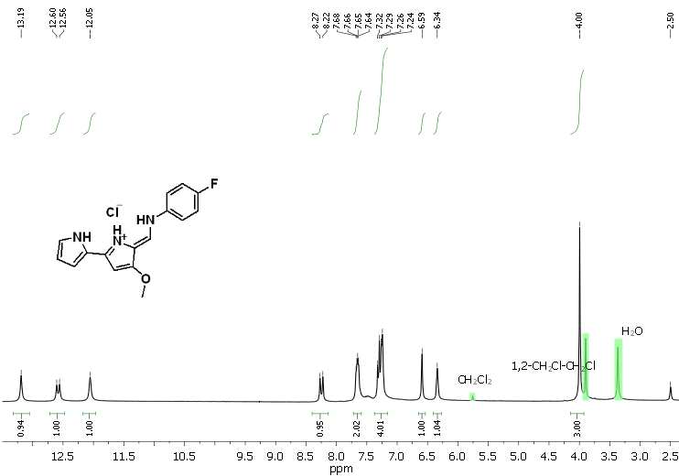
Figure S40. ¹H NMR (DMSO-d₆) of compound 13. HCl.

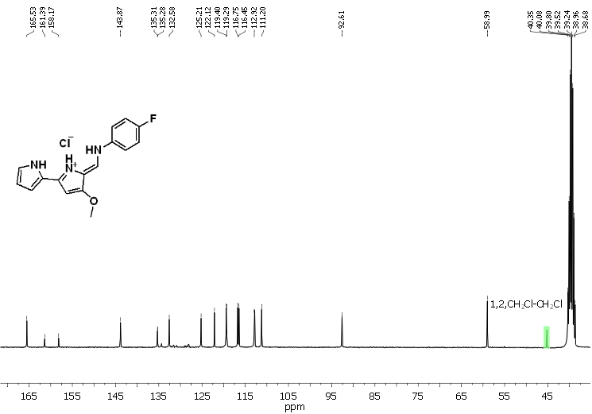Figure S41. ¹³C NMR (DMSO-d₆) of compound 13. HCl.

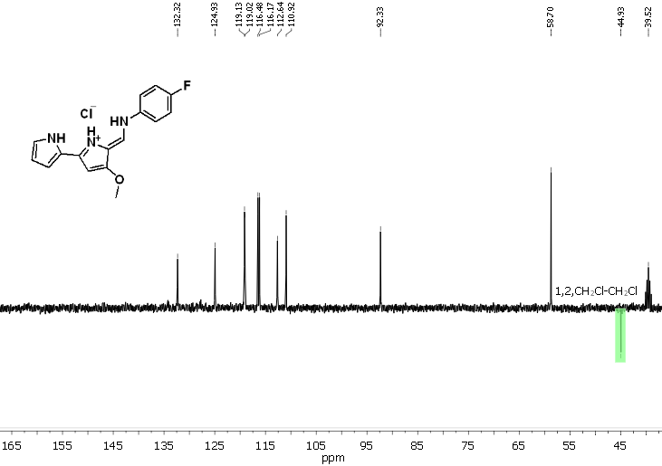
Figure S42. DEPT ¹³C NMR (DMSO-d₆) of compound 13. HCl.

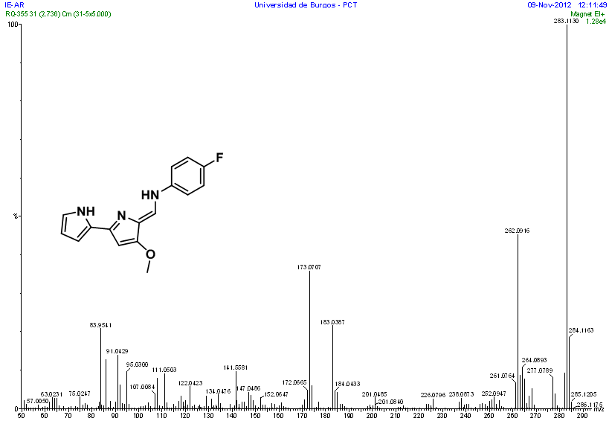Figure S43. HRMS (EI) of compound 13.

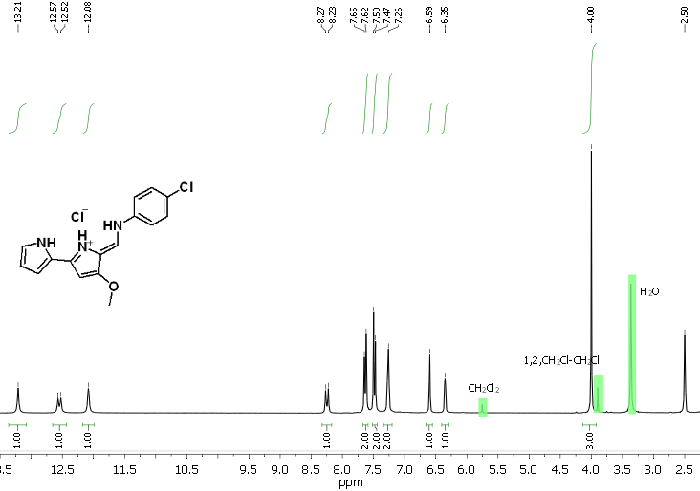Figure S44. ¹H NMR (DMSO-d₆) of compound 14. HCl.

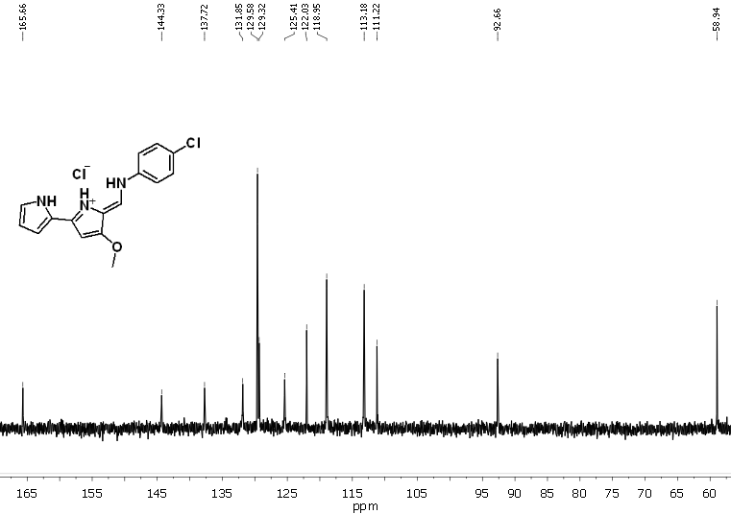Figure S43. ¹³C NMR (DMSO-d₆) of compound 14. HCl.

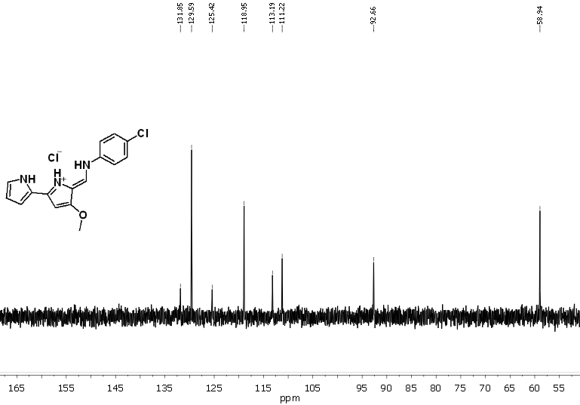Figure S45. DEPT ¹³C NMR (DMSO-d₆) of compound 14. HCl.
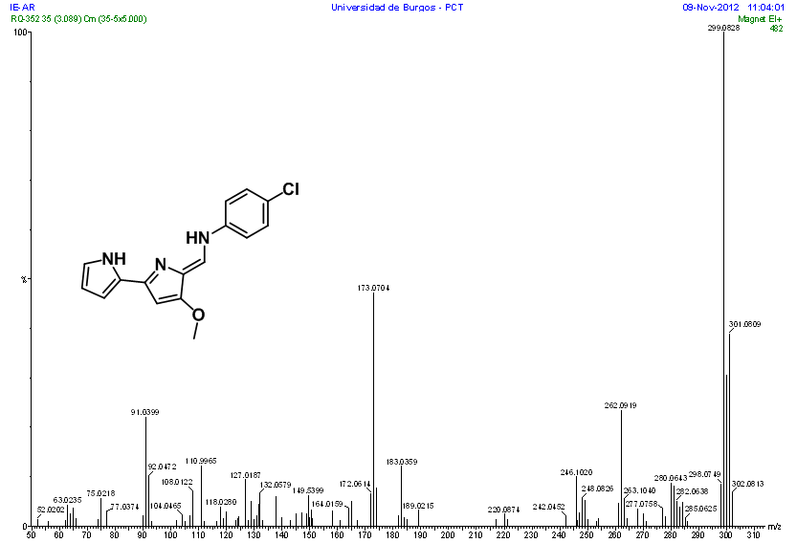Figure S46. HRMS (EI) of compound 14.

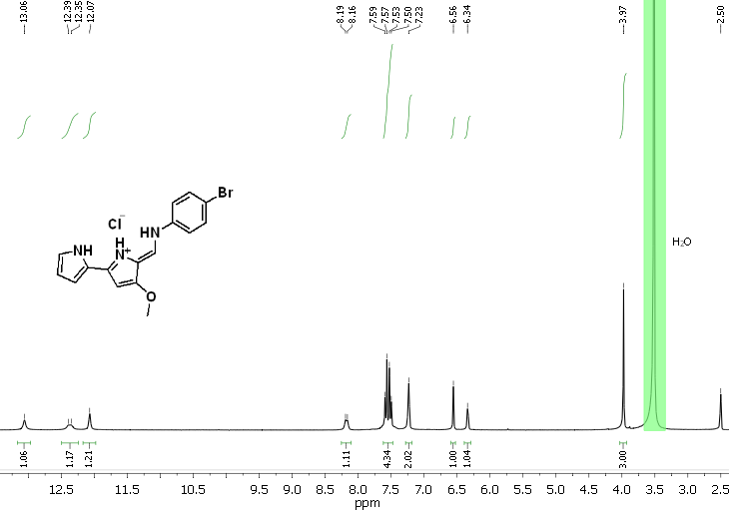Figure S47. ¹H NMR (DMSO-d₆) of compound 15. HCl.

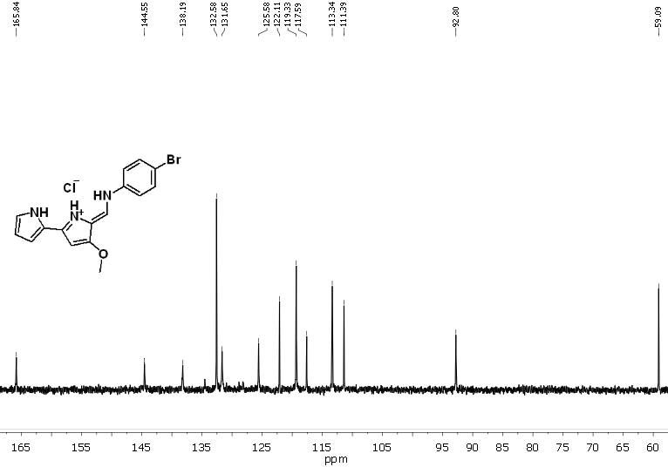Figure S48. ¹³C NMR (DMSO-d₆) of compound 15. HCl.

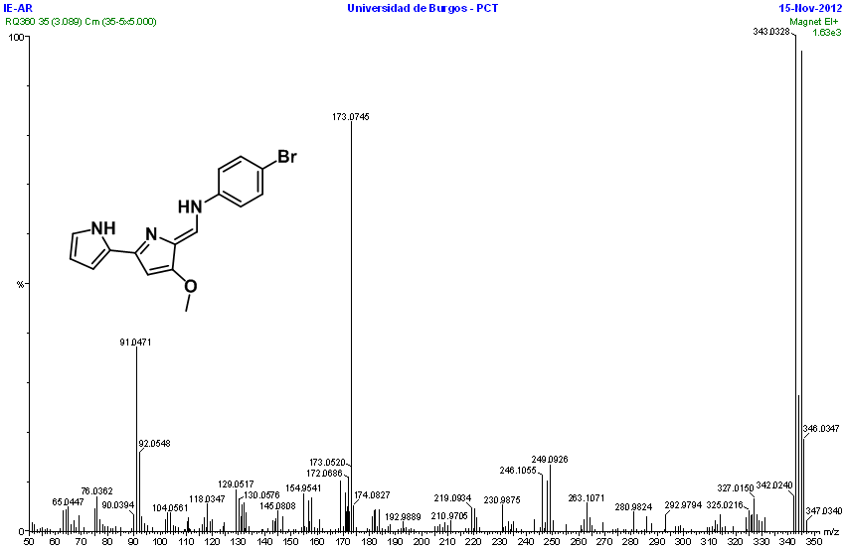Figure S49. HRMS (EI) of compound 15.

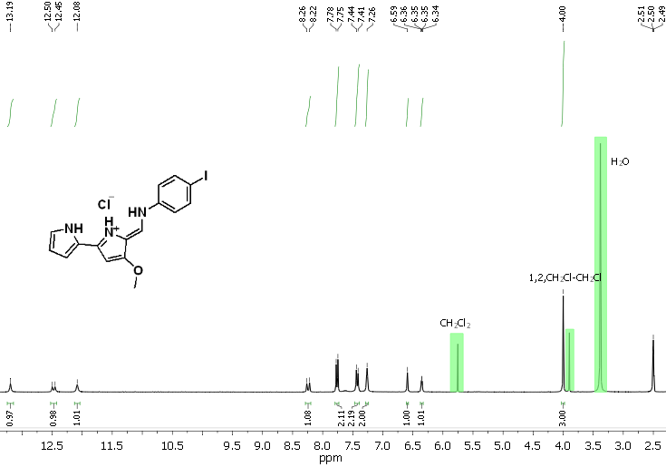Figure S50. ¹H NMR (DMSO-d₆) of compound 16. HCl.

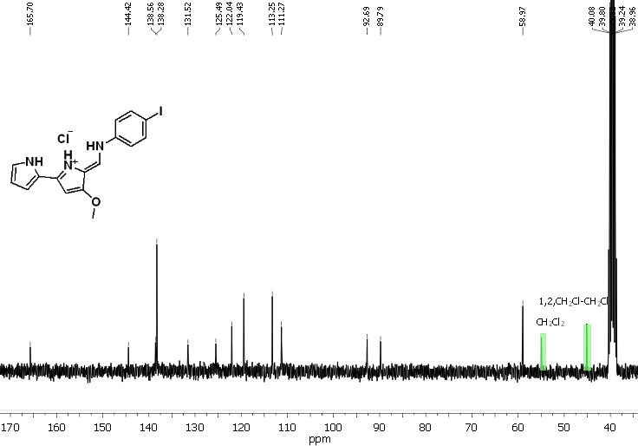Figure S51. ¹³C NMR (DMSO-d₆) of compound 16. HCl.

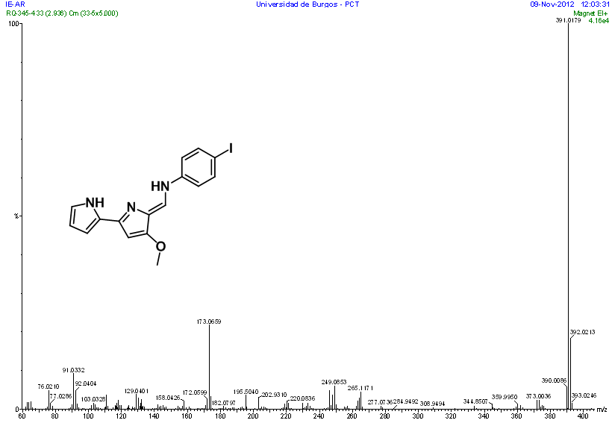Figure S52. HRMS (EI) of compound 16.

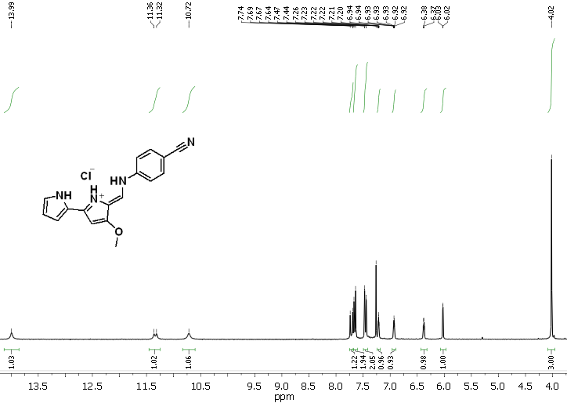 Figure S53. ¹H NMR (CDCl₃) of compound 17. HCl.
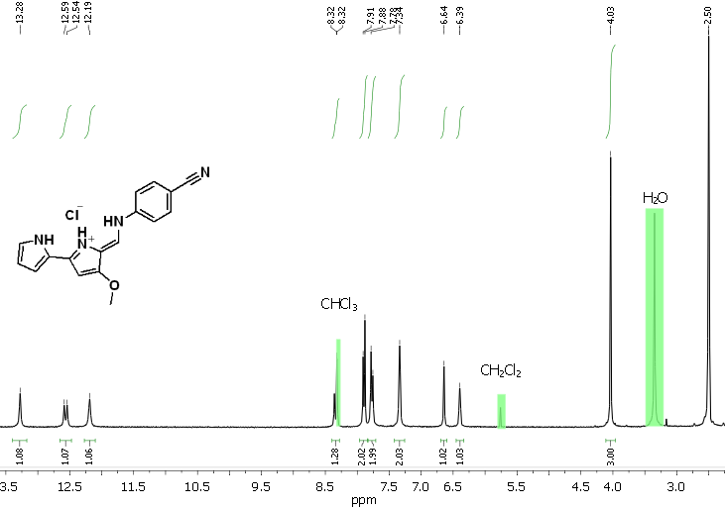 Figure S54. ¹H NMR (DMSO-d₆) of compound 17. HCl.

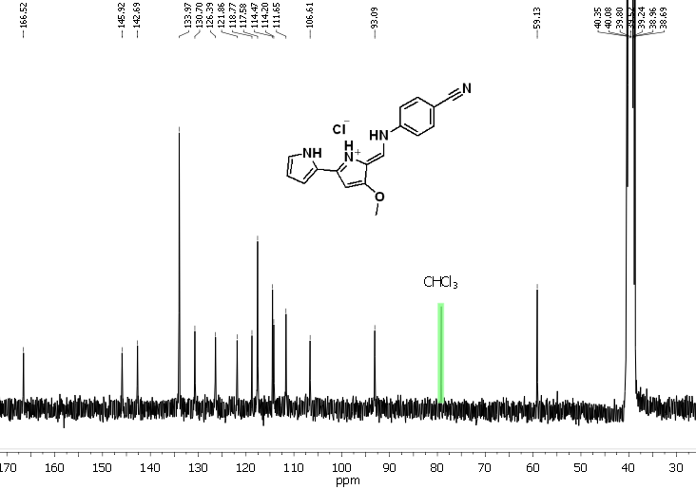 Figure S55. ¹³C NMR (DMSO-d₆) of compound 17. HCl.
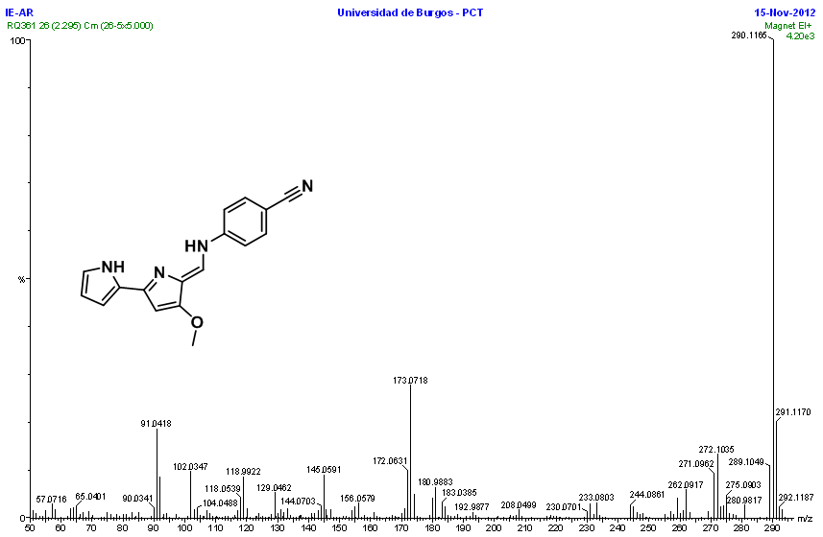Figure S56. HRMS (EI) of compound 17.

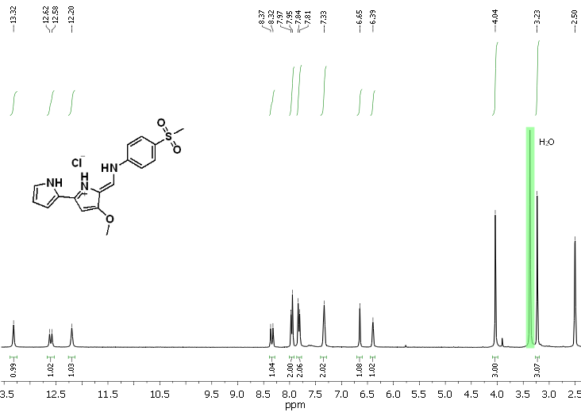Figure S57. ¹H NMR (DMSO-d₆) of compound 18. HCl.

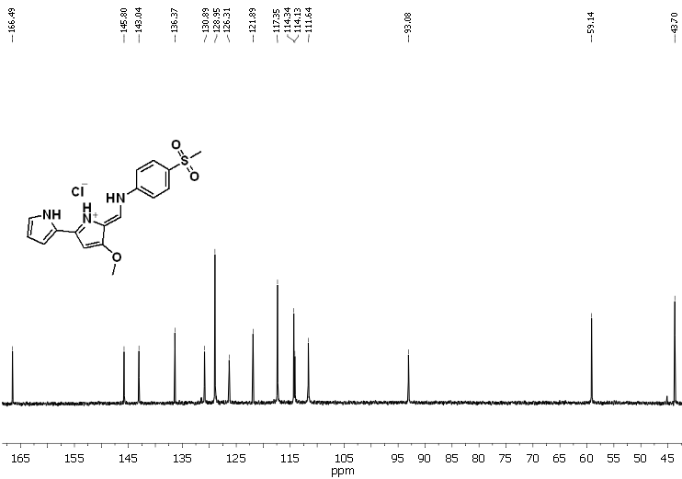Figure S58. ¹³C NMR (DMSO-d₆) of compound 18. HCl.

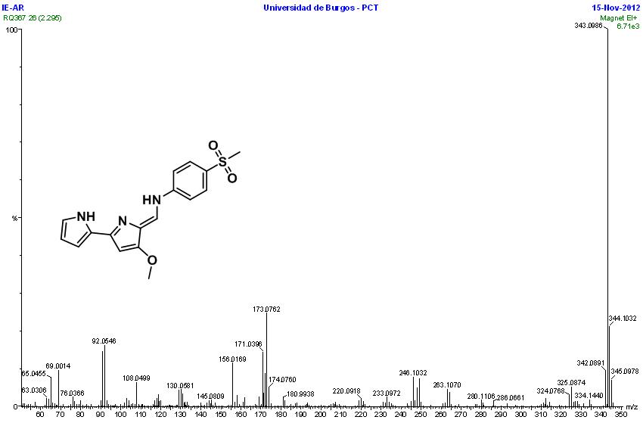Figure S59. HRMS (EI) of compound 18.

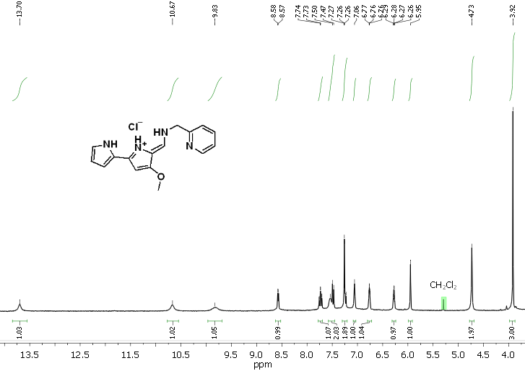
Figure S60. ¹H NMR (CDCl₃) of compound 19. HCl.

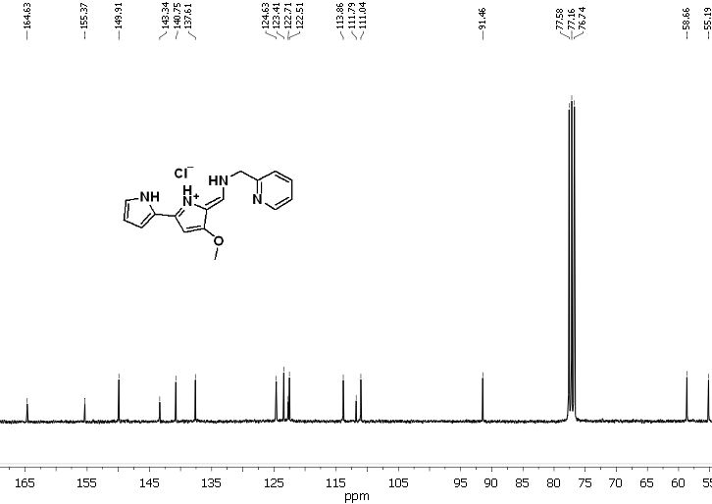
Figure S61. ¹³C NMR (CDCl₃) of compound 19. HCl.
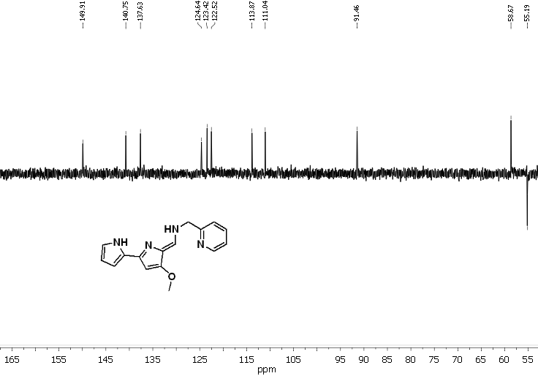
Figure S62. DEPT ¹³C NMR (CDCl₃) of compound 19. HCl.

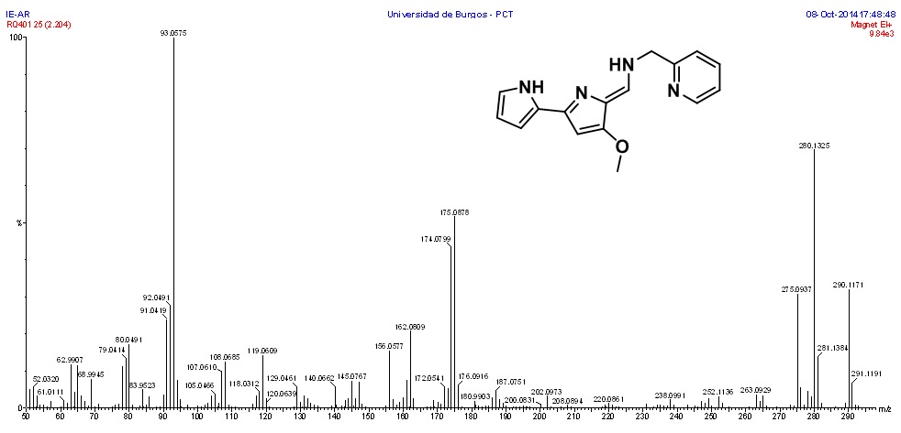
Figure S63. HRMS (EI) of compound 19.

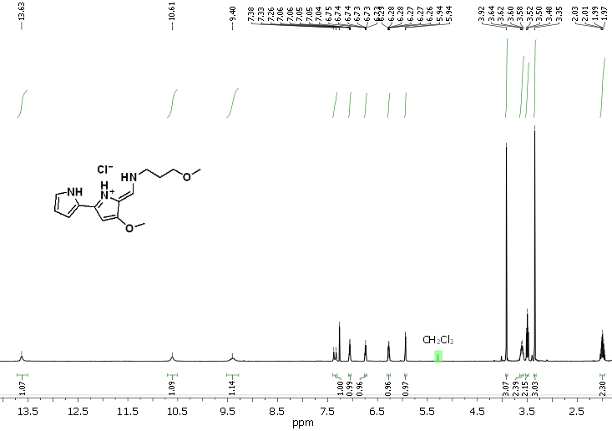
Figure S64. ¹H NMR (CDCl₃) of compound 33. HCl.

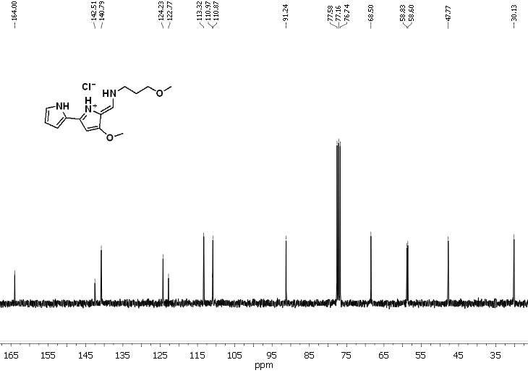
Figure S65. ¹³C NMR (CDCl₃) of compound 33. HCl.
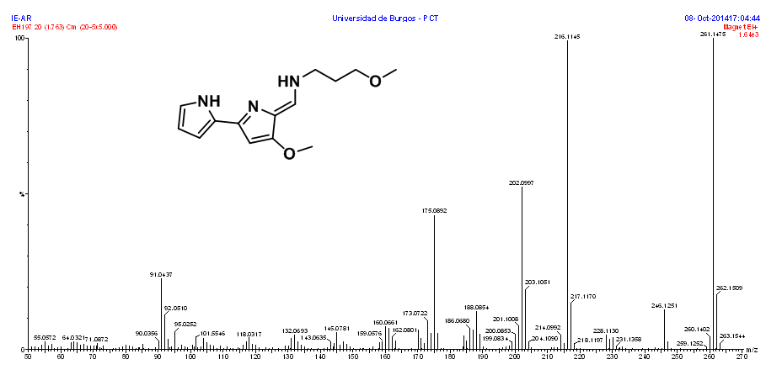
Figure S66. HRMS (EI) of compound 33.

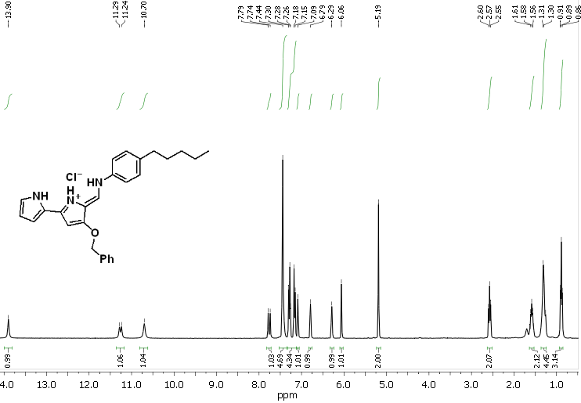
Figure S67. ¹H NMR (CDCl₃) of compound 36. HCl.

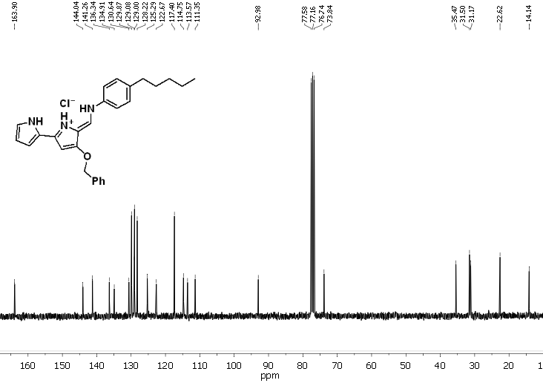
Figure S68. ¹³C NMR (CDCl₃) of compound 36. HCl.

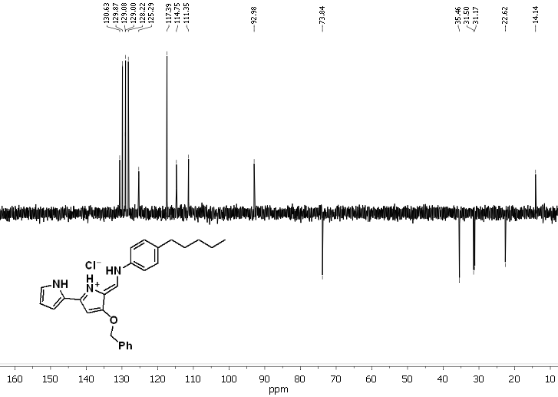
Figure S69. DEPT ¹³C NMR (CDCl₃) of compound 36. HCl.
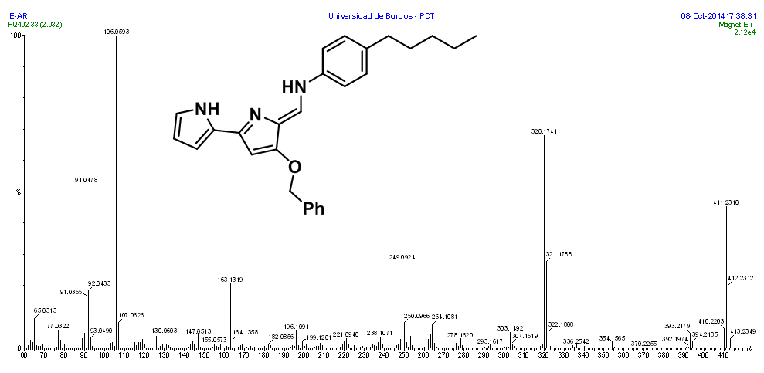
Figure S70. HRMS (EI) of compound 36.

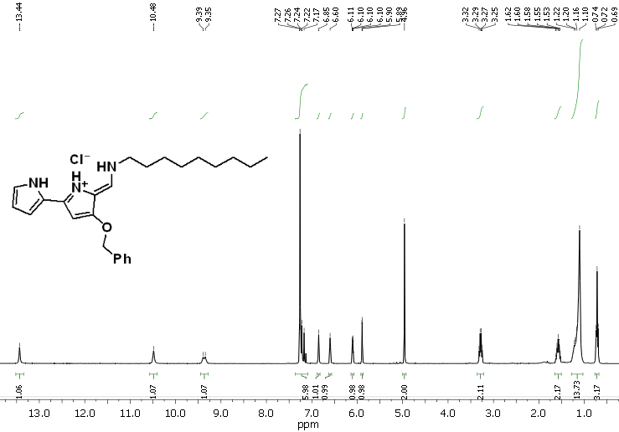
Figure S71. ¹H NMR (CDCl₃) of compound 41. HCl.

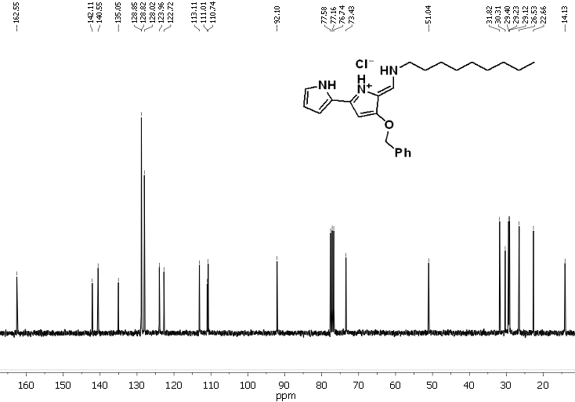
Figure S72. ¹³C NMR (CDCl₃) of compound 41. HCl.
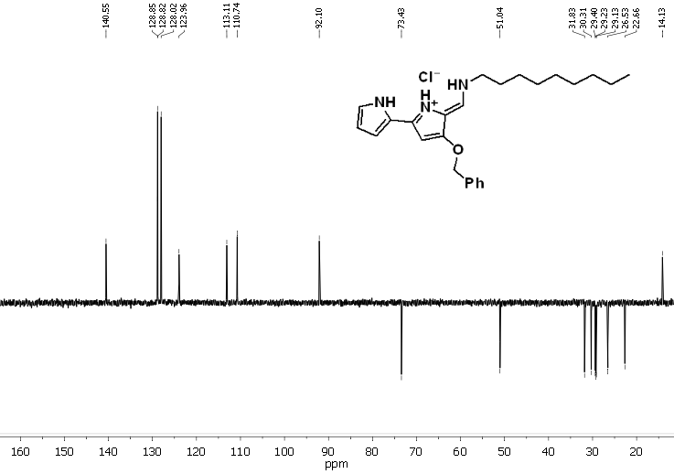
Figure S73. DEPT ¹³C NMR (CDCl₃) of compound 41. HCl.

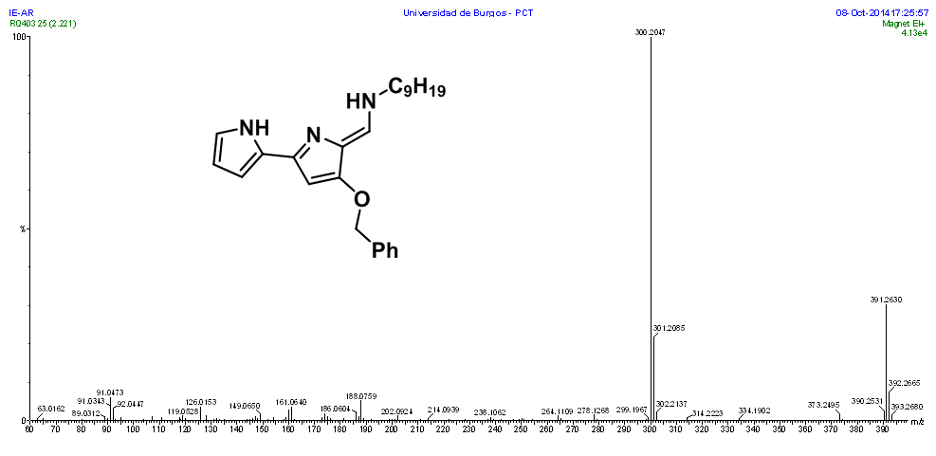
Figure S74. HRMS (EI) of compound 41.

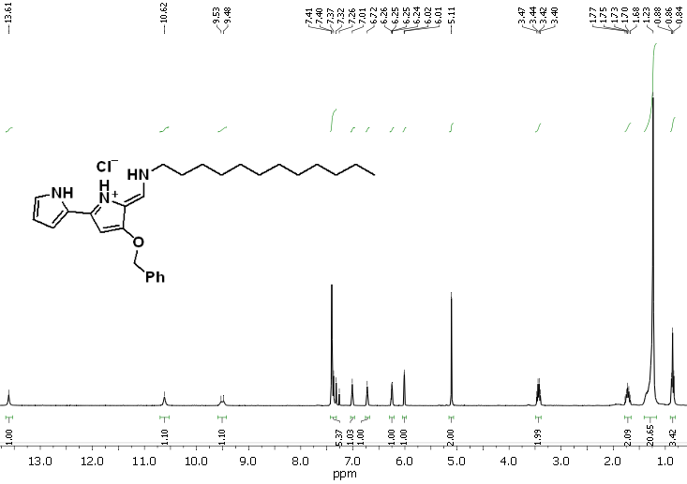
Figure S75. ¹H NMR (CDCl₃) of compound 43. HCl.

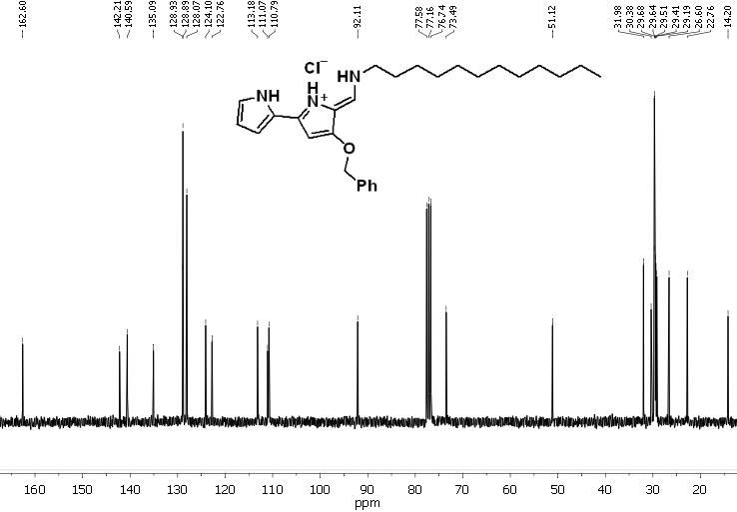
Figure S76. ¹³ CNMR (CDCl₃) of compound 43. HCl.

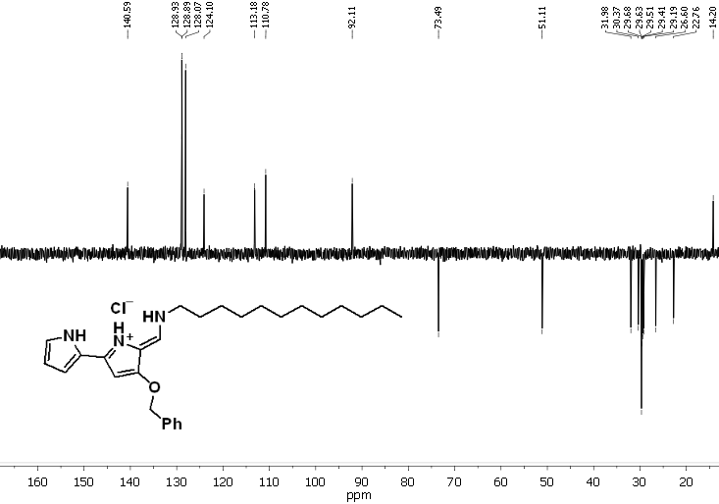
Figure S77. DEPT ¹³ CNMR (CDCl₃) of compound 43. HCl.
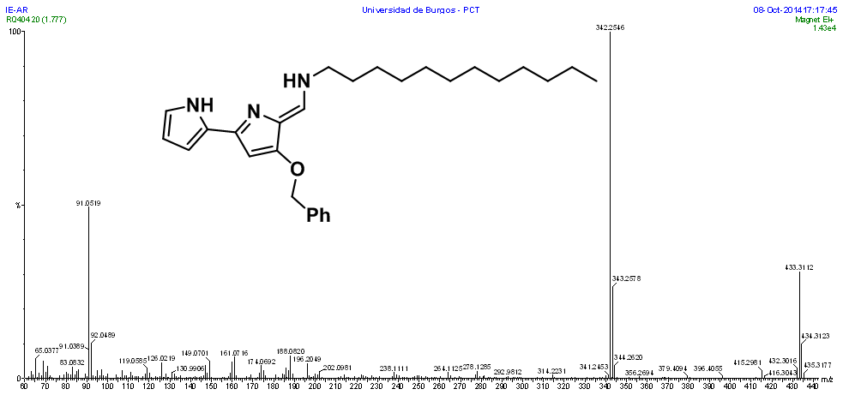
Figure S78. HRMS (EI) of compound 43.

a) K. Dairi, S. Tripathy, G. Attardo and J.–F. Lavallee, Tetrahedron Lett., 2006, 47, 2605–2606; b) P. Iglesias Hernández, D. Moreno, A. Araujo Javier, T. Torroba, R. Pérez-Tomás, R. Quesada, Chem. Commun., 2012, 48, 1556-1558
E. Hernando, V. Soto-Cerrato, S. Cortés-Arroyo, R. Pérez-Tomás and R. Quesada, Org. Biomol. Chem., 2014, 12, 1771–1778
V. Saggiomo, S. Otto, I. Marques, V. Félix, T. Torroba and R. Quesada, Chem. Commun., 2012, 48, 5274–5276
D. M. Pinkerton, M. G. Banwell and A. C. Willis, Org. Lett., 2007, 9, 5127–5130

