  - Initial rate of chloride efflux (kini) determination
The initial rate of chloride release (k_{ini}) was calculated from chloride/nitrate transport experiments as described above. The chloride release by 0.05% tambjamine was monitored over time. The chloride efflux was fitted with the following asymptotic function using Origin 8.1, where y is the chloride efflux (%) and x is the time (s):

The initial rate of chloride release (k_{ini}) is calculated as k_{ini} = -b·ln(c) and is expressed in % s⁻¹. Figures S79-S121 show all of the obtained transport data for 0.05% tambjamine to lipid and the corresponding asymptotic fit. An overview of the obtained initial rates of chloride release (k_{ini}) can be found in Table S1 in S91.

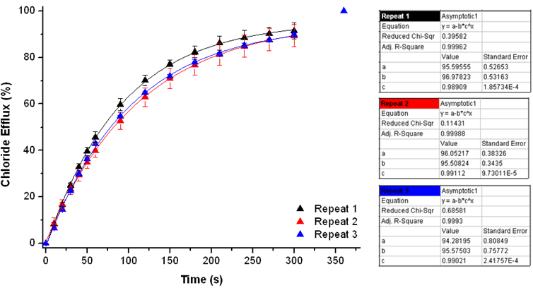 Figure S79: Overview of the initial rate of chloride release (k_{ini}) for compound 1. For experimental details, see main text.

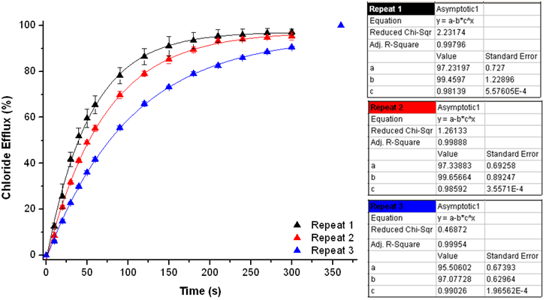 Figure S80: Overview of the initial rate of chloride release (k_{ini}) for compound 2. For experimental details, see main text.

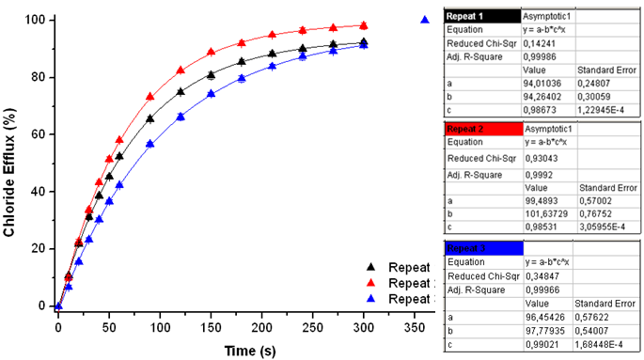Figure S81: Overview of the initial rate of chloride release (k_{ini}) for compound 3. For experimental details, see main text.

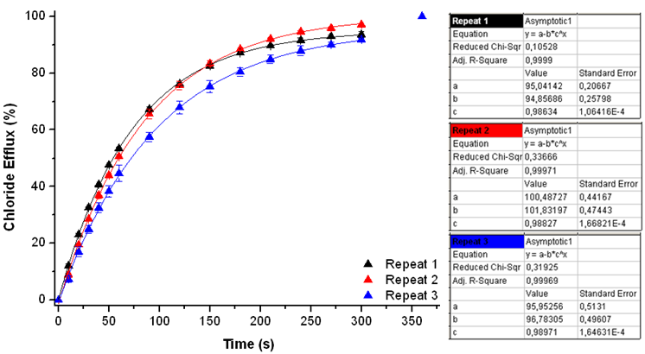Figure S82: Overview of the initial rate of chloride release (k_{ini}) for compound 4. For experimental details, see main text.

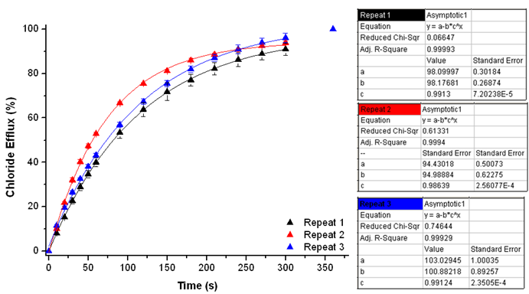 Figure S83: Overview of the initial rate of chloride release (k_{ini}) for compound 5. For experimental details, see main text.

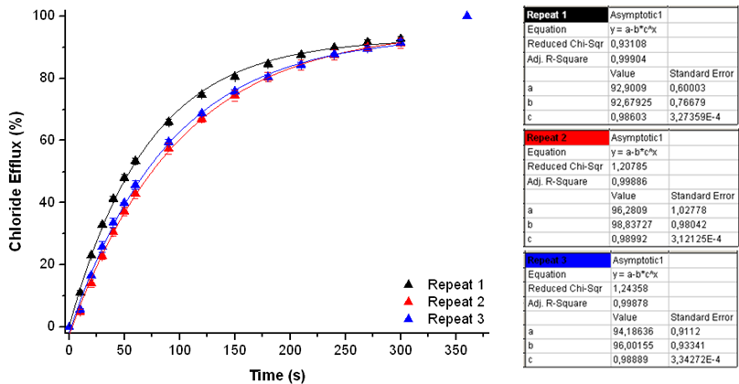Figure S84: Overview of the initial rate of chloride release (k_{ini}) for compound 6. For experimental details, see main text.

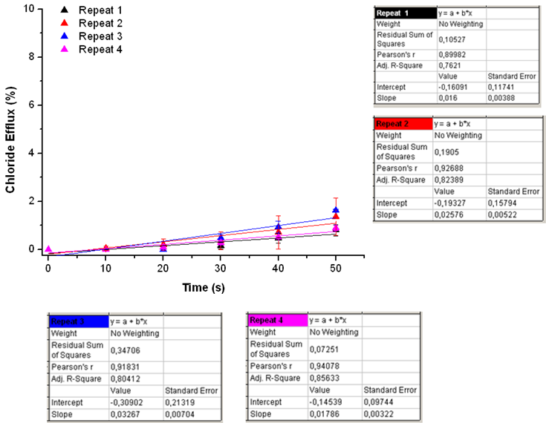Figure S85: Overview of the initial rate of chloride release (k_{ini}) for compound 7. For experimental details, see main text.

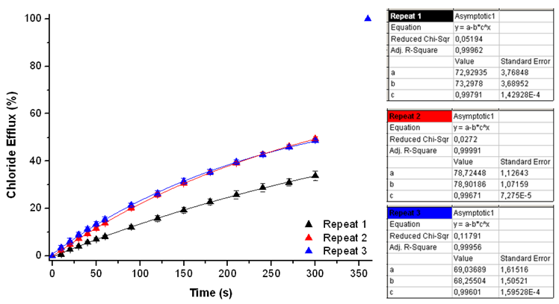Figure S86: Overview of the initial rate of chloride release (k_{ini}) for compound 8. For experimental details, see main text.

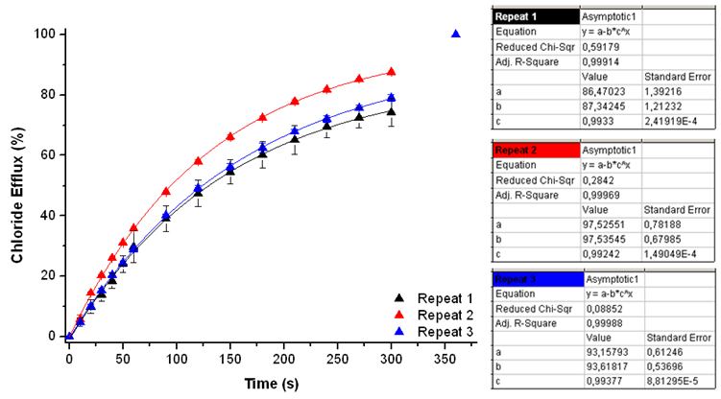Figure S87: Overview of the initial rate of chloride release (k_{ini}) for compound 9. For experimental details, see main text.

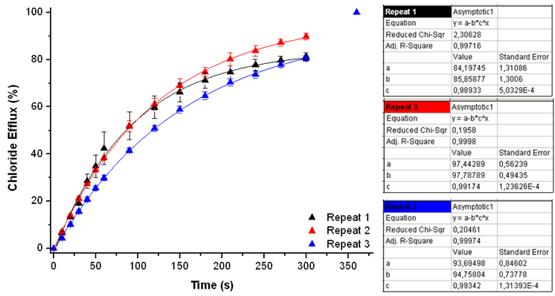Figure S88: Overview of the initial rate of chloride release (k_{ini}) for compound 10. For experimental details, see main text.

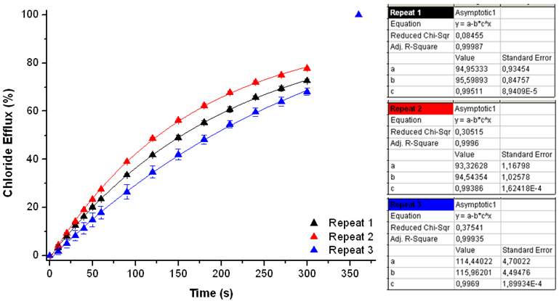
Figure S89: Overview of the initial rate of chloride release (k_{ini}) for compound 11. For experimental details, see main text.

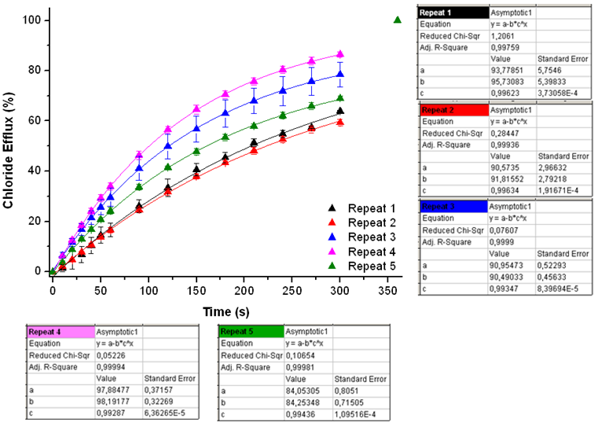
Figure S90: Overview of the initial rate of chloride release (k_{ini}) for compound 12. For experimental details, see main text.

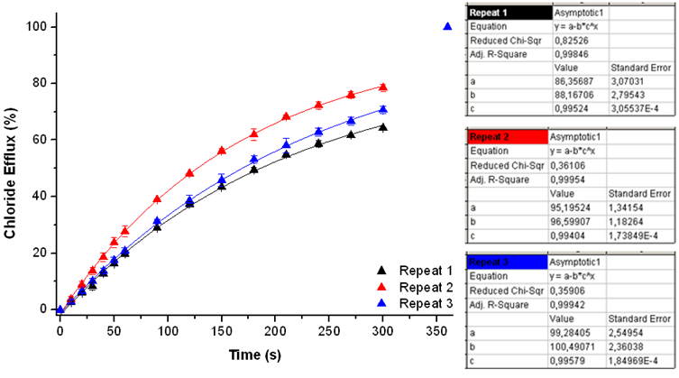Figure S91: Overview of the initial rate of chloride release (k_{ini}) for compound 13. For experimental details, see main text.

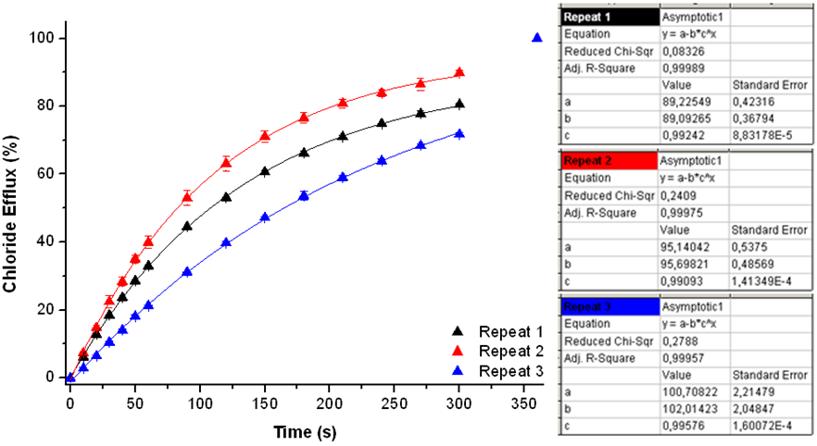Figure S92: Overview of the initial rate of chloride release (k_{ini}) for compound 14. For experimental details, see main text.

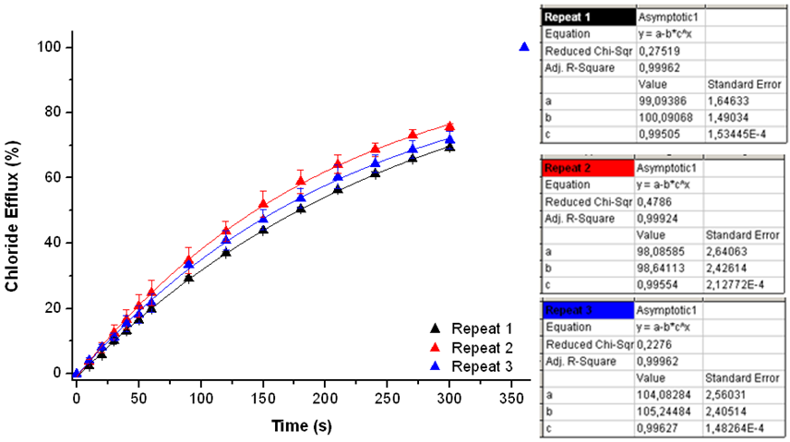Figure S93: Overview of the initial rate of chloride release (k_{ini}) for compound 15. For experimental details, see main text.

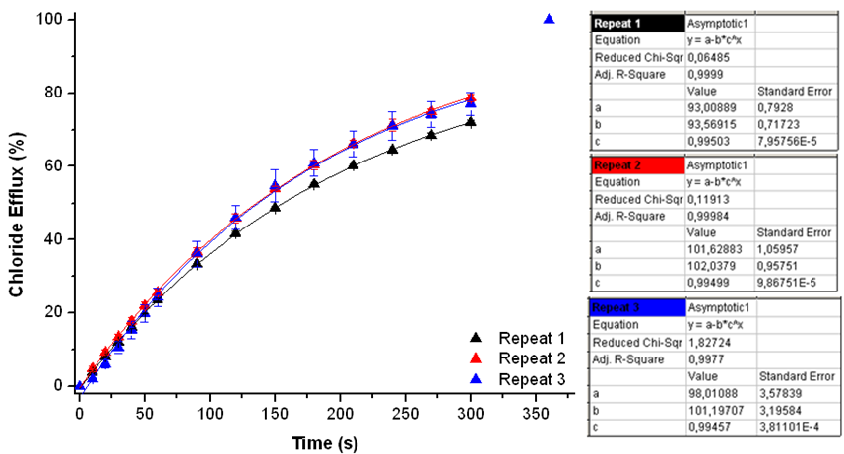Figure S94: Overview of the initial rate of chloride release (k_{ini}) for compound 16. For experimental details, see main text.

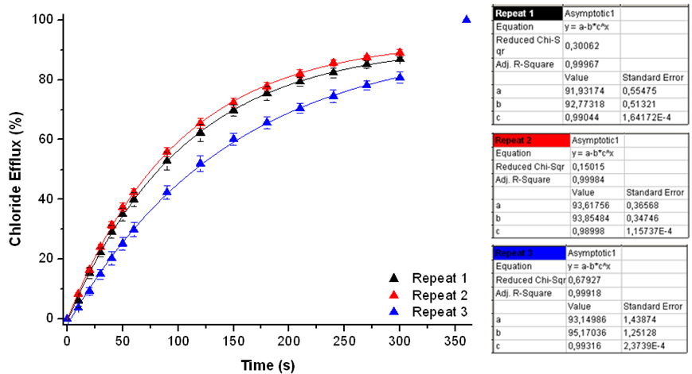Figure S95: Overview of the initial rate of chloride release (k_{ini}) for compound 17. For experimental details, see main text.

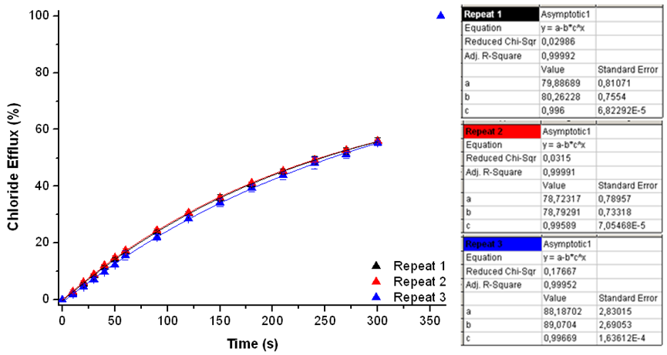Figure S96: Overview of the initial rate of chloride release (k_{ini}) for compound 18. For experimental details, see main text.

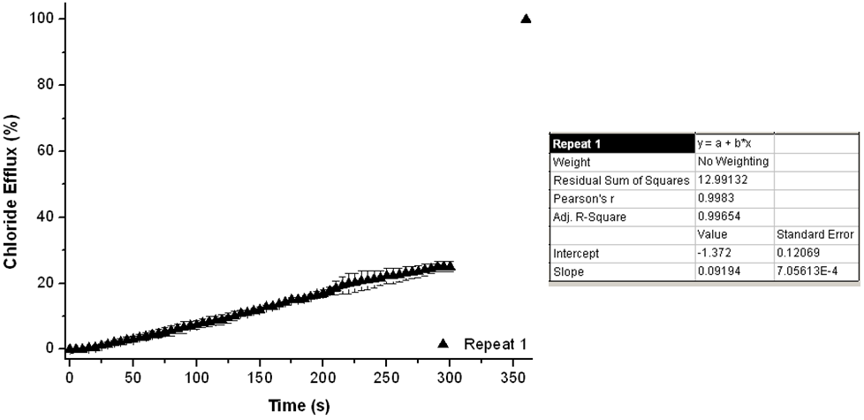Figure S97: Overview of the initial rate of chloride release (k_{ini}) for compound 19. For experimental details, see main text.

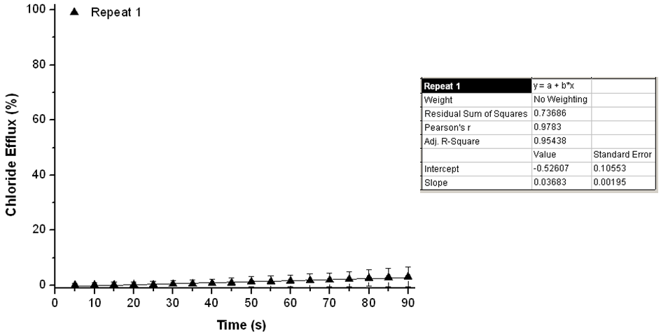Figure S98: Overview of the initial rate of chloride release (k_{ini}) for compound 20. For experimental details, see main text.

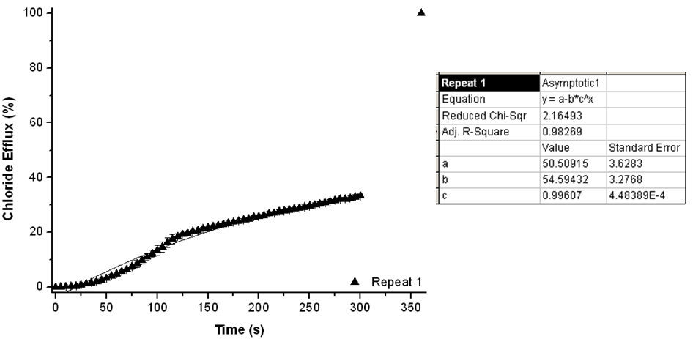Figure S99: Overview of the initial rate of chloride release (k_{ini}) for compound 21. For experimental details, see main text.

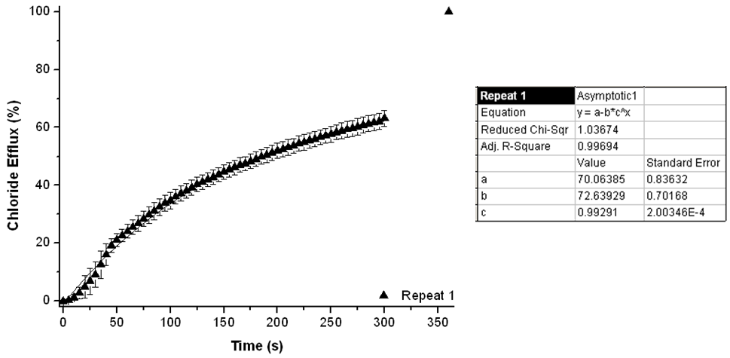Figure S100: Overview of the initial rate of chloride release (k_{ini}) for compound 22. For experimental details, see main text.

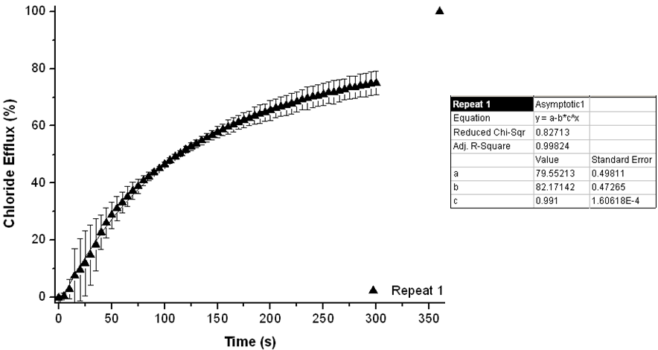Figure S101. Overview of the initial rate of chloride release (k_{ini}) for compound 23. For experimental details, see main text.

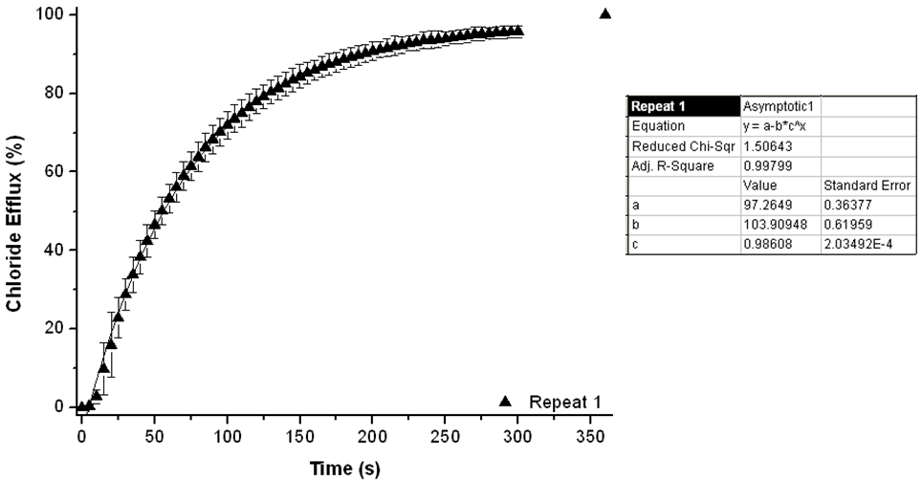
Figure S102. Overview of the initial rate of chloride release (k_{ini}) for compound 24. For experimental details, see main text.

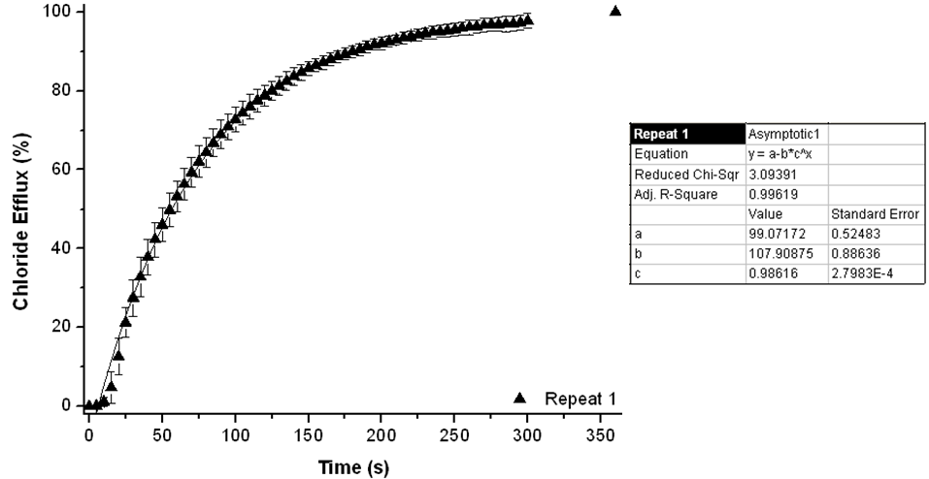Figure S103. Overview of the initial rate of chloride release (k_{ini}) for compound 25. For experimental details, see main text.

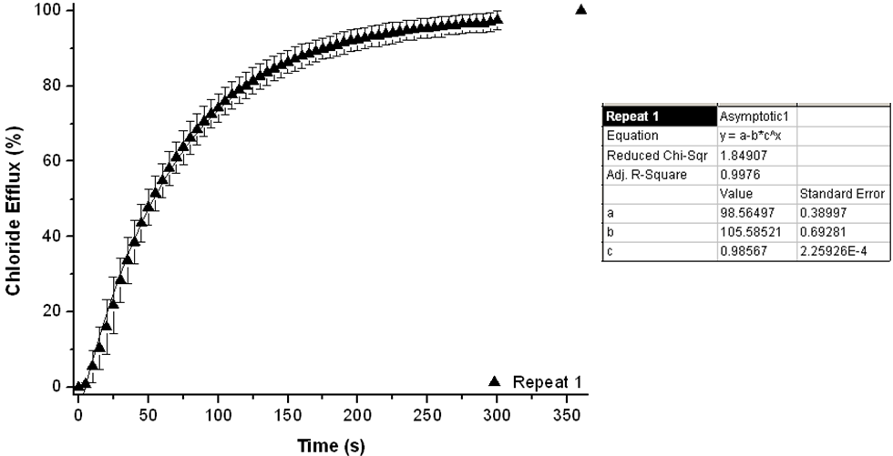Figure S104. Overview of the initial rate of chloride release (k_{ini}) for compound 26. For experimental details, see main text.

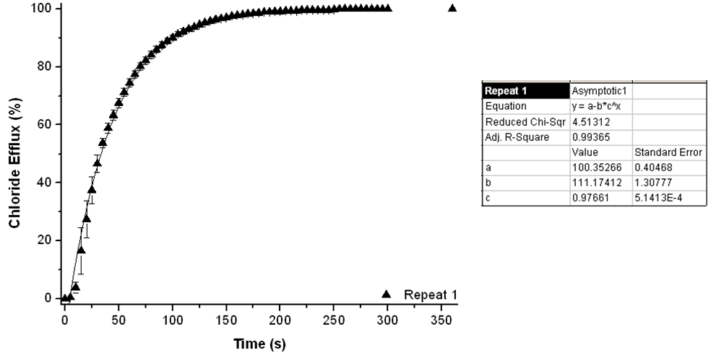
Figure S105. Overview of the initial rate of chloride release (k_{ini}) for compound 27. For experimental details, see main text.

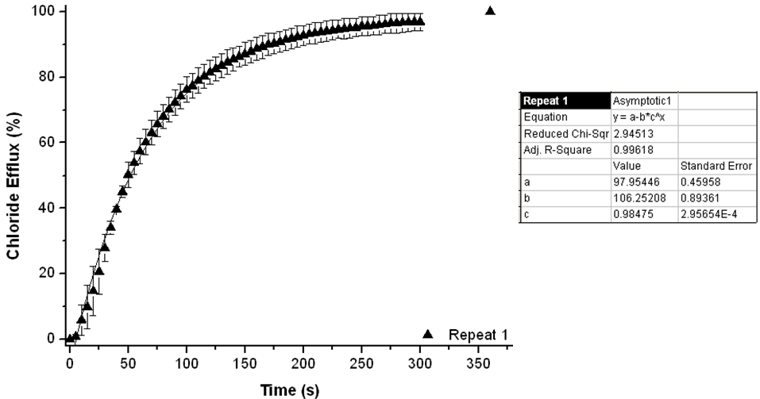Figure S106. Overview of the initial rate of chloride release (k_{ini}) for compound 28. For experimental details, see main text.

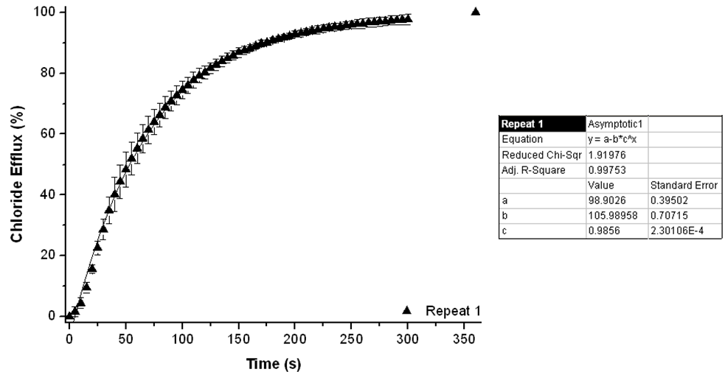Figure S107. Overview of the initial rate of chloride release (k_{ini}) for compound 29. For experimental details, see main text.

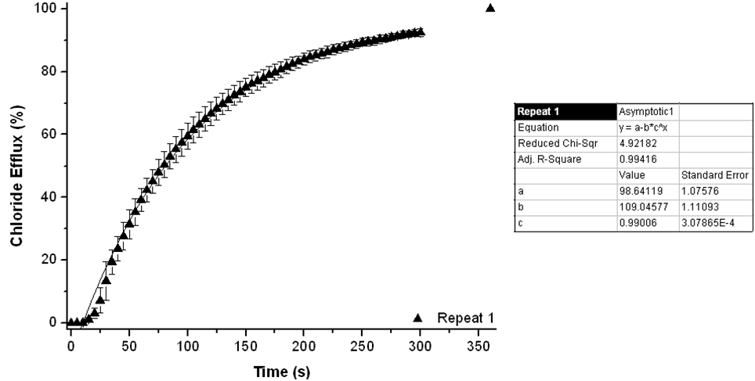Figure S108. Overview of the initial rate of chloride release (k_{ini}) for compound 30. For experimental details, see main text.

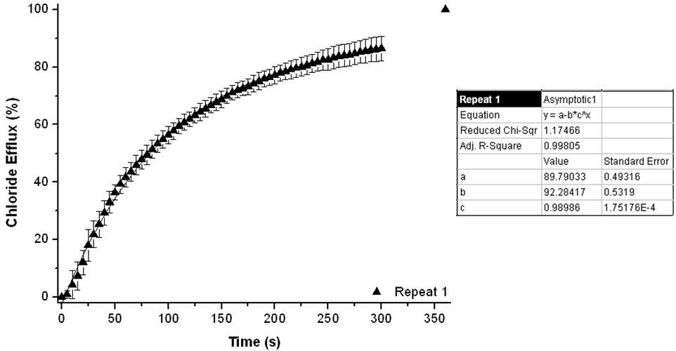Figure S109. Overview of the initial rate of chloride release (k_{ini}) for compound 31. For experimental details, see main text.

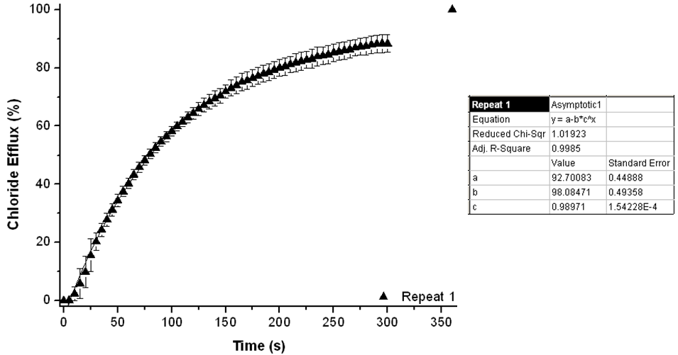Figure S110. Overview of the initial rate of chloride release (k_{ini}) for compound 32. For experimental details, see main text.

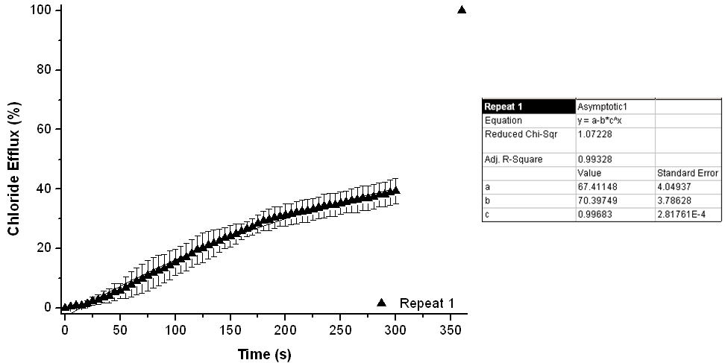Figure S111. Overview of the initial rate of chloride release (k_{ini}) for compound 33. For experimental details, see main text.

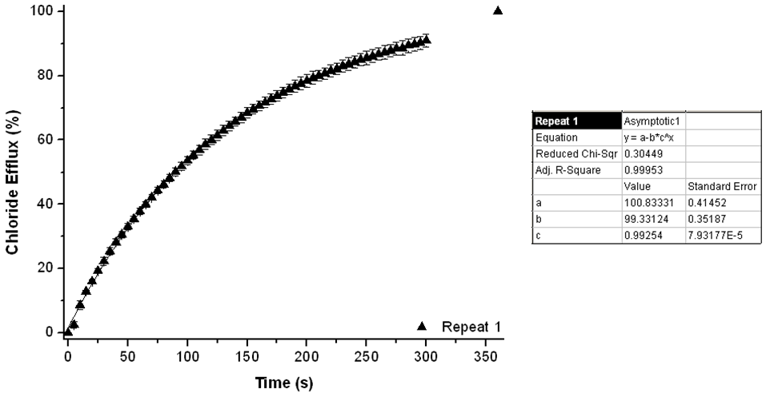Figure S112. Overview of the initial rate of chloride release (k_{ini}) for compound 34. For experimental details, see main text.

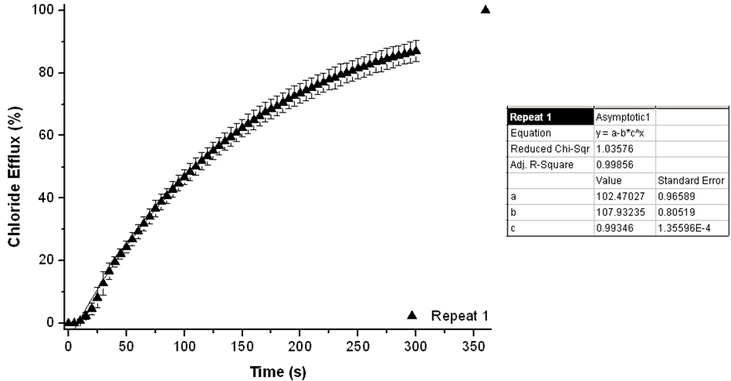Figure S113. Overview of the initial rate of chloride release (k_{ini}) for compound 35. For experimental details, see main text.

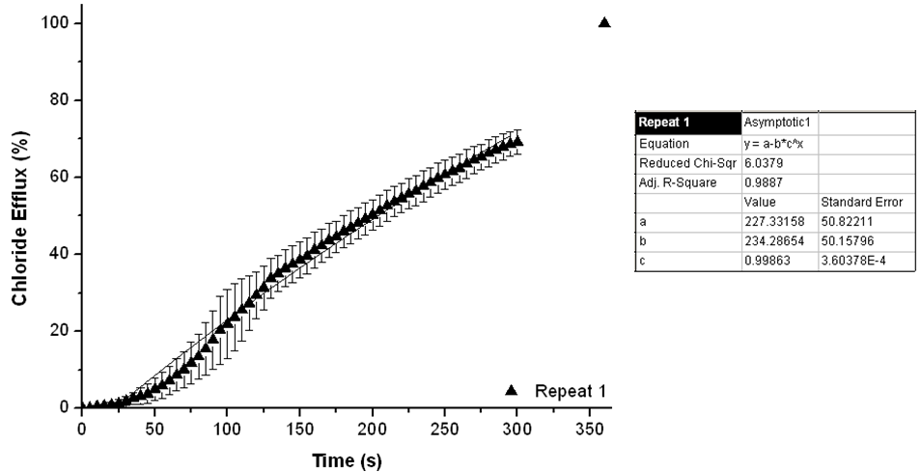Figure S114. Overview of the initial rate of chloride release (k_{ini}) for compound 36. For experimental details, see main text.

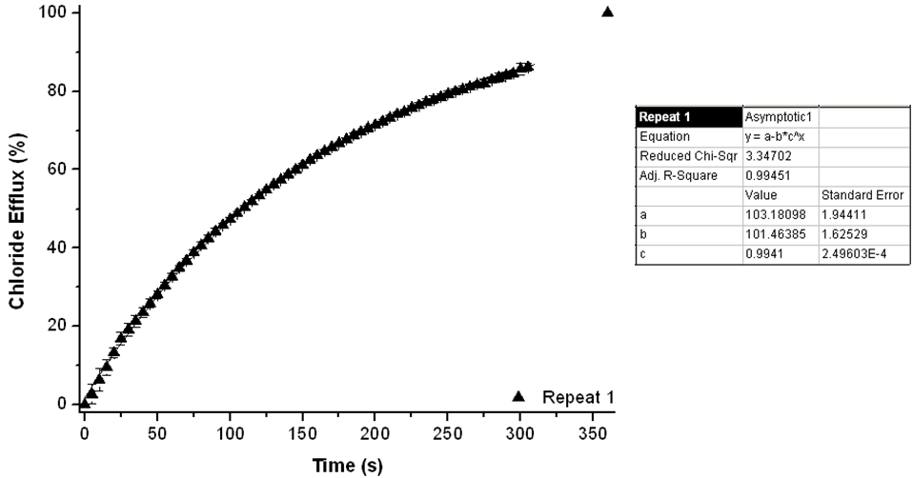Figure S115. Overview of the initial rate of chloride release (k_{ini}) for compound 37. For experimental details, see main text.

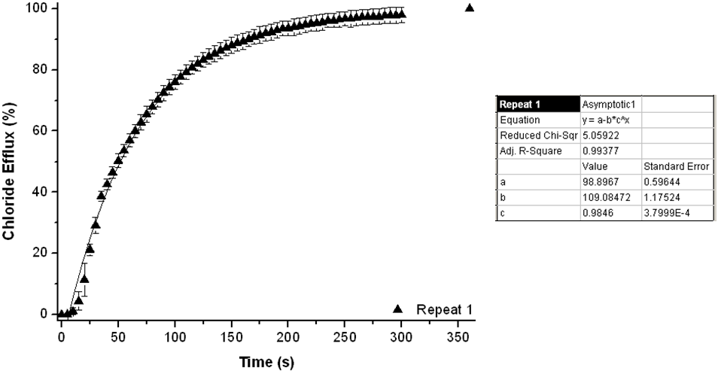Figure S116. Overview of the initial rate of chloride release (k_{ini}) for compound 38. For experimental details, see main text.

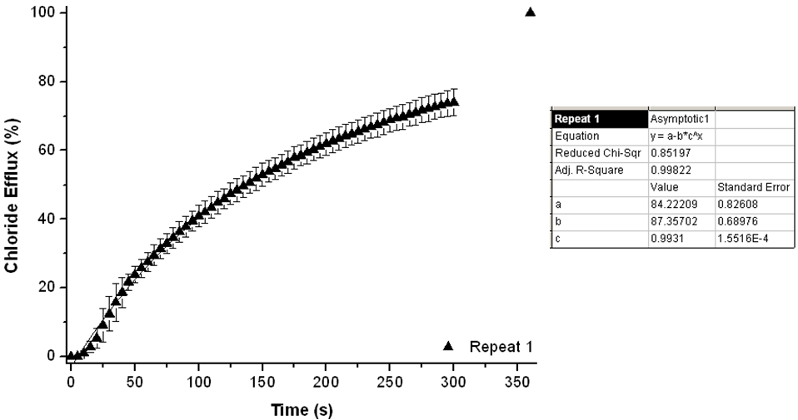
Figure S117. Overview of the initial rate of chloride release (k_{ini}) for compound 39. For experimental details, see main text.

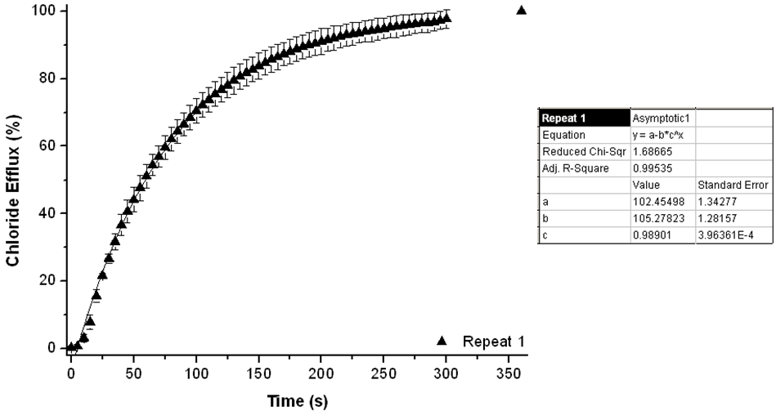
Figure S118. Overview of the initial rate of chloride release (k_{ini}) for compound 40. For experimental details, see main text.

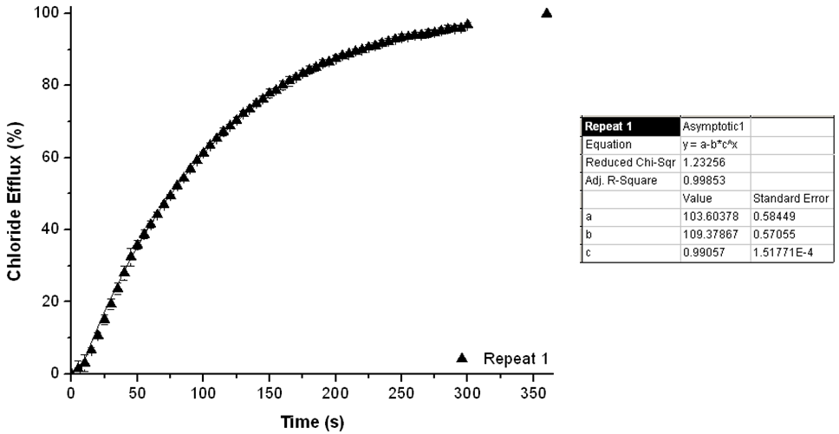
Figure S119. Overview of the initial rate of chloride release (k_{ini}) for compound 41. For experimental details, see main text.

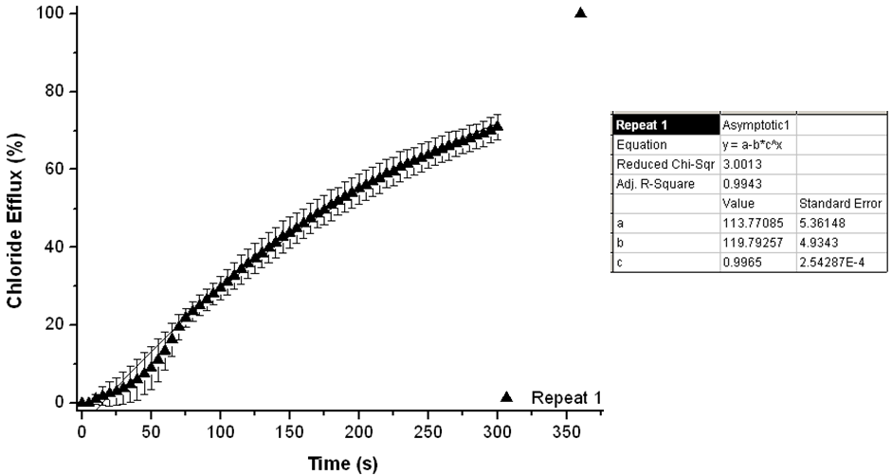
Figure S120. Overview of the initial rate of chloride release (k_{ini}) for compound 42. For experimental details, see main text.

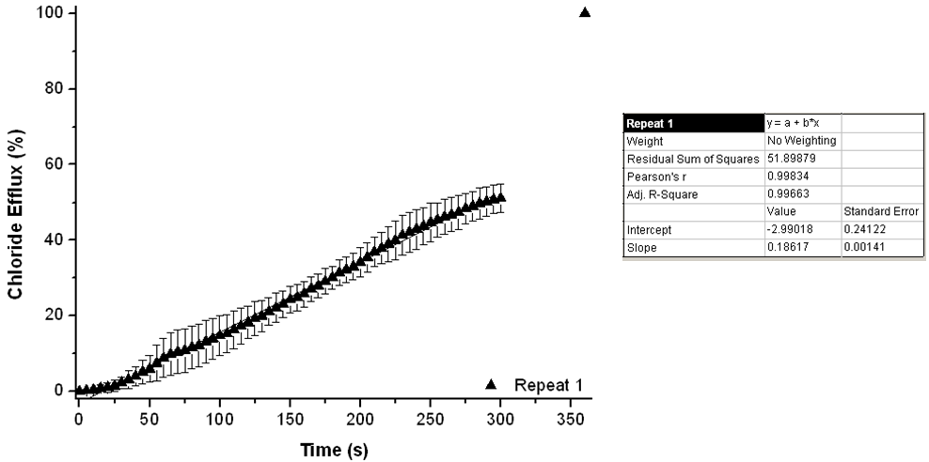
Figure S121. Overview of the initial rate of chloride release (k_{ini}) for compound 43. For experimental details, see main text.

