  - Hill plot analyses. EC₅₀ determination
Chloride/nitrate transport assays were carried out using various concentrations of carriers as described. The chloride efflux (%) at 290 s was plotted as a function of the carrier concentration and the obtained results fitted with the Hill equation using Origin 8.1:

where x is the anion carrier concentration, V_{max} is the maximum chloride efflux (100%), y is the chloride efflux at 290 s (%), n is the Hill coefficient and k is the anion carrier concentration needed to achieve V_{max}/2 (when V_{max} is fixed to 100%, k equals EC₅₀); k and n are the parameters to be fitted. EC₅₀, defined as the anion carrier concentration (molar % carrier to lipid) needed to induce 50% release of the total of the chloride encapsulated in the time scale of our experiments, can be obtained directly from the graphs. Figures S122-S164 show all of the obtained transport data. An overview of the EC₅₀ values can be found in Table S1 in S91.

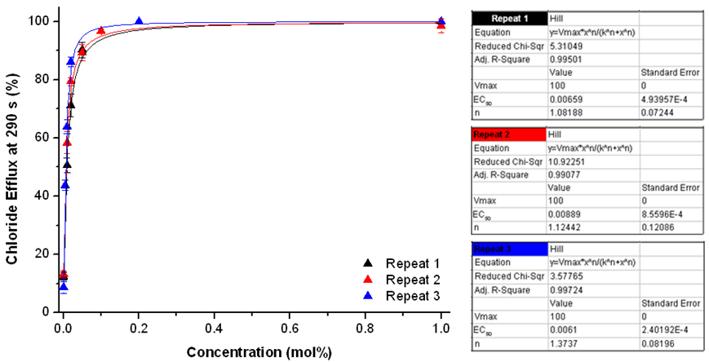
Figure S122. Overview of the Hill plots for compound 1. For experimental details, see main text.

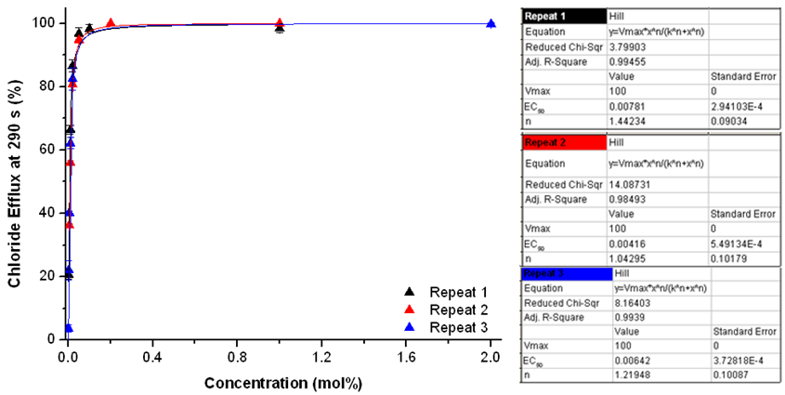
Figure S123. Overview of the Hill plots for compound 2. For experimental details, see main text.

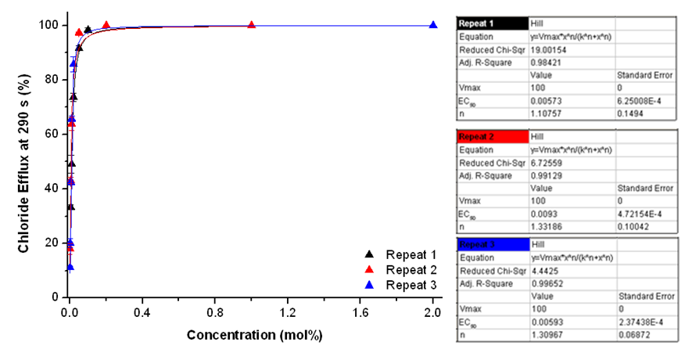
Figure S124. Overview of the Hill plots for compound 3. For experimental details, see main text.

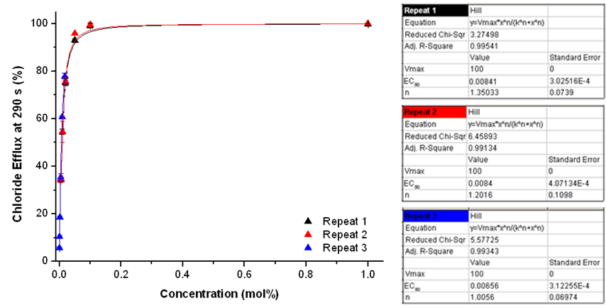
Figure S125. Overview of the Hill plots for compound 4. For experimental details, see main text.

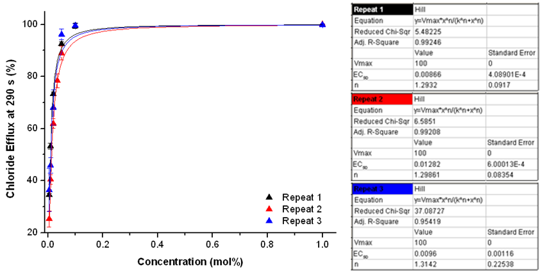
Figure S126. Overview of the Hill plots for compound 5. For experimental details, see main text.

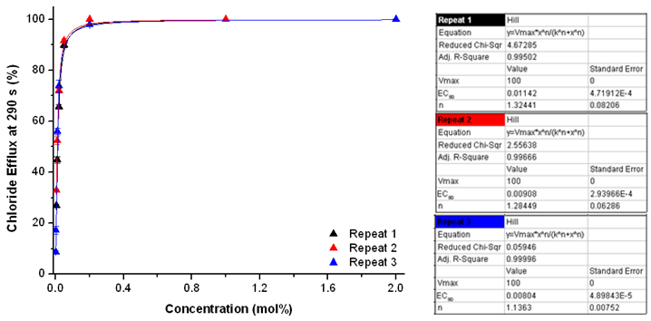
Figure S127. Overview of the Hill plots for compound 6. For experimental details, see main text.

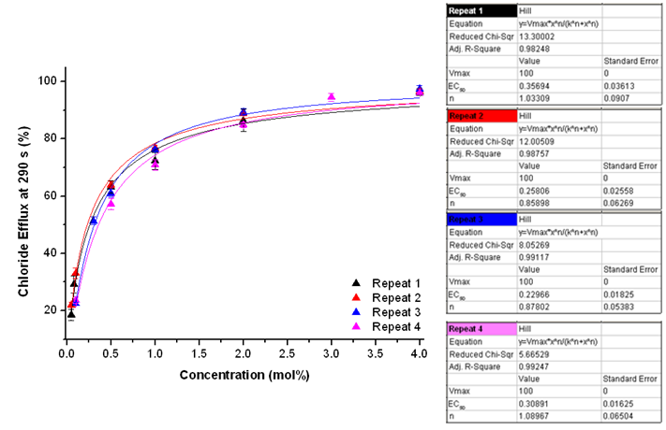
Figure S128. Overview of the Hill plots for compound 7. For experimental details, see main text.

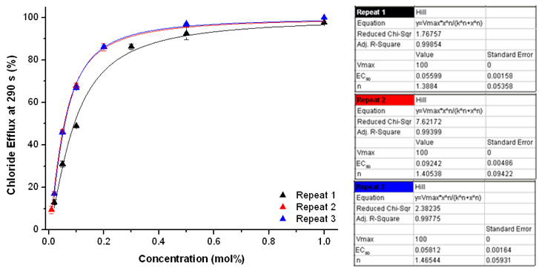
Figure S129. Overview of the Hill plots for compound 8. For experimental details, see main text.

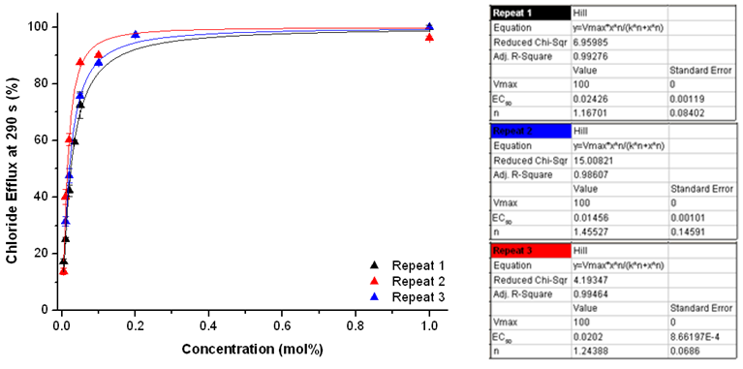
Figure S130. Overview of the Hill plots for compound 9. For experimental details, see main text.

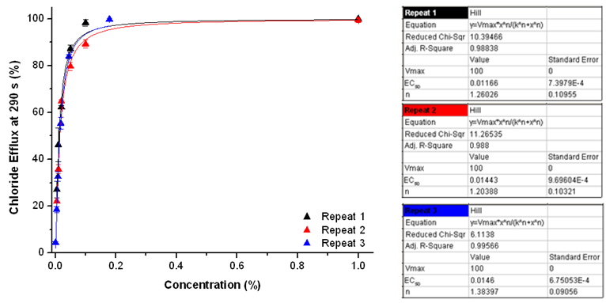
Figure S131. Overview of the Hill plots for compound 10. For experimental details, see main text.

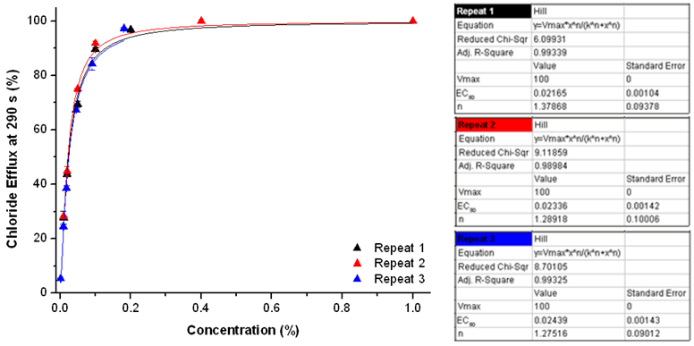
Figure S132. Overview of the Hill plots for compound 11. For experimental details, see main text.

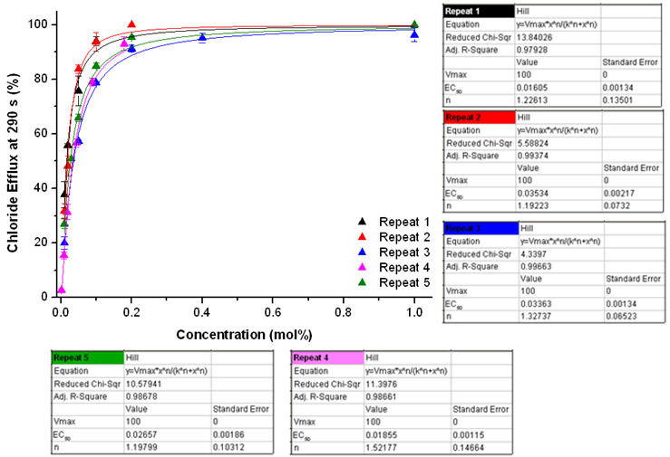
Figure S133. Overview of the Hill plots for compound 12. For experimental details, see main text.

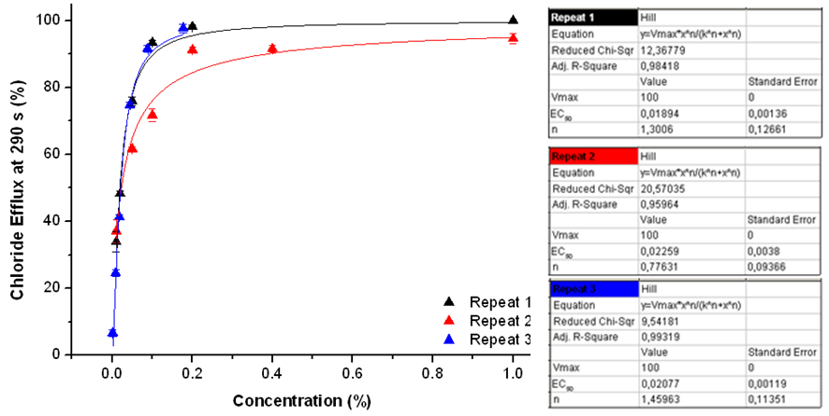
Figure S134. Overview of the Hill plots for compound 13. For experimental details, see main text.

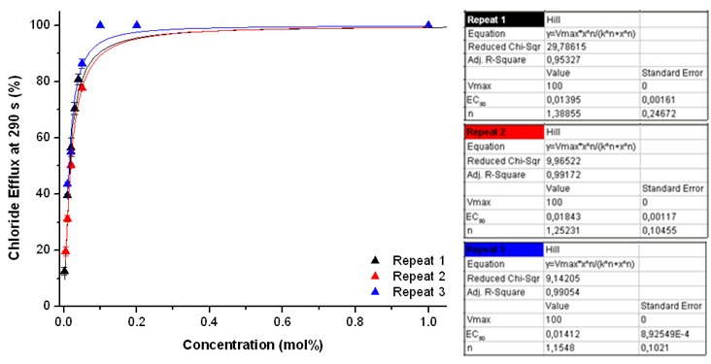
Figure S135. Overview of the Hill plots for compound 14. For experimental details, see main text.

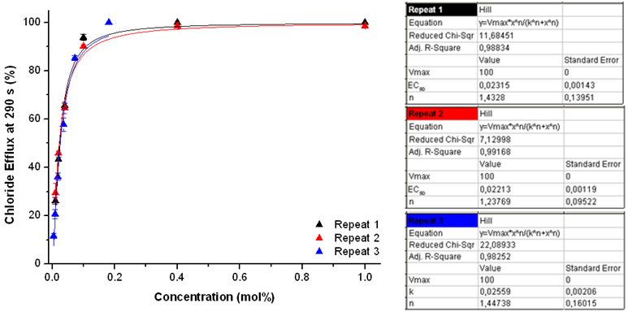
Figure S136. Overview of the Hill plots for compound 15. For experimental details, see main text.

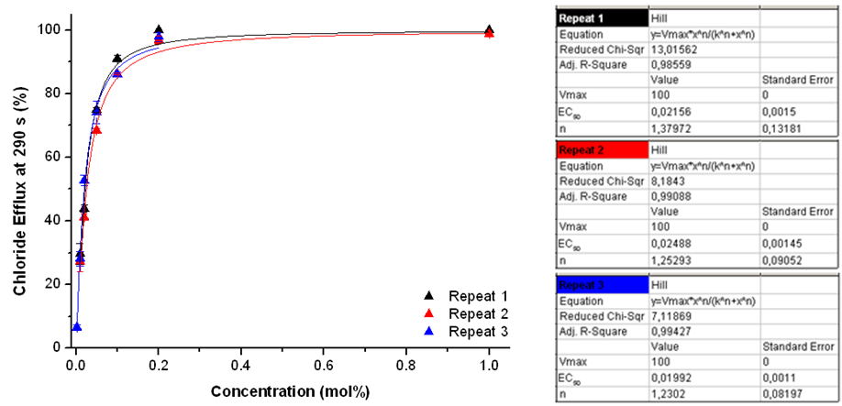
Figure S137. Overview of the Hill plots for compound 16. For experimental details, see main text.

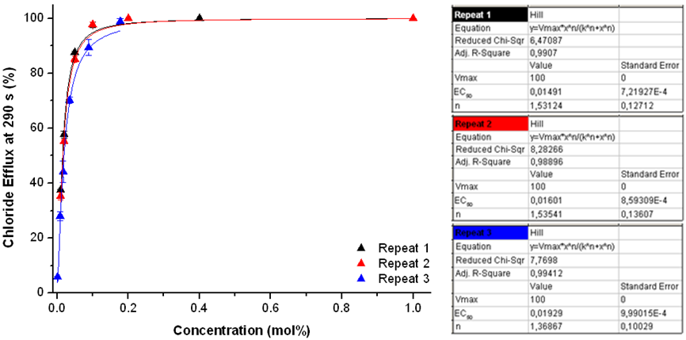
Figure S138. Overview of the Hill plots for compound 17. For experimental details, see main text.

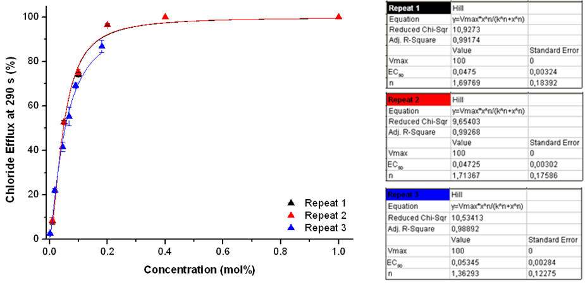
Figure S139. Overview of the Hill plots for compound 18. For experimental details, see main text.

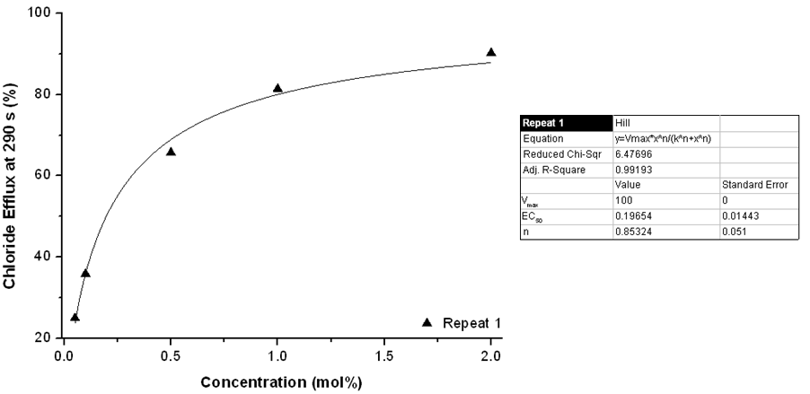
Figure S140. Overview of the Hill plots for compound 19. For experimental details, see main text.

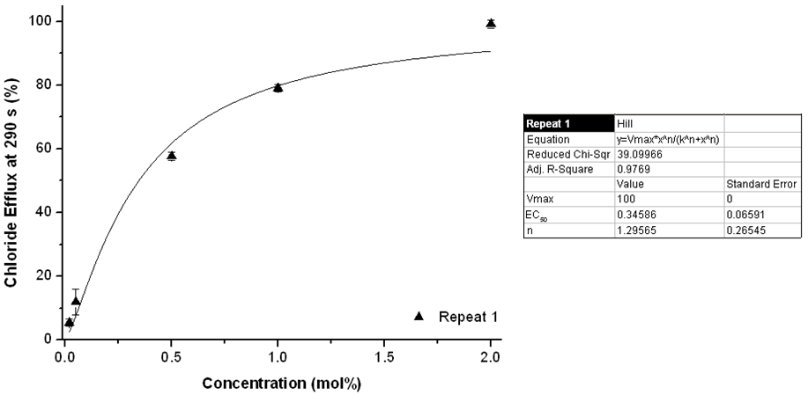
Figure S141. Overview of the Hill plots for compound 20. For experimental details, see main text.

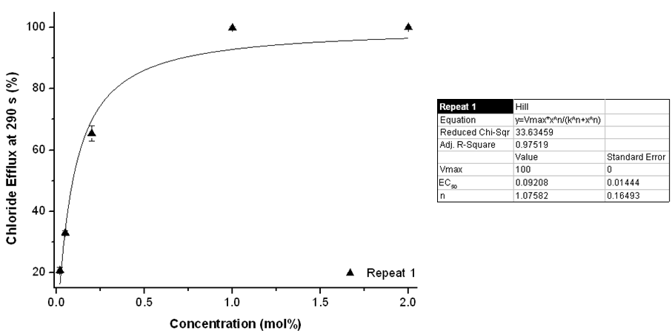
Figure S142. Overview of the Hill plots for compound 21. For experimental details, see main text.

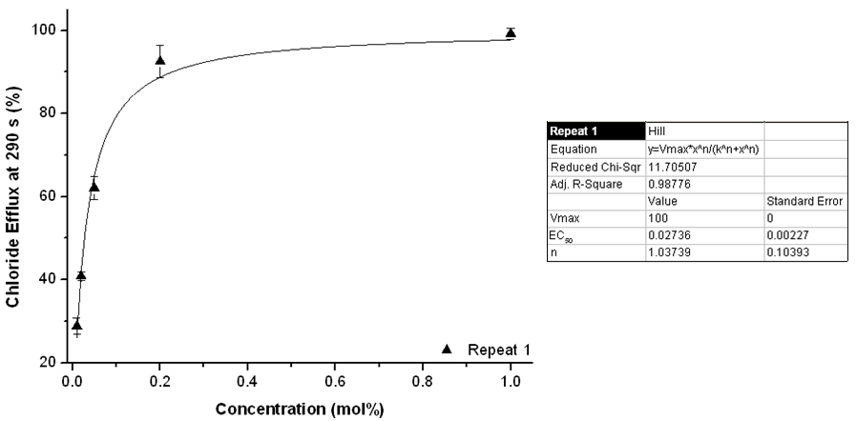
Figure S143. Overview of the Hill plots for compound 22. For experimental details, see main text.

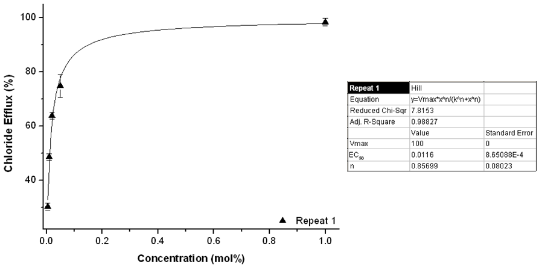
Figure S144. Overview of the Hill plots for compound 23. For experimental details, see main text.

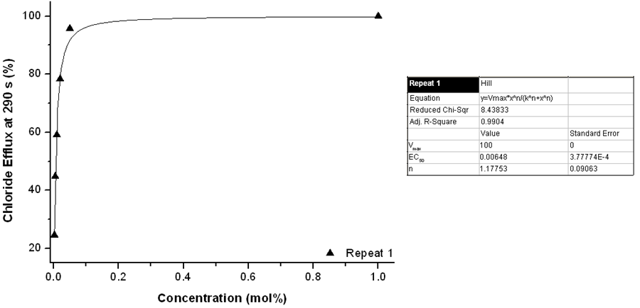
Figure S145. Overview of the Hill plots for compound 24. For experimental details, see main text.

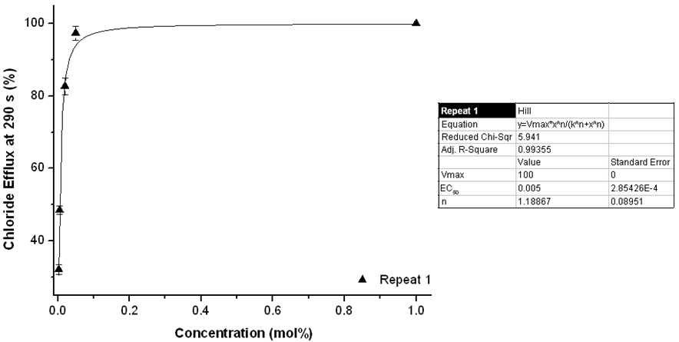
Figure S146. Overview of the Hill plots for compound 25. For experimental details, see main text.

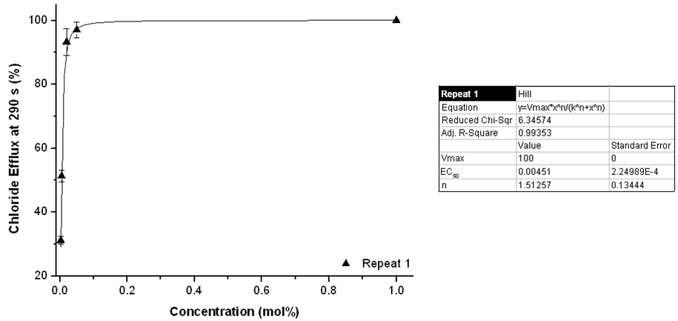
Figure S147. Overview of the Hill plots for compound 26. For experimental details, see main text.

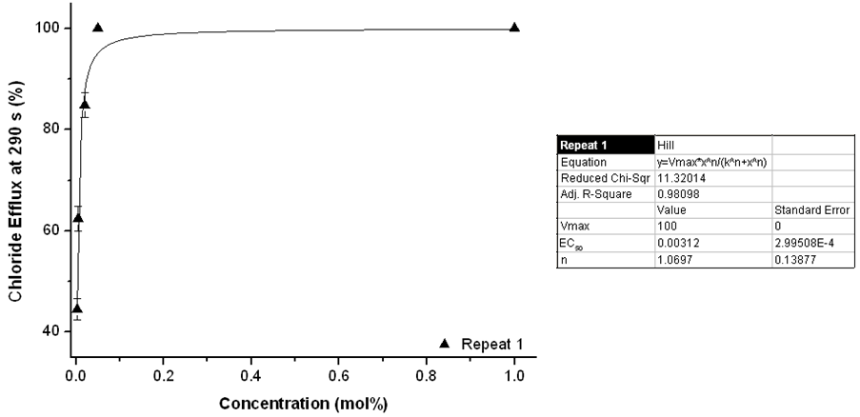
Figure S148. Overview of the Hill plots for compound 27. For experimental details, see main text.

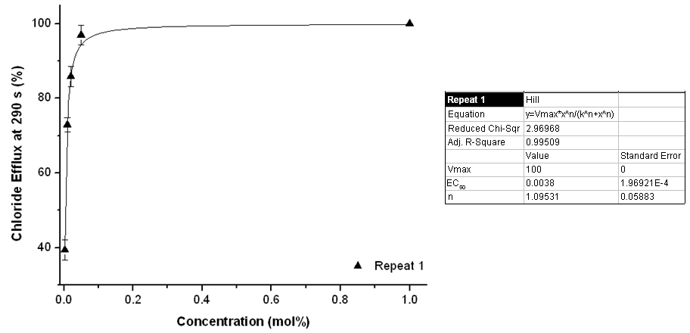
Figure S149. Overview of the Hill plots for compound 28. For experimental details, see main text.

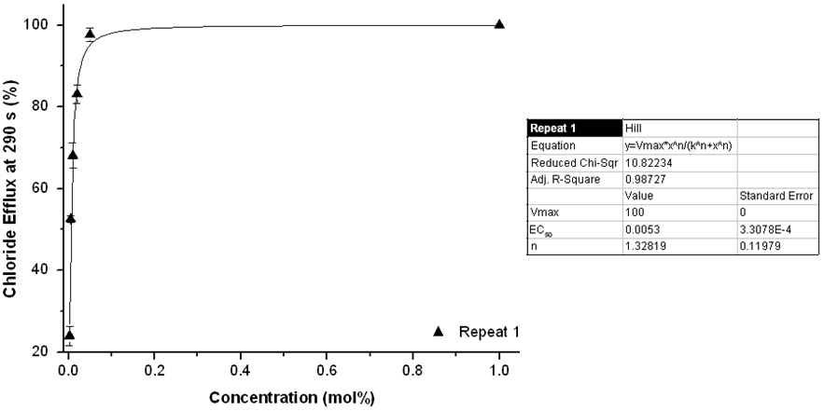
Figure S150. Overview of the Hill plots for compound 29. For experimental details, see main text.

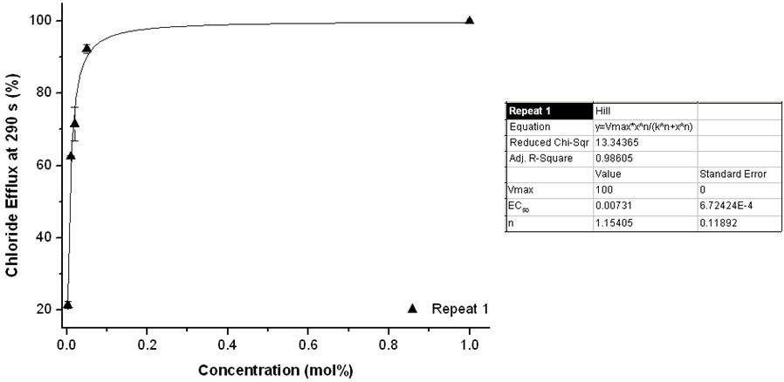
Figure S151. Overview of the Hill plots for compound 30. For experimental details, see main text.

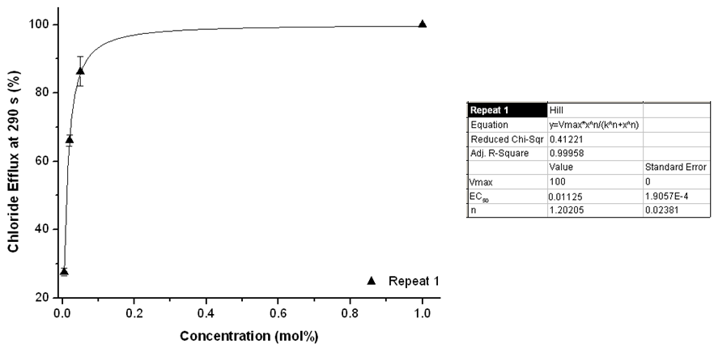
Figure S152. Overview of the Hill plots for compound 31. For experimental details, see main text.

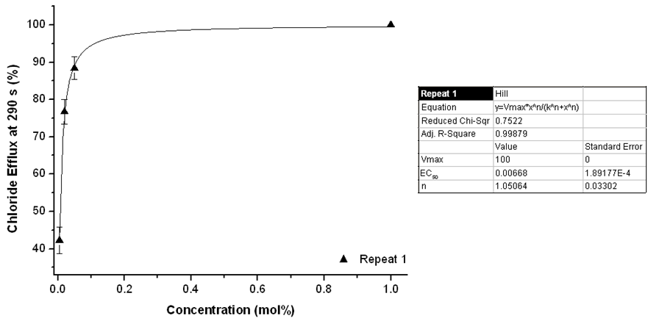
Figure S153. Overview of the Hill plots for compound 32. For experimental details, see main text.

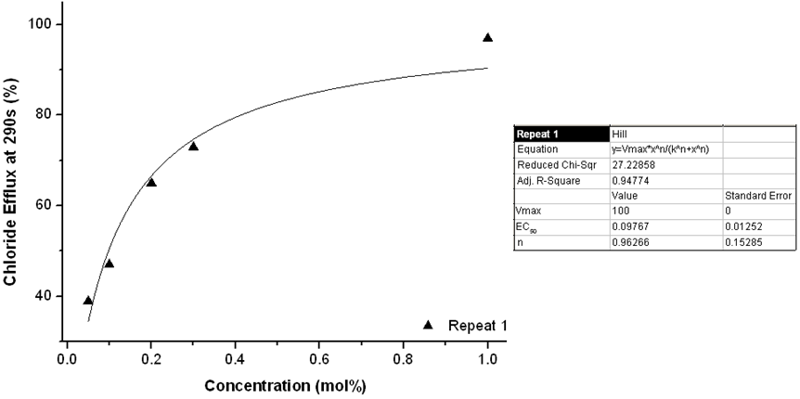
Figure S154. Overview of the Hill plots for compound 33. For experimental details, see main text.

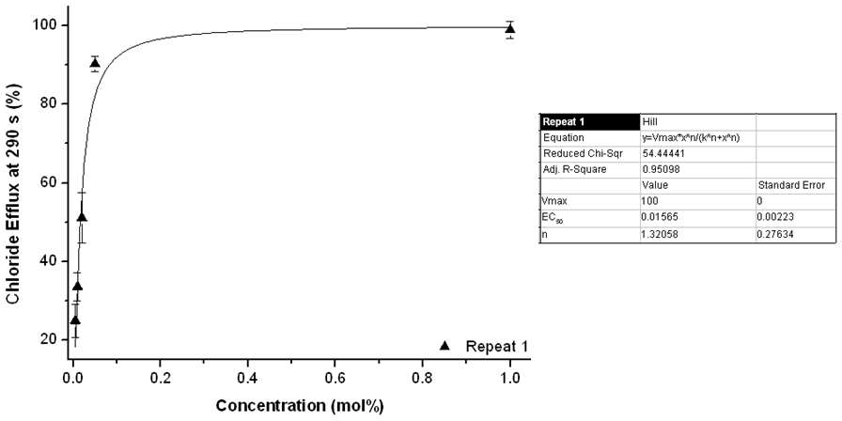
Figure S155. Overview of the Hill plots for compound 34. For experimental details, see main text.

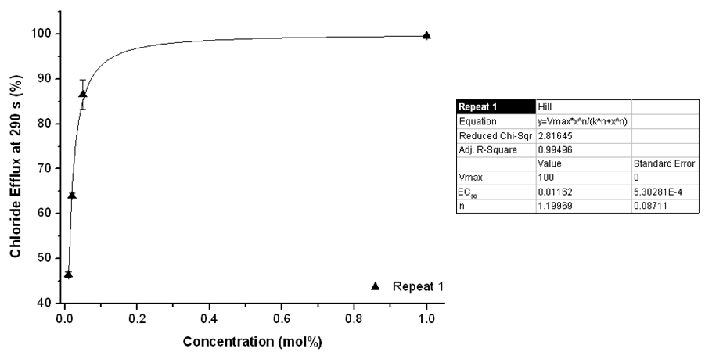
Figure S156. Overview of the Hill plots for compound 35. For experimental details, see main text.

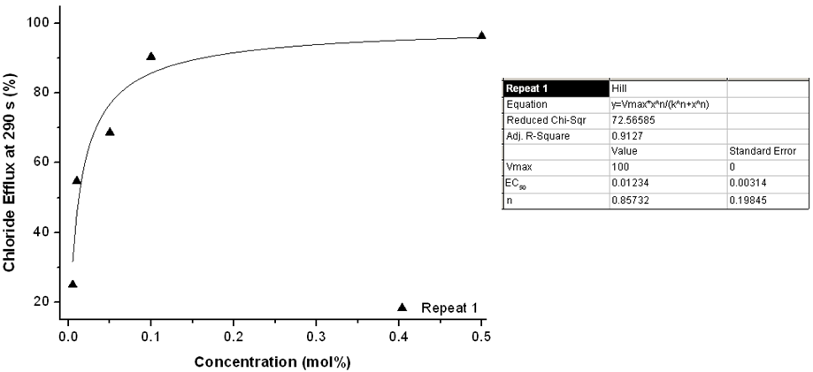
Figure S157. Overview of the Hill plots for compound 36. For experimental details, see main text.

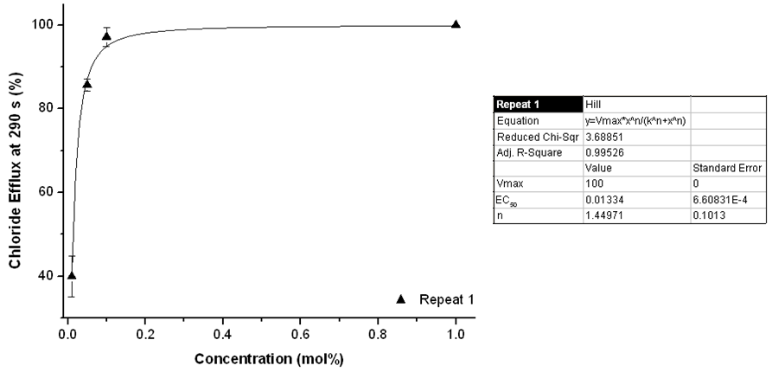
Figure S158. Overview of the Hill plots for compound 37. For experimental details, see main text.

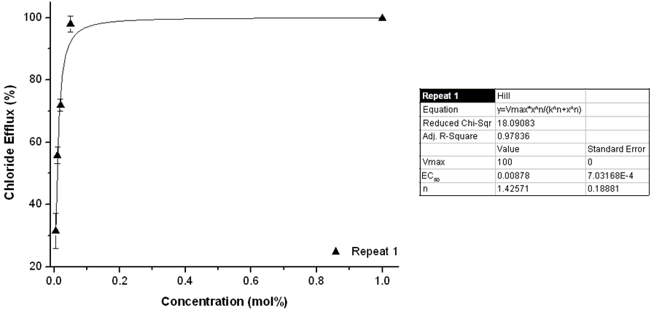
Figure S159. Overview of the Hill plots for compound 38. For experimental details, see main text.

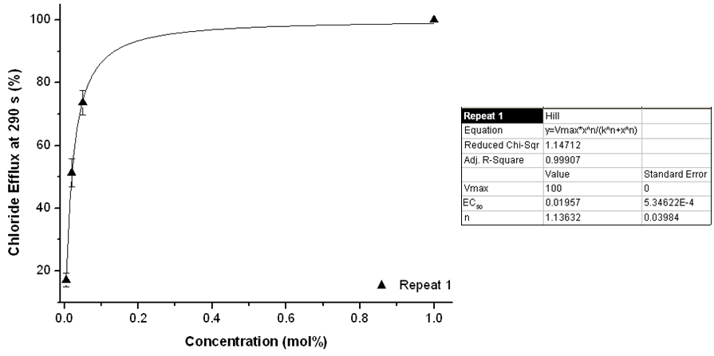
Figure S160. Overview of the Hill plots for compound 39. For experimental details, see main text.

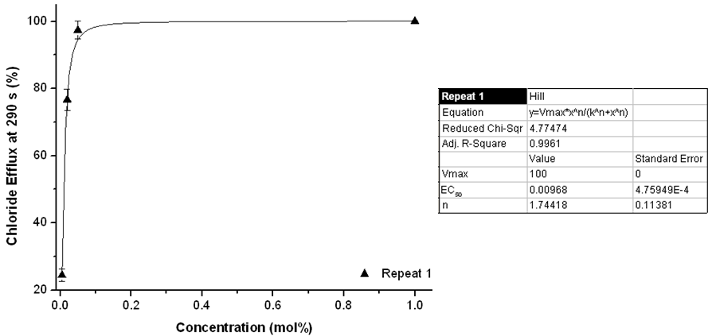
Figure S161. Overview of the Hill plots for compound 40. For experimental details, see main text.

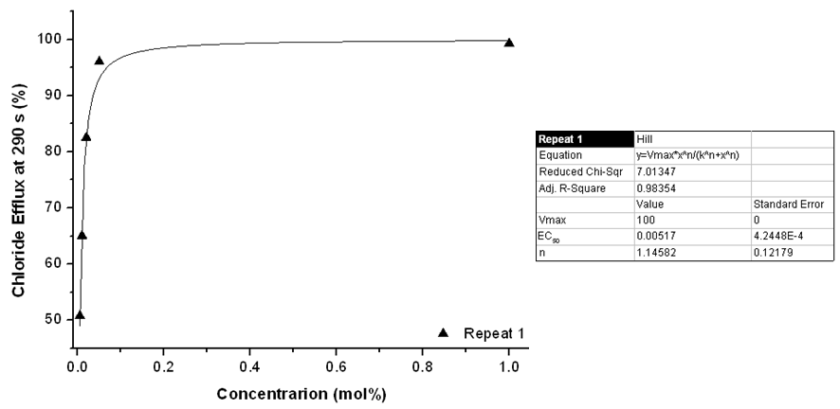
Figure S162. Overview of the Hill plots for compound 41. For experimental details, see main text.

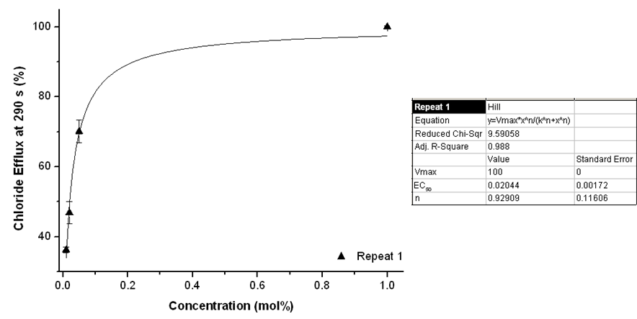
Figure S163. Overview of the Hill plots for compound 42. For experimental details, see main text.

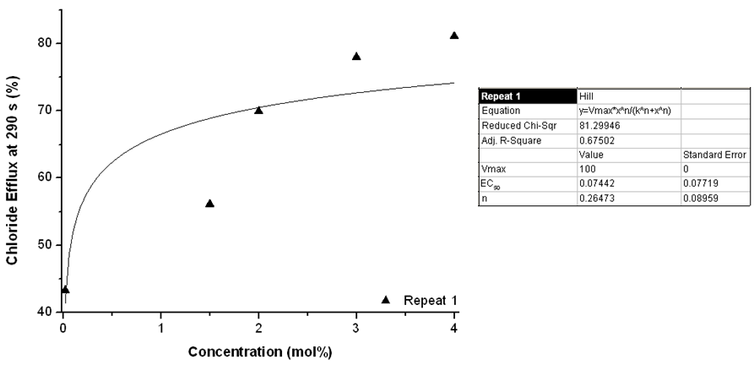
Figure S164. Overview of the Hill plots for compound 43. For experimental details, see main text.

  - K_{ini} EC₅₀ correlation for EC₅₀ Prediction

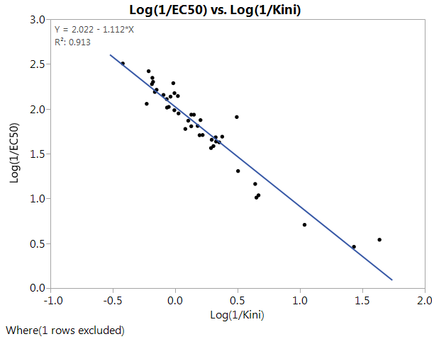

Figure S165 –Correlation Plot for Log(1/k_{ini}) and Log(1/EC₅₀) excluding compound 43.
Used in the prediction of EC₅₀ for compound 43

