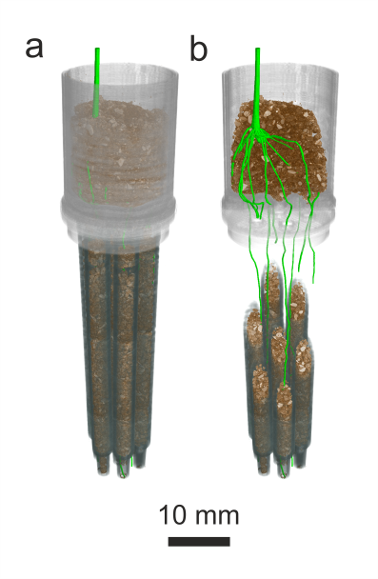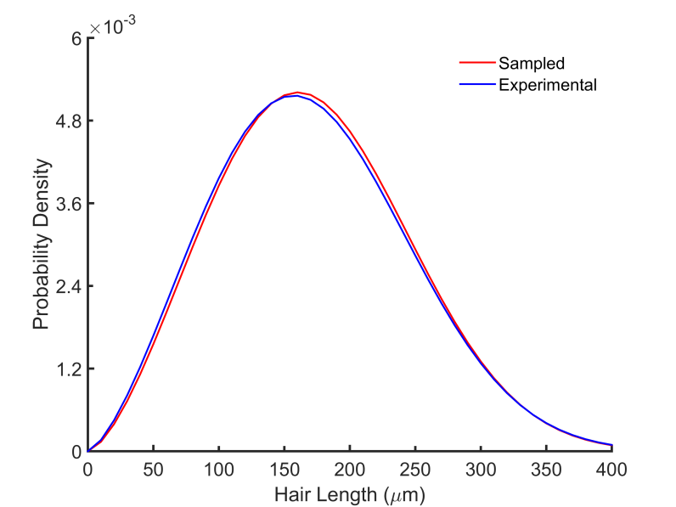

Supplementary Figure 1: Schematic of the assay used for imaging. a) The seed cup guides roots into an array of 7 soil-filled syringe barrels. B) In cutaway view, it is seen that individual barrels contain roots. The seed cup is removed, excising the roots, and barrels are then individually imaged using SRXCT.