Real-time Arm Movement Recognition using FPGA

Dwaipayan Biswas, Gerry Juans Ajiwibawa,
Koushik Maharatna, Andy Cranny
Faculty of Physical Sciences and Engineering
University of Southampton
Highfield, Southampton, UK
E: {db9g10, gja1g13, km3, awc}@ecs.soton.ac.uk
Josy Achner, Jasmin Klemke, Michael Jöbges
Brandenburg Klinik
Bernau, Berlin, Germany
E: {josy.achner, ergo_n1, joebges}@brandenburgklinik.de

Abstract— In this paper we present a FPGA-based system to detect three elementary arm movements in real-time (reach and retrieve, lift cup to mouth, rotation of the arm) using data from a wrist-worn accelerometer. Recognition is carried out by accurately mapping transitions of predefined, standard orientations of an accelerometer to the corresponding arm movements. The algorithm is coded in HDL and synthesized on the Altera DE2-115 FPGA board. For real-time operation, interfacing between the streaming sensor unit, host PC and the FPGA was achieved through a combination of Bluetooth, RS232 and an application software developed in C# using the .NET framework to facilitate serial port controls. The synthesized design used 1804 logic elements and recognised the performed arm movement in 41.2 µs, @50 MHz clock on the FPGA. Our experimental results show that the system can recognise all three arm movements with accuracies ranging 85%-96% for healthy subjects and 63%-75% for stroke survivors involved in 'making-a-cup-of-tea’, typical of an activity of daily living (ADL).
Keywords—Accelerometer, activity recognition, remote health monitoring, wireless sensor network (WSN), synthesis, FPGA.

Introduction
Human activity recognition in natural settings has been used in remote health monitoring systems to assess patient mobility. The advent of mobile and ubiquitous computing facilities using low-cost inertial sensors [1], radio-frequency identification (RFID) [2] and fusion of vision-based and inertial sensor based approaches [3] have helped to recognize activities in real-time for continuous subject monitoring. Sensor based activity recognition generally involves complex data processing using feature extraction/selection and a range of learning algorithms such as Hidden Markov Models (HMMs) [4], Support Vector Machines (SVM) [5], Decision Trees (DT) [6] and Artificial Neural network (ANN) [6]. Research and development into Wireless Sensor Networks (WSN) have shown that for real-time continuous operations using wearable systems, the data analysis primarily needs to be carried out at the sensor node to yield energy efficient solutions as compared to conventional remote monitoring approaches based on continuous transmission of data to a remote station. For battery powered and resource constrained WSN nodes, this efficiency can only be achieved by selecting low-complexity data processing algorithms [7]. Therefore, the above mentioned recognition techniques may not always be applicable for real-time continuous operations using WSN nodes. This therefore motivated us to implement the low-complexity movement recognition methodology developed in [8] on an FPGA with a view towards real-time detection of arm movements as a proof-of-concept methodology.
The detection and enumeration of particular arm movements (e.g. clinically prescribed exercises) during daily activities can, over time, provide a measure of rehabilitation progress in pathologies associated with neurodegenerative diseases such as stroke or cerebral palsy. Continuous monitoring of activities in an unconstrained scenario involves data segmentation and activity recognition. Although interrelated, individually they are two separate research problems owing to the possible qualitative non-uniqueness of an activity pattern exhibited by an individual subject. Here, we concentrate only on the activity recognition part.
This work was supported by the European Union under the Seventh Framework Programme, grant agreement #288692, StrokeBack.
The algorithm presented in [8] works by mapping six standard orientations of a tri-axial accelerometer to the corresponding arm movements investigated. The methodology works by predicting the most likely orientation of the sensor module at any particular time by assessing which of the three accelerometer axes is the most active at that time. The arm movements are inferred by detecting transitions between the standard sensor orientations. In this paper, we present a system that processes data from a wrist-worn tri-axial accelerometer on a FPGA to detect arm movements in real-time. The algorithm was coded in System Verilog and implemented on Altera DE2-115 FPGA board. The DE2 board does not have a Bluetooth receiver and hence, interfacing between the streaming sensor module and the FPGA was done through a combination of Bluetooth, RS232 and application software using the .NET framework to facilitate serial port controls. The synthesized RTL used approximately 1804 logic elements and took 41.2 µs@50 MHz clock to detect a performed movement. In this investigation, the implemented design was tested on experimental data collected from four healthy and four stroke survivors involved in an archetypal activity of daily living (ADL), ‘making-a-cup-of-tea’. Our results show that the implemented design can successfully recognise the three movements across all the subjects.
The remainder of this paper is organized as follows. Section II presents the experimental protocol whilst Section III presents a system overview. The architectural design is presented in Section IV and its evaluation is presented in Section V. Finally a discussion is presented in Section VI.

Experimental Protocol
In this investigation, experiments were performed with four healthy subjects at the University of Southampton (all right arm dominant) and with four stroke survivors at the Brandenburg Klinik (both left and right impaired arm). We designed an activity-list (cf. Table I) that emulated the process of ‘making-a-cup-of-tea’, a common activity performed in daily life, involving repeated occurrences of three elementary types of arm movements: (1) Action A – reach and retrieve object, (2) Action B – lift cup to mouth and (3) Action C – perform pouring/(un)locking action. The activity-list comprises 20 individual activities including 10 occurrences of Action A, and 5 each of Action B and Action C. The healthy subjects performed the activity-list four times with a 10 minute rest period between trials whereas the stroke survivors performed two trials since they tend to tire quicker. The experiment was performed in an unconstrained environment to ensure a wider range of variability in the data.
- Use Case Activity-List – ‘Making-A-Cup-Of-Tea’.
Activity |  | Action
1. | Fetch cup from desk | A
2. | Place cup on kitchen surface | A
3. | Fetch kettle | A
4. | Pour out extra water from kettle | C
5. | Put kettle onto charging point | A
6. | Reach out for the power switch on the wall | A
7. | Drink a glass of water while waiting for kettle to boil | B
8. | Reach out to switch off the kettle | A
9. | Pour hot water from the kettle in to cup | C
10. | Fetch milk from the shelf | A
11. | Pour milk into cup | C
12. | Put the bottle of milk back on shelf | A
13. | Fetch cup from kitchen surface | A
14. | Have a sip and taste the drink | B
15. | Have another sip while walking back to desk | B
16. | Unlock drawer | C
17. | Retrieve biscuits from drawer | A
18. | Eat a biscuit | B
19. | Lock drawer | C
20. | Have a drink | B
A Shimmer 9DoF wireless kinematic sensor module housing tri-axial accelerometers with ± 1.5 g range, was used as the sensing platform [9]. We chose not to use the gyroscope or magnetometers in view of using a minimal number of sensors to minimise power requirements and to reduce the amount of data processing. In addition, magnetometers were not used since they can be affected by the presence of ferromagnetic materials [8]. The sensor was placed on the wrist of the dominant arm (healthy subjects) or the impaired arm (stroke survivors), with the XY plane in contact with the dorsal side of the forearm and the Z-axis pointing away from it. Senor data were collected at a rate of 51.2 Hz, transmitted along with a timestamp to a host computer using Bluetooth. The accelerometers were calibrated using the omnipresent gravitational acceleration (g) as a reference standard, prior to any measurements, details of which can be found in [8].

System Overview
An overview of the hardware setup is shown in Fig. 1. For real-time implementation, the accelerometer transmits data through Bluetooth to a host PC, where the raw sensor data is converted to physical values and transmitted through a RS232 to the FPGA board. The recognition algorithm was coded using System Verilog as the HDL and synthesized on the FPGA board, programmed through the USB blaster in Active Serial (AS) mode. The RTL implementation of the RS232 receiver and the recognition algorithm were integrated to complete the hardware functionality.
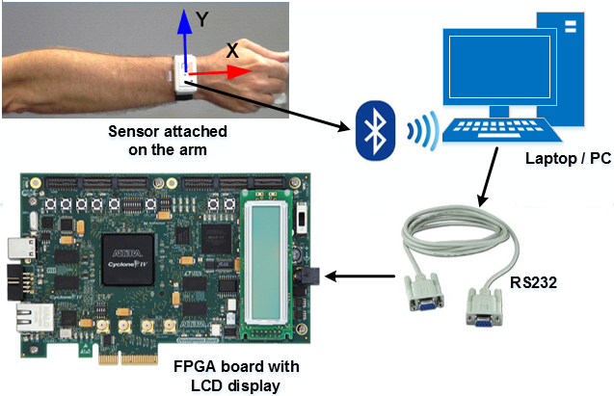
Fig. 1. Setup for real-time recognition of arm movements using the sensor orientation based algorithm.
The FPGA operates at a much higher frequency (50 MHz) compared to the sensor which streams data at 51.2 Hz. The application ShimmerConnect was used for the Bluetooth communication between the sensor and the host PC [9]. Using the .NET 4.5 framework, an application software in C# was developed for the serial port control [10]. For transmitting the data from the PC to the FPGA, the baud rate was set to 4800 bits per second, with each set of data being 64-bits wide (16-bits each for X, Y, Z axes and a header code). The header code was used to indicate the start of transmission so that the receiver can determine the correct axes values. On the FPGA, a baud tick generator produces a pulse (based on a counter logic) necessary for interface synchronization. The LCD screen on the board is used to display physical acceleration data whereas the recognized arm movements are displayed on a 7-segment display in real-time.

Algorithm To Architecture Mapping
The architecture presented in Fig. 2, is divided into three modules (described later) and has three16-bit inputs for the tri-axial acceleration data and one 4-bit output for the detected arm movement.
Fig. 2. Architectural overview of the sensor based orientation algorithm.
Orientation Detection (OD) – Each performed movement generates a data segment comprised of individual samples from each accelerometer axis (X, Y and Z). We consider a segment length of 512 samples, implying duration of 10 seconds, for each movement which is deemed sufficient time, even in view of the stroke survivors exhibiting varying levels of impairment. The absolute maximum acceleration value, its polarity and the corresponding axis for each data segment is computed using a maximum detector as illustrated in Fig. 3.
Fig. 3. Architecture for computing the maximum from incoming data samples.
The maximum acceleration values on respective axes are further compared with a predefined threshold (cf. Table II) using a comparator module and a multiplexing logic is used accordingly to denote the corresponding orientation state for each sample in the segment. A 3-bit orientation state for each incoming data samples is computed on the fly, thereby negating the use of any memory. On successful computation, a 1-bit signal, readyOD, is set high which acts as an input flag to the next module, Sequence Detection. The six standard orientations of the sensor module in the horizontal plane are illustrated in Fig. 4 and are referred to as Positions 1-6.
- Computing Logic For Orientation States [8].
Orientation | Processing
1 | maximum acceleration occurs on the Y-axis, is negative, and lies within the range -g ± 0.5 g
2 | maximum acceleration occurs on the Z-axis, is positive, and lies within the range g ± 0.5 g
3 | maximum acceleration occurs on the Y-axis, is positive, and lies within the range g ± 0.5 g
4 | maximum acceleration occurs on the Z-axis, is negative, and lies within the range -g ± 0.5 g
5/6 | maximum acceleration occurs on the X-axis, is positive, and lies within the range g ± 0.5 g, Orientation 5 if the sensor module is worn on the left arm or Orientation 6 if worn on the right
0 | indicating an unknown position
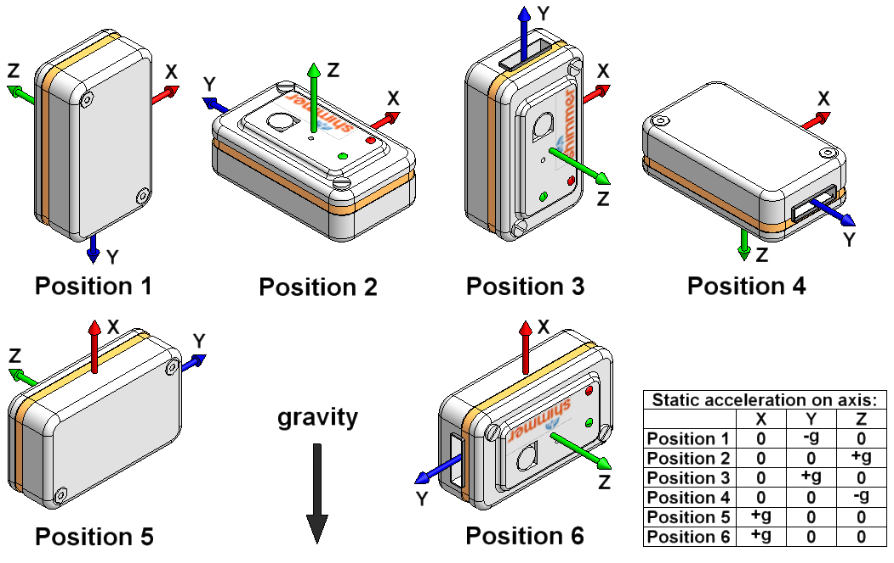
Fig. 4. Predefined orientations of the sensor module with respect to the direction of gravity, showing positive directions of accelerometer axes [8].
The positions shown cater for all orientations of the sensor module expected when performing the target actions, and with forearm movement constrained to the horizontal plane [8].
Sequence Detection (SD) – This module executes each time the readyOD signal is set high. A specific orientation is considered part of a sequence only if a continuous set of orientations of the same type span for more than 13 samples (considering a particular arm position which lasts for more than quarter of a second). A counter module is used to look through 512 orientation states determined for each data segment pertaining to a performed movement and a comparator is used to compute the changes in orientation states. A register bank, Sequence Type (3-bits × 8) is used to store up to a maximum of 8 unique orientation states (c.f. Fig. 2) and correspondingly a readySD signal is set high to activate the next module.
Action Detection (AD) – We look for pre-defined transitions (cf. Table III) of orientation states within the Sequence Type register to determine the performed movements. The reverse transitions are also checked since each action involves a reciprocal of the original movement, for example bringing the arm down after raising it to perform a drinking action. The architecture for inferring the movements from the respective orientations in the Sequence Type register is illustrated in Fig. 5. A comparator and multiplexing logic are used to infer Action B and C using the pre-defined transitions, but inferring Action A requires additional processing as it can involve different transitions (orientations 1, 2 or 3) or no transition at all. We use a subtractor to compute the acceleration range (maximum-minimum value) for each orientation sequence and compare it against a pre-defined threshold of ±0.2g [8], using a comparator logic. The computed acceleration range must be larger than the threshold (indicating movement within the horizontal plane) for the majority of the sequences stored in Sequence Type, otherwise the movement is considered as an Unknown Action (U) [8].
- Sequence Transitions And Corresponding Actions [8].
Orientation Transitions |  |  | Arm | Action
Remaining in Positions 1, 2 or 3 |  |  | Both | A
1 → 2 | or | 2 → 1 | Left | A
1 → 2 → 1 | or | 2 → 1 → 2 | Left | A
3 → 2 | or | 2 → 3 | Right | A
3 → 2 → 3 | or | 2 → 3 → 2 | Right | A
1 → 5 → 1 |  |  | Left | B
3 → 6 → 3 |  |  | Right | B
Any transition between subsets of Positions 1 to 4 |  |  | Both | C
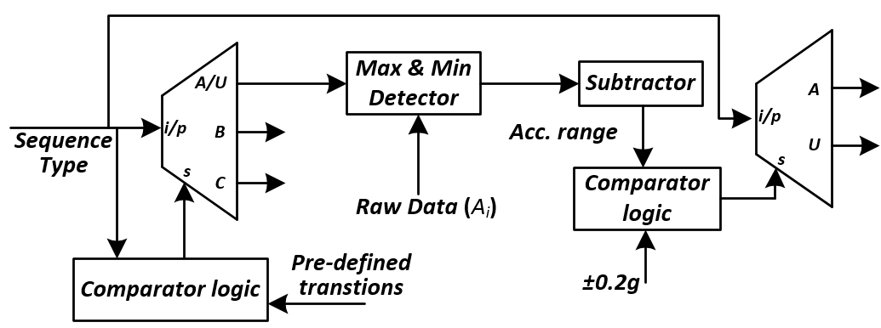
Fig. 5. Architecture for Action Detection.

Evaluation
The synthesized RTL on the FPGA was tested to recognize the movements performed as part of the experimental protocol of ‘making-a-cup-of-tea’. Test vectors were stored in memory initialisation files (MIF) and the implemented design was tested at 50 MHz. The average accuracy of correctly recognizing the 3 actions over the 4 trials for all healthy subjects is within a range of 85%-96% (cf. Table IV) and for all stroke survivors is 63-75% (cf. Table V), representing only slight differences from the results achieved with the software implementation [8]. The average accuracy dropped by 4.8% for healthy subjects and 6.8% for the stroke survivors. This is primarily due to the changes in the implemented design where we have not filtered the raw sensor data prior to processing, to keep the computations at a minimal level.
- Recognition Of Trials For Healthy Subjects.
Subject | Recognised Actions (Out of 20) |  |  |  | Average Accuracy (%)
Subject | Trial 1 | Trial 2 | Trial 3 | Trial 4 | Average Accuracy (%)
1 | 18 | 19 | 18 | 18 | 91
2 | 16 | 20 | 18 | 18 | 90
3 | 18 | 16 | 18 | 16 | 85
4 | 18 | 20 | 19 | 20 | 96
- Recognition Of Trials For Stroke Survivors.
Subject | Recognised Actions (Out of 20) |  | Average Accuracy (%)
Subject | Trial 1 | Trial 2 | Average Accuracy (%)
1 | 15 | 15 | 75
2 | 12 | 14 | 65
3 | 16 | 12 | 70
4 | 15 | 10 | 63
The OD module takes 4 clock cycles for computing the orientation of each data sample. The SD computes the Sequence Type from a sample length of 512 orientation states in 2050 cycles (512×4 + 2) cycles and AD takes 10 cycles to infer the performed movement. Therefore, the synthesized design uses 1804 logic elements and takes 2060 clock cycles (≈ 41.2 µs) to produce the desired output. We present a simulation waveform in Fig. 6, with acceleration values (scaled up by a factor of 10000) and orientation states stored in Type (Sequence Type).
Fig. 6. Simulation showing the detection of Action B for an orientation transition from position 1 to 5 in the Type register.
A readySerial signal which is activated when a set of X, Y and Z values are obtained from the serial receiver. The signal readyOD is set high every 4 clock cycles after computing the orientation state for every data sample. A signal readySD is set high once the orientation changes are stored in Sequence Type (the segment length parameter has been set to 8 instead of 512 for sake of brevity). Finally, a readyAD signal is set high to signify the detected action (Action B). In this implementation, the internal RAM was not used since OD computes the orientation states on the fly. Furthermore, we did not use any multiplication or division in order to minimize the number of synthesized logic elements. For evaluating the system (cf. Fig. 1) in real-time, the arm movements (Action A, B and C) were performed multiple times with the sensor worn on the wrist, which were detected successfully and displayed on the LEDs.

Discussion
In this paper we have demonstrated a real-time arm movement recognition system implemented on an FPGA in conjunction with a tri-axial accelerometer placed on the wrist as a proof-of-concept methodology. The implemented design does not use any memory element and avoids the overheads of complex data processing involved in any standard activity recognition system. Although implemented on FPGA, the salient features of the architecture (i.e. no use of multiplications, divisions and memory elements) makes it amenable for low power applications in WSN nodes. The architectural design can be further implemented as a low-power ASIC chip and embedded on a sensor platform along with other vital components such as A/D converter and a de-noising circuit to detect real-time arm movements for long-term continuous monitoring. Enumerating occurrences of these movements over time can indicate rehabilitation progress since the patient is more likely to repeat these movements as their motor functionality improves.
References
- B. Najaﬁ et al., “Ambulatory system for human motion analysis using a kinematic sensor: Monitoring of daily physical activity in the elderly,” IEEE Trans. Biomed. Eng., vol. 50, no. 6, pp. 711-723, Jun. 2003.
- F. E. Martınez-Pérez et al., “Activity inference for ambient intelligence through handling artifacts in a healthcare environment,” Sensors, vol. 12, no. 1, pp. 1072–1099, Jan. 2012.
- C. Zhu and W. Sheng, “Motion- and location-based online human daily activity recognition,” Pervasive and Mobile Computing, vol. 7, no. 2, pp. 256-269, Apr. 2011.
- H. Junker et al., “Gesture spotting with body-worn inertial sensors to detect user activities,” Pattern Recognition, vol. 41, no. 6, pp. 2010-2024, Jun. 2008.
- D. Fuentes et al., “Online motion recognition using an accelerometer in a mobile device,” Expert Systems with Applications, vol. 39, no. 3, pp. 2461-2465, Feb. 2012.
- J. Parkka et al., “Activity classification using realistic data from wearable sensors,” IEEE Transactions on Information Technology in Biomedicine, vol.10, no.1, pp.119-128, Jan. 2006.
- K. Maharatna et al., “Towards the development of next-generation remote healthcare system: Some practical considerations,” in Proc. IEEE Int. Symp. Circuits and Systems (ISCAS), Seoul, pp. 1–4, May. 2012.
- D. Biswas et al., “Recognition of elementary arm movements using orientation of a tri-axial accelerometer located near the wrist,” Physiological measurement, vol. 35, no. 9, p. 1751, 2014.
- A. Burns et al., “Shimmer – A wireless sensor platform for noninvasive biomedical research,” IEEE Sensors Journal, vol. 10, no. 9, pp.1527–1534, Sep. 2010.
- “SerialPort Class.” [Online]. Available: http://msdn.microsoft.com/en-us/library/system.io.ports.serialport%28v=vs.110%29.aspx. [Accessed: 06-2014].

