Coherent excitation-selective spectroscopy of multipole resonances

Xu Fang^{1†}, Ming Lun Tseng², Din Ping Tsai^{2,3}, and Nikolay I. Zheludev^{1,4†}
¹Optoelectronics Research Centre and Centre for Photonic Metamaterials, University of Southampton, Southampton SO17 1BJ, UK
²Department of Physics, National Taiwan University, Taipei 10617, Taiwan
³Research Center for Applied Sciences, Academia Sinica, Taipei 115, Taiwan
⁴Centre for Disruptive Photonic Technologies, Nanyang Technological University, Singapore 637371, Singapore
† Correspondence and requests for materials should be addressed to
X.F. (e-mail: x.fang@soton.ac.uk) or to N.I.Z.(e-mail: niz@orc.soton.ac.uk)

Thin films of functional materials, from graphene to semiconductor heterostructures, from nano-membranes to Langmuir-Blodgett films play key roles in modern technologies. For such films optical interrogation is the main and often the only practical method of characterization. Here we show that characterization of optical response of thin films can be greatly improved with a new type of coherent spectroscopy using two counter-propagating beams of light. The new spectroscopy is selective to particular types of multipole resonances that form the absorption spectrum of the film, therefore can reveal lines that are hidden in conventional absorption spectroscopy. We explicitly demonstrated selectivity of this spectroscopy in a series of proof-of-principle experiments with plasmonic metamaterial arrays designed to exhibit different multipole resonances. We further demonstrate analytic potential of this spectroscopy by extracting hidden resonance from the spectrum of a complex nanostructure.

I. INTRODUCTION

The study of multipole excitations in matter is a key theme in photonics research that has become even more important in nano-systems [1-14]. In this paper we propose and report a new spectroscopic technique to detect multipole resonances in matter with increased selectivity. Recently it was shown that strength of absorption in a thin film depends on the position of the film in a standing wave [15,16]. The spectroscopic technique proposed in this work goes much further: it exploits the fact that by placing a subwavelength thin film at magnetic field node (where magnetic field and electric field gradient vanish) or electric field node (where electric field vanishes) in a standing wave, one can selectively emphasize electric dipole or magnetic dipole and electric quadrupole resonances correspondingly [see Fig. 1(a)]. Such selectivity gives the opportunity to detect resonances hidden by strong lines. Here we illustrate this in a series of proof-of-principle experiments by selectively detecting multipole resonances and by demonstrating the detection of a hidden absorption line in a complex spectrum.

Indeed, the excitation-selective nature of the coherent spectroscopy can be understood by considering the Hamiltonian $H_{int}$ of the interaction between electromagnetic radiation and matter [17]:
$H_{int}= \frac{1}{c}\hat{d}\frac{∂A}{∂t}-\frac{1}{c}(\frac{d{\hat{q}}^{il}}{dt}-e_{ilj}{\hat{m}}^{j})∇_{l}A_{i}$ (1)
where $A$is the vector potential of electromagnetic field, $\hat{d}, \hat{q}, \hat{m}$ are the operators of electric dipole, electric quadrupole and magnetic dipole moments of the medium, respectively, c is the speed of light, t is the time, and e_{ilj} is the Levi-Civita symbol with i, l and j denote a permutation of the Cartesian coordinates x, y and z. For a standing wave formed by two coherent linearly polarized waves counter-propagating in $±z$ directions and oscillating at frequency ω, $A_{x}=A_{0}\cos{(ωt-kz)}+A_{0}\cos{(ωt+kz)}$, where A₀ is the amplitude of the vector potential and k is the wave vector. The Hamiltonian now is reduced to:
$H_{int}= 2A_{0}\frac{1}{c}\left[\left(\frac{d{\hat{q}}^{xz}}{dt}+{\hat{m}}^{y}\right)k\cos\left(ωt\right)\sin\left(kz\right)-{\hat{d}}^{x}ω\sin\left(ωt\right)\cos\left(kz\right)\right]$ (2)
For a subwavelength thin film located at electric node (E-node) of the standing wave, where $cos(kz)=0$, electric dipole interaction vanishes while magnetic dipole and electric quadrupole interactions become the dominant terms of the Hamiltonian. On the contrary, for the same sample located at magnetic node (B-node), where $sin(kz)=0$, magnetic dipole and electric quadrupole interactions vanish while electric dipole interaction becomes the dominant term. This analysis implies that coherent absorption can be measured for any film of subwavelength thickness and no requirement exists on the level of sample’s reflection or transmission.

As one can see from the derivation above (Eqs. 1 & 2), the technique can separate electric dipole from magnetic dipole in absorption. It can also separate electric dipole from electric quadrupole. However, it cannot separate magnetic dipole from electric quadrupole since they simultaneously reach zero at B-node. Here we shall note that the interference of multiple waves can in principle create any value of magnitude and gradient of magnetic and electric fields at a given point in free space [18]. Therefore we argue that more elaborate versions of our technique using multiple beam interference could be better suited for distinguishing contributions of higher order multipoles.

A spectrometer based on a Mach-Zehnder interferometer arrangement is utilized for experimental demonstration [see Fig. 1(b)]. A femtosecond laser is used as light source for its widely tunable wavelength (from 700 nm to 1040 nm). A standing wave is generated from two loosely-focused counter-propagating laser beams, α and β, at sample position. By adjusting the phase difference between the two beams, the metamaterial position is swept through field nodes and antinodes, and the output light intensity is recorded simultaneously. By repeating this process at different wavelengths, two absorption spectra lines are generated, with one induced by electric dipole resonance and the other magnetic dipole and electric quadrupole resonances. Assisted with numerical calculation, we are able to assign absorption peaks to different resonances (see the Supplemental Material [19] for more details).

II. COHERENT CONTROL OF ELECTRIC DIPOLE RESONANCE

The first metamaterial sample in this work is a planar array of slit nanoantennas [see Figs. 2(a) and 2(b)] made from a MgF₂/Au/Si₃N₄ thin film [20]. Its optical response is dominated by electric dipole resonance [21-24], as the metasurface does not support other multipoles when illuminated at normal incidence [25,26]. Figures 2(c) and 2(d) show the experimental and numerically simulated absorption spectra [27-29] at electric field antinode (E-antinode) and node (E-node) of a standing wave, together with those in a travelling wave (the MgF₂ side is illuminated) , where experimental spectra show good agreement with theoretical simulation. The peak wavelength of the travelling-wave absorption coincides with that at E-antinode. At E-antinode, the experimental and theoretically simulated absorption at around 870 nm are 0.89 and 0.99, respectively; both of them are close to total absorption. These absorption values are almost doubled from the travelling-wave absorption. In comparison, the absorption at E-node is much smaller, with the experimental and theoretical absorption at 0.07 and 0.01, respectively, at around 870 nm. The experimental value is slightly higher than simulation, which is attributed to experimental imperfections.

Figure 2(e) shows induced surface charges at E-antinode, where charges with opposite sign at opposite wall resemble electric dipole resonance [21-24]. The amplitude of the induced charges in this case is much larger than that excited by a travelling wave [see Fig. 2(f)]. This indicates a stronger electric dipole resonance of the metamaterial at E-antinode. Very different from that in Figs. 2(e) and 2(f), Fig. 2(g) shows no discernable charge accumulation at E-node. Both the spectra and the charge distribution clearly demonstrate that the electric dipole resonance of the slit nanoantennas can be significantly amplified or suppressed by selecting the excitation mode of the coherent spectroscopy.

III. COHERENT CONTROL OF MAGNETIC DIPOLE AND ELECTRIC QUADRUPOLE

The second sample is a multilayered nanowire metamaterial [see Figs. 3(a) and 3(b)] for which the optical response is dominated by magnetic dipole and electric quadrupole resonances [30-34]. Figures 3(c) and 3(d) show the experimental and simulated absorption spectra at magnetic field antinode (B-antinode), magnetic field node (B-node), and in a travelling wave. Because of their asymmetric shape, the nanowires show different absorption spectra with changing illumination direction (see Fig. S1 in the Supplemental Material [19]) and the average is shown here. The experimental absorption spectra have good agreement with the theoretical simulation [see Figs. 3(c) and 3(d)]: Absorption at B-antinode is considerably stronger than that in the travelling-wave and they show similar resonance features; meanwhile, absorption is suppressed at B-node. The resonance is broader and weaker in experiment than in simulation, which may come from imperfections such as thickness fluctuation of the Si₃N₄ layer. The absorption at B-node comes from electric dipole contribution.

Figure 3(e) shows anti-parallel electric displacement current in the Au layers and strong magnetic field inside the Si₃N₄ layer at B-antinode. Both of them are the characteristics of magnetic dipole and electric quadrupole resonances of the metamaterial. The strength of the central magnetic hot spot is much bigger than the travelling-wave case [see Fig. 3(f), the top surface is illuminated]. In comparison, at B-node [see Fig. 3(g)], the induced electric displacement current is observed only in the top Au layer, and the magnetic hot spot is significantly suppressed. Results in Fig. 3 clearly demonstrate that, the same as electric dipole resonance, magnetic dipole and electric quadrupole resonances can also be actively controlled by the coherent spectroscopy technique.

IV. RECOVERY OF HIDDEN RESONANCE AND MANIPULATION OF HOT SPOTS

A multilayered asymmetric split ring slit metamaterial, the third metamaterial sample, is designed for the demonstration of the recovery of a hidden resonance in the coherent spectroscopy. The SEM image and schematic illustration of the sample are shown in Figs. 4(a) and 4(b), respectively. The experimental and theoretically simulated absorption spectra of the sample under the three excitation conditions are shown in Figs. 4(c) and 4(d), respectively. In comparison with the travelling wave spectra, the E-antinode spectra exhibit a similar Fano-type profile [35-37] but have larger absorption. As discussed above, this result indicates that the Fano-type resonance of the complex metamaterial is induced by the electric field of incident light. For both the E-antinode and the travelling-wave spectra, measured absorption peaks are slightly weaker and shifted in wavelength comparing to simulation. This may be attributed to experimental imperfections such as inhomogeneity of the nanostructure.

Most interestingly, the E-node spectra in both experiment and simulation [see Figs. 4(c) and 4(d)] are dominated by a single resonance feature at around 910 nm. Based on the discussion above, we conclude that this resonance comes from multipole resonances different from that of the Fano-type resonance: This peak is different from the peak observed at similar wavelength in travelling-wave excitation. This hidden resonance cannot be isolated using a conventional spectrometer (see Fig. S1 in the Supplementary Material [19] also for reflection and transmission). The very small feature at 780 nm observed in experiment [see Fig. 4(c)] is attributed to experimental imperfections.

Multipole radiation power of the metamaterial is numerically calculated for analyzing the resonance properties and the strength of induced multipoles under different excitation conditions [38]. Electric dipole, magnetic dipole, electric quadrupole, magnetic quadrupole, and toroidal dipole are calculated. The leading terms at E-antinode and E-node are shown in Figs. 4(e) and 4(f), respectively. The excitation of the sample is obviously dominated by electric dipole resonance at E-antinode. On the contrary, magnetic dipole and electric quadrupole resonances are most strongly induced at E-node. Because the magnetic dipole and the electric quadrupole are weaker than the electric dipole by around one order of magnitude, the resonance feature at around 910 nm can easily be covered by the electric dipole resonance in the travelling-wave spectroscopy. Experimental results of Fig. 4 clearly demonstrate the capability of recovering hidden resonances of the coherent spectroscopy.

An interesting additional function of the coherent spectroscopy can be seen in Figs. 4(g) and 4(h), which show the electric field distribution at the middle plane of the metamolecule at E-antinode and E-node. Near-field hot spots can be clearly seen in both cases, and their locations change with excitation condition. They are localized inside the straight slit at E-antinode, but appear between adjacent metamolecules at E-node. This indicates the possibility of using the coherent excitation to spatially manipulate near-field optical hot spots, a function that usually requires modulating spatial profile of excitation light [39,40].

The coherent spectroscopy not only can recover hidden resonances from a travelling-wave spectrum as shown in Figs. 4(c) and 4(d), but also can be used to interrogate travelling-wave spectra with complex features. Figure 5 compares the simulated absorption spectra of three samples at the three different excitation conditions. One sample [see Fig. 5(b)] has been reported in Fig. 4, and the other two samples [see Figs. 5(a) and 5(c)] are different from it only in the thickness of the middle Si₃N₄ layer. The travelling-wave spectra in both Figs. 5(a) and 5(c) show small plateaus which can be very difficult to interpret using conventional methods. By separating the resonances on the travelling-wave spectra using the coherent spectroscopy, we can see that the plateaus come from magnetic dipole and electric quadruple resonances.

V. CONCLUSIONS

Ultrathin metamaterial films specifically designed to show complex multipole resonances give excellent experimental demonstration of the selectivity of the coherent spectroscopy. Coherent absorption spectra measured at field node and antinode of an optical standing wave show both improved excitation efficiency and contrast between multipoles. These functions originate from the doubled local field intensity at field antinode and the spatial separation of electric and magnetic fields. In principle, this technique works at arbitrary low laser power, and can be extended to any designated wavelength regime.

This method can be useful for the characterization of subwavelength thin films of different nature, including both metamaterials and natural materials. Although the standing wave technique is two times more sensitive than conventional travelling-wave absorption measurement, it can realistically work only with noticeable absorption at present. However, sample position in a standing wave can be modulated at high frequency and the corresponding change in absorption can be detected by phase locking techniques, which could greatly improve detection sensitivity. Such opportunity does not exist in conventional travelling-wave measurement.

The technique is not only suitable for free-standing thin films, but also can be satisfactorily used for thin films on low-refractive-index substrates if: 1) the substrates are anti-reflection coated on the side opposite to analyte layer or 2) the films are sandwiched between two identical substrates. We also envisage that some of the analyte layers can be deliberately manufactured on very thin substrates to make them compatible with the new coherent spectroscopy. Indeed media like graphene and pellicle films are routinely used as thin substrates.

As progress in materials science, physics, and biochemistry is underpinned by and crucially depends on the development of analytical techniques, our new coherent spectroscopy offers a new, simple, efficient, and uniquely informative technique with large application potential. The proposed standing wave approach can be extended to the development of new ultrafast transient spectroscopies, nonlinear spectroscopies, and polarization spectroscopies.

ACKNOWLEDGEMENTS

We thank Vassili Savinov, Jun-Yu Ou, Kevin F. MacDonald, Eric Plum, Pin Chieh Wu and Yao-Wei Huang for helpful discussions. This work was supported by the Engineering and Physical Sciences Research Council of the United Kingdom (Grant No. EP/G060363/1), the Ministry of Education of Singapore (MOE2011-T3-1-005), the Ministry of Science and Technology of Taiwan (104-2745-M-002-003-ASP), and Academia Sinica of Taiwan (AS-103-TP-A06).

[1] | M. L. Andersen, S. Stobbe, A. S. Sørensen, and P. Lodahl, Strongly Modified Plasmon-Matter Interaction with Mesoscopic Quantum Emitters, Nat. Phys. 7, 215 (2011).
[2] | T. H. Taminiau, S. Karaveli, N. F. van Hulst, and R. Zia, Quantifying the Magnetic Nature of Light Emission, Nat. Commun. 3, 979 (2012).
[3] | N. Noginova, Y. Barnakov, H. Li, and M. A. Noginov, Effect of Metallic Surface on Electric and Magnetic Dipole Emission Transitions in Eu³⁺ Doped Polymeric Film, Opt. Express 17, 10767 (2009).
[4] | P. K. Jain, D. Ghosh, R. Baer, E. Rabani, and A. Paul Alivisatos, Near-Field Manipulation of Spectroscopic Selection Rules on the Nanoscale, Proc. Natl. Acad. Sci. USA 109, 8016 (2012).
[5] | S. M. Hein and H. Giessen, Tailoring Magnetic Dipole Emission with Plasmonic Split-Ring Resonators, Phys. Rev. Lett. 111, 026803 (2013).
[6] | B. Rolly, B. Bebey, S. Bidault, B. Stout, and N. Bonod, Promoting Magnetic Dipolar Transition in Trivalent Lanthanide Ions with Lossless Mie Resonances, Phys. Rev. B 85, 245432 (2012).
[7] | R. Filter, S. Mühlig, T. Eichelkraut, C. Rockstuhl, and F. Lederer, Controlling the Dynamics of Quantum Mechanical Systems Sustaining Dipole-Forbidden Transitions via Optical Nanoantennas, Phys. Rev. B 86, 035404 (2012).
[8] | W. Lukosz and R. E. Kunz, Light Emission by Magnetic and Electric Dipoles Close to a Plane Interface. I. Total Radiated Power, J. Opt. Soc. Am. 67, 1607 (1977).
[9] | W. Lukosz and R. E. Kunz, Light Emission by Magnetic and Electric Dipoles Close to a Plane Interface. II. Radiation Patterns of Perpendicular Oriented Dipoles, J. Opt. Soc. Am. 67, 1615 (1977).
[10] | W. Lukosz, Light Emission by Magnetic and Electric Dipoles Close to a Plane Dielectric Interface. III. Radiation Patterns of Dipoles with Arbitrary Orientation, J. Opt. Soc. Am. 69, 1495 (1979).
[11] | N. Noginova, G. Zhu, M. Mavy, and M. A. Noginov, Magnetic Dipole Based Systems for Probing Optical Magnetism, J. Appl. Phys. 103, 07E901 (2008).
[12] | N. Noginova, R. Hussain, M. A. Noginov, J. Vella, and A. Urbas, Modification of Electric and Magnetic Dipole Emission in Anisotropic Plasmonic Systems, Opt. Express 21, 23087 (2013).
[13] | S. Karaveli and R. Zia, Spectral Tuning by Selective Enhancement of Electric and Magnetic Dipole Emission, Phys. Rev. Lett. 106, 193004 (2011).
[14] | S. Karaveli, A. J. Weinstein, and R. Zia, Direct Modulation of Lanthanide Emission at Sub-lifetime Scales, Nano Lett. 13, 2264 (2013).
[15] | J. Zhang, K. F. MacDonald, and N. I. Zheludev, Controlling Light-with-Light without Nonlinearity, Light: Sci. & Appl. 1, e18 (2012).
[16] | X. Fang, M. L. Tseng, J. Y. Ou, K. F. MacDonald, D. P. Tsai, and N. I. Nikolay, Ultrafast All-Optical Switching via Coherent Modulation of Metamaterial Absorption, Appl. Phys. Lett. 104, 141102 (2014).
[17] | Y. P. Svirko and N. I. Zheludev, Polarization of Light in Nonlinear Optics (Wiley, 1998), p. 182.
[18] | N. Yang and A. E. Cohen, Local Geometry of Electromagnetic Fields and Its Role in Molecular Multipole Transitions, J. Phys. Chem. B 115, 5304 (2011).
[19] | See Supplemental Material at http://link.aps.org for additional details on the experiment and simulation methods, the travelling-wave spectra, and the measured and simulated coherent absorption.
[20] | J. Brian Leen, P. Hansen, Y. T. Cheng, and L. Hesselink, Improved Focused Ion Beam Fabrication of Near-Field Apertures Using a Silicon Nitride Membrane, Opt. Lett. 33, 2827 (2008).
[21] | B. Sepúlveda, Y. Alaverdyan, J. Alegret, M. Käll, and P. Johansson, Shape Effects in the Localized Surface Plasmon Resonance of Single Nanoholes in Thin Metal Films, Opt. Express 16, 5609 (2008).
[22] | T. Rindzevicius, Y. Alaverdyan, B. Sepulveda, T. Pakizeh, M. Käll, R. Hillenbrand, J. Aizpurua, and F. Javier García de Abajo, Nanohole Plasmons in Optically Thin Gold Films, J. Phys. Chem. C 111, 1207 (2007).
[23] | F. J. García-Vidal, L. Martín-Moreno, E. Moreno, L. K. S. Kumar, and R. Gordon, Transmission of Light through a Single Rectangular Hole in a Real Metal, Phys. Rev. B 74, 153411 (2006).
[24] | Y. Alaverdyan, B. Sepúlveda, L. Eurenius, E. Olsson, and M. Käll, Optical Antennas Based on Coupled Nanoholes in Thin Metal Films, Nat. Phys. 3, 884 (2007).
[25] | F. Monticone, N. M. Estakhri, and A. Alù, Full Control of Nanoscale Optical Transmission with a Composite Metascreen, Phys. Rev. Lett. 110, 203903 (2013).
[26] | C. Pfeiffer and A. Grbic, Metamaterial Huygens’ Surfaces: Tailoring Wave Fronts with Reflectionless Sheets, Phys. Rev. Lett. 110, 197401 (2013).
[27] | E. D. Palik, Handbook of Optical Constants of Solids (Academic Press, 1985), p. 899.
[28] | Z. Yin and F. W. Smith, Optical Dielectric Function and Infrared Absorption of Hydrogenated Amorphous Silicon Nitride Films: Experimental Results and Effective-Medium-Approximation Analysis, Phys. Rev. B 42, 3666 (1990).
[29] | Z. Liu, A. Boltasseva, R. H. Pedersen, R. Bakker, A. V. Kildishev, V. P. Drachev, and V. M. Shalaev, Plasmonic Nanoantenna Arrays for the Visible, Metamaterials 2, 45-51 (2008).
[30] | W. Cai, U. K. Chettiar, H. K. Yuan, V. C. de Silva, A. V. Kildishev, V. P. Drachev, and V. M. Shalaev, Metamagnetics with Rainbow Colors, Opt. Express 15, 3333 (2007).
[31] | U. K. Chettiar, S. Xiao, A. V. Kildishev, W. Cai, H. K. Yuan, V. P. Drachev, and V. M. Shalaev, Optical Metamagnetism and Negative-Index Metamaterials, MRS Bulletin 33, 921 (2008).
[32] | N. Liu, L. Fu, S. Kaiser, H. Schweizer, and H. Giessen, Plasmonic Building Blocks for Magnetic Molecules in Three-Dimensional Optical Metamaterials, Adv. Mater. 20, 3859 (2008).
[33] | P. Grahn, A. Shevchenko, and M. Kaivola, Electric Dipole-Free Interaction of Visible Light with Pairs of Subwavelength-Size Silver Particles, Phys. Rev. B 86, 035419 (2012).
[34] | J. Valentine, S. Zhang, T. Zentgraf, E. Ulin-Avila, D. A. Genov, G. Bartal, and X. Zhang, Three-Dimensional Optical Metamaterial with a Negative Refractive Index, Nature 455, 376 (2008).
[35] | B. Luk'yanchuk, N. I. Zheludev, S. A. Maier, N. J. Halas, P. Nordlander, H. Giessen, and C. T. Chong, The Fano Resonance in Plasmonic Nanostructures and Metamaterials, Nat. Mater. 9, 707 (2010).
[36] | V. A. Fedotov, N. Papasimakis, E. Plum, A. Bitzer, M. Walther, P. Kuo, D. P. Tsai, and N. I. Zheludev, Spectral Collapse in Ensembles of Metamolecules, Phys. Rev. Lett. 104, 223901 (2010).
[37] | N. Papasimakis, Z. Luo, Z. X. Shen, F. D. Angelis, E. D. Fabrizio, A. E. Nikolaenko, and N. I. Zheludev, Graphene in a Photonic Metamaterial, Opt. Express 18, 8353 (2010).
[38] | V. Savinov, V. A. Fedotov, and N. I. Zheludev, Toroidal Dipolar Excitation and Macroscopic Electromagnetic Properties of Metamaterials, Phys. Rev. B 89, 205112 (2014).
[39] | T. S. Kao, S. D. Jenkins, J. Ruostekoski, and N. I. Zheludev, Coherent Control of Nanoscale Light Localization in Metamaterial: Creating and Positioning Isolated Subwavelength Energy Hot Spots, Phys. Rev. Lett. 106, 085501 (2011).
[40] | B. Gjonaj, J. Aulbach, P. M. Johnson, A. P. Mosk, L. Kuipers, and A. Lagendijk, Active Spatial Control of Plasmonic Fields, Nat. Photon. 5, 360 (2011).

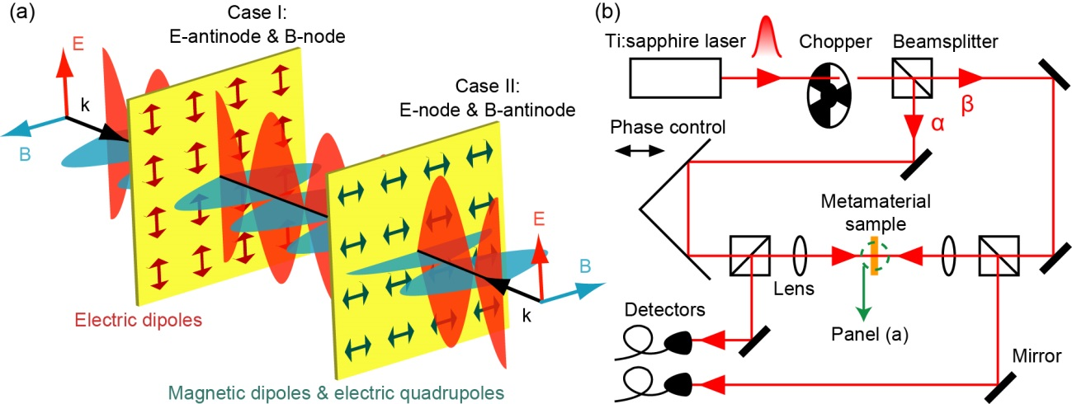
FIG. 1. Selective excitation of coherent spectroscopy for ultrathin films: principle and experimental setup. (a) In a standing wave formed by two counter-propagating normal incident laser beams, the absorption of a subwavelength thin film depends on its position. At electric antinode and magnetic node (Case I), electric dipole absorption is at its maximum, while magnetic dipole and electric quadruple absorption vanishes. On the contrary, at electric node and magnetic antinode (Case II), electric dipole resonance is suppressed and magnetic dipole and electric quadrupole resonances are selectively excited. (b) Schematic illustration of the coherent excitation spectrometer (see the Supplemental Material for details) with a zoom-in view around the sample shown in (a).

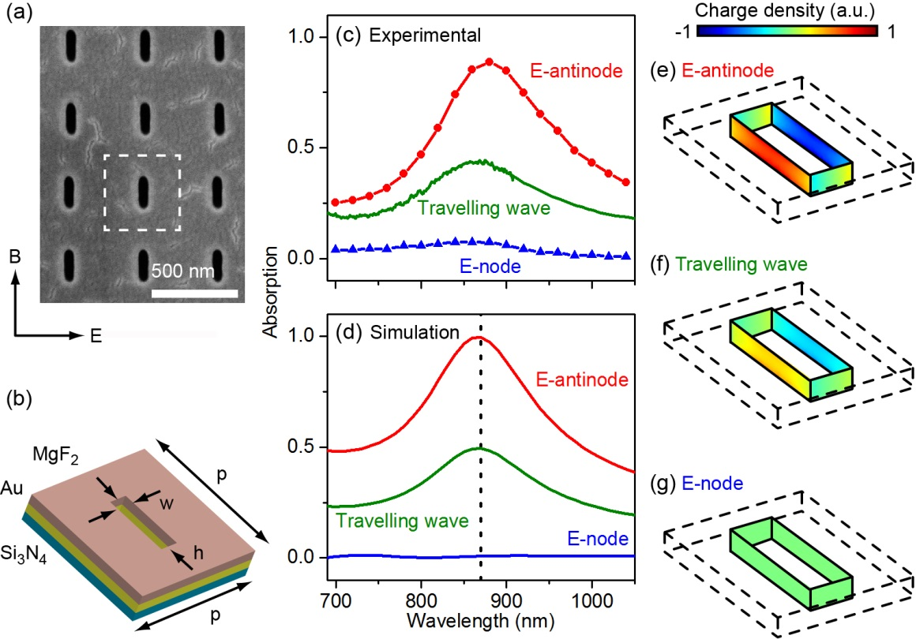
FIG. 2. Coherent control of electric dipole resonance in metamaterial. (a) SEM image of the slit nanoantenna metamaterial. Unit cell of the metamolecule is marked with the white dashed line. The polarization of the incident light is depicted. (b) Dimensions of a unit cell: p = 430 nm, h = 180 nm, and w = 60 nm. (c)-(d) Experimental and numerically simulated absorption spectra of the slit nanoantennas at E-antinode (red line) and E-node (blue line) of a standing wave, and in a travelling wave (green line). (e)-(g) Corresponding surface charge density distribution on the inner walls of the slit in the Au layer. The wavelength is 870 nm [highlighted by the dashed line in (d)]. All panels are shown at the same color scale.

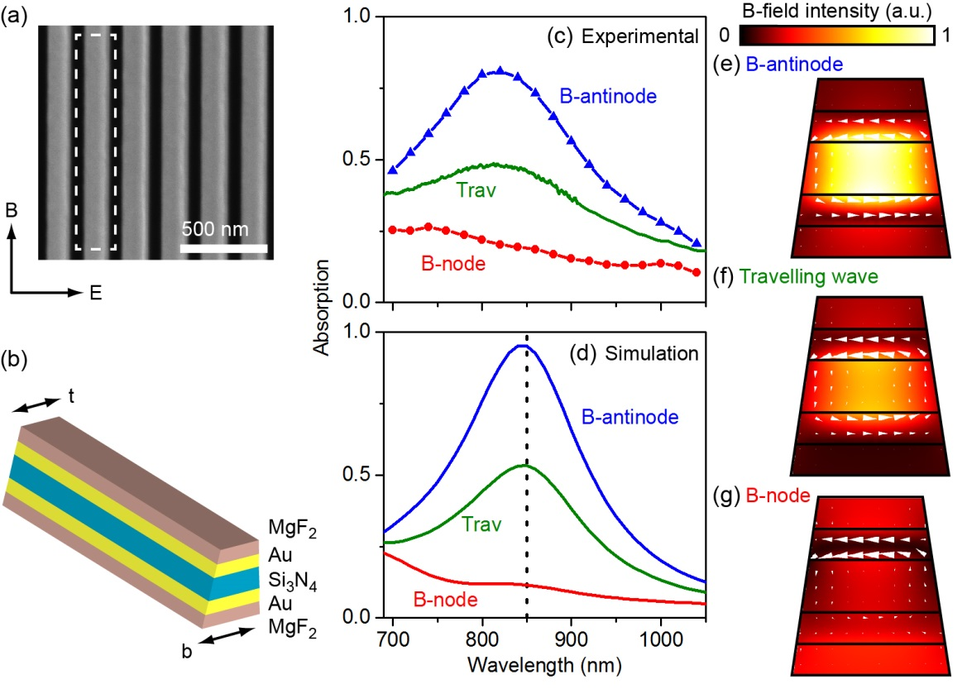
FIG. 3. Coherent control of magnetic dipole and electric quadrupole resonances in metamaterial. (a) SEM image of the nanowire metamaterial. Polarization of the incident light is depicted. Unit cell of the metamolecule is marked with the white dashed line. (b) Dimension of a unit cell: t = 100 nm and b = 150 nm. The periodicity is 220 nm and the wire length is 30 μm. (c)-(d) Experimental and simulated absorption spectra of the nanowires at B-antinode (blue line), B-node (red line), and in a travelling wave (green line). (e)-(g) Corresponding magnetic field (color map) and induced displacement current (white arrows) at the cross-section of the metamolecule at the resonance wavelength [850 nm, highlighted in (d)].

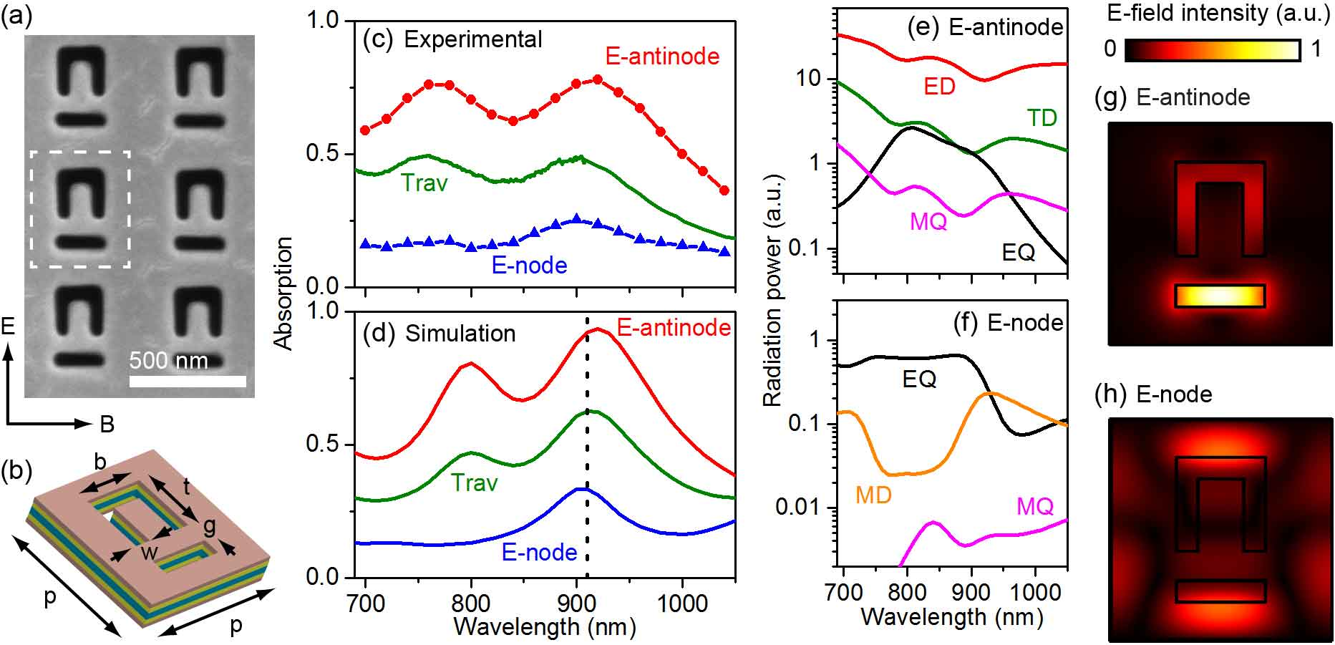
FIG. 4. Recovery of hidden resonance and manipulation of near-field hot spots in metamaterial. (a) SEM image of the multilayered asymmetric ring slit metamaterial. Polarization of the incident light is depicted. Unit cell of the metamolecule is marked with the white dashed line. (b) Dimensions of a unit cell: p = 520 nm, b = 210 nm, t = 220 nm, g = 70 nm, and w = 50 nm. (c)-(d) Experimental and simulated absorption spectra of the sample at E-antinode (red line), at E-node (blue line), and in the travelling wave (green line). (e)-(f) Leading terms of multipole radiation power at (e) E-antinode and (f) E-node. ED: electric dipole, MD: magnetic dipole, TD: toroidal dipole, EQ: electric quadrupole, and MQ: magnetic quadrupole. (g)-(h) Electric field in the middle of the Si₃N₄ layer at the resonance wavelength of the hidden peak [910 nm, highlighted in (d)].

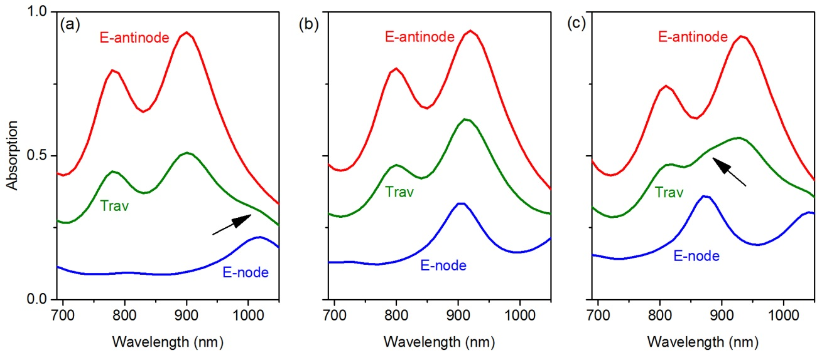
FIG. 5. Interrogating complex travelling-wave spectra using coherent spectroscopy. Numerically simulated absorption spectra are shown for three split ring slit metamaterials of different dimensions. The planar nanostructure dimensions are the same as in Fig. 4. The thickness of the middle Si₃N₄ layer is (a) 30 nm, (b) 50 nm (the same sample as in Fig. 4), and (c) 60 nm. As different multipole resonances have different dependence on metamolecule size, the hidden resonance in (b) moves away from the Fano resonance and therefore can be seen in the travelling-wave spectra in both (a) and (c) (highlighted by arrows).

