Electronic Supplementary Information for
The Role of Hydrogen Bonds in Excited State Proton Transfer.
D.A. Horkeª, H.M. Watts^{b}, A.D. Smith^{b}, E. Jager^{b}, E. Springate^{c}, O. Alexander^{c}, C. Cacho^{c}, R.T. Chapman^{c}, and R.S. Minns^{b*}
ªCenter for Free-Electron Laser Science, DESY, Notkestrasse 85, 22607 Hamburg, Germany
^{b}Chemistry, University of Southampton, Highfield, Southampton SO17 1BJ, UK
^{c}Central Laser Facility, STFC Rutherford Appleton Laboratory, Didcot, Oxfordshire
OX11 0QX, UK
*r.s.minns@soton.ac.uk

Pump Probe Experiments
An amplified femtosecond laser system (Red Dragon, KM labs) generates 30 fs duration pulses of 800 nm light with pulse energies up to 12 mJ at 1 kHz repetition rate. The output of the laser is split into two equal parts before compression allowing for independent optimisation of the chirp, duration and energy of the pulses used to generate the pump and probe beams. The pump is generated from the 5 mJ output of compressor 1 which is frequency doubled in beta-barium borate (BBO) crystals, followed by two stages of sum frequency generation (SFG). The first SFG stage generates 266 nm light through mixing the fundamental 800 nm with the second harmonic at 395 nm in a type II process in BBO. The second SFG stage mixes the 266 nm light with a previously separated 800 nm beam to generate the pump at 200 nm with a controllable pulse energy of up to 20 μJ. For the experiments described in the main paper the pulse energy is kept to ∼1 μJ. The probe is generated from second harmonic generation of the output of compressor 2, and attenuated to pulse energies of ∼4 μJ at 395 nm. The combined photon energy of the pump and probe beams is kept low, such that the total photon energy (pump + probe = 9.3 eV) is above the appearance energy (9.19 eV) and adiabatic ionisation potential (8.65 eV) of the dimer,[20,24] but remains below the ionisation potential of the ammonia molecule (10.07 eV).[24] The pump beam is focussed into the interaction region of a velocity map imaging (VMI) spectrometer with a 1 m focal length mirror, where it is crossed at a small angle (~3º) by the probe. The probe is reflection focussed to the same point with a 1 m focal length toroidal mirror with the relative delay between the pump and probe pulses controlled by a optical delay line.
The VMI spectrometer follows the standard three plate design of Eppink and Parker[30]. The molecular beam is produced by expanding 10% ammonia in helium through a 200 μm pulsed nozzle (Amsterdamn cantilever[31]) at 2 bar pressure. The centre of the resulting expansion passes through a 1 mm skimmer and through a small hole in the repeller plate of the VMI spectrometer. The pulsed nozzle is operated at 1 kHz to match the laser repetition rate and synchronised such that maximum gas density is obtained within the interaction region when the pump and probe laser pulses arrive. The laser pulses intersect the molecular beam at right angles with the polarisation perpendicular to the time of flight axis of the VMI spectrometer. The released electrons are accelerated towards a 70 mm position sensitive detector consisting of a dual-MCP and phosphor screen (photonis), with the resulting phosphorescence imaged by a CCD camera (PCO Gold Edge 5.5).
Each raw photoelectron image is collected for approximately 10⁶ laser shots, and the photoelectron spectrum and photoelectron angular distributions (PADs) extracted from the background subtracted images using the polar onion peeling method[32]. The background was taken as the average of four images from negative time delays (probe arriving before the pump) between -300 fs and -200 fs. The PADs are obtained through fits to the standard functional[32,14]:
$$\frac{dσ}{dΩ}=\frac{σ}{4π}\sum_{n}{β_{n}P_{n}\left(cos θ\right),}$$
where $\frac{dσ}{dΩ}$ defines the photodetachment cross section per unit solid angle, $β_{n}$ are the anisotropy parameters and $P_{n}(cosθ)$ are the nth order Legendre polynomials. For linear parallel polarisations used in the present experiment, the sum runs over all even numbers up to twice the number of photons used in the excitation and ionisation process. The current experiment contains two photons such that the expansion can be cut at $β_{4}$.
Time dependent photoelectron intensity fits
In the main paper fits to the time dependent photoelectron yield at energies above 0.1 eV are presented in figure 3. The fits are based on a biexponential decay convoluted with the Gaussian instrument response function defined by the pump and probe laser pulse durations,
$I\left(t\right)=\sum_{n}{g(μ,σ)*a_{n}exp⁡(-k_{n}t)}.$ (1)
For each 0.1 eV energy region the amplitudes, $a_{n}$, and decay constants, $k_{n}$, of the two exponential decays and the delay in appearance time, $μ$, are least squares fit to the experimental measurements. The cross-correlation full width at half maximum, $σ$, is fit simultaneously across all plots and has a value of approximately 50 fs. The results of these fits provide a timescale for the hydrogen process through the delay in appearance time ($μ)$ and approximate values for the decay of the excited population into either the charge transfer state or through dissociation on the excited state surface. The values obtained from the fit are given in table S1 and plots of the components in figure S1. Details of the analysis of the fits are provided in the main paper.

Table 1. Kinetic parameters obtained from fits of equation (1) to the measured photoelectron intensity at particular energies.
 | Energy Region / eV
 | 0.1-0.2 | 0.2-0.3 | 0.3-0.4 | 0.4-0.5 | 0.5-0.6
Delay / fs | 88 | 103 | 118 | 127 | 130
Lifetime / fs | 2974 | 1910 | 1654 | 1737 | 1982
Lifetime / fs | 361 | 239 | 160 | 128 | 118

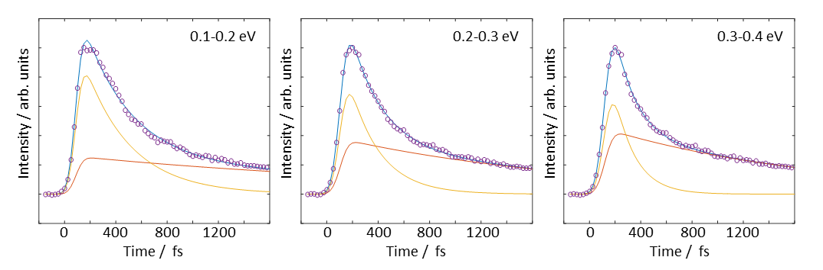
Figure S1. Photoelectron intensity integrated over spectral slices (as indicated) as a function of pump-probe delay (blue circles). Shown in red and orange are the two components of the biexponential fits to the measured intensity distributions with the resultant sum plotted as a solid blue line through the data points.

XUV photoelectron spectroscopy
To calibrate the velocity map imaging spectrometer and to characterise the molecular beam we perform a series of single photon extreme ultraviolet (XUV) photoelectron spectroscopy experiments. The XUV data was collected at the same time and with the same laser and vacuum detection systems as the pump probe experiments described above and presented in the main paper. The XUV pulses were generated in a high harmonic generation source by focussing approximately 400 μJ of 395 nm light into an Argon gas jet, generating a broad range of high harmonics. A single harmonic is isolated in a time preserving monochromator[33] and focused into the interaction region of the VMI spectrometer with a 1 m focal length toroidal mirror. The isolated harmonic has a photon flux at the interaction region of approximately 10⁷ photons per pulse, as measured with a calibrated channel electron multiplier. To calibrate the VMI spectrometer we ionise Argon using a series of isolated harmonics from the generated frequency comb providing sharp photoelectron peaks.
Figure S2: XUV photoelectron spectra following single photon ionisation of the molecular beam at 1.5 bar and 5 bar stagnation pressures with a 15.5 eV pulse of 20 fs duration.

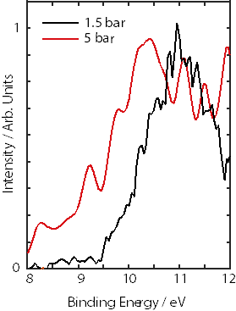
To characterise the molecular beam we isolate the 5th harmonic at 15.5 eV and collect images for approximately 10⁸ laser shots. In figure S2 we plot the photoelectron spectra obtained from the expansion of 10% ammonia in helium at 1.5 bar and 5 bar pressure.
The photoelectron spectrum obtained at low pressure is dominated by signal from the ammonia monomer. The ionisation potential (10.07 eV) and ionisation maximum (11 eV) match that expected for ammonia but the spectrum also contains a small feature at lower binding energies (9.5 – 10 eV) due to a small contribution from ammonia clusters. As the pressure is increased to 5 bar, the low binding energy feature grows in intensity with a major component rising from around 9 eV and peaking at 10 eV as well as an increase in photoelectron signal between 8 and 9 eV. The features peaking at 10 eV match previous He I photoelectron spectroscopy measurements of the ammonia dimer, which show a vertical ionisation potential of 9.19 eV and an ionisation maximum at 10 eV[24]. Larger clusters have lower appearance potentials than the dimer and while there are some photoelectron at these lower binding energies in the XUV spectrum, between 8 and 9 eV, these are much weaker and make a very limited contribution to the overall photoelectron spectrum, even at a relatively high backing pressure (5 bar). Based on our photoelectron spectra and the photoelectron spectra of the dimer from Carnovale et al[24] we estimate that clusters larger than the dimer make up less than 20% of the cluster contribution in the high pressure (5 bar) photoelectron spectrum and provide zero contribution to the low pressure (1.5 bar) photoelectron spectrum. As the experiment presented in the main paper was performed at a low stagnation pressure of 2 bar, this produced a molecular beam dominated by the ammonia monomer with an appreciable contribution from the dimer. By careful control of the expansion conditions and with a choice of pump and probe energies that keep us below the ionisation potential of the monomer we are therefore able to generate time resolved signals that are dominated by contributions from the dimer.
Further evidence for this can be seen in our early time spectra shown in the main paper. At early times (at the time of excitation) we would expect to see significant contributions from larger clusters due to being further above the ionisation potential. For example, the ammonia trimer has an appearance potential close to the PMD ionisation potential of the dimer[20,22] producing electron up to 0.8 eV. Compared with the poor overlap of the dimer and the weak photoelectron signal observed at early times, any significant population of the trimer would be clearly visible in our photoelectron spectra. Photoelectrons at such high energies are not observed until significant dimer population has undergone hydrogen transfer, further confirming that we do not have any appreciable trimer, or larger cluster, contributing in our molecular beam. Furthermore, the time dependent changes in angular distribution obtained in the photoelectron images are more evidence that a single cluster size dominates the signal. If significant contributions from larger cluster were present we would expect an isotropic photoelectron angular distribution (PAD) with less pronounced time dependent changes due to the different structures of the larger clusters.

