**ADDITIONAL DATA**

for

Polyhedron DOI: 10.1016/j.poly.2015.12.032

**Complexes of aluminium, gallium and indium trifluorides with neutral oxygen donor ligands: synthesis, properties and reactions**.

Rajiv Bhalla,a Jennifer Burt,b Andrew L. Hector,b William Levason,b* Sajinder K. Luthra,c Graeme McRobbie,c Francesco M. Monzittub and Gillian Reidb

*a Centre for Advanced Imaging, University of Queensland, Brisbane, Queensland 4072, Australia.*

*b School of Chemistry, University of Southampton, Southampton SO17 1BJ, UK.*

*c GE Healthcare Healthcare UK, White Lion Road, Amersham HP7 9LL, UK.*

Corresponding author: E-mail [wxl@soton.ac.uk](mailto:wxl@soton.ac.uk)

**AlF3·3H2O**

PXRD pattern. AlF3(OH2)3 as reported in Solid State Sci. 8 (2006) 1443.

**InF3·3H2O**

PXRD pattern. [{InF2(OH2)2(µ-F)2}n]⋅nH2O as reported in Inorg. Nucl. Chem. Letts. 14 (1978) 79.

**[AlF3(OH2)2(dmso)]**

1H NMR spectrum (400 MHz, CD3OD, 298 K)



19F NMR spectrum (400 MHz, CD3OD, 298 K)



(The broad underlying absorption is from Teflon in the NMR probe)

19F NMR spectrum (400 MHz, CD3OD, 183 K)



27Al NMR spectrum (400 MHz, CD3OD, 298 K)



(The large resonance is Al in the probe)

IR spectrum



**[GaF3(OH2)2(dmso)]**

1H NMR spectrum (400 MHz, CD3OD, 298 K)



19F NMR spectrum (400 MHz, CD3OD, 298 K)



19F NMR spectrum (400 MHz, CD3OD, 193 K)



IR spectrum



Crystallographic data in cif format have been deposited with the Cambridge Crystallographic Data Centre (CCDC) and given number 1429860.

**[InF3(OH2)2(dmso)]**

1H NMR spectrum (400 MHz, CD3OD, 298 K)



19F NMR spectrum (400 MHz, CD3OD, 193 K)



IR spectrum



**[AlF3(OH2)2(PyNO)]**

1H NMR spectrum (400 MHz, CD3OD, 298 K)



19F NMR spectrum (400 MHz, CD3OD, 298 K)



IR spectrum



**[GaF3(OH2)2(PyNO)]·PyNO·H2O**

1H NMR spectrum (400 MHz, CD3OD, 298 K)

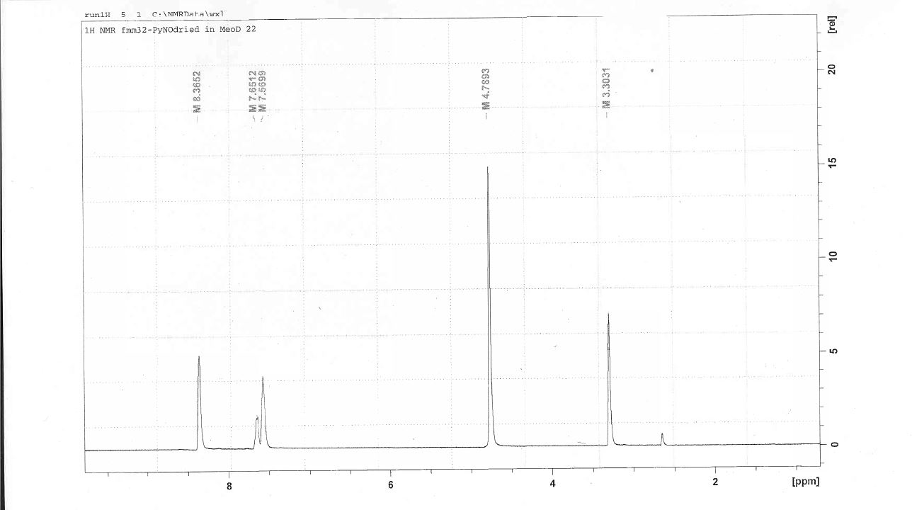

19F NMR spectrum (400 MHz, CD3OD, 298 K)

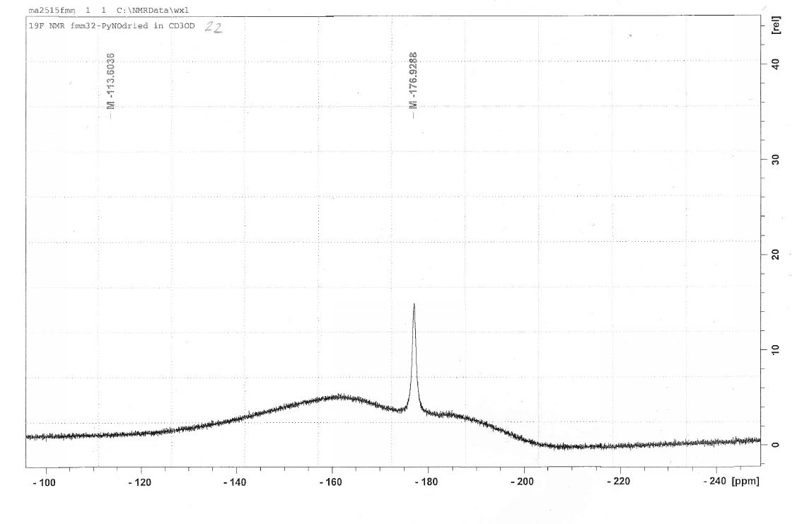

1H NMR spectrum (400 MHz, CD3OD, 183 K)

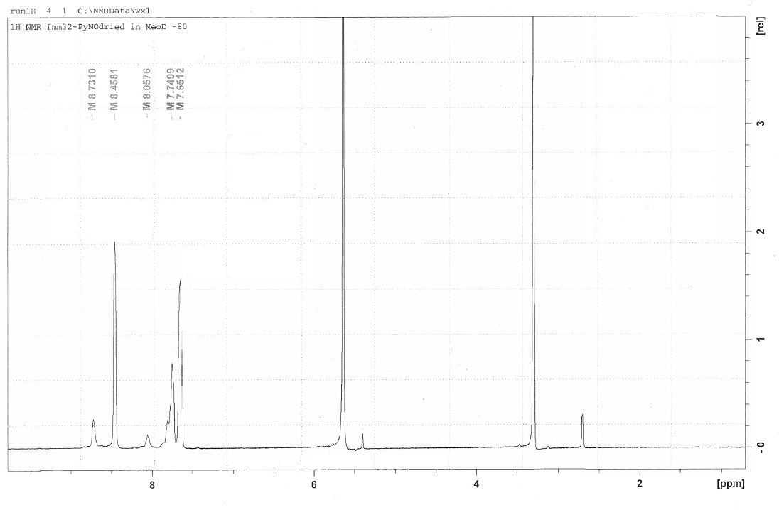

19F NMR spectrum (400 MHz, CD3OD, 193 K)

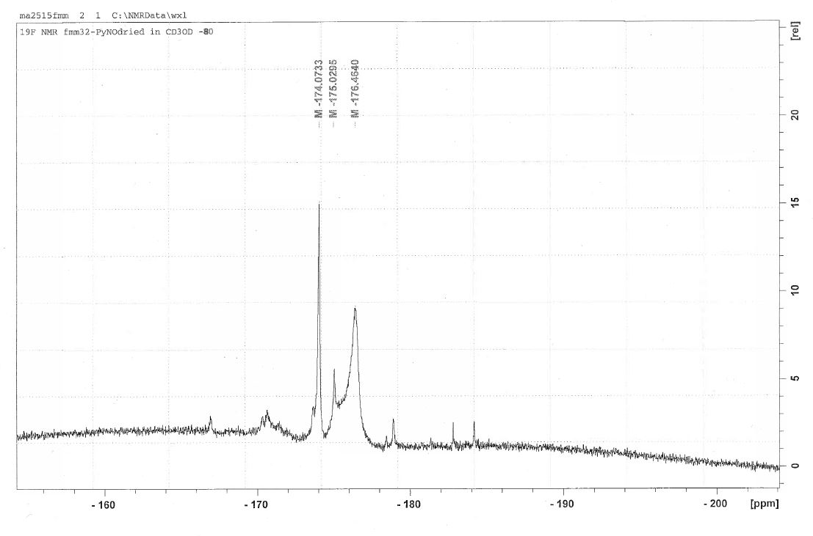

IR spectrum



Crystallographic data in cif format have been deposited with the Cambridge Crystallographic Data Centre (CCDC) and given number 1429863.

**[GaF4(PMDTAH)]**

1H NMR spectrum (400 MHz, CD2Cl2, 298 K)



13C{1H} NMR spectrum (400 MHz, CD2Cl2, 298 K)



19F NMR spectrum (400 MHz, CD2Cl2, 298 K)



IR spectrum



Crystallographic data in cif format have been deposited with the Cambridge Crystallographic Data Centre (CCDC) and given number 1429858.

**[AlCl3(OPMe3)]**

1H NMR spectrum (300 MHz, CD2Cl2, 295 K)

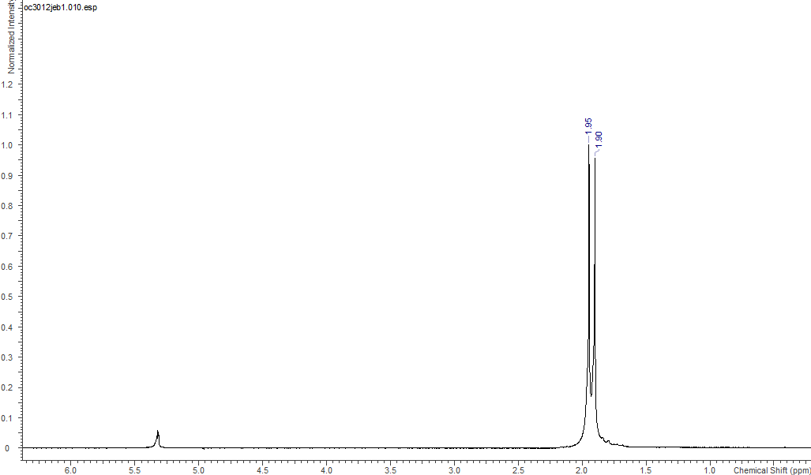

31P{1H} NMR spectrum (300 MHz, CD2Cl2, 295 K)

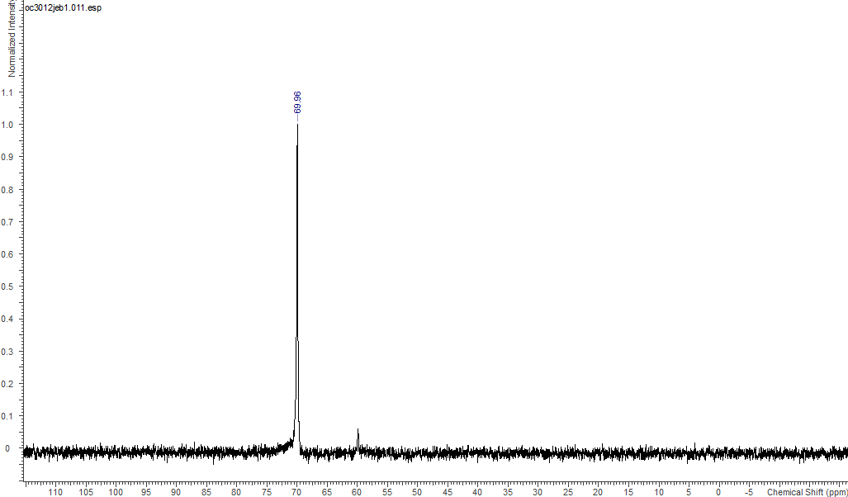

27Al NMR spectrum (400 MHz, CD2Cl2, 295 K)

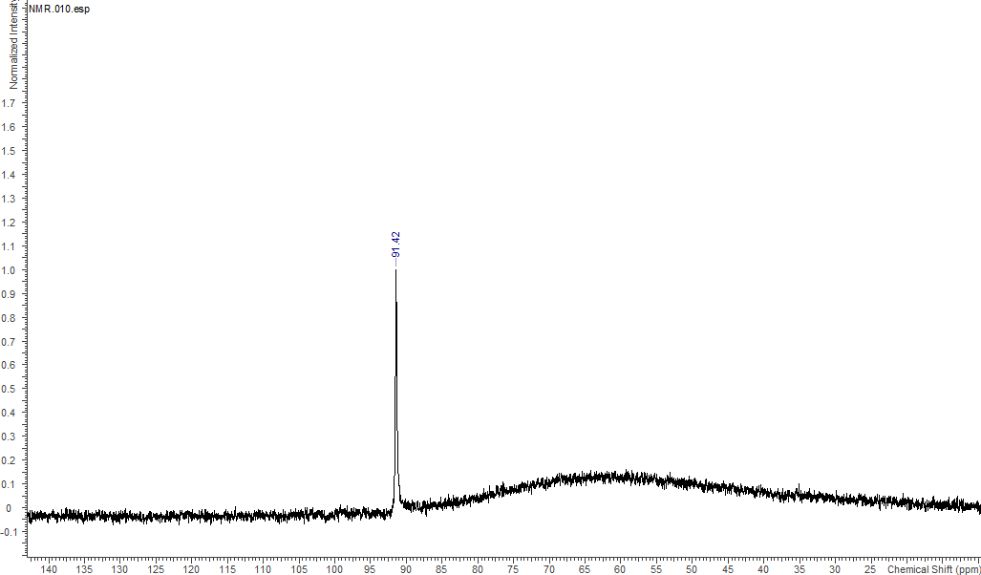

IR Spectrum

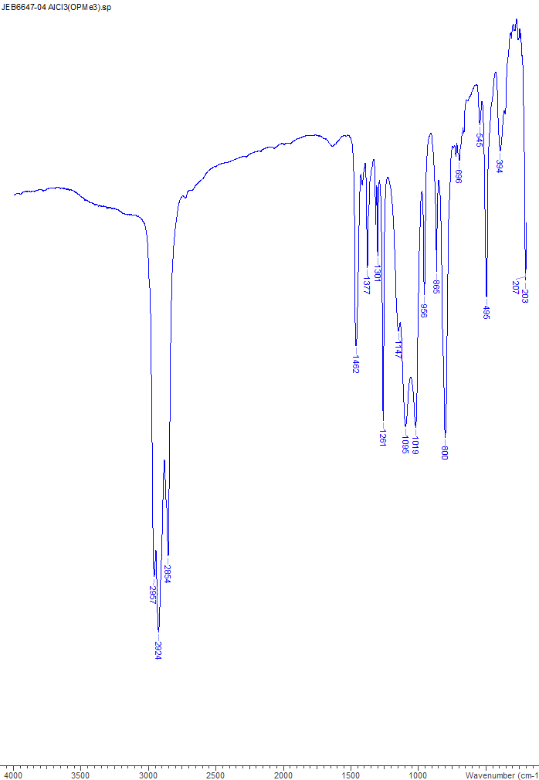

**[AlCl3(OAsPh3)]**

1H NMR spectrum (300 MHz, CD2Cl2, 295 K)

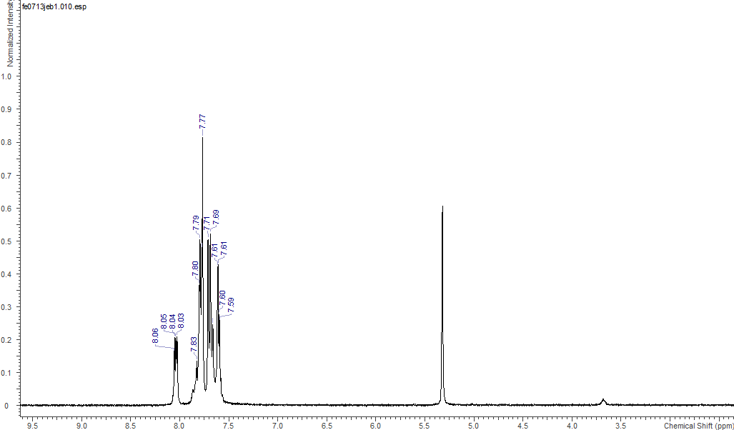

27Al NMR spectrum (400 MHz, CD2Cl2, 295 K)

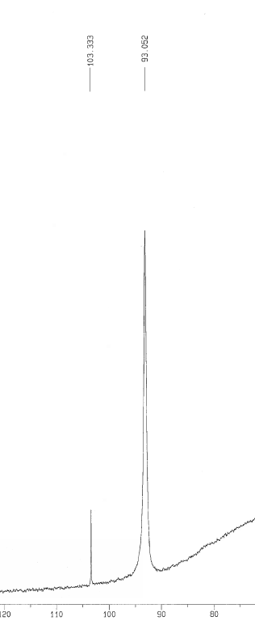

IR Spectrum

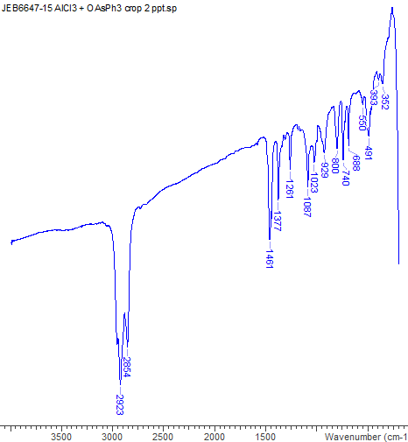

Crystallographic data in cif format have been deposited with the Cambridge Crystallographic Data Centre (CCDC) and given number 1429857.