Fig 1 Scatterplot of fat-free mass (FFM) (kg) of neonates measured by air-displacement plethysmography (ADP) and FFM derived from Growing Up in Singapore Towards Healthy Outcomes prediction equations based on weight (W), sex (S) and impedance quotient (L²/R₅₀) and W, S and recumbent length (L) in the validation group at birth (a and b) and week 2 (c and d). Dotted lines are lines of identity. ICC, intra-class correlation coefficient

Birth | Week 2
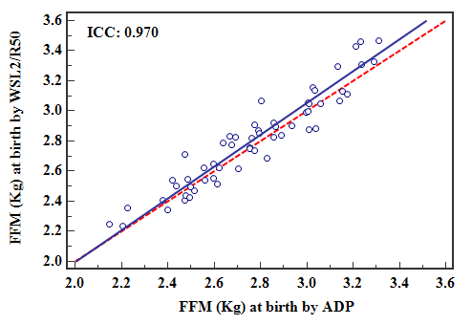 | 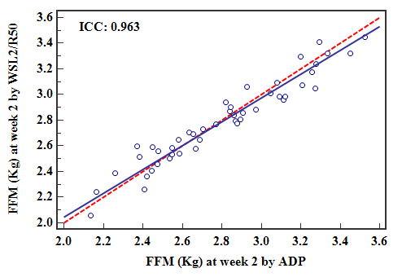
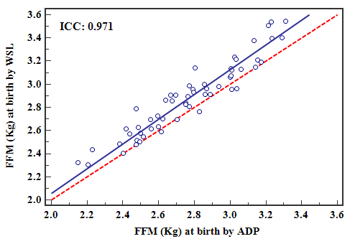 | 