Note submitted to Italian Journal of Zoology:

First report of live deep-water cnidarian assemblages from the Malta Escarpment.

Angeletti Lorenzo 1, Mecho Ariadna 2 , Doya Carol 2 , Micallef Aaron 3*, Huvenne Veerle
4 , Georgiopoulou Aggeliki 5 , Taviani Marco 1

1 ISMAR-CNR, UOS Bologna, Via Gobetti 101, 40129 Bologna, Italy. Tel: +39 0516398874; Fax: + 39 0516398940; E-mails: lorenzo.angeletti@bo.ismar.cnr.it; marco.taviani@bo.ismar.cnr.it.
2 Institut de Ciències del Mar, CSIC, Passeig Marítim de la Barceloneta, 37-49, 08003
Barcelona, Spain. Tel: +34 93 230 9500; Fax: +34 93 230 95 55; E-mails: mecho@icm.csic.es; crldoya@icm.csic.es.
3 Department of Physics, Faculty of Science, University of Malta, Msida, MSD 2080, Malta. Tel: +356 23403613; E-mail: aaron.micallef@um.edu.mt.
4 National Oceanography Centre, University of Southampton Waterfront Campus, European Way, Southampton, SO14 3ZH, United Kingdom. Tel: +44 (0)2380 596575; E-mail: vaih@noc.ac.uk.
5 School of Geological Sciences, Science Centre, Belfield, University College Dublin,
Dublin, Ireland. Tel: +353 17162063; E-mail: aggie.georg@ucd.ie.
*Corresponding author

Abstract

A recent geo-marine survey of the Malta Escarpment revealed for the first time the existence of live cnidarian assemblages at about 300 m depth. These associations have been observed by means of a Remote Operated Vehicle (ROV) during surveys carried out on the upper part of the Malta Escarpment. The assemblages established on hard bedrocks were chiefly composed of the antipatharian Leiopathes glaberrima. The Malta Escarpment is known to have been successfully colonised by deep-water scleractinian assemblages until the last glacial age. However, no living specimens had been observed, and only specimens of dead but relatively fresh Dendrophyllia cornigera had been reported. This area of the Mediterranean Sea, which connects the deep Ionian basin to the western Mediterranean, is largely unknown and in clear need of thorough exploration.

1. Introduction

The routine application of detailed multibeam mapping, coupled with Remotely Operated Vehicle (ROV) inspection of promising submerged topographies, has often led to the discovery of deep-water habitats characterised by sessile megabenthic communities in the Mediterranean Sea. By large, the most relevant actors of such aphotic communities are cnidarians and sponges associated with poorly sampled hard bottoms at depths exceeding 200 m. This is primarily the case of the so-called white coral communities documented at bathyal depths in the Strait of Sicily, southern Adriatic, Ionian, Ligurian, Marmara, north-western Mediterranean and Alboran seas (Tursi et al., 2004; Taviani et al., 2005a, b, 2011a; Freiwald et al., 2009; Mastrototaro et al., 2010; Vertino et al., 2010; Gori et al., 2013; Angeletti et al., 2014, Fabri et al., 2014), the sponge-dominated habitats in the Tyrrhenian, Ionian and Adriatic seas (Bo et al., 2012; Calcinai et al., 2013), and antipatharian-gorgonacean communities in the Tyrrhenian, Ionian and Adriatic Sea and in the Strait of Sicily (Costantini et al., 2010; Taviani et al., 2010; Bo et al., 2011, Angeletti et al., 2014, Deidun et al., 2014). From this ecological perspective, the Malta Escarpment in the central Mediterranean happens to be one of the least-explored in European waters. It borders westwards the deep Ionian Sea and comprises the eastern entrance into the Strait of Sicily, both areas hosting significant deep-water coral presence (Taviani et al., 2011a). A recent ROV-assisted geo-marine survey inspected the upper part of the north Malta Escarpment, discovering for the first time live cnidarian assemblages dominated by antipatharians (black corals) in this region. The scope of this study is to describe new findings of hard bottom assemblages present in the upper Malta Escarpment.

2. Regional setting

The Malta Escarpment is a dominant physiographic element in the central Mediterranean Sea. It consists of a steep, NNW-SSE trending slope that extends southwards from the east coast of Sicily for 250 km with a vertical relief of up to 3.5 km (Biju-Duval et al., 1982; 1983; Groupe Escarmed 1982). The Malta Escarpment is the expression of a passive margin separating the continental crust of the Malta Plateau from the oceanic crust of the Ionian Basin (Argnani and Bonazzi, 2005). The age of the Malta Escarpment remains controversial, with estimates ranging from Late Triassic to Early Cretaceous (Argnani et al., 2012). Triassic-Neogene shallow-water to basinal carbonate sequences outcrop along the escarpment (Scandone et al., 1981; Casero et al., 1984). The Malta Escarpment incorporates extensional block faulting and sinistral strike-slip deformation as a result of the different rates of underthrusting between the buoyant Malta Plateau and the Ionian crust (Grasso, 1993; Adam et al., 2000; Catalano et al., 2000). The Malta Escarpment can be classified as a sediment-starved margin (at least since the Messinian), with an estimated post-Messinian sedimentation rate of ~6 cm ka⁻¹ (Max et al., 1993; Osler and Algan, 1999). A series of submarine canyons has been mapped from bathymetric data acquired in the late 1970s (Scandone et al., 1981). Landslide activity across the Malta Escarpment had mainly been inferred from sediment cores, with turbidites, megaturbidites and debris flows being reported from the base of the Malta Escarpment (Scandone et al., 1981; Casero et al., 1984; Rebesco et al., 2000). More recently, submarine landslides, in the form of translational slides, spreads and debris flows, have been shown to be a widespread geomorphologic phenomenon across the outer Malta Plateau and upper Malta Escarpment (Micallef et al., 2013). The outer Malta Plateau also hosts four channels and a number of straight to non-linear bedrock ridges (Micallef et al., 2013).

3. Material and Methods

The outer Malta Plateau and upper Malta Escarpment (Fig 1A) were surveyed during the CUMECS cruise (28th June – 2nd July 2012) on board the R/V Urania. Swath bathymetry data were acquired from 370 km² of seafloor using a Kongsberg Simrad EM710 multibeam echosounder with a nominal sonar frequency of 70–100 kHz (Micallef et al., 2013). A ROV dive was carried out to obtain video footage and still photographs of small-scale morphology, benthic habitats and biota from the canyon heads in order to ground-truth the acoustic data. The ROV carried a forward-looking 1/3 inches Sony CCD (Charche Coupling Device) colour video camera placed inside the POD. Video frames of the seabed described in the present study were acquired along one transect on the upper Malta Escarpment (Fig. 2; Table 1). The survey lasted approximately 5 h. The covered distance was of ca. 2.7 km and the depth range surveyed was from 300 m to 537 m depth. One bottom sampling was carried out across a non-linear bedrock ridge using a rock dredge to allow a correct taxonomic identification of the species observed by ROV (Table 1).

4. Results

ROV imagery shows a general habitat covered with a thick drape of fine-grained sediment displaying a wide variety of bioturbation features. Sedimentary bottoms of the shelf edge and upper slope (300-310 m) were colonised by octocorals as Funiculina quadrangularis (Pallas, 1766). (Fig. 2). Fish fauna included the trumpet fish, Macroromphosus scolopax (Linnaeus, 1758), Helicolenus dactylopterus (Delaroche, 1809), Lepidopus caudatus (Euphrasen, 136 1788), Polyprion americanus (Bloch and Schneider, 1801) and Naucrates ductor (Linnaeus, 1758).

The ROV dive showed the presence of antipatarian assemblages on a bedrock ridge of the Malta Escarpment, where large colonies of two different black coral species, Leiopathes glaberrima (Esper, 1788) and Antipathes dichotoma (Pallas, 1776) were observed at depths of 310-315 m (Fig. 2). Colonies are sparsely distributed along the ROV track, although L. glaberrima dominates over A. dichotoma. Most of the colonies appeared healthy, although some showed signs of degradation. L. glaberrima branches hosted decapods (i.e. Anamathia rissoana, Roux, 1828), barnacles (i.e., Verruca sp.) and other unidentified fauna.

Somewhat deeper (342 m depth,) gorgonians (e.g., cf. Paramuricea macrospina) and encrusting yellow and blue hexactinelliid sponges were found. Vagile benthos included crustaceans (i.e. Munida tenuimana, Sars, 1872) and echinoids (i.e. Cidaris cidaris, Linnaeus, 1758)

Along the transect we observed several linear elongate depressions on the sediment surface, which we interpret as trawl marks, as well as lost fishing gear snagged around the rock outcrops.

Dredged material from one of these escarpments consists of carbonate hardgrounds.

5. Discussion

The high, steep and sediment-starved flanks of the Malta Escarpment are ideal sites for the formation of hardgrounds, which also served as substrate to a variety of encrusting organisms and sessile megabenthos since at least the Pleistocene (Allouc 1986, 1990; Biju-Duval et al., 1983). As such, the escarpment has also been episodically colonised by deep-water corals and other macrobenthic epifauna. This is proven by abundant skeletal remains of scleractinians dredged and observed by submersible dives at depths exceeding 2000 m during Italian and French missions in the 1980s (Cita et al., 1979, 1980; Taviani and Colantoni 1984). None of the observed organisms had been proven to be alive. By large, deep-water corals are represented by well preserved, still- aragonitic sub-fossil corallites embedded into micritic authigenic crusts, the external surfaces of which are patinated by Mn-Fe oxides (Taviani and Colantoni 1984). A distinct assemblage dominated by the cosmopolitan solitary taxon Desmophyllum dianthus (Esper, 1794), with minimal intermixing with colonial species, was identified between 2500 m and 3500 m. Coral rubbles of Dendrophyllia cornigera (Lamarck, 1816) were present at such depths, but no live colonies had been observed. These sub-fossil corals have been dated to the last glacial age (Delibrias and Taviani, 1985), and represent a distinct deep-water coral assemblage that inhabited the Mediterranean Sea during the glacial Pleistocene. Such assemblages have mostly been reported at considerable depths in the Mediterranean basin (e.g. Eastern Mediterranean Basin, Zibrowius 1981; Taviani et al., 2011b).

Our study produces evidence that sessile megabenthos, especially the black coral Leiopathes glaberrima, forms live assemblages at shallower depths in association with gorgonians, and confirm their cosmopolitan distribution in the Mediterranean waters at depth down 300 m (e.g. Bo et al., 2008, Deidun et al., 2010; Angeletti et al., 2014; Deidun et al., 2014). In some cases, L. glaberrima provide a habitat for commercially important crustaceans, as reported in the Atlantic and Pacific Oceans (e.g. Le Guilloux et al., 2010, Cañete and Haussermann, 2012).

To the best of our knowledge, no information on living deep-water scleractinian corals on the Malta Escarpment was available until the present study. This is puzzling, considering the fact that live colonies of deep-water corals as Lophelia pertusa (Linnaeus, 1758), Madrepora oculata (Linnaeus, 1758), Dendrophyllia cornigera (Lamarck, 1816) and the solitary coral Desmophyllum dianthus (Esper, 1794) have been well documented in the Strait of Sicily and elsewhere in the Ionian Sea, at depths comparable to those in the present study (Schembri et al., 2007; Freiwald et al., 2009; Angeletti and Taviani 2011, Taviani et al., 2011a). Most occurrences in our study area often referred to dead pre-modern material (e.g. Fink et al., 2012; McCulloch et al., 2012). Nevertheless, it seems unlikely that the Malta Escarpment as a whole would be deprived of such cnidarians. Our discovery of living antipatharians may suggest that the absence of deep-water coral reports in this area could be the result of the paucity of studies carried out on the Malta Escarpment. Our results stress the need to increase the geo-marine sampling effort across the Malta Escarpment for a more complete assessment of biodiversity in the central Mediterranean basin.

Acknowledgements

We are indebted to officers, crew and shipboard party for their cooperation during the CUMECS cruise. This research was supported by funding from the Union Seventh Framework Programme (FP7/2007-2013) under grant agreements n° 228344 (EUROFLEETS), n° 252702 (CAGE), n° 618149 (SCARP) and ERC Starting Grant n° 258482 (CODEMAP). This paper contributes to RITMARE and EU CoCoNet projects, and is ISMAR-CNR scientific contribution no. 1826.

References

Adam J., Reuther C. D., Grasso M., Torelli L., 2000 - Active fault kinematics and crustal stresses along the Ionian margin of southeastern Sicily. Tectonophysics, 326: 217-239.
Allouc J., 1986 - Les encroutements sous-marins de Méditerranée orientale: une explication génétique. Revue de l’Institute Français du Pétrole, 41: 351–376.
Allouc J., 1990 - Quaternary crusts on slopes of the Mediterranean Sea: A tentative explanation for their genesis. Marine Geology, 94: 205–238.
Angeletti L., Taviani M., 2011 - Entrapment, preservation and incipient fossilization of benthic predatory molluscs within deep-water coral frames in the Mediterranean Sea. Geobios, 44: 543-548.
Angeletti L., Taviani M., Canese S., Foglini F., Mastrototaro F., Argnani A., Trincardi F., Bakran-Petricioli T., Ceregato A., Chimienti G., Mačić V., Poliseno A., 2014 . New deep-water cnidarian sites in the southern Adriatic Sea. Mediterranean Marine Science, 15(2), 263-273. DOI: http://dx.doi.org/10.12681/mms.558
Argnani A Bonazzi C., 2005 - Malta Escarpment fault zone offshore eastern Sicily: Pliocene-Quaternary tectonic evolution based on new multichannel seismic data. Tectonics, 24, TC4009.
Argnani A., Armigliato A., Pagnoni G., Zaniboni F., Tinti S., Bonazzi C., 2012 - Active tectonics along the submarine slope of south-eastern Sicily and the source of the 11 January 1693 earthquake and tsunami. Natural Hazards and Earth System Sciences, 12: 1311-1319.
Biju-Duval B., Morel Y., Baudrimont A., Bizon G., Bizon J. J., Borsetti AM., Burollet P. F., Clairefond P., Clauzon G., Colantoni P., Mascle G., Montadert L., Perrier R., Orsolini P., Ravenne C., Taviani M., Winnock E., 1982 - Données nouvelles sur les marges du bassin Ionien profond (Mediterranée orientale): résultats des campagnes Escarmed. Revue Institute Francais du Pétrole, 37: 713-731.
Biju-Duval B., Morel Y., Baudrimont A., Bizon G., Bizon J.J., 1983 - Exemples de sédimentation condensée sur les escarpements de la mer Ionienne (Méditerranée orientale). Observations à partir du submersible Cyana. Revue Institute Francais du Pétrole, 38(4): 427-438.
Bo M., Bavestrello G., Canese S., Giusti M., Salvati E., Angiolillo M., Greco S., 2008 – Characteristics of a black coral meadow in the twilight zone in the central Mediterranean Sea. Marine Ecology Progress Series, 397: 53-61.
Bo M., Bavestrello G., Canese S., Giusti M., Angiolillo M., Cerrano C., Salvati E., Greco S., 2011 - Coral assemblage off the Calabrian Coast (South Italy) with new observations on living colonies of Antipathes dichotoma, Italian Journal of Zoology, 78: 231-242.
Bo M., Bertolino M., Bavestrello G., Canese S., Giusti M., Angiolillo M., Pansini M., Taviani M., 2012 - Role of deep sponge grounds in the Mediterranean Sea: a case study in southern Italy. Hydrobiologia, 687: 163-177.
Calcinai B., Moratti V., Martinelli M., Bavestrello G., Taviani M., 2013 - Uncommon sponges associated with deep coral bank and maerl habitats in the Strait of Sicily (Mediterranean Sea). Italian Journal of Zoology, 80(3): 412-423.
Casero P., Cita M. B., Croce M., De Micheli A., 1984 - Tentative di interpretazione evolutiva della scarpata di Malta basata su dati geologici e geofisici. Memorie della Societa` Geologica Italiana, 27: 233-253.
Catalano R., Doglioni C., Merlini S., 2000 - On the Mesozoic Ionian Basin. Geophysical Journal International, 143: 1-24.
Cañete J. I., Haussermann V., 2012 - Colonial life under the Humboldt Current System: deep-sea corals from O'Higgins I seamount. Latin American Journal of Aquatic Research, 40: 467-472.
Cita M. B., Fantini Sestini N., Salvatorini G., Mazzei R., Kidd R. B., 1979 - Late Neogene sediments and fossils from the Malta Escarpment and their geodynamic signiﬁcance. Annales Géologique des Pays Hellenique, 1: 273-283.
Cita M. B., Benelli F., Biggiogero B., Chezar H., Colombo A., Fantini Sestini N., Freeman-Lynde R., Iaccarino S., Jadoul F., Legnani R., Malinverno A., Massiotta P., Paggi L., Premoli-Silva I., 1980 - Contribution to the geological exploration of the Malta Escarpment (eastern Mediterranean). Rivista Italiana di Paleontologia e Stratigrafia, 86: 317-356.
Costantini F., Taviani M., Remia A., Pintus, E., Schembri, P. J., Abbiati M., 2010 - Deep-water Corallium rubrum (L., 1758) from the Mediterranean Sea: preliminary genetic characterisation. Marine Ecology, 31: 261-269.
Deidun A., Andolaro F., Bavestrello G., Canese S., Consoli P., Micallef A., Romeu T., Bo M., 2014 - First characterisation of a Leiopathes glaberrima (Cnidaria: Anthozoa: Antipatharia) forest in Maltese exploited fishing grounds. Italian Journal of Zoology, 1-10, http://dx.doi.org/10.1080/11250003.2014.986544
Deidun A., Tsounis G., Balzan F., Micallef A., 2010 – Records of Black coral Antipatharia and red coral Corallium rubrum fishing activities in the Maltese Islands. Marine Biodiversity Records, 3, doi:10.1017/S1755267210000709.
Delibrias G., Taviani M., 1985 - Dating the death of Mediterranean deep-sea scleractinian corals. Marine Geology, 62: 175–180.
Fabri M-C., Pedel L., Beuck L., Galgani F., Hebbeln D., Freiwald A., 2014. Megafauna of vulnerable marine ecosystems in French mediterranean submarine canyons: Spatial dstribution and anthropogenic impacts. Deep Sea Research Part II: Topical Studies in Oceanography, 104, 184-207. Fink H. G., Wienberg C., Hebbeln D., McGregor H. V., Schmiedl G., Taviani M., Freiwald A., 2012 - Oxygen control on Holocene cold-water coral development in the eastern Mediterranean Sea. Deep-Sea Research 1, 62: 89-96
Freiwald A., Beuk L., Rüggeberg A., Taviani M., Hebbeln D., R/V Meteor Cruise M70- 1 Participants., 2009 - The White Coral Community in the Central Mediterranean Sea Revealed by ROV Surveys. Oceanography, 22: 58-74.
Gori A., Orejas C., Madurell T., Bramanti L., Martins M., Quintanilla E., Marti-Puig P., Lo Iacono C., Puig P., Requena S., Greenacre M., Gili J. M., 2013 - Bathymetrical distribution and size structure of cold-water coral populations in the Cap de Creus and Lacaze-Duthiers canyons (northwestern Mediterranean). Biogeosciences, 10: 2049-2060.
Grasso M., 1993 - Pleistocene structures along the Ionian side of the Hyblean Plateau (SE Sicily): Implications for the tectonic evolution of the Malta Escarpment, in: Max MD, Colantoni P. (Eds.), Geological Development of the Sicilian-Tunisian Platform. UNESCO, Urbino, pp. 49-54.
Groupe Escarmed, 1982 - Observations geologiques effectuées sur les escarpements ioniens (resultats preliminaires). Oceanis, 8: 637-643.
Le Guilloux E., Hall-Spencer J.M., Söffker M.K., and Olu K., 2010 - Association between the squat lobster Gastroptychus formosus and cold-water corals in the North Atlantic. Journal of the Marine Biological Association of the United Kingdom, 90:1363- 1369.
IOC, IHO, and BODC, 2003 - Centenary Edition of the GEBCO Digital Atlas, in Organisation, I.H., ed., General Bathymetric Chart of the Oceans: Liverpool, British Oceanographic Data Centre.
Mastrototaro F., D’Onghia G., Corriero G., Matarrese A., Maiorano P., Panetta P., Gherardi M., Longo C., Rosso A., Sciuto F., Sanfilippo R., Gravili C., Boero F., Taviani M., Tursi A., 2010 - Biodiversity of the white coral bank off Cape Santa Maria di Leuca (Mediterranean Sea): An update. Deep-Sea Research Part II: Topical Studies in Oceanography, 57: 412-430.
Max M. D., Kristensen, A., Michelozzi E., 1993 - Small scale Plio-Quaternary sequence stratigraphy and shallow geology of the west-central Malta Plateau, in: Max MD, Colantoni P. (Eds.), Geological Development of the Sicilian-Tunisian Platform. UNESCO, Urbino, pp. 117-122.
McCulloch M, Falter J, Trotter J, Montagna P. 2012. Coral resilience to ocean acidification and global warming through pH up-regulation Nature Climate Change 2: 623-627.
Micallef A., Georgiopoulou A., Le Bas T., Mountjoy J. J., Huvenne V., Lo Iacono C., 2013 - The Malta-Sicily Escarpment: Mass Movement dynamics in a sediment- undersupplied margin, in: Krastel S., Berhmann J. H., Volker D., Stipp M., Berndt C., Urgeles R., Chaytor J. D., Huhn K., Strasser M., Harbitz C. B., (Eds.), Submarine Mass Movements and Their Consequences. Springer International Publishing, Switzerland, pp. 317-328.
Osler J., Algan O., 1999 - A high resolution seismic sequence analysis of the Malta Plateau, Saclantcen Report.
Rebesco M., Della Vedova B., Cernobori L., Aloisi G.. 2000 - Acoustic facies of Holocene megaturbidites and the Eastern Mediterranean. Sedimentary Geology, 135: 65-74.
Scandone P., Patacca E., Radoicic R., Ryan W. B. F., Cita M. B., Rawson M., Chezar H., Miller E., McKenzie J., Rossi S., 1981 - Mesozoic and Cenozoic rocks from Malta Escarpment (Central Mediterranean). American Association of Petroleum Geologists Bulletin, 65: 1299-1319.
Schembri P.J., Dimech M., Camilleri M., Page R., 2007 - Living deep-water Lophelia and Madrepora corals in Maltese waters (Strait of Sicily, Mediterranean Sea): Cahiers de Biologie Marine, 48: 77-83.
Taviani M., Colantoni P., 1984 - Paléobiocenoses profondes a scléractiniaires sur lʼescarpement de Malte-Syracuse (Mer Méditerranée): leur structure, leur âge et leur signiﬁcation. Revue de l’Institute Francais du Pétrole, 39: 547-552.
Taviani M., Freiwald A., Zibrowius H., 2005a - Deep coral growth in the Mediterranean Sea: an overwiev. In: Freiwald A., Roberts J. M. editors. Cold-water Corals and Ecosystems. Springer-Verlag, Berlin Heidelberg, pp. 137-156.
Taviani M., Remia A., Corselli C., Freiwald A., Malinverno E., Mastrototaro F., Savini A., Tursi A., 2005b. - First geo-marine survey of living cold-water Lophelia reefs in the Ionian Sea (Mediterranean basin). Facies, 50: 409–417.
Taviani M., Freiwald A., Beuck L., Angeletti L., Remia A., Vertino A., Dimech M., Schembri P. J., 2010 - The deepest known occurrence of the precious red coral Corallium rubrum (L. 1758) in the Mediterranean Sea. In: Bussoletti E., Cottingham D., Bruckner A., Roberts G., Sandulli R., (eds). Proceedings of the International Workshop on Red Coral Science, Management, and Trade: Lessons from the Mediterranean. NOAA Technical Memorandum CRCP-13, Silver Spring, MD, pp. 233.
Taviani M., Angeletti L., Antolini B., Ceregato A., Froglia C., López-Correa M., Montagna P., Remia A., Trincardi F., Vertino A., 2011a - Geo-biology of Mediterranean Deep-Water Coral Ecosystems. CNR@Sea, 705-720.
Taviani M., Vertino A., López-Correa M., Savini A., De Mol B., Remia A., Montagna P., Angeletti L., Zibrowius H., Alves T., Salomidi M., Ritt B., Henry P., 2011b - Pleistocene to Recent scleractinian deep-water corals and coral facies in the Eastern Mediterranean. Facies, 57: 579-603.
Tursi A., Mastrototaro F., Matarrese A., Maiorano P., D’Onghia G., 2004 - Biodiversity of the white coral reefs in the Ionian Sea (central Mediterranean). Chemistry and Ecology, 20:107–116.
Vertino A., Savini A., Rosso A., Di Geronimo I., Sanﬁlippo R., Mastrototaro F., Sanﬁlippo R., Gay G., Etiope G., 2010 - Benthic habitat characterization and distribution from two representative sites of the deep-water SML Coral Province (Mediterranean). Deep Sea Research II, 57:380–396.
Zibrowius H., 1981 - Thanatocoenose pléistocène profonde à Spongiaires et Scléractiniaires dans la Fosse Hellenique. Journées d’études sur la systérnatique évolutive et la biogéographie en Méditerranée. Cagliari CIESM, 1980: 133-136.

Legends to figures

Fig. 1. A) Bathymetric map of the Malta Escarpment, central Mediterranean Sea (Source: IOC et al., 2003). The yellow dots indicate the locations of glacial Pleistocene deep-water coral hardgrounds found during previous campaigns (Taviani and Colantoni, 1984). B) Detailed multibeam bathymetric data of the upper Malta Escarpment, acquired during the CUMECS cruise, where the live cnidarian dominated assemblages were discovered.

Fig. 2. Detail of the Malta Escarpment showing the track of ROV dive and dredge with photos of emblematic cnidarians; A) Most dense aggregation of the antipatharian Leiopathes glaberrima (313 m depth); B) Moribund/dead stalk of black coral (314 m depth); C) A specimen of the octocoral Funiculina quadrangularis, a common inhabitant of deep-sea muddy bottoms (303 m depth).

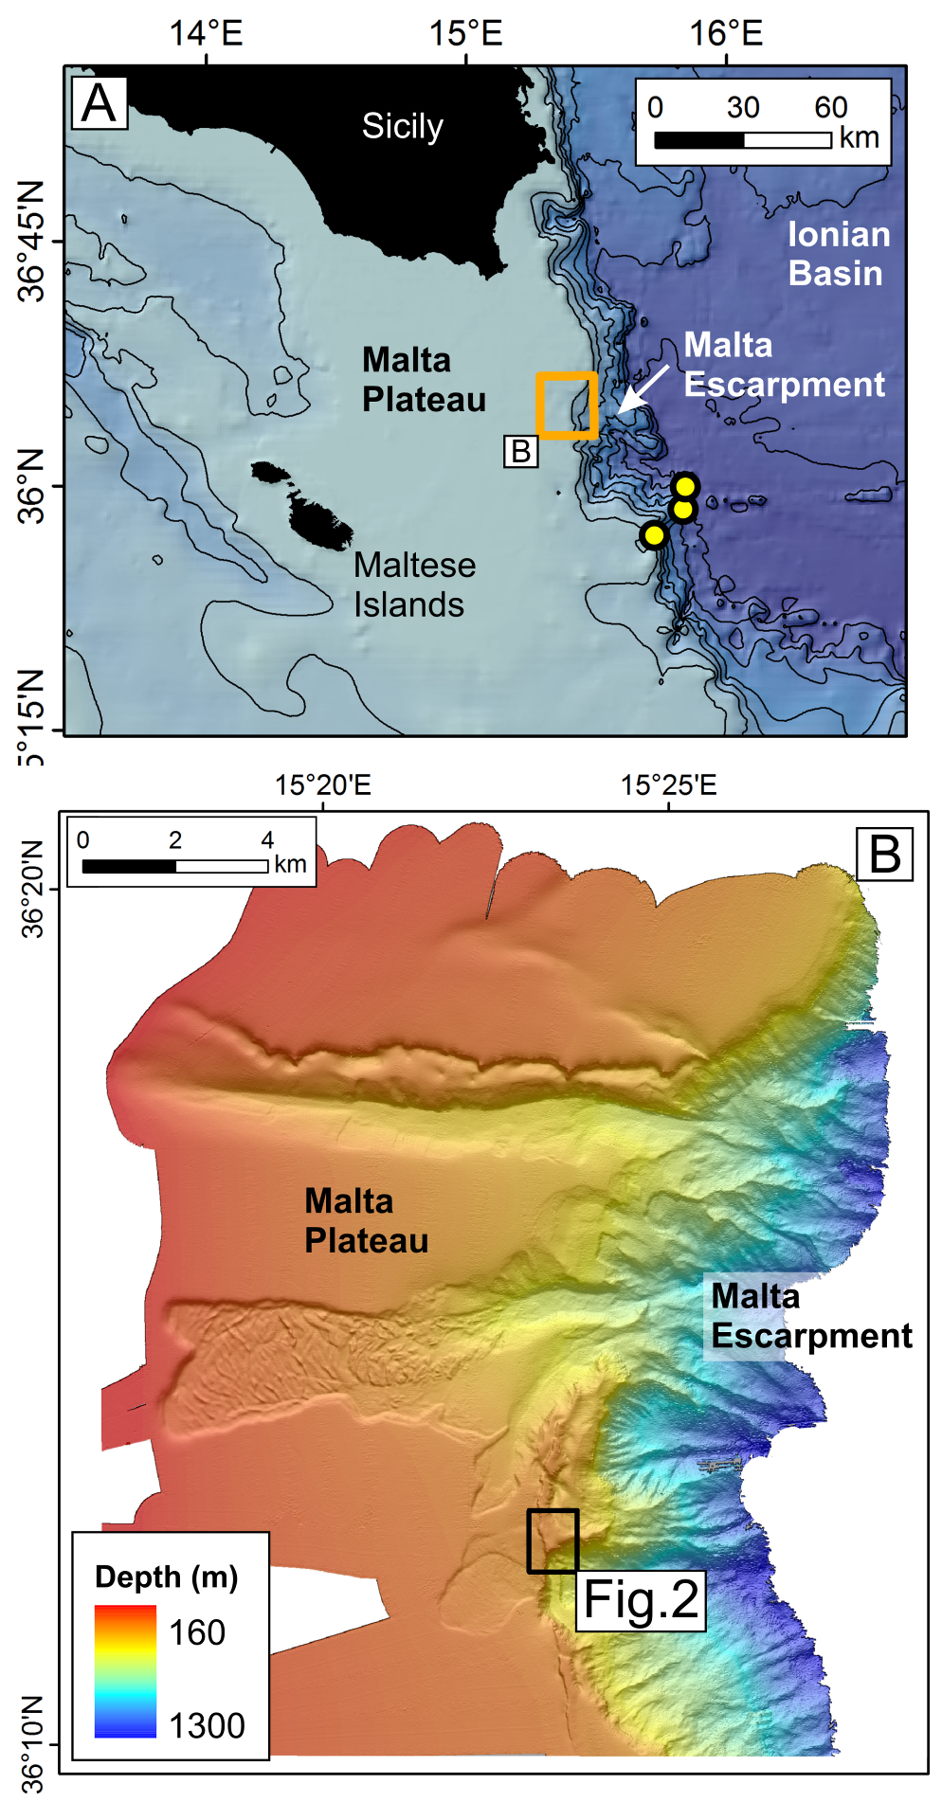
Fig. 1
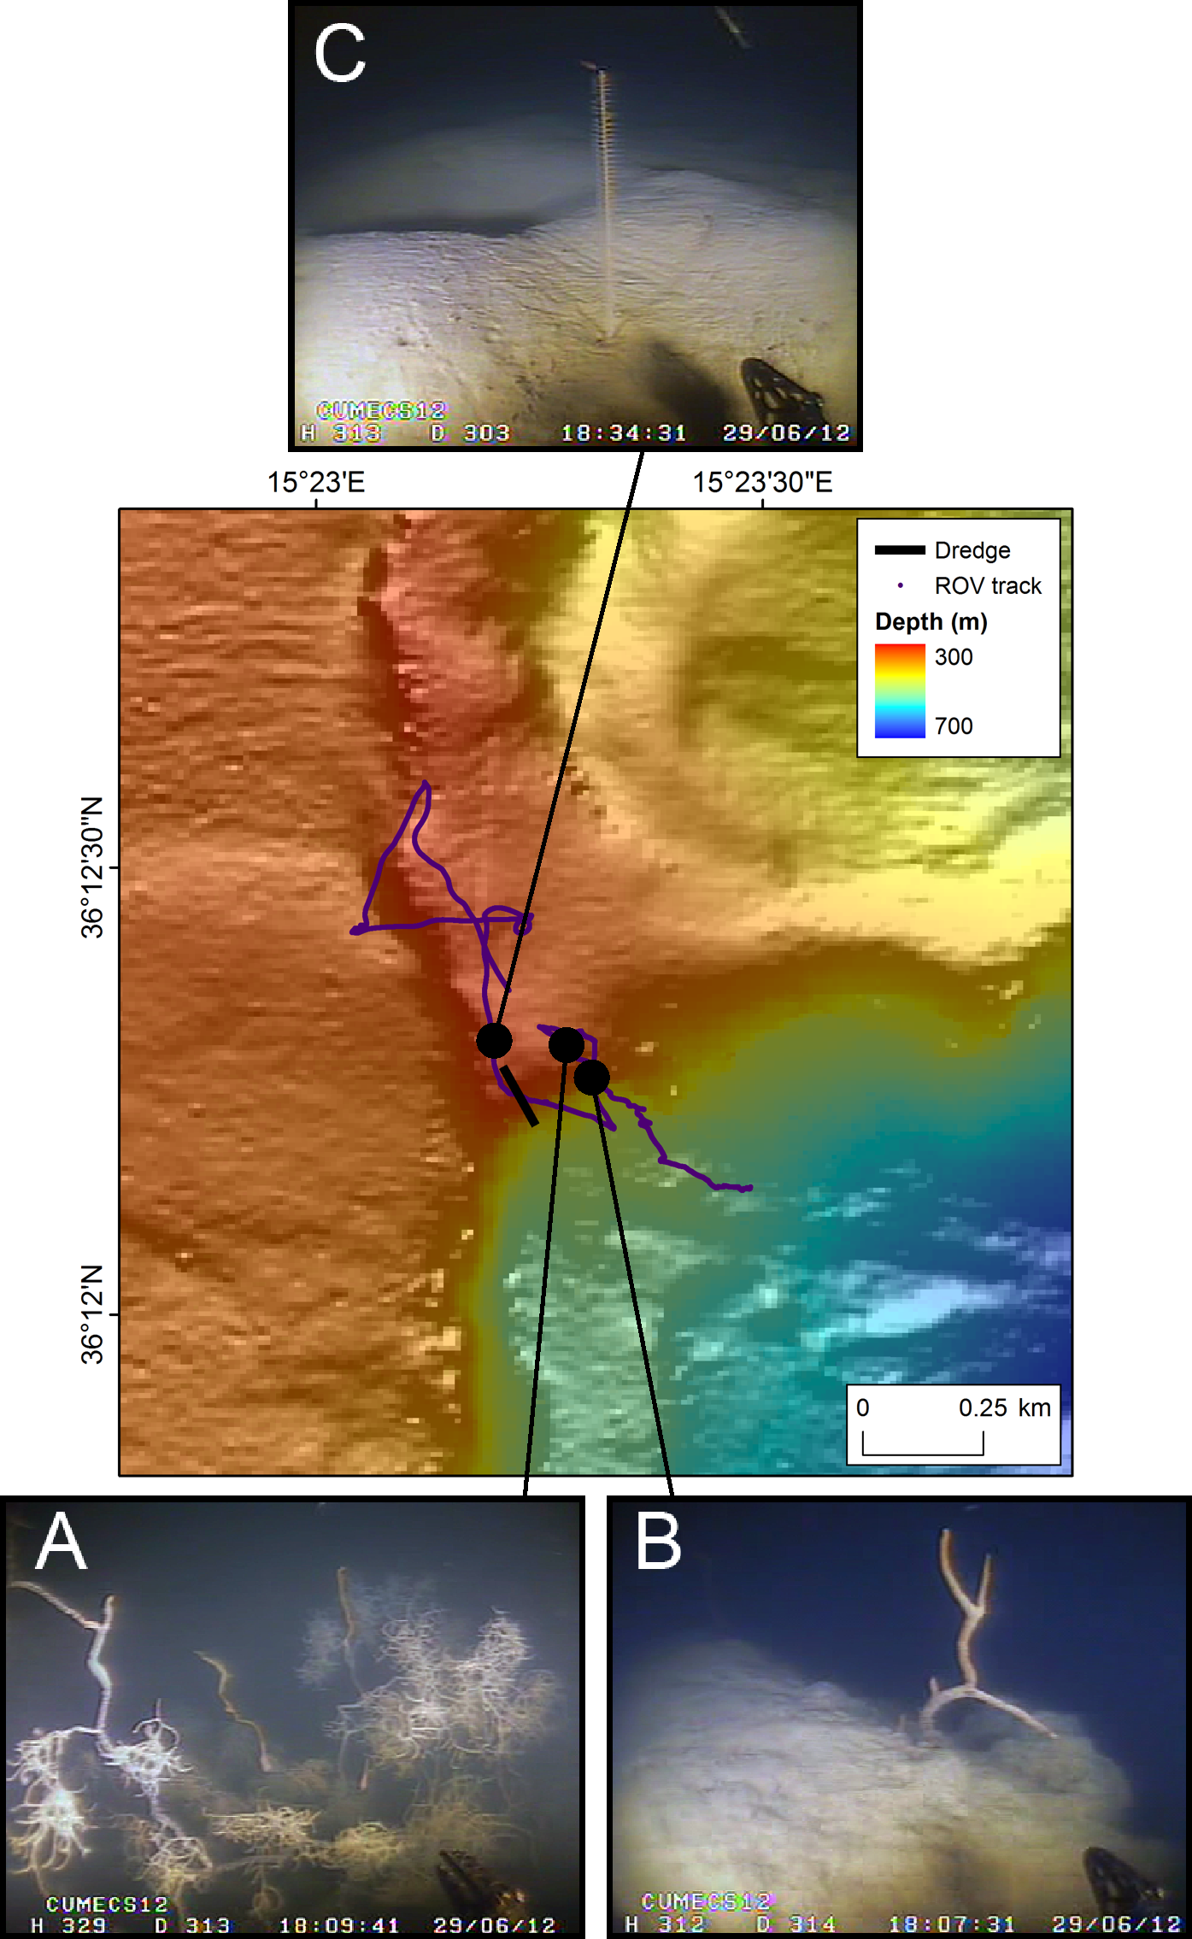
Fig. 2

